CRITICAL REVIEW ON MICROWAVE-ASSISTED EXTRACTION METHOD FOR EXTRACTING PHYTOPHARMACEUTICALS

T. Likitha¹, R. Gayathri² , , Dr. Sneha Thakur³, Dr Koduru Swathi⁴, Dr Kalepu Swathi⁵ , Dr Mitta Chaitanya⁶, H.V. Santosh Allu⁷

1,2-Student, St. Pauls college of Pharmacy, Turkayamjal, R.R Dist, Hyderabad-501510, Telangana

3- Associate Professor, HOD, Department of Pharmacognosy, St. Pauls college of Pharmacy, Turkayamjal, R.R Dist, Hyderabad-501510, Telangana

4,5,6-Associate Professor, Bojjam Narasimhulu Pharmacy College forWomen, Saidabad, Hyderabad-500059

7- Associate Professor, Avanthi Institute of Pharmaceutical Sciences, Cherukupally,

Vizianagaram-531162, India

Corresponding author
Koduru Swathi
Associate Professor, Bojjam Narasimhulu Pharmacy College forWomen, Saidabad, Hyderabad-500059

CRITICAL REVIEW ON MICROWAVE-ASSISTED EXTRACTION METHOD FOR EXTRACTING PHYTOPHARMACEUTICALS

Abstract
Microwave extraction is a green and advanced extraction technique that offers advantages such as reduced extraction time and solvent consumption, which improves the simultaneous extraction of multiple samples. It offers a very attractive alternative to conventional methods for the extraction of organic and organo-metallic compounds. This process uses microwave energy to heat solvents in contact with the sample to separate the analytes from the sample matrix into the solvent. Microwaves involve heating the sample molecules through the two mechanisms of ion conduction and dipole rotation. This extraction involves microwaves to heat the moisture and simultaneous evaporation, which creates immense pressure to break the cell wall, which ultimately washes away the plant ingredients. Recent advances in microwave extraction with optimization of process parameters have advantages over traditional methods such as a simple, fast, convenient and less labor-intensive process. The extraction power is increased and the phytoconstituents were found to be stable and active
Keywords: MAE; Solvents; Phytopharmaceuticals; Advantages; Limitations

Introduction
Extraction is the separation of one or more compounds from a liquid or solid mixture using a liquid invisible solvent[1]. Extraction is the first basic step in the study of medicinal plants, because the preparation of crude plant extracts is the starting point for the separation and purification of chemical components of plants[2]. Conventional techniques for solvent extraction of plant materials are mostly based on the proper selection of solvents and the use of heat and/or agitation to increase the solubility of the desired compounds and improve mass transfer [3]. In general, the traditional technique requires a longer extraction time, which poses a significant risk of thermal degradation of most herbal ingredients. New extraction methods, such as microwave extraction (MAE), supercritical fluid extraction (SCFE), and pressure solvent extraction (PSE), have attracted considerable research in the past decade[4]. Microwave extraction is a process that utilizes microwave energy to heat solvents in contact with the sample to partition analytes from the sample matrix into the solvent [5]. In this heating takes place purposefully and selectively, so that no heat is lost to the environment, because the heating process is done in a closed system[6]. It is an effective method for extracting natural compounds from raw plants. This allows a faster extraction of organic substances with similar or better yields. The solvents used in this extraction process are called menstruum, and the inert fibrous and other insoluble matter remaining after extraction is called MARC[7]. Its main application is the extraction of phytocomponents and nutrients. Some of the microwave extraction (MAE) processes include solute penetration into the solid matrix, dissolution and degradation of components, solute transport from the solid matrix, transfer of the extract into the solid, solute migration of the extracts from the outer surface solid into solution[8]. This extraction technique is very attractive because it is much faster, uses much less solvents and is an environmentally friendly technique. MAE enables the desorption of compounds of interest from the plant matrix [9]. This is due to the targeted heating of free water molecules in the glandular and vascular systems; this leads to localized heating that causes dramatic expansion subsequent rupture of their walls, allowing essential oil to flow towards the organic solvent [10]. Microwave extraction uses microwaves that easily penetrate the pores of the sample, so that the solvent in the pores is heated uniformly and quickly[11]. Microwaves are non-ionizing electromagnetic waves with a frequency of 300-300 GHz. Microwaves consist of two oscillating perpendicular fields, such as an electric field, and an ambient magnetic field. This mechanism significantly reduces extraction time compared to Soxhlet [12,13]. The principle of microwave heating is based on its direct effect on polar materials (Figure 1). Heating is effective only at 2450 MHz. Modern extraction techniques operate at much higher temperatures and pressures and consume less time[14]. In this microwave extraction, the samples are sealed with the solvent in high quality Teflon containers and heated to a controlled temperature using microwave power [15].
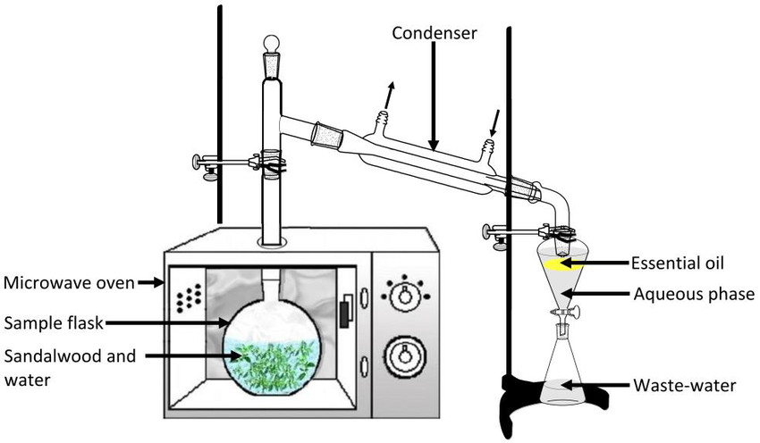
Figure 1: Technique of microwave-assisted extraction
INSTRUMENTATION:
Types of microwave-assisted extraction: There are two types of extractions[16] they are:
(a) Closed vessel system
(b) Open vessel system.
CLOSED VESSEL SYSTEMS:
In a closed system, the process is carried out in a sealed vessel under uniform microwave heating. Such systems are generally advised for digestion or acid mineralization or extractions under drastic conditions, since the solvents may be heated[17,18] at 100°C above their atmospheric boiling point. Both extraction speed and efficiency are obtained in this procedure. To overcome the non-homogeneity of the field, the cells are placed on a rotating carousel as in a domestic oven[19].. The temperature can be set at a fixed value by adjusting the microwave power. Typically, the cells are made of Teflon. In closed vessel systems, the maximal power delivered is about 600–1000 W, but the chosen power has to be set correctly to avoid excessive temperatures leading to possible solute degradation and overpressure problems. The vessel must be cooled to room temperature before opening: this is particularly important in the presence of volatile solutes. The pressure and temperature of this system allow fast and efficient extraction.. In a closed system, the process is carried out in a sealed vessel under uniform microwave heating. Such systems are generally advised for digestion or acid mineralization or extractions under drastic conditions, since the solvents may be heated[17,18] to 100°C above their atmospheric boiling point. The extraction speed and efficiency are enhanced in this procedure. To overcome the non-homogeneity of the field, the cells are placed on a rotating carousel as in a domestic oven[19]. The solvents can be varied, and the pressure in the vessels depends upon the volume and boiling point of the solvents used. The temperature can be set at a fixed value by adjusting the microwave power. Typically, the cells are made of Teflon. In closed vessel systems, the maximal power delivered is about 600–1000 W, but the chosen power has to be set correctly to avoid excessive temperatures which may leads to possible solute degradation and overpressure problems. The vessel must be cooled to room temperature before opening: this is particularly important in the presence of volatile solutes. The pressure and temperature of this system allows fast and efficient extraction.
OPEN VESSEL SYSTEMS:
These cells are quartz vessels topped by a vapor condenser[20]. The system works at atmospheric pressure and the maximum temperature which is determined by the boiling point of the solvents used. The solvent refluxed through the sample, and in this the microwaves are focused on the sample placed into the vessel allowing homogeneous and very efficient heating. The sample to be extracted can be placed into a Soxhlet-type cellulose cartridge(Figure 2) to avoid filtration steps or may be directly dipped into the solvent. Compared to closed vessel extractions, open cells offer increased safety in sample handling and they allow larger samples to be extracted.

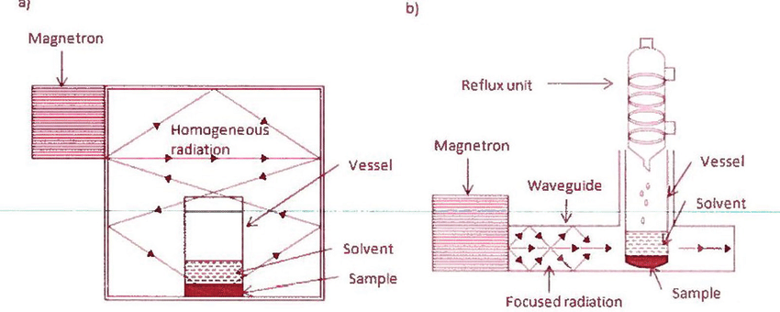
Figure 2: Closed and Open system of microwave-extracted extraction
PROCEDURE:
1. Heat energy[17-19] is created by microwave radiation.70 C, time, 13.8 min, and solvent volume 2.0 ml are adjusted.
2. Heat energy is absorbed by the sample.
3. Creation of high vapor pressure due to moisture evaporation.
4. Disruption of the cell wall of matrices.
5. Release of the desired compound into solvents.
Figure 3: Method of extraction using microwave
Usage of high-frequency Microwave radiation

Electric energy converted to heat energy

Diffusion of solvent and oil is released
Plant cell ruptures once the cell wall is expanded
The heated moisture builds up pressure on the cell wall
Intracellular moisture inside oil-bearing material gets heated up
mmmmbmater
Table 1: Yield of extract in plants in microwave-assisted extraction[7,15]
Plant materials | Yield of extract(mg/g) | MicrowaveExtraction (%)
G.Sibiricum linne, | 40 | 6.79%(corilagin),19.82%(geraniin)
Citrus unshiu | 10 | 47.7%
Milk thistle seed | 38 | 56.67%
Ganoderma atrum | 25 | 0.97%
Ribulus terrestris | 20 | 91.30%
Olive leaves | 8 | 95%
Rodgersia aesculifolia | 2 | 6.35%
Radix bupleuri roots | 30 | 95.05-96.91%
Potentilla anserina rhizomes | 15 | 13.33%
Apple pomace | 15 | 15.75%
Gymnema svlvestre | 25 | 0.76%
Platyclaudus orientalis leaves | 30 | 1.72%
Andrographis paniculata nees | 10 | 1.13%
Elletaria cardamomum seeds | 67 | 2.70%
Inonotus obliquus | 11 | 3.25%
Tomatoes | 10 | 97.40%
Lemon grass | 20 | 22.3%
Corydalis saxicola bunting | 20 | 9.45%
Ganoderma atrum | 25 | 5.11%
The defatted residue of yellow horn | 30 | 11.62%

ADVANTAGES OVER SOXHLET EXTRACTION:
MAE has been considered[8,16] as a potential alternative to traditional solid–liquid extraction. Some advantages of Soxhlet extraction are highlighted below
1. Significant reduction of extraction time. Extraction time usually ranges from a few seconds to a few minutes (15 – 20 min)
2. Reduced solvent usage. In MAE only a few milliliter of solvent is required
3. Improved extraction yield
4. Automation provides better accuracy and precision
5. Suitable for thermolabile constituents
6. Can even extract minute traces of constituents including heavy metals and pesticide residue from a few milligrams of plant sample
7. Provides agitation during extraction, which improves the mass transfer phenomenon.
8. Instrumental setups like Soxhlet and microwave combines both the features of Soxhlet and the advantages of microwave, thus making extraction even more attractive.
APPLICATION:
1) Microwave-assisted extraction[9,15] is widely used to extract nutraceuticals from plant sources.
2) It is used to extract compounds from plastics, biological samples, foods, animal feeds, and paper.
3) It is used for the isolation and extraction of phytoconstituents from plant material.
4) Microwave-assisted extraction is considered to be a green extraction technique as it is used to extract natural compounds from the plant matrices.
5) It can be carried out under an inert atmosphere or vacuum
6) It is enabling technology for accelerating drug discovery and development processes.
7) Microwave-assisted extraction is used to extract anti-oxidative compounds from tomatoes.
8) Microwave-assisted extraction can reduce the extraction time of ginseng saponin from 12h using conventional extraction methods to a few seconds.
ADVANTAGES[5,12]:
- It consumes less time.
- It can be used easily.
- It is low cost.
- It reduces solvent consumption.
- Has good reproducibility and minimal sample for the extraction process.
- Microwaves use a short time for preparing the process.
- Can be maintained easily.
- Shorter set up.
- Ability to process large samples.
DISADVANTAGES [10,13]:
- Reduction of extraction yield.
- Need to be extra cautious in the extraction of the thermal labile compounds.
- Additional filtration is necessary to remove the solid residue.
- The open system of extraction cannot process many samples.
- Less environmentally friendly.
- Organic solvent.
- High power consumption.
FACTORS AFFECTING MAE[12,15]
Some of the factors that affect microwave-assisted extraction are,
- Solvent nature and volume
- Extraction time
- Microwave power
- Matrix characteristics
- Temperature
OPTIMIZATION STRATEGIES IN MAE
As MAE is influenced by many factors as described and with these factors severely interacting with one another a statistical optimization strategy[15-19] needs to be adopted for determination of the optimum operating conditions. The Orthogonal array design is a powerful optimization strategy given by Taguchi, where the influence of individual factors on the experiment output and interaction within the factors can be studied in the shortest possible number of experimental trials. A full evaluation of four factors with three levels each will require 81 experimental trials with the classical approach, but the same objective can be achieved with only 9 trials by using the Taguchi L9 array. Design of experiments using the Taguchi approach can be effectively used for product and process designs, studying the effects of multiple factors on performance, and solving production problems by objectively laying out the investigative experiments. Taguchi's method improves the quality of products and processes, which is achieved when a higher level of performance is consistently achieved. The high performance is obtained by determining the optimum combination of design factors. The consistency of performance is determined by making the product/process insensitive to the influence of the uncontrollable factor. Some of the statistical software used for the optimization purpose are STATGRAHICS, MINITAB, STATGRAPHICS PLUS, DOE software.

CONCLUSION

This short review is based on the microwave-assisted extraction suitable for the extraction of biopharmaceuticals and nutraceuticals in a short time. This extraction has proved to be effective in all aspects. Chemical analysis of extracts from plant material plays a central role in the development and modernization of herbal medicine. It offers more advantages for the extraction process. It is an automated green extraction technique involving modern applications to reduce overall energy usage. The shortcomings can be overcome by working more on the process parameters. This MAE method of extraction is proven beneficial for many phytocompounds with high extraction efficacy and precision using two models of MAE. The usage of less solvent with improved extraction efficacy and precision is remarkable. The method is suitable for even thermolabile compounds. The best utility is the extraction of heavy metals and pesticide residues in milligrams of plants. Thus the MAE is an advantageous and beneficial novel method to extract phytochemicals and if each step is optimized can be a novel method to extract phytopharmaceuticals.

Conflicts of interest
The authors declare no conflicts of interest.

REFERENCE
- Delazar A, Nahar L, Hamedeyazdan S, Sarker SD. Microwave-assisted extraction in natural products isolation. Methods Mol Biol. 2012;864:89-115. doi: 10.1007/978-1-61779-624-1_5. PMID: 22367895.
- P. Tatke and Y. Jaiswal, 2011. An Overview of Microwave Assisted Extraction and its Applications in Herbal Drug Research. Research Journal of Medicinal Plants, 5: 21-31
- Chee, K.K., M.K. Wong and H.K. Lee, 1996. Microwave-assisted extraction of organochlorine compounds in marine sediments with organized molecular systems. Chromatographia, 42: 378-378.
- Cresswell, S.L. and S. Haswell, 1999. Extraction techniques for solid samples. Analyst, 124: 1361-1361.
- Freitag, W. and O. John, 1990. Microwave-assisted extraction combined with gas chromatography and enzyme-linked immunosorbent assay. Makromol. Chem., 175: 181-181
- Afoakwah AN, Owusu J, Adomako C and Teye E (2012). Microwave-assisted extraction (MAE) of antioxidant constituents in plant materials. Global Journal of Biological Sciences & Biotechnology, 1(2): 132-140.
- Barbero GF, Palma M and Barroso CG (2006). Determination of capsaicinoids in peppers by microwave-assisted extraction high-performance liquid chromatography with fluorescence detection. Anal. Chimca. Acta., 578: 227-233.
- Barnabas IJ, Dean JR, Fowlis IA and Owen SP (1995). Comparison of pressurized liquid extraction with Soxhlet extraction for the analysis of polychlorinated dibenzo-p-dioxins and dibenzofurans from fly ash and environmental matrixes. J. Chromatogr A., 815: 231- 241.
- Microwave-assisted extraction of phytochemicals an efficient and modern approach 228 Pak. J. Pharm. Sci., Vol.32, No.1, January 2019, pp.223-230.
- Beejmohun V, Ophelie F, Eric G, Frederic L, Lamine B, Philippe C, Jose K, Marc-Andre F and Francois M (2007). Microwave-assisted Extraction of the Main Phenolic Compounds in Flax Seed. Phytochem. Anal., 18: 275-282.
- Bieri S, Ilias Y, Bicchi C, Veuthey JL and Christen P (2006). Focused microwave-assisted extraction combined with solid-phase microextraction and gas chromatography-mass spectrometry for the selective analysis of cocaine from coca leaves. J. Chromatogr. A, 1112: 127-32.
- Bimakr M, Russly AR , Farah ST, Ali G and Liza MS (2011). Comparison of different extraction methods for the extraction of major bioactive flavonoid compounds from spearmint (Mentha spicata L.) leaves. Food Bioprod Process, 89(1): 67-72.
- Brachet A, Christen P and Veuthey JL (2002). Focused microwave-assisted extraction of cocaine and benzoylecgonine from coca leaves. Phytochem. Anal., 13: 162-169. Camel V (2001).
- Recent extraction techniques for solid matrices-super critical fluid extractions and Microwave assisted extraction: Their potentials and pitfalls. Roy. Soc. Chem., 126: 1182-1193. Chan HC, Yusoff R, Cheng G and Kung FL (2011).
- Microwave-assisted extractions of active ingredients from plants. J. Chromatogr. A, 1218(37): 6213-6225. Chemat S, Hamid AA, Ahcene L and Esveld DC (2005).
- Microwave-assisted extraction kinetics of terpenes from caraway seeds. Chemical Engineering and Processing: Process Intensification, 44(12): 1320- 1326.
- Chen L, Song D, Tian Y, Ding L, Yu A, and Zhang H (2008) Application of online microwave sample preparation techniques. Trends Anal Chem., 27: 151- 159.
- Datta AK, Sumnu G, and Raghavan GSV (2005) Dielectric properties of foods. In: Rao MA, Rizvi SSH & Datta AK (Eds.), Engineering properties of Foods, Chapter 11 (3rd ed. 501-566). Taylor & Francis, New York, USA.
- Desai M, Jigishah P and Parikh (2010). Extraction of natural products using microwaves as the heat source. Separation and Purification reviews, 39(1-2): 1-32.
- Desrosiers NA, Caroline CD and James HW (2009). Microwave-assisted extraction in toxicological screening of the skeletal tissues. Oral Oncology, 188(1- 3): 23-30.
- Devgun M, Nanda A and Ansari SH (2009). MicrowaveAssisted Extraction A Promising Extraction Technique for Natural Products. The Pharma. Reviews, 7: 87-94.
- Eskilsson CS and Bjorklund et al., (2000). Analytical Scale Microwave assisted extraction. J. of Chrom. A. 902(1): 227-250

