Eco-design for enhancing PHA polymer production ability of Cyanobacteria
Khushboo Sharma¹, Prachi Sharma¹, Jyoti¹, Aanandi Bandral¹, Sakshi Kumari¹, Nandani Kumari¹, Shivani Tyagi¹, Mamtesh Singh¹*

1 Department of Zoology, Gargi College (University of Delhi), Siri Fort Road, New Delhi 110049

Cyanobacteria are one of the ancient bacteria having the photosynthetic abilities i.e. to fix inorganic carbon (C) atmospheric CO₂ and nitrogen using sunlight as energy source. This makes them adaptive to stress in extreme environmental conditions with minimal nutrient requirements. Thus, it is clear that they provide an option for efficient system that can provide maximum output with minimal resources input if explored properly. Cyanobacteria have attracted considerable attention as potential raw materials for producing valuable biochemicals, including pigments, polysaccharides, lipids, fatty acids, and molecular metabolites, C-sequestration, biopolymer and biofuel production (Borowitzka, 2013; Kamravamanesh et al., 2018). This chapter deals with the biopolymer (polyhydroxyalkanoate; PHA) producing ability of cyanobacteria, its limitations and possible strategies to design the bioprocess system in more sustainable manner i.e. a sustainable eco-design for PHA production.
PHAs are biopolymer produced by bacteria as storage reserve material. A number of bacteria from different genus (Cupriavidus, Pseudomonas, Bacillus and recombinant Escherichia coli) are reported to produce PHA, from renewable/waste organic waste feed including domestic, agricultural, industrial, dairy waste, in an attempt to reduce the production cost attributed to some feed material (Singh et al., 2009; Akdogan and Çelik, 2018; Brojanigo et al., 2020; Kalia et al., 2021; Tyagi et al., 2021). The concerns related to enhanced PHA production cost due to substrate cost can be addressed through the use of cyanobacteria which has the ability to accumulate complex organic molecules using sunlight energy, water and inorganic nutrients. Cyanobacteria have PHA producing ability. Genus such as Nostoc, Arthrospira, Synechocystis and Synechococcus are majorly used (Troschl et al 2017, Afreen et al., 2021) for PHA production.

Need for an Eco -design
As we all know cyanobacteria is photo auto trophic organism and thus it requires special conditions for its cultivation. Limitation associated with photosynthetic cultivation interfere with its application for high scale PHA production. The culture density achieved in photoautotrophic cultivation is very low causing low yield of PHA (out of DCM). Also, it requires extensive efforts to maintain closed photo bioreactor in lab, and in open pond culture maintaining monoculture is difficult. In comparison, heterotrophic cultivation provides, better opportunities in reference to large scale reactor set up and culture biomass density if cyanobacteria are cultivated under dark (Bharti and Mallick, 2015, Wagner et al., 2016; Afreen et al., 2021). Autotrophic cultivation has resulted in maximum yield achieved so for only up-to 22.7 % with phosphorus limitation (with Nostoc) (Panda et al., 2005) and 55% imparting phosphate limitation with Synechococcus. In comparison PHA yield could be achieved up to 78% of DCM with Nostoc under heterotrophic cultivations under N-limitation and exogenously provided acetate, glucose & valerate (Bharti and Mallick, 2015). This results in enhanced cell biomass and PHA yield (up to 2-9-fold improvement in PHA yield). In order to enhance yield under heterotrophic cultivation these factors can be implemented such as gas exchange limitation and nitrogen limitation. Moreover, in industrial batch fermentation techniques, building facilities and scaling up the production are easier for heterotrophic culture.
Thus, we need to adopt a strategy that can combine the benefits of both photoautotrophic and heterotrophic cultivation. The following strategies have been reported to enhance the polymer producing capacity in a system exploiting the photoautotrophic as benefits in cyanobacteria

Types of Eco-design approach
- Mixotrophy
Mixotrophy is a strategy which combines the benefit of autotrophic and heterotrophic cultivation (Fig. 1). Such cultivation enables the microorganism to utilize the diverse feed material and energy sources under different environmental conditions making it more sustainable. Mixotrophic culture combines the ascendancy of two of the preceding trophic modes. In mixotrophic culture, cyanobacteria utilize inorganic CO₂ as a carbon source to produce biomass through photosynthesis and grows heterotrophically to increase biomass in the presence of organic sources in feast phase. More economically, less organic carbon is required for growth in the mixotrophic mode than in the heterotrophic mode for production of PHA. In other words, Cyanobacteria can utilize inorganic nutrients, and sunlight energy to produce complex organic matter releasing O₂, and on shifting it to heterotrophic cultivation, it utilizes C- Sources in comparatively lower level achieving higher biomass utilize O₂ released during autotrophic cultivation and release CO₂ which can in turn be used in phototrophic cultivation. Mixotrophic and heterotrophic cultivation have promoted the growth, biomass, lipid and polysaccharide biosynthesis of C. vulgaris.
In reference to PHA, Mixotrophy is proposed to get this benefit in reports of mixotrophy yields obtained are 65% DCM with poultry litter as feed by Nostoc (Bharti and Mallick, 2016), 40% of DCM with glucose, acetate and gas exchange limitation by Nostoc (Sharma and Mallick, 2005), and up to 3% DCM with acetate as exogenous feed by Arthrospira. These yields are better than the results obtained in photoautotrophic cultivation with Nostoc (upto 22.7%; Panda et al., 2005). Although it is lower than heterotrophic results, but it provide more efficiency as addition of exogenous C source may not be required reducing the cost attributed to that. Mixotrophy enables an organism to use both organic and in-organic nutrient sources resulting in overall efficient and optimum productivity. Thus, the proposed system has Cyanobacteria growth in light phase under which it attains biomass with autotrophic mode and in next stage the culture is subjected to dark phase with certain levels of exogenous C-source which obviously will be required less in comparison to pure heterotrophic cultivation under N/P limitation to achieve high PHA yield.

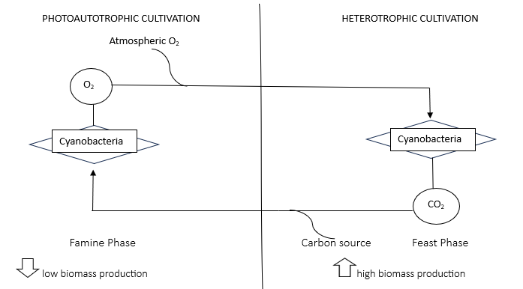

Figure 1: Mixotrophic cultivation with Cyanobacteria to achieve high PHA productivity (Afreen et al., 2021)

- Consortium:
Another strategy that is followed in different studies is the use of consortium. The use of consortium in any system provides an opportunity to utilize the resources optimally by virtue of division of labor as a result productivity, nutrient cycling, nutrient distribution can be achieved with maximum output (Fig. 2). In this proposed and eco design consortium of autotrophic and heterotrophic bacteria can be developed. Since exposing and autotrophic organism to heterotrophic condition may have lower efficiency, this in alternative, a heterotrophic bacteria can be added to perform that function under hetrotrophic condition with the same culture strategy as in mixotrophy consortium is subjected to light phase when phototropic bacteria perform it function utilizing CO₂. This is the famine phase releasing the reducing equivalents and O₂ into the media. In the feast phase, the dark phase, heterotrophic bacteria perform its function, PHA accumulation occur utilizing reducing equivalents and CO₂ such consortium have been used for other purposes such as nitrogen or phosphorus uptake from waste water (consortium consisting of microalga Chlorella vulgaris and the bacterium Pseudomonas aeruginosa). Such consortium of bacteria and algae have been reported for PHA too by Fradinho et al., 2013, in which 30% PHA/VSS was observed on optimizing alternate light dark phase. Similar concept of division of labour was observed with lichen associated Pseudomonas where in addition to detoxification and utilize naphthalene and anthracene the consortium was able to produce PHA with 3-HHx monomer units upto30.62% of DCM (Nahar et al., 2019).

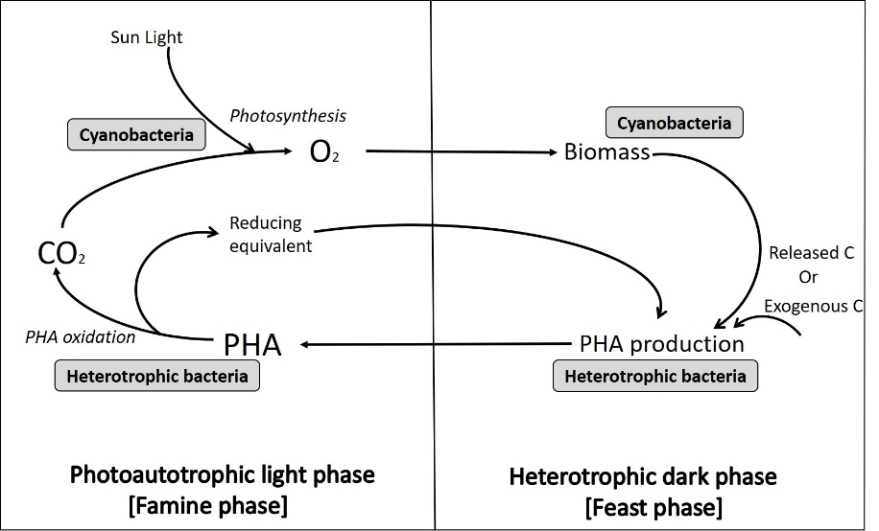
Figure 2: Consortium based approach for Cyanobacterial cultivation to achieve enhanced PHA productivity (Afreen et al., 2021)

- Separate module
While studying above strategies we get the idea that photo autotrophic cultivation followed by heterotrophic cultivation is required to enhance productivity. Which uses internally stored organic matter or exogenous organic sources for PHA accumulation. The next strategy was cyanobacteria as a source of exogenous organic seed which can be achieved either as a byproduct of cyanobacteria culture or the cyanobacterial biomass itself to be used in next stage heterotrophic cultivation (Fig. 3). Biomass from cyanobacterial source can be processed through hydrothermal liquefaction (HTL) for its utilization as feed and production of other bio products for example PHA. These can be harvested by other methods too and different scientists have reported this approach as harvested biomass was used for PHB accumulation by recombinant E coli (Rahman et al., 2014). Using defatted biomass also gives an interesting option reported by Goo et al. He showed 82% biopolymer yield using defatted mass of microalgae Dunaliella tertiolecta with different salt concentration (Goo et al., 2013).
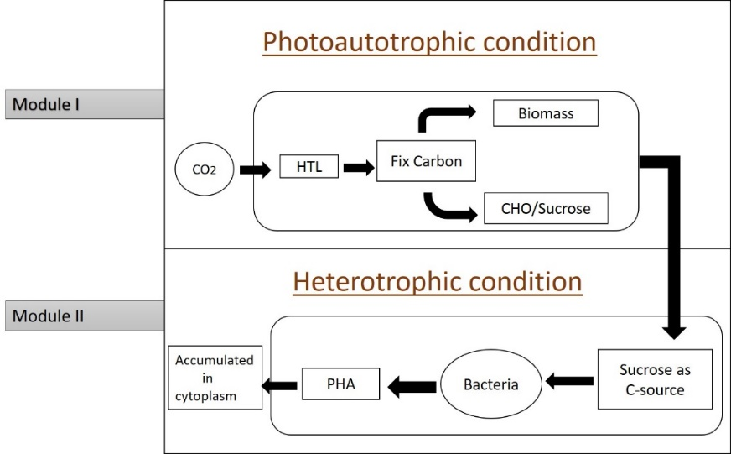

Figure 3: Separate module cultivation with Cyanobacteria for enhanced PHA productivity (Afreen et al., 2021)

Conclusion
Due to the limitations associated with photo autotrophic cultivation of cyanobacteria incorporation of heterotrophic machinery is required to overcome this limitation. These combined benefits of autotrophic and heterotrophic cultivation can be exploited in mixotrophy, consortium and two module-based approach. These approaches can overcome the limitations of lower culture density, difficulty in maintaining photobioreactor in closed lab condition or maintain monoculture in open pond system. Since exploiting both mode i.e. photoautotrophic and heterotrophic mode can provide optimal utilization of resources available based on the trophic conditions. Thus, the system provides a sustainable design to enhance PHA polymer production ability using Cyanobacteria.

References
- Afreen, R., Tyagi, S., Singh, G. P., & Singh, M. (2021). Challenges and perspectives of polyhydroxyalkanoate production from microalgae/cyanobacteria and bacteria as microbial factories: an assessment of hybrid biological system. Frontiers in Bioengineering and Biotechnology, 9, 624885.
- Akdoǧan M., Çelik E. (2018). Purification and characterization of polyhydroxyalkanoate (PHA) from a Bacillus megaterium strain using various dehydration techniques. J. Chem. Technol. Biotechnol. 93 2292–2298.
- Bhati R., Mallick N. (2015). Poly (3-hydroxybutyrate-co-3-hydroxyvalerate) copolymer production by the diazotrophic cyanobacterium Nostoc muscorum Agardh: process optimization and polymer characterization. Algal Res. 7 78–85.
- Bhati R., Mallick N. (2016). Carbon dioxide and poultry waste utilization for production of polyhydroxyalkanoate biopolymers by Nostoc muscorum Agardh: a sustainable approach. J. Appl. Phycol. 28 161–168.
- Borowitzka M. A. (2013). High-value products from microalgae—their development and commercialisation. J. Appl. Phycol. 25 743–756.
- Brojanigo S., Parro E., Cazzorla T., Favaro L., Basaglia M., Casella S. (2020). Conversion of starchy waste streams into polyhydroxyalkanoates using Cupriavidus necator DSM 545. Polymers 12:1496.
- Fradinho J. C., Oehmen A., Reis M. A. M. (2013). Effect of dark/light periods on the polyhydroxyalkanoate production of a photosynthetic mixed culture. Bioresour. Technol. 148 474–479.
- Goo B. G., Baek G., Choi D. J., Park Y. I., Synytsya A., Bleha R., et al. (2013). Characterization of a renewable extracellular polysaccharide from defatted microalgae Dunaliella tertolecta. Bioresour. Technol. 129 343–350.
- Kalia V. C., Patel S. K. S., Shanmugam R., Lee J.-K. (2021). Polyhydroxyalkanoates: trends and advances toward biotechnological applications. Bioresour. Technol. 326:124737.
- Kamravamanesh D., Lackner M., Herwig C. (2018b). Bioprocess engineering aspects of sustainable polyhydroxyalkanoate production in cyanobacteria. Bioengineering 5:111.
- Nahar S., Jeong M. H., Hur J. S. (2019). Lichen-associated bacterium, a novel bioresource of polyhydroxyalkanoate (PHA) production and simultaneous degradation of naphthalene and anthracene. J. Microbiol. Biotechnol. 29 79–90.
- Panda B., Sharma L., Mallick N. (2005). Poly-β-hydroxybutyrate accumulation in Nostoc muscorum and Spirulina platensis under phosphate limitation. J. Plant Physiol. 162 1376–1379.
- Rahman A., Anthony R. J., Sathish A., Sims R. C., Miller C. D. (2014). Effects of wastewater microalgae harvesting methods on polyhydroxybutyrate production. Bioresour. Technol. 156 364–367.
- Sharma L., Mallick N. (2005). Enhancement of poly-β-hydroxybutyrate accumulation in Nostoc muscorum under mixotrophy, chemoheterotrophy and limitations of gas-exchange. Biotechnol. Lett. 27 59–62.
- Singh M., Patel S. K., Kalia V. C. (2009). Bacillus subtilis as potential producer for polyhydroxyalkanoates. Microb. Cell Fact. 8:38.
- Troschl C., Meixner K., Drosg B. (2017). Cyanobacterial PHA production—Review of recent advances and a summary of three years’ working experience running a pilot plant. Bioengineering 4:26.
- Tyagi, S., Singh, M., Singh, G. P., Afreen, R., Kaushik, N., Pruthi, A., ... & Tyagi, S. (2021). Exploiting Biological Waste Hydrolysate for its Management and Biological Polymer Production: Parameter Optimization and Biological Process Modeling. J.Env.Bio-Sci., 35 (1): 1-10
- Wagner J., Bransgrove R., Beacham T. A., Allen M. J., Meixner K., Drosg B., et al. (2016). Co-production of bio-oil and propylene through the hydrothermal liquefaction of polyhydroxybutyrate producing cyanobacteria. Bioresour. Technol. 207 166–174.

