The Role of Automation and Robotics in Industry 4.0: A Paradigm Shift in Manufacturing

Attel Manjunathª, Akshay Simha^{b}
ª Associate Professor, Dept. of Mechatronics Engg.,
^{b} Assistant Professor, Dept. of Mechanical Engg.,
Acharya Institute of Technology, Bengaluru,
Karnataka, India
^{a*} attelmanjunath@acharya.ac.in

Manjushree H
Lecturer, Department of Electronics & Communication Engineering
Government Polytechnic, Tumkur
Karnataka, India

ABSTRACT
In the framework of Industry 4.0, this book chapter explores the revolutionary effects of automation and robotics on the industrial sector. It provides a comprehensive overview of how these technologies contributed to the paradigm shift that led to the advent of a new era of digitalized and intelligent manufacturing. Within the context of Industry 4.0, the chapter explores the different facets of automation and robotics, including their advancements, applications, benefits, challenges, and future prospects, within the framework of Industry 4.0.
A revolutionary period known as "Industry 4.0" is characterized by the incorporation of digital technologies into production procedures, which improves productivity, efficiency, and agility. The extensive use of robotics and automation is one of the main forces driving this revolution.
Automation and robotics technologies have ushered in a new era of smart factories, enabling manufacturers to achieve unprecedented levels of flexibility and customization. With advancements in artificial intelligence (AI) and machine learning, robots are becoming increasingly intelligent, capable of performing complex tasks, and adapting to dynamic production environments.
Furthermore, the integration of automation systems with the Internet of Things (IoT) has facilitated the creation of cyber-physical systems, forming the backbone of Industry 4.0.
The abstract concludes by emphasizing the revolutionary potential of automation and robotics in Industry 4.0. It emphasizes their pivotal role in creating intelligent, interconnected, and efficient manufacturing ecosystems. In order to effectively profit from Industry 4.0 and responsibly manage the related concerns, it is imperative for industry, policymakers, and stakeholders to adapt and embrace these technologies as they evolve.
Keywords: Industry 4.0, automation, robotics, productivity, efficiency, workforce, smart factories, intelligent production systems

Keywords— Industry 4.0; automation; robotics; productivity; efficiency; workforce; smart factories;

INTRODUCTION

Automation and robotics are at the forefront of the transformative changes taking place in the manufacturing sector under the umbrella of Industry 4.0. Organizations are rapidly incorporating cutting-edge technologies to build smart factories and transform their manufacturing processes as the Fourth Industrial Revolution takes shape. This paradigm shift is largely driven by automation and robotics, which result in higher productivity, efficiency, and innovation.
Automation, in the framework of Industry 4.0 [1], involves the use of software, systems, and technologies to perform tasks and processes with minimal human intervention. It aims to streamline workflows, eliminate manual errors, and enhance operational efficiency. Process automation, cognitive automation, and robotic process automation (RPA) are different forms of automation utilized in Industry 4.0. Process automation focuses on automating repetitive and rule-based tasks, while cognitive automation leverages AI algorithms to automate complex decision-making processes. RPA involves the use of software robots to automate tasks that mimic human interactions with digital systems.
Robotics, on the other hand, involves the application of physical machines, commonly known as robots, to perform tasks traditionally done by humans. In Industry 4.0, robots are designed to collaborate with humans, enhancing productivity, safety, and flexibility. Industrial robots are programmable machines capable of performing precise and repetitive tasks with speed and accuracy [2}. Collaborative robots (cobots) are specifically designed to work alongside humans, facilitating human-robot collaboration on the shop floor. Autonomous mobile robots navigate autonomously and perform various tasks such as material handling, logistics operations, and inspection.
The integration of automation and robotics in Industry 4.0 brings numerous benefits. Increased productivity and efficiency are key advantages, as automation eliminates bottlenecks, reduces cycle times, and enhances overall production output. By automating repetitive and mundane tasks, organizations can allocate their workforce to more value-added activities that require creativity and problem-solving skills. Automation also contributes to improved product quality, as it minimizes human errors and variations.
Industry 4.0 represents a new era of manufacturing, where cyber-physical systems merge physical components with digital intelligence. It combines technologies such as the Internet of Things (IoT), artificial intelligence (AI), big data analytics, and cloud computing to enable seamless connectivity and real-time data exchange. Automation and robotics act as catalysts, enabling organizations to leverage the full potential of Industry 4.0 [3].
However, the adoption of automation and robotics in Industry 4.0 is not without challenges. Initial investment costs, technical complexities, and the need to integrate these technologies with existing systems pose significant hurdles for organizations. Moreover, there are concerns regarding job displacement as tasks traditionally performed by humans become automated. The workforce needs to adapt and acquire new skills to thrive in the changing landscape of Industry 4.0. Ethical considerations, such as the responsible use of AI and the social impact of automation, must also be addressed.

HISTORY OF THE INDUSTRIAL REVOLUTION

The history of the Industrial Revolution is a transformative narrative that covers several centuries as in Figure 1 and brought about significant changes in human society and economy. Rapid technological development, urbanization, and economic growth, fundamentally changing the way people lived and worked.
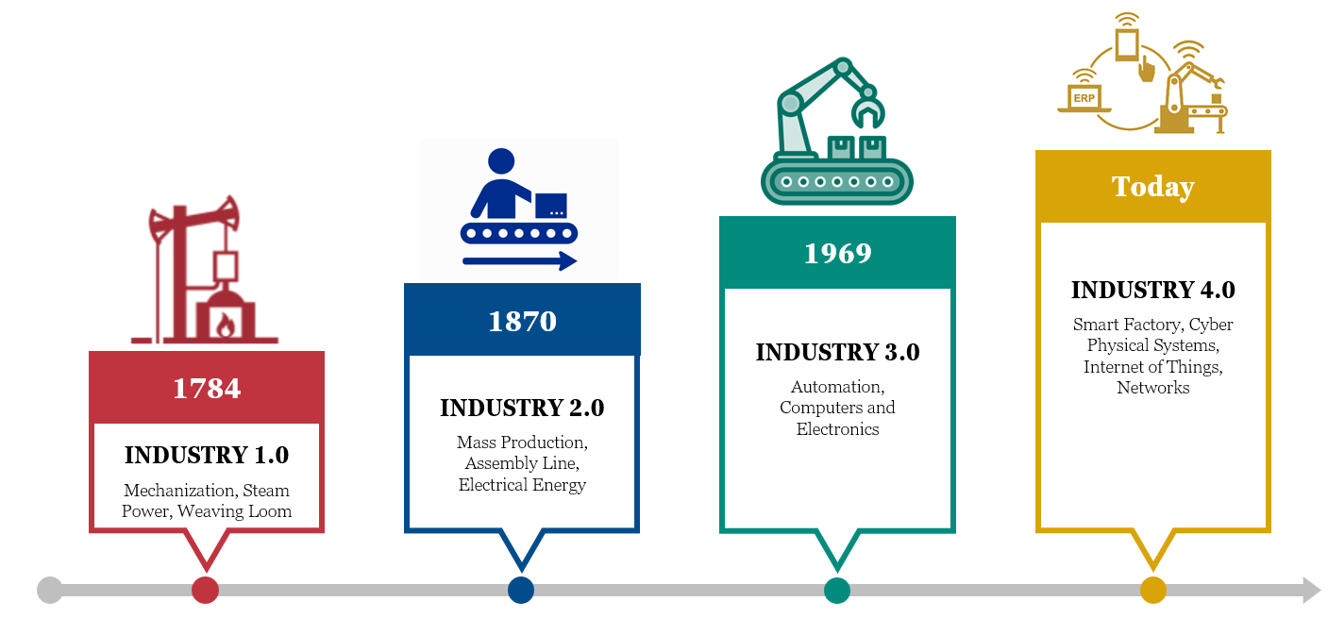

Figure 1: History of Industrial Revolution

First Industrial Revolution (INDUSTRY 1.0)
The First Industrial Revolution, also known as the "Mechanization Revolution," began in Great Britain during the late 18th century. It was characterized by the shift from agrarian and craft-based economies to mechanized and factory-based production. Key innovations included the invention of the steam engine by James Watt, which revolutionized transportation and manufacturing. The textile industry was one of the first to be mechanized, with the introduction of spinning jennies, power looms, and cotton gins. This revolution significantly increased productivity, leading to urbanization and the growth of industrial cities.

Second Industrial Revolution (INDUSTRY 2.0)
The Second Industrial Revolution, also called the "Technological Revolution," occurred during the mid-19th to early 20th centuries. It was marked by even more significant technological advancements, including the steel production, the development of electrical power, and the invention of the telephone and telegraph. These innovations accelerated the expansion of railways and the construction of infrastructure, enabling the mass production and distribution of goods on a global scale. The Second Industrial Revolution also saw the rise of heavy machinery and the implementation of assembly-line production methods, pioneered by Henry Ford in the early 20th century.

Third Industrial Revolution (INDUSTRY 3.0)
The Third Industrial Revolution, known as the "Digital Revolution," emerged during the post-World War II era. It was characterized by the rise of computers, semiconductors, and digital technologies. The key milestones include invention of the integrated circuit, the development of mainframe computers, and the establishment of the internet and World Wide Web in the late 20th century. The digital revolution transformed communication, commerce, and information processing, laying the foundation for the modern information age.

Fourth Industrial Revolution (INDUSTRY 4.0)
The Fourth Industrial Revolution, often referred to as "Industry 4.0," is the ongoing phase of technological advancement characterized by the convergence of physical, digital, and biological technologies. It involves the integration of artificial intelligence, robotics, the Internet of Things (IoT), cloud computing, and big data analytics. Industry 4.0 is transforming manufacturing and other sectors, with smart factories and cyber-physical systems at the forefront of this revolution. It is marked by a focus on data-driven decision-making, automation, and the interconnectivity of devices and systems [4].

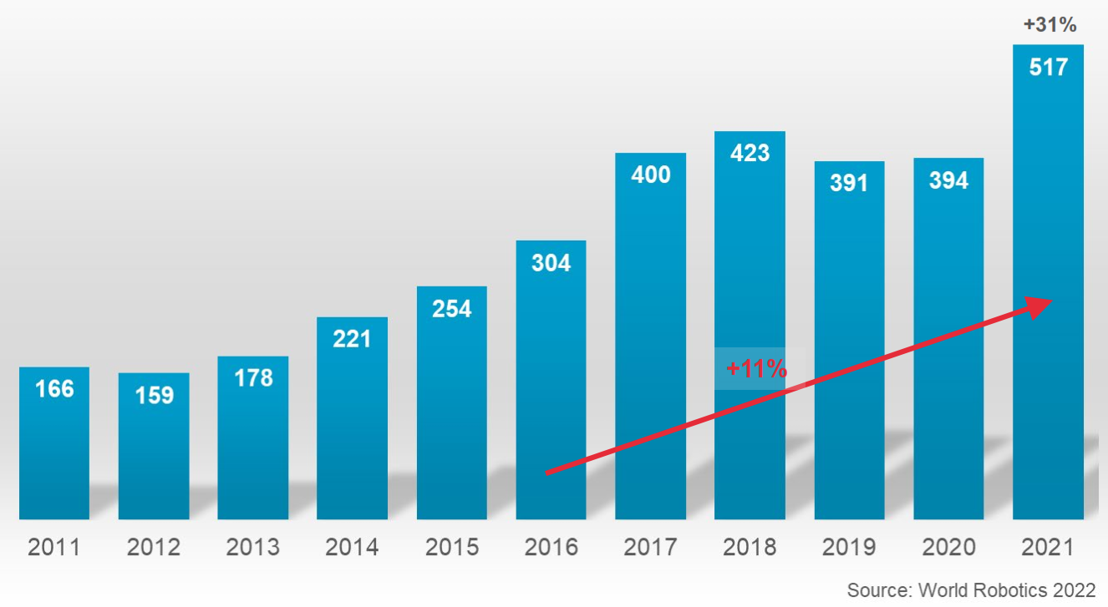
Figure 2: Worldwide annual installation of industrial robots (in 1000 Units)

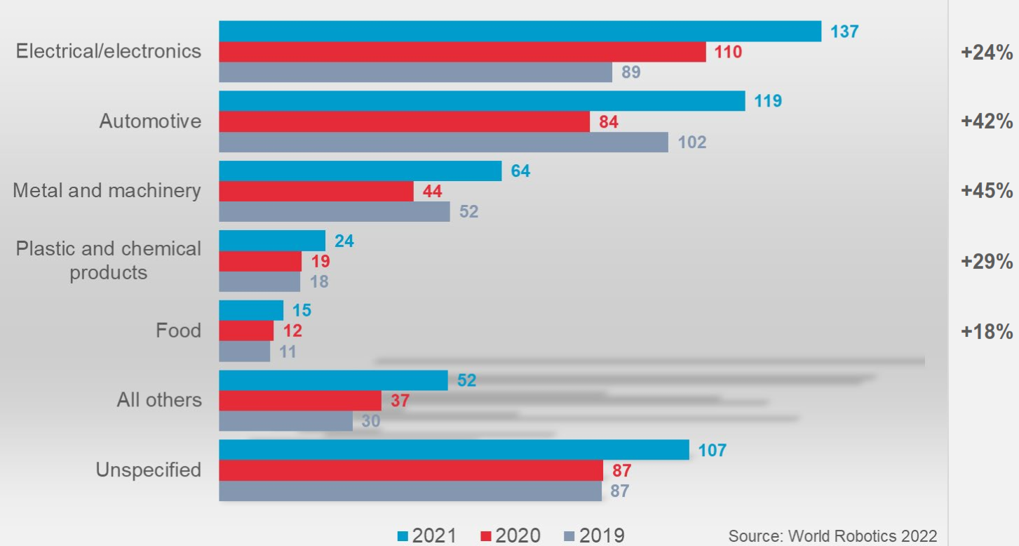

Figure 3: Worldwide annual installation of industrial robots by customer industry (in 1000 Units)

The World Robotics 2022 survey exhibits the growth of worldwide annual installation of industrial robots and worldwide annual installation of industrial robots by customer industry as shown in Figure 2 and 3, it clearly indicates the adoption of Industry 4.0 is rapidly increasing across the world [22].
Each industrial revolution brought significant changes, from the rise of factories and mass production to the digitalization of information and the current era of smart and interconnected technologies. These revolutions have shaped modern societies, economies, and lifestyle.

BENEFITS AND CHALLENGES OF AUTOMATION AND ROBOTICS

Benefits
Increased Productivity: Automation and robotics enable organizations to achieve higher levels of productivity by streamlining processes, reducing errors, and increasing production speed. With the ability to operate 24/7, machines can maintain consistent output, leading to improved overall efficiency.
Enhanced Efficiency: Automation minimizes time-consuming manual tasks, leading to faster and more efficient production cycles. Robots can perform repetitive and dynamic tasks with high precision, eliminating human errors and increasing process reliability [5].
Improved Product Quality: Automation and robotics contribute to improved product quality by reducing variations and ensuring consistent manufacturing standards. With precise and accurate operations, machines can deliver products with higher levels of accuracy, reducing defects and enhancing customer satisfaction.
Flexibility and Adaptability: Robots and automation systems can be easily reprogrammed and reconfigured to adapt to changing production requirements. This flexibility allows for efficient production line adjustments, shorter changeover times, and the ability to handle diverse product variations.
Workforce Safety: Automation and robotics improve workers' exposure to hazardous and physically demanding tasks, reducing the risk of workplace accidents and injuries [6]. Human-robot collaboration ensures safer working conditions and frees up employees to focus on higher-value activities that require critical thinking and creativity.

Chanllenges
Initial Investment Costs: Implementing automation and robotics technologies requires significant upfront investments, including the purchase of equipment, software, and system integration. Organizations must carefully evaluate the return on investment (ROI) and develop a comprehensive business case to justify these costs.
Technological Complexity: The integration of automation and robotics with existing systems can be complex and require specialized expertise. Organizations need to invest in skilled personnel and ensure seamless integration between different technologies and processes.
Workforce Adaptation: Automation and robotics have the potential to disrupt traditional job roles and require workers to develop new skills to collaborate effectively with machines. Organizations must invest in workforce training and reskilling programs to ensure a smooth transition and maximize the benefits of human-robot collaboration [7].
Job Displacement Concerns: The automation of certain tasks can lead to concerns about job losses and workforce displacement. Organizations must approach automation as an opportunity to augment human capabilities rather than replace workers, ensuring that employees are upskilled for higher-value roles that align with evolving job requirements [8].
To fully capitalize on the benefits of automation and robotics in Industry 4.0 while addressing the associated challenges, organizations should develop a holistic approach. This involves comprehensive planning, strategic investment decisions, collaboration between technology providers and the workforce, and a commitment to continuous learning and adaptation. By navigating the benefits and challenges of automation and robotics effectively, organizations can position themselves as leaders in the digital era of manufacturing.

IMPLICATIONS FOR THE WORKFORCE OF AUTOMATION & ROBOTICS IN INDUSTRY 4.0

Automation and robotics have significant implications for the workforce in the framework of Industry 4.0. As these technologies become increasingly integrated into manufacturing processes, they reshape job roles, skill requirements, and the dynamics of the workforce. Understanding and addressing these implications is crucial for organizations to navigate the transition successfully and ensure the optimal utilization of human and machine capabilities.

Evolving Job Roles
Automation and robotics automate routine and repetitive tasks, leading to a shift in job roles. Some jobs may become obsolete, while new roles emerge that require expertise in operating and maintaining automated systems. Workers will need to adapt and acquire new skills to take on these evolving job roles, focusing on areas such as programming, system integration, data analysis, and collaboration with machines.

Human-Robot Collaboration

Industry 4.0 emphasizes the collaboration between humans and robots to maximize productivity and efficiency. Instead of replacing humans, robots are designed to complement human capabilities, augmenting their strengths and compensating for limitations. The workforce will need to develop skills in working along with robots, including effective communication, problem-solving, and teamwork in a human-robot collaborative environment [9][10].

Upskilling and Reskilling
To succeed in the era of Industry 4.0, organizations must invest in upskilling and reskilling programs for their workforce. This involves providing training opportunities to enhance existing skills and acquire new ones that align with the requirements of automation and robotics [11]. Continuous learning and development will be essential for employees to adapt to changing technologies and stay relevant in the workforce.

Job Displacement and Transition
Automation and robotics may lead to concerns about job displacement, particularly for tasks that can be automated. It is crucial for organizations to manage this transition responsibly by providing support to affected employees. This can include offering retraining programs, career counselling, and assistance in transitioning to new roles within the organization or in other industries.

Collaboration and Change Management
Successfully integrating automation and robotics into the workforce requires effective collaboration between management, employees, and relevant stakeholders. Change in management strategies should be employed to address concerns, communicate the benefits of automation, and involve employees in decision-making processes. Open and transparent communication can help reduce resistance and raise a positive work culture.

Redefining Work-Life Balance
Automation and robotics have the potential to optimize productivity and reduce manual labour. This redefines the concept of work-life balance, enabling employees to focus on higher-value tasks and creative endeavors [12]. Organizations should encourage a healthy work environment that emphasizes employee well-being and allows for a balance between work and personal life.
By recognizing and proactively addressing the implications for the workforce, organizations can navigate the integration of automation and robotics in Industry 4.0 more effectively. By investing in upskilling programs, development of collaboration between humans and machines, and supporting employees through the transition, organizations can unlock the full potential of automation and robotics while creating a sustainable and resilient workforce.

FUTURE TRENDS OF AUTOMATION AND ROBOTICS IN INDUSTRY 4.0

Advancements in AI and Machine Learning
Automation and robotics will witness further advancements in artificial intelligence (AI) and machine learning. AI-driven systems will become more sophisticated, allowing robots to adapt to dynamic environments, learn from data, and make complex decisions with higher accuracy. This will lead to more intelligent and autonomous robots that can perform a wider range of tasks with minimal human intervention.

Collaborative Robots (Cobots) on the Rise
Collaborative robots, or cobots, will continue to gain popularity in Industry 4.0. These robots are designed to work safely along with humans, promoting human-robot collaboration on the shop floor. The integration of cobots will lead to more flexible and agile production processes, where humans and robots complement each other's strengths, further enhancing efficiency and productivity [13].

Expanding Use of Autonomous Mobile Robots (AMRs)
The adoption of autonomous mobile robots will increase significantly in various industries. AMRs can navigate autonomously and perform tasks such as material handling, logistics, and warehousing operations. The ability of AMRs to optimize material flow and increase supply chain efficiency will make them a valuable asset for modern manufacturing facilities.

Industrial Internet of Things (IIoT) and Connectivity
Industry 4.0 will see a greater emphasis on the Industrial Internet of Things and connectivity as shown in Figure 4. Machines, robots, and sensors will be interconnected, enabling real-time data exchange and facilitating predictive maintenance. IIoT will play a crucial role in optimizing production processes, reducing downtime, and ensuring data-driven decision-making [14].

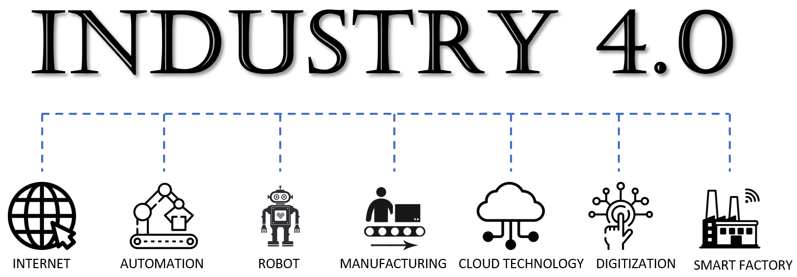

Figure 4: Components of Industry 4.0

3D Printing and Additive Manufacturing Integration
The integration of 3D printing and additive manufacturing with automation and robotics will revolutionize production processes. Robots will be used for tasks such as part handling and post-processing in additive manufacturing, leading to faster and more efficient production of complex components [15][16][17][18].

RECOMMENDATIONS FOR MAXIMIZING BENEFITS

Continuous Skill Development
Organizations should invest in continuous skill development for their workforce. Training programs should focus on developing technical competencies related to automation and robotics, as well as soft skills to support human-robot collaboration and critical thinking.

Strategic Planning and Implementation
Before adopting automation and robotics, organizations should conduct thorough assessments and develop comprehensive implementation plans. Clear objectives and a phased approach will ensure a successful integration that aligns with business goals [19].

Data Security and Privacy
With increased connectivity, organizations must prioritize data security and privacy. Robust cybersecurity measures should be implemented to protect sensitive information and prevent potential cyber threats.

Agile and Adaptive Management
As technology evolves rapidly, organizations should adopt agile and adaptive management practices. Flexibility in decision-making and a willingness to embrace emerging trends will enable organizations to stay ahead in the rapidly changing landscape of Industry 4.0.

Collaboration and Knowledge Sharing
Collaboration between industry peers, academia, and technology providers is essential for staying informed about the latest developments in automation and robotics. Knowledge sharing and best practices will drive innovation and help organizations make informed decisions.
By staying up-to-date of future trends and implementing these recommendations, organizations can effectively harness the potential of automation and robotics in Industry 4.0, gaining a competitive edge and driving transformative change in the manufacturing sector.

CONCLUSIONS

In summary, automation and robotics play a pivotal role in driving the transformation of the manufacturing sector under Industry 4.0. The integration of advanced technologies, such as artificial intelligence, the Internet of Things (IoT), and data analytics, with automation and robotics, has ushered in a new era of industrialization characterized by interconnected smart factories and intelligent production systems [20][21].
In Industry 4.0, automation and robotics offer numerous advantages. Simplified procedures and fewer human errors lead to increased production, enhanced efficiency, and superior product quality. The ability of robots to perform repetitive and physically demanding tasks also enhances workplace safety and frees up human workers to focus on more creative and value-added activities.
Furthermore, automation and robotics enable a higher degree of flexibility and adaptability in production processes, empowering manufacturers to respond quickly to changing market demands and customer preferences. The integration of collaborative robots (cobots) fosters human-robot collaboration, leading to increased efficiency and optimized workflows.
However, adopting automation and robotics in Industry 4.0 also presents challenges like initial investment costs, technological complexities, and concerns about job displacement require careful consideration. Organizations must address these challenges by implementing effective change in management strategies, investing in workforce upskilling and reskilling programs, and fostering a culture of continuous learning.
To fully capitalize on the potential of automation and robotics, organizations must adopt strategic planning and proactive management. Organizations can establish an environment where humans and machines work together in harmony to drive innovation, competitiveness, and sustainable growth by utilizing the power of technology and investing in human capital.
Looking into the future, automation and robotics in Industry 4.0 are expected to continue evolving rapidly. Advancements in AI, machine learning, and robotics will lead to more intelligent and autonomous systems, driving further optimization and productivity gains. Collaborative robots and autonomous mobile robots will become increasingly prevalent, enabling even greater human-robot collaboration and material handling efficiency.
Successful integration of automation and robotics will be a key differentiator for manufacturers in the era of Industry 4.0. Organizations that adapt, innovate, and integrate their workforce with these transformative technologies will be in the best position to succeed in the dynamic and ever-evolving environment of modern manufacturing. The role of automation and robots in Industry 4.0 will continue to influence the future of manufacturing as we move deeper into the Fourth Industrial Revolution and open the door for a more effective, connected, and profitable industrial environment.

REFERENCES

- P. Zheng, Z. Sang, R.Y. Zhong, Y. Liu, C. Liu, K. Mubarok, X. Xu, “Smart manufacturing systems for Industry 4.0: conceptual framework, scenarios, and future perspectives”, Frontiers of Mechanical Engineering, Vol.13 (2), 2018, pp. 137-150.
- M.A.K. Bahrin, M.F. Othman, N.H.N. Azli, M.F. Talib, “Industry 4.0: a review on industrial automation and robotic”, Jurnal Teknologi, Vol.78, 2016, pp. 6-13.
- E. Oztemel, S. Gursev, “Literature review of Industry 4.0 and related technologies”, Journal of Intelligent Manufacturing, Vol.31 (1), 2020, pp. 127-182.
- J. Qin, Y. Liu, R. Grosvenor, “A Categorical Framework of Manufacturing for Industry 4.0 and Beyond, Changeable, Agile, Reconfigurable & Virtual Production”, Procedia CIRP 52, 2016, pp. 173 – 178.
- Mohd Javaid, Abid Haleem, Ravi Pratap Singh, Rajiv Suman, “Substantial capabilities of robotics in enhancing industry 4.0 implementation”, Cognitive Robotics, Vol. 1, 2021, pp. 58-75.
- L. Gualtieri, E. Rauch, R. Vidoni, “Emerging research fields in safety and ergonomics in industrial collaborative robotics: A systematic literature review”, Robotics and Computer-Integrated Manufacturing, Vol.67, 2021, Article 101998, pp.1-30.
- A. Bhargava, M. Bester, L. Bolton, “Employees’ perceptions of the implementation of robotics, artificial intelligence, and automation (RAIA) on job satisfaction, job security, and employability”, Journal of Technology in Behavioral Science, Vol. 6 (1), 2021, pp. 106-113.
- A. Petrillo, F. De Felice, R. Cioffi, F. Zomparelli, “Fourth industrial revolution: Current practices, challenges, and opportunities Digital Transform”. Smart Manufacturing, 2018, pp. 1-20.
- C. Heyer, “Human-robot interaction and future industrial robotics applications”, 2010 IEEE/RSJ International Conference on Intelligent Robots and Systems, IEEE (2010), pp. 4749-4754.
- V. Villani, F. Pini, F. Leali, C. Secchi, “Survey on human–robot collaboration in industrial settings: Safety, intuitive interfaces and applications”, Mechatronics, Vol.55, 2018, pp. 248-266.
- L.M. Kipper, S. Iepsen, A.J. Dal Forno, R. Frozza, L. Furstenau, J. Agnes, D. Cossul, “Scientific mapping to identify competencies required by industry 4.0”, Technology in Society., Vol.64, 2021, Article 101454.
- M.A. Moktadir, S.M. Ali, S. Kusi-Sarpong, M.A.A. Shaikh, “Assessing challenges for implementing industry 4.0: implications for process safety and environmental protection”, Process Safety and Environmental Protection, Vol.117, 2018, pp. 730-741.
- P. Poór, T. Broum, J. Basl, “Role of collaborative robots in Industry 4.0 with target on education in Industrial Engineering”, 2019 4th International Conference on Control, Robotics and Cybernetics (CRC), IEEE 2019, pp. 42-46.
- A.T. Rizvi, A. Haleem, S. Bahl, M. Javaid, “Artificial intelligence (AI) and its applications in Indian manufacturing: a review”, Current Advances in Mechanical Engineering. 2021, pp. 825.
- A.P. Calitz, P. Poisat, M. Cullen, “The future African workplace: the use of collaborative robots in manufacturing”, SA Journal of Human Resource Management, Vol.15, 2017, pp. 11.
- H. Parmar, T. Khan, F. Tucci, R. Umer, P. Carlone, “Advanced robotics and additive manufacturing of composites: towards a new era in Industry 4.0”, Materials and Manufacturing Processes, 2021, pp. 483-517.
- A. Haleem, M. Javaid, “Additive manufacturing applications in industry 4.0: a review”, Journal of Industrial Integration and Management, Vol.4(4), 2019, Article 193000104.
- J.Z. Gul, M. Sajid, M.M. Rehman, G.U. Siddiqui, I. Shah, K.H. Kim, K.H. Choi, “3D printing for soft robotics–a review”, Science and Technology of Advanced Materials, Vol.19 (1), 2018, pp. 243-262.
- P. Kumar, R.K. Singh, V. Kumar, “Managing supply chains for sustainable operations in the era of industry 4.0 and circular economy: analysis of barriers”, Resources, Conservation and Recycling, Vol.164, 2021, Article 105215.
- E. Hozdić, “Smart Factory for Industry 4.0: A Review”, International Journal of Modern Manufacturing Technologies, ISSN 2067–3604, Vol. 7(1), 2015, pp.28-35.
- S. Wang, J. Wan, D. Li, C. Zhang, “Implementing Smart Factory of Industrie 4.0: An Outlook”, International Journal of Distributed Sensor Networks, 2016, Article ID 3159805, pp. 1-10.
- World Robotics 2022, IFR International Federation of Robotics, Germany, October 2022, pp. 1-52.

