Waste to Wealth: The Potential of Waste Management in Agricultural Engineering

Hemant Kumar Sharma
Department of Farm Machinery & Power Engg.
GBPUAT, Pantnagar
Email address : 52817@gbpuat.ac.in

Apoorva Sharma
Department of Farm Machinery & Power Engg
GBPUAT, Pantnagar
Email address : 59296@gbpuat.ac.in

Dr. Triveni Prasad Singh
Department of Farm Machinery & Power Engg.
GBPUAT, Pantnagar
Email address : tpsingh_62@yahoo.co.in

Dr. Tarun Kumar Bhattacharya
Department of Farm Machinery & Power Engg.
GBPUAT, Pantnagar
Email address : tkb.183@gmail.com

ABSTRACT

India produces 500 MT/y agricultural waste which is a serious environmental challenge but also presents a significant possibility of wealth creation. In India, there is a total potential for 5690 MW of energy to be produced from organic waste. Waste management in agriculture can aid in lowering pollution, conserving resources, and enhancing the condition of the land. The negative effects of traditional waste disposal techniques, which result in environmental contamination and resource depletion, highlight the need for proper waste management in agriculture. This chapter's main focus is on waste-to-wealth approaches, which provide environmentally friendly substitutes for managing agricultural waste. Composting and anaerobic digestion are important techniques for turning waste into useful products. According to studies, composting produces bio-fertilizers that are nutrient-rich, improving soil health and lowering reliance on artificial fertilizers. Anaerobic digestion generates biogas for the production of renewable energy while also supplying nutrient-rich digested for soil replenishment. We also emphasize the value of organic soil amendments made from agricultural waste in improving soil fertility and structure. Field studies show that adding organic amendments increases the availability of nutrients and soil water retention, which boosts crop output and promotes sustainable agriculture practices. There is a crucial role of supportive policies and laws, in addition to technology developments, play in promoting the widespread adoption of sustainable waste management techniques. To have the desired impact, policymakers' dedication to fostering an environment that supports waste-to-wealth projects is crucial. Agricultural waste management promotes a radical change in how waste is handled, viewing trash as a resource rather than a burden. The agriculture industry may promote a circular economy, lessen its impact on the environment, and greatly contribute to sustainable development by adopting waste-to-wealth initiatives.

Keywords—Waste management; agricultural waste; biomass; biomass valorization; sustainable agriculture

- INTRODUCTION

The population of the world increased from 3.7 billion in 1970 to 7.9 billion in 2021 and it is expected to reach 9 billion by 2050 and 11 billion by 2100, respectively [1]. As a result, ensuring food security in the future will be a difficult task [2]. Production of both livestock and crops has increased significantly in response to the high demand of a growing population, which has also increased the amount of agricultural waste produced [3]. China, India, and Africa have seen tremendous population growth, economic expansion, as well as an increase in the capacity to produce agricultural waste over the past century [4]. The process of collection, transport, disposal, recycling, and monitoring of waste is called waste management [5]. Waste management is undertaken to recycle the waste so as to reduce the ill effects of waste on the environment, health, and aesthetics. In the pursuit of sustainable and resource-efficient agricultural practices, waste management plays a pivotal role. The agricultural sector generates vast amounts of waste, including crop residues, animal manure, and byproducts from food processing. If not managed effectively, this waste can lead to environmental degradation, greenhouse gas emissions, and economic losses. However, with the concept of "Waste to Wealth," waste management in agricultural engineering presents a transformative solution by harnessing the potential of these discarded materials as valuable resources.
Crop residues in India amount to approximately 550 MT (million tons) annually, and improper disposal or burning of these residues contributes to air pollution, respiratory issues, and the loss of potential organic matter beneficial to soil health [6]. Livestock farming also poses environmental risks due to the accumulation of animal manure, which can lead to excessive nutrients leaching into water bodies and causing eutrophication [7]. Inadequate management of food processing byproducts can result in inefficient resource utilization and increased landfill burden [8]. Therefore, it is crucial to implement proper management practices for crop residues, animal manure, and food processing byproducts to mitigate environmental risks and promote sustainable agriculture [9]. There are several kinds of waste produced such as agricultural waste, municipal waste, industrial waste, and mining waste. Some wastes are more hazardous such as medical wastes and nuclear wastes. Various techniques are used for the management of wastes which includes landfilling, incineration, anaerobic digestion, pyrolysis, plasma gasification, recycling, and composting.
It becomes clear that sustainable waste-to-wealth methods offer a pathway towards a more resilient and resource-efficient agricultural system as we set out on a trip to investigate the potential of waste management in agricultural engineering. In-depth exploration of the cutting-edge scientific research, technological developments, and regulatory frameworks that make it possible to turn agricultural waste into valuable resources is the goal of this chapter. We can pave the way for a more sustainable and successful future for agriculture by tackling present issues, embracing novel ideas, and implementing circular economy concepts. This chapter delves into the fascinating topic of waste management in agriculture, emphasizing how it can support the development of a circular economy and promote agricultural engineering in the future.

- CURRENT CHALLENGES IN AGRICULTURAL WASTE MANAGEMENT

In the agricultural sector, a diverse array of waste is generated throughout the production and processing stages. These waste materials, if not properly managed, can pose environmental challenges and economic losses. However, with innovative approaches, agricultural waste can be harnessed and transformed into valuable resources, contributing to a sustainable circular economy [10]. There are different types of waste that are generated from our daily or industrial activities such as organic waste, e-waste, hazardous waste, inert waste, etc. Organic waste refers to waste that degrades or is broken down by microorganisms over time. All organic wastes are essentially carbon-based compounds; though they may be diverse in nature and have different degradation rates. Organic waste has a significant portion in overall waste generation in the industrial/urban/ agricultural sector and therefore it can be used for energy generation. The organic fraction of waste can be further classified as non-biodegradable and biodegradable organic waste.
Biodegradable waste comprises organics that naturally occurring microorganisms can use for sustenance in an acceptable amount of time. Agro residue, food processing rejects, municipal solid waste (food waste, leaves from garden waste, paper, cloths/rags, etc.), waste from poultry farms, waste from cattle farm slaughterhouses, dairy, sugar, distillery, paper, oil extraction plant, waste from starch processing and waste from the leather industry are all included in the category of biodegradable organics.
Non-Biodegradable organic substances either resist biological deterioration or degrade at a very slow rate. This largely consists of woody plants, cardboard, cartons, containers, wrappings, pouches, abandoned garments, wooden furniture, agricultural dry waste (bagasse, rice husk, etc.), and other similar materials. The estimated generation of solid and liquid waste, as well as the potential for energy and bio-CNG production in India, are shown in Table 1.

Table 1: Waste Generation, Bio-CNG potential and energy potential of India

SN | State | Solid Waste  (Million Ton) | Liquid Waste (Million m³) | Energy Generation Potential (MW) | Bio-CNG Potential (TPD)
 | Andaman And Nicobar | 8 | 12 | 13 | 64
 | Andhra Pradesh | 27 | 964 | 426 | 2,043
 | Arunachal Pradesh | 1 | 5 | 6 | 29
 | Assam | 17 | 184 | 193 | 922
 | Bihar | 47 | 600 | 477 | 2,292
 | Chandigarh | 9 | 74 | 22 | 107
 | Chhattisgarh | 13 | 279 | 138 | 663
 | Dadra And Nagar Haveli | 8 | 13 | 13 | 60
 | Daman And Diu | 8 | 5 | 14 | 67
 | Delhi | 12 | 1,220 | 98 | 468
 | Goa | 0 | 22 | 4 | 21
 | Gujarat | 42 | 1,782 | 778 | 3,734
 | Haryana | 13 | 515 | 173 | 829
 | Himachal Pradesh | 8 | 22 | 54 | 260
 | Jammu And Kashmir | 6 | 165 | 75 | 362
 | Jharkhand | 16 | 385 | 159 | 764
 | Karnataka | 27 | 1,370 | 491 | 2,366
 | Kerala | 6 | 1,118 | 136 | 656
 | Ladakh | 0 | 4 | 11 | 54
 | Lakshadweep | 8 | 4 | 12 | 56
 | Madhya Pradesh | 47 | 952 | 516 | 2,488
 | Maharashtra | 40 | 3,109 | 811 | 3,898
 | Manipur | 1 | 29 | 7 | 34
 | Meghalaya | 1 | 28 | 14 | 67
 | Mizoram | 0 | 26 | 3 | 15
 | Nagaland | 0 | 18 | 7 | 31
 | Odisha | 13 | 320 | 175 | 843
 | Puducherry | 9 | 66 | 23 | 109
 | Punjab | 15 | 624 | 672 | 3,233
 | Rajasthan | 48 | 853 | 466 | 2,235
 | Sikkim | 0 | 7 | 3 | 13
 | Tamil Nadu | 27 | 1,804 | 668 | 3,212
 | Telangana | 17 | 936 | 327 | 1,563
 | Tripura | 1 | 28 | 15 | 74
 | Uttar Pradesh | 106 | 2,541 | 1,912 | 9,185
 | Uttarakhand | 5 | 214 | 135 | 647
 | West Bengal | 44 | 1,519 | 539 | 2,589
 | Total | 651 | 21,818 | 9,586 | 46,053

By understanding the many types of agricultural waste and implementing sustainable waste management practices, the agricultural sector may move toward a circular economy. This change encourages the creation of value out of trash, supports environmental sustainability, and lessens reliance on limited resources. Agriculture may contribute to the development of a world with less energy and resource use by using such innovative practises. It is imperative to solve the problems with agricultural waste management. Crop residues are a significant part of the trash produced by agricultural operations globally. Considering the availability of agricultural waste, a theoretical estimate shows that between 3.5 and 17.0 billion tonnes of agricultural waste might be produced globally [11]. India produces a lot of solid garbage each year, with agricultural waste coming in at the top with about 350-990 MT/y [12]. India is the second-largest producer of agricultural waste in the world, behind China, and it produces more than 130 million tonnes of paddy straw, of which half is used as animal feed and the other half is composted [13]. Additionally, the habit of burning rice bran (parali) in the northwest region significantly worsens air pollution and poses a risk to public health [14]. Crop residue that is disposed of improperly produces greenhouse gases (GHGs) such as carbon dioxide (CO₂), nitrous oxide (N₂O), and methane (CH₄), endangering both people and the environment [15]. Let's explore the various sorts of agricultural waste as illustrated in Figure 1 which can be used and the value addition they can provide.

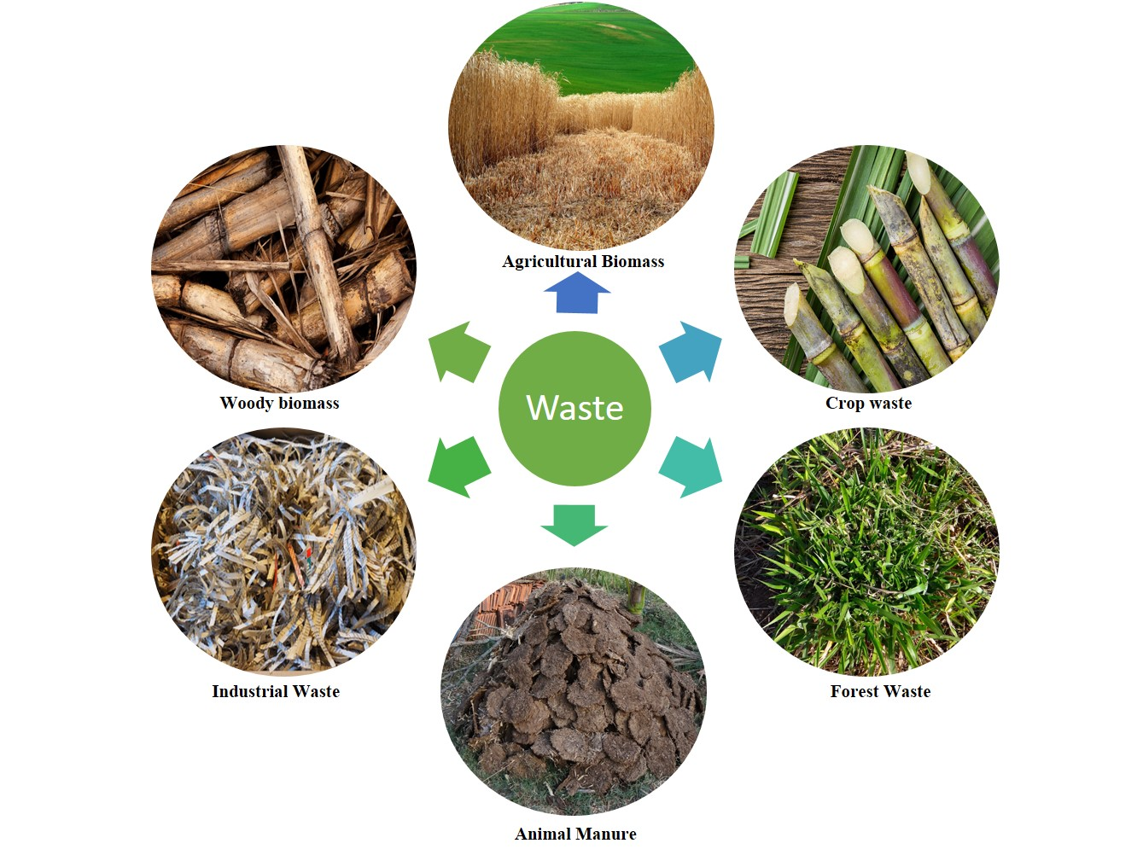

Figure 1: Classification of waste

- Crop Residues
One of the most prevalent types of agricultural waste is crop residue. They include plant pieces like stems, leaves, husks, and straw that are left over after harvesting. Even though they are frequently burned or abandoned, these residues have a huge potential for value addition. Crop leftovers can be composted to create nutrient-rich organic matter, which boosts soil fertility, strengthens soil structure, and encourages greater water retention. Additionally, anaerobic digestion can be used to produce biogas from biomass obtained from crop leftovers. This renewable energy source provides a healthy substitute for fossil fuels because it may be used to generate electricity, heat homes, and cook food.

- Animal Manure
Another big type of agricultural waste is animal manure. However, incorrect management can result in nutrient leaching and water pollution even though it acts as a natural fertilizer. Animal dung, however, can be a useful resource for the creation of biofertilizers if it is properly managed. Animal dung can be converted into nutrient-rich organic fertilizers that improve soil health and encourage the growth of sustainable crops through composting or vermicomposting processes. Additionally, anaerobic digestion may create biogas from animal waste, which offers renewable energy and lowers greenhouse gas emissions.

- Food Processing Byproducts
Byproducts from the food processing sector, such as peels, shells, and pulp, are produced in large quantities. If not handled properly, these byproducts may contribute to waste disposal and environmental damage. They do, however, have a lot of potential to add value. These byproducts can be treated by biorefining to obtain important substances including phytochemicals and bioactive substances, which have uses in the pharmaceutical, cosmetic, and food sectors. Additionally, it is possible to produce bioenergy from the biomass obtained from food processing waste, which adds to the mix of sustainable energies.

- Aquaculture Waste
Waste from the aquaculture sector includes uneaten feed and fish waste. This garbage can cause ecosystem disruption and a decline in water quality if it is not adequately managed. These wastes can, however, be used to create value. Fish feces can be used as a nutrient source for hydroponic or aquaponic plant cultivation using aquaponics or integrated aquaculture systems. This comprehensive strategy promotes resource efficiency, reduces waste, and boosts overall productivity.

The share of energy generation potential through waste generated in different sectors in India is illustrated in Figure 2.

Figure 2: Waste sector share in energy potential in India

Crop residues (leaf litter, seed pods, stalks, stems, straws, husks, weeds), livestock wastes (urine, dung, wash water, leftover milk, waste feed), poultry waste (spilled feed, feathers, droppings, bedding material), slaughterhouse waste (blood, hair, hides, flesh, bones, etc.), and agro-industrial waste [bagasse, molasses, peel] are the main categories of agricultural waste that have (uneaten feed, fecal waste) [3]. The total agricultural biomass production, its utilization and the availability of surplus biomass is estimated [16] and presented in Figure 3.
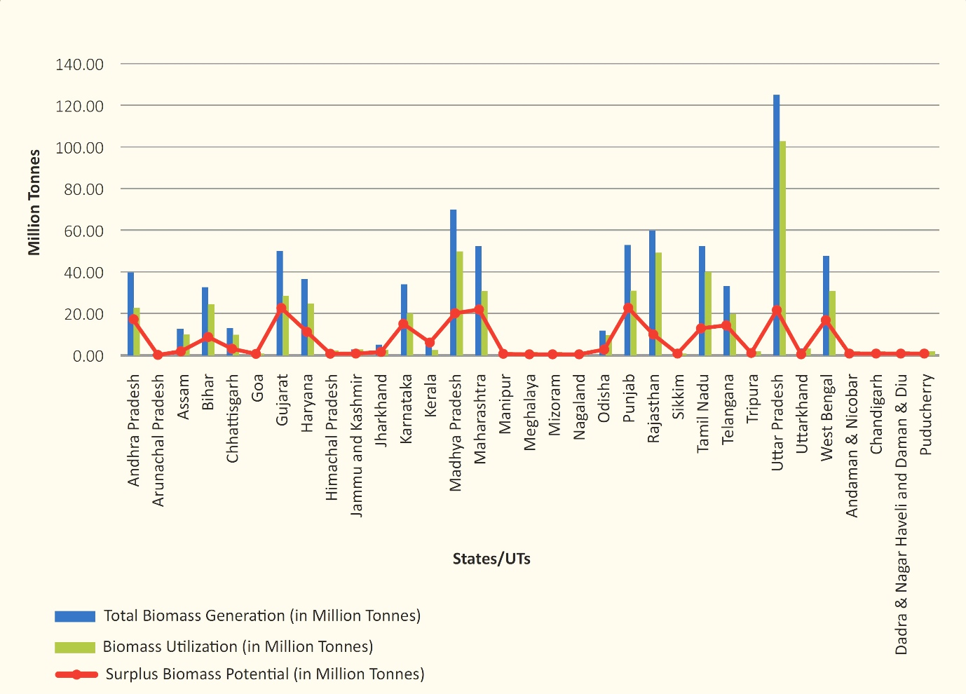

Figure 3: Total agricultural biomass production, utilization and surplus biomass potential in India States

- INNOVATIVE TECHNOLOGIES AND PRACTICES IN WASTE MANAGEMENT

Fortunately, waste management techniques and technologies are rapidly improving in the field of agricultural engineering. The issues caused by agricultural waste can be successfully addressed by these inventions. Technologies that can turn organic waste into useful resources, such as anaerobic digestion and composting, have gained prominence. In addition to aiding in waste disposal, anaerobic digestion, a biological process that generates biogas, also offers a sustainable source of renewable energy [17]. The process of composting, on the other hand, enables the transformation of organic waste into nutrient-rich compost, improving soil fertility and lowering the need for artificial fertilizers. Additionally, bioconversion techniques like vermicomposting have demonstrated the capacity to effectively transform organic waste into useful vermicompost that promotes soil improvement and plant growth. These cutting-edge methods demonstrate the enormous potential for recycling garbage into useful resources while fostering environmental sustainability.
Agricultural waste management has changed dramatically over time, with cutting-edge methods and technologies paving the way for effective and sustainable waste management. These developments help to promote resource efficiency and environmental protection while addressing the problems associated with trash generation and disposal. Let's look at a few of the cutting-edge techniques and technology that are revolutionizing the way that agricultural waste is managed. The following list includes waste-to-energy (WTE) systems to recover energy from waste in the form of electricity and biogas/syngas.

- Anaerobic Digestion
Anaerobic digestion is a technology that involves the decomposition of organic matter by microbes in the absence of oxygen to produce biogas. It has several benefits such as waste remediation, bioenergy generation, and reducing greenhouse gas emissions. Anaerobic digestion is a bacterial fermentation process that operates without free oxygen and results in a biogas containing mostly methane (~60%), carbon dioxide (~40%) and other gases [16]. Recent advancements in anaerobic digestion have expanded its applications beyond biogas. These include anaerobic biorefinery, chain elongation, treatment of micropollutants, digestate as biofertilizer, and carbon sequestration, among others [18]. An anaerobic digestion apparatus has been developed to improve the efficiency of biogas production. It utilizes an inner and outer vessel, liquid reverse-flow pipe, and impulse mixer to prolong the retention time of organic matter and enhance digestion efficiency [19]. Co-digestion of organic wastes with cattle manure and sludge has been studied, showing that increasing the substrate load can significantly increase biogas production. The use of fresh cattle manure as an inoculum has also been found to improve biogas production [20]. The stability of anaerobic digestion in biogas production has been studied, with pH and alkalinity parameters used to assess reactor stability. The process has shown relatively stable pH and alkalinity levels, with varying biogas production volumes at different temperatures [21]. By using the biomethanation process, 20-25 kgs of Cattle dung can generate about 1m³ of biogas and further 1m³ of Biogas has the potential to generate 2 units of electricity or 0.4 kgs of Bio-CNG [16]. Figure 4 demonstrate the anaerobic digestion of biomass in biogas plant.

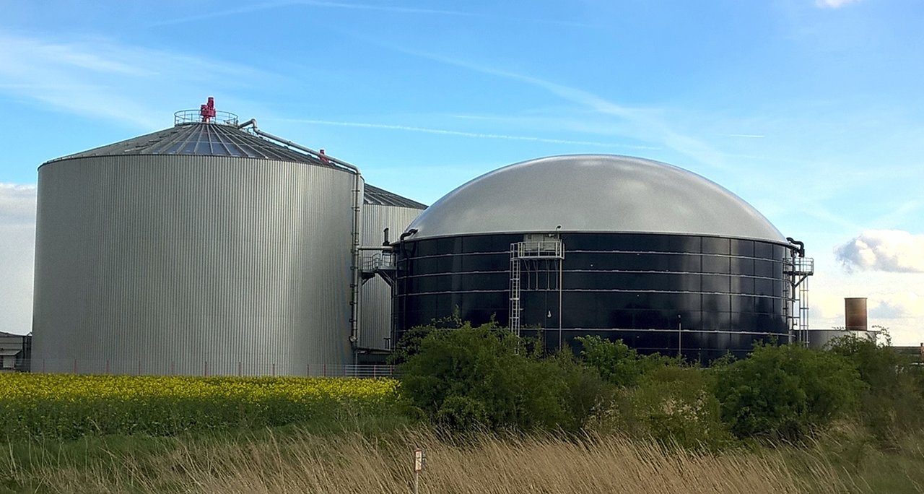

Figure 4: Anaerobic digestion of biomass in biogas plant

- Composting
Composting agricultural biomass is a viable solution for managing crop residues and generating organic fertilizer. Composting involves the efficient bioconversion of organic materials into a nutrient-rich soil amendment [22]. Different types of biomass, such as rice straw, pine wood chips, and livestock and poultry excrement, can be used in the composting process. Composting not only helps in the disposal of agricultural residues but also improves soil quality by increasing organic matter content and enhancing physical, chemical, and biological properties [23]. Studies have shown that composting, including the use of biochar and biochar-compost blends, can reduce environmental impacts compared to mineral fertilizers, while also providing benefits such as nutrient enrichment and carbon sequestration [24]. Composting of oil palm biomass is also being explored as a means to recycle waste and produce a useful byproduct for agriculture, thereby addressing environmental concerns associated with the oil palm industry as presented in Figure 5.

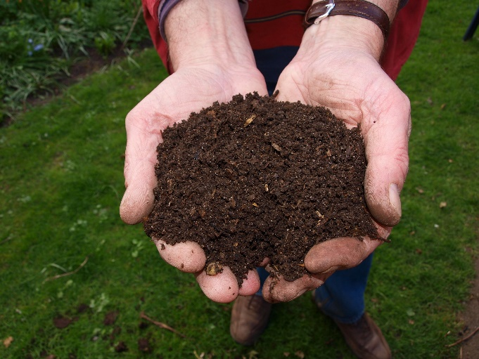

Figure 5: Bio-compost from agricultural waste

- Bioconversion Technologies
Bioconversion of biomass involves the conversion of lignocellulosic biomass into value-added products through various processes such as composting, thermochemical conversion, and hydrothermal liquefaction. Pretreatment methods play a crucial role in enhancing the bioconversion efficiency of lignocellulosic biomass. Thermochemical conversion processes, including pyrolysis, hydrothermal treatment, gasification, and combustion, have been found to be techno-economically feasible and effective for biomass conversion [25]. Hydrothermal liquefaction is a promising technology for sustainable biocrude production from biomass, and understanding the transformation mechanism is crucial for downstream biocrude upgrading [26]. Integration of biochemical, thermochemical, physical, and catalytic conversion processes in biorefineries can enhance the yield and reduce reaction time, leading to the production of a wide range of bio-based products [27]. Pressurized hot water pretreatment has been shown to be an effective method for improving the saccharification efficiency of lignocellulosic biomass, reducing the cost of poly-hydroxy-alkanoate production [28].

- Incineration
The incineration of biomass is a method used to produce energy. Biomass can be burned in an incinerator to generate heat energy, which can then be used for various purposes. One approach is to integrate wastewater treatment and incineration plants, where the exhaust heat generated in the incineration plant is utilized to dry sewage sludge in the companion wastewater treatment plant, thereby enhancing total energy efficiency [29]. Another method involves the use of a biomass recycling device, which includes an incinerator and a corrugated smoke discharge pipe. The device is designed to achieve vibration of the spiral spring and the smoke discharge pipe, resulting in high heat energy recycling rates [30]. Additionally, there are various processes involved in the incineration of biomass, such as gasification, pyrolysis, and co-generation, which allow for the efficient utilization of energy from biomass. Furthermore, a biomass smoke-emission-free incineration steam power generation process has been developed, which achieves comprehensive utilization of waste resources and maximum economic benefits [30]. Finally, a novel biomass incineration boiler has been designed to address safety hazards and ensure sufficient combustion of biomass waste for heat energy utilization [31].

- Gasification
Gasification of biomass is a process that converts biomass into fuel gases. It is a thermo-chemical reaction that involves the incomplete combustion of biomass in a high-temperature gasifier (500-1800º C). The resulting gases, such as CO, H₂, and methane, can be used as fuel for various applications, including heat and electricity production, internal combustion engines, and small-scale heating and refrigeration [32]. Biomass, which includes agricultural products, residues, wood industry waste, and organic components from urban and industrial waste, is a widely available renewable resource for gasification [33]. Different biomasses have been analyzed for their performance in gasification, with sawdust found to have the highest energy and exergy efficiencies [34]. Additionally, a biomass energy conversion method utilizing a jet flow gasification smelting furnace has been developed, allowing for the full utilization of biomass waste without generating pollution.

- Pyrolysis
Pyrolysis of biomass involves the thermal decomposition of biomass to produce solid, liquid, and gaseous products that can be used as alternative sources of fuels and chemicals [35]. The process of pyrolysis can be carried out using various methods and reactors. One method involves subjecting the biomass material to radiofrequency electromagnetic radiation, such as microwave radiation, while agitating the material to produce the desired degree of pyrolysis [36]. Another method utilizes a pyrolysis reactor with a rotating chamber that allows for better utilization of the raw materials and improved reaction efficiency [37]. The pyrolysis process can produce bio-oil and other valuable hydrocarbons from lignocellulosic biomass, which can be upgraded to meet transport requirements [38]. However, there are challenges in the utilization of bio-oil as an alternative to conventional transport fuel, which need to be addressed.

- Briquetting
Briquetting of biomass involves the process of compacting biomass materials into denser forms, such as briquettes, to improve their use in energy production. This technique increases the calorific value of the fuel, reduces transportation costs, and improves the fuel situation in both urban and rural areas [39]. Industrial briquetting presses can exert high pressure and generate heat during the compression process, allowing for the production of hard, solid briquettes without the need for binders [39]. The capacity of industrial presses ranges from 250-3000 kg/h, and the production chain includes waste collection, storage, drying, grinding, pressing, cooling, storing, and transportation [40]. Briquetting biomass has been found to be a viable technology for upgrading agricultural residues and other bio-waste resources, providing benefits such as reduced volume, improved combustion characteristics, and CO₂ neutrality [41]. Various materials, including wheat straw, cotton stalk, sawdust, and waste paper, can be compressed into briquettes with or without binder materials [42]. The use of biomass feedstock as a substitute for fossil fuels has significant potential for reducing greenhouse gas emissions. Figure 6 represents the briquettes of agricultural biomass.

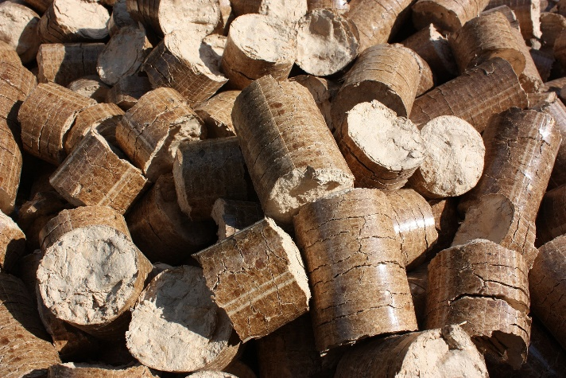

Figure 6: Briquettes of agricultural biomass

- Algae Cultivation for Wastewater Treatment
Algae cultivation can be used for agriculture waste management by utilizing algae for bioremediation of agricultural waste and as a substrate for methane production. Algae have the ability to grow in different types of wastewater, including those sourced from industrial, domestic, and agricultural sectors, and can accumulate neutral lipids for mitigation and growth [43]. Microalgae-based wastewater treatment systems offer opportunities for nutrient recycling and the production of valuable biomass and metabolites, such as biofuels, biofertilizers, animal feed, and bioactive compounds [44]. Algae can also be used to remove nitrogen, phosphorus, and toxic metals from agricultural and industrial wastewater, and genetic modifications can further enhance their potential in wastewater treatment and bioremediation [45]. By integrating algae cultivation into wastewater treatment processes, the treatment efficiency can be improved, and valuable products can be generated, contributing to the management of agricultural waste [46].

- Integrated Farming Systems
Integrated farming is a concept that focuses on the management of agricultural waste by utilizing it in a sustainable manner. It involves the integration of agricultural and livestock systems to reprocess waste materials and reduce the reliance on inorganic fertilizers. The implementation of integrated farming practices has shown success in various regions. For example, a regional partnership program in Tindaki Village, Parigi Moutong Regency, Indonesia, aimed to assist farmers in developing integrated farming businesses based on zero-waste agriculture [47]. In the Middle East and North Africa (MENA) region, the exploitation of non-conventional resources such as agricultural residues for economic agricultural and industrial products is increasingly needed [48]. Smart agriculture (SA) practices, incorporating optimal farming management and the use of sensors, can also contribute to effective waste-to-resource loops in agricultural systems [49]. The management and utilization of agricultural residues have the potential to improve soil properties, supply nutrients to crops, and foster the development of small-scale agro-industries. However, the integration of smart waste management in the context of smart agriculture is still limited [50]. To further enhance integrated farming and waste management, strategies at both national and regional levels are necessary.

- Internet of Things (IoT) Applications
The Internet of Things (IoT) can be used to improve waste management in agriculture by providing real-time data on various factors such as weather, humidity, soil conditions, and fertility [51]. IoT technology allows farmers to monitor and control the production process remotely, enabling them to make informed decisions and take necessary actions to reduce waste. By using sensors, cameras, and other devices, IoT turns every element and action involved in farming into data, which can be analyzed to identify areas of waste and inefficiency [52]. Additionally, the integration of IoT with big data analytics, wireless sensor networks, and cloud computing offers the potential for predicting, processing, and analyzing circumstances in real-time, further improving waste management in agriculture [53]. Overall, IoT provides farmers with the tools and information they need to optimize their operations, reduce waste, and improve efficiency in agriculture.
Embracing these innovative technologies and practices presents a pathway towards a more sustainable and resource-efficient agricultural sector. By valorizing agricultural waste, we not only minimize environmental pollution and greenhouse gas emissions but also contribute to a circular economy, where waste becomes a valuable resource for enhancing agricultural productivity and supporting sustainable development.

- Hydrogen from waste
Hydrogen production from agricultural biomass is a promising and sustainable alternative to fossil fuels. Various processes such as thermochemical (pyrolysis and gasification) and biological (biophotolysis, water-gas shift reaction, and fermentation) can be used to convert biomass into hydrogen. The use of biomass as a feedstock for hydrogen production has been studied in different regions, including Punjab, Pakistan, where agricultural biomass such as rice, sugarcane, cotton, wheat, and maize residues have been identified as potential sources of hydrogen. Additionally, the co-gasification of banana peel with other biomass has shown promising results in terms of hydrogen-rich gas production. However, there are challenges to overcome, such as improving hydrogen yield and reducing manufacturing costs. Further research is needed to optimize the production processes and make hydrogen from agricultural biomass a viable and cost-effective solution for clean energy.

- Other value-added products from waste
Agricultural waste can be managed in a sustainable way through various methods. One approach is the valorization or recovery of waste into products, which involves converting waste into reusable and sustainable products that align with the concept of circular economy [54]. Another method is the cyclical usage of agricultural waste, such as cellulosic biomass, in different agricultural and industrial endeavors. This includes using cellulosic waste for green synthesis of nanomaterials, composting to produce fertilizer, utilizing spent mushroom substrate as livestock feed, and combining livestock manure with cellulosic waste for composting [55]. Agroforestry waste can also be effectively managed through waste collection, transportation, and recycling or valorization into products like biofuel, fertilizers, biochar, and industrial chemicals [56]. Biotechnology techniques have been developed to convert agro-waste into eco-friendly and value-added products, providing sustainable raw materials for various applications. Additionally, proper clean and green waste management approaches are needed, focusing on efficient conversion of waste to value-added products and assessing the impact on soil quality and productivity.

- RESOURCE RECOVERY AND CIRCULAR ECONOMY

The circular economy can be applied to agriculture to reduce waste and recover resources by adapting the general circular economy framework to the specificities of the agricultural sector. This involves defining the circular economy applied to agriculture, adapting the principles of the circular economy to the field, and defining circular economy strategies for agricultural activity. Additionally, there is a need to develop internationally recognized standards and units of measurement to assess the circularity performance of agricultural production systems [57]. The agri-food sector can benefit from the circular economy by reusing and valorizing wastes and by-products, which can enhance and optimize production and consumption in a sustainable manner. In the intensive agriculture of Almeria, the circular economy can address the increasing volume of plastic waste generated by implementing improved management systems and considering the relationship between the price of raw materials and the volume of recycled plastics. Furthermore, the natural ability of mealworms and super worms to consume and degrade polystyrene presents a zero-waste sustainable bioremediation cycle that can simultaneously tackle the global plastic problem and urban farming issue.
Embracing a circular economy approach, the agricultural sector is transitioning towards waste-to-resource models, making efficient use of waste materials and closing the loop in the production-consumption chain. One notable outcome of this paradigm shift is the generation of bioenergy from agricultural waste. A study demonstrates the potential for converting agricultural residues into biofuels, providing an eco-friendly alternative to fossil fuels [37]. Similarly, the extraction of valuable compounds and bioactive molecules from agricultural waste presents an opportunity to produce bio products with various applications in industries like pharmaceuticals, cosmetics, and agriculture. Moreover, the concept of biofertilizers derived from waste materials has gained traction due to their ability to enrich soil fertility and foster sustainable agricultural practices. The integration of resource recovery practices in agricultural engineering not only minimizes waste but also adds economic value to the entire system, promoting a circular economy in agriculture.
Agricultural waste has the capacity to be transformed into bioenergy, bioproducts, and biofertilizers, providing a number of benefits. It offers a green method for valorizing solid waste for sustainable development, to start. By using waste products having a biological origin, it also lessens the environmental problems caused by the use of fossil fuels. Thirdly, biofertilizers made from algae found in wastewater can be a comprehensive source of nutrients for farming, increasing production and soil fertility. Additionally, solid-state fermentation provides a technique to manage agricultural waste and produce useful products by converting it into valuable bioproducts. However, there could be drawbacks as well. Additionally, equipment failure, disruptions in the feedstock supply, and seasonal variations in demand might have an impact on the dependability of bioenergy parks, which use agricultural waste.
The high biomass produced by agriculture, one of the primary biological industries, can help the bioeconomy. In order to ensure the security of food and health, waste valorization to produce value-added products, farmer's livelihood, employment opportunities for youth, and agricultural sustainability, agricultural waste management based bioeconomic strategies can prevent underutilization of livestock excrement and careless/random burning of crop residues [58]. The majority of the agricultural waste stated above may readily degrade, and the results of the process will not only supply vital nutrients for plants but will also make the soil porous (improves soil aeration and water retentivity). So, by transforming agricultural wastes and byproducts into valuable resources, it will not only create green markets and employment possibilities but also help to reduce GHG pollution and reliance on fossil fuels, which will ultimately lead to clean, safe, and sustainable agriculture. To decouple environmental constraints from economic growth (both resource and impact decoupling), lessen human dependence on the use of resources, and prevent pressures on soil, biodiversity, and global food security, it is crucial to reduce, reuse, and recycle agricultural waste [12]. Table 2 depicts the waste to energy generation potential of India.

Table 2: Waste to energy generation potential of India

Sl N | Sectors | Energy potential (MW)
1 | Urban Solid Waste | 1247
2 | Urban Liquid waste | 375
3 | Paper (liquid waste) | 254
4 | Processing and preserving of meat (liquid waste) | 182
5 | Processing and preserving of meat (solid waste) | 13
6 | Processing and preserving of fish ( liquid waste) | 17
7 | Vegetable Processing (solid waste) | 3
8 | Vegetable Raw(solid waste) | 579
9 | Fruit Processing (solid waste) | 8
10 | Fruit Raw (solid waste) | 203
11 | Palm Oil (solid waste) | 2
12 | Milk Processing/Dairy Products (liquid waste) | 24
13 | Maize Starch (liquid waste) | 47
14 | Tapioca Starch (liquid waste) | 36
15 | Tapioca Starch (solid waste) | 15
16 | Sugar (liquid waste) | 49
17 | Sugar press mud (solid waste) | 200
18 | Distillery (liquid waste) | 781
19 | Wine Industry | NA
20 | Slaughterhouse (solid waste) | 48
21 | Slaughterhouse (liquid waste) | 263
22 | Cattle farm (solid waste) | 862
23 | Poultry (solid waste) | 462
24 | Chicory (solid waste) | 1
25 | Tanneries (liquid waste) | 9
26 | Tanneries (solid waste) | 10
Total (MWeq) |  | 5690

In India, there is a total potential for 5690 MW of energy to be produced from organic waste generated in cities and businesses [16]. The Ministry of New and Renewable Energy (MNRE), New Delhi, has created a GIS-based waste mapping tool as part of the GEF-MNRE-UNIDO PROJECT to make it easier to map the presence of various waste categories and their potential for energy generation throughout India.

- WASTE MANAGEMENT FOR SOIL HEALTH AND NUTRIENT MANAGEMENT

Waste management procedures are essential for improving soil health and recycling nutrients in agricultural systems. Effective waste management improves soil fertility, structure, and overall production while reducing environmental pollutants and greenhouse gas emissions. There are different waste management techniques that can benefit nutrient recycling and soil health.

- Composting application
Composting is a natural waste management method that creates nutrient-rich compost from organic waste, including agricultural leftovers, culinary remnants, and animal manure. When compost is added to the soil, the organic matter content is enriched, which enhances the soil's structure and water retention. Compost also provides plants with a slow-release source of nutrients by gradually releasing vital components, lowering the risk of nutrient runoff into water bodies and nutrient leaching. A healthier and more robust soil ecosystem is produced as a result of the increased organic matter in the soil, which also increases microbial activity and biodiversity.

- Biochar Application
As a soil amendment, biochar made from the pyrolysis of organic waste can be added to the ground. Biochar's porous nature offers a home to advantageous soil microbes, enhancing the health of the soil. By storing carbon in the soil, biochar functions as a carbon sink to slow global warming. It also increases the amount of nutrients that are retained in the soil, lowering nutrient losses from leaching and runoff. The cation exchange capacity of the soil is improved by the addition of biochar, which increases the amount of nutrients available to plants and improves the ecosystem's total nutrient recycling.

- Bio-fertilizer Application
An effective biofertilizer can be made from the digestate that results from the anaerobic digestion of organic waste. The digestate, when added to the soil, enriches it with vital substances like nitrogen, phosphorus, and potassium, promoting plant development and nutrient cycling. The digestate's organic material helps to build up the soil's structure and promotes good microbial activity. Additionally, the use of anaerobic digestate as a biofertilizer lessens the demand for synthetic fertilizers, reducing the possibility of nutrient imbalances and the effects on the environment.

- Green Mulching
Planting cover crops and adding green manure to the soil are waste management techniques that not only serve to reduce weed development and erosion but also increase soil health and nutrient recycling. When cover crops break down, they release organic materials into the soil, improving soil fertility and microbial diversity. Additionally, they absorb extra nutrients from the soil, stopping leaching and minimizing nutrient losses. Prior to reaching maturity, green manure crops can be ploughed under to release vital nutrients into the soil, so improving it for succeeding harvests.

- Efficient Irrigation and Nutrient Application
Important elements of waste control in agriculture include appropriate irrigation management and precise nutrient application. Under-irrigation can prevent plants from absorbing nutrients, while over-irrigation can cause nutrients to be leached. Utilizing effective irrigation strategies, like drip irrigation or sprinkler systems, aids with water conservation and lowers nutrient losses. In addition, applying fertilizers only where and when they are required allows farmers to maximize nutrient use efficiency while minimizing environmental impacts.
Agricultural waste-derived organic amendments are essential for improving soil fertility and structure. These amendments, which are rich in organic matter and nutrients and offer a variety of advantages to the soil ecology, include compost, biochar, and anaerobic digestate. Let's examine the essential functions of organic amendments in enhancing soil structure and fertility.

- Increased Organic Matter Content
A rich source of organic carbon, organic amendments increase the amount of organic matter in the soil. The organic matter acts as a food supply for good soil bacteria when it is added to the soil. These microorganisms are essential in releasing nutrients in a form that plants can easily absorb. They break down organic components. An increase in organic matter content increases the soil's ability to retain water, lowering water runoff and enhancing the water supply for plant uptake during dry spells.

- Nutrient Enrichment
Nitrogen, phosphorus, potassium, and a number of other vital nutrients are abundant in organic additions. These nutrients act as a slow-release nutrition source when they are integrated into the soil, gradually making them available to plants. Organic additions release nutrients gradually, limiting the chance of nutrient runoff and environmental damage, unlike synthetic fertilizers that can leak into water bodies. This nutrient enrichment boosts general soil fertility, promotes robust plant growth, and increases crop yields.

- Enhanced Soil Structure
By encouraging the production and stabilization of soil aggregates, the addition of organic amendments aids in the enhancement of soil structure. The organic content and microbial activity that hold together soil aggregates, which are tiny, naturally occurring clusters of soil particles. Better aeration, root penetration, and water infiltration result from the well-structured soil that these aggregates produce. Additionally, a better soil structure lessens soil compaction, which is essential for nutrient uptake and the growth of strong roots.

- Promotion of Beneficial Microbial Activity
The perfect environment for healthy soil microbes is provided by organic additions. By breaking down organic materials, these bacteria release nutrients and increase soil fertility. Additionally, they promote the health of the soil and lower the risk of plant illnesses by suppressing the growth of dangerous microorganisms. A diversified and robust microbial community is necessary for a healthy ecosystem and for the growth of plants.

- pH Regulation
Some organic amendments, like biochar, have the ability to control the pH of the soil. When biochar is put to acidic soils, it functions as a buffer, raising the pH and establishing a more neutral atmosphere. This is advantageous because it increases the availability of nutrients and increases plant nutrient uptake. On the other side, biochar can also help alkaline soils retain water better, creating ideal circumstances for plant growth.

- Climate Change Mitigation
The addition of organic amendments to the soil helps to sequester carbon, which lowers the atmospheric concentration of carbon dioxide. Organic amendments serve as a long-term carbon sink by increasing the amount of organic matter in the soil. This increases the stability of the carbon stored in the soil. This promotes sustainable agriculture methods and helps to mitigate climate change.
A promising approach for minimizing the use of chemical fertilizers in agriculture while maintaining long-term soil fertility and crop yield is waste-based nutrient management. Farmers can use waste-based strategies that not only give crops a balanced supply of nutrients but also have minimal negative effects on the environment by utilizing the important nutrients found in diverse agricultural wastes and organic leftovers. Agricultural waste, which includes agricultural residues, animal manure, and leftovers from the food industry, contains significant amounts of essential elements like nitrogen, phosphate, and potassium. Instead of being thrown away or burned outside, these leftovers can be recycled through composting, anaerobic digestion, or vermicomposting. The resulting organic amendments can be used to restore soil fertility as a sustainable alternative to synthetic fertilizers. Biochar and bio-oil can be produced from agricultural waste and biomass using processes like pyrolysis and gasification. As a slow-release fertilizer, the nutrient-rich ash created by these processes can be used to supplement crops' nutrient needs and lessen the need for synthetic fertilizers. It also contains essential minerals.
Long-term cost savings for farmers may result from the use of waste-based nutrient management. Composting or anaerobic digestion plants may require early investments, but as chemical fertilizer usage declines, costs may eventually be reduced. Additionally, waste-based techniques provide prospective prospects for money generation through the creation and sale of organic fertilizers.

- POLICY FRAMEWORKS FOR SUSTAINABLE WASTE MANAGEMENT

Promoting and rewarding sustainable waste management techniques in agriculture depends heavily on supportive laws and regulations. Farmers and other stakeholders are encouraged to embrace environmentally friendly practices through these policies, which offer a framework for waste reduction, recycling, and resource recovery. For improving sustainable waste management in agriculture, the following main factors make supportive policies and laws crucial.

- Environmental Protection
Supportive laws and regulations work to protect the environment by reducing the harm that agricultural waste causes to the quality of the soil, water, and air. These regulations aid in preventing environmental deterioration, cutting greenhouse gas emissions, and safeguarding natural resources by ensuring proper trash disposal and promoting recycling practices.

- Waste Reduction and Resource Efficiency
Reduction, reuse, and recycling of garbage are encouraged through policies supporting sustainable waste management. These laws facilitate the conversion of waste into useful resources, eliminating the need for landfills and preserving natural resources by promoting techniques like composting, anaerobic digestion, and biomass conversion.

- Climate Change Mitigation
By lowering greenhouse gas emissions, sustainable waste management techniques can help combat climate change. For instance, composting organic waste lowers the emission of methane during decomposition by helping to store carbon in the soil. Supportive laws can encourage waste-to-energy initiatives, such as the generation of biogas, which can substitute fossil fuels and cut net greenhouse gas emissions.

- Circular Economy Promotion
The shift to a circular economy model in agriculture can be facilitated by supportive policies. These regulations produce financial incentives for waste valorization by promoting the use of waste as a resource. By encouraging a closed-loop system where garbage is recycled, repurposed, and turned into useful products, lessens the need for virgin resources and cuts down on waste production.

- Knowledge and Technology Transfer
In waste management, policies and regulations can help with knowledge uptake and technological adoption. Policymakers can persuade farmers and stakeholders to adopt cutting-edge waste management strategies and technologies by providing financial incentives, subsidies, or training programmes.

- Economic and Health Benefits
Sustainable waste management techniques can benefit farmers and the agricultural industry financially. Supportive policies can make waste-based ventures more commercially viable and promote their adoption by providing tax incentives, subsidies, or grants. Hazards to public health and environmental contamination are decreased by proper waste management. Communities are shielded from contaminants and pathogens by regulations that demand safe and sanitary waste management procedures.

- Collaboration and Stakeholder Engagement
A platform for cooperation and participation among many stakeholders, such as farmers, waste management businesses, academic institutions, and governmental organizations, is provided through supportive policies. This group effort encourages creativity and efficient waste management techniques.

- Compliance and Enforcement
Regulations guarantee that waste management techniques adhere to environmental and safety standards. They contribute to the prevention of unauthorized burning, unlawful dumping, and incorrect garbage disposal, ensuring that waste management procedures follow secure and safe procedures.
The advancement of sustainable waste management techniques in agriculture is impossible without the aid of supportive laws and legislation. Policymakers can persuade farmers and stakeholders to adopt resource- and environment-wise waste management methods by offering a legal framework, incentives, and rules. These regulations not only safeguard the environment and the general public's health but also encourage innovation, the circular economy, and a more resilient and sustainable agriculture industry. Highlights of some effective waste management initiatives that have been implemented in various areas and their results.

- Japan - 3R (Reduce, Reuse, Recycle) Policy
With its 3R (Reduce, Reuse, Recycle) programme, Japan has been a leader in trash management. To reduce trash production, enhance resource efficiency, and promote recycling, the Japanese government has established extensive waste management programmes. Japan has attained excellent recycling rates for a variety of waste streams because of public awareness initiatives and stringent trash separation regulations. For instance, they recycle more than 90% of PET bottles there. This policy has helped Japan conserve natural resources, reduce environmental pollution, and considerably reduce its dependency on landfills [59].

- Germany - Dual System for Packaging Recycling:
The Green Dot system, a dual recycling method for packaging, was developed in Germany and has proved successful in advancing environmentally friendly waste management. Manufacturers and distributors are required under the system to assume responsibility for the packaging waste they produce. Depending on the type of packaging they use, businesses contribute to a recycling fund, which pays for the collection and recycling of packaging waste. Germany has thereby achieved high recycling rates for various packaging materials, helping to save resources and decrease landfill usage [60].

- South Korea - Pay-As-You-Throw (PAYT) System:
In order to manage municipal waste, South Korea has successfully established a Pay-As-You-Throw (PAYT) system. Residents are taxed according to how much rubbish they dispose of under this arrangement. The cost of waste disposal increases as more waste is produced. This promotes waste reduction and motivates locals to recycle and compost more frequently. As a result, South Korea has witnessed a marked rise in recycling rates as well as a decline in garbage production. The PAYT system has been essential in encouraging sustainable waste management techniques and preventing garbage from going to landfills [61].

- San Francisco, USA - Zero Waste Initiative:
Under the auspices of its Zero Garbage Initiative, San Francisco in the United States has set high standards for waste management. By 2020, the city wants to divert all of its garbage from landfills. San Francisco has put in place extensive trash reduction, recycling, and composting programmes to achieve this. The city has offered curbside pickup for organic trash, strictly enforced waste separation regulations, and encouraged composting in homes and businesses. San Francisco has one of the greatest diversion rates in the country as a result of these programmes, proving the value of regional waste management regulations [62].

- Taiwan - Waste-to-Energy Incineration and Recycling:
Taiwan has implemented a waste management strategy that combines recycling and waste-to-energy incineration. The nation features cutting-edge facilities for waste incineration that effectively turn non-recyclable waste into electricity while upholding tight environmental regulations. Taiwan's renewable energy targets are aided by the electricity produced by waste-to-energy facilities. Taiwan has also placed a significant priority on recycling, with comprehensive waste separation programmes and high rates of recycling for metals, plastics, and paper. Taiwan has greatly decreased its use of landfills as a result of these joint efforts, and it has also made great strides toward sustainable waste management [63].
These illustrations show how effective waste management strategies change depending on local objectives and demands. Diverse regions have seen substantial reductions in trash, promotion of recycling, and support for a more sustainable future by using tactics including recycling incentives, waste reduction programmes, waste-to-energy technologies, and public participation.
Effective waste management policies can confront a number of obstacles and difficulties during implementation. These obstacles may encompass social, economic, technological, and political issues and can differ from one place to another. Here are some typical roadblocks and difficulties in putting waste management strategies into practice.

- Lack of Awareness and Education
Policy implementation may be hampered by low stakeholder and public understanding of the value of sustainable waste management. Inadequate waste management training may result in incorrect trash disposal and inadequate recycling, composting, and waste separation techniques.

- Inadequate Infrastructure and Technology
Resource recovery can be hampered by inadequate waste management infrastructure, such as recycling facilities, composting facilities, and waste-to-energy plants. Challenges may also arise from the high cost and complexity of implementing modern waste management technology, particularly in developing nations.

- Lack of Regulatory Enforcement
Policies' efficacy may be harmed by lax or ineffective waste management regulations enforcement. Without effective enforcement, waste generators might not follow rules for trash separation or recycling requirements, impeding attempts to divert garbage.

- Political and Policy Fragmentation
Inconsistent waste management policy may result from political division and a lack of cooperation between the various tiers of government. This may lead to inconsistencies in rules and prevent the development of an all-inclusive waste management framework.

- Market Demand Global Waste Trade
Recycling activities are greatly influenced by consumer demand for recycled goods. The economic feasibility of recycling programmes and trash diversion activities may be hampered by low demand for recycled products. The trade and dumping of garbage, where waste is exported to nations with loose restrictions, can thwart national waste management initiatives and increase environmental problems in the nations that receive the waste.
A multifaceted strategy that includes public education and awareness campaigns, financial incentives, technical improvements, strict regulatory enforcement, and cooperation across diverse stakeholders is needed to address these obstacles and challenges. It is crucial for policymakers to take into account the local context and customize waste management policies to successfully handle particular difficulties in each location. By overcoming these obstacles, nations and regions can progress toward waste management strategies that are more environmentally friendly and help to create a cleaner, safer world.

- FUTURE PROSPECTS IN WASTE MANAGEMENT

Due to the pressing need to solve environmental issues, increase resource efficiency, and promote sustainable agricultural practices, waste management in agricultural engineering has a bright future. Technology advancements and novel methods are anticipated to revolutionize waste management in agriculture and create a more circular and environmentally friendly system. An outlook on prospective developments in agricultural engineering waste management is provided below:

- Integration of IoT and AI
Agriculture waste management will change thanks to the Internet of Things (IoT) and smart technology. Real-time data collection on trash creation, composting procedures, and anaerobic digestion will be made possible by smart sensors and monitoring devices. This data-driven strategy will improve resource efficiency, minimize waste, and handle waste more effectively. The processes for sorting waste, recycling, and resource recovery will be significantly influenced by artificial intelligence and automation. Robotic systems powered by AI will improve garbage separation while lowering contamination and increasing recycling rates.

- Decentralized Waste Management Solutions
Solutions for decentralized garbage management will become more popular, particularly in outlying and rural areas. Farmers and towns will be able to manage trash locally, lowering transportation costs and fostering self-sufficiency. This will be made possible by modular waste-to-energy systems, small-scale anaerobic digesters, and compact composting units.

- Advanced Waste Conversion Technologies
Agricultural waste may be transformed into higher-value goods like charcoal and biofuels because to improvements in waste conversion technologies like pyrolysis and gasification. These technologies will enable the creation of renewable energy sources and carbon sequestration in addition to helping to reduce trash.

- Bio-Based Packaging Materials
The agricultural sector will investigate bio-based packaging products made from leftover agricultural trash. These materials will be environmentally beneficial substitutes for traditional plastics and lessen the impact of packaging waste on the environment.

- Circular Economy Models
Trash management will increasingly rely on circular economy concepts, which encourage the conversion of waste into useful resources. The use of integrated farming methods, which convert waste from one process into a resource for another, will reduce waste and advance resource efficiency.

- Public-Private Partnerships
Innovations in garbage management will be driven by public-private partnerships. To create and put into practise sustainable waste management practices, governments, research institutions, waste management businesses, and agricultural stakeholders will collaborate.

- Waste-to-Value Chains
There will be an increase in waste-to-value chains, where agricultural waste is converted into a variety of products with additional value. These could include bio-based pharmaceuticals, nutraceuticals, and bioactive substances with uses across numerous sectors of the economy.

- Policy and Regulatory Support
Governments will continue to be key factors in determining waste management regulations and offering incentives for environmentally friendly behaviour. Progress in waste management will be fueled by tightening rules and establishing challenging waste reduction goals.
Policymakers, academics, and practitioners can jointly advance sustainable waste management techniques in agriculture by incorporating these proposals into their strategies. Adopting sustainable waste management practices is not only necessary for the environment, but it also presents a chance to encourage the development of a greener, more resilient agriculture industry that will help ensure a sustainable future for everybody. In conclusion, promising developments that will result in more sustainable, effective, and resource-conscious methods are predicted for the future of waste management in agricultural engineering. A more environmentally friendly agricultural industry will emerge as a result of the integration of technology, circular economy concepts, and creative waste conversion techniques. This will reduce waste, conserve resources, and promote a more resilient and sustainable future.

- CONCLUSION

Utilizing and managing agricultural wastes can help agricultural systems make the transition to more sustainable production methods. Various technologies for turning agricultural wastes into bioenergy and their availability are important elements that raise the value of this kind of feedstock. Agricultural wastes can also be used as plant growing mediums, soil supplements, fertilizer alternatives, and weed control. To prevent disrupting the dynamics of soil carbon and other nutrients, it is crucial to set suitable limits and maintain monitoring. Traditional methods of disposing of waste, such as open burning and landfilling, have long proven harmful to the environment, causing pollution, greenhouse gas emissions, and soil deterioration. It is critical to reconsider our approach to waste management and look into more responsible and progressive ways as our world experiences ever-increasing environmental pressures. Using waste-to-wealth techniques, we can unlock the potential of agricultural waste and transform it into a priceless resource for our agricultural systems and beyond. By using these tactics, we may progress toward a more circular economy, where waste is seen as a resource to be used and recycled rather than a problem to be solved.
Organic matter and nutrients are abundant in crop wastes, animal dung, and byproducts of the food processing industry. We can transform these waste products into nutrient-rich biofertilizers and organic amendments through composting, anaerobic digestion, and other cutting-edge techniques. This not only improves the soil's structure and ability to retain water, but also fills it with crucial nutrients, resulting in a favourable environment for the development of strong plants. Farmers can lessen their dependency on synthetic fertilizers and the environmental consequences of excessive chemical use by using organic amendments made from agricultural waste. Additionally, organic additions encourage beneficial microbial activity in the soil, increasing biodiversity and the overall health of the ecosystem.
We found the possibility of pyrolysis, gasification, and biochar production using cutting-edge waste management methods. These cutting-edge technologies provide fascinating possibilities for turning agricultural waste into worthwhile bio-based goods, such biochar and biofuels. We can reduce trash production, generate renewable energy, and improve carbon sequestration by utilizing these cutting-edge technology, which will help to mitigate the effects of climate change. However, enabling rules and regulations are necessary in order to fully realize the advantages of waste-to-wealth methods. In order for waste management technologies to succeed, policymakers must foster an atmosphere that is favourable to their development. Governments can promote the adoption of sustainable waste management methods throughout the agriculture sector by developing comprehensive waste management legislation, offering financial incentives, and fostering public-private collaborations.
In essence, waste management in agricultural engineering has a bright future if it is directed by the waste-to-wealth concepts. Adopting these measures will be crucial in safeguarding the health of our planet and the prosperity of future generations as we move towards a greener and more sustainable future. We can turn waste into money by making responsible decisions and putting ethical methods into practice. This will help ensure that agriculture and the environment as a whole have a brighter and more sustainable future.
REFERENCES

[1] S. H. A. Koop and C. J. van Leeuwen, “The challenges of water, waste and climate change in cities,” Environ Dev Sustain, vol. 19, no. 2, pp. 385–418, Apr. 2017, doi: 10.1007/S10668-016-9760-4/TABLES/4.
[2] H. C. J. Godfray et al., “Food Security: The Challenge of Feeding 9 Billion People,” Science (1979), vol. 327, no. 5967, pp. 812–818, Feb. 2010, doi: 10.1126/SCIENCE.1185383.
[3] N. Tripathi, C. D. Hills, R. S. Singh, and C. J. Atkinson, “Biomass waste utilisation in low-carbon products: harnessing a major potential resource,” npj Climate and Atmospheric Science 2019 2:1, vol. 2, no. 1, pp. 1–10, Oct. 2019, doi: 10.1038/s41612-019-0093-5.
[4] F. Wang, Z. Cheng, A. Reisner, and Y. Liu, “Compliance with household solid waste management in rural villages in developing countries,” J Clean Prod, vol. 202, pp. 293–298, Nov. 2018, doi: 10.1016/J.JCLEPRO.2018.08.135.
[5] M. A. Bhat, A. W. Adil, B. M. Sikander, Y. Lone, and J. Ahmad. Malik, “Waste Management Technology for Sustainable Agriculture,” 2020, pp. 156–176. doi: 10.4018/978-1-7998-0031-6.ch009.
[6] G. K. Porichha, Y. Hu, K. T. V. Rao, and C. C. Xu, “Crop Residue Management in India: Stubble Burning vs. Other Utilizations including Bioenergy,” Energies (Basel), vol. 14, no. 14, p. 4281, Jul. 2021, doi: 10.3390/EN14144281.
[7] B. Fu, L. Chen, H. Huang, P. Qu, and Z. Wei, “Impacts of crop residues on soil health: a review,” Environmental Pollutants and Bioavailability, vol. 33, no. 1, pp. 164–173, Jul. 2021, doi: 10.1080/26395940.2021.1948354.
[8] V. Venkatramanan, S. Shah, A. K. Rai, and R. Prasad, “Nexus Between Crop Residue Burning, Bioeconomy and Sustainable Development Goals Over North-Western India,” Front Energy Res, vol. 8, Jan. 2021, doi: 10.3389/FENRG.2020.614212/FULL.
[9] R. Durgapal and R. Upadhyay, “Comprehension of Pamphlet Developed on Composting from Agriculture and Animal Waste,” Int J Curr Microbiol Appl Sci, vol. 9, no. 10, pp. 2145–2152, Oct. 2020, doi: 10.20546/IJCMAS.2020.910.261.
[10] S. Roszkowska and N. Szubska-Włodarczyk, “What are the barriers to agricultural biomass market development? The case of Poland,” Environ Syst Decis, vol. 42, no. 1, pp. 75–84, Mar. 2022, doi: 10.1007/s10669-021-09831-1.
[11] N. E. Korres, “Utilization and Management of Agricultural Wastes for Bioenergy Production, Weed Control, and Soil Improvement Through Microbial and Technical Processes,” in Environmental Microbiology and Biotechnology, Singapore: Springer Singapore, 2020, pp. 143–173. doi: 10.1007/978-981-15-6021-7_8.
[12] B. Koul, M. Yakoob, and M. P. Shah, “Agricultural waste management strategies for environmental sustainability,” Environ Res, vol. 206, p. 112285, Apr. 2022, doi: 10.1016/j.envres.2021.112285.
[13] Y. Singh and H. S. Sidhu, “Management of Cereal Crop Residues for Sustainable Rice-Wheat Production System in the Indo-Gangetic Plains of India,” Proc Indian Natn Sci Acad, vol. 80, no. 1, pp. 95–114, 2014, doi: 10.16943/ptinsa/2014/v80i1/55089.
[14] P. Shyamsundar et al., “Fields on fire: Alternatives to crop residue burning in India,” Science (1979), vol. 365, no. 6453, pp. 536–538, Aug. 2019, doi: 10.1126/SCIENCE.AAW4085/SUPPL_FILE/AAW4085_SHYAMSUNDAR_SM.PDF.
[15] A. Kaab, M. Sharifi, H. Mobli, A. Nabavi-Pelesaraei, and K. wing Chau, “Combined life cycle assessment and artificial intelligence for prediction of output energy and environmental impacts of sugarcane production,” Science of The Total Environment, vol. 664, pp. 1005–1019, May 2019, doi: 10.1016/J.SCITOTENV.2019.02.004.
[16] “Ministry of New & Renewable Energy - Government of India.” https://mnre.gov.in/ (accessed Jul. 27, 2023).
[17] D. Vyas, F. Sayyad, M. Khardiwar, and S. Kumar, “Physicochemical Properties of Briquettes from Different Feed Stock,” Current World Environment, vol. 10, no. 1, pp. 263–269, Apr. 2015, doi: 10.12944/cwe.10.1.32.
[18] S. Kumar Khanal, F. Lü, J. W. C. Wong, D. Wu, and H. Oechsner, “Anaerobic digestion beyond biogas,” Bioresour Technol, vol. 337, p. 125378, Oct. 2021, doi: 10.1016/j.biortech.2021.125378.
[19] “Anaerobic digestion apparatus producing biogas from organic solid matter.” Jun. 10, 2021. Accessed: Jul. 26, 2023. [Online]. Available: https://typeset.io/papers/anaerobic-digestion-apparatus-producing-biogas-from-organic-kiug5r8o03
[20] N. Guendouz, H. Rezzaz-Yazid, S. Laib, and Z. Sadaoui, “Evaluation of the biogas potential of a lignocellulosic residue.,” Water Science and Technology, vol. 84, no. 8, pp. 1827–1838, Oct. 2021, doi: 10.2166/WST.2021.350.
[21] D. T. Kimia, B. Trisakti, and B. Sitompul, “Stabilitas Digester Anaerobik Satu Tahap dalam Produksi Biogas pada Variasi Temperatur Menggunakan Reaktor Batch,” Jurnal Teknik Kimia USU, vol. 10, no. 1, pp. 25–30, Mar. 2021, doi: 10.32734/JTK.V10I1.3271.
[22] A. Persiani, M. Pergola, C. Ingrao, A. M. Palese, and G. Celano, “Supply of agricultural biomass residues for on-farm composting: a cross-analysis of relevant data sets for the most sustainable management combination,” Agroecology and Sustainable Food Systems, vol. 45, no. 1, pp. 134–156, Jan. 2021, doi: 10.1080/21683565.2020.1787294.
[23] “Biomass organic fertilizer.” Oct. 12, 2018. Accessed: Jul. 26, 2023. [Online]. Available: https://typeset.io/papers/biomass-organic-fertilizer-x3r1kh27pt
[24] M. Vakili, M. Rafatullah, M. H. Ibrahim, B. Salamatinia, Z. Gholami, and H. M. Zwain, “A review on composting of oil palm biomass.,” Environ Dev Sustain, vol. 17, no. 4, pp. 691–709, Aug. 2015, doi: 10.1007/S10668-014-9581-2.
[25] M. W. Seo et al., “Recent advances of thermochemical conversieon processes for biorefinery,” Bioresour Technol, vol. 343, p. 126109, Jan. 2022, doi: 10.1016/j.biortech.2021.126109.
[26] J. Lu, J. Watson, Z. Liu, and Y. Wu, “Elemental migration and transformation during hydrothermal liquefaction of biomass,” J Hazard Mater, vol. 423, p. 126961, Feb. 2022, doi: 10.1016/j.jhazmat.2021.126961.
[27] G. Velvizhi, K. Balakumar, N. P. Shetti, E. Ahmad, K. Kishore Pant, and T. M. Aminabhavi, “Integrated biorefinery processes for conversion of lignocellulosic biomass to value added materials: Paving a path towards circular economy,” Bioresour Technol, vol. 343, p. 126151, Jan. 2022, doi: 10.1016/j.biortech.2021.126151.
[28] X. Yan, D. Li, X. Ma, and J. Li, “Bioconversion of renewable lignocellulosic biomass into multicomponent substrate via pressurized hot water pretreatment for bioplastic polyhydroxyalkanoate accumulation,” Bioresour Technol, vol. 339, p. 125667, Nov. 2021, doi: 10.1016/j.biortech.2021.125667.
[29] M. Piaskowska-Silarska, S. Gumuła, K. Pytel, and P. Migo, “Technical and economic analysis of using biomass energy,” E3S Web of Conferences, vol. 14, p. 02016, Jan. 2017, doi: 10.1051/E3SCONF/20171402016.
[30] N. Nakatsuka, Y. Kishita, T. Kurafuchi, and F. Akamatsu, “Integrating wastewater treatment and incineration plants for energy-efficient urban biomass utilization: A life cycle analysis,” J Clean Prod, vol. 243, p. 118448, Jan. 2020, doi: 10.1016/j.jclepro.2019.118448.
[31] M. Piaskowska-Silarska, S. Gumuła, K. Pytel, and P. Migo, “Technical and economic analysis of using biomass energy,” E3S Web of Conferences, vol. 14, p. 02016, Jan. 2017, doi: 10.1051/E3SCONF/20171402016.
[32] L. Maisyarah and Y. Siregar, “Utilization of wood biomass as a renewable energy source using gasification technology,” IOP Conf Ser Mater Sci Eng, vol. 1122, no. 1, p. 012080, Mar. 2021, doi: 10.1088/1757-899X/1122/1/012080.
[33] P. Sharma, B. Gupta, M. Pandey, K. Singh Bisen, and P. Baredar, “Downdraft biomass gasification: A review on concepts, designs analysis, modelling and recent advances,” Mater Today Proc, vol. 46, pp. 5333–5341, Jan. 2020, doi: 10.1016/j.matpr.2020.08.789.
[34] S. Rupesh, C. Muraleedharan, and P. Arun, “Energy and exergy analysis of syngas production from different biomasses through air-steam gasification,” Frontiers in energy, vol. 14, no. 3, pp. 607–619, Sep. 2020, doi: 10.1007/S11708-016-0439-1.
[35] “Pyrolysis reactor of biomass fuel.” Jan. 07, 2015. Accessed: Jul. 26, 2023. [Online]. Available: https://typeset.io/papers/pyrolysis-reactor-of-biomass-fuel-51d3ywyzmn
[36] V. L. Budarin et al., “Pyrolysis of biomass,” Bioresour Technol, vol. 100, no. 23, pp. 6064–6068, Mar. 2011, doi: 10.1016/J.BIORTECH.2009.06.068.
[37] V. Dhyani and T. Bhaskar, “Pyrolysis of biomass,” Biomass, Biofuels, Biochemicals: Biofuels: Alternative Feedstocks and Conversion Processes for the Production of Liquid and Gaseous Biofuels, pp. 217–244, Jan. 2019, doi: 10.1016/B978-0-12-816856-1.00009-9.
[38] N. Canabarro, J. F. Soares, C. G. Anchieta, C. S. Kelling, and M. A. Mazutti, “Reactor for pyrolysis of biomass,” Sustainable Chemical Processes, vol. 1, no. 1, Sep. 2010, doi: 10.1186/2043-7129-1-22.
[39] H. K. Sharma, T. K. Bhattacharya, R. P. Singh, and A. K. Verma, “Traditional vs. modified approach of pine needle char beehive block production,” Biomass Convers Biorefin, vol. 12, no. 12, pp. 5799–5812, Dec. 2022, doi: 10.1007/s13399-020-01008-1.
[40] H. K. Sharma, A. Kumain, and T. K. Bhattacharya, “Characteristic properties of pine needle biochar blocks with distinctive binders,” Curr Sci, vol. 118, no. 12, 2020, doi: 10.18520/cs/v118/i12/1959-1967.
[41] A. Kumain, T. K. Bhattacharya, and H. K. Sharma, “Physicochemical and Thermal Characteristics of Pine Needle Biochar Briquetted Fuel using Soil, Lime and Cement as a Binder,” Int J Curr Microbiol Appl Sci, vol. 9, no. 10, pp. 3675–3690, Oct. 2020, doi: 10.20546/ijcmas.2020.910.425.
[42] L. Kaur, H. Singh, H. Kumar Sharma, T. P. Singh, and J. Singh, “Effect of storage on properties of pine needle cattle dung briquettes,” 2021.
[43] N. Singh and M. Ghosh, “Genetic engineered algae: Recent developments and the promising engender for wastewater treatment,” An Integration of Phycoremediation Processes in Wastewater Treatment, pp. 379–398, Jan. 2022, doi: 10.1016/B978-0-12-823499-0.00011-0.
[44] E. G. Nwoba, A. Vadiveloo, C. N. Ogbonna, B. E. Ubi, J. C. Ogbonna, and N. R. Moheimani, “Algal Cultivation for Treating Wastewater in African Developing Countries: A Review,” Clean-soil Air Water, vol. 48, no. 3, p. 2000052, Mar. 2020, doi: 10.1002/CLEN.202000052.
[45] P. H. Rao, R. R. Kumar, and N. Mohan, “Phycoremediation: Role of Algae in Waste Management,” pp. 49–82, Jan. 2019, doi: 10.1007/978-981-13-7904-8_3.
[46] M. A. El-Esawi, “Genetic Technologies and Enhancement of Algal Utilization in Wastewater Treatment and Bioremediation,” Application of Microalgae in Wastewater Treatment, pp. 163–175, Jan. 2019, doi: 10.1007/978-3-030-13913-1_9.
[47] B. Nasir et al., “Development of Integrated Farming Businesses Based on Zero Waste Agriculture in Parigi Moutong Regency,” Journal of Community Practice and Social Welfare, vol. 1, no. 2, pp. 28–39, Oct. 2021, doi: 10.33479/JACIPS.2021.1.2.28-39.
[48] H. M. El Shaer, “Integrated Systems for Management and Utilization of Agriculture Wastes in Some MENA Regions,” Springer Water, pp. 355–375, Jan. 2020, doi: 10.1007/978-3-030-18350-9_18.
[49] C. P. C. Bong, L. Y. Lim, C. T. Lee, Y. Van Fan, and J. J. Klemeš, “The Role of Smart Waste Management in Smart Agriculture,” Chem Eng Trans, vol. 70, pp. 937–942, Aug. 2018, doi: 10.3303/CET1870157.
[50] A. Reetsch, K. H. Feger, K. Schwärzel, C. Dornack, and G. Kapp, “Organic farm waste management in degraded banana-coffee-based farming systems in NW Tanzania,” Agric Syst, vol. 185, p. 102915, Nov. 2020, doi: 10.1016/j.agsy.2020.102915.
[51] G. Virupaxappa and S. Thangam, “Smart agriculture and role of IOT,” Proceedings of the 3rd International Conference on Inventive Research in Computing Applications, ICIRCA 2021, pp. 651–658, Sep. 2021, doi: 10.1109/ICIRCA51532.2021.9545042.
[52] M. B. Abhishek, S. Tejashree, R. Manasa, and T. G. Vibha, “Smart Agriculture Management System Using Internet of Things (IoT),” Lecture Notes in Networks and Systems, vol. 176 LNNS, pp. 363–375, Jan. 2021, doi: 10.1007/978-981-33-4355-9_28.
[53] N. A. Hussain, S. Saradha, M. Sc, and M. Phil, “Precision Agriculture using IoT Sensor Network System – A Review,” Turkish Online Journal of Qualitative Inquiry, vol. 12, no. 7, pp. 8366–8375, Aug. 2021, Accessed: Jul. 26, 2023. [Online]. Available: https://www.tojqi.net/index.php/journal/article/view/5194
[54] M. A. Amran et al., “Value-Added Metabolites from Agricultural Waste and Application of Green Extraction Techniques,” Sustainability, vol. 13, no. 20, p. 11432, Oct. 2021, doi: 10.3390/SU132011432.
[55] R. Nepomuceno, C. M. B. Brown, and M. B. Brown, “A Paradigm Shift towards Sustainability: Utilizing Agricultural Waste as a Valuable Resource in Various Agricultural Endeavours,” Agri-Based Bioeconomy, pp. 131–142, May 2021, doi: 10.1201/9781003033394-9.
[56] J. Gupta, M. Kumari, A. Mishra, Swati, M. Akram, and I. S. Thakur, “Agro-forestry waste management- A review,” Chemosphere, vol. 287, p. 132321, Jan. 2022, doi: 10.1016/j.chemosphere.2021.132321.
[57] F. J. Castillo-Díaz, L. J. Belmonte-Ureña, F. Camacho-Ferre, and J. C. Tello-Marquina, “The Management of Agriculture Plastic Waste in the Framework of Circular Economy. Case of the Almeria Greenhouse (Spain).,” Int J Environ Res Public Health, vol. 18, no. 22, p. 12042, Nov. 2021, doi: 10.3390/IJERPH182212042.
[58] S. Bracco, O. Calicioglu, M. G. S. Juan, and A. Flammini, “Assessing the Contribution of Bioeconomy to the Total Economy: A Review of National Frameworks,” Sustainability 2018, Vol. 10, Page 1698, vol. 10, no. 6, p. 1698, May 2018, doi: 10.3390/SU10061698.
[59] H. Takiguchi and K. Takemoto, “Japanese 3R Policies Based on Material Flow Analysis,” J Ind Ecol, vol. 12, no. 5–6, pp. 792–798, Oct. 2008, doi: 10.1111/J.1530-9290.2008.00093.X.
[60] V. Wollny, G. Dehoust, U. R. Fritsche, and P. Weinem, “Comparison of Plastic Packaging Waste Management Options: Feedstock Recycling versus Energy Recovery in Germany,” J Ind Ecol, vol. 5, no. 3, pp. 49–63, Jul. 2001, doi: 10.1162/108819801760049468.
[61] V. Elia, M. G. Gnoni, and F. Tornese, “Designing Pay-As-You-Throw schemes in municipal waste management services: A holistic approach,” Waste Management, vol. 44, pp. 188–195, Oct. 2015, doi: 10.1016/J.WASMAN.2015.07.040.
[62] A. U. Zaman and S. Lehmann, “The zero waste index: a performance measurement tool for waste management systems in a ‘zero waste city,’” J Clean Prod, vol. 50, pp. 123–132, Jul. 2013, doi: 10.1016/J.JCLEPRO.2012.11.041.
[63] C. H. Tsai, Y. H. Shen, and W. T. Tsai, “Analysis of Current Status and Regulatory Promotion for Incineration Bottom Ash Recycling in Taiwan,” Resources 2020, Vol. 9, Page 117, vol. 9, no. 10, p. 117, Sep. 2020, doi: 10.3390/RESOURCES9100117.

