Synthesis of Crown Ethers with Additional Azomethine/Schiff-Base Functionality and Their Metal Complexes
Partha Pratim Das
P.G. Department of Chemistry, Magadh University, Bodh-Gaya, Bihar
Abstract:
The most investigated macromolecules are crown ethers, which are distinguished by their varied host-guest chemistry. Because of their wide-ranging significance, modifying simple crown ethers is of relevance to scientists everywhere. The confluence of two or more distinct kinds of functionalities in one molecular framework leads to ambidentate chelating complexes. Off late Schiff base appended oxa-crown ether systems and their metal complexes have been extensively studied. Schiff bases and their metal complexes, have been studied even before crown ethers were synthesized. Numerous research opportunities are made possible by the fact that it may interact with both Group I/II metal ions i. e. s-block metal ions [Lithium (I), Potassium (I), Sodium (I), Barium (II), etc.] via the crown ether component and transition metals or d-block metal ions of intermediary hardness [Iron (II), Manganese (II), Manganese (III), Cobult (II), Cobult (III), Nickel (II), Copper (II), Zinc (II), etc.] via the Schiff base fraction. Such systems have found numerous applications in diverse fields. These modified crown ethers are more sensitive, selective, and capable of binding ions than the initial crown ether. This chapter extensively covers general synthesis processes of mono-, bis-, and multi-crown ether schiff base molecules along with their metal complexes. A handful of these complexes' catalytic properties were emphasised. When compared to the similar schiff base compounds, these complexes exhibit enhanced catalytic activity.

Introduction
Supramolecular chemistry is one of the most sought after fields of research these days. Because it builds vast, complicated systems with a greater degree of accuracy, such as chlorophyll, haemoglobin, vitamin B₁₂, etc., nature replicas are typically favoured by scientists. These kinds of well-diverse, naturally found macrocycles serve as the inspiration for the idea of supramolecular chemistry. Since the discovery of first crown ether dibenzo-18-crown-6 by Pederson¹, this field has progressed to newer heights due to their range of applications². Crown ethers in particular due to its diverse host-guest chemistry³, are the most studied macromolecules. The ability of crown ethers to form compounds with ionic hosts, such as the cations of elements in the first and second groups of the periodic table, is their most prominent feature. It is possible to choose a certain crown ether core to coordinate with a given cation. To alter the ion bonding potential, sensitivity, and selectivity of the initial crown ethers, methodically synthesized crown ether ligands with an additional donor atoms in the side chain framework had been synthesized. Over the years they have been functionalized⁴ as per the needs of the scientific community too. Schiff bases are known long before crown ethers. Their coordination property with transition metal ions in particular, alkali /alkaline metal ions and even with lanthanides is reported in literature in abundance. These complexes have also found applications in diverse areas⁵. Ambidentate chelating systems results from the coexistence of these two types of molecules in a single molecular structure. Since it is able to interact with both s-block metal ions (Li⁺, K⁺, Na⁺, Ba²⁺ etc.) via the crown ether part and d-block metals of intermediate hardness (Fe²⁺, Mn²⁺, Mn³⁺, Co²⁺, Co³⁺, Ni^{2+,} Cu²⁺ and Zn²⁺ etc.) via the azomethine component, it opens up many possibilities in research. Crown ethers with Schiff bases are examined because they are crucial for the development of chemosensors and particle extraction. Antipyrine Schiff base crown ether chemistry⁶ has received a lot of interest recently. Crown ether azomethine group of 4-antipyrine and its components are used in a variety of ways in the pharmaceutical, clinical, logical, and natural worlds⁷. In this chapter, we will emphasize on the synthesis of numbers of crown ethers with additional azomethine/schiff-Base group(s) and their metal complexes of importance.

Synthesis of Crown Ethers with Additional Azomethine/Schiff-Base Functionality and their complexes
These ligands are relatively easy to develop, as their formation reaction and isolation is very much time and cost effective with moderate to good yield and purity. They are synthesized by combination of aldehydes and amines [condensation of amino crown ethers with aldehydes, condensation of formyl crown ethers with amines and direct coupling of crown ethers with Schiff bases]. The precursors (aldehyde and amine) are designed as per the requirement of ligand frame work. Numerous reported methodologies are available for generating those functionalized precursors in literature. The general reaction procedure involves refluxing mainly in alcoholic solution (methnol/ ethanol). In few cases, inert nitrogen atmosphere has been used during reflux. They can be studied as Schiff base ligands with mono crown ether and bis-crown ether moiety. Below few examples of mono crown ether based Schiff base ligands are shown.
By refluxing the 4-aminobenzo-15-crown-5 and the equivalent salicylaldehyde in ethanol, Garcia et. al.⁸ synthesized the ligands depicted in Scheme 1. These substances are crystalline solids that are soluble in water and the majority of polar solvents but insoluble in n-hexane.
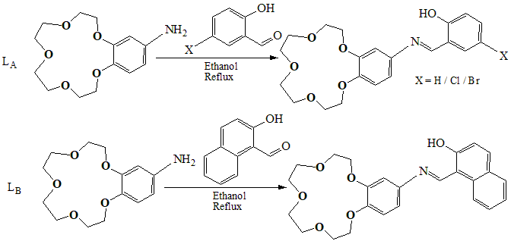
Scheme 1
The powders of the Ligands in Subsection L_{A} of Scheme 1 exhibit thermochromism, changing from yellow, yellowish orange, or orange at 298 K to light yellow, or even white, upon cooling to 77 K. The enol/cis-keto tautomerization is what causes this color change. It was discovered that the naphthalene analogue in subsection L_{B} of Scheme 1 is not thermochromic.
They also reported⁹ the development of an extremely effective fluorescent Zn²⁺ "turn-on" sensor, using the ligand depicted in Scheme 2. It exhibits great selectivity and sensitive amplification of fluorescence intensity in water due to the production of [ZnL₂] upon addition of Zn(NO₃)₂. Synthesis of {[KZnL_{2]}NO3}_{n} results from the equimolar addition of KNO₃ to [ZnL₂]. Synthetic methodology and structure of [ZnL₂] is displayed also, along with the schematic diagram of {[KZnL_{2]}NO3}_{n}.
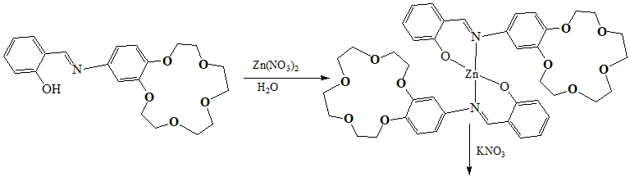
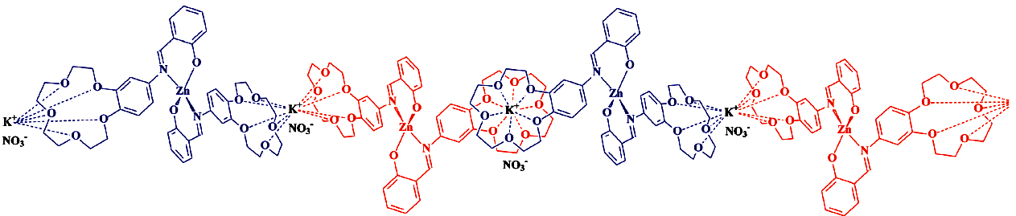
Scheme 2
Freire et. al.¹⁰ reported copper(II) and nickel(II) complexes with a Schiff base ligand bearing benzo-15-crown-5 functionality as flexible arm [Scheme 3] and tried to conduct recognition experiments on the ions of aluminium, lanthanide, alkaline-earth and other elements. The M³⁺ ions used [lanthanides (Er³⁺, Gd³⁺, and Pr³⁺) and Al³⁺] only significantly alter the charge transfer [CT] and intra-ligand electronic spectrum [π−π band region (wavelength 335-550 nm)] of the Ni²⁺ and Cu²⁺ complexes. However, for these complexes, incremental additions of dmf solution of Al³⁺ and lanthanide ions mentioned above, result in significant modifications to the electronic band profile. These changes are similar for both complexes. The combination of single trivalent ion for each crown ether species allowed stability constants to be calculated as a result of spectral shifts brought on by rising M³⁺ levels.
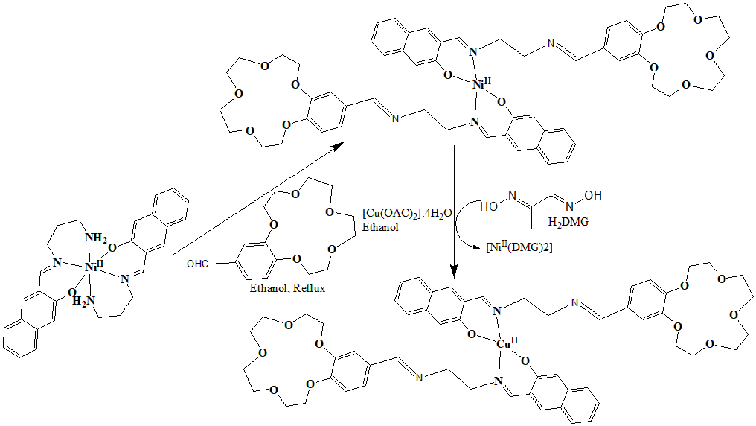
Scheme 3
Menon et. al. synthesized a series of dibenzo-18-crown-6 based Schiff bases [Scheme 4]¹¹. Compounds [1-4] shows behaviour like thermotropic liquid crystals at high temperatures, studied by both DSC and POM. Mesophases do not exist in compound [5-8]. Since these molecules lack a terminal alkoxy or alkyl group, it is likely too stiff to exhibit mesomorphic behaviour.
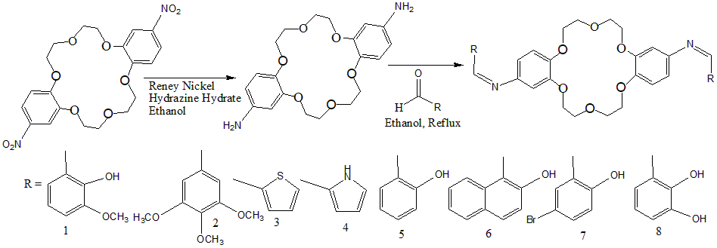
Scheme 4
Zn(II) complexes of crown ether-based azomethine ligands were synthesized. These were analysed utilising a variety of analytical techniques. It shows that the hard Li⁺ bonds to the crown ether moiety in the geometry of mono-(Li) and binuclear-(Li,Zn) complexes, in accordance with HSAB (Hard Soft Acid Base) principle. Even with a fivefold excess of Zn²⁺, binuclear complexes do not form when the complexation sequence involves, first production of crown ether complexes and then addition of Zn²⁺ into corresponding CH₃CN solutions [Scheme 5]¹². This is most likely caused by the alkali metal ion's deactivating influence on the chelation of Zn²⁺ ion at the schiff base portion.
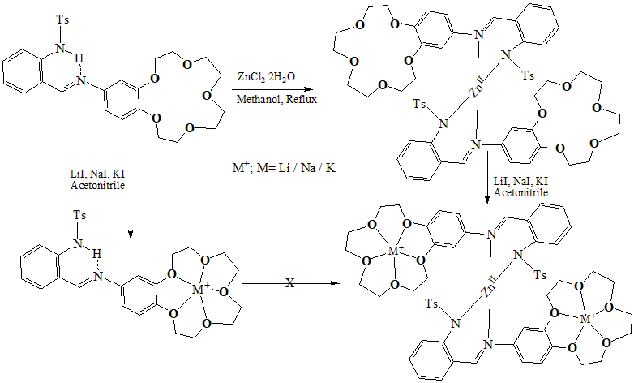
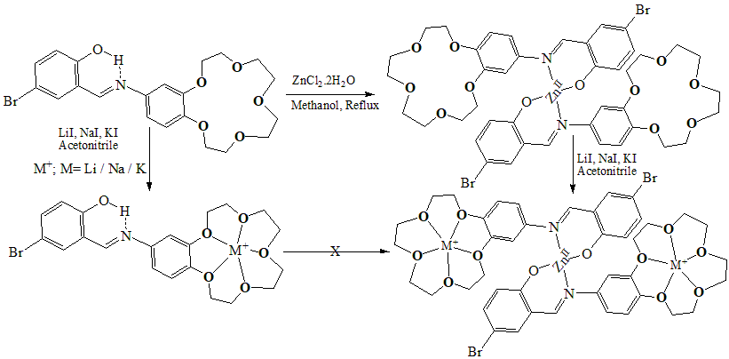
Scheme 5
In the same line, structurally similar kind of ligands [Scheme 6] was synthesized by Zhao et. al.¹³ and fluorescence spectra underwent clear modifications as a result of their coordinations with Na⁺ or/and Zn²⁺. They showed observable fluorosolvatochromism when the solution was switched from ethanol to acetonitrile. The spectral adjustments within those two solvents, one can describe as the AND logic function. Fluorescence spectra alterations were explained by mechanisms called photo-induced electron transfer (PET) and charge transfer transition (CT).
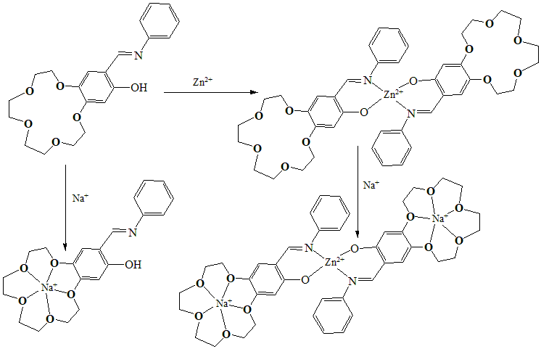
Scheme 6
Similar types of ligands [Scheme 7] were developed by Sadovskaya et. al.¹⁴ and by using spectrophotometry, their complexation with cations of first row transition metals [Cu(II), Zn(II), Fe(III), Co(III), and Ni(II)] was investigated. Further their thermal stability was measured by DTA. Lilac (Ligand 1), violet (Ligand 2), or blue (Ligand 4) were the colours that resulted from adding an aqueous solution of CuCl₂ to solutions of ligands 1-3 in CH₃OH. Additionally, distinct absorption bands at 581, 585, and 592 nm were seen in the electronic spectroscopic analysis. When Ligand-4 and Ligand-5 reacted with Cu(II) salt, there were no noticeable changes in the absorption spectra. Ligands 1 through 5 interacted with Zn²⁺, Co²⁺, Fe³⁺, and Ni²⁺ differently. After adding an equimolar quantity of CH₃OH solutions of Zn²⁺, Co²⁺, Fe³⁺, and Ni²⁺ chlorides to Ligand 1-3's CH₃OH solutions, the colour did not alter much. However, the lone exception is complexation of Ligand 2 with FeCl₃, where the λ_{max} blue shifted by 16 nm.
In order to measure K⁺ using potentiometry, 15-Crown-5 derivatives [Scheme 8], notably anthracene, were utilised as neutral transporters for ion selective electrodes by Bae et. al¹⁵. Among the five ligands, anthracene based derrivatives are found to be the best with respect to stability and selectivity. The response time was likewise quite good, and after three weeks of continuous use, the analytical and selectivity characteristics remained unaltered.

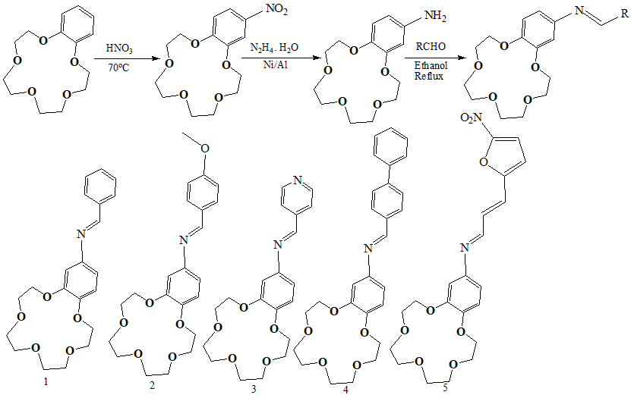
Scheme 7
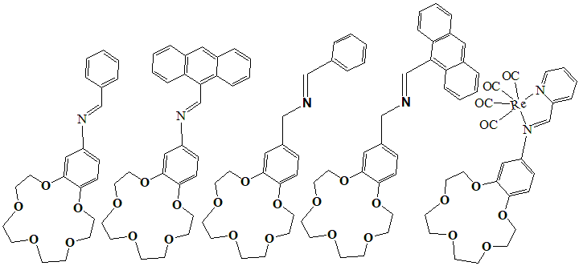
Scheme 8
Scheme 9 shows the fusion of cis-diaminodibenzo-l8-crown-6 and salicylaldehyde resulting in the production of two-arm crown ether, where two cation binding side arms having an imine bond are present. Macrocyclic Schiff base compounds with the transition metal ions [Cu²⁺, Co²⁺, Ni²⁺, and Mn²⁺] had been developed¹⁶, and their coordination tendency had been investigated. The metal complexes were synthesized by refluxing corresponding chlorides with ligands in dioxane. Mass spectroscopy suggested 1:1 metal to ligand attachments for all the isolated complexes irrespective of the metal chloride used during reaction.
There are numerous uses for Schiff bases of 4-antipyrine and related compounds in the fields of biology, medicine, analysis, and pharmacology. 4-Antipyrine based schiff base crown ether was synthesized following the procedure shown in scheme 10 by Zeliha Hayvali¹⁷. An 1:1 [Na+:L; L = ligand] complex has been made. Fe^{II} and Cu^{II} salts reacted with ligand to form the complexes [Fe^{II}LCl₂] and [Cu^{II}L₂Cl₂]. It has also been possible to generate both heteronuclear complexes [Fe^{II}LCl₂Na^{I}](ClO₄) and [Cu^{II}L₂Cl₂Na](ClO₄) by reacting [Fe^{II}LCl₂] and [CuL₂Cl₂] with NaClO₄. Spectroscopic techniques and microanalyses were used to describe the substances.
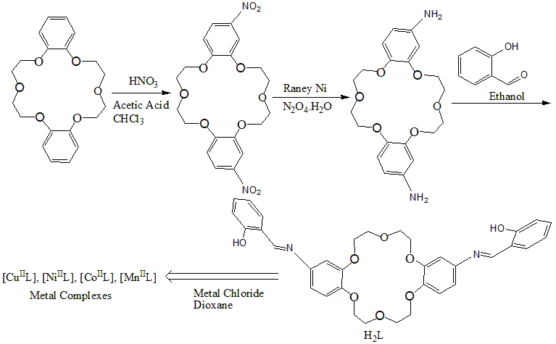
Scheme 9
Hayvali et. al.¹⁸ synthesized a series of Schiff base crown ethers shown in scheme 11. They form complexes with sodium ion in equimolar ratio. Those were characterized in details by spectroscopic technique. Utilizing electronic absorption spectroscopy, tautomeric equilibrium in the macromolecules between phenolimine, O-H-N and keto-amine, O-H-N forms, were thoroughly investigated. Polar, non-polar, acidic, and basic mediums were used to monitor the spectra of the ligands and associated complexes. The Schiff base was seen to undergo tautomeric interconversion into the keto-amine form in solutions of polar solvents.
The same group developed a new chain of similar ligands [Scheme 12]¹⁹. With sodium perchlorate and potassium iodide, respectively, Na⁺ and K⁺ complexes of these ligands were formed. Their synthetic routes are shown in Scheme 12. Spectroscopic investigations were carried out categorically to characterize them. To assess the effectiveness of their extraction in dichloromethane, various main group and first row transition metal picrates [metal ions of sodium (I), potassium (I), lead (II), chromium (III), nickel (II), copper (II), and zinc (II)] were used.
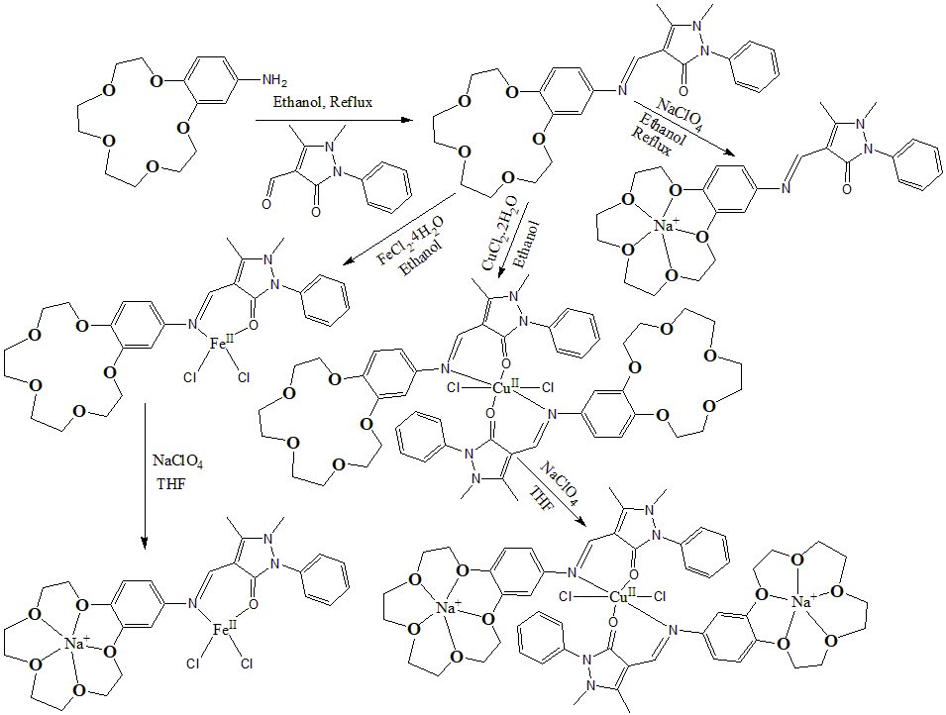
Scheme 10
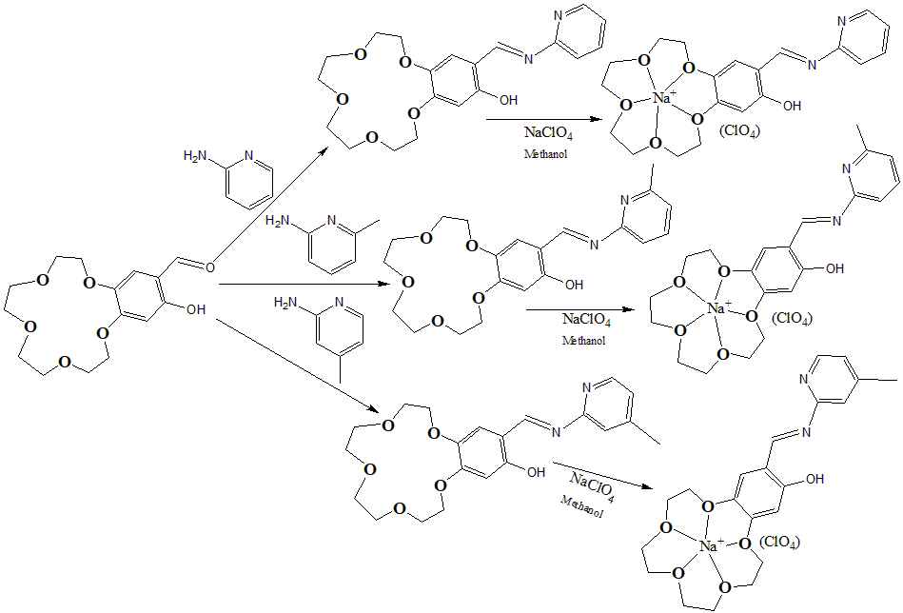
Scheme 11

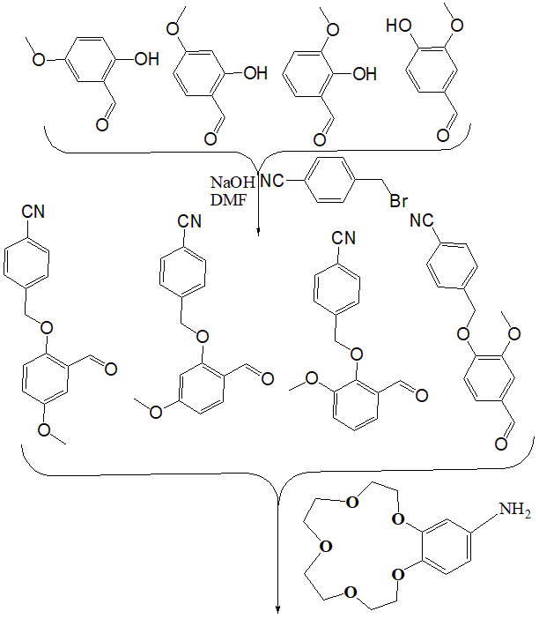
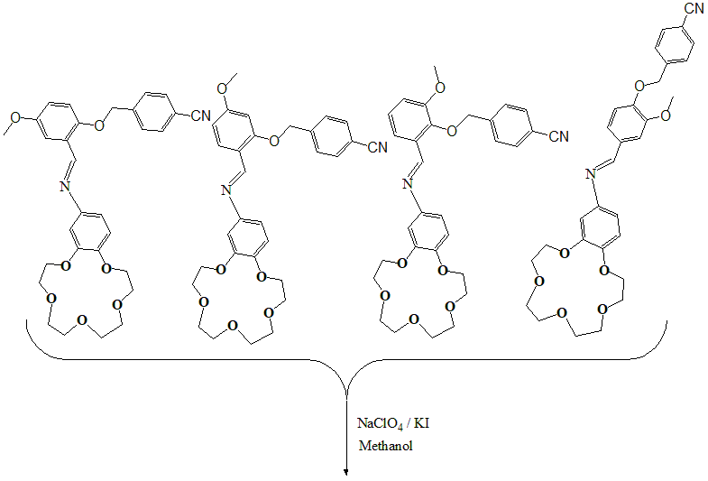
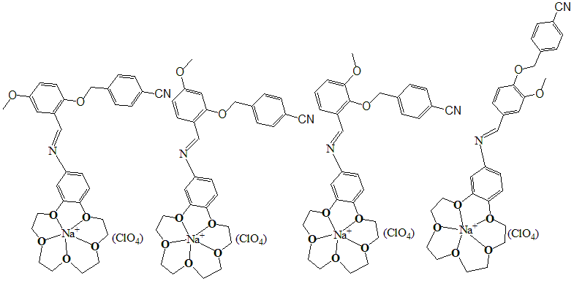
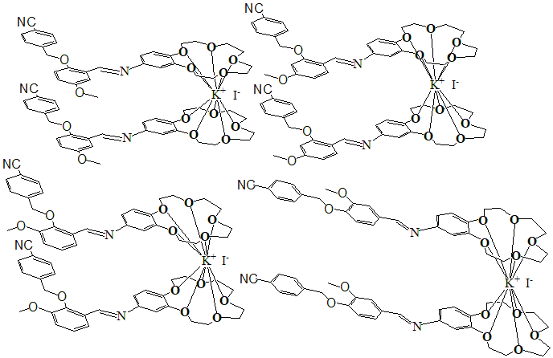
Scheme 12
So far we were emphasizing on mono crown ether based Schiff base ligands. Qin et. al.²⁰ in 2005 reported p-nitrophenyl picolinate (PNPP) hydrolysis by Mn^{III} complexes of both mono and tri crown ether based Schiff base ligands. Their synthesis is displayed in Scheme 13. Investigation was done on the kinetics as well as mechanism of this catalytic hydrolysis. How the ligand architecture, the crown ether rings in compounds, and the temperature range influence the speed of catalytic PNPP hydrolysis, was also studied. These ligands are more reactive than crown ether free similar ligands.
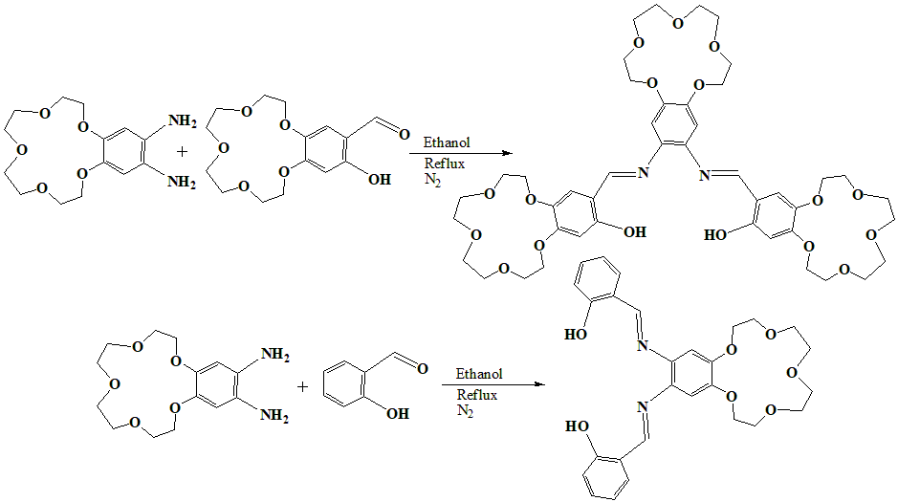
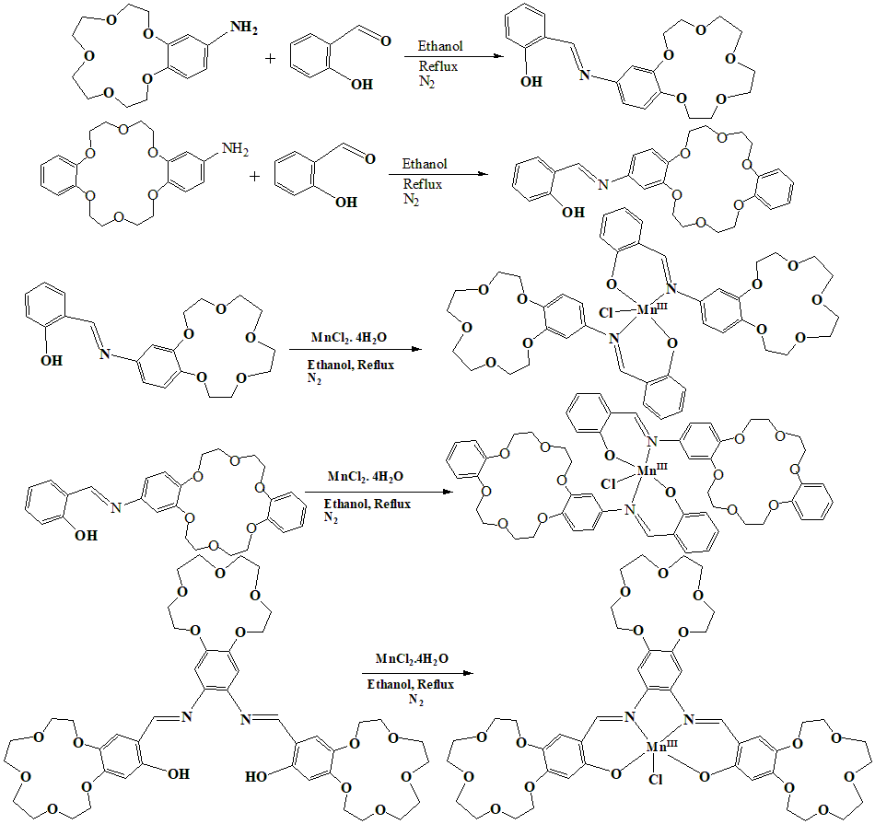
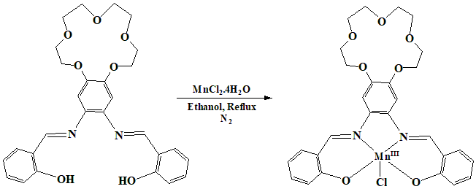
Scheme 13
Scheme 14 can be used to describe the catalytic hydrolysis of PNPP in an aqueous medium of the compounds. With a rise in reaction system’s pH, the k parameter of the PNPP catalytic hydrolysis rises. This suggests that a proton transfer occurs during the step that determines rate of the reaction.
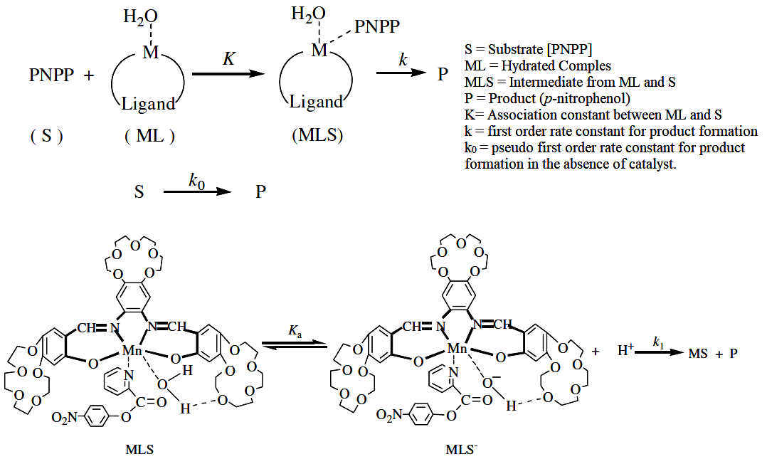
Scheme 14
Scheme 15

In Scheme 15, the hypothesised process for the catalytic hydrolysis of p-nitrophenyl picolinate is shown. The Mn^{III} ion might be coordinated to water, which would cause a hydrated compound to develop in aqueous medium. This hydrated compound might actually be the catalyst for the catalytic hydrolysis of p-nitrophenyl picolinate. Intramolecular hydroxide is produced after the Mn^{III} ion and crown ring work together to activate water linked to the Mn^{III} center. The intermediate MLS is formed when the Mn^{III} ion in the compound coordinates to the nitrogen atom of the pyridine ring in the p-nitrophenyl picolinate moiety. With a first-order rate constant (k), active H₂O attacks the positive carbon centre of the carbonyl group of ester in the p-nitrophenyl picolinate molecule, which is the rds of the overall reaction. This promotes the exit of the generating p-nitrophenol. Picolinic acid molecule that was bound to the Mn^{III} ion is freed, and water quickly bonds back to the Mn^{III} ion.
Now our focus will be on bis-crown ether based Schiff based ligands. Sandaroos et. al. synthesized a series these type of ligands²¹. Their Mn^{III} complexes were synthesized, which can act as catalysts [Scheme 16]. Cyclohexene and cyclooctene were oxidised in biphasic water/chloroform medium at normal temperature and pressure, using a mixture of oxone [Potassium peroxymonosulfate, KHSO₅] and these metal complexes. Investigations were also conducted into how temperature, axial pyridine base, and other Group I metal salts affected reaction timings and chemical yields. Only a very little quantity of epoxide was produced by the non-catalytic system, which is likely a result of oxone's poor solubility in the organic layer.
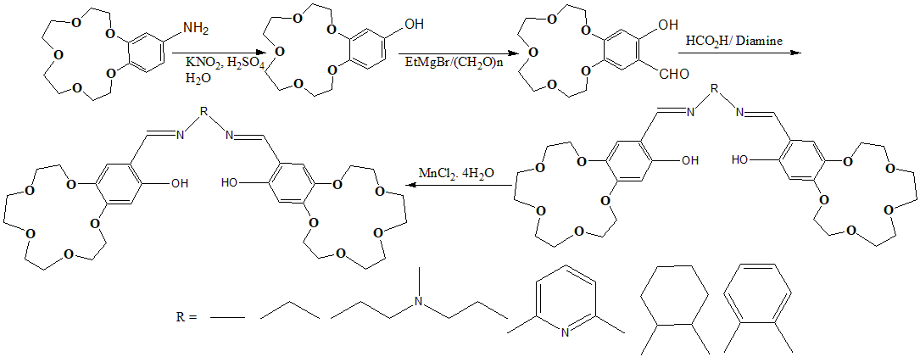
Scheme 16
Fernandez et. al. synthesized bis-crown ether based bis-schiff base ligand²² by reaction between terephthalaldehyde and 4’-aminobenzo-15-crown-5 in CHCl₃. This ligand forms a novel doubly cyclometalated acetato-bridged compound when it reacts with Pd(OAc)₂ in dry CHCl₃ at 50ºC. The doubly cyclometalated chloro- and bromo-bridged complexes were generated through reaction with [tBu₄N]Cl and [tBu₄N]Br. To avoid binding of the cation to the crown ether core, bulky [tBu₄N]⁺ rather than sodium chloride was utilised in the metathesis procedure. Reaction of doubly cyclometalated chloro-bridged complex with thallium acetylacetonate in acetone, produces acac coordinated discrete dimeric complex, which has better solubility than all the previous polymeric molecules. After the breaking of chloro-bridged linkages and generation of two new Pd-P bonds for each molecule, the reaction of the doubly cyclometalated chloro-bridged complex with the tertiary monophosphines PPh₃ and P(p-OMeC₆H₄)₃ [molar ratio; Pd atom: phosphine =1:1] results in discrete dimeric products [Scheme 17].
Further reactivity of doubly cyclometalated chloro-bridged towards diphosphines was studied [Scheme 18]. Using bis(diphenylphosphino)methane (dppm) in 2:1 molar ratio between the Pd atom and diphosphine, complexes in which the latter act as bridging ligands between two cyclometalated fragments, was formed. But in a 1:1 palladium to diphosphine molar ratio, interaction with bis(diphenylphosphino) methane [dppm] or 1,2-bis(diphenylphosphino) ethane [dppe], produced dinuclear cyclometalated products with two chelated phosphine ligands and two chloride counteranions. Dimeric cyclometalated complexes with the diphosphines acting as chelating ligands were generated by reaction with 1,4-bis(diphenylphosphino)butane (dppb), 1,5-bis(diphenylphosphino)pentane (dpppe), or 1,6-bis(diphenylphosphino)hexane (dpph). All these metal complexes were characterized by different spectroscopic techniques.
Series of polymeric crown ether Schiff base ligand²³ was also reported [Scheme 19], where each monomeric unit has only one crown ether moiety. This type of ligand system was synthesized using normal condensation route in DMF solution. TGA and DTA were used to study their thermal characteristics in greater detail.

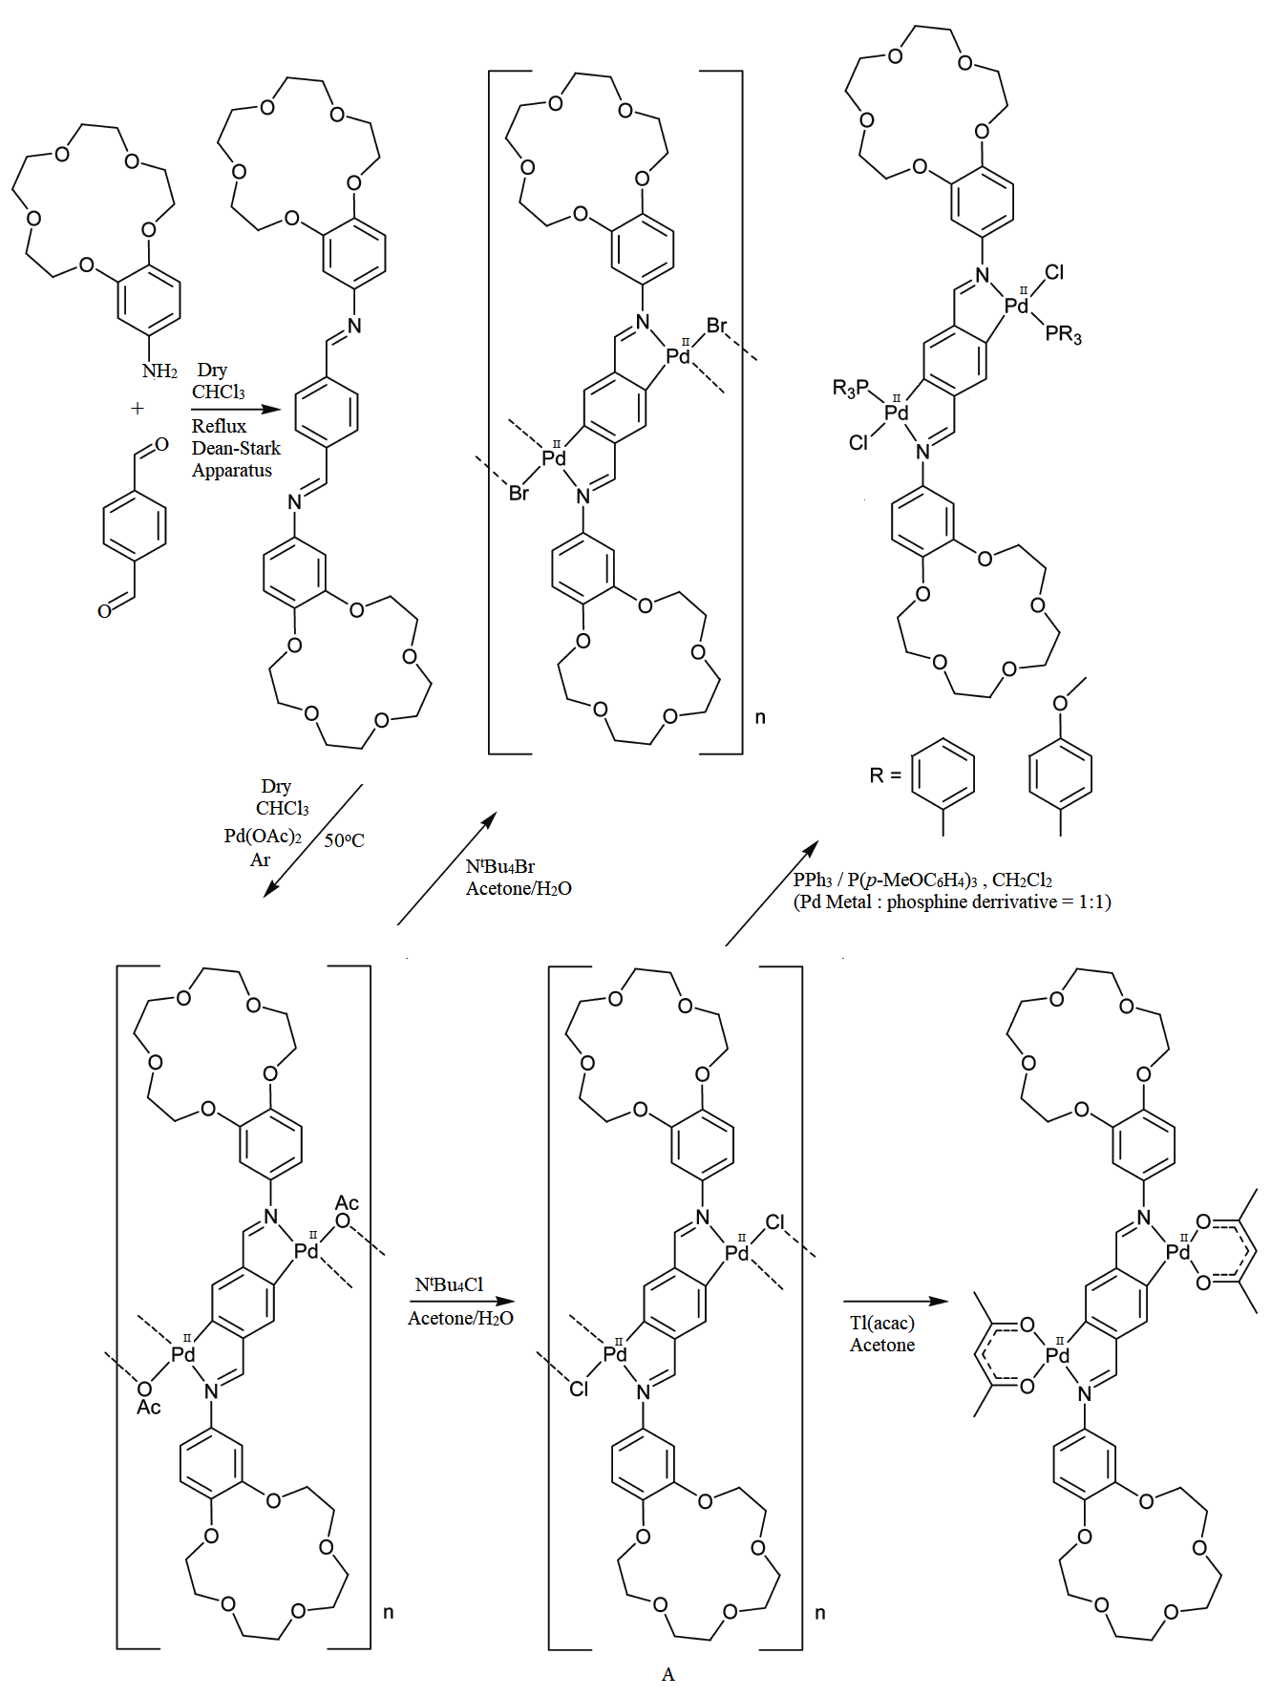
Scheme 17

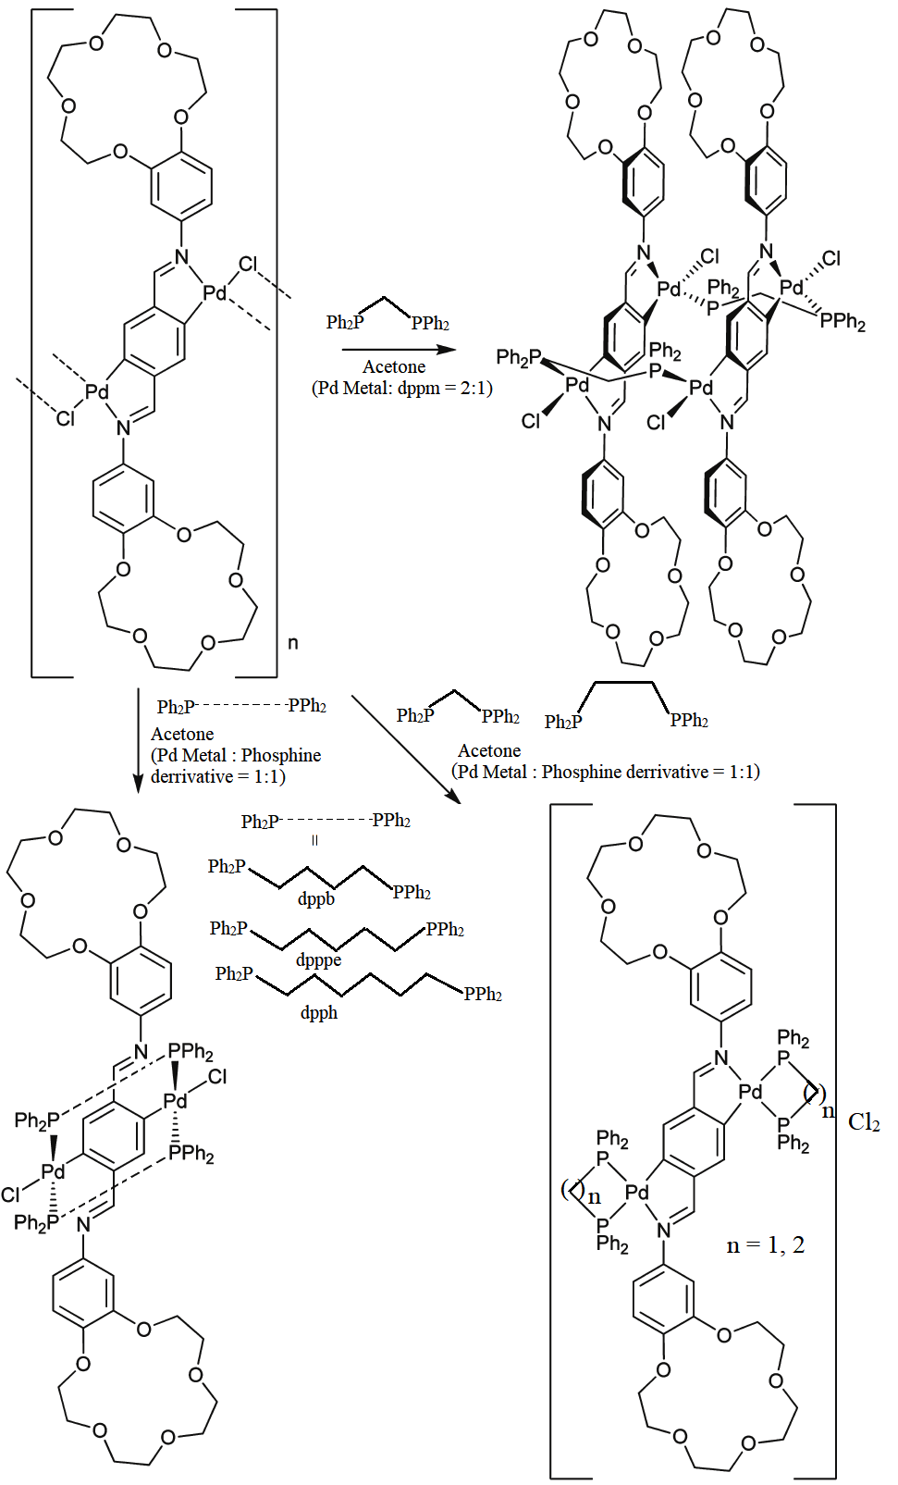
Scheme 18

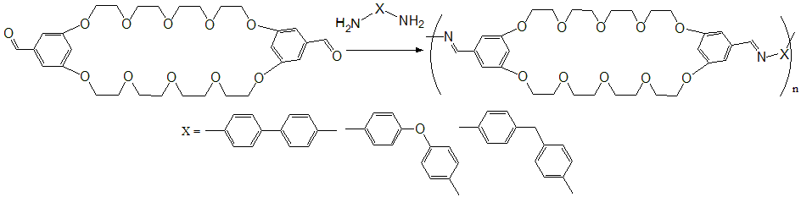
Scheme 19
By cyclotetramerizing the newly synthesised dicyano macrocycle in the presence of suitable metal salts in non-aqueous medium, a unique soluble metallophthalocyanine analogue containing 14-membered [1,4,8,11] diazadithia-macrocycles attached to a 15-membered crown-ether was created by bekaroglu et. al²⁴. It is symmetrical in structure and has overall four crown ether moieties in the molecular frame work. In nonpolar media, the N-tosylated compounds are very soluble. Less soluble compounds were produced as a result of the interaction between the complex's crown-ether groups and the group I metal salts. Chloroform solution of this nickel phthalocyanine and ethanolic solution of potassium thiocyanate [KSCN] was heated to generate the alkami metal aduct. The Schmetic represenations are shown in Scheme 20. By solvent extracting alkali metal picrates, the nickel phthalocyanine's alkali metal binding capacity was calculated. Of all the alkali metal ions, potassium's highest sensitivity was found.
Lastly, an interesting ligand sytem will be discussed, which is exactly not a crown ether but it has flexible polyoxyethylene chain of variable sizes and Schiff bases inside the same frame work. This redox-active ionophore has electrochemical recognition catability²⁵. Group I and Group II metal cations, as well as NH₄⁺, are electrochemically recognised by macrocyclic redox ionophores made by linking a Schiff base with a polyoxyethylene network. This behaviour was monitored by cyclic voltammetry. These ionophores have two distinct complexing cavities. Increasing concentrations of Gorup I or Group II metal cations have a significant impact on the cathodic response of the receptors with Ni(II) and Cu(II). Appearance of new signal/ gradual redox potential shift upon complexation of Group I and Group II metal ions with the crown ether-like part was highlighted in details. The inclusion of an Group I and Group II metal cations significantly increases the solubility of the receptors with Ni(II) and Cu(II) in acetonitrile, testifying to the development of complexes between the receptors and these guest metal cations. This type of aduct formation was further confirmed by electronic absorption spectroscopy and mass spectroscopy. The reaction scheme is displayed in Scheme 21. The same group also reported one such similar type of work with similar framework sytem²⁶.
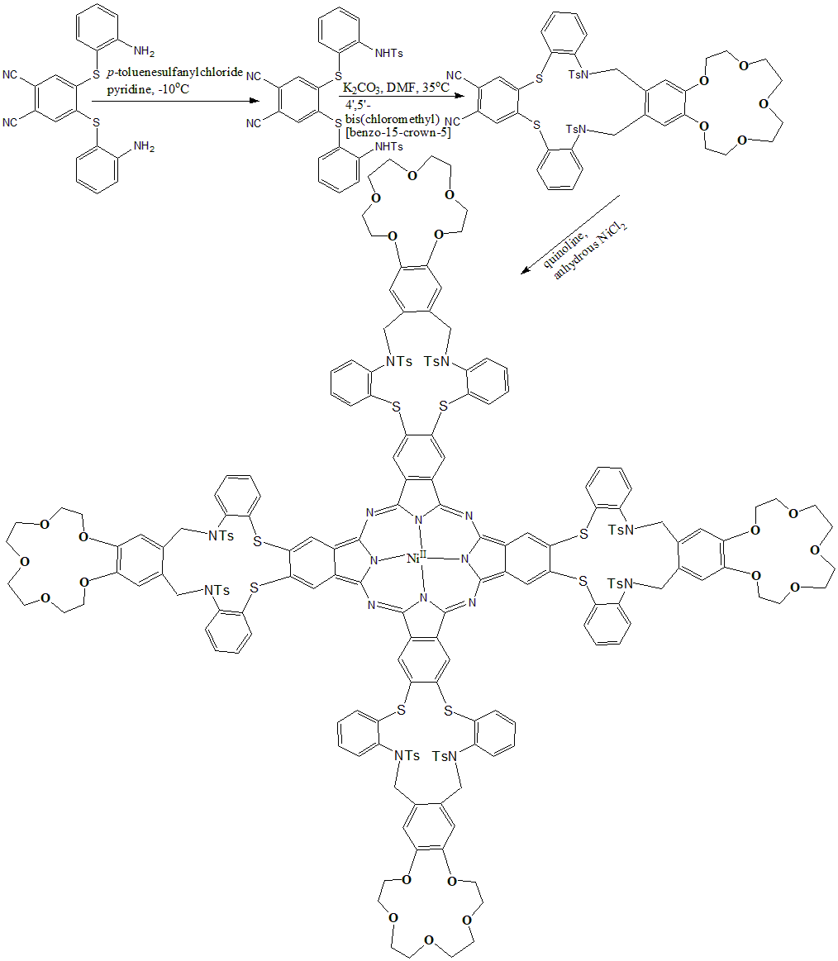
Scheme 20
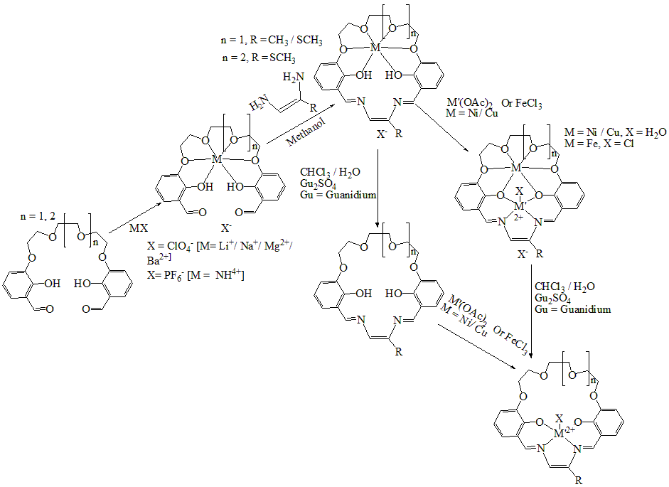
Scheme 21
Conclusion:
Researchers worldwide are interested in functionalizing simple crown ethers for their multifaceted importance. These functionalized crown ethers has better ion binding capacity, sensitivity and selectivity, than original crown ether. In this chapter general synthetic pathways of of mono-, bis- and multi- crown ether schiff base ligands and their metal complexes were discussed categorically. Catalytic activity of few such complexes was highlighted. These complexes show better catalytic activity than their corresponding schiff base complexes.
Reference:

C. J. Pedersen, “Cyclic polyethers and their complexes with metal salts”, J. Am. Chem. Soc., Vol. 89, pp. 7017–7036, 1967.

(a) K Kimura E. Hayata and T. Shono, “Convenient, efficient crown ether-containing stationary phases for chromatographic separation of alkali metal ions: dynamic coating of highly lipophilic crown ethers on octadecylsilanized silica”, J. Chem. Soc., Chem. Commun., Issue 5, pp. 271-272, 1984. (b) T. Imato, M. Katahira and N. Ishibashi, “Effects of concentration of neutral carrier and addition of organophosphorus compounds on alkali metal ion-selectivity of the dibenzo-14-crown-4 liquid-membrane electrode”, Anal Chim Acta, Vol. 165, pp. 285-289, 1984. (c) T. Shono, M. Okahara, I. Ikeda, K. Kimura and H. Tamura, “Sodium-selective PVC membrane electrodes based on bis(12-crowns-4)s”, J. Electroanal. Chem., Vol. 132, pp. 99-105, 1982. (d) H. Nakamura, M. Takagi and K. Ueno, “Sodium-selective PVC membrane electrodes based on bis(12-crowns-4)s”, Anal. Chem., Vol. 52, pp. 1668-1671, 1980. (e) H. Nishida, M. Tazaki, M. Takagi and K Ueno, “Photometric reagents based on crown ether complex formation. VII”, Mikrochim Acta., Vol. 75, pp. 281-287, 1981. (f) F. Hu and T. Song, “Application of functionalized ether in lithium ion batteries”, RSC Adv., Vol. 7, pp. 54203-54212, 2017. (g) S. D. Jagadale, A. M. Teli, S. V. Kalake, A. D. Sawant, A. A. Yadav and P. S. Patil, “Functionalized crown ether assisted morphological tuning of CuO nanosheets for electrochemical supercapacitors”, J. Electroanal. Chem., Vol. 816, pp. 99-106, 2008. (h) M. G. Mohamed and S. -W. Kuo, “Crown Ether-Functionalized Polybenzoxazine for Metal Ion Adsorption”, Macromolecules, Vol. 53, pp. 2420–2429, 2020.

(a) R. Schettini, M. Sicignano, F. De Riccardis, I. Izzo and G. Della Sala, “Macrocyclic Hosts in Asymmetric Phase-Transfer Catalyzed Reactions”, Synthesis, Vol. 50(24), pp. 4777–4795, 2018. (b) S. -P. Zheng, L. -B. Huang, Z. Sun and M. Barboiu, “Self-Assembled Artificial Ion-Channels toward Natural Selection of Functions”, Angew. Chem., Int. Ed., Vol. 60, pp. 566–597, 2021. (c) S. J. Loeb and J. A. Wisner, “A New Motif for the Self-Assembly of [2]Pseudorotaxanes; 1,2-Bis(pyridinium)ethane Axles and [24]Crown-8 Ether Wheels”, Angew. Chem., Int. Ed., Vol. 37, pp. 2838–2840, 1998. (d) E. Ishow, A. Credi, V. Balzani, F. Spadola and L. Mandolini, “A Molecular-Level Plug/Socket System: Electronic Energy Transfer from a Binaphthyl Unit Incorporated into a Crown Ether to an Anthracenyl Unit Linked to an Ammonium Ion”, Chem. Eur. J., Vol. 5, pp. 984–989, 1999. (e) R. M. Izatt, J. D. Lamb, N. E. Izatt, B. E. Rossiter, Jr., J. J. Christensen and B. L. Haymore, “A calorimetric titration study of the reaction of several organic ammonium cations with 18-crown-6 in methanol”, J. Am. Chem. Soc., Vol. 101, pp. 6273–6276, 1979.

(a) S. A. Girard, T. Knauber and C.-J. Li, “The Cross-Dehydrogenative Coupling of C_{sp}³-H Bonds: A Versatile Strategy for C-C Bond Formations”, Angew. Chem., Int. Ed., 2014 Vol. 53, pp. 74–100, 2014. (b) R. Beniazza, B. Abadie, L. Remisse, D. Jardel, D. Lastécouères and J.-M. Vincent, “Light-promoted metal-free cross dehydrogenative couplings on ethers mediated by NFSI: reactivity and mechanistic studies”, Chem. Commun., Vol. 53, pp. 12708–12711, 2017. (c) F. Risi, A.-M. Alstanei, E. Volanschi, M. Carles, L. Piazzala and J.-P. Aycard, “Photoaddition of Aliphatic Ethers to 4-Methyl-1,2,4-triazoline-3,5-dione: Application to the Synthesis of Functionalized Crown Ethers and Mechanism”, Eur. J. Org. Chem., Issue 4, pp. 617–626, 2000. (d) Y. Nakamura, A. Asami, T. Ogawa, S. Inokuma and J. Nishimura, “Regioselective Synthesis and Properties of Novel [60]Fullerene Bisadducts Containing a Dibenzocrown Ether Moiety”, J. Am. Chem. Soc., Vol. 124, pp. 4329–4335, 2002. (e) J. D. Pike, D. T. Rosa and D. Coucouvanis, “Lipophilic Metal-Salicylideneimine-Crown Ether Hybrids-Ditopic Carriers in the Facilitated Transport of Amphiphilic Molecules Across Bulk Liquid Membranes”, Eur. J. Inorg. Chem., Issue 3, pp. 761–777, 2001. (f) N. Z. Saifullina and A. K. Tashmukhamedova, “Acylation of Dibenzo-18-crown-6 with Alkali-metal Acetates in Polyphosphoric Acid”, Chem. Heterocycl. Compd., Vol. 41, pp. 973–976, 2001. (g) A. D. Grebenyuk, L. V. Zotova and A. K. Tashmukhamedova, “Sulfonation of Benzocrown Ethers by Potassium Sulfate in Polyphosphoric Acid”, Chem. Heterocycl. Compd., Vol. 37, pp. 822–826, 2001.

(a) Z. Cimernan, N. Galic and B. Bosner, “The Schiff bases of salicylaldehyde and aminopyridines as highly sensitive analytical reagents”, Anal. Chim. Acta, Vol. 343, pp. 145-153, 1997. (b) S. Yamada, “Advancement in stereochemical aspects of Schiff base metal complexes”, Coord. Chem. Rev., Vol. 190, pp. 537-555, 1999. (c) M. -G. Xie, M. -S. Peng, Q. Jiang, Z. -L. Hu and X. -L. Wang, “Synthesis of Schiff's base and azo liquid crystalline crown ethers”, Liq. Cryst., Vol. 21, pp. 461-467, 1996. (d) T. Panniyamurthy, B. Bhatia, M.M. Reddy, G.C. Maikap and J. Iqbal, “A versatile cobalt(II)-Schiff base catalyzed oxidation of organic substrates with dioxygen: Scope and mechanism”, Tetrahedron, Vol. 53, pp. 7649-7670, 1997. (e) N. Kim and J. Suh, “Artificial Metallophosphoesterases Built on Poly(ethylenimine)”, J. Org. Chem., Vol. 59, pp. 1561-1571, 1994. (f) D. Chen, A.E. Martell and Y. Sun, “New synthetic cobalt Schiff base complexes as oxygen carriers”, Inorg. Chem., Vol. 28, pp. 2647-2652, 1989.

(a) N. Raman, A. Kulandaisamy, A. Shunmugasundaran, and K. Jeyasubramanian, “Synthesis, spectral, redox and antimicrobial activities of Schiff base complexes derived from 1-phenyl-2,3-dimethyl-4-aminopyrazol-5-one and acetoacetanilide”, Transit Met Chem., Vol. 26, pp. 131-135, 2001. (b) K. Z. Ismail, “Synthesis, spectral, redox and antimicrobial activities of Schiff base complexes derived from 1-phenyl-2,3-dimethyl-4-aminopyrazol-5-one and acetoacetanilide”, Transit Met Chem., Vol. 25, 522-528, 2000. (c) N. Raman, A. Kulandaisamy, C. Thangarajan, P. Manisankar, S. Viswanathan and C. Vedhi, Transit Met Chem., Vol. 29, 129-135, 2004.

R. A. Agarwal, L. Singh and D. K. Sharma, “Synthesis, Biological, Spectral, and Thermal Investigations of Cobalt(II) and Nickel(II) Complexes of N-Isonicotinamido-2′,4′-Dichlorobenzalaldimine”, Bioinorg, Chem Appl., Vol. 1, pp. 135, 2006.

D. A. Safin, K. Robeyns and Y. Garcia, “Crown ether-containing N-salicylidene aniline derivatives: synthesis, characterization and optical properties”, Cryst Eng Comm., Vol. 14, pp. 5523-5529, 2012.

D. A. Safin, M. G. Babashkina and Y. Garcia, “Crown ether-containing Schiff base as a highly efficient “turn-on” fluorescent sensor for determination and separation of Zn²⁺ in water”, Dalton Trans., Vol. 42, pp. 1969-1972, 2013.

C. Sousa, P. Gamerio, C. Freire and B. De Castro, “Nickel(II) and copper(II) Schiff base complexes bearing benzo-15-crown-5 functionalities as probes for spectroscopic recognition of lanthanide ions”, Polyhedron., Vol. 23, pp. 1401-1408, 2004.

V. B. Parikh And S. K. Menon, “Synthesis and Mesomorphic Properties of Novel Crown Ether Schiff Bases”, Mol. Cryst., Vol. 482, pp. 71-83, 2008.

A. S. Burlov, A. V. Tsukanov, G. S. Borodkin, V. RevinskiiYu. A. D. Dubonosov, V. A. Bren, A. D. Garnovskii, A. Y. Tsivadze and V. I. Minkin, “Complexing properties of ambidentate benzo-15-crown-5-substituted azomethine ligands”, Russ. J. Gen. Chem., Vol. 76(6), 992-996, 2006.

L. Zhao, X. Chen, F. Guo, B. Gou, C. Yang and W. Xia, “Complexing properties of ambidentate benzo-15-crown-5-substituted azomethine ligands”, J. Lumin., Vol. 145, pp. 486-491, 2014.

N. Yu. Sadovskaya, V. N. Glushko, V. M. Retivov, S. K. Belus and V. V. Grokhovskii, “Synthesis and properties of macroheterocyclic azomethines based on 4-aminobenzo-15-crown-5”, Russ. J. Gen. Chem., Vol. 85(12), pp. 2771–2777, 2015.

Z. -U. Bae, S. -B. Lee, S. -H. Chang and U. -R. Kim, “Potentiometric Determination of Potassium Ion Using 15-Crown-5 Derivatives with Anthracene for the Ion Selective Material”, J. Kor. Chem. Soc., Vol. 45(1), pp. 31-39, 2001.

S. K. Jogani, S. K. Menon and Y. K. Agrawal, “Synthesis and Characterization of a Crown Ether Schiff Base and its Reactivity with Metal Ions”, Synth. React. Inorg. Met.-Org. Chem, Vol. 30(7), pp. 1317-1329, 2000.

Z. Hayvali, “Preparation and spectroscopic characterization of iron(II) and copper(II) complexes of a functionalized crown ether”, Transition Met. Chem., Vol. 34, pp. 97-101, 2009.

Z. Hayvali, M. Hayvali, Z. Kilic, T. Hökelek and E. Weber, “New Benzo-15-Crown-5 Ethers Featuring Salicylic Schiff Base Substitutions – Synthesis, Complexes and Structural Study”, J. Incl. Phenom. Macrocycl. Chem., Vol. 45, pp. 285–294, 2003.

H. Güler, Z. Hayvali, H. Dal and T. Hökelek, “Syntheses, spectroscopic and structural characterizations and metal ion binding properties of Schiff bases derived from 4′-aminobenzo-15-crown-5”, Polyhedron, Vol. 31, pp. 688-696, 2012.

J. Z. Li; B. Xu, S. -X. Li and S. –Y. Qin, “PNPP Hydrolysis Catalyzed by Manganese(III) Complexes with Crowned Salicylaldimine Schiff Base Ligand”, Transit. Met. Chem., Vol. 30, pp. 669-676, 2005.

S. M. Seyedi, G. H. Zohuri and R. Sandaroos, “Synthesis and application of new Schiff base Mn(III) complexes containing crown ether rings as catalysts for oxidation of cyclohexene and cyclooctene by Oxone”, Supramol. Chem., Vol. 23(7), pp. 509–517, 2011.

A. Fernandz, M. Lopez-Torres, S. Castro-Juiz, M. Merino, D. Vazquez-Garcia, J. M. Vila and J. J. Fernandez, “Dimetalated Crown Ether Schiff Base Palladacycles. Influence of the Carbon Chain Length on the Coordination Mode of Bidentate Phosphines. Crystal and Molecular Structure of the Novel Complex [Pd₂{1,4-[C(H)═N{9,10-(C₈H₁₆O₅)C₆H₃}]₂C₆H₂-C2,C5}(Cl)₂{μ-Ph₂P(CH₂)₅PPh₂}₂]”, Organometallics., Vol. 30, pp. 386–395, 2011.

P. K. Dutta, “Synthesis and characterization of new polycrown ether (schiff base)”, Indian J. Chem. Technol., Vol. 8, pp. 515-517, 2001.

M. Kandaz, I. Yılmaz and O. Bekaroglu, “Synthesis and characterization of novel symmetrical phthalocyanines substituted with mono- or bi-macrocycles”, Polyhedron, Vol. 19, pp. 115-121, 2000.

J. -C. Moutet, E. Saint-Aman, E. -M. Ungureanu, V. Arion, N. Gerbeleu, M. Revenco, “Heterodinucleating macrocyclic compounds designed for electrochemical recognition”, Electrochim. Acta., Vol. 46, pp. 2733-2740, 2001.

V. Arion, M. Revenco, J. Gradinaru, Y. Simonov, V. Kravtsov, N. Gerbeleu, E. Saint-Aman and F. Adams, “Mixed macrocyclic coordination compounds containing thiosemicarbazide and crown-ether moieties (synthesis, structure and properties)”, Rev. Inorg. Chem., Vol. 21, pp. 1–42, 2001.

