Difference In Palmprint Ridge Density of Males and Females

Sibin Benzen , Assistant Professor

Department of Forensic Science,

School Of Allied Health Sciences,

Vinayaka Mission Research Foundation (Deemed to be University)

AVMC&H Campus, Puducherry

ABSTRACT
The aim of this work was to investigate the difference in male and female palm brush viscosity as a system for sex detection. Four eminence regions were anatomized on victory tracks, which included the middle eminence, then the eminence (P1), the hypothenar region; in proximal axial triradius (P2), medium size position; triradius proximal and lateral attachment of the replacement site (P3); proximal to the triradius of the fifth digit (P4). The average gain print viscosity was significantly higher in women than in men in all marked areas of both hands, except for the P3 area of ​​the right hand. Statistically significant differences in the brush viscosity of the victory print were observed between the different victory areas of right- and left-handed men and women. For women, only in P3 and P4 areas differences were observed. Win print brush viscosity is a sexually dimorphic variable; its mileage for evaluating the ratio in forensic detection may be limited due to significant overlap of values. In addition, brush viscosity can be considered a morphological point of individual variation.
Keywords: Palmprint, Ridge Density, Thenar, Hypothenar, Medial Mount, Lateral Mount

- INTRODUCTION
The area between the wrist and the finger is called the palm, and the mark left by the friction stripes on the palm is called the palm impression. Palmprint recovery is an important forensic technique. Moisture and grease in the palm cause palm prints on glass or metal surfaces, for example. Human palm prints have many unique and stable characteristics [1]. The main features of a palm print are top lines, folds, edges, individual dots and branching dots. Palmprints are rich in physical features of skin patterns, such as lines, dots, and textures, which provide stable and distinguishable information sufficient to distinguish an individual from a large population. In addition, Death Victory prints also have many textural features, including brush tip and brush bifurcation. In addition, it has several functions: videlicet figure point, Delta point, upper line function and finally fold function. All these features are distinguished by different styles. Palmprint differs from a few points in that it also includes details that can be used to compare wins, such as texture, hacks and marks. The difference is the raised area of ​​the epidermis on the fingers (brown and toe), hand or sole, which consists of one or more interconnected ridges of dermis. The skin appears wavy and the raised edges are divided into the lower wrinkles. In other words, this skin is not flat and smooth like other skins. disunion ridge skin is somewhat elastic in nature and helps to grasp objects and shells. Parting brushes are formed in the womb in the fourth month of fetal development and remain unchanged and absolute throughout a person's life, rotting only after death. These unique factors make the separating brush skin ideal for use in special detection
- HISTORY OF PALMPRINT
Since decayed brush skin was considered valuable and reliable for special identification, various people began to develop systems to retrieve and also organize these prints. Faults originally used the printer's essay to fingerprint his subjects. At the beginning of the 20th century, the American chemist John A Dondero (1900-1957) developed new printing inks, including special ones for printing essays. Edward Henry developed a system to classify and form mass scorecards with the support of two Indian civic maps. This system is the one that Ferrier participated in and is still known as the Henry system. With the introduction of automatic identification systems, the use of the Henry system declined Since decayed brush skin was considered valuable and reliable for special identification, various people began to develop systems to retrieve and also organize these prints. Faults originally used the printer's essay to fingerprint his subjects. At the beginning of the 20th century, the American chemist John A Dondero (1900-1957) developed new printing inks, including special ones for printing essays. Edward Henry developed a system to classify and form mass scorecards with the support of two Indian civic maps. This system is the one that Ferrier participated in and is still known as the Henry system. With the introduction of automatic identification systems, the use of the Henry system declined.
- COLLECTION PROCEDURE
Healthy subjects progressing 20-60 times were included in the study after informed consent. Black duplicating ink was uniformly applied on a clean glass plate using a roller. Subjects were asked to place their hands on the glass plate and regular pressure was applied to achieve winning results.[1] Palm prints were obtained from both the right and left hands. Samples are collected using various collection tools, e.g
      - Duplicating ink ( Black)
      - Ink roller
      - Inking glass plate
      - Ink cleaning supplies
      - Palm print cards for recording the prints
      - Rulers, Markers and Magnifying lens
      - Transparent OHP sheet

- ANALYSIS OF PALM PRINT

Palm impressions were taken on paper where the sample was also cut using a hand lens and a 5 mm × 5 mm (0.5 cm) transparent OHP spacer. A transparent OHP spacer was placed over the anatomical area defined in the gain print sample. A count was made across the entire front yard to measure brush viscosity or the number of brushes given. Bands were counted with a hand lens. (2) This value represents the number of edges in a 25 mm square area and reflects the brush density value. also the brush viscosity of the four eminences was anatomized on gain prints that included the central eminence, then the eminence (P1), the hypothenar region; in proximal axial triradius (P2), medium size position; triradius proximal and lateral attachment of the replacement site (P3); Proximal trigeminal data from the fifth digit (P4) were recorded, fully sequenced and statistically distributed.[3][4]

CONCLUSION
Palm prints play an important role in determining the gender of an individual. Indeed, large differences in the viscosity of a winning print brush can be valuable for identifying severed hands in medico-legal investigations to establish personal identity in mass-disaster mass murders.[5] In this environment, the viscosity ratio of the fingerprint to windmark brush comes into play. Despite its reputation as an infallible means of identification. It has significant limitations for forensic identification. The brush pattern of the palm print develops during pregnancy and remains unchanged until death, when it changes as a result of decomposition. Gender identification is crucial in forensic science. A criminal can be identified using palm print analysis. Crime scene prints are matched to suspects to confirm their involvement in the crime.[6][7][8] This study was conducted to investigate the difference in palm print brush viscosity between men and women, and it was able to determine that women tend to have higher brush viscosity than men. In women, the viscosity of the brush progressed in both the right and left arms, except in the mid-attachment area (P3). It is evident that there is a statistically significant difference in palmar brush viscosity between different regions of the right and left hands of men and women. Therefore, it is concluded that the viscosity of the palm is an elegant parameter for gender identification. This study would help determine gender in most cases where palm prints are placed and other evidence is destroyed or insufficient for identification.[6][7][8]

APPENDIX

Male Palmprint Sample
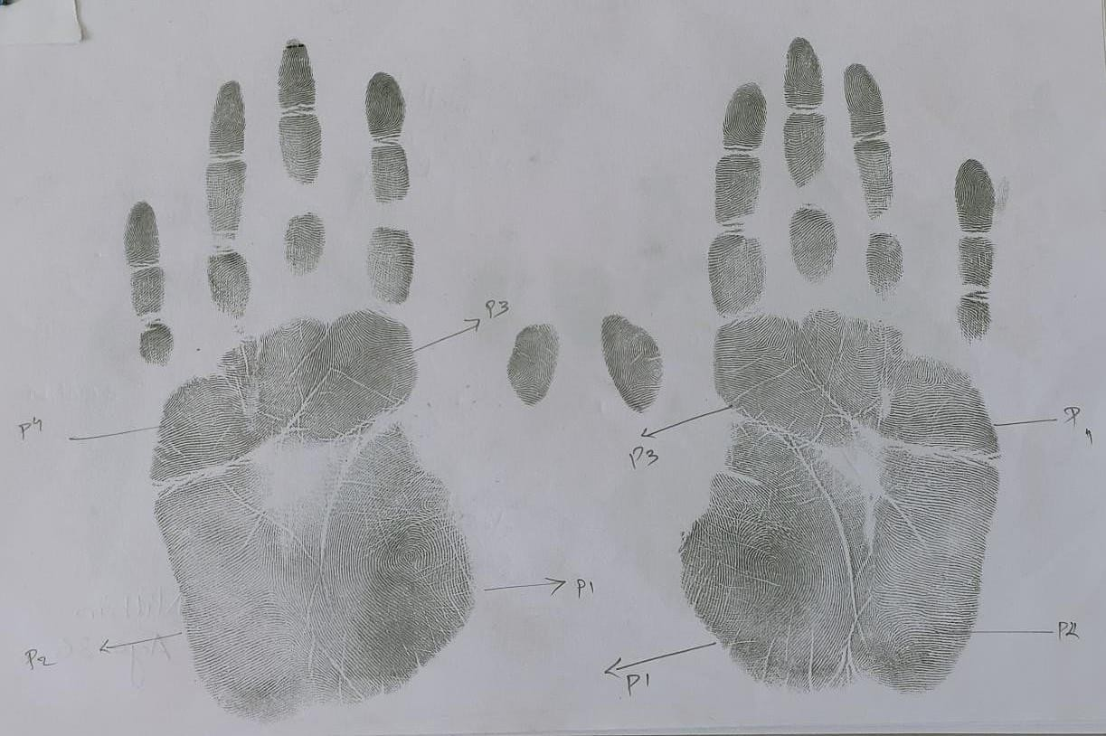
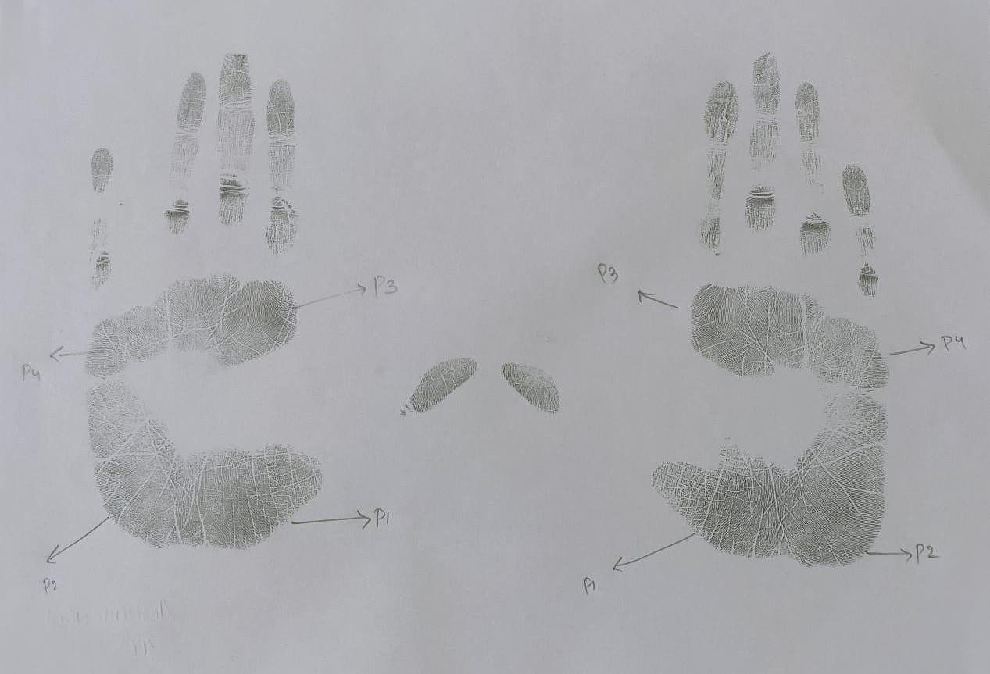

Female Palmprint Sample

REFERENCES

Fathelrahman Idris Ali, Altayeb Abdalla Ahmed, Sexual and topological variability in palmprint ridge density in a sample of Sudanese population, Forensic Science International: Reports, Volume 2, 2020, 100151, ISSN 2665-9107, https://doi.org/10.1016/j.fsir.2020.100151
- Yaacob, R., Hadi, H., Ibrahim, H. et al. Evaluating the potential application of palmprint creases density for sex determination: an exploratory study. Egypt J Forensic Sci 12, 26 (2022). https://doi.org/10.1186/s41935-022-00282-6
- Badiye, Ashish & Kapoor, Neeti & Mishra, Swati. (2019). A novel approach for Sex determination using palmar tri-radii: A pilot study.. Journal of Forensic and Legal Medicine. 65. 10.1016/j.jflm.2019.04.005
- Gornale, S.S., Patil, A., Hangarge, M., Pardesi, R. (2019). Automatic Human Gender Identification Using Palmprint. In: Luhach, A.K., Hawari, K.B.G., Mihai, I.C., Hsiung, PA., Mishra, R.B. (eds) Smart Computational Strategies: Theoretical and Practical Aspects. Springer, Singapore. https://doi.org/10.1007/978-981-13-6295-85

Sánchez-Andrés A, Barea JA, Rivaldería N, Alonso-Rodríguez C, Gutiérrez-Redomero E. Impact of aging on fingerprint ridge density: Anthropometry and forensic implications in sex inference. Sci Justice. 2018 Sep;58(5):323-334. doi: 10.1016/j.scijus.2018.05.001. Epub 2018 May 3. PMID: 30193658

Taduran RJ, Tadeo AK, Escalona NA, Townsend GC. Sex determination from fingerprint ridge density and white line counts in Filipinos. Homo. 2016 Apr;67(2):163-71. doi: 10.1016/j.jchb.2015.11.001. Epub 2015 Nov 12. PMID: 26619792.

Pattanawit Soanboon, Somsong Nanakorn, Wibhu Kutanan, Determination of sex difference from fingerprint ridge density in northeastern Thai teenagers, Egyptian Journal of Forensic Sciences, Volume 6, Issue 2, 2016, Pages 185-193, ISSN 2090-536X, https://doi.org/10.1016/j.ejfs.2015.08.001.
- Ahmed AA, Osman S. Topological variability and sex differences in fingerprint ridge density in a sample of the Sudanese population. J Forensic Leg Med. 2016 Aug;42:25-32. doi: 10.1016/j.jflm.2016.05.005. Epub 2016 May 12. PMID: 27227288.

