Natural Resources

The state is gifted with abundant natural resources and the resources can be grouped into biotic or a – biotic, both of which can be renewable. Biotic resources include agriculture crops fodder and forests. The entire Himalayan region is endowed with natural flora and fauna, and is a natural paradise for nature lovers, conservationists, botanists, zoologists and environmentalists etc. There are 4,000 species of flowering plants, 300 species of ferns and its allies, 11 species of Oaks, 8 species of tree ferns, and 30 to 40 species of Primulas 20 species of bamboos. In Fauna, the state is also very rich 144 species of mammals and 500 to 600 species of birds, over 400 species of butterflies and moths. Many species of reptiles etc. are available and many medicinal plants/ herbs/ and important shrubs are found in low and high altitude areas. Other resources are water resources, human resources, livestock resources, hydro – electric potential, tourism, agricultural, horticulture etc. In forest, non – wood forest produce has a vast potential like sand, boulders and other materials. Under economic geology the minerals like copper, iron, lime, dolomite/ limestone, coal, quartzite and tale, silicate and graphite are available in the state. Garnet is abundant in the gneiss and mica schist’s at places. Large cardamoms production is very high in the state. The basic information on various natural resources is either not available or if available it is not adequate and up to date. There is a vast potential for hydro – electric power generation and tourism development deserves consideration to add to the economy of the region/ state.

Socio – Economic Profile Index

Uttarakhand was carved out of the State of Uttar Pradesh on 9th November 2000 and was the 27th State of India. It is strategically located at the foothills of the Himalayan Range. Forming the Northern part of the country, it shares its boundary with China, Tibet in the North, Himachal Pradesh in the West and Northwest, Gangetic Plains of Uttar Pradesh in the South and Nepal in the East. The total geographic area 2 of the State is 53,483 Square Kilometers (1.63% of India) with a total population of 1.01 Crore. Dehradun is the capital of the State. The State of Uttarakhand is a rich repository of natural resources with plenty of water resources, glaciers, and dense forests etc. It is endowed with around 175 rare species of aromatic and medicinal plants. Rich in natural resources, the State has almost all major climatic zones, making it suitable for a variety of commercial opportunities in horticulture and floriculture activities. The mainstay of the economy is agriculture as more than 75% of the total population depends on agriculture for their livelihood. Uttarakhand holds immense importance as a religious place and experiences vast inflow of domestic as well as international tourists. “Badrinath, Kedarnath, Gangotri, Yamunotri and Haridwar” attract regular religious tourists, which significantly add to the State economy. The State is divided into two regions i.e., “Garhwal and Kumaon” and comprises 13 Districts out of which four Districts are in the plains and the other nine are in the hills. The Figure 3 Showing Index Map of Projected Road.

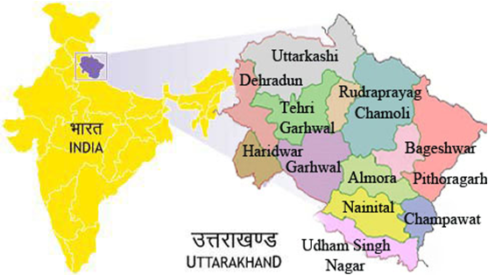

Figure 3: Index Map Showing Projected Road.

Uttarakhand Demographic Index

Uttarakhand is a Multi – Ethnic State and broadly, the population can be divided into tribal and non – tribal groups. The Uttarakhand State is facing the problem of quick translation of rainfall to surface runoff because of slope and faces the problems of landslides. Thus to cope up with these issues, an organized calculation of probability distribution to understand and selection of the best – fit probability distribution on an annual series of rainfall data for a period of 1991 – 2002 of 13 districts of Uttarakhand was made. The choice of best probability distribution could also be used to influence decisions relating to local economics and hydrologic safety systems. Further to this seasonal rainfall distribution, it reveals that the area receives about 82% of the total annual rainfall during the monsoon season, 10% during the post – monsoon season, and 8% during the pre – monsoon season. This preliminary result will help the water resource planner in hydrological modeling and the policy maker to frame general guidelines for the best use of rainfall for Uttarakhand.

Uttarakhand State is mainly known for two different mountainous regions, namely Kumaon and Garhwal. Most of the parts of the state are under forest cover and main rivers like Ganga and Yamuna originate from this state. All 13 districts of the state were selected for this study, which includes Almora, Bageshwar, Chamoli, Champawat, Dehradun, Haridwar, Nainital, Pauri, Pithoragarh, Rudraprayag, Tehri, Udham Singh Nagar and Uttarkashi. They are dominant ethnic group in the state and the people from the plain mostly involved in trade and services represent a marginal group. The Digital Terrain Model (DTM)/ DEM Generation of Geo – Tiff – Format of Projected Road, Vetting/ Geology and Slope Stability by Environmental Team Experts is as shown in the Figure 4. As per the 1991 census of India, the total population of the state is 4, 06,457, whereas in 1981 it was 3, 16,385 only. Decennial growth has come down, as in 1971 to 81 and it was 50.77% whereas for the years 1981 to 91 and it was found 28.47% only. The overall density of population in the Uttarakhand State is 83,743 Km². East district is the most populated where as North's density only 7, is least populated. Sex ratio (females per thousand male) in 1981 was 835, where as it has improved and now is 878. There are only eight urban towns and urban population is 9.10% of total population. Schedule caste and schedule tribe population is 5.93% and 22.36% respectively, North district is a tribal district and it has about 55.38% tribal population. Literacy rate is 56.94% (19th position), higher than the all India average literacy rateare of 52.11%. Figure 4: The Tentative Prototype – Paradigm – Digital Sample/ Example of Terrain Model (DTM)/ DEM Generation of Geo – Tiff – Format of Kurkuti – Ghamsali – Niti (17.56 Km) Projected New Road at Kurkuti Latitude of 29.9831° (North) and Longitude of 78.5278° (East); Niti Latitude of 30.7776° (North) and Longitude of 79.8412° (East). Vetting/ Geology and Slope Stability are observed by Environmental Team Experts. (Part – I)

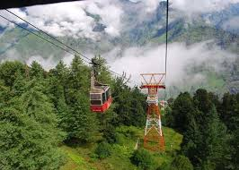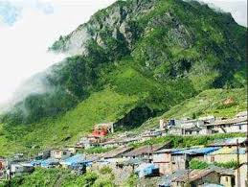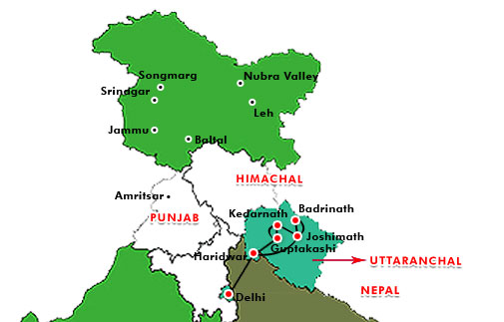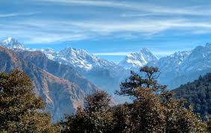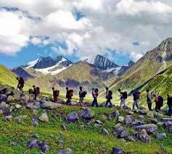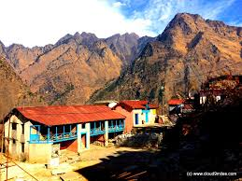
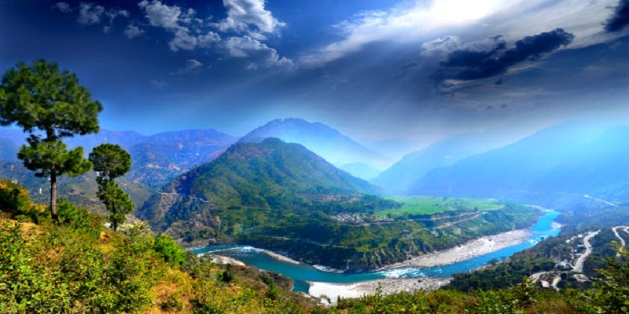
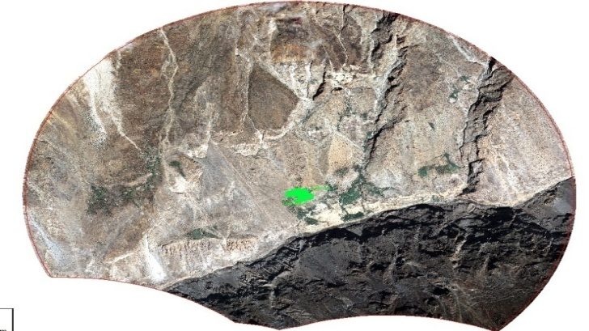 | 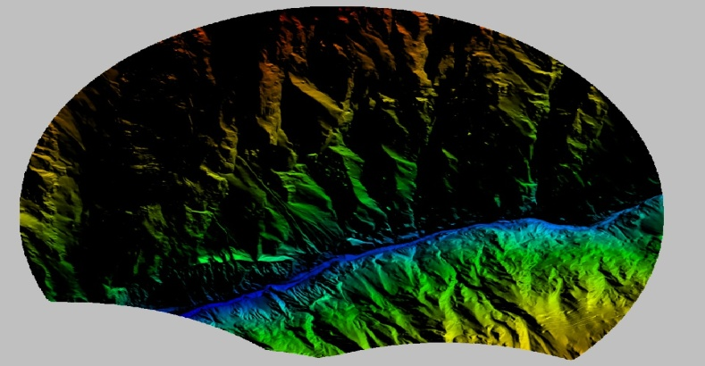
Kurkuti – Ghamsali – Niti Road,  Village (UK) Area – 37.625 Sq. Km. Overview of the 50 cm GSD Ortho – photo. | The 5 m Grid DEM a Relief View (An Overview for the Whole Area of Interest).
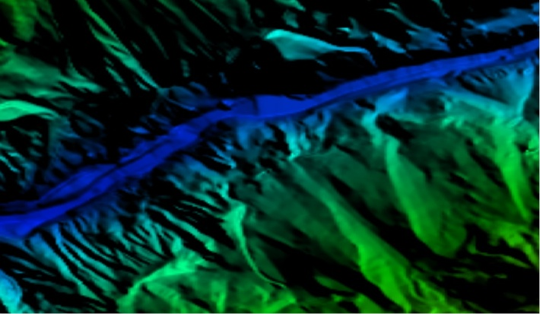 | 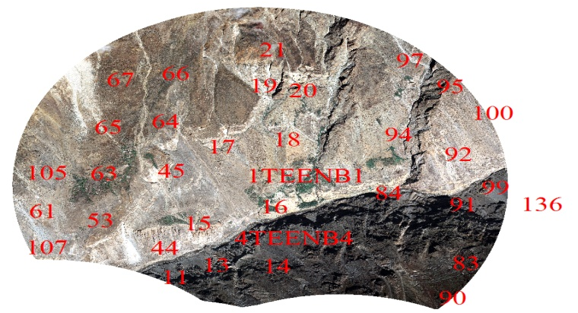
The DEM in Relief View for a Part of a River. | The Plan 3D Features Over the Ortho – photo an Overview.
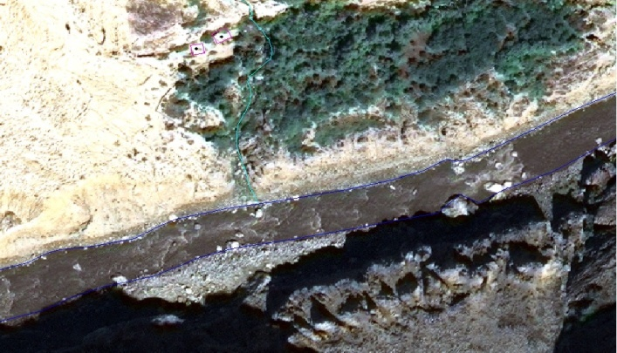 | 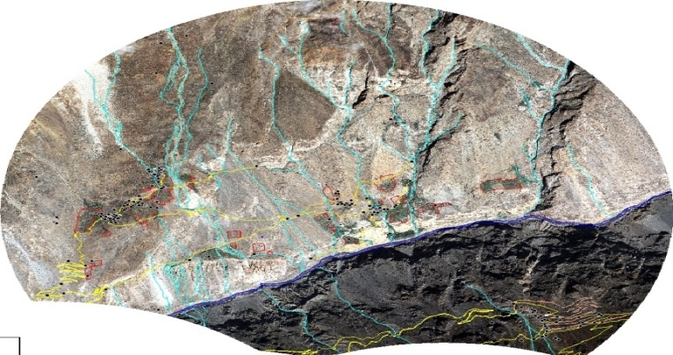
The Plan 3D Features – Part of a River; Roads and Buildings Plan Over the Ortho – photo. | Differences at Ground Scale between Measured and Adjusted Tie Photogrammetric Points.
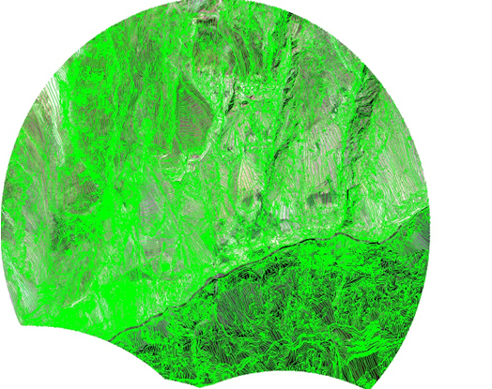 | 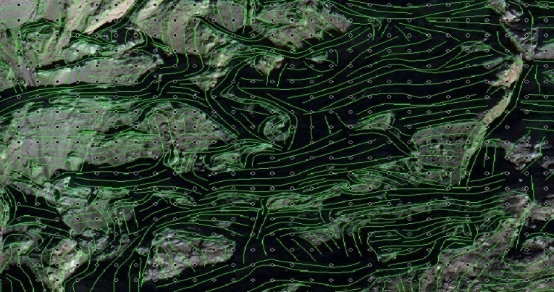
Compilation of Break Lines (A Line Portrays the Sudden Changes in the Elevation) and Mass Points Using Stereo Images.
State:  Name:  Total Length of the Road as per Remote Sensing:  Total Sq. Km. Area as per 5 Km Buffer Boundary: | Uttarakhand State  Kurkuti – Ghamsali – Niti, Road (UK) ^{Package– I}  17.565 Km  37.625 Sq. Km.

Figure 4: The Tentative Prototype – Paradigm – Digital Sample/ Example of Digital Terrain Model (DTM)/ DEM Generation of Geo – Tiff – Format of Kurkuti to Ghamsali to Niti Road, Village (17.565 Km) Projected New Road at Kurkuti Latitude of 30.7116° (North) and Longitude of 79.8381° (East); Niti Latitude of 30.7776° (North) and Longitude of 79.8412° (East). Vetting/ Geology and Slope Stability are observed by IIT Delhi/ Roorkee Team Experts. (Package – I)

Climatic Projection Index

The Climate of Uttarakhand is sharply demarcated in case of its two distinct divisions: the predominant hilly terrain and the smaller plain region. The most favorable time to visit Uttarakhand happens to be in the course of the summers when the weather is very clement and mild. Certain areas of the hills even become inaccessible in winter due to extremities of climate causing prolonged snowfall. The plain region seems to be at its best in terms of climate in winter, when the weather is pleasant. The type of climate that is mainly to be found in the plains closely resembles the corresponding state in the Gangetic plain. Summers are exceedingly hot with temperatures crossing the 40°C mark and considerable humidity. Winters can be chilly with temperatures going below 5°C at times. The climate in the Northern part of Uttarakhand is typically Himalayan. This mountain range itself exerts an appreciable extent of influence on monsoon and rainfall patterns. Within the Himalayas, climate differs depending on altitude and position. Climate ranges from subtropical in the Southern foothills, averaging summer temperatures of about 30°C (about 86°F) and winter temperatures of about 18°C (about 64°F). Warm temperate conditions prevail in the Middle Himalayan valleys, with summer temperatures usually hovering about the mark of 25°C (about 77°F) and cooler winters.

Cool temperate conditions dominate the higher areas of the Middle Himalayas, where the summer temperatures are usually around 15°C to 18°C (59°F to 64°F) and winters drop below the freezing point. You will encounter a cold alpine climate at higher reaches where summers are cool and winters are harsh. At altitudes over 4,880 Meters (16,000 Feet), the climate is bitterly cold with temperatures consistently below the freezing point and the area perennially shrouded in snow and ice. The Eastern flanks of the Himalayan ranges are subject to heavy rainfall while the Western section is relatively dry. Uttarakhand is characterized by two types of climate, sharply differentiated in the plains and the mountainous regions. The climate of the Uttarakhand State has been roughly divided into the tropical, temperature and alpine zones. For most of the period in a year, the climate is cold and humid as rainfall occurs in each month. The area experiences a heavy rainfall due to its proximity to the Bay of Bengal. The rainfall in North district is comparatively less than of the other districts. The general trend of decrease in temperature with increase in altitude holds good everywhere. Pre – monsoon rain occurs in April – May and monsoon (South – West) operates normally from the month of May and continues up to early October.

Temperature Profile Index

The mean temperature in the lower altitudinal zone, it varies from 1.5°C to 9.5°C. Temperature varies with altitude and slope. The maximum temperature is recorded usually during July and August and minimum during December and January. Fog is a common feature in the entire state from May to September. Biting cold is experienced at high altitude places in the winter months and snowfall is also not uncommon during this period.

The average temperature for the year in Uttarakhand is 23.5°C or 74.3°F. The warmest month, on average, is June with an average temperature of 31.1°C or 88.0°F. The coolest month on average is January, with an average temperature of 13.3°C or 55.9°F. The average amount of precipitation for the year in Uttarakhand is 1,132.5 milli Metres or 44.59 inches. The month with the most precipitation on average is August with 330.3 milli Metres or 13.00 inches of precipitation. The month with the least precipitation on average is November with an average of 4.8 milli Metres or 0.19 inches. There is an average of 46.8 days of precipitation, with the most precipitation occurring in August with 11.9 days and the least precipitation occurring in November with 0.6 days (Table 3).

Table 3: Average Temperature for the Year in Uttarakhand.

Climate Data for Uttarakhand
Month | Jan | Feb | Mar | Apr | May | Jun | Jul | Aug | Sep | Oct | Nov | Dec | Year
Average High °C (°F) | 11.0  (51.8) | 14.8  (58.6) | 19.7  (67.5) | 25.9  (78.6) | 24.5  (76.1) | 28.0  (82.4) | 25.9  (78.6) | 25.4  (77.7) | 23.2  (73.8) | 19.1  (66.4) | 15.9  (60.6) | 13.5  (56.3) | 20.6  (69.0)
Daily Mean °C (°F) | 13.3  (55.9) | 15.9  (60.6) | 21.1  (70.0) | 27.1  (80.8) | 30.6  (87.1) | 31.1  (88.0) | 28.7  (83.7) | 28.4  (83.1) | 27.5  (81.5) | 24.5  (76.1) | 19.4  (66.9) | 14.7  (58.5) | 16.4  (61.5)
Average Low °C (°F) | 2.6  (36.7) | 4.9  (40.8) | 9.5  (49.1) | 13.3  (55.9) | 17.0  (62.6) | 20.2  (68.4) | 18.7  (65.7) | 16.5  (61.7) | 13.9  (57.0) | 11.9  (53.4) | 7.0  (44.6) | 3.7  (38.7) | 11.6  (52.9)
Average Precipitation mm (inches) | 26.6  (1.05) | 26.1  (1.03) | 21.3  (0.84) | 15.2  (0.60) | 31.9  (1.26) | 140.9  (5.55) | 318.4  (12.54) | 330.3  (13.00) | 172.2  (6.78) | 34.4  (1.35) | 4.6  (0.18) | 10.6  (0.42) | 1,132.5  (44.6)
Average Precipitation Days | 2.1 | 2.0 | 1.9 | 1.3 | 1.9 | 4.9 | 11.3 | 11.9 | 6.2 | 1.8 | 0.6 | 1.0 | 46.8
Average Snowy Days | 6.3 | 3.8 | 0.1 | 0.0 | 0.0 | 0.0 | 0.0 | 0.0 | 0.0 | 0.0 | 0.7 | 4.4 | 15.2
Mean Daily Sunshine Hours | 10.9 | 11.6 | 12.4 | 13.3 | 14.1 | 14.5 | 14.3 | 13.6 | 12.7 | 11.8 | 11.1 | 10.7 | 12.6
Source: India Meteorological Department Weather Base.

Humidity Index

Basic Information: Meteorological Data at 03, 06, 09 and 12 Universal Time Coordinated (UTC) and also upper air data through pilot balloon observation manually at 01/ 02 and 11/ 12 UTC daily. Thermometers namely Maximum, Minimum, Dry Bulb and Wet Bulb thermometers are kept inside a Singles Stevenson Screen (Dry Bulb gives the air temperature at an instant and Relative Humidity and Dew Point Temperature of air is determined from the Hygrometric Table corresponding to the Dry Bulb and Wet Bulb temperatures at the instant). The Self – Recording Instruments Namely Thermograph to record air temperature and Hygrograph to record Relative Humidity of air on daily basis are kept in Double Stevenson Screen. Ordinary Rain Gauge to record daily total rainfall and the Self – Recoding Rain Gauge are installed inside the observatory, besides Open Pan Evapori – Meters to record the evaporation of air. Charts for all the Self – Recording Instruments are changed at 0820 Hrs 1st daily. The Wind Instruments Namely Wind Vane to record the direction of air, Anemometers to record the wind speed and Sunshine Recorder are installed on the Pilot Balloon Observation Tower. From this tower, Upper Air Circulation over Uttarakhand of Kurkuti – Ghamsali – Niti Road is observed manually from instrument known as Optical Theodo – lite. Upper Data are analyzed digitally through Hand Held Data Logger. Both the Kew Pattern (K. P.) Barometers and Self – Recording Barograph installed in the Observatory Office records the Atmospheric Pressure at any instant.

Rainfall Index

Heavy rains lashed many parts of Uttarakhand, especially those in Kumaon region, with Khatima in Udham Singh Nagar district receiving the maximum of 222 mm of showers. Kichcha, another town in Udham Singh Nagar district, received 135 mm of rainfall followed by Kalsi in Dehradun district which received 129 mm and Raiwala which recorded 115 mm of rainfall. Banbasa in Champawat district recorded 79 mm rainfall, the Disaster Management office in Dehradun said. The Kali and Gori rivers in Pithoragarh district were in spate, is flowing just a few metres below the danger level at 888.70 Metres and 604.55 Metres respectively. The Ganga was flowing at 291.20 Metres, around three Metres beneath the danger mark. The Met department has forecast similar weather till July 15th with heavy rain likely in “Nainital, Champawat, Udham Singh Nagar, Pithoragarh, Chamoli, Tehri, Pauri, Dehradun and Haridwar”. The weatherman attributed it to the presence of a trough extending from Punjab to South Assam in lower levels across Haryana, Uttar Pradesh and center of low pressure area over East Uttar Pradesh and strengthening of South Westerly flow from Arabian Sea in lower levels which it said would enhance the moisture incursion over Uttarakhand. The minimum temperature in Dehradun was 24.1 degrees Celsius, the Met department said, adding the maximum was likely to hover around 29°C.

In Haridwār, the average annual temperature is 23.6°C. The average annual rainfall is 1,285 mm. The averages maximum annual rainfall of 2426.77 mm occurred in Champawat, whereas the lowest average annual rainfall 406.70 mm occurred in Haridwar.

Wind Pattern Index

The wind intensity is not high except when accompanied by Pre – monsoon thunderstorms. However, in the afternoon they are comparatively more severe. Their direction is generally South Easterly in the mornings and sometimes changes to North Westerly in the evenings.

Extra Widening/ Improvement Index

- The Project road is proposed as two lanes with shoulder, drain, and extra widening (7.0 m + 2 × 0.9 m + 0.6 m + 0.6 m) as shown in the Table 4.

Table 4: Extra Widening/ Improvement and Land Acquisition Index.

Sr. No. | Feature | Description
1. | Extra Widening/ Land Acquisition  (7.0 m + 2 × 0.9 m + 0.6 m + 0.6 m) | 24 m Wide Strip of Land is Required

The aim of reconnaissance survey was to assess the scope of land acquisition and resettlement study and accordingly the detailed plan of action was prepared for the preparation of land acquisition planning and resettlement plan. The transparent process for land acquisition for industrialization, development of essential infrastructural facilities and urbanization with the least disturbance to the owners of the land and other affected families and provide just fair compensation to the affected families whose land has been acquired or proposed to be acquired or are affected by such acquisition and make adequate provisions for such affected persons for their rehabilitation and resettlement and for ensuring that the cumulative outcome of compulsory acquisition should be that affected persons become partners in development leading to an improvement in their post acquisition social and economic status and for matters connected therewith or incidental thereto.

Methodology for Social Impact Assessment

Project Road if traverses through hilly/ mountainous and steepas well as plain terrain. The proposed alignment improvement design is based on various parameters. The design principles for alignment selection have been evolved based on discussions with the expertise in Highway Engineers, Bridge Design Specialists, Environmentalist, Transport and other key personnel. The selection of the alignment is broadly based on the following criteria:

- Technical soundness and economic viability;
- Least social and environmental adverse impact;
- Least displacements and loss of public property;
- Avoiding adverse impact to water bodies and other environmental features;
- Locations of required causeways;

3. PROJECT DESCRIPTION AND ALIGNMENT

Projected Road Description: The Project Section of Kurkuti – Ghamsali – Niti, Road is located in the district of Chamoli, which in turn is located in the State of Uttarakhand length as per topography survey is 18.53 Km and as per design is 17.56 Km. The alignment of the project road is connecting Kurkuti, Farkiya, Bampa, Kurkuti and Niti. The project road Kurkuti – Ghamsali – Niti having length of 17.56 Km and the project stretch is traversing in hilly terrain from Kurkutiat (21.3199° N Latitude and 82.5646° E Longitudes) and Ends at Niti Village (30.7776° N Latitude and 79.8412° E Longitudes) in the State of Uttarakhand. The RL difference between two locations is 203 m. The Proposed designed alignment/ corridor between these stations comes out to be from 00+000 Km to 18+530 Km.

Start/ End Points, Terrain and Land Form

The roads are Kurkuti – Ghamsali – Niti in the state of Uttarakhand. The starting point of the Project road is Kurkuti and Ends at Niti. The Place Kurkuti is spread in valley which is surrounded by high hills on East and West side. It is situated in District Mehargoan Valley.

Niti: This is the last point of project stretch and is spread on a wide flat ground (plateau) surrounded by high hills. It is 20.0 Km from Niti and since the place is on a high altitude, it is experienced that the oxygen level is low. There is no existing road except foot track from Kurkuti towards Niti for most of the length except some isolated sections where the conditions are badly damaged. The remaining portion of the project stretch is traversing in hilly terrain starting at Niti and Ends at Niti. This stretch is for an approximate length of 17.56 Km and the place Kurkuti is spread in valley which is surrounded by high hills on East and West side. It is situated in District Mehargoan Valley and the project road is passing through in hilly terrain throughout the stretch.

Shoulder and Road Width

The reconnaissance and alignment of project road survey, no boundary stones were found. Further, it was confirmed that land for the proposed alignment is yet to be acquired depending upon the design of the alignment, hence no existing ROW. Kurkuti – Ghamsali – Niti, starts from Kurkuti and terminates at Niti. The actual design length of the proposed alignment is 17.56 Km. On the project road (Kurkuti – Ghamsali – Niti), as it is entirely new alignment and there is only a foot track, there is no traffic plying on this section comprises Single lane (3.75 wide for entire length), with 1.25 m wide shoulders on either side and the terrain is mountainous and has steep gradients. The proposed alignment is a link for Kurkuti – Ghamsali – Niti. The pattern on both side of road is barren land. The details of land use pattern along the project road are (Figure 5):

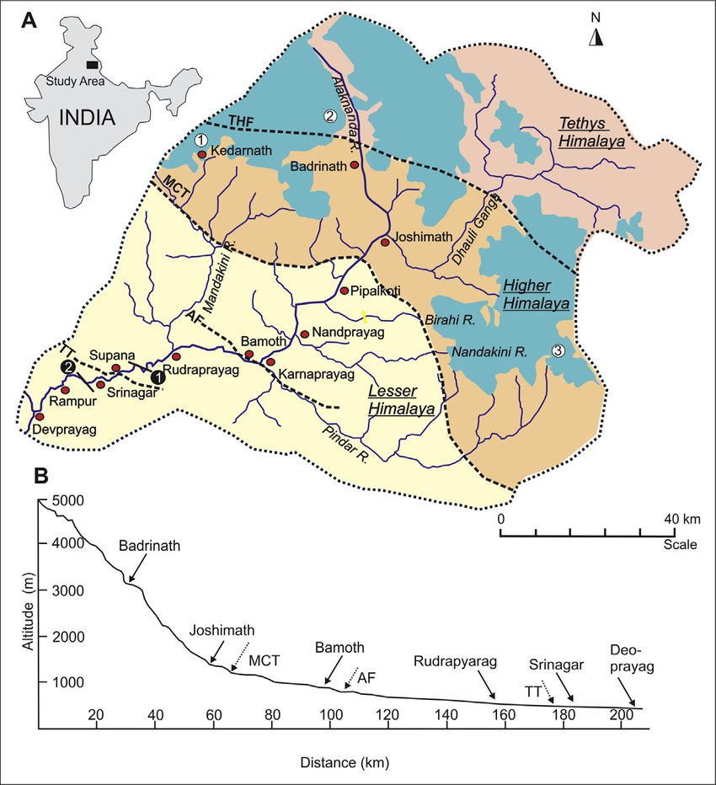

Figure 5: Project Alignment of Kurkuti – Ghamsali – Niti Road.

Traffic Survey Overview: Traffic surveyors comprehend the gratitude of existing traffic and travel distinctiveness is immensely important to boost wide – ranging traffic and transportation plan. With tremendous years of knowledge in survey services viz. Traffic survey, Pedestrian Count, Vehicle Parking, Origin – Destination Survey and Connected Services, Traffic surveyors brings a wealth of acquaintance/ knowledge and practice to any proposed projects. The proposed alignment is a link between Kurkuti – Ghamsali – Niti in the state of Uttarakhand and the total length of the proposed alignment is 17.56 Km. As the entire proposed alignment is a new alignment, there is no traffic survey have been conducted on the same study report.

Road Description: The project road Kurkuti – Ghamsali – Niti is having length of 17.56 Km. The project stretch is traversing in hilly terrain from Kurkuti (3139 m or 10298.56 Feet in Height) and ends at Niti (5,070 m or 16633.86 Feet in Height). The Reduced Level (RL) difference between two locations is 5,632 m (18,478 Feet). The Proposed designed alignment between these station comes out to be 17.56 Km. (As shown above in yellow colour) given in Figure 3. The Projected Corridor Kurkuti – Ghamsali – Niti, Road in North Uttarakhand is a newly declared under Part: 1, connecting link NH/ SH in the Uttarakhand State.

Ghamsali (घमसाली) Overview

It is an ancient village of Uttrakhand State of India, which is famous for its natural pure water which comes from inside of Earth. It is said that one who drink it, all the health problems such as BP, Hypertension, cancer, bone problems etc. are removed just because of its natural source. A forever pure water river is also there which just 30 Meters away from village is and anybody can take free swimming enjoyment over there.

About Ghamsali (घमसाली)

Ghamsali is a small Village/ Hamlet in Dwarikhal Block in Pauri Garhwal District of Uttarakhand State, India. It comes under Ghamsali Panchayath and it is located 70 Km towards South from District head quarters of Pauri. About 135 Km from State capital Dehradun Kurkuti having Pin Code is 246 173 and postal head office is Silogi. Ghamsali is surrounded by Kaljikhal Block towards North, Nainidanda Block towards East, Rikhnikhal Block towards North, and Sult Block towards East. Ramnagar, Jaspur, Kotdwara, Sherkot are the nearby Cities to Ghamsali Village.

Ghamsali 2011 Census Details

Ghamsali Local Language is Hindi and Ghamsali Village Total population is 110 and number of houses are 38. Female Population is 67.3% and Village literacy rate is 66.4% and the Female Literacy rate is 40.0% (Table 5).

Table 5: Ghamsali Village Population and Literacy Rate.

Census Parameters (Particulars) | Census Data
Total Number of Houses | 38
Total Population | 110
Female Population Rate %age | 67.3% (74)
Total Literacy Rate %age | 66.4% (73)
Female Literacy Rate %age | 40.0% (44)
Child (0 – 6)Population by 2011 | 12
Working Population Rate %age | 40.9%
Schedule Caste Population%age | 6.4% (7)
Schedule Tribe Population%age | 0.0% (0)
Girl Child (0 – 6) Population % by 2011 | 58.3% (7)

Kurkuti (कुर्कुटई)

Kurkuti, Uttarakhand is close to Margaon and North of Kosa Reserved Forest and Kurkuti has an elevation of 3,139 Metres. As per Uttaranchal Village Information the area Rewal Chak Kurkuti (रेवाल चक कुर्कुटई) is located in the Joshimath tehsil of Chamoli district (Table 6 and Figure 6).

Table 6: Demographics of Rewal Chak Kurkuti Village with Population and Literacy Rate.

Census Parameters (Particulars) |  | Detail Remarks
Town/ Village Name | : | Rewal Chak Kurkuti
District | : | Chamoli
Tehsil | : | Joshimath
Number of Households | : | 8
Total Population | : | 23
Population – Male | : | 9
Population – Female | : | 14
Sex Ratio | : | 1,556 (Females per 1,000 Males)
Literacy Rate | : | 78.26%
Male Literacy Rate | : | 100%
Female Literacy Rate | : | 64.28%

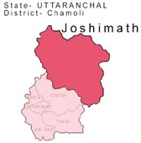

Figure 6: Demographic Map of Rewal Chak Kurkuti Village.

Niti (नीति) Overview

Niti is a Village in Joshimath Block in Chamoli District of Uttarakhand State, India. It is located 30 Km towards East from District head quarters Chamoli Gopeshwar and approximately 173 Km from State capital Dehradun. Niti Pin Code is 246 443 and postal head office is Vishnupuram. Niti is surrounded by Dasholi Block towards West, Gopeshwar Block towards West, Ghat Block towards South, Pokhari Block towards West and Pauri, Almora, Tehri, Chamba are the nearby Cities to Niti.

Niti 2011 Census Details

Niti Local Language is Hindi and Niti Village Total population is 47 and number of houses are 29. Female Population is 53.2% and Village literacy rate is 78.7% and the Female Literacy rate is 34.0% (Table 7).

Table 7: Niti Village Population and Literacy Rate.

Census Parameters (Particulars) | Census Data
Total Number of Houses | 29
Total Population | 47
Female Population Rate %age | 53.2% (25)
Total Literacy Rate %age | 78.7% (37)
Female Literacy Rate %age | 34.0% (16)
Child (0 – 6)Population by 2011 | 01
Working Population Rate %age | 95.7%
Schedule Caste Population%age | 0.0% (0)
Schedule Tribe Population%age | 97.9% (46)
Girl Child (0 – 6) Population % by 2011 | 0.0% (0)

Joshimath (जोशीमठ) Tehsil Population

Joshimath Tehsil in Chamoli District and Uttarakhand State Total population is 48,202. Rural Population is 29,055 and Urban Population is 19,147. Joshimath, also known as Jyotirmath is a city and a municipal board in Chamoli District in the Indian state of Uttarakhand. Located at a height of 6,150 Feet (1,875 m), it is gateway to several Himalayan mountain climbing expeditions, trekking trails and pilgrim centers like Badrinath. Valley of Flowers is a fairy – land situated high in the Himalayas of the Uttaranchal, at an altitude of 3,600 Meters above sea – level, protected by snowy mountains (Table 8).

Table 8: Joshimath Tehsil Population Rate.

Category | Population | Male | Female
Rural | 29,055 | 15,786 | 13,269
Urban | 19,147 | 12,042 | 7,105
Total | 48,202 | 27,828 | 20,374

About Joshimath Tehsil

Located in the Indian state of Uttarakhand, the Jyotirmath – Malari Road is an asphalted high mountain road within the Nanda Devi National Park. The road is 64.6 Km and extremely steep. It links Jyotirmath (also known as Joshimath), a city at an elevation of 1.934 m above the sea level, and Malari, a small village near the Tibet border at 3.033 m above the sea level. Take special care with rare snow leopards and bears. The road includes countless hairpin turns along the Dhauliganga River. This cliff road is swept away by the winter snow and ice or by flooding of the river waters periodically.

Joshimath is a Tehsil in Chamoli District of Uttarakhand State, India and Joshimath Tehsil Head Quarters is Joshimath town. It is located 32 Km towards East from District head quarters Chamoli Gopeshwar. Around 174 Km from State capital Dehradun towards West and Joshimath Tehsil is bounded by by Gopeshwar Tehsil towards West, Ghat Tehsil towards South, Pokhari Tehsil towards West, Ukhimath Tehsil towards West. Pauri City, Tehri City, Almora City, Chamba City are the nearby Cities to Joshimath.
Joshimath (Joshimath), Auli (Bugyal), Govindghat, Hemkund Sahib (Hemkunt Sahib), Badrinath are the nearby important tourist destinations to see.

Geography of Uttarakhand

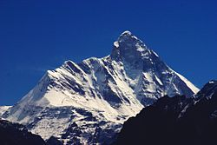

With the elevation of 7,816 Metres (25,643 Feet) above sea level, Nanda Devi is the highest mountain in Uttarakhand and the second – highest mountain in India, following Kangchenjunga in Sikkim.Uttarakhand has a total area of 53,483 Km², of which 86% is mountainous and 65% is covered by forest. Most of the Northern part of the state is covered by high Himalayan peaks and glaciers. In the first half of the nineteenth century, the expanding development of Indian roads, railways and other physical infrastructure was giving rise to concerns over indiscriminate logging, particularly in the Himalaya. Two of the most important rivers in Hinduism originate in the glaciers of Uttarakhand, the Ganges at Gangotri and the Yamuna at Yamunotri. They are fed by myriad lakes, glacial melts and streams. These two along with “Badrinath and Kedarnath” form the “Chota Char Dham”, a “Holy Pilgrimage” for the “Hindus”.

The state hosts the Bengal tiger in Jim Corbett National Park, the oldest national park of the Indian subcontinent. The “Valley of Flowers”, a “UNESCO World Heritage Site” located in the upper expanses of Bhyundar Ganga near Joshimath in Gharwal region, is known for the variety and rarity of its “Flowers and Plants”. One who raised this was Sir Joseph Dalton Hooker, Director of the Royal Botanic Gardens, Kew, who visited the region. As a consequence, Lord Dalhousie issued the Indian Forest Charter in 1855, reversing the previous laissez – faire policy. The following “Indian Forest Act” (IFA) of 1878 put Indian forestry on a solid scientific basis. A direct consequence was the founding of the Imperial Forest School at Dehradun by Dietrich Brandis in 1878. Renamed the “Imperial Forest Research Institute” in 1906, it is now known as the “Forest Research Institute” (FRI). The model “Forest Circles” (FC) around Dehradun, used for training, demonstration and scientific measurements, had a lasting positive influence on the forests and ecology of the region. The Himalayan ecosystem provides habitat for many animals (including bharal, snow leopards, leopards and tigers) plants, and rare herbs.

Uttarakhand lies on the Southern slope of the Himalaya range, and the climate and vegetation vary greatly with elevation, from glaciers at the highest elevations to subtropical forests at the lower elevations. The highest elevations are covered by ice and bare rock. Below them, between 3,000 and 5,000 Metres (9,800 Feet and 16,400 Feet) are the Western Himalayan Alpine Shrub and Meadows. The temperate “Western Himalayan Subalpine Conifer Forests” grow just below the tree line. At 3,000 to 2,600 Metres (9,800 to 8,500 Feet) elevation the transition to the temperate Western Himalayan Broadleaf Forests, which lie in a belt from 2,600 to 1,500 Metres (8,500 to 4,900 Feet) elevation? Below 1,500 Metres (4,900 Feet) elevation laid the Himalayan Subtropical Pine Forests. The “Upper Gangetic Plains Moist Deciduous Forests” and the “Drier Terai – Duar Savanna and Grasslands” cover the lowlands along the Uttar Pradesh border in a belt locally known as “Bhabar”. These lowland forests have mostly been cleared for agriculture, but a few pockets remain. In June 2013 several days of extremely heavy rain caused devastating floods in the region, resulting in more than 5,000 people missing and presumed dead. The flooding was referred to in the Indian media as a “Himalayan Tsunami”.

Subdivisions: Administrative Divisions of Uttarakhand

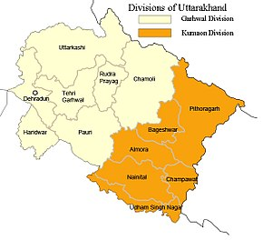

Divisions and Districts of Uttarakhand

There are 13 Districts in Uttarakhand, which are grouped into two divisions, Kumaon and Garhwal. Four new districts named Didihat, Kotdwar Ranikhet, and Yamunotri were declared by then Chief Minister of Uttarakhand, Ramesh Pokhriyal, on 15th August 2011, but yet to be officially formed (Table 9).

Table 9: Divisions and Districts in Uttarakhand (Uttaranchal).

Divisions | Districts/ Regions/ Areas
Kumaon Division | Almora, Bageshwar, Champawat, Nainital, Pithoragarh, and Udham Singh Nagar.
Garhwal Division | Chamoli, Dehradun, Haridwar, Pauri Garhwal (Commonly Known as Pauri), Rudraprayag, Tehri Garhwal (Commonly Known as Tehri), Uttarkashi.

Each district is governed by a district magistrate. The districts are further divided into sub – division, which is governed by sub – divisional magistrates; sub – divisions comprise blocks containing panchayats (village councils) and town municipalities. According to the 2011 census, Haridwar, Dehradun, and Udham Singh Nagar are the most populous districts, each of them having a population of over one million.

Culture Symmbols; Architecture and Crafts (Monuments of National Importance and State Protected Monuments in Uttarakhand)

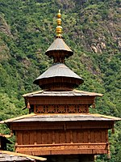

Mahasu Devta Temple at Hanol is notable for its traditional wooden architecture.

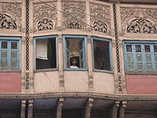

Architectural details of a Dharamshala, Established in 1822, Haridwar.

Abhisarika Nayika, a Painting by Mola Ram.

Among the prominent local crafts is wood carving, which appears most frequently in the ornately decorated temples of Uttarakhand. Intricately carved designs of floral patterns, deities, and geometrical motifs also decorate the doors, windows, ceilings, and walls of village houses. Paintings and murals are used to decorate both homes and temples. Pahari painting is a form of painting that flourished in the region between the 17th and 19th century. Mola Ram started the Garhwal Branch of the Kangra School of painting. Guler State was known as the “Cradle of Kangra Paintings”. Kumaoni art often is geometrical in nature, while Garhwali art is known for its closeness to nature. Other crafts of Uttarakhand include handcrafted gold jewellery, basketry from Garhwal, woollen shawls, scarves, and rugs. The latter are mainly produced by the Bhotiyas of Northern Uttarakhand.

Arts and Literature (Dehradun Literature Festival)

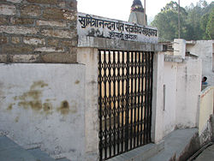

Sumitranandan Pant Museum, Kausani (Uttarakhand).

Uttarakhand's diverse ethnicities have created a rich literary tradition in languages including Hindi, Garhwali, Kumaoni, Jaunsari, and Bhoti. Many of its traditional tales originated in the form of lyrical ballads and chanted by itinerant singers and are now considered classics of Hindi literature. Abodh Bandhu Bahuguna, Badri Datt Pandey, Ganga Prasad Vimal, Harikrishna Raturi, Mohan Upreti, Naima Khan Upreti, Prasoon Joshi, Shailesh Matiyani, Shekhar Joshi, Shivani, Shiv Prasad Dabral “Charan”, Taradutt Gairola, Tom Alter; Lalit Kala Akademi fellow – Ranbir Singh Bisht; Sangeet Natak Akademi Awardees – B. M. Shah, Narendra Singh Negi, Prem Matiyani and Urmil Kumar Thapliyal; Sahitya Akademi Awardees – Leeladhar Jagudi, Manglesh Dabral, Manohar Shyam Joshi, Ramesh Chandra Shah, Ruskin Bond and Viren Dangwal; Jnanpith Awardee and Sahitya Akademi fellow “Sumitranandan Pant” are some major literary, artistic and theatre personalities from the state. “Prominent philosophers, Indian independence activists and environmental activists Gaura Devi, Govind Ballabh Pant, Chandi Prasad Bhatt, Kalu Singh Mahara, Mukandi Lal, Shri Dev Suman, Sunderlal Bahuguna and Vandana Shiva are also from Uttarakhand”.

Flora and Fauna

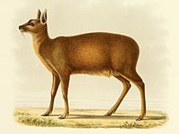

Alpine Musk Deer (Moschus chrysogaster).

Himalayan Monal (Lophophorus impejanus).

West Himalayan Common Peacock (Papilio bianor polyctor).

Uttarakhand has a diversity of flora and fauna. It has a recorded forest area of 34,666 Km² which constitutes 65% of the total area of the state. Uttarakhand is home to rare species of plants and animals, many of which are protected by sanctuaries and reserves. National parks in Uttarakhand include the “Jim Corbett National Park” (the oldest national park of India) in Nainital and Pauri Garhwal District, and “Valley of Flowers National Park” and “Nanda Devi National Park” in Chamoli District, which together are a “UNESCO World Heritage Site”. A number of plant species in the valley are internationally threatened, including several that have not been recorded from elsewhere in Uttarakhand. “Rajaji National Park” in “Haridwar and Dehradun Distric” and “Govind Pashu Vihar National Park” and “Gangotri National Park” in “Uttarkashi District” are some other protected areas in the State.

Leopards are found in areas, which are abundant in hills but may also venture into the low land jungles. Smaller felines include the jungle cat, fishing cat, and leopard cat. Other mammals include four kinds of deer (barking, sambar, hog and chital), sloth, Brown and Himalayan black bears, Indian gray mongooses, otters, yellow – throated martens, bharal, Indian pangolins, and langur and rhesus monkeys. In the summer, elephants can be seen in herds of several hundred. Marsh Crocodiles (Crocodylus palustris), Gharials (Gavialis gangeticus) and other reptiles are also found in the region. Local crocodiles were saved from extinction by captive breeding programs and subsequently re – released into the Ramganga River. Several freshwater terrapins and turtles like the Indian Sawback Turtle (Kachuga tecta), Brahminy River Turtle (Hardella thurgii), and Ganges Softshell Turtle (Trionyx gangeticus) are found in the rivers. Butterflies and birds of the region include Red Helen (Papilio helenus), the Great Eggfly (Hypolimnos bolina), Common Tiger (Danaus genutia), Pale Wanderer (Pareronia avatar), Jungle Babbler, Tawny – Bellied Babbler, Great Slaty Woodpecker, Red – Breasted Parakeet, Orange – Breasted Green Pigeon and Chestnut – Winged Cuckoo. In 2011, a rare migratory bird, the Bean Goose, was also seen in the Jim Corbett National Park. A critically endangered bird, last seen in 1876 is the Himalayan quail endemic to the Western Himalayas of the State.

Evergreen oaks, rhododendrons, and conifers predominate in the hills. Sal (Shorea robusta), Silk Cotton Tree (Bombax ciliata), Dalbergia sissoo, Mallotus philippensis, Acacia catechu, Bauhinia racemosa, and Bauhinia variegata (Camel's Foot Tree) are some other trees of the region. Albizia chinensis, the sweet sticky flowers of which are favoured by sloth bears, are also part of the region's flora. A decade long study by “Professor Chandra Prakash Kala” concluded that the “Valley of Flowers” is endowed with 520 species of Higher Plants (angiosperms, gymnosperms and pteridophytes), of these 498 are “Flowering Plants”. The park has many species of medicinal plants including Dactylorhiza hatagirea, Picrorhiza kurroa, Aconitum violaceum, Polygonatum multiflorum, Fritillaria roylei, and Podophyllumhexandrum. In the summer season of 2016, a large portion of forests in Uttarakhand caught fires and rubbled to ashes during “Uttarakhand Forest Fires” incident, which resulted in the damage of forest resources worth billions of rupees and death of 6 people with hundreds of wild animals died during fires.

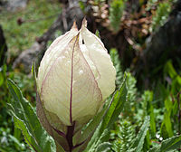

Brahma Kamal (Saussurea obvallata).

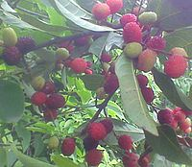

Kaphal (Myrica esculenta).

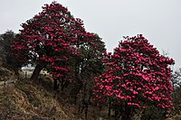

Burans (Rhododendron arboreum).

Transport (Char Dham Highway and Char Dham Railway)

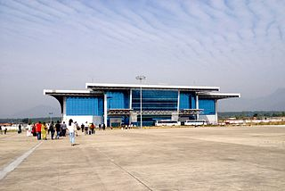

Jolly Grant Airport, Dehradun.
Uttarakhand has 28,508 Km of roads, of which 1,328 Km are national highways and 1,543 Km are State Highways. The “State Road Transport Corporation” (SRTC), which has been reorganised in Uttarakhand as the “Uttarakhand Transport Corporation” (UTC), is a major constituent of the transport system in the state. The Corporation began to work on 31st October 2003 and provides services on interstate and nationalised routes. As of 2012, approximately 1,000 buses are being plied by the UTC on 35 nationalised routes along with many other non – nationalized routes. There are also private transport operators operating approximately 3,000 buses on non – nationalised routes along with a few interstate routes in Uttarakhand and the neighbouring state of U. P. For travelling locally, the state, like most of the country, has “Auto Rickshaws” and “Cycle Rickshaws”. In addition, remote towns and villages in the hills are connected to important road junctions and bus routes by a vast network of crowded share jeeps.

The air transport network in the state is gradually improving “Jolly Grant Airport” in “Dehradun” is the busiest airport in the state with six daily flights to Delhi Airport. Pantnagar Airport, located in Pantnagar of the Kumaon region has 1 daily air service to Delhi and return too. There government is planning to develop Naini Saini Airport in Pithoragarh, Bharkot Airport in Chinyalisaur in Uttarkashi District and Gauchar Airport in Gauchar, Chamoli District. There are plans to launch helipad service in Pantnagar and Jolly Grant Airports and other important tourist destinations like “Ghangaria and Hemkund Sahib”.

As over 86% of Uttarakhand's terrain consists of hills, railway services are very limited in the state and are largely confined to the plains. In 2011, the total length of railway tracks was about 345 Km. Rail, being the cheapest mode of transport, is most popular and the most important railway station in Kumaun Division of Uttarakhand is at Kathgodam, 35 Kilometres away from Nainital. Kathgodam is the last terminus of the broad gauge line of North East Railways that connects Nainital with Delhi, Dehradun, and Howrah. Other notable railway stations are at “Pantnagar, Lalkuan and Haldwani”.

Dehradun railway station is a railhead of the Northern Railways. Haridwar station is situated on the Delhi – Dehradun and Howrah – Dehradun railway lines. One of the main railheads of the Northern Railways, Haridwar Junction Railway Station is connected by broad gauge line. Roorkee comes under Northern Railway region of Indian Railways on the main Punjab – Mughal Sarai trunk route and is connected to major Indian cities. Other railheads are Rishikesh, Kotdwar and Ramnagar linked to Delhi by daily trains.

Tourism in Uttarakhand

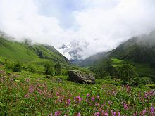

Valley of Flowers National Park.

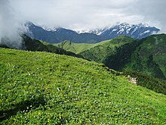

View of a Bugyal (Meadow) in Uttarakhand.
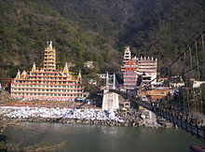

Rishikesh view and 13 stories Shiva Temple across Lakshman Jhula bridge over the Ganges.

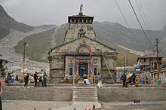

Kedarnath Temple is one of the 12 Jyotirlingas.

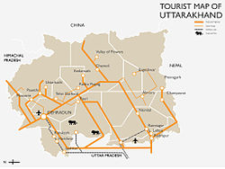

Schematic Tourist Map of Uttarakhand.

Uttarakhand has many tourist spots due to its location in the Himalayas. There are many ancient temples, forest reserves, national parks, hill stations, and mountain peaks that draw large number of tourists. There are 44 nationally protected monuments in the state and “Oak Grove School” in the state is on the tentative list for “World Heritage Sites”. Two of the most holy rivers in Hinduism the Ganges and Yamuna, originate in Uttarakhand.

Uttarakhand has long been called “Land of the Gods” as the state has some of the holiest Hindu shrines, and for more than a thousand years, pilgrims have been visiting the region in the hopes of salvation and purification from sin. Gangotri and Yamunotri, the sources of the Ganges and Yamuna, dedicated to Ganga and Yamuna respectively, fall in the upper reaches of the state and together with Badrinath (dedicated to Vishnu) and Kedarnath (dedicated to Shiva) form the Chota Char Dham, one of Hinduism's most spiritual and auspicious pilgrimage circuits. Haridwar, meaning “Gateway to the God”, is a prime Hindu destination. Haridwar hosts the Haridwar Kumbh Mela every twelve years, in which millions of pilgrims take part from all parts of India and the world. Rishikesh near Haridwar is known as the preeminent “Yoga Centre” of India. The state has an abundance of temples and shrines, many dedicated to local deities or manifestations of “Shiva and Durga”, references too many of which can be found in Hindu scriptures and legends. Uttarakhand is, however, a place of pilgrimage for the adherents of other religions too. Piran Kaliyar Sharif near Roorkee is a pilgrimage site to Muslims, Gurdwara Hemkund Sahib, Gurdwara Nanakmatta Sahib and Gurdwara Reetha Sahib are pilgrimage centers for Sikhs. Tibetan Buddhism has also made its presence with the reconstruction of Mind rolling Monastery and its Buddha Stupa, described as the world's highest at Clement Town, Dehradun.“Auli and Munsiari” are well – known skiing resorts in the state.

The state has 12 National Parks and Wildlife Sanctuaries, which cover 13.8% of the total area of the state. They are located at different altitudes varying from 800 to 5,400 Metres. The oldest national park on the Indian sub – continent, Jim Corbett National Park, is a major tourist attraction. “Vasudhara Falls”, near “Badrinath” is a waterfall with a height of 122 Metres (400 Feet) set in a backdrop of snow – clad mountains. The state has always been a destination for mountaineering, hiking, and rock climbing in India. A recent development in adventure tourism in the region has been white water rafting in “Rishikesh”. Due to its proximity to the Himalaya ranges, the place is full of hills and mountains and is suitable for trekking, climbing, skiing, camping, rock climbing, and paragliding. Roopkund is a trekking site, known for the mysterious skeletons found in a lake, which was featured by “National Geographic Channel” in a documentary and the trek to “Roopkund Passes” through the “Meadows of Bugyal”.

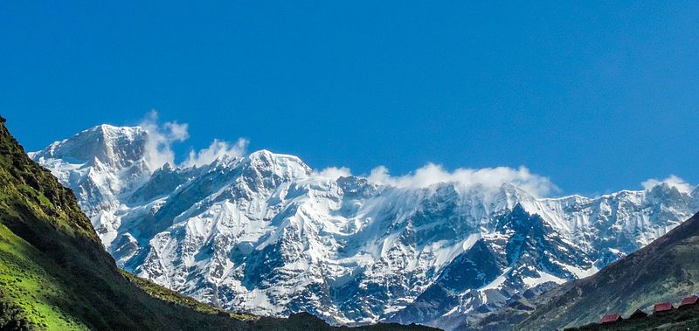

Himalayan Mountains Range in Kedarnath, Uttarakhand.

Institutions of Higher Education in Uttarakhand

On 30th September 2010 there were 15,331 primary schools with 1,040,139 students and 22,118 working teachers. At the 2011 census the literacy rate of the state was 78.81% with 87.4% literacy for males and 70% literacy for females.The language of instruction in the schools is either English or Hindi. There are mainly government – run, private unaided (no government help), and private aided schools in the state. The main school affiliations are CBSE, CISCE or UBSE, the state syllabus defined by the Department of Education of the Government of Uttarakhand. Uttarakhand is also home to a number of universities and degree colleges and Dehradun is known as “School Capital of India”.

Sports

The high mountains and rivers of Uttarakhand attract many tourists and adventure seekers. It is also a favorite destination for adventure sports, such as paragliding, sky diving, rafting and bungee jumping. More recently, golf has also become popular with Ranikhet being a favorite destination. The Uttarakhand Cricket Association is the governing body for cricket activities. The Uttarakhand cricket team represents Uttarakhand in Ranji Trophy, Vijay Hazare Trophy and Syed Mushtaq Ali Trophy. The “Uttarakhand State Football Association” (USFA) is the governing body for association football. The Uttarakhand football team represents Uttarakhand in the Santosh Trophy and other leagues.

How to Reach Joshimath Tehsil

By Rail: There is no railway station near to Joshimath Tehsil in less than 10 Km. However, Rishikesh Railway Station is major railway station 147 Km near to Joshimath. Pin Codes of Joshimath Tehsil 246 472 (Pipalkoti), 246 483 (Tapoban), 246 422 (Badrinath Seasonal), 246 443 (Vishnupuram), 246 424 (Chamoli), 246 423 (Niti).
Banks in Joshimath: Punjab National Bank, Joshimath (IFSC Code: PUNB0024500, Micr Code: NON – MICR); State Bank of India, Joshimath (IFSC Code: SBIN0006170, Micr Code: 246002022); and The Nainital Bank, Joshimath (IFSC Code: NTBL0JOS086, Micr Code: ××××××1234).

- Colleges in Joshimath: Government Inter Collage (G.I.C.),
Address: Karanprayag Road Narayanbagar.

- Govt Inter Collage (G.I.C.) Rohida,
Address: P.O. Rohida District Chamoli, Block Gairsain, Pin – 246 428.

- G.I.C. Bhagawati,
Address: Shri Guru G.I.C. Bhagawati, Chamoli Village – Bhagoti District – Chamoli.

- G.I.C. Lolti,
Address: G.I.C. Ratgaon, Village Ratgaon P.O. Ratgaon.

Itinerary (Route and Schedule)

- Day 01: Arrival at Joshimath (6,696 Feet);
- Day 02: Joshimath to Mana (10,429 Feet) – 50 Km [Drive];
- Day 03: Mana to Laxmiban (12,000 Feet) – 8.5 Km;
- Day 04: Laxmiban to Chakrateerth (13,658 Feet) – 9.5 Km;
- Day 05: Chakrateerth to Satopanth Lake (14,258 Feet) to Chakrateerth – 7.5 Km;
- Day 06: Chakrateerth to Somtoli (11,745 Feet) – 11 Km;
- Day 07: Somtoli to Mana – 6.5 Km. Drive to Joshimath;
- Day 08: Joshimath to Dehradun.

- The Existing Alignment of Kurkuti – Ghamsali – Niti, Road is Newly Declared as NH/ SH; is connecting to Newly Declare Road. The Total Existing Length of the Projected Road is approximately 18.53 Km.
- The Actual Design Length of the Project Road is around 17.56 Km.
- The project road section between Kurkuti – Ghamsali – Niti, Road has been divided into following homogeneous section in the Table 10:

Chapter Purpose

- To Identify Existing Traffic Data in the Region/ State;
- To Describe New Data Collection Requirements;
- To Presents the Findings of Data Collection Undertaken;
- To Determine if the Data Collection is Fit for Use;

Table 10: The Inventory of Kurkuti – Ghamsali – Niti Project Road.

ROAD INVENTORY
Road Name: Kurkuti – Ghamsali – Niti
Section : From Km 00+000 To 17+56 Km. |  |  |  |  |  |  |  |  |  |  | District: Chamoli Uttarakhand
Chainage |  | Type of Terrain | Land Use Pattern | Name of Village/ Town | Right of Way (m) | Roadway Width (m) | Carriageway |  |  | Shoulders |  |  | Average Height of Embankment or Depth of Cutting (m) | Road Side Drainage |  | Service Road, If Any | Details of Cross Roads |  |  | Remarks
Km | Km |  |  |  |  |  | Type | Width (m) | Condition | Type |  | Width (m) |  | Exists (F/ NF) | Does not Exist |  | Location | Destination | C/W (m)
00+000 | 17+56 | Hilly | Barren and No Use of Forest Land | NIL | NIL | NIL | NIL | NIL | NIL | NIL |  | NIL | NIL | NIL | NIL | NIL | NIL | NIL | NIL | Foot Track

- The Existing road Starts from 00+000 Km Kurkuti Village of Latitude and Longitude (21.3199° N Latitude and 82.5646° E Longitudes) and the road Terminates at 18+530 Km. of Niti Village with Latitude and Longitude (30.7776° N Latitude and 79.8412° E Longitudes). The Project Road Kurkuti – Ghamsali – Niti is situated in Uttarakhand State.
- The consultancy services for the same is to include design of best possible alignment and pavement composition, design of bridges, culverts and other structures in addition to analysis of costs, determining project feasibility, preparation of Land – Acquisition – Plan (LAP), if applicable in any area, and obtaining of all requisite clearances as per need or suitability in the projected areas.

- The index map illustrates the Approved Project Alignment of Kurkuti – Ghamsali – Niti Road Projected are presented in the Figure 7 below:

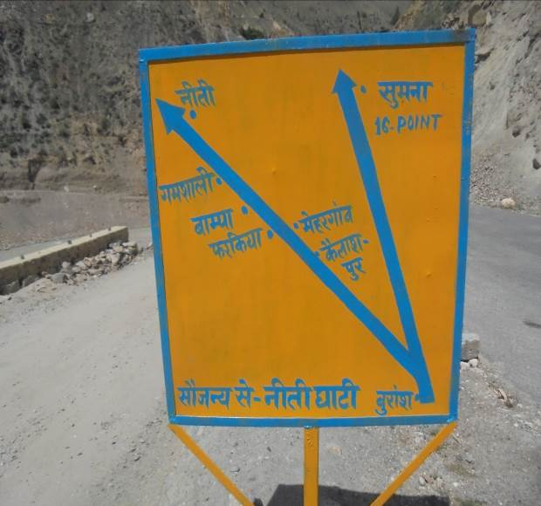 | 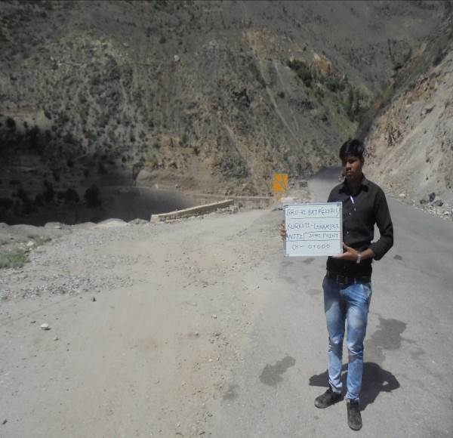

Start Point at Kurkuti Village Chainage = 00+000 Km.
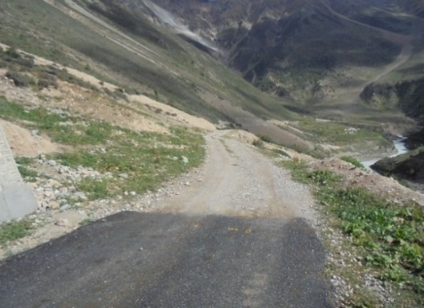 | 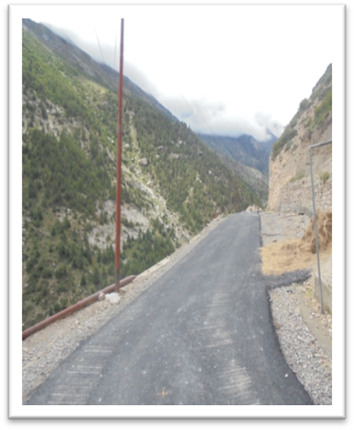

End Point at Niti Village Chainage = 18+530 Km.

Figure 7: Approved Project Alignment of Kurkuti – Ghamsali – Niti Road Projected as per Inception Reportby Environmental Team Experts.

Meticulous/ Particular TOR for Satellite Imagery

The coordinates of the origin and destination points of the proposed roads provided in the TOR were tentative. These have been checked on ground by us in concurrence of ITBP posts at the particular stations by GPS to ensure the accuracy of the coordinates.

4. OBJECTIVE OF CONSULTANCY SERVICES

Objective of Consultancy Services: The main objectives of the consultancy services are to prepare Initial Environmental Examination (IEE)/ DPR Report and bid documents for the length of 17.56 Km. of Kurkuti – Ghamsali – Niti Road and to establish the techno, economical, viability of the project and prepare detailed project reports for design of roads and bridges. An important requirement with regard to improving the Project Road is that the development of work shall be within the Right of Way (ROW) of 24 Meters and avoiding additional land acquisition as far as possible. All these means that the development schemes for the Project Road should be as economical as possible consistent with the functional requirements and that it should amenable for quick implementation without delays.

To serve the environmental aspects and adopt good Road Construction Practices (Sustainable Environmental Development Practices) under this project are being considered. The present research methodology aims to use the waste of some industries like polypropylene, polyester (as waste of backing and carpet industries respectively) in the preparation of a special type of asphalt to be used in the production of Hot Mix Asphalt (HMA) for roads, bridges, structures and dams construction during the civil work. The solid materials in paving mix were low quality aggregates of high absorptive type and waste marble filler with the final objective to provide added value, to reduce the production costs and keep the virgin solid materials especially aggregates for a longer period of time. The produced mixes are of similar or of better performance compared to the conventional asphalt mixtures. And there is an urgent need to address the great challenges of our times: climate change, resource depletion, pollution, and peak oil. These issues are all accelerating rapidly, and all have strong links with the road as well as building industry as shown below in Project Execution Objectives and Decision Making Work – Life Cycle (Figure 8).

- Ground Control Point Survey by using Differential Global Positioning System (DGPS);
- Procurement of 0.5 m Resolution of Satellite Imagery from National Remote Sensing Centre (NRSC), Hyderabad, India;
- Development of Geographical Information System(GIS) Layers and Digital Elevation Model (DEM) of Finalized Alignment of Border Roads;
- Contours Creation at 2.5 m Interval;
- Ortho – photo Generation at 0.5 m Ground Sample Distance (GSD);

Major Tasks and Scope of Consultancy Services

- Engineering Surveys and Investigations

- Topographic Surveys;
- Hydraulic and Hydrological Investigations;
- Traffic Surveys;
- Material Investigations;

- Engineering Designs

- Geometric Designs;
- Pavement and Road Designs;
- Design of Bridge and Structures;
- Drainage Designs;

- Project Cost Estimations

- Detailed Project Report; Initial Environmental Examination and Bid Documents

- General Topographical Features of the Area/ Region/ State

- Proposed Drainage Facilities/ Structures of the Area/ Region/ State

- Establishing the Most Suitable Alignment of the Projected Road;

- Minimal Adverse/ Unfavourable/ Unpleasant Impact on the Surrounding Environment.

HAMARA SANDESH…!!! HARA BHARA “UTTARAKHAND” PRADESH…!!!

Figure 8: Project Execution Objectives and Decision Making Work – Life Cycle.

There is a growing consensus from scientists and the industry that, we are going to reach peak for construction in the next twenty years, and that we might have reached this point already. Global demand is soaring, whilst global production is declining, and oil is set to become increasingly expensive and scarce. The road and building industry is hugely dependent on cheap resources from the manufacture and transportation of its materials, to the machinery and tools used in demolition and construction. Not only in India, but also in other countries, they use vast quantities of fossil fuels, accounting for over half of total carbon emissions that lead to increase in temperature, global warming and climate change. The built environment is also responsible for significant amounts of air, soil and water pollution, and millions of tones of landfill waste and this is a situation that clearly needs to change. Strategic value of these always occur, because our roads, belongs to some very important and informative objectives, which makes our country strong against another country as whole around the World OR Globe OR Precious Earth Sphere.

5. PROPOSED APPROACH AND METHODOLOGY: Eco – Friendly OR Environmental Friendly Road Construction Methods and Materials

General Approach: The general approach of the Consultants would be to comprehensively address the various issues involved in the project, to carry out all the field and design office activities as set out in the Scope of Services of the Term of Reference (TOR) and finally to develop improvement proposals satisfying the objectives of the project.

Methodology: The project involves a series of inter – related activities, both in the field and in the design office. Methodology for carrying out these activities is described in the following paragraphs.

Topographical Surveys: The topographical surveys by means of Global Positioning System (GPS), for fixing of ground control points for the entire length of the corridor. Further, the survey has been completed with the 0.5 m high resolution satellite imagery.

Soil and Material Investigations: Prospective sources of construction materials have been located by the Consultants to add in list of sources of materials. To estimate the quantities of available suitable materials; the Consultants have prepared quarry/ material source charts including lead distances etc. This shall form an input in Rate Analysis of borrow/ quarry materials, following which recommendations for the use of the materials from different sources can be made. Material investigation done for engineering properties reveals that the material available at site is fit for use in protection, drainage and surfacing works aggregate and no quarry outside the site is required. The material can be used for crust layer execution by processing the available material by stone crusher and rotary screen. Only local transportation is the need for transporting the aggregates for preparation of bituminous mix preparation and laying at respective chainages.

For the completion of this environmental report the data was collected from different sources including government department and our DPR as well as Initial Environmental Examination (IEE) Report, Expert/ Specialist Team. The main aim of this report is to produce a smart; innovative/ informative/ adaptive/ applicable guideline for good construction practices. Eco – friendly design methodologies and technologies can further reduce energy consumption by minimizing energy inputs for heating, cooling and light, and incorporating energy efficient appliances and applications. Saving energy for the occupant also saves money – an issue that will become increasingly important as the cost of fossil fuels and materials for road, bridges, and structure are used inevitably rises in the near future. High absorptive aggregate and waste polymer must play a very important role in road paving to decrease the cost of construction and maintenance. With the inevitability of declining fossil fuels, and the threat of global climate change, reducing our energy consumption is an essential survival strategy. Choosing to Build – Green...!!! And Go – Green...!!! To Save Energy Consumptions and its Valuable Resources to Achieve Significant Prospective Goals in the Projected Area Study. The low embodied energy of green products ensures that very little energy went into their manufacture and production, with a direct reduction in carbon emissions. The best modifier of asphalt must contain high percentages of Iso and Cyclo – Paraffins and lower percentage of asphaltenes similar to asphalt composition itself and the waste polymer from other industries can be used in future work.

The report mainly contains environmental points regarding different stages of the Designing; Construction and Operational Phases like three as depicted below for Kurkuti – Ghamsali – Niti Road, which is situated in the Northern part of Uttarakhand State to achieve projected goals and mainly these are in:

- Designing Phase;
- Construction Phase;
- Operational Phase.

Bitumen, as a residue from crude oil distillation, is the complex mixture of four main families of compounds, referred to as SARA fractions (Saturates, Aromatics, Resins and Asphaltenes). The behaviour of bitumen depended on the relative concentration and the chemical features of asphaltenes and maltenes; thus, variation in its composition strongly affects its mechanical properties. Methodological Perspective Over – View of Road Date Base Construction Photographs is given in Figure 9.

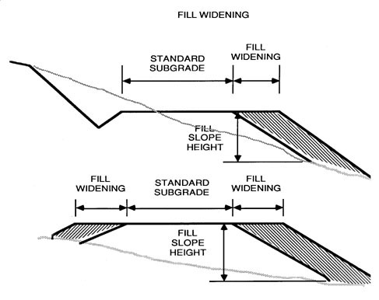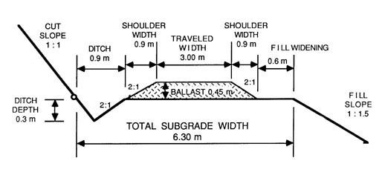
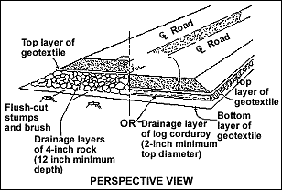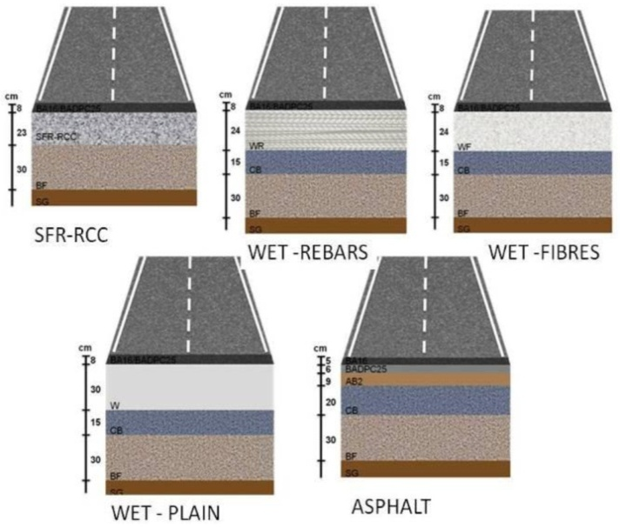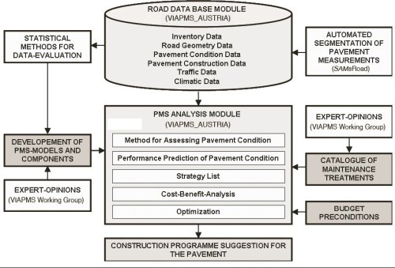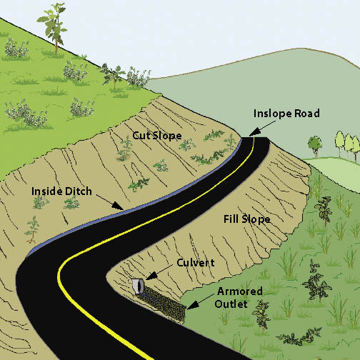

Figure 9: Methodological Perspective Over – View of Road Date Base Construction Photographs.

It presents a large set of interesting potential properties: impermeability, ductility, adhesivity and resistance to the effect of weathering and chemicals, etc. In the last 20 years, a wide spectrum of modifying polymeric materials has been tested with bitumens for their use in road construction. For a polymer to be effective it must blend with bitumen and improve its resistance at high temperatures without making the bitumen too viscous at mixing temperatures or too brittle at low temperatures. It should be capable of being

