**Organic Copolymer Resin-II Synthesis, Characterization, Morphology and Chelation Ion-Exchange Properties**

|  |  |  |  |
| --- | --- | --- | --- |
| Wasudeo Gurnule  Department of Chemistry  Kamla Nehru Mahavidyalaya  Nagpur-440024, Maharashtra, India  *Corresponding Author Email: [wbgurnule@gmail.com](mailto:wbgurnule@gmail.com) | Yashpal Rathod  Department of Chemistry  C. J. Patel College  Tirora-441911, Maharashtra, India  Email: [yashpalrathod2012@gmail.com](mailto:yashpalrathod2012@gmail.com) | Sunil Zanje  Department of Chemistry  J. M. Patel College  Bhandara-441904, Maharashtra, India  Email: [sunilzanje@gmail.com](mailto:sunilzanje@gmail.com) | Narayan Das  Department of Chemistry  Dr. Ambedkar College of Arts, Commerce and Science, Chandrapur-442404, India  Email: ncdas29@gmail.com |

**ABSTRACT**

By polymerizing 2, 4-dihydroxypropiophenone, 1,5-diaminonaphthalene and formaldehyde in the presence of 2M hydrochloric acid as a catalyst, a novel terpolymer was created. The synthesized 2,4-DHP-1,5-DANF-II terpolymer was characterized using a variety of methods, including elemental analysis, FTIR, 1H NMR, and SEM. Metal ions such as Cu2+, Pb2+, Zn2+ Hg2+, Ni2+, and Cd2+ were removed from aqueous solution using the synthesized 2,4-DHP-1,5-DANF-II terpolymer. The function of electrolytes in various concentrations and the influence of pH in various ranges have both been explored as influences upsetting the metal ions adsorption on terpolymer using batch equilibrium approach. As pH and electrolyte concentration rise, the effectiveness of removing metal ions also rises.

**Keywords:** Polycondensation, Batch equilibrium, Chelating, Ion-exchange properties, Terpolymer.

**I. INTRODUCTION**

Heavy metal pollution of the environment poses a serious hazard to both aquatic ecosystems and human health. The poisonous heavy metals and their ions pose risks to other life forms in addition to humans [1-3]. The most hazardous metals from an eco-toxicological perspective are lead, the hazardous metals copper, mercury, nickel, zinc, cobalt, arsenic, cadmium and vanadium are recognized to any concentration of living things. Causes of hazardous heavy metals in water and/or soil are most frequently waste water includes electroplating, pigment & dye, textile, leather, and petroleum refining effluents. Industries include refining, metallurgy, and painting that use a lot of heavy metal ions [4]. To prevent soil and water pollution, removing hazardous weighty metals from these wastes is a significant task. For the exclusion of metal ions, a number of techniques have been developed, including ion-exchange, electro-coagulation, reverse osmosis, precipitation, solid-liquid abstraction, and electro winning. The majority of these techniques have certain shortcomings, such as more capital operating costs and a problematic with disposing of leftover metal slush. Though, a potent environmentally friendly method aimed at the departure and retrieval of harmful heavyweight metal ions as of industrialized wastes tainted water is the metal ions removal by chelating ion exchange terpolymer employing batch equilibrium method [5-8]. Important categories of metal ion chelating agents include chelating ion-exchange terpolymers containing groups such-NH2, -OH and -COOH [9].

In this book chapter, we discuss a new terpolymer made from 2,4-dihydroxypropiophenone, 1,5-diaminonaphthalene and formaldehyde (2,4-DHP-1,5-DANF-II). Basic spectrum analysis has been used to characterize and confirm the synthesized 2,4-DHP-1,5-DANF-II terpolymer. In-depth research was done on the 2,4-DHP-1,5-DANF-II terpolymers sorption capabilities towards specific hazardous divalent metal ions.

**II. MATERIALS AND METHODS**

Chemical purity grade or AR refers to all of the chemicals. Formaldehyde (S.D. Fine Chemicals), 1,5-diaminonaphthalene (Himedia, India), 2,4-dihydroxypropiophenone, and solvents like DMF, DMSO, THF, acetone, and dimethyl ether were acquired from Merck in India.

**A. Synthesis of 2, 4-DHP-1, 5-DANF-II Copolymer**

Terpolymer resin was prepared by the condensation polymerization of 2,4-dihydroxypropiophenone, 1,5-diaminonaphthalene and formaldehyde in the molar proportion of 1:1:2 in hydrochloric acid medium (Fig. 1). This mixture became heated for 5 hrs. At 124 0C in an oil bath with periodic shaking to ensure exhaustive blending followed by the methodology in view of prior writing [10].



**Figure 1: Synthesis of 2,4-DHP-1,5-DANF-II copolymer resin**

**III. RESULTS AND DISCUSSION**

**A. Elemental analysis**

Table 1 provides the computed and founded values for the C, H, N, and S elements. The 2,4-DHP-1,5-DANF-II terpolymer has an 79% yield. Based on the findings, it was determined that C31H30N2O6 and 526, respectively, are the empirical formula and weight of the single repeating unit of the terpolymer, which are in good agreement with the calculated values.

**Table1: Elemental analysis and empirical formula of copolymer resin**

|  |  |  |  |  |  |
| --- | --- | --- | --- | --- | --- |
| Terpolymer resins | % of ‘C’  observed  calculated | % of ‘H’  observed  calculated | % of ‘N’ observed  calculated | Empirical formula of repeat unit | Empirical formula of repeat unit |
| 2,4-DHP-1,5-DANF-II | 69.06  70.72 | 5.16  5.07 | 6.01  5.32 | C31H30N2O6 | 526 |

**B. Infrared Spectra**

Fig. 2 shows the FTIR spectrum of the 2, 4-DHP-1,5-DANF-II terpolymer. Due to the existence of aromatic ring stretching vibration, a strong band is present near 3031 cm-1. Peaks between 800, 1200 and 3200 cm-1 are indicative of an aromatic ring with 1,3,4,5 substitutions. The existence of the -OH stretching vibration of the -COOH group may be the cause of the broad band near 3328 cm-1. A sharp band about 1656 cm-1 is caused by the carboxylic groups -CO stretching. The -NH stretching may be the cause of a sharp band about 3216 cm-1. Finally, a band about 2978 cm-1 might be an aromatic ring-bridging -CH2 group [11].



**Figure 2: FTIR-spectra of 2,4-DHP-1,5-DANF-II copolymer resin**

**C. 1H-NMR Spectra**

Fig. 3 displays the 1H NMR spectrum of the 2,4-DHP-1,5-DANF-II terpolymer obtained in DMSO-d6 solvent. The signals for the terpolymer that were collected were evaluated using the literature [12-13]. The aromatic protons (Ar-H) are responsible for the signal around 6.3–7.0 ppm. The signal was attributed to the Ar-OH group at 9.5 ppm and it denotes the intramolecular hydrogen bonding between the terpolymer resin's -NH group and the -OH group of Ar-OH. Ar-CH2 is responsible for the signal that emerged in the 3.1, while Ar-CH2-N is likely responsible for the signal that appeared in the 2.5–3.5 ppm range.



**Figure 3: H1-NMR-spectra of 2,4-DHP-1,5-DANF-II copolymer resin**

**D. Scanning Electron Microscopy**

SEM images taken at various magnifications were used to examine the resin's surface characteristics, as shown in Figure 4. It provides details on surface topography and structural flaws. The morphology displays fringed models and spherulites. The spherules have a good and smooth surface and are a complicated polycrystalline structure. This demonstrates the 2, 4-DHP-1, 5 DANF-II copolymer sample's crystalline form. Additionally, it displays the amorphous and crystalline structure fringes model. As a result, the resin is both crystalline and amorphous, or in between the two [14].

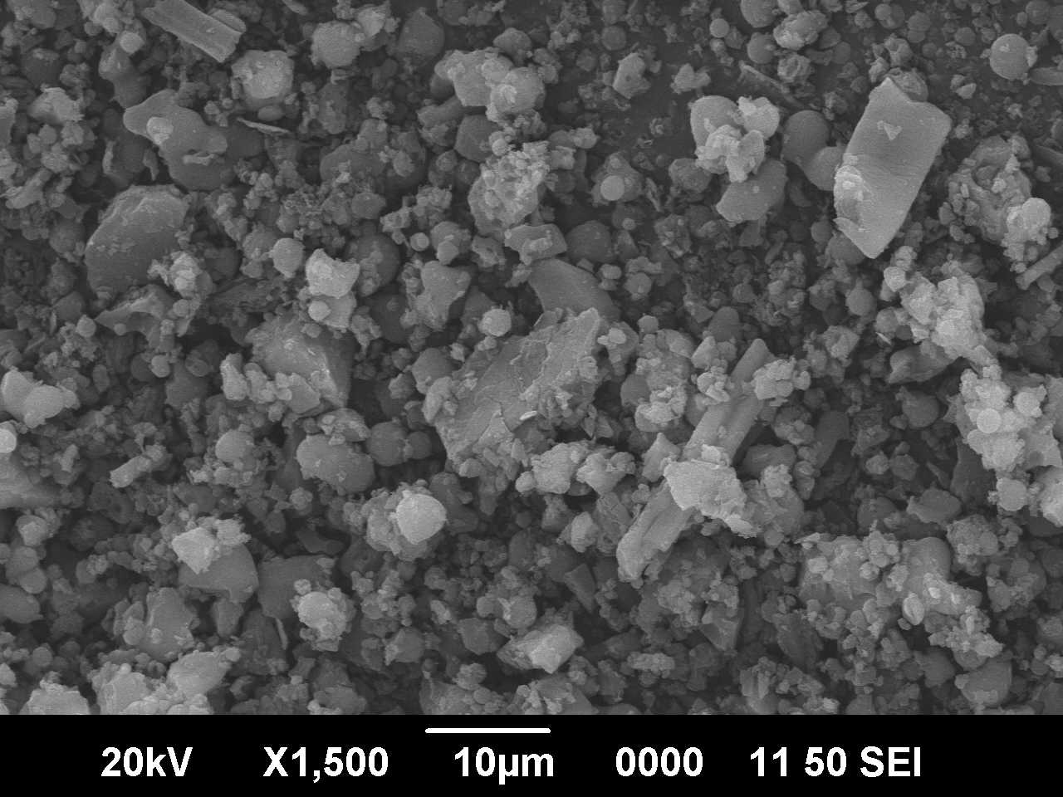 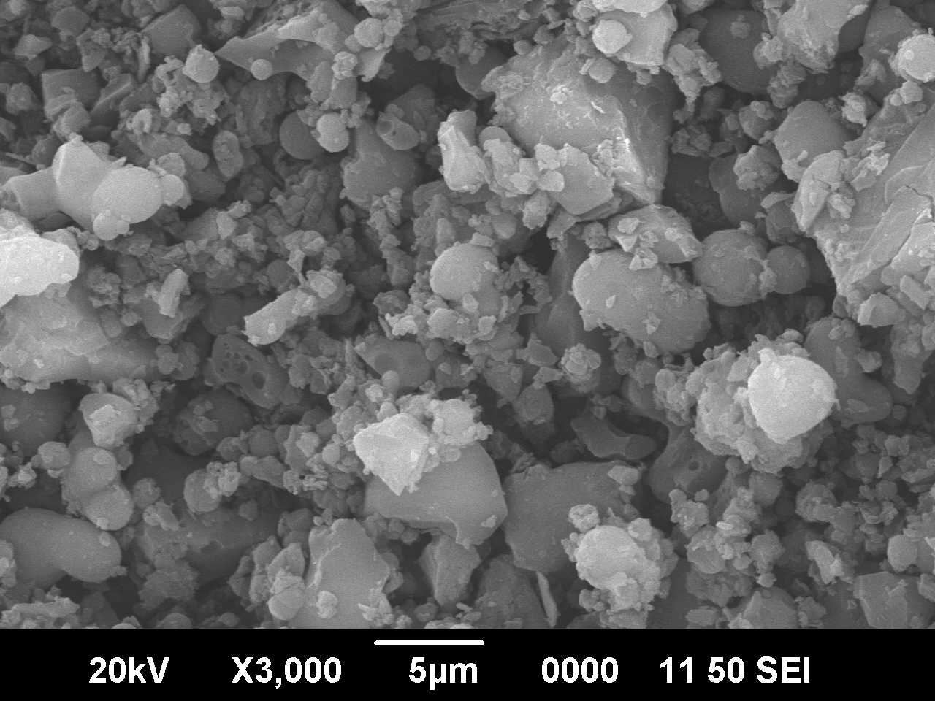

**Figure 4: SEM micrograph of 2, 4-DHP-1, 5-DANF-II copolymer resin**

**Ion-exchange Study**

The ion-exchange capabilities of resin were examined with reference to the influence of various electrolytes, the rate of metal uptake, and the distribution of metal ions between the resin and solution in order to determine the selectivity of 2,4-DHP-1,5-DANF-II. Table 5-6 and graph Figure 5 illustrate the findings of the batch equilibrium investigation performed using the 2,4-DHP-1,5-DANF-II terpolymer resin.

**Effect of electrolytes on the metal uptake**

Table 5 lists the impact of electrolyte on metal uptake. The analysis of the data shows that compared to NaCl, Na2SO4, and NaClO4, NaNO3 increases the number of metal ions that are taken up. For the metal ions Cu2+, Ni2+, Mg2+, and Zn2+, the exchange capacity rises with rising NO3-, ClO42-, and Cl- concentrations while falling with rising SO42- concentrations. This is because, compared to metal-resin interaction, the metal ions under investigation create kinetically more inert compounds with regard to SO42-. However, the addition of NO3-, ClO4-, and Cl- increased the metal exchange capacity of metal resin, which was ascribed to a strong but kinetically inert metal-resin interaction [15-16].

**Table 2: Estimation of the impact of diverse electrolytes on the uptakea of numerous metal ions by**

**2, 4-DHP-1, 5-DANF-II copolymer**

|  |  |  |  |  |  |  |
| --- | --- | --- | --- | --- | --- | --- |
| Metal ion | pH | Conc. | Weight of metal ion (in mg.) taken up in the presence of | | | |
| NaClO4 | NaCl | NaNO3 | Na2SO4 |
|  |  | 0.01 | 1.79 | 1.45 | 1.66 | 3.60 |
| 0.05 | 2.11 | 2.10 | 1.92 | 2.92 |
| Cu2+ | 4.5 | 0.10 | 2.62 | 2.72 | 2.22 | 2.09 |
|  | 0.50 | 3.27 | 3.10 | 2.80 | 1.40 |
|  | 1.00 | 4.13 | 3.31 | 3.63 | 0.80 |
|  | 0.01 | 1.76 | 1.20 | 1.11 | 2.96 |
|  | 0.05 | 2.24 | 1.34 | 1.79 | 2.50 |
| Ni2+ | 4.5 | 0.10 | 3.04 | 1.41 | 2.09 | 1.72 |
|  | 0.50 | 3.16 | 2.72 | 2.77 | 1.42 |
|  | 1.00 | 3.52 | 3.08 | 3.36 | 0.81 |
|  | 0.01 | 1.72 | 1.76 | 1.91 | 1.73 |
|  | 0.05 | 1.56 | 1.34 | 1.72 | 1.51 |
| Co2+ | 5.0 | 0.10 | 1.29 | 1.22 | 1.36 | 1.26 |
|  | 0.50 | 0.95 | 0.90 | 1.12 | 0.97 |
|  | 1.00 | 0.70 | 0.76 | 0.83 | 0.89 |
|  | 0.01 | 2.12 | 1.79 | 2.39 | 2.01 |
|  | 0.05 | 1.85 | 1.54 | 2.02 | 1.73 |
| Zn2+ | 5.0 | 0.10 | 1.41 | 1.21 | 1.71 | 1.42 |
|  | 0.50 | 1.13 | 0.84 | 1.53 | 1.11 |
|  | 1.00 | 0.65 | 0.56 | 0.82 | 0.87 |
|  | 0.01 | 1.65 | 1.76 | 1.80 | 1.93 |
|  | 0.05 | 1.37 | 1.41 | 1.71 | 1.68 |
| Pb2+ | 6.0 | 0.10 | 1.14 | 1.15 | 1.34 | 1.35 |
|  | 0.50 | 0.85 | 0.92 | 1.03 | 1.05 |
|  | 1.00 | 0.62 | 0.49 | 0.92 | 0.72 |

a[M(NO3)2] = 0.1 mol/l; Volume = 2 ml; Volume of electrolyte solution : 25 ml

Weight of resin = 25 mg; time: 24 h : Room temperature.

**Rate of Metal Ion Uptake as a Function of Time**

As time goes on, the rate of metal intake for all metal ions gradually becomes constant after first growing sharply. While it took 5 hours for Pb2+ to establish equilibrium, it took 6 hours for Zn2+, Ni2+, Cu2+ and Co2+ ions to do so. According to the experimental findings, Ni2+, Co2+, Cu 2+, and Zn2+ ingest metal ions at a faster rate than Pb2+. The rate of absorption of metal ions decreases from Cu2+, Ni2+ to Sb3+ to Zn2+ to Mg2+ in that sequence [17–19].

**Table 3: Comparison of the rates of metal (M) ion uptakea by 2, 4-DHP-1, 5-DANF-II copolymer**

|  |  |  |  |  |  |  |  |
| --- | --- | --- | --- | --- | --- | --- | --- |
| Metal ion | pH | % of metal ion uptakeb at different time (hrs.) | | | | | |
| 1 | 2 | 3 | 4 | 5 | 6 |
| Cu2+ | 4.5 | 48.1 | 63.6 | 78.1 | 85.4 | 92.6 | - |
| Ni2+ | 4.5 | 62.5 | 70.4 | 78.1 | 88.1 | 93.4 | - |
| Co2+ | 5 | 44.2 | 62.6 | 74.4 | 85.6 | 92.8 | - |
| Zn2+ | 5 | 48.4 | 62.3 | 73.4 | 86.4 | 93.6 | - |
| Pb2+ | 6 | 38.3 | 53.2 | 64.5 | 74.3 | 86.4 | 94.6 |

**a** [M(NO3)2]= 0.1 mol/l; volume : 2ml; NaNO3 = 1.0 mol/l; volume: 25ml, Room temperature.

**b**Metal ion uptake = (Amount of metal ion absorbed x 100) / amount of metal ion absorbed at equilibrium.

**Distribution Ratios of Metal Ions at Different pH**

Table 4 explains how pH affects the ratio of metal ions distributed between the resin and solution phase. To stop the hydrolysis of metal ions, the investigation was conducted at a higher pH limit. The distribution ratios of the Ni2+ and Cu2+ ions were observed to rise when pH levels rose. At pH 6, the 2, 4-DHP-1, 5-DANF-II copolymer order of distribution ratio was decreasing as Cu (II) > Ni (II) > Co(II) > Zn(II) > Pb(II).

**Table 4: Distribution Ratio ‘D’a of Different Metal Ionsb as a function of different pH of**

**2, 4-DHP-1, 5-DANF-II Copolymer resin**

|  |  |  |  |  |  |  |  |  |
| --- | --- | --- | --- | --- | --- | --- | --- | --- |
| Metal ions | Distribution ratios of different metal ions at different pH | | | | | | | |
| 1.5 | 2.0 | 2.5 | 3.0 | 3.5 | 4 | 5 | 6 |
| Cu2+ | - | - | 75.8 | 85.4 | 97.6 | 162.6 | 451.1 | 1212.1 |
| Ni2+ | - | - | 67.3 | 73.3 | 92.3 | 166.2 | 333.4 | 755.2 |
| Co2+ | - | - | 40.1 | 66.2 | 91.3 | 133.3 | 230.4 | 367.3 |
| Zn2+ | - | - | 36.5 | 55.5 | 76.2 | 88.3 | 142.4 | 245.1 |
| Pb2+ | - | - | 33.2 | 55.3 | 75.4 | 96.1 | 127.1 | 222.4 |

**a**D = weight (in mg) of metal ions taken up by 1g of copolymer/weight (in mg) of metal ions present in 1ml of solution. **b**[M(NO3)2]= 0.1 mol/l; volume : 2ml; NaNO3 = 1.0 mol/l; volume: 25ml, time 24h (equilibrium state) at Room temperature.

The findings of this kind of research are useful in determining the ideal pH for the selective uptake of a particular metal cation from a mixture of various metal ions. For instance, the ideal pH for the separation of Cu2+ and Pb2+ ions is 5, at which the distribution ratios of Cu2+ and Pb2+ are 451.1 and 127.1, respectively [20].

**IV. CONCLUSION**

A novel 2, 4-dihydroxypropiophenone and 1, 5-diaminonaphthalene formaldehyde (2, 4-DHP-1, 5-DANF-II) terpolymer was successfully created by us using condensation polymerization, and several spectral analyses validated its structure. The 2, 4-DHP-1, 5-DANF-II terpolymer was found to have greater degradation stability by heat study. According to the batch equilibrium experiments, the SASF terpolymer can effectively adsorb a variety of divalent metal ions, including Ni2+, Cu2+, Pb2+, Cd2+, Hg2+, and Zn2+ ions.

**ACKNOWLEDGEMENT**

The Kamla Nehru Mahavidyalaya Principal in Nagpur has graciously allowed the writers to thank him for providing laboratory resources. The Director of STIC at Cochin University in Cochin is also acknowledged by the authors for conducting the spectral study.

**REFERENCES**

[1] A. K. Rashid and K. A. Omran, Ion-exchange application of newly synthesized of aminoacetophenone, biuret

formaldehyde derivative as new chelating derivatives, Asian J. Chem., 29 (11), 2419 – 2424, 2017.

[2] S. P. Dhote, W. B. Gurnule and A. B. Zade, Metal ion binding properties of a terpolymer resin: synthesis, and

its application as a ion exchanger, IOSR, J. Appl. Chem., ISSN: 2278-5736, 35-39, 2014.

[3] W. B. Gurnule and J. V. Khobragade, Removal of heavy metals using ion-binding copolymer involving pthalic

acid with formaldehyde by batch equilibrium technique, I J R B A T, 5(2), 1-9, 2017.

[4] N. Abdullah, M. Z. Yahya and R. Mahmod, Comparative study of strong anion exchange hypercrosslinked

poly( HEMA-co- EGDMA-co-VBC) and strong anion cxchange poly(styrene-co-EGDMA-co-VBC):

Synthesis and characterization, Chem. Engg. Res. Bull., 19, 96-101, 2017.

[5] M. Ravichander, G. A. Reddy, V. Malathi, J. Pochampalli and R. Thampu, synthesis, antimicrobial and ion

exchange studies of some terpolymer resins derived from substituted resorcinol, biuret and formaldehyde, J.

Chem.. Pharm. Res., 7(9), 868-871, 2015.

[6] D. T. Masram, K. P. Kariya and N. S. Bhave, Synthesis of resin-VI: Salicylic acid, diaminobenzoic acid and

formaldehyde resin and its ion exchange properties, Der Pharma Chemica, 6(3), 292-299, 2014.

[7] K. Nandekar, S. Mandavgade and W. B. Gurnule, Chelation ion-exchange properties of copolymer resin

derived from salicylic acid, semicarbazide and formaldehyde J. Inform. Knowledge, Res. Human. Soc., 1(4),

177-188, 2016.

[8] S. S. Katkamwar, M. Ahmed and W. B. Gurnule, Studies on chelation ion-exchange properties of copolymer

resin derived from p-cresol,dithio oxamide and formaldehyde, J. Environ. Res. Develop., 1(7), 330-337, 2012.

[9] R. N. Singru, Semiconducting and chelating applications of newly synthesized terpolymer, Advances in

Applied Science Research, 2(6), 206-214, 2011.

[10] N. C. Das and W. B. Gurnule, Electrical conductivity of newly synthesized copolymer resin-IV from 2,4-

Dihydroxypropiophenone, 1,5-diaminonaphthalene and formaldehyde, IJARSCT, 2(3), 235-243, 2023.

[11] W. B. Gurnule and N. C. Das, Electrical conducting behavior of copolymer resin-III synthesized from 2,4-

dihydroxypropiophenone, 4-pyridylamine and formaldehyde, Ajanta, 8(1), 16-25, 2019.

[12] N. C. Das and W. B. Gurnule, Synthesis, characterization and morphology of organic copolymer resin-III

resulting from 2,4- Dihydroxypropiophenone, 1,5-diaminonaphthalene and formaldehyde, IJARSCT, 4(12),

2021.

[13] M. M. Yeole, S. Shrivastava and W. B. Gurnule, Synthesis and characterization of copolymer resin derived

from 4-methylacetophenone, phenylhydrazine and formaldehyde, Der Pharm. Chem., 7(5), 124-129, 2015.

[14] W. B. Gurnule, J. Khobragade and M. Ahamed, Synthesis, characterization and chelation ion exchange

properties of copolymer resin , Der Pharmacia Lettre, 6 (6), 297-303, 2014.

[15] N. C. Das, W. B. Gurnule, Y. U. Rathod and V.U. Pandit, Studies of chelation ion exchange properties of

copolymer resin derived from 2,4- Dihydroxypropiophenone, 1,5-diaminonaphthalene and formaldehyde,

Materials Today: Proceedings, 53, 80-85, 2022.

[16] K. Nandekar, S. Mandavgade and W. B. Gurnule, Studies of chelating ion exchange properties of novel

copolymer derived from salicylic acid and semicarbazide, J. Information, Knowledge and Research in

Humanities and Social, 1(4), 177-187, 2016.

[17] S. S. Rahangdale, Synthesis and chelation Ion-exchange properties of 2,4-HABF-IV terpolymer resin,World

Appl. Sci. J., 21 (2), 237-243, 2013.

[18] R. N. Singru, V. A. Khati, W. B. Gurnule, A. B. Zade and J. R. Dontulwar, Studies on semiconducting,

chelating and thermal properties of p-cresol-oxamide-formaldehyde terpolymer resin, Anal. Bioanal.

Electrochem., 1(3), 67-86, 2011.

[19] W. B. Gurnule, and S. S. Dhote, Der Pharma Chemica, Preparation, characterization and chelating ion-

exchange properties of copolymer resin derived from 2,4-dihydroxybenzoic acid ethylene diamine and

formaldehyde, 4 (2), 791-799, 2012.

[20] W. B. Gurnule, and D. B. Patle, Preparation, characterization and chelating ion-exchange properties of

terpolymer resin derived from o-aminophenol, urea and formaldehyde, Elixir Appl. Chem., 50, 10338-

10345, 2012.