**Fundamentals of Biofuels**

Mr.M.Sanjay, Mr.S.Hari Prasadh, Mr.R.Vivek, Dr.C.Vijayakumar

Department of Mechatronics Engineering

K.S.Rangasamy College of Technology,Tiruchengode

Mail Id:hariprasadhdeee@gmail.com

**Introduction**

* A biofuel is any fuel, including gases, liquids, and solids, generated from biomass.Biofuels are frequently used to describe gases and liquids generated from biomass.Waste from plants, algae, or animals may make up the biomass.

Biofuel is viewed as a source of sustainable energy as opposed to fossil fuels like petroleum, coal, and natural gas because of how easy it is to access such feedstock material.In view of the rising expense of petroleum and the growing concern over the role that fossil fuels play in contributing to global warming, biofuel is frequently recommended as a more economical and ecologically friendly substitute for petroleum and other fossil fuels.Due to the potential loss of huge tracts of arable land needed for food production as well as the financial and environmental costs connected with the refining process, many opponents are concerned about the breadth of the proliferation of various biofuels. Most of the plants that are used to produce biofuels are either high in starch, sugar, or oils, like maize and tapioca, or high in sugar, starch, or both, like sugarcane, sugarbeet, and sweet sorghum. The following images depict the source and the biofuel:

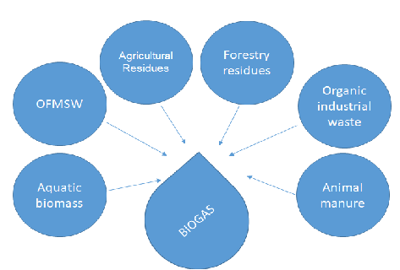

**Figure 1 : Source of biogas**

**Types of Biofuel**

Biofuels, which are mostly made from biomass, are liquid or gaseous fuels for transportation.

* Biofuels are widely acknowledged to provide a number of advantages, such as sustainability, a decrease in greenhouse gas emissions, and supply security.
* Biofuels are mainly used in transportation, even though they can be used to generate electricity in fuel cells or motors.
* Biofuels are made from biomass resources and can be used to make a variety of fuels, including liquid fuels like ethanol, methanol, biodiesel and Fischer-Tropsch diesel as well as gaseous fuels like hydrogen and methane in the figure 2.

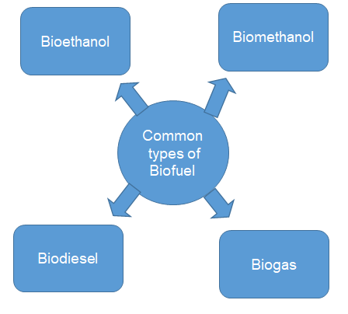

**Figure 2 : Types of Biofuel**

**Bioethanol**

* Bioethanol is produced by the fermentation of cellulosic biomass, sugars, or starches as a fuel additive or alternative. Bioethanol may be made cheaply from resources like wood, straw, and even domestic waste.
* The demand for ethanol is rising every day, and in order to keep up, fresh discoveries must be made and released into the market.
* Over 60% of the world's sugarcane crop is used as the feedstock for ethanol manufacturing. The most common liquid biofuel, ethanol, is often produced commercially from sugar cane and sugar beets since starches and cellulosic biomass sometimes need pricey pre-treatment.
* Ethanol is a sustainable energy source in addition to being used to create alcohol, cosmetics, and medicines.Ethanol, which was also the first synthetic organic chemical ever used by humans, is one of the most important ones.

**Biogas**

* Biowastes are digested anaerobically, or in the absence of oxygen, to produce biogas, which is mostly made of methane and carbon dioxide.
* Using feedstock like sewage or manure, digesters produce biogas, a viable biofuel.
* Ten to a few weeks are given to the digestive process.
* Using a series of chemical processes, the Fischer-Tropsch method, also referred to as "FT Synthesis," converts a combination of hydrogen and carbon monoxide into liquid hydrocarbons.When metal catalysts are present, these reactions frequently take place between 150 and 300 °C (302 and 572 °F) and at atmospheric pressures ranging from one to many tens of atmospheres.
* Franz Fischer and Hans Tropsch of Germany developed the method in 1925.
* The Fischere-Tropsch (FT) synthesis, an alternative process for converting synthesis gas into synthetic fuels, has been the subject of much study.
* With the use of mainly ruthenium, cobalt, and iron catalysts, FT is a high-performance synthesis based on metallic catalysis that converts syngas into hydrocarbons and chemical precursors.
* Lignocellulosic material must be seen as a low-cost feedstock for the bulk manufacture of liquid biofuel as the gasification process employs it as a raw material. Syngas produced by biomass gasification is used as a feedstock by the Fischer-Tropsch synthesis to ultimately convert it into biofuels. The emphasis is on using biosyngas as a synthetic fuel source to replace traditional, nonrenewable fossil fuels.Recent advances in our comprehension of reaction kinetics and thermodynamics have increased the FT's performance and commercial feasibility.
* To convert nonpetroleum carbon sources such coal, natural gas, shale gas, coal-bed gas, biogas, and biomass into liquid fuels and chemicals, the Fischer-Tropsch synthesis (FT) process is required.
* The activity of the FT synthesis may be impacted by the catalyst's behaviour, temperature, and pressure.
* The catalytic factors, which influence the CO conversion activity and other product properties, include the chemical states, promoters, sizes, and microenvironments of the active phases as well as their selectivity to C5+ hydrocarbons.
* By using the FT synthesis process, syngas, a gas mixture of CO and H2 produced during the gasification of biomass, can be converted into a range of hydrocarbons with different lengths.
* By combining biomass gasification with FTS, the process for creating liquid fuels from biomass transforms a renewable feedstock into a clean fuel.
* The following provides an explanation for FTS: Figure 3 (a and b)

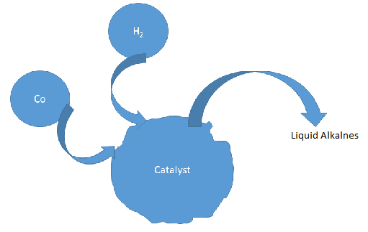

a)

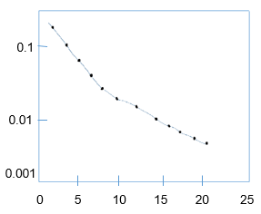

Carbonnumber,Cn

b)

**Figure 3 (a and b) : Fischer-Tropch synthesis for biofuels.**

* The FTS data mostly consist of an aliphatic straight chain hydrocarbon called CxHy.
* Among the products obtained by FTS are the light hydrocarbons methane (CH4), ethane (C2H4), and ethane (C2H6), LPG (C3-C4, propane, and butane), petrol (C5-C12), diesel fuel (C13-C22), and waxes (C23-C33).
* The catalyst, along with other process variables like temperature, pressure, and residence time, affects how the products are distributed.Numerous researchers have thoroughly examined and reported on the FTS.

**Vegetable Oils**

* Pure vegetable oil cannot be used in direct-injection diesel engines, such as those generally used in traditional tractors, since they cook after several hours of operation. Vegetable oils from sustainable oil seeds may be utilised as an alternative to diesel fuels.
* Over the past few years, biodiesel production from animal and vegetable fats has advanced technologically.
* Diesel fuel made from petroleum can be replaced with biodiesel.
* The majority of the ingredients in biodiesel are monoalkyl esters of fatty acids, which are frequently produced from extracted plant oils and/or harvested animal fats.
* Soy, canola, maize, rapeseed, and palm oils are a few well-known sources of biodiesel's basic materials.
* Novel plant oils like cotton seed, mustard seed, peanut, sunflower, and others are being taken into consideration.
* Beef, hog, and poultry fats are the most frequently used animal fats.

**Key Feedstock’s for Biofuel Production**

* At the moment, maize makes up more than 60% of the ethanol produced, followed by sugar cane at 25%, molasses at 7%, wheat at 4%, other grains including cassava, and sugar beets at 20%.
* Vegetable oils, such as those from soybean, pea, and rapeseed, or residual cooking oil (22%) are used to make around 77% of the biodiesel that is generated. The generation of all biofuels is largely unaffected by more sophisticated techniques based on cellulose feedstock’s (such as wood, agricultural leftovers, or crops specifically bred for energy production).
* However, because they are designed to have a smaller impact on food supplies and produce fewer greenhouse gas emissions, they are typically viewed as crucial technology for the future. National policies with the three major goals of supporting farmers, reducing greenhouse gas emissions, and/or reducing energy dependence have a big influence on the worldwide biofuel industry.

**Lignocellulose**

* Lignocellulosic material, which is made from non-edible crops, offers the benefit of reducing agricultural growth and related emissions when handled appropriately.
* Switchgrass, trees, and crop waste from agricultural goods including rice straw, wheat straw, maize stover, and sugarcane bagasse are just a few of the countless sources of this feedstock.
* Depending on the source, a wide range of different types of land are available.
* Straw was readily available in 2011 in quantities of 2.3 billion tonnes, and it may have been used to produce 560 million tonnes of ethanol.
* Depending on where it comes from, lignocellulose has different environmental and water requirements for growth.
* There is a rationale for switching from conventional maize to this non-food crop. It is difficult to produce the fuel at a low cost since the conversion of expensive fibrous plant barriers into sugars is required.
* Sugars can be fermented to create cellulosic ethanol once they have been created.

**Algae**

* Depending on the method of production, the group of photosynthetic organisms known as algae provides a considerable potential for biofuels due to its high oil content, constrained waste streams, and minimal land needs (relative to biomass).
* The varied techniques for growing and recovery have an impact on the environment and energy use. • Algae require a variety of water types, including fresh water, brackish water, salty water, and wastewater.
* There is a great deal of uncertainty regarding the effects of this feedstock on the environment because there is a dearth of current data.
* Scaled manufacturing has not yet been shown as of 2011, hence it was determined that the effects on the environment at this time were minimal.

**Corn**

* Although it may be produced in a variety of settings, from tropical to temperate, maize (maize), a basic food staple, may be prone to cold. For this crop, a lot of fertilisers and insecticides are required.
* The United States is the largest producer of ethanol from maize in the world, and the production of feedstock and ethanol requires relatively little water per unit of ethanol produced.

**Jatropha**

* Jatropha is a perennial non-food plant that can grow in a variety of soil, climate, and water conditions on marginal land.
* It has great drought resistance, can shed its leaves to conserve water, and can thrive in a variety of climes.
* Several nations throughout the world are investing larger sums of money on jatropha.
* At the moment, Guatemala, which has designated 25,000 acres of land for the growing of jatropha, has the highest output. India, Mexico, Ethiopia, the Sudan, and the Sudan are additional nations that are investing in this crop.

**Palm**

* Palm oil, which is produced for biofuels in Indonesia, Malaysia, and other Southeast Asian nations, is one of the main sources of feedstock for biodiesel.This feedstock grows in humid, tropical climates and needs deep soil, a temperature that is normally steady, and year-round precipitation. Its oil is an important nutrient and the primary source of vegetable oil consumed worldwide.
* Soybeans Soybeans are an important source of food and fuel, making up 25% and 65%, respectively, of the world's consumption of oil/fats and meal/cakes. The two main producers are the USA and Brazil. In temperate, subtropical, and tropical climes, this crop can be grown.

**Sugarcane**

* Sugarcane, a staple food crop grown in tropical regions, is the second-largest source of raw materials for ethanol production worldwide.
* Sugarcane is cultivated in deep soil using fertilisers that are high in nitrogen and potassium and low in phosphorus. It is possible that a single plantation may yield numerous harvests. Sugarcane needs a steady supply of water during the growing season, although the amount depends on the climate.Brazil used to be the most notable producer of ethanol made from sugarcane.

**Savoury Sorghum**

* A versatile annual grass crop, sweet sorghum is mostly grown in India, Nigeria, and the US.
* It is a sorghum cultivar with a high sugar content that can grow in temperate, subtropical, and tropical conditions.
* Sweet sorghum can grow in shallow or poor soil with little water, making it more adaptable than sugarcane.
* Why Compared to sugarcane and sugar beetroot, sweet sorghum grows in a four-month cycle and is more drought tolerant.
* Because sorghum includes 70% water, treatment must be started as soon as possible after harvest.
* With maturity timeframes ranging from 85 to 130 days, jatropha, rapeseed, soybeans, and wheat have some of the quickest growth rates when compared to other feedstock’s.
* While sugarcane requires a higher temperature environment, rapeseed and rye may be cultivated on a regular basis at lower temperatures.
* In comparison to other plants, algae, palm, and sugarcane all require more water.Primary and secondary biofuels are the two basic categories of biofuels. When utilised in their natural state, the most popular biofuels, such as fuel wood, wood chips, and pellets, are often used for cooking, heating, or producing power.
* Secondary biofuels like ethanol, biodiesel, DME, and others are produced by processing biomass and may be utilised in vehicles and a number of industrial activities.
* Primary biofuels are unprocessed organic resources like firewood, wood chips, and pellets that are predominantly utilised in their unmodified native chemical condition. In both small-scale and large-scale industrial applications, primary fuels are utilised directly to generate heat, electricity, or fuel for cooking.

**Primary biofuels** that have been modified and are produced as gases, liquids, or solids (such ethanol, biodiesel, and bio-oil), or as solids (like charcoal), are known as secondary biofuels.

Based on the components and production processes employed, the first-, second-, and third-generation biofuels are further split into the secondary biofuels.

**Generating classifications for secondary biofuels (Suc-classification)**

Based on the sources, the biofuels have been divided into four groups in accordance with this classification. First generation, second generation, third generation, and fourth generation biofuels are all of them.

**First-generation**

* Soybeans, palm, canola, and rapeseed are a few examples of the food bio-feedstock’s utilised to create first generation biodiesel.
* The marketing of the first generation of biodiesel led to issues with human interaction of food chains, including water management, land use, and supply and demand equilibrium.
* When using conventional methods, Grain is widely used to make feedstock’s like sugar, starch, vegetable oil, or animal fats, that have been fermented to produce bioethanol and contain significant amounts of sugar or starch, or from seeds that have been pressed to produce vegetable oil, which is then used to produce biodiesel.
* Vegetable oils, biodiesel, bio alcohols, biogas, solid biofuels, and syngas are examples of common first-generation biofuels.

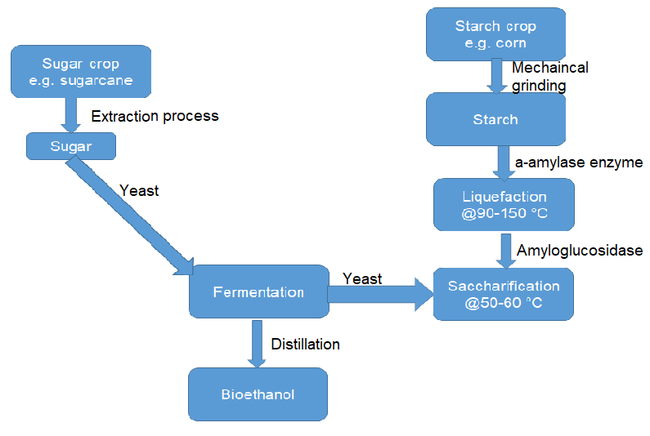

**Figure 4 : The first generation biofuel.**

**Second Generation**

* Non-food crops, such as cellulosic biofuels and residual biomass (wheat and maize stalks as well as wood), are used to make the second generation of biofuels.
* Advanced biofuels are a common name for second generation biofuels.
* The fact that their feedstock is frequently not a food crop distinguishes second generation biofuels from first generation biofuels.
* Only plants that have been used to make food in the past may be used to make second-generation biofuels.
* One type of second generation biofuel is used vegetable oil that has been utilised and is no longer suitable for human consumption.
* However, the first type of biofuel would be virgin vegetable oil is a diverse techniques are frequently employed to extract energy from second generation biofuels since diverse feedstock’s are used to create them.
* This is not to argue that biomass can't be burned directly in second-generation biofuels.
* In reality, certain second-generation biofuels, such as switch grass, are grown only for their direct biomass properties.

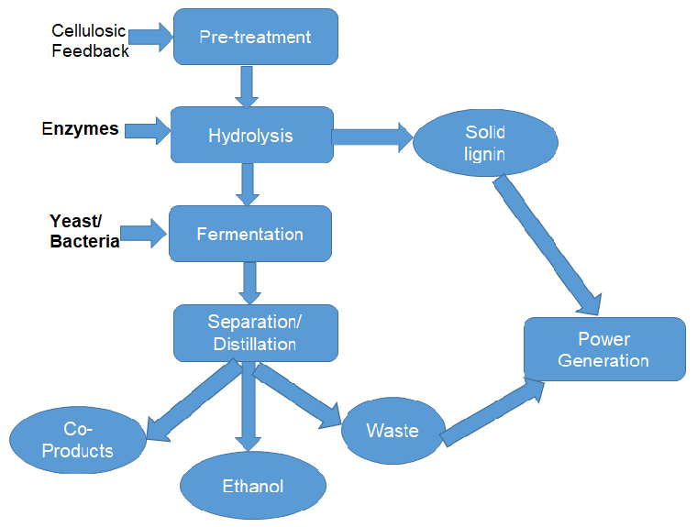

**Figure 5 : Second generation biofuel.**

**Third-generation**

* Third generation biodiesel is known by the term that has recently gained popularity.
* In the past, algae was used in second-generation biofuels.
* The third category of biofuels was formed as a consequence of suggestions that algae be given their own category when it became clear that they could produce considerably better yields with less resource input than other feedstock. Numerous benefits are offered by algae.
* The third generation of biofuels—also known as "oilgae"—are supposed to be cheap, high-yielding, and capable of producing up to 30 times as much energy per unit area as the current, conventional "firstgeneration" biofuel feedstocks.
* The Figure 6 shows photoreactors with algae raceways.

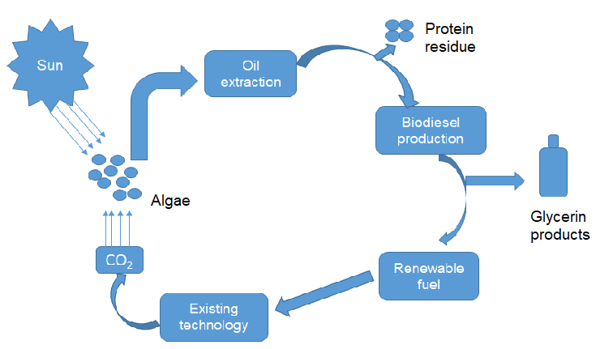

**Figure 6 : Third generation biofuel.**

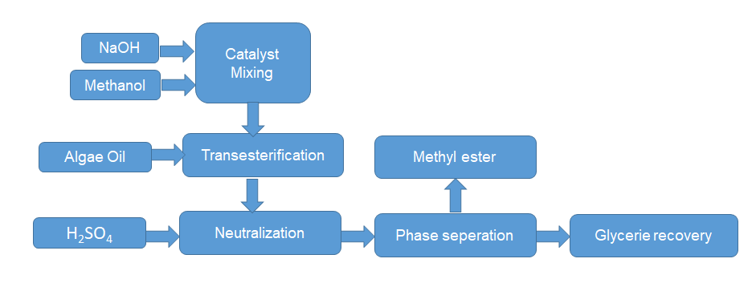

**Figure 7 : Algae biofuel production.**

**Fourth Generation Biofuel**

* Due to their ecological effect and economic feasibility, the current spectrum of biofuel production methods is inadequate to replace fossil fuels and reduce their influence on the inventory of Green House Gas (GHG) in the earth's atmosphere.
* Most people are aware that the first generation of biofuels is produced from agricultural materials like sugarcane or maize. The 4th generation biofuel that could fill this need is produced using engineered algae.
* All types of cellulosic biomass—the technical term—are used in second generation biofuels.
* The "algae-to-biofuels" technology is used in the third and fourth generations of biofuel production. In the first, algal biomass is converted into biofuel, but in the second, oxygenic photosynthetic microorganisms are converted into biofuels using metabolic engineering of algae. Figures 14 and 15 depict how fourth generation ethanol is produced.



**Figure 8 : Fourth-generation biofuel made from engineered algae**

**Advantages and Challenges of Biofuels**

* Although there are many advantages of biofuels for the environment, the economy, and energy security, there are still some problems that need to be resolved before these advantages can be exploited.
* The main benefit of using renewable resources to manufacture biofuels is the utilisation of natural bio resources, which are more geographically uniformly distributed than fossil fuels, and the bioenergy produced provides independence and supply security.
* Products manufactured from lignocellulosic materials have a low net GHG emission rate, which reduces their adverse environmental effects.
* By using residual substrates and agricultural waste as raw materials, bio fertiliser and bio insecticides can be produced while lowering the likelihood of a fuel-food conflict.
* According to a report by the United States Department of Agriculture (USDA), there are many advantages to using biodiesel as fuel, including the fact that it is renewable, an appropriate replacement for petroleum-derived diesel, can be used in most diesel engines without requiring much modification, has the potential to lower greenhouse gas emissions, is biodegradable with little to no toxicity, and can be made from recycled materials or agricultural products.
* Studies using biodiesel made from various types of oil discovered that the fuel had decreased carbon dioxide and polycyclic aromatic hydrocarbon (PAH) emissions. Since any carbon dioxide produced during the combustion of biodiesel was already absorbed from the environment during the vegetative crop's growth, biodiesel is categorised as a "carbon neutral" fuel. Considering that biodiesel is believed to have a lower flash point than gasoline derived from petroleum, transporting it is thought to be safer and simpler. Despite the many advantages, creating and using biofuels is not without its difficulties.
* The biggest obstacle to building a commercial biofuel plant is a better method for collecting and storing biomass waste.
* Strict regulations are required for the collection of organic waste and the expanding blending of biofuels.
* The development of new technologies may enhance system performance and generate co-products with added value, which would lower manufacturing costs. Tax credits for their use would establish a market, and subsidies for the construction of biofuel plants will hasten the production of these fuels.
* Key Concerns and Performance Factors for Sustainable Biofuels
* In the perspective of sustainability, the difficulties and performance factors for biofuels are highlighted in the following. The impacts on social, economic, and ecological systems are being researched.

**The Food-Fuel Debate**

* The public's concern over the battle for farmland between biofuels and food increased between the years 2006 through 2008 and 2010 through 2011 as a result of the fluctuating price of agricultural commodities [56-60]. (Figure-9).
* For instance, between 2006 and 2008, the price of grains and oilseeds doubled, closely tracking increases in the overall price of the food index.
* Grain and oilseed peak prices rose in 2011–2012, but maize prices rose even more in 2012–2013.
* Why Sugar prices increased by a factor of more than 2.5 between 2007 and 2011 and tracked more unpredictably.
* Since there were food price crises in the 1950s and 1970s, price adjustments are regular.
* The most recent jump increased both the number of countries affected and the level of volatility.
* Figure 9 displays the main elements of the food price index. FAO data has been changed. The food price index is calculated by averaging the prices of five different product categories.
* Growing food prices and technological advances in biofuel production have raised questions about the connections between food and fuel.
* The price of staple foods was emphasised in the G20 agendas in 2008 and 2011.
* The two primary areas of concern were the potential conversion of land for fuel-based crops, which may displace food-based crops or result in additional land being taken elsewhere, and the effect of biofuels on food prices, which would disproportionately affect the poor.
* No particular cause was found.
* Analysis found that several factors, including growing oil prices, meteorological conditions, investor speculation, and the development of biofuels, were at play.
* Some people believe that the worldwide biofuels boom may be to blame for 20% to 40% of the increase in food costs.
* Others draw attention to the complex interactions between variables influencing the use of land, finished goods, and markets for flexible crops.
* Despite the fact that social, environmental, and economic issues must be taken into account, there is ongoing discussion on how to define and precisely assess price volatility.

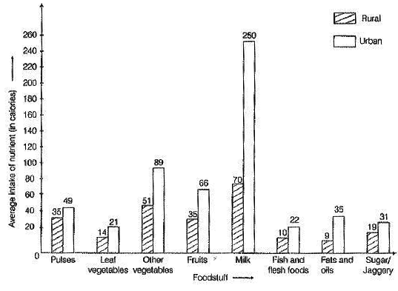

**Figure 9 : Food-Fuel Debate**

**Emissions**

* The subject of conversation in recent years has been emissions from biofuels.The primary explanations for this include the employment of sophisticated and highly sensitive procedures, assumptions, value judgements, and localised data disputes, as well as potential effects of temporal and geographic scope on the outcomes.
* It is hardly unexpected that the literature on biofuels makes a number of contradictory sustainability assertions.
* For instance, it has been argued that the net GHG emissions from biofuels under the lifetime assessment scenario may have greater climatic effects than those related to petrol.
* Biofuels are said to cut GHG emissions by 60% to 94% when compared to fossil fuels.
* The fact that the production of biofuels in less technologically advanced countries results in higher GHG emissions than in more technologically advanced countries is also emphasised.
* This use of biofuels could lead to socioeconomic inequalities and environmental problems, which could have unpredictable sustainability effects.
* For instance, biodiesel may successfully lower particulate matter by about 88% when compared to diesel derived from petroleum.
* The same fuel, though, might potentially damage the environment by releasing more nitrogen oxides.

**Land**

* Land usage is a vital aspect of the sustainability of biofuels.
* As the world's population expands, the production of food, social advancement, and biofuels will increase the use of land.
* Since 1961, cultivated land has increased by a net 159 million hectares (Mha), or 12%, doubled in area under irrigation, and agricultural production has increased by a factor of 2.5 to 3. These findings are from the Food and Agriculture Organisation of the United Nations.
* Concerns about food shortages during this time period were partially allayed by new applications for genetics and digital information, as well as increased usage of pesticides and fertilisers.
* There are concerns regarding land grabs and indirect land use change even though less than 3% of the world's arable land is now utilised to produce crops for biofuels.
* Future research on the biomass potential of land has provided insight into the viability of producing biofuels.
* According to one estimate, of the world's total land area of 13.4 billion hectares (Gha), 0.7 Gha is grossly accessible land, and 0.44 Gha is the technical upper limit of what may be exploited to produce biofuels and other types of bioenergy by 2050.
* The average annual productivity of all biologically productive regions on Earth is denoted by the abbreviation Gha (measured in hectares).
* Angola, the Democratic Republic of the Congo, Sudan, Argentina, Bolivia, Brazil, and Columbia are among the countries in South and Central America and Africa where cultivable land may be found, accounting for little under 80% of all potential sites. These nations will have a significant impact on the environmental, economic, and social elements of biofuels as well as the increasing agricultural needs that will arise in the absence of technological improvements like improved agricultural yields.

**Water**

* Like land, water presents concerns about the restrictions on biofuels.
* To put this issue in perspective, remember that 70% of the freshwater in the globe is used for agriculture and that some nations are already facing water shortages.
* By the middle of the century, the current total of 30 afflicted countries is expected to rise to 55.
* If biofuel production increases together with food production, there may be an undue demand on both the quantity and quality of water available.
* In locations where runoff into rivers and aquifers already causes dead zones, farming for biofuel feedstock may exacerbate issues. By 2050, it is predicted that there will be about 9 billion people on the planet, and to feed them, agriculture would need to grow more intensive and utilise more fertilisers to produce fuel crops.
* Importantly, a variety of biofuel production methods are thought to have favourable effects on water usage.
* To assist reduce the amount of nitrate in the groundwater, switch grass, for example, may be carefully planted next to fields and streams.
* It is currently difficult to understand the geographical and temporal patterns of water consumption due to increased energy demands, dwindling water supplies, and hydrologic variability.
* It is obvious that this is still a serious problem whose impacts on society and the environment need to be watched.

**Biodiversity**

* An facet of sustainability related to the environment called biodiversity may be impacted by land conversion and its usage for biofuels.
* The risk of harming or upsetting the natural habitats of a number of species increases when crops are planted on ground that has been stripped of trees.
* However, techniques for assessing the effects of biodiversity are still in their infancy.
* Figure10Estimates for lifetime assessments are used for the metrics "potentially lost endemic species" and "biodiversity damage potential".
* It is obvious that this industry, like ecosystem services, is crucial for determining the viability of biofuels and conducting associated assessments.
* Up to this point, biofuel planning may have done the best job of integrating biodiversity into agricultural zoning.

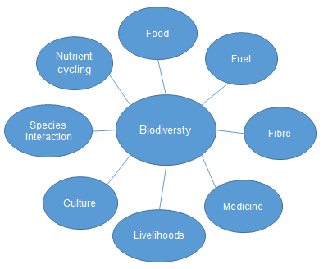

**Figure 10 : Flow chart of Biodiversity**

**Fuel Performance**

* Biofuels and their fossil fuel equivalents differ in a number of ways.
* For instance, biofuels may demonstrate advantageous octane increases along with less favourable energy fuel economics when compared to fossil fuel substitutes.
* The ability to tolerate compression before igniting is indicated by higher octane ratings.
* When ethanol is compared to petrol, its fuel efficiency causes a reduction in fuel miles per volumetric unit of 25%–30%; however, this difference is smaller (relative to diesel) for biodiesel.
* Mid-level biofuel blends at 20%–40% can be used to increase octane without incurring the high energy costs of higher blends, but infrastructural investment as well as changes to engine and vehicle design are also necessary.
* Tests analysing the average impact of biodiesel on emissions for heavy-duty highway engines show that it reduces pollutants, albeit the amount depends on the source and blend of the fuel. While overall hydrocarbon, particle, and CO emissions are roughly decreased by 70% when using 100% biodiesel, NOx emissions are 10% higher.
* In addition, biodiesel has about half the tendency to contribute to ozone generation when compared to regular diesel.
* Sulphur oxide emissions, which contribute to acid rain, are insignificant in compared to those from ordinary diesel.
* It's critical to consider how rising acetaldehyde emissions may impact smog and ozone levels in the atmosphere.
* The supply chain emissions for ethanol and biodiesel, excluding land usage, have been calculated to be 2-69 kg CO2-eq/GJ for ethanol and 20-49 kg CO2-eq/GJ for biodiesel. This suggests that ethanol and biodiesel have different environmental effects.
* Other distinctions dependent on the feedstock production method employed become evident when concentrating intensively on one fuel type, such as ethanol.
* For instance, the lignin needs to be broken down more thoroughly for producing ethanol from second-generation cellulosic feedstock.However, because to the higher overall fuel and fertiliser inputs during production, conventional biofuel emissions may still be higher than those from second-generation fuels.
* Alterations to the ethanol production process that increase enzyme efficiency may be able to lower the second-generation ethanol's overall system-level emissions.

**Reference**

1. [Aguilar-Reynosa, A., Romaní, A., Ma. Rodríguez-Jasso, R., Aguilar, C.N., Garrote, G., Ruiz, H.A., 2017. Microwave heating processing as alternative of pretreatment in second-generation biorefinery: an overview. Energy Convers. Manage. 136, 50-65.](https://doi.org/10.1016/j.enconman.2017.01.004)
2. [Charte, F., Romero, I., Pérez-Godoy, M.D., Rivera, A.J., Castro, E., 2017. Comparative analysis of data mining and response surface methodology predictive models for enzymatic hydrolysis of pretreated olive tree biomass. Comput. Chem. Eng. 101, 23-30.](https://doi.org/10.1016/j.compchemeng.2017.02.008)
3. [Bannor B, E., Acheampong, A.O., 2019. Deploying artificial neural networks for modeling energy demand: international evidence. Int. J. Energy Sect. Manage. 14(2), 285-315.](https://doi.org/10.1108/ijesm-06-2019-0008)
4. [Bannor B, E., Acheampong, A.O., 2019. Deploying artificial neural networks for modeling energy demand: international evidence. Int. J. Energy Sect. Manage. 14(2), 285-315.](https://doi.org/10.1108/ijesm-06-2019-0008)
5. [Dong, C., Chen, J., 2019. Optimization of process parameters for anaerobic fermentation of corn stalk based on least squares support vector machine. Bioresour. Technol. 271, 174-181.](https://doi.org/10.1016/j.biortech.2018.09.085)
6. [Erdem Günay, M., Yıldırım, R., 2020. Recent advances in knowledge discovery for heterogeneous catalysis using machine learning. Catal. Rev. 63(1), 120-164.](https://doi.org/10.1080/01614940.2020.1770402)
7. [Alviso, D., Artana, G., Duriez, T., 2020. Prediction of biodiesel physico-chemical properties from its fatty acid composition using genetic programming. Fuel. 264, 116844.](https://doi.org/10.1016/j.fuel.2019.116844)
8. [Cheah, W.Y., Sankaran, R., Show, P.L., Tg. Ibrahim, T.N.B., Chew, K.W., Culaba, A., Chang, J.S., 2020. Pretreatment methods for lignocellulosic biofuels production: current advances, challenges and future prospects. Biofuel Res. J. 7(1), 1115-1127.](https://www.biofueljournal.com/article_103970_1157c8da770b92dd2eb19c10742d089c.pdf)
9. [Chouaibi, M., Daoued, K.B., Riguane, K., Rouissi, T., Ferrari, G., 2020. Production of bioethanol from pumpkin peel wastes: comparison between response surface methodology (RSM) and artificial neural networks (ANN). Industrial Crops and Products. 155, 112822.](https://doi.org/10.1016/j.indcrop.2020.112822)
10. [Alpaydin, E., 2020. Introduction to Machine Learning, 4 (ed). The MIT Press.](https://www.bme.ufl.edu/wp-content/uploads/2018/07/Fall-2015-Syllabus-BME6938-Machine-Learning.pdf)
11. Aui, A., Wang, Y., Mba-Wright, M., 2021. Evaluating the economic feasibility of cellulosic ethanol: a meta-analysis of techno-economic analysis studies. Renew. Sust. Energy Rev. 145, 111098.
12. [Coşgun, A., Günay, M.E., Yıldırım, R., 2021. Exploring the critical factors of algal biomass and lipid production for renewable fuel production by machine learning. Renewable Energy. 163, 1299-1317.](https://doi.org/10.1016/j.renene.2020.09.034)
13. [Dave, N., Varadavenkatesan, T., Selvaraj, R., Vinayagam, R., 2021. Modelling of fermentative bioethanol production from indigenous Ulva prolifera biomass by Saccharomyces cerevisiae NFCCI1248 using an integrated ANN-GA approach. Sci. Total Environ. 791, 148429.](https://doi.org/10.1016/j.scitotenv.2021.148429)
14. [Ezzatzadegan, L., Yusof, R., Morad, N.A., Shabanzadeh, P., Muda, N.S., Borhani, T.N., 2021. Experimental and artificial intelligence modelling study of oil palm trunk sap fermentation. Energies. 14(8), 2137.](https://doi.org/10.3390/en14082137)
15. [Dharmalingam, B., Tantayotai, P., Panakkal, E.J., Cheenkachorn, K., Kirdponpattara, S., Gundupalli, M.P., Cheng, Y.S., Sriariyanun, M., 2022. Organic Acid Pretreatments and Optimization Techniques for Mixed Vegetable Waste Biomass Conversion into Biofuel Production. BioEnergy Res.](https://doi.org/10.1007/s12155-022-10517-y)
16. [Aruwajoye, G.S., Faloye, F.D., Kassim, A., Saha, A.K., Kana, E.G., 2022. Intelligent modelling of fermentable sugar concentration and combined severity factor (CSF) index from pretreated starch-based lignocellulosic biomass. Biomass Convers. Biorefin.](https://doi.org/10.1007/s13399-022-03013-y)
17. [Chen, W.H., Lo, H.J., Aniza, R., Lin, B.J., Park, Y.K., Kwon, E.E., Sheen, H.K., Grafilo, L.A.D.R., 2022. Forecast of glucose production from biomass wet torrefaction using statistical approach along with multivariate adaptive regression splines, neural network and decision tree. Appl. Energy. 324, 119775.](https://doi.org/10.1016/j.apenergy.2022.119775)
18. [Coşgun, A., Günay, M.E., Yıldırım, R., 2022. Analysis of lipid production from Yarrowia lipolytica for renewable fuel production by machine learning. Fuel. 315, 122817.](https://doi.org/10.1016/j.fuel.2021.122817)
19. [Culaba, A.B., Mayol, A.P., San Juan, J.L.G., Vinoya, C.L., Concepcion, R.S., 2nd, Bandala, A.A., Vicerra, R.R.P., Ubando, A.T., Chen, W.H., Chang, J.S., 2022. Smart sustainable biorefineries for lignocellulosic biomass. Bioresour. Technol. 344(Part B), 126215.](https://doi.org/10.1016/j.biortech.2021.126215)
20. [Ganguly, P., Das, P., 2022. Integral approach for second-generation bio-ethanol production and wastewater treatment using peanut shell waste: yield, removal, and ANN studies. Biomass Convers. Biorefin.](https://doi.org/10.1007/s13399-021-02277-0)