Production of third generation biofuel from oleaginous bacteria- an approach for utilization of lignocellulosic substrates biodiesel production

Authors
1) Rajakumari Pandiyan ⁽¹⁾
School Of Life Sciences
Bharathidasan University
Mail.id: nandhjara2000@gmail.com
2) Snegalatha D ⁽²⁾
School Of Life Sciences
Bharathidasan University
Mail.id: snegalathasls2025@gmail.com
Abstract

Population growth is a serious issue nowadays since it is increasing at an alarming rate while the earth's resources are still being degraded. Resources for conventional fossil fuels are exhausted and unsustainable. Alternatives to fossil fuels include biofuels. They possess qualities such as sustainability, low production costs, great productivity, short incubation times, etc. Microorganisms with an oily nature are harnessed for the production of third-generation biofuels, aiming to address the limitations of both first and second-generation methods. Single cell oil is the name given to the lipid that the microorganisms create. The biofuel production from oleaginous bacteria is the recent interest area in the research field which uses lignocellulosic biomass as their substrate. This review discussed the lipid contents in bacteria and its extraction by bioprocessing technologies and the utilization of lignocellulosic biomass.
Keywords; Oleaginous microbes, lignocelluloses, transesterification, metabolic engineering

Introduction

Rapid population increase, grossly unbalanced provision of food, declining petroleum reserves, and depletion of natural resources have all triggered the emergence of the world's energy threats [1]. Around eight times the amount of fossil fuels that were consumed in 1950 have been utilized since that year. This pattern of consumption has remained relatively consistent since 1980 [2]. Along with the rising petroleum price, the reserves of fossil fuels are exhausted, non-renewable, and exploiting the natural environment. To cope with these issues, we need a novel approach to sustainable utilization of energy. Biodiesel stands out as a type of renewable energy source. It stems from renewable biomass, which undergoes a transformative process known as transesterification. This process yields altered forms of lengthy fatty acids, coupled with brief alcohol chains, notably forming fatty acid methyl esters (FAMEs) and fatty acid ethyl esters (FAEEs). When compared to conventional petroleum diesel, biodiesel showcases certain advantages: it contains more oxygen, boasts improved combustion efficiency, and possesses lower levels of sulfur and aromatic components. Furthermore, biodiesel demonstrates environmental friendliness, holds a superior cetane number, and boasts a higher flash point. Importantly, it emits fewer greenhouse gases than regular diesel, and it doesn't contribute to elevated atmospheric carbon dioxide or sulfur levels [3-6].
Four generations of biodiesel were identified based on the feedstock used in manufacturing[7-9]. First-generation biofuel is created using a variety of dietary sources, including animal fat and edible plant oils. The non-edible feedstock used to make second-generation biofuel includes things like non-edible oil, food waste, animal-based waste, and crop residue [9][10]. Microbiologically generated biodiesel is a type of third-generation biofuel. [12-14]. Fourth-generation biofuels come into being through hydro-refining techniques akin to those employed in petroleum production. They also make use of innovative methods and cutting-edge biochemical procedures, such as Joule's special "solar-fuel" system, that fail to neatly fall into any recognized type of biofuel [15].

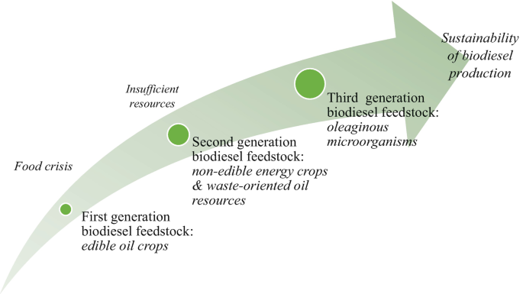

Fig 1:Generations of biofuels

Table 1: Different generations of biodiesel: their sources, advantages, and difficulties (Leong et al., 2018; Sigh et al., 2020)

S.No | Biofuels | 1st generation | 2nd generation | 3rd generation | 4th generation
1 | Source | Feedstocks for edible oils, such as soybean, rapeseed, sunflower, and corn, among others | Unusable feedstocks include jatropha seeds, food scraps, animal fat scraps, and other scraps of a variety of industries. | Bacteria, fungi, yeast, microalgae, and other oleaginous microorganisms | Electro-fuels, photobiological solar fuels, and synthetic cells
2 | Benefits | Renewable energy, environmental friendliness, and straightforward biodiesel conversion method | Biodegradable, renewable, and not in competition with food crops | These biofuels possess qualities such as renewability, biodegradability, lack of competition with food crops, absence of land requirements, freedom from climate dependence, and a faster growth rate. | High energy content, ample supply, and renewable
3 | Challenge | land, labor-intensive farming, and growing food costs | Costly to produce since it needs additional land and labor for cultivation. | Low production for commercialization, challenging to maintain, etc. | Research focuses on early childhood.

Microorganisms rich in oils, commonly referred to as oleaginous microorganisms due to their lipid content exceeding 20%, present promising potential for generating fatty acids as a viable and sustainable biofuel option [16][17]. The process of biologically crafting lipids through such oleaginous microorganisms—ranging from microalgae and yeast to fungi and bacteria—has been extensively explored through various studies [21-26]. These microorganisms are harnessed as substitute raw materials for manufacturing oil and fat [18].International interest in single-cell oils, microbial lipids used in the production of biodiesel, has grown significantly [19]. Most of the lipids generated by oleaginous microorganisms consist of straight carbon chains spanning from 4 to 28 carbons in length. These lipids exhibit the potential to be either saturated or unsaturated fatty acids, a characteristic determined by the configuration of the carbon chain and the count of double bonds it accommodates [20]. As metabolic byproducts of metabolizing fatty acids and triacylglycerol (TAG), various microbes form hydrocarbons. Eukaryotic organisms including yeast, fungus, plants, and animals utilise TAG as an energy reserve. Triacylglycerols (TAG) can be effectively produced by bacteria groups from a wide range of carbon sources, including carbohydrates, aromatic acids, ethanol, n-alkanes, extended alkanes, phenylalkanes, lipids, and even coal-derived lipids, though this process is still poorly understood. According to Bharti et al. (2014a) and Kumar et al. (2020), the fatty acids and TAG produced by microbial bacteria could serve as initial materials for cultivating microbial lipids, a valuable source for biodiesel generation. When compared to vegetable oil, bio-lipids originating from oleaginous microorganisms possess an advantageous fatty acid composition. Importantly, this composition can be tailored as needed by adjusting nutrient or substrate availability, alongside employing metabolic engineering strategies. Additionally, noteworthy findings indicate that oleaginous bacteria adeptly convert high-carbon waste into lipids through an efficient process [36][37]. Oleaginous bacteria, such as Arthrobacter sp. [18], Rhodococcus opacus [27], and Acinetobacter calcoaceticus [28], demonstrate rapid growth rates and have the capacity to accumulate oil content that can make up to 87% of their dry biomass. Additionally, they generate substantial amounts of biomass in a short span [28-31]. Recent research has concentrated on Rhodococcus sp.'s capacity to degrade fiber and then integrate each of its constituent parts into the pathway for lipid formation [32] [33]. In one study [34], when grown on aromatics derived from the organosolv treatment of loblolly pine and mixed with lignocellulosic pretreatment byproducts comprising a variety of carbohydrates, Rhodococcus opacus showed a lipid content of 26.8% w/w. The same species was also used to convert lignin from Kraft exposed to oxygen into useful lipids [35]. This review article will focus over the extraction of biofuel from oleaginous bacteria using lignocellulosic substrate (dry matter of plants) and it gives the significance of third generation biofuel and the role of oleaginous bacteria in utilizing the lignocellulosic subtrates.

Lipid content in various oleaginous bacteria
Although bacteria demonstrate rapid cell growth rates, they accumulate fewer lipids in comparison to fungi and microalgae. Employing simple cultivation methods, bacterial lipids are produced within cell cytoplasm as small droplets, while maintaining high cell growth rates. Additionally, certain strains have the ability to amass oil under specific environmental conditions [40]. In conditions of ample carbon supply coupled with limited availability of essential nutrients, primarily nitrogen, bacteria initiate the production of lipids. To promote favorable lipid accumulation, the carbon-to-nitrogen ratio of the culture medium must be high. Extra carbon in the cell is transformed into the lipid triacylglycerol [38][39]. Polyhydroxyalkanoic acids are a highly prevalent class of neutral lipids present in a wide range of microbial species. These acids act as both energy and carbon storage molecules within the body [41]. The lipid synthesis in bacteria is influenced by the various factors such as pH ,temperature, nutrients etc., The highest amounts of triacylglycerols are produced by various bacterial genera, including Rhodococcus, Mycobacterium, Arthrobacter, Streptomyces, Nocardia, Acinetobacter, Clostridium etc,. R. opacus was the oleaginous bacterial strain that attracted the most study interest in terms of fermentation and optimization. According to reports, species like Arthrobacter and Rhodococcus can store fatty substances up to 87% of their air-out cellular weight, demonstrating significant biomass [42]. It has yet to be determined that gram negative species have a significant lipid content, in contrast to these gram positive bacterial species [42][43].
Lipid biosynthesis in bacteria
In cells, fatty acid biosynthesis (FAS) is an essential activity. For the construction and metabolism of cells, fatty acids are crucial. The increasing fatty acid chain is stabilized and transported by an acyl carrier protein (ACP) throughout the enzymatic modules of the FAS system for stepwise catalysis [44]. The monoenoic C18 acids contain various double-bond locations and often lack polyunsaturation. Some bacteria produce 3-hydroxy acyl acids, whereas others produce branched-chain fatty acids. Type I and type II are the two primary chemical pathways for the synthesis of fatty acids (FAS). The method of fatty acid synthesis in the type I system, which is typically found in mammals, is centered on one huge polypeptide unit with many domains. In contrast, the type II system, observed in bacteria, plants, and protozoa, involves the involvement of the acyl carrier protein (ACP) alongside other components [45][46]. Since the majority of bacteria have the ability to integrate external fatty acids into their membrane phospholipids, it is crucial to determine whether this ability will enable them to get around FASII inhibitors by obtaining the fatty acids they require from the host [47]. The synthesis start and elongation phases of fatty acid elongation are carried out in succession by the FAS system using various enzyme modules.

Initiation
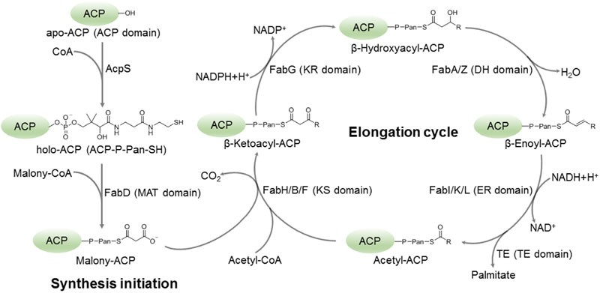
A covalent bond is created between the terminal sulfhydryl of the 4-phosphopantetheine arm, also known as the 4′-Pan-arm, and the carrier protein for the substrate at the early stage of fatty acid synthesis start. A complete acyl carrier protein (holo-ACP) is the name of this transporter protein. There is a short acetyl (or malonyl) group involved in this interaction. To facilitate the elongation of fatty acids, the ACP sequentially interfaces with about four distinct enzymatic modules within the elongation cycle. During each cycle, an extra two carbon units are integrated into the substrate chain, with this process repeating until the final product is liberated. The connections between ACP and enzyme modules within FASN or specific enzymes within FAS-II have only been briefly studied, with the exception of a few rare cases like the incomplete enoyl reduction (FabI)-ACP complex and the covalently linked -hydroxyacyl-ACP dehydratase (FabA)-ACP structure. This is a result of ACP's naturally high degree of flexibility and diffuse nature [48][49]. Consequently, the fundamental mechanisms governing the recognition and manipulation of ACP by enzyme modules for substrate catalysis, particularly during the elongation cycle, remain largely uncharted.
Elongation
An acyl-enzyme or acyl thioester (such as acyl-ACP or acetyl-CoA, notably in the case of FabH) participates in a Claisen fusion process involving malonyl-ACP during the cycle of fatty acid synthesis. The result of this interaction is the formation of a 3-ketoacyl-ACP molecule, as well as the release of the enzyme in its loose state, ACP (or CoA), and the emission of carbon dioxide (CO2). Three E. coli-specific enzymes that were originally known as synthases I, II, and III have since come to be known by their gene names, FabB, FabF, and FabH, respectively. The catalysis of the 3-ketoacyl-ACP synthesis processes is carried out by those enzymes. The enzymes FabB and FabF, structured as dimers, are capable of driving both saturated and unsaturated fatty acid synthesis processes. Due to this step being an irreversible element of the growth process involved in the fatty acid synthesis process, 3-ketoacyl-ACP synthases control the spread of products created by this pathway [50].
Reduction
The 3-keto-thioester, also known as 3-ketoacyl-ACP, proceeds through reduction that is aided by NADPH-dependent 3-ketoacyl-ACP reductase (referred to as Fab G), producing 3-hydroxy acyl-ACP as a byproduct. There is just one 3-ketoacyl-ACP reductase in E. coli, and it is active across the entire range of acyl chain lengths [51].
Dehydration
The enzyme 3-hydroxy acyl-ACP dehydratase, which is also identified as FabZ, assists in eliminating a water molecule from the substrate. This process leads to the creation of enoyl-ACP. The dehydratase enzyme has demonstrated its capability to successfully dehydrate both short-chain and long-chain 3-hydroxy acyl-ACPs, including those with saturated and unsaturated properties [52].

Reduction
The action of enoyl-ACP reductase (FabI) leads to the generation of an acyl-ACP through a reduction pathway. This enzyme, the final one in the fatty acid cycle, plays a pivotal role in governing the precision of fatty acid production. FabI exerts control over the reversible phases of the cycle by influencing the activity of other enzymes, namely FabG and FabZ. The resulting acyl-ACP can act as a starting point for further expansion or, as necessary, for the development of sufficiently prolonged chains, which may eventually result in the production of complex lipids. In the context of E. coli, the prominent saturated fatty acid is crafted through the elongation of trans-3-decanoyl-ACP by FabI. Subsequently, either FabB or FabF follows this step [52].

Lipid extraction from oleaginous bacteria:
Effective solvent extraction of intracellular lipids and the breakdown of protective cell walls in microorganisms, a biomass pretreatment approach such as cell disruption is commonly employed. This process not only improves lipid accessibility by reducing cell wall barriers but also enhances mass transfer and streamlines subsequent processing stages [53]. The advancement of lipid extraction methods has been driven by the need for high-quality products. These procedures include, among others, solvent extraction, the Soxhlet method, the Folch strategy, the Bligh and Dyer plans, the use of supercritical fluids, and ultrasonic treatment [52]. An innovative approach, ultrasonication, has gained widespread use in boosting the yield of bioproducts from various organic waste sources. It has been integrated into a number of processes, including the production of biofuels and oil from crude recovery, and has been proven to be scale-up-applicable. [54][55]. In-situ trans-esterification, a revolutionary technique for making biodiesel, enables bacteria to directly transform oil into fuel without changing its chemical makeup. [55]. In addition to lipid extraction, a number of pretreatment techniques improve lipid recovery. The series employs enzymatic, chemical, and physical approaches to pretreat isolated lipids [56].

Transesterification

Transesterification is a chemical process that entails converting one carboxylic acid ester into another form. The most common transesterification method normally involves an acid's catalyzed contact between an ester and an alcohol. Triacylglycerols (TAGs) and free fatty acids (FFAs) are important lipids from microbial oil while producing biodiesel. By using alcohols like methanol or ethanol, these lipid components can go through transesterification. The development of fatty acid (m)ethyl esters is the result of this reaction being aided by the presence of an acid, an alkali, or an enzyme catalyst [56].
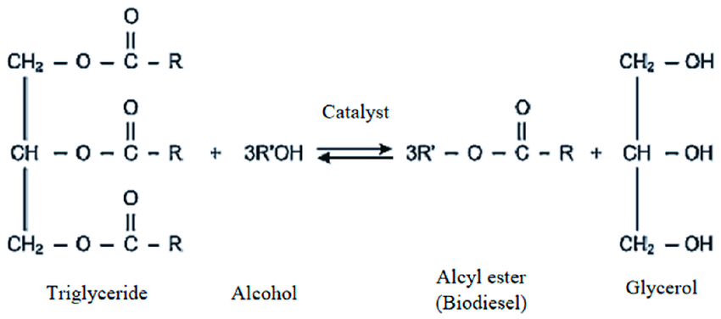

Fig 3: Transesterification process:(Linganiso, Ella & Tlhaole et al.,2022)

Enzymatic transesterification, the dynamics of homogeneous acid-base reactions, and the characteristics of heterogeneous acid-base transesterification represent merely a subset of the various transesterification methods available.

Biodiesel production by oleaginous bacteria from lignocellulosic substrate

The widely available and renewable resource known as lignocellulosic biomass (LB) is mostly made up of the polysaccharides cellulose and hemicellulose as well as the aromatic polymer lignin. Three polymers make up : lignin (10–25%), hemicellulose (20–40%), and cellulose (35–55%). Sugar-rich lignocellulosic biomass can promote the growth of heterotrophic organisms. The production of biofuels, biosourced chemicals, and minerals using LB has a significant potential as a substitute for fossil resources without endangering the world's food supply[57][58][59]. For instance, lipid made up to 70% of the DCW under nitrogen-deficient conditions. The process of fermenting lignocellulosic biomass to produce biogas or ethanol has been studied extensively. Triacylglycerols (TAGs), a precursor for the synthesis of biodiesel, have also been investigated as a potential outcome of these experiments [60][61]. Oleaginous microorganisms (OMs) can use cheap feedstocks, such as waste substrates and lignocellulosic substrates (LCSs), to accumulate more lipid [62]. Delignification, saccharification, the use of microorganisms in fermentation to increase lipid synthesis, and the final transformation through transesterification are the four basic steps in the production of biodiesel from lignocellulosic biomass . [63][64].

Fig 4: Diagrammatic representation of the oleaginous bacteria used in the production of lipids from lignocellulosic biomass.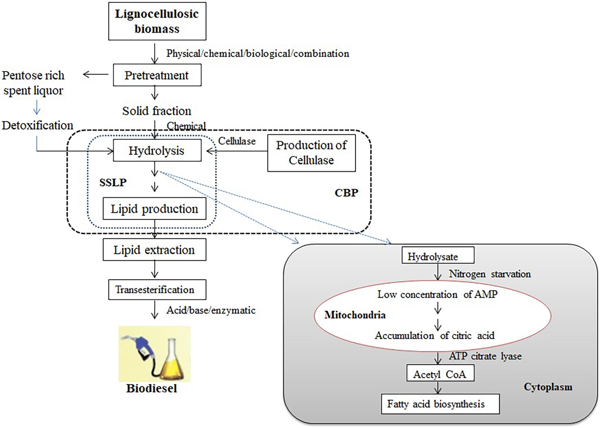

Application of metabolic engineering in microbial cells' synthesis of lipids:
Significant attention is being paid to microbial sources of lipids that can be employed as nutraceuticals or as sources of energy [65]. More than others, the gene regulatory mechanisms for fatty acid production in bacteria are well understood. The most recent method of altering the metabolism of microorganisms through genetic engineering is known as metabolic engineering. Metabolic engineering primarily focuses on the enhancement of existing biochemical pathways or the integration of necessary components [66][67]. When it comes to boosting lipid production in bacteria, specific techniques within the realm of metabolic engineering are employed [52].
Conclusion
The utilization of fossil fuels, urban expansion, and population growth have exerted a notable influence on the economies and resource reserves of numerous countries. Among the prominent solutions to promote sustainability in the environment, biofuels stand out as a highly significant renewable energy source. An developing method for the productive synthesis of third generation biofuels uses oleaginous bacteria and lignocellulosic biomass as a substrate. The negative effects of using both edible and non-edible feedstocks are considerably reduced by the use of oleaginous microorganisms and lignocellulosic biomass.The modification of these cells at genetic and metabolical level is quite easy. There are many ongoing research projects which implement the efficient utilization of microbial cells in the production of biofuels by metabolic engineering technologies.
REFERENCE:
- Ulucak R., Khan S.U.-D. Determinants of the ecological footprint: Role of renewable energy, natural resources, and urbanization. Sustain. Cities Soc. 2019;54:101996. [Google Scholar]
- Hannah Ritchie, Max Roser and Pablo Rosado (2022) - "Energy". Published online at OurWorldInData.org. Retrieved from: 'https://ourworldindata.org/energy' [Online Resource]
- Jared A. DeMello et al.Biodegradation and environmental behavior of biodiesel mixtures in the sea: an initial study Mar Pollut Bull(2007)
- H.M. Alvarez et al.Triacylglycerols in prokaryotic microorganisms Appl Microbiol Biotechnol (2002)
- Mahlia TMI, Syazmi ZAHS, Mofijur M et al (2020) Patent landscape review on biodiesel production: technology updates. Renew Sust Energ Rev 118:109526. https://doi.org/10.1016/j.rser.2019.109526
- Patel A, Arora N, Antonopoulou I (2020a) Single cell oil and ethanol production by the oleaginous yeast Trichosporonfermentans utilizing dried sweet sorghum stalks. Renew Energ 146:1609–1617. https://doi.org/10.1016/j.renene.2019.07.107
- Alalwana HA, Alminshidb AH, Aljaafari HAS (2019) Promising evolution of biofuel generations. Renew Energy Focus 8:127–139. https://doi.org/10.1016/j.ref.2018.12.006
- Aron NSM, Khoo KS, Chew KW et al (2020) The Hong Phong Nguyen sustainability of the four generations of biofuels—a review. Int J Energy Resources. https://doi.org/10.1002/er.5557
- Singh D, Sharma D, Soni SL et al (2020) A review on feedstocks, production processes, and yield for different generations of biodiesel. Fuel 262:116553. https://doi.org/10.1016/j.fuel.2019.116553
- Ferrero GO, Sanchez Faba EM, Rickert AA et al (2020) Alternatives to rethink tomorrow: biodiesel production from residual and non–edible oils using biocatalyst technology. Renew Energy 150:128–135. https://doi.org/10.1016/j.renene.2019.12.114
- Allen J, Unlu J, Demire Y et al (2018) Integration of biology, ecology and engineering for sustainable algal-based biofuel and bioproduct biorefinery. Bioresour Bioprocess 5:47. https://doi.org/10.1186/s40643-018-0233-5
- Hossain N, Mahlia TMI (2020) Progress in physicochemical parameters of microalgae cultivation for biofuel production. Crit Rev Biotechnol 39:835–859. https://doi.org/10.1080/07388551.2019.1624945
- Zhang J, Gao H, Xue Q (2020a) Potential applications of microbial enhanced oil recovery to heavy oil. Crit Rev Biotechnol 40:459–474. https://doi.org/10.1080/07388551.2020.1739618
- Zeghloulia J, Guendouza A, Duchezb D (2021) Valorization of co-products generated by argan oil extraction process: application to biodiesel production. Biofuels. https://doi.org/10.1080/17597269.2021.1941573.
- Demirbas, M.F., 2011. Biofuels from algae for sustainable development. Appl. Energy 88, 3473–3480. https://doi.org/10.1016/j.apenergy.2011.01.059.
- Chisti Y. Biodiesel from microalgae. Biotechnol Adv 2007;25:294–306
- Clark JH, Deswarte FEI, Farmer TJ. The integration of green chemistry into future biorefineries. Biofuels Bioprod Biorefin 2009;3:72–90.
- Maa X, Gaoa Z, Wang Q et al (2018) Biodiesels from microbial oils: opportunity and challenges. Bioresource Technol 263:631–641. https://doi.org/10.1016/j.biortech.2018.05.028
- Carsanba E, Papanikolaou S, Erten H (2018) Production of oils and fats by oleaginous microorganisms with an emphasis given to the potential of the nonconventional yeast Yarrowialipolytica. Crit Rev Biotechnol 38:1230–1243. https://doi.org/10.1080/07388551.2018.1472065

- Patel A, Karageorgou D, Rova E et al (2020b) An overview of potential oleaginous microorganisms and their role in biodiesel and omega-3 fatty acid-based industries microorganisms. Microorganisms 8:434. https://doi.org/10.3390/microorganisms8030434
- Chen G, Zhao L, Qi Y. Enhancing the productivity of microalgae cultivated in wastewater toward biofuel production: a critical review. Appl Energy 2015;137:282–91
- Meng X, Yang J, Xu X, Zhang L, Nie Q, Xian M. Biodiesel production from oleaginous microorganisms. Renew Energy 2009;34:1–5.
- Jin M, Slininger PJ, Dien BS, Waghmode S, Moser BR, Orjuela A, et al. Microbial lipid-based lignocellulosic biorefinery: feasibility and challenges. Trends Biotechnol 2015;33:43–54.
- Williams PJLB, Laurens LML. Microalgae as biodiesel & biomass feedstocks: review & analysis of the biochemistry, energetics & economics. Energy Environ Sci 2010;3:554–90.
- Sawangkeaw R, Ngamprasertsith S. A review of lipid-based biomasses as feedstocks for biofuels production. Renew Sustain Energy Rev 2013;25:97–108.
- Pienkos PT, Darzins A. The promise and challenges of microalgal-derived biofuels. Biofuels Bioprod Biorefin 2009;3:431–40.
- Alvarez HM, Steinbüchel A. Triacylglycerols in prokaryotic microorganisms. Appl Microbiol Biotechnol 2002;60:367–76.

- Alvarez HM, Pucci OH, Steinbüchel A. Lipid storage compounds in marine bacteria. Appl Microbiol Biotechnol 1997;47:132–9.
- Alvarez HM, Luftmann H, Silva RA, Cesari AC, Viale A, Wältermann M, et al. Identification of phenyldecanoic acid as a constituent of triacylglycerols and wax ester produced by Rhodococcus opacus PD630. Microbiology 2002;148:1407–12.
- Alvarez HM, Kalscheuer R, Steinbüchel A. Accumulation of storage lipids in species of Rhodococcus and Nocardia and effect of inhibitors and polyethylene glycol. Fett/Lipid 1997;99:239–46.
- de Andrés C, Espuny MJ, Robert M, Mercadé ME, Manresa A, Guinea J. Cellular lipid accumulation by Pseudomonas aeruginosa 44T1. Appl Microbiol Biotechnol 1991;35:813–6
- Kosa M., Ragauskas A.J. Bioconversion of lignin model compounds with oleaginous Rhodococci. Appl. Microbiol. Biotechnol. 2012;93:891–900. doi: 10.1007/s00253-011-3743-z. [PubMed] [CrossRef] [Google Scholar]
- Kosa M., Ragauskas A.J. Lignin to lipid bioconversion by oleaginous Rhodococci. Green Chem. 2013;15:2070–2074. doi: 10.1039/c3gc40434j. [CrossRef] [Google Scholar]
- Wells T., Wei Z., Ragauskas A. Bioconversion of lignocellulosic pretreatment effluent via oleaginous Rhodococcus opacus DSM 1069. Biomass Bioenergy. 2015;72:200–205. doi: 10.1016/j.biombioe.2014.11.004. [CrossRef] [Google Scholar]
- Wei Z., Zeng G., Huang F., Kosa M., Huang D., Ragauskas A.J. Bioconversion of oxygen-pretreated Kraft lignin to microbial lipid with oleaginous Rhodococcus opacus DSM 1069. Green Chem. 2015;17:2784–2789. doi: 10.1039/C5GC00422E. [CrossRef] [Google Scholar] [Ref list]
- Kumar S, Gupta N, Pakshirajan K (2015) Simultaneous lipid production and dairy wastewater treatment using Rhodococcusopacus in a batch bioreactor for potential biodiesel application. J Environ Chem Eng 3:1630–1636. https://doi.org/10.1016/j.jece.2015.05.030
- Kot AM, Blazejak S, Kurcz A et al (2017) Effect of initial pH of medium with potato wastewater and glycerol on protein, lipid and carotenoid biosynthesis by Rhodotorulaglutinis. Elect J Biotechnol 27:25–31. https://doi.org/10.1016/j.ejbt.2017.01.007
- Wu, S., Hu, C., Jin, G., Zhao, X., Zhao, Z.K., 2010. Phosphate-limitation mediated lipid production by Rhodosporidium toruloides. Bioresour. Technol. 101, 6124–6129. https://doi.org/10.1016/j.biortech.2010.02.111.
- N.M. Zabermawi, Faten A.S. Alsulaimany, M.T. El-Saadony et al., New eco-friendly trends to produce biofuel and bioenergy from microorganisms: An updated review, Saudi Journal of Biological Sciences, https://doi.org/10.1016/j.sjbs.2022.02.024
- Qadeer S, Khalid A, Mahmood S et al (2017) Utilization oleaginous bacteria and fungi for cleaner energy production. J Clean Product 168:917–928. https://doi.org/10.1016/j.jclepro.2017.09.093
- Carsanba E, Papanikolaou S, Erten H (2018) Production of oils and fats by oleaginous microorganisms with an emphasis given to the potential of the nonconventional yeast Yarrowialipolytica. Crit Rev Biotechnol 38:1230–1243.
- Kumar M, Rathour R, Gupta J et al (2020) Bacterial production of fatty acid and biodiesel: opportunity and challenges. Ref Biomass Resid Sust Energ Bioprod. https://doi.org/10.1016/B978-0-12-818996-2.00002-8Return to ref 2020 in article
- Babu MV, Murthy KM, Rao GAP (2020) Production process optimization of SterculiaFoetida Methyl Esters (Biodiesel) using response surface methodology. Int J Ambient Energy. https://doi.org/10.1080/01430750.2020.1723692
- Zhang, L., Xiao, J., Xu, J. et al. Crystal structure of FabZ-ACP complex reveals a dynamic seesaw-like catalytic mechanism of dehydratase in fatty acid biosynthesis. Cell Res 26, 1330–1344 (2016). https://doi.org/10.1038/cr.2016.136
- Ratledge C (2004) Fatty acid biosynthesis in microorganisms being used for Single cell oil production. Biochimie 86:807–815
- Qadeer S, Khalid A, Mahmood S et al (2017) Utilization oleaginous bacteria and fungi for cleaner energy production. J Clean Product 168:917–928. https://doi.org/10.1016/j.jclepro.2017.09.093
- S. Brinster, G. Lamberet, B. Staels, P. Trieu-Cuot, A. Gruss, C. Poyart ,Type II fatty acid synthesis is not a suitable antibiotic target for Gram-positive pathogens Nature, 458 (2009), pp. 83-86
- Rafi S, Novichenok P, Kolappan S, et al. Structure of acyl carrier protein bound to FabI, the FASII enoyl reductase from Escherichia coli. J Biol Chem 2006; 281:39285–39293.
- Nguyen C, Haushalter RW, Lee DJ, et al. Trapping the dynamic acyl carrier protein in fatty acid biosynthesis. Nature 2014; 505:427–431.
- Janben HJ, Steinbuchel A (2014) Fatty acid synthesis in Escherichia coli and its applications toward the production of fatty acid–based biofuels. Biotechnol Biofuels 7:1–26. https://doi.org/10.1186/1754-6834-7-7
- Javidpour P, Pereira JH, Goh EB et al (2014) Biochemical and structural studies of NADH–dependent FabG used to increase the bacterial production of fatty acids under anaerobic conditions. Appl Environ Microbiol 80:497–505. https://doi.org/10.1128/AEM.03194-13
- Koreti, D., Kosre, A., Jadhav, S.K. et al. A comprehensive review on oleaginous bacteria: an alternative source for biodiesel production. Bioresour. Bioprocess. 9, 47 (2022). https://doi.org/10.1186/s40643-022-00527-1
- Tao Dong, Eric P. Knoshaug, Philip T. Pienkos, Lieve M.L. Laurens, Lipid recovery from wet oleaginous microbial biomass for biofuel production: A critical review, Applied Energy,Volume 177,2016, Pages 879-895,ISSN 0306-2619, https://doi.org/10.1016/j.apenergy.2016.06.002.
- Wang Z, Gu S (2017) State-of-the-art on the development of ultrasonic equipment and key problems of ultrasonic oil production technique for EOR in China. Renew Sustain Energ Review 82:2401–2407. https://doi.org/10.1016/j.ultsonch.2017.03.035
- Chen J, Li J, Zhang X (2018) Ultra-sonication application in biodiesel production from heterotrophic oleaginous microorganisms. Crit Rev Biotechnol 38:902–917. https://doi.org/10.1080/07388551.2017.1418733
- Patel A, Karageorgou D, Rova E et al (2020b) An overview of potential oleaginous microorganisms and their role in biodiesel and omega-3 fatty acid-based industries microorganisms. Microorganisms 8:434. https://doi.org/10.3390/microorganisms8030434
- Menon, V., and Rao, M. (2012). Trends in bioconversion of lignocellulose: biofuels, platform chemicals and biorefinery concept. Prog. Energy Combust. Sci. 38, 522–550. doi: 10.1016/j.pecs.2012.02.002
- Chandel, A. K., Garlapati, V. K., Singh, A. K., Antunes, F. A. F., and da Silva, S. S. (2018). The path forward for lignocellulose biorefineries: bottlenecks, solutions, and perspective on commercialization. Bioresour. Technol. 264, 370–381 doi: 10.1016/j.biortech.2018.06.004
- Cheah WY, Sankaran R, Show PL et al (2020) Pretreatment methods for lignocellulosic biofuels production: current advances, challenges and future prospects. Biofuel Res J 25:1115–1127. https://doi.org/10.18331/BRJ2020.7.1.4
- Kumar D, Singha B, Korstad J (2017a) Utilization of lignocellulosic biomass by oleaginous yeast and bacteria for production of biodiesel and renewable diesel. Ren Sustain Energy Rev 73:654–671. https://doi.org/10.1016/j.rser.2017.01.022
- Sun J, Zhang L, Loh KC (2021) Review and perspectives of enhanced volatile fatty acids production from acidogenic fermentation of lignocellulosic biomass wastes. Bioresour Bioprocess 8:68. https://doi.org/10.1186/s40643-021-00420-3
- Kumar, S. P. J., Kumar, N. S., and Chintagunta, A. D. (2020d). Bioethanol production from cereal crops and lignocelluloses rich agro-residues: prospects and challenges. SN Appl. Sci. 2:1673. doi: 10.1007/s42452-020-03471-x
- Zhao, X., Kong, X. L., Hua, Y. Y., Feng, B., and Zhao, Z. B. (2008). Medium optimization for lipid production through co-fermentation of glucose and xylose by the oleaginous yeast Lipomyces starkeyi. Eur. J. Lipid Sci. Technol. 110, 405–412. doi: 10.1002/ejlt.200700224
- Kumar, S. P. J., Gujjala, L. K. S., Dash, A., Talukdar, B., and Banerjee, R. (2017c). “Biodiesel production from lignocellulosic biomass using oleaginous microbes,” in Lignocellulosic Biomass Production and Industrial Applications, eds A. Kuila and V. Sharma (Hoboken, NJ: Wiley), 65–92. doi: 10.1002/9781119323686.ch4
- Ledesma-Amaro R. Microbial oils: A customizable feedstock through metabolic engineering. Eur. J. Lipid Sci. Technol. 2015;117:141–144. doi: 10.1002/ejlt.201400181. [CrossRef] [Google Scholar] [Ref list]
- Liang MH, Jiang JG (2013) Advancing oleaginous microorganisms to produce lipid via metabolic engineering technology. Prog Lipid Res 52:395–408. https://doi.org/10.1016/j.plipres.2013.05.002
- Nie L, Xu K, Zhong B et al (2022) Enhanced l-ornithine production from glucose and sucrose via manipulation of the fructose metabolic pathway in Corynebacterium glutamicum. Bioresour Bioprocess 9:11. https://doi.org/10.1186/s40643-022-00503-9

