EVIDENCE BASED PRACTICE
INTRODUCTION
Evidence based practice (EBP) is the conscientious use of current best evidence in making decisions about patient care. EBP in nursing is a way of providing nursing care that is guided by the integration of the best. It is a problem solving approach to clinical practice and administrative issues that integrates. A systematic search for and critical appraisal of the most relevant evidence to answer a burning clinical question One's own clinical expertise Patient preferences and values.
Evidence-based practice describes a wider, more encompassing discipline, as compared to the original term evidence-based medicine (EBM). The concept of EBM was made a part of medical studies in 1991, but it wasn’t till 2005 that a more inclusive approach was taken. It was found that similar principles can be followed in more fields of healthcare than just medicine.
The EBP process is a method that allows the practitioner to assess research, clinical guidelines, and other information resources based on high quality findings and apply the results to practice.
EBP also involves integrating the best available evidence with clinical knowledge and expertise, while considering patients’ unique needs and personal preferences. If used consistently, optimal patient outcomes are more likely to be achieved.
Using EBP means abandoning outdated care delivery practices and choosing effective, scientifically validated methods to meet individual patient needs. Health care providers who use EBP must be skilled at discerning the value of research for their specific patient population.
Evidence-based practice (EBP) is a really important idea in nursing that is a key component of exceptional patient care. EBP in nursing is an integration of research evidence, clinical expertise, and a patient’s preferences. This problem-solving approach to clinical practice encourages nurses to provide individualized patient care.

EBP has developed over time to now integrate the best research evidence, clinical expertise, the patient's individual values and circumstances, and the characteristics of the practice in which the health professional works.³
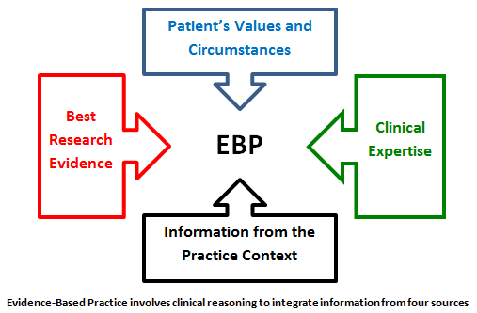
DEFINITION
- The conscientious, explicit and judicious use of current best evidence in making decisions about the care of the individual patient.
- Integrating individual expertise with the best available external clinical evidence from systematic research.
- Available scientific knowledge with nursing expertise. This approach requires nurses to critically assess relevant scientific data or research evidence and to implement high quality interventions for their nursing practice.
- The Sicily Statement on Evidence-Based Practice was published in 2005, and it defined EBP in a similar manner, albeit with slight modifications to make it applicable in fields other than just medical practice. It states that decisions regarding a patient’s healthcare should always be taken on the basis of relevant, recent, and verified evidence.
- However, the patient should be presented with the same evidence as well before finalizing any plan of treatment. The evidence and the best possible treatment paths must be simplified and explained to a patient by concerned healthcare professionals so that the patient can take an informed decision.
Need for Evidence Based Practice:
- For making sure that each client get the best possible services.
- Update knowledge
- Provide clinical judgment
- Improvement care provided and save lives.
EBP is one useful approach to improving the impact of practice in nursing.
EBP put particular emphasis on the result of experimental comparisons.

Steps in EBP Process:
EBP allows the practitioner to assess current and past research, clinical guidelines and other
Information resources.
Steps in EBP Process are
- Formulating a well – built question
- Finding evidence

- Appraising the evidence
- Applying the evidence/ make clinical decision
- Re – evaluation.
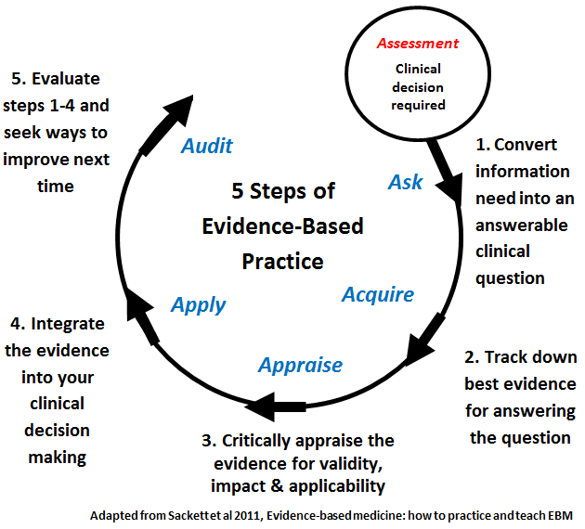

AIM OF EBP
To do the right thing, at the right time, for the right person, ensure quality care for the individual client.
Needed skills for EBP
- Observant and sensitive
- Clinical competence. Knowledge
- Communication
- Learner
- Practitioner
- Learning skills
- Research competent.
EBP PROCESS

Frame question
Select key words
Reevaluate access evidence

Evaluate evidence
Resources of EBP
- Background information/Expert opinion [Books]
- Research articles/ Studies [PubMed]
- Evidence guidelines
- Evidence summaries and abstracts
- Systematic reviews and meta analyses.

EBP IN NURSING
It should be noted that a long, long time before evidence-based practice became a discipline,
Florence Nightingale had successfully used similar ideas to treat soldiers during the mid-1800s. Of
course, EBP in nursing has come a long way since then, but her work in later life is considered to
have laid the foundations of modern nursing. Today, evidence-based nursing education and practice center around a few broad steps, such as:
Value Establishment and Preparation – Often referred to as Step 0 in EBP, it involves establishing the importance, benefits, and value of following evidence-based practice in the mind of nursing students. Step 0 is about preparing them to embrace the Spirit of Inquiry.
Training in EBP – Training nurses in EBP so that they can gain the knowledge and skills required to successfully implement the discipline inpatient care.
PICOT – The five aspects of creating a patient inquiry are called PICOT in short. The letters stand for:
- P – Patient/patients concerned
- I – Intervention
- C – Comparison
- O – Outcome
- T – Time

PRINCIPLES OF EBP FOR PATIENT SAFETY
- First, consider the context and engage health care personnel who are at the point of care in selecting and prioritizing patient safety initiatives, clearly communicating the evidence base (strength and type) for the patient safety practice topic(s) and the conditions or setting to which it applies. These communication messages need to be carefully designed and targeted to each stakeholder user group.
- Second, illustrate, through qualitative or quantitative data (e.g., near misses, sentinel events, adverse events, injuries from adverse events), the reason the organization and individuals within the organization should commit to an evidence-based safety practice topic. Clinicians tend to be more engaged in adopting patient safety initiatives when they understand the evidence base of the practice, in contrast to administrators saying, “We must do this because it is an external regulatory requirement.” For example, it is critical to converse with busy clinicians about the evidence-based rationale for doing fall-risk assessment, and to help them understand that fall-risk assessment is an external regulatory agency expectation because the strength of the evidence supports this patient safety practice.
- Third, didactic education alone is never enough to change practice; one-time education on a specific safety initiative is not enough. Simply improving knowledge does not necessarily improve practice. Rather, organizations must invest in the tools and skills needed to create a culture of evidence-based patient safety practices where questions are encouraged and systems are created to make it easy to do the right thing.
- Fourth, the context of EBP improvements in patient safety need to be addressed at each step of the implementation process; piloting the change in practice is essential to determine the fit between the EBP patient safety information/innovation and the setting of care delivery. There is no one way to implement, and what works in one agency may need modification to fit the organizational culture of another context.
- Finally, it is important to evaluate the processes and outcomes of implementation. Users and stakeholders need to know that the efforts to improve patient safety have a positive impact on quality of care. For example, if a new barcoding system is being used to administer blood products, it is imperative to know that the steps in the process are being followed (process indicators) and that the change in practice is resulting in fewer blood product transfusion errors (outcome indicators).

Advantages of EBP
- Provide better information to practitioner
- Enable consistency of care
- Better patient outcome
- Provide client focused care
- Structured process
- Increases confidence in decision – making
- Generalize information
- Contribute to science of nursing
- Provide guidelines for further research
- Help nurses to provide high quality patient care.
Disadvantages of EBP
- Not enough evidence for EBP
- Time consuming
- Reduced client choice
- Reduced professional judgment/ autonomy
- Suppress creativity
- Influence legal proceedings
- Publication bias.

BENEFITS OF EBP
EBP is the only logical method of formulating a treatment plan, as it is based on medical evidence and not guesswork. If we were to identify the specific advantages which the discipline added to healthcare, they would be as follows. Structure – EBP is a structured, step-by-step procedure for finding the best possible treatment and care plans for each patient. The standardized protocols are evidence-based and verified, so the final treatment plan naturally has a higher chance of success. Current and Relevant – Evidence in the form of lab exam results and the latest findings are backbones of EBP treatment and care. Opinion-based treatment plans are often recommended by senior professionals, which is an outdated method because It may not take into account the most recent developments in medical science.
The senior professional may often forego the need for evidence in favor of his/her professional opinion on the matter.
Increased Accountability – Most hospitals and clinics have now adopted a transparent, step-by-step, evidence-based approach. As a result, tracing accountability to the responsible healthcare provider is quite easy. This has created advantageous situations for both the patient party and the healthcare provider.
If a patient is not content with the outcome of an evidence-based treatment plan, they can consult their lawyer and check for discrepancies between the steps that were supposed to be taken based on the available evidence, and the steps that were actually taken. At the same time, if the clinician did follow all standardized protocols of EBP, they are much less likely to be sued by disgruntled patients.
Improved Chances of Positive Outcomes – When treatment and care plans are in complete sync with the latest medical facts, patient preferences, and sound real-time evidence, they are far more likely to succeed. In the absence of evidence, it is better to wait, if that is an option. Uneducated guesswork can do more damage than good in most cases.
Customization – Before EBP, patients were not made privy to their own treatment plans, which meant that they had little to no say in the final course of action. As we explained in the definition of evidence-based practice itself, involving the patient is a critical part of the whole approach.
Hierarchy of Evidence
- Systematic reviews and meta analysis
- Randomized controlled trials with definitive results
- Randomized controlled trials with non definitive results
- Cohort studies
- Case control studies
- Cross- sectional studies
- Case reports.
Models of EBP in clinical setting
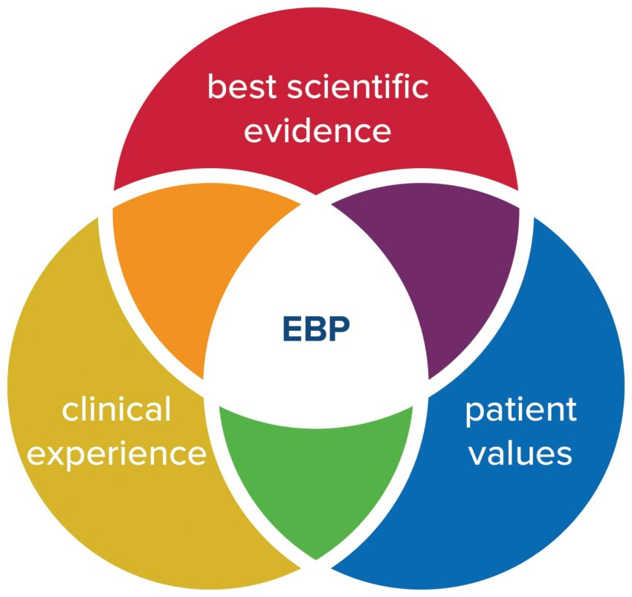
A = Clinical expertise
B= patient value
C=best evidence
John Hopkins nursing EBP model

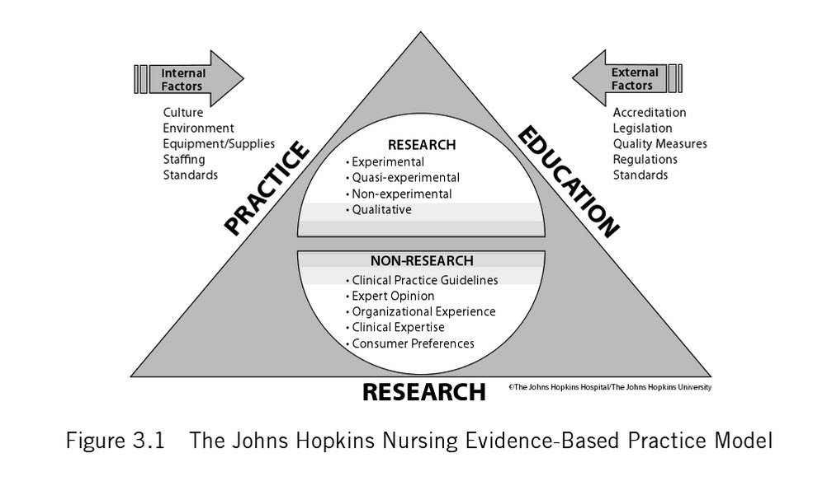
Expert opinion
- Research
- Patient experience
- Practitioner expertise
- Other evidence
[ Evidence Based practice: A Practical approach to implementation JONA, New house R,
Barriers in EBP
- Lack of value for research in practice
- Difficulty in bringing change
- Lack of administrative support
- Lack of knowledge mentors
- Lack of time for research
- Lack of knowledge about research
- Research reports not easily available
- Complexity of research reports
- Lack of knowledge about EBP.

Conclusion
The goal of conducting EBP is to utilize current knowledge and connect it with patient preferences and clinical expertise to standardize and improve care processes and, ultimately, patient outcomes. Regarded as key decision makers within the healthcare team. They are also expected to use the best available evidence in their judgments and decisions. The prescriptive model of evidence-based decision making and the search-appraise- implement process that accompanies it is an active process. Evidence-based practice has gained momentum in nursing, and definitions vary widely. Research findings, knowledge from basic science, clinical knowledge, and expert opinion are all considered "evidence"; however, practices based on research findings are more likely to result in the desired patient outcomes across various settings and geographic locations. Evidence-based practice demands changes in education of students, more practice-relevant research, and closer working relationships between clinicians and researchers. Evidence-based practice also provides opportunities for nursing care to be more individualized, more effective, streamlined, and dynamic, and to maximize effects of clinical judgment. When evidence is used to define best practices rather than to support existing practices, nursing care keeps pace with the latest technological advances and takes advantage of new knowledge developments.

