A brief review on: methods of preparation of solid lipid nanoparticle.
Pallavi P Sambarkar, Priyanka P Thore.
Sdmvm’s Diploma In Pharmacy Institute, chh. Sambhajinagar
ABSTRACT Solid lipid nanoparticles (SLN) are at the front of the speedily emerging field of nanotechnology with several potential applications in drug delivery and research.Different invented nanoparticles and drugs retaining low solubility and poor pharmacokinetic profiles are the two major substances widely delivered to specific target sites.Solid lipid nanoparticles (SLN) has as a severalpotential applications in drug delivery and research. Due to their characteristic size dependent properties, solid lipid nanoparticles offerprospect to develop new therapeutics. The capacity to combine drugs into nanocarriers deals with new sample in drugdelivery that could usage for drug directing. Therefore solid lipid nanoparticles hold excessivecapacity for getting the goal ofcontrolled and site specific drug delivery and thereforeinvolved wide consideration of researchers. This review presents carriers and different methods of preparations of SLN.

Key words: nanocarriers, Colloidal drug carriers, Homogenization, TEM, Biodistribution targeting.

INTRODUCTIONThe reduction in the particle size of materials at the nanometer scale increases their overall surface area by several orders of magnitude. Particles with a size in the range of 1 nm to 1000 nm are known as nanoparticlesSolid lipid nanoparticles (SLN) introduced in 1991 represent an alternative carrier system to conventional colloidal carriers such as - emulsions, liposomes, and nanoparticles1.Nanoparticles prepared from solid lipids are fascinating major attention as novel colloidal drug carrier forintravenous uses as they have been proposed as an another particulate carrier system. SLN offer distinctive properties such as small size, largesurface area, high drug loading and the interaction of phases at the edge and are attractive for theirpotential to improve performance of pharmaceuticals2,5,6.In order to overcome the drawbacks associated with the liquid state of the oil droplets, the liquidlipid was substituted by a solid lipid nanoparticals, which ultimatelyaltered into solid lipid nanoparticles.Solid lipid nanoparticles are one of the distinctive potential colloidal carrier systems as substitutematerials to polymers which is identical to oil in water emulsion for parenteral nutrition, but the liquid lipidsof the emulsion has been replaced by a solid lipid shown on Fig. 1.

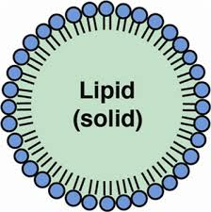

Fig. 1: A diagrammatic representation on SLN over emulsions and liposomes

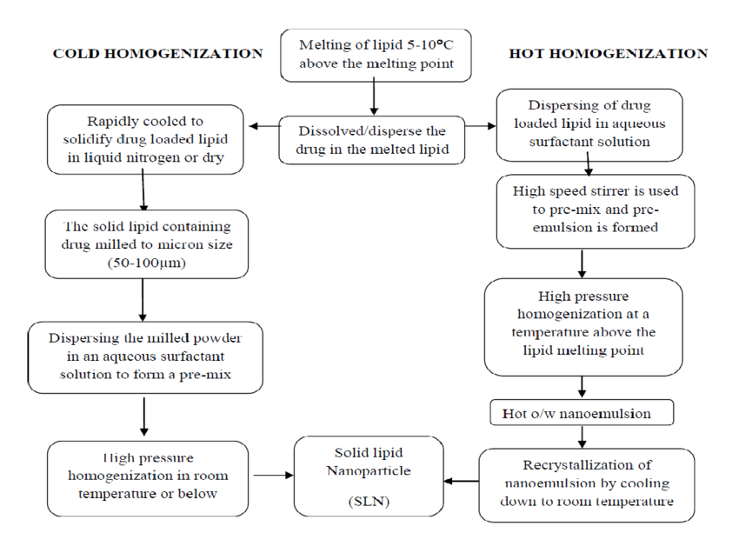The schematic representation of different particulate drug carriers such as emulsions and liposomes and theiradvantages are compared with SLNs SLNs combine all the advantages of polymeric nanoparticles,fat emulsions and liposomes.

Advantages of SLN1-4
• Control and target specific drug release.
• Excellent biocompatibility5.
• Improve stability of pharmaceuticals4.
• High and enhanced drug content.
• Easy to scale up and sterilize.
• Enhanced control concluded release kinetics of encapsulated compounds.
• Enhanced bioavailability of entrapped bioactive compounds.
• Chemical protection of labile incorporated compounds.
• It is easier to manufacture than bio polymeric nanoparticles.
• No special solvent required.
• Conventional emulsion manufacturing methods applicable.
• Raw materials required is the same as in emulsions.
• Very high long-term stability.
• Application versatility.
• Can be subjected to commercial sterilization procedures.
Aims of solid lipid nanoparticles6,9
• Possibility of controlled drug release.
• Increased drug stability.
• High drug content.
• No bio-toxicity of the carrier.
• Anticipation of organic solvents.
• Fusion of lipophilic and hydrophilic drugs.
Preparation of solid lipid nanoparticles1- 4,6,43,52,56
SLNs are also the potential carriersSLNs are prepared from lipid, emulsifier and water/solvent by using different methods, these methods are discussed here
Methods of preparation of solid lipid nanoparticles
1. High pressure homogenization
A. Hot homogenization
B. Cold homogenization
2. Ultra sonication/high speed homogenization
A. Probe ultrasonication
B. Bath ultrasonication
3. Solvent evaporation method
4. Solvent emulsification-diffusion method
5. Supercritical fluid method
6. Microemulsion based method
7. Spray drying method
8. Double emulsion method
9. Precipitation technique
10. Film-ultrasound dispersion

1. High pressure homogenization (HPH)
It is a prevailing technique, which is used for the production of SLNs. High pressurehomogenizers impulse a liquid by high pressure (100–2000 bar) through a narrow gap (in the range of a fewmicrons). The fluid accelerates at high velocity (over 1000 Km/h)over a very short distance. Because of Very highshear stress and force particles distripute down to the submicron range. Normally 5-10% lipidcontent is used but may increase up to 40%.Two general techquines of HPH are hot homogenization and cold homogenization, both are work on thesame concept of mixing the drug in bulk of lipid melt.

A. Hot homogenization: this method is carried out at above the melting point oflipid and can hence it is known as the homogenization of an emulsion. Melting of pre-emulsion of the drugloaded lipid and the aq. emulsifier phase at same temprature is obtained by high-shear mixingdevice. HPH of the pre-emulsion is above melting point of lipid.Due to the decreased viscosity of the inner phase and higher temperatures result in lower particle sizes.Due to high temperatures may cause increase the degradation rate of the drug and the carrier. Increasing the number of cycles and homogenization pressure often results in an increase of the particle size due to highkinetic energy of the particles.

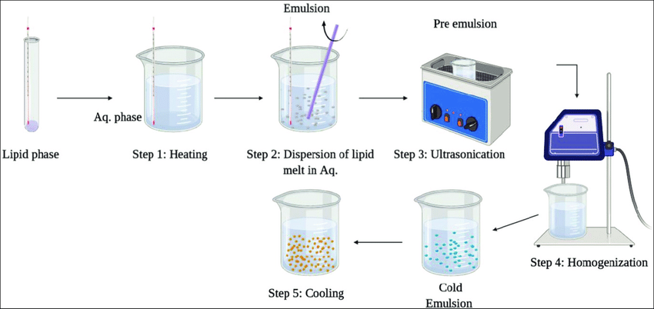

Fig. 3: hot homogenization method

B. Cold homogenization
Cold homogenization method is very useful to overcome the various problems in hothomogenization like Temperature-induced drug degradation, drug distribution into the aqueous phase, Complexion of the crystallization.this is modified method in which drug containing lipid melt is cooled, the solidlipid ground to lipid microparticles and these lipid microparticles are dispersed in a cold surfactant solutionyielding a pre-suspension. Then this pre-suspension is homogenized at or below room temperature, thegravitation force is strong enough to break the lipid microparticles directly to solid lipid nanoparticles.

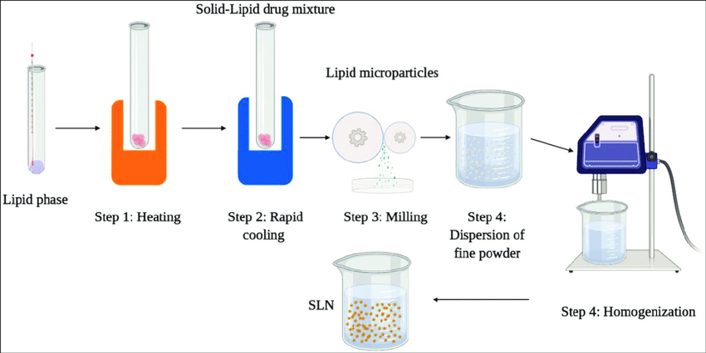

Fig. 4: cold homogenization process

2. Ultrasonication/high speed homogenization
SLNs are also prepared by ultrasonication or high speed homogenization techniques. To reduced particle size both ultrasonication and high speed homogenization is required. Reduce shear stress is most important advantage.

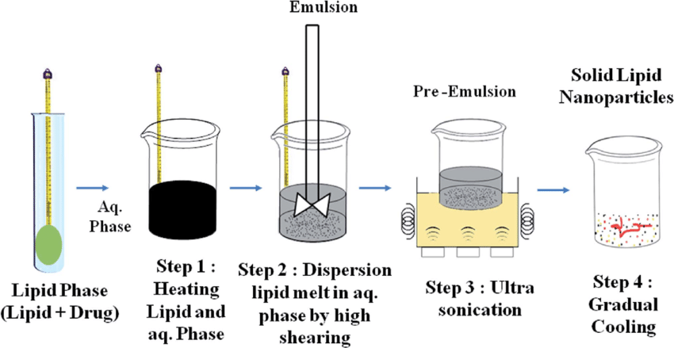

Fig.5: Ultrasonication/high speed homogenization process

3. Solvent evaporation
SLNs can also prepared by solvent evaporation method. The material is dissolved in a water-immiscible organic solvent (e.g. cyclohexane) and isemulsified in an aqueous phase. By the evaporation of the solvent, nanoparticles dispersion is formed by precipitation of the lipid in the aqueous medium by formation of the nanoparticles of 25 nm mean size. The solution was emulsified in an aqueous phaseby high pressure homogenization. The organic solvent was removed from the emulsion by evaporation under reduced pressure (40–60 mbar).solvent evaporation method is scalable continuous and commercially demonstrated.

4. Solvent emulsification-diffusion method
Thismethod involves the emulsification of organic solution of drug which is miscible with water and it also encloses stabilizers. The particles with normal diameters of 30-100 nm can be acquired by this method. Prevention of heat during the process is the most significant advantage of this technique.

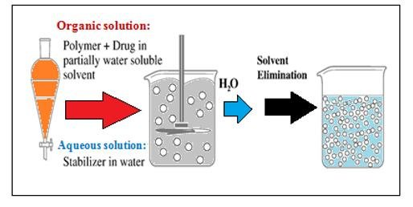

Fig. 5: Systematic representation for emulsification-diffusion method

.
5. Supercritical fluid method
This is an alternative method of preparing SLNs by particles from gas saturated solutions (PGSS)this method is very useful for particle of dry powder and mild pressure temp condition.
this technique is the suitable to minimize the use of solvents.
The Particles are obtained in the form of dry powder.
Mild pressure and temperature conditions.

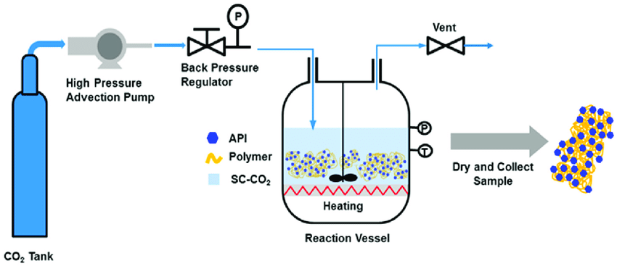

6. Microemulsion based method
This method is established on the dilution of microemulsions. This method is composed of micro-emulsions which are of two-phase systemscomposed of an inner and outer phase (e.g. o/w microemulsions). They are made by stirring an opticallytransparent mixture at 65-70°C, which typically composed of a low melting fatty acid (e.g. stearic acid), anemulsifier (e.g. polysorbate 20), co-emulsifiers (e.g. butanol) and water. With continuous stirring the hot microemulsion is dispersedin cold water (2-3°C) . SLN dispersion method can be used as granulation fluid for shifting in tosolid product (tablets, pellets) by granulation method. High-temperature gradients help in rapid lipid crystallization and avoidaggregation.
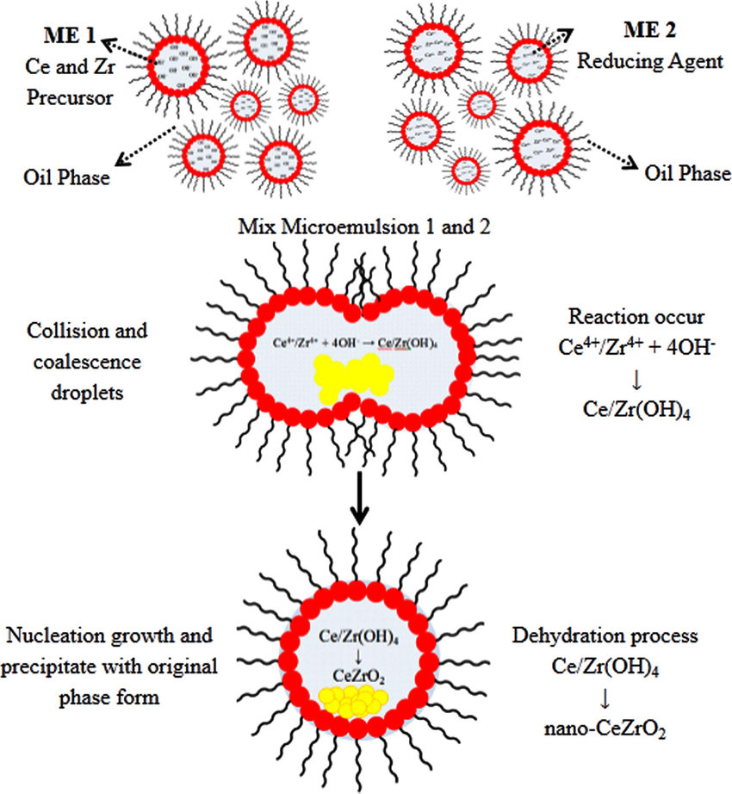

Fig. 6: Microemulsion method

7. Spray drying method
It issubstitute technique to the lyophilization method. This remarks the use of lipid withmelting point more than 70oC. The best results were obtained with SLN concentration of 1% in a solution in water or 20 in ethanol-water mixture.
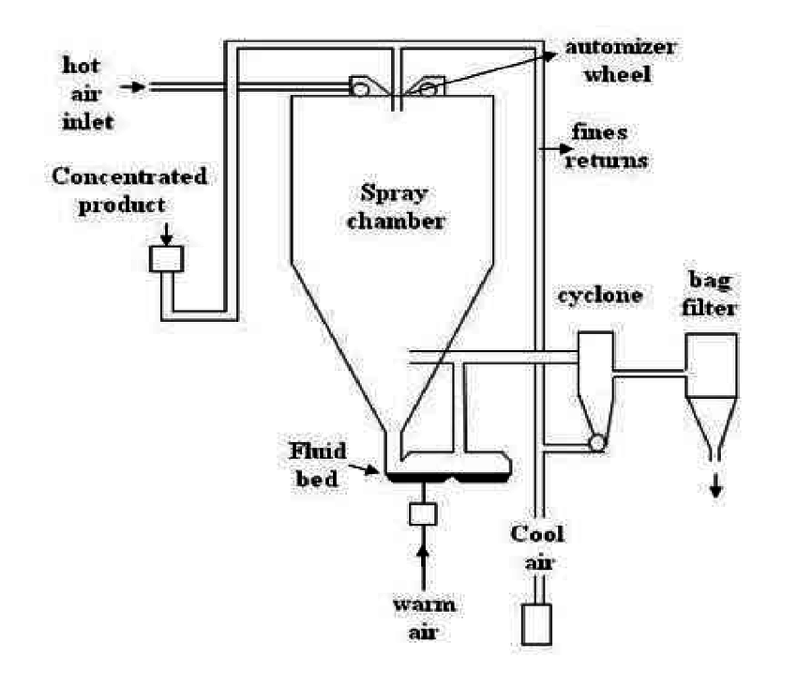

Fig 07-Spray drying method

8. Double emulsion method
In this method the drug is encapsulated with a stabilizer to prevent the separating of drug in to external waterphase during solvent evaporation in the external water phase of w/o/w double emulsion.

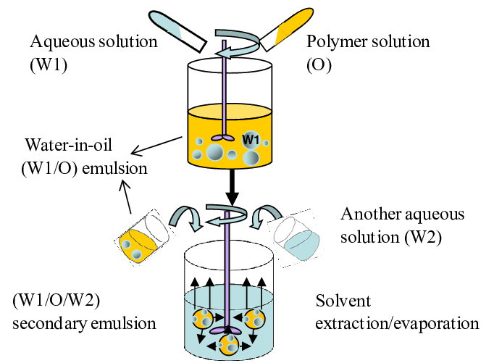

Fig 08-Double emulsion method

9. Precipitation method
The glycerides are liquefied in an organic solvent (e.g. chloroform) and the solution will form an aqueous phase. After evaporation of the organic solvent the lipid will be precipitatedand form nanoparticles.Chemical precipitation is the most common method used in removing dissolved (ionic) metals from solutions, such as process wastewaters containing toxic metals. The ionic metals are altered to an insoluble form (particle) by the chemical reaction between the soluble metal compounds and the precipitating reagent. The particles made by this reaction are removed from solution by settling and/or filtration. The unit operations typically required in this technology includes neutralization, precipitation, coagulation/flocculation, solids/liquid separation, and dewatering.

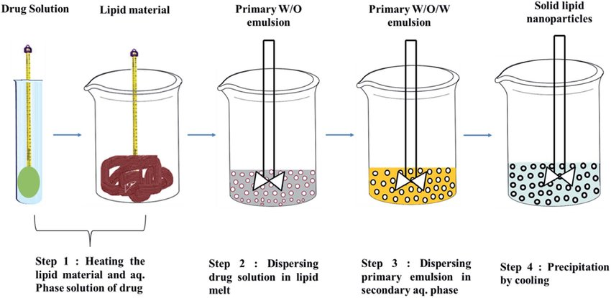

Fig 09-Precipitation method

10. Film-ultrasound dispersion
The solvent and the drug were put into suitable organic solutions, after decompression, rotation andevaporation of the organic solutions, a lipid film is formed, then the aqueous solution which includes theemulsions was added. By the ultrasound with the analysis to diffuser at last, the SLN with the slight andconstant particle size is formed.

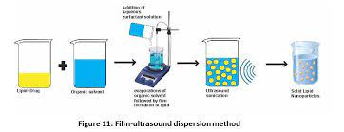
Conclusion-. SLN provide a novel and unique drug-delivery system. The SLNs have the potential to achieve, at least partially, these broad objectives. Apart from these, the regular objective of controlled drug delivery is aptly achieved with SLNs.Clear advantages of SLN include the composition (physiological compounds), the rapid and effective production process including the possibility of large scale production, the avoidance of organic solvents and the possibility to produce carriers with higher encapsulation efficiency. The appropriate characterization of the complex surfactant/lipid dispersions requires several analyticalmethods in addition to the determination of the particle size.

References
1.S. Mukherjee, S. Ray and R. S. Thakur, Ind. J. Pharm. Sci., 349-358 (2009).
2. M. R. Mozafari, 41-50 (2006).
3. Rainer H. Muller, Karsten Mader and Sven Gohla, Eur. J. Pharm. Biopharm., 50(1), 161-177 (2000).
4. Wolfgang Mehnart and Karsten Mader, Adv. Drug. Deliv. Rev., 47, 165-196 (2001).

5. Houli Li, Xiaobin Zhao, Yukun Ma and Guangxi Zhai, Ling Bing Li and Hong Xiang, Lou. J. Cont.
Release, 133, 238-244 (2009).

6. Melike Uner, Gulgun Yener, Int. J. Nanomedicine, 2(3), 289-300 (2007).

Indu Pal Kaur, Rohit Bhandari, Swati Bhandari and Kakkur. J. Cont. Rel., 127, 97-109 (2008).

Antonio J. Almeida and Eliana Souto, Adv. Drug Delivery Rev., 59, 478-490 (2007)
S. P. Vyas and R. K. Khar, Controlled Drug Delivery - Concepts and Advances, First Edition, Vallabh
Prakashan (2002) pp. 38-50.
Joseph Robinson and Vincent H. L. Lee, Controlled Drug Delivery - Fundamentals and Applications,
2nd Edition, 4-33.

