Polymeric materials and their applications in civil construction
Shashikala A R^{1*} and Sridhar B S²
^{1*}Department of Chemistry, Presidency University, Itgalpura, Bengaluru-64
²Department of IEM, M S Ramaiah Institute of Technology, MSR Nagar, Bengaluru-54
*Corresponding author Email ID:aarudirs@gmail.com
Abstract
With the technological advancements in the field of architecture industry advanced construction materials are gaining importance. Advanced materials are slowly replacing conventional construction materials due to their large number of advantages. Even though conventional materials have higher strength they do not provide resistance to flame, oxidation and are static in nature. Polymeric materials are gaining more importance as they possess better functional properties and are easily synthesized when compared to conventional inorganic construction materials. Polymeric materials can be used as binders, top coats as well as substrates. The properties of polymeric materials can be altered as per the requirements by blending with additives. These polymeric materials can be mixed with conventional materials like concrete to improve the properties. This chapter provides the classification, properties, applications, merits and demerits of polymeric materials in the construction field.
Key words: Polymers, FRPs, Building materials, Polyester, Epoxy resin, Concrete
1.0 Introduction
Polymers are the macromolecules obtained by combining many small repeat units. The repeat units are called monomers and the processes by which monomers combine to form polymers is called Polymerization [1]. Formation of polymers depends on the functionality of the monomers, which is related to number of bonding sites. A monomer should have minimum two bonding sites for the formation of polymers. Polymers can be obtained by either addition or condensation polymerisation mechanism. The monomers will be simply added together to give polymers without the elimination of by-products in addition polymerisation (ex: PE, PVC, Teflon) but in condensation polymerisation polymers are formed by condensation reaction [2] between the monomeric units with the elimination of by-products (Ex: Nylon, Epoxy resin, Bakelite).
Building materials can be classified into three types as structural materials, decorative materials and special materials based on the requirement [3]. Structural materials which provide foundation and protect entire building. Commonly used structural materials are bamboo, wood, metals, concrete, composites, glasses etc. Decorative materials provide pleasing appearance and special effects viz coatings, resins, colouring agents, glasses etc. Special materials are used for specific application. They provide flame retardance, corrosion resistance, heat and sound insulation etc.
Due to advent in polymer technology, there are many polymers which can replace conventional building materials due to their superior properties. The main advantages of polymers are they are light weight, flexible, antistatic, good insulators, high strength, water proof, resistant to corrosion, capable of heat and sound insulation. As a result, they can be used in construction industry, as structural materials, decorative materials and special materials.
2.0 Polymer Concrete as structural material
Polymer concrete is a composite material prepared by mixing the polymers with aggregates which acts as binding materials providing strength and durability. Polymers that can be used as binding materials in the polymer concrete preparation are polyurethane (PU), Polyesters, Epoxy resin and Poly acrylates like PMMA. These liquid polymers act as resins in the aggregates and provide better binding. Table 1 provides the properties of polymers [4] used in polymer concrete and Figure 1 gives the chemical structure of these polymers.
Table 1: Properties of commercial polymers used in construction industry
Sl. No. | Name of the polymer | Properties
1 | Polyurethane | Less toxic  Resistant to chemicals  Good adhesion properties  Greater strength  Shrinkage resistant  Can be cured easily  Good insulator
2 | Polyester | Resistant to heat  Higher strength  High abrasion resistance  Have dimensional stability  Good molding properties
3 | Epoxy resin | - Less toxic  - High tensile strength  Good adhesion and molding properties  - Good shrinkage resistance  - Resistant to chemicals  - Low cost
4 | Acrylates (PMMA) | High strength  Transparent in nature  Resistant to weathering  Good refractive index  UV stable  Bio-compatible

In comparison with cement, polymer concrete has advantages and better functional properties with higher mechanical strength which is essential in the construction field. Polymer concrete have good thermal properties and are stable at elevated temperatures [5]. Polymer concrete is chemically inert and do not undergo corrosion as liquid polymers does not allow chemical gases and moisture to diffuse in to the structure. Unlike cement concrete, polymer concrete do not allow destruction in the structure due to dissolution of the concrete material. It is reported in literature that [6], the freeze thaw resistance of Polymer concrete is much higher than that of normal cement concrete when they were subjected to weight loss experiments. The Figure 2 shows the freeze thaw of the structure wherein normal Portland cement is used. Atmospheric Carbon dioxide normally diffuses in to the Portland cement which reacts with cement in presence of moisture resulting in carbonation of cement. Carbonation of cement leads to reduced alkalinity, changes in microstructure and loss of material which affects the durability of the structure. On the other hand, Polymer concrete does not allow diffusion of Carbon dioxide and moisture into the concrete and prevents carbonation of cement [7].

Figure 1: Chemical structure of polymers used in polymer concrete
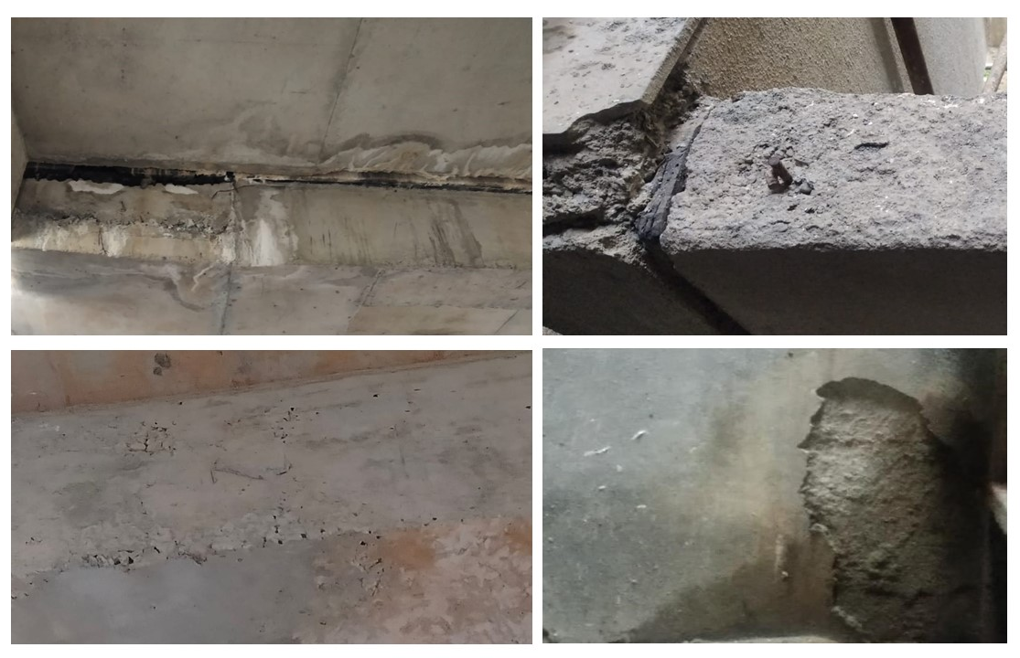
Figure 2: Freeze thaw observed in the building constructed with normal concrete
Some of the major advantages of polymer concrete over cement concrete is given below,
- provide better adhesion
- easy to apply on narrow cross section
- higher mechanical strength
- lower moisture and air permeability
- greater compression strength
- resistant to corrosion
- higher resistance to impact
- long lasting
- can withstand higher pressure
- resistance to wear and tear
- light in weight
- require less curing time and sets easily
Polymer concrete also have few disadvantages in comparison with Portland cement concrete. They are listed below,
- at most care to be taken while mixing polymers with aggregates in appropriate ratio
- as chemicals are used in polymer concrete, it may not be safe for people working on it. Safety kits to be used while working with polymer concrete
- it is expensive than normal concrete
- skilled workers are required while mixing polymer concrete

3.0 Polymer binders
Many polymers are used as binders in mortars due to its flexibility and adhesion strength. Polymers can minimize stiffness and friction during binding. Polymers can be mixed with cement in a proper ratio to improve the properties. As the ratio of polymer to cement increases stiffness reduces. Glass transition temperature of the polymer has remarkable effect on binding properties. Glass transition temperature is the temperature below which the polymer will be hard and brittle, above which it will be soft and flexible. It gives an idea about the processing temperature of the polymer, flexibility and workability of the polymer. Young’s modulus of polymer decreases with decrease in glass transition temperature and have greater influence on cement hydration [8]. Methyl cellulose is a promising binder extensively used in mortars. Methyl cellulose, an ester of cellulose is synthesized by treating cellulose with methyl chloride in presence of alkali at high temperatures [9]. It has low molecular weight and provide better strength. Methyl cellulose is water soluble, have excellent thermal gelation properties and used as pharmaceutical binder. Incorporation of methyl cellulose as binder increased the adhesion in mortars providing low slip due to its higher viscosity.
Biopolymers can also be used as binders due to its advantages. Biopolymers are ecofriendly in nature and can be used as plasticizing material in cement. Lignin an organic polymer obtained from plants and its derivative may be used as adhesive in building materials due to its greater workability, mechanical strength. Lignosulphonate a derivative of lignin finds application as admixture [10]. Low conducting, rigid lignin based polyurethanes are being used as construction and insulation material. Chemical structure of lignin is provided in Figure 3. Properties and applications of biopolymers used as binders are listed in table 2.
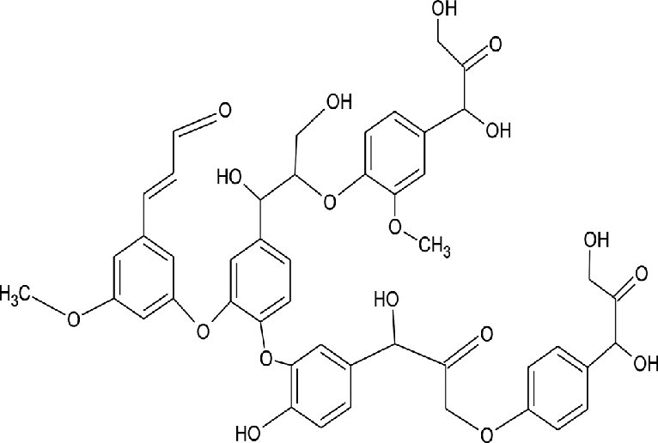

Figure 2: Chemical structure of Lignin a Biopolymer
General properties of biopolymers are listed below:
- they are biodegradable
- ecofriendly
- carbon neutral
- have good mechanical strength
- sustainable
- non toxic
- non carcinogenic
- do not coagulate
- chemically inert
Table 2: Properties and applications of biopolymers used as binders
Sl. No. | Name of the Biopolymer | Property | Applications
1 | Lignin | Biodegradable  Good insulator  Adhesive and coatings  Plasticity | Binder in concrete industry, corrosion resistant coating, plasticizer
2 | Proteins | Good strength,  Amphoteric in nature  Color less  Viscous | Paints, additive in construction industry,  Engineered living materials, edible coating material, emulsifier
3 | Natural polysaccharides | Adhesive  Good mechanical strength  Need little water while mixing | Additive/ binder in construction industry, effluent treatment
4 | Bacterial cellulose | Bio-compatible  Eco friendly  Good tensile strength  Capable of high water holding  Good mechanical properties | Composite resin, food industry, textile industry

Natural polysaccharides, proteins, bacterial cellulose also finds application in construction industry. Natural polysaccharides are hydrophobic in nature hence are water insoluble, but soluble in organic solvents. They can be neutral of acidic in nature. Natural polysaccharide based admixtures enhances water retention power in fresh cement mortars [11-13]. Proteins are the macromolecules having long chain amino acid groups which play major role in providing the nutritional benefit for plant and animals. Casein a biopolymer protein can be used effectively in the manufacture of green buildings. Casein lower the environmental impact and finds application as construction material. As it is viscous in nature, finds applications as paints and coating material. Cracks in the structure reduces life of the building and deteriorate the entire structure of the building. Filling of the cracks is a challenge and is also expensive. Bacterial cellulose, a biopolymer synthesised from bacteria play a major role in repairing the cracks by filling. Many researchers have studied the effect of bacterial cellulose concentration on the strength and durability of the concrete. The reports suggest compression strength and acid resistance may be improved with the incorporation of bacterial cellulose. Bacillus Megaterium, a bacterial cellulose can improve the durability and performance of cement even at lower concentration as 10,000 cells per mL [14].
4.0 Polymer coatings
Polymer coatings are the excellent protective materials used extensively in industries. Polymer coatings are used in construction fields, automobile and electronic industries due to its barrier properties. They act as a protective barrier between the air/ moisture/chemicals and the metal, protecting the metal structure from corrosion [15]. They are resistant to penetration of media. Phenolic resins, epoxy resins, polyesters, polyvinyl alcohols, polyacrylates are being used as industrial coating applications [16]. Polymer coatings also provide decorativeness to the substrate along with protection against corrosion. They protect the structure from wear and damage. Polymer coatings are applied on the concrete structure or a metal to provide an additional thin layer protection. They have self-healing capacity and can be applied on the floors, exterior as well as interior walls and roofs [17, 18]. These coatings provide water proofing, fire retardance, thermal insulation ability and are corrosion resistant.
Conclusions
Polymers have been used extensively in construction industry due to its advantages and attractive properties. Polymeric building materials not only provide protection and strength but also provide durable finish on the structures. When polymeric materials are added to concrete or mortar, the resulting compound has greater advantages over conventional building materials. Mixing polymers with aggregates improves the strength of the concrete, provide better adhesion, thermal insulation and reduce curing time. They also improved resistance to weathering and corrosion. Polymer binders can replace conventional building materials due to its inherent properties. Polymers are not only used in the manufacturing of polymer concrete but also as binders and coatings. Many organic and biopolymers provide protection when used on walls, floor and roofs. They can be used as sterilizer coating, water proof coatings, thermal insulation coatings, flame retardant coating and self-healing coatings. To conclude, polymers are one of the most useful material invented in 20th century and have wide range of applications in various industries due to its excellent properties.
References
- Saldivar-Guerra, E., & Vivaldo-Lima, E. (2013). Handbook of polymer synthesis, characterization, and processing. John Wiley & Sons.
- S. Fakirov, Condensation Polymers: Their Chemical Peculiarities Offer Great Opportunities, Progress in Polymer Science, Volume 89, 2019, Pages 1-18, ISSN 0079-6700, https://doi.org/10.1016/j.progpolymsci.2018.09.003.
3. The Basic Properties of Building Materials, Editor(s): Haimei Zhang, In Woodhead Publishing Series in Civil and Structural Engineering, Building Materials in Civil Engineering,
Woodhead Publishing, 2011, Pages 7-423, ISBN 9781845699550, https://doi.org/10.1533/9781845699567.7.
4. Xiaoqing Wang, Biao Ma, Shasha Chen, Kun Wei, Xingxiang Kang, Properties of epoxy-resin binders and feasibility of their application in pavement mixtures, Construction and Building Materials, Volume 295, 2021, 123531, ISSN 0950-0618, https://doi.org/10.1016/j.conbuildmat.2021.123531.
5. M.M. Reda Taha, M. Genedy, Y. Ohama, 17 - Polymer concrete, Editor(s): Sidney Mindess, In Woodhead Publishing Series in Civil and Structural Engineering, Developments in the Formulation and Reinforcement of Concrete (Second Edition), Woodhead Publishing, 2019, Pages 391-408, ISBN 9780081026168, https://doi.org/10.1016/B978-0-08-102616-8.00017-4.
6. Jingjing Shen, Jianwei Liang, Xinfeng Lin, Hongjian Lin, Jing Yu and Zhaogang Yang, Recent progress in polymer-based building materials, International Journal of Polymer Science, Volume 2020, Article ID 8838160, pages 1-15. https://doi.org/10.1155/2020/8838160
7. Branko Šavija, Mladena Luković, Carbonation of cement paste: Understanding, challenges, and opportunities, Construction and Building Materials, Volume 117, 2016, Pages 285-301, ISSN 0950-0618. https://doi.org/10.1016/j.conbuildmat.2016.04.138
8. Jansen, D., Lu, Z., Kong, XM. et al. The influence of the glass transition temperature (T_{g}) of polymers on early OPC hydration: a complete study of the heat flow, phase evolution, and pore solution chemistry. Mater Struct 52, 120 (2019). https://doi.org/10.1617/s11527-019-1435-9
9. Anuj Kumar, Yuvraj Singh Negi, Nishi Kant Bhardwaj, Veena Choudhary, Synthesis and characterization of methylcellulose/PVA based porous composite, Carbohydrate Polymers, Volume 88, Issue 4, 2012, Pages 1364-1372, ISSN 0144-8617, https://doi.org/10.1016/j.carbpol.2012.02.019.
10. A. Sinha, D.Z.H. Lim, J. Wei, A lignin-based capsule system with tunable properties tailored for robust self-healing concrete, Cem. Concr. Compos., 132 (Sep. 2022), 10.1016/j.cemconcomp.2022.104643
11. Patural, P. Marchal, A. Govin, P. Grosseau, B. Ruot, O. Devès, Cellulose ethers influence on water retention and consistency in cement-based mortars, Cem. Concr. Res., 41 (1) (Jan. 2011), pp. 46- 55. https://doi.org/10.1016/j.cemconres.2010.09.004
12. C. Marliere, E. Mabrouk, M. Lamblet, P. Coussot, How water retention in porous media with cellulose ethers works, Cem. Concr. Res., 42 (11) (Nov. 2012), pp. 1501-1512, https://doi.org/10.1016/j.cemconcomp.2012.04.010
13. M. Lasheras-Zubiate, I. Navarro-Blasco, J.M. Fernández, J.I. Álvarez, Effect of the addition of chitosan ethers on the fresh state properties of cement mortars, Cem. Concr. Compos., 34 (8) (Sep.2012), pp. 964-973, https://doi.org/10.1016/j.cemconcomp.2012.04.010
14. B. Dharmabiksham, K. Murali, Experimental investigation on the strength and durability aspect of bacterial self-healing concrete with GGBS and dolomite powder, Mater. Today Proc., 66 (Jan. 2022), pp. 1156-1161, 10.1016/j.matpr.2022.04.955
15. Yuqin Tian, Haowei Huang, Weishan Wang, Yanqi Ma, Xiaoling He, Li Zhang, Xinxin Sheng, Xinya Zhang, Chapter 24 - Corrosion resistant nanoscale polymer-based coatings, Editor(s): Sabu Thomas, Jesiya Susan George, Polymer-Based Nanoscale Materials for Surface Coatings, Elsevier, 2023, Pages 547-584, ISBN 9780323907781, https://doi.org/10.1016/B978-0-32-390778-1.00031-1.
16. Jesiya Susan George, Suraj P R, Sabu Thomas, Poornima Vijayan P, Chapter 13 - Mechanical properties of nanoscale polymer coatings, Editor(s): Sabu Thomas, Jesiya Susan George, Polymer-Based Nanoscale Materials for Surface Coatings, Elsevier, 2023, Pages 259-274, ISBN 780323907781, https://doi.org/10.1016/B978-0-32-390778-1.00020-7.
17. K. S. Rebeiz, D. W. Fowler, and D. R. Paul, “Polymer concrete and polymer mortar using resins based on recycled poly(ethylene terephthalate),” Journal of Applied Polymer Science, vol. 44, no. 9, pp. 1649–1655, 1992.
18. Correia Diogo, A. (2015). Polymers in Building and Construction. In: Gonçalves, M., Margarido, F. (eds) Materials for Construction and Civil Engineering. Springer, Cham. https://doi.org/10.1007/978-3-319-08236-3_10.

