Earthquake Resistant Materials & Construction Technologies for Housing
Author - Prof. Shilpa Nagapurkar
MIT Art, Design & Technology University, School of Architecture, Loni Kalbhor, Pune – 412201
shilpa.nagapurkar@mituniversity.edu.in Contact no : 9890282138

Summery:
Today the buildings and cities all over world are facing destructive forces and diverse challenges due to fast urbanization, natural disasters like flooding, earthquake, storm, etc. This causes more damages to the building structures, and cities. To overcome such damages due to disasters, the resilient structure is adopted.
In India, many cities/regions come under earthquake prone zones and facing the problem that leads to destruction of buildings and cities. This brought the need of resilience in the buildings from earthquake. Some of the core cities faces the problem with conventional way of construction, also being developing country, there is a need of rapid construction with resilience.
This chapter identifies the advanced construction materials and technologies used for earthquake resilient housing construction.

Introduction
In India many cities face problems during earthquake, major damages to the buildings effects the livelihood of the people. To overcome such problems, the resilient strategies in construction should be used. The resilience in building makes it more safe and sound. There is no need to argue on the vulnerability of buildings to understand the necessity to build resilience in all components of the construction technology.

The challenges faced by environmental everyday by the effects of change in climate, population growth and environmental degradation. These challenges came be overcome by making smatter, better and in more resilient ways. This study aims the need to promote the concept of resilience in architecture through learning the materials and advanced technologies.
By adapting the advanced technologies, can help us build resilient cities in an affordable cost in different seismic zones. India being developing country the advanced technology advantages in the faster construction in an economical solution.

Advanced Technologies for Earthquake Resilient structures
- Pre-fabricated sandwich panel system
The pre-fabricated sandwich panel system are more environmentally friendly building materials which enhances the building with required strength. These technologies enable the construction of cellular structures made of cast-in-place sandwich squat concrete walls that can support the weight of low-rise buildings while also acting as shear walls to withstand lateral loads. This method also provides designer to use different type of materials preferably lightweight materials.
In this construction process the site is cleaner and dust free as the cement panels are manufactured in industries under controlled conditions and then dispatched on the site. Also, the erection process which is a headache part, is reduced in this system. Aim of this technology is to make building more ecofriendly, hazard resilient and more importantly to make it sustainable. This technology speeds the construction process with better quality and are cost-effective.
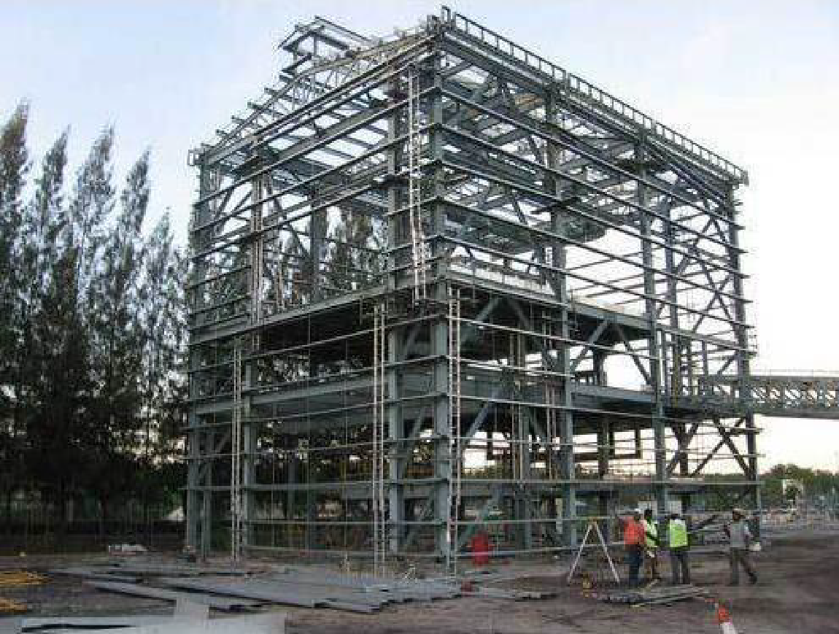
Fig 1: Steel structure installation
Source: Prefabricated sandwich panel system in India
https ://ijaers.com/uploads/issue_files/4IJAERS-07202147-Prefabricated.pdf

- Light gauge steel structural systems

All across the world, steel is a building material that is used extensively. The usage of reinforced concrete, structural brickwork, and timber are preferred over steel, which is seen to be uneconomical for landed properties. Cold framing is a technique that was utilized to create the affordable steel frame, which is now used in many nations. It is a high-tech building material intended for the construction of prefabricated buildings and other structures. In order to maximize utility space, LGSF technology uses high-quality galvanized steel profiles in load-bearing walls, interior walls, floor slabs, and roofing frames. Since the light gauge steel is created using the cold formed technique without the use of heat, the makers are able to generate light weight but highly tensile steel sheets. These steel sheets are created by first treating metallic scrap and then going through the cold-forming process. The c- or s-shaped parts of the steel are created by passing thin sheets of the metal through a series of rollers (of varying shapes). The sheet surface is then thoroughly covered and rendered corrosion-resistant by applying a zinc alloy coating. The steel frame buildings are strong and can last for up to 50 years.

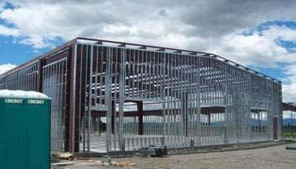
Fig 2: Example of structural design for LGSF Construction
Source: Light Gauge Steel Frame Building Construction
https ://theconstructor.org/structural-engg/light-gauge-steel-frame/37722/

- Monolithic tunnel formwork
The RCC slab and walls are built using this type of formwork technology, which involves continuous concrete pouring. Due to industrialization, the use of the modular construction approach, low cost, and time-saving benefits, medium to high rise buildings with the same plans are frequently constructed. Recent studies have shown that there are insufficient standards for the seismic design of these structures in the present seismic codes and guidelines. The design base shear of a structure is calculated using this methodology using the basic period and the recommended behavior factor (R factor). The steel half cells, which are l-shaped and make up the tunnel formworks, are linked to create a single cell unit. This system's major parts are walls and flat plate slabs, which are formed concurrently from in-situ concrete poured into two half-tunnel forms to construct load-bearing walls and floor slabs. With the use of this technology, quick constructions can be completed, and the units can be cast in just 24 hours. In tunnel-shaped structures, walls serve the dual purposes of carrying vertical loads and resisting lateral loads. The structure becomes more seismically resistant as a result of the monolithic slab and walls. The water tightness has improved because there are fewer joists. Extensive planning, engineering, and construction management are all necessary for the complicated and dangerous process of construction.

Fig. 3: Tunnel formwork
Source: Introduction to advanced TUNNEL Formwork system - IRJET
https ://www.irjet.net/archives /V4/i3/IRJET-V4I397.pdf

A project is effective when each of these processes works in unison with the others. Any structure's foundational element, formwork directly affects the construction process's quality. The building industry uses a variety of aluminum formwork, including both standard and unique forms. The global real estate building business has a reputation for being behind in terms of new innovation, cutting-edge construction methods, and management. However, there is a lot of research being done in this area these days, and enhanced tunnel formwork is a notable illustration of this innovation.

Discussion
The essential development and land use policies that protect individual, build economy, enhance community and enrich environment now need to be adapted due to the change in environmental and social conditions. To overcome damages, to protect the cities from the hazards that are occurred due to climatic change there is need of resilience. By adapting principles of resilience, balance can be achieved in the sustainable aspects with respect to ecological system and human settlement. To incorporate the urban resilience either the conventional construction principles should be improvised or the implementation of advanced technologies should be adapted. In Indian context various calamities hitting the cities brought a need of impactful technologies, which have already been tested and applied in various other countries. The technologies and materials which are effective for earthquake that are used in various other countries are monolithic tunnel formwork, prefabricated sandwich panel system, light gauge steel frame system.

Considering the advantages of advanced technologies like affordable, time saving, easy installation, easy material transportation and better than conventional construction system, it is seen to be used successfully in India. The regions where conventional construction system in a hard, the advanced technologies can be useful. The developing region where there is a need of fast construction these technologies can be helpful. Using these technologies, the structure gains modern aesthetics. These technologies and materials are more recommended in seismic zones in India.

Acknowledgement: This study has been carried out with the help of Fourth Year students (B. Arch Batch 2019-2023) Ms. Nakshatra Kale & Ms. Shrusti Nandankar.

References:

Manual Hazard Resistant Construction in India - Assam ...
http://sdmas sam.nic.in/pdf/publication/undp/manual _hazard_resistant_construction_in_india.pdf

Types of Disasters
https ://sdma.goa.gov.in/types-of-disasters

Prefabricated Sandwich Panel System in India - IJAERS
https ://ijaers.com/uploads/issue_files/4IJAERS-07202147-Prefabricated.pdf

Seismic Behaviour of Tunnel Form Concrete Building Structures
https ://www.iitk.ac.in/nicee/wcee/article/14_05 -03-0175.PDF

Resilience to Adaptation | Architect Magazine
https ://www.architectmagazine.com/aia-architect/aiafeature/resilience-to-adaptation_o

Sutapa Das, Parthasarathi Mukhopadhyay, Multi-hazard disaster resilient housing with bamboo -based system, Procedia Engineering,2018

Role of Architects in Creating Building and Urban Resilience
https ://res earchleap.com/role-architects-creating-building-urban-resilience/

Introduction to advanced TUNNEL Formwork system - IRJET
https ://www.irjet.net/archives /V4/i3/IRJET-V4I397.pdf

Nivedita G. Gogate, Pratap M. Raval, Identifying objectives for sustainable stormwater management in urban Indian perspective: a case study, International Journal of Environmental Engineering,2015

What Is Tunnel Formwork System | Advantages | Process | PPT
https ://www.civilengineeringweb.com/2021/01/tunnel-formwork-sys tem.html

The role of perception of local government officials on climate ...
https ://www.emerald.com/insight/content/doi/10.1108/IJDRBE-01-2020-0003/full/html

Light Gauge Steel Frame Building Construction - The ...
https ://theconstructor.org/structural-engg/light-gauge-steel-frame/37722/

