CHAPTER NAME: RECENT TRENDS IN ROOT CANAL IRRIGANT ACTIVATION DEVICES
AUTHOR NAME: DR. K SATHYANARAYANAN, DR. PAVITRA P.S., DR. JAYAKRISHNAN P
ORGANIZATION NAME: SATHYABAMA DENTAL COLLEGE AND HOSPITAL
CONTENTS:
- INTRODUCTION
- CLASSIFICATION OF IRRIGANT ACTIVATION DEVICES
- MANUAL DYNAMIC AGITATION
- ULTRASONIC AND SONIC DEVICES
- ENDOACTIVATOR
- PRESSURE ALTERATION DEVICES
- ENDOVAC
- PHOTON-INDUCED PHOTOACOUSTIC STREAMING (PIPS)
- CONCLUSION
- REFERENCES

INTRODUCTION
The key to successful endodontic treatment involves the thorough removal of both living and decayed parts of pulp tissue, along with microorganisms and their toxins from the intricate root canal system. This process, known as chemo-mechanical debridement, faces challenges due to the complex anatomy of the root canal, making it difficult to entirely shape and clean. Despite advancements like nickel-titanium instruments and rotary systems, these technologies primarily address the central part of the canal, leaving areas such as fins, isthmi, and cul-de-sacs untouched after preparation. These untreated areas could potentially harbor debris, microbes, and by-products, hindering proper adaptation of the sealing material and leading to persistent inflammation around the root. To address this, irrigation is a crucial aspect of root canal cleaning. While no single irrigant is perfect, contemporary endodontic practice commonly employs dual irrigants, such as sodium hypochlorite (NaOCl) combined with ethylenediaminetetraacetic acid (EDTA) or chlorhexidine (CHX), as initial and final rinses. This approach compensates for the limitations of individual irrigants. It's vital that irrigants come into direct contact with the entire canal wall, particularly the narrow apical segments of small canals, to effectively cleanse them. To achieve this, two main categories of methods have been developed: manual agitation techniques and machine-assisted agitation devices.

CLASSIFICATION OF ROOT CANAL IRRIGATION DEVICE
According to Gu, S., et al in 2009, (1)

MANUAL DYNAMIC AGITATION
The Manual Dynamic Activation (MDA) technique is effective for eliminating the smear layer and achieving clean canals in the apical region. This method offers a swift, affordable, secure, and practical approach to conducting irrigant agitation during the final stages of root canal preparation (1). Additionally, it aids in the thorough blending of newly introduced solution with any stagnant solution present in the apical portion of the canal (2).
Procedure
Effective agitation of the master cone plays a pivotal role in distributing and replacing the solution throughout the canal's inner space, thus amplifying the efficacy of antiseptics and solvents (Figure 1). Through the Manual Dynamic Activation (MDA) technique, the irrigant makes direct contact with the canal walls, extending to the canal's apex, thereby dislodging the vapor lock effect (3).
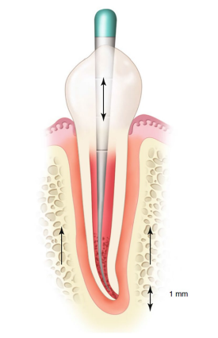
Figure 1. Manual Dynamic Agitation (MDA)
This technique generates increased intracanal pressure fluctuations when the gutta-percha cone is moved in and out, and the frequency of these movements generates disturbances that promote diffusion through shear stresses.
- Begin by preparing the root canal. The Manual Dynamic Activation (MDA) technique commences early, coinciding with the introduction of the initial scouting hand file into the canal. As the instrument advances apically, the irrigant extends beyond the tip. Upon reaching the working length, a vertical reciprocating motion is employed to ensure the comprehensive involvement of the entire canal space.
- Choose a gutta-percha master cone with a slightly smaller taper than that of the canal. The master cone should fit snugly at the working length.
- Grasp the master cone using tweezers, positioning them one millimeter away from the working length.
- After aspirating the primary irrigant, sodium hypochlorite (NaOCl), introduce 1 ml of ethylenediaminetetraacetic acid (EDTA) into the canal using a 30-gauge NiTi needle.
- Commence the manual agitation of the master cone using an upward and downward motion, achieving a 2 mm amplitude, and repeating this motion for approximately 1 minute.
- Deliver another 1 ml of EDTA using the irrigating needle to flush out debris.
- Utilize suction to remove the remaining EDTA solution.
- Thoroughly flush the canal with 1 ml of NaOCl, and repeat the same process, employing 50 in-and-out strokes within a span of 30 seconds. Conclude by performing a final flush with 3 ml of NaOCl.

MACHINE ASSISTED IRRIGANT ACTIVATION
ULTRASONIC AND SONIC DEVICES
Sonic and ultrasonic instrumentation involves the transfer of energy from a vibrating instrument to the fluid used for irrigation within a root canal. This energy transmission occurs through the utilization of either sonic or ultrasonic waves. As a result of this process, the fluid experiences acoustic streaming and cavitation effects (4).
Cavitation refers to the formation, expansion, and forceful implosion of tiny gas bubbles generated due to a decrease in pressure within the fluid (5). It could potentially result in a transient reduction in the strength of the cell membrane, thereby enhancing its permeability to NaOCl (6).
Acoustic streaming (Figure 2)characterizes the collective motion of a fluid in response to the propagation of pressure waves within it. This process results in the creation of a circular or vortex-type movement surrounding a vibrating entity (7). The phenomenon of acoustic streaming has the capability to generate significant shear forces, which are capable of removing debris from instrumented canals. Additionally, it induces the breakdown of bacterial biofilms, leading to the dispersion of bacteria clusters. As a result of this process, the individual planktonic bacteria become more receptive to the effects of NaOCl (8).
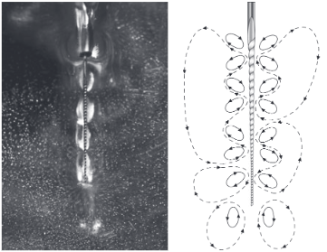
Figure 2. Acoustic streaming around a file in free water (left) and a schematic drawing (right)
Beyond the influence of acoustic streaming and cavitation, ultrasonic instruments also generate heat, causing a rise in temperature within the irrigant (9). This increase in temperature enhances the efficacy of NaOCl, resulting in improved tissue dissolution capabilities and an augmented antibacterial impact (10).
Ultrasonic units are categorized into two types: piezoelectric and magnetostrictive systems. The piezoelectric system is known for its efficient energy transmission to the files while producing minimal heat, eliminating the need for handpiece cooling. Specially designed tips are accessible for piezoelectric systems, facilitating the careful removal of dentine or pulp stones from pulp chambers and canals. These tips offer the advantage of small size, significantly improving visibility compared to conventional bur methods. Moreover, ultrasonic units can be applied for activated irrigation through various tools like files, smooth wires, plastic inserts, or irrigation needles (1).
Ultrasonic irrigation is termed "passive" due to the objective of preventing the file from coming into contact with the canal walls, which might result in uncontrolled and uneven dentine removal. Passive ultrasonic irrigation (PUI) has demonstrated its effectiveness in eliminating pulp tissue and the smear layer. This effectiveness is maximized when the file is positioned loosely, enabling unrestricted oscillation within the canal. Therefore, it is advisable to perform PUI subsequent to canal preparation and enlargement, ensuring that the file can move freely (11).
Two irrigation techniques have been explored in conjunction with PUI:
- A constant flow of irrigant from the ultrasonic handpiece.
- A periodic flush using a syringe between activations, resembling the method employed between files during traditional root treatment procedures (4).
Van der Sluis et al.(12) discovered that both approaches were equally proficient in eliminating dentine debris from grooves they had artificially created in canal walls during in vitro experiments. In the case of the intermittent flush approach, they subjected 2% NaOCl to ultrasonic activation for a duration of 3 minutes, administering 2 mL of solution through a syringe every 30 seconds.
Carver et al. (13) devised a continuous flush apparatus, essentially involving an irrigation needle attached to an ultrasonic tip through a clamp. This arrangement enables the transmission of ultrasonic motion to the irrigation needle. Their device demonstrated a substantial ultrasonic output, leading to the creation of cavitation within treated canals. Observations have indicated that this method yielded notably cleaner canals, marked by significant reductions in colony-forming units and positive cultures. A contributing factor to this success could be the ongoing supply of fresh and active irrigating solution into the canals. Since the tissue dissolution capabilities of NaOCl diminish swiftly, maintaining a constant supply is crucial for optimal outcomes. However, a notable concern associated with this technique is the potential for irrigant extrusion beyond the apex of the tooth.
An important aspect to consider regarding ultrasonic activation is that the phenomena of acoustic streaming and cavitation exclusively manifest in liquids. Therefore, if a gas bubble is present in the apical region and the ultrasonic tip enters it, no observable effects will take place within this particular area (4).
To address this air bubble concern, it is advisable to eliminate the bubble by employing a properly fitting master GP point, as previously detailed (14). There are specialized non-cutting nickel-titanium inserts available that can be affixed to conventional ultrasonic devices, such as the ESI ENDO SOFT (EMS Optident, UK) or Irrisafe Tips (Figure 3), as well as the Saltelec piezoelectric scaling unit (Satelec ACTEON, St Neots, UK).
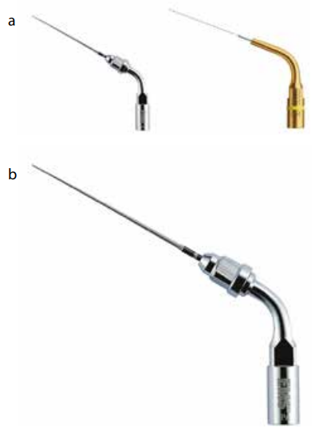
Figure 3. Endodontic irrigation ultrasonic inserts:
(a) ESI ENDO SOFT ultrasonic insert; (b) Irrisafe Tips ultrasonic insert.
Alternatively, standard endodontic instruments like files and irrigation needles can be "engaged" and indirectly set into motion through an ultrasonic scaler tip, thereby transmitting the ultrasonic effects to the instrument.
There are also specifically produced devices, such as the EndoActivator (Dentsply Tulsa Dental Specialties, York, USA) and the ProUltra® PiezoFlow™ (Dentsply Tulsa Dental Specialties, York, USA). Additionally, the MiniEndo II (SybronEndo, California, USA) is a purpose-built ultrasonic unit tailored for endodontic procedures (11).
ENDOACTIVATOR
The EndoActivator constitutes a canal irrigation system driven by sonic technology. This system is composed of a portable handpiece and disposable 22mm polymer tips that are designed not to cut. Specialized features include: Practical snap-on/snap-off design, Color-coded by size for easy identification and convenient depth gauge marks at 18, 19 and 20mm. The tips are available in three sizes: Yellow (#15/.02), Red (#25/.04) and Blue (#30/.04).
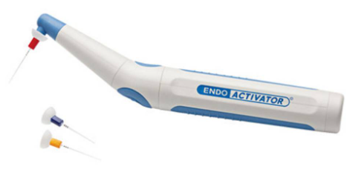
Figure 4. Endoactivator
Comparative studies have demonstrated its notable efficacy in removing debris and accessing lateral canals, surpassing the performance of conventional syringe irrigation and passive ultrasonic irrigation (15). An advantage of the smooth polymer tips is their non-cutting nature, minimizing the risk of inadvertent damage. The knowledge that these tips are non-cutting allows operators to incorporate additional vertical strokes in combination with the sonic motion. This aspect could elucidate why certain studies have indicated that this sonic technique, despite being less powerful than ultrasonic alternatives, delivers superior outcomes. However, it's worth noting that the tips have faced criticism for being radiolucent, which could pose a concern in cases of potential fracture (1).
PRESSURE ALTRATION DEVICES
Negative and positive pressure irrigation systems strive to address the delicate equilibrium between ensuring the comprehensive immersion of the canal in irrigant, thus eliminating any trapped air, while simultaneously preventing excessive irrigation that could lead to irrigant extrusion beyond the apex (4).
Lussi et al.(16) were pioneers in this field, conducting initial experiments and creating an 'alternate pressure' device that didn't involve instrumentation. This device demonstrated the capability to achieve cleaner root canals compared to the conventional step-back preparation method coupled with static irrigation. Regrettably, this promising approach was deemed unsafe for in vivo animal studies and consequently wasn't pursued further.
The key challenge associated with positive pressure (PP) irrigation and incidents involving NaOCl lies in its unpredictable nature. This lack of predictability appears to be linked to the condition of the apical region and various anatomical factors (17). In clinical practice, promptly diagnosing the occurrence of significant irrigant extrusion into apical tissues is challenging, and foreseeing these undesirable NaOCl accidents is virtually impossible (18). An additional drawback of positive pressure irrigation is the establishment of an apical stagnation plane (19). This specific configuration facilitates the entrapment of gas, resulting from the breakdown of organic tissue. This physical phenomenon, referred to as vapor lock, hinders effective debridement of the canal's apical termination (20). To address these limitations comprehensively, the Apical Negative Pressure (ANP) technique for irrigation was introduced (21).
ENDOVAC
The development of the EndoVac system aimed to provide a secure and consistent method of conveying irrigants to the apical endpoint (22). The effectiveness of an irrigation solution primarily relies on its successful diffusion into the root canal system and its volume. The depth at which the needle is placed, along with irrigant penetration and the delivery of substantial irrigant quantities, have been linked to elevated pressures (23). This is a fundamental reason why conventional irrigation systems often fall short of achieving comprehensive root canal debridement. This deficiency is particularly notable because these systems are typically positioned at a safety depth of 2-3 mm from the working length (WL) to mitigate the risk of hypochlorite accidents (24). However, this constraint doesn't apply to Apical Negative Pressure (ANP) systems. Due to their underlying philosophy, ANP systems possess the capability to administer irrigants up to the WL while effectively eliminating any risk of apical extrusion (25). Moreover, studies have evidenced the efficacy of ANP systems in delivering irrigants to the WL, offering a contrast to traditional irrigation methods. This efficacy also ties in with the phenomenon of apical vapor lock (20,26).
In 2007, first commercial ANP system, the EndoVac system (SybronEndo, Orange, CA), was introduced. Later, another ANP system known as INP (ASI Medical, Englewood, CO) was introduced. Notably, the INP system employs distinct materials and methods in comparison to the EndoVac system. However, there is a dearth of research validating its effectiveness, thus precluding the provision of evidence-based insights into its efficacy (21).
The Device
EndoVac (SybronEndo, Orange, CA) system comprises four key components: the hand and finger pieces, the macro- and microcannula, the Multiport Adapter (MPA), and the Master Delivery Tip (MDT).
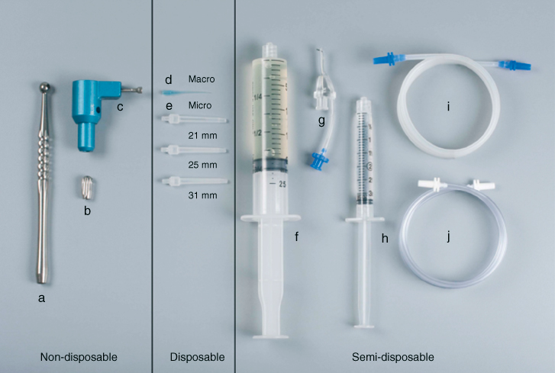
Figure 5.1 EndoVac (SybronEndo, Orange, CA) (a) Handpiece; (b) fingerpiece; (c) multiport adapter; (d) macrocannula; (e) microcannula (21, 25, 31 mm); (f) syringe 20 cc (for NaOCl); (g) master delivery tip (MDT); (h) syringe 3 cc (for EDTA); (i) MDT evacuation tubing (blue); and (j) handpiece/fingerpiece evacuation tubing (white).
Multiport Adapter (MPA): is directly connected to the Hi-Vac system and functions as a holder for the EndoVac tubing. This design allows for effortless detachment and reattachment of other components, facilitating optimal portability between different operatories (21).
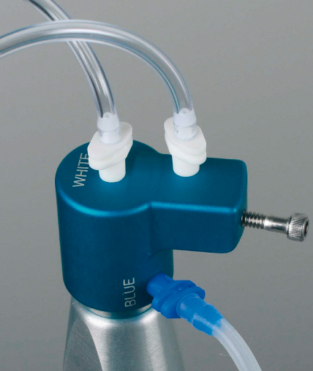
Figure 5.2 Multiport Adapter (MPA)
Master Delivery Tip (MDT): provides space for an irrigant-filled syringe, which dispenses the irrigant via a 20-gauge needle. Surrounding this needle, a plastic suction hood is affixed, linked to clear plastic tubing. This tubing is connected to a multiport adaptor and subsequently connected to a high-volume suction. This configuration enables the MDT to effectively administer the irrigant while also evacuating any surplus irrigant that might spill over from the pulp chamber (22).
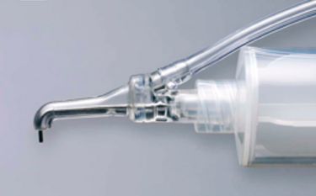
Figure 5.3 Master Delivery Tip (MDT)
The macro cannula serves the purpose of using suction to extract irrigant from the chamber, directing it towards the coronal and middle sections of the canal. Simultaneously, irrigant is delivered to the pulp chamber, with its flow directed towards an axial wall and intentionally avoiding any direct flow towards a canal orifice.
Either the macro cannula or micro cannula is linked to the high-speed suction of the dental unit through clear plastic tubing, facilitated by the multiport adaptor. The plastic macro cannula, characterized by an external diameter equivalent to ISO size 0.55 mm and an internal diameter of ISO size 0.35 mm, is crafted from blue translucent plastic material. This cannula has a 0.02 taper and is intended for single-patient usage exclusively. It securely attaches to an autoclavable aluminum handpiece and is employed in an up-and-down pecking motion. Concurrently, irrigant is passively directed to the pulp chamber using the method outlined earlier. The primary function of the macro cannula is to eliminate substantial debris and tissue remnants that persist after instrumentation (22).
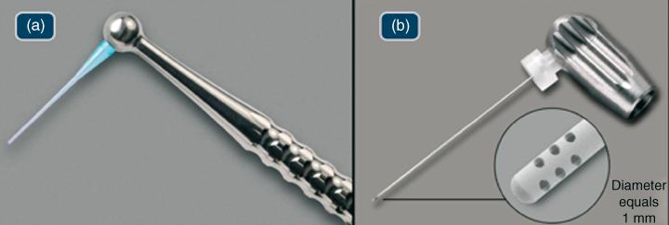
Figure 5.4 (a) Macrocannula; (b) Microcannula
The micro cannula features 12 microscopic holes that enable the effective evacuation of debris to the complete working length. Constructed with an external diameter of 0.32 mm, this stainless-steel micro cannula lacks taper and incorporates four clusters of three laterally positioned holes that are laser-cut. These holes, situated adjacent to the closed end, each measure 100 µ in diameter and are spaced at intervals of 100 µ. This configuration serves as a filtering mechanism, preventing blockages within the micro cannula's internal lumen, which possesses an ISO size internal diameter of 0.20 mm.
The micro cannula connects to an autoclavable aluminum finger piece and is utilized for irrigating the apical segment of the canal while positioned at the working length. Notably, the micro cannula terminates in a closed end, necessitating insertion to the full working length to aspirate irrigants and debris effectively. This tool is suitable for use in canals that have been expanded with endodontic files to ISO size 0.35 mm with a taper of 0.04 or larger. Alternatively, a non-tapered preparation can be considered, wherein the manufacturer recommends enlarging the root canal to 40/0.02.
Throughout the irrigation process, the MDT channels irrigant to the pulp chamber with a direction towards a chamber wall, while also preventing excessive irrigant from overflowing by drawing off the surplus. The macro cannula and micro cannula, on the other hand, create a negative pressure effect that pulls new irrigant from the chamber. This fresh irrigant travels down the canal to the cannula's tip, passing through the holes at the tip and entering the cannula's internal space. Subsequently, it exits through the suction via the clear plastic tubing. Consequently, a consistent flow of fresh irrigant is actively transported to the working length through negative pressure suction (22).
Clinical Technique
Canal Instrumentation:
Throughout the entire instrumentation process, the MDT method involves delivering 1 ml of 5-6% NaOCl using the Microcannula Delivery Tip before and after each change of instrument. This replenishing action clears the debris drawn into the pulp chamber by the preparation tools while also introducing fresh irrigant that the subsequent instrument will work down the canal (21). In a randomized clinical investigation, Cohenca et al. (27) found that various instrumentation strategies or types didn't impact the effectiveness of the EndoVac irrigation technique. Nevertheless, a minimum apical preparation size of 0.32 mm is necessary to accommodate the microcannula, requiring instrumentation with at least a #35/0.02 hand instrument to working length after completing smaller NiTi instrumentation sizes.
Macroevacuation:
A macro is employed to remove large debris from the root canal post-instrumentation. It's utilized for 30 seconds in each canal, moving rapidly from its apical stop point to just below the pulp floor, while 5-6% NaOCl is passively delivered via the MDT at 6-8 ml/min. Continuous monitoring ensures unobstructed fluid flow. Following 30 seconds of rapid irrigant exchange, the canal is "Charged" with NaOCl by withdrawing the macrocannula swiftly while MDT maintains NaOCl delivery. The canal is left untouched for 60 seconds (the "passive wait"), as the same method treats other canals. In a single-rooted tooth, the canal remains undisturbed during these 60 seconds (21).
Microevacuation:
Micro irrigation begins right after the passive wait of macro irrigation. It's important to note that mastering this technique requires practice. A common error during the learning process is misusing the Macrocannula, leading to unnecessary clogging of the Microcannula's filtration holes. Once the microcannula is correctly positioned at full working length, the MDT initiates a continuous flow of irrigant into the pulp chamber. Throughout this process, the exhaust tube of the microcannula is monitored to ensure consistent irrigant flow (21).
Microcycles:
The microevacuation consists of three irrigant "microcycles" (NaOCl, EDTA, NaOCl). The first microcycle uses 6% NaOCl to clear debris and biofilm from the apical walls. The flow is stopped after 6 seconds, creating a "purge" that removes bubbles formed by hydrolysis. This is repeated five times (30 seconds total). The microcannula is then swiftly withdrawn, leaving the canal charged for 60 seconds while treating other canals. The second microirrigation cycle involves 17% EDTA to remove the smear layer. EDTA is added for 10 seconds, and the canal is charged for 60 seconds without purging. The third cycle treats tubules, lateral canals, and irregularities with 5-6% NaOCl, allowing diffusion. Canals are eventually purged of irrigant, dried with paper points, and prepared for the next steps (21).
Efficacy
EndoVac's efficacy is rooted in its capacity to establish a range of negative pressure spanning approximately -30 to -260 mm Hg across the entire root canal system. This negative pressure effect commences at the coronal access opening and extends to the apical limit of the major diameter (28). This unique characteristic facilitates the secure and efficient draw of irrigants in ample quantities, which travel downward and/or across the canal walls and through intricate intracanal features such as isthmus areas and wall fins. As these irrigants are introduced coronally, they are concurrently evacuated apically.
Depending on the nature of the utilized irrigant, the process entails hydrolysis, chelation, and/or mechanical dislodgement of organic and inorganic debris from the canal system, followed by its evacuation. Additionally, this consistent irrigation exchange surpasses mere fluid dynamics of delivery and evacuation. It aids in the formation of a diffusion gradient, allowing hyperconcentrated solutions like 5% NaOCl to diffuse into confined spaces (29).
Penetration
In 2010, the initial investigation into EndoVac's ability to introduce irrigant into the main canal and canal irregularities was conducted by de Gregorio et al (30). This study delivered irrigant via positive pressure (PP), activating it using either sonic or passive ultrasonic irrigation (PUI), or complementing it with Apical Negative Pressure (ANP) irrigation using EndoVac. This model enabled simultaneous measurement of irrigant depth in the main canal and its penetration into simulated non-instrumented lateral canals measuring 60 µm in diameter and positioned 2, 4, and 6 mm from the apical termination.
For ISO #40 instrumented root canals, EndoVac achieved complete penetration to the apical termination, outperforming other groups significantly. This confirmed the microcannula's efficacy in overcoming challenges like the "stagnation zone" (19) or "vapor lock" (31). In terms of artificial lateral canal penetration, while the EndoVac system is designed primarily for abundant full-length canal irrigation rather than activation, it wasn't as effective at filling lateral canals as PUI.
Goode et al. (28) demonstrated that EndoVac provided superior debris removal compared to PP, manual dynamic, sonic, and ultrasonic activation, although ultrasonic activation couldn't effectively clean a multiplaner canal. Cohenca's team studied oval canals, confirming EndoVac's advantages over PP and the self-adjusting file (SAF) system (32). Spoorthy et al. (33) added a new experimental group to the de Gregorio model, ANP + PUI, which exhibited superior results in the most apical termination, showing the synergistic effect of both techniques, unaffected by root canal curvature.
Munoz and Camacho-Cuadra (26) clinically evaluated irrigant penetration in vivo, using a radiopaque contrast solution in mesial curved canals of mandibular molars. EndoVac's flexibility demonstrated its effectiveness, revealing a statistically significant difference in full canal-length irrigation compared to PP and similar outcomes to PUI.
Debridement
Conventionally, in order to improve the process of debridement, it has been suggested to enlarge the diameter and taper of the apical preparation (34). Nevertheless, the effective design of EndoVac allows for ample and secure delivery of irrigants even when the apical preparation is as narrow as a #35 ISO size (25). Hockett et al (25) emphasized that the action of Apical Negative Pressure (ANP) plays a more vital role in thoroughly cleansing and disinfecting the canals compared to relying on larger tapers.
Susin et al. investigated the effectiveness of two irrigant agitation methods (MDA and ANP) in a closed system for canal and isthmus debridement. While there wasn't a notable difference between the groups in the main canal, ANP proved more efficient at removing organic debris in isthmus areas (Figure 5.6). These findings align with Siu and Baumgartner's research (36), which demonstrated superior debridement with ANP compared to the PP group, particularly in the final millimeters.
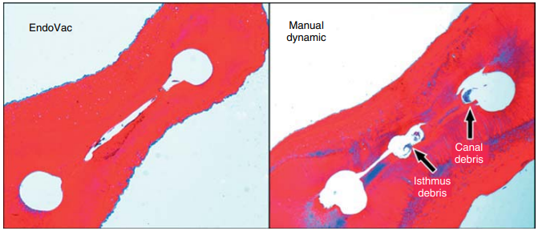
Figure 5.6 Both sections were taken at working length—1 mm. In the manual dynamic activation (MDA) group, greater isthmus debris was apparent.
Notably, Howard et al. (37) yielded contrasting outcomes compared to earlier mentioned research. Their study, focused on mesial roots of mandibular molars, revealed no significant distinctions among ANP, PP, and CUI using the PiezoFlow device (ProUltra, Dentsply, Tulsa, OK).
Smear Layer
Saber Sel and Hashem (38) discovered that activating 17% EDTA through MDA or ANP led to significantly improved removal of smear layer compared to PP or PUI. In 2006, Fukumoto et al. (39) observed that ANP was more successful in eliminating smear layer than standard irrigation (Figure 5.7). Gómez-Pérez replicated Fukumoto's study with the EndoVac system and achieved consistent positive outcomes (21).
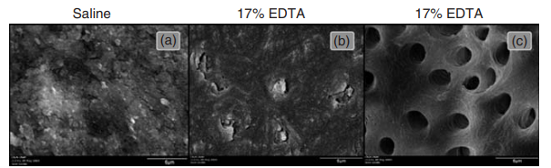
Figure 5.7 SEM examination at WL—1 mm. (a) Saline control; (b) traditional irrigation; and (c) EndoVac irrigation.

Antimicrobial activity
Hockett et al. (35) assessed the effectiveness of ANP and PP irrigation in eradicating Enterococcus faecalis biofilms in previously instrumented canals, notably being the first study to evaluate mature 30-day biofilms. The study also examined the impact of taper in both techniques. ANP proved effective in both groups - with variable taper and without taper. A clinical trial by Cohenca et al. (27) involving mandibular molars supported these findings, with results paralleling the in-vitro study. Notably, the EndoVac group had no positive cultures after final irrigation, while the PP group had 33% positive cultures. Pawar et al. (40) also clinically tested the EndoVac and found comparable outcomes between ANP and traditional irrigation.
Safety
The primary advantage of the ANP technique lies in its prioritization of safety. Comparative studies have assessed ANP in relation to other irrigation systems, notably the EndoVac, which is presently marketed by SybronEndo (SybronEndo, Orange, CA). Desai and Himel (25) conducted an in-vitro study, demonstrating that ANP did not result in any irrigant extrusion. Conversely, groups utilizing the Max-i-Probe (Dentsply Rinn, Elgin, IL), Rinsendo (Dürr Dental GmbH & Co. KG, Bietigheim-Bissingen, Germany), and continuous ultrasonic irrigation (CUI) needle exhibited significant irrigant extrusion, potentially causing irritation and toxicity to the apical tissues. Such irrigant extrusion has the potential to lead to considerable postoperative pain. Gondim et al. (41) examined this parameter and reported a notable reduction in postoperative pain levels among patients treated with ANP in comparison to traditional needle irrigation.
PHOTON-INDUCED PHOTOACOUSTIC STREAMING (PIPS)
Photon-induced photoacoustic streaming utilizes laser impulses of subablative energy (20 mJ at 15 Hz) to interact with water molecules in a radial firing stripped tip. This interaction, with peak powers reaching 400 W, generates expansion, shock waves, and powerful fluid streaming within the root canal, all without raising the temperature (42).
Mechanism of Action
PIPS, a laser-activated irrigation method, indirectly stimulates irrigants without heat. It generates a potent photoacoustic shockwave, spreading irrigants three-dimensionally within the root canal system. Unlike conventional laser methods, PIPS employs a distinctive tapered tip, placed only in the pulp chamber, avoiding the need for larger files and instruments. This enables efficient delivery of irrigants to delicate areas like the apical one-third, fins, isthmuses, and lateral canals. The nonthermal pressure wave effectively eliminates living and dead tissues, eradicates bacteria, removes biofilm, and disinfects dentin tubules (42).
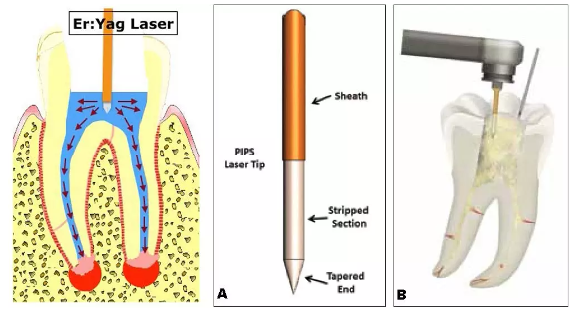
Figure 6. Photon-Induced Photoacoustic Streaming (PIPS)
PIPS Protocol
- The PIPS tip remains in the pulp chamber, not the root canal, and remains stationary during activation.
- A continuous flow of solution from a dental irrigating syringe is applied during laser activation.
- Keeping the pulp chamber flooded with sufficient irrigating solution to submerge the PIPS tip is crucial.
- PIPS activation occurs in cycles of 30 seconds.
- The current protocol involves six cycles of laser activation, with three 30-second rest phases in between, using NaOCl.
- Following three cycles of laser-activated irrigation with NaOCl, an additional 30-second irrigation with water using PIPS takes place.
- The pulp chamber is emptied, and 17% EDTA is employed with PIPS and continuous flow for 30 seconds.
- The final step is another 30 seconds of laser activation with water alone.
- After these steps, the canal system is prepared for obturation (42).
In a study by Peters (43), the effectiveness of disinfection and biofilm disruption in the root canal's apical third was evaluated. PIPS didn't entirely eliminate bacteria from infected dentinal tubules; however, it exhibited superior performance in reducing infection and removing biofilm compared to the passive ultrasonic irrigation technique group.
In a study by Ordinola et al. (44), the impact of PIPS was explored using a 6% NaOCl solution to eliminate ex vivo biofilm in a unique dentin bovine model. The researchers observed better cleansing of infected dentin in the PIPS groups compared to the PUI group. Notably, the remarkable outcome of this experiment was that the PIPS tip was positioned 22 mm from the target area, while ultrasonic, sonic, and passive irrigation methods were applied directly to the target area.
In an in-vitro study by Jaramillo et al. (42), infected single-rooted teeth with E. faecalis were subjected to PIPS and compared to conventional needle irrigation. The results demonstrated 100% disinfection in the PIPS group after just 1 minute of irrigation, compared to 83% disinfection in the conventional group after 20 minutes of continuous irrigation with a buffred 0.5% NaOCl solution.
Alshahrani et al. (45) also found that combining PIPS with 6% NaOCl was more effective than using water with PIPS or irrigating solely with 6% NaOCl.
According to Ordinola and Alshahrani, the best disinfection results are achieved through the combination of PIPS and 6% NaOCl.
Lloyd et al. (46) used high-resolution microcomputed tomography to analyze PIPS's effect on debris removal from mesial canals of lower molars, including isthmuses, fins, and lateral canals. They compared PIPS to standard needle irrigation (SNI) and found that PIPS achieved about 2.6 times greater debris removal than the SNI group.
In a study by Jaramillo et al. (47), using the photoacoustic delivery system PIPS, combined with 20 seconds of Er:YAG laser irradiation and 6% sodium hypochlorite, was found to be highly effective in suppressing the growth of Enterococcus faecalis.
Heat generation is a critical consideration in dental laser applications. CO2 and Nd:YAG lasers are utilized for photothermal effects, where the surrounding hard tissues absorb laser energy and transform it into heat. Saunders (48) noted that a temperature increase of over 10°C for more than 1 minute could potentially lead to bone tissue damage.
Er:YAG lasers are highly absorbed by water, causing minimal penetration into enamel and dentin. The mechanical ablation process involves micro-explosions without significant temperature elevation. Sonntag (42) observed that the pulp's histological reaction to Er:YAG laser resembled that of a high-speed handpiece.
Armengol (49) compared high-speed carbide bur, Er:YAG (140 mJ, 4 Hz), and Nd:YAP (240 mJ, 10 Hz) lasers with and without water spray. As expected, Nd:YAP laser generated higher temperature increases than Er:YAG laser and high-speed handpiece. Both approaches showed similar temperature rise patterns with water spray.
CONCLUSION
Effective irrigation plays a pivotal role in successful endodontic treatment. Despite sodium hypochlorite (NaOCl) being a crucial irrigant, no single solution can fulfill all irrigation requirements. Advancements like positive and negative irrigation have introduced novel devices that employ diverse methods for delivering irrigants, debriding soft tissues, and, depending on the treatment approach, eliminating smear layers. Negative irrigation stands out due to its superiority over positive pressure methods. It prevents the extrusion of irrigants into periapical areas, enhances cleansing, eliminates vapor lock concerns, and ensures sufficient irrigant volume. Nevertheless, more research is needed to fully explore its potential benefits.

REFERENCES
- Gu L sha, Kim JR, Ling J, Choi KK, Pashley DH, Tay FR. Review of contemporary irrigant agitation techniques and devices. J Endod. 2009 Jun;35(6):791–804.
- Machtou PP. Manual dynamic activation technique. Clin Dent Rev. 2018 Sep 20;2(1):21.
- Basrani B, Malkhassian G. Update of Endodontic Irrigating Solutions. In: Basrani B, editor. Endodontic Irrigation [Internet]. Cham: Springer International Publishing; 2015 [cited 2023 Jun 16]. p. 99–115. Available from: https://link.springer.com/10.1007/978-3-319-16456-4_5
- Holliday R, Alani A. Traditional and contemporary techniques for optimizing root canal irrigation. Dent Update. 2014;41(1):51–2, 54, 56-58 passim.
- Ahmad M, Pitt Ford TR, Crum LA, Walton AJ. Ultrasonic debridement of root canals: acoustic cavitation and its relevance. J Endod. 1988 Oct;14(10):486–93.
- Huang TY, Gulabivala K, Ng YL. A bio-molecular film ex-vivo model to evaluate the influence of canal dimensions and irrigation variables on the efficacy of irrigation. Int Endod J. 2008 Jan;41(1):60–71.
- Walmsley AD. Ultrasound and root canal treatment: the need for scientific evaluation. Int Endod J. 1987 May;20(3):105–11.
- Joyce E, Phull SS, Lorimer JP, Mason TJ. The development and evaluation of ultrasound for the treatment of bacterial suspensions. A study of frequency, power and sonication time on cultured Bacillus species. Ultrason Sonochem. 2003 Oct;10(6):315–8.
- Zeltner M, Peters OA, Paqué F. Temperature changes during ultrasonic irrigation with different inserts and modes of activation. J Endod. 2009 Apr;35(4):573–7.
- Zehnder M. Root canal irrigants. J Endod. 2006 May;32(5):389–98.
- Ahmad M, Pitt Ford TR, Crum LA. Ultrasonic debridement of root canals: an insight into the mechanisms involved. J Endod. 1987 Mar;13(3):93–101.
- van der Sluis LWM, Gambarini G, Wu MK, Wesselink PR. The influence of volume, type of irrigant and flushing method on removing artificially placed dentine debris from the apical root canal during passive ultrasonic irrigation. Int Endod J. 2006 Jun;39(6):472–6.
- Carver K, Nusstein J, Reader A, Beck M. In vivo antibacterial efficacy of ultrasound after hand and rotary instrumentation in human mandibular molars. J Endod. 2007 Sep;33(9):1038–43.
- Boutsioukis C, Lambrianidis T, Verhaagen B, Versluis M, Kastrinakis E, Wesselink PR, et al. The effect of needle-insertion depth on the irrigant flow in the root canal: evaluation using an unsteady computational fluid dynamics model. J Endod. 2010 Oct;36(10):1664–8
- Kanter V, Weldon E, Nair U, Varella C, Kanter K, Anusavice K, et al. A quantitative and qualitative analysis of ultrasonic versus sonic endodontic systems on canal cleanliness and obturation. Oral Surg Oral Med Oral Pathol Oral Radiol Endod. 2011 Dec;112(6):809–13.
- Lussi A, Nussbächer U, Grosrey J. A novel noninstrumented technique for cleansing the root canal system. J Endod. 1993 Nov;19(11):549–53.
- Behrents KT, Speer ML, Noujeim M. Sodium hypochlorite accident with evaluation by cone beam computed tomography. Int Endod J. 2012 May;45(5):492–8.
- Papageorge MB, Oreadi D. A clinico-pathologic correlation. J Mass Dent Soc. 2005;54(2):38–40, 42–3.
- Boutsioukis C, Lambrianidis T, Kastrinakis E. Irrigant flow within a prepared root canal using various flow rates: a Computational Fluid Dynamics study. Int Endod J. 2009 Feb;42(2):144–55.
- Schoeffel GJ. The EndoVac method of endodontic irrigation, part 2--efficacy. Dent Today. 2008 Jan;27(1):82, 84, 86–7.
- Cohenca N. Disinfection of Root Canal Systems: The Treatment of Apical Periodontitis. John Wiley & Sons; 2014. 899 p.
- EndoVac Apical Negative Pressure: Safe and Effective Endodontic Irrigation from Beginning to END [Internet]. Oral Health Group. 2015 [cited 2023 Aug 27]. Available from: https://www.oralhealthgroup.com/features/endovact-apical-negative-pressure-safe-and-effective-endodontic-irrigation-from-beginning-to-end/
- Abou-Rass M, Piccinino MV. The effectiveness of four clinical irrigation methods on the removal of root canal debris. Oral Surg Oral Med Oral Pathol. 1982 Sep;54(3):323–8.
- Chow TW. Mechanical effectiveness of root canal irrigation. J Endod. 1983 Nov;9(11):475–9.
- Desai P, Himel V. Comparative safety of various intracanal irrigation systems. J Endod. 2009 Apr;35(4):545–9.
- Munoz HR, Camacho-Cuadra K. In vivo efficacy of three different endodontic irrigation systems for irrigant delivery to working length of mesial canals of mandibular molars. J Endod. 2012 Apr;38(4):445–8.
- Cohenca N, Paranjpe A, Heilborn C, Johnson JD. Antimicrobial efficacy of two irrigation techniques in tapered and non-tapered canal preparations. A randomized controlled clinical trial. Quintessence Int Berl Ger 1985. 2013 Mar;44(3):217–28.
- Goode N, Khan S, Eid AA, Niu L na, Gosier J, Susin LF, et al. Wall shear stress effects of different endodontic irrigation techniques and systems. J Dent. 2013 Jul;41(7):636–41.
- Malentacca A, Uccioli U, Zangari D, Lajolo C, Fabiani C. Efficacy and safety of various active irrigation devices when used with either positive or negative pressure: an in vitro study. J Endod. 2012 Dec;38(12):1622–6.
- de Gregorio C, Estevez R, Cisneros R, Paranjpe A, Cohenca N. Efficacy of different irrigation and activation systems on the penetration of sodium hypochlorite into simulated lateral canals and up to working length: an in vitro study. J Endod. 2010 Jul;36(7):1216–21.
- Tay FR, Gu LS, Schoeffel GJ, Wimmer C, Susin L, Zhang K, et al. Effect of vapor lock on root canal debridement by using a side-vented needle for positive-pressure irrigant delivery. J Endod. 2010 Apr;36(4):745–50.
- Paranjpe A, de Gregorio C, Gonzalez AM, Gomez A, Silva Herzog D, Piña AA, et al. Efficacy of the self-adjusting file system on cleaning and shaping oval canals: a microbiological and microscopic evaluation. J Endod. 2012 Feb;38(2):226–31.
- Spoorthy E, Velmurugan N, Ballal S, Nandini S. Comparison of irrigant penetration up to working length and into simulated lateral canals using various irrigating techniques. Int Endod J. 2013 Sep;46(9):815–22.
- Usman N, Baumgartner JC, Marshall JG. Influence of instrument size on root canal debridement. J Endod. 2004 Feb;30(2):110–2.
- Hockett JL, Dommisch JK, Johnson JD, Cohenca N. Antimicrobial efficacy of two irrigation techniques in tapered and nontapered canal preparations: an in vitro study. J Endod. 2008 Nov;34(11):1374–7.
- Siu C, Baumgartner JC. Comparison of the debridement efficacy of the EndoVac irrigation system and conventional needle root canal irrigation in vivo. J Endod. 2010 Nov;36(11):1782–5.
- Howard RK, Kirkpatrick TC, Rutledge RE, Yaccino JM. Comparison of debris removal with three different irrigation techniques. J Endod. 2011 Sep;37(9):1301–5.
- Saber SED, Hashem AAR. Efficacy of different final irrigation activation techniques on smear layer removal. J Endod. 2011 Sep;37(9):1272–5.
- Fukumoto Y, Kikuchi I, Yoshioka T, Kobayashi C, Suda H. An ex vivo evaluation of a new root canal irrigation technique with intracanal aspiration. Int Endod J. 2006 Feb;39(2):93–9.
- Pawar R, Alqaied A, Safavi K, Boyko J, Kaufman B. Influence of an apical negative pressure irrigation system on bacterial elimination during endodontic therapy: a prospective randomized clinical study. J Endod. 2012 Sep;38(9):1177–81.
- Gondim E, Setzer FC, Dos Carmo CB, Kim S. Postoperative pain after the application of two different irrigation devices in a prospective randomized clinical trial. J Endod. 2010 Aug;36(8):1295–301.
- Irrigation of the Root Canal System by Laser Activation (LAI): PIPS Photon-Induced Photoacoustic Streaming | SpringerLink [Internet]. [cited 2023 Aug 28]. Available from: https://link.springer.com/chapter/10.1007/978-3-319-16456-4_13
- Peters OA, Bardsley S, Fong J, Pandher G, Divito E. Disinfection of root canals with photon-initiated photoacoustic streaming. J Endod. 2011 Jul;37(7):1008–12.
- Ordinola-Zapata R, Bramante CM, Aprecio RM, Handysides R, Jaramillo DE. Biofilm removal by 6% sodium hypochlorite activated by different irrigation techniques. Int Endod J. 2014 Jul;47(7):659–66.
- Al Shahrani M, DiVito E, Hughes CV, Nathanson D, Huang GTJ. Enhanced Removal of Enterococcus faecalis Biofilms in the Root Canal Using Sodium Hypochlorite Plus Photon-Induced Photoacoustic Streaming: An In Vitro Study. Photomed Laser Surg. 2014 May 1;32(5):260–6.
- Lloyd A, Uhles JP, Clement DJ, Garcia-Godoy F. Elimination of intracanal tissue and debris through a novel laser-activated system assessed using high-resolution micro-computed tomography: a pilot study. J Endod. 2014 Apr;40(4):584–7.
- Jaramillo DE, Aprecio R, Angelov N, Divito E, McClammy TV. Efficacy of photon induced photoacoustic streaming (PIPS) on root canals infected with Enterococcus faecalis: A pilot study. Endod Pr. 2012 Jan 1;5:28–32.
- Saunders EM. In vivo findings associated with heat generation during thermomechanical compaction of gutta-percha. 1. Temperature levels at the external surface of the root. Int Endod J. 1990 Sep;23(5):263–7.
- Armengol V, Jean A, Marion D. Temperature rise during Er:YAG and Nd:YAP laser ablation of dentin. J Endod. 2000 Mar;26(3):138–41.

