Capitalizing on Social, Relationship & Human Capital with Generative AI

In today's interconnected world, the importance of social, relationship &human capital within organizations cannot be overstated. Organizations that harness the power of these intangible assets effectively obtain a competitive advantage, drive innovation, and foster collaboration. This paper explores the transformative power of generative AI solutions in unleashing the potential of social, relationship and human capital. We examine the distinctive characteristics and benefits of such solution and cast light on its potential to unlock new growth opportunities.
Social capital encompasses the networks, connections, and relationships within an organization. It facilitates knowledge sharing, encourages innovation, and fosters a collaborative culture. Relationship capital focuses on the quality and depth of relationships, building trust and cooperation among individuals, teams, and stakeholders. By tapping into these valuable resources, organizations can foster collaboration, knowledge sharing, and innovation, ultimately driving superior business outcomes.
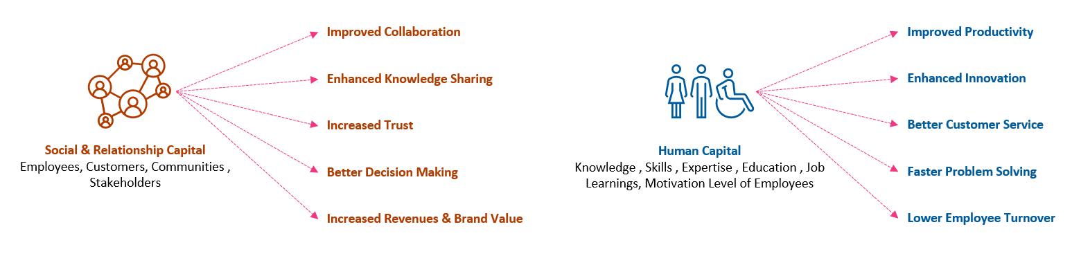
Figure: Social, Relationship & Human Capital
Human capital represents the skills, expertise, and knowledge of employees, forming the bedrock of organizational capability and success.
Several human resource management software and performance management systems are available in the market. These software solutions aim to streamline HR processes, improve employee engagement, and provide data-driven insights to decision-makers. However, these tools are more focused on HR management and less on identifying, developing & harnessing the powers of human and social capital. Traditional approaches and existing market offerings often fall short in fully capitalizing on social, relationship, and human capital. These tools lack the sophistication and depth required to extract valuable insights from complex networks and relationships.
Current solutions for identifying and developing human and social capital often rely on subjective assessments such as performance reviews or manager feedback or responses from employees` surveys. These methods can be prone to biases and may not fully capture the range of skills and expertise that employees possess. They struggle with data quality and often limit user personalization. They only employ dashboard and reporting services because these solutions don't fully utilize advanced analytics and artificial intelligence. In contrast, a tool using Generative AI can provide a more objective and data-driven approach to identifying and developing human and social capital.
Furthermore, traditional models often rely on a ‘one-size-fits-all’ approach to employee development, providing generic training programs that may not meet the specific needs of individual employees. A tool using generative AI can analyze a wide range of data sources to identify the unique skills and areas of expertise that each employee possesses, allowing for a more personalized and targeted approach to employee development.
As a result of using the available marketplace solutions, organizations may struggle to fill skills gaps, identify high-potential employees, or foster a culture of continuous learning and development. There is a need for a tool that can use generative AI capabilities to identify and develop the human and social capital within an organization more accurately and comprehensively.
Introducing AI-HSC Management Tool: Unleashing the potential
The role and advantage of generative AI in this context is that it can analyze large amounts of data quickly and accurately, identifying patterns and relationships that may not be obvious to human analysts. It can also provide insights that can help organizations make more informed decisions about how to develop their workforce and improve their operations.
‘AI-HSC Management tool’ is an innovative solution that revolutionizes the way organizations capitalize on social, relationship, and human capital. Built on the foundation of generative AI, it combines advanced algorithms with sophisticated data processing techniques to unlock the true potential of these valuable assets. The tool seamlessly integrates with existing systems, capturing data from various sources, and transforming it into actionable insights.
Let's examine the AI-HSC Management tool's process flow and see how it accelerates time to value:
Figure: AI-HSC Management Tool Process Flow

STAGE I – Data Sourcing
The tool would need to access a variety of data sources to effectively identify and develop human and social capital. These will include employee records, performance data, communication patterns, and network data.
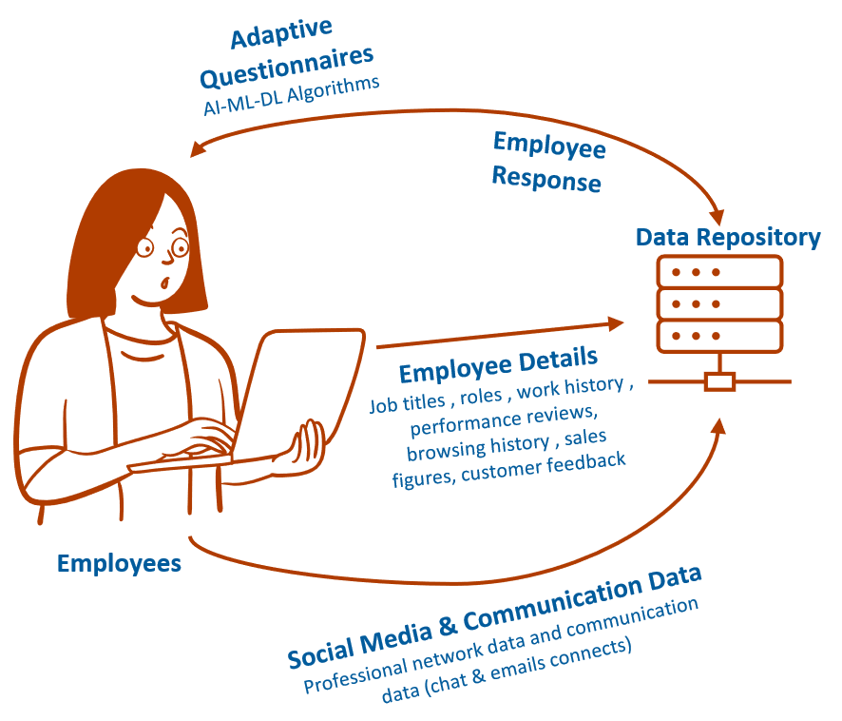
Figure: Data Sourcing for AI-HSC Management Tool

Employee Response: Based on the data set used to train the AI-HSC Management tool, adaptive questionnaires will be floated to employees. These questions will correspond to the specifics of the individuals' responses. For example, if an employee responds that he works in the domain of supply-chain consulting, the questions that follow will be from that specific domain, and the difficulty or scope of the next question will depend on the employee's response to the current question.
This will allow for a comprehensive evaluation of the employees' current skill set, his depth in a particular domain, and the breadth of his knowledge in that domain.
As the data from these responses continue to accumulate, our data repository will be continually enriched, and the machine learning models will assist in enhancing the quality of the questionnaires on an ongoing basis.
Employee Data: Employee data, such as job titles, work history, and performance reviews, can be used to help identify areas of expertise and potential leaders. We can integrate the organization's current HRM solutions and extract this information from its database.
Social media data: Social media data, such as LinkedIn profiles, can provide additional information about an employee's skills, experience & networks.
Communications data: Communications data, such as email and chat communication patterns, can help determine with whom employees frequently communicate and their networking abilities. It will also aid in identifying the individual's working environment.
Performance data: Performance data, such as sales figures or customer feedback, can be used to identify high-performing employees and areas where additional training may be needed.
With all this information, we will be able to create a database that will be utilized for processing and analysis. We will employ the remarkable capabilities of generative AI, machine learning, and other technologies to analyze this data and extract actionable insights.
STAGE II – Data Processing & Analytics
Once data has been collected from the various sources, it would need to be processed and analyzed using generative AI techniques. This could involve natural language processing, machine learning algorithms, and network analysis techniques.
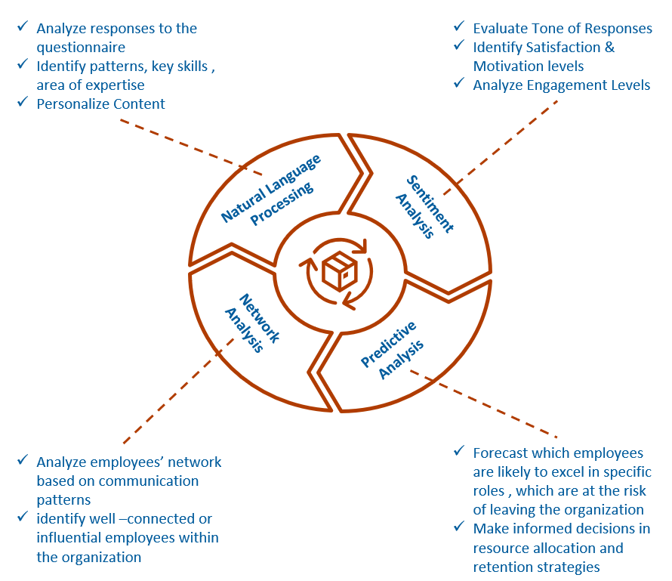
Figure: Data Processing & Analytics for AI-HSC Management Tool

Natural language processing (NLP): NLP algorithms will be used to analyze the written responses to the questionnaire and extract relevant information. NLP will help to identify patterns in the responses, including key skills and areas of expertise.
Sentiment analysis: Generative AI will use sentiment analysis to evaluate the tone of the employee's responses. This would help to identify employees who may be struggling or unhappy in their role, or those who may be highly motivated and engaged.
Network analysis: Generative AI will use network analysis to identify the relationships between employees, including who they work with, who they communicate with frequently, and who they turn to for help. This will help to identify employees who may be well-connected and influential within the organization.
Predictive analytics: The tool will use predictive analytics to forecast which employees are likely to excel in specific roles or to identify which employees are at risk of leaving the organization. This will help managers make informed decisions about resource allocation and retention strategies.
Similarly, we can analyze the data using various algorithms and fully utilize the capabilities of these more recent technologies. This will make us better able to identify many areas where we need to improve in our organization, and it will also help us maintain a competitive advantage over organizations that are still utilizing traditional HRM solutions and are not leveraging AI-powered solutions.
STAGE III – Actionable Insights
Based on the analysis of the data, the tool would identify areas where employees need support and development and provide targeted training and coaching to address these areas. The tool would also identify high-performing employees and potential leaders and provide them with opportunities for growth and development.
The tool will generate reports and visualizations to help managers and leaders understand the strengths and weaknesses of their workforce, and track progress over time. This would include dashboards, charts, and related graphs.
Skill and Expertise Identification: The tool would analyze the data sources to identify the unique skills and areas of expertise that each employee possesses. This will include analyzing performance data, communication network and training records.
Gap Analysis: Based on the identified skills and areas of expertise, the tool would analyze the gaps in knowledge or skills that exist for each employee. This would involve comparing the employee's current skillset with the skillset required for their current role, as well as any future roles they may be interested in.
Targeted Development: The tool would provide targeted development opportunities to address the identified gaps. This could involve providing access to online training courses, coaching sessions with subject matter experts, or on-the-job training opportunities.
The AI-HSC tool will generate personalized training materials, audio/video modules, and gamified e-learning modules based on the current data set on which the model is trained and the content available on the internet, utilizing generative AI capabilities. It will also monitor employees' progress towards their objectives and facilitate self-learning.
These development opportunities would be personalized to the employee's specific needs, based on the results of the gap analysis.
Leadership Identification: The tool would also identify high-performing employees and potential leaders within the organization. This will involve analyzing performance data and communication patterns to identify employees who have strong leadership skills or who are influential within their team or department. These employees could then be provided with targeted leadership development opportunities.
Dashboard Creation: The tool would create a dashboard that provides a high-level overview of the organization's workforce. The dashboard would include metrics such as employee engagement, skills gaps, and leadership potential etc.
Data Visualization: The tool would generate visualizations such as charts and graphs to help managers and leaders understand the data. For example, the tool could generate a chart showing the distribution of skills across the organization, or a graph showing the growth in employee engagement over time.
Detailed Reports: The tool could also generate detailed reports on specific areas of interest. For example, the tool could generate a report on the effectiveness of a particular training program or a report on the skill gaps within a specific department.
Leveraging Social-Relationship Capital & Optimizing Human Capital
‘AI-HSC Management Tool’ utilizes generative AI to map and analyze social networks, identifying key influencers, collaboration patterns, and knowledge flows. It helps organizations identify untapped opportunities for cross-functional collaboration, establish communities of practice, and strengthen relationships across teams and departments. By leveraging social and relationship capital, organizations can foster a culture of collaboration, innovation, and collective intelligence.
Through advanced analytics and natural language processing, ‘AI-HSC Management Tool’ assesses and evaluates the expertise, skills, and experiences of employees. It enables organizations to identify subject matter experts, build competency profiles, and optimize talent allocation. The tool facilitates personalized learning and development pathways, enabling employees to acquire new skills, bridge knowledge gaps, and unlock their full potential.
Adoption of 'AI-HSC Management Tool' provides organizations with a variety of benefits and results, including:
Social Sustainability: Enhanced social sustainability and corporate social responsibility through community-building and stakeholder engagement initiatives.
This will also help enhance ESG ratings and contribute to the organization's initiatives-related Sustainability development goals.
Enhanced Talent Management: Improved talent management and workforce optimization using social and relationship capital to identify high-performers, nurture mentorship programs, and enhance collaboration.
The tool will identify high-performing employees and potential leaders, which can help to ensure that talent is effectively managed and developed. This can lead to a more engaged and motivated workforce, which can help to improve employee retention and reduce the costs associated with turnover.
Improved customer satisfaction: Enhanced customer satisfaction via personalized interactions, leveraging relationship capital to strengthen connections, and delivering customized experiences.
By identifying employees who excel in areas such as customer service or sales, the tool can help to ensure that the organization is providing the highest quality customer experience possible. This can lead to improved customer satisfaction, increased loyalty, and ultimately, increased revenue.
Informed & Improved decision-making: Data driven comprehensive insights into the organization's social networks, relationships, and expertise to facilitate decision making process.
This will also facilitate more informed hiring, training, and development decisions, as well as the promotion of candidates to leadership roles. Organization can have channelized resource allocation process based on the skill set details of individual associates.
Eliminate Bias: Elimination of bias and promotion of diversity through data-driven assessments and talent allocation processes.
As the tool follows a Machine First and data-driven strategy, there will be minimal reliance on traditional feedback and review methods, allowing us to eliminate all associated biases.
Cultural Shift: This tool will enable steady transition from a traditional "command and control" hierarchy to a collaborative and nurturing environment that encourages employee engagement and ownership.
The tool will facilitate agile decision making within the organization by facilitating data-driven, well-informed decision making. Employees will develop a sense of empowerment and ownership by completing self-study modules and bridging skill set deficits.
Content Creation: Utilizing the organization's collective knowledge and experiences, content is created for the purposes of training and mentoring.
This must individualize the employee learning experience. Individual requirements, skill gaps, and aspirations will inform the development of the training material. This will also facilitate self-learning and increase employee engagement, leading to higher levels of productivity, quality of work and job satisfaction.
Effective team building: By identifying employees with complementary skills and areas of expertise, the tool can help managers to build more effective teams. This can lead to improved collaboration, higher quality work, and a more innovative and agile organization.
With the aid of network analysis capabilities, the tool will provide a comprehensive view of employees' social capital and facilitate the transfer of necessary resources and the exchange of information among various individuals within an organization. It will encourage employees to work together and build trusting relationships.
Stronger brand building: By developing a skilled and motivated workforce, the tool can help to strengthen the organization's brand image. This can lead to increased brand recognition, improved reputation, and ultimately, increased revenue.

In conclusion, capitalizing on social, relationship, and human capital with generative AI opens new horizons for organizations seeking sustainable growth, innovation, and competitive advantage. ‘AI-HSC Management Tool’ empowers organizations to unlock the hidden potential within their networks, relationships, and talent, fostering collaboration, driving informed decision-making, and optimizing workforce capabilities. As organizations embrace this AI-powered revolution, such solutions open doors to future of endless possibilities and opportunities.

