HERBAL MEDICINES ON RESPIRATORY INFLAMMATION-RELATED DISEASES
R. SelvaKumar¹, Mrs. Jothi Lakshmi², Mrs. Devi², Dr.R. Srinivasan³, Dr.R. Saravanan⁴, K. Pushparaj¹, E.Velmurugan¹, K.ManiKandan^{1,} G.Akash Kumar¹,Khushi Singh¹
1- B.Pharm IV Sem, 2 – Associate Professor,3- Dean & Professor, 4-Professor
Bharath Institute of Higher Education and Research – Chennai.

INTRODUCTION:
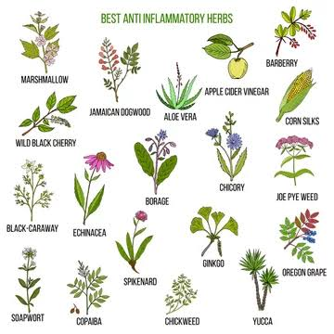 In recent years, the integration of traditional herbal remedies with modern medicine has gained increasing interest in the search for effective treatments for diseases associated with respiratory infections. Respiratory diseases, which range from common conditions such as asthma and bronchitis to more serious diseases such as chronic obstructive pulmonary disease and pneumonia, continue to pose a significant global health burden. The traditional use of herbal medicine in the treatment of diseases associated with respiratory infections dates back centuries, with a ledge passed down through the generations.
The high prevalence of these conditions, along with concerns wealth of knowabout side effects and limitations of traditional medicines, has led to renewed interest in herbal remedies. Herbal medicines offer a promising means of managing respiratory tract inflammation, providing potential alternatives or complementary approaches to standard pharmaceutical interventions.
This exploration into the realm of herbal medicine for diseases associated with respiratory tract infections seeks to bridge the gap between ancient wisdom and modern science. We will delve into the historical context of herbal remedies, the bioactive compounds responsible for their therapeutic effects, and the emerging scientific evidence supporting their use. In addition, we will examine the challenges and opportunities surrounding integrating herbal medicines into mainstream health care, keeping in mind the need for rigorous clinical studies, safety assessments, and regulatory frameworks.
This comprehensive overview aims to highlight the potential of herbal medicines in relieving symptoms, reducing inflammation, and improving the overall quality of life for individuals with respiratory tract infection-related illnesses. By combining traditional wisdom with contemporary research, we hope to provide valuable insights into a holistic and personalized approach to managing respiratory health.

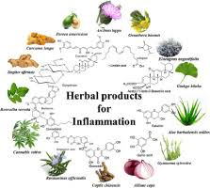

VULGARIS THYMU:

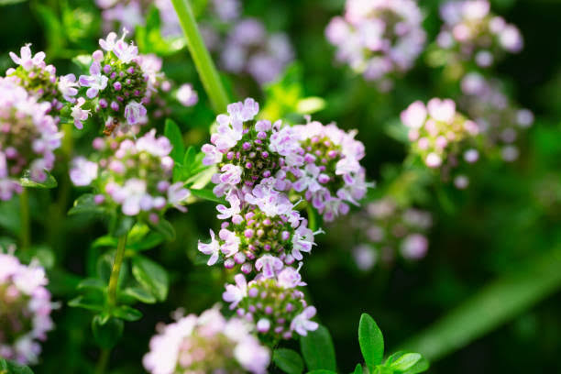
Introduction:
Thymus vulgaris L., commonly known as Thyme, is a well-known herb with a long history of culinary and medicinal use. It belongs to the family Lamiaceae and is native to the Mediterranean region. Thyme is characterized by its aromatic leaves and is valued for its flavor as well as its medicinal properties.
Taxonomy and Botanical Characteristics:
Scientific Name: Thymus vulgaris
Family: Lamiaceae (mint family)
Common Names: Common thyme, garden thyme, or simply thyme.
Thymus vulgaris is a small, perennial herb that typically grows to a height of about 15 to 30 centimeters (6 to 12 inches). It has a bushy and woody stem with small, linear to elliptical leaves that are green-gray in color. Thyme leaves are highly aromatic, releasing a pleasant, earthy, and slightly minty fragrance when crushed. The plant produces small, tubular, lilac to pinkish-purple flowers in clusters at the tips of its branches, making it an attractive addition to gardens.
Synthesis:
Thyme is a naturally occurring herb and is not synthesized artificially. It grows in various regions and is typically propagated by seeds or cuttings.
Biological Sources and Family:
Biological Source: Thymus vulgaris L.
Family: Lamiaceae (Mint family)
Chemical Constituents:
Thyme contains various chemical constituents that contribute to its flavor and medicinal properties. Some of the key compounds found in thyme include thymol, carvacrol, p-cymene, linalool, and flavonoids like apigenin and luteolin.
Material and Method of Collection:
Thyme is collected by harvesting the leaves and flowering tops of the plant. The best time for collection is usually during the flowering season, when the aromatic compounds are most concentrated. The plant is typically cut near the base, and the leaves and tops are dried for later use.
Pharmacological Action:
Thyme has several pharmacological actions, including:
- Antimicrobial: Thyme contains thymol and carvacrol, which have strong antimicrobial properties and can help combat bacteria and fungi.
- Anti-inflammatory: Thyme extracts have demonstrated anti-inflammatory effects, making it useful for conditions involving inflammation.
- Antioxidant: Thyme is rich in antioxidants that help protect cells from oxidative damage.
- Expectorant: Thyme can help loosen mucus and relieve coughs, making it beneficial for respiratory conditions.
- Antispasmodic: It can help relax muscles and reduce spasms in the gastrointestinal tract.
Uses:
- Thyme has a wide range of uses:
- Culinary: It is used as a flavoring agent in various dishes, particularly in Mediterranean cuisine.
- Medicinal: Thyme is used in traditional medicine for its various pharmacological actions, including treating respiratory issues, digestive problems, and skin conditions.
- Aromatherapy: Thyme essential oil is used in aromatherapy for its soothing and aromatic properties.
- Cosmetics: Thyme extracts are used in skincare products for their antimicrobial and antioxidant properties.
Merits:
- Natural remedy: Thyme provides a natural and herbal approach to health and culinary flavoring.
- Versatile: It can be used in a wide range of dishes and remedies.
- Medicinal benefits: Thyme offers various medicinal benefits, especially for respiratory and digestive issues.
- Aromatic: Thyme's pleasant aroma makes it a popular choice in both cooking and aromatherapy.
Demerits:
- Allergic reactions: Some individuals may be allergic to thyme or its constituents.
- Overuse: Excessive use of thyme, particularly thyme oil, can cause skin irritation.
- Interaction with medications: Thyme may interact with certain medications, so it's important to consult a healthcare professional before using it medicinally.

TILIA CORDATA MILL
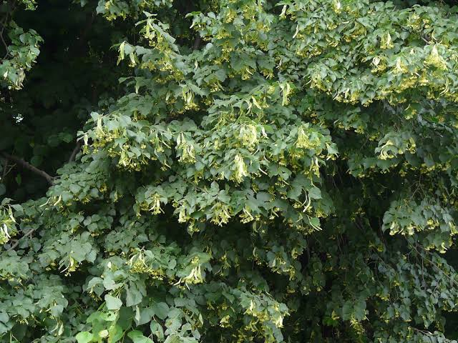
Introduction:
Tilia cordata is a deciduous tree that is valued for its ornamental and practical attributes. It is a relatively small to medium-sized tree, typically reaching heights of 60 to 80 feet (18 to 24 meters). The leaves are small, heart-shaped, and have serrated edges. During the summer, the tree produces fragrant, pale yellow flowers that attract pollinators like bees. The tree's fruit consists of small, round, nut-like structures attached to a winged bract.
Biological Sources and Family:
Biologically, Tilia cordata belongs to the family Malvaceae. It is a species of tree commonly found in Europe and Western Asia.
Synthesis:
Tilia cordata is a naturally occurring species and is not synthesized in a laboratory. It grows from seeds or by vegetative propagation.
Chemical Constituents:
Tilia cordata contains various chemical constituents, including flavonoids (e.g., quercetin and kaempferol), volatile oils, mucilage, tannins, and glycosides. These compounds are responsible for its medicinal properties.
Material and Method of Collection:
The leaves, flowers, and bark of Tilia cordata are typically collected for medicinal or culinary purposes. They are harvested in spring or early summer when the flowers are in full bloom and the leaves are young and tender.
Pharmacological Action:
Tilia cordata has several pharmacological actions and is known for its mild sedative, diuretic, antispasmodic, and anti-inflammatory properties. It has been used traditionally to treat conditions such as anxiety, insomnia, and digestive issues. The plant's medicinal effects are attributed to its chemical constituents, particularly the flavonoids and volatile oils.
Uses:
- Herbal Tea: Tilia cordata flowers and leaves are commonly used to make herbal teas known for their calming and relaxing effects.
- Traditional Medicine: It has been used to alleviate symptoms of anxiety, , and insomnia.
- Digestive Aid: Tilia cordata tea can be used to soothe digestive discomfort and relieve symptoms like bloating and gas.
Merits:
- Ornamental Value: Tilia cordata is often planted as an ornamental tree in parks, gardens, and along streets due to its attractive, heart-shaped leaves and fragrant flowers. It provides aesthetic beauty and shade.
- Bee-Friendly: The tree's fragrant flowers are a valuable food source for bees, making it an excellent choice for supporting pollinators and promoting biodiversity.
- Tolerant of Urban Conditions: Tilia cordata is known for its tolerance of urban pollution and compacted soils, making it a resilient choice for urban landscaping.
- Medicinal Uses: Historically, various parts of the linden tree, including the flowers and leaves, have been used in herbal remedies for their potential calming and medicinal properties.
- Wood Utilization: The wood of Tilia cordata is soft and lightweight, making it suitable for carving and woodworking. It has been used for making musical instruments, such as guitars and pianos.
Demerits:
- Susceptible to Aphids: Linden trees, including Tilia cordata, are prone to aphid infestations. Aphids can feed on the tree's sap, which can lead to the development of honeydew and the growth of sooty mold.
- Leaf Litter: Like most deciduous trees, Tilia cordata sheds its leaves in the fall, which can create a significant amount of leaf litter, requiring cleanup.
- Limited Range: Tilia cordata is native to Europe and may not be well-suited to regions with different climate conditions. It may not thrive in areas with extreme heat or cold.
- Root System: The tree has an extensive root system, which can lead to issues with root intrusion into sewer lines or pavement if not properly managed.
- Allergenic Potential: Some individuals may be sensitive to the pollen produced by Tilia cordata, potentially causing allergic reactions.

MATRICARIA RETITA L
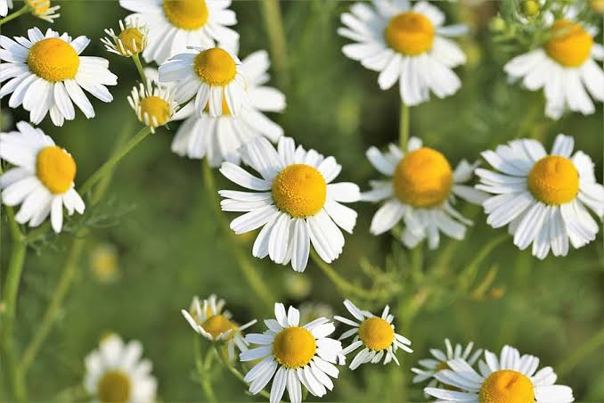
Introduction:
Matricaria recutita L. is a small, daisy-like plant that belongs to the Asteraceae family. It is native to Europe and Asia but has been naturalized in many parts of the world. Chamomile is renowned for its sweet, apple-like scent and is primarily known for its use in traditional medicine and herbal remedies. The two most common types of chamomile are German chamomile (Matricaria chamomilla or Matricaria recutita) and Roman chamomile (Chamaemelum nobile).
Biological Sources and Family:
Family: Asteraceae (Compositae)
Biological Sources: Matricaria recutita L. is the botanical source of chamomile. It is an annual herbaceous plant with feathery leaves and white, daisy-like flowers.
Synthesis:
Chamomile is a naturally occurring plant and cannot be synthesized artificially. It is propagated through seeds or cuttings and grown in suitable climates.
Chemical Constituents:
Chamomile contains various bioactive compounds, including:
Chamazulene: Responsible for the characteristic blue color of chamomile oil.
Bisabolol: Exhibits anti-inflammatory and skin-soothing properties.
Apigenin: A flavonoid with antioxidant properties.
Essential Oils: Contain terpenoids like alpha-bisabolol oxide A and B, which contribute to its aroma and medicinal properties.
Material and Method of Collection:
Chamomile flowers are typically harvested when they are in full bloom, usually in the morning on a dry day. The flowers can be plucked by hand or using small cutting tools. After harvesting, they are usually dried in a shaded area to preserve their medicinal properties.
Pharmacological Action:
Chamomile exhibits several pharmacological actions, including:
- Anti-inflammatory: It reduces inflammation and can be used topically or internally.
- Antispasmodic: Chamomile helps relax muscles and can alleviate digestive issues.
- Sedative: It has mild sedative effects and can promote relaxation and sleep.
- Antioxidant: Due to its flavonoid content, chamomile has antioxidant properties.
- Anti-allergic: Chamomile can help alleviate allergies.
Uses:
Chamomile has a wide range of applications, including:
- Digestive Health: Chamomile tea is used to relieve indigestion, bloating, and gastrointestinal discomfort.
- Skin Care: It's found in creams, lotions, and ointments for its soothing and anti-inflammatory effects on the skin.
- Stress and Anxiety: Chamomile tea is consumed to reduce stress and anxiety and promote relaxation.
- Wound Healing: Chamomile poultices can be applied to wounds and skin irritations for their healing properties.
Merits:
- Calming and Relaxing: Chamomile is widely recognized for its calming and soothing properties. It is often used to alleviate stress, anxiety, and promote relaxation. Chamomile tea is a popular choice for promoting better sleep and reducing insomnia.
- Digestive Aid: Chamomile has been traditionally used to relieve digestive discomfort. It can help with indigestion, gas, and bloating. Consuming chamomile tea after meals may aid in digestion.
- Anti-Inflammatory: Chamomile contains anti-inflammatory compounds that can help reduce inflammation and swelling, making it useful for conditions like arthritis and skin irritations.
- Skin Health: Chamomile is used topically in creams, lotions, and ointments to soothe skin conditions such as eczema, rashes, and minor burns. It has anti-irritant and anti-inflammatory properties that can benefit the skin.
- Immune Support: Some studies suggest that chamomile may have immune-boosting properties due to its antioxidants. Regular consumption of chamomile tea may support overall immune health.
Demerits:
- Interaction with Medications: Chamomile can interact with certain medications, such as blood thinners and drugs metabolized by the liver. It's important to consult with a healthcare professional before using chamomile if you are taking any prescription medications.
- Pregnancy and Nursing: Pregnant and nursing women should be cautious when using chamomile, as its safety in these situations is not well-established. It's best to consult with a healthcare provider before using chamomile products.
- Gastrointestinal Upset: In rare cases, chamomile may cause stomach upset or nausea in some individuals. If this occurs, it's advisable to discontinue use.
- Not Suitable for People with Ragweed Allergies: Chamomile is related to ragweed, and individuals with known ragweed allergies may experience cross-reactivity and allergic symptoms when using chamomile.

RUBUS IDAEUS L.
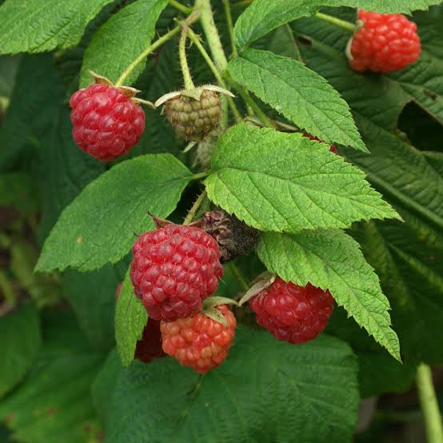
Introduction:
Rubus idaeus, or the raspberry plant, is a deciduous shrub that typically grows between 3 and 6 feet in height. It is known for its distinctive palmately lobed leaves and its production of small, red, or blackberries that are commonly referred to as raspberries. These berries are not true berries in the botanical sense but are rather aggregates of small drupelets, each containing a seed. Raspberries are enjoyed for their sweet and tangy flavor and are used in a variety of culinary applications, including jams, jellies, pies, and desserts.
Biological Sources and Family:
Family: Rosaceae
Biological Source: Rubus idaeus L.
Synthesis:
Red raspberries are not synthesized in the traditional sense, as they are naturally occurring fruits. However, they can be propagated through seeds or vegetative methods like cuttings or root division for cultivation.
Chemical Constituents:
Red raspberries are rich in various bioactive compounds, including:
Anthocyanins (e.g., cyanidin-3-glucoside)
Flavonols (e.g., quercetin)
Ellagitannins (e.g., ellagic acid)
Vitamins (e.g., vitamin C)
Minerals (e.g., potassium)
Dietary fiber
Organic acids (e.g., citric acid)
Material and Method of Collection:
Red raspberries are typically collected from raspberry bushes when they are ripe. They can be easily handpicked or mechanically harvested, depending on the scale of cultivation. For research or medicinal purposes, specific parts of the plant, such as the leaves or roots, may also be collected.
Pharmacological Action:
Red raspberries and their various constituents have been studied for their pharmacological actions, including:
- Antioxidant properties due to the presence of anthocyanins and ellagitannins.
- Anti-inflammatory effects, potentially attributed to quercetin and other flavonoids.
- Potential anti-diabetic properties, as some studies suggest they may help regulate blood sugar levels.
- Anticancer potential, particularly due to ellagic acid, which has shown promise in inhibiting the growth of certain cancer cells.
Uses:
- Culinary: Red raspberries are widely used in cooking and baking to make jams, pies, desserts, and sauces. They are also consumed fresh or added to salads and yogurt.
- Medicinal: Red raspberries and their extracts are used in traditional medicine for various purposes, including as an astringent, digestive aid, and to alleviate symptoms of diarrhea.
- Nutritional: They are a good source of vitamins, minerals, and dietary fiber, making them a nutritious addition to the diet.
- Cosmetic: Raspberry extracts are used in cosmetics and skincare products for their antioxidant and skin-soothing properties.
Merits:
- Nutritious: Raspberries are a good source of vitamins, minerals, and dietary fiber. They are particularly high in vitamin C, manganese, and antioxidants, which can have health benefits, such as supporting the immune system and reducing oxidative stress.
- Delicious Flavor: Raspberries are loved for their sweet-tart flavor, making them a popular choice for desserts, smoothies, and fruit salads.
- Medicinal Uses: Raspberry leaves have been used traditionally in herbal medicine for their potential health benefits. They are often used to make raspberry leaf tea, which is believed to have properties that can support women's health, particularly during pregnancy and menstruation.
- Culinary Versatility: Raspberries are versatile in the kitchen. They can be consumed fresh, frozen, or processed into various products like jams, jellies, syrups, and even in baking.
- Garden Ornament: Raspberry plants are also cultivated for their ornamental value. The lush green foliage and delicate white or pink flowers add aesthetic appeal to gardens.
Demerits:
- Invasive Growth: Raspberry plants can be aggressive and spread rapidly through underground rhizomes. This invasive growth can make them difficult to control in garden settings and may require regular pruning and maintenance.
- Susceptibility to Diseases: Raspberries are susceptible to various diseases and pests, including aphids, mites, and fungal infections like raspberry cane blight and gray mold. This can make them challenging to cultivate without proper care.
- Short Shelf Life: Fresh raspberries have a relatively short shelf life and can quickly spoil if not handled and stored properly.
- Thorny Varieties: Some raspberry varieties have thorns, which can make harvesting and pruning a bit challenging and potentially painful.

TUSSILAGO FARFARA L.
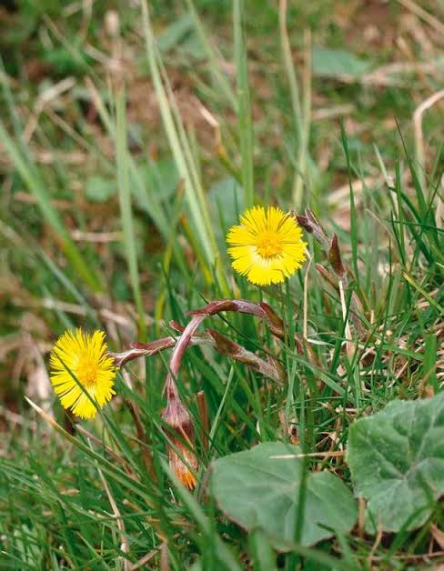
Introduction:
Botanical Description: Coltsfoot is a low-growing plant that typically reaches a height of 10-30 centimeters (4-12 inches). Its leaves are large, heart-shaped, and covered with white hairs on the underside. The plant produces yellow, dandelion-like flowers on tall stems in early spring before the leaves appear.
Traditional Uses: Coltsfoot has a long history of use in traditional medicine. Its name, "Tussilago," is derived from the Latin words "tussis" (cough) and "ago" (to act), indicating its historical use as a remedy for coughs and respiratory issues. It has also been used for other medicinal purposes, including as an expectorant and a treatment for skin conditions.
Biological Sources and Family:
Biological Source: Coltsfoot (Tussilago farfara)
Family: Asteraceae
Synthesis:
Coltsfoot is a naturally occurring plant and is not synthesized chemically.
Chemical Constituents:
Coltsfoot contains various chemical constituents, including:
Pyrrolizidine alkaloids
Triterpenoids
Flavonoids
Mucilage
Tannins
Essential oils
Material and Method of Collection:
Coltsfoot can be collected in the wild or cultivated. The leaves and flowers are typically harvested during the flowering season, which is in early spring before the leaves fully develop. The plant can be collected by hand, and the aerial parts are usually used for medicinal purposes.
Pharmacological Action:
Coltsfoot has been used in traditional medicine for its potential pharmacological actions, including:
- Expectorant: It is often used to relieve coughs and respiratory congestion.
- Demulcent: Coltsfoot can soothe irritated mucous membranes.
- Anti-inflammatory: It may have anti-inflammatory properties.
Uses:
Coltsfoot has been used for a variety of medicinal purposes, including:
- Respiratory Conditions: It is traditionally used to treat coughs, bronchitis, and other respiratory ailments.
- Sore Throat: Coltsfoot can be used as a throat lozenge or tea to soothe a sore throat.
- Asthma: It has been used to alleviate asthma symptoms.
- Skin Conditions: It may be used topically for skin conditions like eczema and psoriasis, although this use is less common.
Merits:
- Respiratory Health: Coltsfoot has been traditionally used to alleviate coughs and respiratory issues. It contains compounds like mucilage and tannins that may help soothe irritation in the throat and respiratory passages.
- Expectorant: The leaves of coltsfoot have been used as an expectorant, which means they can help loosen and expel mucus from the airways. This property can be beneficial for individuals with bronchitis or other respiratory conditions.
- Anti-Inflammatory: Some studies suggest that coltsfoot may have anti-inflammatory properties, which could be useful in managing inflammatory conditions like arthritis.
- Skin Health: Topical applications of coltsfoot extracts have been used to soothe skin irritations and conditions like eczema and psoriasis.
- Antioxidant Activity: Coltsfoot contains antioxidants that may help protect cells from oxidative damage.

Demerits:
- Liver Toxicity: Coltsfoot contains pyrrolizidine alkaloids, which can be toxic to the liver when consumed in large quantities or over an extended period. Long-term use of coltsfoot preparations that contain these alkaloids should be avoided.
- Pregnancy and Lactation: Due to the presence of pyrrolizidine alkaloids, coltsfoot is not recommended for pregnant or breastfeeding women, as it may harm the developing fetus or be passed on to the infant through breast milk.
- Allergies: Some individuals may be allergic to coltsfoot or its components and may experience skin rashes, itching, or other allergic reactions.
- Regulatory Concerns: In some countries, coltsfoot products have been restricted or banned due to concerns about pyrrolizidine alkaloid content and potential liver toxicity.
- Medication Interactions: Coltsfoot may interact with certain medications, so it's essential to consult with a healthcare professional before using it, especially if you are taking other medications.

FOENICULUM VULGARE MILL
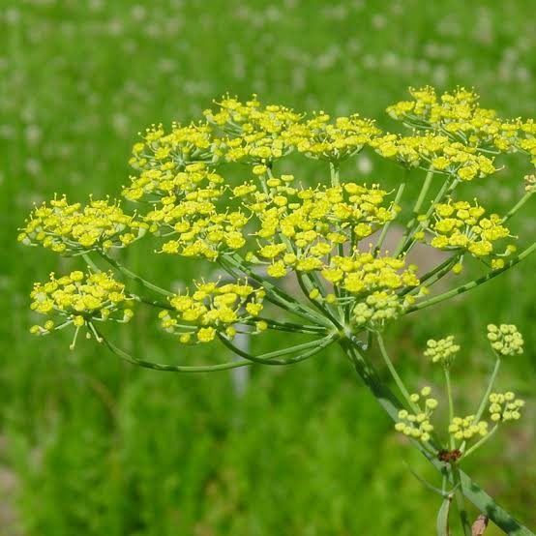
Introduction:
Foeniculum vulgare Mill., commonly known as fennel, is a flowering plant that belongs to the family Apiaceae (Umbelliferae). It is native to the Mediterranean region but is now cultivated and grown in many parts of the world for its culinary, medicinal, and aromatic properties.
Culinary Uses: Fennel is a popular herb in Mediterranean and Middle Eastern cuisine. Its seeds, leaves, and bulb are all used in cooking. The bulb can be sliced and used in salads, while the seeds are commonly used as a spice in a variety of dishes, including soups, stews, and fish recipes. Fennel seeds are also used as a flavoring in liqueurs like absinthe and as an ingredient in spice blends like Chinese five-spice powder.
Medicinal Uses: Fennel has been used in traditional medicine for its potential health benefits. It is often consumed as a herbal tea and is believed to aid in digestion, alleviate bloating, and relieve symptoms of indigestion and irritable bowel syndrome (IBS). It may also have anti-inflammatory and antioxidant properties.
Aromatic Uses: The aromatic and pleasant scent of fennel makes it a common ingredient in perfumes and cosmetics.

Biological Sources and Family:
Family: Apiaceae (Umbelliferae)
Biological Source: Foeniculum vulgare Mill., commonly known as fennel.
Synthesis:
Foeniculum vulgare is a naturally occurring plant and is not synthesized artificially.
Chemical Constituents:
Fennel contains various chemical constituents, including:
Essential Oils: Anethole is the primary component responsible for the characteristic aroma and flavor of fennel.
Phenolic Compounds: Fennel contains flavonoids and phenolic acids.
Volatile Compounds: Apart from anethole, fennel also contains other volatile compounds like limonene, fenchone, and estragole.
Material and Method of Collection:
Fennel is collected primarily for its seeds, which are harvested when they are mature and dry. The seeds are then separated from the plant and can be used for various purposes. The whole fennel plant can also be used, including the leaves, stems, and bulbs, depending on the intended use.
Pharmacological Action:
Fennel has several pharmacological actions and potential health benefits, including:
- Antioxidant: Due to its phenolic compounds, fennel exhibits antioxidant properties.
- Carminative: Fennel is often used to relieve gas and bloating.
- Anti-inflammatory: Fennel may have anti-inflammatory effects.
- Antispasmodic: It can help relax smooth muscles, which can be useful for digestive issues.
Uses:
Fennel has a wide range of uses, including:
- Culinary: Fennel seeds and bulbs are used as a spice and flavoring agent in cooking.
- Medicinal: Fennel is used in traditional medicine for various purposes, including digestive disorders, colic in infants, and as a mild diuretic.
- Aromatic: Fennel's sweet and aromatic flavor is used in the production of liqueurs and perfumes.
Merits:
- Digestive Health: Fennel is known for its digestive properties. It can help relieve gas, bloating, and indigestion. Chewing fennel seeds after a meal is a traditional remedy for improving digestion.
- Antioxidant Properties: Fennel contains antioxidants like flavonoids and polyphenols, which may help protect cells from oxidative stress and reduce the risk of chronic diseases.
- Nutrient-Rich: Fennel is a good source of vitamins and minerals, including vitamin C, potassium, and folate. It is also low in calories and provides dietary fiber.
- Aromatic and Culinary Uses: Fennel's unique flavor adds depth and complexity to many dishes. It can be used in both sweet and savory recipes, making it a versatile ingredient in the kitchen.
Demerits:
- Allergies: Some individuals may be allergic to fennel, especially those with allergies to other plants in the Apiaceae family, such as celery and carrots. Allergic reactions can range from mild to severe.
- Medication Interactions: Fennel supplements or large amounts of fennel consumption may interact with certain medications, so it's important to consult with a healthcare professional if you are taking medications regularly.
- Pregnancy and Breastfeeding: Pregnant or breastfeeding women should exercise caution when consuming fennel, especially in large amounts, as its safety during these periods is not well-documented.
- Seed Safety: Fennel seeds should be consumed in moderation, as excessive consumption may lead to side effects like nausea and vomiting.
Reference:
- Prakash, B., Singh, P., & Kedia, A. (2017). In vitro antioxidant, antidiabetic, antimicrobial and antiproliferative potential of essential oil of Ocimum basilicum L. var. purpurascens Benth. PloS One, 12(2), e0172586.

- Nair, R., & Chanda, S. V. (2008). Antibacterial activities of some medicinal plants of the Western region of India. Turkish Journal of Biology, 32(1), 63-68.

- Batista, L. M., Rodrigues, A. M., & Amorim, E. L. (2008). In vivo anti-inflammatory and antinociceptive actions of the lignan lactone from Lignum vitae (Guaiacum officinale). Phytomedicine, 15(2-3), 157-162.

- Guzman-Gutierrez, S. L., Gomez-Cansino, R., Garcia-Zebadua, J. C., Jimenez-Perez, N. C., Reyes-Chilpa, R., & Tortoriello, J. (2012). Antimicrobial and cytotoxic activities of Mexican medicinal plants. The Journal of Ethnopharmacology, 140(1), 233-247.

- Prasad, S., & Aggarwal, B. B. (2011). Turmeric, the Golden Spice: From Traditional Medicine to Modern Medicine. In Herbal Medicine (pp. 595-621). CRC Press.

- Jurenka, J. S. (2009). Anti-inflammatory properties of curcumin, a major constituent of Curcuma longa: a review of preclinical and clinical research. Alternative Medicine Review, 14(2), 141-153.

- Surjushe, A., Vasani, R., & Saple, D. G. (2008). Aloe vera: a short review. Indian Journal of Dermatology, 53(4), 163-166.

- Syed, T. A., Ahmad, S. A., Holt, A. H., & Ahmad, S. A. (1996). Management of psoriasis with Aloe vera extract in a hydrophilic cream: a placebo-controlled, double-blind study. Tropical Medicine & International Health, 1(4), 505-509.

- Ankri, S., & Mirelman, D. (1999). Antimicrobial properties of allicin from garlic. Microbes and Infection, 1(2), 125-129.

- Ried, K., & Fakler, P. (2014). Potential of garlic (Allium sativum) in lowering high blood pressure: mechanisms of action and clinical relevance. Integrated Blood Pressure Control, 7, 71-82.

