Factors Related to Bioremediation of Oil contaminated Soil by Bacteria
Abujur Ansari*, Rohit Oraon, Rupa Verma
1. MS c Biotechnology, University Department of Botany, Ranchi University, Ranchi-834006, Jharkhand, India,834008
* Correspondence adress: abujursd1280@gmail.com
Abstract
Bioremediation means the process of removal of harmful substances from soil, air, water etc. that pollutes environment using biological way such as use of bacteria, fungi or plant, if not taken care of this environmental pollutants they will eventually affects us and the biological way to treat them is most sustaining and economical. Removing or degrading oil contaminants pollutants by biological means using bacteria. Leakage of oil in soil and water causes several harmful environmental impacts, chemical substances present in oil are less available for biodegradation decreases water and nutrient accessibility to plants directly disturbs plant growth and development and eventually harms the health of plant and animal life. These oil contaminants are accumulated in the environment by various human activities. This Oil includes Gasoline, Kerosene, Diesel, lubricants, and Tar, etc. These oils contain hydrocarbons such as aliphatic and aromatic (PAHs). Polycyclic Aromatic hydrocarbons (PAHs) are acyclic abiotic chemical substances for an ecosystem and are easily accumulated in soil and sediment due to their less soluble and high hydrophobic nature, which affects their bioavailability and causes less accessibility for degradation. Microorganism such as bacteria which are capable of degrading Oils can prevent these harmful effects, which eventually converts aliphatic and aromatic hydrocarbons into CO₂ and H₂O in their metabolic pathway which are the cyclic abiotic component in any ecosystem. In this Review, we are going to talk about the factors which will affect positively the biodegradation of oil contaminants in the soil if taken into consideration. This review will help to study the major factors which can increase the biodegradation rate even at higher levels by observing some factors more closely related with biodegradation of oil using bacteria, to remove oil contaminants from soil so that further soil erosion and harmful effects on environment can be mitigated.

Keywords: -Bioremediation, Biodegradation Rate, Hydrocarbons, PAHs, Bacteria, Bioavailability, Biochar

1. Introduction

Soil Pollution by Hydrocarbons can be a major global issue because of the various problems it causes by its bioaccumulation in an ecosystem.¹ As soil comes into contact with oil due to extraction, refining, transportation, and industrial activities etc. increases soil infertility, reduces the diversity of soil-dwelling plants and microbes, disturbs the biological balance of the soil, delays germination, reduces chlorophyll content, and makes some crops fail when planted in soil that is substantially contaminated with petroleum [1], ultimately affects agriculture and even endanger human health. Hydrocarbons found in oil can be aliphatic or PAHs, Aliphatic hydrocarbons are easily biodegradable as compared to PAHs. The degradability of hydrocarbons is influenced by their molecular weight. Compared to high-molecular-weight hydrocarbons, low-molecular-weight hydrocarbons have improved bioavailability because they are comparatively less hydrophobic. Aliphatic have greater hydrocarbon susceptibility to microbial breakdown than PAHs because of their bioavailability. The greater the fused rings in PAHs, the more hydrophobic it is and less susceptible to microbial biodegradation.

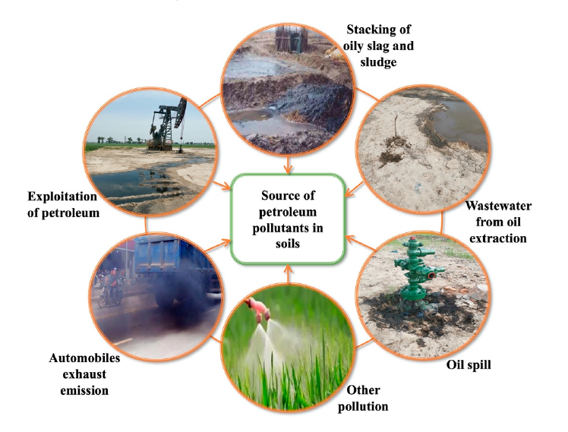
Figure 1.Shows the principal sources of hydrocarbons in soil [2].

The group of chemical compounds known as polycyclic aromatic hydrocarbons (PAHs) consists of molecules containing two or more fused benzene rings arranged in linear, angular, or cluster structural configurations. [3].They comes from the combustion of fossil fuels, the burning of trash, the gasification of coal, and the refinement of petroleum. PAH’s found everywhere in environment, including air [3], water, soil, sediment etc. Due to PAH's toxicity to numerous living things and their potential for mutation and cancer in humans across the food chain, the United States Environmental Protection Agency (USEPA) classified PAHs as a significant concern. Naphthalene, Fluorene, Anthracene, Pyrene etc and other polycyclic aromatic hydrocarbons are examples of such hydrocarbons. As their molecular weight rises, they become more hydrophobic in nature and less soluble.
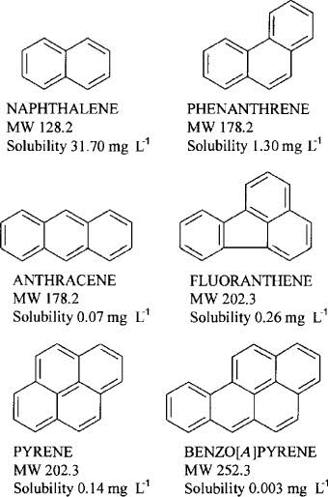

Figure 2. Some soil contaminating PAHs chemical structure [3]

Up till now, there are various techniques to remove oil contamination such as physical and chemical treatment techniques are mostly confined to harmful byproducts-producing synthetic chemical surfactants or booms for spill containment [4]. Therefore, the most economical and sustainable that is, bioremediation by bacteria is a way of treating environmental conditions that causes fewer physical, chemical, and biological changes.. A bacterium uses hydrocarbons as its sole carbon source inits metabolic activities.Bacterial bioremediation of hydrocarbons includes adsorption, bioaugmentation and biodegradation by microbial metabolic activity and eventually complete mineralization into CO_{2,} H₂O, cell proteins, inorganic substances, and the catabolism of complicated organic contaminants into other simpler organic compounds. As PAHs have less bioavailability, and less solubility in aqueous and are a major concern to affect soil fertility and eventually the food chain and ecosystem. Therefore some factors need to be taken into consideration for better results of bioremediation of soil from PAHs using bacteria.
For example, environmental conditions, Bacterial consortia, biochar, biosurfactants, etc. (i) Biosurfactants have amphiphilic nature andwork as an emulsifier andincreasing surface contact with PAHs, hence, increasingthe biodegradation rate of hydrocarbons from the soil. [5] (ii) Since a single microorganism's metabolism can be limited to a particular amount of substrate, microbial consortia have a better capacity for degradation than a single microbial species. This is because using a single microbe would diminish the efficacy % [4]. (iii) The biochar-immobilized bacterial consortium had the best remediation impact on oil-contaminated soil, and after 28 days of remediation, the clearance rate of petroleum hydrocarbons was 78.32% [6]. (iv) Each Bacterium has its optimum physical conditions where it can grow to its maximum capacity. The activity of some bacteria is impacted when the environmental circumstances are unfavorable such as when soil salinity is higher than 8% or the pH is either lower than 4 or higher than 9.
Hence, we can observe that these factors are very useful for maximum results of bioremediation of hydrocarbons by bacteria.

2.Biosurfactants

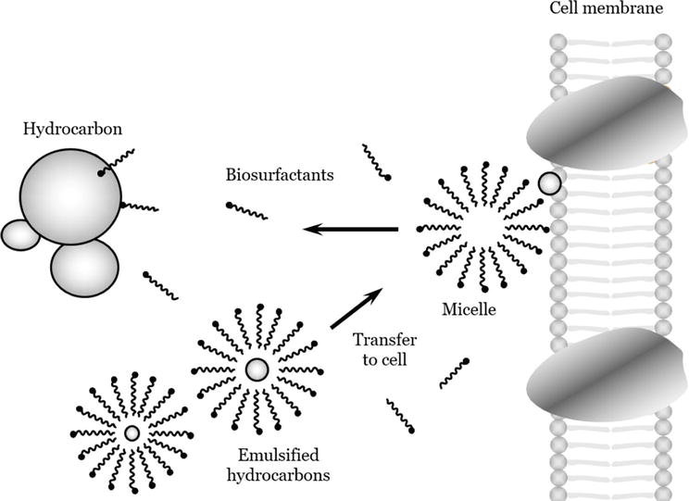

Figure 3. Emulsification process by biosurfactants [7]

Biosurfactants are emulsifiers that have both hydrophobic and hydrophilic nature and due to their amphiphilic nature they are soluble with both water loving an d water hating subtances, hence they increase the accessibility of hydrocarbons with bacteria, ultimately increasing the biodegradation rate. The two isolates (F2 and F3) came from pesticide-contaminated areas, whereas the other three isolates (F1, F4, and F5) came from waste oil-contaminated soil, The two Staphylococcus aureus strains F1 and F4 had the highest emulsification indices of the five isolates, each at 44.44 percent and 35%, respectively, moreover the remaining isolates F2, F3, and F5 displayed significant levels of E24(24–28%)[5]. Staphylococcus aureus isolates are F1, F4, and F5 while Bacillus subtilis isolates are F2 and F3 shows different emulsification efficiency.
From the above findings, we can conclude that bacteria found in oil-contaminated sites have a high biodegradation rate, because, unlike other microbes, they can produce surfactant chemicals biologically. We can see that pesticide-contaminated site shows comparatively lower biodegradation rate which means we can conclude that bacteria found anywhere but oil-contaminated regions have higher biosurfactants-producing microbes and we can choose specific isolate from there with a high rate of remediation and introduce them into soil contaminated with oil sites for the high rate of biodegradation and bioremediation. However, indigenous bacteria show less time in the lag phase compared to bacteria that are introduced in a different environment, it is because they take some time to adapt and accommodate according to a new environment.

3. Microbial (bacterium) Consortia

The efficiency of hydrocarbon degradation in the consortia ranges from 58% to 84%, compared to individual cultures' ranges of 25% to 47% and the 60-day in vitro oil degradation test's 43% degradation of aliphatic compounds in the consortium with the more strains which is comparatively higher than the consortium with the fewest strains [4]. Axenic cultures and mixed consortia both produced good results for C32 alkanes, however the mixed consortia produced better results (90%) than the axenic cultures [4]. The bacterial consortium degraded each petroleum component more evenly, the petroleum hydrocarbon degradation rates of A2 (Pseudomonas putida), A4 (Acinetobacter calcoaceticus), and L5 (Sphingomonas sp. ) as well as the bacterial consortium after 28 days of cultivation were 42.8%, 48.01%, 26.56%, and 81.07% respectively, the removal rates of the saturated hydrocarbons and aromatic hydrocarbon reached 89.93% and 82.08%, respectively [6].
From the above findings, we can conclude that different strains or species of bacterium capable of biodegradation of PAHs when used altogether have better output results, it is because they can act on different oil substrates individually and produce a higher rate of degradation. However, certain bacteria are more effective in their individual actions; for instance, in the breakdown of C40 alkanes, pure strains showed a larger degradation [4].
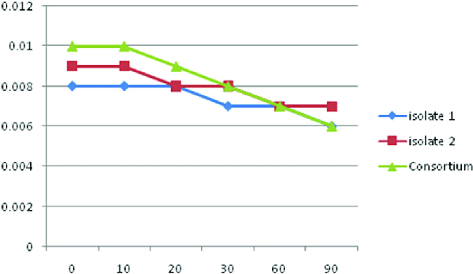

Figure 4. Consortium showing higher biodegradation rate than isolates [8]

4.Biochar

Petroleum hydrocarbons were removed at a rate of 78.32% in the CTB treatment, which was 18.0% or 32.51% greater than in the TB-BC or TB treatments, respectively. This finding suggests that the addition of biochar may increase soil respiration and microbial activity, the number of microorganisms, intensity of soil respiration, and dehydrogenase activity were different in the free bacterial consortium (TB), biochar-free bacterial consortium (TB-BC), and biochar-immobilized bacterial consortium (CTB) [6]. This was due to the fact that biochar has a porous nature and has abundance of nutrient, which both not only supplies the needs of microorganisms for growth, metabolism, and reproduction but also protecting them from the toxic soil environment. [6].
As we know PAHs have very less bioavailability, hence, poor in adsorption with bacteria and fewer PAHs biodegradation rate, but it’s the biochar that immobilizes petroleum hydrocarbons into its pores, increasing the adsorption and bioavailability, hence increasing biodegradation rate.

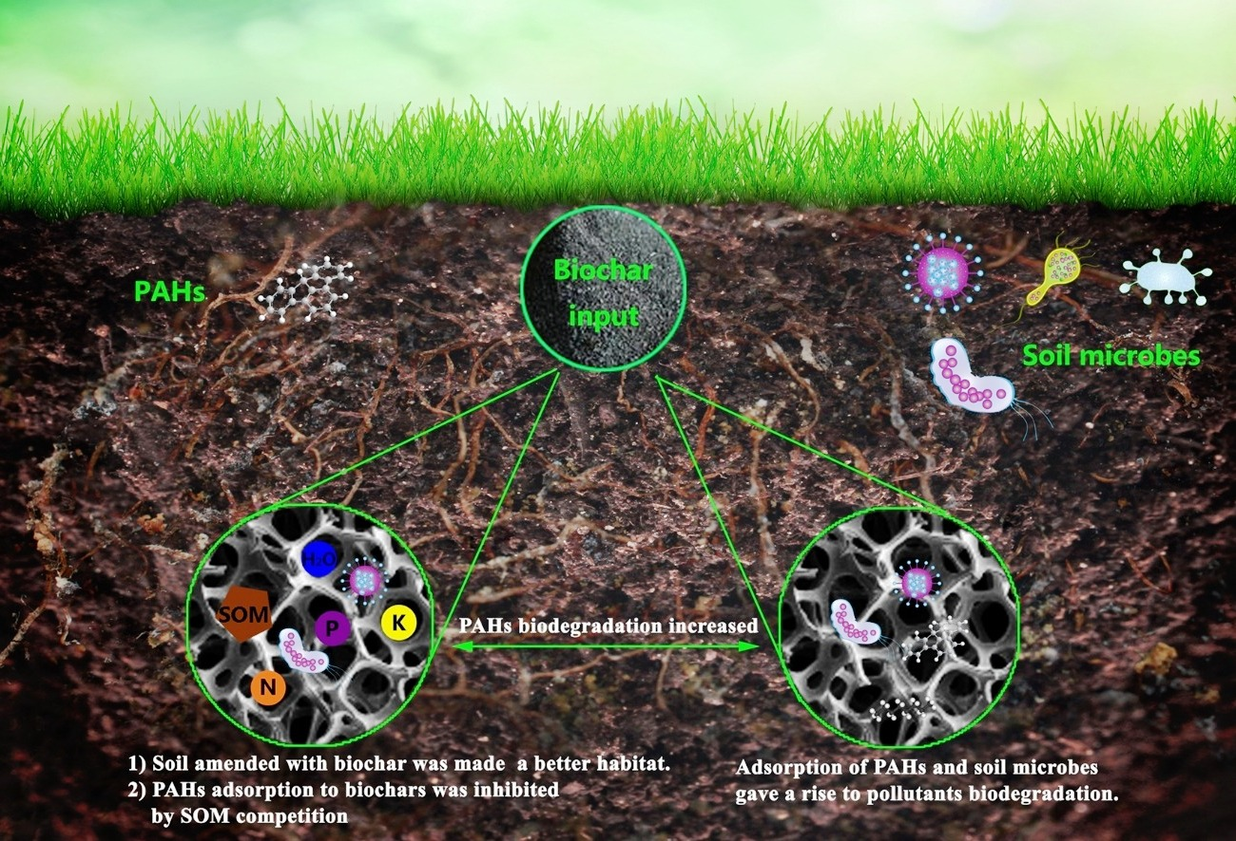

Figure 5. Biochar increased adsorption and bioavailability of hydrocarbons [9]

5.Environmental Conditions
5.1 Temperature: -
It is common to see that the degradation rate decreases at low temperatures, which is assumed to be due to lower enzyme activity rates [10]. One of the elements influencing PH biodegradation is temperature, which alters the physical and chemical makeup of PAHs [11]. Despite the fact that biodegradation of hydrocarbons can occur at a wide range of temperatures, the rate of degradation decreases with temperature changes from optimum tempratue. In soil, marine, and freshwater environments, the highest rates of degradation occurred at temperatures between 30 to 40 degrees Celsius, 20 to 30 degrees Celsius, and 15 to 20 degrees Celsius, respectively [11]. Hexadecane mineralization by microorganisms in 50 days at 4 and 10 degree Celsius produces 45% CO₂ and at 25 degree Celsius it is 68%. [12]. It follows that it is evident that the rate of biodegradation of hydrocarbons increases with increasing temperature towards optimum temperature, and this optimum temperature in soil always resides around 30 degrees Celsius.

5.2 pH: -
While improving biological treatment such as bio-degradation rate by bacteria, the pH can be extremely variable and must be taken into account because biological functions such as enzyme activity and catalytic reaction balance and cell membrane trafficking are all impacted by the pH of the environment [13]. [Pawar (2015), 14] observed that the breakdown of most the PAHs was most easily accomplished in soil with a pH of 7.5. Acinetobacter baylyi ZJ2 activity is impacted by soil salinities greater than 8% and pH values greater than 4 or lower than 9, as well as the production of a particular quantity of lipopeptide surfactant is prohibited, which lessens the rate at which microorganisms degrade petroleum [15]. All bacterium has an optimum pH where they are very active as their enzymes and proteins structures aren’t affected, and changes can affect their maximum degradation rate of hydrocarbons, and for most bacterium, this pH is around 7.0 – 8.0, which is found in soil.

5.3 Nutrients: -
For better bioremediation by bacteria, hydrocarbons are the only carbon source employed in nutrients; however, the only carbon source may become limited at point, thus affecting the bio degradation process [16]. The bioremediation of coastal sand contaminated with crude oil has improved because to the use of commercial mineral NPK fertilizer [17]. In run 1, with high concentrations of KH₂ PO₄ and NH₄ NO₃ in the mineral salt medium, the maximum phenanthrene removal efficiency was seen [16]. Therefore, bio-stimulation of oil-contaminated soil with the addition of macro-nutrients, micro-nutrients, and trace elements boosts the bio-degradation rate, with macro-nutrients NPK (Nitrogen, Phosphorus, and Potassium) having the most influence on the rate of bio-degradation.
With a rise in anthracene content, the Bacillus foraminis's maximum growth rate likewise shrank [18]. At 50 mg per litre and 100 mg per liter, respectively, the average clearance rates of anthracene were 0.298 ±0.009 mg per hour and 0.25±0.012 mg per hour. The lag phase grew with a higher anthracene content, as was seen in the case of anthracene. [18]. As we can see, the sole carbon source nutrient, here PAHs anthracene, is giving maximum biodegradation output at a certain concentration.

5.4 Other Factors: -
The rate-limiting factor for the environmental degradation of PAHs has been identified as oxygen content [19] Because the soil's ability to hold oxygen is influenced by the rate at which microbes consume oxygen, the kind of soil, whether it is wet, and the existence of a substrate that can eat up oxygen[20]. For anaerobic obligates or facultative anaerobes with hydrocarbon-degrading bacterium, is an advantageous point, as it is free from limited access to O₂, however, things can be disadvantageous in the case of obligate aerobes.
Salinity has a significant impact on microbial growth and diversity as well as the bio-remediation and bio-degradation processes, some important enzyme complexes that are involved in the process of degrading hydrocarbons are negatively impacted by salinity [8]. A more saline environment can cause osmotic pressure due to the transfer of solvent across; this may be the reason salinity decreases microbial action.

6. Conclusion

In this review article we have discussed some factors that can affect the bioremediation rate very positively, these factors can be used in combination or individually for better results of biodegradation, however combination or individual use open for researches findings only then we can draw certain units that can be considered for better bioremediation. As we know PAHs are more harmful than aliphatic hydrocarbons and they are less accessible for biodegradation, however when we consider these factors we draw better outlets for higher bioremediation rate of PAHs and the elimination of harmful toxins from the environment, hydrocarbon-free soil affects its fertility positively, deceases biomagnifications in ecosystems and eventually reduces health risk of animals and plants.

References

- E O Ekundayo , T O Emede, and D I Osayande. Effects of crude oil spillage on growth and yield of maize in soils of Midwestern Nigeria, in 2001, Plnt. Foods Hum. Nutrition, 56, 313–324.

- Sui X , Wang , Li and Ji. Remediation of Petroleum-Contaminated Soils with Microbial and Microbial Combined Methods: Advances, Mechanisms, and Challenges. Sustainability, in 2021; 13(16):9267.

- Bamforth and Singleton. Bioremediation of polycyclic aromatic hydrocarbons: current knowledge and future directions, in 2006, J Chem Technolgy Biot 80: 723-736.

- Sergio Gómez , Mariana Castillo ,Carina Shianya , Patricia and Susana. Biodegradation of hydrocarbons from contaminated soils by microbial consortia: A laboratory microcosm study, in 2023, Electrnc. Journal of Biotechnlgy., 61, 24–32.

- Rupa Verma, Mukul , Abhay and Ladly Rani. Screening of Biosurfactant Production in Bacteria Isolated from Oil and Pesticide Contaminated Soil of Ranchi District, in 2022, Journal of Scientific Research, Volume 66, Issue 4.

- Xiao Wei, Pai , Yao , TingTing, ZhiPing , Qiong and JiaBo. Degradation Performance of Petroleum-Hydrocarbon-Degrading Bacteria and its Application in Remediation of Oil Contaminated Soil, in 2021, Earth and Environmtl. Scien., 766, 012096.

- M. Stainsby F, Hodar and Vaughan. Biosurfactant Production by Mycolic Acid-Containing Actinobacteria. Actinobacteria - Diversity, Applications and Medical Aspects, in 2022, Intech Open. DOI: 10.5772/intechopen.104576.

- Skariyachan, Sinosh, Megha, M. Kini, Meghna, Kamath, Manali, Rizvi, Aliya, Vasist and Kiran. Selection and screening of microbial consortia for efficient and eco-friendly degradation of plastic garbage collected from urban and rural areas of Bangalore, in 2014, Environmental Monitoring and Assessment, India. 187, 10.1007/s10661-014-4174-y.

- Lulu Kong, Yuan, Qixing , Xuyang and Zhongwei. Biochar accelerates PAHs biodegradation in petroleum-polluted soil by bio-stimulation strategy, in 2018, Journal of Hazardos. Materils., Volume 343, Pages 276-28.

- Bisht S, Pandey, Bhargava, Sharma, Kumar and Sharma KD. Bioremediation of PAHs using rhizo-sphere technology, in 2015, Braz Jornal Microbiology, 1;46(1):7-21. doi: 10.1590/S1517-838246120131354. PMID: 26221084; PMCID: PMC4512045.

- Atlas, R.M. Affects of hydrocarbons on microorganisms and petroleum, Biodegradation in arctic ecosystems and petroleum effects in the arctic environment, in 1985, 63-100.

- Hamamura N, Fukui and Ward. Assessing soil microbial populations responding to crude-oil amendment at different temperatures using phylogenetic, functional gene (alkB), and physiological analyses, in 2008, Enviromn. Sci. Technology, 42, 7580–7586.

- Bonomo RP, Cennamo , Purrello, Santoro and Zappalà. Comparison of three fungal laccases from Rigido-porus-diagnosis and Pleurotusostreatus: correlation between conformation changes and catalytic activity. J, in 2001, Inorgani, Biochemtry. 83 (1), 67–75.

- Pawar and R. The effect of soil pH on bioremediation of polycyclic aromatic hydrocarbons (PAHs), in 2015, J. Bioremediation Biodegrad.

- Zou, Changjun , Wang, Meng , Xing, Y.Z., Lan, Guihong, Ge, Tingting ,Yan, Xueling, Gu and Tong. Characterization and optimization of biosurfactants produced by Acinetobacter baylyi ZJ2 isolated from crude oil-contaminated soil sample toward microbial enhanced oil recovery applications, in 2014, Biochemistry Engineering journal 90, 49–58.

- Kalantary RR, Mohseni, Esrafili, Nasseri, Ashmagh, Jorfi and Ja'fari. Effectiveness of biostimulation through nutrient content on the bioremediation of phenanthrene contaminated soil, in 2014, Iranian Jornal Environ. Health Science Eng. 12 (1), 143.

- da Silva, de Oliveira , Bernardes and de França. Bioremediation of marine sediments impacted by petroleum, in 2009, Applied Biochem. Biotechnolgy, 153:58–66.
- T. Velayutham, Ashokkumar and Sankaran. Biodegradation of Polycyclic Aromatic Hydrocarbons by Bacteria, May 2019, JETIR ,Volume 6, Issue 5.

- von Wedel, R. J., Mosquera, J. F., Goldsmith, C. D., Hater, G. R., Wong, A., Fox, T. A., Hunt, W. T., Paules, M. S., Quiros, J. M. and J. W. Bacterial biodegradation of petroleum hydrocarbons in groundwater: in situ augmented reclamation with enrichment isolates in California, in 1988, Water Science Technol. 20 (11–12), 501–503.

- Haritash, A., Kaushik and C. Biodegradation aspects of polycyclic aromatic hydrocarbons, in 2009, J. Hazard. Mater. 169 (1–3), 1–15.

- Hanson, J. R., Ackerman, C. E and Scow. Biodegradation of methyl tert-butyl ether by a bacterial pure culture, in 1999, Aplid. and Enviroental. Microbiol., 65, 4788-479.

- Ramsay JA, Li , Brown and Ramsay BA . Naphthalene and anthracene mineralization linked to oxygen, nitrate, Fe(III) and sulfate reduction in a mixed microbial population, in 2003, Biodegradation, 14; 321-329.

- Robert Hinchee, John , Wilson and Downey. Intrinsic bioremediation, in 1995.

- Rockne KJ and Strand. Biodegradation of bicyclic and PAHs in anaerobic enrichments, in 1998, Environmental Scienc. Technol., 32; 3962-3967.

- Rockne KJ and Strand. Anaerobic biodegradation of naphthalene, phenanthrene, and biphenyl by denitrifying enrichment culture, in 2001, Environmental Scie. Technol., 35; 291-299.

- Saito A, Iwabuchi and Harayam. A novel phenanthrene dioxygenase from Nocardioidesspstrain KP7: Expression in Escherichia coli, in 2000, Jornal of Bacteriol 182; 2134-2141.

- Santos EC, Jacques , Bento , Peralba, Selbach , Sa and Camargo. Anthracene biodegradation and surface activity by an iron-stimulated Pseudomonas sp., in 2008, Bioresource Technolgy 99;2644-2649.

- Sartoros C, Yerushalmi , Beron and Guiot. Effects of surfactant and temp. on bio-transformation kinetics of anthracene and pyrene. Chemosphere, in 2005, 61; 1042-1050.

- Seeliger S, Cord and Schink . A peri-plasmic and extracellular c-type cyto-chrome of Geo-bacter-sulfurreducens acts as a ferric iron reductase and as an electron carrier to other acceptors or to partner bacteria, in 1988, Jornal Bacteriolgy., 180 ; 3686-3691.

- Seo Y and Bishop. Influence of nonionic surfactant on attached biofilm formation and phenanthrene bioavailability during simulated surfactant enhanced bioremediation, in 2007, Environtl. Scie. Technology. 41 ; 7107-7113.

- Rockne KJ, Chee, Sanford , Hedlund, Staley and Strand. Anaerobic naphthalene degradation by microbial pure cultures under nitrate-reducing conditions, in 2000, Appld. Environtl. Microbiol., 66(4) ; 1595-601. doi: 10.1128/AEM.66.4.1595-1601.2000. PMID: 10742247; PMCID: PMC92028.

