SECONDARY METABOLITE PRODUCTS OF PLANTS
Poozhithodikovilingal Subrahmanian Anila, Vivek Padmanabhan Jayanthikumari, Resmi Mohankumar Saraladevi*
PG and Research Department of Botany, Sree Neelakanta Government Sanskrit College Pattambi, Palakkad 679306, Kerala, India.
*Correspondence email id: resmims@sngscollege.org
Orcid id: 0000-0002-5110-6978

ABSTRACT
Plants are sessile organisms and, therefore, amicable to various stress conditions, and in order, they produce various secondary metabolites as a defence mechanism. Plants’ secondary metabolites were classified into three major classes: Phenolics, terpenoids and nitrogen- containing compounds, including alkaloids. In this review, we start with a general introduction to the different pathways producing significant classes of secondary metabolites in plants. We also discuss recent literature producing representatives of plant secondary metabolite classes in heterologous hosts by tissue culture. Additionally, metabolic engineering strategies to increase the bioactivity and stability of plant secondary metabolites be surveyed, by focusing on stigmasterol, gymnemic acids, catechin, atropine, betulinic acid, oleanolic acid, and ursolic acid, withanolides such as withaferin A and withanolide A glycosyltransferases. The efficient production of secondary metabolite representatives by cell suspension cultures, hairy root cultures etc., was also discussed. We end our review by proposing futuristic strategies to enhance the production of plant secondary metabolites with particular focus on zinc finger nucleases (ZFNs), transcription activator-like effector nucleases (TALENs), and clustered regularly interspaced short palindromic repeats (CRISPR) – CRISPR associated protein 9 (Cas9) genome editing.
Keywords: Secondary metabolites, plant tissue culture, cell suspension culture, hairy root culture, genome editing

INTRODUCTION
The existence of all organisms relies on the large group of the plant kingdom. Plants are being exploited primarily for food and medicine because of the organic compounds produced by them. The compounds produced in large quantities that have functional roles in primary metabolism, such as photosynthesis, respiration, protein synthesis, nutrient assimilation, differentiation, etc. are the primary metabolites. While plants produce certain organic compounds in smaller quantities as byproducts of primary metabolism that have no direct function in growth and development. These diverse arrays of natural products are secondary metabolites, and restrict their distribution to particular plant species or groups of species.
Plants produce these natural compounds as part of their defence mechanism against biotic and abiotic stresses to survive and evolve in various environmental conditions. Many studies proved the significant role of major groups of secondary metabolites such as glucosinolates, benzoxazinoids, terpenes, flavanols and aromatics in the regulation of growth-defence patterns by various mechanisms like auxin-dependent and auxin-independent transcriptional regulation, Target of Rapamycin regulation, and auxin-mediated ROS accumulation and as chelators in iron uptake by herbs and grasses.
Though all the natural products are variously classified on the basis of chemical structure, their composition, solubility in different solvents and the pathways of their biosynthesis, they are generally grouped into three major classes, Phenolics, Terpenoids and Nitrogen-containing compounds, including alkaloids.
Phenolics are a large variety of products with a phenol group and serve as defence compounds, provide mechanical support, and absorb harmful UV rays. Plants use these compounds to attract allelopathic agents, pollinators and seed-dispersing animals [1]. Since these are biosynthesized by different ways, they constitute a heterogeneous group. Allelopathic compounds caffeic acid and ferulic acid, the rigid organic substance lignin, defensive compound tannins and flavonoids, including anthocyanin, flavonols and isoflavonoids, come under the group of polyphenols. Kaempferol is an antiherpes flavonoid isolated from Kalanchoe blossfeldiana pollen [2]. Hydroxybenzoic acids are the phenolic acids found in cereals, cowpea, squash shells and seeds, raspberry, coffee, blackberry and oilseeds and hydroxycinnamic acids are the phenolic acids abundantly produced by citrus, coffee, peaches, plums, spinach, potatoes, cherries and almonds [3]. The well-known resveratrol which has an antioxidant effect on the cardiovascular system [4], is a stilbene that comes under the phenolic group.
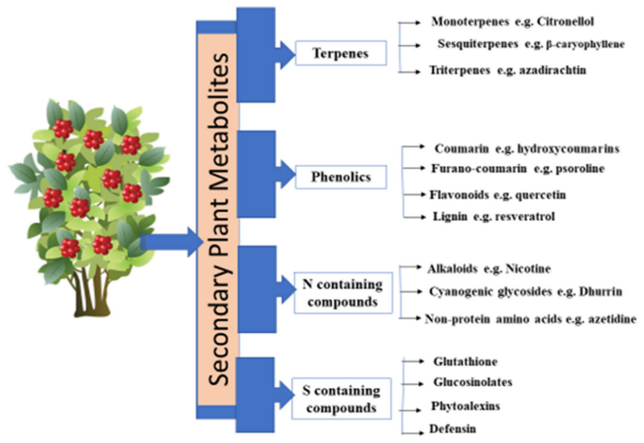
Figure 1: Different types of secondary metabolites [5]
The water-insoluble compounds with repeating isoprene units serve as growth inhibitors, insecticides and insect attractants which derived from acetyl-CoA or glycolytic intermediates are the terpenoids. These are classified variously into, Hemiterpenes, Monoterpenes, Sesquiterpenes, diterpenes, sesterterpenes, triterpenes, and carotenoids on the basis of number of isoprene units. The essential oils produced by many plants are mixtures of volatile monoterpenes and sesquiterpenes. The classical antimalarial drug artemesinin is a sesquiterpene obtained from the medicinal plant Artemesia annua. Betulinic acid and savinin are the two anti-viral terpenoids present in some orchids. Digitalin, a cardiac glycoside from Digitalis purpurea, is used to treat cardiac insufficiency. Liquorice, ginsenosides, etc., are the triterpene saponins used as expectorant, analgesic and anti-inflammatory agents [6].
Alkaloids are a large group of secondary metabolites that possess nitrogen as part of a heterocyclic ring. Positively charged and water-soluble alkaloids are alkaline, as the term indicates itself. Nicotine, retrorsine, atropine, morphine, cocaine, lupinine, coniine, codeine, etc., are some of the most popular alkaloids produced by various plants. Alkaloids help plants in defences against herbivores, especially mammals. Although alkaloids are poisonous to human beings, certain alkaloids, such as morphine, codeine, and scopolamine, are used as medicines at lower doses. Huperzine A, an alkaloid isolated from the plant Huperzia serrata is used to treat schizophrenia and Alzheimer’s disease. The efficiency of plants of the family Amaryllidaceae in traditional medicine for the treatment of neurologic diseases was proved by isolating certain alkaloids, pancratinin B, bufanidrine, buphanisine and epibuphanisine from the Crossyne flava bulbs and investigating their neuroprotective effects in an invitro model of Parkinson’s disease [7]. Pyrrolizidine alkaloids possess anti-cancer, antimicrobial, anti-viral and anti-inflammatoryactivities, though these are hepatic toxins for humans and animals [8]. Plants of Fumariaceae, Papaveraceae and Rutaceae contain alkaloids of benzophenanthridines that exhibit wide range of biological properties and the plants have been used traditionally for various disorders.
PATHWAYS OF SECONDARY METABOLITE PRODUCTION
Secondary metabolites are produced by plants to cope with defence as they are non-motile and do not possess an immune system. These natural products are synthesized as byproducts of primary metabolism under stress conditions through specific biosynthetic pathways.
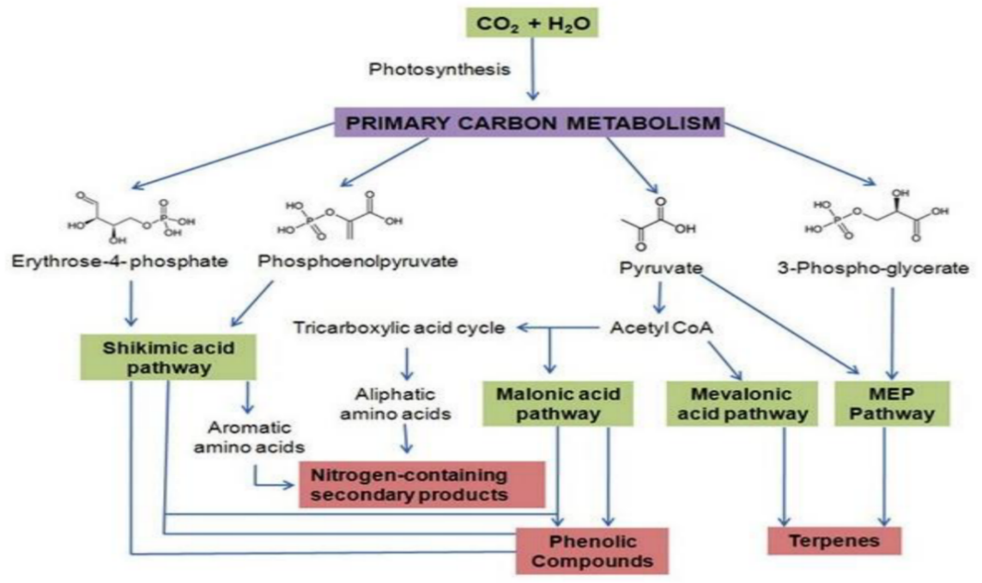
Figure 2: Diagrammatic sketch of major biosynthetic pathways of secondary metabolites and their interrelationship with primary metabolism [9]
Shikimic acid pathway:
Plants produce phenolic compounds via the Shikimic acid pathway that bridges between the primary metabolism and the secondary metabolism by producing shikimic acid from the end products of glycolysis and the pentose phosphate pathway. Hydroxybenzoic acids such as gallic acid and salicylic acid are a group of polyphenols produced directly from shikimic acid. Another group of polyphenols, hydroxycinnamic acids, are the phenylpropanoids produced via the phenylpropanoid pathway that utilizes phenylalanine and tyrosine, the aromatic amino acids as precursors. These amino acids are synthesized by rearranging the aliphatic chain, transamination and dehydration of chorismate, the intermediate compound formed from shikimic acid.
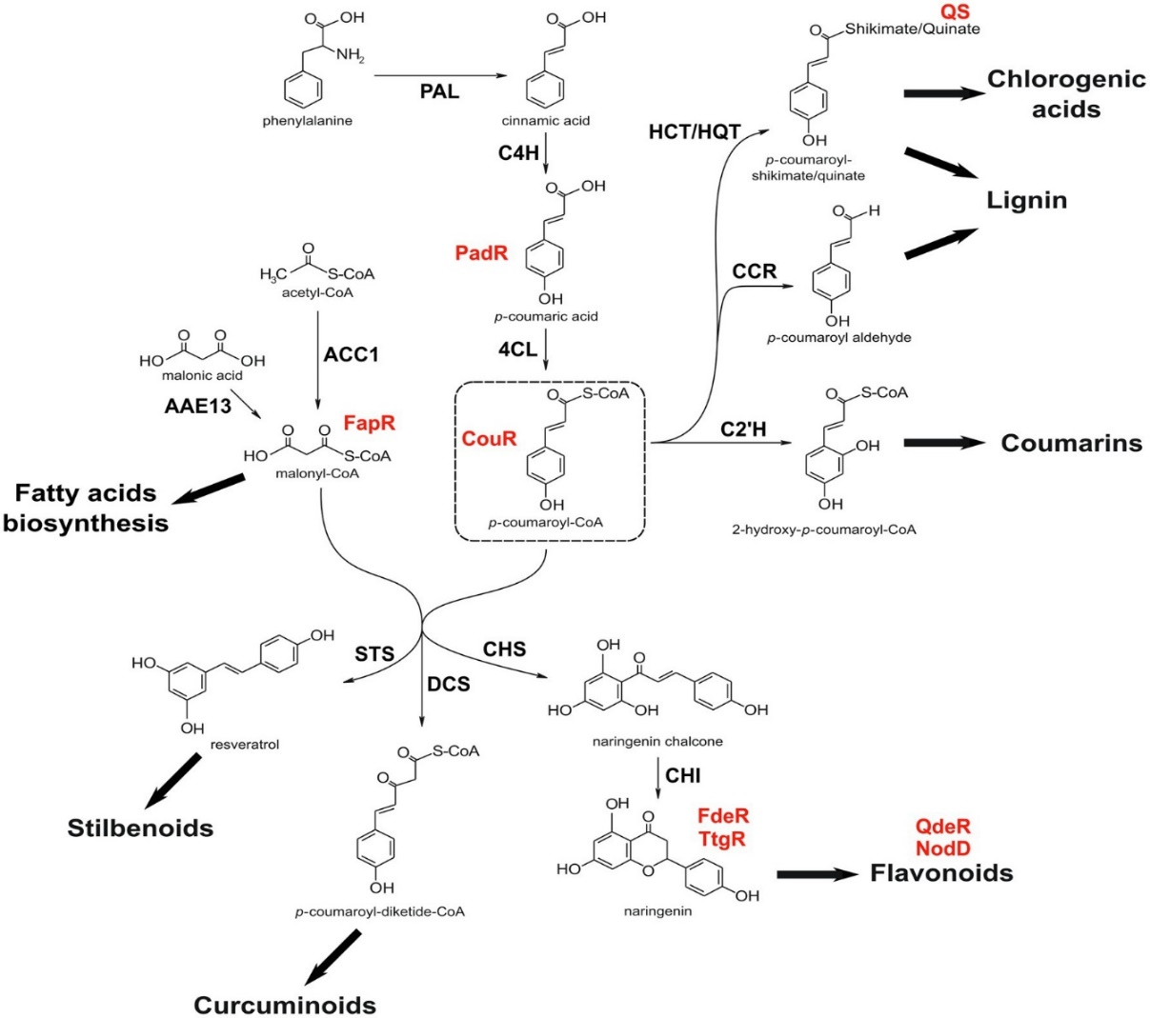
Figure 3: Biosynthetic steps involved in the formation of various phenylpropanoids [10]
The phenylpropanoid pathway begins by the activity of deaminating enzymes Phenylalanine Ammonia Lyase (PAL) and Tyrosine Ammonia Lyase (TAL) on the aminoacids phenylalanine and tyrosine respectively. Trans-cinnamic acid is formed by the deamination of phenylalanine which is then hydroxylated to p-Coumaric acid by the enzyme cinnamate-4-hydroxylase (C4H), while TAL deaminates tyrosine directly into p-coumaric acid. Various enzymes convert these compounds into Caffeic acid, ferulic acid and synaptic acids and direct them to lignin synthesis. Flavonoids and stilbenes are formed from the molecules p-coumaroyl-CoA and malonyl-CoA by polyketide synthases. UDP-glucose: flavonoid 3-O-glucosyl transferases catalyse glycosylation of anthocyanidins, the last step in the anthocyanin biosynthesis [11].
Terpenoid Biosynthesis:
Building blocks of terpenes, the isopentenyl diphosphates (IPP) are formed via two different pathways: the mevalonic acid pathway and the methyl erythritol phosphate (MEP) pathway. IPP and its isomer dimethyl allyl diphosphate (DPP) combine to form geranyl diphosphate (GPP), a precursor of monoterpenes. GPP then join to another molecule of IPP to form farnesyl diphosphate (FPP), the precursor of sesquiterpenes. Diterpenes are formed from geranylgeranyl diphosphate (GGPP) precursors, which is the product of the combination of FPP and IPP, and ultimately FPP dimerize to form triterpenes and GGPP dimerize to form tetraterpenes [9].
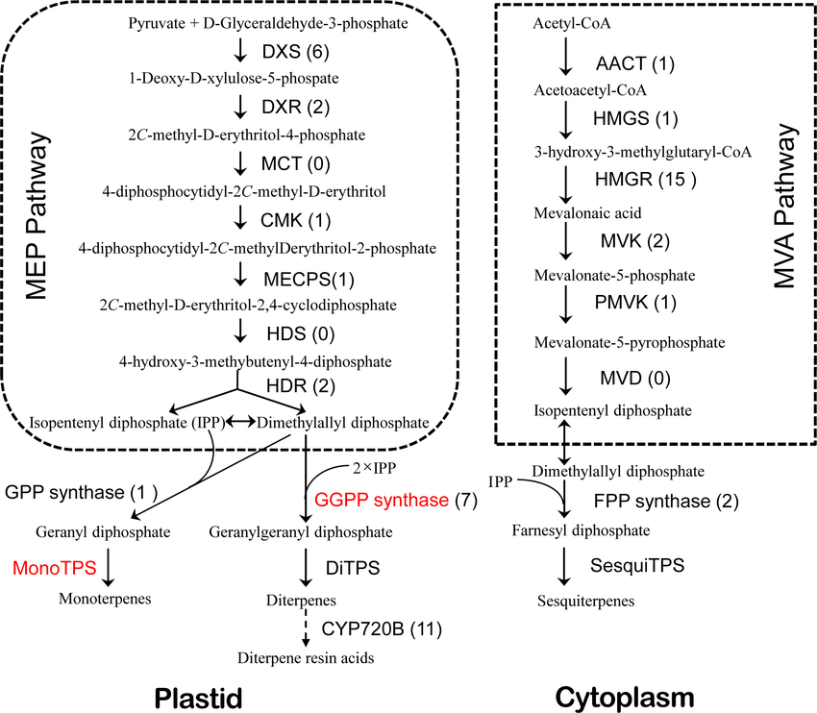
Figure 4: Biosynthetic pathway of terpenes in conifer [12]

Biosynthesis of nitrogen containing compounds
Alkaloid biosynthesis:
As alkaloids are nitrogen-containing compounds, these are formed from common amino acids, especially lysine, tyrosine and tryptophan. Some alkaloids derive their carbon skeleton from the terpene pathway.
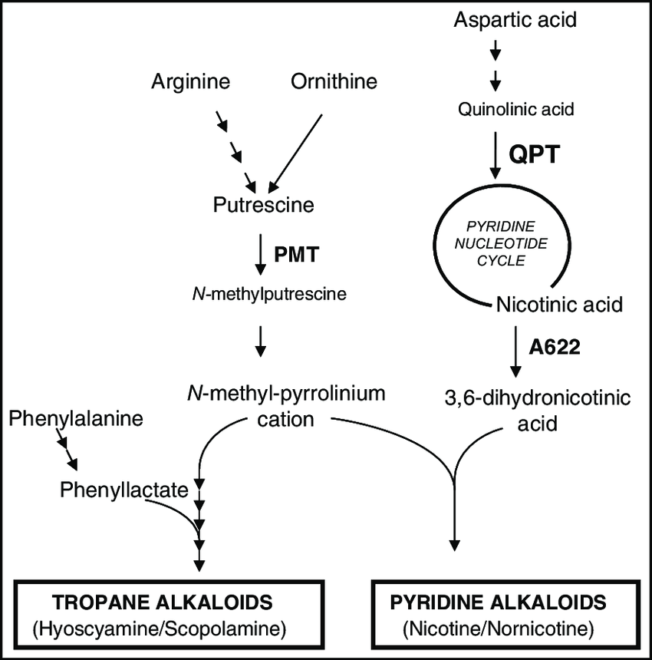
Figure 5: Schematic representation of alkaloid biosynthesis [13]
Alkaloid biosynthesis is much more complex, and its first steps are crucial in forming a wide variety of chemical compounds. Typical steps involved in the first stage of alkaloid biosynthesis are 1) the amine precursor accumulation, 2) the aldehyde precursor accumulation, 3) the iminium cation formation, and 4) a Mannich-like reaction. Monoterpenoid indole alkaloids are the products of tryptamine, which is the decarboxylated tryptophan by the enzyme tryptophan decarboxylase. Catharanthus roseus and Rauvolfia serpentina are the significant sources of these compounds. Benzylisoquinolines are tyrosine-derived alkaloids. Tyrosine decarboxylase decarboxylates tyrosine into tyramine, contribute the benzyl component, and dihydroxyphenylalanine into dopamine, provides the isoquinoline moiety to the benzylisoquinolines formed by the condensation of these tyrosine derivatives. Putrescine N-methyl transferase enzyme methylate putrescine to N-methyl putrescine to begin the tropane alkaloids and nicotine biosynthesis. Caffeine and theobromine are the purine alkaloids formed from the purine nucleotides. Pyrrolizidine alkaloids are composed of a necine base and one or more necic acids. Homospermidine synthase begins the necine biosynthesis by the condensation of spermidine and putrescine to form homospermidine. In different plants, biosynthesis and accumulation of alkaloids are associated with a variety of cell types and, the subcellular compartmentalization of alkaloid biosynthesis is as complex as the cell type-specific localization of gene transcripts, enzymes, and metabolites [14].
Cyanogenic glycosides, glucosinolates and non-protein amino acids:
These are the various nitrogen-containing compounds that are involved in plant’s defence system. Poisonous gas, hydrogen cyanide, is released by the enzymatic breakdown of cyanogenic glycosides. Glucosinolates are predominantly found in brassicacean plants, which release volatile defensive substances by hydrolytic enzymes. These volatile oils are herbivore toxins and feeding repellents. A close analogue of canavine is a non-protein amino acid present in free form to act as a protective substance [9].
Expanding human population increases the rate of exploitation of plants for food and medicine. Overutilization of plants, along with habitat destruction due to urban development, eventually led to the decline of most of the plant populations. Major medicinally valuable plants are endangered and under threat, according to IUCN. In order to ensure sustainable use, we should have to develop new policies for the production of therapeutic and agronomic produce from plants.
Plant Tissue Culture
The plant tissue culture technique is an efficient method for mass propagation, germplasm conservation, and the study and production of bioactive compounds [15]. The application of plant tissue culture introduced by Haberlandt (1902) has been widely used worldwide to overcome many plant growth and structural conditions [16] as well as to develop economically essential crops by regenerating various explants [17] in a Murashige & Skoog medium under optimized conditions.
The process of production of Secondary metabolites from plants mainly relies on plant tissue culture techniques. Plant secondary metabolites are the medicinally valuable compounds. These economically important biopharmaceuticals are also produced as recombinant proteins via this method [18]. Secondary metabolite biosynthesis can be inducted by different elicitation methods, which include abiotic elicitors like heavymetal salts, salicylic acid, aromatic amino acids, methyl jasmonate, etc., and biotic elicitors such as fungal and bacterial pathogens [19].
The requirement of the propagation of relevant plant parts only for specific secondary metabolites [20] within a short duration of time is the primary advantage of plant tissue culture. Identification of triterpenoids from the petioles and leaves of Centella asiatica like Asiaticoside, Madecassoside, Madecassic acid, and Asiatic acid [21], different kinds of phenolic acids such as Caffeic acid, Rosmarinic acid, Chlorogenic acid, Lithospermic acid, and Cinnamic acid from Mentha spicata leaves and shoots [22], bioactive compounds like genistein, daidzein and psoralen from the callus cultures of Cullen corylifolium cotyledon [23], and phenolics, flavonoids, tannins and essential oils from Artemisia arborescens nodes [24] are some of the recent reports of such tissue culture methods.
Clonal micropropagation is an effective method for the isolation of therapeutic compounds from medicinally important plants since a selected mother plant provides a large number of clonal plants for the isolation of these compounds within a short period. Callus cultures are another strategy for secondary metabolite production that utilises the homogenous mass of dedifferentiated cells in non-embryogenic callus cultures [25]. Any plant part can be used as an explant for callus culture. Maintainance of callus culture by subculture is also essential for the success of production of secondary metabolite through callus culture. There were many reports of the production of secondary metabolite by callus cultures. Phenolic molecules, including genistein, apigenin, trans-ferulic acid, luteolin, salicylic acid, rutin hydrate, naringenin and p-coumaric acid from Coryphantha macromeris [26], Phenylethanoids salidroside and tyrosol, rosavin and rosarin phenylpropanoids and p-coumaric acid, gallic acid, and cinnamic acids of phenolics from Rhodiola imbricata [27], quercetin, isoquercetin, ferulic acid, rutin, quercetin-7-O-glucoside and luteolin from Hyssopus officinalis [28], furostanol type phenylethanoids and steroidal glycosides from Digitalis lanata [29], etc. were some of the examples.
In genetic engineering and crop improvement programs, protoplasts have a broad range of applications as they can fuse and able to take up genes. The source of protoplasts in plants is the mesophyll tissues [30]. The isolated viable protoplasts are cultured in a synthetic media [31]. Callus cultures and cell suspension cultures provide the protoplasts for protoplast culture methods. Although secondary metabolites can be synthesised via protoplast culture, a few studies have been reported. The report of isolation of 3-O-p-coumaroylquinic acid and 3-O-feruloylquinic acid from Bambusa multiplex [32] and phenolics and flavonoids from Satureja sahendica [33] were the recent ones.
Cell culture is an advanced method for the cumulative production of secondary metabolites that utilizes suspension culture and elicitation strategies. Cell suspension culture can be utilised for the industrial-level secondary metabolite production [34]. The advantage of a suspension culture maintained under controlled conditions is the predictability of a growth curve based on multiple environmental factors [35]. Biosynthetic pathways of various secondary metabolites can be studied by adopting a cell suspension culture [36]. Stigmasterol, gymnemic acids, oleanolic acid, catechin, atropine, betulinic acid and ursolic acid, withanolides such as withaferin A and withanolide A, etc., were the secondary metabolites produced by various plant suspension cultures [37,38,39,40,41,42].
Another promising approach for producing secondary metabolite is the hairy root culture in which the secondary metabolites are enhanced with the help of a gram-negative soil bacteria Agrobacterium rhizogenes [43]. Limitations of geographical, seasonal and environmental conditions can be overcome by shoot cultures and hairy root cultures [44]. High-level of chromosomal stability possessed by hairy roots, hairy root cultures are more stable than undifferentiated cell cultures for metabolic production [45,46].
Various kinds of alkaloids from Rhazya stricta [47], feruloyl-glucoside in Turbinicarpus lophophoroides [48], podophyllotoxin and related aryl tretralin-lignans in Linum flavum [49], curcumin and curcumin mono glucoside from Atropa belladonna [50], triterpenoids from Centella asiatica [51] and taxol from Taxus baccata sub sp. Wallichiana [52] are some reports of secondary metabolite production by hairy root culture.
For the large-scale production of bioactive compounds, hairy root cultures need viable bioreactor systems having various physical and chemical parameters at optimum configuration, along with agrobacterial concentration [53]. The bioreactor system allows rapid growth of cultures and promotes the bulk transfer of nutrients and gases. The process is scaled up by this cost-effective approach by creating constant micro-environmental conditions and an automated cultivation system [54].
Phenolics and rosmarinic acid in Salvia nemorosa [55], flavonoids in Orostachys cartilaginous [56], antifungal saponins in Solanum chrysotrichum [57], phenolic acids such as cafeic acid, rosmarinic acid, salvianolic acid F (I) and salvianolic acid F (II), methyl rosmarinate cafeic acid hexoside, and phenylethanoids such as leucosceptoside, verbascoside, iso verbascoside and martynoside in Salvia viridis [58] and some phenolic acids, flavonoids, a stilbenoid resveratrol and phenylethanoid glycosides acteoside and echinacoside in Scrophularia striata [59] were some secondary metabolites produced in bioreactors using cell suspension cultures.
Futuristic trends in the secondary metabolite production: Its advantages and limitations
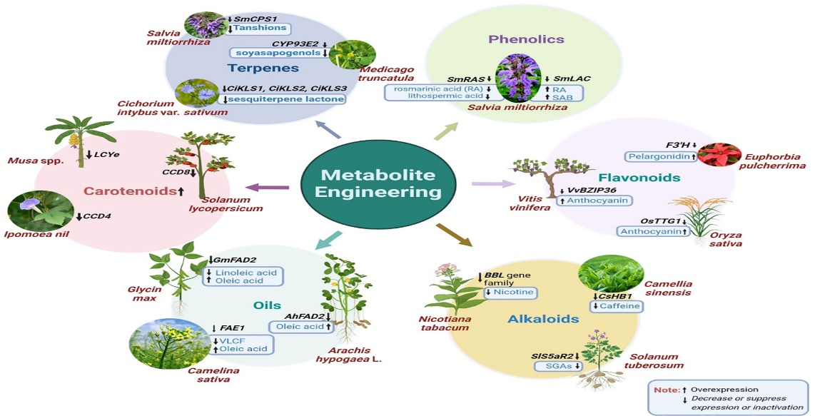
Metabolic engineering and combinatorial biosynthesis are the current and future perspectives to meet the market demand for biologically active, pharmacologically important and commercially valuable secondary metabolites. CRISPR(clustered regularly interspaced short palindromic repeats)– Cas9 (CRISPR-associated protein 9), TALENs (transcription activator-like effector nucleases) and ZFNs (Zinc finger nucleases) are the genome editing tools use commonly in plants. For crop improvement like herbicide tolerance, high yield, etc., ZFNs are reported to be used in plant genome editing [60]. High off-target binding and low affinity to AT-rich regions and their challenging construction are the limitations of ZFNs. Qualitative and functional genomic studies in Arabidopsis, rice, barley, soybean and maize have been improved using TALEN technology. Though this is a powerful genome editing tool, TALENs are unable to edit methylated target sites, and their larger size makes its delivery method more challenging. The CRISPR-Cas system of genome editing is an emerging trend in metabolite engineering in plants.
Figure 6: Schematic representation of metabolite engineering in plants [61]
Secondary metabolite production can be regulated by increasing or decreasing through the CRISPR-Cas system. According to Watanabe et al. [62], gene functions of colour changes in horticultural plants can be studied with the help of CRISPR-Cas9 technology. Carotenoids and flavonoids were enhanced by multi-target editing of related genes in the biosynthetic pathways in plants using the CRISPR-Cas9 system. The effectiveness of the CRISPR/Cas9 system in identifying essential genes related to metabolic pathways by CRISPR/Cas9 editing of the rosmarinic acid synthase gene involved in the phenolic biosynthesis within the Salvia miltiorrhiza plant was pointed out [63]. Directional mutation of transcription factor gene CsHB1 using the CRISPR/Cas tool lowered the expression of two biosynthetic genes, CsHB1 and yhNMT1 resulting in the reduction of caffeine accumulation in the callus of tea [64]. Bitter-tasting compounds sesquiterpene lactones (STLs) could be removed in chicory by editing the four genes encoding for germacrene A synthase enzyme with the help of the CRISPR/Cas9 approach [65]. CRISPR/Cas9 editing system serves as a promising tool in the studies of biosynthetic pathway elucidation. Easy-to-use tools at affordable cost widen the applicability of the CRISPR/Cas9 system in almost all living organisms. The formation of a few non-specific double-stranded breaks (DSBs) upstream of the protospacer adjacent motif is the only limitation faced by this tool [66]. Off-target mutations by CRISPR/Cas9 are much lesser than those by ZFNs and TALENs. The availability of whole genome sequences makes the designing of guide RNAs much easier to reduce off-target binding, thereby enabling genome editing tools for the enhancement of secondary metabolites.
REFERENCES:
1. Rodney RL, Stagno JL, Beckman EJ, Russell AJ. Enzymatic synthesis of carbonate monomers and polycarbonates. Biotechnol. Bioeng. 2000; 62(3):259 – 266.
2. Urmenyi FG, Saraiva G, Casanova LM, et al. Anti-HSV-1and HSV-2 flavanoids and a new kaempferol triglycoside from the medicinal plant Kalanchoe daigremontiana. Chem Biodiversity. 2016; 13(12):1707-1714.
3. Zhao G, Hong Y, Li L, Zhang H, Xu R, Hao Y. Selection and characterization of plant-derived alkaloids with strong antialgal inhibition: growth inhibition selectivity and inhibitory mechanism. Harmful Algae. 2022; 117, 102272. doi: 10.1016/j.hal.2022.102272
4. Xia N, Daiber A, Forstermann U, Li HG. Antioxidant effects of resveratrol in the cardiovascular system. Braz. J. Pharm. 2017; 174-(12):1633-1646.
5. Divekar PA, Narayana S, Divekar BA, Kumar R, Gadratagi BG, Ray A, Singh AK, Rani V, Singh V, Singh AK, et al. Plant Secondary Metabolites as Defence Tools against Herbivores for Sustainable Crop Protection. Int. J. Mol. Sci. 2022; 23(5): 2690.
6. Teoh ES. Medicinal orchids of Asia. Springer Cham. 2015. ISBN: 978-3-319-24272-9.
7. Omoruyi SI, Ibrakaw AS, Ekpo OE, Boatwright JS, Cupido CN, Hussein A A. Neuroprotectiveactivities of Crossyne flava bulbs and amaryllidacea alkaloids: Implications for parkinson’s disease. Mol. 2021; 26: 3990.
8. Wei X, Ruan W, Vreiling K. Current knowledge and perspectives of pyrrolizidine alkaloids in pharmacological applications: A mini review. Mol. 2021; 26(7): 1970.
9. Taiz L, Zeiger E. Secondary metabolites and plant defence. Plant physiology. 3rd ed. Sunderland: Sinauer Associates; 2003. 285 – 308.
10. Ferreira SS, Antunes MS. Re-engineering plant phenylpropanoid metabolism with the aid of synthetic biosensors. Front. Plant Sci. 2021; 12. ISSN: 1664-462x.
11. Rosa LA, Moreno-Escamilla JO, Rodrigo-Gracia J, Alvarez-Parrilla E. Phenolic compounds. Postharvest Physiol. Biochem. Fruits. Veg. 2019; 253-271.
12. Zulak KG, Bohlmann J. Terpenoid biosynthesis and specialized vascular cells of conifer defense. J. Integr. Plant Biol. 2010; 52: 86–97.
13. Ryan, Suzanne & Deboer, Kathleen & Hamill, John. Alkaloid production and capacity for methyljasmonate induction by hairy roots of two species in Tribe Anthocercideae, family Solanaceae. Func. Plant Biol. 2015; 10:1071.
14. Ziegler J, Facchini PJ. Alkaloid biosynthesis: Metabolism and trafficking. Annual Rev. Plant Biol. 2008; 59:735 – 769.
15. Mulabagal V, Tsay HS. Plant cell cultures – an alternative and efficient source for the production of biologically important secondary metabolites. Int. J. Appl. Sci. Engl. 2004; 2: 29 – 48.
16. Torres KC. Tissue culture techniques for horticultural crops. New York: Springer Science & Business Media. 2012.
17. Uysal H. In vitro propagation of black cumin (Nigella sativa L.,) plants. Genetik. 2021; 53 (1) 295-303.
18. Secgin Z, Okumus A. Domates (Lycopsersicum esculentum l.)’te sentetik tohum üretiminde aljinat oranlarının depolama zamanına etkisi. Front. Life Sci. 2022; RT 3 (1), 30–35. doi: 10.51753/flsrt.1041120
19. Piatczak E, Jeleń A, Makowczyńska J, Zielińska S, Kuźma Ł, Balcerczak E. Establishment of hairy root cultures of Rehmannia elata NE brown ex prain and production of iridoid and phenylethanoid glycosides. Ind. Crops Prod. 2019;137, 308–314. doi: 10.1016/j.indcrop.2019.05.022
20. Mishra A. Allelopathic properties of Lantana camara. Int. Res. J. Basic Clin. Study. 2015; 3, 13–28. doi: 10.14303/irjbcs.2014.048
21. Baek S, Ho TT, Lee H, Jung G, Kim YE, Jeong CS, et al. Enhanced biosynthesis of triterpenoids in Centella asiatica hairy root culture by precursor feeding and elicitation. Plant Biotechnol. Rep. 2020;14(1),45–53. doi: 10.1007/s11816-019-00573-w
22. Yousefian S, Lohrasebi T, Farhadpour M, Haghbeen K. Production of phenolic acids in hairy root cultures of medicinal plant Mentha spicata l in response to elicitors. Mol. Biol. Res. Commun. 2020; 9 (1), 23. doi: 10.22099%2Fmbrc.2020.36031.1475
23. Singh T, Yadav R, Agrawal V. Effective protocol for isolation and marked enhancement of psoralen, daidzein and genistein in the cotyledon callus cultures of Cullen corylifolium (L.) medik. Ind. Crops Prod. 2020;143,111905. doi: 10.1016/j.indcrop.2019.111905
24. Riahi L, Chograni H, Ben Rejeb F, Ben Romdhane M, Masmoudi AS, Cherif A. Efficient in vitro regeneration of the endangered species Artemisia arborescens l. through direct organogenesis and impact on secondary metabolites production. Horticult. Environment Biotechnol. 2022; 63(3),439–450. doi: 10.1007/s13580-021-00400-8
25. Filová A. Production of secondary metabolities in plant tissue cultures. Res. J. Agric. Sci. 2014;46 (1), 236–245.
26. Karakas FP. Efficient plant regeneration and callus induction from nodal and hypocotyl explants of goji berry (Lycium barbarum l.) and comparison of phenolic profiles in calli formed under different combinations of plant growth regulators. Plant Physiol. Biochem. 2020;146, 384–391. doi: 10.1016/j.plaphy.2019.11.009
27. Rattan S, Sood A, Kumar P, Kumar A, Kumar D, Warghat AR. Phenylethanoids, phenylpropanoids, and phenolic acids quantification vis-à-vis gene expression profiling in leaf and root derived callus lines of rhodiola imbricata (Edgew.). Ind. Crops Products. 2020;154, 112708. doi: 10.1016/j.indcrop.2020.112708
28. Babich O, Sukhikh S, Pungin A, Astahova L, Chupakhin E, Belova D, et al. Evaluation of the conditions for the cultivation of callus cultures of Hyssopus officinalis regarding the yield of polyphenolic compounds. Plant. 2021;10 (5), 915. doi: 10.3390/plants10050915
29. Tomilova SV, Kochkin DV, Tyurina TM, Glagoleva ES, Labunskaya EA, Galishev BA, et al. Specificity of growth and synthesis of secondary metabolites in cultures in vitro Digitalis lanata ehrh. Russian J. Plant Physiol. 2022;69(2),1–11. doi: 10.1134/S1021443722020200
30. Patra JK, Das G, Das SK, Thatoi H. “Plant tissue culture techniques and nutrient analysis,” in A practical guide to environmental biotechnology. Singapore: Springer. 2020;135–164.
31. Chadipiralla K, Gayathri P, Rajani V, Reddy PVB. “Plant tissue culture and crop improvement,” in Sustainable agriculture in the era of climate change. Cham: Springer. 2020; 391–412.
32. Nomura T, Yoneda A, Ogita S, Kato Y. Activation of cryptic secondary metabolite biosynthesis in bamboo suspension cells by a histone deacetylase inhibitor. Appl. Biochem. Biotechnol. 2021;193(11), 3496–3511. doi: 10.1007/s12010-021-03629-2
33. Tarigholizadeh S, Motafakkerazad R, Kosari-nasab M, Movafeghi A, Mohammadi S, Sabzi M, et al. Influence of plant growth regulators and salicylic acid on the production of some secondary metabolites in callus and cell suspension culture of satureja sahendica bornm. Acta Agricult. Slovenica. 2021;117(4),1–12. doi: 10.14720/aas.2021.117.4.773
34. Sharifi-Rad R, Bahabadi SE, Samzadeh-Kermani A, Gholami M. The effect of non-biological elicitors on physiological and biochemical properties of medicinal plant Momordica charantia l. Iranian J. Sci. Technol. Trans. A: Sci. 2020; 44 (5),1315–1326. doi: 10.1007/s40995-020-00939-8
35. Daffalla HM, Elsheikh AM. Secondary metabolites accumulation and production through in vitro cultures. Phytochem. Mar. Sources Ind. Applications Recent Adv. 2018; 131.
36. Shahzad A, Parveen S, Sharma S, Shaheen A, Saeed T, Yadav V, et al. “Plant tissue culture: applications in plant improvement and conservation,” in Plant biotechnology: principles and applications. Eds. Abdin M, Kiran U, Kamaluddin A. Singapore: Springer. 2017; 37–72.
37. Rao K, Chodisetti B, Gandi S, Giri A, Kishor PK. Cadmium chloride elicitation of abutilon indicum cell suspension cultures for enhanced stigmasterol production. Plant Biosystems-An Int. J. Dealing All Aspects Plant Biol. 2021;156 (3), 613–618. doi: 10.1080/11263504.2021.1891151
38. Mahendran G, Iqbal Z, Kumar D, Verma SK, Rout PK, Rahman L. Enhanced gymnemic acids production in cell suspension cultures of Gymnema sylvestre (Retz.) r. br. ex sm. through elicitation. Ind. Crops Prod. 2021;162,113234. doi: 10.1016/j.indcrop.2020.113234
39. Ardianto C, Khotib J, Purwanto DA, Muslihatin W. Production of the secondary metabolite catechin by in vitro cultures of Camellia sinensis l. J. Basic Clin. Physiol. Pharmacol. 2020; 31 (5):1–7. doi: 10.1515/jbcpp-2019-0357
40. Abdelazeez WMA, Anatolievna KY, Zavdetovna KL, Damirovna AG, El-Dis A, Rayan G, et al. Enhanced productivity of atropine in cell suspension culture of Hyoscyamus muticus l. Vitro Cell. Dev. Biol.-Plant. 2022; 58, 593–605.
41. Bakhtiar Z, Mirjalili MH. Long-term cell suspension culture of Thymus persicus (Lamiaceae): a novel approach for the production of anti-cancer triterpenic acids. Ind. Crops Prod. 2022; 181,114818. doi: 10.1016/j.indcrop.2022.114818
42. Mirjalili MH, Esmaeili H. Callus induction and withanolides production through cell suspension culture of Withania coagulans (Stocks) dunal. J. Med. Plants. 2022; 21 (81), 79–91. doi: 10.52547/jmp.21.81.79
43. Ozyigit II, Dogan I, Artam-Tarhan E. “Agrobacterium rhizogenes-mediated transformation and its biotechnological applications in crops,” In: Hakeem K, Ahmad P, Ozturk M. (eds) Crop Improvement. Boston.MA:Springer. 2013;1–48. doi: 10.1007/978-1-4614-7028-1_1
44. Fazili MA, Bashir I, Ahmad M, Yaqoob U, Geelani SN. In vitro strategies for the enhancement of secondary metabolite production in plants: a review. Bull. Natl. Res. Centre. 2022; 46 (1), 1–12. doi: 10.1186/s42269-022-00717-z
45. Giri A, Narasu ML. Transgenic hairy roots: recent trends and applications. Biotechnol. Adv. 2000;18 (1), 1–22. doi: 10.1016/S0734-9750(99)00016-6
46. Pistelli L, Giovannini A, Ruffoni B, Bertoli A, Pistelli L. Hairy root cultures for secondary metabolites production. Bio-farms Nutraceuticals. 2010; 167–184. doi: 10.1007/978-1-4419-7347-4_13
47. Akhgari A, Laakso I, Maaheimo H, Choi YH, Seppänen-Laakso T, Oksman-Caldentey KM, et al. Methyljasmonate elicitation increases terpenoid indole alkaloid accumulation in Rhazya stricta hairy root cultures. Plants. 2019; 8(12), 534. doi: 10.3390/plants8120534
48. Solis-Castañeda GJ, Zamilpa A, Cabañas-García E, Bahena SM, Pérez-Molphe-Balch E, Gómez-Aguirre YA. Identification and quantitative determination of feruloyl-glucoside from hairy root cultures of Turbinicarpus lophophoroides (Werderm.) buxb. & Backeb. (Cactaceae). Vitro Cell. Dev. Biol.-Plant. 2020; 56(1),8–17. doi: 10.1007/s11627-019-10029-z
49. Mikac S, Markulin L, Drouet S, Corbin C, Tungmunnithum D, Kiani R, et al. Bioproduction of anticancer podophyllotoxin and related aryltretralin-lignans in hairy root cultures of Linum flavum l. Plant Cell Tissue Differentiation Secondary Metabolites: Fundamentals Appl. 2021; 503–540. doi: 10.1007/978-3-030-30185-9_20
50. Singh S, Pandey P, Akhtar MQ, Negi AS, Banerjee S. A new synthetic biology approach for the production of curcumin and its glucoside in atropa belladonna hairy roots. J. Biotechnol. 2021b; 328, 23–33. doi: 10.1016/j.jbiotec.2020.12.022
51. Baek S, Han JE, Ho TT, Park SY. Development of hairy root cultures for biomass and triterpenoid production in Centella asiatica. Plants. 2022; 11(2), 148. doi: 10.3390/plants11020148
52. Sahai P, Sinha VB. Development of hairy root culture in Taxus baccata sub sp wallichiana as an alternative for increased taxol production. Mater. Today: Proc. 2022; 49, 3443–3448. doi: 10.1016/j.matpr.2021.03.407
53. Honda H, Liu C, Kobayashi T. “Large-Scale plant micropropagation,” in Advances in biochemical engineering/biotechnology. Ed. Zhong, JJ Berlin/Heidelberg: Springer. 2001; 157–182.
54. Sidal U. Citric acid production using rotating biodisc reactor (RBR). Front. Life Sci. RT. 2022; 3 (1), 25–29. doi: 10.51753/flsrt.1035228
55. Heydari H R, Chamani E, Esmaeilpour B. Effect of total nitrogen content and NH4+/NO3-ratio on biomass accumulation and secondary metabolite production in cell culture of salvia nemorosa. Iranian J. Genet. Plant Breed. 2020; 9(1), 17–27. doi: 10.30479/IJGPB.2020.12321.1258
56. Hao YJ, Cui XH, Li JR, An XL, Sun HD, Piao XC, et al. Cell bioreactor culture of Orostachys cartilaginous a. bor. and involvement of nitric oxide in methyl jasmonate-induced flavonoid synthesis. Acta Physiol. Plantarum. 2020; 42 (1), 1–10. doi: 10.1007/s11738-019-3008-5
57. Salazar-Magallón JA, Huerta de la Peña A. Production of antifungal saponins in an airlift bioreactor with a cell line transformed from Solanum chrysotrichum and its activity against strawberry phytopathogens. Preparative Biochem. Biotechnol. 2020; 50 (2), 204–214. doi: 10.1080/10826068.2019.1676781
58. Grzegorczyk-Karolak I, Staniewska P, Lebelt L, Piotrowska DG. Optimization of cultivation conditions of Salvia viridis l. shoots in the plantform bioreactor to increase polyphenol production. Plant Cell Tissue Organ Culture. 2022; 149 (1), 269–280. doi: 10.1007/s11240-021-02168-2
59. Ahmadi-Sakha S, Sharifi M, Niknam V, Zali H. Production of phenylethanoid glycosides under PEG-induced osmotic stress in Scrophularia striata boiss. cell culture in bioreactor. Ind. Crops Prod. 2022; 181, 114843. doi: 10.1016/j.indcrop.2022.114843
60. Ran Y, Patron N, Kay P, Wong D, Buchanan M, Cao Y Y, et al. Zinc finger nuclease-mediated precision genome editing of an endogenous gene in hexaploidy bread wheat (Triticum aestivum) using a DNA repair template. Plant Biotechnol. J. 2018; 16: 2088 – 2101.
61. Devi AM, Devi KK, Devi PP, Devi ML, Das S. Metabolic engineering of plant secondary metabolites: Prospects and its technical challenges. Front. Plant Sci. 2023; 14: 1-16.
62. Watanabe K, Kobayashi A, Endo M, Sage-Ono K, Toki S Ono M. CRISPR/Cas9-mediated mutagenesis of the dihydroflavonol-4-reductase-B (DFR-b) locus in the Japanese morning glory Ipomoea (Pharbitis) nil. Sci. Rep. 2017; 7: 1–9.
63. Zhou Z, Tan H, Li Q, Chen J, Gao S, Wang Y, et al. CRISPR/Cas9-mediated efficient targeted mutagenesis of RAS in Salvia miltiorrhiza. Phytochem. 2018; 148: 63–70.
64. Ma W, Kang X, Liu P, Zhang Y, Lin X, Li B, et al. The analysis of transcription factor CsHB1 effects on caffeine accumulation in tea callus through CRISPR/Cas9 mediated gene editing. Proc. Biochem. 2021; 101: 304 – 311.
65. Canker K, Bundock P, Sevenier R, Hakkinen s T, Hakkert JC, Beekwilder J, et al. Inactivation of the germacrene A synthase genes by CRISPR/Cas9 eliminates the biosynthesis of sesquiterpene lactones in Chicorium intybus L. Plant Biotechnol. J. 2021; 19, 2442-2453.
66. Jiang F, Doudna JA. CRISPR/Cas9 structures and mechanisms. Ann. Rev. Biophys. 2017; 46: 505-529.

