Performance of Fuzzy Inference System Model to predict the Effect of Steel Fibre on Compressive Strength of Concrete
Daha S. Aliyu¹ Mahmoud M. Farouq²
School of Engineer School of Architecture,
University of Newcastle Upon Tyne, NE1 7RU, University of Nottingham
United Kingdom United Kingdom
engrshanono@gmail.com mahmoudmurtala@gmail.com

Haruna Ibrahim³ Abdullahi G. Usman⁴
Department of Civil Engineering, Department of Analytical Chemistry,
Cerge ParisUniversity, Faculty of Pharmacy, Near East University,
Neuville-sur-Oise, France TRNC, Mersin 10, Nicosia 99138, Turkey
hibrarogo@gmail.com abdullahigusman@gmail.com

Sani I. Abba⁵
Interdisciplinary Research Centre for Membrane and Water Security,
King Fahad University of Petroleum and Mineral,
Dhahran31261, Saudi Arabia
saniisaabba86@gmail.com

Abstract
This research article investigates the effects of different combinations of high-performance steel fibre-reinforced concrete (HP-SFRC) on its mechanical properties. The parameters analysed consist of a water-to-binder ratio (w/b) of 0.35, 0.40, and 0.45, replacement of 10% and 15% of cement with silica fume, and fibre volume fractions (Vf) of 0, 0.5, 1.0, and 1.5% with aspect ratios of 80 and 40. The study's findings indicate that including silica fume and steel fibres leads to a moderate increase in the compressive strength of HP-SFRC at Vf = 1.5%. Moreover, a machine learning framework based on an adaptive neuro-fuzzy inference system (ANFIS) was devised to enhance the accuracy of these predictions. Lastly, the effectiveness of multiple linear regression (MLR) models was assessed in predicting the strength of HP-SFRC mixes and compared with existing data.
Keywords: Empirical equation, High-performance concrete, Micro-silica, multiple linear regression, Neuro-fuzzy inference system, Steel fibre Fibre reinforced concrete.

1. Introduction
Concrete is a widely used and durable construction material for various infrastructure applications, such as constructing buildings, bridges, and sewage pipelines, due to its exceptional longevity. Despite its impressive compressive strength, concrete often faces limitations in its capacity to withstand tension and bending loads [1], [2]. However, an emerging approach is replacing the conventional method of relying solely on mild steel reinforcement to address these vulnerabilities. Researchers like [1] [3] have explored alternative types of fibres, including steel, glass, polypropylene, and their combinations, as potential substitutes to enhance concrete's tensile and flexural strength.
Numerous investigations have been conducted to assess the influence of steel fibres on the compressive strength of test samples [4], [5]. The findings indicate that introducing steel fibres does not significantly elevate the compressive strength of concrete. For example, when considering samples with a reinforcement ratio of 1.5%, the control specimen exhibited a compressive strength of 201 MPa, while the test specimen showed 211 MPa. [6], [7] reported that the incorporation of steel fibres only marginally impacted the compressive strength of concrete specimens. [7] A mere 12% improvement in compressive strength was observed by adding 0.9% steel fibres.
Experiments conducted by [7] [8] highlight that incorporating steel fibres has a notable and positive effect on the flexural strength of test samples. [8] observed a 20% increase in flexural strength and a ductile mode of failure due to the crack-bridging effect of steel fibres. Additionally, [7] discovered that the equivalent flexural strength ratio, representing the ratio of the initial peak strength to the energy absorption capacity, improved by 22% with the inclusion of steel fibres. These outcomes underscore steel fibres' role in enhancing the samples' flexural strength and energy absorption capacity.
The research underscores the utility of fuzzy logic as an accessible tool for formulating rules based on experience. Fuzzy logic models offer the ability to expound upon the connection between input and output in simplified terms, which is especially beneficial when the correlation is not straightforward. Several scholars, including [9], have harnessed fuzzy logic and neural networks to investigate the impact of additives (e.g., low lime concrete and fly ash) on diverse concrete properties, including compressive and flexural strength. Research findings validate that fuzzy logic accurately predicts the compressive strength of concrete test specimens, with a root mean square (RMS) value of 0.28. Additionally, neural networks achieve an RMS value of 1.79.
Moreover, the Fuzzy model exhibits slope and intercept values of 0.9764 and 0.5842, respectively. In a study by [10], gene expression programming accurately forecasts the compressive strength of cement mortar, yielding an RMS value of 1.4956. Similarly, [11] uses fuzzy logic and artificial neural networks to predict concrete compressive strength, yielding an RMS value of 2.02. The equation's linear fit yields a slope value of 0.9824 and an intercept value of 0.6354. According to statistical analysis, both models provide satisfactory and reliable outputs.
A research project investigates the mechanical behaviour of HP-SFRC across various w/b ratios (ranging from 0.45 to 0.35) and steel fibre volume fractions (ranging from 0 to 1.5%, with an RI range of 0 - 3.88) alongside 10% and 15% silica fume replacements. Formulas are developed to predict compressive and flexural strength, accounting for specimen size, shape, and length variations. Furthermore, a power relationship between compressive and flexural strength is derived and compared to prior research and the American Concrete Institute model [12]. Experimental data from earlier studies validate the accuracy of the proposed model.
To ensure construction project safety and progress, a computational analysis simulates the compressive strength of High-Performance Steel Fiber Reinforced Concrete (HP-SFRC). This analysis incorporates eight input parameters tied to mixture proportions. A machine learning framework is integrated to establish a predictive model for compressive strength, addressing the challenge of determining in-situ HP-SFRC strength influenced by site-specific and ambient conditions. The model leverages known mixture proportions as inputs to estimate HP-SFRC's compressive strength. This approach is chosen due to the complexities associated with accurately determining on-site strength, as noted by [13].
2. Materials and methods
2.1 Materials and mixture proportions
The study used 53-grade Ordinary Portland cement, which displayed a compressive strength of 54.5 MPa after 28 days and possessed a specific gravity of 3.15. Alongside this cement, silica fume was integrated as an extra cementitious component. The silica fume had a distinct surface area of 23000 m2/kg, a specific gravity of 2.25, and a 2% fineness based on leftover material on a 45 μm sieve. The composition of the micro-silica was identified to be 88.7% silicon dioxide, 0.9% carbon, and 1.8% loss on ignition. Moreover, the micro-silica satisfied the criteria outlined in ACI 234R-1996 [14]. For the fine aggregate, the research employed river sand, which could traverse a 4.75 mm sieve and fulfil the grading zone II requirements outlined in IS: 383-1978 (Standard, 2003).
Regarding the coarse aggregate, crushed blue granite stones with a maximum size of 12.5 mm were employed. A high-range water-reducing admixture was incorporated to enhance the characteristics of the mixtures. This admixture consisted of locally accessible sulfonated naphthalene formaldehyde condensate with a specific gravity of 1.20. Additionally, crimped steel fibres with the specified physical traits given in Table 1 were included in the combinations.

Table 1: Physical properties of round crimped steel fibre
Fibre | Fibre diameter | Fibre length | fibre wavelength | Aspect ratio l/d | Ultimate tensile strength fu | Elastic tensile strength Ef
Crimped round fibre | 0.9mm | 35 and 26mm | 0.8mm | 80 and 40 | 1200Mpa | 200Gpa

Per the guidelines in reference [14], sixteen sets of formulations for high-performance steel fiber-reinforced concrete (HP-SFRC) were created. The composition ratios employed in this research are provided in Table 2. Each formulation retained a consistent water-to-binder ratio (w/b) and integrated a fibre volume fraction (Vf) of 0.5%, 1.0%, or 1.5% relative to the total volume of the concrete. Additionally, a strong plasticiser was added to the blends, with the quantity varying between 1.75% and 2.5% in relation to the binder's weight. To evaluate the effectiveness of these HP-SFRC blends, batches of three cylinders with dimensions of 150 mm in diameter and 300 mm in height, along with three prisms measuring 100 mm × 100 mm × 500 mm, were produced for each formulation. Following this, these specimens were subjected to curing in water at a controlled temperature of 27 ± 2°C.
2.2. Methods of testing
At least three samples were tested to determine the mean compressive potency. The assessment of compressive strength followed the directives of ASTM C 39–92. This was performed using a servo-driven compression testing device, which administered an application rate of 14 MPa per minute. Similarly, the flexural strength (the Modulus of Rupture) was gauged following the standards outlined in ASTM C 78–92, as elucidated by [15]. The samples were situated over a 400 mm support and exposed to central loading through a 100 kN closed-loop hydraulic Universal Testing Machine for this trial. The loading was employed at a pace of 0.1 mm per minute. All specimens experienced a curing regimen within a laboratory setting before experimentation. Following that, they were retrieved and conditioned promptly before the tests commenced.
Top of Form
Bottom of Form
3. Results and discussion
3.1. Mechanical properties
The study's outcomes disclosed that introducing steel fibres into High-Performance Concrete (HPC) resulted in a 12% improvement in compressive strength at a 1.5% fibre volume fraction. Regarding regular concrete with water-to-binder (w/b) ratios of 0.45, 0.40, and 0.35, the corresponding compressive strengths were 58.4 MPa, 63.84 MPa, and 69.67 MPa, respectively. HPC has a w/b ratio of 0.45 and 19% silica fume content, so its compressive strength surged by 28.4% compared to the control samples. Incorporating additional supplementary cementitious materials (SCMs), such as micro-silica, led to enhancements in mechanical characteristics. The combined influence of silica fume and steel fibres on the compressive strength of High-Performance Steel Fiber-Reinforced Concrete (HP-SFRC) is observable in Table 3 and Figure 1. As the fibre volume fraction escalated, the potency of HP-SFRC also ascended, as evident in Table 3 and Figure 2. An empirical formula was devised to foresee the compressive strength (f'cf) of HP-SFRC as a factor of fibre volume fraction, Vf (%), for a w/b ratio of 0.4, achieving an R2 score of 0.9233, as portrayed in Figure 3. This tendency was noted to be consistent amid other adaptations of HP-SFRC.

Figure 1: Effect of fibre reinforcing index (RI) on compressive strength of HPSFRC (5% micro silica replacement)
The stress-deformation response of High-Performance Steel Fiber Reinforced Concrete (HP-SFRC), having a water-to-binder ratio (w/b) of 0.45 and 10% steel fibre (SF) content, was examined, as depicted in Figure 2. Generally, the stress-deformation pattern of concrete consists of two distinct stages: an initial ascending segment leading to the highest stress point, followed by a subsequent declining phase characterised by the occurrence of cracks and softening.
Crucial factors commonly employed to depict the initial ascending segment of the stress-deformation graph encompass the primary tangent modulus, the utmost compressive strength, and the strain at which the peak stress arises. Figure 2 presents the usual stress-deformation (σ–ε) diagrams for High-Performance Concrete (HPC) lacking fibres and SFRC. Notably, the stress-deformation patterns derived from this analysis unveil specific tendencies for HPC. The strength results in a more conspicuous curvature in the ascending section and a sharper decline in the subsequent phase. Conversely, SFRC manifests a progressively gentler reduction in the post-peak area.
The behaviour of SFRC, after reaching the peak, gradually decreases, retaining residual stress even at a deformation of 0.015. This conduct is ascribed to the extraction of fibres and the adherence between fibres and the matrix. Incorporating Supplementary Cementitious Materials (SCM) amplifies this impact due to their potency and filler characteristics. The resilience of HP-SFRC under compression is augmented as the maximum load is postponed due to the adherence between the fibres and the matrix. Furthermore, including fibres in the mixture heightens pliability, as evident from the values of deformation observed after the peak.
The stress-deformation graph indicates that elevating the volume fraction of fibres or the Reinforcement Index (RI) culminates in a larger region beneath the curve. This leads to an elongated post-peak declining phase, ultimately contributing to elevated sturdiness and malleability, as demonstrated by the stress-deformation behaviour of SFRC beyond the peak point.

Figure 2: Stress-strain curves for HPC and steel fibre reinforced concrete (w/cm = 0.45, SF content = 5%).
Incorporating steel fibres into High-Performance Concrete (HPC) at a 1.5% volume fraction or Reinforcement Index (RI) of 3.88 resulted in a significant 37% increase in flexural tensile strength. This strength surge is a significant indication, primarily attributed to extracting fibres from the matrix. Experimental examination of prism specimens unveiled a prolonged failure stage beyond the point of achieving the ultimate load. This extended failure behaviour implies a noteworthy improvement in the ductility and flexural toughness of High-Performance Steel Fiber Reinforced Concrete (HP-SFRC). These findings correspond with the outcomes observed in prior research investigations conducted by [16]–[18].

Figure 3: Effect of fibre volume fraction on compressive strength of HPSFRC (w/cm = 0.40)
Table 2: Mix proportion design of HPFRC
Mix | w/b | FA, kg | CA, kg | SF, kg | B, kg | W, kg | SP(%) | SF V_{f} (%)
M1  M1  M1  M1  M1*  M2  M2  M2  M2  M2*  M3  M3  M3  M3  M3* | 0.45  0.45  0.45  0.45  0.45  0.40  0.40  0.40  0.40  0.40  0.35  0.35  0.35  0.35  0.35 | 640  638  625  622  640  636  627  625  623  636  611  603  595  587  635 | 1090  1087  1079  1075  1090  1090  1086  1084  1073  1090  1090  1077  1073  1068  1068 | 44.5  44.5  44.5  44.5  67.4  49.7  49.7  49.7  49.7  74.9  56  56  56  56  56 | 435  435  435  435  435  483  483  483  483  483  547  547  547  547  547 | 196  196  196  196  196  193  193  193  193  193  191  191  191  191  191 | 1.65  1.65  1.65  1.65  1.65  2  2  2  2  2  2.7  2.7  2.7  2.7  2.7 | 0  0.5  1.0  1.5  0  0  0.5  1.0  1.5  0  0  0.5  1.0  1.5  0
M1 to M3 and M1 to M3 is Silica fume replacement at 10% and 15%, respectively,
SP (%) Superplasticiser in percentage by the weight of binder material
Vf (%) is the steel fibre in the percentage of the total volume of concrete.

Table 3: Mechanical properties result of HPSFRC of fibre =80
 |  | Steel fibre
Mix | w/b | Vf | RI | f'cf (Mpa)
M1 | 0.45 | 0 | 0 | 53.56
M1 | 0.45 | 0.5 | 1.39 | 55.77
M1 | 0.45 | 1 | 2.68 | 57.01
M1 | 0.45 | 1.5 | 3.98 | 58.4
M2 | 0.40 | 0 | 0 | 56.85
M2 | 0.40 | 0.5 | 1.39 | 60.65
M2 | 0.40 | 1 | 2.68 | 63.05
M2 | 0.40 | 1.5 | 3.98 | 63.84
M3 | 0.35 | 0 | 0 | 64.86
M3 | 0.35 | 0.5 | 1.39 | 68.12
M3 | 0.35 | 1 | 2.68 | 69.91
M3 | 0.35 | 1.5 | 3.98 | 69.67
M1* | 0.45 | 0 | 0 | 57.7
M1* | 0.45 | 1 | 2.68 | 62.21
M1* | 0.45 | 1.5 | 3.98 | 62.17
M2* | 0.40 | 0 | 0 | 60.42
M2* | 0.40 | 1 | 2.68 | 64.41
M2* | 0.40 | 1.5 | 3.98 | 65.59
M3* | 0.35 | 0 | 0 | 65.28
M3* | 0.35 | 1 | 2.68 | 71.04
M3* | 0.35 | 1.5 | 3.98 | 73.12
Fibre reinforcing index (RI) = wf *(l/d) and average density of HSFRC = 2425 kg/m.3.
Weight fraction (wf) = (density of fibre/density of fibrous concrete) *Vf.
Aspect ratio = (l/d).
f'cf = 150 Ø x 300 mm cylinder compressive strength of HPSFRC (MPa).

4. Correlation between compressive strength ratio and fibre volume fraction (%)
Figure 4 shows the compressive strength ratio of advanced steel fiber-reinforced concrete with superior properties (HP-SFRC) and the proportion of fibres present (Vf, %). Using the empirical analysis, precise formulas were established to foresee the strength ratio (f'cf/f'c) of HP-SFRC while considering a water-to-binder ratio (w/b) ranging from 0.35 to 0.45. These equations were formulated with substantial precision (R2 = 0.8699) using regression analysis applying the least squares method.
f’cf/f’c = 1+ 0.067Vf…………………………………………………………………1
The numerical value representing the coefficient of determination, marked as R2 = 0.8699, gauges the degree to which the fluctuations in the compressive strength seen in both high-performance concrete (HPC) and high-performance steel fibre-reinforced concrete (HP-SFRC) can be clarified by the reinforcing parameter. This parameter considers factors like the specimen's size and various independent factors. Notably, the investigation discloses that approximately 84% of the variability in strength can be elucidated by changes in the fibre volume fraction (Vf) in the concrete blend.
Where f'c = compressive strength of HPC (Mpa), f'cf = compressive strength of HP-SFRC (Mpa) and Vf = fibre volume fraction, %.

Figure 4: HPSFRC vs. fibre volume fraction compressive strength ratios, Vf (%).
Equation (1) was expanded to assess the compressive strength of High-Performance Steel Fiber Reinforced Concrete (HP-SFRC). In this modified equation, the second component signifies the impact of the interplay between the matrix and the fibres on the overall strength. This interplay hinges on the properties of fibre adhesion strength and extraction within the matrix. This equation was applied to cylindrical HP-SFRC specimens with a fibre aspect ratio (l/d) 40. These specimens encompassed a range of Reinforcement Indices (RI) from 0 to 2.10, serving to verify the suggested model. The results of these experiments displayed a mean absolute deviation of only 0.36% between predicted and observed values. Furthermore, the correlation coefficient (R) yielded a value of 0.92, while the integral absolute error (IAE) stood at 0.97. For further details, the anticipated values are provided in Table 4.

Table 4: Compressive strength of HPSFRC and absolute variation by the model of (Eq. (1)) - aspect ratio of fibre (l/d) = 40.
Mix design | w/b | Steel fibre content |  | Compressive strength (Mpa) |  | Absolute % error
 |  | Vf (%) | RI | Experimental | Predicted
M2 | 0.4 | 0 | 0 | 56.85 | 56.74 | 0.11
M2 | 0.4 | 0.5 | 1.39 | 60.65 | 60.84 | 0.19
M2 | 0.4 | 1 | 2.68 | 63.05 | 63.34 | 0.29
M2 | 0.4 | 1.5 | 3.98 | 63.84 | 64.47 | 0.63
M2* | 0.4 | 0 | 0 | 60.42 | 60.73 | 0.31
M2* | 0.4 | 1 | 2.68 | 64.41 | 64.86 | 0.45
M2* | 0.4 | 1.5 | 3.98 | 65.59 | 66.1 | 0.51

5. Numerical simulation of strength
This research utilised numerical simulation to explore the correlation between the mixture's composition and the 28-day compressive strength of High-Performance Steel Fiber Reinforced Concrete (HP-SFRC), which also integrated micro-silica. The examination encompassed eight input variables for assessing the concrete's compressive strength. The outcomes of the statistical analysis, drawn from collected information in existing literature, are expounded upon in this specific study segment.
- Cement content (kg) | 5) Superplasticiser (kg)
- Coarse aggregate (kg) | 6) Silica fume (kg)
- Fine aggregate (kg) | 7) Water (kg)
- Water/Cement ratio | 8) Fibre volume fraction (kg)
The researchers collected information from 40 different sources to assess the precision of the strength model for high-performance concrete (HPC) and high-performance steel fiber-reinforced concrete (HP-SFRC). A total of 250 combinations of mixtures from the research studies were evaluated. Several samples were excluded due to their substantial aggregate size, specific curing conditions, and other elements that did not apply to the ongoing investigation. As a result, a dataset containing 241 entries, each featuring eight distinct factors, was compiled from the experimental investigations conducted in this study, as well as from Liao et al. [17], [19]–[21]. The ranges of components found within the dataset are presented in Table 5.
Table 5: Range of data set for HPFRC
Component | Minimum | Maximum
Cement (kg) | 385.3 | 679
Coarse aggregate | 903 | 1295
Fine aggregate | 365 | 902
Water (kg) | 119.2 | 221
Water/binder ratio | 0.35 | 0.45
Superplasticiser (kg) | 0 | 30.08
Fibre volume fraction | 0 | 0.02
Fibre (kg) | 0 | 120
Compr. strength (MPa) | 43.6 | 100

6. Machine learning: prediction of strength
The machine learning (ML) algorithm discussed in this study is tailored to predict the compressive strength of High-Performance Steel Fiber Reinforced Concrete (HP-SFRC) based on eight distinct factors. Unlike
Unlike conventional methods like multiple linear regression, machine learning (ML) has the capability to analyse both linear and non-linear relationships present in the data, providing a more direct interpretation of physical connections [22]. Furthermore, ML demonstrates enhanced precision in testing compared to conventional techniques. Another benefit lies in its capacity to capture intricate links between potency attributes and formulating HP-SFRC, allowing for adjustments with new information. Consequently, the main goal is to ascertain the compressive potency of HP-SFRC by considering the composition and quantities of its components.
To avoid a scenario where the count of parameters for learning surpasses the available training examples, it is crucial to confine the number of ML inputs [23]. The eight components (referred to as characteristics in Figure 5) are split into four clusters to achieve this input regulation. These characteristics are standardised within the range of 0 to 1 and combined within each group to establish distinct features: cement and water, aggregate, superplasticiser content, and fibre volume fraction. For instance, when deriving each concrete specimen's cement and water features, individual attributes like the w/c ratio, cement, silica fume, and concrete water are normalised between 0 and 1 using equation (2). Subsequently, these normalised values for the w/c ratio, cement, silica fume, and concrete water are melded to shape the cement and water features.
$zi=\frac{di-min⁡(d)}{\max\left(d\right)-min⁡(d)}$…………………………………………………...………2
The normalised and actual values for each attribute in a given sample (i) are denoted by zi and di, respectively; the maximum and minimum d for all samples are represented by max(d) and min(d).

Cement, Water, Silica fume
Coarse aggregate, Fine aggregate
Superplasticizer
Fibre volume fraction
Cement and water content
Aggregate content
Superplasticizer content
Fibre volume fraction content
ANFIS (First order Sugeno fuzzy model)
Compressive Strength
Attribute
ML input
ML training
Output

Figure 5: Determination of Compressive strength Using ML algorism
[24] applied comparable data processing methodologies and outlined the normalisation procedure in their work. The grouping of attributes is also depicted in Figure 5. For the machine learning process aimed at predicting the compressive strength of HP-SFRC, inputs such as cement, water, aggregate, superplasticiser content, and fibre volume fraction were employed.
Due to its extensive use in this field, the choice was made to explore the non-linear system using an Adaptive Neuro-Fuzzy Inference System (ANFIS). This system utilises a combination of learning methods to efficiently adjust weights, thereby reducing the difference between predicted and observed outcomes. This mechanism controls the tuning of parameters and construction of the fuzzy inference system (FIS). The fundamental Sugeno fuzzy model, which forms the basis of ANFIS, is depicted in Figure 6.
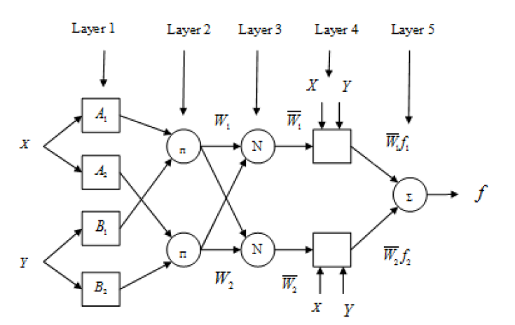
Figure 6: ANFIS structure
For example, assume the FIS has two inputs, x and y, and one output, f. A typical set of two fuzzy "if-then" rules might look like this:
Rule 1: if x is A₁ and y is B₁, then $f_{1}=p_{1}x+q_{1}y+r_{1}$
Rule 2: if x is A₂ and y is B₂ , then $f_{2}=p_{2}x+q_{2}y+r_{2}$
where,$A_{i},$ $B_{i}$ Refer to the membership functions of the inputs and $p_{i, }q_{i}, r_{i}$ Are parameters which can be adjusted during the learning process. The structure of ANFIS, as illustrated in Figure 2, comprises layers and nodes. The square nodes, which are flexible, contain the modifiable parameters, whereas the circular nodes are constant and associated with specific functions, such as:
Layer 1: In this layer, every node $ⅈ$ is an adaptive node having a node function.
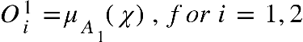………………………………………………………….3
Or
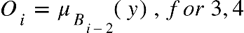……………………………………………………………4
Where 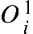 is the membership grade for input . The membership function could include Gaussian, Triangular, Trapezoidal, and Gbell membership.
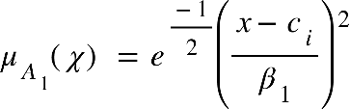……………………………………………………….….5
Where 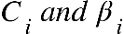 are the premise parameters to be optimised using gradient descent?
Layer 2: Every node in this layer is fixed, which multiplies the incoming signal and sends the product out.
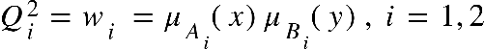…………………………………….…………6
Layer 3: This layer contains circular nodes, which compute the ratio of the firing strengths of the rules.
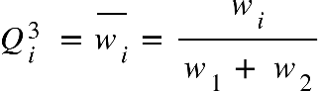…………………………………………………..…………7
Layer 4: Every node in this layer is an adaptive node and performs the consequent of the rules.
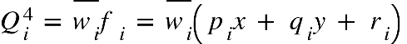………………………………………………...8
The parameters 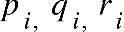 are consequent parameters to be determined.
Layer 5: The single node in this layer computes the overall output
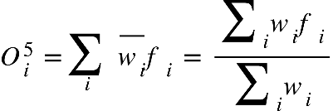………………………………………………………..9

The ANFIS, first introduced by [25], combines two methods: gradient descent and least squares. These approaches work together to modify the characteristics of both the initial and fourth layers in the neural network's architecture. When the premise parameters are kept constant, the output is calculated in the forward pass, as showcased in the studies by [26] [27]. Throughout this operation, the input vector advances through the network, and parameter alterations are applied using the least squares technique. The resulting expression can be formulated as follows:
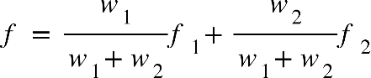
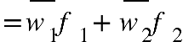
……………………………10
where 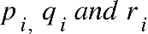 and are the consequent parameters
………………………………………………………………………….....11
For invertible X Matrix
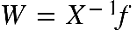………………………………………………………………………….12
Otherwise, pseudo-inverse is applied to obtain
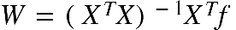……………………………………………………...…………13
In the backward pass, the error propagates back through the network, and the premise parameters 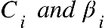 are optimised by gradient descent.
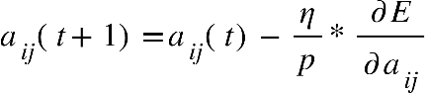……………………………………………………14
where is the learning epoch, is the learning rate for 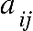 and is the number of input patterns.
The parameters are updated using the expression
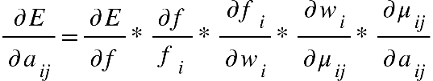…………………………………………….15
The function is expressed as
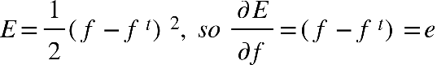…………………………………………….16
Where is the expected output and shows the fuzzy system output.
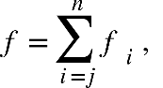 considering 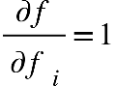………………………………………………….17
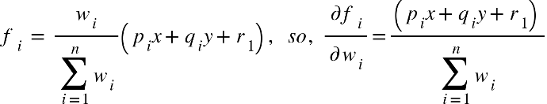……………………………….18
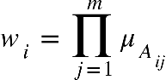 , therefore, 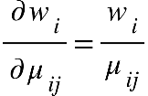…………………………………………….19
Hence, the gradient can now be expressed as:
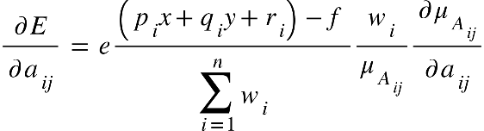……………………………………...….20
Or
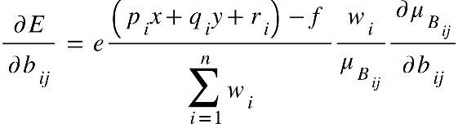……………………….……………….…21
ANFIS is a learning system that utilises input-output data to create a model mapping. After acquiring a set of parameters for the model, a comparison is executed between the model's output for each training data pair and the corresponding measured values. This computation determines the difference between the real and observed values. The completion of the model takes place once the specified stopping criterion is achieved. In this investigation, the model arrangement illustrated in Figure 7 was formulated utilising the MATLAB toolbox. The model is structured with four separate inputs linked to a duo of bell-shaped membership functions. Following a training phase consisting of one hundred cycles, the ANFIS's performance was assessed using test data. This procedure led to establishing sixteen if-then rules and a total of one hundred and four parameters necessitating optimisation.
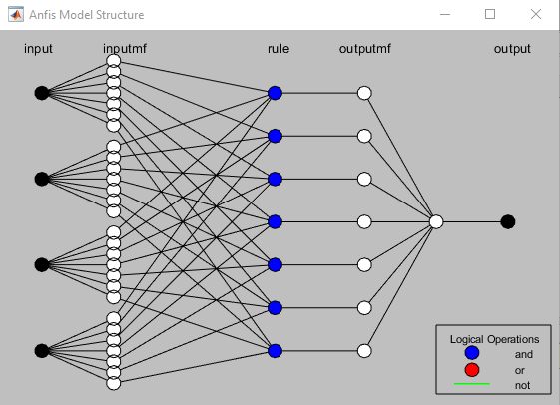
Figure 7: ANFIS Model structure for compression strength prediction of HP-SFRC.

Figure 8 illustrates the connection between predicted outcomes and actual compressive potencies for training and test sets. The substantial coefficient of determination (R²) is conspicuous in both scenarios, indicating the model's proficiency in precisely foreseeing concrete compressive potency, in line with [28] discoveries. Moreover, the square root mean squared error (RMSE), computed using formula (22), stands at 0.17 regarding the training set and 0.56 regarding the test set. This result underscores the accuracy of the machine learning model.
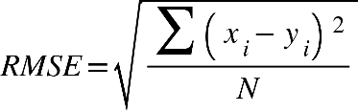…………………………………………………….22
Where is the measured value, is the predicted value and refers to the number of samples.
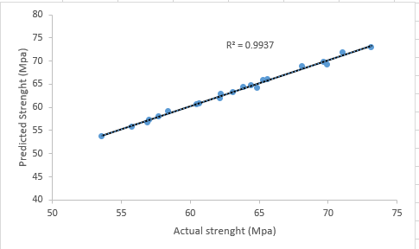 | 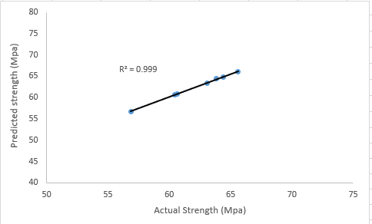

a) Training data b) Testing data
Figure 8: Correlation between actual compressive strength and predicted compressive strength by the ANFIS
Using the XLSTAT application, an analysis was conducted on a dataset containing eight different factors to construct a multiple linear regression equation. The resultant model (Equation 23) demonstrated an R-squared value of 0.87 and was utilised for the estimation of the 28-day compressive strength of High-Performance Steel Fiber Reinforced Concrete (HP-SFRC). The formula of the multiple linear regression equation is presented below:
y=106.1751 - 65.9815 /cm + 0.06052 C - 0.0049 FA - 0.00782 CA + 0.21315 SF - 0.23387 W - 0.3603 SP + 0.04146 Fiber (R=0.982) ……………………………………………………………23
7. Parametric study of the ANFIS model
The main aim of this study was to evaluate the effect of incorporating steel fibres and other factors on the compressive strength of High-Performance Steel Fiber Reinforced Concrete (HP-SFRC), as predicted by the ANFIS model. The outcomes of this investigation were represented using a 3D graph, shown in Figure 9. This graph demonstrates the impact of an extra parameter on the compressive strength of HP-SFRC. According to the graph, introducing steel fibres to High-Performance Concrete (HPC) resulted in a significant increase of 12% in compressive strength.
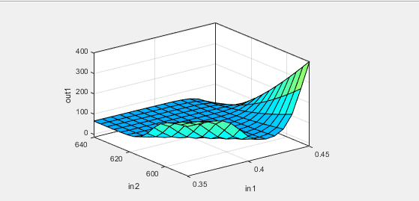
Figure 9: 3D surface plot for HP-SFRC
8. Conclusion
The study draws from experimental and numerical investigation into High-Performance Steel Fiber Reinforced Concrete (HP-SFRC), incorporating micro-silica as a Supplementary Cementitious Material (SCM). It is deduced that introducing steel fibres to High-Performance Concrete (HPC) moderately enhances its compressive strength. Moreover, increasing the replacement of micro-silica in the concrete matrix improves its mechanical performance.
The research has developed Empirical equations that estimate compressive strength based on fibre volume fraction. The accompanying Integral Absolute Error (IAE) values were calculated as 0.92. Importantly, these equations remain unaffected by specimen parameters, encompassing non-dimensional variables, and are suitable across a wide range of water-to-binder (w/b) ratios.
A thorough machine learning framework was also established, utilising an Adaptive Neuro-Fuzzy Inference System (ANFIS). Post-training, this framework demonstrated high precision in predicting HP-SFRC's compressive strength. Specifically, the Root Mean Squared Error (RMSE) values stood at 0.17 and 0.56 for the training and testing datasets.
Furthermore, a comparative assessment revealed that the strength forecasts generated by Multiple Linear Regression (MLR) models were more accurate than those produced by machine learning (ML) forecasts. The coefficient of determination was 0.87 for ML and 0.982 for MLR, underscoring the MLR model's superior accuracy in this context.
References
[1] H. Fathi, T. Lameie, M. Maleki, and R. Yazdani, “Simultaneous effects of fiber and glass on the mechanical properties of self-compacting concrete,” Constr. Build. Mater., vol. 133, pp. 443–449, 2017, doi: 10.1016/j.conbuildmat.2016.12.097.
[2] D. Falliano, D. De Domenico, G. Ricciardi, and E. Gugliandolo, “Compressive and flexural strength of fiber-reinforced foamed concrete: Effect of fiber content, curing conditions and dry density,” Constr. Build. Mater., vol. 198, pp. 479–493, 2019, doi: 10.1016/j.conbuildmat.2018.11.197.
[3] W. Abbass, M. I. Khan, and S. Mourad, “Evaluation of mechanical properties of steel fiber reinforced concrete with different strengths of concrete,” Constr. Build. Mater., vol. 168, pp. 556–569, 2018, doi: 10.1016/j.conbuildmat.2018.02.164.
[4] Y. Qin, H. Wu, Y. Zheng, W. Wang, and Z. Yi, “Microscopic Texture of Polypropylene Fiber-Reinforced Concrete with X-Ray Computed Tomography,” Adv. Civ. Eng., vol. 2019, pp. 1–9, 2019, doi: 10.1155/2019/2386590.
[5] D. Y. Yoo and Y. S. Yoon, “Structural performance of ultra-high-performance concrete beams with different steel fibers,” Eng. Struct., vol. 102, pp. 409–423, 2015, doi: 10.1016/j.engstruct.2015.08.029.
[6] T. Wu, X. Yang, H. Wei, and X. Liu, “Mechanical properties and microstructure of lightweight aggregate concrete with and without fibers,” Constr. Build. Mater., vol. 199, pp. 526–539, 2019, doi: 10.1016/j.conbuildmat.2018.12.037.
[7] J. H. Lee, B. Cho, and E. Choi, “Flexural capacity of fiber reinforced concrete with a consideration of concrete strength and fiber content,” Constr. Build. Mater., vol. 138, pp. 222–231, 2017, doi: 10.1016/j.conbuildmat.2017.01.096.
[8] D. Y. Yoo, S. Kim, G. J. Park, J. J. Park, and S. W. Kim, “Effects of fiber shape, aspect ratio, and volume fraction on flexural behavior of ultra-high-performance fiber-reinforced cement composites,” Compos. Struct., vol. 174, pp. 375–388, 2017, doi: 10.1016/j.compstruct.2017.04.069.
[9] M. Saridemir, “Predicting the compressive strength of mortars containing metakaolin by artificial neural networks and fuzzy logic,” Adv. Eng. Softw., vol. 40, no. 9, pp. 920–927, 2009, doi: 10.1016/j.advengsoft.2008.12.008.
[10] B. S. Thamma P, Application of soft computing. 2009.
[11] I. B. Topçu and M. Saridemir, “Prediction of compressive strength of concrete containing fly ash using artificial neural networks and fuzzy logic,” Comput. Mater. Sci., vol. 41, no. 3, pp. 305–311, 2008, doi: 10.1016/j.commatsci.2007.04.009.
[12] G. Arslan and E. Cihanli, “Curvature ductility prediction of reinforced High-strength concrete beam sections,” J. Civ. Eng. Manag., vol. 16, no. 4, pp. 462–470, 2010, doi: 10.3846/jcem.2010.52.
[13] M. Sofi, E. Lumantarna, P. Mendis, and A. Zhong, “Thermal Stresses of Concrete at Early Ages,” J. Mater. Civ. Eng., vol. 31, no. 6, pp. 1–9, 2019, doi: 10.1061/(asce)mt.1943-5533.0002684.
[14] ACI 211, “Standard Practice for Selecting Proportions for Normal,” ACI Mater. J., vol. 90, no. 3, 2009.
[15] Y. Choi and R. L. Yuan, “Experimental relationship between splitting tensile strength and compressive strength of GFRC and PFRC,” Cem. Concr. Res., vol. 35, no. 8, pp. 1587–1591, 2005, doi: 10.1016/j.cemconres.2004.09.010.
[16] F. Bencardino, L. Rizzuti, G. Spadea, and R. N. Swamy, “Stress-Strain Behavior of Steel Fiber-Reinforced Concrete in Compression,” J. Mater. Civ. Eng., vol. 20, no. 3, pp. 255–263, 2008, doi: 10.1061/(asce)0899-1561(2008)20:3(255).
[17] W. C. Liao, W. Perceka, and E. J. Liu, “Compressive stress-strain relationship of high strength steel fiber reinforced concrete,” J. Adv. Concr. Technol., vol. 13, no. 8, pp. 379–392, 2015, doi: 10.3151/jact.13.379.
[18] F. Köksal, F. Altun, I. Yiǧit, and Y. Şahin, “Combined effect of silica fume and steel fiber on the mechanical properties of high strength concretes,” Constr. Build. Mater., vol. 22, no. 8, pp. 1874–1880, 2008, doi: 10.1016/j.conbuildmat.2007.04.017.
[19] C. S. Poon, Z. H. Shui, and L. Lam, “Compressive behavior of fiber reinforced high-performance concrete subjected to elevated temperatures,” Cem. Concr. Res., vol. 34, no. 12, pp. 2215–2222, 2004, doi: 10.1016/j.cemconres.2004.02.011.
[20] M. Nili and V. Afroughsabet, “Combined effect of silica fume and steel fibers on the impact resistance and mechanical properties of concrete,” Int. J. Impact Eng., vol. 37, no. 8, pp. 879–886, 2010, doi: 10.1016/j.ijimpeng.2010.03.004.
[21] W. T. Lin, R. Huang, C. L. Lee, and H. M. Hsu, “Effect of steel fiber on the mechanical properties of cement-based composites containing silica fume,” J. Mar. Sci. Technol., vol. 16, no. 3, pp. 214–221, 2008, doi: 10.51400/2709-6998.2010.
[22] Z. Keshavarz and H. Torkian, “Application of ANN and ANFIS Models in Determining Compressive Strength of Concrete,” J. Soft Comput. Civ. Eng., vol. 2, no. 1, pp. 62–70, 2018, doi: 10.22115/SCCE.2018.51114.
[23] Y. M. Wang and T. M. S. Elhag, “An adaptive neuro-fuzzy inference system for bridge risk assessment,” Expert Syst. Appl., vol. 34, no. 4, pp. 3099–3106, 2008, doi: 10.1016/j.eswa.2007.06.026.
[24] D. K. Sinha, R. Satavalekar, and S. Kasilingam, “Application of Adaptive Neuro-Fuzzy Inference System for Evaluating Compressive Strength of Concrete,” Int. J. Fuzzy Log. Intell. Syst., vol. 21, no. 2, pp. 176–188, 2021, doi: 10.5391/IJFIS.2021.21.2.176.
[25] J. R. Jang, “ANFIS : Adap tive-Ne twork-Based Fuzzy Inference System,” vol. 23, no. 3, 1993.
[26] M. A. Denaï, F. Palis, and A. Zeghbib, “ANFIS based modelling and control of non-linear systems: A tutorial,” Conf. Proc. - IEEE Int. Conf. Syst. Man Cybern., vol. 4, pp. 3433–3438, 2004, doi: 10.1109/ICSMC.2004.1400873.
[27] J. S. R. Jang, C. T. Sun, and E. Mizutani, “Neuro-Fuzzy and Soft Computing-A Computational Approach to Learning and Machine Intelligence [Book Review],” IEEE Trans. Automat. Contr., vol. 42, no. 10, pp. 1482–1484, 2005, doi: 10.1109/tac.1997.633847.
[28] O. Ünal, F. Demir, and T. Uygunoǧlu, “Fuzzy logic approach to predict stress-strain curves of steel fiber-reinforced concretes in compression,” Build. Environ., vol. 42, no. 10, pp. 3589–3595, 2007, doi: 10.1016/j.buildenv.2006.10.023.

