AN ANALYTICAL STUDY OF NON-FARM ACTIVITIES IN RURAL TANK OF TAMILNADU, INDIA

Anuradha B^{1†} Deepa K² Vasanthi.P³ Priyanka.M⁴ Packialakshmi S⁵ Sheena.A.D⁶

¹²³⁴Chennai Institute of Technology, Chennai-600069
⁵ VISTAS, Chennai
⁶ Sathyabama Institute of Science and Technology, Chennai

†Email:anubas2003@gmail.com

ABSTRACT
Tanks are the rural resources constructed across a shallow valley to conserve water for multiple uses. Apart from predominant use for farming, this stored water is also been used for non-farm and off-farm activities by local communities. Hence objective of tank rehabilitation not only focus enhancing agricultural activities but also its associated livelihood options. Hence this analytical study is a prudent attempt of assessing the improved livelihood status of a selected rural village during post tank rehabilitation era in various non-farm activities. Result shows that percentage of per capita increased net income from non-farm anmong total increased income is 29 %.

Keywords: Tank Rehabilitation, On-farm, off-farm, Livelihood, Multiple use of water

INTRODUCTION
Farmer’s involvement in tank rehabilitation and leadership traits at crucial stages are needed to solve problems in time (Karunakaran 1994). The involvement in watershed improvement under the new participatory methodology in India shows that prompt outcomes are sure as far as ascend in water tables, crop yields work and salary of the members (Rao 2000). Tanks are considered to have a close association with farming and non-farming activities in rural villages. This conventional water storage structures are seen in each and every village of Tamilnadu, since the local community is solely depend on surface water and groundwater (through recharge) for carrying out agricultural activities for their livelihood. Non-farm is the term denotes the allied activities of farming and especially correlated with landless people of village group. In this study the accountable non-farm activities are Mini contract laborers for sugarcane cutting, fuel wood cutting, washing, rat trapping, barber and tank bund tree plantation. The utilization of the tank bed and nearby waste land for vegetable farming, tree growing, fuel wood expansion, dairy cattle grazing and generating employment women depiction in the institution; non-farm exercises identifying with tank use, and tank water shortage driving relocation were reflected (Sakthivadivel 2004). Reasonable increment was seen in non-farm income compared to farming household (Kajisa and Palanichamy 2006). When water storage is increased after tank rehabilitation it leads to change in cropping pattern from paddy to sugarcane gives more working days for mini contract labours. During summer, trees from tank bed will be procured for fuel wood consumption. For washing abd barber group it is related to their wage in terms of agricultural produce given by farmers for their service during harvest period. In case of more augmentation of water in tank, vast cultivation will be practiced which helps rat trapping group for their livelihood. With available moisture content in tank bund, trees planted on it will also give some remuneration to the local village administration. Hence tank rehabilitation not only helps in exponential improvement in farming activities but also improvise rural non-farm livelihood activities by and large. Thereby villagers under poverty line will also benefit through water storage structures renovation.
REVIEW OF LITERATURE

The southern part of India, tanks as a common property resource plays a major role for irrigating agricultural fields (Sengupta, 1985; Anbhumozhi et al 2001; Anuradha and Ambujam 2011; Jana et al 2012).Defunct of tanks due to various reasons was realized in mid of 1980’s and selected tanks were rehabilitated to regain its original structures (Sakthivadivel et al 2004; Shah 2013). Livelihoods of the community and tank ecosystem are under severe threat which needs immediate solution for future sustainability (Hemamalini et al 2015). A small scale water harvesting structure like a tank is not just a physical unit in itself; yet in addition a self-supportable economy (Roy and Kumari 2018). Regenerating tank systems requires focus on the interactions among social, technical and environmental variables (Raju and Shah 2000). Apart from renovating the physical structures to their originally designed standard, rehabilitation of tank also facilitate proper maintenance, efficient water management and improved cropping practices in a sustained manner (Shanmugam and Gurunath 2007). Improvising the tank management will upgrade tank supplies which will lessen the interest for increasingly number of wells in the tank command area and subsequently endeavors ought to be made to improve the framework efficiencies through tank modernisation techniques including the Water Users Associations/affiliations (Palanisami et al 2008).

METHODOLOGY

Karaipoondi village is located in Polur taluk, Chetpet block of Thiruvannamalai district in Tamil Nadu, Village population taken from secondary data collection is 1256. Paddy and sugarcane are the major crops cultivated in this the command area. Tank water through field channel and groundwater using deep and side bore well are the major source of irrigating crops when precipitation is not sufficient. Questionnaire was used to collect data for farming related information and focus group discussion was done to collect information regarding non-farm activities. After the tank rehabilitation, percentage of increased income from non-farm activities other than farming activities is computed as (Anuradha 2009)

I_{nip} = [(I_{nif} - I_{nin}) / I_{nit}] × 100

where I_{nip} is percentage of increased per capita net income from non-farm
I_{nif} is increased per capita net income from farming;
I_{nin} is increased per capita net income from non-farm
I_{nit} is increased per capita total net income from farm and non-farm activities;

RESULTS AND DISCUSSION

Non-Farm Activities in Karaipoondi

Mini contract labourers
Number of mini-contractor labour groups is increased after tank rehabilitation in Karaipoondi and in neighboring areas. Before rehabilitation the area harvested by 20 groups of mini contract labour was 13.16 ha of sugarcane cultivated area and earned a total amount of Rs. 92,120/- (Rs. 7,000/ha). Due to availability of more surface water many farmers shifted from paddy cultivation to sugarcane since it is cash crop (Sideriusa et al 2015). Since the area of cultivation is increased as 40.45 ha in post rehabilitation period, amount was also increased to Rs. 2, 83,150/-. Hence, the tank rehabilitation has a positive impact on mini contract labour group of Karaipoondi village. Farm road constructed in the field plays a major role for the increased sugarcane cultivation area (Anuradha et al. 2012). Before rehabilitation tractor cannot go nearer to the fields and it has to be stopped in the main road itself. It made loading and unloading of sugarcane bundles difficult. Extra labourers were appointed to bring the sugarcane bundles to the tractor resulted in a cost of Rs. 7/- extra charges i.e., Rs. 700/ha for 100 tons.
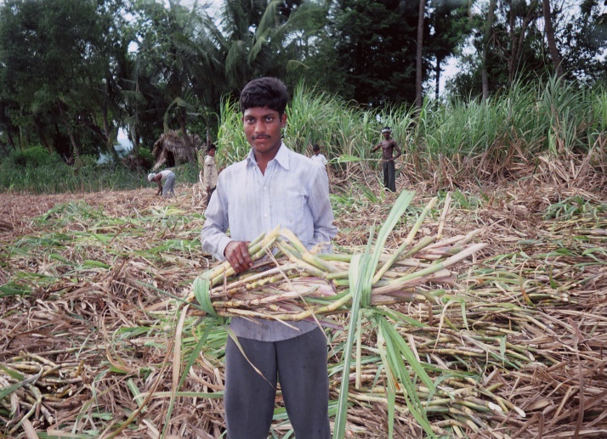

Fig.1 Non-farming activities in Karaipoondi - Mini contract group
In spite of taking extra amount, labors health got affected due to the lifting of heavy loads. Hence construction of an infrastructure in the form of a road as a part of the rehabilitation has helped both farmers as well as labourers. A female gang leader was also found in maintaining a group of 10 members from the same village constitutes 3 males and 7 females. Farmers and sugar mill owner have dealing that the sugar mill directly credits the payment in the contractors group’s bank account.
Fuel wood cutting

There are four groups in Karaipoondi with 7 members in each group for fuel wood cutting. One of the group members will act as the head for supplying equipment, negotiation, contracting and completing the contracting work satisfactorily. These wood cutting groups cut wood in Karaipoondi tank bed and bund. In addition, they also seek jobs on contract basis as in nearby villages. These groups were paid in cash for the contracted work. The amount received (contracted amount) as labour charges is divided into eight equal shares. Since the head of the group is supplying required and provide support equipment services, he will be receiving two shares from the amount obtained. Respondents of the village said that number of working days available in their own village was only 150 days/year before rehabilitation. So they were forced to temporarily migrate to nearby villages/towns for their livelihood. But, the number of working days in the village has increased to 250 to 300 days in the post rehabilitation period due to increased water availability and increased biomass production in the tank bed and bund. These augmented resources helped them to stay back in their own village and carry out agricultural labour work and wood cutting work when they are free (Sophia and Anuradha 2006). Hence, tank rehabilitation helped them in procuring more number of wage labour in their own village throughout the year. The total amount received by this four group before rehabilitation was Rs. 2, 94,000 (wage rate Rs. 70/- each for 28 labours in 150 days). This was increased to Rs. 5, 88,000/- in post rehabilitation period with increased number of 300 working days. Hence, the increased income shows a near 100% impact of tank rehabilitation on fuel wood cutting.

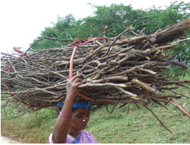
Fig.2 Non-farming activities in Karaipoondi - Fuel wood cutting
Moreover, village respondents informed that increased growth of trees in the tank bed and bund after tank rehabilitation tempted children below 12 years to involve in fuel wood collection. They acquire at least Rs.600/month through juliflora (a sort of fuel wood) cutting and selling. They cut juliflora from tank bed and bund. They figure out how to cut around 5 packages in seven days. Contingent on the size of the wood, each pack costs around Rs.30/ - to Rs. 40/. They are able to earn Rs.170/week on an average. Cutting of juliflora not only provides livelihood avenues for poor families but in a way it helps in reducing tank maintenance cost. Another highlighting feature of this activity is that school going children involved in cutting trees perform this task during holidays and daily before and after their school hours. This work culture, villagers say, help their young kids to become responsible citizens. Trees planted in tank bed are lent for auction by local Panchayat and the person who had taken auction will appoint fuel wood cutters for cutting trees. Since they will not cut the trees till the root level, villagers are allowed to dig it for their household fuel wood consumption. According to the villagers, matured tree roots are very tough to remove but very helpful to reduce their fuel wood cost (Kaul, 2000; Sato, 2013; Bitterman 2016). Out of 495 households, in Karaipoondi only 60 are having LPG (Liquefied Petroleum Gas) connections. The remaining families are depending upon fuel wood for cooking and other purposes. Tree roots collected for one week period (approximately 100 kg) will help them to make use of it for three months period. This is absolutely at free of cost, whereas if they purchase fuel wood from shop for the same three months period, they are in need of minimum 400 kg which may cost around Rs. 1,000/- (Rs. 2.50 per kg). Moreover, roots taken from tank bed will withstand for a long time while burning, which leads to low consumptions when compared to other types of fuel woods. Thus trees planted in the tank bed helps on all possible ways for the village population (Palanisami 2010).

Washing

Six Dhobi (washer man) families residing in the Karaipoondi village are depending upon the tank water for their livelihood (Palanisami and Ruth 2001; Ariza et al 2007; Madhavi Ganesan 2008). These families wash villager’s clothes during normal days, during festival times, and other household functions and receive emoluments either in kind or in cash from villagers.
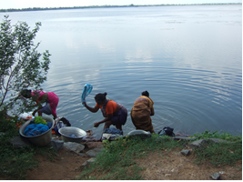
Fig.3 Non-farming activities in Karaipoondi - Washing
The respondents said that before the rehabilitation the dead storage in tank was low and it increased after the rehabilitation helping them in all possible ways. Instead of taking money for washing clothes, they used to receive five bundles of paddy crop/ha/year from the farmers. The total area of paddy cultivation was 110.82 ha before the rehabilitation and this allowed them to receive 554 paddy crop bundles i.e. 23 bags of paddy/season (24 bundles give one bag of paddy). Since the area of paddy cultivation was decreased to 106.85 ha in post rehabilitation period, they could receive only 534 paddy crop bundles i.e. 22 bags/season of paddy for all six households. In spite of a minimal reduction in paddy crop cultivated area, there is a significant increase in sugarcane cultivation area in the Karaipoondi village. However, each of the Dhobi families receive Rs. 125/ha from sugarcane cultivators. Before the rehabilitation, 57.37 ha were cultivated with sugarcane and the amount received was around Rs. 7,171/family/year. This was increased in the post rehabilitation period to Rs. 12,795/year/family with an increased cultivated area of 102.36 ha. Hence, the total amount earned by all six families before the rehabilitation was Rs. 43,026/-, which was increased to Rs. 76,770/- in the post rehabilitation period. The amount received has been increased mainly due to the tank rehabilitation. This shows a positive impact of the tank rehabilitation of about 78.43% for service community group in the Karaipoondi village.

Rat trapping

An amazing livelihood change for a landless community called Irular community has emerged during the study in the Karaipoondi village. Rats threaten farmer’s livelihoods all over the world. They eat the crops and spread diseases. Controlling rat is a global issue. Rats move freely between the fields and houses in rural areas. Eating the germinating seeds, missing hills or plants, cutting or pulling up of transplanted plants, chopping young seedlings, irregular cuttings of stem, cutting tillers near base at 45° angle, chewed developing of buds or ripening grains, missing grains and panicles are some of the major crop related problems raised by the rat population in agricultural fields. The respondents revealed that all the above damages result in a reduction of 20 to 40% of the normal yield. Farmers tried a few methods like fixing live current wires along the ridges of fields and raising water levels in fields to solve the problem. But, the results were not favorable to them, because the former one is not safe and the latter one spoils the crop roots leads to reduction in yield/ha. Therefore, a particular community group called Irular is appointed to catch the rats. Nearly, ten households constitutes 68 members (all are coming under landless group) belong to this community are residing in the Karaipoondi village. All heads of the ten household forms a group and take up rat catching as their livelihood option for their survival. They receive Rs.250/ha/ year to clear up atleast 70% of the alive rats.

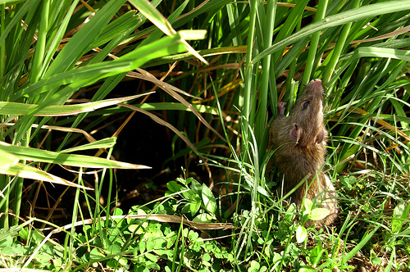

Fig.4 Non-farm activities in Karaipoondi - Rat trapping
Before the rehabilitation since the total cultivated area in both the wet and garden lands was 168.19 ha, they earned around Rs.42,048/year. This was increased to Rs. 51,303/year in the post rehabilitation period as the total cultivated area increased to 205.21 ha. Apart from cash, they are also allowed to take the paddy stored in rat burrows for themselves. It was estimated that each 7 ha of land will give one bag of paddy. Hence, the Irulars get 16 bags of paddy in before and after the rehabilitation. Hence, the total amount earned by the ten families was Rs. 4, 20,480/- before the rehabilitation, which was increased to Rs. 5,13,030/- (Rs. 755/capita) in the post rehabilitation. Thus, the tank rehabilitation shows 22% impact on rat trapping. Moreover, rats caught by them will be consumed by their household members. Traditionally Irular’s are known to eat the meat of rats and other rodents. Thus the tank rehabilitation promotes the livelihood of landless group in the Karaipoondi village.

Barber

There are 4 families belonging to the service caste called Barber in the Karaipoondi village. They work as hair dressers to the villagers. They are not paid in cash for their services. Instead, they receive two Marakkals (12 kg) of paddy/ha/year from farmers. Therefore, they received 1330 kg from 110.82 ha of paddy cultivated land before the rehabilitation i.e. 18 bags (each bag weighs 75 kg of paddy). Since the paddy cultivation area was decreased to 106.85 ha, in post rehabilitation period, they received 17 bags/season of paddy.
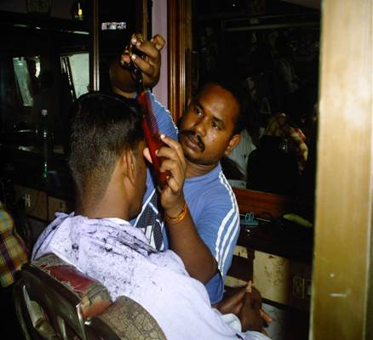

Fig.5 Non-farm activities in Karaipoondi - Barber

Tank bund plantation
In the Karaipoondi tank, seedlings of fuel, feed and timber delivering trees were planted along the limit line for example in the foreshore of the tank bed and in the portion of land sited in the middle of its Full Tank Level (FTL) and Maximum Water Level (MWL). Trees were additionally planted on the banks of feeder channels and along the frontier of the Government land. These tree plantations gave extra salary to the individuals from their usufructs other than their development esteem (Jodha, 1990; Kumar et al, 2000; Ajay kumar and Puri 2004). This extra income, however imparted to the nearby Panchayat, helped the individuals to use the parity support for periodical repair and the protection of the tank. Tree planting serves to forestall infringement of these grounds by unapproved people. In addition, they cover fowls and protect the environment of water bodies. Normally Juliflora tree is planted on the Karaipoondi tank bund. The Panchayat (local office) paid Rs. 12,000/- to the Government and obtained the rights for the auction. This auction is called Nilam Magasul (Nilam means land and magasul means production). The person who had taken the auction paid Rs. 69,000/- to the Panchayat where the money is used for small water conservation structure repair works and also local village temple renovation and maintenance related works.
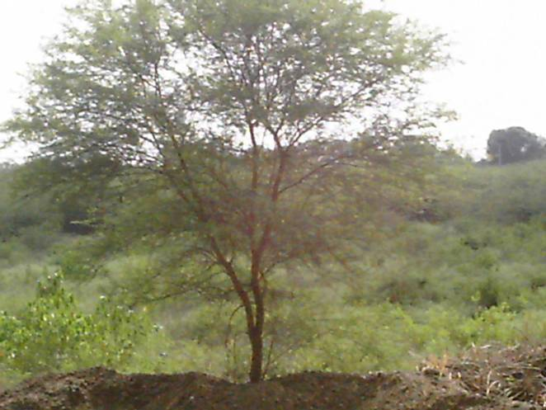

Fig.6 Non-farm activities in Karaipoondi - Tank bund plantation

The respondents said that before the rehabilitation if the trees were allowed to grow for a year, Rs. 80,000/- (Rs. 8.50/ha/year) was the profit and for two years Rs. 1,70,000/-(Rs.16/ha/year). But after the rehabilitation moisture content in the tank bund was enhanced by increased water storage. This led to increased number of trees with good quality timbers which raised the profit to Rs. 1,50,000/- (Rs.16/ha/year) and Rs. 3,00,000/- (Rs. 32/ha/year) respectively for one and two years period. Hence, the tank rehabilitation has an impact of 87.5% on tree plantation in the tank bund. As a result, the next year auction amount paid to local Panchayat is expected to be higher than before. In this way, the tank rehabilitation has contributed to increased earnings of money through village common properties not only for the community but also for the Panchayat under which the tank is located.
The work sheet for the estimation of percentage of increased income through non-farm and off-farm activities during the post rehabilitation period in Karaipoondi village is presented in Table 1. It is evident from this table that increased net income from non-farming activities in the Karaipoondi village is 41% higher than the net income from farming activities during the post rehabilitation period. Considerable increase in yield/ha is seen in paddy and sugarcane crop cultivation after the tank rehabilitation. On an average, there is a raised production of 7 bags/ha and 10 tons/ha in paddy and sugarcane respectively. Hence, the increased gross income for paddy at the cost of Rs. 500/bag is Rs. 3,500/- and for sugarcane at the cost of Rs. 1,025/ton is Rs. 10,250/-. Thereby the total gross income is Rs. 13,750/-. The amount added for byproduct income is 5%. of the total gross income (CWR 2000).
Table 1 Increased net income through non-farm activities in Karaipoondi village
S. No. | Description | Net income (Rs.) |  | Increased net income (Rs.)
 |  | Before rehabilitation | After rehabilitation
 | Non-farm activities
1 | Mini contract labour | 4,04,590 | 7,16,520 | 3,11,930
2 | Fuel wood cutting | 2,94,000 | 5,88,000 | 2,94,000
3 | Washing | 43,026 | 76,770 | 33,744
4 | Rat trapping | 4,20,480 | 5,13,030 | 92,550
5 | Barber | 22,948 | 40,944 | 17,996
6 | Tank bund plantation | 1,50,000 | 3,00,000 | 1,50,000
 | Total | 13,35,044 | 22,35,264 | 9,00,220

Increased expense/ha for enhanced production is approximately Rs. 4,000/ha. Hence, the increased net income from farming activities is arrived as Rs. 9,750/ha in Karaipoondi village. Development of irrigation increases the intensity of cultivation which in turns increases the agricultural labours. This process not only helps to increase the money wage rates and number of days of employment for agricultural labours but also increases the total earnings of agricultural labours (Narayamoorthy 2001). Thus, the increased net income for the increased cultivated area of 41.02 ha by 102 respondents is Rs. 3, 99,945/-. There is also an increased working days for farm labourers for one season (120 days) at Rs. 60/day. For 41.04 ha, the increased wage rate is Rs. 2, 95,344/- during the post rehabilitation period. Therefore the total increased net income from farming activities is Rs. 6, 95,289/-. Total increased net income from farming activities is Rs. 12, 29,949/-. Hence, with the village population of (1256) the increased net income per capita from farming is found out to be Rs. 979/-. The increased net income from non-farm activities like, mini contract labour group, fuel wood, washing, rat trapping, barber and tank bund plantation is calculated as Rs. 9,00,220/-. With the existing village population, the increased income/capita from non-farm activities is evaluated to be Rs. 716/-. From the above computation, the percentage of per capita increased net income from non-farm and off-farm activities is worked out as 41%. This clearly shows that indirect tank users are the most beneficiaries with the tank rehabilitation program. At the same time, most of them depend upon the direct users (farmers) for their livelihood options.

Table 2 Work sheet for estimation of percentage of increased income through non-farm and off-farm activities during post-rehabilitation period in Karaipoondi village
S.No. | Description | Unit | Karaipoondi
1 | Command area | ha | 198
2 | Rehabilitation cost | Rs. | 30,01,000
3 | Village population | number | 1256
4 | Benefits
5 | Increased paddy yield | bags/ha | 7
6 | Increased sugarcane yield | tons/ha | 10
7 | Gross income
8 | Paddy @ Rs. 500/bag | Rs./ha | 3,500
9 | Sugarcane @ Rs. 1250/ton | Rs./ha | 10,250
10 | Total gross income | Rs./ha | 13,750
11 | By product (5%) | Rs./ha | 680
12 | Total increased expenses | Rs./ha | 4,000
13 | Increased net income | Rs./ha | 9,750
14 | Net income for 102 respondents from increased cultivated area of 41.02 ha | Rs. | 3,99,945
15 | Wages for 120 days at Rs. 60/day for increased cultivated area of 41.02 ha | Rs. | 2,95,344
16 | Increased net income from farming activities | Rs. | 6,95,289
20 | Increased income per capita from farming | Rs. | 553
21 | Increased net income from non-farm activities
23 | Mini contract labour group | Rs. | 3,11,930
24 | Fuel wood | Rs. | 2,94,000
25 | Washing | Rs. | 33,744
27 | Rat trapping | Rs. | 92,550
28 | Barber | Rs. | 17,996
29 | Tank bund tree plantation | Rs. | 1,50,000
30 | Total increased net income from non-farm activities |  | 9,00,220
34 | Income per capita through non-farm | Rs. | 716
36 | Income per capita from farm and non-farm | Rs. | 1269
37 | Percentage of per capita increased net income from non-farm among total increased income | % | 29%

CONCLUSION
Rehabilitation of tanks with community participation is expected to have an overall positive impact on the rural community. Augmented supply of irrigation water, better recharge of ground water, improved quality of drinking water, increased production and productivity, enhanced employment opportunities and better prosperity of the stake holders communities are the outcome expected in post rehabilitation period. It is intended to benefit mainly the farmers but as a spin off effect the poor and landless also receive some benefits during rehabilitation. Total increased net income from farming activities is Rs. 6, 95,289/-. Total increased net income from non-farm activities is Rs. 9, 00,220. Percentage of per capita increased net income from non-farm and off-farm activities among total increased income is 29%. Moreover the increased income from various livelihood options is equally distributed among the villagers shows the progressive scenario.
REFERENCE
- Ajay Kumar and S.K. Puri (2004), “The Management of Village Common Lands of Aravalli, India”, Forests, Trees and Livelihoods, vol. 14, pp. 77-89
- Anbumozhi, V., Matsumots, K., Yamaji, E (2001), “Towards improved performance of irrigation tanks in semi-arid regions of India: Modernization opportunities and challenges”. Irrigation. Drainage System. 15, 293–309.
- Anuradha, B., and Ambujam, N.K (2011) “Impact of Irrigation Tank Rehabilitation on Garden Land Agriculture – A Case Study in Rural Village of Tamilnadu”, International Journal of Agricultural and Statistical Sciences, vol 7, no.2, pp 493-498.
- Anuradha. B, N.K.Ambujam (2012), “Impact of Tank Rehabilitation on Improved Efficiency of Storage Structures”, International Journal of Engineering Research and Applications vol. 2, Issue4, pp.1941-1943
- Centre for Water Resources (CWR) (2000), ‘Monitoring and evaluation:
Phase I and Phase II – Extension Tank Modernisation project with EEC assistance: Final Report’, vol. I and II, Anna University, Chennai, November.
- Dipankar Roy and Shobha Kumari (2018), “Social actors in traditional tank rehabilitation: a case study of Tamil Nadu (India)” Sustainable Water Resources Management https://doi.org/10.1007/s40899-018-0221-0.
- Hemamalini. J, B.V.Mudgal , J.D.Sophia (2015), “ Sustainability of Tank Eco-Systems from IWRM Perspective”, Aquatic Procedia 4 ( 2015 ) 633 – 640.
- Jana, S. K., Palanisami, K., & Das, A. (2012), “Prospect of the sustainable tank option in the dry zones of West Bengal”, Indian Journal of Agricultural Economics, 67(2), 225–237
- Jodha, N. S. (1990). Common Property Resources: Contributions and Crisis. Economic and Political Weekly, XXV, No. 26, A65-78.
- Kajisa, K.; and Palanichamy, N.V (2006), “Income Dynamics in Tamil Nadu, India from 1971 to 2003: Changing Roles of Land and Human Capital”, Agricultural Economics 35 (supplement): 437–448.
- Karunakaran K. (1994), ‘Tank rehabilitation in Tamilnadu: A study of participatory management in irrigation’, Ph.D. thesis, Centre for Water Resources, Anna University, Chennai - 600025.
- Kaul, R. N. (2000) “Success and Sustainability of Desertification control in the Aravalli Hills of Haryana: An Analysis”, Desertification Control Bulletin, 36, 50-53.
- Kumar, A., Bren, L., and Ferguson, I. (2000), “The Use and Management of Common Lands of the Aravalli, India”, The International Forestry Review. 2(2), 97-104.
- Madhavi Ganesan (2008), “The temple tanks of Madras, India: rehabilitation of an ancient technique for multipurpose water storage”, Vol.1 No 7, pp 1-8.
- Narayanamoorthy A. (2001), ‘Irrigation and rural poverty nexus: A state wise analysis’, Indian Journal of Agricultural Economics, vol. 56, No.1, Jan.–March.
- Palanisami K, Amarasinghe UA, Sakthivadivel R (2008), “Policy Interfacing and Irrigation Development in Tamil Nadu”. State Planning Commission. Government of Tamil Nadu. Chennai
- Palanisami.K and Ruth Meinzen-Dick (2001), “Tank Performance and Multiple Uses in Tamil Nadu, South India”, Irrigation and Drainage Systems 15: 173–195.
- Palanisami.K, Ruth Meinzen-Dick, Mark Giordano (2010), “Climate Change and Water Supplies: Options for Sustaining Tank Irrigation Potential in India”, Economic & Political Weekly , vol xlv nos 26 & 27
- Patrick Bitterman , Eric Tate , Kimberly J. Van Meter , Nandita B. Basu (2016), “Water security and rainwater harvesting: A conceptual framework and candidate indicators, Applied Geography 76, 75-84.
- Pere Ariza1, Elena Galán, Tarik Serrano, Victoria Reyes-García (2007), “Water tanks as ecosystems. Local Eco systemic perception for integral management of water tanks in Tamil Nadu, South India”, Perifèria, 7, December.
- Raju, K. V., and Shah, T. (2000). “Revitalisation of irrigation tanks in Rajasthan. Economic and Political Weekly, 35(23), 1930–1936.
- Rao C.H. (2000), “Watershed development in India, recent experience and emerging issues”, Economic and Political Weekly, vol. 35, no. 45, November 4.
- Sakthivadivel.R, P Gomathinayagam, Tushaar Sha (2004) “Rejuvenating Irrigation Tanks through Local Institutions”, Economic and Political Weekly July 31, 3521-3526.
- Sato, T. (2013), “Beyond water-intensive agriculture: Expansion of Prosopis juliflora and its growing economic use in Tamil Nadu, India”, Land Use Policy, 35, 283-292
- Sengupta, N. (1985) “Irrigation Traditional vs Modern”, Economic and Political Weekly, 20(45–47), 1919–1938
- Shah M (2013), “Water: towards a paradigm shift in the twelfth plan”, Economic and political weekly.48 (3): 40–52.
- Shanmugam C.R. and Gurunathan A. (2007), ‘Irrigation tanks and their Traditional local management: A remarkable ancient history of India’, International History Seminar on Irrigation and Drainage, Tehran, Iran, May 2-5, 2007.
- Sideriusa.C, H. Boonstraa, V. Munaswamyb, C. Ramanab, P. Kabatc,E. van Ierlandd, P. Hellegersd, Alterra,, (2015), “Climate-smart tank irrigation: A multi-year analysis of improved conjunctive water use under high rainfall variability”, Agricultural Water Management 148, 52–62
- Sophia J.D. and Anuradha B. (2006), “Livelihood and gender issues in tank irrigation’, Rehabilitation and Management of Tanks in India - A Study of Select States”, Asian Development Bank Publication.

