LIPOSOME – a salient tool of nanotechnology

Deeptarka Ghosh,
Department of Chemistry,
Acharya Prafulla Chandra College,
Kolkata, West Bengal, India - 700131
Email- ghoshdeeptarka@gmail.com

ABSTRACT

The various types of nanoparticles have immense use in technology. Among nanoparticles, the liposomes fall under the category of organic nanoparticles. They have proved to be one of the salient tools of nanotechnology. The structure, types and various synthesis processes of liposomes have been illustrated here. Liposomes have enormous use in the medicinal field in delivering drugs and have shown effective carrier properties. Liposomes also serve many other interesting roles which are highly useful for us. The various applications of liposomes have been discussed briefly in this chapter.

I. INTRODUCTION

A. Nanoparticles

The idea of nanotechnology was first introduced by the Noble Laureate physicist Richard Feynman in 1959. Then over a decade later, professor Norio Taniguchi coined the term ‘Nanotechnology’. Nanotechnology is a branch of science inter-related to material science, engineering and synthetic chemistry which deals with extremely small particles which can’t be observed under light microscope.
Nanoparticles are substances which have at least one dimension in the range of 1-100 nm. These have special surface properties and specific surface area.
Based on the size or shape, nanoparticles can be classified into:

- Zero dimensional nanoparticles:
These have all the three dimensions less than 100 nm. For example- fullerene, quantum dots.

- One dimensional nanoparticles:
In these, one of the three dimensions has size less than 100 nm. For example- carbon nanotubes, nanofibers, nanowires, etc.

- Two dimensional nanoparticles:
These have two-dimensional arrangement of atoms in the nanoscale region. For example- graphene.

- Three dimensional nanoparticles:
These have three-dimensional arrangement of atoms in the nanoscale region. For example- nano-diamond.

Based on the composition, nanoparticles can be classified into:

- Inorganic nanoparticles like silver and gold nanoparticles.

- Organic nanoparticles like liposomes, dendrimers, etc.

- Carbon nanoparticles like fullerene, graphene, etc.

The two prime factors which make nanoparticles different from bulk materials are:

- Surface area:
As the particle size decreases, a greater proportion of atoms are found at the surface. Thus, a greater amount of the substance is exposed towards the surroundings leading to better catalysis.

- Quantum confinement:
When the diameter of a particle becomes of the same magnitude of an electron, the energy difference between the energy levels increases. This affects the electrical and optical properties of the nanoparticles. As a consequence, change in size results in different colours of the nanoparticles.

Nanoparticles can be seen through electron microscopes like Transmission Electron Microscope (TEM) and Scanning Electron Microscope (SEM). This is because an electron microscope uses a beam of accelerated electrons as a source of illumination. As the wavelength of an electron is 100000 times shorter than that of visible light photons, an electron microscope has a higher resolving power than the light microscopes and can show the structure of smaller objects.

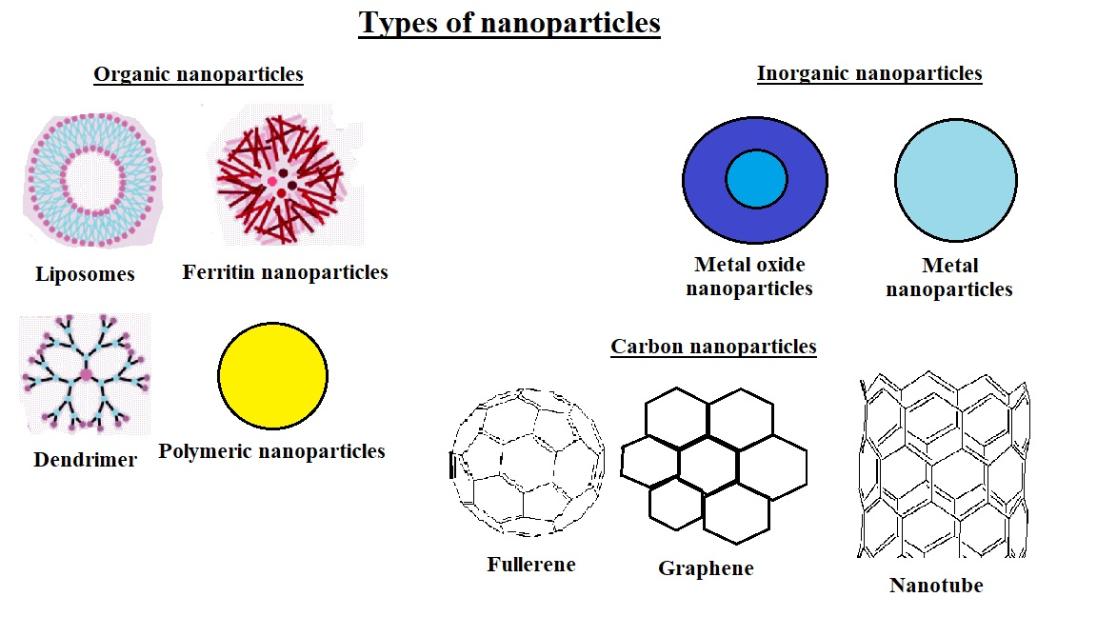
Figure-1 – Types of nanoparticles

B. Organic nanoparticles

Lipids, proteins and carbohydrates are the major components of the organic nanoparticles. In the food industry, organic nanoparticles are used to generate flavour and texture. In the context of food, as the organic nanoparticles are easily digested, organic nanoparticles are considered to be safe [1-3].
Carbohydrate nanoparticles are mainly constituted of polysaccharides. Carbohydrate nanoparticles can be produced by the self-assembly of polysaccharides or by the controlled disintegration of bulk polysaccharide materials. Carbohydrate nanoparticles are often used as vitamin carriers [4-8].
Protein nanoparticles are utilised as functional ingredients in foods and beverages. Casein micelles are natural nanoparticles containing proteins which are found in milk. Protein nanoparticles are used as carriers and also helps to replace fats wherever required [9].

Lipid nanoparticles have prime roles in the application of nanotechnology. Lipid nanoparticles often serve as carriers for lipophilic drugs and oil-soluble vitamins, which are chemically less stable and are less soluble in water. Lipid nanoparticles like micelles, liposomes, nanoemulsions, etc. act as carriers. Liposomes are formed from polar lipids such as phospholipids whereas non-polar lipids such as triacylglycerols lead to the formation of solid fat particles [10-11].

C. Micelle and reverse micelle

Micelles are aggregate of generally surfactant molecules dispersed in a polar liquid in which the lyophilic polar heads lie outwards towards the solvent and the lyophobic non-polar tails face the core. These are observed in phases like oil in water.
On the other hand, in case of a non-polar liquid, the lyophobic tails lie towards the solvent and the lyophilic heads point towards the core. Such an aggregate is known as a reverse micelle. These are observed in phases like water in oil.
Both micelles and reverse micelles play critical roles in drug delivery. Micelles are used as emulsifiers above the critical micelle concentration (CMC). CMC is the concentration of surfactants above which micelle formation starts. Reverse micelles are used to purify proteins.

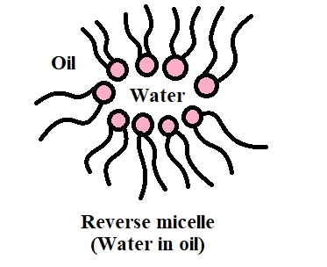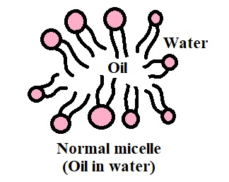
Lyophilic head
Lyophobic tail

Figure-2 – Micelle and Reverse Micelle

D. A brief introduction to liposomes

Alec Douglas Bangham, the British haematologist was the first to describe liposomes [14-16]. The Greek words ‘Lipo’ and ‘Soma’ literally mean fat and body respectively.
Liposomes fall under the category of organic nanoparticles. These are simple microscopic vesicles in which an aqueous volume is entirely enclosed by phospho-lipid bilayer membrane.
As clearly shown in the figure-3, the phospho-lipid bilayer consists of micelles whose lyophilic heads are pointing towards the solvent and reverse micelles whose lyophilic heads point towards the aqueous volume enclosed by the liposome at the core.
The polar heads may be positively or negatively charged or may also be zwitterionic in nature. The lyophobic chains are basically acyl groups. Liposomes mimic the structure of bio-membranes. Liposomes are thus, amphiphilic in nature.

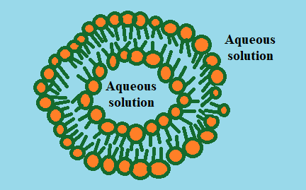

Figure-3- Structure of liposomes

Based on their structures, liposomes can be classified into the following categories: small unilamellar vesicles (SUV), large unilamellar vesicles (LUV), giant unilamellar vesicles (GUV), multilamellar vesicles (MLV) and multivesicular vesicles (MVV). The unilamellar vesicles have mono phospholipid bilayer whereas the multilamellar vesicles have an onion-like structure. MVV constitutes of a multilamellar arrangement having concentric phospholipid spheres [17-18].

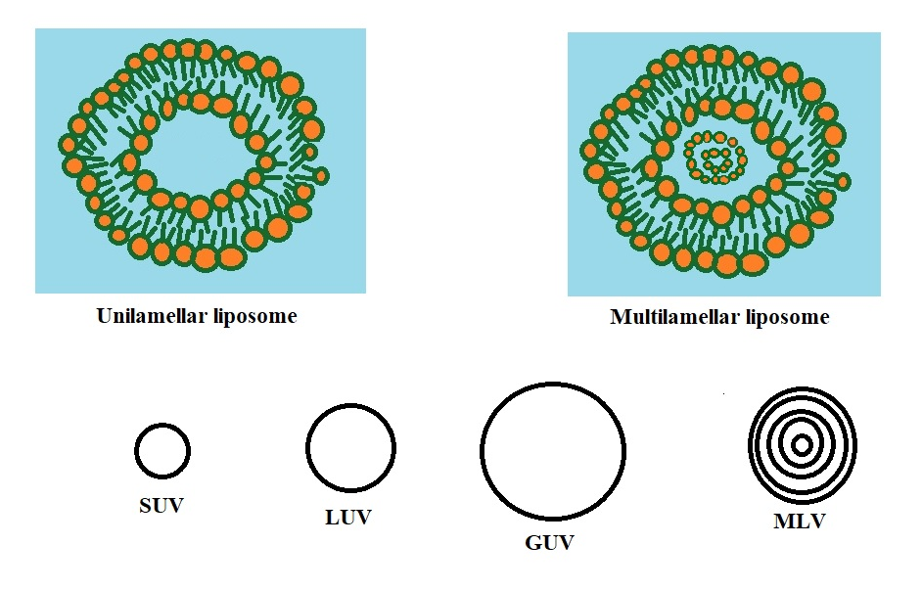
Figure-4- Types of liposomes based on their structure

Based on the composition and applications, liposomes can be further classified as the following:

Conventional liposomes:

These are first generation liposomes which were synthesized from natural or synthetic phospholipids. Cholesterol is added to increase the fluidity [19].

- Charged liposomes:
These acquire charges which repel and facilitate to reduce aggregation.

- Stealth stabilised liposomes:
These are second generation liposomes which are stabilised by polymers like polyethylene glycol (PEG).

- Actively targeted liposomes:
These are third generation liposomes which are highly specific and help in targeted drug delivery [20-21].

- Stimuli responsive liposomes:
These release the loaded drug rapidly as a response to stimuli like pH, temperature, electric or magnetic fields, redox potentials, etc. [22]

- Bubble liposomes:
These are gas encapsulated liposomes which function as gene delivering agents [23].

II. SYNTHESIS OF LIPOSOMES

Various methods can be used to fabricate liposomes such as the following:
- Thin film hydration method (Bangham method):

In this method named after Alec Douglas Bangham, a round bottom flask is taken and all the lipids and hydrophobic drugs are dissolved in an organic solvent. Then, the solvent gets evaporated under pressure. A thin film is obtained which is hydrated with an aqueous buffer solution above the transition temperature of the lipid. The rate of hydration is inversely proportional to the efficiency of the liposome to encapsulate the drug. Size and lamellarity are controlled by extrusion or sonication [25-27].

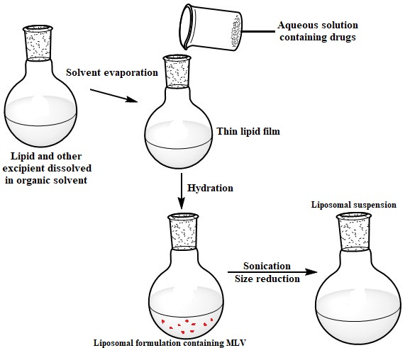

Figure-5- Thin film hydration method

- Reverse phase evaporation method:

Here, a water in oil emulsion is formed. Other than that, all the steps are similar to that in the thin film hydration method. This method is suitable for molecules having high molecular weight [28-29].

- Solvent injection methods:

In these methods differentiated by the solvent used, the organic solvent is injected into an aqueous phase which can dissolve lipids and hydrophobic agents. Diethyl ether helps in the evaporation of the solvent [32-33].

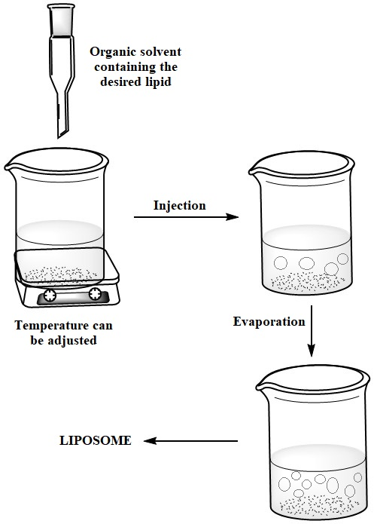

Figure-6- Solvent injection method

- Detergent removal method:

In this method, a surfactant possessing high critical micelle concentration is dissolved in a suitable organic solvent along with lipids. A mixed micelle solution is formed after hydrating the film of the lipid obtained after the solvent gets evaporated. Then the surfactant may be removed via dialysis or size-exclusion chromatography [34-35].

- Dehydration-rehydration method:

This method involves dehydration to evaporate water under nitrogen followed by hydration. Both the processes help to entrap or encapsulate drug molecules. Lipids of low concentration are put into an aqueous solution directly followed by sonication. Organic solvents are not required here [26,36].

- Heating method:

Firstly, lipids are directly hydrated using an aqueous solution. Then for one hour or more, those are heated above the transition temperature of the phospholipids. The process is carried out in the presence of a hydrating agent like glycerine [37].

- pH jumping method:

In this case, MLVs are broken down into SUVs by exposing the aqueous solution of phosphatidylcholine and phosphatidic acid to a pH four times higher [38-39].

- Microfluidic channel method:

Here, the solution of lipids in ethanol or isopropanol is injected within the micro-channels of the aqueous medium. Liposomes are formed by mixing of the organic and aqueous solutions [40].

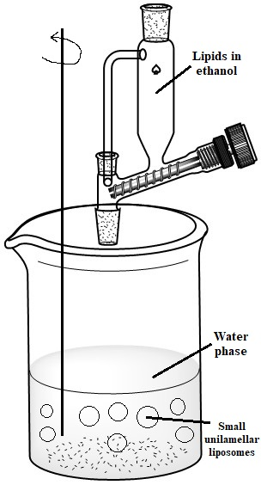

Figure-7- Microfluidic channel method

- Supercritical fluidic method:

Here, lipids are dissolved by a supercritical fluid - carbon dioxide. An effective liquid pump is used to ensure the continuous flow and occurrence of phase transition. Liposomes are generated after removing carbon dioxide and lowering the pressure. This method has high efficacy [42].

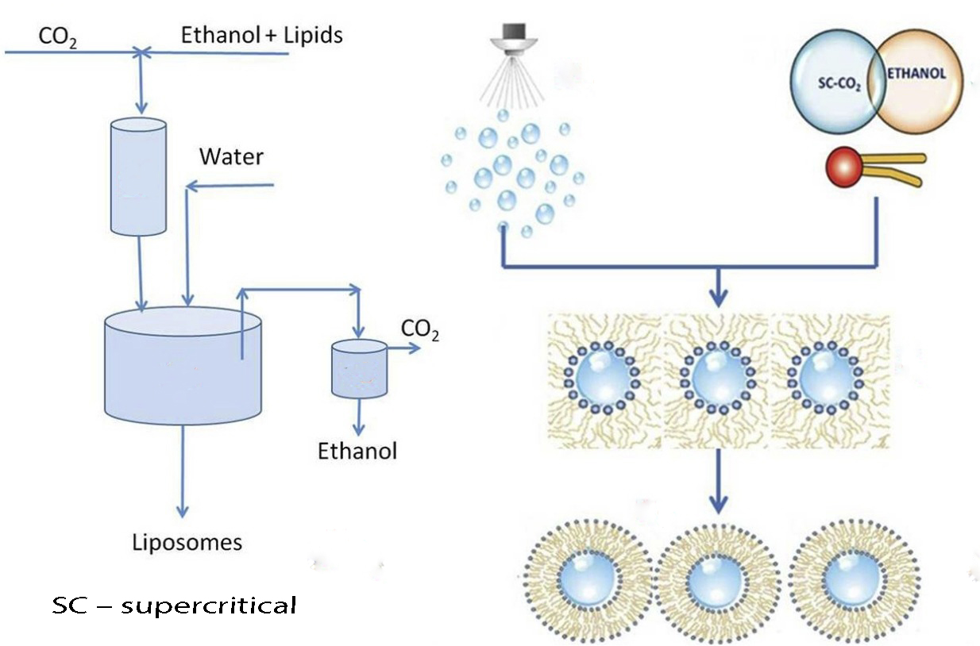

Figure-8- Supercritical fluidic method [43]

III. APPLICATIONS OF LIPOSOMES

A. Drug Delivery

a. Potency of liposomes

The amphiphilic character, biocompatibility, ease of surface modification are the qualities possessed by liposomes which make them very suitable for drug delivery. Drugs which are incorporated to the core of the liposomes are protected from interaction with any surrounding material by the phospholipid bilayer and hence, those drugs don’t get degraded easily. The bilayer can fuse with the cell membrane of the affected cells and release the drug effectively.
The presence of both micelles and reverse micelles in liposomes help them to carry both hydrophilic and hydrophobic drugs as per requirement. Hydrophobic drugs can be embedded in between the hydrophobic tails of the micelles and the reverse micelles. On the other hand, hydrophilic drugs can be trapped in the inner core surrounded by the reverse micelles. Hydrophilic drugs can also be attached to the polar heads of the normal micelles via electrostatic interaction which are exposed towards the outer region.

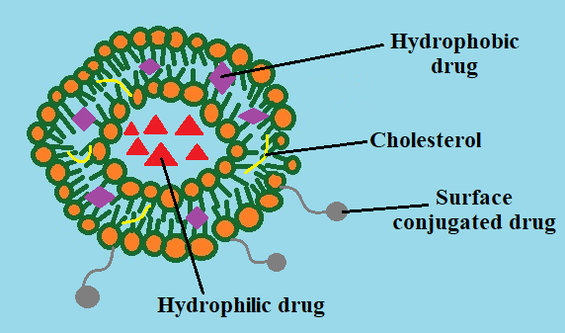

Figure-9- Liposome loaded with drugs

b. Drug loading in liposomes

Drug loading in liposomes can be performed via the following approaches:

- Active drug-loading approach:

Here, the drugs are loaded in the empty liposomes. Diffusion of the drug occurs from the outer region to the liposome driven by pH gradient or ion concentration. This process takes less time and is quite effective. DOXIL is a drug loaded in liposomes via this approach [45].

- Passive drug-loading approach:
In this approach, the drugs are encapsulated while the liposomes are generated. The drug is embedded in the bilayer through ionic and covalent interactions. But the encapsulation efficacy is significantly low in this process. Drugs like DepoCyte and Expel are formed via this method [45].

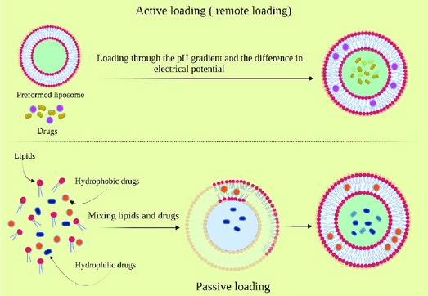

Figure-10- Active and passive drug loading [49]

- Drug-lipid conjugation by covalent linking:

Drugs can also be loaded in liposomes by covalent linking of drugs to lipids using efficient linkers [46-47].

- Combination method:

Vyxeos is the first approved liposome in which two different drugs called cytarabine and daunorubicin were loaded. Both active and passive loading approaches are used here [48].

c. Targeted drug delivery via liposomes

If the nature of the receptors attached to the affected cells can be known, the ligands complementary to those receptors can be attached to the surface of liposomes and then targeted to the affected cells for undergoing specific interaction. This can also reduce side effects as there lies negligible interaction with the other unaffected cells. The drug loaded liposomes along with those ligands can get engulfed by the cells via the formation of vesicles. This process is called endocytosis. After the release of the drug, the empty vesicle may go to the suicidal bags of the cells called lysosomes or the endosomes. The liposomes may also fuse with the cell membrane and release the drug accordingly. These liposomes are called fusogenic liposomes.

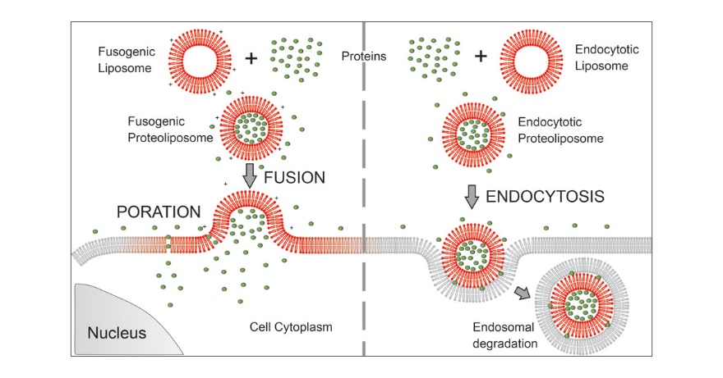

Figure-11- Fusion and endocytosis of liposomes with the cell membrane [50]

d. Anti-cancer therapy using liposomes

In order to reduce the toxic side effects and interaction with unaffected cells, liposomes are used to deliver anti-cancerous drugs.
Cancerous cells possess specific receptors which are not present in normal cells. Ligands or markers specific to those receptors when attached to the surface of drug loaded liposomes, can make the liposomes specifically bind to those cancerous cells and release the drugs effectively. Receptors like human epidermal growth factor receptor 2, vascular receptors, transferrin receptors, etc. are specifically present on the cancerous cells [51].
Polyethylene glycol (PEG) can increase the stability of liposomes and trigger the accumulation of drugs in the tumour cells. PEG associated liposomes are known as PEGylated liposomes [52].

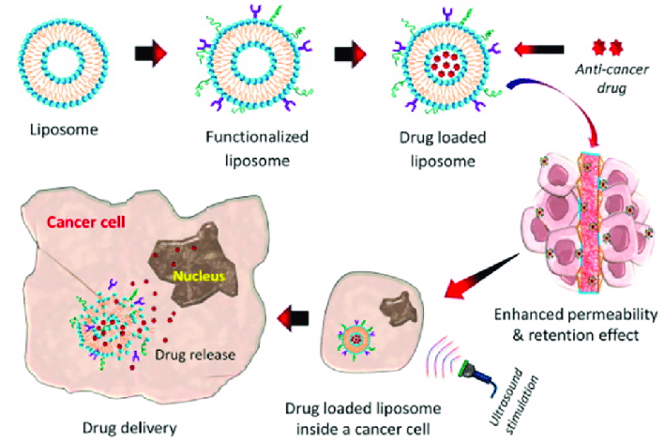

Figure-12- Cell targeted anti-cancer therapy using liposomes [53]

B. Targeted gene therapy/transfer

a. Gene therapy

Gene therapy basically refers to the modification of the genetic code of a person in order to provide any clinical result. Various nucleic acids are used for this purpose [54-55]. Gene therapy is effective even at a small dose [56].
Viral vectors are viruses generated artificially consisting of genes exhibiting desired characteristics. On the other hand, the non-viral vectors include various nanoparticles like liposomes [57].

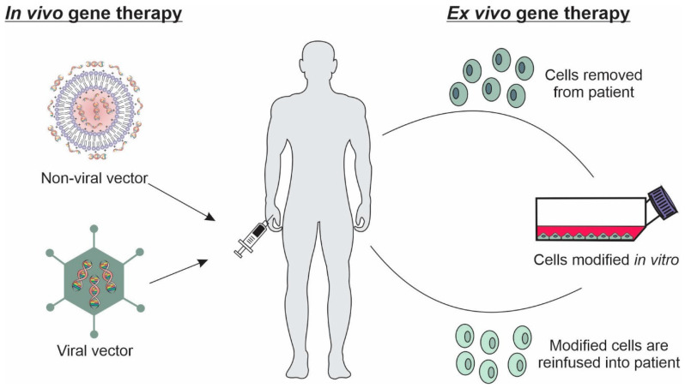

Figure-13- Types of gene therapy [55]

b. Role of liposomes

Liposomes can effectively help in delivering genes into cells. Liposomes are less toxic and immunogenic in nature [58-59].
Nucleic acids can be attached to the surface of the liposomes or may be encapsulated to the core of the liposomes [60-62]. Due to the mimicking of the structure of the bio-membrane, the liposomes are biocompatible which increases their efficiency to deliver genes. The phosphate group of DNA undergoes repulsion with the anionic lipids and hence, cationic lipids are preferred more for gene transfer. The complexes formed by nucleic acids and cationic liposomes are called lipoplexes [63-64].

Figure-14- Formation of lipoplexes
Fast lasting electrostatic interaction is the first step. The second step is a slower process which involves rearrangement irreversibly and hence, stabilisation occurs. In the second step, the hydrophobic parts of the cationic lipids are put in an aqueous medium and unstable conformations are generated. This is followed by spontaneous hydrophobic interactions finally leading to the formation of the lipoplex [65-66].
Then the liposomes can carry the nucleic acids to the cells, enter the cells and release the nucleic acids as required via endocytosis.

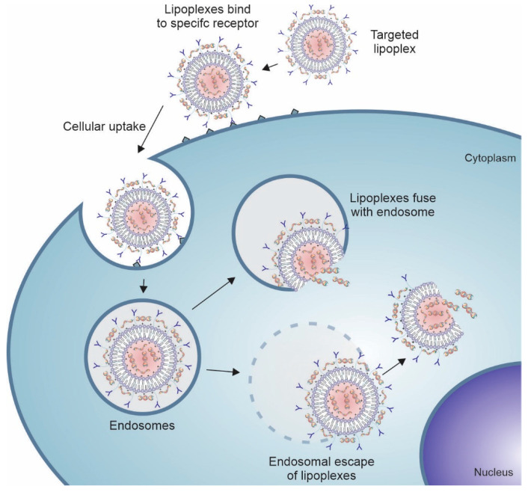

Figure-15- Gene delivery via endocytosis of liposomes [55]

C. Vaccine carrier

Aluminium salts used to trigger the immune power of vaccines are called adjuvants. Liposomes possess versatility and plasticity which make them potent vaccine carriers. Water soluble compounds like peptides and nucleic acids can be encapsulated within the core whereas lipophilic compounds such as adjuvants and antigens are attached to the lipid bilayer. Antigens can also be attached to the surface of the liposomes via adsorption or chemical linking. Different antigens and adjuvants can be combined to produce effective desired vaccines [67].
Liposomal DNA vaccines, liposomal messenger RNA vaccines, cationic liposome adjuvant vaccines, veterinary vaccines, therapeutic cancer vaccines are the various types.

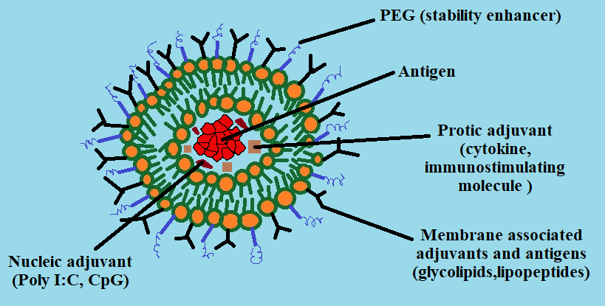

Figure-16- Transport of antigens and adjuvants by liposomes

D. Artificial blood surrogates

Liposomes containing haemoglobin in the lipids are called artificial red blood cells (ARBCs). Liposomes protect the haemoglobin enclosed within them from dissociation. Hence, pretty similar to RBCs, ARBCs are also capable of transporting oxygen.
According to many clinical trials, even in the absence of natural blood, ARBCs can keep animals alive. ARBCs don’t cause any significant toxic effects to the vital organs. Blood pressure, pulse rate, breathing rate, cardiac output, etc. are found to be normal during replacing natural blood with ARBCs due to the significant flowing properties of ARBCs. ARBCs are termed as ‘universal blood donors’ because membrane proteins are absent. ARBCs are long lasting too. But one of the major disadvantages is that ARBCs suppress the reticuloendothelial system. This effect needs to be reduced before human trials [70].

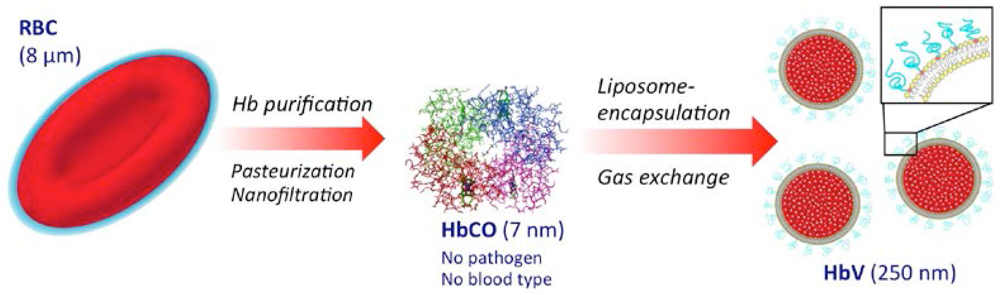

Figure-17- Preparation of haemoglobin vesicles (HbV) i.e. ARBCs using liposomes [71]

E. Radiopharmaceutical and radio-diagnostic carriers

a. Radiolabelling

Liposomes are mostly labelled using ^{99m}Tc. Radiolabelling methods of liposomes can be classified based on the portion of the liposome the radionuclide is attached to. The classifications are:

- Surface labelling:
Here, the radionuclides are inserted into the lipid bilayer of the liposomes.

- Intraliposomal labelling:
Here, the radionuclides are inserted into the liposomal core. This process helps in protecting the radionuclide from the interaction with the surroundings [72].

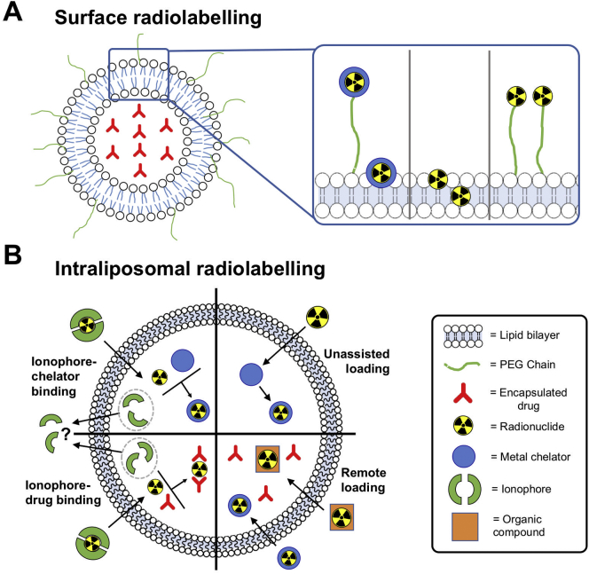

Figure-18 [72]

b. Role of radiolabelled liposomes in oncology

Radiolabelled liposomes can effectively identify unsuspected tumours and hence, help in cancer treatment. The metabolic status of tumours can be detected by using radiolabelled liposomes along with some radiotracers [73-76].
Alpha-emitters, beta-emitters and Auger electron-emitters can label liposomes and suitably play roles in radionuclide therapy [72].

c. Role of radiolabelled liposomes in ophthalmology

The mammalian eye possesses many barriers which restrict the delivery of therapeutic concentrations of drugs. ¹¹¹In or ^{99m}Tc labelled cationic liposomes are capable of penetrating the cornea. Hence, radiolabelled liposomes can be used in ophthalmology [77-80].

d. Role of radiolabelled liposomes in treating other diseases

The presence of infiltrated macrophages in case of atherosclerosis can be detected by using ¹¹¹In-labelled liposomes [81]. ¹⁸F labelled liposomes are also used as drug delivery vehicles to treat Alzheimer’s disease [82].
F. Cosmetics and dermatology

Our skin is highly protective and restricts the UV rays from the Sun to enter our body. Liposomes can effectively carry the components present in cosmetic products to the epidermis.
The complex structure of the upper intercellular lipid sheets can be altered by the liposomes. This can enhance the penetration of the components of the cosmetic products. Liposomes can hence, deliver nutrients to the aging cells. In such a way, the liposomes can hydrate the skin and make it wrinkle free.

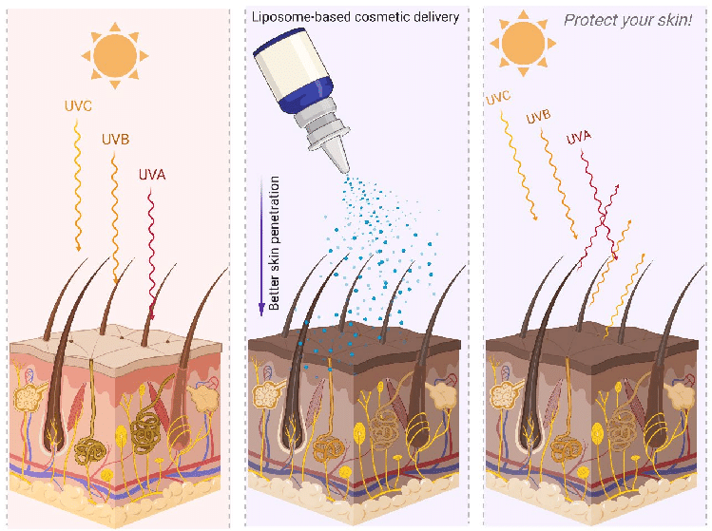.
Figure-19- Cosmetic delivery using liposomes [83]

IV. Advantages and disadvantages of liposomes

The advantages of liposomes are:
- Liposomes are non-toxic in nature.
- Liposomes are biocompatible.
- Drugs loaded in liposomes are protected from the interaction with the surroundings due to the lipid bilayer.
- The amphiphilic nature of liposomes makes them capable of entrapping both lyophilic and lyophobic drugs.
- Liposomes can be fabricated quite easily.
- Liposomes can fuse with the cell membrane quite effectively or may undergo endocytosis.
- The surface of the liposomes can be functionalised accordingly.

The disadvantages of liposomes are:
- Lower encapsulation efficiency of liposomes.
- Chance of leakage of drugs in the presence of blood.
- Poor storage stability.

V. Conclusion

Liposomes are one of the most useful nanoparticles which have enormous utilisation in drug delivery, gene therapy, various clinical treatments including the diagnosis of cancer, etc. Liposomes cover a broad space in scientific research still now and new facts related to liposomes are being studied. Liposomes have been one of the greatest discoveries and will be serving mankind further.

REFERENCES

- Recent Advances in the Gastrointestinal Fate of Organic and Inorganic Nanoparticles in Foods by Hualu Zhou and David Julian McClements, Nanomaterials 2022, 12(7), 1099
- Pan, K.; Zhong, Q. Organic Nanoparticles in Foods: Fabrication, Characterization, and Utilization. Annu. Rev. Food Sci. Technol. 2016, 7, 245–266
- McClements, D.J.; Xiao, H.; Demokritou, P. Physicochemical and colloidal aspects of food matrix effects on gastrointestinal fate of ingested inorganic nanoparticles. Adv. Colloid Interface Sci. 2017, 246, 165–180
- Koshani, R.; Madadlou, A. A viewpoint on the gastrointestinal fate of cellulose nanocrystals. Trends Food Sci. Technol. 2018, 71, 268–273.
- Mackie, A.; Gourcy, S.; Rigby, N.; Moffat, J.; Capron, I.; Bajka, B. The fate of cellulose nanocrystal stabilised emulsions after simulated gastrointestinal digestion and exposure to intestinal mucosa. Nanoscale 2019, 11, 2991–2998.
- Qiu, C.; Wang, C.; Gong, C.; McClements, D.J.; Jin, Z.; Wang, J. Advances in research on preparation, characterization, interaction with proteins, digestion and delivery systems of starch-based nanoparticles. Int. J. Biol. Macromol. 2020, 152, 117–125.
- Melikoğlu, A.Y.; Bilek, S.E.; Cesur, S. Optimum alkaline treatment parameters for the extraction of cellulose and production of cellulose nanocrystals from apple pomace. Carbohydr. Polym. 2019, 215, 330–337.
- Lv, S.; Zhou, H.; Bai, L.; Rojas, O.J.; McClements, D.J. Development of food-grade Pickering emulsions stabilized by a mixture of cellulose nanofibrils and nanochitin. Food Hydrocoll. 2021, 113, 106451.
- Cho, Y.-H.; Jones, O.G. Chapter Two—Assembled protein nanoparticles in food or nutrition applications. In Advances in Food and Nutrition Research; Lim, L.-T., Rogers, M., Eds.; Academic Press: Cambridge, MA, USA, 2019; Volume 88, pp. 47–84.
- Safaya, M.; Rotliwala, Y.C. Nanoemulsions: A review on low energy formulation methods, characterization, applications and optimization technique. Mater. Today Proc. 2020, 27, 454–459.
- Luo, Y. Perspectives on important considerations in designing nanoparticles for oral delivery applications in food. J. Agric. Food Res. 2020, 2, 100031.
- Inorganic Nanoparticles and Composite Films for Antimicrobial Therapies -Vera Alexandra Spirescu , Cristina Chircov , Alexandru Mihai Grumezescu , Bogdan Ștefan Vasile , Ecaterina Andronescu Int J Mol Sci 2021 Apr 27;22(9):4595.
- A Review of The Lesser‐Studied Microemulsion‐ Based Synthesis Methodologies Used for Preparing Nanoparticle Systems of The Noble Metals, Os, Re, Ir and Rh Mohammad Soleimani Zohr Shiri, William Henderson and Michael R. Mucalo- Materials 2019, 12, 1896
- Bangham, A. D.; Horne, R. W. (1964). "Negative Staining of Phospholipids and Their Structural Modification by Surface-Active Agents as Observed in the Electron Microscope". Journal of Molecular Biology. 8 (5): 660–668.
- Horne, R. W.; Bangham, A. D.; Whittaker, V. P. (1963). "Negatively Stained Lipoprotein Membranes". Nature. 200 (4913): 1340.
- Bangham, A. D.; Horne, R. W.; Glauert, A. M.; Dingle, J. T.; Lucy, J. A. (1962). "Action of saponin on biological cell membranes". Nature. 196 (4858): 952–955.
- Liposomes: structure, composition, types, and clinical applications- Heliyon. 2022 May; 8(5): e09394.
- Leitgeb M., Knez Ž., Primožič M. Sustainable technologies for liposome preparation. J. Supercrit. Fluids. 2020;165:104984.
- Bangham A. A correlation between surface charge and coagulant action of phospholipids. Nature. 1961;192:1197–1198
- Allen T.M., Cullis P.R. Liposomal drug delivery systems: from concept to clinical applications. Adv. Drug Deliv. Rev. 2013;65:36–48
- Leserman L.D., Weinstein J.N., Blumenthal R., Terry W.D. Receptor-mediated endocytosis of antibody-opsonized liposomes by tumor cells. Proc. Natl. Acad. Sci. U. S. A. 1980;77:4089–4093
- Lee Y., Thompson D.H. Vol. 9. Wiley Interdiscip Rev Nanomed Nanobiotechnol; 2017.
- Katsuji S., Nobuki K., Katsuyuki Y., Ryo S., Kazuo M. IEEE Ultrasonics Symposium; 2008. Characterization of Bubble Liposomes by Measurements of Ultrasound Attenuation: Effects of Shell Materials, 2008; pp. 1675–1678.
- Liposomes- N.van Rooijen, in Encyclopedia of Immunology (Second Edition), 1998
- Akbarzadeh A., Rezaei-Sadabady R., Davaran S., Joo S.W., Zarghami N., Hanifehpour Y., Samiei M., Kouhi M., Nejati-Koshki K. Liposome: classification, preparation, and applications. Nanoscale Res. Lett. 2013;8:102
- Large D.E., Abdelmessih R.G., Fink E.A., Auguste D.T. Liposome composition in drug delivery design, synthesis, characterization, and clinical application. Adv. Drug Deliv. Rev. 2021;176:113851
- Bhupendra P., Narendra K., Suman S., Amit R. Liposome: method of preparation, advantages, evaluation and its application. J. Appl. Pharmaceut. Res. 2015;3:1–8
- Shi N.-Q., Qi X.-R. In: Liposome-Based Drug Delivery Systems. Lu W.-L., Qi X.-R., editors. Springer Berlin Heidelberg; Berlin, Heidelberg: 2017. Preparation of drug liposomes by reverse-phase evaporation; pp. 1–10.
- Szoka F., Jr., Papahadjopoulos D. Comparative properties and methods of preparation of lipid vesicles (liposomes) Annu. Rev. Biophys. Bioeng. 1980;9:467–508
- QbD Enabled Azacitidine Loaded Liposomal Nanoformulation and Its In Vitro Evaluation - Polymers 2021, 13(2), 250
- Microfluidics Technology for the Design and Formulation of Nanomedicines - Jaradat, E.; Weaver, E.; Meziane, A.; Lamprou, D.A. Microfluidics Technology for the Design and Formulation of Nanomedicines. Nanomaterials 2021, 11, 3440
- Has C., Sunthar P. A comprehensive review on recent preparation techniques of liposomes. J. Liposome Res. 2020;30:336–365.
- Szoka F., Jr., Papahadjopoulos D. Procedure for preparation of liposomes with large internal aqueous space and high capture by reverse-phase evaporation. Proc. Natl. Acad. Sci. U. S. A. 1978;75:4194–4198.
- Vemuri S., Rhodes C.T. Preparation and characterization of liposomes as therapeutic delivery systems: a review. Pharm. Acta Helv. 1995;70:95–111.
- Jiskoot W., Teerlink T., Beuvery E.C., Crommelin D.J. Preparation of liposomes via detergent removal from mixed micelles by dilution. The effect of bilayer composition and process parameters on liposome characteristics. Pharm. Weekbl. - Sci. Ed. 1986;8:259–265.
- Shew R.L., Deamer D.W. A novel method for encapsulation of macromolecules in liposomes. Biochim. Biophys. Acta Biomembr. 1985;816:1–8
- Mozafari M.R. Liposomes: an overview of manufacturing techniques. Cell. Mol. Biol. Lett. 2005;10:711–719
- Gutman M. The pH jump: probing of macromolecules and solutions by a laser-induced, ultrashort proton pulse--theory and applications in biochemistry. Methods Biochem. Anal. 1984;30:1–103
- Genç R., Ortiz M., O′Sullivan C.K. Curvature-Tuned preparation of nanoliposomes. Langmuir. 2009;25:12604–12613.
- Carugo D., Bottaro E., Owen J., Stride E., Nastruzzi C. Liposome production by microfluidics: potential and limiting factors. Sci. Rep. 2016;6:25876
- Liposome production by microfluidics: potential and limiting factors - Scientific Reports | 6:25876
- William B., Noémie P., Brigitte E., Géraldine P. Supercritical fluid methods: an alternative to conventional methods to prepare liposomes. Chem. Eng. J. 2020;383:123106
- Trucillo, P., Campardelli, R., & Reverchon, E. (2019). A Versatile Supercritical Assisted Process for the One-Shot Production of Liposomes. The Journal of Supercritical Fluids. doi:10.1016/j.supflu.2019.01.015
- Updates on Responsive Drug Delivery Based on Liposome Vehicles for Cancer Treatment - Pharmaceutics 2022, 14(10), 2195
- A Review of Liposomes as a Drug Delivery System: Current Status of Approved Products, Regulatory Environments, and Future Perspectives - Molecules. 2022 Feb; 27(4): 1372
- Signorell R.D., Luciani P., Brambilla D., Leroux J.C. Pharmacokinetics of lipid-drug conjugates loaded into liposomes. Eur. J. Pharm. Biopharm. 2018;128:188–199. doi: 10.1016/j.ejpb.2018.04.003
- Irby D., Du C., Li F. Lipid–Drug Conjugate for Enhancing Drug Delivery. Mol. Pharm. 2017;14:1325–1338. doi: 10.1021/acs.molpharmaceut.6b01027
- Louie A., Swenson C., Mayer L., Janoff A. Fixed Drug Ratios for Treatment of Hematopoietic Cancers and Proliferative Disorders. 8,092,828 B2. U.S. Patent. 2012 January 10
- Liposomes: Structure, Biomedical Applications, and Stability Parameters With Emphasis on Cholesterol. Front. Bioeng. Biotechnol. 9:705886- 2021
- Fusogenic Liposomes as Nanocarriers for the Delivery of Intracellular Proteins - Langmuir 2017, 33, 4, 1051–1059
- Liposomes in Cancer Therapy: How Did We Start and Where Are We Now - Int J Mol Sci. 2023 Apr; 24(7): 6615.
- PEGylated liposomes enhance the effect of cytotoxic drug: A review - Heliyon. 2023 Mar; 9(3): e13823.
- Transferrin: Biology and Use in Receptor-Targeted Nanotherapy of Gliomas - : ACS Omega 2021, 6, 8727−8733
- Maestro S., Weber N.D., Zabaleta N., Aldabe R., Gonzalez-Aseguinolaza G. Novel vectors and approaches for gene therapy in liver diseases. JHEP Rep. 2021;3:100300
- Targeted Liposomes: A Nonviral Gene Delivery System for Cancer Therapy - Pharmaceutics. 2022 Apr; 14(4): 821.
- Garrison L.P., Pezalla E., Towse A., Yang H., Faust E., Wu E.Q., Li N., Sawyer E.K., Recht M. Hemophilia Gene Therapy Value Assessment: Methodolocial Challeges and Recomendations. Methodology. 2021;24:1628–1633.
- Patil S., Gao Y.G., Lin X., Li Y., Dang K., Tian Y., Zhang W.J., Jiang S.F., Qadir A., Qian A.R. The development of functional non-viral vectors for gene delivery. Int. J. Mol. Sci. 2019;20:5491
- Ponti F., Campolungo M., Melchiori C., Bono N., Candiani G. Cationic lipids for gene delivery: Many players, one goal. Chem. Phys. Lipids. 2021;235:105032
- Luiz M.T., Tofani L.B., Araújo V.H.S., Di Filippo L.D., Duarte J.L., Marchetti J.M., Chorilli M. Gene therapy based on lipid nanoparticles as non-viral vectors for Glioma treatment. Curr. Gene Ther. 2021;21:452–463.
- Shabana A.M., Xu B., Schneiderman Z., Ma J., Chen C.C., Kokkoli E. Targeted liposomes encapsulation miR-603 complexes enhance radiation sensitivity of patient-derived glioblastoma stem-like cells. Pharmaceutics. 2021;13:1115.
- Kim J.S., Kim M.W., Kang S.J., Jeong H.Y., Park S.I., Lee Y.K., Kim H.S., Kim K.S., Park Y.S. Tumor-specific delivery of therapeutic siRNAs by anti-EGFR immunonanoparticles. Int. J. Nanomed. 2018;13:4817–4828.
- Dehkordi N.G., Elahian F., Khosravian P., Mirzaei A.A. Intelligent TAT-coupled anti-HER2 immunoliposomes knock downed MDR1 to chemosensitize phenotype of multidrug resistant carcinoma. J. Cell. Physiol. 2019;234:20769–20778
- Noack L.C., Jaillais Y. Functions of Anionic Lipids in Plants. Annu. Rev. Plant Biol. 2020;71:71–102.
- Balazs D.A., Godbey W. Liposomes for Use in Gene Delivery. J. Drug Deliv. 2011;2011:326497
- Fujii S., Nishimura T., Sakurai K. Thermodynamics of lipoplex formation: Relationship between the lipid alkyl tail length and thermodynamic functions. Chem. Lett. 2012;41:501–503
- Gao L., Cao J., Fang W. Self-assembly of lamellar lipid-DNA complexes simulated by explicit solvent counterion model. J. Phys. Chem. B. 2010;114:7261–7264.
- Torchilin V.P. (2005) Recent advances with liposomes as pharmaceutical carriers. Nat Rev Drug Discov 4: 145–160
- Heegaard P., Dedieu L., Johnson N., Le Potier M., Mockey M., Mutinelli F., et al.. (2011) Adjuvants and delivery systems in veterinary vaccinology: current state and Future developments. Arch Virol 156: 183–202
- Liposomes as vaccine delivery systems: a review of the recent advances - Ther Adv Vaccines. 2014 Nov; 2(6): 159–182
- Chapter- Liposomes as Blood Surrogates by Ljubomir Djordjevich, Anthony D. Ivankovich, Book - Liposomes in Drug Delivery, 1st Edition, eBook ISBN – 9780203748824
- Overview of Potential Clinical Applications of Hemoglobin Vesicles (HbV) as Artificial Red Cells, Evidenced by Preclinical Studies of the Academic Research Consortium - J. Funct. Biomater. 2017, 8(1), 10
- Nuclear imaging of liposomal drug delivery systems: A critical review of radiolabelling methods and applications in nanomedicine - Adv Drug Deliv Rev. 2019 Mar 15; 143: 134–160.
- Lopez-Berestein G., Kasi L., Rosenblum M.G., Haynie T., Jahns M., Glenn H., Mehta R., Mavligit G.M., Hersh E.M. Clinical pharmacology of ^{99m}Tc-labeled liposomes in patients with cancer. Cancer Res. 1984;44:375–378.
- Turner A.F., Presant C.A., Proffitt R.T., Williams L.E., Winsor D.W., Werner J.L. In-111-labeled liposomes: dosimetry and tumor depiction. Radiology. 1988;166:761–765.
- Presant C.A., Proffitt R.T., Turner A.F., Williams L.E., Winsor D., Werner J.L., Kennedy P., Wiseman C., Gala K., McKenna R.J., Smith J.D., Bouzaglou S.A., Callahan R.A., Baldeschwieler J., Crossley R.J. Successful imaging of human cancer with indium-111-labeled phospholipid vesicles. Cancer. 1988;62:905–911
- Presant C.A., Ksionski G., Crossley R. ¹¹¹In-labeled liposomes for tumor imaging: clinical results of the international liposome imaging study. J. Liposome Res. 1990;1:431–436
- Agarwal R., Iezhitsa I., Agarwal P., Abdul Nasir N.A., Razali N., Alyautdin R., Ismail N.M. Liposomes in topical ophthalmic drug delivery: an update. Drug Deliv. 2014:1–17.
- Fitzgerald P., Hadgraft J., Wilson C.G. A gamma scintigraphic evaluation of the precorneal residence of liposomal formulations in the rabbit. J. Pharm. Pharmacol. 1987;39:487–490.
- Al-Muhammed J., Özer A.Y., Ercan M.T., Hincal A.A. In-vivo studies on dexamethasone sodium phosphate liposomes. J. Microencapsul. 1996;13:293–305.
- Zhang J., Wang S. Topical use of coenzyme Q10-loaded liposomes coated with trimethyl chitosan: tolerance, precorneal retention and anti-cataract effect. Int. J. Pharm. 2009;372:66–75.
- Ogawa M., Umeda I.O., Kosugi M., Kawai A., Hamaya Y., Takashima M., Yin H., Kudoh T., Seno M., Magata Y. Development of ¹¹¹In-labeled liposomes for vulnerable atherosclerotic plaque imaging. J. Nucl. Med. 2014;55:115–120.
- Rokka J., Snellman A., Kaasalainen M., Salonen J., Zona C., La Ferla B., Nicotra F., Re F., Masserini M., Forsback S., Lopez-Picon F., Rinne J.O., Haaparanta-Solin M., Solin O. ¹⁸F-labeling syntheses and preclinical evaluation of functionalized nanoliposomes for Alzheimer’s disease. Eur. J. Pharm. Sci. 2016;88:257–266
- New Insights on Unique Features and Role of Nanostructured Materials in Cosmetics - Cosmetics 2020, 7, 24
- Liposomes for Drug Delivery - J Biotechnol Biomater, Vol 7(4)

------------------------------

