PLANNING, ANALYSIS & DESIGN OF REINFORCED CONCRETE BRIDGE NEAR KANAKAPURA
Bikram.K.M¹, Rahul.K. Y¹, Subhash.C. Y¹, Tariqul I. Sani¹, Dr. S. Kavitha²
¹Department of CIVIL, Faculty of Engineering and Technology, Jain Deemed-To-Be University, Bangalore, India
²Department of Civil Engineering, Dr. Ambedkar Institute of technology, Bangalore, India
---------------------------------------------------------------------***---------------------------------------------------------------------
Abstract - Infrastructure development has increasingly become a critical element in urban expansion, with bridges serving as vital transportation connections and facilitating efficient traffic flow. This paper focuses on the planning, analysis, and design of a reinforced concrete bridge near Kanakapura Road. The deck slab and pile analysis, utilizing STAAD Pro software, aims to ensure structural effectiveness and integrity. Meanwhile, the abutment and foundation design adhere to the Indian Standard (IS) code book. Thorough investigations into the load-bearing capability, responsiveness to various loads, and static behaviors of the deck slab are conducted through the software analysis. The piling analysis guarantees a strong foundation system capable of withstanding anticipated loads and geological conditions near the water body. Comprehensive studies are carried out on the bridge's behavior, stability, deflection characteristics, and stress distribution, providing valuable insights for the design process. The study also evaluates the effectiveness and acceptability of using STAAD Pro software, while by considering soil qualities, hydrological conditions, and construction constraints, manual design of abutment and foundation system were evaluated using IS code book which ensures safety and conformity. From the aforementioned examination of the deck slab, pier, abutments, and foundation, it has been determined that the results are safe according to the IS Code. Therefore, employing STAAD Pro software, which employs the principle of finite element analysis, produces superior results while saving time.
Key Words: Reinforced concrete bridge, Analysis, Deck slab, STAAD Pro, Abutment, Foundation, Piers.

1.INTRODUCTION

A bridge is a structure made to span a physical barrier, like a river, road, or valley, to allow access over the barrier. There are many different design variations, each with unique functions and applications. A bridge's design is influenced by its purpose, the features of the terrain on which it is built and anchored, the materials used in its construction, and the amount of funding available for construction. Public funds are used for the construction of all important bridges. Therefore, the most effective bridge design has three goals. To be as effective, economical and elegant as possible. Efficiency is a scientific concept aimed at using less material while doing more work. Economy is a social ideal that emphasizes efficiency while reducing construction and maintenance costs. Finally, elegance is a symbolic or visual term that brings the designer's unique perspective to the fore without sacrificing efficiency or effectiveness. There is minimal dispute over what efficiency and economy mean, but there has never been a consensus on what elegance. Starting with the Scottish engineer Thomas Telford, contemporary designers have been discussing elegance and aesthetics in their writing since the early 19th century. The public, who ultimately decides on this issue, has a mediating role, but generally the expert takes one of his three perspectives. According to the first principle, the engineer is responsible for the construction of the bridge, and only with the addition of architecture can its beauty be fully realized. A second argument is that from a pure engineering perspective, bridges that make the most efficient use of materials are by definition attractive.

1.1 COMPONENTS OF BRIDGES
1.1.1 DECK SLAB
A deck slab is a vital element in the construction of a reinforced concrete bridge. It acts as a horizontal surface, spanning across the supporting beams or girders of the bridge structure. The deck slab is primarily composed of reinforced concrete, incorporating steel reinforcement bars or mesh to enhance its strength and durability. This reinforcement helps the slab withstand tensile forces and prevents cracking caused by various loads, including traffic and environmental factors. The design and construction of the deck slab consider anticipated loads such as the weight of vehicles, pedestrians, and other dynamic forces. Serving as the road surface for vehicles and pedestrians, the deck slab efficiently distributes the loads from traffic and transfers them to the supporting beams or girders, which ultimately transmit the forces to the bridge piers or abutments. Overall, the deck slab plays a critical role in ensuring the strength and functionality of a reinforced concrete bridge, providing a dependable and safe surface for transportation.
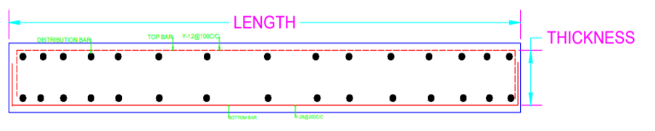
Fig. 1 Typical slab details
1.1.2 PIERS
The piers are vertical supports for the foundation’s deck or the bearings used to transfer loads to the soil below. At intermediate places, these buildings act as supports for the bridge spans.
The pier structure primarily serves two purposes:
1. Transmission of loads to the Foundation
2. Defense against horizontal forces
Piers are typically built to withstand just vertical loads. It is advised to build the pier for lateral stresses as well in seismically active areas. The pier is a vertical element that uses a shear mechanism to withstand forces. The majority of these forces are lateral forces. A bent pier is one that is made up of several piers.
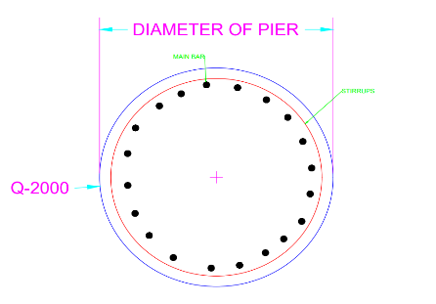
.
Fig.2 Typical Pier detailing

1.1.3 ABUTMENT:
Abutments are vertical constructions that hold the ground in front of bridges in order to support and stabilise them. They support the superstructure of the bridge, including both static (dead) and dynamic (live) loads. The approach embankment's lateral pressure is a key consideration in the design of abutments. Abutments' main purpose is to stop sliding and overturning, which maintains the stability of the overall bridge system. They are made to withstand the pressures put on them and safely transmit the loads they are carrying to the earth. Abutments are vital in maintaining the integrity and safety of the bridge construction by acting as a firm base and resisting lateral movement.
The following factors influence the design loads on the abutment:
1. The abutment type used
2. The order in which things are built

The main purpose of the abutments is to prevent sliding and overturning. The stability of the entire system is given more attention.
1.1.4 FOUNDATION
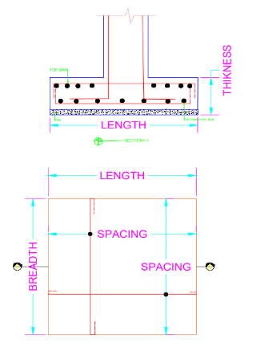
Buildings called foundations are designed to distribute the weight of piers, abutments, wing walls, and returns uniformly throughout the strata. In order to prevent scouring from water movement or to lessen the likelihood of undermining, the foundations provided for bridge structures are deep enough.
Fig. 3 Typical Foundation details
2.LITERATURE REVIEW
2.1 THWE HTAY
This study analyzed and designed the superstructure of a Reinforced Concrete Bridge using STADD Pro software. The bridge had a total length of 450ft with 5 spans of 90ft each. Prestressed concrete I-beams were used for the floor beams. The analysis considered 1619 beams, 868 nodes, and 794 load combinations. Various loads were applied, and the bridge was analyzed using STADD-Pro. The roadway slab was 6in thick, sidewalk slab was 4.5in thick, and a 2in wearing surface was used. The main reinforcement for the roadway and sidewalk slabs were No.6 and No.4 bars, respectively. The prestressed concrete I-beams had seven wire strands and a height of 56in. Node displacements were controlled under specific load combinations, and deflection checks were satisfactory. The maximum deflection due to seismic load was 0.243in, which met the allowable limit.
2.2 Maria Rashidi and Brett Lemass
This study developed a Decision Support model for bridge remediation planning based on a literature review and expert judgment. The model includes the Condition Index (CI) evaluation of the bridge to select appropriate courses of action such as monitoring, maintenance, rehabilitation, or downgrading. The CI considers various factors that affect the bridge's condition, with structural and functional performance being the most important. The CI can also be used to prioritize bridge projects for intervention. Remediation strategies are ranked using Simple Multi Attribute Rating Techniques (SMART), which provide simplicity and flexibility. The model was verified through interviews and case studies, and a real case study validated its effectiveness in quantifying the bridge's condition and suggesting improvement solutions.

2.3 H. M. SHIN et.al.
This study chose a 3D object model with parametric modelling capabilities as its information model for the structure analysis and design process within a CPLM environment, consequently providing a strategy to effectively handle design changes. In order to reduce errors and information gaps and enable effective design, 3D information models offer a method for storing the information required throughout analysis and design processes in 3D models. The findings of this study will offer fundamental knowledge that may be used to create an automated, unified system for the design of civil structures.

2.4 T.Muhilan, A.Yacop Raja
This project involved the analysis, design, and detailing of a PSC-deck slab bridge, considering specific vehicle loads. Two types of deck sections were designed using the manual working stress method, and a comparative statement was provided based on the results obtained. The T-beam girder was found suitable for lower spans, while traditional slab and T-beam bridges were recommended for spans ranging from 10 to 25m. For spans greater than 30m, a box girder was considered the most economical and suitable option. The design and analysis were conducted, but wind load was not considered for this particular report on a minor bridge span.

3.OBJECTIVES & METHODOLOGY
  - Objectives:
- To Analysis RC bridge using STAAD-Pro software.
- To Design Structural components of Bridges i.e., Deck slab, Pier, Foundation, Abutment.
- To check for IS code provisions.

  - METHODOLOGY
3.2.1 General
Before beginning to study any subject, it is essential to review the pertinent prior research that has been conducted on the subject. because it offers a great understanding of the issue and opens the way to filling in the gaps that the research study's inquiry uncovered. It helps in identifying the newest areas of research. Basically, there are two main stages in the design of a bridge:
- The initial data gathering:
- The designs from the last stage:

3.2.2 Preliminary data collected:
- Name of the stream: Arkavathi river
- Location in km to centre of crossing 7th kilometre from Kanakapura towards Ramanagar
- Highest flood lever (HFL): 640m
- Ordinary flood level: 650m
- Bed level: 635m
- Maximum discharge: 1095cumsec
- 7. Hard rock soil, 0.67 metres from the HBL
- Safe Bearing Capacity of soil: 300KN/m^2
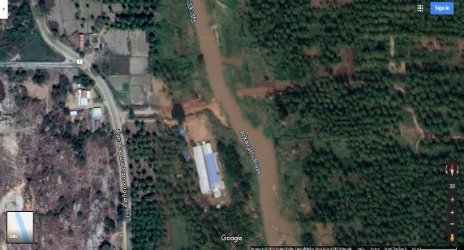
Fig. 4 Location of the Site

3.2.3 MODELLING IN STAAD PRO SOFTWARE
- The bridge was developed in STAAD.pro, a programme for structural analysis and design, for the dimensions shown below.
- Bridge length overall: 100m
- Clear span: 9.8
- Effective span: 10.9
- Thickness of deck slab: 0.75m
- Width of the deck slab: 12m
- Total length of two-lane road: 8m
- Width of the footpath on both side way: 2m
- The pier's height is 7 m
- The parapet wall is 0.25 metres thick.
- Circular pier shape
- Pier diameter: 2m
- Considered loads include:
- The structure's self-weight
- Live load: 5KN/M
- vehicular load (tracked): 700KN/M
Fig. 5 Flow Diagram of Design of Bridge
3.2.4 Modelling in STAAD.pro Software.
The RC slab bridge is developed and analysed using the STAAD Pro software. The model is initially created for a single span and then replicated for the desired number of spans. Meshing is performed on the deck slab to obtain precise analysis reports for each element. The deck slab is divided into smaller elements, but maximum values from all elements are considered during the slab design. Initially, only the dead load of the structure and live load of pedestrians are applied. The model is developed and analysed.
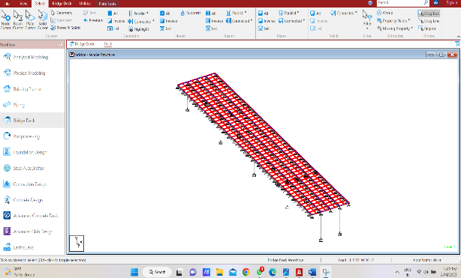
Fig. 6 Modelling of Deck Slab & pier – Bridge

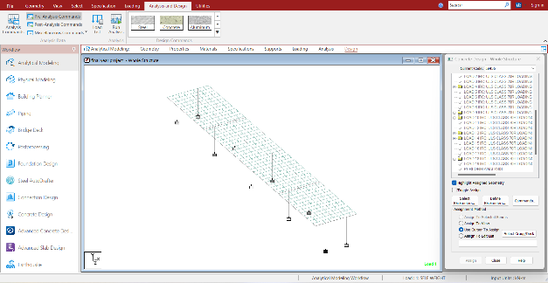
Fig. 7 Concrete designing of the model according
to IS456

4. DESIGNING (DETAILING) MANUALLY ACCORDING TO IS CODES:
The developed model is then analysed in the software. The analysed results are then used to design the components of the bridge according to IS codes. Compressive strength of concrete f_{ck}= M35, yield strength of steel f_{e}= 415 N/mm² are adopted.
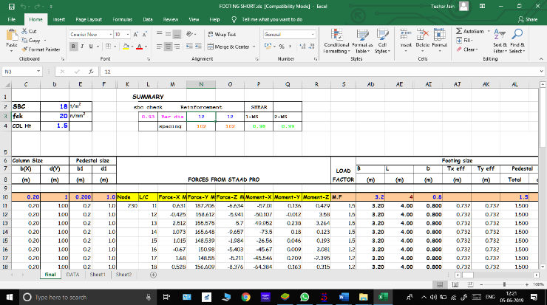
Fig. 8 Detailing of components according to IS code in excel sheets

4.1 TABLE OF CALCULATION

Table 1: Loads and combination
Load number | Description
1 | Self-weight and live load
2 | IRC: SLS class AA loading N1065: DISP Y-ve
3 | IRC: SLS class AA loading N3: React FY +ve
4 | IRC: SLS class AA loading N6: React FY +ve
5 | IRC: SLS class AA loading N159: React FY +ve
6 | IRC: SLS class AA loading N302: React FY +ve
7 | IRC: SLS class AA loading N445: React FY +ve
8 | IRC: SLS class AA loading N588: React FY +ve
9 | IRC: SLS class AA loading N731: React FY +ve
10 | IRC: SLS class AA loading N874: React FY +ve
11 | IRC: SLS class AA loading N1017: React FY +ve
12 | Combinations

4.2 REINFORCEMENT DETAILING:
4.2.1 Reinforcement detail for Deck slab.
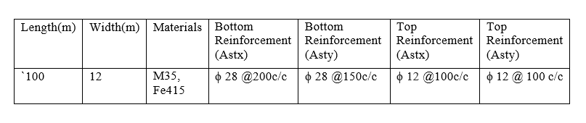
Table 2: Deck slab summary and reinforcement detailing

4.3 REINFORCEMENT DETAIL FOR PIER:
Table 3: Pier summary and reinforcement details
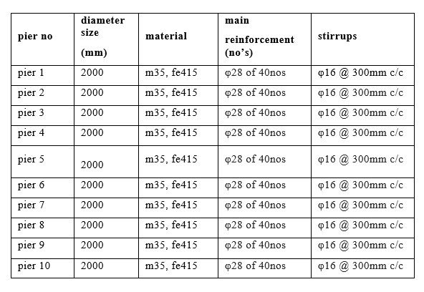
4.4 REINFORCEMENT DETAIL FOR FOOTING
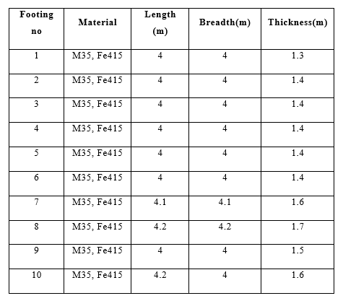
Table 4: Footing summary

Table 5: Footing reinforcement detail
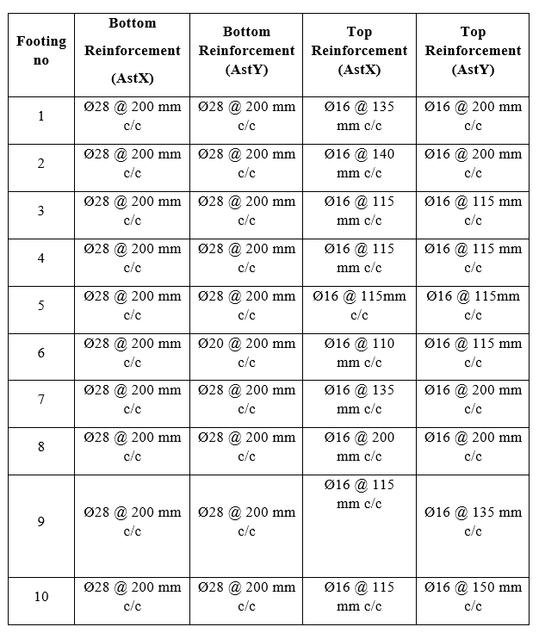
5. CONCLUSION
- Information from the programmed was received for the deck slab analysis. The maximum moment in the deck slab was found to be 932 KN/M, and the steel's equivalent area was 3260 mm2. Consequently, it is built in accordance with IS standards and has been deemed safe.
- Pier analysis data was obtained from the software. The maximum moment of 620kN-m is acting on the pier. The area of steel obtained in the software is 12278mm² corresponding to the area of steel obtained from manual calculations 12315mm2 which are approximately equal. Hence the pier was found to be safe. The design was carried out with the software value.
- As the design for the foundation is not possible in software, it is designed manually according to the IS codes. All the stresses are within permissible limits and is found to be safe.
- As the design for the abutment is not possible in software, it is designed manually according to the IS codes. All the stresses are within permissible limits and is found to be safe.
- Using software for the project has saved the time as it reduces those lengthy calculations, which otherwise are to be done manually.
- Finally, employing STAAD-Pro software has the benefit of applying the finite element analysis idea, which produces better analytical findings. Additionally, real-time loadings are simple to apply and understand the results of.

REFERENCES
1.THWE HTAY. Study on Analysis and Design of a Superstructure of Reinforced Concrete Bridge, Vol.03, Issue.06, May-2014,
2.Thanushree H, Siddesha H, Dattatreya J K, and Dr.S.V.Dinesh, “Analysis of Rcc Bridge Deck Slab for Various Spans,”International Journal of Scientific & Engineering Research, vol. 7, Issue 3, March 2016.
3.M. Prabhu and R.Vijayasarathy, "Design and Analysis of Sub-Structure of Bridge-A Review," International Journal of Engineering and Management Research, vol. 6, pp. 221- 225, October 2016.
4.B.K. Vishwanath and S.Sudheer, “MANUAL DESIGN OF PIER CAP AND PIER,” Global Journal for Research Analysis, vol. 6, October 2017
5. Ramesh Kumar Dhakal and Pradeep K.Goyal, "Structural Analysis of Arch Bridge with a Span of 350m Using STAAD.Pro: A Case Study," International Journal of Advance Engineering and Research Development, vol. 4, November 2017.
6. Maria Rashidi and Brett Lemass. A Decision Support Methodology for Remediation Planning of Concrete Bridges

