Career Path for Data Science Professional and Data Scientist

Mr. Prashant Kumar Koshta
Department of Computer Science & Engineering
Gyan Ganga College of Technology
Jabalpur, India
prashantkumarkoshta@gmail.com

Dr. Vimmi Pandey
Department of Computer Science & Engineering
Gyan Ganga College of Technology
Jabalpur, India
vimmipandey@ggct.co.in

ABSTRACT
Data science careers often offer a wide range of professional choices. Data scientists gather and examine data using statistical methods and tools in order to produce valuable insights. Principles, procedures, and methodologies for comprehending phenomena through the (automated) study of data are included in data science. Understanding a data scientist's career path will help you assess the field if you are thinking about working in it. Data Science Career Pathways explains the fundamental abilities required for this job, explains how to become a data scientist, and provides information on average pay in each location. Data science is an exciting, enjoyable, interesting, promising, and rewarding field of work [1] [3]. It is crucial to remember that, in contrast to other conventional vocations, it is not necessary to acquire a degree.
Several components of data science have their roots in fields like machine learning and data mining. Data science, machine learning, and data mining are actually frequently used in the same sentence. These disciplines have one thing in common: they put a lot of effort into using data analysis to make decisions better. Although borrowing from these other subjects, data science has a wider range of applications. The development and assessment of algorithms that extract patterns from data are the main goals of machine learning (ML)[2]. Data mining typically focuses on commercial applications and is generally concerned with the examination of structured data. All of these factors are taken into account, but data science also deals with other issues like gathering, cleaning, and transforming unstructured data from social media.

Keywords— Algorithms, Data analytics, Visualization, Business intelligence, Machine learning

INTRODUCTION

Data interpretation is a component of data science. In order to gain useful information, those who engage in data science can extract, store, sort, and analyze data. Most companies gather data as part of their routine business operations. Data on customer behavior, demographics, and purchasing power may be included. Depending on how you obtained it, this data may be classified as unstructured or structured. Unstructured data is a collection of many sorts of data that is stored in its original format, while structured data is exact data that is kept in a certain manner [23]. To provide businesses with knowledge about the market they engage with, a data scientist gathers, organizes, and evaluates the data. This aids businesses in making judgements. Data managers and researchers gather data.
- Compiling and arranging data into new formats to make analysis easier
- Collecting data from a range of sources, such as company records and market news
- Creating software to automate data collecting and organization
- Gathering insightful data and information
- Pattern-finding and data analysis
- Creation of thorough reports that help guide management decisions

Specializing in data science specialization is simply about focusing on one area within data science to focus on and expanding your knowledge and skills in that area until you are a professional. Specializing helps you as a data scientist because it establishes you as a professional and resource for that field, making you highly sought after by companies looking for someone to work in that area of data science. There are many areas of data science that you can specialize in, from data analytics to database management to Big Data to machine learning.

Data science itself is a field that applies scientific principles and advanced analytics techniques to analyze data sets and extract useful information to help develop business strategies and guide important business decisions [7][9]. It spans multiple industries and has evolved as interest in data analytics has grown to the extent that each area of data science has gained prominence in its own right. A company looking for a data scientist may now want someone with more experience in a particular area of data science, such as statistics, machine learning, or database management [23] [24].

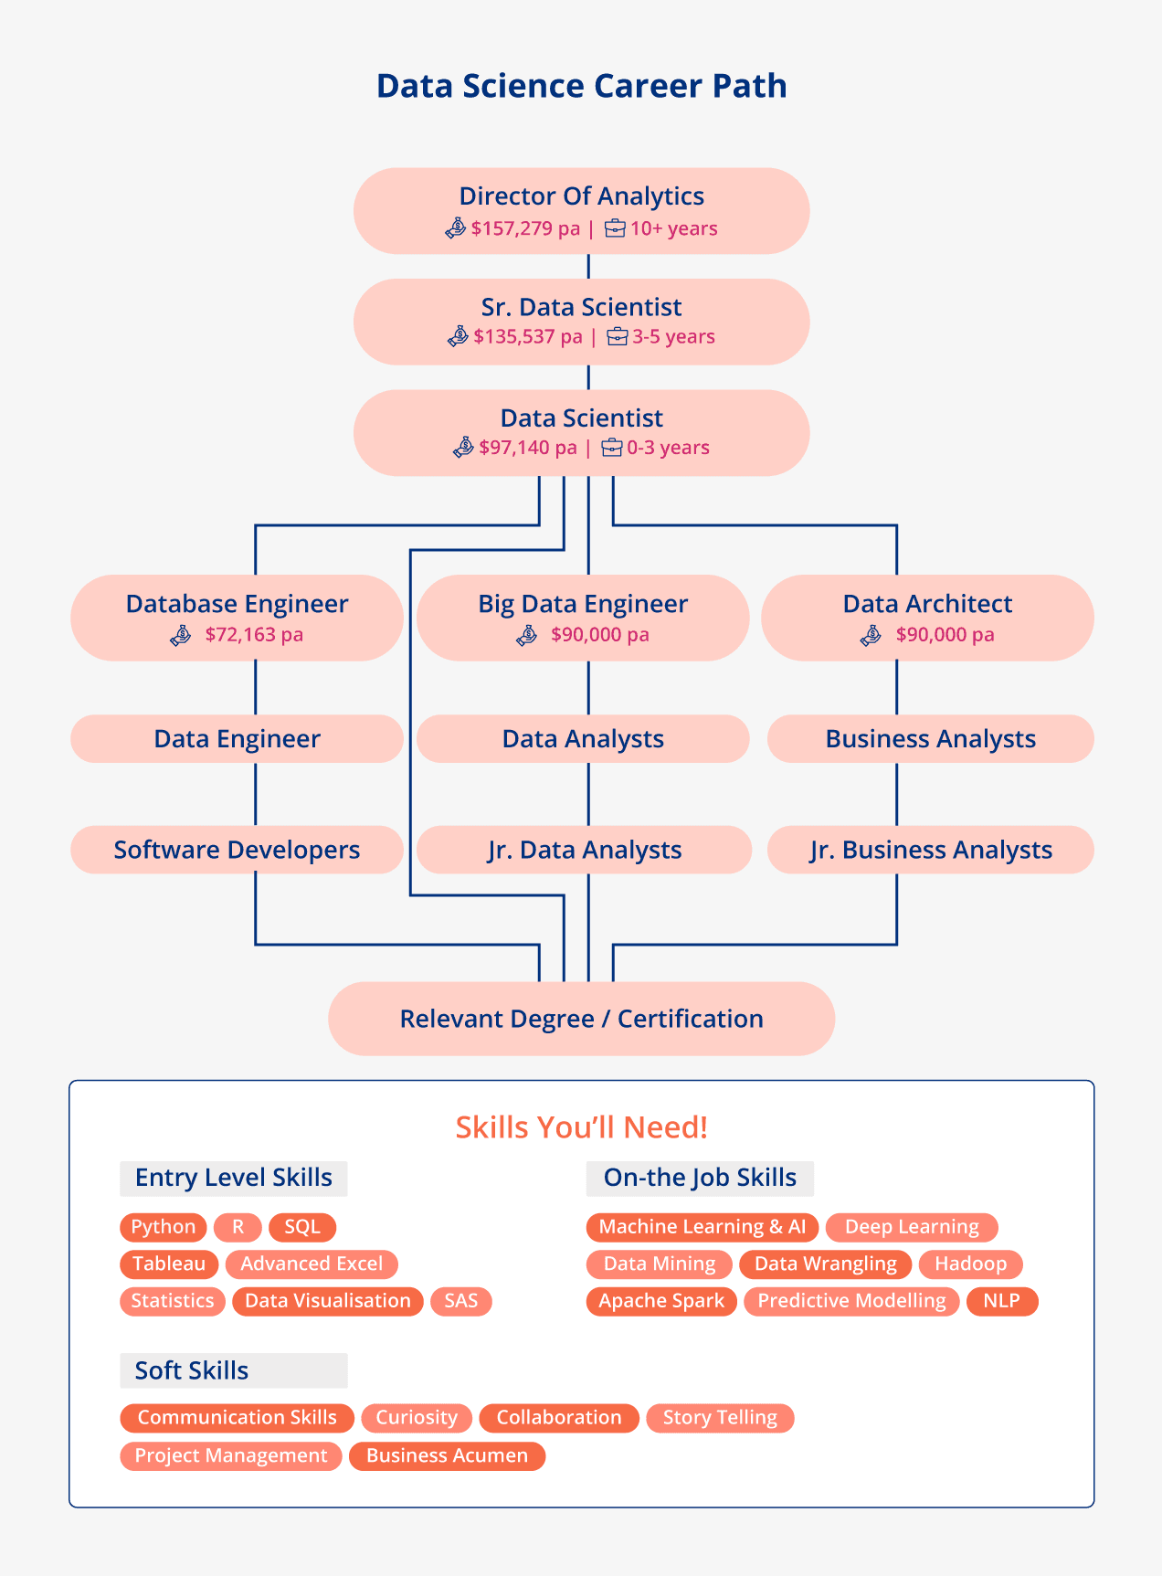
Figure 1. Data Science Career Path

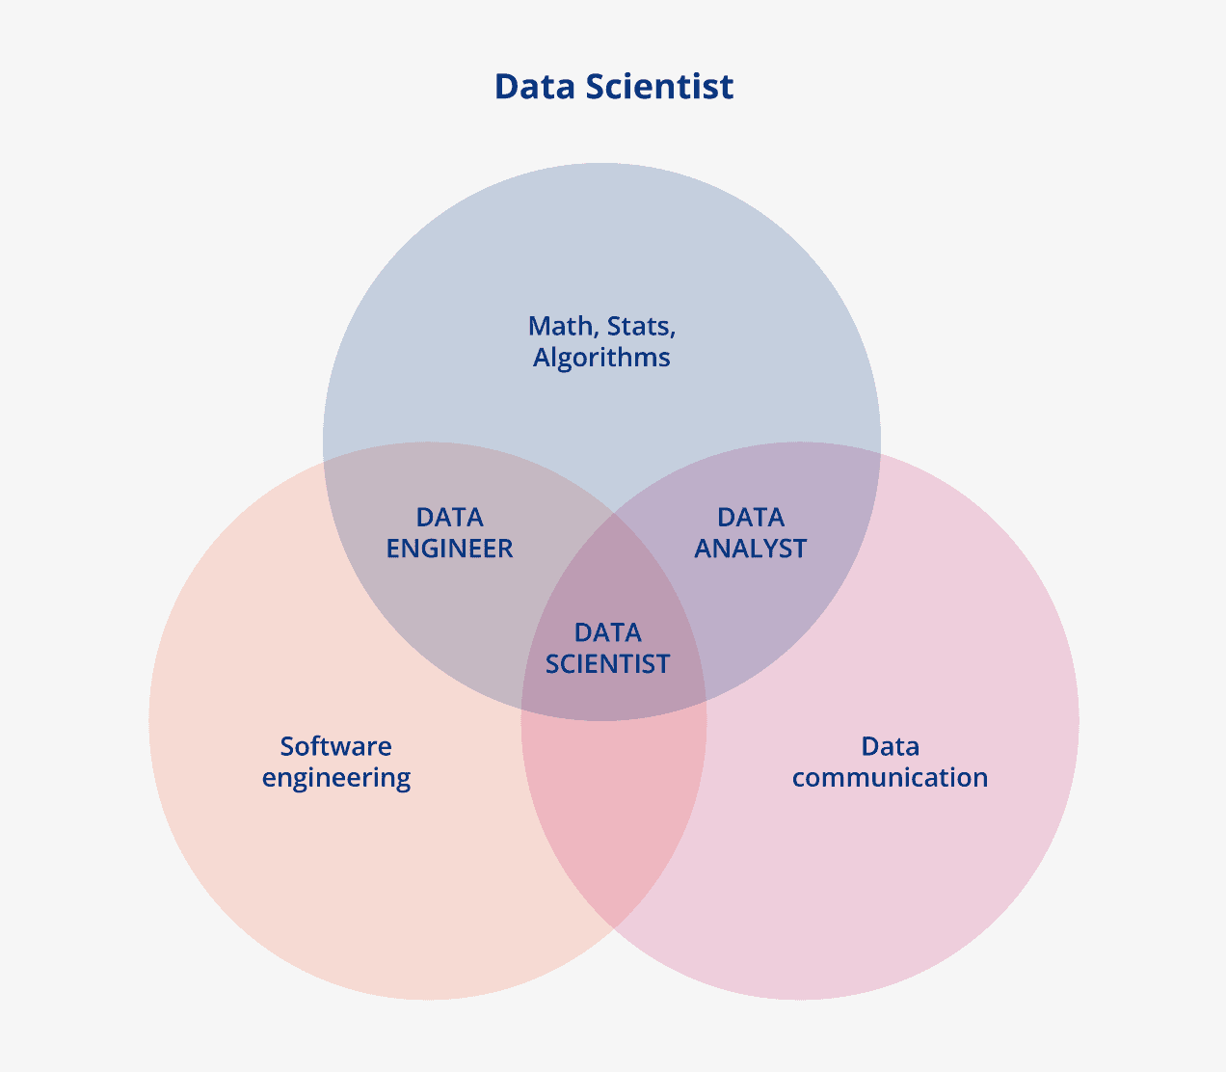
Figure 2. Data Scientist

Data Scientists Skills Required: Career Path
It is now well known that each company wants to dominate data science and machine learning, as evidenced by Apple, Google, Twitter, Spotify, Swiggy, and Ola. There is no doubting that one of the fields with the quickest growth is data science. The Data Science industry, however, is severely lacking in trained Data Scientists. Despite the fact that there is more employment in the field of data science than ever before, qualified data scientists are in short supply. The qualifications you should have to succeed as a data scientist are listed below. Developing all of these skills takes time and effort, but it is not impossible. Figures 1 and 2 can be learned and mastered with patience and perseverance.
Understanding the basic concepts of Data Science
It must understand the foundational principles of this discipline in order to become a master in it. Hence, it is essential that it comprehend the fundamentals of the industry.
Statistics
The development of machine learning algorithms is based on mathematics and statistics. It must have a solid foundation in mathematics and statistics. A general understanding of statistics is required but a Doctorate or master's degree is not.
Programming skills
To teach computers to put analysis into action, It must have excellent programming skills. It must enjoy using computer language. Python is the language that is most frequently used in the sector, thus you must be skilled in it. It will also need to learn other languages including R, C, C++, shell scripting, and SQL in addition to Python. These languages are essential to the data scientist's career.
Data manipulation and analysis
It must possess an experimental attitude that enables it to discover and investigate various approaches to manipulate and maximize the available data. It will need to learn a variety of data preparation procedures to accomplish this. This can begin with SQL, which is a necessary foundational skill before entering the field of data science.
Data Visualization
For data science, the phrase "a picture is worth a thousand words" is ideal. It must produce accurate and insightful data graphs and charts that show the pattern on their own. For it to pick from, there are numerous paid and free tools on the market. PowerBI, Tableau, QlikSense, etc. are a few examples. Also, it can test out free Python libraries like Seaborn and Matplotlib.
Machine Learning
At its core, data science is ML-based. It must therefore develop superior knowledge of the many types of algorithms, how they operate on deployed datasets, how to assess the efficacy of algorithms, and lastly, when to apply particular algorithms.
Deep Learning
Deep learning, a more sophisticated form of machine learning that is inspired by the human brain and designed for usage with complex use cases and data sets. A smart data scientist must acquire and comprehend the intricate Deep Learning methods.
Big Data
Since the previous ten years, the size and variability of data have altered significantly. Data scientists are expected to be familiar with the travel of data and how to use artificial intelligence to handle it efficiently for any activity.
Software Development
When imagining the end-to-end operation of any ML application, application development expertise is very helpful. It is aware of the evolution of data and operations from one stage to another.
Model Execution
Building a precise model is just one step in the procedure. To implement that model, it must possess certain features. For your model to be used in real-time production systems, it will need to learn and implement a variety of techniques.
Skills in Communication
The requirement to properly and simply communicate results and analyses to a larger audience that often has a background in technical or data solutions makes this ability the most vital.
Logical Thinking
The study of data is an experimental field. As a result, it must acquire and use a systematic and clear thought process to assess and test various strategies. It will become lost if it decides to move in a minimal way.

Curiosity and an Openness to New Information
Data science is a field that also is continually changing, and as a result, daily advancements are being made. It must continually learn and put new skills into action if this wants to remain cutting edge. It must therefore be prepared to acquire fresh information. This is by no means a detailed list of the abilities required to become a data scientist or an ideal guide. It can still view this as a foundation, and as it develops these skills, it will come across and pick up additional ones.
Current Data on Job Growth in the Field of Data Science
It is assumed that they have already decided on a career path or are in the process of doing so. draw attention to some more crucial elements that may aid in decision-making. There were more than 137,000 open data science positions in 2022 alone. Incredibly, analytical employment increased by 47% over the previous year [1] [12]. According to the mentioned statistics, demand for data science experts is increasing across a range of industries, regions, and even experience levels. The demand for data science positions will continue to increase as more businesses adopt data-based solutions.
It further sets the data scientist role apart from the next three roles.:
- Data authors are the researchers who develop digital data, including scientists, teachers, students, and other participants. These include specialists, teachers, and students who are interested in the study that will be done using the data.
- Data managers are the businesses and data scientists [our emphasis is to highlight the possibility for misunderstanding] in charge of database upkeep and management as well as a trustworthy and knowledgeable partner in data archiving and preservation.
- Users of data include the greater scientific and educational communities, as well as those groups' professional and scientific partners.

It wouldn't draw these differences in this way after studying data management in the research community in the UK, particularly with regard to practice in HEIs as needed by the project sponsor. In this context, the jobs that stand out the most are:
Data producers, often called data authors, are researchers with specialized knowledge who produce data. Due to experience, a particular interest, or a requirement, these individuals may possess a high level of proficiency in handling, manipulating, and using data.
Data scientists are those who operate in the research environment—or, in the case of data centre staff, in close collaboration with the data creators—and do all or some of the tasks listed in the NSF's definition above, including—as is often the case—creating the data. They may have been trained as computer scientists or information technologists or as domain specialists, and their professional advancement may have forced them to incorporate skills from a different discipline [14]. A data scientist with a background in software engineering may have a significant amount of biological knowledge, whereas a data scientist with a background in systems biology may be a biologist by training who has also gained very significant computing abilities. Some data scientists advised us that a key component of their job is to act as a "translator," explaining to data managers the demands of the data makers (see below), and collaborating with them to make sure that data are stored and available in a useful manner [17].
Data managers are those who manage computing resources, data storage, ongoing access, and data preservation. They may be computer scientists, information technologists, or information scientists. They work very closely with data scientists to make sure that the research team has access to the proper technology resources for carrying out its work. Some data managers defined their job as that of a "plumber" of data, plumbing information from one location to another while ensuring that data flows are efficient and that important information is not lost.
Data librarians are trained professionals who specialize in the curation, preservation, and archiving of data and are drawn from the library community. The phrase "data librarian" was first thought to only refer to librarians who dealt with social science data, but it is increasingly used to refer to those with data abilities across all academic fields. [4] When universities start to create digital repositories for the collecting and curation of their research results, it is an especially crucial field. Datasets are a component of those outputs, and an institutional repository—which is often under the management of the library—is the repository's natural home. Even if "big science" has its own (global) data centers and some UK research bodies offer national data storage facilities, "little science" will require institutional support. There will still be a need for local facilities for data that do not qualify, for one reason or another, for inclusion in that data center, and data librarians will remain the custodians of that body of data even if a third player in the shape of a national data service does arise.
Due to the size of the big data and analytics sector, a framework can be useful in assessing the needs of particular curricula[5]. Kang and his colleagues' (2015) recent research defined four analytics pillars and suggested corresponding skills for each pillar (See Figure 3). These are the four pillars:
Preprocessing, storing, and retrieval of data; data exploration; third- and fourth-order analytical models and algorithms; and data product. Other studies have also highlighted a number of big data-related topics, including 10 big data skill categories and 19 big data content issues (Columbus, 2014; Gefen et al.,2011). The study's three aims and five research questions are based on this framework [[4][6][8].
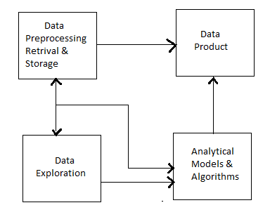

Figure3. Skills Required by Pillars of Analytics(Kang,Holden andYu,2015)
Objective 1: What modifications have been made to Big Data/analytics courses between 2011 and 2016 using the pillars of analytics as a framework?
Question 1: How many more Big Data/analytics courses were added to curricula between 2011 and 2016?
Question 2: What analytics products are most frequently offered?
Objective 2: Do the department's 2011 course offerings have an impact on the adjustments to its 2016 course offerings for analytics?
Question 3: What effect did the 2011 advanced database course offers have on the 2016 offerings of analytics courses?
Question 4: What effect would following the 2010 Model Curriculum guidelines have on the availability of analytics courses in 2016?
Objective 3: Are modifications in the analytics courses offered in 2016 depend on departmental resources?
Question 5: What effect does education have on analytics?

LITERATURE REVIEW

2.1 Research on Big Data and Analytics in the IS Curriculum
An ICIS group looked at the MIS curriculum in 2011 and discovered a disconnect between what is taught in universities and what businesses need. The panel specifically urged for more focus and instruction in business analytics, data mining, SQL, and Big Data (Gefen et al., 2011). Since Big Data and analytics with a data-centric approach have their roots in the database industry (Chen, Chiang, and Story, 2012) [11], SQL was probably addressed. Universities have made an effort to close the knowledge gaps in the area [3][8]. The chance to provide university programmers with a focus on data and business analytics to train data scientists has notably attracted the attention of IS Organizations. These initiatives are widely disseminated (Goes, 2014, p. iii).

Pillars of Analytics | Skills
Preprocessing, storing, and retrieving of Data | Data modelling, data warehousing & distribution, and parallel computing, No SQL
Exploration of Data | Analysis and Visualization of Statistics
Models and algorithms for analysis | Information retrieval, Natural Language Processing, and Machine Learning
Data Product | Organization of data and information, representation of knowledge, and development of applications

Table 1. Skills Required by Pillars of Analytics (Kang,Holden, andYu,2015)

Anderson and colleagues present a third big data/analytics strategy (Anderson et al., 2014). They emphasize on an extensive program for undergraduates in data mining, machine learning, and predictive analytics, noting that undergraduate Big Data and analytics education has been possible for more than ten years (Anderson et al., 2014). Anderson et al(2014) .'s architecture addresses extra problems outside of the conventional Big Data area by integrating topics like ethics and corporate communications, even if there are similarities with Kang, Holden, and Yu's (2015) four pillars.
The discussion from before and the necessary abilities needed for big data and analytics courses are summarized in Table 2. The ability to provide career options that allow students to focus on a specific area, such as data analytics, is highlighted (Topi et al., 2010)[10]. Despite the fact that the 2010 IS curriculum guidelines do not specifically address course offerings in analytics, aside from database/SQL as part of the core.
"As a scientific community, we would be negligent if we did not fully exploit the scientific potential afforded by the accessibility of Big Data, sophisticated analytical tools, and robust computer infrastructures" (Agarwal and Dhar, 2014, p. 447).

Research | #ofAreas | Areas/Pillars/Topics
2014 Anderson et al. | Big Data/Analytics in Eight Areas | 1) Create/design, access, clean, analyze, aggregate, organize, and visualize large data collections; 2) Design, storage, query, and modelling of databases; 3) AI techniques, including pattern matching, machine learning, neural networks, and genetic algorithms; 4) Algorithms and software: design, coding, and testing; 5) Information retrieval: text mining, data mining, and information theory; Logic and counting, discrete structures, statistics, modelling, and simulation are all areas of mathematics. 7) Written and verbal communication; 8) Social, moral, and legal concerns: security and privacy
Goes, Chiang and Stohr (2012) | Three Topics for Big Data Curriculum | 1) IT knowledge and skills (e.g., relational databases, ETL, OLAP, visualization); 2) business skills (e.g., understanding business problems and functional business sectors); and 3) analytical capabilities (e.g., data mining, neural networks).
Goul, Gupta and Dinter,2015 | Four Foundations for Analytics | 1) BI Overview; (2) DBMS; (3) Dimensional Modeling; 4) BI infrastructure, including data warehouses and dashboards; 5) BI infrastructure; Data mining and visualization, EIS, and BI applications are among the other topics. 10), BI management, 11), the business case for BI applications, 12), the strategic use of BI, and 13), data security; Future trends, Business Performance Management, Web-based BI, Ethical issues in BI, and BI and organizational challenges are some of the topics covered in this article (e.g., culture)
Kang,Holden,and Yu,2015 | Four Foundations for Analytics | 1) Data preprocessing, storage, and retrieval (such as NoSQL, data modelling); 2) Data exploration (such as visualization); and 3) Data analysis. 3) Analytical models and algorithms (such as data mining and machine learning); Data product 4) (e.g., application development)
Andersonet al.,2014 | Big Data/Analytics in Eight Areas | 1) Create/design, access, clean, analyze, aggregate, organize, and visualize large data collections; databases: modelling, design, storage, and query; 3) AI techniques, including pattern matching, machine learning, neural networks, and genetic algorithms; 4) Algorithms and software: design, coding, and testing; 5) Information retrieval: text mining, data mining, and information theory; Logic and counting, discrete structures, statistics, modelling, and simulation are all areas of mathematics. 7) Written and verbal communication; 8) Social, moral, and legal concerns: security and privacy
Chiang, Goes and Stohr,2012 | Three Subjects for Big Data Education | 1) IT knowledge and skills (e.g., relational databases, ETL, OLAP, visualization); 2) business skills (e.g., understanding business problems and functional business sectors); and 3) analytical capabilities (e.g., data mining, neural networks).
Gupta, Goul and Dinter,2015 | 18 Subject Matter Areas (Undergrad &Grad) | 1) An introduction to business intelligence; 2) a DBMS; 3) dimension modelling; 4) a data warehouse; 5) a dashboard; 6) Data visualization; 7) Data/text mining; 8) Enterprise Information Services (EIS); 9) Business Intelligence (BI) Applications; 10) Business Case for BI Applications; 11) BI Management; 12) Strategic Use of BI; 13) Data protection; Web-based BI, future developments, business performance management, ethical difficulties in BI, and number 14; 18) Organizational and BI difficulties (e.g., culture)
Kang, Holden and Yu,2015 | Four Foundations for Analytics | 1) Data preprocessing, storage, and retrieval (such as NoSQL, data modelling); 2) Data exploration (such as visualization).3) Analytical models and algorithms (such as data mining and machine learning); Data product 4) (e.g., application development)

Table 2. Skills Required for Big Data and Analytics

2.2 Shortage of Analytics Expertise in Industry
With global data growing at 40-50% per year, professionals with Big Data and analytics skills are in high demand (Gordon, 2013; Manyika et al., 2011). Data scientists with degrees in information systems-related fields are also in high demand, and hiring shortages are expected for those with deep Big Data and analytics skills (Manyika et al., 2011)[10]. A survey of 153 professionals from IT found that technological skills such as SQL, computer languages, and web design are critical to the future needs of the industry (Downey, McMurtrey, and Zeltmann, 2008). In addition, the demand for graduates with SQL skills continues to increase as it remains a standard method of accessing Big Data (Soat, 2014). The high salaries and high demand are exerting upward pressure, and average salaries for professionals in Big Data and analytics exceed $100,000(Columbus,2014). Average pay for Big Data and analytics specialists surpass $100,000, and demand for these people is substantial, exerting upward pressure on salaries (Columbus,2014).
Outside MIS, there is a huge need for graduates with experience in big data and analytics. "Since the Internet became widely used about 20 years ago, big data represents the biggest possibility for marketing and sales" (Davis et al., 1997, p. 1). He further contends that businesses who employ Big Data and analytics effectively outperform their rivals in terms of profitability by more than 5%. Databases, for instance, can aid in the development of a thorough consumer profile so that businesses can tailor their services and respond to their needs (Gordon, 2013).
Marketing communications, sales, profitability, and product development are all improved through database marketing (Duval, 2013). The analysis of Big Data kept in the healthcare industry is predicted to have a potential yearly worth of over $300 billion (Manyika et al., 2011). Wall Street investment banks and security organizations are also recruiting for analysts with database skills (Taft, 2012). (Taft, 2012).
Companies that are driven by data and the internet are increasing demand for workers with machine learning and predictive modelling skills (Dhar, 2013). The most in-demand Big Data specialists have specialized knowledge of Linux (76%), SQL (76%) and Python programming (96%). (Columbus, 2014).
A list of further in-demand Big Data and analytics-related talents may be found in Table 3. Employers are looking for people who have programming languages like Python and SQL because software development currently accounts for approximately one in 20 careers in the United States (Gallagher, 2015).
Skill | % Growth in Demand Over Previous Year
Python | 96
Structured QueryLanguage(SQL) | 76
Linux | 76
Data warehousing | 69
Java | 63
Table 3. Industry Demand Increases for Big Data Professionals (Columbus, 2014)
2.3 Research Techniques and Data Gathering
Data for our analyses were gathered during two months in late 2015 and early 2016, as detailed in more depth in the following two sections, and over three months in the fall of 2011. An assortment of AACSB-accredited programs at American colleges made up our sample. To address our research questions and aims, specific questions were developed, reviewed by other professors who are authorities in MIS courses, and amended as necessary [15]. Examining college websites, course catalogues, and, in some cases, conducting phone interviews with academic advisors helped identify the data that did not originate from internet sources for the answers to these questions. Below, we go into further detail about our processes [13] [14].
2.3.1 Sample and Population: The demographic for this study includes students taking undergraduate information systems courses at US universities with the AACSB accreditation. Our baseline data originated from the same 118 programs (from of roughly 485 AACSB programs) that Bell, Mills, and Fadel (2013) randomly selected and used in their 2011 analysis. The data were gathered during three months in the fall of 2011 as detailed in their publication. For the sample size to give adequate statistical power for the statistical analyses, at least 74 of the 485 AACSB programs were necessary, in accordance with Yamane's (1967) formula based on a 90% confidence interval. Our sample size of 118 is greater than the required number. A total of 104 programs (80%) were offered by public institutions, and 25 by private ones [16].
2.3.2 Data gathering techniques: The survey instrument (see Appendix A) concentrated on the analytic pillars (Kang, Holden, and Yu, 2015), analytic skills (Columbus, 2014), and programe clusters and was constructed mostly based on the literature study described earlier in this thesis (Mills et al., 2012). The first author created a preliminary set of queries to address our research's goals and questions. Two professors with experience in information systems and curriculum design then went over them to make sure the right information was gathered. Little adjustments were made in response to their feedback, showing that the final set of questions satisfied the criteria for content validity.
The Bell, Mills, and Fadel (2013) data collection, which was first gathered during three months in the fall of 2011, provided the baseline data for 2011. The second data set was gathered over a two-month period in the fall of 2015 and the spring of 2016 directly from college websites. A department's website, which listed course offers, and online course catalogues, which offered details on course content, were primary sources. When crucial information was missing from a department's website, we contacted academic advisors. Two researchers collected the 2011 data set, and a third researcher verified that the data were appropriately gathered and interpreted [22] by looking at a randomly selected subset of 20 programs, as stated in Bell et al. (Bell, Mills, and Fadel, 2013).
III. DATA ANALYSIS AND RESULTS
3.1 Research Question 1
How many new Big Data/analytics courses have been added to degree programs? Around 60% of study programs launched at least one new Big Data/Analytics course between 2011 and 2016, according to the analysis of the direct survey data. 35 percent of programs introduced one new course, 15 percent added two, 7 percent or so added three, and 3 percent of programs added four. The proportion of programs that added a Big Data/Analytics course option is seen in Table 4 [21].
Course Offering | Frequency | Percent
0 | 47 | 39.8
1 | 42 | 35.6
2 | 18 | 15.3
3 | 8 | 6.8
4 | 3 | 3.4
Total | 118 | 100
Table 4. Frequency and Percent of IS Programs adding Analytics Courses 2011-2016
3.2 Research Question 2
What are the most frequent citations for analytics? For this inquiry, the Big Data/analytics course averages for all schools in 2011 and 2016 were calculated. We contrasted these averages to show the development of big data and analytics during the previous four years (see Tables 5-8). According to the findings, courses in business data analytics, business intelligence, and big data/analytics were most commonly added in that order [9].
Pillar1Offerings | 2011 | 2016 | %Change
DatabaseManagement | 113 | 114 | 0%
Advanced DatabaseManagement | 17 | 19 | 11%
OtherDatabase/Administration | 5 | 9 | 88%
Table 5. Pillar 1 – Data Preprocessing, Storage, and Retrieval Comparison – Mean Averages of Courses

Pillar2Offerings | 2011 | 2016 | %Change
Visualization | 1 | 3 | 300%
Business DataAnalysis | 9 | 26 | 289%
BusinessIntelligence | 10 | 26 | 260%
Table 6. Pillar 2 – Data Exploration Comparison – Mean Averages of Courses
.
Pillar3Offerings | 2011 | 2016 | %Change
DataMining | 13 | 22 | 69%
DataWarehousing | 7 | 10 | 43%
Table 7. Pillar 3 – Models and Data Mining Comparison– Mean Averages of Courses

Pillar4Offerings | 2011 | 2016 | %Change
Big Data Analytics | 6 | 34 | 583%
Decision Support and Expert Systems | 7 | 9 | 29%
Table8. Pillar4–Product Comparison – Mean Averages of Courses

3.3 Research Question3
What effects may a 2011 advanced database course have had on 2016 analytics courses? The number of new analytics courses given in 2016 was the dependent variable in a one-way between-group analysis of variance (ANOVA) that was used to investigate this research topic. The independent variable was the offering of advanced database courses in 2011. There was a 0 (no advanced database course in 2011) or a 1 for the independent variable (advanced database course in 2011). The range of the dependent variable for new analytics courses in 2016 was from 0 to 4. Levene's test for homogeneity of variances (Levene statistic 0.255, df1 1, df2116, Sig.0.614) was used to evaluate the homo scedasticity hypothesis [12]. There was a significant effect of departments offering advanced database courses in 2011 on offering new analysis courses in 2016 at the <.05 level[F (1,116) =6.219,p=0.014](SeeTables 10and11).
New Analytics Course Offerings | N | Mean | Std.  Deviation | Std. Error | 95%  Confidence Interval for Mean
No(0) | 101 | 0.87 | 0.997 | 0.099 | 0.067 | 1.07
Yes(1) | 17 | 1.53 | 1.068 | 0.259 | 0.98 | 2.08
Total | 118 | 0.97 | 1.029 | 0.095 | 0.78 | 1.15
Table 10. 2011 Advanced Database Impact on 2016 Analytics Course Offerings

 | Sum of Squares | Df | Mean Square | F
Between Groups | 6.302 | 1 | 6.302 | 6.219**
Within Groups | 117.562 | 116 | 1.013
Total | 123.864 | 117
**P<.05
Table 9. ANOVA for the Regression Equation, Data base on Analytics Offerings

IV. DISCUSSION

Many of the elements of data science are not new, but their significance is growing as firms acknowledge the value of analytics in improving performance (Agarwal and Dhar, 2014). It is now clear that the traditional data science elements have joined with modern data tools and models to create a brand-new, distinct discipline called data science [4].
This study offers the first empirical investigation of IS programs moving to Big Data and analytics, and the findings show that there has been a significant rise since 2011. The highest increases were seen in Pillars 2 (Data Exploration) and 4 (Product), which included courses in business data analytics, visualizations, and business data analytics, corroborating earlier statements that WIS programs are pushing curriculum development in this area (Brandon, 2015). At the same time, 36% of IS programs added just one Big Data or analytics course, while 40% added none at all (see Table 4) [10].
One possible cause is that many IS departments lacked the necessary faculty or were unable to acquire additional instructors to teach more difficult computer science courses. Another possibility is that departments were unable or unwilling to make this trade-off because doing so would have required them to drop existing courses from their IS curricula. To determine whether this explanation is accurate, more investigation is required. But it's hard to overstate how much MIS has shifted in favor of big data and analytics. Like business data analytics courses, the number of business intelligence courses expanded from 10 in 2011 to 26 in 2016, for instance (see Table 6[7] [11]). In Pillar 2 (Data Exploration), which also covers statistical approaches, both courses are included. The fact that HIS faculty and teachers who teach quantitative methods sometimes work in the same department may be one factor for the pillar's remarkable growth. The faculty members who are skilled in quantitative methods might more quickly retool to teach courses on the analysis of economic data, therefore IS Programs may have found it easier to increase the number of course offerings in the pillar.
This study demonstrates that Big Data/analytics offerings are substantially more likely to be offered by programs with established database offerings, including an advanced database course (Pillar 1 - Data Preprocessing). This makes sense because subsequent data science offerings naturally build upon the first pillar of data pre-processing. Experts in the field who teach advanced database courses were perhaps among the first academics in IS to acknowledge the value of data to businesses as it increased. Once businesses became aware of the advantages, there was a sharp increase in demand for new workers with data science training.
Analytical Models &Algorithms

-Big Data Analytics
-Decision Support/Expert Systems
Data Exploration

-Data Visualization
-Business Intelligence
-Business Data Analysis
Statistical Methods
Data Preprocessing, Storage, & Retrieval

-Data & Information Management
-Advanced Database Management
-Programming with Python
Data Product

-Data Mining
-Data Warehousing
Figure 4. Skills Required by Pillar of Analytics based on Current Study Data (Kang, Holden and Yu, 2015)

V. CONCLUSION
The most in-demand profession of this decade has been and will be data science. Professional employment competitiveness is at its height as public knowledge of the field rises. It is certain that you will find the ideal way for it if you follow this instructions and do a thorough self-evaluation. Please keep in mind that choosing the proper professional choice is just the beginning of the trip.

VI. REFERENCES

[1] AACSB International. (2013). AACSB Assurance of Learning Standards: An Interpretation. Retrieved from http://www.aacsb.edu/~/media/AACSB/Publications/whit e-papers/wp-assurance-of-learning-standards.ashx.
[2] Agarwal, R. & Dhar, V. (2014). Big Data, Data Science, and Analytics: Opportunity and Challenge for IS Research. Information Systems Research, 25(3), 443-448.
[3] Anderson, P., Bowring, J., McCauley, R., Pothering, G., & Starr, C. (2014). An Undergraduate Degree in Data Science: Curriculum and a Decade of Implementation Experience. ACM Special Interest Group on Computer Science Education (SIGCSE), Atlanta, GA.
[4] Bell, C. C., Mills, R. J., & Fadel, K. (2013). An Analysis of Undergraduate Information Systems Curricula: Adoption of the IS 2010 Curriculum Guidelines. Communications of the Association for Information Systems, 12(4), 73-94.
[5] Brandon, D. (2015). Teaching Data Analytics Across The Computing Curricula. Journal of Computing Sciences in Colleges, 30(5), 6-12.
[6] Breslin, S. (2016). Data Scientists: The Myth and the Reality. Retrieved from http://www.datanami.com/2016/01/22/data-scientists-themyth-and-the-reality/.
[7] Chaudhuri, S., Vivek, D., & Narasayya, V. (2011). An Overview of Business Intelligence Technology. Communications of the ACM, 54(8), 88-98.
[8]Chen, H., Chiang, R. H. L., & Storey, V. C. (2012). Business Intelligence and Analytics: From Big Data to Big Impact. MIS Quarterly, 36(4), 1165-1188.
[9] Chiang, R. H. L., Goes, P., & Stohr, E. A. (2012). Business Intelligence and Analytics Education, and Program Development: A Unique Opportunity for the Information Systems Dicipline. ACM Transactions on Management Information Systems, 3(3), 12.11-12.13.
[10]Columbus, L. (2014). Where Big Data Jobs Will Be In 2015. Forbes. Retrieved from http://www.forbes.com/sites/louiscolumbus/2014/12/29/w here-big-data-jobs-will-be-in-2015/.
[11] Davenport, T. H., Barth, P., & Bean, R. (2012). How 'Big Data' IS Different. Sloan Management Review, 22-24.
[12] Davenport, T. H. & Patil, D. J. (2012). Data Scientist: The Sexiest Job of the 21st Century. Harvard Business Review, 70-76.
[13] Davis, G. B., Gorgone, J. T., Couger, J. D., Feinstein, D. L.,& Longenecker, H. E. (1997). IS '97 Model Curriculum and Guidelines for Undergraduate Degree Programs in Information Systems. The DATA BASE for Advances in Information Systems, 26(1), 1-94.
[14] Dhar, V. (2013). Data Science and Prediction.Communications of the ACM, 56(12), 64-74.
[15] Downey, J. P., McMurtrey, M. E., & Zeltmann, S. M. (2008). Mapping the MIS Curriculum Based on Critical Skills of New Graduates: An Empirical Examination of IT Professionals. Journal of Information Systems Education, 19(3), 351-363.
[16] Duval, J. (2013). What is Database Marketing and When Can it Be Used? Customer Think. Retrieved from http://customerthink.com/what_is_database_marketing_and_when_can_it_be_used/.
[17] Gallagher, S. (2015). Software is Eating the Job Market. Retrieved from http://techcrunch.com/2015/06/09/software-is-eating-thejob-market/#.qe7szzq:2jgD.
[18] Gefen, D., Ragowsky, A., McLean, E. R., Markus, M. L., Rivard, S., & Rossi, M. (2011). ICIS 2011 Panel Report: Are We on the Wrong Track and do MIS Curricula Need to be Reengineered? Communications of the Association of Information Systems, 30(11), 161-170.
[19] Glassdoor. (2016). 25 Best Jobs in America. Retrieved from https://www.glassdoor.com/Best-Jobs-in-AmericaLST_KQ0,20.htm?utm_medium=email&utm_source=new sletter&utm_campaign=January2016_US&utm_content= BESTJOBS16US.
[20] Goes, P. B. (2014). Big Data and IS Research. MIS Quarterly, 38(3), iii-viii.
[21] Gordon, J. (2013). Big Data, Analytics and the Future of Marketing and Sales. McKinsey: Digital Advantage.
[22] Gupta, B., Goul, M., & Dinter, B. (2015). Business Intelligence and Big Data in Higher Education: Status of a Multi-Year Model Curriculum Development Effort for Business School Undergraduates, MS Graduates, and MBAs. Communications for the Association of Information Systems, 36, 449-476.
[23] Web Site https://www.knowledgehut.com/blog/data-science/data-science-skills
[24] Web Site https://www.quora.com

