Bio gas Production from Jack fruit (Artocarpusheterophyllies)

Suryanarayana. K*¹, MaheshaKeerikkadu²
*¹Professor, Department of Physics, Srinivas Institute of Technology, Mangalore, Karnataka, India
surya_nekkare@yahoo.com
²M. Pharm,Srinivas College of Pharmacy, Mangalore, Karnataka, India
maheshkeerikkadu@gmail.com

Abstract
Farmers have suffered significant losses as a result of the jack fruit's (Artocarpus heterophyllus) excessive production during the harvest season and its little shelf life. The unused jackfruit and its components also pollute the atmosphere by giving out an unpleasant stench. We can use it as a source for the generation of biogas because it is readily biodegradable. The current study focuses on the development ofBiogas from jack-fruit and its wastes.A small biogas plant is fabricated for this purpose. The quantity of biogas obtained from Jack fruit flesh, Outer part of Jack fruit, Mixture of all the part of jack fruit and Jack fruit seed are measured. It is found that jack fruitproduces good amount of biogas compared to cow dung with the limitation of taking long time for decay process. It is found that 1 kg of jackfruit flesh,Outer part of Jack fruit,Mixture of all the part of jack fruitand Jack fruit seedcan produce biogas of about, 21.3L, 24.8L 16.8 L and 27.5L respectively.
Key words: Fermentation, Biogas, cow dung, Biogas plant

Introduction
The jackfruit is a kind of tree of the Artocarpus genus of the mulberry family (Moraceae), sometimes known as jack tree, jakfruit, or occasionally just jack or jak. It is indigenous to portions of South and Southeast Asia, although it is thought to have come from the south-western rain forests of India, specifically from Tamil Nadu, Kerala, the coastal regions of Karnataka, and Maharashtra. The jackfruit tree thrives in tropical lowlands, and its fruit, which may weigh up to 40 kg and measure up to 36 inches (90 cm) in length and 20 inches (50 cm) in diameter, is the largest tree-borne fruit.
Farmers have suffered significant losses as a result of the overproduction of jackfruit (Artocarpusheterophyllus) during the harvest season and its short shelf life. The waste product also pollutes the environment. The fact that the entire jackfruit is biodegradable and a good source of cooking gas is also quite intriguing. Using a 60-liter and 50-liter fiber container and a few other tiny accessories, we created a miniature bio-gas plant for this project.Using this, we looked at how much biogas is produced when jack fruit meat, the outer cover, the jack fruit seed, and all the other useless bits are combined, etc. Every time, we discovered, we received a sizable amount of cooking gas. We conducted a comparative analysis of the generation of biogas in several scenarios.
Biogas technology is lauded as an archetypal suited technology that addresses the fundamental requirement for cooking fuel in rural areas and offers an alternative source of energy in rural India. dung and energy are produced locally using organic wastes like animal dung. On the basis of this, we got to work producing biogas from the jack fruit meat and other leftover fruit bits. For this test, we built a custom bio-gas plant.^{[1,2,3]}

Experimental
Components of the Bio-gas Plant:
The digester tank, the input for feeding the waste biodegradable material, the gas holder tank, the exit for the digested slurry, and the gas delivery system for extracting and using the produced gas are the main parts of the bio-gas plant.

Materials required:
- Empty PVC can 60 L capacityto be used as Digester Tank
- Empty PVC can 50 L capacity to be used as Gas Holder Tank
- 60 mm diameter PVC pipe: about 40 cm long for feeding waste material
- 30 mm diameter PVC pipe: about 20 cm long which was fixed on digester tank to act as outlet for digested slurry
- M-seal, water-proof adhesive
- Gas outlet system: ball valve, couplers and flexible Gas pipe
- A single burner bio-gas stove or a Bunsen burner
Different steps:
- The 60 L and 50 L capacity PVC cans are brought; second one should fit inside the first one.
- (fig1.a and 1.b)
- 60mm PVC pipe will be used for feeding the jack fruit is fitted to inverted 50 L tank
- Gas outlet system with ball valve and water proof couplers and flexible Gas pipe is fitted
- A small piece of 12 mm diameter pipe will be used as outlet for the slurry at the top side of the 60 L tank.
- One additional out let is kept below it if any need of removing excess slurry.
- Completed biogas tank is shown in fig 1.c. and burning gas is shown in fig 1.d.

Biogas production method:
To begin the gas generation process, cow dung will be fed into the system in a 1:1 mixture with water. As more gas is produced, the gas holder will rise. The flesh or other components of the jack fruit will then be diluted with water and utilized to feed the system. To raise the gas pressure, we can place some more weight on top of the gas holder. The extra digested slurry that escapes from the system when we feed it can be collected, diluted, and used as organic manure.
Initial gas output will be non-burning and will include oxygen, methane, carbon dioxide, and other gases. By opening the ball valve at least three or four times, these gases can be expelled into the atmosphere. Bunsen burners or biogas stoves can be used to burn subsequent gas.

Analysis:
We analyzed the production of gas with different materials in our system. It is reported [graph 2] that the following consumption rates in liters per hour (L/h) can be assumed for the use of biogas:
- Household burners: 200-450 L/h
- Industrial burners: 1000-3000 L/h
- 1 kg of cattle dung delivers 40 L of biogas
On this basis we calculated the production quantity of gas.

Calculation:
- Considering the house hold burners using an average of 320 L/hour.
- Average of 320 L of gas can be used for 1 hr. (3600 s).
- Therefore As 1 L of gas can burn for 11.25 second,1kg cow dung produce 40L gas can be used for 450 s.
- In our set, up we observed that 1 kg of cow dung produces gas which can be used for about 220 sec. Continuously for 7 days we observed and taken the average value.
- Thus, we can conclude that 1 kg of cow dung produces about 19.5 L of gas.
- The difference in the quantity may be due to constructional defects.
- By taking this as reference we conducted the experiment to verify the gas production from the jack fruit.

Table I: comparison table of biogas from different materials per Kg
For initialization the cow dung is needed

Sl.No. | Material | Minimum Time needed to produce the gas (in days | Time of cooking gas available (T in sec) | Quantity of gas in liter (T/11.25)
1 | Cow dung | 1 | 220 | 19.5
2 | Jack fruit flesh | 2 | 240 | 21.3
3 | Outer part of Jack fruit | 4 | 280 | 24.8
4 | Mixture of all the part of jack fruit | 7 | 190 | 16.8
5 | Jack fruit seed | 12 | 310 | 27.5
Fig1: Different stages of bio gas plant

a.60L can b) 50L can
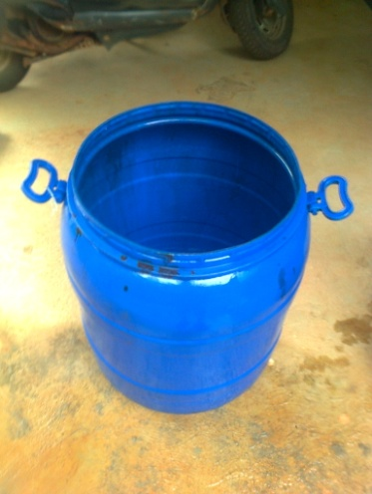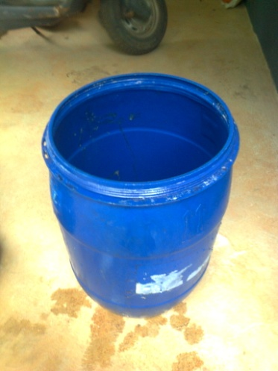
c. Completed plant d. Burning gas
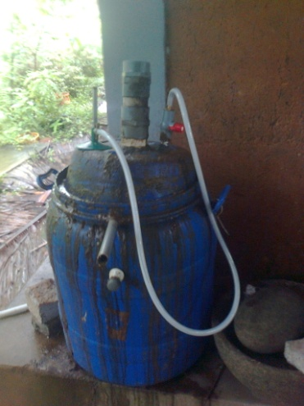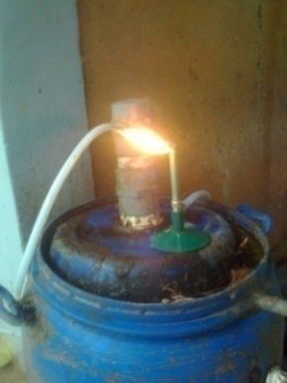

Conclusion
- Farmers have suffered significant losses as a result of the jack fruit's (Artocarpusheterophyllus) excessive production during the harvest season and its little shelf life.
- The production of cooking gas from jack fruit helps the village people to use the wastage as the source of energy.
- Same set up can be used to produce the gas from other biodegradable waste materials like food waste, vegetable wastes etc.
- The energy from waste is the main theme of this work
- The excess slurry from the biogas plant can be used as manure for the plants
- Jack fruit is good source of cooking gas
- Jack fruit seed contains good amount of gas, but it takes more time to produce the gas
- The mixture of all the parts of jack fruit give less quantity of gas, may be due to the slow decomposing materials like the outer cover of the seed

REFERENCES
- Ola Eriksson (2010). Environmental Technology Assessment of Natural Gas Compared to Biogas, Natural Gas, PrimozPotocnik (Ed.), ISBN: 978-953-307-112-1, InTech, Available from: http://www.intechopen.com/books/natural-gas/environmental-technology-assessment-of-natural-gascompared-to-biogas
- Sai Bhaskar Reddy DrN, complete profile V my. MINI BIOGAS PLANT - SRUSHTI [Internet]. MINI BIOGAS PLANT - SRUSHTI. 2007. Available from: http://e-biogas.blogspot.com/
- Tech SE. Samuchit Enviro Tech - Enabling Sustainability [Internet]. Samuchit Enviro Tech - Enabling Sustainability.Available from: http://www.samuchit.com/index.php?option=com_content&view=article&id=8&Itemid

