Sunitha N V

CHAPTER 1

  - Introduction

INTRODUCTION

Speech synthesis technology has undergone a revolution thanks to the creation of the Text to Speech with Custom Voice system. This system has found use in a variety of fields, including accessibility, education, and entertainment thanks to its capacity to produce spoken recordings in unique voices. For example, the technology can be applied to produce voiceovers for videos, provide audio output for those who are blind or visually handicapped, and enhance the accessibility of digital information for users with various language or dialect requirements.
A WaveRNN vocoder, a synthesiser, and a speaker encoder make up the suggested system. Together, these modules create a unique voice that closely resembles the target speaker. The speaker encoder, which collects pertinent features from the speaker's speech and generates a fixed-dimensional embedding vector to represent the speaker's voice, is essential to the process. The synthesiser network based on Tacotron2 then uses this speaker embedding to extract a mel spectrogram from the input text. The mel spectrogram is then translated into time-domain waveform samples by the WaveRNN vocoder, which produces audio as the system's output.
The speech encoder, synthesiser, and vocoder need to be trained on various speaker datasets in order to operate at their peak levels. By doing this, the system is guaranteed to accurately reproduce the desired voice, even for speakers who were not part of the training set. Furthermore, the system's modular structure makes it simple for outside users to include it into their goods. The system is considerably more adaptable and adjustable because to the ability of users to update particular modules and pipeline phases without altering the source code.

Problem Statement

Research into text-to-speech technology with personalised voice cloning is now necessary due to the growing need for more personalised and natural audio content, as well as the development of a system that can clone voices without needing a lot of training data or retraining the model. Currently, training a deep neural network for voice cloning needs hours and hours of audio recordings of a single speaker, which can be expensive and time-consuming.
By developing a system that can imitate voices from small samples of reference speech, we can lessen the amount of training data required and increase the efficiency of the voice cloning procedure. The user experience can be enhanced and more people can access digital information with the help of this technology. The capacity to execute voice cloning using only a little quantity of data can be useful in some situations when getting vast amounts of training data is not practical. For instance, this could be helpful if the speaker has died away or is no longer available for recording. Therefore, by exploring new deep learning methodologies and developing novel algorithms, we may improve the efficiency and accuracy of voice cloning systems, making it easier to create customized voices for a number of applications. These investigations are essential to the development of text-to-speech technology with personalized voice cloning.

Objectives

The main goal of this research is to develop a Text to Speech with Custom Voice system capable of producing speech audio in custom voices that are not included in the training data. We want to create a system that can learn to produce speech patterns unique to individual speakers by utilizing the most recent developments in deep learning, giving users total control over the tone and manner of their voice.
Three main components—a speaker encoder, a synthesiser, and a WaveRNN vocoder—will make up the proposed system. The task of the speaker encoder is to examine the incoming speech data and produce a speaker embedding that captures the distinctive features of the target voice. The WaveRNN vocoder will convert the created audio into a waveform that can be played out through speakers or headphones. The synthesiser will use the speaker embedding to produce high-quality speech audio.
We want to produce a modular design that is simple to incorporate into a variety of goods and applications so that the suggested system is usable by outside users. Users will be able to benefit from the system's capabilities thanks to this modular architecture without having to spend a lot of time or money modifying their current software or hardware.
In addition to creating a cutting-edge Text to Speech with Custom Voice system, our goal is to research new deep learning techniques and create cutting-edge algorithms that can enhance voice cloning systems' efficacy and accuracy. These initiatives will concentrate on lowering the volume of recorded speech needed to train a model, making it simpler and more reasonably priced for users to produce customised voices for a number of applications.

Scope

This work intends to investigate the potential of a Text to Speech with Custom Voice system, which has a wide range of applications. The main goal of the system is to produce speech sounds in custom voices, even ones that are not included in the training data, by utilising deep learning methods like the WaveRNN vocoder, speaker encoder, and synthesiser. Raw audio is transformed by the speaker encoder into a speaker embedding, which is then supplied into the voice synthesiser to create a unique voice. The unprocessed audio signal is then synthesised using the WaveRNN vocoder.
Another crucial component of the system is its adaptable modular architecture, which enables third parties to swiftly incorporate the technology into their products. This can be especially helpful in fields where personalised voices can have a big impact, like entertainment, education, and accessibility. Custom voices, for instance, can be utilised to develop engaging interactive learning tools for students, especially those who struggle with learning. Custom voices can be used to create distinctive characters or voiceovers in the entertainment industry, bringing new levels of creativity and innovation.
In order to improve the efficiency and precision of voice cloning systems, this work also intends to develop new deep learning techniques. A single speaker's recorded speech must be used for several hours in order to train a deep neural network for voice cloning, which can be both time-consuming and expensive. In order to make it easier to create customized voices for a variety of applications, we want to design new techniques that can duplicate sounds using fewer samples of reference speech.

CHAPTER 2

LITERATURE SURVEY
  - Existing system

Several hours of speech from a single speaker are used to train a deep neural network in the present voice cloning method [1]. Although this method has proved effective in many text-to-speech applications, it has a number of limitations; including being time-consuming, expensive, and impractical in some situations, particularly when there is a lack of training data. Recent studies have suggested numerous unique strategies to enhance voice cloning systems and lessen the dependency on massive amounts of training data.
Tacotron, an end-to-end voice synthesis model that can produce speech from characters, is one such method [1]. The model may be trained from scratch using pre-existing text and audio pairs and is based on a sequence-to-sequence architecture with attention. The authors separated the synthesis of the final waveform from the generation of the acoustic features by using a neural vocoder to convert the generated auditory characteristics into a waveform.
An effective neural audio synthesis method dubbed WaveRNN was suggested in another work [2]. The authors proposed a new generation method based on subscale and used a weight-pruning methodology to minimise the WaveRNN's weights. Additionally recommended as a key component to enhance multi-speaker text-to-speech synthesis is transfer learning [3]. To extract speaker-specific features from audio signals, the authors of one study trained a speaker verification model on a substantial corpus of speaker verification data [4]. In order to enhance the effectiveness of voice cloning systems, they looked at the encoding layer and loss function in an end-to-end speaker and language recognition system.
An end-to-end neural network architecture termed Char2Wav for speech synthesis from character-level text input was developed in another recent study [5]. In order to encode text input, the authors employed a convolutional neural network (CNN), and in order to produce speech, they used a WaveNet-like neural network. The model produced state-of-the-art outcomes in terms of voice quality and naturalness after being trained on a sizable dataset of single-speaker speech.
Additionally, transfer learning from multi-speaker text-to-speech synthesis to speaker verification has been researched [3]. A approach for multi-speaker TTS synthesis employing a speaker verification model trained on a sizable dataset of clean speech was proposed by the authors of the paper [6]. They extracted speaker embeddings from the model and utilized those to condition a TTS system based on neural networks. Without the need for distinct training data for every speaker, the resulting system was capable of synthesizing speech in the voices of several speakers.

Limitations of existing system
The previous system's necessity for a substantial amount of training data, which may not always be available, is one of its major flaws. Furthermore, the current method might not work when the speaker is no longer accessible for recording or when the desired voice is not available. The inability of the existing voice cloning technique to create customised voices for a range of applications is another drawback.

Proposed System
A system that duplicates voices accurately while using only a little quantity of reference speech can be created to get around the drawbacks of the existing technique. This can be achieved by creating fresh deep learning methods and innovative algorithms. The user experience can be improved by using the suggested approach to personalize voices for a variety of applications. The suggested technique can also be useful in situations where gathering a substantial amount of training data is not practical. The suggested voice cloning technology will therefore be more effective, affordable, and usable than the current system.

CHAPTER 3
SYSTEM REQUIREMENTS SPECIFICATIONS
A description of a software system that has to be created is called a software requirements specification (SRS). The functional and non-functional needs are outlined in the software requirements specification, which may also include a list of use cases that outline the user interactions the product must support. Functional requirements and use cases are two different terms. Use cases aren't the only requirements in the SRS; there are also non-functional requirements. Non-functional requirements place restrictions on the design or implementation. The SRS outlines the logical properties of each interaction between the software product and the hardware components for the hardware requirements. It details the hardware specifications needed for the software to function, such as memory constraints, cache size, processor, RAM size, etc. Prior to the more detailed system design stages, software requirements specification conducts a thorough review of the needs with the intention of minimizing subsequent redesign.

Overall description
The SRS is a document that entirely outlines the software's outward behaviour. The broad factors that have an impact on the product and its needs are discussed in this section of the SRS. The system will be described in its context to demonstrate how it interacts with other systems and to present its fundamental functionalities.

Product Perspective
      - A user-friendly website with a clear user interface and easy to use.
      - User will upload a clean audio file of 5 to 10 seconds in .wav or .flac format and a text file .

Product Functions
To address the demand for unique and authentic audio content, our suggested project intends to create a Text to Speech with custom voice system. The system's efforts will be directed towards reducing the amount of training data needed and enhancing the voice cloning procedure. The method will enable voice duplication without the need for substantial data collecting by using short samples of reference speech, making it more economical and effective. This innovation will improve user interactions and widen access to digital data. Additionally, it will be helpful when gathering substantial training data is impractical, such as when the speaker is absent or has passed away.

Assumptions and Dependencies

Assumptions

- Real-time voice cloning technology leverages deep learning algorithms to generate customized voices.
- The system is intended for use by individuals seeking personalized audio content or applications requiring natural-sounding speech.

Dependencies
- Performance of the system relies on the availability of a sufficient amount of reference speech data for the target speaker.
- The system's effectiveness depends on the accuracy of the speaker embedding generated by the speaker encoder module.
- Availability of powerful hardware resources, such as GPUs, to accelerate the training and inference processes.
- Reliance on established deep learning frameworks and libraries, such as PyTorch or TensorFlow, to develop and implement the voice cloning system.

Specific Requirements
This section includes the detailed description about the hardware requirements, software requirements, functional requirements and non-functional requirements.

Hardware Requirements
Hardware requirements refer to the physical parts of a computer and related devices. Internal hardware devices include motherboards, hard drives and RAM External hardware devices include monitors, keyboards, mice, printers, and scanner.
- Processor: Intel core i5 or above.

- Hard Drive: Minimum 32GB or more.

- Memory (RAM): Minimum 8GB or more RAM.

- Display: Minimum resolution of 1920 x 1080 pixels monitor.

- GPU: GTX 1650 Ti.

Software Requirements
Software requirement is a field within Software Engineering that deals with establishing the Deeds of stakeholders that are to be solved by the software. The software requirements of our project given below:
- Python
- Pip

- TensorFlow

- NumPy

- Pandas

- Anaconda

- PyTorch

- Jupyter

- HTML5

- CSS3

- JavaScript

- Flask

Python
Python is an interpreter-based, high-level, general-purpose programming language that was developed by Guido Van Rossum and initially made available in 1991. With its noticeable usage of substantial whitespace, Python places a strong emphasis on code readability. Its language constructs and object-oriented methodology are designed to aid programmers in creating clean, comprehensible code for both little and big projects. It is trash collected and dynamically typed. Programming paradigms including procedural, object-oriented, and functional programming are all supported. Python has a big and active developer community that contributes to its development and shares libraries and tools, as well as a straightforward and intuitive syntax that makes it simple to read and create code. Python has grown to be a popular choice for both new and seasoned programmers due to its adaptability, usability, and efficiency.

Pip

Pip is a Python-based package management tool that is used to install and manage software packages. For installing Python programmes and their dependencies during deployment, the Python Software Foundation suggests using pip. Python projects require external libraries and dependencies, which Pip makes simple for developers to install and maintain.

TensorFlow

The Google Brain Team created the open-source machine learning framework known as TensorFlow. Deep neural networks (DNNs), convolutional neural networks (CNNs), recurrent neural networks (RNNs), and other machine learning models can all be built and trained using this technology. To represent the mathematical processes in a machine learning model, TensorFlow employs a dataflow graph. Each node in the graph represents a mathematical operation, and the edges between the nodes reflect their input/output connections. TensorFlow can parallelize and optimize the calculation using this network across a variety of hardware, including CPUs and GPUs.

NumPy
A well-liked Python package for numerical computing is called NumPy. It is an open-source library that offers assistance for sizable, multidimensional arrays and matrices, as well as a number of mathematical operations that may be performed on these arrays. Since its initial release in 2006, NumPy has grown to be a crucial tool for machine learning, data research, and scientific computing. Because it is constructed on top of the C programming language, it can operate quickly even when dealing with huge datasets.

Pandas
A well-liked open-source library for Python data analysis is called Pandas. It offers flexible and effective data structures and operations for handling and analyzing data. Since its initial release in 2008, Pandas has emerged as a key tool in data science and analysis workflows.

Anaconda

With the goal of streamlining package management and deployment, Anaconda is a free and open-source version of the Python and R computer languages for scientific computing. Conda, a package management system, controls package versioning. For Windows, Linux, and macOS, the Anaconda distribution provides data-science packages. In addition to the conda package manager and virtual environment manager, Anaconda distribution includes 1,500 packages that were chosen from the PyPI (Python Package Index). In addition, a graphical user interface (GUI), Anaconda Navigator, is provided as a replacement for the command-line interface (CLI).

PyTorch

A machine learning framework called PyTorch was created by Facebook's AI Research (FAIR) team. It provides a dynamic and flexible method for creating and refining machine learning models, enabling programmers to quickly create and alter their models using Python syntax. The foundation of PyTorch is a notion known as "dynamic computation graph," where the computational graph is built and specified as-needed while the programme is being run. This framework offers automatic differentiation, making it possible to compute gradients for model training quickly and effectively. For activities like data loading, model construction, and optimization, PyTorch offers a broad variety of pre-built modules and functions. Additionally, it provides robust GPU acceleration support, enabling users to take advantage of the speed and efficiency of GPUs for training and inference. Due to its simplicity, adaptability, and vibrant development community, PyTorch has grown in popularity in the machine learning community. It is widely utilized for many different applications, such as reinforcement learning, natural language processing, and computer vision.

Jupyter

Developers can create and share documents with live code, visuals, and narrative text using the open-source Jupyter interactive computing environment for the web. The three primary programming languages that it supports, Julia, Python, and R, are where the name "Jupyter" originates. Developers can create and run code in a web browser using Jupyter notebooks, which are the main application for utilizing Jupyter. This makes it simple to experiment with code and data without the need for a special programming environment. Notebooks are an ideal tool for data analysis, scientific computing, and machine learning since they may contain a variety of content kinds, including code cells, markdown cells, and interactive widgets.

HTML5

The most used mark-up language for online pages is HTML, or Hyper Text Mark-up Language. By indicating structural semantics for text elements like headers, paragraphs, lists, etc. as well as for links, quotes, and other objects, it offers a way to generate structured texts. It enables the embedding of objects and pictures and can be applied to the development of interactive forms. Within the text of the web page, it is written as HTML components made up of "tags" enclosed in angle brackets. . It can include or load scripts written in languages like JavaScript that modify how HTML processors like web browsers process HTML, as well as Cascading Style Sheets (CSS), which specify how text and other content should look and be organized. The W3C, which oversees both the HTML and CSS standards, promotes the usage of CSS over presentational mark-up that is explicitly presented.

CSS3

A style language called CSS (Cascading Style Sheets) is used to specify the visual appearance of HTML or XHTML-coded web pages. In order to give developers control over a webpage's layout, typography, colours, and other visual elements, CSS works by separating the content of a webpage from its presentation. Websites that are responsive and aesthetically pleasing that are optimized for various devices and screen sizes can be made by developers using CSS. It is feasible to design interactive and captivating user interfaces with CSS because it provides animations and transitions. Overall, CSS is a crucial tool for web development since it enables programmers to build appealing, useful websites that are simple to update and manage.

JavaScript

The primary purpose of the programming language JavaScript is to create interactive front-end web applications. It is a high-level, interpreted language that may be applied to both the client and server sides of an application. JavaScript gives programmers the ability to add interactivity to HTML and CSS elements to create dynamic and interactive web sites. On the client side, JavaScript is frequently used for DOM manipulation, user interface interactivity, and form validation. JavaScript can be used to build web servers, manage data, and communicate with databases on the server.

Flask
A well-liked Python web framework for creating web applications is Flask. It is renowned for being straightforward, adaptable, and simple to use. Because Flask is a "micro" framework, it only includes the bare minimum of functionalities required to construct web applications, allowing developers to add any additional features they desire. Flask is compatible with any WSGI-compliant web server, such as Apache or Nginx, as it is built on the WSGI (Web Server Gateway Interface) protocol. Python 2 and Python 3 are supported by Flask, which also has a sizable and vibrant development community.

    - Functional Requirements
The exact features, skills, and functionalities that the system being developed should have in order to satisfy the user needs are known as the functional requirements of a project. These requirements serve as the foundation for the project's design, development, testing, and deployment and are often outlined in a functional specification.
- Operating system Windows 10 or above.
- Chrome v8.
- Hard Drive: Minimum 32GB.
- Active internet connection.

Non-Functional Requirements

Non-functional requirements are those that have no direct bearing on the particular function that the system provides. Instead of describing particular behaviors, they define the standards that can be applied to evaluate how a system works. They might have to do with user needs, organizational policies, the necessity for interoperability with other software, and emergent system features like dependability, response speed, and store occupancy.
- Accuracy: The system should be able to accurately detect and classify brain tumors with a high degree of accuracy.
- Reliability: The system should be reliable and able to produce consistent results.
- Scalability: The system should be scalable, able to handle large volumes of data, and process it quickly.
- User-friendly interface: The system should have a user-friendly interface that is easy to use and understand.

CHAPTER 5

SYSTEM DESIGN

Architectural Diagram
The process of defining the collection of hardware and software components and their interfaces to establish the framework for the development of the project.

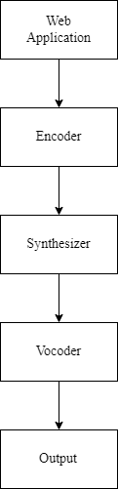
Fig 5.1 Architectural Diagram

Sequence Diagram
A Sequence diagram is a type of interaction diagram because it describes how and in what order a group of objects work together.

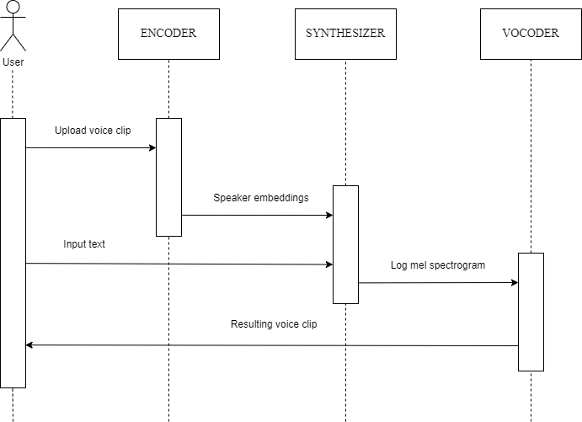
Fig 5.2 Sequence Diagram

Data flow Diagram
A data flow diagram (DFD) is a graphical or visual representation using a standardized set of symbols and notations to describe a business’s operations through data movement.

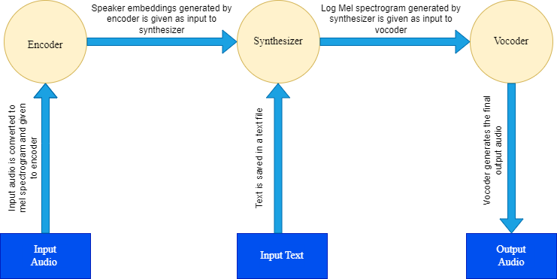

Fig 5.4 Dataflow Diagram

CHAPTER 6
IMPLEMENTATION

Module implementation

Three neural networks that were trained separately make up the system. The first network converts the speech signal into a fixed-dimensional vector and is in charge of encoding the speaker's voice. The second network is a synthesizer that uses inputs like phonemes or graphemes to produce mel-spectrograms. Finally, the resulting spectrogram is transformed into time domain waves by the third network using an autoregressive WaveRNN vocoder. Together, these three networks create synthetic speech.
A brief reference utterance from the speaker to be copied is given to the speaker encoder at the moment of inference. A sentence that has been converted into a phoneme sequence is provided as input to the synthesizer, and it generates an embedding that is used to condition the synthesizer. The vocoder creates the speech waveform using the synthesizer's output. Figure 6.1 provides an illustration of this.

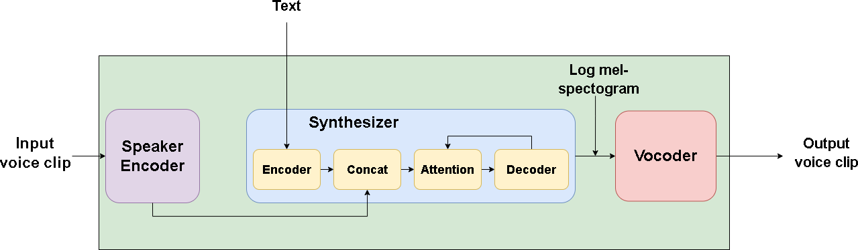

Fig.6.1 Components of Text-To-Speech With Custom Voice System
One feature is that each model may be trained independently on different datasets. One aims to have a noise-resistant model for the encoder that can capture the diverse qualities of the human voice. Therefore, it would be preferable to train the encoder on a wide corpus of numerous different speakers rather than imposing strict noise-level requirements. In addition, the encoder is trained using the GE2E loss, which only needs to know who the speaker is. When using GE2E, the model must learn a speaker verification task, which has little to do with voice cloning on its own. But the assignment is written so that the network will produce an embedding that accurately captures the speaker's speech.
The synthesizer can be trained on a voice using this embedding. Transcripts are necessary for the vocoder and synthesizer datasets, and the quality of the resulting audio can only be as excellent as the data. As a result, it is often the case that smaller, higher quality, and annotated datasets are needed.

Speaker Encoder

A reference speech signal from the desired target speaker is used to condition the synthesis network using the speaker encoder. The usage of a representation that captures the features of various speakers and the capacity to recognize these qualities from just a brief adaption signal, independent of its phonetic content and background noise, are essential for effective generalization. A speaker-discriminative model that was trained on a text-independent speaker verification challenge satisfies these characteristics. The speaker encoder's goal is to create a latent, fixed-dimensional embedding that will be utilized to train the synthesizer network using reference speech sounds from the selected target speaker. The latent embedding must capture all of the properties of the human voice, regardless of background noise or phonetic content, in order to achieve effective generalization across speakers.
For speaker verification, we use a neural network framework that is very scalable and precise. A series of log-mel spectrogram frames calculated from a voice utterance of any length are translated by the network into a fixed-dimensional embedding vector called the d-vector. The network is trained to maximize a generalized end-to-end speaker verification loss, resulting in high cosine similarity between embeddings of utterances from the same speaker and low cosine similarity between those of utterances from other speakers, which are spread out widely in the embedding space. There are no transcripts used; instead, the training dataset consists of 1.6-second-long segments of spoken audio examples with speaker identification labels.
Input A stack of three LSTM layers, each with 768 cells, is used to create the network, which receives 40-channel log-mel spectrograms. Each layer is then projected to 256 dimensions. The output of the top layer is L2-normalized at the last frame to produce the final embedding. An arbitrary length speech is divided during inference into 800 ms segments that are 50% overlapped. The outputs from each window's individual network runs are averaged and normalized to get the final utterance embedding. We discover that training on a speaker discrimination task results in an embedding that is directly suited for conditioning the synthesis network on speaker identity, even though the network is not directly optimized to learn a representation that captures speech attributes relevant to synthesis.
On a speaker verification task, the speaker encoder is trained. A common biometrics application is speaker verification, which uses a person's voice to confirm their identification. By determining a person's speaker embedding from a few utterances, a template is made for them. Enrollment is the name of this procedure. The system compares the embedding of a user's self-identification utterance with the enrolled speaker embeddings during runtime.
Each utterance in a training batch has a set duration of 1.6 seconds. These shorter entire utterances in the dataset were sampled from the greater complete utterances. Despite the fact that the model architecture can accommodate inputs of different lengths, it is reasonable to assume that it will work best with utterances that are similar in length to those used in training. As a result, a speech is divided into 1.6-second segments at inference time that overlap by 50%, and the encoder forwards each segment separately. To create the utterance embedding, the outputs are normalized and then averaged.
During inference, an arbitrary length speech utterance is divided into 1.6 second windows with a 50% overlap. The network then operates individually on each window, and the final utterance embedding is calculated by taking the average of all outputs. This method is illustrated in Figure 6.2.
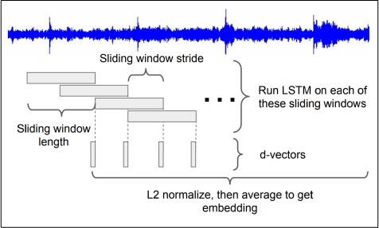

Figure 6.2 Sliding window approach used during inference.

Synthesizer

To generate the Mel spectrogram from text, we employ a sequence-to-sequence neural network based on Tacotron 2, which is conditioned on the speaker embedding. At each time step, the speaker embedding is concatenated with the synthesizer encoder output to condition the output and match the speaker's voice.
The architecture features an attention mechanism that connects a recurrent sequence-to-sequence encoder-decoder architecture. Modifications to the architecture are made to allow multiple speakers in a manner akin to Deep Voice 2. To transfer the characteristics of the target voice, the speaker embedding vector acquired from the Speaker encoder network, which corresponds to the target speaker, must be merged into the Synthesizer network. At each time step, the embedding vector and encoder output of the synthesizer network are combined. For the model to converge across different speakers, it is sufficient to feed the concatenated embeddings to the attention layer.
Mel-frequency spectrogram, a low-level acoustic representation, is used as an intermediate feature representation. This format is smoother than waveform representations and is easily generated from time-domain waveforms. It is simpler to train with a squared error loss since it is phase invariant within each frame. Mel-spectrograms provide a more compact summary of the frequency data. It is calculated using a non-linear transform applied to the short-time Fourier transform (STFT) frequency axis, which was motivated by how the human auditory system works. Humans do not hear audio frequencies on a linear scale, according to study. Lower frequency variations are easier to spot than higher frequency variations. The Mel-scale is an example of an auditory frequency scale that emphasizes lower-frequency aspects that are essential for speech intelligibility while downplaying subtleties in higher frequencies that are mostly dominated by fricatives and other noise bursts and do not require high-fidelity modeling.
An encoder-decoder network connected by attention makes up the architecture of the synthesizer. A latent feature representation is created by the encoder using the input character sequence. We concatenate the speaker embedding to each encoder frame rather than just using the encoder output for decoding. This makes it easier for the synthesis process to add the desired voice qualities to the resulting mel-spectrograms.

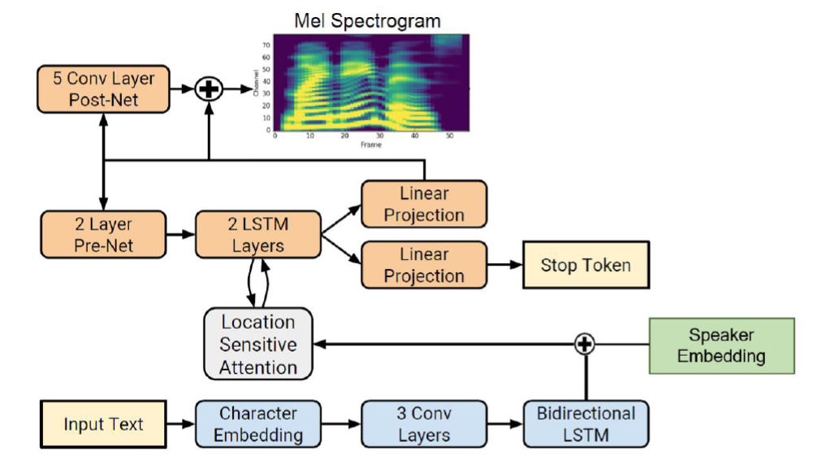

Figure 6.3 The Tacotron2 architecture conditioned on speaker-embeddings. The blue and orange blocks represent the encoder and the decoder, respectively.
The decoder then employs this concatenated form to forecast a spectrogram. The input characters are represented by a learnt 512-dimensional character embedding, which is subsequently processed by a stack of three convolutional layers, batch normalization, and activation. Each convolutional layer includes 512 filters with a 5 x 1 shape and a 5 character range. The convolutional layers model the long-term context (like N-grams) associated with the input character sequence. The output of the final convolutional layer is fed into a single 512-unit bi-directional LSTM layer, or 256 units in each direction, to create the encoded features.
The synthesizer's decoder uses an autoregressive recurrent neural network to predict a mel-spectrogram one frame at a time from the encoded input sequence. For the prediction produced by the previous time-step, an information bottleneck layer consisting of a pre-net with two fully connected layers and 256 hidden units with ReLU is utilised. The pre-net output and the attention context vector are combined, then fed via a stack of two unidirectional LSTM layers, each with 1024 units. The concatenation of the LSTM output and the attention context vector is projected through a linear transform to forecast the target spectrogram frame. Finally, the predicted mel spectrogram is fed into a convolutional post-net with 5 layers, which determines a residual to add to the prediction and improve the entire reconstruction. Each post-net layer is made up of 512 filters with a shape of 5 x 1. All layers except the final layer are subjected to batch normalization and tanh activations.

Vocoder

The system uses WaveRNN as a vocoder, which performs autoregressive synthesis to create time-domain audio waveforms from Mel spectrograms produced by the synthesis network. By training on input from numerous speakers, the synthesizer network is able to easily create a multi-speaker vocoder by capturing all the features required for high-quality synthesis of distinct voices in the form of Mel spectrograms.

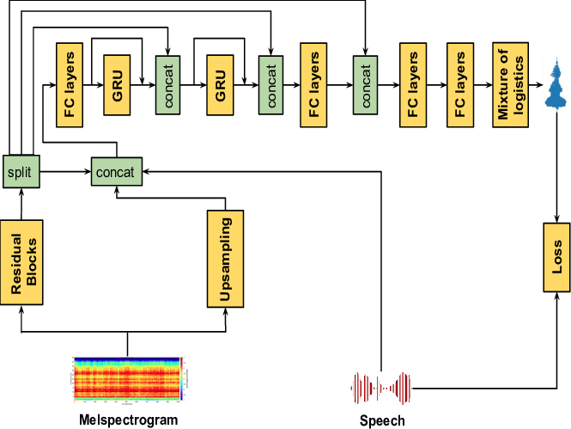

Figure 6.4 The WaveRNN architecture.

The 60 WaveNet convolutions are all replaced by a single GRU layer in WaveRNN. The ground truth audio serves as the model's target and the GTA mel spectrogram produced by the synthesizer serves as its input. The model makes predictions for fixed-size waveform segments during training. The bottom 8 bits (coarse) of the target 16-bit sample are predicted first and are then utilized to condition the prediction of the higher 8 bits in the forward pass of WaveRNN, which is implemented with only N = 5 matrix-vector products. The output is sampled from a distribution from which parameters are being predicted.
As shown in Fig. 6.4, this design consists of residual block sand up sampling network, followed by GRU and FC layers. The conditional network and the recurrent network are the two main networks that make up the architecture. A pair of residual networks, an up-sampling network, and a network with three scaling factors make up the conditioning network. With the use of several residual blocks, we first transfer the input's acoustic properties, or mel-spectrograms, to a latent representation. After that, the latent representation is divided into four components, each of which will serve as an input to the recurrent network. To match the desired temporal size of the input signal, the up-sampling network is put into place. Speech is supplied into the recurrent network along with the outputs of these two convolutional networks, namely the residual and up-sampling networks. Two unidirectional GRUs are used in the recurrent network, and there are a few fully connected (FC) layers at the very end. By design, the overhead complexity is decreased by using fewer parameters and better utilizes the temporal context.
The speaker encoder's output is not directly conditioned on by the network. A multi-speaker vocoder can be created by simply training on data from numerous speakers since the mel spectrogram predicted by the synthesizer network captures all of the pertinent information required for high quality synthesis of a variety of voices.

CHAPTER 7

TESTING

The testing stage of a product's development life cycle is crucial. In order to assess whether the programme is operating as intended, a collection of test cases were used to execute the test programme. The output of the programme for each test case was then examined. The following testing procedures were used to identify errors, which were then fixed and documented for future use. So, before the system was prepared for implementation, it underwent a number of tests. Software testing should be distinguished from the independent discipline of Software Quality Assurance (SQA), which covers all business process domains, not simply testing, as this is a crucial aspect.

Testing Levels
Testing is part of Verification and Validation. Testing plays a very critical role for quality assurance and for ensuring the reliability of the software.
The objective of testing can be stated in the following ways.
    - A successful test is one that uncovers as-yet-undiscovered bugs.

    - A better test case has high probability of finding un-noticed bugs.

    - A pessimistic approach of running the software with the intent of finding errors.

Testing can be performed in various levels like unit test, integration test and system test.

Unit Testing
To guarantee that the different parts function properly, unit testing is used. Each component is examined separately from the rest of the system. Each module of this system was properly tested, and the results were compared to the predicted output. Unit testing concentrates verification work on the software design module's tiniest unit.

Integration Testing
Another type of testing is integration testing, which is typically carried out to find issues with how data moves between interfaces. Since the unit-tested components are grouped and tested in short segments, it is simpler to identify and fix mistakes. This strategy is maintained until all modules have been integrated to create the entire system.

System Testing
System testing is a type of testing that verifies a fully integrated, finished piece of software. A system test's objective is to assess the complete system requirements. The software is typically just a small part of a bigger computer-based system. The software is ultimately interfaced with other software and hardware systems. System testing is basically a collection of several tests performed solely for the goal of exercising the entire computer-based system.

Acceptance Testing
Acceptance Testing is a method of software testing where a system is tested for acceptability. The major aim of this test is to evaluate the compliance of the system with the business requirements and assess whether it is acceptable for delivery or not. After testing the system at different levels, how the complete system is accepted which meets all the mentioned functional and non-functional requirements.

Test Cases
A test case is a software testing document, which consists of events, action, input, output, expected result and actual result. Technically a test case includes test description, procedure, expected result and remarks. Test cases should be based primarily on the software requirements and developed to verify correct functionality and to establish conditions that reveal potential errors. Individual PASS/FAIL criteria are written for each test case. All the tests need to get a PASS result for proper working of an application.

Results:

Table 7.2: Test cases for project

Test Numbers | Test Case | Expected Results | Actual Output | Status
1 | Running the Web Application. | The Web application should run on local host on web browser | As expected, result. | Pass
2 | Taking audio input from the user in wav  or flac format. | The Web application should take audio input  from the device. | As expected, result. | Pass
3 | Taking text input  from the user in .txt format. | The Web application  should take text file input from the device. | As expected, result. | Pass
4 | Generating the output audio file. | The web application should generate an audio file in the target speaker's voice for  the given text. | As expected, result. | Pass

CHAPTER 8

RESULTS AND SNAPSHOTS

- Initially, when the user visits the website's homepage, they will be presented with the choice to input audio in either .wav or .flac format, as well as the option to upload a text file in .txt format.

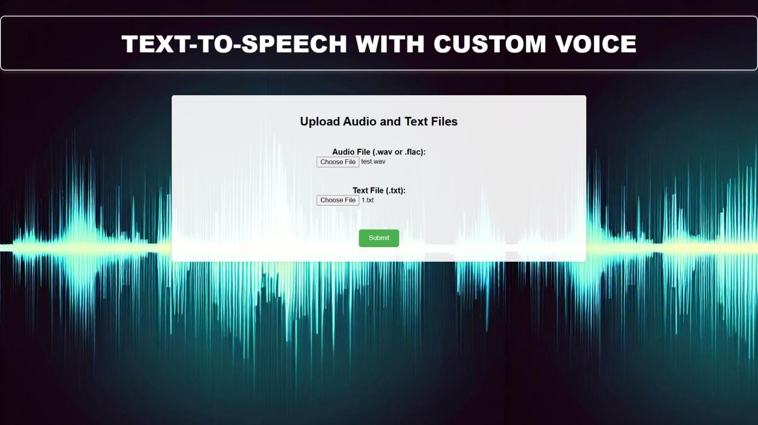

Fig 8.1: Home page of the website

- Once the user has provided the audio and text file inputs, they can proceed by clicking the submit button. After clicking the submit button, the user will receive a message indicating that the audio file is being generated. The generation of the audio file will take some time.

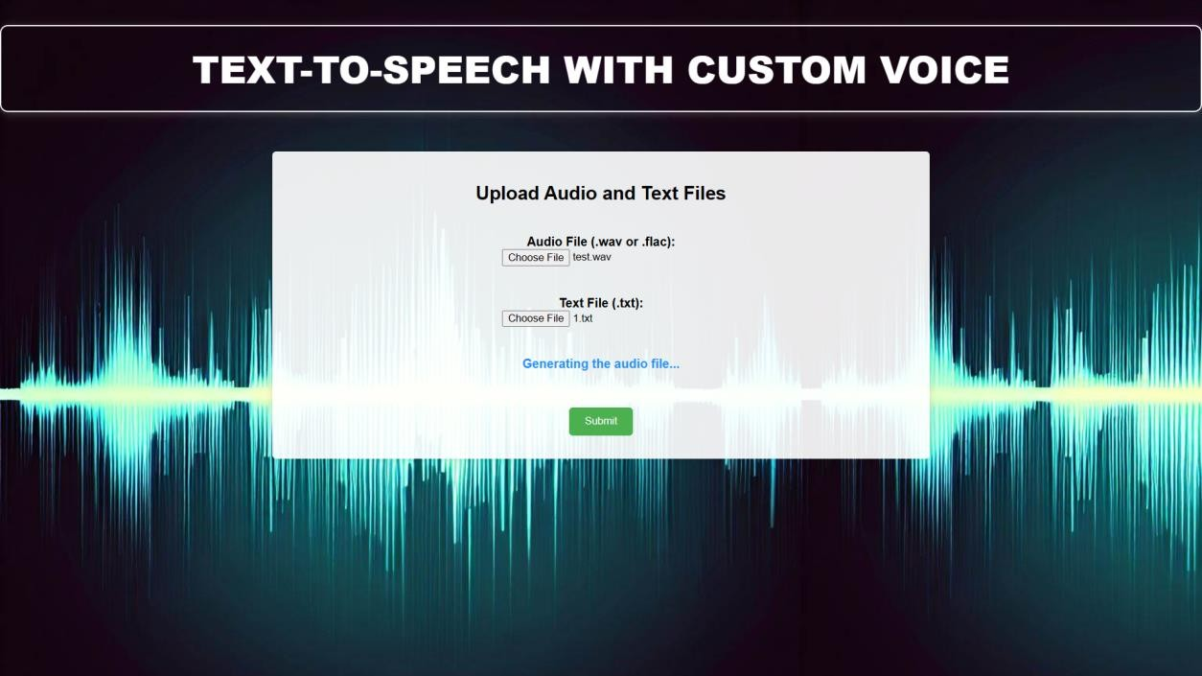

Fig 8.2: Result generation page

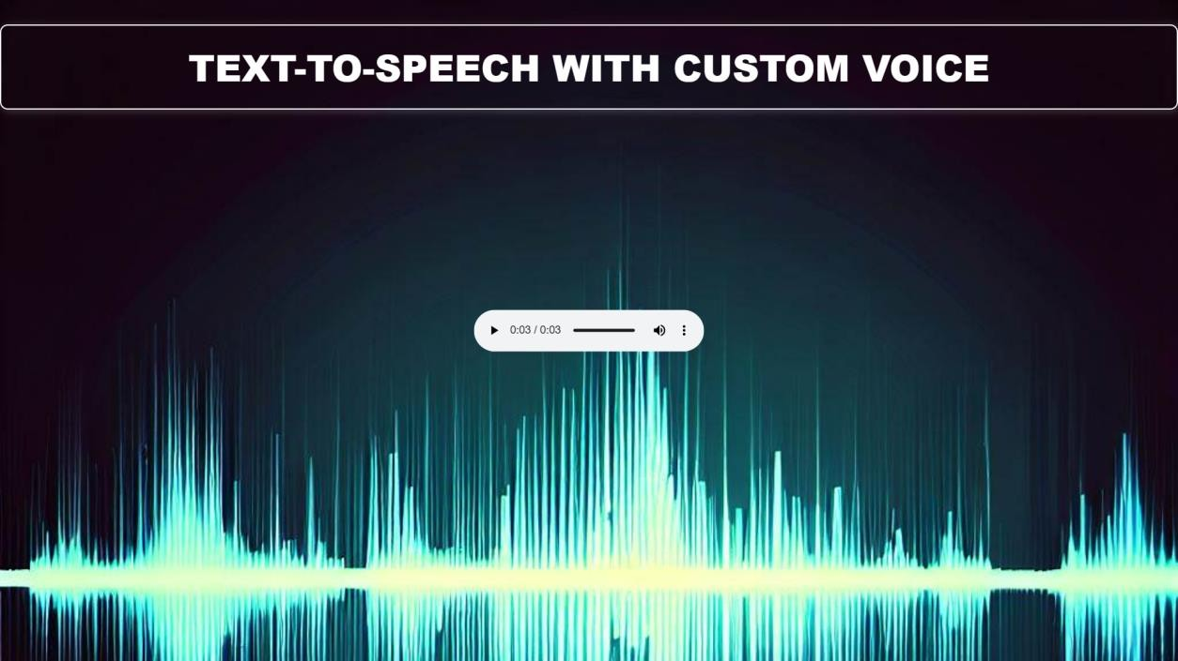
Fig 8.3: Output audio page

- Upon uploading the audio and text file and clicking the submit button, the application will commence generating the audio file. Once the audio file has been generated, it will be played back to the user on the output page.

The Mean Opinion Score (MOS) metric is a widely accepted method to measure the quality of synthesized speech. In this study, we used MOS to evaluate the synthesized speech of ten speakers, five of whom were included in the training data and five who were not. The rating scale used ranged from 1 (Least Similar/Natural) to 5 (Extremely Similar/Natural) in increments of 0.5.
Our evaluation yielded a Naturalness rating of 4.1, which indicates that the synthesized speech is highly natural and similar to human speech. A Naturalness score of 4.1 suggests that there are very few noticeable artifacts or distortions in the speech, making it sound like it was produced by a human speaker. This is a particularly promising result as the speakers used in the evaluation include both trained and untrained voices, indicating that our model can generate high-quality speech for a wide range of speakers.
In addition to the Naturalness rating, our evaluation also yielded a Similarity rating of 3.7, which indicates that the synthesized speech is moderately similar to the original speech. While the Similarity rating is not as high as the Naturalness rating, it still suggests that our model is capable of producing speech that is relatively close to the original input.
Overall, our results suggest that the model we developed is highly effective at synthesizing natural- sounding speech for a wide range of speakers. This is a promising result, as natural-sounding synthesized speech has a range of applications, including text-to-speech systems, voice assistants, and audio books.
The evaluation was done on a rather limited sample size of 10 speakers, it should be noted. Although the results are encouraging, it is crucial to evaluate the model using a bigger sample size in order to more thoroughly verify its efficacy. Further investigation into the precise elements that affect the Naturalness and Similarity ratings may also be done in order to provide guidance for future model development.

CHAPTER 9
CONCLUSION AND FUTURE WORK
In conclusion, the development of a text-to-speech system using personalised voice cloning technology has opened up new possibilities for creating distinctive and realistic-sounding voices. The availability of large speech datasets and advancements in machine learning techniques have made it possible to create high-quality customised voices that closely match the voice of a human speaker. Applications for Text To Speech with Custom Voice System include greater accessibility to digital content, more personalised audio content delivery, and improved human-computer interactions. However, there are still a number of challenges in creating a real-time voice cloning system that can produce speech in real-time without any audible pauses or errors.
Future research could concentrate on a number of topics to improve the functionality of the voice cloning system. One of the key areas that requires improvement is the system's ability to produce speech that sounds more realistic. Customers may currently find it difficult to interact with the information because the system's speech can sound artificial or mechanical. Researchers may look into incorporating more NLP techniques into the system to address this issue and produce expressive, fluid speech.
The system could be improved further by adding support for more languages. The system now only supports English, which reduces the number of users it could accommodate. The technology could benefit a larger audience by enhancing its language skills to incorporate additional spoken languages, such as Indian languages.
Additionally, future studies can concentrate on creating a system that is lighter and more effective and can be included into a variety of applications. The system's computational complexity might be reduced, and it could be made to work better in real-time, making it an important tool for improving the accessibility and customization of digital content.

Page 36

REFFERENCES

- W. Ping, K. Kainkaryam, Y. Wang, D. Stanton, Y. Zhang, R. J. Weiss, and B. Li. (2018). TACTRON: Towards end-to-end speech synthesis. arXiv preprint arXiv:1703.10135.
- K. Arık, A. H. van den Oord, and O. Vinyals. (2019). Efficient Neural Audio Synthesis. In Proceedings of the 36th International Conference on Machine Learning, ICML 2019, Long Beach, California, USA, 9-15 June 2019 (pp. 232-241).
- Y. Zhang, Y. Fan, N. Hu, and L. Zhang. (2019). Transfer Learning from Speaker Verification to Multi-Speaker Text-To-Speech Synthesis. arXiv preprint arXiv:1806.04558.
- D. Snyder, D. Garcia-Romero, G. Sell, D. Povey, and S. Khudanpur. (2018). Exploring the Encoding Layer and Loss Function in End-to-End Speaker and Language Recognition System. In Proceedings of the 19th Annual Conference of the International Speech Communication Association (INTERSPEECH 2018) (pp. 306-310).
- H. Zen, A. Senior, and M. Schuster. (2019). Char2Wav: End-to-end speech synthesis. arXiv preprint arXiv:1905.02316.
- Jia, Y., Zhang, Y., Weiss, R. J., Wang, Q., Shen, J., Ren, F., Chen, Z., Nguyen, P., Pang, R., Moreno, I. L., & Wu, Y. (2019). Transfer Learning from Speaker Verification to Multispeaker Text-To-Speech Synthesis. In ICASSP 2019-2019 IEEE International Conference on Acoustics, Speech and Signal Processing (ICASSP) (pp. 6965-6969). IEEE.

Page 37

