Hazards and Toxic effects on the different Living organism of Cadmium and its related safety Assessment.
Om Singh*¹ Vinod Kumar Singh¹, Rajendra Yadav ²
¹Department of Chemistry, COER University, Roorkee Haridwar, Uttarakhand India.
²Department of Pharmaceutical Sciences, Gurukula Kangri Vishwavidyalaya Haridwar, Uttarakhand India.
Abstract
Cadmium element is harmful, non-essential and dangerous for human health, Soil and aquatic life. Cadmium plays negative role for soil organisms and soil ecology. Other impacts of Cadmium in Human body Cadmium causes poor bone mineralization, enhances possibility of bone fracture and osteoporosis. It also causes serve pain associated with bone. Cadmium has good corrosive resistance properties, and working as stabilizers for Polyvinylchloride. Cadmium exposure cause pathophysiological damages as well as growth rate reduction in fish. Continuous exposure damages Larva and decreases their growth rate, fluid replacement supplemental oxygen, and mechanical ventilation may effective if Cadmium poisoning occur and gastric lavage also beneficial soon after exposure.
Key words: Cadmium effects, Sources of Cadmium, Toxicity, Reproductive biology, Uses
*Corresponding author: Om Singh
*Corresponding author Email: - omchemist.singh@gmail.com
Introduction
Cd (Cadmium) is a by-product of zinc, or lead refining and easily to recyclable. Cadmium enters in soil due to application of insecticides, fungicides, fertilizers and sludge in agriculture Baby, J., et al. 2010. Cadmium plays negative role for soil organisms and soil ecology. Cadmium element is harmful, non-essential and dangerous for human health Magrath, S.P. 1999. It has good corrosive resistance properties; hence its coating provides better protection in marine environment, aerospace application where safety and reliability is essentially required. It has been found that coating of Cadmium corrodes preferentially the material on which it is covering. Cadmium is used as pigments in paints. It is good stabilizer for polyvinylchloride where it prevents degradation of material due to direct exposure to sunlight.
Routes of Cadmium exposure
In industries, Cd is used since long various industrial purpose and its toxicity focused in the middle of the last century. As discussed in introductory part that ores of Zn, Cu, and Pb contain Cd. Concentration of Cadmium increase in environment temporarily due to Volcanic eruption. Exposure and accumulation of cadmium in excess causes highly toxic effects on human body.
By the Natural Environment
Groundwater rarely contains high levels of Cd, till the unreacted waste water from industries & mining operations are not involved. Cadmium dissolved from water lines in presence of Soft or acidic water, its raised level in water also due to leaching from house hold pipes and fitments. But these are neglected in case of clinical toxicity of Cd. Cadmium occurs in air as particulate matter as Cadmium Oxide through the soldering, smelting or industrial process carried out at high temperature.
By the Food Chain
From soil system, cadmium uptakes place in plants like tobacco, rice, potatoes, vegetables and grains. Cadmium is accumulated particularly in liver and kidney. High concentration of Cadmium in Shellfish and mushrooms in certain areas also affect the human health due to regular consumption.
Chemical Properties
Cd is transition metal which contain 1 mmHg pressure at 394ºC. Cd is odorless and corrosive resistant. Cadmium metals and its oxides do not dissolve in water. Cadmium has (+2) oxidation state. Solid Cd is not flammable but powdered of Cd will burn and produce corrosive and toxic fumes National Toxicology Program 2004 & Schaefer, H. R., et al 2020. Chloride, Sulphate, and Nitrate salt of Cadmium dissolves in water. Some of the salts of Cadmium are insoluble but gets dissolved in water when interact with acids or exposed to light/ oxygen. Cadmium melts at 321⁰C.
Cd Half-Life
After studying some kinetic literature on aromatic compounds like o-Anisidine Singh, J., Kaushik, R. D., et al. 2017. The half-lives of aromatic amines in blood plasma are 1.5 hours to 80 hours and Benzoquinones half-life approximately several days like 8 - 21 days. So, in the comparison of aromatic amines Cadmium half-life in the kidney ranges quite long as between Six to Thirty-eight years; and in the liver is between Four to Nineteen years Schaefer, H. R., et al 2020.
Hazardous effects of Cd
Cadmium dust or fumes damage the fertility, and organs of child in womb. It causes long term toxicity in water bodies and hazardous for aquatic life.
Effects on the environment
After a threshold level of heavy metal concentration, it becomes harmful to aquatic animals and human health, and also affect the ecological balance. Heavy metals get accumulated in soft tissues and leaves toxic effect on human body. The aquatic organisms are exposed to heavy metal via their body surface, gills and consumption of food. Baby, J., et al. 2010. Human exposure like as combustion of fossil fuel, phosphate fertilizers, activities as associated with production of iron, steel, cement in industries, and also through production of solid municipal solid & its related activities Morrow, H. 2000.
Effect on human health
In human body heavy metals enter through air, water and food. Agricultural activities and involvement of human in manufacturing of pharmaceuticals causes absorption of toxic heavy metals by absorption through skin. Cd considers as a carcinogen and cause lung cancer Liu, W. 2010. Inhalation of Cd through dust (fine), vapors or intake of vastly soluble complexes of cadmium (Cd) may cause cause pneumonitis, pulmonary edema, and death Morrow, H. 2000 & Hayes A.W. 2008. As an endocrine disruptor, Cadmium can interact with hormonal activity as noted in some laboratory study. Cadmium easily binds to estrogen which influences the transduction along the estrogen and MAPK signaling pathways at low doses, Fechner, P.; et al. 2011. & Stoica, A.; et al.2000., & Ali, I.; et al. 2010, Ali, I.; et al. 2012 & Johnson, M. D.; et al. 2003.
Effects of Cd in reproductive biology
The ovarian steroidogenic pathway in rats is influenced by Cd. Piasek et al. study the direct effects of in vitro Cd exposure on steroidogenesis in rat ovaries. Generally, cadmium attacks on hormones like testosterones and progesterone. Piasek M, et al. 1999. Using of low dosage of Cd stimulate the ovarian progesterone biosynthesis, in spite of high dosages inhibit it Henson MC et al. 2004. After some study find out Cd is a powerful nonsteroidal estrogen in vivo and in vitro. Cadmium precipitation increased uterine wight in rat and boosted mammary development also, Johnson MD, et al. 2003.
Respiratory Effects
If excess concentration of Cd Fumes and its related compound inhaled may cause pulmonary disease. Production of Cd alloy, Cd coated steel welding, smelting and refining of Cd. The Initial symptoms of Cd poisoning, are fever, cold, myalgia somewhat similar to flu like illness. Appearance of chest pain, cough and dyspnea may take place in later stages. Davison, A. G, et al.1988.
Gastrointestinal Effects
Take the acidic food or beverages, cigrates and improper stored contains food with Cd coating Cause irritates the gastric epithelium and show the symptoms of gastrointestinal disorder like vomiting, pain in abdomen and cramps, looseness of the bowels, and tenesmus Bowers, N., et al. 1997., & Schaefer, H. R., et al. 2020 & Saini, S., et al. 2020. High doses of cadmium irritate the gastric epithelial tissue Nordberg GF 2004.
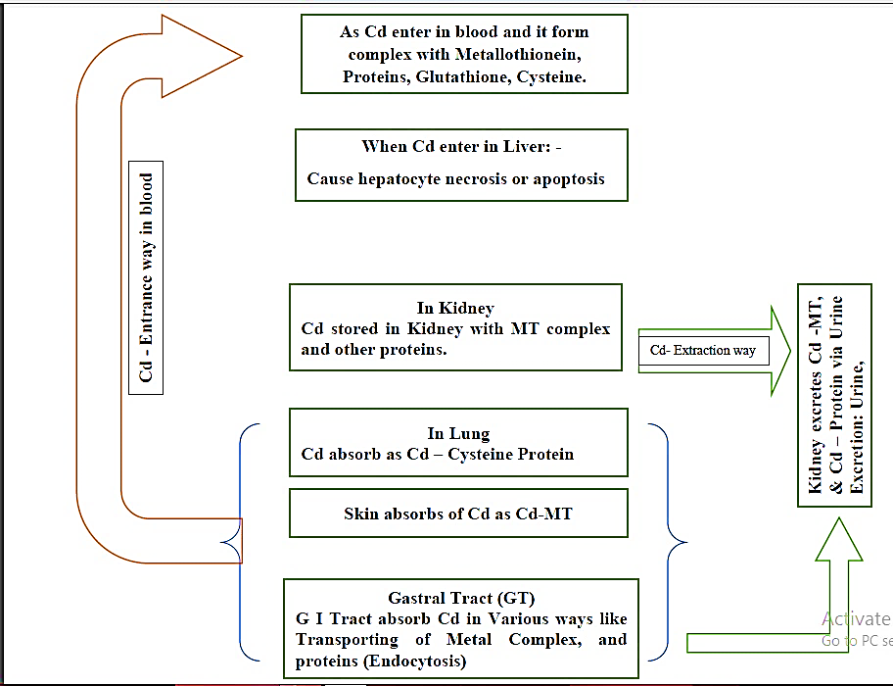
Fig. 1 Effect on Human Health by Cd
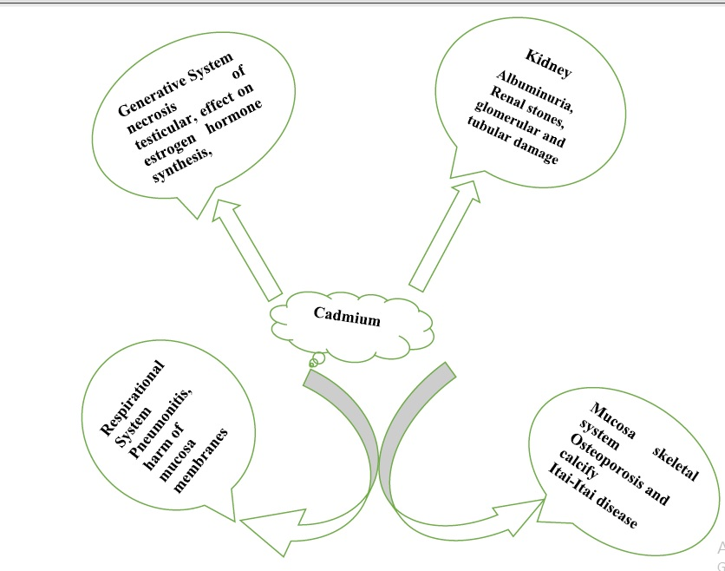
Fig. 2 Effected organs by Cd
Effect on Aquatic Ecosystem
When Cd enter in freshwaters, is precipitate in huge amount and be located in the bottom as residues. So, sediment is main source of Cd for aquatic environment WHO, 2000. Cd direct and indirect affect the aquatic organism’s life, populations and ecosystems due to its toxic nature. Cd consider as a pollutant and so can change the trophic levels of aquatic organism like as fish Sorensen, E.M.B. 1991. Cd uptake from sediment bottom and feeding by fauna and sediments-rooted flora and circulate the food chain in fishes with specific path Irwin, R.J. et al 1997.
Toxic effects of Cd on fish
Due to toxic nature of Cd it is a tensioning agent for fish the results Cd exposure causes pathophysiological damages as well as growth rate reduction in fish Annabi, A., et al. 2013 ., & Hansen, J.A., et al. 2002. In mammals and fish Cd cause hepatic and renal injuries with the probable to induce oxidative stress Kim, J.H., et al. 2010.
Cd causes hypocalcemia when interacts with the calcium and during its metabolism process. The higher concentrations of calcium in water protect fish from Cd uptake. Cd should be chronically toxic due to long time exposure. Continuous exposure of cadmium destroys the larva and decrease the rate of growth. Cadmium has acute toxic effect but organism may die due to higher concentration of Cd for short time period AMAP., 1998. After above discussion we find that the how much impact of Cd will be on aquatic organism, its depend upon the Cd chemical forms because Cd and its salts has different type of toxicities and bio-concentration. This form binds with metallothionein and decreases its toxicity normally occurs in fish’s liver. Though, higher concentration of Cadmium produces toxic effects. Bradl, H., 2005 & Wright, D.A. et al. 2002.
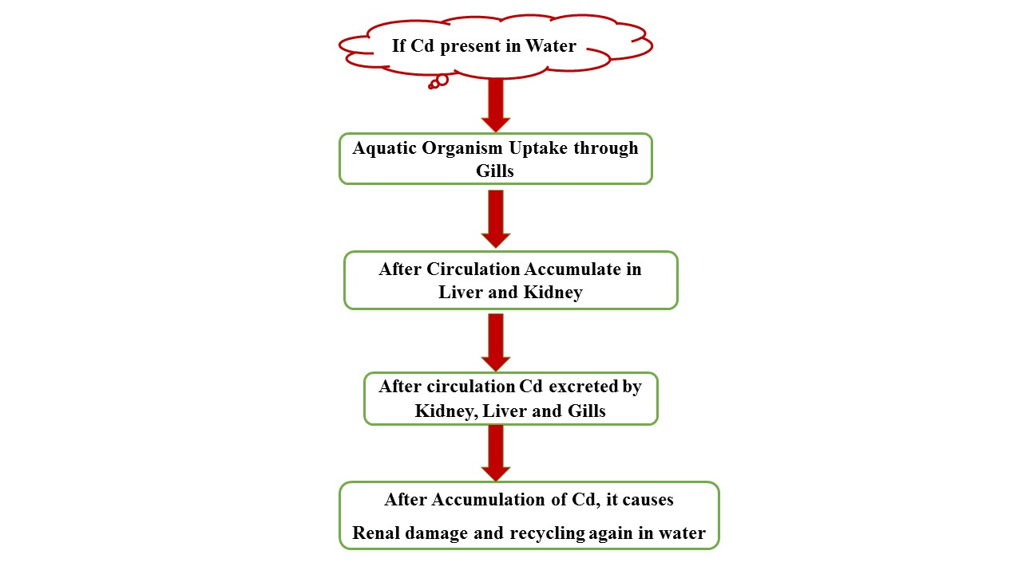
Fig. 3 Effect of Cd on Aquatic Life
Safety Assessment: -
if the dust/fumes of Cd Oxide are inhaled it may cause cancer. Cd dust or fumes damage the fertility, and organs of the fetus & cause lifelong injurious for aquatic life so a precautionary system is necessary. Not only Cd but also any chemical species before handling first we understand the handling procedure and safety measures and then use it Soni, R. K., et al. 2021 & Singh, O. 2021. Before handling the Cd First read and understand the safety precaution. Chose a well-ventilated area for Cd-related work. wear always respiratory safety mask for breathing, when using this product wash your hands properly before eating, drinking or smoking. as Cd get moisture should be explosively so avoid moisture or another surface because it may leave traces and can accumulate, so ensure that any effluent or solid waste disposal, and consider dry covered area.
Substance like polyphenolic compounds mostly present in plants prevents the harmful effect of Cd, polyphenolic compound involves in biological activity and has antioxidant properties. Such compound has at least one aromatic ring with active phenolic group. Some relevant substance which contains polyphenolic group examples are given below.
Cloves, Plums, Cocoa Powder, Apples, Walnuts, Almond, Green olives, Spinach, Red Onion, Red Wine, Green Tea, Black Tea, Coffee, Black Chokeberry and Peppermint etc.
Applications/ Uses
Normally Cd is used as electric batteries, pigments, Buxbaum, Gunter; et al 2005. Cd used as coating agents, Smith C.J.E.; et al. 1999
Another use of Cd is electroplating. In Nuclear fission work as Neutron absorber Scoullos, Michael J.; et al. 2001
Batteries; Nickel-Cd, Krishnamurthy, N. et al. 2013
In Television technology, as QLED TVs, Maynard, Andrew.2017
In medical field cd used as Anticancer drugs, Abyar, Selda; et al. 2019
In past years Cd oxide used in black and white television Lee, Ching-Hwa; et al. 2002
photoconductive surface used CdS coating for photocopier drums. Miller, L. S.; et al. 1991
Cd used as light, heat, & also used as weather stabilizer in polyvinylchloride, Jennings, Thomas C. 2005
FUTURE DIRECTIONS
Cd toxicity relation in plants is a key source for future research direction and how to mitigate this toxicity-related problem. Understand the interactivity, quality of water, condition and cadmium in fish as well as existence of other metal interaction, protection, future threats, and the genetic influence of Cd bioaccumulation. Invents new agricultural tools for mitigating Cd related harmful problems, identification, genetic reasons which give more resistant species for future.
Conclusion
Due to nonbiodegradable toxic nature of cadmium, it is a very serious problem for rising countries. It effects on photosynthesis process in plants, and crops productivity also not only in the harvest but is also harmful to human health major known reason is Cigarette smoking, which cause lung or kidney disease. use new methods for mitigating Cd-related problems like microbial remediation, and phytodegradation, implement Cd counter agricultural tools. The European Commission has proposed the limits like 60 – 20mg Cadmium per Kilogram. Displacement of Fluid, supplementary Oxygen and better or instant ventilation may very effective. In case ingestion of Cadmium, gastrointestinal distillation via vomiting or gastric lavage may be effective after exposure of Cadmium.
Acknowledgement: I thankful to my head of the department he encourage me for this manuscript and all Authors are thankful to COER University Roorkee Haridwar 247667 provide the necessary facilities.
Declaration of conflict of interest: Authors has no conflict of interest for this manuscript all authors are agree for proceed this.
Funding details: Authors did not get any fund for this manuscript.

References:
- Baby, J., Raj, J. S., Biby, E. T., Sankarganesh, P., Jeevitha, M. V., Ajisha, S. U., & Rajan, S. S. (2010). Toxic effect of heavy metals on aquatic environment. International Journal of Biological and Chemical Sciences, 4(4).
- Magrath, S.P. (1999). Adverse effects of Cd on soil microflora and fauna. In B.R. Singh (eds), Cd in Soils and Plants. Kluwer Academic Publishers, Dordrecht. pp. 199-218.
- National Toxicology Program (2004). NTP classifies Cd as known to be a human carcinogen.
- Schaefer, H. R., Dennis, S., & Fitzpatrick, S. (2020). Cd: Mitigation strategies to reduce dietary exposure. Journal of food science, 85(2), 260-267.
- Singh, J., Kaushik, R. D., Singh, O., Saini, R., & Kumari, E. (2017) Stopped flow kinetics of Mn^{II} catalysed Periodate Oxidation of o-Anisidine–First Report on Stability constant of the ternary Intermediate complex formation. International Journal of ChemTech Research, 10(6), 228 – 240.
- Morrow, H. (2000). Cadmium and Cadmium Alloys, Kirk-Othmer Encyclopedia of Chemical Technology. 1-36.
- Liu, W., Zhou, Q., An, J., Sun, Y., & Liu, R. (2010). Variations in Cd accumulation among Chinese cabbage cultivars and screening for Cd-safe cultivars. Journal of Hazardous Materials, 173(1-3), 737-743.
- Hayes, A. W. (2008). Principles and Methods of. Toxicology.
- Fechner, P.; Damdimopoulou, P.; Gauglitz, G. (2011). "Biosensors paving the way to understanding the interaction between Cd and the estrogen receptor alpha".
- Stoica, A.; Katzenellenbogen, B. S.; Martin, M. B. (2000). "Activation of estrogen receptor-alpha by the heavy metal Cd". Molecular Endocrinology (Baltimore, Md.)
- Ali, I.; Penttinen-Damdimopoulou, P. E.; Mäkelä, S. I.; Berglund, M.; Stenius, U.; Akesson, A.; Håkansson, H.; Halldin, K. (2010). "Estrogen-like effects of Cd in vivo do not appear to be mediated via the classical estrogen receptor transcriptional pathway". Environmental Health Perspectives.
- Ali, I.; Damdimopoulou, P.; Stenius, U.; Adamsson, A.; Mäkelä, S. I.; Åkesson, A.; Berglund, M.; Håkansson, H.; Halldin, K. (2012). "Cd-induced effects on cellular signaling pathways in the liver of transgenic estrogen reporter mice". Toxicological Sciences.
- Johnson, M. D.; Kenney, N.; Stoica, A.; Hilakivi-Clarke, L.; Singh, B.; Chepko, G.; Clarke, R.; Sholler, P. F.; Lirio, A. A.; Foss, C.; Reiter, R.; Trock, B.; Paik, S.; Martin, M. B. (2003). "Cd mimics the in vivo effects of estrogen in the uterus and mammary gland". Nature Medicine.
- Piasek M, Laskey JW. (1999). Effects of in vitro Cd exposure on ovarian steroidogenesis in rats. J Appl Toxicol. 19:211–217
- Henson MC, Chedrese PJ. (2004). Endocrine disruption by Cd, a common environmental toxicant with paradoxical effects on reproduction. Exp Biol Med (Maywood). 229:383–392.
- Davison, A. G., Taylor, A. N., Darbyshire, J., Chettle, D. R., Guthrie, C. J. G., O'Malley, D., & Gompertz, D. (1988). Cd fume inhalation and emphysema. The Lancet, 331(8587), 663-667.
- Bowers, N., Pratt, J. R., Beeson, D., & Lewis, M. (1997). Comparative evaluation of soil toxicity using lettuce seeds and soil ciliates. Environmental Toxicology and Chemistry: An International Journal, 16(2), 207-213.
- Saini, S., & Dhania, G. (2020). Cd as an environmental pollutant: ecotoxicological effects, health hazards, and bioremediation approaches for its detoxification from contaminated sites. Bioremediation of industrial waste for environmental safety: Volume II: biological agents and methods for industrial waste management, 357-387.
- Nordberg GF. (2004) Cd and health in the 21st century--historical remarks and trends for the future. Biometals.; 17:485–489.
- WHO., (2000). Cd. In: Air Quality Guidelines for Europe, WHO (Ed.). Chapter 6.3, World Health Organization, Regional Office for Europe, Copenhagen, Denmark, ISBN-13: 9789289013581, pp: 136-138.
- Sorensen, E.M.B., (1991). Metal Poisoning in Fish. CRC Press, Boston, MA., USA.,
- Irwin, R.J., M. van Mouwerik, L. Stevens, M.D. Seese and W. Bashaw, (1997). Environmental contaminants encyclopedia: Copper entry. National Park Service, Water Resources Divisions, Water Operations Branch, Fort Collins, CO., USA., July 1, 1997, pp: 1-99.
- Annabi, A., K. Said and I. Messaoudi, (2013). Cd: Bioaccumulation, histopathology and detoxifying mechanisms in fish. Am. J. Res. Commun., 1: 60-79
- Hansen, J.A., P.G. Welsh, J. Lipton and M.J. Suedkamp, (2002). The effects of long‐term Cd exposure on the growth and survival of juvenile bull trout (Salvelinus confleuentus). Aquat. Toxicol., 58: 165-174.
- Kim, J.H., J.S. Rhee, J.S. Lee, H.U. Dahms, J. Lee, K.N. Han and J.S. Lee, (2010). Effect of Cd exposure on expression of antioxidant gene transcripts in the river pufferfish, Takifugu obscurus (Tetraodontiformes). Comp. Biochem. Physiol. C: Toxicol. Pharmacol., 152: 473-479
- AMAP., (1998). AMAP assessment report: Arctic pollution issues. Arctic Monitoring and Assessment Programme (AMAP), Oslo, Norway
- Bradl, H., (2005). Heavy Metals in the Environment: Origin, Interaction and Remediation. 1st Edn., Academic Press, New York, USA., ISBN-13: 9780120883813, Pages: 282.
- Wright, D.A. and P. Welbourn, (2002). Environmental Toxicology. Cambridge University Press, Cambridge, UK., ISBN-13: 9780521588607, Pages: 630.
- Soni, R. K., & Singh, O. (2021). Arsine: Risk assessment, environmental, and health hazard. In Hazardous Gases (pp. 11-21). Academic Press.
- Singh, O. (2021). Arsenic pentafluoride: Risk assessment, environmental, and health hazard. In Hazardous Gases (pp. 1-9). Academic Press.
- Buxbaum, Gunter; Pfaff, Gerhard (2005). "Cd Pigments". Industrial inorganic pigments. Wiley-VCH. pp. 121–123. ISBN 978-3-527-30363-2.
- Smith C.J.E.; Higgs M.S.; Baldwin K.R. (20 April 1999). "Advances to Protective Coatings and their Application to Ageing Aircraft". RTO MP-25. Archived from the original (PDF) on 17 May 2011. Retrieved 29 May 2011.
- Scoullos, Michael J.; Vonkeman, Gerrit H.; Thornton, Iain; Makuch, Zen (2001). Mercury, Cd, Lead: Handbook for Sustainable Heavy Metals Policy and Regulation. Springer. ISBN 978-1-4020-0224-3.
- Krishnamurthy, N. (2 July 2013). Engg. Chemistry, 2/e. New York: PHI Learning Private Limited. pp. 82–83. ISBN 978-81-203-3666-7.
- Maynard, Andrew. (2017). "Are quantum dot TVs – and their toxic ingredients – actually better for the environment?". The Conversation. Retrieved 23 July 2017.
- Abyar, Selda; Khandar, Ali Akbar; Salehi, Roya; Abolfazl Hosseini-Yazdi, Seyed; Alizadeh, Effat; Mahkam, Mehrdad; Jamalpoor, Amer; White, Jonathan M.; Shojaei, Motahhareh; Aizpurua-Olaizola, O.; Masereeuw, Rosalinde (December 2019). "In vitro nephrotoxicity and anticancer potency of newly synthesized Cd complexes". Scientific Reports. 9 (1): 14686.
- Lee, Ching-Hwa; Hsi, C. S. (2002). "Recycling of Scrap Cathode Ray Tubes". Environmental Science & Technology. 36 (1): 69–75.
- Miller, L. S.; Mullin, J. B. (1991). "Crystalline Cd Sulfide". Electronic materials: from silicon to organics. Springer. p. 273. ISBN 978-0-306-43655-0.
- Jennings, Thomas C. (2005). "Cd Environmental Concerns". PVC handbook. Hanser Verlag. p. 149. ISBN 978-1-56990-379-7.

