Vitamin B₁₂ Fortification: Methods, Technologies & Regulations

Samikshya Panda¹, Aswani Thekkangil², Yashwanthi², Anjana², Shivani Chauhan³, Gurdeep Rattu^{4,*}
¹ Department of Biochemistry & Bioinformatics, Gandhi Institute of Technology and Management, Visakhapatnam, Andhra Pradesh-530045, India.
² Department of Biotechnology, Reva University, Rukmini Knowledge Park, Srinivasa Nagar, Bengaluru, Karnataka 560064, India
³ Department of Microbiology, University of Delhi South Campus, Benito Juarez Road, New Delhi-110021, India
⁴ National Horticulture Research and Development Foundation (NHRDF), Nashik-Aurangabad Road, Nashik-422003, Maharashtra, India

Authors email:
Samikshyapanda.20@gmail.com
Aswani.t@reva.edu.in
yashwanthik85@gmail.com
shivanichauhan109@gmail.com
* gurdeep.r147@gmail.com (corresponding author)

Editor Id “IIPER1680036292"

Abstract
Vitamin B₁₂ is incredibly vital for human metabolism and located in very low concentrations of the Pico molar level in body fluid causing anaemia and other severe conditions. Dairy products, meat, and fish are a few examples of foods high in vitamin B₁₂. Although the B₁₂ content of different types of milk is not high, increased milk consumption was associated with higher serum B₁₂ levels in geriatric persons in good health, showing that milk is a useful source of B₁₂. Reasons to fortify food products with vitamin B₁₂ are considered, including the high prevalence of depletion and deficiency of this vitamin that occurs in persons of all ages in resource-poor countries and in the elderly in wealthier countries, and the adverse functional consequences of poor vitamin B₁₂ status. From a global perspective, the main cause of inadequate intake and status is a low intake of animal-source foods; even lacto-ovo vegetarians have lower serum vitamin B₁₂ concentrations than omnivores, and for various reasons many populations have limited consumption of animal-source foods. In this chapter, we explained the molecular structure, chemistry, physical properties, bioavailability, and deficiency of vitamin B₁₂ followed by the strategies such as diet diversification, food fortification, challenges and vitamin B₁₂ fortification using nanotechnology.

Keywords: Food, fortification, vitamin B₁₂, deficiency, dairy products

  - Introduction
All animals and some microbes require vitamin B₁₂, which is a well-known by-product of specific bacteria. The water-soluble vitamin B₁₂, also known as cobalamin, is one of the necessary vitamins that significantly contribute to the health of neurological systems and the creation of blood cells (Antherjanam, 2021). Vitamin B₁₂ is incredibly vital for human metabolism and located in very low concentrations of the Pico molar level in body fluid so, cause anaemia and also the production of huge red blood cells (K.B. Akshaya, 2020). Dairy products, meat, and fish are a few examples of foods high in vitamin B₁₂. Although the B₁₂ content of different types of milk is not high, increased milk consumption was associated with higher serum B₁₂ levels in geriatric persons in good health, showing that milk is a useful source of B₁₂ (Tomohiro , 2016). It can also be manufactured in a lab and is usually taken along with other B vitamins. A few examples of body parts that require vitamin B₁₂ for proper development and operation are the brain, nerves, and blood cells. Methylocobalamin, cyanocobalamin, adenosylcobalamin, and hydroxocobalamin are the four distinct forms of cobalamin. The metabolically active forms of vitamin B₁₂ are 5-deoxyadenosylcobalamin and methylcobalamin. However, after being changed into methylcobalamin or 5-deoxyadenosylcobalamin, two more forms of cyanocobalamin and hydroxycobalamin become biologically active (Zhuo Cheng, 2016).
The European Food Safety Authority recommends that adults receive 4 μg of vitamin B₁₂ per day, and that these requirements are higher during pregnancy and lactation. Infants and children from mothers who are deficient in vitamin B₁₂ are at risk for developing a vitamin B₁₂ deficiency. Elderly people are also at risk for developing a deficiency in this vitamin (Obeid R, 2019). Over 690 million people globally are suffering from hunger, and close to 750 million people have experienced food insecurity in 2019 (FAO, 2020). Globally, current food consumption is shifting away from fresh, unprocessed foods like fruits and vegetables but towards animal-based foods and highly processed items (Bodirsky, 2020). The patterns of food intake vary depending on socioeconomic position as well as geographical, cultural, and demographic characteristics. According to Agriculture and Rural Development at the European Commission, emerging economies like China have seen a large rise in their consumption of high-value foods like meat and dairy products. Meanwhile, trends in developed economies like those in Europe and North America reflect a shift away from the intake of red meat and toward plant-based foods like fruits and vegetables (Agriculture and Rural Development, 2019). Growing worries about climate change, the environment, animal welfare, and health have coincided with a rise in plant-based diets (such as veganism or vegetarianism) in middle- and high-income countries (Jones, 2020).
Since animal products are the natural source of vitamin B₁₂, vitamin B₁₂ deficiency is particularly prevalent among vegetarians. In addition to impacting the production of red blood cells and the regular operation of the nervous system, it might result in neurological, haematological, and psychiatric symptoms (Nakos, 2021). In the context of severe and ongoing vitamin B₁₂ deficiency, neurocognitive manifestations such as dementia, cognitive impairment, depression, memory loss, delirium, and psychotic episodes are also feasible. Infertility, hearing loss, Glossitis, macular degeneration, skin hyperpigmentation, and bone disease are some additional symptoms of vitamin B₁₂ deficiency in adult individuals (Infante, 2021). In this chapter, we begin by focusing on the physical properties, chemistry, molecular structure, bioavailability, and deficiency of vitamin B₁₂. We then discuss strategies such as diet diversification, food fortification, challenges and vitamin B₁₂ fortification using Nanoparticle technology.

    - Vitamin B₁₂: discovery and nomenclature
Over the course of more than a century, vitamin B₁₂ was discovered, its role in metabolism was clarified, and the effects and remedies for its deficiency were discovered (Scott, 2012). Physicians in England had discovered the illness pernicious anaemia, a sickness that causes the body to generate few red blood cells, in the middle of the 1800s—well before vitamins were understood. The illness can be fatal and makes patients feel exhausted and out of breath. A group of doctors from Harvard University determined that most patients could avoid pernicious anaemia by consuming half a pound of liver daily in 1926. As a result, scientists around the world started looking for a way to separate the liver's anemia-preventing component. Randolph West (1890–1949) of Columbia University joined with Folkers to identify participants and administer various liver extractions to them. Due to the rarity of the disease, the researchers had to work carefully and wait weeks to find any individuals with pernicious anaemia.
A fortunate coincidence produced a crucial breakthrough: people discovered that Mary Shorb (1907–1990), a microbiologist who had previously worked for the U.S. Department of Agriculture, had discovered a bacterium that was responsive to liver extracts. Folkers brought Shorb to Merck to expedite his research after realising that the bacteria may be used as a substitute for human test subjects. The scientists noticed that the liver extracts that had the most encouraging effects on Shorb's bacteria had a pinkish hue, which suggested that the coveted vitamin was actually a red molecule. Vitamin B₁₂ (cobalamin) was separated in 1947 by Folkers and his team, producing tiny, vivid red crystals of the vitamin (Figure 1). The next year, this novel substance was examined on a patient with pernicious anaemia. Later research revealed that cobalamin is a vital component of animal growth. This insight prompted the practise of supplementing the vitamin in animal diets, which dramatically enhanced yields for cattle farmers (ACS, 2016).
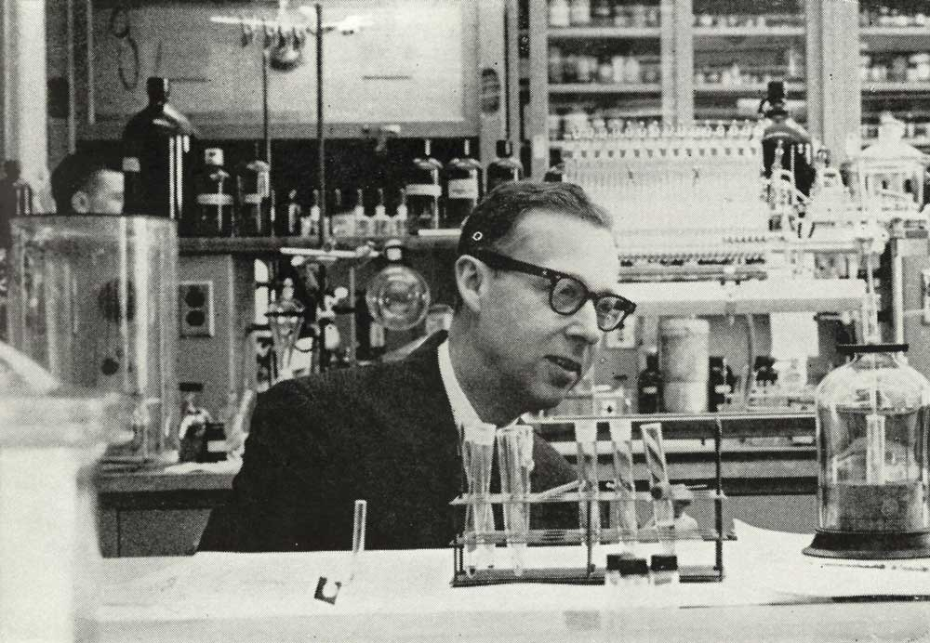
Fig. 1. Karl Folkers, director of Merck research, discovered vitamin B₁₂ (ACS, 2016)

The end result of a 10-year hunt for the liver component that would regulate pernicious anaemia was the discovery of vitamin B₁₂. Some pure red B₁₂ crystals are magnified 240 times as shown in Figure 2. Vitamin B₁₂ comes in a variety of forms, with cyanocobalamin being the main one utilised in vitamin supplements and pharmaceuticals. The cobalamins are a series of chemical compounds with a complicated structure that are closely linked and interconvertible. The larger family of corrinoids, which includes all cobalamins, consists of a planar four-membered pyrole ring (corrin-ring) with a central cobalt atom (Green, 2017). The IUPAC name for vitamin B₁₂ (cyanocoblamine B₁₂) is - (5, 6-dimethyl-benz-imidazolyl) cobamidcyanide. Its chemical formula is C63H88CoN14O14P, and its molecular weight is 1355.388 g mol (Mohamed, 2020; PubChem, 2022).

Fig. 2. Isolation of vitamin B₁₂ by researchers at Merck & Co., Inc. - A photomicrograph showing pure red crystals of Vitamin B₁₂ (cobalamin). (ACS, 2016)

    - Biosynthesis
The cobalt particle is arranged in a corrin ring of a porphyrin to form the octahedral cobalt (III) complexes that make up cobalamin (Figure 3). Four of the six coordination sites of the triply ionised cobalt atom are closely bonded by the formation of a corrin ring, while the fifth site is coupled by the formation of a dimethylbenzimidazole group. And the six coordination sites can be a hydroxyl bunch (-OH), a cyano aggregate (-CN), a methyl gather (-CH3) or a 5'- deoxyadenosyl gathering (Ahmed, 2018).
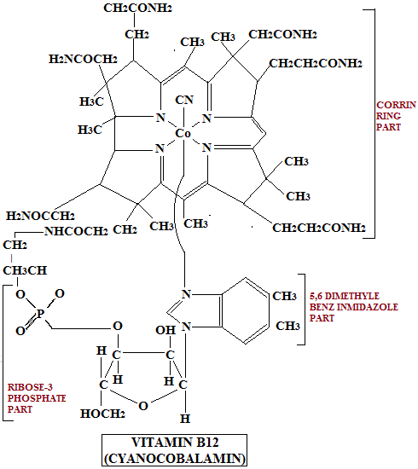
Fig. 3. Structure of Vitamin B₁₂ (Warren, 2012)

Depending on the molecular oxygen requirement and the timing of cobalt insertion, cobalamin can be produced de novo in prokaryotes through two different pathways. These pathways are aerobic and anaerobic pathways. Some strains can also produce cobalamin by utilising a salvage pathway to take in corrinoids. Cobalamin belongs to the family of modified tetrapyrroles, which also includes compounds like chlorophyll, haem, sirohaem, and coenzyme F₄₃₀ (Moore, 2012).

1.1.2.1. De novo pathway
Alpha-lipoic acid (ALA) is the first committed precursor in the pathway that produces tetrapyrroles. Either the C4 pathway or the C5 pathway can produce ALA. The enzyme ALA synthase catalyses the production of ALA from glycine and succinyl-CoA in the C4 pathway. In the C5 pathway, three enzyme processes convert glutamate into ALA (Moore SJ, 2012). Porphobilinogen synthase converts two molecules of ALA into monopyrrole porphobilinogen, which is then polymerized and cyclized to form uroporphyrinogen III. The enzymes porphobilinogen deaminase and uroporphyrinogen III synthase are responsible for catalysing this process. Precorrin-2, a common precursor of cobalamin, siroheme, and coenzyme F₄₃₀ are produced as a result of the methylation of uroporphyrinogen III at positions C-2 and C-7. The pathways for aerobic and anaerobic metabolism diverged at precorrin-2 and converge at coby(II)rinic acid a, c-diamide as show in Figure 4. During de novo cobalamin production, eight peripheral methylation processes take place in the same temporal and spatial order in the aerobic and anaerobic pathways (Avissar, 1989; Zappa, 2010; Cohen, 2014).
Fig. 4. De novo pathway of vitamin B₁₂ synthesis (Moore,2012)

1.1.2.2. Salvage pathway
For bacteria and archaea to get cobalamin, the salvage pathway is an efficient (in terms of energy) method (Figure 5). Exogenous corrinoids are taken up by gram-negative bacteria by an ATP-binding cassette (ABC) transport system, which is made up of the components BtuC, BtuD, and BtuF, which are membrane permease, ATPase, and periplasmic-binding protein, respectively. Corrinoid is transported by BtuB, a TonB-dependent transporter in the outer membrane, to the periplasmic corrinoid-binding protein BtuF. The latter then transports corrinoid to the inner membrane's BtuCD complex. ABC transporters are also utilised by Archaea for corrinoid absorption. In Halobacterium sp. strain NRC-1, archaeal orthologs of the bacterial BtuC, BtuD, and BtuF have been discovered (Moore, 2012). Following membrane transport, ATP:co(I)rrinoid adenosyltransferases adenosylate cobinamide (ACATs). There are three ACAT families: CobA, EutT, and PduO. AdoCbi is a substrate for a bifunctional enzyme with kinase and guanylyltransferase activities found in bacteria (CobU in S. typhimurium or CobP in P. denitrificans). The cbiZ gene in archaea produces an amidohydrolase that breaks down adenosylcobyric acid into AdoCbi, which is then combined with 1-aminopropanol-O-2-phosphate by an AdoCbi-P synthase (CbiB) to produce AdoCbi-P. CobY, which contains GTP:AdoCbi-P guanylyltransferase activity, is employed to transfer guanylyl to AdoCbi-P because the archaeal enzyme lacks AdoCbi kinase activity. Similar to the de novo process, the salvage pathway involves two additional reactions that transfer lower axial ligands onto AdoCbi-GDP to create AdoCbl (Fang, 2017).
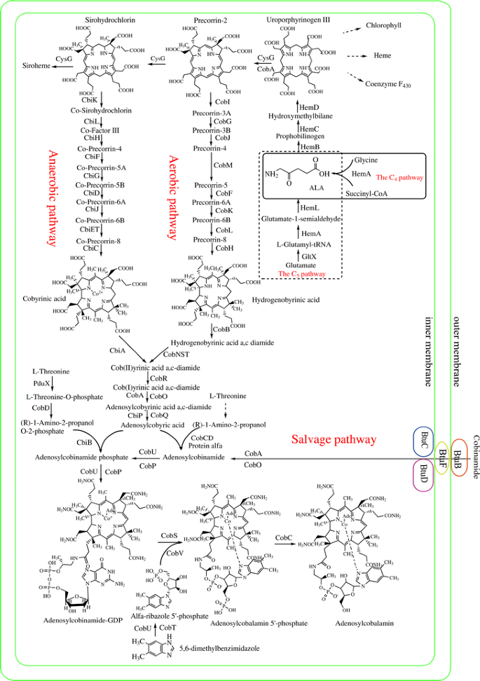
Fig. 5. Overall pathway (obeid, 2017)

1.2. Source
All mammals need vitamin B₁₂, which they ultimately get from microbial synthesis products. In their rumens, ruminant animals actually harbour bacteria that produce Cbls. Animal food such as meats, fish, shellfish, etc., dairy products, and eggs provide humans with vitamin B₁₂. The largest quantities are found in shellfish and organ meats. Improved corrinoid analytical techniques have revealed that some algae, fermented vegetable meals, and other plant products may contain B₁₂. Many prepared meals, including cereal, sports nutrition products, and other supplemented foods have synthetic vitamin B₁₂ added to them, particularly those sold in the United States to vegetarians (Stabler, 2020).

Vitamin B₁₂ in Animal Food
MEAT
Approximately 83, 3, and 33 μg/100 g of vitamin B₁₂ are present in cooked cow liver, lean meat, and turkey, respectively. Cooking meats caused significant vitamin B₁₂ losses (33%), according to reports. With increases in vitamin B₁₂ intake every meal, vitamin B₁₂ bioavailability should fall off dramatically (USDA, 2007).
Milk
Milk and dairy products are important sources of vitamin B₁₂ intakes, as the general population consumes a lot of dairy products, despite the fact that the vitamin B₁₂ concentration of different types of milk (0.3–0.4 μg/100 g) is not high. All of the naturally occurring vitamin B₁₂ in cow's milk is bonded to the transcobalamin, a protein that binds vitamin B₁₂ in mammals (Fedosov, 1996). Significant vitamin B₁₂ losses have been seen during the processing of milk; boiling for 2-5 minutes and 30 minutes led to 30 % to 50 % loss, microwave cooking for 5 minutes produced a 50 % loss, and pasteurisation resulted in losses of 5 % to 10 %. On the other hand, there was no visible decrease in the content of milk vitamin B₁₂ when the pasteurised milk was chilled for 9 days under retail-simulating or household handling circumstances. In cottage cheese, hard cheese, and blue cheese, about 20 % to 60 % of the vitamin B₁₂ that was initially contained in milk is restored.
EGG
The amount of vitamin B₁₂ in an entire egg ranges from 0.9 to 1.4 μg/100 g, with the majority of this vitamin being found in the yolk. Because eggs are a common dietary item, people typically consume high amounts of vitamin B₁₂ from them. Comparatively to other animal food sources, vitamin B₁₂ in eggs is typically poorly absorbed.

SHELLFISH
Numerous shellfish are widely consumed. It is well known that mussels are good sources of vitamin B₁₂, with concentrations often exceeding 10 μg/100 g, because they absorb significant amounts of vitamin B₁₂-synthesizing bacteria from the water.

Vitamin B₁₂ in Plant Food
Vegetables
It has been suggested that bamboo shoots are a good source of vitamin B₁₂. But it turns out that they don't have a lot of vitamin B₁₂ in them. Cabbage, spinach, celery, garland chrysanthermum, lily bulb, and taro produced similar outcomes. Only very little levels of vitamin B₁₂ were discovered in broccoli, asparagus, Japanese butterbur, mung bean sprouts, tassa jute, and water shield (0.1 μg/100 g of wet weight edible portion), which was calculated by subtracting the alkali-resistant factor from total vitamin B₁₂. These veggies could be able to absorb the vitamin B₁₂ present in some organic fertilisers. Mozafar showed that adding cow manure, an organic fertiliser, dramatically raises the amount of vitamin B₁₂ in spinach leaves and barley grains (Mozafar A, 1994).
Tea Leaves and Drinks
Different types of tea leaves contain significant levels of vitamin B₁₂: green tea (0.1-0.5 μg vitamin B₁₂ per 100 g dry weight), blue tea (approximately 0.5 μg), red tea (about 0.7 μg), and black tea (0.3-1.2 μg). Only 1-2 litres of fermented tea drink are consumed on a regular basis (typical in Japan), which is insufficient to achieve the RDA of 2.4 μg of vitamin B₁₂ per day for adults.
Vitamin B₁₂–Fortified Cereals
Ready-to-eat cereals that have been fortified with vitamin B₁₂ are known to make up a significant amount of daily vitamin B₁₂ intake. Several research teams hypothesised that consuming a morning cereal supplemented with folic acid, vitamin B₁₂, and vitamin B6 would raise these vitamins' blood concentrations and lower plasma, total homocysteine levels in elderly populations. For elderly persons and vegetarians, fortified breakfast cereals have emerged as a very beneficial source of vitamin B1

1.2.1. Stability in foods
Cyanocobalamin, often known as vitamin B₁₂, is a micronutrient that must be obtained through diet. However, vitamin B₁₂ is only present in foods made from animals, and it is highly susceptible to many factors. Given that the vitamin is present in a limited number of foods and in low concentrations, providing them with an adequate vitamin-B₁₂ supplement would be crucial for ensuring their health. When exposed to light, an acidic or basic environment, oxidising chemicals, and continuous heating at or near neutral pH, cyanocobalamin may deteriorate quickly. In this manner, the microencapsulation procedure would be an alternative to reduce the issues brought on by its instability (Mazzocato, 2019). The success of any fortification scheme depends on the fortificants' stability in the selected food matrix. There are numerous reports of co-crystallization being used in the food sector to boost the durability of taste components, safeguard anti-oxidants and keep delicate chemicals. Co-crystals are non-ionic molecular complexes that are utilised to increase the bioactive chemicals' solubility, stability, and bioavailability (Bajaj, 2020).

1.2.2. Vitamin B₁₂ bioavailability
The low bioavailability of vitamin B₁₂ (VB₁₂) is one of the most prevalent nutritional issues in the world. The bioavailability of nutrients is significantly influenced by the lipid content of cell membranes and interactions between molecules and cell membranes. The biological action of VB₁₂ is constrained by inadequate bioavailability. Despite eating a balanced diet and getting enough of this vitamin, the human body can only use, on average, 50% of the VB₁₂ that is taken in. Which results in VB₁₂ deficiency in roughly 15% of the population (Ramalho, 2020). Estimated Average Requirements (EARs) for vitamin B₁₂ range from 0.7 μg/day in infancy to 2.0 μg/day in adults; EARs satisfy 50% of population groups' needs, and the proportion of these groups failing to reach their EAR is used as a measure of adequate consumption. Each life stage group's EAR should be consumed by around 95% of the population, and fortification programmes should be developed to bridge the gap between typical intake and the EAR. During a person's lifetime, the recommended dietary allowances for B₁₂ vary from 0.9 to 2.4 μg/day, meeting the needs of 97.5% of the population. The widespread consensus is that taking large amounts of vitamin B₁₂ poses no health risks. Even at large intakes, there doesn't seem to be much of a risk of negative impacts on the general population (Institute of Medicine, 2000). The European Food Standards Agency (EFSA) created an algorithm to calculate vitamin B₁₂ bioavailability that takes intake into account: log absorption 5 0.7694 3 log intake 2 0.9614 (EFSA NDA Panel, 2015). This equation does not account for the possibility of a day's worth of ingestion leading to potentially more effective absorption. Further testing is required for these methods of determining absorption effectiveness from intake.

1.3. Vitamin B₁₂ deficiency
Symptoms of a vitamin B₁₂ shortage might be neurological, psychological, or physical. Medication containing vitamin B₁₂ can be used to treat it. Haematological and neurological problems might result from a B₁₂ shortage. B₁₂ is stored in excess in the liver; however, when B₁₂ cannot be absorbed for an extended length of time (due to nutritional insufficiency, malabsorption, or a lack of intrinsic factor), hepatic stores are depleted and shortage develops (Ankar, 2022). Vitamin deficiency in vegans is mostly caused by insufficient food intake, and B₁₂ malabsorption is linked to gastrointestinal disorders. Inherited conditions (such as Addison's pernicious anaemia, intrinsic factor deficiency), bariatric surgery, gastrectomies, and obesity are the main causes of B₁₂ malabsorption. Other reasons include pancreatic insufficiency, obstructive jaundice, bacterial overgrowth, parasite infestations, tropical sprue, inflammatory bowel illnesses, and celiac disease (Guéants, 2022).
Human body has to perform two things in order to absorb vitamin B₁₂ from the food that you eat. First, the hydrochloric acid in your stomach dissolves the vitamin B₁₂ in the food. Then, vitamin B₁₂ mixes with a protein produced by your stomach known as intrinsic factor. Your digestive system is then able to absorb vitamin B₁₂. Pernicious anaemia is a rare illness that prevents some people from having their stomachs produce intrinsic factor. As a result, they suffer from a vitamin B₁₂ deficiency since their body is unable to absorb vitamin B₁₂ effectively. In older adults, vitamin B₁₂ insufficiency is typical and has been linked to ischemic stroke (Yahn, 2021). Humans require vitamin B₁₂, which is also a critical component of the human gut bacteria. In newborns who are solely breastfed, vitamin B₁₂ insufficiency is prevalent. Infants' gut microbiota, in contrast to that of adults, has been demonstrated to have a reduced potential for the de novo production of vitamin B₁₂ and to rely on dietary sources of the vitamin (Boran, 2020).

    - Indicators for vitamin B₁₂
Combining four blood markers—total B₁₂ (B₁₂), holotranscobalamin (holoTC), methylmalonic acid (MMA), and total homocysteine (tHcy)—is a novel way to assess vitamin B₁₂ sufficiency. The formula for this combined B₁₂ status indicator is cB₁₂=log10 [(holoTC.B₁₂)/(MMA.Hcy)] - (age factor) (Fedosov, 2015).However, none of these indications alone have the best sensitivity or specificity for vitamin B₁₂ deficiency, which is difficult to diagnose (Miller JW, 2018). It should be noted, nevertheless, that there is not perfect agreement on these definitions. Additionally, both total vitamin B₁₂ and holoTC have a middle concentration range where the diagnosis is uncertain. Low and high blood concentrations of these substances are reliable markers of deficiency and adequacy, respectively. Although both homocysteine and methylmalonic acid have elevated levels when there is a vitamin B₁₂ deficiency, the reason for this is renal deficiency, whereas the causes of elevated homocysteine include folate and vitamin B6 deficiencies, hypothyroidism, genetic disorders, and the use of medications that affect one-carbon metabolism and homocysteine.
Total B₁₂
Actually, a measurement of serum cobalamin is used to determine vitamin B₁₂ levels. The most popular method for determining vitamin B₁₂ levels is the measurement of vitamin B₁₂ in serum. However, the test also evaluates serum holohaptocorrin and serum holotranscobalamin, and as a result, it may cover up true deficiency or erroneously suggest a condition of deficiency. The test employs an automated process and competitive-binding immune chemiluminescence, and it is widely accessible and inexpensive. It is unclear exactly how much serum cobalamin is considered clinically normal. According to some research, a blood cobalamin level of 148 pmol/L (200 ng/L) would be sensitive enough to identify vitamin B₁₂ deficiency in 97 % of individuals. What serum cobalamin level would indicate subclinical insufficiency is unclear (Devalia, 2014).
Plasma total homocysteine (tHcy)
A decrease in cobalamin leads to an increase in plasma total homocysteine (tHcy). A sensitive biomarker of cobalamin deficit, plasma tHcy increases early in the course of the deficiency, sometimes prior to symptoms and advances as the deficiency gets worse. However, tHcy is not unique to cobalamin deficiency as concentrations of tHcy are elevated in individuals with renal failure, hypothyroidism, and other genetic polymorphisms, as well as in cases of folate and B6 deficiency.
Holotranscobalamin (HoloTC)
Compared to serum cobalamin levels, the plasma cobalamin's "active" fraction may be more accurate. The HoloTC assay outperforms the serum cobalamin assay in clinical research studies when determining deficiency based on MMA levels. For HoloTC, healthy people should have levels between 35 to 171 pmol/l. The lower and upper reference ranges for plasma HoloTC are 19–42 pmol/l and 134–157 pmol/l, respectively.
Plasma methylmalonic acid (MMA)
When there is a cobalamin shortage, plasma MMA rises. Subjects with renal illness, small bowel bacterial overgrowth, and haemoconcentration may also experience artificially increased levels. Despite these restrictions, extremely high plasma MMA levels (>075lmol/l) nearly often signify cobalamin deficiency. Using mass spectrometry and gas chromatography, MMA in plasma is measured. As a result, this test is expensive, which has limited its use. High cut-off normal reference intervals for plasma MMA range from 027 to 075 lmol/l (Heil, 2012).

    - Vitamin B₁₂ prevalence across the globe
The signs of a severe vitamin B₁₂ shortage are well known, and Pernicious Anemia, an inflammatory illness where the intrinsic factor needed for the vitamin to be actively and efficiently absorbed is missing, is a prime example. Megaloblastic anaemia, as well as neurological, cognitive, and developmental difficulties, among other issues, will emerge from a lack of consistent injections or high oral doses of the vitamin (Allen, 2018; Green, 2017). Anemia or neurological issues are less common at the population level because B₁₂ deficiency is mostly brought on by inadequate intakes. Instead, the deficiency causes biochemical abnormalities such low plasma B₁₂ or high methylmalonic acid. Due to the lack of clinical symptoms, this condition is known as "subclinical cobalamin deficiency" (Carmel, 2013). However, if pregnant women have low vitamin stores, their unborn child will have low vitamin stores at birth, and this situation is difficult to entirely overcome by maternal supplementation in pregnancy (Duggan, 2014; Siddiqua, 2014). In contrast, fortification gives women the chance to enter pregnancy with enough B₁₂ reserves. In addition, B₁₂ levels in breast milk are often quite low in B₁₂ deficient women. Babies and kids whose mothers don't get enough vitamin B₁₂ have worse motor and mental development. Poor vitamin B₁₂ status in the old is linked to white matter degeneration and brain shrinkage, which is addressed by supplementation, along with high plasma homocysteine concentrations (Allen, 2018).
The metabolism of homocysteine in diabetic and non-diabetic people was studied. They discovered that compared to Europeans, 40-year-old Indians had double the concentrations of homocystein. Fascinatingly, the difference was attributed to a high prevalence of vitamin B₁₂ deficiency rather than folate deficiency, with higher MMA concentrations as support. Another study comparing urban and rural men found that vitamin B₁₂ deficiency is very common and has a substantial correlation with hyperhomocysteinemia. In contrast to slum dwellers and rural men, vitamin B₁₂ deficiency was twice as prevalent in urban middle-class men. The increasing prevalence of vegetarianism, improved hygiene and education, and increased obesity in the middle class could all contribute to this discrepancy. When the vitamin B₁₂ status of pregnant mothers was examined. Two out of three mothers had poor vitamin B₁₂ levels, 1/3 had high homocysteine levels, and 9/10 had high MMA levels. Children whose mothers had high levels of folate but low levels of B₁₂ during pregnancy had the highest levels of insulin resistance (Figure 6).
Fig. 6. HOMA-IR in the children in realation to maternal vitamin B₁₂ (18 weeks) and red cell folate levels (28 weeks).Low maternal vitamin B₁₂ (18 weeks) and high erythrocyte folate (28 weeks) predict high insulin resistance in the child at 6 years of age. Combined with the finding of higher adiposity in the children of mothers with high folate status suggests that maternal imbalance between these 2 vitamins during pregnancy may increase the risk of diabetes in the offspring. HOMA-IR, homeostasis model assessment of insulin resistance (Chittaranjan, 2020).

1.3.3. Vitamin B₁₂ deficiency and health concerns
The most typical cause of severe vitamin B₁₂ malabsorption is the autoimmune disease pernicious anaemia (Green, 2017). The disease affects people of all racial and ethnic backgrounds worldwide, and its frequency rises with age and female sex. Despite its rarity, pernicious anaemia can strike young people, and those of African descent may be more susceptible to its early onset (Stabler, 2020). Since the Cbl secreted in the bile cannot be bound to IF and is lost in the stool, there is impaired enterohepatic circulation of Cbl in pernicious anaemia, which causes a more rapid depletion of Cbl when treatment is stopped (Stabler, 2018). Dietary vitamin B₁₂ deficiency is common in areas with limited resources where people cannot access animal-based foods, particularly in parts of Africa, Asia, and South America. People who forgo the majority of animal products, like those in India, are also very likely to have it. Vegetarianism is becoming more popular in North America and Europe, which has led to a vitamin B₁₂ deficiency in otherwise healthy individuals. The infant is born with a vitamin B₁₂ deficiency even if the mother shows no symptoms. These infants have permanent disabilities as well as failures in myelination and brain development (Huemer, 2018). There is a very wide range of severity and symptoms associated with vitamin B₁₂ deficiency (Stabler, 2013).

1.3.4. Recommended dietary allowance
A vital nutrient, vitamin B₁₂ is crucial for many biological functions, including DNA synthesis and DNA methylation, the production of blood cells, and neuron function. The only sources of vitamin B₁₂ in human nutrition are animal products such meat, poultry, fish, eggs, and milk (Wolffenbuttel, 2020). Vegans are more likely to experience nutritional deficiencies, particularly vitamin B₁₂ deficiency. Although the lowest daily intake of B₁₂ necessary to maintain life is unknown, it is most likely less than 0.5 mcg per day. However, this would not maintain normal biochemical levels.
The Recommended Dietary Allowance (RDA) for vitamin B₁₂ is based on the quantity required to maintain normal serum vitamin B₁₂ levels and haematological status. The advised intake takes a 50% absorption rate into account. Adults require 2.4 μg of vitamin B₁₂ daily. To meet their RDA, adults over 50 are advised to primarily consume foods fortified with vitamin B₁₂ or a vitamin B₁₂-containing supplement because 10 to 30% of older people may have trouble absorbing naturally occurring vitamin B₁₂. Patients who have vitamin B₁₂ deficiencies brought on by a lack of intrinsic factor must receive medical attention (Brito, 2018). The advised doses for pregnant and lactating mothers were raised to 2.6 and 2.8 ug, respectively. The recommended daily allowances for children rise from 0.4 ug for newborns to 1.8 ug for teenagers (Table 1).
Table 1: Show Recommended Dietary Allowance (RDA) for children, boys and girls of different age group (k venkaiah,2002)
RDA for children | 1–3 years | 0.9 μg/day of vitamin B₁₂
 | 4–8 years | 1.2 μg/day of vitamin B₁₂
RDA for boys | 9–13 years | 1.8 μg/day of vitamin B₁₂
 | 14–18 years | 2.4 μg/day of vitamin B₁₂
RDA for girls | 9–13 years | 1.8 μg/day of vitamin B₁₂
 | 14-18 years | 2.4 μg/day of vitamin B₁₂

1.4. Food fortification
Food fortification is defined as the process of adding essential vitamins or minerals during the processing of commonly consumed food to alleviate their nutritional values. It is widespread in all regions of the world and especially in lower income countries. Deficiency of essential micronutrients is highly prevalent in all sections of the society. Food fortification has been demonstrated to be a cost-effective technique with higher social, economic, and most importantly better health benefits. It has direct implications in physical and cognitive skills of people who are affected by the deficiencies of essential micronutrients (Olson, 2019). An intervention study conducted in 2020 stated that when compared with placebo/no intervention, MMN (multiple micro nutrient) fortification may reduce iron deficiency by 56%, iron deficiency anaemia by 72%, anaemia by 32%, vitamin B2 deficiency by 64%, vitamin B6 deficiency, vitamin A deficiency by 58%, by 91% and vitamin B₁₂ deficiency by 58% (Das et al., 2019).
Food fortification programs have been conducted in several countries to overcome micronutrient deficiency and related problems with various degrees of effectiveness (Dewi, 2021). Food fortification with vitamins have been on the rise in recent times owing to increasing trends of deficiencies and malnutrition as a result of it. Rice fortification with vitamins and minerals has the potential to increase the nutrition in rice-consuming countries where micronutrient deficiencies exist (Pena-Rosas JP 2019).
Numerous studies have been conducted globally, including in India, to assess the status of Vitamin B₁₂. It was observed that Vitamin B₁₂ concentration was highest in colostrum and gradually decreased over the first 3-4 months of lactation. Some evidence indicated a positive association between habitual maternal vitamin B₁₂ intake and milk vitamin B₁₂ concentration in marginally nourished women. Supplementation with 50-250 µg of vitamin B₁₂ per day during pregnancy and lactation increased human milk vitamin B₁₂ concentrations while the intervention was ongoing (Dror DK, 2018).
Research has also shown that decreased B₁₂ vitamin levels and increased total choline or homocysteine in maternal blood are associated with an elevated risk of Neural Tube Defects (NTDs). Certain genetic polymorphisms involved in these pathways have also been implicated in the risk of developing NTDs. Consequently, choline, betaine, and B₁₂ metabolism, which are crucial for optimal methylation, are emerging as potential risk factors (Figure 7). The accumulation of scientific evidence warrants intervention studies based on periconceptional supplementation of vitamin B₁₂, choline or betaine (Imbard A, 2013).
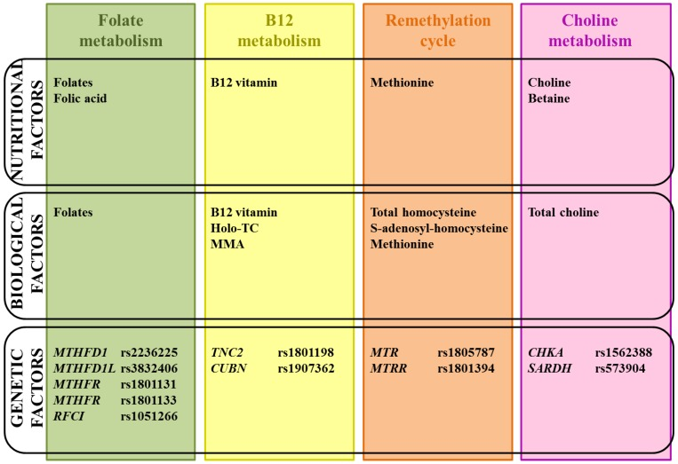
Fig. 7. Supplementation of vitamin B₁₂ (Imbard A, 2013)

1.5. Fortification guidelines
Although historically rare, vitamin B₁₂ deficiency is now recognised as a global health problem that poses severe clinical issues, including progressive megaloblastic anaemia and potentially irreversible neurological abnormalities. Numerous studies have shown that many people, particularly the elderly populations, suffer from this asymptomatic vitamin B₁₂ deficiency. These studies include data presented at the WHO Technical Consultation. This necessitates the fortification of vitamin B₁₂ in foods. To ensure that fortification is effective and safe, it is essential to consider specific parameters. These include setting beneficial and safe standards, operational procedures, micronutrient premix procurement, storage, handling, quality control, sampling, analysis, record-keeping, labelling with logo, packaging, and distribution; so that fortification should be both safe and effective (Allen et al., 2010; Carmel et al., 2010).

1.5.1. Foods fortified with vitamin B₁₂
A lack of vitamin B₁₂ can cause severe issues and poor health. Vitamin B₁₂ is vital for proper red blood cell development, brain function, and DNA synthesis, and its deficiency can lead to severe complications and illness. Its necessary amount can be obtained via food for those with a varied diet that includes animal products. However, those who consume a plant-based diet and older adults, those taking certain medications or suffering from gastrointestinal issues, may be more susceptible to deficiency. These people can only get vitamin B₁₂ from fortified foods or supplements. The recommended dietary allowances (RDAs) differ depending on a person’s age and whether they are pregnant or nursing, claims the National Institutes of Health Trusted Source. Vitamin B₁₂ is needed in doses of 2.4 mcg per day for healthy adults and 2.8 mcg per day for pregnant and lactating women. And for people over the age of 50, the RDA for B₁₂ is 25 to 100 mcg, which should be met through supplements and fortified foods (NMCD database 2010; Mayo 2010). The RDA for vitamin B₁₂ is shown in Figure 8.
Vitamin B12 intake (mcg)

Fig.8. Recommended dietary allowances of vitamin B₁₂ for different populations.

Since vitamin B₁₂ cannot be produced by our body, we must obtain it from outside sources. It is mostly attainable through animal products. As a result, it can be difficult for vegans and vegetarians to receive enough vitamin B₁₂. Yoghurt, milk, other dairy products, eggs, nutritional yeast, nori, tempeh, vitamin B₁₂ supplements, and fortified meals are a few good sources of vitamin B₁₂ besides animal sources (Mayo 2010). The vitamin B₁₂ source from fortified foods and its intake per saving were mentioned in Table 2.
Table 2: Dietary intake values for vitamin B₁₂ (in mcg) from different fortified foods (NMCD database 2010)
Fortified foods | Servings | Intake (mcg)
Almond or oat beverage | 1 cup | 1.1
Soy or rice beverage | 1 cup | 1.0
Soy burger | 2 ½ oz | 1.8
Cereals | 1 cup | 0.6-2.1

Cereals can be fortified with vitamin B₁₂, folate, iron, and vitamin A including the bran and whole wheat oats. Regular consumption of fortified cereals can help the body to raise vitamin B₁₂ levels. Non-dairy milk that is fortified, such as soy and almond milk, does not naturally contain vitamin B₁₂; this vitamin is added during the fortification process. One cup of soy or almond milk contains 2.1 mcg of vitamin B₁₂ daily (Didit et al., 2018). Table 3 explicitly shows the amount of vitamin B₁₂ consumed in fortified cereals and non-dairy milk based on serving size.
Table 3: Dietary intake values for vitamin B₁₂ from fortified cereals and non-dairy milk in different servings (NMCD database 2010; Mayo 2010; Didit et al., 2018).
Fortified cereals | Vitamin B₁₂  per 3/4 Cup | Vitamin B₁₂  per 100g | Vitamin B₁₂  per 200 Calories
 | 6.1μg  (254% DV) | 21μg  (875% DV) | ₁₂.8μg  (535% DV)
Fortified non-dairy milk | Vitamin B₁₂  per 16oz Glass | Vitamin B₁₂  per 100g | Vitamin B₁₂  per 200 Calories
 | 6μg  (249% DV) | 1.2μg  (51% DV) | 7.5μg  (311% DV)

1.6. Vitamin B₁₂ fortification methods: Challenges
There are various ways to fortify food. It is possible to fortify foods that are widely consumed by the general population (mass fortification), to fortify foods designed for specific population subgroups, such as complementary foods for young children or rations for displaced populations (targeted fortification), and/or to allow food manufacturers to fortify foods on the market (market-driven fortification) voluntarily. In general, mass fortification is almost always mandatory, targeted fortification can be either mandatory or voluntary depending on the public health significance of the problem being addressed, and market-driven fortification is always voluntary but subject to regulatory limits. Typically, national conditions determine whether food fortification is required or optional. For instance, enforcing mandatory fortification may not be feasible in nations where small mills produce a significant portion of maize flour. If possible, in such a situation, one option would be to permit small mills to fortify their product voluntarily while adhering to predetermined rules.
Because of the wide range of national circumstances and public health objectives worldwide, many different approaches to food fortification regulation have emerged. Food fortification guidelines are established by law or through cooperative agreements in most industrialised nations. Conversely, fortified foods are manufactured without government oversight or control. It is generally advised that all forms of food fortification be properly regulated to ensure the safety of all consumers and the maximum benefit to target groups because it is the government's responsibility to protect public health. Legally speaking, fortification can be classified as either mandatory or voluntary. These terms describe the degree of responsibility expected of food producers to adhere to governmental intentions stated in the law. Regarding food fortification, the critical distinction between mandatory and voluntary regulation is the degree of certainty over time that a specific category of foods will contain a predetermined amount of a micronutrient. Mandatory fortification increases the likelihood that the relevant population group will have a consistent supply of fortified foods to consume, which benefits public health.

1.7. Conclusion
The rationale behind vitamin B₁₂ fortification is supported by several key factors. Firstly, there is a significant prevalence of deficiency globally, spanning across all age groups. Notably, the perinatal period is particularly vulnerable to the adverse consequences of deficiency. Another crucial consideration is the necessity to prevent the worsening of deficiency due to folic acid fortification. Importantly, no known risks of adverse effects on health or the quality of fortified foods have been identified, and the overall cost of implementing fortification is affordable. In conclusion, this book chapter serves as a comprehensive guide to Vitamin B12 fortification, offering a wealth of knowledge and actionable insights for policymakers, researchers, and stakeholders invested in public health and nutrition. By fostering collaborations between scientific innovation and regulatory diligence, we can pave the way towards a healthier, fortified future, where Vitamin B12 becomes more accessible, and its benefits are reaped by populations around the globe.
Acknowledgments
This research article was supported by The Gandhi Institute of Technology and Management, Visakhapatnam, Reva University, University of Delhi South Campus, and National Horticulture Research and Development Foundation (NHRDF), India.

Conflicts of interest
The authors declare no conflict of interest, financial or otherwise.

Ethical approval
Ethics approval was not required for this work.

Reference
- Antherjanam, S., Saraswathyamma, B., Krishnan, R.G. et al. “Electrochemical sensors as a versatile tool for the quantitative analysis of Vitamin B₁₂ ’’. Chem. Pap. 75, 2981–2995 (2021).
- Agriculture and Rural Development (2019). Global Food Supply and Demand, Consumer Trends, Trade Challenges. In EU Agricultural Markets Briefs. Rome: FAO, 16.
- American Chemical Society National Historic Chemical Landmarks. The Vitamin B Complex.http://www.acs.org/content/acs/en/education/whatischemistry/landmarks/vitamin-b-complex.html.
- Ahmed, L.M., Saaed, S.I. and Marhoon, A.A.,. “Effect of oxidation agents on photo-decolorization of vitamin B ₁₂ in the presence of ZnO/UV-A system”. Indonesian Journal of Chemistry, 18(2), pp.272-278, 2018.
- Ankar A, Kumar A. “Vitamin B₁₂ Deficiency”. [Updated 2022 Jun 5]. In: StatPearls [Internet]. Treasure Island (FL): StatPearls Publishing; 2022 Jan.
- Allen, Lindsay H., Joshua W. Miller, Lisette De Groot, Irwin H. Rosenberg, A. David Smith, Helga Refsum, and Daniel J. Raiten. "Biomarkers of Nutrition for Development (BOND): vitamin B-₁₂ review." The Journal of nutrition 148, no. suppl_4 (2018): 1995S-2027S.
- Allen, L. H. (2018). “Efficacy and Safety of Vitamin B₁₂ Fortification. Food Fortification in a Globalized World”, 255–261.
- Avissar Y, Ormerod J, Beale S. “Distribution of δ-aminolevulinic acid biosynthetic pathways among phototrophic bacterial groups”. Arch Microbiol. 1989;151: 513–9.
- Bodirsky, B. L., Dietrich, J. P., Martinelli, E., Stenstad, A., Pradhan, P., Gabrysch, S., et al. (2020). “The ongoing nutrition transition thwarts long-term targets for food security, public health and environmental protection”. Scientific Reports 10:19778. doi: 10.1038/s41598-020-75213-3
- Boran, P., Baris, H.E., Kepenekli, E., Erzik, C., Soysal, A. and Dinh, D.M., 2020. “The impact of vitamin B₁₂ deficiency on infant gut microbiota. European journal of paediatrics”, 179(3), pp.385-393.
- Brito A, Habeych E, Silva-Zolezzi I, Galaffu N, Allen LH. “Methods to assess vitamin B₁₂ bioavailability and technologies to enhance its absorption”. Nutr Rev. 2018;76: 778e792.
- Bajaj, S. R., & Singhal, R. S. (2020). “Enhancement of stability of vitamin B₁₂ by co-crystallization: A convenient and palatable form of fortification. Journal of Food Engineering”, 110231. doi:10.1016/j.jfoodeng.2020
- Cohen GN. “Biosynthesis of cobalamins including vitamin B₁₂ “. In Microbial biochemistry. Dordrecht: Springer; 2014. p. 555–565
- Chittaranjan, Y. (2020). “Vitamin B₁₂: An Intergenerational Story”. Nestlé Nutrition Institute Workshop Series, 91–102. doi:10.1159/000503358
- Carmel, R., 2013. “Diagnosis and management of clinical and subclinical cobalamin deficiencies: why controversies persist in the age of sensitive metabolic testing”. Biochimie 95 (5), 10471055.
- Devalia V, Hamilton M, Molloy A. “Guidelines for the diagnosis and treatment of cobalamin and folate disorders”. Br J Haematol 2014;166: 496-513.
- Duggan, C., Srinivasan, K., Thomas, T., Samuel, T., Rajendran, R., Muthayya, S., et al., 2014. “Vitamin B-₁₂ supplementation during pregnancy and early lactation increases maternal, breast milk, and infant measures of vitamin B-₁₂ status”. J. Nutr. 144 (5), 758764.
- EFSA NDA Panel (EFSA Panel on Dietetic Products Nutrition and Allergies, 2015. Scientific opinion on dietary reference values for cobalamin (vitamin B₁₂). EFSA J. 13, 41504213.
- FAO (2017). “Nutrition-Sensitive Agriculture and Food Systems in Practice. Options for Intervention”. In Nutrition-Sensitive Agriculture and food Systems in practice. Options for Intervention. Rome: FAO.
- Fang, Huan, Kang, Jie, Zhang, Dawei (2017) “Microbial production of vitamin B₁₂: a review and future perspectives, Microbial Cell Factories, 1475-2859
- Fedosov SN, Petersen TE, Nexø E. “Transcobalamin form cow milk: isolation and physico-chemical properties”. Biochim Biophys Acta 292: 113–119, 1996.
- Fedosov SN, Brito A, Miller JW, Green R, Allen LH. “Combined indicator of vitamin B₁₂ status: modification for missing biomarkers and folate status and recommendations for revised cut-points”. Clin Chem Lab Med. 2015 Jul;53(8):₁₂15-25.
- Green R, Allen LH, Bjørke-Monsen AL, et al. “Vitamin B (₁₂) deficiency”. Nat Rev Dis Primers. 2017;3, 17040.
- Green, R., Allen, L.H., Bjorke-Monsen, A.L., Brito, A., Gueant, J.L., Miller, J.W., et al., 2017. “Vitamin B₁₂ deficiency”. Nat. Rev. Dis. Primers 3, 17040.
- Guéant JL, Guéant-Rodriguez RM, Alpers DH. “Vitamin B₁₂ absorption and malabsorption”. Vitam Horm. 2022;119:241-274.
- Green, R., Miller, J.W., Zempleni, J., Rucker, R.B., McCormick, D.B. and Suttie, J.W., 2007. Vitamin B₁₂.
- Heil, S.G., de Jonge, R., de Rotte, M.C., van Wijnen, M., Heiner-Fokkema, R.M., Kobold, A.C., Pekelharing, J.M., Adriaansen, H.J., Sanders, E., Trienekens, P.H., Rammeloo, T. & Lindemans, J. (2012) “Screening for metabolic vitamin B₁₂ deficiency by holotranscobalamin in patients suspected of vitamin B₁₂ deficiency: a multicentre study”. Annals of Clinical Biochemistry, 49, 184–189.
- Huemer M, Baumgartner MR. The clinical presentation of cobalamin-related disorders: from acquired deficiencies to inborn errors of absorption and intracellular pathways. J Inherit Metab Dis. 2018;Dec 27.
- Institute of Medicine, food and nutrition board. Dietary Reference Intakes for Thiamin, Riboflavin, Niacin, Vitamin B(6), Folate, Vitamin B(₁₂), Pantothenic Acid, Biotin, and Choline.Washington ,DC:National Academies press;1998.
- Infante M, Leoni M, Caprio M, Fabbri A. Long-term metformin therapy and vitamin B₁₂ deficiency: An association to bear in mind. World J Diabetes. 2021 Jul 15;₁₂(7):916-931.
- Institute of Medicine, 2000. Dietary Reference Intakes: Thiamin, Riboflavin, Niacin, Vitamin B6, Folate, Vitamin B₁₂, Pantothenic Acid, Biotin, and Choline. National Academies Press, Washington, D.C.
- Jones, L. (2020). Veganism: Why are Vegan Diets on the Rise?–BBC News. In BBC News. London: BBC News, 1–2.
- K.B.AkshayaVargheseAnithaM.NidhinY.N.SudhakarGeorgeLouis. Electrochemical sensing of vitamin B₁₂ deficiency marker methylmalonic acid using PdAu-PPy tailored carbon fiber paper electrode. Volume 217,(2020),₁₂1028,ISSN 00399140.
- Moore TC, Newmister SA, Rayment I, Escalante-Semerena JC. Structural insights into the mechanism of four-coordinate Cob(II)alamin formation in the active site of the Salmonella enterica ATP:Co(I)rrinoid adenosyltransferase enzyme: critical role of residues Phe91 and Trp93. Biochemistry. 2012;51:9647–57.
- Mazzocato, M. C., Thomazini, M., & Favaro-Trindade, C. S. (2019). Improving stability of vitamin B₁₂ (Cyanocobalamin) using microencapsulation by spray chilling technique. Food Research International, 108663.
- Miller JW. Proton Pump Inhibitors, H2-Receptor Antagonists, Metformin, and Vitamin B-₁₂ Deficiency: Clinical Implications. Adv Nutr. 2018 Jul 1;9(4):511S-518S. doi: 10.1093/advances/nmy023.
- Mozafar A. Enrichment of some B-vitamins in plants with application of organic fertilizers. Plant Soil 167:305–311, 1994
- Moore, S. J., & Warren, M. J. (2012). The anaerobic biosynthesis of vitamin B₁₂. Biochemical Society Transactions, 40(3), 581–586.
- Mohamed, G.G., Fekry, A.M., Abou Attia, F.M., Ibrahim, N.S. and Azab, S.M., 2020. Simultaneous determination of some antidepressant drugs and vitamin B₁₂ in pharmaceutical products and urine sample using HPLC method. Journal of Chromatography B, 1150, p.₁₂2178.
- Nakos, M. (2016). Quantitative Determination of Vitamin B ₁₂ in Plants [Gottfried Wilhelm Leibniz Universität Hannover].
- National Center for Biotechnology Information. "PubChem Compound Summary for CID 91820207, Adenosylcobalamin" PubChem, https://pubchem.ncbi.nlm.nih.gov/compound/Adenosylcobalamin. Accessed 21 August, 2022.
- Obeid R, Heil SG, Verhoeven MM, Van den Heuvel EG, De Groot LC, Eussen SJ. Vitamin B₁₂ intake from animal foods, biomarkers, and health aspects. Frontiers in Nutrition. 2019 Jun 28;6:93.
- Ramalho, M. J., Andrade, S., Coelho, M. A. N., Loureiro, J. A., & Pereira, M. C. (2020). Molecular interactions between vitamin B₁₂ and membrane models: a biophysical study for new insights into the bioavailability of Vitamin. Colloids and Surfaces B: Biointerfaces, 111187.
- Scott, J. M., & Molloy, A. M. (2012). The Discovery of Vitamin B₁₂. Annals of Nutrition and Metabolism, 61(3), 239–245.
- Stabler, S. P. (2020). Vitamin B₁₂. Present Knowledge in Nutrition, 257–271. doi:10.1016/b978-0-323-66162-1.00015-9 10.1016/b978-0-323-66162-1.00015-9
- Siddiqua, T.J., Allen, L.H., Raqib, R., Ahmed, T., 2014. Vitamin B₁₂ deficiency in pregnancy and lactation: Is there a need for pre and post-natal supplementation? J. Nutr. Disorders Ther. 4, 142.
- Stabler, S. P. (2020). Vitamin B₁₂. Present Knowledge in Nutrition, 257–271.
- Stabler SP. Megaloblastic anemias. In: Goldman L, Schafer AI, eds. Goldman-Cecil Medicine. 26th ed. Philadelphia, PA: Elsevier; 2018.
- Stabler SP. Clinical practice: vitamin B₁₂ deficiency. N Engl J Med. 2013;368:149e160
- Tomohiro Bito, Mariko Bito, Yusuke Asai, Shigeo Takenaka, Yukinori Yabuta, Kazunori Tago, Masato Ohnishi, Toru Mizoguchi, and Fumio WatanabeJournal of Agricultural and Food Chemistry 2016 64 (45), 8516-8524
- USDA National Nutrient Database for Standard Reference, Release 18. Reports by single nutrients. Vitamin B-₁₂ (lg) content of selected foods per common measure, sorted by nutrient content. USDA Nutrient Data Laboratory.
- Wolffenbuttel, Bruce HR, M. Rebecca Heiner-Fokkema, Ralph Green, and Rijk OB Gans. "Relationship between serum B₁₂ concentrations and mortality: experience in NHANES." BMC medicine 18, no. 1 (2020): 1-14.
- Yahn GB, Abato JE, Jadavji NM. Role of vitamin B₁₂ deficiency in ischemic stroke risk and outcome. Neural Regen Res. 2021 Mar;16(3):470-474.
- Zhuo Cheng, Haruki Yamamoto, Carl E. Bauer,Cobalamin's (Vitamin B₁₂) Surprising Function as a Photoreceptor, Trends in Biochemical Sciences,Volume 41, Issue 8,2016,Pages 647-650,ISSN 0968-0004Zappa S, Li K, Bauer CE. The tetrapyrrole biosynthetic pathway and its regulation in Rhodobacter capsulatus. Adv Exp Med Biol. 2010;675:229–50.
- Zayas CL, Escalante-Semerena JC. Reassessment of the late steps of coenzyme B₁₂ synthesis in Salmonella enterica: evidence that dephosphorylation of adenosylcobalamin-5′-phosphate by the CobC phosphatase is the last step of the pathway. J Bacteriol. 2007;189:2210–8.
- Dror DK, Allen LH. Vitamin B-₁₂ in Human Milk: A Systematic Review. Adv Nutr. 2018 May 1;9(suppl_1):358S-366S. doi: 10.1093/advances/nmx019.
- Imbard A, Benoist JF, Blom HJ. Neural tube defects, folic acid and methylation. Int J Environ Res Public Health. 2013 Sep 17;10(9):4352-89.
- Rathee S, Nayak V, Singh KR, Ojha A. Nanofortification of vitamin B-complex in food matrix: Need, regulations, and prospects. Food Chem (Oxf). 2022 Mar 14;4:100100.
- Olson R, Gavin-Smith B, Ferraboschi C, Kraemer K. Food Fortification: The Advantages, Disadvantages and Lessons from Sight and Life Programs. Nutrients. 2021 Mar 29;13(4):1118.
- Das JK, Salam RA, Mahmood SB, Moin A, Kumar R, Mukhtar K, Lassi ZS, Bhutta ZA. Food fortification with multiple micronutrients: impact on health outcomes in general population. Cochrane Database Syst Rev. 2019 Dec 18;₁₂(₁₂):CD011400. doi: 10.1002/14651858.CD011400.pub2.
- Das JK, Salam RA, Kumar R, Bhutta ZA. Micronutrient fortification of food and its impact on woman and child health: a systematic review. Syst Rev. 2013 Aug 23;2:67.
- Detzel P, Klassen-Wigger P. Market-Driven Food Fortification to Address Dietary Needs. World Rev Nutr Diet. 2020;₁₂1:81-88.
- Dewi, N.U.; Mahmudiono, T. Effectiveness of Food Fortification in Improving Nutritional Status of Mothers and Children in Indonesia. Int. J. Environ. Res. Public Health 2021, 18, 2133.
- Peña‐Rosas JP, Mithra P, Unnikrishnan B, Kumar N, De‐Regil LM, Nair NS, Garcia‐Casal MN, Solon JA. Fortification of rice with vitamins and minerals for addressing micronutrient malnutrition. Cochrane Database of Systematic Reviews 2019, Issue 10. Art. No.: CD009902.

