ANDROGRAPHOLIDE AND ITS ANALOGUES IN LUNG CANCER

M. Alagusundaram¹, Mishra Namrata *¹, Bhattacharya Vijeta², Venketeshwarlu Goli ²
Assistant professor school of Pharmacy, ITM University Gwalior, Madhya Pradesh
mishranamrata2710@gmail.com
Introduction
Lung cancer is one type of cancer that develops in the lungs. You can breathe in oxygen and exhale carbon dioxide thanks to the two flexible organs called your lungs, which are situated in your chest. Lung cancer is the primary cause of cancer-related deaths globally. Even those who have never smoked can develop lung cancer, but smokers are more at risk than nonsmokers. Your chance of developing lung cancer is influenced by how many cigarettes you've smoked and how frequently. Quitting smoking can significantly reduce your risk of developing lung cancer, even after years of smoking. A disorder known as cancer occurs when the body's cells proliferate unrestrained. Lung cancer is another name for the condition when it first manifests. In addition to lymph nodes and other body organs including the brain, lung cancer can also start in the lungs. Figures 1 and 2 illustrate how lung cancer can spread from different organs. When cancer cells spread from one organ to another, they are referred to as metastases.
Adenocarcinoma and squamous cell carcinoma are two examples of small and non-small cell lung tumors that fall into these two main types. These numerous types of lung cancer have distinctive patterns of development and therapeutic responses. Non-small-cell lung cancer is more common than small-cell lung cancer. The major method of prevention is to avoid risk factors including smoking and air pollution. Treatment and long-term outcomes are influenced by the type of cancer, the stage (amount of spread), and the patient's general condition. Most illnesses cannot be cured. Radiotherapy, chemotherapy, and surgery are often used treatments. Surgery is occasionally used to treat NSCLC, although chemotherapy and radiotherapy are typically more effective for treating SCLC.
Lung cancer will have killed 1.8 million people and impacted 2.2 million people globally in 2020. For both men and women, it is the leading cause of cancer-related death. The average diagnosis age is 70. The five-year survival rate is typically between 10 and 20%, however it reaches 33% in Japan, 27% in Israel, and 25% in the Republic of Korea. Results are frequently worse in underdeveloped nations.
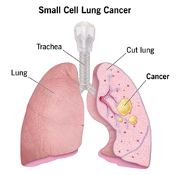

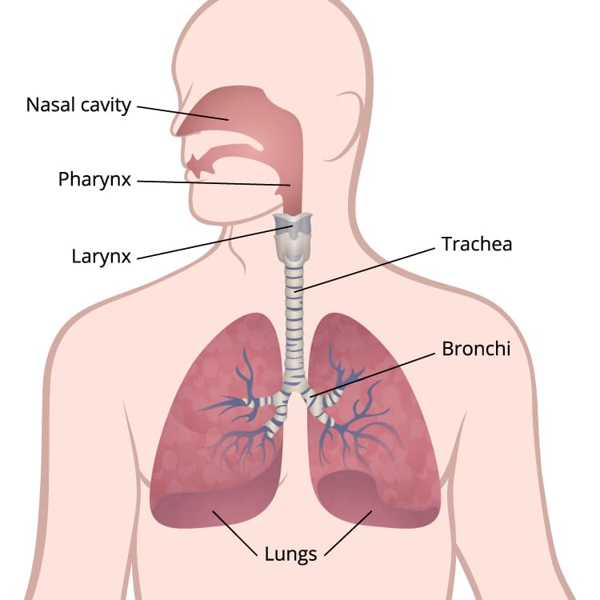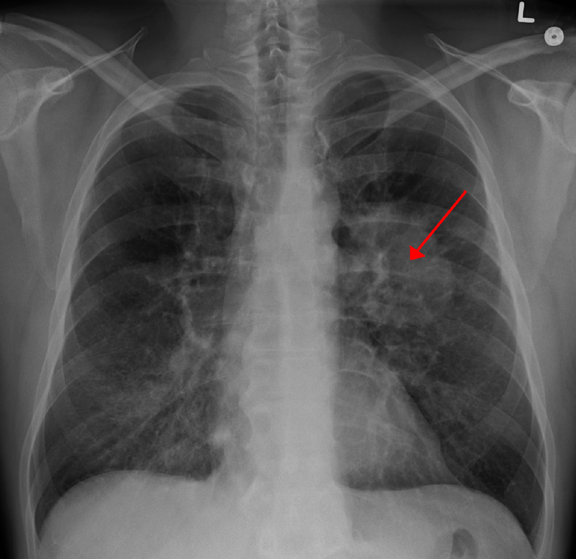
Lung’s cancer
Prevalence and Death Rates highlight the severity of the diseases
Number of Cancer Deaths Anticipated In the United States, cancer-related fatalities are predicted to total 609,360 in 2022, or over 1700 each day. Male lung, prostate, and colorectal cancers cause the most fatalities, while female lung, breast, and colorectal cancers cause the most fatalities (Fig. 1). The anticipated mortality toll from these and other prevalent cancers is broken out by the state in Table 4. Lung cancer will claim the lives of more than 350 individuals per day, which is 2.5 times more than CRC, the second biggest cause of cancer death, and more than breast, prostate, and pancreatic cancers altogether. In 2022, smoking-related fatalities will account for about 105,840 of the 130,180 lung cancer deaths (81%), and another 3650 deaths will result from secondhand smoke. 26 The other 20,700 non-smoking-related lung cancer deaths would be the ninth most common cancer death caused for both sexes if they were counted individually.
To benefit from improvements in statistical modeling and increased cancer registration coverage, the methodology for determining current cancer cases and deaths was modified in 2021 and is discussed in detail elsewhere. Invasive cancer incidence data from 50 states and the District of Columbia were used to estimate complete counts for each state from 2004 to 2018 using delay-adjusted, high-quality incidence data (98% population coverage; data were unavailable for a few sporadic years for a small number of states). To account for state-level changes in sociodemographic and lifestyle characteristics, clinical settings, and cancer screening habits, a generalized linear mixed model was utilized. Then, a novel, data-driven join point technique was used to extrapolate modeled state and national counts to 2022.
Using age-specific NAACCR incidence rates (data from 49 states with high-quality data available for all 10 years) and US Census Bureau population estimates obtained through SEER*State, the estimated number of new cases of lung cancer or death cases, new cases of ductal carcinoma in situ of the female breast, and new cases of situ melanoma of the skin diagnosed in 2022 was first estimated. The counts were then projected to 2022 based on the average APC produced by the joining point regression model and corrected for reporting delays using SEER 21 delay factors for invasive disease (delay factors are unavailable for in situ cases). The estimation of the projected number of cancer deaths in 2022 was made possible by using the previous data-driven join point technique outlined for the case projection to report cancer fatalities from 2005 through 2019 at the state and national levels as reported to the NCHS.
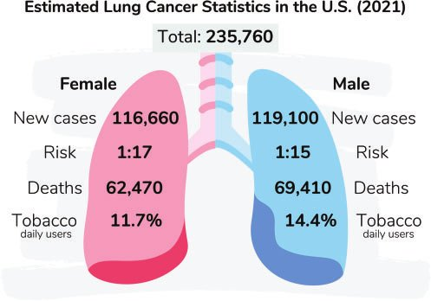
Ten Most Common Cancer Types by Estimated New Cases and Deaths from Cancer by Sex in the United States in 2022 Except for bladder cancer, estimates are rounded to the closest 10 and do not include basal cell, squamous cell, or in situ carcinomas. The ranking may not match the most current observed data because it is based on predicted projections..
Current treatment of lung cancer and their limits
Depending on the type of cancer and the extent of its spread, there are many treatments for lung cancer. Surgery, chemotherapy, radiation therapy, targeted therapy, or a combination of these treatments may be used to treat non-small-cell lung cancer patients. Typically, radiation treatment and chemotherapy are used to treat people with small-cell lung cancer.
Surgery. Is a procedure where cancerous tissue is removed by doctors.
Chemotherapy. using unique medications to reduce or eradicate cancer The drugs may be taken orally, administered intravenously, or occasionally both.
Radiation treatment. using X-ray-like high-energy beams to eradicate cancer
Targeted treatment. blocking the growth and spread of cancer cells using medication Drugs might be administered intravenously or as pills that you ingest. You will undergo tests to see whether targeted therapy is appropriate for your particular cancer type before starting this treatment.
Various medical professions frequently collaborate to treat lung cancer. Pulmonologists are medical professionals that specialize in lung conditions. Doctors who perform procedures are known as surgeons. Chest, heart, and lung surgery is the area of expertise for thoracic surgeons. Oncologists are medical professionals who use medication to treat cancer. Radiation oncologists are medical professionals who use radiation to treat cancer.

Diagnosis
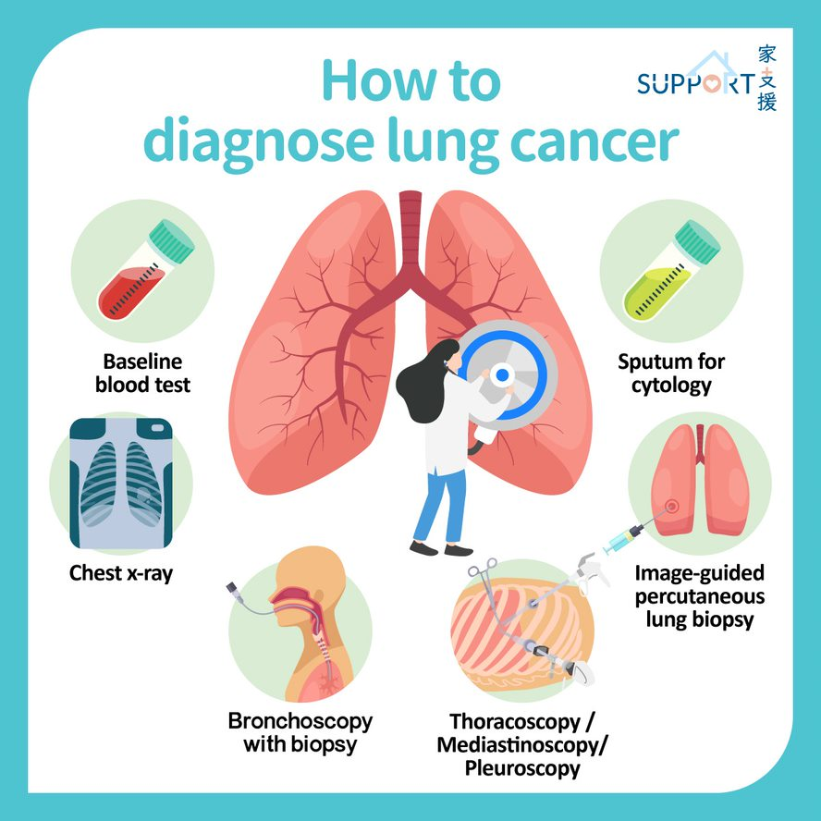

Testing healthy people for lung cancer
People who are at a greater risk for lung cancer may want to think about getting yearly low-dose CT scans to check for the disease. In the aforementioned Figure 4, the bronchoscopy pop-up dialog box is used to diagnose malignancy. Older persons who have smoked heavily for many years or who have quit within the last 15 years typically receive lung cancer screening.
Talk to your doctor about your risk of lung cancer. You and your partner can determine if lung cancer screening is a good idea for you.
Lung cancer diagnostic procedures Your doctor may run a number of tests to look for malignant cells and rule out other disorders if there is cause to believe that you may have lung cancer.
Testing might involve:
- Image-based tests. An abnormal tumor or nodule in your lungs could be seen on an X-ray. Small lung lesions may not be seen on an X-ray but can be seen on a CT scan.
- Pneumonia cytology. When sputum is coughed up and examined under a microscope, lung cancer cells can occasionally be seen. This is especially true if you have a cough and are producing sputum.
- A biopsy sample of tissue. A process known as a biopsy allows for the removal of a sample of aberrant cells. A biopsy can be done in a number of methods by your doctor, including bronchoscopy, which involves passing a lit tube down your neck and into your lungs to examine for abnormal lung tissue..
- Mediastinoscopy, in which an incision is made at the base of your neck and surgical tools are inserted behind your breastbone to take tissue samples from lymph nodes is also an option.
- Another option is needling biopsy, in which your doctor uses X-ray or CT images to guide a needle through your chest wall and into the lung tissue to collect suspicious cells.
- A biopsy sample may also be taken from lymph nodes or other areas where cancer has spread, such as your liver.
- Careful analysis of your cancer cells in a lab will reveal what type of lung cancer you have. Results of sophisticated testing can tell your doctor the specific characteristics of your cells that can help determine your prognosis and guide your treatment.

Tests to determine the extent of the cancer
The extent (stage) of your cancer will be determined by your doctor when lung cancer has been detected. The stage of your cancer aids you and your doctor in selecting the best course of action. Imaging techniques may be used as part of staging testing so that your doctor may check for signs that cancer has moved outside of your lungs. These examinations consist of bone scans, positron emission tomography (PET), CT, and MRI. Discuss whether tests are acceptable for you with your doctor because not everyone needs them. The stages of lung cancer are denoted by Roman numerals ranging from 0 to IV, with the lowest stages signifying lung-specific malignancy. Stage IV signifies the cancer's advanced stage and the extent to which it has spread throughout the body. Your overall health, the type, and stage of your illness, as well as your preferences, all play a role in the cancer treatment plan that you and your doctor decide on. You might decide in some circumstances not to receive therapy. For instance, you might believe that the risks of the medication outweigh any potential advantages. If that is the case, your doctor might advise comfort care, which merely addresses cancer's associated symptoms like pain or shortness of breath.
Lung cancer surgery Open pop-up dialog box

Your surgeon works to remove the lung cancer along with a margin of healthy tissue during surgery. Lung cancer removal techniques include:

Using a wedge resection, the tumor-containing lung tissue and a portion of surrounding healthy tissue are removed.

Using a segmented resection, more of the lung can be removed without removing a full lobe.

To remove one lung's whole lobe, do a lobectomy.

A complete lung is removed during a pneumonectomy.

If you have surgery, your surgeon might also remove some of your chest lymph nodes to look for any indications of malignancy. If your cancer is limited to your lungs, surgery can be a possibility. To decrease a larger lung cancer before surgery, your doctor may advise chemotherapy or radiation treatment. Your doctor may advise chemotherapy or radiation therapy following surgery if there's a chance that cancer cells were left behind or if your cancer might relapse

Radiation therapy

High-powered energy beams from sources like X-rays and protons are used in radiation treatment to kill cancer cells. You lie on a table during radiation therapy as a machine rotates around you, directing radiation to specific areas of your body. Radiation therapy might be applied either before or after surgery for patients with locally advanced lung cancer. It frequently goes hand in hand with chemotherapy treatments. Combining chemotherapy and radiation therapy may be your main course of treatment if surgery is not an option. Radiation therapy may assist in symptom relief for advanced lung malignancies and those that have spread to other parts of the body, such as discomfort.

Chemotherapy
Drugs are used in chemotherapy to kill cancer cells. It is possible to get one or more chemotherapy medications intravenously or orally. A series of treatments using a combination of medications are often administered over a few weeks or months, with intervals in between to allow for recovery. After surgery, chemotherapy is frequently administered to eradicate any cancer cells that could have survived. Radiation therapy may be coupled with it or used alone. To make malignancies smaller and easier to remove after surgery, chemotherapy may also be administered. Chemotherapy can be used to treat advanced lung cancer patients’ symptoms, including discomfort.

Stereotactic body radiotherapy
Stereotactic body radiotherapy, sometimes referred to as radiosurgery, is a strenuous radiation therapy that directs several radiation beams toward cancer from various angles. Usually, stereotactic body radiation is finished in one or a few sessions. For those with tiny lung malignancies who cannot have surgery, stereotactic body radiation may be an alternative. It can also be used to treat lung cancer that has progressed to the brain and other organs.

Targeted drug therapy
Targeted medication therapies concentrate on particular defects that are prevalent in cancer cells. Targeted medication therapies can kill cancer cells by preventing these aberrations. Although there are numerous targeted treatment medications available, the majority are only prescribed for patients with advanced or recurring cancer. Certain genetic alterations in cancer cells are only present in patients who can benefit from targeted therapy. In a lab, your cancer cells may be examined to see if these medications could be beneficial.
Immunotherapy
Your immune system is used in immunotherapy to combat cancer. Due to the cancer cell’s ability to create proteins that aid in their concealment from immune system cells, your body's disease-fighting immune system may not attack your cancer. Immunotherapy affects that process to work. Patients with locally advanced lung malignancies and tumors that have migrated to other parts of the body typically only get immunotherapy treatments.
Palliative medicine
The adverse effects of treatment as well as disease symptoms are frequently experienced by people with lung cancer. Working with a doctor to lessen your signs and symptoms is a key component of supportive care, sometimes referred to as palliative care. To make sure you're comfortable throughout and after your cancer treatment, your doctor might advise that you meet with a palliative care team immediately after your diagnosis.
According to a study, persons with advanced non-small cell lung cancer who started receiving supportive care as soon as they received their diagnosis lived longer than those who continued receiving treatments including chemotherapy and radiation. People who received supportive care said their moods and quality of life had improved. They lived nearly three months longer than those who received routine care on average
Importance of natural products and highlight the importance of medicinal plants in lung cancer

Natural goods are priceless presents from nature to humans. They comprise a variety of chemical substances that are produced naturally in humans and animals, as well as extracts from plants and animals, metabolites from insects, marine life, and microorganisms. Additionally, natural ingredients combined with TCM theory form the foundation of traditional Chinese medicine (TCM). Drug discovery has traditionally benefited from the use of natural products. Numerous prescription medications used for treatment are made from natural sources, according to the most recent information on medications approved by the Food and Drug Administration (FDA) in the United States. Over 50% of newly approved medications between 1946 and 2019 were natural small compounds. Chinese medicines and plant-based remedies are examples of multi-component, multi-channel, and multi-targeted products. Natural products continue to catch the attention of researchers due to their variety of structures and functions. The natural compounds that target and control the TME of lung cancer have not been systematically compiled, even though TME has been the subject of many studies. The anticancer effect of natural products on TME in lung cancer is discussed in this review. We list pertinent natural products together with explanations of how they modulate the TME in lung cancer when taken alone (Table 1), in combination with anticancer medications (Table 2), and combination with substances like nanomaterials (Table 3).

Table 1
The effects of natural products on modulation of the TME.
No. | Natural Products | Common Source | Cell Lines or Animal Models or Patients | Function or Molecular Mechanism | Ref.
Targeting angiogenesis
1 | Jolkinolide A (1) | Euphorbia  fischeriana | A549, HUVEC;  A549 cell xenograft mice | Inhibition of the Akt-STAT3-mTOR signaling pathway and reduction of VEGF protein expression; inhibition of HUVEC migration
2 | Jolkinolide B (2)
3 | Parthenolide (3) | Tanacetum  parthenium | A549, H526 | Inhibition of A549 and H526 cell proliferation in the presence and absence of nicotine; induction of apoptosis; inhibition of angiogenesis; down-regulation of Bcl-2 expression and up-regulation of E2F1, p53, GADD45, Bax, Bim, and caspase 3,7,8,9 expression

Bronchoscopy Open pop-up dialog box
Examining healthy individuals for lung cancer
People who are at a greater risk for lung cancer may want to think about getting yearly low-dose CT scans to check for the disease. Older persons who have smoked heavily for many years or who have quit within the last 15 years typically receive lung cancer screening. Talk to your doctor about your risk of lung cancer. You and your partner can determine if lung cancer screening is a good idea for you.
Tests to establish cancer's severity
The extent (stage) of your cancer will be determined by your doctor when lung cancer has been detected. The stage of your cancer aids you and your doctor in selecting the best course of action. Imaging techniques may be used as part of staging testing so that your doctor may check for signs that cancer has moved outside of your lungs. These examinations consist of bone scans, positron emission tomography (PET), CT, and MRI. The stages of cancer are shown in Figure 5. Discuss whether tests are acceptable for you with your doctor because not everyone needs them.
The stages of lung cancer are denoted by Roman numerals ranging from 0 to IV, with the lowest stages signifying lung-specific malignancy. Stage IV signifies the cancer's advanced stage and the extent to which it has spread throughout the body.
Risk factors of colon cancer
As you age, your risk of developing colorectal cancer rises. Other danger considerations include:
- Crohn's disease and ulcerative colitis are examples of inflammatory bowel conditions
- A history of colorectal cancer or polyps in the family or personally.
- A genetic syndrome like Lynch syndrome or familial adenomatous polyposis (FAP), which are hereditary non-polyposis colorectal cancers.

The following are some examples of lifestyle elements that could raise the risk of colorectal cancer.
- Absence of frequent exercise
- A fruit and vegetable-poor diet.
- A diet that is high in processed meats or is poor in fiber and high in fat.
- Obesity and overweight
- Alcohol consumption.

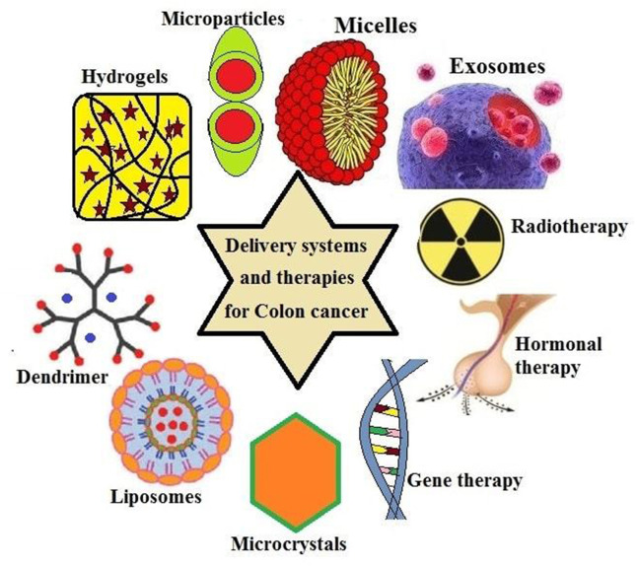
Drug targets in colon cancer
Researchers have created new kinds of medications that directly target the cell changes that lead to colon or rectal cancer as they learn more about these changes. Chemotherapy treatments function differently from targeted medications. They frequently have different adverse effects and occasionally are more effective than chemo medicines. If chemo is not an option, it can be used either alone or in conjunction with chemo. Similar to chemotherapy, these medications are absorbed into the bloodstream and reach practically every part of the body, making them effective against malignancies that have spread to far-flung regions of the body.
Current treatment strategies and side effects
Use a scope to do a colonoscopy to look into your colon. During a colonoscopy, your whole colon and rectum are seen thanks to a long, flexible, and thin tube that is connected to a video camera and monitor. Your doctor may insert surgical instruments through the tube to take tissue samples (biopsies) for analysis and remove polyps if any questionable regions are discovered.
a blood test. No blood test can diagnose colon cancer. However, your doctor may perform blood tests to look for indicators of your general health, such as outdated kidney and liver function tests.
Your doctor may perform a blood test to check for a substance called a carcinoembryonic antigen, or CEA, which colon tumors occasionally generate. Your doctor may be able to determine your prognosis and whether your cancer is responding to therapy by monitoring the level of CEA in your blood over time.
Skin issues including an acne-like rash on the face and chest during therapy, which can occasionally result in infections, are the most frequent side effects of these medications. It might be necessary to use an antibiotic cream or ointment to help prevent the rash and associated illnesses. When this rash appears, the malignancy is frequently responding to therapy. The majority of those who have this rash live longer, and those who experience more severe rashes also appear to recover faster than those who get milder rashes. Other negative effects include: fatigue, fever, and Diarrhea, among other symptoms
An allergic reaction that occurs during the infusion of these medications is an uncommon but dangerous adverse effect that may result in breathing difficulties and low blood pressure. Before receiving therapy, you might receive medication to help avoid this. Importance of medicinal plants and phytocompounds in colon cancer
To improve a thorough examination, a methodical search approach was created. phrases like "colorectal cancer", "colon cancer", "adenomatous polyps", "colorectal tumor", and "colon tumor" were combined with one or more of the Mesh phrases "anti-tumor", "anti-cancer", "bioactivity", "biological activity", "phytochemicals", and "pharmacological activities". The following plant or fungus terms have to be used in conjunction with these terms: "banana," "pomegranate," "leguminous plant," "legumes," "hibiscus," "hibiscus sabdariffa," "cruciferous vegetables," or "cruciferous."
The physiological effects of nutritional support treatments, such as different herbal, mineral, and vitamin supplements, are now better understood as a result of extensive research. Additionally, it is thought that a deeper comprehension of the biological makeup of cancer cells would help certain complementary treatments and cancer-fighting medications work more effectively over time. Yeşilada claims that 5-fluorouracil (5-FU), a chemotherapy drug used to treat colon cancer, has significant side effects that patients must tolerate in real-world situations. In a related study on the topic, the blood values of the experimental animals also significantly increased (red cell, neutrophil, and monocyte counts increased by 1,2 fold, 9 fold, and 6 fold, respectively). He mentioned that blueberries are useful in the treatment of colon cancer. The literature research has demonstrated the therapeutic and preventive effects of Rheum ribs, Nigella sativa, Echinacea purpurea, Lignum usitatissimum, Punica granatum, Cronus mas, and Vaccinium myrtillus on colon cancer.
Cancer and Rheum Ribes: It promotes the treatment of cancer kinds like stomach, intestinal, lung, brain, and lymphocyte lymphoma in Figure 6, in addition to its many other advantages. Many distinct recipes call for raw Rheum ribs along with olive oil, egg, ginger, and Rheum
Rheum ribes
Drugs for rheumatoid arthritis directly affect malignant cells and cause them to shrink; even after just two days, 50% of them are gone. Rheumatoid ribs are therefore often utilized in the pharmaceutical business.

The active component of Nigella sativa (black seed), Timokinone, is utilized as an antioxidant, anti-inflammatory, and antineoplastic (anti-tumor cells inhibit development) medicine. Nigella sativa and cancer. Figure 7 shows how to diagnose lung cancer with nigella sativa. Timokinone is used as a starting ingredient in medications for adenocarcinomas of the chest, colorectal, colon, pancreatic, uterine, neoplastic keratinocytes, human osteosarcoma, fibrosarcoma, and lung. Additionally, the androgen hormone receptor (non-responsive) timocino prevents prostate cancer by concentrating on the E2F-1 transcription factor and receptor.
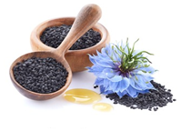
Nigella sativa
Laboratory tests have demonstrated that the black seeds of Nigella sp. boost the immune system, increasing resistance to cancer as well as the body's ability to fight off viruses and other harmful bacteria.

Echinacea purpurea (L.) and cancer Moench: E. purpura is effective against pancreatic and colon cancer in Figure 8. E. purpura is taken in large quantities as an anti-aging agent in several countries due to its potent antioxidant capabilities.
Echinacea purpurea
E. purpurea is used to complement chemotherapy in many cancer therapies, particularly those for blood cancers because it lowers free radicals. Tea in particular helps to boost immunity and stave against other diseases by preventing immunological deficiencies brought on by chemotherapy.
Linum usitatissimum (L.) and cancer Figure 9 is utilized to treat lung cancer in the example below. Breast, colon, and pancreatic cancer are all prevented by consuming flax seeds. Omega 3 fatty acids alpha-linolenic acid (ALA), Omega 6 fatty acids linoleic acid (LA), Omega 9 fatty acids oleic acid (OA), lignans (SDG), mucilage, and vitamin A (beta-carotene) are all found in flax seed.
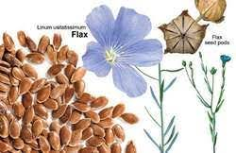
Linum usitatissimum
Usitatissimum has a high percentage of modest amounts of potassium, magnesium, iron, copper, zinc, and different vitamins, as well as a lot of fiber and highly polyunsaturated fatty acids.
Punica granatum (L.) and cancer: Punica granatum L. is useful in the treatment of prostate, breast, and colon cancer. Alkaloids with the names starch, manner, resin, triterpene acids, tannins, pellets, Impellitteri, and methylpelletieri can be found in the root and trunk shells. Figure 10 shows that the fruit peel and flowers—again, as previously mentioned—contain alkaloids and tannins. Pomegranate, Iron, potassium, calcium, phosphorus, and vitamins B1, B2, and C are also included (Ayaz and Alpsoy, 2007). High quantities of antioxidant tannin and flavonoid compounds are present in pomegranate juice. Pomegranate juice has potent anti-tumor properties that induce apoptosis, alter the cell cycle, and suppress androgen receptor expression.

High quantities of iron and vitamin C block the impacts that could result from boosting people's immune systems (Başgöl, 2007). As a result, frequent pomegranate juice consumption has been shown to have positive effects on avoiding prostate cancer and slowing the spread of the disease.
Cornu’s mas (L.) and cancer Lung, head and neck, colon, liver, breast, prostate, oesophageal, and soft tissue malignancies can all be successfully treated with C. mass. The hormone melatonin is secreted in the brain.
It is present in cranberry fruit, which improves our quality of life. Utilized in Figure 11. Due to this, it is also utilized to stop side effects including depression and sleep issues that patients may suffer while undergoing treatment. Because it is a potent diuretic, it also functions as an antioxidant. It effectively gets rid of toxic substances that have built up in the body. Additionally, C. mas contains a variety of organic plant compounds, vitamin K, manganese, and phytonutrients.

They defend the body from damaging free radicals, as evidenced by their anti-inflammatory and anti-cancer capabilities. Due to the vitamin C it contains, it is a potent natural antioxidant. It can decrease the body's susceptibility to pathogenic pathogens and reduce some damage caused by free radicals (Topuz, 2012). One prominent cause of urinary tract infections is urinary tract infections (UTIs). Cranberries should be consumed, especially by people who frequently get sick or who are in danger of getting sick. By preventing Helicobacter pylori bacteria from adhering to the lining of the stomach wall, cranberry juice also guards against stomach ulcers and stomach cancer (Topuz, 2012). The plant of C. mas can be used to make water, sherbet when boiled, or fruits. However, if sugar is added to the syrup, it loses its ability to prevent cancer and starts to cause it. Because of this, just like with any plant, how the cranberry plant is ingested is crucial.
Vaccinium myrtillus (L.) with cancer: Pterostilbene, ellagic acid, and vitamin C are all present in blueberries, which are also high in several cancers, particularly colon, uterine, and liver cancers. Cancer is being treated in Figure 12. A daily serving of fresh or dried blueberries greatly lowers the chance of developing cancer in people (HTML Access Date: May 1, 2013). Some proanthocyanidins, a type of dye called V. myrtillus, vitamins A and C, beneficial sugars, organic acids, tannins, pectin, and merlin give the fruit its color. V. myrtillus fruit can be eaten fresh, dried, or made into tea.
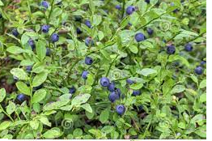

Andrographolide and its analogy role in colon cancer
Additionally, andrographolide has been demonstrated to inhibit colon cancer by way of the apoptotic route. Human HT-29 colon cancer cells experienced apoptosis as a result of it, which appears to be related to increased intracellular ROS levels and disturbance of the mitochondrial membrane potential via the regulation of caspase-3 activity.
- Analogy and andrographolide have traditionally been used to treat disorders like allergic responses, hemorrhagic lesions, and central nervous system malfunction. According to reports, andrographolide, and its derivatives have a strong therapeutic potential for treating human cancer, inflammation, common colds and coughs, and liver diseases. As antipyretic, anti-inflammatory, hepatoprotective, immunostimulant, and anti-neoplasm medicines, these metabolites have also been employed. Andrographolide has poor bioavailability due to its low aqueous solubility, which is then employed for oral administration in adequate tissue localization and for subpar therapeutic objectives. Because of their short half-lives and ease of excretion through the gastrointestinal system and urine, andrographolide and its derivatives have great qualities in that they do not stay in the body for a very long time.
- Hepatoprotection
- anti-aggregation of platelets
- Anti-inflammation Anticancer
- Cytotoxicity
- Induction of apoptosis
- Antitumor

CONCLUSION
Anticancer treatments have benefited significantly from the use of natural ingredients. All of the potent and effective anticancer medications including aspirin, vincristine, vinblastine, and paclitaxel are derived from bioactive compounds found in plants. In numerous nations, including India, Andrographis paniculate has been used medicinally in traditional medicine. In addition to having immunosuppressive, antipyretic, analgesic, hepatoprotective, antiviral, and anti-inflammatory effects, andrographolide is one of the key bioactive compounds. Figure 2 illustrates the cumulative effects and mechanism of action of andrographolide. Andrographolide and analog triggered cell cycle arrest, promoted apoptosis in a variety of cancer cells, and showed anticancer effects. In both animal and human cancer cells, andrographolide and analogs produced cell cycle arrest, apoptosis, and reduced metastasis and anti-angiogenesis. Because andrographolide can suppress the activity of v-Src, NF-B, STAT3, and PI3K/AKT as well as impede the advancement of the cell cycle, inflammation, metastasis, and the formation of new blood vessels, these effects are the outcome of the compound. For the development of anticancer drugs, substantial chemical-biological research has been conducted on analog and andrographolide. In both in vitro and in vivo models, several andrographolide analogs have demonstrated superior anticancer activity. To confirm the pharmacological, pharmaceutical, and toxicological effects of andrographolide, additional clinical and biological investigations are needed.

