Impact of Employee Motivation on productivity of organization
Shaik Rahim Basha
Research Scholar, Department of Management, SRI Y.N. College, Narasapur,
Adikavi Nannaya University, Rajamahendravaram
DR.R.Pardhasaradhi
Head of the Department, Department of Management, SRI Y.N. College, Narasapur
…………………………………………………………………………………………………
Abstract
Employees are the beating heart of any business. Employee cooperation cannot be substituted in order for any organization to run efficiently and without interruption. It is critical that an organization's employees not only have a strong relationship with top management, but also have a healthy and professional relationship with their co-workers. The current chapter is focus on how motivating methods influence employee performance for betterment. The chapter also discussed about what are factors which are more influenced and how to boost employee motivation.
Keywords: Employee Motivation, Organization Productivity, psychological trait
1.INTRODUCTION
What drives employees to "go the extra mile" in order to provide outstanding service in any organization? The solution to this problem is contained in this unique research paper. Motivation is simply a complex set of circumstances that each individual encounters, demanding a number of techniques. Motivation, in its broadest sense, is the union of a motive and an action. According to Vroom [1,] performance is a multiplicative function of ability [2, 3]. {P=F (M.A)}. In the motivation model, motivation is defined as "a process governing choices made by persons or lower organisms among alternative forms of voluntary activity" [1]. It indicates that an employee's ability determines only a portion of his or her production or productivity. Another critical issue is his level of motivation.
The authors of "Contemporary Management," Jones and George [3], define "psychological forces that shape a person's behaviour within an organization, as well as their level of effort and persistence." Employee motivation is essential in the management profession, both conceptually and practically. A human resource manager's primary task, it is considered, is to assure employee dedication to their employment, which can only be accomplished by motivating them. Identification and measurement of factors associated with individual variances in employee work performance is a key focus in industrial relations. People are driven when they can (1) participate, (2) feel accomplished and recognized for their efforts, (3) communicate frequently, and (4) have possibilities for career and knowledge improvement. This identification and measurement is the core function of tools or motivational variables.
2.CONCEPT OF MOTIVATION
In addition to perception, personality, attitude, and learning, motivation is a crucial component of behavior understanding. Motivation is described as "a process that starts with a physiological deficiency or need that activates a behavior or drive that is aimed at a goal incentive" by the dictionary. assert that, in a systemic sense, needs, desires, and incentives—the three interacting and interrelated components—are what motivate people. Management academics firmly believe that without the ongoing commitment of the organization's members, organizational goals cannot be achieved. Motivation is a psychological trait unique to humans that affects how committed a person is. Motivation is the determination to achieve a goal, demonstrated by conduct that is goal-directed. When we talk about someone being motivated, we mean that person is working really hard to complete a particular task. However, in order to complete that duty with the greatest efficiency, we need more than just motivation. Ability is important in this aspect as well as possessing the information and skills necessary to do the work. It can occasionally determine effectiveness.
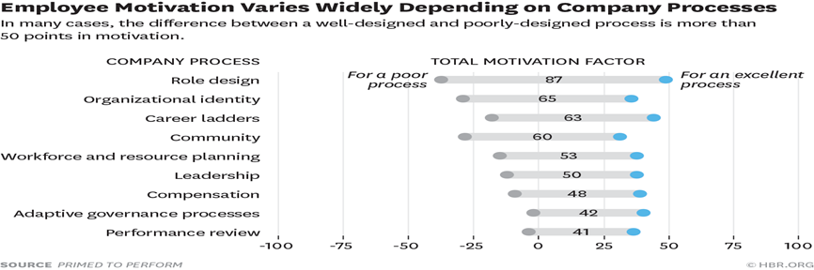
Figure-1

2.1 EMPLOYEES
Employee motivation to meet their esteem, physiological safety, social safety, psychological, and self-actualization levels is always a direct influence on them. As motivating factors for employees, Herzberg [9] described job satisfaction as acknowledgment, accountability, and potential for progress. He defined the dissatisfiers as hygienic elements that affect health, comfort, and social wellbeing after separating the satisfiers from the dissatisfiers. Employee unhappiness will result from the removal of these variables. Company policy, employee relations, working conditions, pay, and job security are examples of hygiene factors [10].
2.3 DECISION MAKING
Making decisions independently inspires employees to be aware of their rights inside an organization. It benefits the employee to keep their thoughts and works more consistently consistent. through connecting career exploration with the motivational process. Internal locus of control was the highest predictor of career exploration as one of the most important predictions, decision making allowing the employees to realize their own identity and actions. i) Career exploration varies in the way that individual develops and sustains motivation. ii) Autonomy and control orientations were positively related to self-exploration and in the utility of career decision making exploration. Both internal and external pressures can have an affect on employees, but how much of a difference depends on their level of internal and external locus of control.
2.4 PRODUCTIVITY
Productivity is the ratio of an organization's workforce's output or production capability. Improved productivity is the main focus of employee motivation. A successful employee combines a strong skill set with a positive work environment. Employees are essential to a company's ability to create and provide high-quality goods and services. When an employee tries to carry out their job responsibilities, they are affected by a number of internal and external pressures. This has a direct bearing on production.
3. Organizational goals, organizational performances and job satisfaction
Achieving organizational goals, a degree of performance set up in terms of several criteria, is the primary motivation for carrying out tasks for every organization. The main factor in achieving such objectives is organizational performance. Some people think it just comes down to how satisfied someone is with their job, or if they enjoy it or specific components of it, such the type of work they do or the supervision they receive. Having achieved personal goals, an employee feels good about themselves and is more inspired to keep working. Motivation contributes to improved performance and, ultimately, the achievement of corporate goals through enhancing competence and employee connection. Motivation acts as a psychological catalyst that changes the spirit into an embodied thing. The degree to which an organization is effective depends on how well it uses its resources and how little pressure it places on its employees to achieve its objectives. Additionally, it aids in ensuring the effective use of human resources, employee satisfaction, interdependent consistency, and workforce durability, all of which are crucial for achieving organizational goals, enhancing organizational performance, and ultimately fostering job satisfaction.
4. DIFFERENT THEORIES OF MOTIVATION
Organizations use motivation as a strategy to get their staff more interested in and committed to their work, which in turn boosts productivity. In a nutshell, motivation is what gets you going on your own volition.
The term "motivation" has been extensively defined by numerous modern authors. One definition of motivation is "the psychological process that gives behavior purpose and direction," while others say it's "a predisposition to behave purposefully to achieve specific, unmet needs" [8, 9]. In this work, we use an operational definition of motivation as the force that propels people to act in ways that help them achieve their own and their group's goals.
An individual's motivation is the driving force behind their actions. "Motivation refers to the degree to which an organism is ready to pursue some designed goal and implies the determination of the nature and locus of forces inducing the degree of readiness," writes the Encyclopedia of Management. Motivation is the process by which wants cause actions that lead to outcomes that meet those wants.
Maslow’s Hierarchy of Needs: People act with a purpose. To achieve one's goals, one must be motivated to do so. Needs can only be managed and met with determination through inspiration. Maslow's Hierarchy of Needs classified human desires in a scale from basic to higher-level requirements. First, people need to focus on meeting their basic necessities. When needs are met, motivation is no longer necessary. Knowing a person's position in the organizational chart is crucial for inspiring them to achieve their goals.
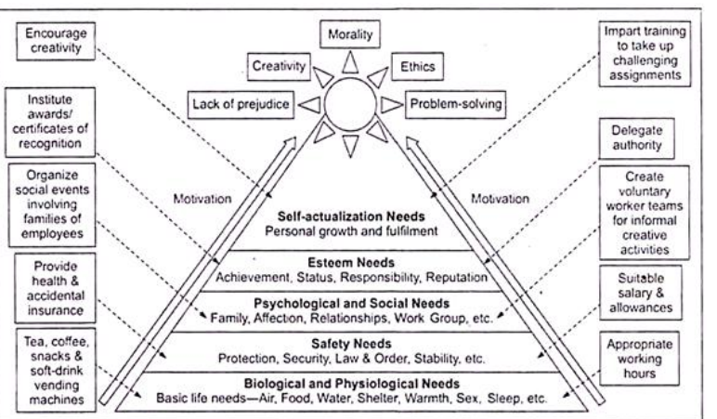
Figure -2
5.Employee Motivation Impacts Productivity
To better understand the ways in which employee motivation affects productivity, we may examine the ways in which it is related to engagement and retention, as well as the ways in which engagement and retention affect productivity.
According to the State of the worldwide Workplace: 2022 Report published by Gallup, employees who are not interested in their work or who are actively disengaged cost the worldwide economy $7.8 trillion in lost productivity, which is equivalent to 11% of global GDP.
Retention is also negatively impacted by a lack of involvement. Businesses in the United States are losing one trillion dollars annually due to voluntary turnover, and they face many challenges in retaining great employees. These challenges include employee dissatisfaction with compensation, ineffective leadership, no or few advancement opportunities, a lack of recognition, failure to provide job clarity, the need for more autonomy, and toxic work environments. Voluntary turnover costs businesses in the United States one trillion dollars annually.
A domino effect is created that can cripple productivity and adversely harm an organization's profitability when people aren't engaged in their work and the turnover rate is high.
Productivity suffers whenever employees are not actively engaged in their work. Employees who are not engaged in their work are less driven to put in long hours or satisfy their employer's expectations. They have the potential to create sixty percent more errors and to bring morale down, so producing toxic work conditions that ultimately fuel turnover, resulting in even greater losses in productivity.
When employees are highly engaged, teams see many benefits and have several advantages over teams with disengaged employees. Some of these benefits and advantages include 17% higher productivity, 41% lower absenteeism, 21% greater profitability, and an increased annual profit yield of $2,400 per employee when organizations increase their investment in employee engagement by just 10%. Disengaged employees on the other hand, see fewer benefits and have fewer advantages.
6.How To Improve Motivation and Productivity
The best leaders are able to inspire their followers to do what they ask of them because their followers want to do so, not because they are required to do so. The same holds true for one's level of motivation. Employees who enjoy their work are more likely to desire to contribute to the success of the company; therefore, executives who want more productive team members should nurture employees' intrinsic drive.
due of the beneficial effect they have on motivation, strategies that aim to promote employee engagement and retention, as well as practices that support a happy employee experience, can also improve productivity. This is due of the positive feedback loop that results from these strategies.
The following are a few elements that, when combined, have the potential to boost productivity and assist employees continue to be engaged in their positions, dedicated to the goal for the long haul, and driven to accomplish exceptional work.

7.Career Advancement Opportunities
Helping employees satisfy their need for personal development is one of the most important factors in inspiring and engaging staff members. It is critical for employees to have the impression that they are making progress in an area that is meaningful to them. They will be more involved in their work if they believe they are professionally progressing as well as increasing their skills and intellectual capabilities in jobs where they can do both of these things.
Giving employees opportunities to develop themselves, such as through training, tuition reimbursement, leadership development, career-pathing, or coaching, not only helps the individual but also delivers results that are beneficial to the company.
According to research collated by LinkedIn, when employees spend time learning on the job, they are 21% more likely to feel confident and cheerful, 47% less likely to be anxious, and 39% more likely to feel productive and successful in their jobs.
8. Recognition
Recognizing employees' accomplishments, whether in words or deeds, has a significant impact on employee motivation. When employees recognize each other's accomplishments, it spreads across the organization and links an employee's success to that of the company. Bonuses and verbal or written praise are examples of private forms of acknowledgment. Public forms include recognition in corporate newsletters, employee-of-the-month awards, company award ceremonies, and social media posts. Employee peer recognition can be a very successful technique to integrate acknowledgment into the everyday culture of the company.
According to studies, 69% of employees think they would work more if their accomplishments were recognized at work, which supports the idea that recognition boosts productivity.Employees are up to ten times more likely to strongly agree that they belong with the company when their contributions are acknowledged. According to the O. C. Tanner 2023 Global Culture Report, recognition can reduce employee burnout by 80% and attrition rates by 29%, respectively. High motivation and increased productivity are the results of these effects.

9. Incentives and Rewards Programs
Incentives and reward programs can help businesses improve their recognition efforts. Incentives and rewards programs for employees aim to create an environment where workers feel valued and appreciated by the company, align their actions with the company's values and goals, and motivate them to do their best.
There is a wide range of employee incentive and reward programs available. Financial incentives might come in the form of bonuses, raises, profit sharing, tuition reimbursement, gift cards, and the like, while non-financial incentives can take the form of extended vacation time, more flexible working hours, referral programs, and in-person experiences. Motivation is increased by incentive and reward programs because they reinforce the actions that lead to success. This can also lead to greater value convergence and, ultimately, greater output. Incentive schemes have been shown to boost productivity by as much as 44 percent and retention by as much as 66 percent.
Remote or hybrid work solutions that provide autonomy or additional paid time off (PTO) can be a powerful incentive for employees. Employees' well-being and motivation can be improved by allowing them more control over their time off from work to focus on family and other personal matters.
A poll conducted by Jabra in 2021 found that the majority of respondents (75%) preferred working for an employer that allowed them to work remotely if given the choice between a higher pay and the ability to do so. Employees and businesses alike might gain from a more adaptable work environment. According to the Gartner 2021 Digital Worker Experience Survey, 43% of workers found that having flexible work hours increased their productivity, while 30% found that spending less time on their commute did the same.
When employees have the information they need to do their jobs effectively, they are more likely to be driven to do their best and more likely to embrace an improvement culture fostered by consistent feedback.
In the workplace, daily conflict over roles and responsibilities arises when workers are confused about their own tasks and obligations. When workers aren't clear on their roles and the direction of the company, they can lose motivation. As a result, productivity suffers. It is critical for workers to be aware that their efforts are noticed by management, to understand their roles and responsibilities as they evolve, and to receive feedback on their performance. A fantastic strategy to clarify responsibilities and keep teams productive is through open and frequent communication about expectations, such as through regular one-on-one conversations.
Establishing a system of feedback in your firm is an excellent method to refine the communication skills necessary for employee engagement with leadership.Employee motivation is increased because feedback fosters an atmosphere of safety and trust in which workers' ideas and input are recognized and used in decision-making. They are able to see where they can boost output, and they maintain the drive to do so. Organizational cultures that value feedback provide regular, constructive input to employees from their managers and encourage individuals to provide constructive feedback to their peers and superiors.
Staff and leadership can use this information to make course corrections and identify problem areas. This practice of providing and receiving feedback has the potential to foster a high-performance culture in which employees consistently adopt a growth mindset and actively seek out new, novel ways to contribute to the company's success.
In addition to ensuring the physical safety of workers, a safe workplace must also ensure that they do not fear for their own well-being while on the job.
Organizations can encourage high levels of intrinsic motivation among their workers by communicating the good influence their efforts have on the world beyond financial gain.
Leaders that succeed in expanding their teams' impact do so by establishing attainable targets. They assist employees make the connection between their day-to-day work and the organization's wider mission and vision by using impact as a measure of success rather than quotas or profits.
Conclusion
Motivation indeed has a momentous effect on employee performance. pragmatically dominates employees’ will to perform and achieve goals of the respective organization When people feel psychologically comfortable, they know they can speak up without fear of retaliation. Employees are more likely to take risks, provide new ideas, and actively engage in making decisions when they feel safe doing so in the workplace. When people feel comfortable in their workplace, they are more likely to be productive, creative, and collaborative. Employees are more likely to be motivated and productive if they feel like they belong at work, and this sense of belonging can be fostered by maintaining a positive, psychologically safe workplace. In fact, research shows that businesses that prioritize their employees' emotional well-being enjoy a 50 percent increase in output.
Decision-making responsibility, development potential, and future outlook were also taken into account. The systematic breakdown of how inspiration boosts productivity in the workplace. It takes more than an annual review or a few lines in someone's personnel file to keep your employees motivated.
References
Moreover, Authority to make decisions, Growth opportunity and prospects were also considered. The tangible sorting of how motivation is responsible for upliftment of employee performance. Motivating your employees is a delicate and purposeful challenge that requires more than an annual review or jotting a few notes in someone’s personnel Life
Decision-making responsibility, development potential, and future outlook were also taken into account. The systematic breakdown of how inspiration boosts productivity in the workplace. It takes more than an annual review or a few lines in someone's personnel file to keep your employees motivated.
References:
- Alshmemri, M., Shahwan-Akl, L., & Maude, P. (2017). Herzberg’s two-factor theory. Life Science Journal, 14(5), 12-16.
- Anderson, A. (2014). Maslow's hierarchy of needs. The Prairie Light Review, 36(2), pp. 7.
- Datuk Dr. Mahamad Zubir bin Seeht Saad. (2018). The impact of employee motivaton on work performance. International Journal of Scientific and Research Publications, 8(3), 295-308.
- Lepper, M. R. & Greene, D. (2016). The hidden costs of reward. New York: Psychology Press.
- McShane S. & Von Glinow M. (2016). Organizational behavior. (3rd ed.). New York: McGraw-Hill Education.
- Miner, J. B. (2015). Organizational behavior: Essential theories of motivation and leadership. New York: Routledge.
- Nilsson, K. (2017). The influence of work environmental and motivation factors on seniors’ attitudes to an extended working life or to retire. A cross sectional study with employees 55-74 years of age. Open Journal of Social Sciences, 5(07), pp. 30-37.

