IOT BASED AIR POLLUTION DETECTOR

Ch Remesh Babu¹, S Dilli Babu*²
¹Professor, Dept of CSE, Matrusri Engineering college, Hyderabad, chramesh522@gmail.com
^{2*}Asst Professor, Dept of CSE, Malla Reddy University, Hyderabad, dillibooks@gmail.com

ABSTACT:
The regulation of air pollution levels is rapidly increasing, and it is one of the most important tasks for the governments of developing countries, especially India. It is important that people know what the level of pollution in their surroundings is and take a step towards fighting against it. The meteorological and traffic factors, burning of fossil fuels, industrial parameters such as power plant emissions play significant roles in air pollution. Among all the particulate matter that determines the quality of the air. When its level is high in the air, it causes serious issues on people’s health. Hence, controlling it by constantly keeping a check on its level in the air is important. This can be found by using the machine learning algorithms. Therefore, the system would monitor the air pollution in real time and predict the measurements in the next given time interval. The data would be sent to the network using WiFi connectivity and the system was comprised of Arduino UNO V3, ESP8266 WiFi module and MQ2 gas sensor for the initial stage development. This gives help to city planning. Air is one of the most crucial elements in the life of human beings. In today’s world, air pollution is rising at an alarming rate because of which there is climate change, and this has adverse consequences on everyone. The air around us is getting polluted because of the release of poisonous gases by industries, vehicle emissions which leads to an increase in the concentration of harmful gases and particulate matter in the atmosphere. The emission of various toxic gases from industries and vehicles is precarious for both the terrestrial organism, as well as marine life. Health problems like stroke, heart diseases, lung cancer, respiratory diseases, etc are arising due to poor air quality. Poor air quality poses a significant risk to children, asthmatics, pregnant women, as well as elderly people. These pollutants are also responsible for the corrosion of our infrastructure and monuments. People must come to know the extent to which their activities affect air quality. WHO statistics have reported that there are millions of premature death cases every year worldwide due to air pollution. From the studies, it has been found that particulate matter has a major contribution to increasing air pollution. Thus, air quality has become one of the major causes of concern around the world. Hence, it is necessary to constantly monitor the air quality index to make our surrounding environment healthy and hence, worth living.

1. Introduction
Air is one of the most crucial elements in the life of human beings . In todays world, air pollution is rising at an alarming rate because of which there is climate change, and this has adverse consequences on everyone. The air around us is getting polluted because of the release of poisonous gases by industries, vehicle emissions which leads to an increase in the concentration of harmful gases and particulate matter in the atmosphere . The emission of various toxic gases from industries and vehicles is precarious for both the terrestrial organism, as well as marine life. Health problems like stroke, heart diseases, lung cancer, respiratory diseases, etc are arising due to poor air quality. Poor air quality poses a significant risk to children, asthmatics, pregnant women, as well as elderly people . These pollutants are also responsible for the corrosion of our infrastructure and monuments. People must come to know the extent to which their activities affect air quality. WHO statistics have reported that there are millions of premature death cases every year worldwide due to air pollution . From the studies, it has been found that particulate matter has a major contribution to increasing air pollution. Thus, air quality has become one of the major causes of concern around the world. Hence, it is necessary to constantly monitor the air quality index to make our surrounding environment healthy and hence, worth living.
Air quality monitoring is a concept of providing the user with a platform where he/she can check the quality of air around them. The air quality monitoring system will help us to indicate the status of the quality of the air we breathe. Internet of Things is now finding a profound use in every sector, it plays a key role in our air quality monitoring system too. This paper focuses on the design and implementation of an IOT based Air Quality Index Monitoring System that we have intended to develop using ESP 32. The setup is going to show the air quality in PPM, temperature, and humidity with the help of various sensors and further, it would be displayed on the IOT Platform, The dashboard of the platform is to be set to public so that everyone and anyone can keep a track of the quality of air at the location where the system would be installed . In this way, we can monitor it very easily by using our computer or mobile. The motivation behind our chapter is to protect our environment by curbing the release of harmful gases emitted by industries, vehicles, etc. We get to know about the quality of air on a real-time basis and hence necessary precautions can be taken immediately whenever needed.
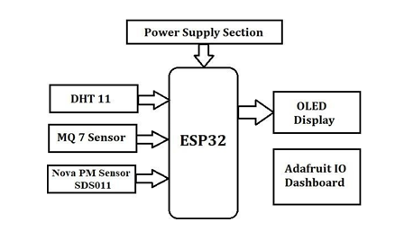
Figure 1: Air Pollution Detector Overview
Air is getting polluted because of release of toxic gases by industries, vehicle emissions and increased concentration of harmful gases and particulate matter in the atmosphere. The level of pollution is increasing rapidly due to factors like industries, urbanization, increasing in population, vehicle use which can affect human health. Particulate matter is one of the most important parameter having the significant contribution to the increase in air pollution. This paper presents a real-time standalone air quality monitoring. Internet of Things is nowadays finding profound use in each and every sector, plays a key role in our air quality monitoring system too. The setup will show the air quality in PPM in web page so that we can monitor it very easily. Air condition is much polluted. In recent years, car emissions, chemicals from factories, smoke and dust are everywhere. That is the reason why now air condition is much polluted. The effect of air pollution is very bad for our health, especially for place where the air in our body is taken for breathing. In our lungs may cause some diseases, such as asthma, cough, lung disorders .The air pollution cannot be detected by human feelings. The air pollution may contain a lot of dangerous substances, such as LPG gas, carbon monoxide, and methane . Substances in the polluted air are very dangerous. For example, if the carbon monoxide is above 100ppm, it makes human feel dizzy, nauseous, and within minutes they coulddie.
2. IOT Related Study
2.1 IOT BASED AIR POLLUTION MONITORINGSYSTEM:
Air pollution is the biggest problem of every nation, whether it is developed or developing. Health problems have been growing at faster rate especially in urban areas of developing countries where industrialization and growing number of vehicles leads to release of lot of gaseous pollutants. Harmful effects of pollution include mild allergic reactions such as irritation of the throat, eyes and nose as well as some serious problems like bronchitis, heart diseases, pneumonia, lung and aggravated asthma. According to survey, due to air pollution 50,000 to 100,000 premature deaths per year occur in the U.S. alone. Whereas in EU number reaches to 300,000 and over 3,000,000 worldwide. IOT Based Air Pollution Monitoring System monitors the Air quality over a web server using Internet and will trigger an alarm when the air quality goes down beyond a certain threshold level, means when there are sufficient amount of harmful gases present in the air like CO2, smoke, alcohol, benzene, NH3, LPG and NO x. It will show the air quality in PPM on the LCD and as well as on web page so that it can monitor it very easily.
2.2 IOT BASED AIR QUALITY MONITORINGSYSTEM
The main objective of this chapter is to monitor the air eminence in industrial and urban areas. The proposed outline includes a set of gas sensors (CO, and NO2) that are positioned on masses and structure of a IOT (Internet of things) and a dominant server to support both short-range real time incident management and a continuing deliberate planning. In this Arduino platform is used to communicate the data simply and quickly. WSN (Wireless sensor network) acts as the trans receiver. This provide a real-time low rate monitoring system over the use of low rate, low information rate, and little control wireless communication technology. The chaptered monitoring system can be transferred to or shared by different applications. Through IOT we can able to visualize the values from the globe. The problem in this paper is they haven calibrated the sensor and not even converted the sensor output value into PPM. As per the guidelines by UN Data, 0-50 is SAFE value and 51-100 is moderate. Delhi is the most polluted city in the world recorded 350PPM. While using two sensors, as both sensors have internal heat element, it draws more power, so though the both sensors are turned ON, its output voltage levels varies and shows predicted values due to insufficient drive. So we used a 9V battery and a 7805 family REGULATOR for the CO sensor MQ7. For MQ135 wehave given the power from Arduinoonly.
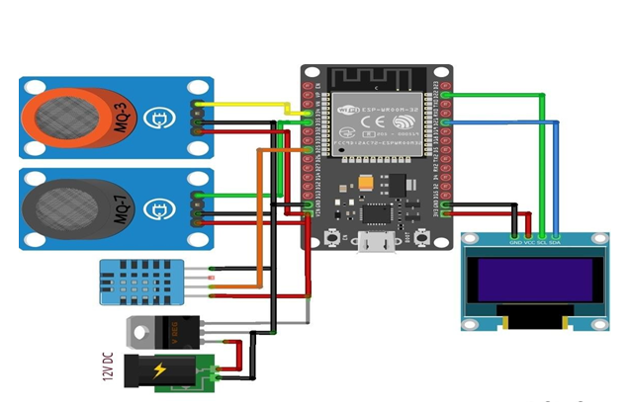
Figure 2: Sensor Overview
2.3 ARDUINO BASED WEATHER MONITORINGSYSTEM:
This Paper makes use of 3 sensors to measure the weather environment factors light intensity, dew point and heat index. The values read from the sensors are processed by the Arduino micro- controller and stored in a text file which can be processed upon to derive analysis. The readings are also displayed on an on board LCD for quick viewing. All these readings can be analyzed to get the weather characteristics of a particular area and record the weather pattern. These recorded parameters are essential and vary from places to places.

3. AIR POLLUTION DETECTORS
Arduino is a great platform for beginners into the World of Microcontrollers and Embedded Systems. With a lot of cheap sensors and modules, you can make several chapters either as a hobby or even commercial.
As technology advanced, new chapter ideas and implementations came into play and one particular concept is the Internet of Things or IoT. It is a connected platform, where several things or devices are connected over internet for exchange of information.
In DIY community, the IOT chapters are mainly focused on Home Automation and Smart Home applications but commercial and industrial IoT chapters have far complex implementations like Machine Learning, Artificial Intelligence, Wireless Sensor Networks etc.
The important thing in this brief intro is whether it is a small DIY chapter by a hobbyist or a complex industrial chapter, any IoT chapter must have connectivity to Internet. This is where the likes of ESP8266 and ESP32 come into picture.
If you want to add Wi-Fi connectivity to your chapters, then ESP8266 is a great option. But if you want build a complete system with Wi-Fi connectivity, Bluetooth connectivity, high resolution ADCs, DAC, Serial Connectivity and many other features, then ESP32 is the ultimate choice.

What isESP32?

ESP32 is a low-cost System on Chip (SoC) Microcontroller from Espressif Systems, the developers of the famous ESP8266 SoC. It is a successor to ESP8266 SoC and comes in both single- core and dual-core variations of the Tensilicas 32-bit Xtensa LX6 Microprocessor with integrated Wi- Fi and Bluetooth. The good thing about ESP32, like ESP8266 is its integrated RF components like Power Amplifier, Low-Noise Receive Amplifier, Antenna Switch, Filters and RF Balun. This makes designing hardware around ESP32 very easy as you require very few external components.
Another important thing to know about ESP32 is that it is manufactured using TSMCs ultra- low-power 40 nm technology. So, designing battery operated applications like wearables, audio equipment, baby monitors, smart watches, etc., using ESP32 should be very easy.
3.2 Specifications ofESP32:
ESP32 has a lot more features than ESP8266 and it is difficult to include all the specifications in this Getting Started with ESP32 guide. So, I made a list of some of the important specifications of ESP32 here. But for complete set of specifications, I strongly suggest you to refer to the Datasheet.
• Single or Dual-Core 32-bit LX6 Microprocessor with clock frequency up to 240MHz.
• 520 KB of SRAM, 448 KB of ROM and 16 KB of RTCSRAM.
• Supports 802.11 b/g/n Wi-Fi connectivity with speeds up to 150Mbps.
• Support for both Classic Bluetooth v4.2 and BLE specifications.
• 34 ProgrammableGPIOs.
• Up to 18 channels of 12-bit SAR ADC and 2 channels of 8-bitDAC
• Serial Connectivity include 4 x SPI, 2 x I2C, 2 x I2S, 3 xUART.
• Ethernet MAC for physical LAN Communication (requires externalPHY).
• 1 Host controller for SD/SDIO/MMC and 1 Slave controller forSDIO/SPI.
• Motor PWM and up to 16-channels of LEDPWM.
• Secure Boot and FlashEncryption.
• Cryptographic Hardware Acceleration for AES, Hash (SHA-2), RSA, ECC andRNG.
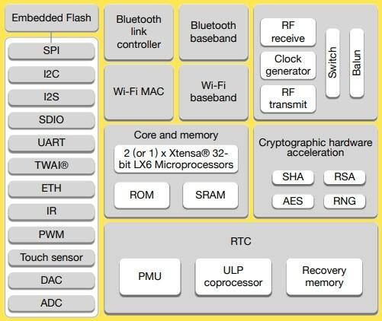
Figure 3: ESP32
3.3 Different Ways to Program:
A good hardware like ESP32 will be more user friendly if it can be programmed (writing code) in more than one way. And not surprisingly, the ESP32 supports multiple programming environments. As Arduino IDE is already a familiar environment, we will use the same to program ESP32 in our upcoming chapters. But you can definitely try out others as well.
3.4 ESP32 DevKit -The ESP32 DevelopmentBoard:
Espressif Systems released several modules based on ESP32 and one of the popular options is the ESP-WROOM-32 Module. It consists of ESP32 SoC, a 40 MHz crystal oscillator, 4 MB Flash IC and some passive components.
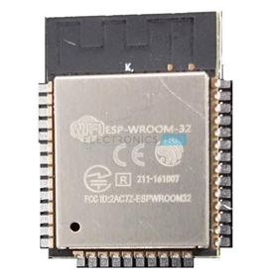
Figure 4: ESP-WROOM-32 Module
The good thing about ESP-WROOM-32 Module is the PCB has edge castellations. So, what third-part manufacturers do is take the ESP-WROOM-32 Module and design a break-out board for this module. One such board is the ESP32 DevKit Board. It contains the ESP-WROOM-32 as the main module and also some additional hardware to easily program ESP32 and make connections with the GPIO Pins.
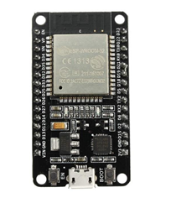
Figure 5: ESP32 Board

3.5 Layout:
We will see what a typical ESP32 Development Board consists of by taking a look at the layout of one of the popular low-cost ESP Boards available in the market called the ESP32 DevKit Board. The following image shows the layout of an ESP32 Development Board which I have. IMPORTANT NOTE: There are many ESP32 Boards based on ESP-WROOM-32 Module available in the market. The layout, pinout and features vary from board toboard. The board which I have has 30 Pins (15 pins on each side). There are some board with 36 Pins and some with slightly less Pins. So, double check the pins before making connections or even powering up the board.
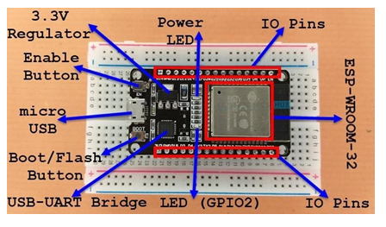
Figure 6: Labelling Of ESP32
As you can see from the image, the ESP32 Board consists of the following: An interesting point about the USB-to-UART IC is that its DTR and RTS pins are used to automatically set the ESP32 in to programming mode (whenever required) and also rest the board after programming.
3.6 Pinout of ESP32Board:
I will make a separate dedicated tutorial on ESP32 Pinout. But for the time being, take a look the pinout diagram of the ESP32 Development Board.
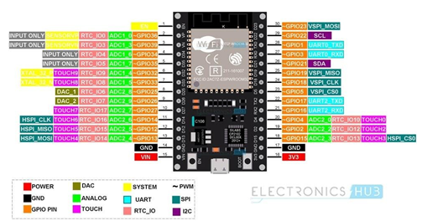
Figure 7: Pin Labelling Of ESP32
This pinout is for the 30 pin version of the ESP Board. In the pinout tutorial, I will explain the pin out of both the 30 pin as well as the 36 pin version of the ESP Boards.
4. Methodology
The proposed structure is an air quality monitoring system based on the Internet of Things. The sensors that we have used are helping in sensing the presence and concentration of few harmful gases, dust particles present in the air at that very time and also to check temperature and humidity at that particular time. These sensors are connected to the controller according to their output type that is an analog or digital output. The controller won't only gather data from various sensors but via an in-built Wi-Fi module, it is also responsible to send the recorded data to an IoT platform. IoT platform will store real-time sensor data and also plot graphs, charts, and numeric values. Thus, we would be able to monitor the air quality at the location where the system would be installed on a real-timebasis.
Figure-1 demonstrates the block architecture of our air quality monitoring system. ESP32 is serving as the main controlling unit in our system. Different environmental parameters like Carbon Dioxide, Carbon Monoxide, particulate matter, Temperature, and Humidity are being sensed by the sensors. The sensors are connected to ESP32. ESP32 gathers data sensed by the sensors and continuously transmits it to the cloud over the internet. The measurement of the particles of diameter 2.5um and 10um is called 2.5PM and 10PM respectively. This sensor can sense up to 2.5PM. It gives an analog output. Other analog sensors used in our system are MQ7. (Gas sensor) and MQ135 (air quality sensor) and they are used for measuring Carbon Monoxide and Carbon Dioxide respectively. DHT11 is the sensor that is used for measuring temperature and humidity sensor and it gives digital output. These sensor data are continuously sent to an IoT platform for monitoring air quality on a real-time basis. The IoT platform we have used is ThingSpeak. The sensor data is displayed in the form of graphs and numeric values on ThingSpeak. A buzzer is also
4.1.1 SYSTEMDESIGN:
Continuous online patient and patients room condition monitoring is the main idea of the proposed system. Therefore, the healthcare monitoring system utilizes the three-stage architectural features, namely (1) Sensor Module (2) Data Processing Module (3) Web User Interface. The sensors are wired which are used to collect data from the patients body and the environment by gathering physiological signs. The collected data are then processed via an ESP32 module and send to the gateway server. For the web user interface, ThingSpeak is used for the graphical interpretation, and display of collected results. ThingSpeak shows the current status and process of transactions. The HTTP protocol provides easy connectivity for the correspondence between a Wi-Fi module and the web server. The HTML user interface is updated every 15 s, allowing patients to be tracked inreal-time.
The overall system architecture of the developed system is illustrated in Fig. 2. From Fig. 2, it can be seen that all the sensors are used to collect data from hospital environment. The sensors all are connected to a processing unit called ESP32. Upon attaching these (temperature, heartbeat, gas) sensors, ESP32 works as a heart of the system. ESP32 collects sensor data and then wirelessly transfers them to IoT websites. The board uses its Wi-Fi and its own processing unit, which is Xtensa dual-core 32-bit LX6 microprocessor. The sensor output is then linked to the website of IoT. The data are accessed through any network supported device. There, the data are graphically shown and it is a channel-based system, and every time while accessing it needs password.
4.2 DHT11SENSOR:
DHT11 Temperature & Humidity Sensor features a temperature & humidity sensor complex with a calibrated digital signal output. By using the exclusive digital-signal-acquisition technique and temperature & humidity sensing technology, it ensures high reliability and excellent long-term stability. This sensor includes a resistive-type humidity measurement component and an NTC temperature measurement component, and connects to a high performance 8-bit microcontroller, offering excellent quality, fast response, anti-interference ability and cost-effectiveness.
Each DHT11 element is strictly calibrated in the laboratory that is extremely accurate on humidity calibration. The calibration coefficients are stored as programmers in the OTP memory, which are used by the sensors internal signal detecting process. The single-wire serial interface makes system integration quick and easy. Its small size, low power consumption and up-to-20 meter signal transmission making it the best choice for various applications, including those most demanding ones. The component is 4-pin single row pin package. It is convenient to connect and special packages can be provided according to users request.
4.2.1 How the DHT11 Measures Humidity and Temperature:
The DHT11 calculates relative humidity by measuring the electrical resistance between two electrodes. The humidity sensing component of the DHT11 is a moisture holding substrate (usually a salt or conductive plastic polymer) with the electrodes applied to the surface. When water vapor is absorbed by the substrate, ions are released by the substrate which increases the conductivity between the electrodes. The change in resistance between the two electrodes is proportional to the relative humidity. Higher relative humidity decreases the resistance between the electrodes while lower relative humidity increases the resistance between the electrodes. Inside the DHT11 you can see electrodes applied to a substrate on the front of the chip. The DHT11 converts the resistance measurement to relative humidity on an IC mounted to the back of the unit and transmits the humidity and temperature readings directly to the Arduino. This IC also stores the calibration coefficients and controls the data signal transmission between the DHT11 and Arduino. The temperature readings from the DHT11 come from a surface mounted NTC temperature sensor built into the unit. To learn more about the thermistor and how to use them on the Arduino, check out our Arduino Thermistor Temperature Sensor Tutorial. The DHT11 uses one signal wire to transmit sensor readings to the Arduino digitally. The power comes from separate 5V and ground wires. A 5K - 10K Ohm pull-up resistor is connected from the signal line to 5V to make sure the signal level stays high by default (see the datasheet for specifics on how the signal issent). There are two different variations of the DHT11 sensor you might come across. One type has four pins, and the other type is mounted to a small PCB that has three pins. The PCB mounted version with three pins is nice since it includes a surface mounted 10K Ohm pull up resistor for the signalline.
4.3 MQ 7SENSOR:
MQ-7 is a Carbon Monoxide (CO) sensor, suitable for sensing Carbon Monoxide concentrations (PPM) in the air. The MQ-7 sensor can measure CO concentrations ranging from 20 to2000ppm. This sensor has a high sensitivity and fast response time. The sensor's output is an analog resistance. The drive circuit is very simple , just a voltage divider; all you need to do is power the heater coil with 5V DC or AC , add a load resistance, and connect the output to an ADC or a simple OPAMP comparator.This sensor comes in a package similar to our MQ-3 alcohol sensor, and can be used with the rhydoLABZ breakout board.

4.4 APPLICATIONS, ADVANTAGES AND FUTURE SCOPE
1) Indoor Air Quality MonitoringSystem
It is quite shocking to know that more than 3.8 million people die annually due to indoor air pollution. The presence of particulate matter and harmful gases drops the quality of air, which when inhaled can cause severe diseases such as asthma, decreased lung function, and even cancer.
2) Outdoor Air Quality MonitoringSystem
Environmental health has been a topic of discussion for decades. Different policies and regulations pertaining to the emission of pollutants in the air have been imposed to keep the air quality high. Hence, to keep the emission rate well under control as per the determined guidelines, it is important for industries to monitor the production of harmful gases.
3) Particulate MatterMonitoring
Particulate matter (PM) or Particulates are solid or liquid microscopic particles suspended in the air. Also known as aerosols, these particles are invisible to the naked eye and can be made up of different components like acids, metals, soil, dust, organic chemicals, etc. Since these particles are very small, they can be easily inhaled and affect health. The severity of the health issues is directly related to the size of these particles. Coarse PM that is generally found near highways or dusty industries ranges between 2.5 and 10 micrometers. However, the particles that are smaller than 2.5 micrometers are more dangerous since they can easily pass through the nose and throat and enter the lungs.
4) Gas DetectionSystem:
In industries like chemical and oil & gas, where harmful gases and toxins are either used or produced in or during manufacturing processes respectively, even a minor leakage can result in a catastrophe.

Such type of system can be used in two ways, one is as a stand-alone device as shown above or it can be installed in vehicles. By installing it in vehicles, it could make drivers educated and aware about driving patterns they follow and how it is impacting the surrounding and increasing the pollution. By adopting better driving habits will in turn lead to a reduction in pollution. It is going to benefit them as well as others by reducing pollution so everyone can breathe cleaner air. In the future, more sensors can also be added to this hence extending the system. Further, we can also modify the system by adding a feature of sending SMS to the user when the quantity of any gas in the atmosphere exceeds a certain value. Such systems can also be implemented on a large scale and help in making a smartcity
5. CONCLUSION
This chapter proposes a system that is cost-efficient, low power consuming and highly accurate system for monitoring air quality on a real-time basis on a small scale with the help of dedicated sensors and alerts people when its level goes beyond a certain limit and displays the data in a way anyone can understand. Leveraging the concept of IoT, the air around the installed system can be monitored by anyone and from anywhere using a phone or a computer. The continuous updating of data enables the users to take timely actions immediately whenever needed. This helps in curbing air pollution in the environment around us which is a big concern. Apart from being low in cost and power consumption, it covers less space and can be installed anywhere. This provides great efficiency andflexibility.
References
[1] Kennedy Okokpujie, Etinosa Noma-Osaghae, Odusami Modupe, Samuel John and Oluga Oluwatosin, A Smart Air Pollution Monitoring System, International Journal of Civil Engineering and Technology, 9(9), 2018, pp.799809.
[2] Rawal R. Air Quality Monitoring System. International Journal of Computational Science and Engineering.2019;9(1):1-9.
[3] Ali, Hassan &Soe, J. & Weller, Steven. (2015). A real-time ambient air quality monitoring wireless sensor network for schools in smart cities. 1-6.10.1109/ISC2.2015.7366163.
[4] Kumar S, Jasuja A. Air quality monitoring system based on IoT using Raspberry Pi. In2017 International Conference on Computing, Communication and Automation (ICCCA) 2017 May 5 (pp. 1341-1346).IEEE.
[5] Gupta, Harsh & Bhardwaj, Dhananjay & Agrawal, Himanshu &Tikkiwal, Vinay & Kumar, Arun. (2019). An IoT Based Air Pollution Monitoring System for Smart Cities. 173-177. 10.1109/ICSETS.2019.8744949.
[6] Kumar A, Kumari M, Gupta H. Design and Analysis of IoT based Air Quality Monitoring System. In2020 International Conference on Power Electronics & IoT Applications in Renewable Energy and its Control (PARC) 2020 Feb 28 (pp. 242-245).IEEE.
[7] AsraNoorain F, Raju J, Varsha V, Nanditha HG. An IoT Based Approach To Minimize And Monitor Air Pollution Using ESP32 and BlynkPlatform.
[8] Jayaratne R, Liu X, Ahn KH, Asumadu-Sakyi A, Fisher G, Gao J, Mabon A, Mazaheri M, Mullins B, Nyaku M, Ristovski Z. Low-cost PM2. 5 sensors: An assessment of their suitability for various applications. Aerosol and Air Quality Research.2020;20(3):520-32.

