FUTURISTIC TRENDS IN DENTISTRY
Artificial Intelligence: A New Diagnostic Software in Dentistry: A Preliminary Performance Diagnostic Study
- Dr.Karthik Shunmugavelu
BDS, MDS OMFP, MSC LONDON, MFDSRCS ENGLAND, MFDSRCPS GLASGOW, FACULTY AFFILIATE RCS IRELAND, MCIP, FIBMS USA, MASID AUSTRALIA
Senior Resident / Consultant Dental Surgeon / Consultant Oral and Maxillofacial Pathologist
Department of Dentistry/Oral and Maxillofacial Pathology
• PSP medical college hospital and research institute Tambaram Kanchipuram main road Oragadam Panruti Kanchipuram district Tamilnadu 631604
Mobile 0091-9789885622/9840023697
https://orcid.org/0000-0001-7562-8802
- Dr Evangeline Cynthia Dhinakaran
MBBS DMCH FUS OBG (MD PATHOLOGY)
Sree Balaji Medical College and Hospital, Chrompet, Chennai-600044, Tamilnadu, India
Mobile – 9952054096
Email – drevangelinedhinakaran@gmail.com
0000-0003-2194-6455

Abstract
Artificial intelligence (AI) has taken hold in public health, especially in dentistry because more and more people are looking to make a diagnosis using technology that allows them to work faster and more accurately, reducing costs and the number of medical errors. Artificial Intelligence has proved itself to be a boon in the field of dentistry. In the future AI-based comprehensive care systems are expected to have high-quality patient care and help researchers know and treat more about diseases. Even though misconceptions and certain limitations about Artificial Intelligence prevail, it continues to flourish due to its advantages in providing precision. Along with AI, certain trends are in use, like 3D printing, Teledentistry, Machine Learning, and Smart Dental Devices. These are just a few of the many ways that technology is changing dentistry. As technology continues to advance, we will likely see even more innovative and ground breaking developments in this field in the years to come. Albert Einstein said, “Imagination is the highest form of research.” so one needs to be National Dental Thinker providing innovative Dental Solutions¹. Nanotechnology, stem cells, and gene therapy are also innovative methods that are used in dentistry ². This review describes some current and future applications of all the above trends in dentistry.
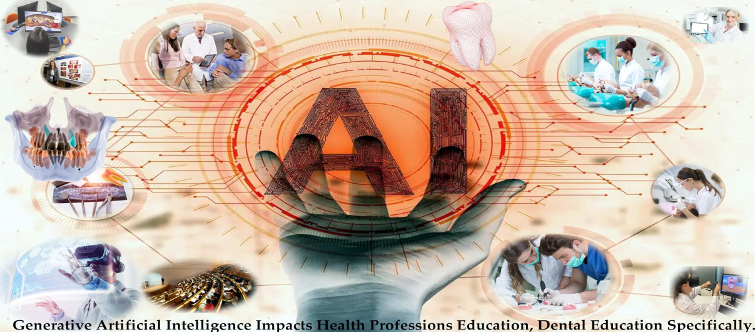
Figure1: Graphical Abstract
Courtesy: Thurzo A, Strunga M, Urban R, Surovková J, Afrashtehfar KI. Impact of Artificial Intelligence on Dental Education: A Review and Guide for Curriculum Update. Education Sciences. 2023; 13(2):150. https://doi.org/10.3390/educsci13020150³
Introduction:
Artificial Intelligence:
Tooth loss is very common, and it can be due to disease or trauma; therefore, dental implants are widely used to provide a replacement for missing teeth. The healthcare sector has been involving more and more technologies like artificial intelligence and machine learning for the past 5 years. The main objective is to analyse the accuracy of artificial intelligence and machine learning in the diagnosis of different dental diseases or conditions. Artificial intelligence (AI) is a fast-moving technology that enables machines to perform tasks previously exclusive to humans⁴. Advances in AI offer benefits such as decreasing post-operative complications, increasing the quality of life, improving decision-making, and decreasing the number of unnecessary procedures⁵. The concept of AI was introduced by John McCarthy, a mathematician from Dartmouth University, in 1956 at a workshop, which credited him as the father of Artificial Intelligence⁶. The term “artificial intelligence” (AI), defined as computerized synthetic human cognitive function, was first introduced in 1956 at Dartmouth University⁷. Richard Bellman, in 1978 defined Artificial Intelligence as “The automation of activities associated with human thinking abilities, which includes learning, decision making and problem-solving”⁸. AI can be regarded as a valuable tool to help dentists and clinicians reduce their workload. Besides diagnosing diseases using a single information source directed at a specified disease, AI can learn from multiple information sources (multi-modal data) to diagnose beyond human capabilities. AI enables us to enter a new era of extremely early diagnosis through the search and detection of pre-symptoms of contracting a given disease⁹. AI has been used to improve image interpretation in dental radiology. AI allows machines to learn from experience, adapt to new inputs, and perform tasks in a human-like manner. Based on various exciting advantages of AI-based technologies, various fields have gained many benefits, including health care and dentistry is particular among them¹⁰. Back in 2020, dated Jan 8, there was a very harmful virus called coronavirus, initially referred to as the Wuhan coronavirus (CoV), was designated as a severe acute respiratory syndrome (SARS)-CoV-2, was responsible for the latest pandemic that was affecting human health and economy across the world¹¹. At that time, healthcare providers were at an increased risk of contracting the infection and becoming potential carriers of the disease. According to Occupational Safety and Health Administration (OSHA), dental health care personnel (DHCP) were placed in the very high exposure risk category as dentists work close to the patient’s oral cavity¹². AI has been demonstrated to increase accuracy, efficiency, and precision on par with medical experts more quickly and affordably¹³. The core component of artificial intelligence technology is a neural network that is designed like that of human brains, which can also simulate human thought. Strongly interconnected neurons make up this type of brain architecture, which primarily functions as a data processing system to address a particular issue¹⁴. Dental education will need to accompany the introduction of clinical AI solutions by fostering digital literacy in the future dental workforce. AI solutions have not, by large, entered routine dental practice, mainly due to (i) limited data availability, accessibility, structure, and comprehensiveness, (ii) lacking methodological rigor and standards in their development, (iii) and practical questions around the value and usefulness of these solutions, but also ethics and responsibility¹⁵. AI is a reliable platform to make dental care better, smoother, and time-saving for professionals. AI helps dentistry professionals fulfil the demands of patients and ensure quality treatment and better oral health care. AI can also help in predicting failures of clinical cases and gives reliable solutions. In this way, it helps reduce the morbidity ratio and increases the quality of treatment of dental problems in the population¹⁶. Artificial intelligence appeared as a reliable modality to enhance future implications in the various fields of dentistry, i.e., diagnostic dentistry, patient management, head and neck cancer, restorative dentistry, prosthetic dental sciences, orthodontics, radiology, and periodontics¹⁷. AI is used in improving image interpretation in dental radiology. The process of machine learning is significantly improved with the breakthrough of deep learning, which enabled the computer to process numerous algorithms effortlessly with graphic processing units¹⁸. Most of the documented work is focused on AI models that rely on convolutional neural networks (CNNs) and artificial neural networks (ANNs). These AI models have been used in the detection and diagnosis of dental caries, vertical root fractures, apical lesions, salivary gland diseases, maxillary sinusitis, maxillofacial cysts, cervical lymph nodes metastasis, osteoporosis, cancerous lesions, alveolar bone loss, predicting orthodontic extractions, need for orthodontic treatments, cephalometric analysis, age and gender determination¹⁹. Based on various exciting advantages of AI-based technologies, various fields have gained many benefits, including health care and dentistry is particular among them²⁰. AI enables the creation of a virtual database to assist professionals in the treatment and also helps in follow-up and emergencies²¹. The results showed that the accuracy of the prediction of the disease is almost 90%–96% when the above algorithms are used²². AI can be involved in the process of locating canals during randomized control trial and radiographic image which shows damaged or decayed tooth²³. AI has the potential to revolutionize many aspects of dentistry, from diagnosis to treatment planning.
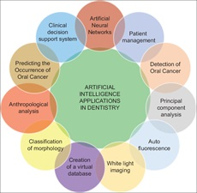
Figure 2: Different applications of artificial intelligence in dentistry
Courtesy: Lingam, Amara Swapna; Koppolu, Pradeep1; Akhter, Fatema; Afroz, Mohammed Malik; Tabassum, Nafeesa; Arshed, Maheen; Khan, Tahseen; ElHaddad, Sally. Future Trends of Artificial Intelligence in Dentistry. Journal of Nature and Science of Medicine 5(3):p 221-224, Jul–Sep 2022. | DOI: 10.4103/jnsm.jnsm_2_22²⁴
The future of Artificial Intelligence:
Artificial intelligence in health care may involve activities ranging from simple to sophisticated, including medical record review, population health trending and analytics, therapeutic medication and device design, radiological image interpretation, and clinical diagnosis and treatment²⁵. Artificial Intelligence is the new renaissance of dentistry. It involves itself in every aspect evolving the manual dental chairs to an electrical ones with voice recognition centres to facilitate command operations by the dentist²⁶. In the future, AI will be adorned by all dental practitioners. With the wise use of machine learning, patient records and diagnostic data can be saved virtually. This will not only help patients maintain health track records but also help practitioners share the data with their colleagues for consultation and case discussion in a hassle-free way. In the future, cutting-edge technologies will serve as great assistants to the dentist by preserving their valuable time and increasing their precision²⁷. Improved Diagnostic Accuracy, Predictive Analytics, Personalized Treatment Planning, Dental Robotics, Augmented Reality, Digital Impression Scanning, and Improved Patient Communication are included, which can be done by the AI models in the coming future.
Challenges of Artificial Intelligence:
AI systems are associated with safety issues. Mechanisms must be created to control the quality of the algorithms used in AI. To remedy this situation, the United States Food and Drug Administration have created a new drug category, “Software as Medical Device,” through which it regulates safe innovation and patient safety. Ambiguous accountability in the use of AI systems is another concern²⁸.
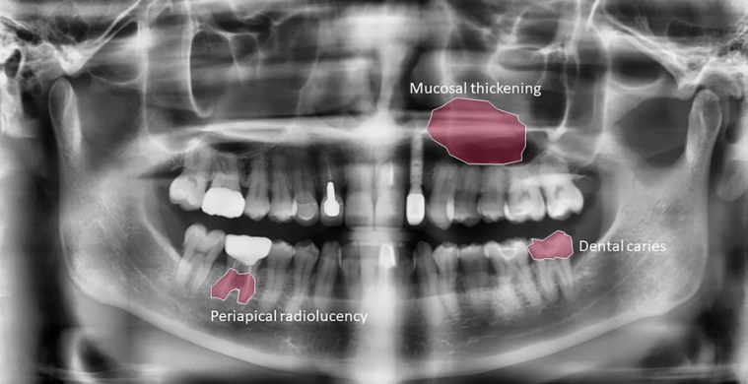
Figure 3: AI dental image analysis
Courtesy: Lee, S, Kim, D, Jeong, HG, (2022) Detecting 17 fine-grained dental anomalies from panoramic dental radiography using artificial intelligence. Research Outreach. Scientific Reports, 12, 5172. doi.org/10.1038/s41598-022-09083-2 DOI: 10.32907/RO-130-2773295876²⁹

Clinical Application of AI in Dentistry:
Osteoarthritis classification: AI has demonstrated the ability to classify 3D images of the mandibular condyle into five stages of structural degenerative changes, achieving 91% close agreement with clinician consensus and an established classification system³⁰.
Cancer Detection: In a recent study, an AI model was able to achieve an F1 score (which includes precision and recall) of 87% for the identification of images containing lesions³¹.
Radiology: Dental radiography, that is, intraoral radiographs, panoramic, cephalometric, advanced imaging techniques, and cone beam computed tomography (CBCT), are collected for diagnosis, treatment planning, and treatment evaluation purposes during routine dental practice. AI can be used as an effective tool to help clinicians make more objective and reproducible assessments of radiological images³².
Orthodontics: It is the branch of dentistry that diagnoses and treats the placement irregularities of the teeth and the development and position disorders of the jaws³³.
Periodontics: Periodontitis is one of the most common oral diseases that can cause alveolar bone loss, tooth mobility, and tooth loss³⁴. The diagnosis of periodontitis can be made by clinical examination and radiographic examination of periodontal tissues³⁵.

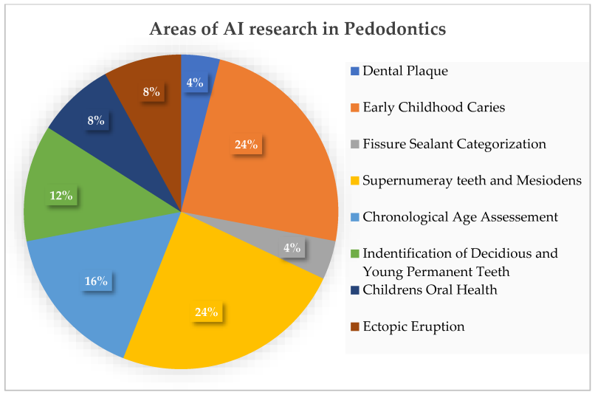
Figure 4: Areas of AI research in Pedodontics
Courtesy: Vishwanathaiah S, Fageeh HN, Khanagar SB, Maganur PC. Artificial Intelligence Its Uses and Application in Pediatric Dentistry: A Review. Biomedicines. 2023; 11(3):788. https://doi.org/10.3390/biomedicines11030788³⁶
Endodontics: It is a branch of dentistry that consumes all components of pulpal and periapical pathologies from their aetiology to their treatment. Areas such as anatomical variations of root canals, canal shaping techniques, and materials used in treatments are some of the topics that are researched and continue to be developed in endodontic³⁷.

Oral pathology³⁸: Artificial intelligence models and networks can learn and process dense information in a short time, leading to an efficient, objective, and accurate clinical and histopathological analysis, which can be useful in improving treatment modalities and prognostic outcomes³⁹.
Machine Learning: It is a branch of AI in which systems learn to perform intelligent tasks without prior knowledge or hand-crafted rules. Instead, the system identifies patterns in samples from large data sets without human assistance. Deep learning (DL) is a sub-branch of ML in which systems attempt to learn not only patterns but also compostable hierarchies of patterns built upon each other⁴⁰.
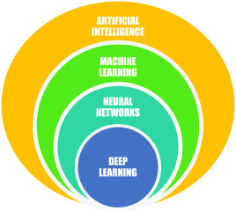
Figure 5: Key Aspects of Artificial Intelligence
Courtesy: Sanjeev B. Khanagar, Ali Al-ehaideb, Prabhadevi C. Maganur, Satish Vishwanathaiah, Shankargouda Patil, Hosam A. Baeshen, Sachin C. Sarode, Shilpa Bhandi, Developments, application, and performance of artificial intelligence in dentistry – A systematic review, Journal of Dental Sciences, Volume 16, Issue 1, 2021, Pages 508-522, ISSN 1991-7902, https://doi.org/10.1016/j.jds.2020.06.019⁴¹.
3D printing: It is being used to create custom dental restorations such as crowns, bridges, and dentures; well, it allows dentists to create these restorations quickly and accurately. With precise 3D scans and virtual models, it is easy to 3D print the aligners with customized treatment plans. As the vast data get computed, it creates an algorithm which in terms intelligently decides how a patient’s tooth or teeth should be moved, with how much pressure, even identifying pressure points for that particular tooth or teeth⁴².
Teledentistry: Teledentistry is a combination of telecommunications and dentistry, involving the exchange of clinical information and images over remote distances for dental consultation and treatment planning⁴³. Teledentistry, defined as the use of health information technology and telecommunications for oral care, was addressed to have the potential to identify high-risk populations; facilitate patient access to dental care; and reduce waiting lists, unnecessary travel, loss of productivity, and also inequalities in dental care access and costs for national health systems⁴⁴. Teledentistry has the potential to address the oral care needs of those who have limited access to care⁴⁵. Teledentistry demonstrated that dental professionals could consult each other even at large distances. This military project demonstrated that teledentistry was able to reduce total patient care costs, extending dental care to distant and rural areas and offering complete information required for deeper analyses⁴⁶.
Smart Dental Devices: These are being developed that can track a patient's oral health and provide feedback to the dentist. These devices can be used to monitor a patient's brushing habits, track the progress of gum diseases and identify potential problems earlier. Artificial neural networks (ANNs) can be more helpful for the diagnosis of the dental condition, thus assisting dental personnel in timely treatment based on the risk assessment of the patient. This is very prominent in the identification of risk groups who are more susceptible to oral cancers. It also helps in the prediction of erupted canine sizes or premolars as well as tooth surface loss. Artificial Intelligence is the new renaissance of dentistry. It involves itself in every aspect evolving the manual dental chairs to electrical ones with voice recognition centers to facilitate command operations by the dentist. In the future, AI will be adorned by all dental practitioners. With the wise use of machine learning, patient records and diagnostic data can be saved virtually. This will not only help patients maintain health track records but also help practitioners share the data with their colleagues for consultation and case discussion in a hassle freeway. In the future, cutting-edge technologies will serve as a great assistant to the dentist by preserving their valuable time and increasing their precision.
Computer-aided design (CAD) technologies: Computer-aided design (CAD) technologies introduced in the last decade into the dental industry have signiﬁcantly facilitated achievements in dentistry⁴⁷.
Robotics in dentistry: The role of intelligent robots in oral implantation mainly includes: (i) preoperative digital 3D scanning of the implant site and imaging data collection/diagnosis analysis; (ii) digital implant surgery plan design; and (iii) real-time navigation and automatic drilling during the operation to improve the accuracy of dental implant surgery, reduce surgical trauma, and shorten the operation time⁴⁸. “Robot” is a new term that emerged in the 20th century. In 1920, the Czech writer Karel Čapek published the science fiction script Rossum’s Omnipotent Robots, in which the word “robot” was first coined from the Czech word “Robota,” with a meaning similar to “labour” or “drudgery”⁴⁹. Masticatory robots are robots, devices, or simulators that can simulate human chewing motion. It can be used in dentistry, food science (evaluation of food texture characteristics and food-chewing dynamics), and biomechanics (analysis of mandibular joint force and stress⁵⁰.Tooth Cleaning- A six-axis robot that was programmed with individual clinical tooth brushing programs performed tooth brushing on artificial teeth, which were covered with a plaque simulation⁵¹. The intervention of robotic technology in dentistry has the potential to provide improved and precise treatment in a shorter time and has a good quality of work.
Applications of AI in the various fields of dentistry:
Today, artificial Intelligence-based virtual dental assistants are available in the market. As virtual assistants, these software can perform a number of simple tasks in the dental clinic with greater precision, less manpower and fewer errors than human counterparts.
Some of these tasks include:
• Booking and coordinating regular appointments according to the convenience of the patients and dentists.
• Alerting the patients and dentists about check-ups whenever any genetic or lifestyle information indicates increased susceptibility to dental diseases. (E.g., periodontal screening for patients with diabetes and oral cancer screening for those who habitually use smoked or smokeless tobacco).
• Managing paperwork and insurance⁵².

Conclusion:
The above overview depicts that artificial intelligence has emerged a lot in current times and might emerge as a common tool in ultramodern dentistry in the upcoming future. The benefits of this system are effectiveness, delicacy, bettered perfection, bettered monitoring, and time savings⁵³. As per researchers, AI is the future of helping clinicians to integrate different fields of knowledge for better patient care⁵⁴. Dental practitioners can identify AI as a supplemental tool to reduce their workload and improve precision and accuracy in diagnosis, decision-making, treatment planning, and prediction of treatment outcomes. The benefits of digital applications will complement human qualities and abilities to achieve improved and cost-efficient healthcare for patients⁵⁵. Teledentistry will help dentists assist patients without adding the risk of cross-infection⁵⁶. These are just a few of the many ways that technology is changing dentistry. As technology continues to advance, we will likely see AI being best viewed as an intelligent assistant in diagnostic and therapeutic care, providing rapid, reliable data to inform clinical decision-making. Ultimately, this could translate to improved protocols and health outcomes for patients. Leveraging the power of AI, dentists can provide more effective and efficient care, ultimately leading to better patient outcomes and improved oral health.AI is best viewed as an intelligent assistant in diagnostic and therapeutic care, providing rapid, reliable data to inform clinical decision-making. Ultimately, this could translate to improved protocols and health outcomes for patients. There should be a clear understanding of the concepts and models of AI to have the full benefit of the technology. Dentists and clinicians also should ensure the collection and providing authentic data in their database to have accurate results from the models. In addition, AI plays a critical role in virtual reality (VR) and augmented reality (AR), which will be very useful to us in the coming future.

References:
1. Tandon, Shobha; Venkiteswaran, Annapurny; Baliga, Sudhindra M1; Nayak, Ullal Anand2. Recent research trends in dentistry. Journal of Indian Society of Pedodontics and Preventive Dentistry 35(2):p 102-105, Apr–Jun 2017. | DOI: 10.4103/0970-4388.206038
2. Venugopal, Chaitra; K, Shobha; Rai, Kiranmai S.; Pinnelli, Venkata B.; Kutty, Bindu M.; Dhanushkodi, Anandh. Current Gene Therapy, Volume 18, Number 5, 2018, pp. 307-323(17)Doi: https://doi.org/10.2174/1566523218666180913152615
3. Thurzo A, Strunga M, Urban R, Surovková J, Afrashtehfar KI. Impact of Artificial Intelligence on Dental Education: A Review and Guide for Curriculum Update. Education Sciences. 2023; 13(2):150. https://doi.org/10.3390/educsci13020150
4. Yu KH, Beam AL, Kohane IS. Artificial intelligence in healthcare. Nat Biomed Eng. 2018 Oct;2(10):719-731. doi: 10.1038/s41551-018-0305-z. Epub 2018 Oct 10. PMID: 31015651.
5. Topol EJ. Deep medicine: how artificial intelligence can make healthcare human again. 1st ed. New York: Basic Books; 2019.
6. Bijo Alexander and Sunil John. (2018); ARTIFICIAL INTELLIGENCE IN DENTISTRY: CURRENT CONCEPTS AND A PEEP INTO THE FUTURE. Int. J. of Adv. Res. 6 (Dec). 1105-1108] (ISSN 2320-5407). www.journalijar.com
7. Obermeyer Z, Emanuel EJ. Predicting the Future - Big Data, Machine Learning, and Clinical Medicine. N Engl J Med. 2016 Sep 29;375(13):1216-9. doi: 10.1056/NEJMp1606181. PMID: 27682033; PMCID: PMC5070532.

8. Khanagar SB, Al-Ehaideb A, Maganur PC, Vishwanathaiah S, Patil S, Baeshen HA, Sarode SC, Bhandi S. Developments, application, and performance of artificial intelligence in dentistry - A systematic review. J Dent Sci. 2021 Jan;16(1):508-522. doi: 10.1016/j.jds.2020.06.019. Epub 2020 Jun 30. PMID: 33384840; PMCID: PMC7770297.
9. Hao Ding, Jiamin Wu, Wuyuan Zhao, Jukka P. Matinlinna, Michael F. Burrow, and James K. H. Tsoi Frontier Dental Medicine, 20 February 2023.Sec. Dental Materials Volume 4 - 2023 | https://doi.org/10.3389/fdmed.2023.1085251
10. Wulff A, Montag S, Steiner B, et al CADDIE2—evaluation of a clinical decision-support system for early detection of systemic inflammatory response syndrome in paediatric intensive care: study protocol for a diagnostic study BMJOpen 2019;9:e028953. doi: 10.1136/bmjopen-2019-028953
11. Prasad S, Potdar V, Cherian S, Abraham P, Basu A; ICMR-NIV NIC Team. Transmission electron microscopy imaging of SARS-CoV-2. Indian J Med Res. 2020 Feb & Mar;151(2 & 3):241-243. doi: 10.4103/ijmr.IJMR_577_20. PMID: 32362648; PMCID: PMC7224615.
12. Centers for Disease Control and Prevention, Interim Infection Prevention and Control Guidance for Dental Settings during the COVID-19 Response, Centers for Disease Control and Prevention, Atlanta, GA, USA, 2019, https://www.cdc.gov/coronavirus/2019-ncov/hcp/dental-settings.html.
13. Aminoshariae A, Kulild J, Nagendrababu V. Artificial Intelligence in Endodontics: Current Applications and Future Directions. J Endod. 2021 Sep;47(9):1352-1357. doi: 10.1016/j.joen.2021.06.003. Epub 2021 Jun 10. PMID: 34119562.Artificial intelligence in endodontics: Current applications and future directions.
14. Bhanushali, Parin & Katge, Farhin & Deshpande, Shantanu & Chimata, Vamsi & Shetty, Shilpa & Pradhan, Debapriya. (2020). COVID-19: Changing Trends and Its Impact on Future of Dentistry. International Journal of Dentistry. 2020. 1-6. 10.1155/2020/8817424. https://doi.org/10.1155/2020/8817424
15. Manne, Ravi and Kantheti, Sneha C., Application of Artificial Intelligence in Healthcare: Chances and Challenges (April 24, 2021). Current Journal of Applied Science and Technology, 40(6): 78-89, 2021, Available at SSRN: https://ssrn.com/abstract=4393347
16. Talpur S, Azim F, Rashid M, Syed SA, Talpur BA, Khan SJ. Uses of Different Machine Learning Algorithms for Diagnosis of Dental Caries. J Healthc Eng. 2022 Mar 31;2022:5032435. doi: 10.1155/2022/5032435. PMID: 35399834; PMCID: PMC8989613. J Healthc Eng.2022 Mar 31;2022:5032435. doi: 10.1155/2022/5032435. eCollection 2022.
17. Ahmed N, Abbasi MS, Zuberi F, Qamar W, Halim MSB, Maqsood A, Alam MK. Artificial Intelligence Techniques: Analysis, Application, and Outcome in Dentistry-A Systematic Review. Biomed Res Int. 2021 Jun 22;2021:9751564. doi: 10.1155/2021/9751564. PMID: 34258283; PMCID: PMC8245240.
18. Yo-Wei chen, Kyle Stanley, Dr Med Dent, Wael Att. Current applications and future perspectives quintessens international volume 51 number 3 march 2020
19. SanjeevB. Khanagar , Ali Al-ehaideb , Prabhadevi C. Maganur , Satish Vishwanathaiah , Shankargouda Patil , Hosam A. Baeshen , Sachin C. Sarode , Shilpa Bhandi .Journal of dental sciences Volume 16 issue1 Jan 2021 pages 508-522 https://doi.org/10.1016/j.jds.2020.06.019
20. Wulff A, Montag S, Steiner B, Marschollek M, Beerbaum P, Karch A, et al CADDIE2-evaluation of a clinical decision-support system for early detection of systemic inflammatory response syndrome in paediatric intensive care: Study protocol for a diagnostic study BMJ Open. 2019;9:e028953
21. Bas B, Ozgonenel O, Ozden B, Bekcioglu B, Bulut E, Kurt M. Use of artificial neural network in differentiation of subgroups of temporomandibular internal derangements: a preliminary study. J Oral Maxillofac Surg. 2012 Jan;70(1):51-9. doi: 10.1016/j.joms.2011.03.069. Epub 2011 Jul 29. PMID: 21802818.
22. Lim K, Moles DR, Downer MC, Speight PM. Opportunistic screening for oral cancer and precancer in general dental practice: results of a demonstration study. Br Dent J. 2003 May 10;194(9):497-502; discussion 493. doi: 10.1038/sj.bdj.4810069. PMID: 12835785.
23. Lingam, Amara Swapna; Koppolu, Pradeep1; Akhter, Fatema; Afroz, Mohammed Malik; Tabassum, Nafeesa; Arshed, Maheen; Khan, Tahseen; ElHaddad, Sally. Future Trends of Artificial Intelligence in Dentistry. Journal of Nature and Science of Medicine 5(3):p 221-224, Jul–Sep 2022. | DOI: 10.4103/jnsm.jnsm_2_22
24. https://chestnutdental.com/blog/the-future-of-dentistry-how-artificial-intelligence-is-changing-oral-healthcare/
25. Agrawal P, Nikhade P (July 28, 2022) Artificial Intelligence in Dentistry: Past, Present, and Future. Cureus 14(7): e27405. doi:10.7759/cureus.27405
26. Da Costa CB, Peralta FDS, Ferreira de Mello ALS. How Has Teledentistry Been Applied in Public Dental Health Services? An Integrative Review. Telemed J E Health. 2020 Jul;26(7):945-954. doi: 10.1089/tmj.2019.0122. Epub 2019 Oct 1. PMID: 31573410
27. Mann DL. Artificial Intelligence Discusses the Role of Artificial Intelligence in Translational Medicine: A JACC: Basic to Translational Science Interview With ChatGPT. JACC Basic Transl Sci. 2023 Jan 18;8(2):221-223. doi: 10.1016/j.jacbts.2023.01.001. PMID: 36908674; PMCID: PMC9998448.July 2022 Journal of Nature and Science of Medicine 5(3):221 DOI:10.4103/jnsm.jnsm_2_22LicenseCC BY-NC-SA 4.0
28. Thomas Nguyen, Naomie Larrivée, Alicia Lee, Olexa Bilaniuk, and Robert Durand J Canadian Dental Association 2021;87:L7
29. Lee, S, Kim, D, Jeong, HG, (2022) Detecting 17 fine-grained dental anomalies from panoramic dental radiography using artificial intelligence. Research Outreach. Scientific Reports, 12, 5172. doi.org/10.1038/s41598-022-09083-2 DOI: 10.32907/RO-130-2773295876
30,31. Strunga M, Urban R, Surovková J, Thurzo A. Artificial Intelligence Systems Assisting in the Assessment of the Course and Retention of Orthodontic Treatment. Healthcare. 2023; 11(5):683. https://doi.org/10.3390/healthcare11050683
32. Hosny A, Parmar C, Quackenbush J, Schwartz LH, Aerts HJWL. Artificial intelligence in radiology. Nature Reviews. Cancer. 2018 Aug;18(8):500-510. doi: 10.1038/s41568-018-0016-5. PMID: 29777175; PMCID: PMC6268174.

33. Tugce Gokdeniz S, Buyuksungur A, Eray Kolsuz M. Artificial Intelligence in Dentistry [Internet]. Dentistry. IntechOpen; 2023. Available from:Artificial Intelligence in Dentistry May 2023 DOI:10.5772/intechopen.111532 License CC BY 3.0 In book: Human Teeth - From Function to Esthetics [Working Title] Seyide Tugce Gokdeniz,Arda Buyuksungur and Mehmet Eray Kolsuz

34. Tonetti MS, Jepsen S, Jin L, Otomo-Corgel J. Impact of the global burden of periodontal diseases on health, nutrition and wellbeing of mankind: A call for global action. Journal of Clinical Periodontology. 2017 May;44(5):456-462. doi: 10.1111/jcpe.12732. Epub 2017 May 8. PMID: 28419559
35. Lin PL, Huang PY, Huang PW. Automatic methods for alveolar bone loss degree measurement in periodontitis periapical radiographs. Comput Methods Programs in Biomedicine. 2017 Sep;148:1-11. doi: 10.1016/j.cmpb.2017.06.012. Epub 2017 Jun 24. PMID: 28774432.
36. Vishwanathaiah S, Fageeh HN, Khanagar SB, Maganur PC. Artificial Intelligence Its Uses and Application in Pediatric Dentistry: A Review. Biomedicines. 2023; 11(3):788. https://doi.org/10.3390/biomedicines11030788
37. Joda T, Yeung AWK, Hung K, Zitzmann NU, Bornstein MM. Disruptive Innovation in Dentistry: What It Is and What Could Be Next. Journal of Dental Research. 2021 May;100(5):448-453. doi: 10.1177/0022034520978774. Epub 2020 Dec 16. PMID: 33322997.
38. Thomas T. Nguyen, Naomie Larrivée; Alicia Lee; Olexa Bilaniuk; Robert Durand, J Canadian Dental Association 2021;87:l7
39. Araújo ALD, da Silva VM, Kudo MS, de Souza ESC, Saldivia-Siracusa C, Giraldo-Roldán D, Lopes MA, Vargas PA, Khurram SA, Pearson AT, Kowalski LP, de Carvalho ACPLF, Santos-Silva AR, Moraes MC. Machine learning concepts applied to oral pathology and oral medicine: A convolutional neural networks' approach. J Oral Pathol Med. 2023 Feb;52(2):109-118. doi: 10.1111/jop.13397. Epub 2023 Jan 4. PMID: 36599081.58 Journal of oral pathology and Medicine , 04 January 2023. https://doi.org/10.1111/jop.13397
40. Nguyen TT, Larrivée N, Lee A, Bilaniuk O, Durand R. Use of Artificial Intelligence in Dentistry: Current Clinical Trends and Research Advances. J Can Dent Assoc. 2021 May;87:l7. PMID: 34343070
41. Sanjeev B. Khanagar, Ali Al-ehaideb, Prabhadevi C. Maganur, Satish Vishwanathaiah, Shankargouda Patil, Hosam A. Baeshen, Sachin C. Sarode, Shilpa Bhandi, Developments, application, and performance of artificial intelligence in dentistry – A systematic review, Journal of Dental Sciences, Volume 16, Issue 1, 2021, Pages 508-522, ISSN 1991-7902, https://doi.org/10.1016/j.jds.2020.06.019.
42. Deshmukh, SonaliVijay. (2018). Artificial intelligence in dentistry. Journal of the International Clinical Dental Research Organization. 10(2): 47. 10.4103/jicdro.jicdro_17_18. January 2018 LicenseCC BY-NC-SA
43. Yoshinaga L. The use of teledentistry for remote learning applications. Pract Proced Aesthet Dent. 2001 May;13(4):327-8. PMID: 11402774.
44. Daniel SJ, Kumar S. Teledentistry: a key component in access to care. J Evid Based Dent Pract. 2014 Jun;14 Suppl:201-208. doi: 10.1016/j.jebdp.2014.02.008. Epub 2014 Mar 5. PMID: 24929605.
45. Susan J. Daniel, Sajeesh Kumar,Teledentistry: A Key Component in Access to Care, Journal of Evidence Based Dental Practice, Volume 14, Supplement, 2014, Pages 201-208, ISSN 1532-3382, https://doi.org/10.1016/j.jebdp.2014.02.008.
46. Duka M, Mihailović B, Miladinović M, Janković A, Vujicić B. [Evaluation of telemedicine systems for impacted third molars diagnosis]. Vojnosanit Pregl. 2009 Dec;66(12):985-91. Serbian. doi: 10.2298/vsp0912985d. PMID: 20095519.
47. Shu-Xian Zheng, Jia Li, and Qing-Feng Sun. 2011. A novel 3D morphing approach for tooth occlusal surface reconstruction. Comput. Aided Des. 43, 3 (March, 2011), 293–302. https://doi.org/10.1016/j.cad.2010.11.003
48. Liu L, Watanabe M, Ichikawa T. Robotics in Dentistry: A Narrative Review. Dent J (Basel). 2023 Feb 24;11(3):62. doi: 10.3390/dj11030062. PMID: 36975559; PMCID: PMC10047128.
49. Almurib Haider , Al-Qrimli Haidar & Thulasiraman Nandha. (2012). A review of application industrial robotic design. Proceedings of the 2011 Ninth International Conference on ICT and Knowledge Engineering, Bangkok, Thailand. 12–13 January 2012; pp. 105–112 ,10.1109/ICTKE.2012.6152387.
50. Liu L, Watanabe M, Ichikawa T. Robotics in Dentistry: A Narrative Review. Dent J (Basel). 2023 Feb 24;11(3):62. doi: 10.3390/dj11030062. PMID: 36975559; PMCID: PMC10047128.
51. Lang T, Staufer S, Jennes B, Gaengler P. Clinical validation of robot simulation of toothbrushing--comparative plaque removal efficacy. BMC Oral Health. 2014 Jul 4;14:82. doi: 10.1186/1472-6831-14-82. PMID: 24996973; PMCID: PMC4094541.
52. Khanna, Sunali & Dhaimade, Prita. (2018). Artificial Intelligence: Transforming Dentistry Today. Indian Journal of Basic and Applied Medical Research; June 2017: Vol.-6, Issue- 3, P. 161-167 .www.ijbamr.com P ISSN: 2250-284X , E ISSN : 2250-285
53. Amisha, Malik P, Pathania M, Rathaur VK. Overview of artificial intelligence in medicine. J Family Med Prim Care. 2019 Jul;8(7):2328-2331. doi: 10.4103/jfmpc.jfmpc_440_19. PMID: 31463251; PMCID: PMC6691444.

54. Priyankar Roy , Lalith Vivekanand and Gurman Preet Singh GSC Advanced Research and Reviews, 2021, 07(01), 082–086. ,10.30574/gscarr.2021.7.1.0078. https://doi.org/10.30574/gscarr.2021.7.1.0078
55. Ossowska A, Kusiak A, Świetlik D. Artificial Intelligence in Dentistry—Narrative Review. International Journal of Environmental Research and Public Health. 2022; 19(6):3449. https://doi.org/10.3390/ijerph19063449
56. Bhanushali, Parin & Katge, Farhin & Deshpande, Shantanu & Chimata, Vamsi & Shetty, Shilpa & Pradhan, Debapriya. (2020). COVID-19: Changing Trends and Its Impact on Future of Dentistry. International Journal of Dentistry. 2020. 1-6. 10.1155/2020/8817424 https://doi.org/10.1155/2020/8817424

