"Synthesis and Characterization of Metal Oxide Nanoparticles: Approaches and Techniques"

Vishal S. Kamble¹  Department of Chemistry, Changu Kana Thakur Arts, Commerce and Science College New Panvel (Autonomous) Maharashtra India 410206.  vishalchemistry1@gmail.com | Jitendra M. Pawara^{2*}  Department of Chemistry, Changu Kana Thakur Arts, Commerce and Science College New Panvel (Autonomous) Maharashtra India 410206.  jmpawara@gmail.com
Satyajit S. Kamble³  Department of Physics, Changu Kana Thakur Arts, Commerce and Science College New Panvel (Autonomous) Maharashtra India 410206.  satyajitkamble2@gmail.com | Sagar L. Khairnar⁴  Department of Mathematics, Changu Kana Thakur Arts, Commerce and Science College New Panvel (Autonomous) Maharashtra India 410206.  sagarkhairnar1604@gmail.com
Digambar K. Patil⁵
Department of Chemistry, Changu Kana Thakur Arts, Commerce and Science College New Panvel (Autonomous) Maharashtra India 410206.
dkmrudula980@gmail.com

ABSTRACT
The abstract summarizes a comprehensive overview of various synthetic methods for preparing metal oxide nanoparticles, emphasizing "top-down" and "bottom-up" approaches. These methods span gases, liquids, solids, supercritical fluids, and vacuum conditions. The "top-down" approach involves breaking down bulk materials into nanoparticles, while the "bottom-up" approach assembles atoms or molecules to form nanoparticles with the help of stabilizers. Common techniques such as chemical vapor deposition, sol-gel, and co-precipitation are explored, each offering distinct advantages and disadvantages. Characterization techniques like XRD, FESEM, HRTEM, FTIR, UV-VISIBLE, EDAX, and XPS are highlighted for understanding the structural and optical properties. This abstract provides a concise overview of the preparation and characterization methods for metal oxide nanoparticles.

Keywords- Nanoparticle synthesis, Metal oxide nanoparticles, Top-down approach, Bottom-up approach, Characterization techniques, XRD, FESEM, HRTEM, FTIR, UV-VISIBLE, EDAX, XPS

INTRODUCTION

Now a day’s numerous physical, chemical and biological synthetic techniques have been developed and reported for the preparation of pure and mixed metal oxide nanoparticles. As shown in Fig.1, nanoparticle synthesis techniques can be narrowly divided into two major groups: "top-down" and "bottom-up" approaches. These approaches are implemented in gases, liquids, solids, supercritical fluids and in vacuum state. The top-down approach involves the synthesis of nanoparticles by efficient breaking down of bulk materials gradually into smaller sized subdivisions. This method is comparatively more expensive and technically complicated due to uncontrolled of particle size and structure. Nevertheless, top-down method still used for nanomaterial’s synthesized of structural, magnetic, and catalytic purposes. Ball milling process, electron beam lithography, photolithography, ion and plasma etching anodization are some of the frequently used top-down approach for the preparation of nanoparticles [1]. In the bottom-up approach, the nanoparticles are synthesized by linking every atom by atom or molecule by molecule or cluster by cluster in the presence of shielding agent or stabilizer shielding agent or stabilizer used to avoid the agglomeration of nanoparticles by either steric repulsion or electrostatic repulsion among nanoparticles. Generally, the majority of the researcher’s usages a bottom-up approach to prepare of nanoparticles. Well known examples of bottom-up approach are sol-gel, chemical vapour deposition, self-assembly of monomeric or polymeric molecules, co-precipitation, laser pyrolysis, bio-assisted synthesis, plasma or flame spraying synthesis [2]. The first goal after completing the preparation of a suitable nanomaterial is to carry out characterizations on that nanomaterial. A nanomaterial's detailed characterization is a crucial parameter for understanding its electrical, structural, morphological, and optical properties. This knowledge of nanomaterial properties aids in the selection of suitable applications in a variety of fields. So as to prepare nanomaterials in a proper way, the main necessities are a various collection of characterization performances. The precise description of the experimental findings discovered through characterization techniques is a major concern. In this chapter, we will briefly address the most common methods for preparing nanoparticles as well as the fundamental principles of the characterization techniques used in the present research work.

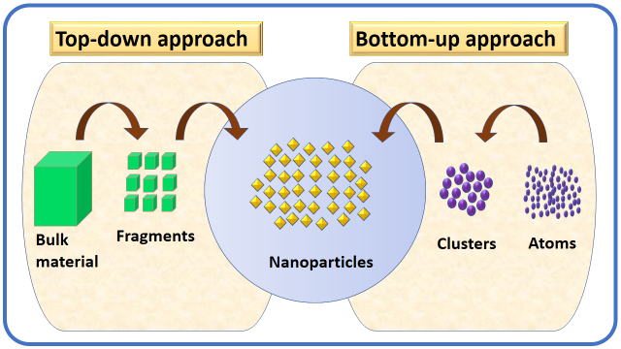
Fig. 1: Schematic representation of nanoparticle preparation and assembly approach

1.0 PREPARATION METHODS FOR NANOMATERIALS

The physicochemical properties and uses of nanomaterials mostly depend upon the preparation method implemented. Since each procedure has its own set of advantages and disadvantages, the characteristics of the final product vary from one to another technique. In literature, the numerous methods have been developed for synthesis of pure and doped ZnO nanomaterials, among them most extensively used methods are briefly described below.

1.1 Vapor techniques

a) Chemical Vapor Deposition (CVD) Method

Of all the bottom-up methods, the CVD process is the most widely known. As a result of various chemical reactions, gaseous molecules are converted into solid materials in the form of powders or thin films and deposited onto the heated surface (usually) of the substrate. Thin film materials, such as nanowires, nanoflakes, nanotubes, and nanoparticles, are commonly prepared using this method. There are several CVD methods useful for the preparation of nanoparticles, such as plasma-assisted, metalo-organic, conventional, and photo CVD techniques [3]. The main advantages of these techniques are making pure, uniform and reproducible thin films. Fig. 2 shows the diagrammatic representation of the CVD deposition procedure. The first step is to vaporise the precursors and transport them into the reactor chamber; the second step is to diffuse the precursor molecules onto the substrate's surface. The third stage is adsorption on the surface. Finally, there will be the decomposition and incorporation into solid thin films with release of volatile by-products in the form of gases state.

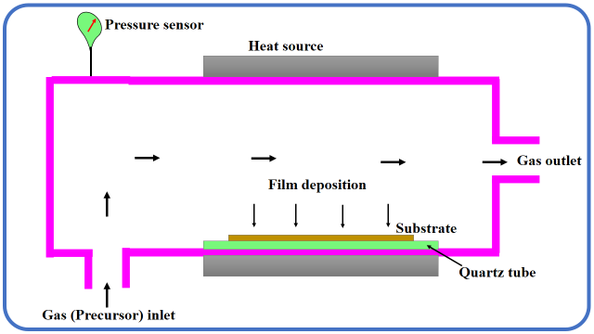
Fig. 2: Schematic illustration of chemical vapour deposition method

b) Physical vapor deposition (PVD) method

The oldest PVD method is an evaporation technique, the principle of PVC process is the source material is heated up to the vaporization and the vapour phase condenses on the surface of substrate in the form of thin film. As a result, physical vapour deposition is a vaporisation coating process that includes material transfer at the atomic level. The process can be broken down into the following stages. (i) The material to be deposited is altered into a vapor phase by physical means (high-temperature vacuum or gaseous plasma), (ii) The vapor is transferred to the low-pressure region from its source to the substrate, and (iii) the vapor undergoes condensation on the substrate to form a thin film. Physical vapor deposition techniques are typically used to create films with thicknesses ranging from a few nanometers to thousands of nanometers. They can, however, be used to create graded composition deposits, multilayer coatings, free-standing structures, and extremely thick deposits. [4]. A typical physical vapor deposition technique is presented in Fig.3.

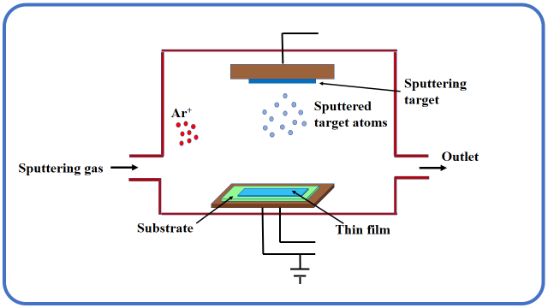
Fig. 3: Schematic representation of physical vapour deposition method

1.2 Hydrothermal/ Solvothermal method

In the hydrothermal method water is taken as the solvent while in the solvothermal process solvents are used excluding water, mostly organic solvents. Hydrothermal/solvothermal method is a technique of synthesis of single crystals (nanoparticles) that depends upon the solubility of minerals in hot aqueous solution under high vapor pressure. Generally, this method is useful for forming roughness on the surface of substrate by using high pressure and temperature. In an autoclave (a tool consists of a steel pressure vessel) precursor along with water or organic solvent are supplied. A temperature gradient is produced between the opposite tops of the autoclave chamber. At the hotter end the nutrient solute dissolves, while at the cooler end it is deposited on a seed crystal, growing the desired crystal. Precursors dissolve at hotter side while at the cooler side they are deposited, thus desired crystals growth take place. The advantages of present technique are to capability to create crystalline phases that are not steady at the melting point. Hydrothermal/solvothermal method is suitable for growing large and decent quality crystals while keeping control over their composition. The current method has several disadvantages, including the high cost of autoclaves and the difficulty of observing crystal growth. Fig. 4 shows the instrumental set up of hydrothermal/ solvothermal method.
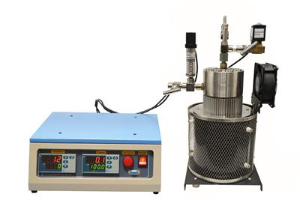

Fig. 4: Instrumental set up of hydrothermal/ solvothermal method

1.3 Spray pyrolysis method

Spray pyrolysis is the process of atomizing a chemical reactant in an instrument that produces a droplet, evaporates in a heated reactor and eventually decomposes into thin films and particles [6]. This method was documented in the 1980 as a central technology to produce different nanostructures from required precursor solutions. Various nanostructures designed by spray pyrolysis method such as thin films, nanowires, nanoplates, nanocomposites, multiroom hollow, core shell, yolk shell, plicated sphere, dense sphere and hollow sphere [7]. Broadly, the spray pyrolysis method involves three main steps: Precursors solution composition, aerosol generation and transport, and material synthesis route. Diagrammatic representation of spray pyrolysis method is represented in Fig.5. The chemical reactants are selected such that other than products all desired compounds are volatile at the temperature of deposition. In present era, spray pyrolysis is demonstrated as an accessible and simple way to prepare homogeneous composites and several nanosized useful materials.

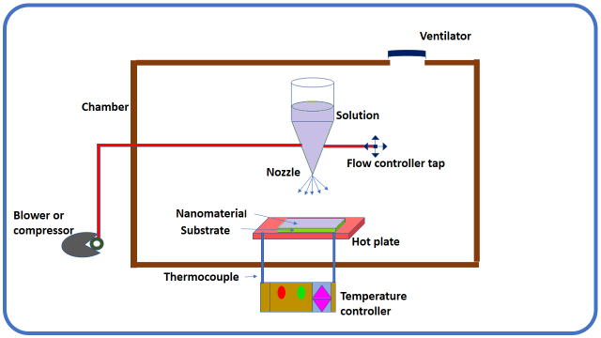
Fig. 5: Diagrammatic representation of spray pyrolysis method

1.4 Successive ionic layer adsorption and reaction (SILAR) method

Successive ionic layer adsorption and reaction (SILAR) method is the modified version of chemical bath deposition (CBD) method and one of the best solution methods to deposit several chemical compound materials in the form of thin films on the substrate. This technique is low-cost, simple and appropriate for large area of deposition. SILAR method is generally depends on the adsorption (accumulation of one substance on the surface of another surface) phenomenon. There are three adsorption systems liquid–solid, gas–solid and gas–liquid. SILAR technique is correlated with adsorption in liquid–solid system [8]. Thin films of nanomaterials are obtained from a SILAR method by immersing the substrate into anionic and cationic precursor solutions individually located and rinsing it with deionized water between each immersion. For ion layer formation, the time of dipping in ion exchange water is crucial. So, formation of precipitation (as like CBD method) i.e. wastage of material, is avoided in SILAR method. A typical SILAR method is presented in Fig.6.

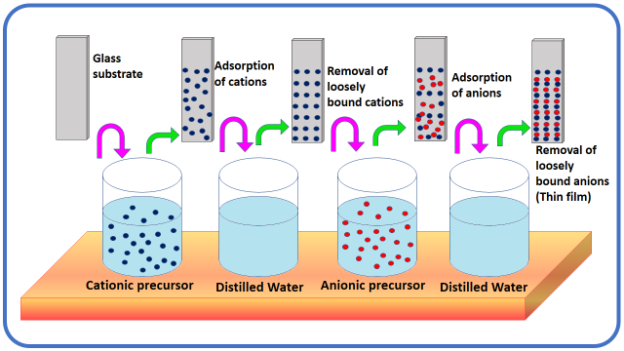
Fig. 6: Schematic illustration of SILAR method

1.5 Mechanochemical method

Mechanochemical preparation is a processing method of solid materials where mechanical and chemical phenomenon are combined on a molecular scale. This technique is useful to prepare a desired nano product using simply a mechanical stroke such as high pressure and mechanical stress between reactants and balls at room temperature or at temperature less than regular solid-state preparation method [9]. In the present method steel balls or refractory transference its energy to the precursors which depends upon number and size of balls, the rotational velocity, ratio of the balls to reactants amount, time and atmosphere of mill. This method is useful to synthesis of all types of materials on large quantity that can be convenient for different applications. Mechanochemical technique is nearly an ideal technique for making of nanostructured metals, alloys or intermetallic compounds powder due to its easiness and the probability of developing composite powder with a constant distribution of grain sizes [10]. The major drawback of this process is adulteration through milling atmosphere or media. A typical mechanochemical method is presented in Fig.7.

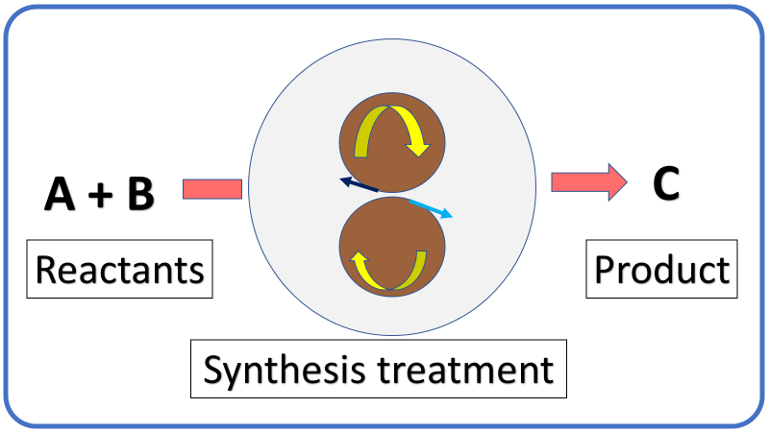
Fig. 7: Typical representation of mechanochemical method

1.6 Microwave-assisted method

A green approach to the preparation of nanosized materials is a microwave-assisted process. Hot plate or oil bath are used as a source of heat for a chemical synthesis in conventional heating systems. While microwave radiation is useful as a heating source in chemical reaction in the microwave-assisted procedure [11]. The dipolar polarization and conduction are the basic mechanisms of the microwave assisted synthesis technique. Microwave-assisted method is an important and simple technique for the synthesis of metal oxide nanomaterials. Generally, this technique is useful for the preparation of superiority nanomaterials through direct microwave irradiation heating (quick heating) of the precursors of reaction mixture. This method requires very small reaction time and it used for the synthesis of transition metal oxides at low temperature. Various metal oxides were prepared using this method, like ZnO, NiO, CuO, TiO₂ and Fe₂O₃. Diagrammatic representation of microwave-assisted method is represented in Fig.8.

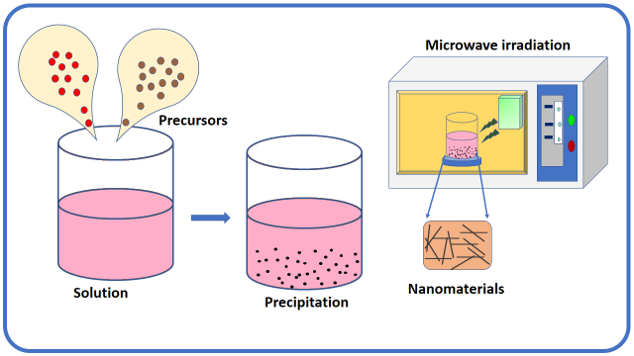
Fig. 8: Diagrammatic representation of microwave-assisted method

1.7 Micro-Emulsion method

The micro-emulsion technique is a very useful method which permits the synthesis of a countless range of nanomaterials just alone or in grouping with additional methods. Hence the preparation of nanoparticles by micro emulsions technique has been current interest topic in research area [12]. The benefit of this method is the biocompatibility and biodegradability of prepared nanomaterials. Emulsion is formed when two or more immiscible or unmixable liquids are mechanically stirred or mixed owing to liquid-liquid phase separation. Normally emulsions are turbid in nature and it stabilized with surfactants. At the point, when water, an organic oil or liquid and surfactant are unified together, under a few critical concentration, micelles or inverse micelles are formed, contingent upon the concentration of organic oil or liquid and water. Generally, the size of emulsions is bigger than 100 nm to few mm. Emulsions having two categories water-in-oil (w/o) and oil-in-water (o/w) [13]. The various types of nanomaterials have been prepared, in both water-in oil and oil-in-water micro-emulsions. Pictorial illustration of micro-emulsion technique is represented in Fig.9.

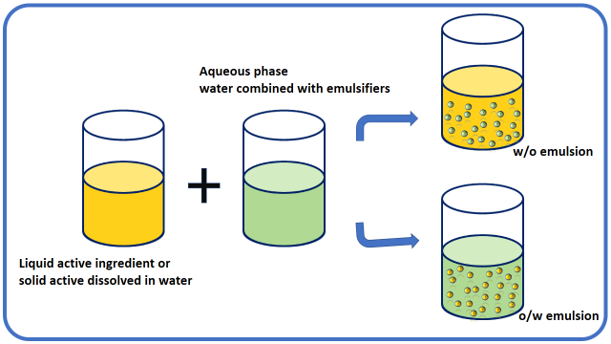
Fig. 9: Pictorial illustration of micro-emulsion technique

1.8 Sol-gel method

Sol-gel method delivers a novel approach to the synthesis of innovative nanomaterials. It is a wet chemical process also known as chemical solution deposition method. The process includes transforming monomers into a colloidal solution (sol), which serves as a precursor for forming an interconnected network (gel) of discrete particles or network polymers in both solid and liquid phases. Distinctive precursors are metal alkoxides. Sol-gel method involves various steps, such as hydrolysis, polycondensation, gelation, aging, drying, densification, and crystallization. The physical and chemical properties of the prepared materials by the sol–gel method is depending on the experimental circumstances applied. This method contains two key reactions: (i) hydrolysis of the precursor in the acidic or basic mediums (ii) polycondensation reaction of the hydrolyzed materials. Usually metal alcoxides [M(OR)₃] are versatile molecular used to obtain oxides, owing to their capability to form homogeneous solution in enormous variety of solvents and in the occurrence of additional alcoxides or metallic derivatives and also for their reactivity toward nucleophilic substances like water [14]. The Illustrative diagram of sol-gel method is shown in Fig.10.
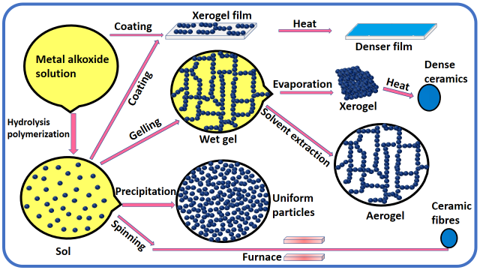
Fig. 10: Pictorial illustration of sol-gel method

1.9 Co-precipitation method

Co-precipitation is the process of a precipitate carrying down substances that are usually soluble under the conditions used [15]. Co-precipitation method is a classical and maybe the simplest and convenient approach for producing pure or multinary metal oxide nanoparticles. In case more than one precursor salt is used for the starting solution, mixed metal oxides may be found in the corresponding hydroxide co-precipitate mode. Preparation of nanoparticles through co-precipitation way requires lower reaction temperature and low-cost equipment. This method is rapid preparation of high purity nanomaterials, energy efficient, an eco-friendly route, easily controllable of size of particles and composition, useful to synthesize large quantity of nanomaterials and it does not requires hazardous organic solvents. Although it is difficult to regulate particle size and dispersal when the precipitation rate is fast, it has been documented that nanostructured pure and doped metal oxide powder can be synthesized with an improved co-precipitation process by maintaining a constant pH level [16-17]. Key steps of co-precipitation reactions are the simultaneous occurrence of nucleation, growth, coarsening, and/or agglomeration processes. The co-precipitation technique involves dissolution of different salt precursors (nitrate, acetate, sulfate, oxychloride, chloride etc.) in desired solvent or water with a particular goal to develop metal oxides nanoparticles, the subsequent metal hydroxides are made precipitate in water or solvent by addition of an alkaline solution like sodium hydroxides or aqueous ammonia solution. The resulting precipitate washed with various solvents to remove free salts. To obtain the absolute metal oxides compound, the filtered hydroxides are calcined at the required temperature in a muffle furnace. At room temperature, the co-precipitation reaction product is normally amorphous. To solve this anonymity, a number of surfactants are now used to gain more control over particle size and morphology. The diversity of co-precipitation chemistry and reaction environments have resulted in several diverse particle morphologies including spheres, rods, cubes, plates, dumbbells, rhomboids, hollow spheres, and others. Some examples of the different morphologies from literature reports are exposed in Fig.11 [18]. Presently, numerous novel co-precipitation approaches have been produced such as sonochemical and microwave assisted [19-20]. The most common method for producing pure and mixed ZnO nanoparticles is the co-precipitation technique. ZnO chemically combined with one or more doped metals including Au, Ni, Co, Fe, Ti, Cu, Pd, Cd, and W etc. and are suitably produced from aqueous solutions of metal salts by the addition of a base under oxygen-free atmosphere at either room or appropriate temperature [21-29]. Due to several advantages of co-precipitation method, we use co-precipitation method in current research work for preparation of pure ZnO and transition metal mixed ZnO for gas sensor application. Schematic representation of co-precipitation approach is given in Fig.12.

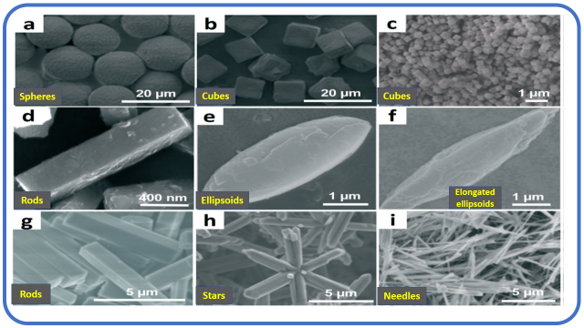
Fig. 11: Particles with different morphologies obtained from co-precipitation reactions

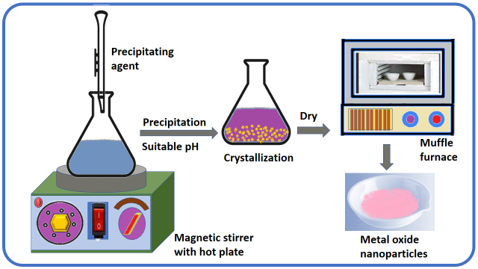
Fig. 12: Diagrammatic representation of co-precipitation method

2.0 Characterization technique

2.1 X-ray diffraction technique (XRD)

The X-ray diffraction (XRD) technique was developed by two English researchers W. L. Bragg and his son W. H. Bragg in 1913 [30]. This is a very powerful a non-destructive type analytical tool commonly used for phase identification of crystalline substances in the form of powder and thin films such as bond angles, unit cell dimensions, geometry and lattice constants, phase transition, orientation of single crystals, and preferred orientation of polycrystalline films, stress, defects, etc. [31]. XRD technique permits recognizing and studying the crystalline materials by means of diffraction phenomenon. Mainly, a monochromatic beam of X-rays of wavelength comparable to atomic spacing’s, incident on the crystal and is diffracted in a specular fashion to undergo constructive interference. X-rays get diffracted at a definite angle (θ) by lattice planes and provide constructive interference for a set of hkl planes whose path difference is an integral multiple of the incident light wavelength.
The essential condition for constructive interference is mathematically given by Bragg’s equation [32].

nλ = 2d sin (θ) (2.1)

Where, n is order of diffraction and the values are 1, 2, 3… (Usually 1) etc. λ is the wavelength of X-ray in angstrom (Copper = 1.54 Å), d is the inter planar distance, θ is the Bragg’s angle in degrees (also known as glancing or diffraction angle) Fig 13 displays the X-ray diffraction from two planes of atoms in a lattice. The intensity corresponding to constructive interference of the diffracted beam from a crystallographic plane is observed as peak, related to the Bragg angle (θ). The relation between the particle size and width of X-ray diffraction line was first derived by scientist Debye-Scherrer in 1918 [33]. The average crystallite size (D) was estimated using the Scherrer formula given as,
D = $\frac{0.9 λ}{β\cos{θ}}$ ( 2.2)

Where λ, is a wavelength of X-ray (1.54 Å for CuKα), β is full width at half maximum (FWHM) in radian, θ is Bragg’s angle. In present work, Bruker D₂ phaser model was used for XRD study of prepared materials.
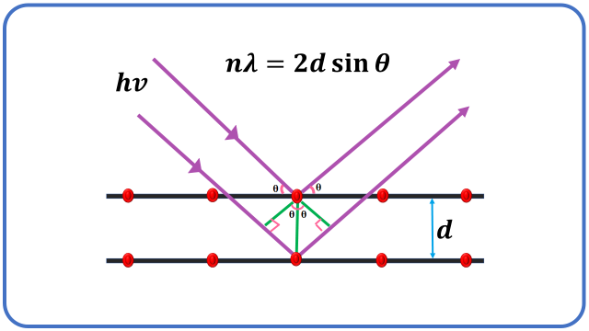
Fig. 13: Schematic illustration of X-ray diffraction set up

2.2 Field Emission Scanning Electron Microscopy (FESEM)

The field emission scanning electron microscope (FESEM) is a microscopic instrument that workings with particles with a negative charge (electrons) in place of light to form an image. These electrons are expelled by a field emission source. The object is scanned by electrons according to a zig-zag pattern. The secondary electron ejected from the surface of the materials but its velocity and angle correlate with the surface structure of the material. The secondary electrons are catches by a detector and produce an electronic signal which amplified accordingly. These amplified singles are transformed to the video scan image of the object or digital image that can be seen on a monitor which is useful for the surface analysis [34]. The schematic illustration of FESEM is represented in Fig.14. The field emission scanning electron microscope (FESEM) is an instrument similar the scanning electron microscope (SEM), provides an extensive variety of information from the material surface, but FESEM produces clearer, less electrostatically distorted images with higher resolution down to 1 to 1/2 nanometers which three to six times better than SEM and a much greater energy range. This is mainly because of emission source of FESEM (field emitter or gun) and SEM (thermionic emitter) [35]. The FESEM is applicable for noticing tiny structures as small as 1 nm on the surface of the prepared samples. This technique is used to examine the morphologies like particle and grain size and shapes, metallographic as well as topographic information and imperfections of crystalline bulk and powders nanomaterials. The present tool is also useful to study the elemental compositions inside the materials in submicron scale. Therefore, FESEM technique is extensively apply in the material science field and its related area. In present study, Zeiss Ultra, 55 FESEM model was used for FESEM analysis of prepared samples.

2.3 High Resolution Transmission Electron Microscopy (HRTEM) and Selected Area Electron Diffraction (SAED)

High resolution transmission electron microscopy (HRTEM) is similar to transmission electron microscopy (TEM) imaging except that the magnification used are sufficient to easily visible the lattice spacing of nanomaterials and direct information about the atomic structure of material can be inspected by HRTEM which is not possible by TEM. HRTEM is an ultimate tool to study various properties of nanomaterials on the atomic level. The image development in HRTEM depend on phase contrast. HRTEM offers the imaging mode of the crystallographic structural resolution down to the angstrom scale and provides data on the atomic packing, more willingly than only the morphology of the nanomaterials. HRTEM gives the information of particle growth, particle size up to 0.05 nm with aberration correctors, shape and arrangement of the particles, defects in a material and crystal phases [36]. Fig. 15 shows diagrammatic representation of HRTEM. In present research, JOEL JEM 2100 Plus model was used for HRTEM investigation of prepared samples.
Selected area electron diffraction (SAED) is an inside of the TEM crystallographic experimental method. The SAED is the observation of a randomly oriented particle's diffraction spot pattern obtained from the TEM spot screen. Such a pattern specifies that the material prepared is crystalline. For studying small crystals and partially disordered material in a few hundred Angstrom unit size, SAED patterns are particularly useful [37].
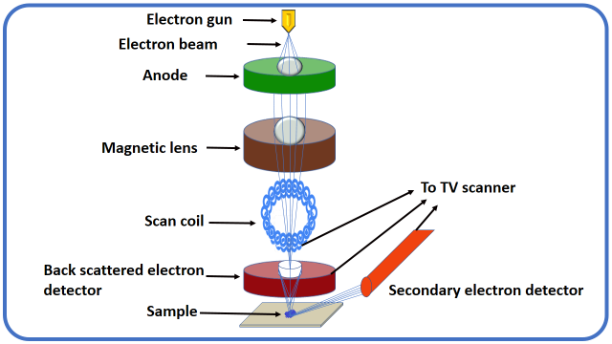
Fig. 14: Schematic representation of FESEM

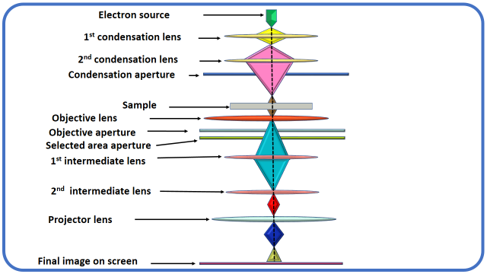
Fig. 15: Schematic illustration of HRTEM

2.4 Fourier-Transform Infrared Spectroscopy (FTIR)

Fourier-Transform Infrared Spectroscopy (FTIR) is the preferred technique of infrared spectroscopy. The term Fourier-Transform Infrared Spectroscopy (FTIR) originates from a mathematical calculation known as “Fourier Transform”. This is essential to transform the raw data into the actual spectrum data of absorption for each wavelength. To perform this type of calculations interference of light is needed [38]. FTIR spectroscopy is one of the most universal spectroscopic method used by researchers all over the world. It is the tool in which absorption measurement of various infrared frequencies (4000 and 400 cm⁻¹) by a material located in the pathway of an IR radiation is observed and documented. The principal purpose of FTIR spectroscopic investigation is to find the functional groups present in the sample. Different functional groups existence in the sample absorb distinctive frequencies of IR beam. By various testing equipment’s, FTIR spectrometer can be used for a wide range of samples such as solids, liquids and gases materials. So, FTIR spectroscopy is unique and general approach for the study of structural features and compound identification. In FTIR, the un-dispersed radiation is pass through the sample and the absorbance at all wavelengths has reached at the detector simultaneously. The FTIR instrument depend on upon interferences of different frequencies of light to produce a spectrum. It has a source, sample, two mirrors one moveable and one fixed, a laser reference, and detector, but the assembly of constituents also consist of a beam splitter and the two strategic mirrors that function as an interferometer. Present FTIR study was done using FT/IR-4600 Jasco, Japan. Schematic presentation of FTIR is given in Fig. 16.
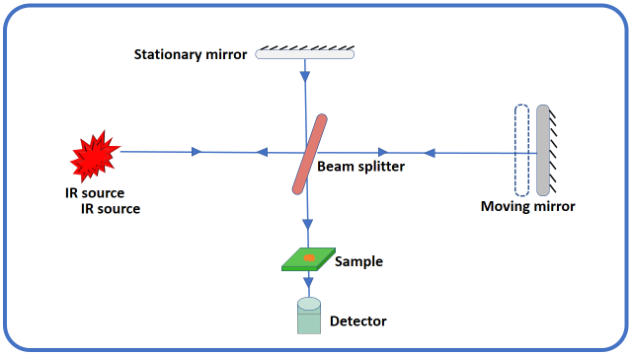

Fig. 16: Diagrammatic presentation of FTIR spectrophotometer

2.5 Ultraviolet-Visible spectroscopy (UV-VISIBLE)

UV-Visible absorption spectroscopy is the more easy and direct technique to study the optical possessions and band structure of metallic and semiconducting materials. This is also beneficial for finding of functional groups, impurity, quantitative and qualitative analysis of nanocomposites. Basically UV-Visible spectroscopy is helpful to determine absorption wavelength across the UV and visible assortments of the electromagnetic radiation passes through the sample. When incident light radiation falls on the matter it can either be absorbed, scattered, transmitted, reflected or it can excite fluorescence. The absorption of UV-Visible light by a sample induces atomic excitation, or the transfer of an electron from its ground energy level to an excited energy level. Absorption study provide a simple means of the estimation of absorption edge, optical band gap, optical transition such as direct/indirect, allowed/forbidden [39]. The energy of photons less than the band gap are transmitted through the sample while the energy of photons greater than the band gap are absorbed by material. Band gap energy is estimated from the Tauc’s relationship as follows,
αhν = A(hν-Eg)^{n} (2.3)
Where α is absorption coefficient (absorbed energy per thickness of the sample) hν is the photon energy, A is constant, Eg is the energy of the optical band gap and the value of the exponent n is the characteristics of the type of radiation. It taken as 1/2, 3/2, 2 and 3 for direct allowed, direct forbidden, indirect allowed and indirect forbidden transitions respectively [40]. The present optical properties of prepared nanostructures were inspected using UV–Vis-NIR (V-770 Jasco, Japan) in assortment of 200–1100 nm. UV-Visible spectrophotometer involves the number of fundamental components such as light sources (UV and visible), monochromator (wavelength selector), sample containers and detector as shown in Fig.17.

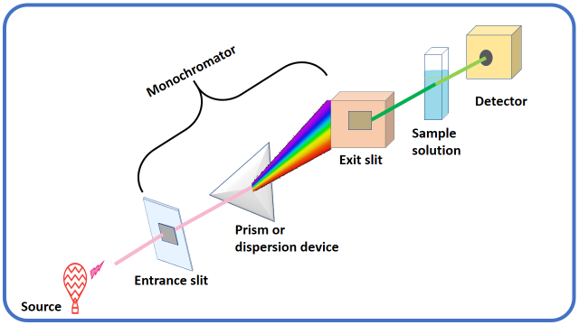
Fig. 17: Representative diagram of UV-VISIBLE spectrophotometer

2.6 Energy Dispersive Analysis of X-rays (EDAX)
Energy dispersive analysis of X-ray (EDAX) sometimes called energy-dispersive X-ray spectroscopy (EDX, EDS, XEDS or EDXS) is an analytical tool used in conjunction with SEM for the chemical characterization or elemental analysis of the material. EDAX is one of the X-ray fluorescence spectroscopy alternatives that depend on electromagnetic radiation interactions with matter to analyze a sample. Its characterization abilities are due in large part to the basic principle that each element has a distinctive atomic structure permitting an exclusive set of peaks on its electromagnetic emission spectrum that is the key principle of spectroscopy [41]. The peak positions are identified by the Moseley's law with precision much better than experimental resolution of a characteristic EDAX tool. Initially, a high energetic beam of charged particles like electrons or X-ray beams, is focused into the sample understudied. At rest, an atom within the sample contains unexcited electrons or ground state in discrete energy levels. Due to the incident X-ray beam an electron in an inner shell may be excited and ejected from the shell and simultaneously created an electron hole where the electron was. An electron from higher energy or outer shell, then fills an electron hole and the in-energy difference between the outer shell and the inner shell may be released in an X-ray form. The number and energy of the X-rays emitted from a sample can be determined by an EDAX. As the energy of the X-rays is characteristic of the difference in energy between the two shells, and of the atomic structure of the element from which they were emitted, this permits the elemental composition of the sample to be measured [42-43]. Fig. 18 shows the instrumental set up of EDAX.
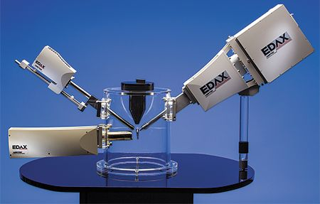
Fig. 18 Instrumental set up of EDAX

2.7 X-ray Photoelectron Spectroscopy (XPS)
X-ray photoelectron spectroscopy (XPS) or electron spectroscopy for chemical analysis (ESCA) is a technique based on the photoelectric effect that was invented by Hertz in 1887. A surface-sensitive method like XPS is a good example. This technique is useful for determining the elements present within a material and covering its surface, such as the elemental composition and oxidation state of the elements, as well as the entire electronic structure and density of the electronic states in solid materials such as insulators, conductors, and polymers. Major strength of XPS is not only shows what elements are present but also what additional elements they are bonded to [44]. When X-rays are bombarded on sample in vacuum, it gives rise to the emission of electrons. The kinetic energy (Ke) of the emitted electrons is calculated by photoelectric effect equation:
Ke = hν – (Be + φ) (2.4)
where hν is photon energy of monochromatic X-rays, Be is the binding energy of the atomic orbital and φ is the work function (minimum amount of energy of an electron requires to emit from the surface) [45]. Each element at definite energy having ability to create an exclusive set of electrons. By calculating the number of these electrons as a function of binding (or kinetic) energy, XPS spectrum is obtained. Through XPS all elements can be identified, excluding H and He. Binding energies of photoelectrons based on the chemical atmosphere of an atoms. Correct measurement of the exact peak position of the elements present gives information on the oxidation state of these elements. Schematic representation of XPS is shown in Fig.19. Thermo Fischer Scientific ESCALAB Xi+ X-ray photoelectron spectrophotometer is used for the study of surface atomic composition and chemical states prepared nanostructures of present investigation.

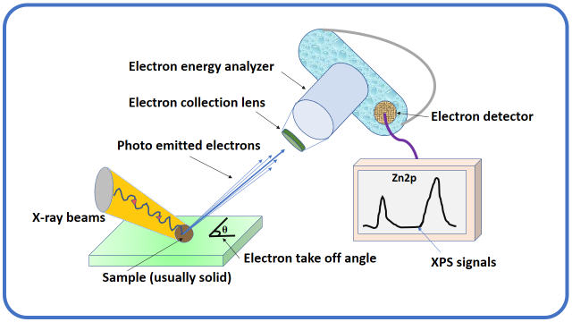
Fig. 19: Schematic representation of XPS

3.0 Conclusion
In conclusion, the realm of metal oxide nanoparticle synthesis is a dynamic field, encompassing a wide array of techniques to tailor materials with desired properties. The distinction between "top-down" and "bottom-up" approaches provide a versatile toolbox for researchers, each offering distinct advantages and challenges. While "top-down" methods allow precise control over particle size and morphology, they often come with complexity and cost. On the other hand, "bottom-up" strategies provide versatility in composition and structure, facilitated by stabilizers and shielding agents.
Characterization techniques such as XRD, FESEM, HRTEM, FTIR, UV-VISIBLE, EDAX, and XPS play a pivotal role in understanding the physical and chemical attributes of synthesized nanoparticles. These methods aid in elucidating crystallographic arrangements, surface morphologies, and elemental compositions. The choice of characterization tools depends on the specific properties being investigated and the nature of the nanoparticles.
Innovations in nanoparticle synthesis and characterization continue to advance numerous applications across various disciplines, including catalysis, electronics, and medicine. The marriage of precise synthesis and comprehensive characterization is essential for harnessing the potential of metal oxide nanoparticles in addressing complex challenges and paving the way for innovative technologies in the future.

4.0 REFERENCES
- C. Dhand, N. Dwivedi, X.J. Loh, A.N.J. Ying, N.K. Verma, R.W. Beuerman, S. Ramakrishna, RSC Adv., 2015, 5(127), 105003-105037.
- C. Daraio, S. Jin, Nanotechnology for biology and medicine, Springer, New York, 2012, 27-44
- B.J. Scott, G. Wirnsberger, G.D. Stucky, Chem. Mater., 2001, 13(10), 3140-3150.
- D.M. Mattox, Handbook of physical vapor deposition (PVD) processing. William Andrew, 2010.
- A.H. Mamaghani, F. Haghighat, C.S. Lee, Chemosphere, 2019, 219, 804-825.
- D.S. Jung, Y.N. Ko, Y.C. Kang, S.B. Park, Adv Powder Technol., 2014, 25(1), 18-31.
- J. Leng, Z. Wang, J. Wang, H.H. Wu, G. Yan, X. Li, Z. Guo, Chem. Soc. Rev., 2019, 48(11), 3015-3072.
- H.M. Pathan, C.D. Lokhande, Bull. Mater. Sci., 2004, 27(2), 85-111.
- F.C. Gennari, J.J. Andrade-Gamboa, J. Electrochem. Energy Convers. Storage, 2018, 429-459.
- K. Wieczorek-Ciurowa, High-Energy Ball Milling, Woodhead Publishing, 2013, 193-223.
- A.S. Grewal, K. Kumar, S. Redhu, S. Bhardwaj, Int. J. Appl. Pharm. Sci. Res., 2013, 3(5), 278-285.
- M.A. Lopez-Quintela, Curr. Opin. Colloid Interface Sci., 2003, 8(2), 137-144.
- J. Eastoe, M.J. Hollamby, L. Hudson, Adv. Colloid Interface Sci., 2006, 128, 5-15.
- L. Baraket, A. Ghorbel, Stud. Surf. Sci. Catal., 1998, 118, 657-667.
- P. Patnaik, Dean’s analytical chemistry handbook. McGraw-Hill Education, 2004.
- A.V. Rane, K. Kanny, V.K. Abitha, S. Thomas, Synthesis of inorganic nanomaterials, Woodhead Publishing, 2018, 121-139.
- H. Ke, W. Wang, Y. Wang, J. Xu, D. Jia, Z. Lu, Z., Y. Zhou, J. Alloys Compd, 2011, 509(5), 2192-2197.
- H. Dong, G.M. Koenig, Cryst. Eng. Comm., 2020, 22(9), 1514-1530.
- S.H. Soytaş, O. Oğuz, Y.Z. Menceloğlu, Polymer Composites with Functionalized Nanoparticles, Elsevier, 2019, 287-323.
- S. Liu, C. Ma, M.G. Ma, F. Xu, Composite Nano adsorbents, Elsevier, 2019, 295-316.
- W. Jinxiao, Y. Jun, H. Ning, Y. Jianfeng Rare Metal Mat. Eng., 2018, 47(6), 1682-1688.
- X. Chu, J. Liu, B. Sun, R. Dai, Y. Pei, M. Qiao, K. Fan, J. Mol. Catal A Chem., 2011, 335(1-2), 129-135.
- X. Su, Y. Jia, X. Liu, J. Wang, J. Xu, X. He, S. Liu, Ceram. Int., 2014, 40(4), 5307-5311.
- Y. Wang, F. Luo, L. Zhang, D. Zhu, W. Zhou, Ceram. Int., 2013, 39(8), 8723-8727.
- H.H. Ko, C.S. Hsi, M.C. Wang, X. Zhao, J. Alloys Compd, 2014, 588, 428-439.
- Y. Tanaka, T. Utaka, R. Kikuchi, K. Sasaki, K. Eguchi, Appl. Catal. A-Gen., 2003, 238(1), 11-18.
- Y. Matsumura, Appl. Catal. A-Gen., 2013, 468, 350-358.
- P. Margan, M. Haghighi, Ultrason. Sonochem., 2018, 40, 323-332.
- H. Zhao, Q. Fang, C. Chen, Z. Chao, Y. Tsang, Y. Wu, Appl. Organomet. Chem., 2018, 32(9), 4449.
- J.E. Chisholm, Mineralogical Magazine, 1998, 62(1), 131-131.
- B.D. Cullity, S.R. Stock, Elements of X-ray Diffraction, Prentice-Hall, 2001.
- P.F. Lindley, D.S. Moss, Acta Crystallogr., Sect. A: Found. Crystallogr. 1970, 26(6), 701-701.
- Y.C. Zhou, M.N. Rahaman, J. Mater. Res., 1993, 8(5), 1680-1686.
- G.J. Janssen, Radboud University Nijmegen, 2015.
- A. Mayeen, L.K. Shaji, A.K. Nair, N. Kalarikkal, Woodhead Publishing,
2018, 335-364
- X. Zhou, G.E. Thompson, Electron and Photon Based Spatially Resolved Techniques, 2017.
- J.P. de Villiers, P.R. Buseck, Mineralogy and Instrumentation, 2003.
- P.R. Griffiths, J.A. De Haseth, FTIR, John Wiley & Sons. 2007, 171.
- A. Goswami, Thin film fundamentals, New Age International 1996.
- C.S. Kumar, (Ed.), UV-VIS & photoluminescence spectroscopy for nanomaterials characterization, Berlin: Springer, 2013, 5-7.
- J. Goldstein, (Ed.), Practical scanning electron microscopy: electron and ion microprobe analysis. Springer Science & Business Media, 2012.
- J.P. Sibilia, A guide to materials characterization and chemical analysis. John Wiley & Sons, 1988.
- D.D. Brandon, W.D. Kaplan, Quantitative Analysis of Microstructure. 1999, 345-397.
- C.S. Fadley, J. Electron Spectros. Relat. Phenomena., 2010, 178, 2-32.
- D.R. Baer, S. Thevuthasan, Handbook of Deposition Technologies for Films and Coatings, William Andrew Publishing, 2010, 749-864.

