Solar-Powered AgriBot: Revolutionizing Indian Agriculture Through Automated Farming Processes
Florance Mary M¹ and Hemakumar B²
^{1,2} Department of Electronics and Instrumentation Engineering, Puducherry Technological University , Puducherry, India

Abstract:
Agriculture is a crucial sector in India, serving as the backbone of the country's economy. However, the industry faces several challenges, such as high investment costs, a shortage of skilled labor, inadequate water resources, and insufficient crop monitoring. To address these issues, the use of robots in agriculture has emerged as a potential solution. While significant investments have been made in the agricultural sector over the past decade, automation has not progressed much due to the complexity of the systems and their lack of user-friendliness. This is where a proposed robot comes in, which can perform all farming processes, including planting, irrigation, and harvesting, using solar energy. The robot can be controlled manually through a mobile phone connected via Bluetooth, and it also has an auto-mode feature that enables it to perform all tasks independently. This robot can perform tasks such as digging, seeding, and watering crops with ease. By utilizing this technology, farmers can increase their productivity and reduce their labor costs while also ensuring the efficient use of resources. Keywords : Agriculture, robot, seeding, solar panel

I Introduction:
In recent decades, the global agricultural sector has been facing unprecedented challenges due to factors such as population growth, climate change, and limited arable land. Traditional farming practices are struggling to keep pace with the increasing demand for food production, leading to a pressing need for innovative and sustainable solutions. In response to these challenges, the integration of robotics and automation in agriculture has emerged as a transformative approach to enhance productivity, reduce labor costs, and optimize resource utilization.
The literature on agricultural robots covers a wide range of topics, including technological advancements, applications, benefits, challenges, and the potential impact of these innovative machines on agriculture and society. This literature review aims to summarize key findings from various studies and research papers on agricultural robots.
Research by Cheng, C et al. [1] demonstrates successful implementations of agrobots in various crops, highlighting their versatility and adaptability to different farming practices and crop types. Gutiérrez et al. [2] proposed Decision Support Systems (DSSs) used in precision agriculture to provide feedback to a variety of stakeholders, including farmers, advisers, researchers and policymakers. However, increments in the amount of data might lead to data quality issues, and as these applications scale into big, real-time monitoring systems the problem gets even more challenging. Several studies emphasize the benefits of agricultural robots, including increased productivity, improved resource management, and reduced environmental impact. Ali et al. [3] report that the use of agrobots leads to more precise application of inputs like fertilizers and pesticides, resulting in minimized wastage and decreased environmental pollution
Despite their potential, agricultural robots face several challenges in widespread adoption. Cost is a common concern, as highlighted by Droukas, L et al. [4] who explore the economic feasibility of agrobot adoption for different farm sizes. Moreover, ensuring robust and reliable performance under various field conditions, as discussed by Xie et al. [5] , remains a challenge for developers. Research papers like Shamshiri RR et al.[6] and Ryan M {7] delve into the social and ethical implications of agricultural robots. These studies address concerns related to potential job displacement for farm laborers, rural development, and the ethical considerations surrounding autonomous decision-making by robots in farming practices. Authors such as Khan, N et al. [8] , Thomas Daum [9] offer insights into the future prospects of agricultural robots. They discuss the potential role of agrobots in addressing global food security challenges, enabling sustainable farming practices, and transforming agriculture into a data-driven industry.

Several research papers investigate the impact of agricultural seeding robots on crop yield improvements. By precisely placing seeds and optimizing planting density, these robots contribute to increased crop yields. Research conducted by Cheng et al. [10] and Hussain et al. [11] showcases the potential benefits of seeding robots in enhancing overall farm productivity and food production. Authors like Pearson et al. [12] and Lin Haibo et al. [13] discuss the adaptability of agricultural seeding robots to different crop types and various field conditions. These studies highlight how modern seeding robots can be equipped with interchangeable seed cartridges and adjustable planting parameters, allowing farmers to switch between crops seamlessly and adapt to varying soil and climate conditions. The literature also explores the environmental and economic benefits of agricultural seeding robots. By optimizing seed placement and reducing the need for manual labour, these robots help in conserving resources and reducing greenhouse gas emissions. Florance Mary M et al. [14] developed a weed removing robot based on neural network Research by Vahdanjoo, M et al. [15] and Balaska et al. [16] highlights the potential cost savings and sustainability advantages of using seeding robots in modern farming practices.
This research paper aims to present an in-depth analysis of agricultural robot design, functionalities, and its potential impact on agriculture. The paper will delve into the core features of the AGROBOT, its applications, and how it addresses key challenges faced by traditional farming methods. By examining its advantages and limitations, we will critically assess the feasibility of AGROBOT as a viable solution for enhancing agricultural productivity, sustainability, and profitability.
II SYSTEM DESCRIPION:
The overall working of the proposed system is shown as block diagram in Fig. 1. .The microcontroller is the heart of the whole block and the circuit is energized by the charge stored in the battery from the solar panel. The mobile app is used to give instructions for the microcontroller through the Bluetooth module.
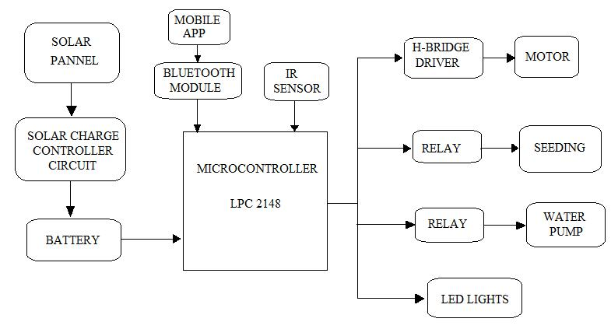

Fig. 1. Functional Block Diagram of seeding robot

The IR sensor is used for detecting obstacle in robot’s path and it also instructs the microcontroller to take necessary action. The motor is connected to the microcontroller through H-bridge driver. The seeding setup and the water pump are connected with the microcontroller through relay circuit. The LED lights for the robot are connected with the microcontroller. The solar power used in this proposed work makes the robot eco friendly.
III CIRCUIT CONNECTION AND DESCRIPTION

Interfacing the individual components with the LPC 2148 microcontroller is explained . Each sub block explains about the component and its interconnection with the microcontroller. It also explains about the pin configurations
The IR sensor which is used for obstacle detection by connecting with the LPC 2148 as shown in Fig 2 .The IR sensor contains three pins Vcc, Ground and out. The Vcc pin is connected to the power circuit board, which supplies the required voltage of 5V. The OUT pin of the sensor is connected to the P0.5 of the LPC 2148 microcontroller. The GND pin is connected to the ground.

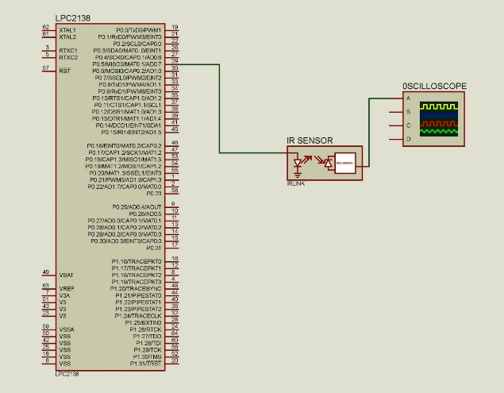

Fig. 2. Interfacing LPC 2148 with IR sensor

The HC-05 Bluetooth module which is the Bluetooth device for the robot is connected with microcontroller LPC2148 is shown in Fig. 3. .he Bluetooth module HC-05 is composed of five pins .The RX pin is used to receive data bit, TX pin is used to transmit data bit, the Vcc pin is connected to 5V supply ,GND pin is connected to ground and the fifth pin is KEY pin. Since only data transmission takes place, the TX pin of the bluetooth module is connected to the P0.9 of the LPC 2148 which is the microcontroller’s UART 1 RX pin .

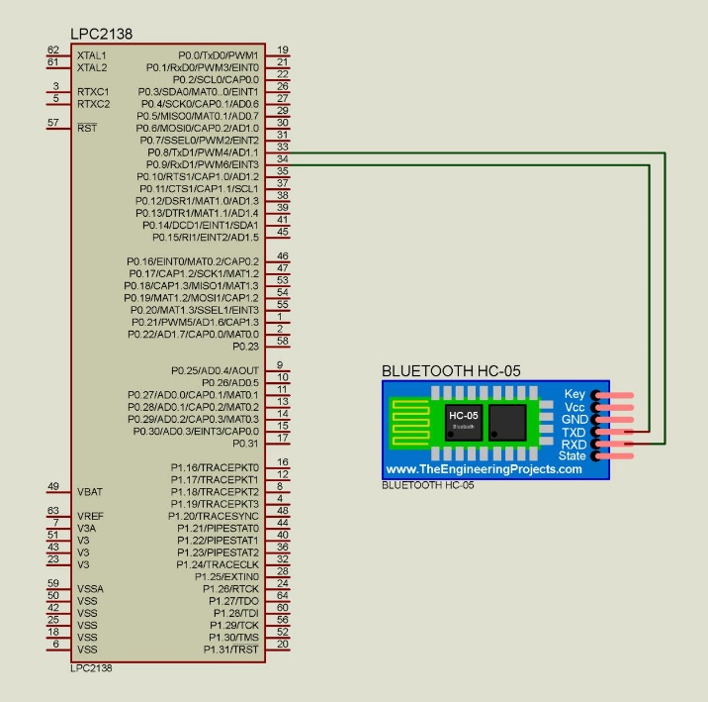

Fig. 3. Interfacing LPC 2148 with HC-05

The H bridge motor driver is responsible for the robot wheel and is connected with LPC 2148 is shown in Fig 4. The H-bridge driver has six major pins. The Vcc pin is connected to the 12V supply and the GND pin is connected to the ground. The pins IN1,IN2,IN3,IN4 are responsible for motor direction and are connected to P1.28,P1.29,P1.30,P1.31 respectively of the LPC2148 microcontroller. The output pin OUT1 and OUT 2 are connected to the motor M2. Similarly the another two output pin OUT3 and OUT4 are connected to the motor M1.
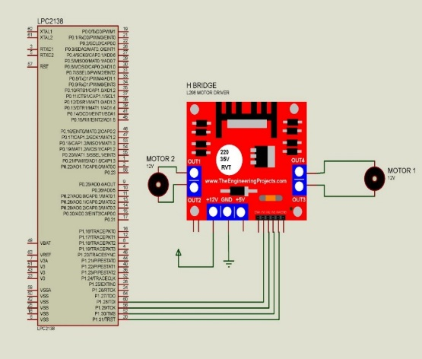

Fig.4. Interfacing LPC 2148 with H-Bridge

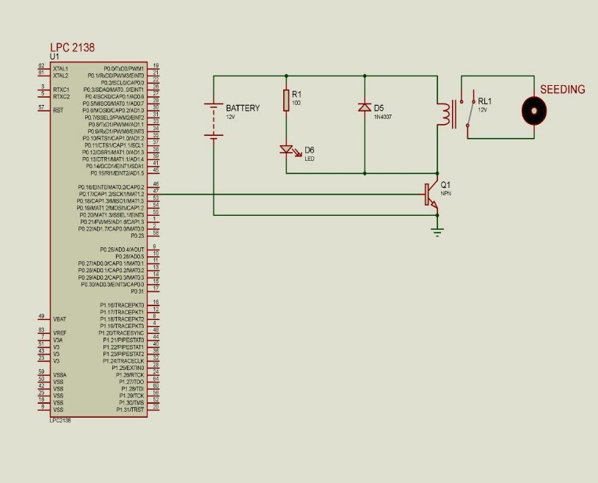
The seeding motor driver is used for the dropping the seeds and is connected with LPC2148 is shown in Fig. 5. The seeding motor is interfaced with microcontroller through a relay. The relay circuit consists of six pins . The Vcc pin is connected to 12V DC supply and the GND pin is connected to ground. The pin IN1 is connected to P0.17 of the microcontroller. The NO (Normally Open) pin is connected to 12V and NC(normally closed) pin is connected to seeding motor. The another terminal of the motor is connected to ground.

Fig 5. Interfacing LPC 2148 with Seeding motor

The motor pump driver, waters the seeds which was dropped by the seeding setup and the motor pump is connected with the LPC 2148 is shown in Fig.6. The motor pump is interfaced with microcontroller through a relay. The relay circuit consists of six pins. The Vcc pin is connected to 12V DC supply and the GND pin is connected to ground. The pin IN2 is connected to P0.23 of the microcontroller. The NO (Normally Open) pin is connected to 12V and NC(normally closed) pin is connected to seeding motor. The another terminal of the motor is connected to ground.

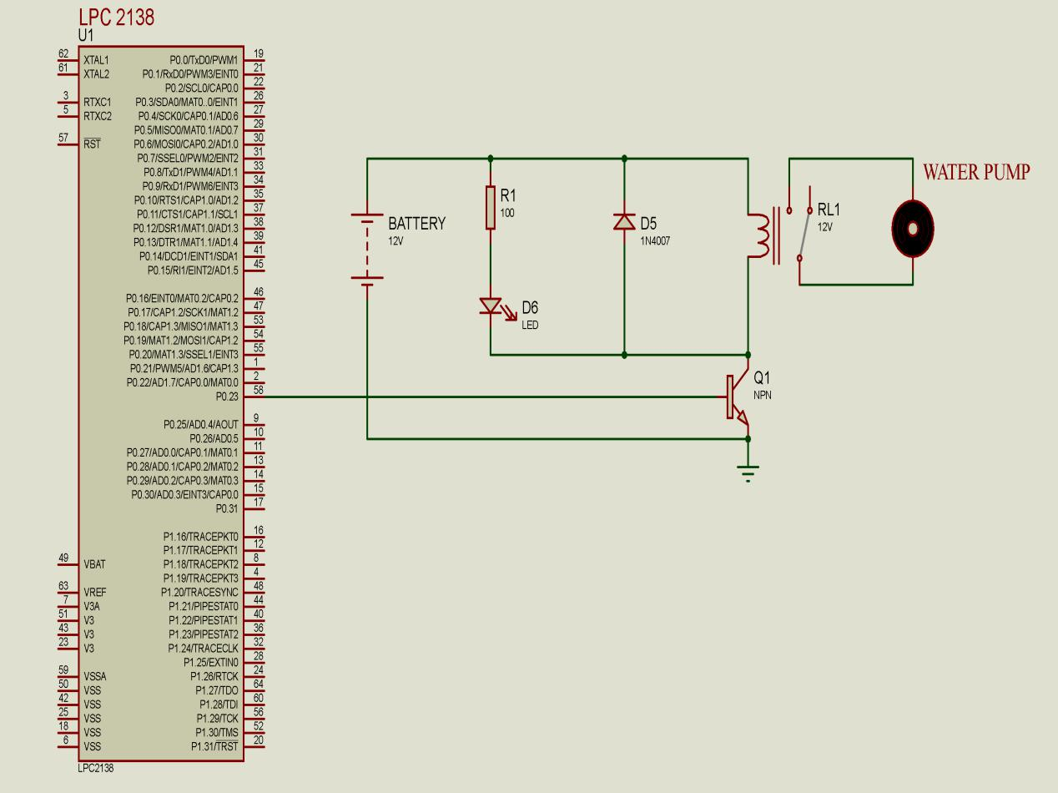

Fig 6. Interfacing LPC 2148 with Water Pump

IV HARDWARE IMPLEMENTATION

A farming robot which can be operated in manual mode as well as automatic mode has been developed as shown in Fig 7. The bot achieved an average speed of 025 m/s and has a battery span of 9 hours A strong wireless communication system has been implemented using Bluetooth. The bot smoothly traverses agricultural fields and performs operations necessary for the cultivation of crops..

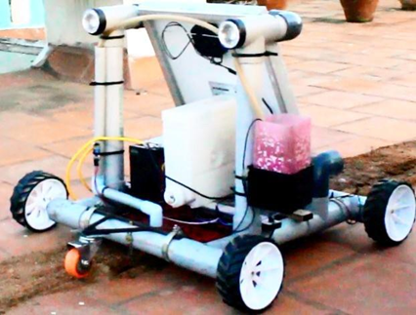 | 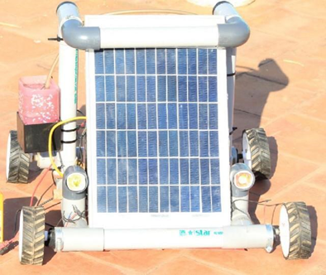
Fig 7.(a) Front View of Robot | Fig 7.(b) Back View of Robot
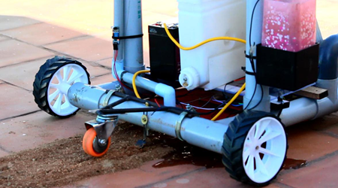 | 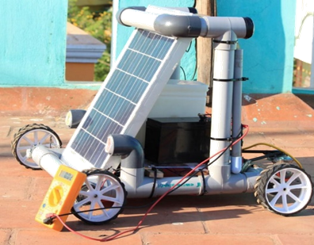
Fig 7.(c) View of seeding and watering using Robot | Fig 7.(d) Side View of Robot

Fig .8. Bluetooth controller screen

The robot successfully receives commands from the mobile app and performs motor direction in control mode as shown in Fig. 8. The Digging, dropping seeds, watering seeds, closing soil and obstacle detection are performed in automatic mode. The robot can work for 9 hours continuously for the fully charged battery. This robot can economically helps the farmers and reduce physical labour.
V CONCLUSION
In conclusion, Seeding Agricultural Robot emerges as a beacon of innovation in agriculture, offering an efficient, sustainable, and intelligent solution to revolutionize the seeding process. The potential of this innovative agricultural robot is not limited to seeding alone; its applications may extend to other critical farming tasks in the future. As we embrace the era of smart farming, Seeding Agricultural Robot paves the way for a more sustainable and prosperous future for agriculture, empowering farmers to feed the world more efficiently and responsibly.
REFERRENCE:
1. Cheng, C.; Fu, J.; Su, H.; Ren, L.,( 2023 ). Recent Advancements in Agriculture Robots: Benefits and Challenges. Machines 11, 48. https://doi.org/10.3390/machines11010048
2. Francisco Gutiérrez, Nyi Nyi Htun, Florian Schlenz, Aikaterini Kasimati, Katrien Verbert, (2019) A review of visualisations in agricultural decision support systems: An HCI perspective, Computers and Electronics in Agriculture, 163(104844), https://doi.org/10.1016/j.compag.2019.05.053.
3. Ali, A.; Hussain, T.; Tantashutikun, N.; Hussain, N.; Cocetta, G. Application of Smart Techniques, Internet of Things and Data Mining for Resource Use Efficient and Sustainable Crop Production. Agriculture 2023, 13, 397. https://doi.org/10.3390/agriculture13020397
4. Droukas, L., Doulgeri, Z., Tsakiridis, N.L. et al. A Survey of Robotic Harvesting Systems and Enabling Technologies. J Intell Robot Syst 107, 21 (2023). https://doi.org/10.1007/s10846-022-01793-z
5. Xie, D.; Chen, L.; Liu, L.; Chen, L.; Wang, H. Actuators and Sensors for Application in Agricultural Robots: A Review. Machines 2022, 10, 913. https://doi.org/10.3390/machines10100913
6. Shamshiri R R, Weltzien C, Hameed I A, Yule I J, Grift T E, Balasundram S K, et al. Research and development in agricultural robotics: A perspective of digital farming. Int J Agric & Biol Eng, 2018; 11(4): 1–14.
7. Ryan, M. The social and ethical impacts of artificial intelligence in agriculture: mapping the agricultural AI literature. AI & Soc (2022). https://doi.org/10.1007/s00146-021-01377-9
8. Khan, N.; Ray, R.L.; Sargani, G.R.; Ihtisham, M.; Khayyam, M.; Ismail, S. Current Progress and Future Prospects of Agriculture Technology: Gateway to Sustainable Agriculture. Sustainability 2021, 13, 4883. https://doi.org/10.3390/su13094883
9. Thomas Daum , Farm robots: ecological utopia or dystopia? , Trends in Ecology & Evolution - SCIENCE & SOCIETY, 36(9), 774-777, SEPTEMBER 2021,DOI:https://doi.org/10.1016/j.tree.2021.06.002
10. Cheng, C.; Fu, J.; Su, H.; Ren, L. Recent Advancements in Agriculture Robots: Benefits and Challenges. Machines 2023, 11, 48. https://doi.org/10.3390/machines11010048
11. Hussain Nor Azmi, Sami Salama Hussen Hajjaj, Kisheen Rao Gsangaya, Mohamed Thariq Hameed Sultan, Mohd Fazly Mail, Lee Seng Hua, Design and fabrication of an agricultural robot for crop seeding, Materials Today: Proceedings, Volume 81, Part 2, 2023, Pages 283-289,ISSN 2214-7853,https://doi.org/10.1016/j.matpr.2021.03.191.
12. Pearson, S., Camacho-Villa, T.C., Valluru, R. et al. Robotics and Autonomous Systems for Net Zero Agriculture. Curr Robot Rep 3, 57–64 (2022). https://doi.org/10.1007/s43154-022-00077-6
13. Lin Haibo, Dong Shuliang, Liu Zunmin, Yi Chuijie, "Study and Experiment on a Wheat Precision Seeding Robot", Journal of Robotics, vol. 2015, Article ID 696301, 9 pages, 2015. https://doi.org/10.1155/2015/696301
14. M Florance Mary and D Yogaraman Neural Network Based Weeding Robot For Crop And Weed Discrimination Journal of Physics: Conference Series, Volume 1979, International Conference on Recent Trends in Computing (ICRTCE-2021) 20-22 May 2021, DOI 10.1088/1742-6596/1979/1/012027
15. Vahdanjoo, M.; Gislum, R.; Sørensen, C.A.G. Operational, Economic, and Environmental Assessment of an Agricultural Robot in Seeding and Weeding Operations. AgriEngineering 2023, 5, 299-324. https://doi.org/10.3390/agriengineering5010020
16. Balaska, V.; Adamidou, Z.; Vryzas, Z.; Gasteratos, A. Sustainable Crop Protection via Robotics and Artificial Intelligence Solutions. Machines 2023, 11, 774. https://doi.org/10.3390/machines11080774

