Assessing the Product Quality of Online Shopping Products
Dr. Satyveer Singh Meena ¹, Vikash ², Pulkit Goyal ³ and Mude Ramanjinaik ⁴
¹Assistant Professor, ² Ph.D. Scholar ^{3&4} MBA Student,
Institute of Agri Business Management, Bikaner, Swami Keshwanand Rajasthan Agricultural University, Bikaner, Rajasthan - 334006

Abstract
While interactions in the real-world shopping is mainly based on face-to-face activities between customers and severe personnel, interactions in electronic commerce take place mainly through the retailer’s website. This study investigated about the product quality on online shopping products. Results of the online survey with consumers indicates the information about product quality and consumers mainly focuses on what type of different quality parameters such as durability of the product, reliability, promises stated by brand, product efficiency to meet the quality standards, finishing, build quality and packaging. The result of study showed that one of the major motivating reasons for online shopping is greater diversity of products and comparison between products and prices. 83.6% of the responses are satisfied with the quality of online products. Most of the respondents feel that the products are durable and meeting their stated promises. Above mentioned were the most appealing factors which influences the consumers to purchase products from an online platform.
Key words: Online shopping, factors, customers, products

Introduction
Mankind has always been curious and eager to try new things or learn new things. Man has created a new device with new technologies to perform any activity or task. In his zeal, man has not abandoned nature. Through technology, man has reached Mars. A new technology is developing something fresh every single day. (Kashyap, 2017) In the past, individuals had to go shopping as part of a trip, but times have changed. To fulfil the demands and desires of himself and his family, a materialistic guy must do a great number of tasks.
There is never enough time to complete everything at once. To find some alone time or to satisfy our cravings, we have travelled a great distance. In light of our increasingly busy lives and the development of the internet, which has reduced the globe to a little village and put everything at our fingertips, businesses have also benefited from this scientific advancement by expanding their company operations (Team, 2021). Today, the majority of large businesses have internet presences. Other businesses also use the internet to market their goods and services. Due to time constraints, people today prefer to buy online since it saves them time and allows them to do it comfortably at their convenience. Previously, people had to go long distances for shopping, and it was thought of as an outing. In light of this significant shift in society, it was considered to investigate how customers felt about internet purchasing. The data from many sources indicated that India was the third-largest country in terms of internet users, but online purchasing statistics were quite low when compared to other nations (Radziszewska, 2018).
We conducted this study to learn why people purchase online and why they don't, since it was discovered that something is preventing the expansion of online shopping somewhere.

Introduction to Online Shopping and E-commerce
Everyone is pressed for time in this dynamic workplace that is constantly changing. Everyone has a tonne of obligations. Because of this, people look for ways to save time and justify doing numerous things at once. With this in mind and the benefit of technology, businesses are attempting to provide clients with convenience at their doorstep. One such advantage for clients is the ability to shop online whenever it suits them. Buying products or services directly from a vendor online in real time without the need of a middleman service is known as online shopping. It is a type of online trade. Electronic transactions are used to accomplish sales and purchases. Business-to-consumer (B2C) online shopping is the act of purchasing goods or services from an online store, e-store, internet store, web store, or online shop (Emerald, 2002).

Introduction to Consumer Perception
The end user of a good or service is referred to as a consumer, as opposed to the buyer, who is referred to as a customer. Buying a good or service is never something you do on a whim. There is much thought, effort, and expense that goes into buying a good or service. We invest different amounts of effort into different buying selections depending on how essential they are to us. At other times, making a buying decision starts to resemble a full-time job. Sometimes, the decision-making process is virtually instinctive; we appear to make a rapid decision based on scant information. A person may actually think about a major purchase for days or weeks.

Research Methodology
India's e-commerce penetration is still rather low, and their area market with room for numerous competitors to coexist and opportunity for significant expansion. The only winners in the all-out battle between e-commerce businesses, which has seen pricing competition and the giving of discounts during promotions, have been the customers. Due to a number of factors, there is a sizable untapped market online.
Customers purchase online to save time, energy, and money, but occasionally they experience a sense of helplessness as a result of ignorance of the process and complicated rules, which reduces the appeal of online shopping. Furthermore, conducting business at arm's length is difficult. A client has certain challenges when shopping online. Teenagers and young people like to purchase online for a variety of reasons, especially those who are educated, working in the private sector, and are time-constrained.
Due to all the concerns raised above as well as the low penetration of internet shopping, particularly in India and Ahmedabad, this study was started. In order to understand what discourages individuals from buying online, their reluctance to do so, and the challenges they encounter as a result of doing so, this study aims to pinpoint the causes of the poor penetration of online shopping.

Research Objectives
The basic objective of the study is to assess the product quality on online shopping products. The main objectives are being noted down in the following:

- To analyse the shopping behaviour of current online shoppers
- To analyse the consumer perception towards online shopping
- To identify the motivational factors that helps in product purchase decision making
- To analyse the consumer’s preference towards different quality parameters

Research Framework
To conduct this study under the quantitative research approach, Conclusive research design was selected for the study wherein Descriptive research designs have been applied for evaluating the product quality on online platforms.

Results and Discussion
In order to confidently establish generalisations about the constructs under consideration, a sample size of 55 was chosen as the appropriate one. As a result, the sample data must be trustworthy and accurately reflect the population's characteristics within a small margin of error.

Fig 1: Gender Distribution of the sample
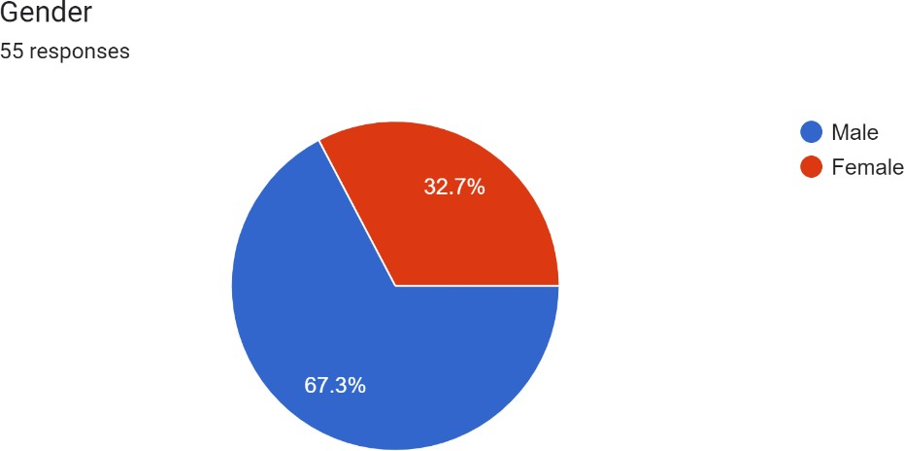
Source: Researcher’s own computation from primary data
We have taken 55 responses who are using online platforms for shopping products among them 67.3% were male and 32.7% were female.

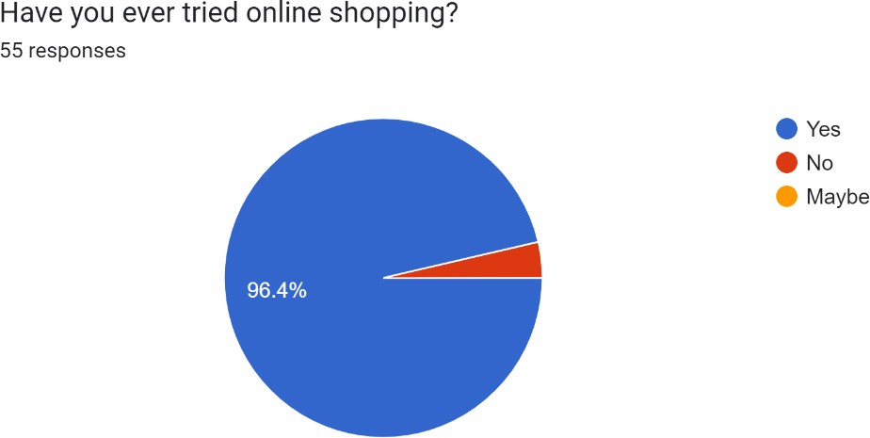
Figure 2: Online shopping carried out
Among 55 responses 96.4% were using online platforms for shopping products online whereas, 3.6% were not using online platforms for shopping.
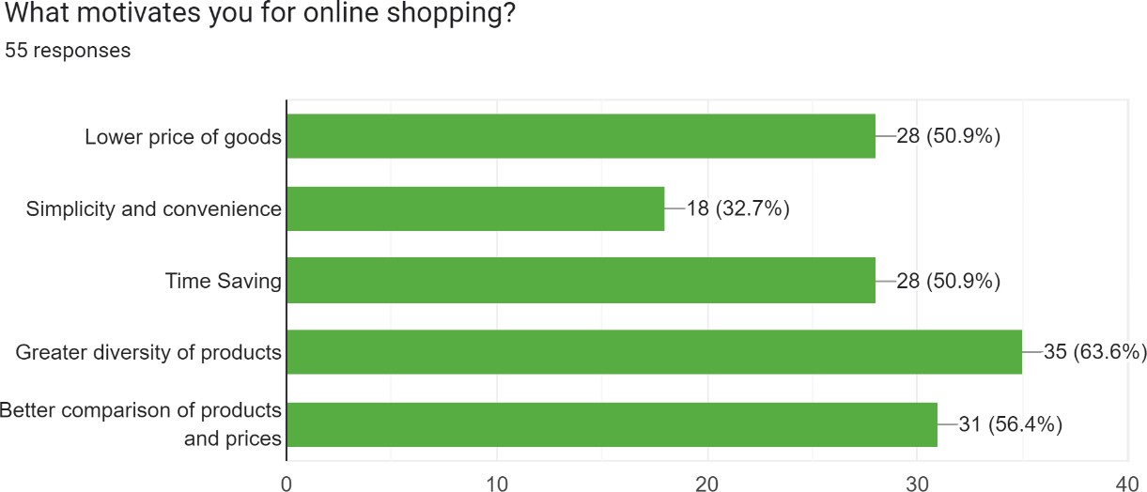
Fig 3: Motivational factor for online shopping distribution
Among 55 responses the major factors motivating customers are greater diversity of products (63.6%), better comparison of products and prices (56.4%), time saving and low price of goods are equally preferred (50.9%) and simplicity and convenience stands at last with (32.7%).

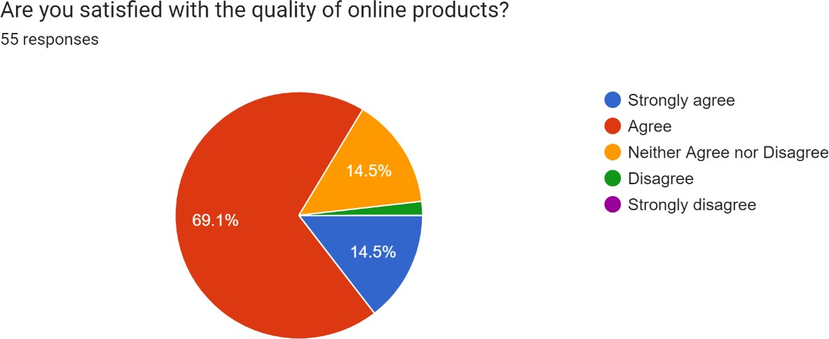
Fig 4: Satisfaction level of consumers distribution

Among 55 responses 14.5% customers are strongly agreed for quality of products, 69.1% are agreed, 14.5% are neutral and 1.9% are disagreed on online platforms product quality.
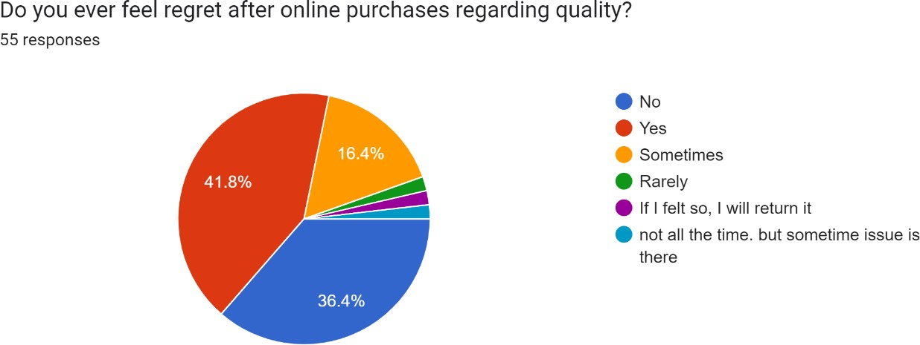
Fig 5: Post purchase regret level customer distribution
Among 55 responses 41.8% consumers are felt regret after buying the products, 36.4% are did not felt regret, 16.4% are sometimes felt and remaining 5.4% are who are having their own reasons are quoted.

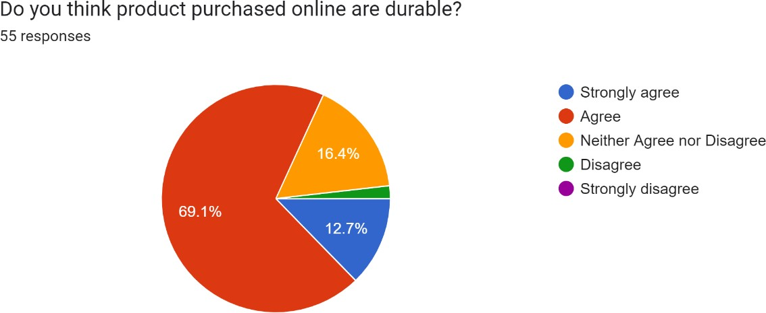
Fig 6: Consumers perception regarding durability distribution
Among 55 responses 12.7% are strongly agreed about durability of products, 69.1% are agreed, 16.4% are neutral and remaining 1.8% are disagreed about durability of products

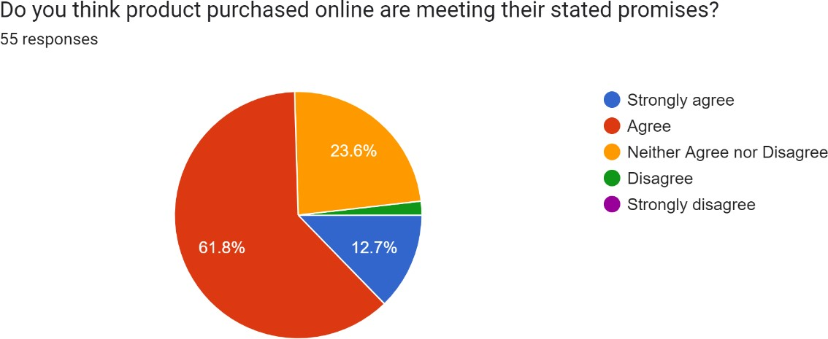
Fig 7: Customers opinion on products meeting their stated promises distribution:
Among 55 responses 12.7% are strongly agreed, 61.8% are agreed, 23.6% are neutral and remaining 1.9% are disagreed on products meeting their stated promises

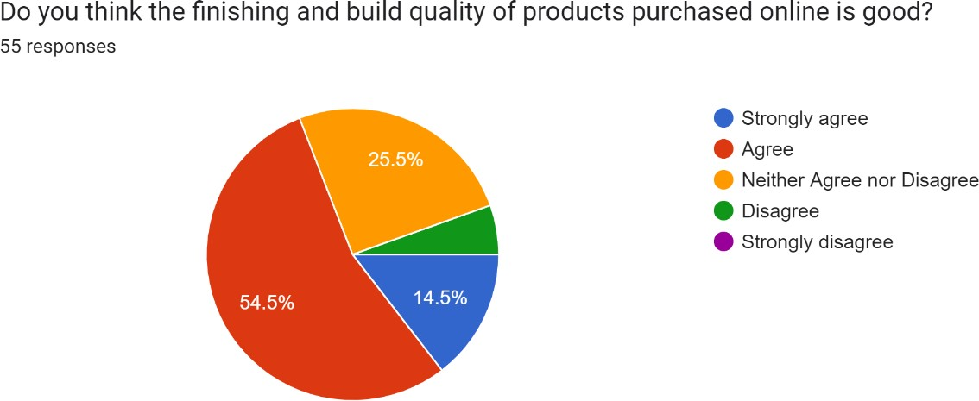
Fig 8: Finishing and build quality of products purchased online distribution

Among 55 responses 14.5% are strongly agreed, 54.5% are agreed and 25.5% are neutral and remaining 5.5% are disagreed about finishing and build quality of products purchased online
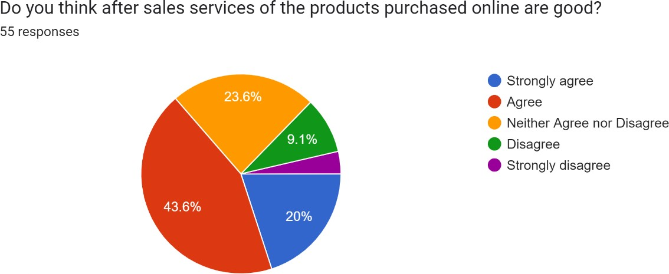
Fig 9: Consumer opinion on post sales services of the products purchased online distribution

Among 55 responses 20% are strongly agreed, 43.6% are agreed, 23.6% are neutral, 9.1% are disagreed and 3.7% are strongly disagreed about post sales services purchased online

Conclusion
After conducting the study, we may conclude that the consumers are switching to the online mode of purchasing products as 96.4% of the sample have experienced online shopping. Mostly the shoppers were belonging from the younger age group category between 18-25. One of the major motivating reasons for online shopping is greater diversity of products and comparison between products and prices. 83.6% of the responses are satisfied with the quality of online products. Most of the respondents feel that the products are durable and meeting their stated promises. Above mentioned were the most appealing factors which influences the consumers to purchase products from an online platform.

References
- Kashyap, R. (2017). Consumers perception towards online shopping for apparel through various websites. Retrieved from https://shodhganga.inflibnet.ac.in/handle/10603/176870
- Team, M. S. (2021). Product Quality - Meaning, Importance, Parameters & Example. MBA Skool. https://www.mbaskool.com/business-concepts/marketing-and-strategy- terms/3231-product-quality.html
- Radziszewska, A. (2018). Quality Assessment of E-Commerce Service in the Context of Customer Expiriences. Retrieved from https://www.researchgate.net/publication/328339443_Quality_Assessment_of_E- Commerce_Service_in_the_Context_of_Customer_Expiriences
- Emerald, I. (2002). Consumer perceptions of Internet retail service quality | https://www.emerald.com/insight/content/doi/10.1108/09564230210447913/full/html

