POLYCYSTIC OVARY SYNDROME (PCOS) AND ITS HEALTH CARE STRATEGIES
Sanasam Birjeni Devi
Department of Nursing, Bareilly International University, Bareilly, Uttar Pradesh, 243006, INDIA
E-mail: sanasambirjenidevi@gmail.com

ABSTRACT:
Polycystic ovary syndrome (PCOS) is characterized by elevated levels of the male hormone called androgen. This condition is named after the presence of multiple small fluid-filled cysts in the ovaries. PCOS affects approximately 5-18% of reproductive women and has lifelong implications on reproductive, metabolic, and psychological well-being. While the exact cause of PCOS remains unknown, it is believed to have genetic and epigenetic components. According to the Rotterdam criteria established in 2003, PCOS is diagnosed when at least two of the following criteria are met: hyperandrogenism, ovulatory dysfunction, and polycystic ovaries. Women with PCOS are at an increased risk of developing serious health problems such as type 2 diabetes, hypertension, cardiovascular diseases, and even uterine cancer. Additionally, they often face challenges in conceiving, leading to infertility. Medical management of PCOS involves addressing irregular menstruation, treating hirsutism, managing infertility, and addressing insulin resistance. Treatment options may include lifestyle modifications (e.g., dietary changes, exercise, yoga, and stress management) or medication. PCOS is a chronic condition that significantly impacts both health and economic well-being. However, certain symptoms can be mitigated through lifestyle modifications and appropriate medical interventions.
Keywords: Polycystic ovary syndrome, PCOS, lifestyle modification, Health care strategies
INTRODUCTION:
Polycystic ovary syndrome is a complex heterogeneous condition where ovaries produce excess amounts of androgens (male sex hormones). Usually, this hormone is present in small amounts in women. In PCOS, many small cysts develop on the outer edge of the ovary. It also causes problems like irregular menstrual periods, excess hair growth, acne, and infertility. Treatment includes medications, lifestyle changes, or a combination of both.
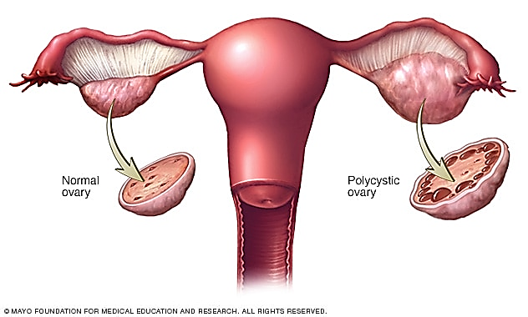Fig.1: Normal ovary vs Polycystic ovary

Definition:
PCOS is a disorder of hormones that affects a large
number of women of reproductive age group.
Causes:
The exact cause of PCOS is unknown. Some other causes of
PCOS include-
- High level of Androgens
- High levels of insulin and Obesity
- Low-grade inflammation
- Heredity
Common Symptoms:
Symptoms include-
- Excessive body hair growth,
- Weight gain and trouble losing weight,
- Ovarian cysts,
- Irregular or missed periods,
- Male pattern baldness or thinning hair,
- High testosterone levels,
- Insulin resistance,
- Fatigue,
- Acne,
- Changes in mood,
- Trouble in getting pregnant or Infertility.
Diagnosis:
Some of the tests are:
- Thyroid function test
- Fasting glucose test
- Lipid level test
- Other tests could include a vaginal ultrasound.
HEALTH CARE STRATEGIES:
- DIET:
1. A low glycaemic index (GI) diet (Fig: 2.1):  They do not cause insulin levels to rise as  much or as quickly as other foods. The low Glycaemic index (GI) diet consists of the following foods: -  - Whole Grains,  - Legumes,  - Nuts,  - Seeds,  - Fruits,  - Starchy Vegetables,  - Other Unprocessed Low-Carbohydrate Foods | 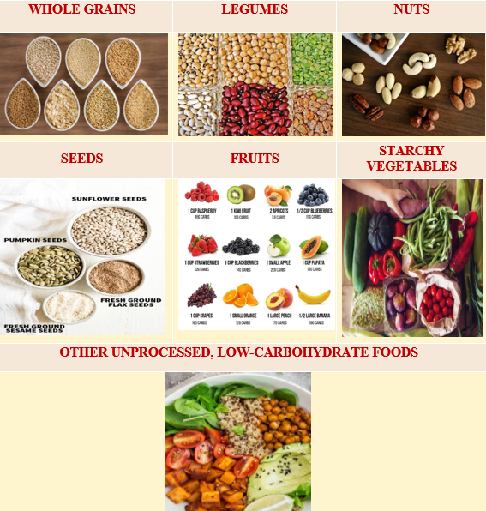  Fig. 2.1: low Glycaemic index (GI) diet
2. An anti-inflammatory diet (2.2):  Anti-inflammatory foods, such as-  - Berries,  - Fatty Fish,  - Leafy Greens,  - Extra Virgin Olive Oil | 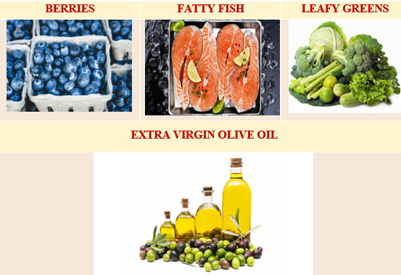  Fig. 2.2: Anti-inflammatory diet
3. The DASH diet (Fig.2.3):  The Dietary Approaches to Stop Hypertension (DASH) diet is beneficial in minimising the risk or impact of heart disease. Patients with PCOS may also benefit from lower insulin levels.  It should be rich in-  - All Fruits and Vegetables,  - Whole Grains (Brown Rice, Quinoa, Whole Wheat),  - Fish and Poultry (Salmon, Chicken, Turkey),  - Legumes (Peanuts, Chickpeas, Peas),  - Nuts and Seeds (Walnuts, Pecans, Flaxseeds, Sunflower Seeds),  - Low-Fat Dairy Produce. | 4. Fibre (Fig. 2.4):  It lowers insulin levels and works as an antioxidant which fights to reduce inflammation and improves gut bacteria.  - Seeds (Chia, Sunflower Seeds, Flax Seed),  - Legumes (Lentils, Black Beans, Chickpeas),  - Berries (Raspberries, Blackberries, Blueberries),  - Whole Grains (Bulgur, Brown Rice, Quinoa, Whole Oats)
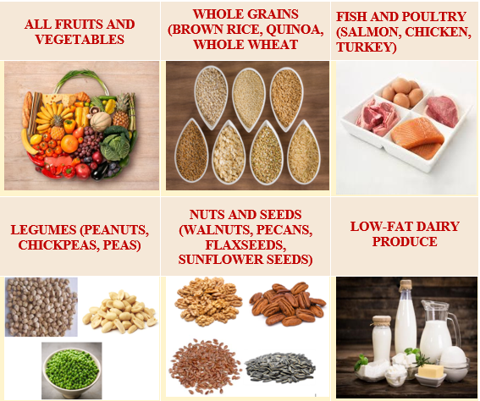  Fig. 2.3: DASH Diet | 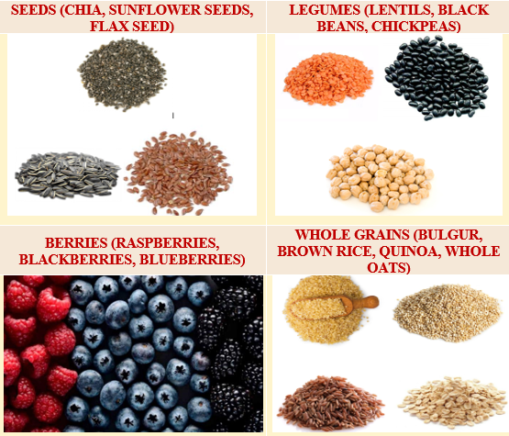  Fig. 2.4: Fibre Diet
5. Lean protein (Fig. 2.5):  Lean protein could aid in weight loss and prolong your feeling of fullness. It includes-  - Fish (Shrimp, Salmon, Cod, Tuna),  - Lean Poultry (Skinless Turkey and Chicken),  - Plant Protein (Peas, Beans, Tempeh, Tofu). | 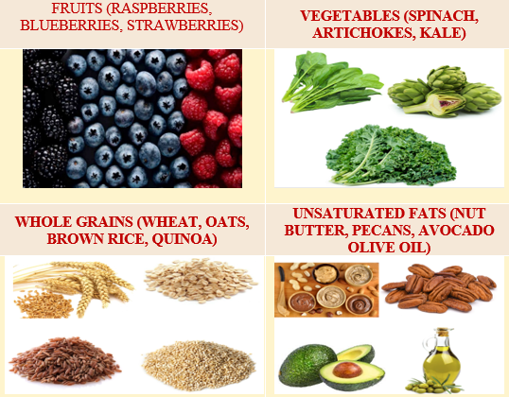  Fig. 2.5: Lean Protein
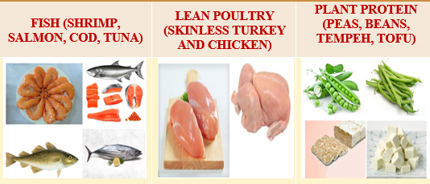  Fig. 2.6: Antioxidant heavy foods | 6. Antioxidant-heavy foods (Fig. 2.6):  The best inflammation-fighting antioxidant-filled foods include-  - Fruits (Raspberries, Blueberries, Strawberries),  - Vegetables (Spinach, Artichokes, Kale),  - Whole Grains (Wheat, Oats, Brown Rice, Quinoa),  - Unsaturated Fats (Nut Butter, Pecans, Avocado Olive Oil).
7. Organic whole soy foods (Fig. 2.7):  It might raise the likelihood of getting pregnant. Organic whole soy has been shown to improve fertility in PCOS women-  - Miso,  - Edamame,  - Tempeh | 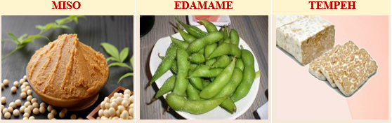  Fig. 2.7: Organic whole soy foods
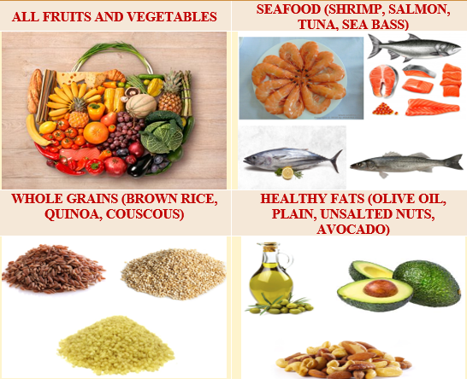  Fig. 2.8: Foods compliant with mediterranean diet | 8. Foods compliant with the Mediterranean diet (Fig. 2.8):  - All Fruits and Vegetables,  - Seafood (Shrimp, Salmon, Tuna, Sea Bass),  - Whole Grains (Brown Rice, Quinoa, Couscous),  - Healthy Fats (Olive Oil, Plain, Unsalted Nuts, Avocado)

II. FOODS TO AVOID ON A PCOS DIET:
When trying to lessen PCOS symptoms, avoid the following foods because they can boost blood sugar, promote inflammation, and cause weight gain.
- Refined carbs (Fig. 3.1):  PCOS women generally do not absorb carbohydrates properly (in most cases, because of high levels of insulin).  - White Bread,  - Pizza Dough,  - Regular Pasta,  - White Rice. | Fig. 3.1: Refined carbs
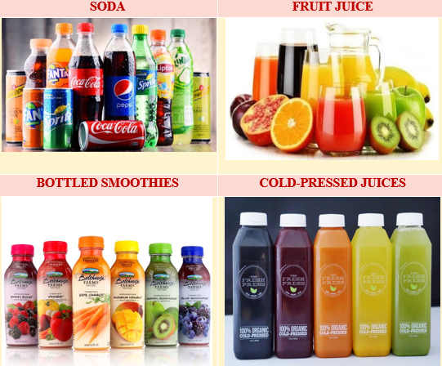  Fig. 3.2: Sugary beverages | - Sugary beverages (Fig. 3.2):  It will spike blood sugar.  - Soda,  - Fruit Juice,  - Bottled Smoothies,  - Cold-Pressed Juices
- Sugary and processed foods (Fig. 3.3):  Sugary foods and drinks should be avoided when following a PCOS diet plan. Avoid the foods like:  - Candy, Cookies, Cakes, and Other Sweets  - Sweetened Cereals  - Yogurts with Added Sugar,  - Ice Cream with High Sugar or Sugar Substitutes | Fig. 3.3: Sugary and processed foods
Fig. 3.4: Saturated and trans fats | - Saturated and trans fats (Fig. 3.4):  They aren't good for weight loss or a well-balanced diet. Additionally, PCOS patients may be harmed by high-fat diets.  - Saturated Fats (Red and Processed Meats),  - Trans Fats (French Fries, Doughnuts, Frozen Pizza).
- Dairy, in some cases (Fig. 3.5):  Reducing dairy intake could potentially help certain women with PCOS lose weight and help some of their hormonal PCOS symptoms.  - Artificial or Heavily Processed Cheeses,  - Yogurts with Added Sugar,  - Ice Creams with Added Sugar or Sugar Alcohol | 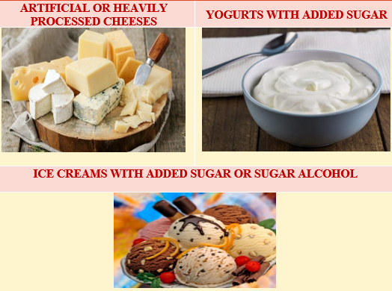  Fig. 3.5: Dairy products
Fig. 3.6: Alcohol | - Alcohol (Fig. 3.6):  Women with PCOS are more likely to have fatty liver, which can only be detected with an ultrasound. Furthermore, alcohol is an irritant to the liver and gut microbiome.  - Cocktails with Sugary Mixers such as Bottled Mixers or Juice,  - Canned Cocktails.

- EXERCISES:
1. Cardio (Fig. 4.1):  - Cardio exercise is excellent for reducing insulin resistance, boosting fertility, and stabilizing mood.  - Brisk walking is a part of this activity. Great PCOS-friendly hobbies include jogging, cycling, and swimming.  - This raises insulin sensitivity, which decreases the risk of type 2 diabetes and cardiovascular disease.  - Exercising 30 minutes a day can also help with weight management, symptoms of depression and anxiety, as well as improving the frequency of menstrual cycles and ovulation. | 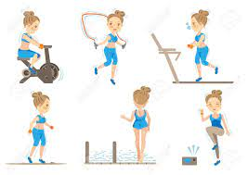  Fig. 4.1: Cardio Exercise
Fig.4.2: Weight taining | 2. Weight training (Fig. 4.2):  - It is highly beneficial for PCOS.  - Losing extra fat from the body helps to perform day-to-day activities easily.  - Obese women with PCOS interfere with the treatment. Thus, this strength training aims to lose extra weight for those women to meet the targets of getting healthy.
3. High-Intensity Interval Training (HIIT) (Fig. 4.3):  - This exercise is more effective in relieving stress in PCOS women. It is also clinically proven for improving the quality of life in PCOS women. It aids in enhancing the metabolic and cardiovascular profiles of PCOS women.  - Additionally, HIIT works to increase the sensitivity of tissues to insulin and halt the onset of insulin resistance. | 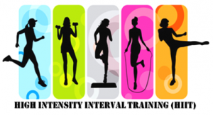  Fig. 4.3: High -Intensity Interval Training (HIIT)
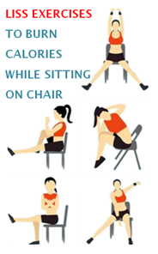  Fig.4.4: Low-intensity steady-state cardio (LISS) | 4. Low-Intensity Steady-State Cardio (LISS) (Fig.4.4):  - It is suggested that HIIT is more beneficial when paired with LISS. It is suggested that HIIT is more beneficial when paired with LISS. It involves performing a repetitive movement at a steady or moderate pace for a long time.  - It aids in the reduction of fasting insulin levels and fat mass in women. Continuous cardio also minimizes physiological stress. Practitioners of mental health advise outdoor steady-state cardio to enhance mental well-being.  - As a result, it is beneficial in PCOS women as it greatly affects their mental health.
5. Swimming (Fig. 4.5):  - Many medical professionals advise swimming to maintain a healthy body because it burns calories.  - For PCOS women, it helps to maintain uterus health along with losing calories.  - One of the primary objectives of PCOS is weight management. | Fig. 4.5: Swimming
Fig. 4.6: Cycling | 6. Cycling (Fig.4.6):  - Cycling supports weight loss in PCOS and increases calorie burn by enhancing tissue glucose uptake. This glucose gets absorbed in the cells, where it is transformed into energy that is used for additional physical activity.  - It is a very healthy and easy-to-do exercise for the body.  - It also helps in building and maintaining muscle in the legs & thighs.
7. Zumba (Fig.4.7):  - Zumba is a type of cardio. It helps to lose weight. It is one of the best exercises for PCOS.  - It helps to lose weight in PCOS women by burning extra fat and calories. Regular Zumba practice helps to avoid the formation of fat in lumps. Zumba workout is enjoyable for the participant, which also aids in reducing stress. | Fig. 4.7: Zumba Dance
Fig. 4.8: Walking | 8. Walking (Fig.4.8):  - Walking is a good exercise for women because it can be done anytime, anywhere. However, it needs to be done frequently and should be increased over time.  - Daily practice helps to balance the body's hormonal and fat profiles while calming the mind and body. It has been observed that daily brisk walking for 30-50 minutes can help to prevent weight gain even if the dietary habits are not changed.
9. Pilates (Fig.4.9):  - Doctors say that doing Pilates can assist with PCOS. In PCOS, the uterus needs to be strengthened with mild workouts such as Pilates.  - It brings down stress levels, prevents depression, and improves hormonal imbalance too.  - Pilates exercise has been shown to eliminate toxins from the body that may be responsible for acne and hair loss. | 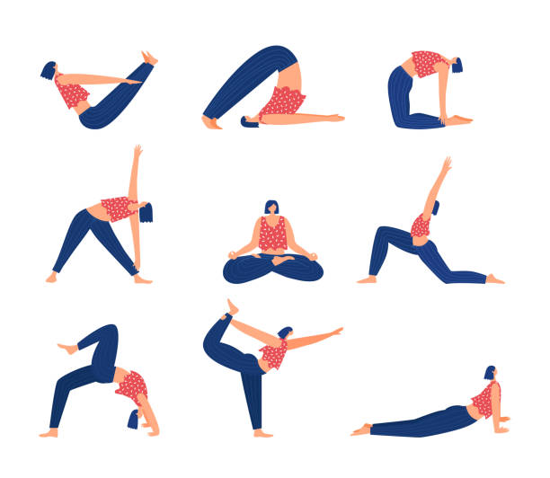  Fig. 4.9: Pilates
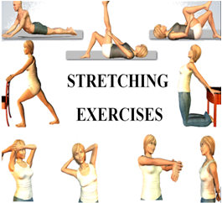  Fig. 4.10: Sretching Exercise | 10. Stretching Exercise (Fig.4.10):  - In PCOS, it is never clear whether to stretch or not. Stretching should be done carefully because PCOS makes the body's tissues extremely sensitive. It specifically aids in weight loss in PCOS by eliminating extra fats.  - Stretching helps to strengthen the tissues inside the body if done smartly. Those stretches should be picked to target a specific tissue inside the body and make it strong.  - It is advised to be gentle with the body when stretching, and it's best to avoid excessive bouncing. Stretching will be easier if the muscles are warmed up first.
11. Yoga:
- Yoga helps to relieve stress which is highly noticed in females affected with PCOS. Due to the relationship between stress and hormones, hormonal imbalance in PCOS can be directly targeted by controlling stress.
- It also helps to reduce weight. Weight gain is the most common symptom of PCOS. Yoga helps to stabilize the mind and burn calories, which helps people lose weight.
- The incorporation of fertility is another way that yoga helps women with PCOS live healthier lives. Infertility is the major outcome of PCOS. But yoga prevents infertility by keeping the brain's hormonal balance by improving blood flow.
Some of those yoga asanas that help to provide relief for PCOS include-
- Sun Salutation or Surya Namaskar (Fig.5.1):  Surya Namaskar is regarded as the best yoga for PCOS. This yoga pose can help with waist and hip fat removal, weight loss, and regulation of the menstrual cycle. | 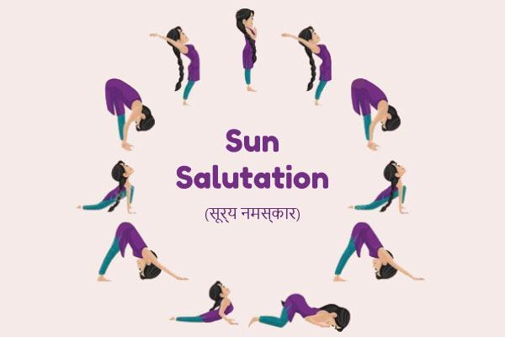  Fig. 5.1: Sun Salutation or Surya Namaskar
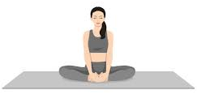  Fig. 5.2: Badhakonasana (butterfly pose) | - Badhakonasana (butterfly pose) (Fig.5.2):  It promotes relaxation and aids in reducing stress. It also helps in widening the pelvic floor. It also aids in maintaining a regular monthly cycle
- Supta Badhakonasana (reclining butterfly pose) (Fig.5.3):  The reclined Butterfly Pose is a variation of the standard butterfly pose. It helps to strengthen the pelvic muscles, relieves pain and stress during the menstrual cycle, and improves blood flow to the ovaries and the uterus. | Fig. 5.3: Supta Badhakonasana (reclining butterfly pose)
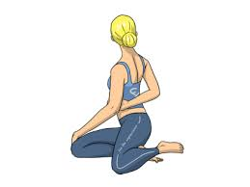  Fig. 5.4: Bharadvajasana (Bharadvaja’s twist) | - Bharadvajasana (Bharadvaja’s twist) (Fig.5.4):  This asana is a seated spinal twist. This asana stimulates the digestion and reproductive systems. This pose also helps to release and tone the muscles around the spine. It helps lower blood pressure and soothes the nervous system.
- Bhuajangasana (cobra pose) (Fig.5.5):  This asana improves flexibility and reduces stress. This pose is frequently included in the list of yoga poses for PCOD. This pose is known to encourage healthy ovaries by soothing the stomach and allowing it to function properly. | 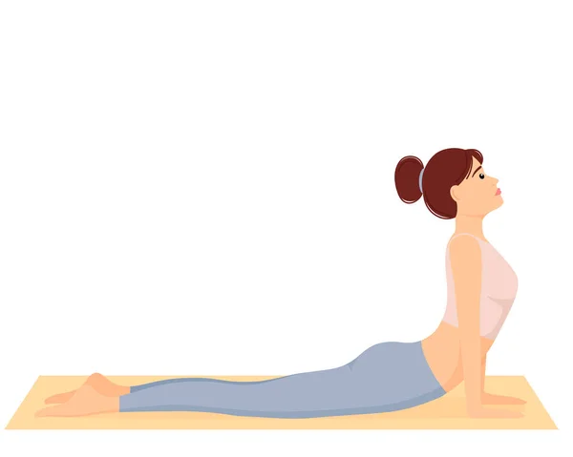  Fig. 5.5: Bhuajangasana (cobra pose)
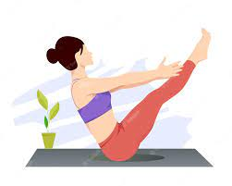  Fig. 5.6: Naukasana (boat pose) | - Naukasana (boat pose) (Fig.5..6):  Naukasana is a yoga pose that emphasizes the abdominal muscles and organs. It may also control thyroid function. It is well-known for its ability to strengthen abdominal muscles and organs. It also reduces stress and enhances ovulatory function.
- Dhanurasana (bow pose) (Fig.5.7):  It stimulates reproductive organs and relieves menstrual cramps. Also, it gives your body a good stretch. | Fig. 5.7: Dhanurasana (bow pose)
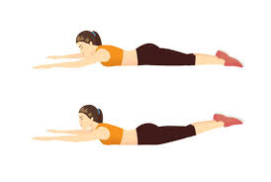  Fig. 5.8: Viparita shalabhasana (Superman pose) | - Viparita shalabhasana (Superman pose) (Fig.5.8):  This PCOS exercise improves ovarian function while also keeping insulin resistance and sugar levels in the normal range.
- Balasana (child’s pose) (Fig.5.9):  Balasana is an excellent asana for hip strengthening. This asana was included in the PCOD yoga asana list because it helps the body return to its natural position after being stretched and lengthened in previous asanas. | Fig. 5.9: Balasana (child’s pose)
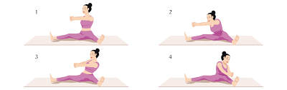  Fig.5.10: Chakki achalasia | - Chakki achalasia (Fig.5.10):  It is also known as the mill churning pose. It promotes reproductive organ function and strengthens other abdominal organs.
- Marjaryasana and Bitilasana (Cat and cow pose) (Fig.5.11):  It makes the spine flexible, strengthens and stimulates abdominal organs, also relieves stress, opens up the chest for better breathing, sciatica relief makes the shoulder spine, and neck flexible, stretches the muscles in the hips, belly, and back, stimulates the adrenal glands, balances the body, and relieves stress from menstrual cramps. | 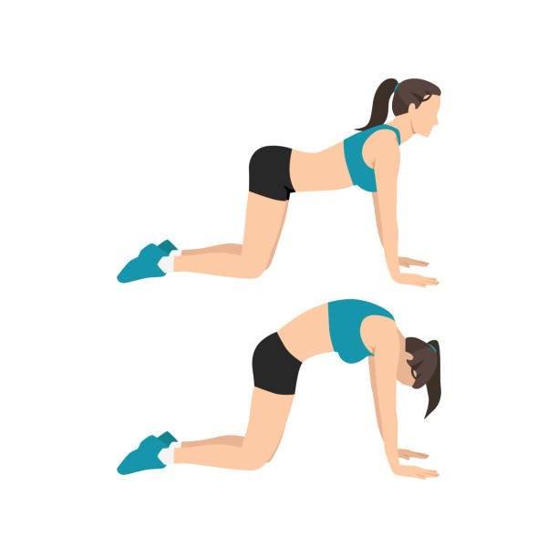  Fig. 5.11: Marjaryasana and Bitilasana (Cat and cow pose)
Fig. 5.12: Bridge Pose or Setu Bandha (Sarvangasana) | - Bridge Pose or Setu Bandha (Sarvangasana) (Fig.5.12):  These yoga poses for PCOS assist in controlling thyroid function, which is directly related to PCOS. It eases menopausal symptoms by relaxing and energizing the abdominal organs.
- Corpse Pose or Savasana(Fig.5.13):  This yoga for PCOS may aid in de-stressing, as stress is one of the common causes of PCOS. Shavasana, or corpse posture, can help in relaxing and maintaining a healthy cortisol level. | Fig.5.13: Corpse Pose or Savasana
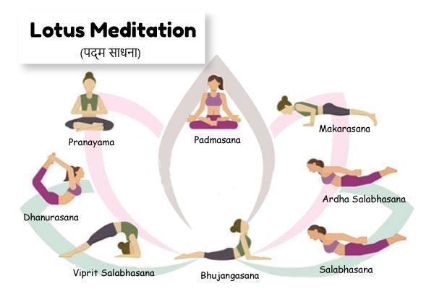  Fig. 5.14: Lotus Meditation or Padma Sadhna | - Lotus Meditation or Padma Sadhna (Fig.5.14):  It promotes deep relaxation and is helpful for PCOS. It is beneficial to both men and women because it affects both sexes' reproductive organs. During the menstrual cycle, sitting in padmasana can dramatically reduce cramps in women.
- Locust Pose or Shalabhasana(Fig.5.15):  PCOS affects the ovaries, therefore, this may be the ideal PCOD workout. Diabetes can be developed as a side effect of PCOS, and the locust position has been shown to be beneficial in diabetes management. | Fig.5.15: Locust Pose or Shalabhasana
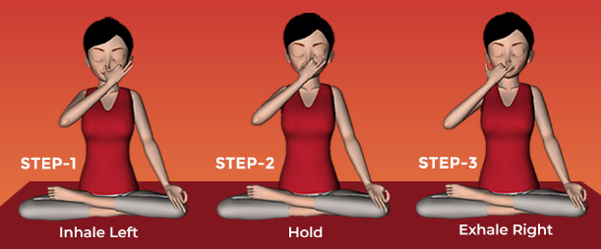  Fig.5.16: Breathing Exercise or Kapalbhati Pranayam | - Breathing Exercise or Kapalbhati Pranayam (Fig.5.16):  This is a breathing method aimed at lowering oxidative stress, increasing blood circulation, and harmonizing glandular output. It improves weight reduction by stimulating the pancreas. This is why it is considered one of the best PCOD exercises. This is the reason it is one of the best successful PCOD exercises.

.IV. HEALTH INFORMATION:
DIETARY MODIFICATIONS FOR PCOS
1. Turmeric:
It owes much of its medicinal property to curcumin and acts as a natural source of oestrogen. Thus, it can be beneficial for menstrual regulation and fertility.
How to use: Add turmeric powder in water or use it as a spice. It is better to consume turmeric milk daily.
2. Omega-3:
It helps in decreasing bad cholesterol and increasing good cholesterol levels, reducing waist circumference, and regulating the interval between menstrual periods.
Include the following omega-3 rich foods in your diet:
- Fish oil: This helps enhance insulin sensitivity and thereby reduce androgen secretion.
- Flaxseeds: While there is some scientific support for the use of flaxseeds for PCOS management, further research is needed to establish its efficacy.
- Tuna
- Salmon
- Walnuts
- Soybeans
3. Vitamin D and Calcium:
- Women with PCOS generally run low on vitamin D. It helps the body effectively absorb calcium from food.
- Additionally, it plays a key physiologic role in reproduction, including ovarian follicular development.
- Therefore, vitamin D deficiency can cause poor bone mineralization and worsen PCOS symptoms.
4. Magnesium:
- Magnesium excretion in the urine above normal levels is associated with type 2 diabetes and/or insulin resistance.
- The continued loss of heavy amounts of magnesium can render one deficient. This is why experts believe there may be an association between magnesium deficiency and the development of insulin resistance.
Some of the best food sources to meet your daily magnesium needs include-
- green leafy vegetables,
- nuts,
- whole grains,
- legumes,
- dairy foods,
- meat.
5. Vitamins- B:
Vitamin B -rich foods treat PCOS symptoms by boosting the optimal functioning of the hormonal system and lowering androgen levels in the body, such as an overwhelming sense of exhaustion. Consume more whole grains, nuts, and skim milk, all of which are brimming with B vitamins and can help you deal with symptomatic fatigue
V. LIFESTYLE AND SELF-CARE:
Many PCOS symptoms improve with positive lifestyle choices.
1. Maintain a healthy weight:
- Women who are overweight often experience more severe PCOS symptoms. Only strict weight management can guarantee that ovaries work correctly. Healthy weight management can help in reducing the risk of other chronic health issues that usually develops with PCOS.
2. Have regular health checks:
- PCOS can pave the way for other chronic medical conditions. Thus, work closely with a doctor to monitor overall health.
- Regular health check-ups can help detect the early signs of other PCOS-related conditions so that they can be treated right at their onset before it becomes serious.
3. Keep your stress in check with yoga and meditation:
- The therapeutic effects of yoga are not limited to the physical body alone but encompass the mind and soul as well.
- Some yoga poses gently massage the internal organs to ease abdominal constriction, restore gastrointestinal balance, and enhance digestion. These asanas enhance blood flow in the body, open up the pelvic area, and make you feel relaxed.
- Meditation is another basic part of yoga that helps center the mind and tune out the stress of the world by focusing energies inward.
- Doing a bit of yoga regularly can also help lose weight and keep your metabolism rate high.
4. Exercise to re-energize (for cramps):
- By reducing insulin resistance in the body, most of the unwanted PCOS health consequences can be effectively treated.
- Regular exercise is extremely effective in this regard, even if it does not result in any noticeable change in weight or body fat measurement.
- Women with PCOS are typically advised to engage in a multifaceted fitness regimen that focuses on improving both heart health and muscle strength.
5. Quit smoking:
According to some studies, women with PCOS who smoke have a higher risk of developing diabetes, metabolic syndrome, and other cardiovascular issues.
6. Try a ketogenic diet:
- A ketogenic diet aims to supplement the body’s energy needs through foods that are low in carbs and high in fat.
- Sticking to this diet may help trigger faster weight loss as the carb intake is greatly reduced while the body uses up the fat reserves for energy.
7. Limit junk food and added sugars:
- If women with PCOS want to prevent ovulation issues and fertility loss, they must maintain a healthy body weight.
- Some foods to be avoided are:
- Milk chocolate
- Potato chips
- Ice cream
- Candy
- Muesli bars
- Fruit juice
- Soft drinks
VI. STRESS REDUCTION STRATEGIES:
- Getting enough sleep,
- Avoiding over-commitment and
- Making time to relax.
REFERENCES
1. PCOS diet: Foods to eat and avoid [Internet]. [cited 2023 Jul 18]. Available from: https://www.medicalnewstoday.com/articles/323002
2. PCOS Diet: Foods to Eat and Avoid With PCOS | CCRM Fertility [Internet]. [cited 2023 Jul 18]. Available from: https://www.ccrmivf.com/news-events/food-pcos/
3. Gaither K. Understanding PCOS: Causes, Symptoms, and Treatment [Internet]. 2021 [cited 2023 Jul 18]. Available from: https://www.emedihealth.com/womens-health/reproductive-health/understanding-pcos
4. The Best Types of Exercise for PCOS - Exercise Right [Internet]. [cited 2023 Jul 18]. Available from: https://exerciseright.com.au/best-types-exercise-pcos/
5. 10 EFFECTIVE EXERCISES FOR PCOS – Chereso Health [Internet]. [cited 2023 Jul 18]. Available from: https://cheresohealth.com/10-effective-exercises-for-pcos/
6. Women’s Health [Internet]. 2020 [cited 2023 Jul 18]. Can Yoga Relieve Symptoms of PCOS ? | Jiva Blogs. Available from: https://www.jiva.com/blog/pcos-stressing-you-out-these-3-yoga-asanas-will-re
7. Yoga for PCOS: Benefits & Specific Poses that Can Help [Internet]. 2022 [cited 2023 Jul 18]. Available from: https://www.finessyoga.com/yoga-asanas/yoga-for-pcos
8. 10 Yoga Asanas You Must Do If You Have PCOS - The Fitness India Show [Internet]. 2022 [cited 2023 Jul 18]. Available from: https://www.fitnessindiashow.com/10-yoga-asanas-must-pcos/
9. 9 Yoga Poses for PCOS : Steps, Benefits and Tips [Internet]. [cited 2023 Jul 18]. Available from: https://www.bajajfinservhealth.in/articles/yoga-for-pcos
10. 10 Yoga for PCOS: Steps to follow and Yoga Tips for PCOD [Internet]. [cited 2023 Jul 18]. Available from: https://www.wellcurve.in/blog/yoga-poses-asanas-for-pcos/
11. Cartoon Female Doing Cardio Exercise.Vector Illustrations Royalty Free SVG, Cliparts, Vectors, And Stock Illustration. Image 91375938. [Internet]. [cited 2023 Jul 18]. Available from: https://www.123rf.com/photo_91375938_cartoon-female-doing-cardio-exercise-vector-illustrations.html
12. Premium Vector | Fitness character | Exercise, Fitness, Cartoon [Internet]. [cited 2023 Jul 18]. Available from: https://in.pinterest.com/pin/premium-vector--430867889361570697/
13. Girl walking side | OpenGameArt.org [Internet]. [cited 2023 Jul 18]. Available from: https://opengameart.org/content/girl-walking-side
14. 617 Pilates Teacher Training Illustrations & Clip Art - iStock [Internet]. [cited 2023 Jul 18]. Available from: https://www.istockphoto.com/search/2/image?mediatype=illustration&phrase=pilates+teacher+training
15. Bound Angle Pose Butterfly Pose Beautiful Girl Practice Baddha Konasana Stock Illustration - Download Image Now - iStock [Internet]. [cited 2023 Jul 18]. Available from: https://www.istockphoto.com/vector/bound-angle-pose-butterfly-pose-beautiful-girl-practice-baddha-konasana-gm1351788728-427408294
16. pose-test - Forte Yoga [Internet]. [cited 2023 Jul 18]. Available from: https://www.forteyoga.com/pose-test/page/4/
17. Premium Vector | Boat pose naukasana navasana woman practicing paripurna navasana yoga exercise [Internet]. [cited 2023 Jul 18]. Available from: https://www.freepik.com/premium-vector/boat-pose-naukasana-navasana-woman-practicing-paripurna-navasana-yoga-exercise_49471561.htm
18. Yoga Poses For PCOS: Steps, Benefits And Tips [Internet]. [cited 2023 Jul 18]. Available from: https://www.lifecell.in/blog/general/yoga-poses-for-pcos-know-steps-benefits-and-tips
19. Saoji AA, Raghavendra BR, Manjunath NK. Effects of yogic breath regulation: A narrative review of scientific evidence. J Ayurveda Integr Med [Internet]. 2019 Jan 1 [cited 2023 Jul 18];10(1):50–8. Available from: https://7pranayama.com/nadishodana-anuloma-viloma-alternate-nostril-breathing-pranayama/

