Medical Tourism – Present and Future Prospects

Dr. Ismail Zabiulla Rifai Dr. Viswanath Narendiran Dr. Ambarish Das
Junior Resident Junior Resident Senior Resident
Dept. of Preventive & Social Medicine Dept. of Preventive & Social Medicine Dept. of Preventive & Social Medicine
JIPMER JIPMER JIPMER
Puducherry, India Puducherry, India Puducherry, India

ABSTRACT

Medical tourism is booming in developing countries like India. Patients from the Western part of the world are traveling all the way to get quality and affordable medical services for their health issues. The growing number of private health facilities makes these countries perfect destinations for medical tourism. Although there is a new record of foreign patients seen every year, there are some concerns with respect to the regulation of this mechanism, safety, security, and equity of healthcare provision that need to be addressed. Medical tourism will reach new heights in the future but for healthy growth of it, all necessary measures should be taken.

Keywords – medical tourism; wellness tourism; data safety; artificial intelligence; accreditation

I. INTRODUCTION

“Medical Tourism” refers to the process of people traveling across borders (both international and national) to receive some form of medical treatment [1]. People have been eager to travel for healthcare access ever since the idea of healthcare first emerged. The concept of long-distance travel for health reasons, and marketing destinations for that purpose, is undoubtedly nothing new. Spas have been around since the time of the Sumerians, Greeks, and Romans, as have the supposed therapeutic qualities of alpine and seaside health resorts in early modern Europe [2]. In the past, people used to travel from less developed countries to medical centers in more developed nations, but recently the trend has reversed where developing countries are preferred due to medical services being offered at lower prices. This chapter explores the evolving landscape of medical tourism, analyzing emerging trends, potential challenges, and the prospects for this global phenomenon. As countries worldwide strive to enhance their healthcare offerings and attract medical tourists, it is crucial to examine the factors that will shape the future of this industry.

II. FACTORS BEHIND THE GROWTH OF MEDICAL TOURISM

Some of the motivators for Medical Tourism include [3]:

A. Cost savings

Rising healthcare costs and increased insurance billing in developed countries. For example, a liver transplant that may cost US$ 300,000 in the United States, would generally cost about US$ 91,000 in Taiwan [4].

Table 1: Medical Tourism prices in selected Countries [5]

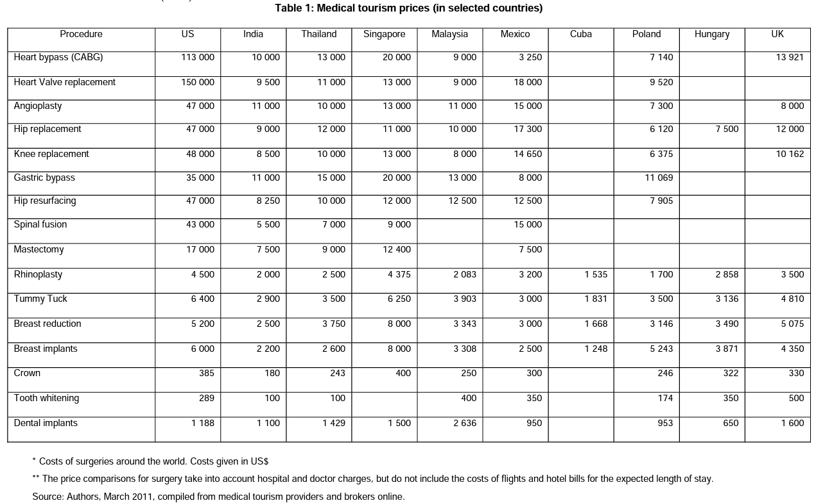

B. Reduced waiting times

Due to long waiting lists in home countries, especially those that have public health care systems. For example, in Canada in the year 2022, a report where the specialist physicians were surveyed showed between referral from a general practitioner and receipt of treatment, a median waiting time of 27.4 weeks was expected. It also has a 16-week wait for cataract surgery and a 26-week waiting period for a hip replacement procedure [6].
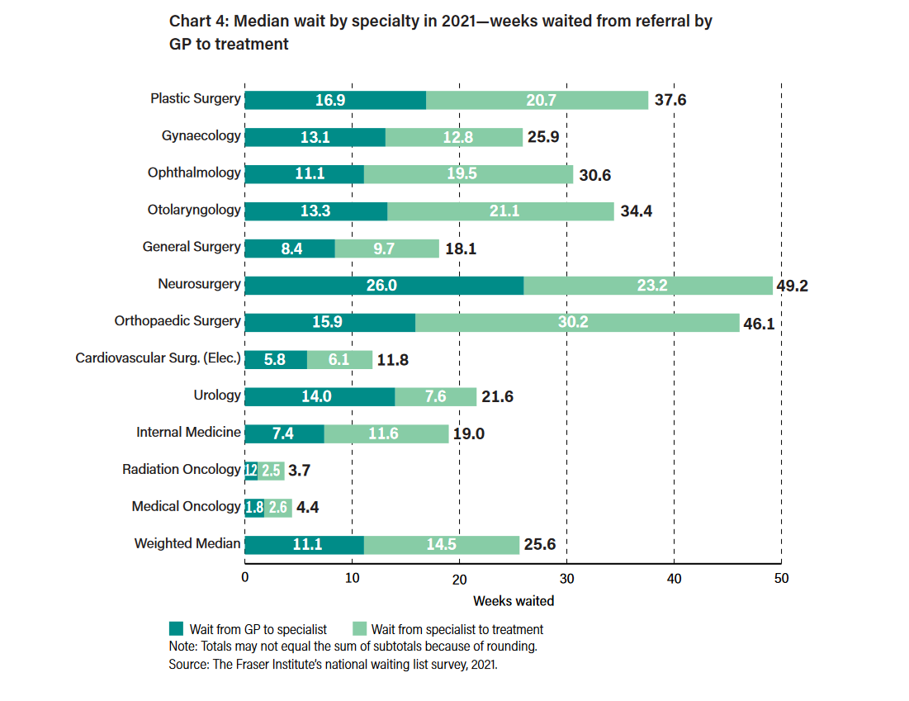

Figure 1: Median wait by specialty in 2021 – weeks waited from referral by GP to treatment [6]

C. Quality of care

The reputation of certain countries for providing high-quality healthcare, access to specialized treatments, advanced procedures, and renowned specialists and medical facilities [7].

D. Ease and affordability of international travel

Many of the world's most well-known airlines are increasingly collaborating with medical tourism facilitator companies, and in certain circumstances, directly with medical centers. For example, Turkey recently introduced a special medical visa that provides a 25% discount to all medical tourists who fly with Turkish Airlines. [8].

Indian Context

India has been ranked 10th in Medical Tourism Index (MTI) for 2020-21 out of 46 destinations by the Medical Tourism Association [10]. Medical tourism is rising in the Indian subcontinent due to lower treatment costs than in developed countries, easily available medical tourism visas (M-visas), availability of high-quality healthcare where several professionals who have trained wholly or in part in the US/ UK, English being widely spoken, particularly among professionals and lastly availability of alternate forms of medicine such as Ayurveda, AYUSH, Naturopathy, Yoga etc. Moreover, India has close to 40 hospitals accredited by US Joint Commission [1].

III. CONSIDERATIONS AND CHALLENGES IN MEDICAL TOURISM

The growth of medical tourism should not be at the cost of safety, security, and provision of necessary medical services to the needy ones. In this regard, both the home countries and destination countries can take responsibility to address the existing challenges in continuing healthy medical tourism.

Challenges specific to home countries are as follows [10]:
- Inadequate regulation within the industry - Beyond patients and health-care professionals, the medical tourism sector is global and involves numerous stakeholders. Currently, the industry lacks international regulation. This might place the country's residents in a precarious position abroad. [11].
- Lack of systematic reporting of clinical outcomes – Data about the outcomes of surgery and therapies of medical tourists from hospitals in developing countries is lacking, leaving citizens to make important decisions without having access to this valuable information [12].
- Taking financial decisions instead of clinical judgements – In order to reduce costs there have been reports of patients reducing the recommended recovery period between 2 orthopaedic procedures [13].
- Exposure to novel health and safety risks - While risks are always anticipated with respect to medical interventions, some unique ones with respect to medical tourism include traveling on long flights soon after major surgery might bring about deep vein thrombosis due to compromised mobility [14].
- Difficulties in continuity of crucial information relevant to care – Systems to ensure a smooth flow of medical information between physicians from home and destination countries are lacking [15].
- Provision of follow-up care and monitoring – In spite of citizens preferring treatment abroad, post-operative rehabilitation and recovery happen in the home country, which might need specific expertise and could turn out to be costly [16].
- Procedures might be illegal or untested – Some patients travel abroad to get operations that are unlawful or inaccessible in their home countries due to their experimental status or ethical concerns to particular procedures in their home nations, a practice known as "circumvention tourism." For example, abortion services, doctor-assisted suicide, etc [17]
- Health inequities could be exacerbated – Since medical tourism is one of the ways of bypassing limitations in home countries, it could exacerbate inequities as only certain people are able to afford it [18].
Challenges specific to destination countries are as follows:

- Development of a two-tiered healthcare system in which foreign patients benefit from sophisticated private hospitals with a high staff-to-patient ratio and pricey, cutting-edge medical technology, while the local population has only access to poor, under-resourced health facilities. [19].
- While there might be a reversal of the international brain drain, an internal brain drain may occur with professionals leaving public health facilities to work for larger super-specialty hospitals [20].
- Resources may be taken away from the rural sector and invested in the private sector; thereby the actual needy population gets overlooked.

IV. THE FUTURE OF MEDICAL TOURISM

A. Technological Advancements in Medical Tourism

- Telemedicine and virtual consultations – Following COVID-19, many healthcare providers shifted to telemedicine, as preliminary consultations and even post-operative care could be provided over the phone for abroad patients. [21].
- Robotics and Artificial Intelligence (AI) - Global market for robotic surgeries is expected to reach USD 18.2 billion in 2030 and will open the door for a greater share of medical value travellers seeking out top-notch care from around the world [22]. Furthermore, the tourism and travel industries are utilizing artificial intelligence (AI) to handle a variety of administrative and customer support activities. [23].
- Digital Health Records and Data Analytics: Initiatives like Ayushman Bharat Digital Mission (India) plan to store Electronic Health Records (EHR) digitally with the healthcare providers and can be used to transfer details of care provided with consent and facilitate seamless patient care. It can also be used to discover prices coupled with information on success ratios of treatments in different hospitals which can further increase the traffic of medical tourists [24].

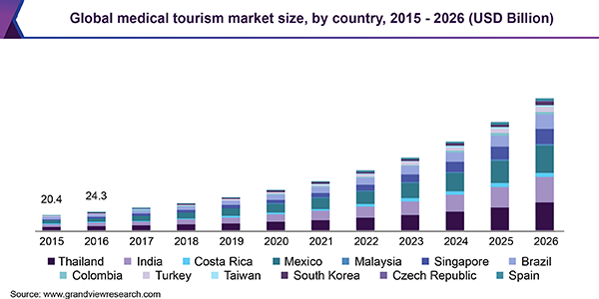

Figure 2: Global medical tourism market size, by country, 2015 – 2026 (USD Billion)

B. Changing Patient Preferences and Expectations

Recently the focus has shifted to holistic approaches to health care. "Health tourism" has replaced the phrase "medical tourism" as a more general description of travel that emphasizes receiving medical care and using healthcare services. It encompasses a broad spectrum of health-oriented travel, from therapeutic and rehabilitative trips to preventative and health-conductive treatments. Wellness tourism is one such upcoming field, where India has a major role to play [25].

V. RECOMMENDATIONS AND WAY FORWARD

- Ensuring Patient Safety and Quality Standards – Organisations like Joint Commission International, QHA Trent Accreditation, and Accreditation Canada work with hospitals to meet standards for patient care and then accredit them. There is a need for more healthcare institutions to meet international standards to ensure a safe and smooth experience for medical tourists [26].
- Transparent Pricing and Cost Estimates – Health institutes should give a clear picture of the estimated costs of various procedures so that a medical tourist can take a well-informed choice. There is also a need for regulations to ensure fair prices across destinations [27].
- Patient Rights and Privacy – Need for more robust legal frameworks to safeguard patient data and privacy and ensure a smooth legal discourse if the need arises [28].
- Integration of Holistic Care and Alternative Therapies – There is a need for incorporating complementary and alternative medicine into medical tourism offerings and integrating traditional healing practices of host countries into treatment plans [29].
- Brain Drain and Local Healthcare Systems - Special attention in mitigating the impact of healthcare professionals migrating to popular medical tourism destinations and developing strategies to ensure adequate healthcare resources for the local population should be considered [30].

REFERENCES

- Ministry of Tourism, Government of India [Internet]. [cited 2023 Jul 29]. Available from: https://tourism.gov.in/wellness-medical-tourism
- Rogers, Kara. "Medical tourism". Encyclopedia Britannica, 24 May. 2023, https://www.britannica.com/science/medical-tourism.
- Tompkins OS. Medical tourism. AAOHN Journal. 2010 Jan;58(1):40-.
- Tung S. Is Taiwan Asia’s next one-stop plastic surgery shop? [Internet]. Time Inc.; 2010 [cited 2023 Jul 29]. Available from: https://content.time.com/time/world/article/0,8599,2004023,00.html
- Lunt N, Smith R, Exworthy M, Green ST, Horsfall D, Mannion R. Medical Tourism: Treatments, Markets and Health System Implications: A scoping.
- Waiting your turn: Wait times for health care in Canada, 2022 report [Internet]. 2022 [cited 2023 Jul 29]. Available from: https://www.fraserinstitute.org/studies/waiting-your-turn-wait-times-for-health-care-in-canada-2022
- Jones CA, Keith LG. Medical tourism and reproductive outsourcing: the dawning of a new paradigm for healthcare. International journal of fertility and women's medicine. 2006 Nov 1;51(6):251-5
- Turkish Airlines offers special discounts for medical tourism patients [Internet]. [cited 2023 Jul 29]. Available from: https://www.magazine.medicaltourism.com/article/turkish-airlines-offers-special-discount-for-medical-tourism-patients
- Update on improving medical tourism in the country [Internet]. [cited 2023 Jul 30]. Available from: https://pib.gov.in/PressReleasePage.aspx?PRID=1909087
- Crooks VA, Snyder J. Medical tourism: what Canadian family physicians need to know. Canadian Family Physician. 2011 May 1;57(5):527-9.
- Crooks VA, Kingsbury P, Snyder J, Johnston R. What is known about the patient's experience of medical tourism? A scoping review. BMC health services research. 2010 Dec;10(1):1-2.)
- MacReady N. Developing countries court medical tourists. The Lancet. 2007 Jun 2;369(9576):1849-50.
- Johnston R, Crooks V, Snyder J. Three Academics' Perspective on Medical Tourism: Reflections on a Trip to Southern India.
- Ma LS. A medical tourism primer for US physicians. The Journal of medical practice management: MPM. 2008 Mar 1;23(5):291.
- Keckley PH, Underwood HR. Medical tourism: update and implications. Washington, DC: Deloitte Center for Health Solutions. 2009.
- Cheung IK, Wilson A. Arthroplasty tourism. Medical Journal of Australia. 2007 Dec;187(11-12):666-7.
- Burkett L. Medical tourism: concerns, benefits, and the American legal perspective. The Journal of legal medicine. 2007 May 31;28(2):223-45.
- Bookman M. Medical tourism in developing countries. Springer; 2007 Aug 6.
- Leahy AL. Medical tourism: The impact of travel to foreign countries for healthcare. The surgeon: journal of the Royal Colleges of Surgeons of Edinburgh and Ireland. 2008 Oct 1;6(5):260-1.
- Arunanondchai J, Fink C. Trade in health services in the ASEAN region. Health Promotion International. 2006 Dec 1;21(suppl_1):59-66.
- Medical tourism companies turn to telemedicine in wake of covid-19 [Internet]. 2020 [cited 2023 Jul 30]. Available from: https://www.hindustantimes.com/cities/medical-tourism-companies-turn-to-telemedicine-in-wake-of-covid-19/story-YA0OpXnbjgmvZfsRoHObRP.html
- Robotic surgery to pave the way for medical value tourism [Internet]. 2022 [cited 2023 Jul 30]. Available from: https://timesofindia.indiatimes.com/blogs/voices/robotic-surgery-to-pave-the-way-for-medical-value-tourism/
- Hassan V, Bellos G. COVID-19: Reshaping Medical Tourism through Artificial Intelligence (AI) and Robotics. Athens Journal of Tourism. 2022;9(2):77-98.
- www.ETHealthworld.com. Promoting medical tourism via Ayushman Bharat Digital Mission - et health world [Internet]. 2021 [cited 2023 Jul 30]. Available from: https://health.economictimes.indiatimes.com/news/industry/promoting-medical-tourism-via-ayushman-bharat-digital-mission/87301743
- [Internet]. [cited 2023 Jul 30]. Available from: https://tourism.gov.in/sites/default/files/2022-05/National%20Strategy%20and%20Roadmap%20for%20Medical%20and%20Wellness%20Tourism.pdf
- A global leader for health care quality and patient safety [Internet]. Jointcommissioninternational.org. [cited 2023 Jul 30]. Available from: https://www.jointcommissioninternational.org/
- Xu H, Dinev T, Smith J, Hart P. Information privacy concerns: Linking individual perceptions with institutional privacy assurances. Journal of the Association for Information Systems. 2011;12(12):1.
- International Committee of Medical Journal Editors. Protection of patients' rights to privacy. BMJ: British Medical Journal. 1995 Nov 11;311(7015):1272.
- Singer J, Adams J. Integrating complementary and alternative medicine into mainstream healthcare services: the perspectives of health service managers. BMC complementary and alternative medicine. 2014 Dec;14(1):1-1.
- Dodani S, LaPorte RE. Brain drain from developing countries: how can brain drain be converted into wisdom gain?. Journal of the Royal society of Medicine. 2005 Nov;98(11):487-91.

