Medicinal and aromatic plants (MAPs): Pioneering the past, transforming the present, shaping the future

Sonveer Singh¹, Prawal P S Verma², Amit Kumar Tiwari¹, Dipender Kumar¹, RC Padalia¹

¹CSIR-Central Institute of Medicinal and Aromatic Plants, Regional Research Centre Pantnagar, Dairy Farm Nagla, U S Nagar, Uttarakhand, India

²CSIR-Central Institute of Medicinal and Aromatic Plants, Regional Research Centre Purara, Bageshwar, Uttarakhand, India

ABSTRACT
The historical and cultural significance of Medicinal and Aromatic Plants (MAPs) spans centuries, with roots in ancient civilizations like Mesopotamia, Egypt, and China, where they were used for medicinal, religious, and culinary purposes. Indigenous cultures and figures like Hippocrates further enriched the traditions of herbal medicine. Beyond their practical uses, MAPs held cultural and spiritual importance, influenced global culinary traditions, and contributed to art and literature. In agriculture, MAPs play a vital role through sustainable farming practices, natural pest control, and soil enrichment. They enhance flavors and aromas in the food industry and offer natural alternatives for supplements and medications. Economically, they are a significant industry, and ecologically, they promote biodiversity and reduce chemical interventions. This chapter explores into the profound historical and cultural significance of MAPs, unravels their pivotal contributions to contemporary agriculture and the food industry, and sheds light on their integral role in advancing sustainability and driving economic prosperity.

Keywords: Medicinal and aromatic plants, Ayurveda, Agricultural Sustainability, industry, Pharmaceutical

- Introduction
Medicinal and Aromatic plants (MAPs) constitute a diverse group of plant species that are either cultivated or gathered for their multifaceted contributions to human well-being. These plants are renowned for their rich reservoir of bioactive compounds, including phytochemicals, essential oils, and secondary metabolites, which have earned them both traditional and scientific recognition for their myriad benefits (Maleš et al., 2022). Medicinal plants hold a prominent place within this group, cherished primarily for their remarkable curative, preventive, and therapeutic properties (F Abogmaza et al., 2020). Spanning across a wide array of botanical families and species, these plants have played a pivotal role in the treatment and alleviation of various health conditions for centuries (D. Singh et al., 2022). They represent an invaluable source of natural remedies and have been integral to traditional medicinal practices across diverse cultures. Conversely, aromatic plants are cultivated primarily for their aromatic compounds, with essential oils taking center stage. These plants are celebrated for their ability to impart delightful scents and enhance flavors, making them indispensable in industries dedicated to fragrances, culinary purposes, and the practice of aromatherapy (Dukhi & Taylor, 2018). The captivating aromas and flavor-enhancing properties of aromatic plants add depth and sensory pleasure to numerous aspects of human life. The significance of medicinal and aromatic plants (MAPs) encompasses a multitude of dimensions that resonate across cultures, history, economies, and ecosystems (Soleimani et al., 2022). These plants bear a rich cultural and historical heritage, deeply interwoven with traditional healing practices and culinary traditions, contributing to physical health, spiritual well-being, and sensory pleasures. Moreover, MAPs are integral to indigenous and traditional medicinal systems, forming the foundation of natural remedies that sustain community health. In the modern era, MAPs continue to play a pivotal role in drug discovery and pharmaceutical development, underpinning countless prescription and over-the-counter medications (Craft et al., 2017). They are indispensable in the culinary world, enhancing flavors and aromas in various dishes and beverages, while also contributing significantly to the global food industry. Economically, the cultivation, processing, and trade of MAPs constitute a substantial global industry, serving as a vital source of income and foreign exchange for many nations. Conservation efforts are equally critical, given that many MAP species face the risks of overharvesting and habitat destruction, emphasizing the need for sustainable cultivation and conservation practices to ensure their long-term survival (Kala, 2015). In the subsequent sections, we will explore the historical use of MAPs, their contemporary applications in pharmaceuticals and food, cultivation practices, emerging trends, and their pivotal role in shaping the future of agriculture and the food industry (Ogura et al., 2022).
The use of medicinal and aromatic plants (MAPs) holds a rich historical and cultural heritage, with roots reaching back thousands of years and deeply embedded in diverse societies globally (Chauhan, 2010). Across ancient civilizations such as Mesopotamia, where plants like myrrh and frankincense played dual roles in medicinal and religious contexts, to the ancient Egyptians who documented herbal remedies dating back to 1550 BCE, and the ancient wisdom of Traditional Chinese Medicine (TCM) with texts like the "Shennong Ben Cao Jing" detailing therapeutic applications of MAPs, the historical significance of these plants is evident (Xu & Zhang, 2020). Indigenous cultures, including Native American Herbalism, have relied on MAPs like sage and echinacea for both medicinal and ceremonial purposes, while Ayurveda in India has incorporated a wide array of MAPs like turmeric and neem into its ancient system of medicine (Sharma & Wallace, 2020). The Greco-Roman contributions of figures like Hippocrates and Dioscorides further shaped Western herbal medicine. Beyond their practical applications, MAPs have held cultural significance in various ways, serving in religious and spiritual rituals, enriching global culinary traditions with spices like cinnamon and cardamom, inspiring art, literature, and folklore (as seen in Shakespeare's works), and serving as a core element of cultural heritage and identity for indigenous communities (Jafarizadeh-Malmiri et al., 2022). This historical perspective provides a foundation for understanding how MAPs have influenced human cultures, traditions, and health practices, continuing to impact various domains in the modern era (Amorin et al., 2021).
In the realm of agriculture and the food industry, medicinal and aromatic plants (MAPs) play a pivotal role, offering a multitude of contributions. These versatile plants enhance agricultural practices through companion planting, allelopathy, and soil enrichment techniques, promoting crop health, natural pest control, and sustainable farming. Within the food industry, MAPs serve as flavor and aroma enhancers, providing the essential ingredients for a vast array of culinary delights and beverages while also contributing to food preservation through their antioxidant-rich properties and natural food coloring abilities. Their nutritional value extends to herbal supplements and functional foods, offering consumers natural alternatives to synthetic additives. Additionally, MAPs are indispensable in pharmaceutical applications, supplying the active ingredients for medications and serving as a foundation for biotechnological advances in drug discovery. Economically, the cultivation, processing, and trade of MAPs form a significant global industry, fostering income generation and employment opportunities. Ecologically, MAPs contribute to environmental balance by promoting biodiversity, reducing the need for chemical interventions, and enhancing soil health in agricultural ecosystems. Thus, MAPs emerge as invaluable assets, shaping the landscape of modern agriculture, enriching the culinary world, driving economic growth, and championing ecological sustainability.
The primary objectives of this chapter are to explore the historical use and cultural significance of these plants, underscore their multifaceted importance in modern agriculture and the food industry, and highlight their pivotal role in enhancing crop health, sustainable agricultural practices, and flavor enhancement in culinary creations. Additionally, this chapter aims to showcase the economic and ecological significance of medicinal and aromatic plants, emphasizing their relevance in shaping a more sustainable and diverse agricultural landscape while offering insights into their evolving role in the present and future of global agriculture and food production.

- Historical Perspective
Throughout the vast expanse of human history, the utilization of medicinal and aromatic plants (MAPs) has left an indelible mark on countless cultures and civilizations. These plants, with their multifaceted roles, hold a captivating place in our collective heritage, offering a glimpse into the profound origins of their significance. In the ancient cradle of human civilization, Mesopotamia, records from over 4,000 years ago unveil the early use of MAPs such as myrrh, frankincense, and the opium poppy in both medicinal and ritualistic contexts. These plants not only possessed therapeutic properties but also played a vital role in the spiritual and religious ceremonies of the time. Similarly, ancient Egypt, a civilization dating back millennia, revered plants like aloe vera, basil, and coriander for their medicinal and cosmetic applications, with remedies dating as far back as 1550 BCE. China, with its rich history spanning over 2,500 years, boasts a profound connection to MAPs through Traditional Chinese Medicine (TCM). The "Shennong Ben Cao Jing," an ancient herbal text, meticulously detailed numerous MAPs and their therapeutic uses, providing the cornerstone for TCM practices that continue to be embraced to this day (Chen et al., 2021). Indigenous wisdom across the globe has fostered deep relationships with indigenous MAPs. In North America, peoples like the Cherokee and Navajo have cultivated profound connections to plants such as sage, echinacea, and sweetgrass. These plants hold pivotal roles in traditional healing practices, not only promoting physical health but also enriching spiritual well-being. India's ancient system of medicine, Ayurveda, stands as a testament to the enduring use of MAPs for holistic health and well-being. With a history spanning thousands of years, Ayurveda incorporates a vast array of MAPs such as turmeric, neem, and tulsi, as outlined in foundational texts like the "Charaka Samhita" and "Sushruta Samhita (Galib et al., 2011)." Even in the classical world, the Greeks and Romans made significant contributions to the understanding and documentation of medicinal plants. Figures like Hippocrates and Dioscorides left an indelible legacy in the field. Dioscorides' monumental work, "De Materia Medica," served as a foundational text for Western herbal medicine for centuries, underscoring the enduring importance of MAPs in shaping human health and well-being (Yildirim, 2013).
In sum, the historical perspective of MAPs reflects their timeless significance in diverse cultures, civilizations, and healing traditions, highlighting their enduring role in promoting human health and spiritual well-being. The historical perspective of traditional knowledge and practices related to medicinal and aromatic plants (MAPs) reveals a profound connection between these plants and human cultures across the ages. Indigenous wisdom, such as Native American Herbalism with its reverence for sage and echinacea, and Ayurveda in India, drawing upon MAPs like turmeric and tulsi, highlight the deep roots of traditional healing practices. Traditional Chinese Medicine (TCM) in China has leveraged MAPs for over two millennia, emphasizing balance and well-being. Globally, indigenous communities have cultivated their unique MAP knowledge, blending sustainability and respect for ecosystems. MAPs have also infused culinary traditions, enriching flavors globally, and contributed to spiritual practices through incense and essential oils. Efforts to preserve and integrate traditional wisdom with contemporary science underscore the enduring significance of MAPs in cultural, spiritual, and healing contexts. This historical legacy continues to guide our understanding and utilization of these plants today.
The historical trade routes and exchanges of medicinal and aromatic plants (MAPs) serve as a testament to the global importance of these botanical treasures. For centuries, MAPs traversed continents and cultures, enriching societies and economies. These exchanges, facilitated by iconic routes like the Silk Road and the Incense Route, sparked not only commerce but also cultural blending between East and West. The Spice Islands and the colonial era witnessed fierce competition and the establishment of trade networks, while bazaars and caravanserais in the Middle East served as vibrant hubs for MAP trade. The quest for MAPs drove explorers in the Age of Exploration, leading to the Columbian Exchange between the Old and New Worlds. These exchanges continue to influence global cuisines, traditional medicines, and modern supply chains, underscoring the enduring and profound value of MAPs in shaping human history and contemporary society.
The historical use and exchanges of medicinal and aromatic plants (MAPs) have profoundly shaped modern herbal medicine. Centuries of traditional knowledge from diverse cultures provide a solid foundation for contemporary herbal practices, as herbalists and healers pass down insights into MAPs' therapeutic properties and safe applications. Historical trade routes like the Silk Road and Spice Routes facilitated the cross-cultural exchange of MAPs, enriching global herbal traditions. Modern science has further validated the medicinal properties of MAPs, uncovering their active compounds and mechanisms of action. Today, herbal medicine integrates traditional wisdom with scientific rigor, offering evidence-based, safe, and effective treatments. Herbal products, from teas to tinctures, combine traditional knowledge with modern manufacturing techniques, contributing to the mainstream acceptance of herbal remedies. This approach emphasizes holistic health, recognizing the interconnectedness of physical, emotional, and spiritual well-being. Additionally, a focus on sustainability ensures ethical sourcing and environmentally responsible practices, securing the long-term availability of MAPs. In essence, the enduring influence of historical MAP use continues to enhance our health and well-being in the contemporary world, bridging the past and present in the realm of herbal medicine.

- Modern Applications
  - Medicinal properties and phytochemical constituents
Medicinal and aromatic plants (MAPs) stand as a testament to the remarkable synergy between nature and human health, boasting a rich repository of medicinal properties and a captivating array of phytochemical constituents. Across cultures and centuries, these botanical treasures have been revered for their multifaceted healing potential, a legacy that endures in modern healthcare and wellness practices. The medicinal properties of MAPs encompass a diverse spectrum, ranging from their potent anti-inflammatory qualities found in plants like turmeric and ginger to their antioxidant prowess, fortified by compounds like polyphenols and flavonoids, which shield our cells from oxidative stress and support longevity. MAPs also serve as natural antimicrobial agents, exemplified by herbs like oregano and thyme, offering an alternative to conventional antibiotics. Furthermore, certain MAPs, including echinacea and astragalus, exhibit immunomodulatory effects, strengthening our body's natural defense mechanisms. Meanwhile, plants like fennel and peppermint contribute to digestive health by alleviating discomfort and promoting smoother digestion, underlining the versatility of MAPs in promoting well-being. These medicinal properties are underpinned by a mesmerizing array of phytochemical constituents. Alkaloids, found in various MAPs, deliver diverse effects, from the stimulating qualities of caffeine to the pain-relieving attributes of morphine. Flavonoids, abundant in plants, offer a plethora of health benefits, including antioxidant and anti-inflammatory actions. Terpenes, abundant in aromatic plants like lavender and rosemary, contribute calming and mood-enhancing properties. Phenolic compounds, prevalent in red wine and numerous herbs, exhibit antioxidant, anti-inflammatory, and anticancer potential. Essential oils, extracted from MAPs, are replete with volatile compounds with distinct properties, such as antibacterial tea tree oil and the relaxing lavender oil.

  - Role in pharmaceuticals and nutraceuticals
Medicinal and aromatic plants (MAPs) stand as indispensable assets in the realms of pharmaceuticals and nutraceuticals, shaping modern healthcare through their multifaceted roles and rich reservoirs of bioactive compounds. In the pharmaceutical arena, MAPs inspire drug discovery with their diverse compounds, with examples like quinine and artemisinin revolutionizing malaria treatment. Traditional medicinal wisdom woven into MAPs informs evidence-based therapies, while herbal remedies complement modern medicine in supportive roles. In the nutraceutical domain, MAP-derived supplements and functional foods offer natural alternatives for promoting wellness, addressing cognitive health, heart health, and more. Extensive research and development efforts, including biotechnological advancements, clinical trials, and rigorous quality control, underpin the credibility and efficacy of MAP-based pharmaceuticals and nutraceuticals. Thus, MAPs continue to be essential partners in modern healthcare, exemplifying their enduring significance and potential to enhance human health and well-being.

  - Utilization in culinary arts and gastronomy
Medicinal and aromatic plants (MAPs) play important roles in the realm of culinary arts and gastronomy, where they serve as indispensable ingredients and flavor enhancers. They weave a complex tapestry of tastes and aromas, elevating ordinary dishes to extraordinary levels of culinary delight. From the vibrant, fresh notes of basil to the comforting warmth of cinnamon, MAPs contribute to a symphony of flavors that captivate our senses and define the very essence of regional culinary traditions, such as turmeric in Indian cuisine or cilantro in Mexican dishes. Globally, they are the pillars of diverse gastronomic identities. MAPs don't restrict themselves to savory creations; they also grace a wide array of beverages, adding layers of complexity to drinks. Whether it's the invigorating mint in a classic mint julep or the soothing chamomile in a relaxing bedtime tea, MAPs create memorable drinking experiences. Modern gastronomy thrives on innovation, and imaginative chefs and culinary enthusiasts push boundaries by experimenting with MAPs in unconventional ways. The fusion of culinary traditions results in unexpected and exciting flavor combinations, where MAPs take center stage in these culinary adventures. Moreover, as the world turns toward health-conscious dining, MAPs find their place in dishes designed to promote wellness without sacrificing taste. Rosemary and thyme, renowned for their antioxidant properties, become favorites of health-conscious chefs, while basil and cilantro infuse dishes with both vitamins and freshness.

  - Aromatherapy and cosmetics
Aromatherapy and cosmetics serve as aromatic realms where the essence of medicinal and aromatic plants (MAPs) takes center stage, weaving a fragrant tapestry of sensory delights and wellness benefits. In aromatherapy, essential oils extracted from MAPs play a profound role in enhancing emotional, psychological, and physical well-being. They offer relief from stress and anxiety, elevate moods, aid sleep, manage pain, enhance cognitive function, and promote respiratory health. In the world of cosmetics, MAPs are pivotal in skincare, fragrances, hair care, and body care products, with essential oils like rosehip, argan, and tea tree delivering nourishing and therapeutic effects (Sofyan et al., 2022). They infuse perfumes and colognes with captivating scents and promote healthy hair and scalp. Furthermore, they form the essence of the natural and organic cosmetics movement, emphasizing the use of MAP-derived ingredients over synthetic additives. Beyond surface-level enhancements, both aromatherapy and cosmetics embrace holistic wellness by harmonizing mind, body, and spirit. As the demand for MAPs in these realms grows, there's an increased focus on sustainability and ethical sourcing practices to ensure the preservation of these botanical treasures for future generations.

  - Case studies showcasing successful applications
India's rich tradition of utilizing medicinal and aromatic plants (MAPs) is exemplified through a series of successful case studies that span various applications within the country's diverse cultural and economic landscape. One noteworthy example is the integration of turmeric into Ayurvedic formulations, particularly the widely recognized "Triphala Guggulu," known for its digestive and anti-inflammatory properties, garnering global attention in the wellness and alternative medicine sectors (Rawat et al., 2022). Tulsi, or Holy Basil, another revered plant in India, has found its place in herbal tea production. Indian tea brands have incorporated tulsi into their blends, offering not only a refreshing taste but also potential health benefits like stress relief and immunity support, appealing to a global audience seeking holistic wellness (Manikanta et al., 2023). Sandalwood, known for its fragrant heartwood, has been successfully employed in India's cosmetic industry, yielding products such as sandalwood-based creams and soaps. These products, celebrated for their soothing qualities and aromatic allure, have gained popularity both domestically and internationally (Jiao et al., 2019). India's embrace of organic farming has extended to the cultivation of aromatic herbs like mint and rosemary, leading to the successful production of organic aromatic herbs that cater to the increasing demand for sustainable and eco-friendly products in culinary and aromatherapy markets worldwide (Janiszewska & Witrowa-Rajchert, 2009). Additionally, neem, often referred to as the "village pharmacy," plays a vital role in India's agriculture sector, particularly in natural pest management. Farmers have adopted neem-based pesticides and fertilizers as environmentally friendly alternatives, contributing to sustainable and organic farming practices while gaining global recognition for their efficacy (Wylie & Merrell, 2022). These case studies collectively illustrate the enduring cultural significance and economic potential of MAPs in India. From Ayurvedic traditions to modern applications in herbal teas, cosmetics, organic farming, and sustainable agriculture, MAPs continue to shape India's diverse landscape of traditional and contemporary practices. Their versatility not only enhances well-being but also promotes sustainability, highlighting their invaluable role in our world.

- Cultivation and Processing
Cultivation and processing are critical phases in harnessing the potential of medicinal and aromatic plants (MAPs), underpinned by sustainable practices, climate and soil suitability, meticulous crop management, careful post-harvest handling, and stringent quality control. Sustainable cultivation, including organic farming, crop rotation, and agroforestry, forms the bedrock of responsible MAPs farming. Understanding the diverse soil types, climate preferences, and altitude requirements of MAPs is pivotal for their successful growth. Efficient crop management, including propagation, spacing, irrigation, and natural pest control, influences MAPs' health and yield. Post-harvest handling and processing methods are essential to preserve the quality of MAPs, involving drying techniques, storage conditions, and precise processing procedures like essential oil extraction or tea production. Ensuring MAP quality and standardization demands chemical and microbiological analyses, standardized procedures, and compliance with regulatory standards such as Good Agricultural and Collection Practices (GACP). A holistic approach to MAPs cultivation and processing harmonizes sustainable practices, environmental suitability, precise management, efficient post-harvest handling, and rigorous quality control. These considerations collectively empower MAPs to realize their full potential, serving as invaluable resources across diverse industries, from traditional medicine to cosmetics and culinary arts.

- Emerging Trends
The world of medicinal and aromatic plants (MAPs) is undergoing continuous transformation, propelled by emerging trends that are reshaping the landscape of MAPs cultivation, utilization, and conservation. One significant trend is the shift toward sustainable and organic production methods, embracing holistic farming practices and certifications that ensure transparency and environmental responsibility. Biotechnological advancements in plant breeding, including precision breeding and tissue culture techniques, are revolutionizing the industry by enhancing specific traits and speeding up propagation. Additionally, a growing emphasis on genetic diversity and conservation efforts through seed banks and in situ conservation is safeguarding MAPs' genetic heritage and their natural habitats. The integration of traditional knowledge with modern science is another prominent trend, with ethnobotanical research and pharmacological studies validating MAPs' therapeutic properties and supporting their evidence-based usage. Furthermore, urban agriculture is embracing MAPs through community herb gardens, green roofs, and vertical gardens, connecting urban dwellers with nature and promoting localized production. These dynamic trends underscore the evolving significance of MAPs in fields such as medicine, agriculture, cosmetics, and culinary arts. Recognizing their value in promoting health, sustainability, and cultural heritage, MAPs are poised to play an increasingly pivotal role in our collective future.

- Future prospects
The future of medicinal and aromatic plants (MAPs) is marked by a compelling interplay of challenges and opportunities that shape the path forward. Climate change resilience, a pressing concern, challenges us to adapt MAPs cultivation to evolving climate conditions. Paradoxically, this challenge brings forth opportunities to identify climate-resilient varieties and explore new geographic regions suitable for MAPs cultivation, potentially expanding their reach and impact. Conservation remains a critical focal point as habitat loss and overharvesting threaten the genetic diversity of MAPs. However, these challenges serve as opportunities to spearhead conservation initiatives that protect and sustain these invaluable plant resources for generations to come. Market trends align favorably with the MAPs sector, driven by a burgeoning global demand for natural and herbal products. This growing consumer interest is a beacon of opportunity for farmers, producers, and businesses involved in MAPs, promising economic growth and an exchange of knowledge on a global scale. Research and innovation hold a prominent place in the future of MAPs. The uncharted territories of bioprospecting beckon us to explore new MAP species and their potential applications, fueling scientific discovery and economic potential. Meanwhile, ongoing advancements in biotechnology offer the promise of heightened MAPs productivity, improved quality, and enhanced resistance to pests and diseases. The contribution of MAPs to food security and health is poised to expand significantly. Their rich phytochemical content offers a valuable resource in addressing nutritional deficiencies by incorporating them into functional foods and nutraceuticals. Moreover, research into their medicinal properties may lead to the development of novel drugs and therapies, furthering advancements in healthcare. Sustainability stands as a linchpin for the future of MAPs. Embracing regenerative agricultural practices like agroforestry and permaculture can bolster soil health, conserve water, and foster biodiversity in MAPs cultivation. Furthermore, aligning MAPs cultivation with biodiversity conservation efforts serves the dual purpose of ecological sustainability and the protection of endangered species. In sum, the future of MAPs is teeming with promise. While challenges like climate change and conservation demand our attention, the opportunities afforded by market growth, globalization, research and innovation, and contributions to food security and health paint a vibrant picture of the road ahead. Sustainability remains the guiding principle, ensuring that MAPs continue to enrich our lives and usher in a healthier, more sustainable future for all.

Conclusion
In conclusion, this comprehensive exploration of medicinal and aromatic plants (MAPs) has illuminated their multifaceted significance and profound impact across diverse aspects of human life and the environment. Throughout this journey, we've recognized MAPs as not mere botanical entities but living treasures deeply interwoven into the fabric of our existence. We've embraced the rich diversity of MAPs, spanning medicinal plants with their therapeutic marvels and aromatic plants gracing our senses with scents and flavors. These plants have historically held pivotal roles in traditions, religions, and culinary heritage, serving as timeless conduits of cultural expression and connection. MAPs have taken center stage in agriculture, food industries, pharmaceuticals, cosmetics, and aromatherapy, shaping our well-being and sensory experiences. Moreover, their cultivation and conservation have emerged as critical components of our ecological responsibility, fostering sustainable practices and safeguarding biodiversity. The ever-evolving world of MAPs is marked by promising trends, biotechnological advancements, and a harmonious fusion of ancient wisdom with modern science, collectively underlining the ongoing and future importance of MAPs.

Acknowledgment
We extend our heartfelt thanks to the researchers, authors, colleagues, and publishing teams who contributed to this chapter on MAPs. We would like to express our gratitude to Elsevier, Springer, books, and websites from which data and information were collected during the writing of this book chapter.

References
Ahmed, R., Wang, Y. H., Ali, Z., Smillie, T. J., & Khan, I. A. (2016). HPLC Method for Chemical Fingerprinting of Guggul (Commiphora wightii)-Quantification of E- and Z-Guggulsterones and Detection of Possible Adulterants. Planta Medica, 82(4). https://doi.org/10.1055/s-0035-1558211
Amorin, R. dos S., Faller, B. V., & Jardim, I. N. (2021). Ethnobotanical inventory of medicinal plants used by specialists in the treatment and cure of diseases in riverside communities in the amazon. Journal of Medicinal Plants Studies, 9(4). https://doi.org/10.22271/plants.2021.v9.i4b.1323
Barwich, A.-S. (2021). Shiner, L. (2020). Art Scents - Exploring the Aesthetics of Smell and the Olfactory Arts . Perception, 50(6). https://doi.org/10.1177/03010066211017095
Caplan, L. R., & Aggarwal, A. (2022). Early Greco-Roman Contributions. In Stories of Stroke. https://doi.org/10.1017/9781009030854.004
Chauhan, R. S. (2010). Socioeconomic improvement through medicinal and aromatic plants (MAPs) cultivation in Uttarakhand, India. Journal of Sustainable Agriculture, 34(6). https://doi.org/10.1080/10440046.2010.493390
Chen, Q. Y., Fu, C. M., Luo, R. F., Lin, M. S., Liao, W., & Gao, F. (2021). Research progress of effect of Rhei Radix et Rhizoma and its anthraquinone in treatment of autoimmune diseases. In Zhongguo Zhongyao Zazhi (Vol. 46, Issue 1). https://doi.org/10.19540/j.cnki.cjcmm.20201012.601
Cohen, M. M. (2014). Tulsi - Ocimum sanctum: A herb for all reasons. In Journal of Ayurveda and Integrative Medicine (Vol. 5, Issue 4). https://doi.org/10.4103/0975-9476.146554
Craft, J., Satyal, P., & Setzer, W. (2017). The Chemotaxonomy of Common Sage (Salvia officinalis) Based on the Volatile Constituents. Medicines, 4(3). https://doi.org/10.3390/medicines4030047
Dipakbhai, P. A., & Mahida, R. J. (2021). Review of Natural Resources used to Hair Dye and Hair Care Products. Journal of Pharmaceutical Sciences and Research, 13(9).
DU, H. Z., HOU, X. Y., MIAO, Y. H., HUANG, B. S., & LIU, D. H. (2020). Traditional Chinese Medicine: an effective treatment for 2019 novel coronavirus pneumonia (NCP). In Chinese Journal of Natural Medicines (Vol. 18, Issue 3). https://doi.org/10.1016/S1875-5364(20)30022-4
Dubey, T., & Chinnathambi, S. (2019). Brahmi (Bacopa monnieri): An ayurvedic herb against the Alzheimer’s disease. In Archives of Biochemistry and Biophysics (Vol. 676). https://doi.org/10.1016/j.abb.2019.108153
Dukhi, N., & Taylor, M. (2018). A focus on four popular “functional foods” as part of a strategy to combat metabolic disease through the increased consumption of fruits and vegetables. Current Research in Nutrition and Food Science, 6(2). https://doi.org/10.12944/CRNFSJ.6.2.05
F Abogmaza, A., F Keer, K., A Takrizzah, A., & Bashir Yahya, E. (2020). A Review on the Medicinal and Aromatic Plants Growing in Libya and Their Therapeutic Properties. International Research Journal of Science and Technology. https://doi.org/10.46378/irjst.2020.020105
Fitrianita, E., Widyasari, F., & Pratiwi, W. I. (2018). Membangun Etos dan Kearifan Lokal melalui Foklor: Studi Kasus Foklor di Tembalang Semarang. Endogami: Jurnal Ilmiah Kajian Antropologi, 2(1). https://doi.org/10.14710/endogami.2.1.71-79
Galib, Barve, M., Mashru, M., Jagtap, C., Patgiri, B. J., & Prajapati, P. K. (2011). Therapeutic potentials of metals in ancient India: A review through Charaka Samhita. In Journal of Ayurveda and Integrative Medicine (Vol. 2, Issue 2). https://doi.org/10.4103/0975-9476.82523
Goswami, M., Chaturvedi, P., Kumar Sonwani, R., Dutta Gupta, A., Rani Singhania, R., Shekher Giri, B., Nath Rai, B., Singh, H., Yadav, S., & Sharan Singh, R. (2020). Application of Arjuna (Terminalia arjuna) seed biochar in hybrid treatment system for the bioremediation of Congo red dye. Bioresource Technology, 307. https://doi.org/10.1016/j.biortech.2020.123203
Huang, L., Yagura, T., & Chen, S. (2008). Sedative activity of hexane extract of Keampferia galanga L. and its active compounds. Journal of Ethnopharmacology, 120(1). https://doi.org/10.1016/j.jep.2008.07.045
Jafarizadeh-Malmiri, H., Anarjan, N., & Berenjian, A. (2022). Developing three-component ginger-cinnamon-cardamom composite essential oil nanoemulsion as natural food preservatives. Environmental Research, 204. https://doi.org/10.1016/j.envres.2021.112133
Janiszewska, E., & Witrowa-Rajchert, D. (2009). The influence of powder morphology on the effect of rosemary aroma microencapsulation during spray drying. International Journal of Food Science and Technology, 44(12). https://doi.org/10.1111/j.1365-2621.2009.02025.x
Jiao, L., He, T., Dormontt, E. E., Zhang, Y., Lowe, A. J., & Yin, Y. (2019). Applicability of chloroplast DNA barcodes for wood identification between Santalum album and its adulterants. Holzforschung, 73(2). https://doi.org/10.1515/hf-2018-0047
Kala, C. P. (2015). Medicinal and aromatic plants: Boon for enterprise development. In Journal of Applied Research on Medicinal and Aromatic Plants (Vol. 2, Issue 4). https://doi.org/10.1016/j.jarmap.2015.05.002
Kanta, C., Chanu, O., Plants, I. S.-J. of M., & 2020, undefined. (2020). Assessment of physiological and biochemical comparison in three common garden plants: Allium sativum L., Coriandrum sativum L., Coleus amboinicus Lour. Plantsjournal.Com, 8(4).
Karatopuk, S., & Yarıcı, F. (2023). Determining the effect of inhalation and lavender essential oil massage therapy on the severity of perceived labor pain in primiparous women: A randomized controlled trial. Explore, 19(1). https://doi.org/10.1016/j.explore.2022.08.006
Kocaadam, B., & Şanlier, N. (2017). Curcumin, an active component of turmeric (Curcuma longa), and its effects on health. Critical Reviews in Food Science and Nutrition, 57(13). https://doi.org/10.1080/10408398.2015.1077195
Li, H., Zhao, M., Shi, Y., Xing, Z., Li, Y., Wang, S., Ying, J., Zhang, M., & Sun, J. (2019). The effectiveness of aromatherapy and massage on stress management in nurses: A systematic review. In Journal of Clinical Nursing (Vol. 28, Issues 3–4). https://doi.org/10.1111/jocn.14596
Lopresti, A. L., Smith, S. J., Malvi, H., Kodgule, R., & Wane, D. (2019). An investigation into the stress-relieving and pharmacological actions of an ashwagandha (Withania somnifera) extract: A randomized, double-blind, placebo-controlled study. Medicine (United States), 98(37). https://doi.org/10.1097/MD.0000000000017186
Manikanta, V, S. V., D, S., & DR, S. S. (2023). Blended tulsi-drumstick herbal tea: Quality and organoleptic properties. The Pharma Innovation, 12(3). https://doi.org/10.22271/tpi.2023.v12.i3a.19385
Maleš, I., Pedisić, S., Zorić, Z., Elez-Garofulić, I., Repajić, M., You, L., Vladimir-Knežević, S., Butorac, D., & Dragović-Uzelac, V. (2022). The medicinal and aromatic plants as ingredients in functional beverage production. In Journal of Functional Foods (Vol. 96). https://doi.org/10.1016/j.jff.2022.105210
McMahon, A. (2020). Early Urbanism in Northern Mesopotamia. Journal of Archaeological Research, 28(3). https://doi.org/10.1007/s10814-019-09136-7
Misbahuddin, M., Ys, A., Cahyani, A. I., Samsudin, T., & Fuad, I. Z. (2023). Normativism of Islamic Law in the Akkattere Hajj Ritual of South Sulawesi’s Ammatoa Community. Samarah, 7(1). https://doi.org/10.22373/sjhk.v7i1.15987
Muller, A., & Soyano, A. (2021). Medicine in Ancient Egypt. In Gaceta Medica de Caracas (Vol. 129, Issue 3). https://doi.org/10.47307/GMC.2021.129.3.21
Murauer, A., & Ganzera, M. (2018). Quantitative determination of major alkaloids in Cinchona bark by Supercritical Fluid Chromatography. Journal of Chromatography A, 1554. https://doi.org/10.1016/j.chroma.2018.04.038
Namchaiw, P., Jaisin, Y., Niwaspragrit, C., Malaniyom, K., Auvuchanon, A., & Ratanachamnong, P. (2021). The Leaf Extract of Coccinia grandis (L.) Voigt Accelerated in Vitro Wound Healing by Reducing Oxidative Stress Injury. Oxidative Medicine and Cellular Longevity, 2021. https://doi.org/10.1155/2021/3963510
Ogura, A. P., Silva, A. C. da, Castro, G. B., Espíndola, E. L. G., & Silva, A. L. da. (2022). An overview of the sugarcane expansion in the state of São Paulo (Brazil) over the last two decades and its environmental impacts. In Sustainable Production and Consumption (Vol. 32). https://doi.org/10.1016/j.spc.2022.04.010
Partarakis, N., Kaplanidi, D., Doulgeraki, P., Karuzaki, E., Petraki, A., Metilli, D., Bartalesi, V., Adami, I., Meghini, C., & Zabulis, X. (2021). Representation and presentation of culinary tradition as cultural heritage. Heritage, 4(2). https://doi.org/10.3390/heritage4020036
Plotnikoff, G. A., & Lillehei, A. S. (2022). Herbal medicines. In Complementary Therapies in Nursing: Promoting Integrative Care. https://doi.org/10.1891/9780826194992.0020
Rastogi, S. (2021). Ayurveda education in India: Addressing the human resource barriers to optimize the delivery. In Journal of Ayurveda and Integrative Medicine (Vol. 12, Issue 2). https://doi.org/10.1016/j.jaim.2020.04.003
Rawat, N., Yadav, Y., Mitra, S., Sharma, U., & Sharma, K. C. (2022). ANTI-INFLAMMATORY AND ANTI-MICROBIAL ACTION OF TRIPHALA GUGGULU: A REVIEW. International Journal of Research in Ayurveda and Pharmacy, 13(04). https://doi.org/10.7897/2277-4343.1304101
Sanjay, K. V. (2020). Comparative analysis of vitamin-C content from locally available fruits and vegetables. Plant Archives, 20(1).
Sartini, S., Supartiningsih, S., Panani, S. P., Damayanti, A. N., & Triyoga, A. I. (2023). Rasulan as a Javanese Slametan Tradition on Compromising the Changing of Society. Journal of Urban Culture Research, 26. https://doi.org/10.14456/jucr.2023.7
Sharma, H., & Wallace, R. K. (2020). Ayurveda and epigenetics. Medicina (Lithuania), 56(12). https://doi.org/10.3390/medicina56120687
Singh, D., Thapa, S., Mahawar, H., Kumar, D., Geat, N., & Singh, S. K. (2022). Prospecting potential of endophytes for modulation of biosynthesis of therapeutic bioactive secondary metabolites and plant growth promotion of medicinal and aromatic plants. In Antonie van Leeuwenhoek, International Journal of General and Molecular Microbiology (Vol. 115, Issue 6). https://doi.org/10.1007/s10482-022-01736-6
Singh, K., Junnarkar, M., Singh, D., Suchday, S., Mitra, S., & Dayal, P. (2020). Associations Between Religious/Spiritual Practices and Well-Being in Indian Elderly Rural Women. Journal of Religion and Health, 59(6). https://doi.org/10.1007/s10943-019-00877-9
Sofyan, D., Abdullah, K. H., Akinci, A. Y., Osiobe, E. U., & Priyatna, C. C. (2022). Map-based communication: a pivotal function of knowledge information in sports. Jurnal Kajian Komunikasi, 10(2). https://doi.org/10.24198/jkk.v10i2.42170
Soleimani, M., Arzani, A., Arzani, V., & Roberts, T. H. (2022). Phenolic compounds and antimicrobial properties of mint and thyme. In Journal of Herbal Medicine (Vol. 36). https://doi.org/10.1016/j.hermed.2022.100604
Williams, M. S., & Liu, C. (2023). Who Am I and Where Do I Belong? The Impact of Heritage Cultural Identity Salience on Immigrant Workers Acculturation Strategies. Journal of International Migration and Integration, 24(2). https://doi.org/10.1007/s12134-022-00978-7
Wylie, M. R., & Merrell, D. S. (2022). The Antimicrobial Potential of the Neem Tree Azadirachta indica. In Frontiers in Pharmacology (Vol. 13). https://doi.org/10.3389/fphar.2022.891535
Xu, J., & Zhang, Y. (2020). Traditional Chinese Medicine treatment of COVID-19. In Complementary Therapies in Clinical Practice (Vol. 39). https://doi.org/10.1016/j.ctcp.2020.101165
Yildirim, R. V. (2013). Estudios sobre de Materia medica de dioscórides en la era Islámica. Asclepio, 65(1). https://doi.org/10.3989/asclepio.2013.07

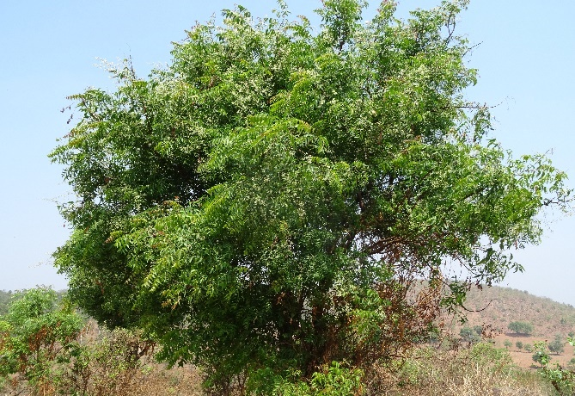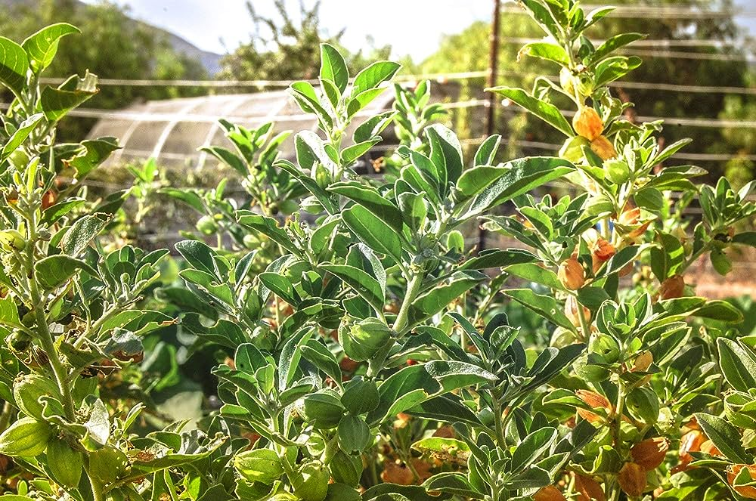
B
A
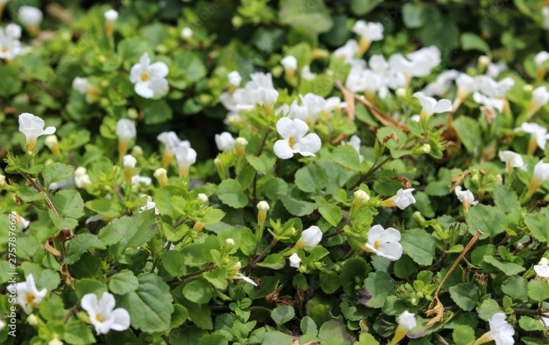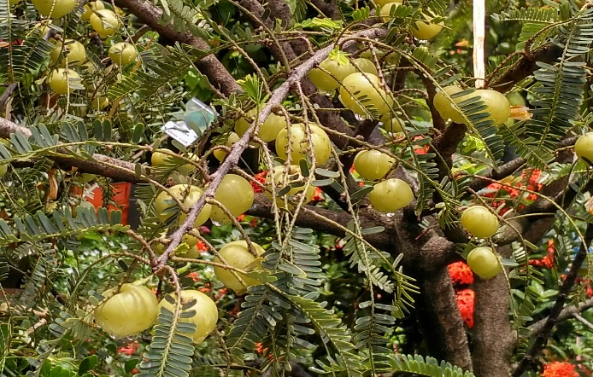
D
C
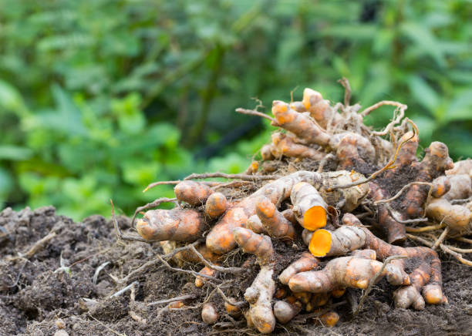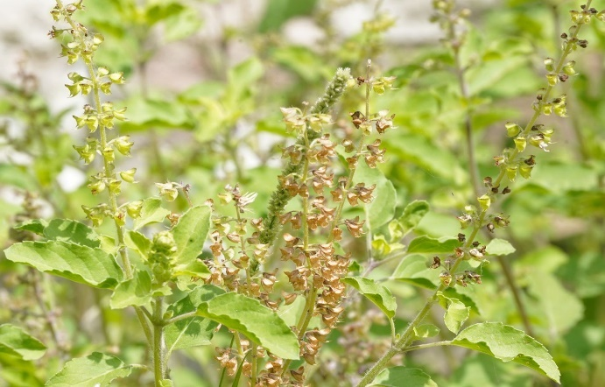
F
E
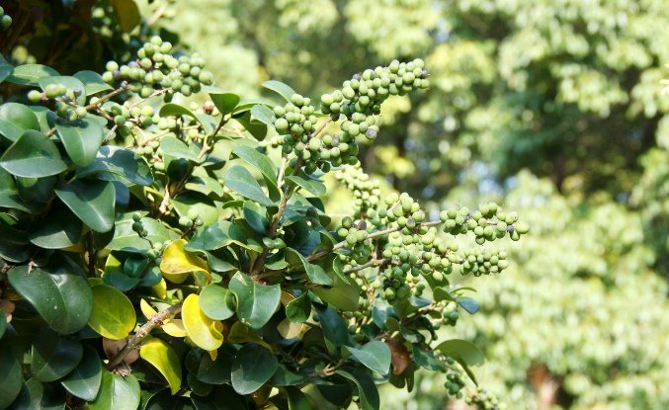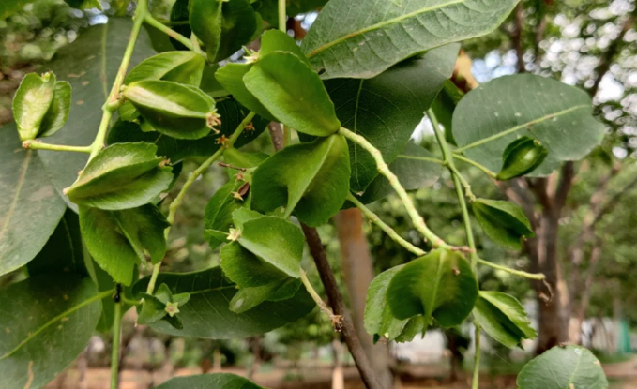
H
G

Fig: 1. Images of important Medicinal and Aromatic Plants (MAPs) used in Ayurvedic practices; [A] Neem (Azadirachta indica); [B] Ashwagandha (Withania somnifera); [C] Brahmi (Bacopa monnieri); [D] Amala (Emblica officinalis); [E] Turmeric (Curcuma longa); [F] Tulsi (Ocimum sanctum); [G] Guggul (Commiphora wightii); [H] Arjuna (Terminalia arjuna)
Table 1. Historical utilization and significance of medicinal and aromatic plants (MAPs).
Historical Context | Utilization of MAPs | Significance or Impact | Ref
Mesopotamia (c. 4000 BCE) | Myrrh and frankincense for medicine and religion | Integral to religious rituals and health practices. | (McMahon, 2020)
Ancient Egypt (c. 1550 BCE) | Herbal remedies documented in medical texts | Foundation of early pharmacopoeia and healthcare. | (Muller & Soyano, 2021)
Traditional Chinese Medicine (Shennong Ben Cao Jing) | Therapeutic applications of MAPs | Forms the basis of an enduring medical tradition. | (DU et al., 2020)
Native American Herbalism | Sage and echinacea for medicinal and ceremonial use | Rooted in indigenous cultures and healing rituals. | (DU et al., 2020)
Ayurveda in India | Turmeric, neem, and various MAPs integrated into the system | Shaping India's traditional healthcare system. | (DU et al., 2020; Rastogi, 2021)
Greco-Roman Contributions | Hippocrates and Dioscorides' influence on Western herbal medicine | Pioneering Western herbalism and pharmacology. | (Caplan & Aggarwal, 2022)
Culinary Traditions | Spices like cinnamon, cardamom enrich global cuisines | Infusing flavors and aromas into diverse culinary traditions. | (Partarakis et al., 2021)
Religious and Spiritual Practices | MAPs used in rituals and offerings | Enhancing the spiritual and sensory experiences. | (K. Singh et al., 2020)
Art, Literature, and Folklore | Inspirations for creative expression | Weaving cultural narratives and artistic creations. | (Fitrianita et al., 2018)
Cultural Heritage and Identity | MAPs integral to indigenous communities' traditions | Fostering cultural identity and connection to nature. | (Williams & Liu, 2023)

Table 2. Applications of MAPs in Pharmaceuticals, Cosmetics, Aromatherapy.
Application area | Description and examples | Ref
Pharmaceuticals
Herbal medicine | Utilized as primary or complementary treatments for various ailments. E.g., ginseng for energy, echinacea for immune support. | (Plotnikoff & Lillehei, 2022)
Active ingredients | Source of bioactive compounds used in drug development. E.g., quinine from cinchona bark for anti-malarial drugs. | (Murauer & Ganzera, 2018)
Traditional remedies | Integration into traditional medical systems worldwide. E.g., Ayurveda in India, Traditional Chinese Medicine (TCM). | (Xu & Zhang, 2020)
Cosmetics
Essential oils | Aromatic plant extracts used for fragrances and aromatherapy. E.g., lavender oil for relaxation, tea tree oil for skincare. | (Huang et al., 2008)
Natural pigments | Plant-based colors for cosmetics and hair dyes. E.g., henna for hair color, beetroot for lip tints. | (Dipakbhai & Mahida, 2021)
Skin and hair care | Herbal extracts for skincare products and natural shampoos. E.g., aloe vera for soothing, rosemary for hair health. | (Namchaiw et al., 2021)
Aromatherapy
Therapeutic oils | Essential oils applied in massage, diffusers, and inhalation for emotional and physical well-being. E.g., eucalyptus for congestion relief, chamomile for relaxation. | (Karatopuk & Yarıcı, 2023)
Stress reduction | Aromatherapy practices to reduce stress, anxiety, and improve mental clarity. E.g., lavender for relaxation, peppermint for alertness. | (Li et al., 2019)
Flavors and fragrances
Culinary delights | Enhancing the flavors of various dishes and beverages. E.g., basil in Italian cuisine, cinnamon in baked goods. | (Kanta et al., 2020)
Perfumery | Scenting perfumes, colognes, and personal care products with floral and herbal notes. E.g., rose, jasmine, and sandalwood. | (Barwich, 2021)
Traditional and cultural uses
Rituals and ceremonies | Incorporation into cultural and religious rituals. E.g., sage smudging in Native American traditions, incense in Hindu rituals. | (Misbahuddin et al., 2023)
Cultural identity | Preservation of cultural heritage and identity through MAPs in traditional practices and art. E.g., henna designs, traditional incense crafting. | (Sartini et al., 2023)

Table 3. Applications of MAPs in pharmaceuticals, cosmetics, and aromatherapy.
Name of MAPs | Ayurvedic name | Traditional applications in ayurveda | Therapeutic benefits | Ref
Turmeric (Curcuma longa) | Haridra | Anti-inflammatory, antioxidant, immune support, and digestive aid | Arthritis management, skin health and immune system booster | (Kocaadam & Şanlier, 2017)
Neem (Azadirachta indica) | Nimba | Antiseptic, blood purifier, anti-parasitic and skin health | Skin conditions (acne, eczema), dental care and blood purification | (Wylie & Merrell, 2022)
Ashwagandha (Withania somnifera) | Ashwagandha | Adaptogen, stress relief, energy booster and cognitive support | Anxiety and stress reduction, improved sleep, and vitality | (Lopresti et al., 2019)
Tulsi (Ocimum sanctum) | Tulasi | Immune support, respiratory health, and stress relief | Cough and cold relief, immune system enhancement and stress management | (Cohen, 2014)
Brahmi (Bacopa monnieri) | Brahmi | Cognitive enhancer, memory support and stress reduction | Improved cognitive function, memory enhancement, anxiety relief | (Dubey & Chinnathambi, 2019)
Amala (Emblica officinalis) | Amalaki | Rich in Vitamin C, digestive support, and antioxidant | Immune system booster, digestive health, and skin rejuvenation | (Sanjay, 2020)
Guggul (Commiphora wightii) | Guggulu | Cholesterol control, anti-inflammatory and weight management | Cholesterol reduction, arthritis relief and weight management | (Ahmed et al., 2016)
Arjuna (Terminalia arjuna) | Arjuna | Cardiovascular health, heart tonic and hypertension management | Heart health support and blood pressure regulation | (Goswami et al., 2020)

