Ferrite-Polymer nanocomposites: structural, electrical, magnetic and EMI shielding properties
P. Raju^{1*}, M. Kanaka Durga¹, G. Neeraja Rani¹ and S. Katlakunta²
¹Geethanjali College of Engineering and Technology, Cheeryal, Hyderabad – 501 301, India.
²Department of Physics, University College of Science, Saifabad, Osmania University, Hyderabad-500004, India
*Corresponding author: panthagani.raju@gmail.com
Abstract
The organic/inorganic electromagnetic absorbing materials based on polyaniline (PANI) filler dispersed in a ferrite (NiCuZnFe₂O₄) matrix were successfully prepared for electromagnetic absorption applications. NiCuZnferrite–PANI nanocomposites were synthesized by the mechanical milling process. The structure and the morphology of the elaborated nanocomposites were investigated by X-ray diffraction (XRD), Fourier Infrared spectroscopy (FTIR) and scanning electron microscopy (SEM). Electromagnetic properties and absorbing behaviours were performed over a frequency range of 8.2-12.4 GHz (X-band) and Ku band (12-18 GHz). The results show that for nanocomposites, the values of the real (ε′) and imaginary permittivity (ε″) and imaginary permeability (µ″) increase, while the value of real permeability (µ′) decreases as the filler content increases. Synthesis parameters such as the amount and particle size of PANI and NCZ affect significantly the morphology, conductivity, and microwave absorption properties of the final materials. It was revealed that the Reflection loss (RL) and total shielding effectiveness (SE_{tot}) are increased with the addition of PANI. The maximum RL of -41.72 dB is obtained for a nanocomposite of 50wt% PANI. The enhanced electromagnetic absorption performance of nanocomposites is attributed to the increment of both magnetic and dielectric losses due to the incorporation of conducting PANI filler in a ferrite matrix. The possibility to modulate the electromagnetic properties of the composite materials is of great interest to fabricate microwave absorbing and electromagnetic shielding materials with high performances.
Keywords: Nanocomposites; Electromagnetic absorption; Reflection loss; Permittivity; permeability;
1. Introduction
Magnetic polymer nanocomposites are potentially essential and have several significant advantages over traditional polymer composites. The Micron-sized composites usually require a high filler phase content to achieve the composite material's desired properties. But, the nanocomposites can achieve the desired and better properties with a much smaller amount of filler. This will yield materials with lower density and higher processability. The nanoparticles have advantages over micron-sized particles, for example; because they can exhibit novel magnetic, optical, thermal, electrical and mechanical properties. Similarly, in nanoparticles, the magnetic properties such as coercivity, saturation magnetization, and frequency-dependent permeability are very different from those found in micron-sized materials.
Magnetic polymer composites have many applications in many fields such as the automobile industry, and the medical field as various types of sensors, in the area of Electromagnetic interference (EMI) suppression. All electronic devices generate and emit radiofrequency waves that can interfere with the operation of electronic components within the same device as well as other electronic devices. In the present day, all electronic devices are moving towards miniaturization and in this process, the electronic components are to be packed very close to each other, which increases the problem of electromagnetic interference. When an electromagnetic wave is incident upon a conductive surface, energy is reflected and absorbed.
The ability of a material to shield electromagnetic energy, whether it be unwanted energy entering a system or escaping a system is called its shielding effectiveness. It consists of losses due to absorption, reflection, and multiple reflections [1]. EMI suppression over a wide band frequency range requires tunability of the impedance (Z), which depends on the tunability of the complex permeability and complex permittivity. Conductivity plays an important role in a material’s ability to shield electromagnetic energy.
Metals, along with capacitors and ferrites are commonly used in EMI suppression and these materials have many disadvantages in terms of their weight, corrosion and physical rigidity [2]. Many scholars have carried out investigations of the absorption properties of one-component EMW absorbers employing ferrite, conducting polymers and other new absorption materials [3, 4]. However, compared with multicomponent materials, the application prospects of one-component materials are limited due to their deficient absorption efficiencies and relatively narrow bandwidth. These properties could be overcome with the development of new composite materials. Out of all composite materials, magnetic nanoparticles doped with conducting and insulating polymers are lightweight, flexible alternatives to micron-sized metal components. Hence, ferrite/polymer nanocomposites are the best choices. Another importance of magnetic-polymer nanocomposites is that critical parameters such as loss tangents and impedance matching, which are important in microwave devices, may be controlled in these materials. The loss tangent is a measure of the inefficiency of a magnetic system. The loss tangents are primarily determined by magnetic and eddy current losses which depend on the resistivity of the material. The resistivity of magnetic nanoparticles increases with the addition of conducting polymer, thereby decreasing the eddy current losses. Generally, magnetic losses in composite materials are controlled by the material grain structure, domain wall resonances etc. and these parameters can be manipulated effectively in nanocomposite materials by the size distribution of nanoparticles and their dispersion in the matrix.
During the transmission, the impedance mismatch between source and load in circuits is the main source of signal attenuation. By manipulating the properties of nanocomposites desired impedance values at specific frequencies are attained and the attenuation can be minimized. The impedance of nanocomposite material can be adjusted by the type and amount of polymer dispersed in the magnetic nanoparticles. The combination of the ferrimagnetic nanoparticles with conducting polymer leads to the formation of an important nanocomposite possessing a unique combination of electrical and magnetic properties. This property of the nanocomposite materials can be used for utilizing them as an electromagnetic shielding material. This is because the electromagnetic wave consists of an electric (E) and a magnetic field (H) right angle to each other. The ratio between E to H factor (impedance) has been subjugated in the shielding application. In ferrite/polymer types of nanocomposites, the conducting polymer type of materials can effectively shield electromagnetic waves generated from an electric source, whereas electromagnetic waves from a magnetic source can be effectively shielded only by magnetic materials.
The primary mechanism of EMI shielding is usually reflection and for this type of radiation by the shield, it must have mobile charge carriers (electrons or holes) which interact with the electromagnetic fields in the radiation. Hence, the shield tends to be electrically conducting, without a high conductivity. For example, a volume resistivity in the order of 1 Ωcm is typically used [5]. A secondary mechanism of EMI shielding is usually absorption. For significant absorption of the radiation, the shield should have electric and/or magnetic dipoles that interact with the electromagnetic fields in the radiation. Thus, having both conducting and magnetic components in a single system could be used as an EMI shielding material [6].
To shield electromagnetic microwave interference to protect precision equipment and keep the human body away from radiation, a considerable amount of research has been focused on the development of composites of polymer and inorganic fillers that have enhanced microwave absorption and electromagnetic shielding properties. The nanocomposites of conductive polymer and magnetic particles have been shown to have a variety of advantages such as low density, high hardness, structural diversity, and improved electromagnetic properties [7-9]. In particular, the conductive polyaniline–magnetic ferrite composites are promising candidates for this type of application due to a hybrid structural and functional combination between the organic and inorganic materials.
The purpose of the present study is to investigate a quantitative relationship between the magnetic and dielectric characteristics of ferrite/polymer composites and their microwave absorbing properties in the X-band (8.2 - 12.4 G Hz) and Ku-band (12.4-18.0 G Hz) frequencies.
Ferrites are magnetic ceramics containing iron oxide as a major constituent in it. It is now more than 70 years since ferrites debuted as an important new category of magnetic materials. These are now very well-established a group of magnetic materials. Today ferrites are employed in a truly wide range of applications and have contributed materially to the advances in electronics. Even though, improvements and innovations continue to take place; many new applications, theories, and preparation technologies are currently under development in the field of ferrites.
NiCuZn ferrites have been the dominant materials for microwave applications due to their good electromagnetic properties [10]. In addition, NiCuZn ferrites have better high-frequency properties compared to that of MnZn ferrites and lower densification temperatures than NiZn ferrites. In recent years, there has been an increased interest in the application of NiCuZn ferrite for the production of multilayer ferrite chip inductor components. The applications of the chip inductors include a) combined with capacitors to form inductor-capacitor (LC) filters, b) as Electromagnetic Interference (EMI) filters, c) as an AC choke for active devices (e.g. transistors), d) used in matching circuits, etc. Apart from this, ferrites are used in audio and visual equipment such as liquid crystal TV set headphone stereos, computer and telecommunication devices such as personal wireless communication systems and automobile telephones etc.
The nanocomposites of polyaniline, synthesized with different ferrites including zinc ferrite, [11] barium ferrite, [12-14] cobalt ferrite, [15, 16] Fe3O4 [17] and manganese–zinc ferrite, [18-20] have been reported, where core–shell structures were formed, i.e. the ferrite nanoparticles are covered by polyaniline shells. Although these nanocomposites have shown microwave absorption and electromagnetic shielding properties, their performance is often less than expected because ferrite nanoparticles tend to aggregate due to their small size and magnetic nature. Aggregation of nanoparticles possesses a significant limitation in the application of electromagnetic absorbing nanocomposites in electrical and electronic devices, reducing the composites' electromagnetic absorbance in both strength and range.
Numerous research papers give an account of EMI shielding of different carbon-based materials, carbon-reinforced polymer composites, polymer composites, metal composites and Magnetic materials in the X-band (8.2–12.4 GHz) area and their utilization in military correspondence satellites, climate forecasting, aviation authority, defence tracking and high determination imaging radars. [21-23]. Ku-band frequency is widely used in satellite communication. The studies on the absorbent only for Ku-band frequency are very limited [24, 25]. However, according to our knowledge, no microwave absorber studies were reported in the literature on ferrite/polymer nanocomposites.
In the present investigation, various Polyaniline (PANI) loaded Ni_{0.48}Cu_{0.12}Zn_{0.4}Fe₂O₄ (NCZ) matrix nanocomposites were prepared using the mechanical milling method. The NCZ can be used in microwave devices and microwave absorption fields due to their high saturation magnetization, excellent chemical stability and corrosion resistance. The nanocomposite powders were the effect of the volume fraction of polymer on the frequency dispersion characteristics of the complex permittivity (ε' & ε") and permeability (μ' & μ") were studied and the obtained results were discussed. The microwave absorption properties of the nanocomposite samples were also determined at different frequencies and sample thicknesses, using a computer simulation based on a model of a single-layered plane wave absorber backed by a perfect conductor. The matching frequencies for minimum reflection and the corresponding matching thicknesses for the best sample (50% PANI) are also presented.
2 Experimental procedures
2.1 Synthesis of NCZ ferrite
The nanopowder of Ni_{0.48}Cu_{0.12}Zn_{0.4}Fe₂O₄ (NCZ) was synthesized using microwave hydrothermal method starting with high purity (99.9%) chemicals of nickel nitrate [Ni (NO3)2•6H2O], zinc nitrate [Zn (NO3)2•6H2O], copper nitrate [Cu (NO3)2 .6H2O] and ferric nitrate [Fe (NO3)3•9H2O] were taken in stoichiometric ratio. These reagents were dissolved in 50 ml of de-ionized water. To this solution, sodium hydroxide (NaOH) was added to maintain the pH of the solution ~12. Controlling pH is the key factor in synthesizing the nanopowder. Then the precipitation was transferred into double-walled digestion vessels that have an inner liner and cover made up of Teflon PFA and an outer high-strength layer made up of Ultem polyetherimide and then treated using microwave-hydrothermal (M-H) method at 160°C/45min. The M-H treatment was performed using a microwave-accelerated reaction system (MARS-5, CEM Corp., Mathews, NC). This system uses 2.45GHz microwave frequency and can be operated at 0–100% full power (1200±50 W). The reaction vessel was connected to an optical probe to monitor and control the temperature during synthesis. The product was separated by centrifugation and then washed repeatedly with deionized water, followed by drying in an Oven overnight at 60°C. Thus the obtained powders were weighed and the percentage yields were calculated from the total expected based on the solution concentration and volume and the amount that was crystallized and a yield of 96% was obtained. Then the as-synthesized powders were characterized by XRD (Philips PW-1730 X-ray diffractometer).
2.2 Synthesis of PANI
The synthesis of PANI was based on mixing aqueous solutions of aniline hydrochloride and ammonium peroxydisulfate at room temperature, followed by the separation of PANI hydrochloride precipitate by filtration and drying. Aniline hydrochloride (equimolar volumes of aniline and hydrochloric acid) was dissolved in distilled water in a volumetric flask to 100 ml of solution. Ammonium peroxydisulfate (APS) (0.25M) was dissolved in water to 100 ml of solution. Both solutions were kept for 1 hour at room temperature (25°C), then mixed in a beaker, stirred with a mechanical stirrer, and left at rest to polymerize. The next day, the PANI precipitate was collected on a filter, washed with 300 ml portions of 0.2 M HCl, and similarly with acetone. Polyaniline (emeraldine) hydrochloride powder was dried in air and then in vacuum at 60°C.
2.3 Synthesis of NCZ-PANI nanocomposites
As synthesized nanopowders of NCZ and PANI were mixed with systematically varying composition to obtain nanocomposites (1-x)NCZ + xPANI, (x = 0, 0.1, 0.2, 0.3, 0.4, 0.5, 1). The samples were named NCZ, NP1, NP2, NP3, NP4, NP5 and PANI respectively. The mixed powders were mechanically milled using a Retsch Co high energy planetary ball mill by using the hardened tungsten carbide (WC) vial together with ten 12 mm WC balls for 30 hr. A ball-to-powder mass charge ratio of 14:1 was chosen. The speed of the mill was set at 400 rpm with an interval of 40 minutes. The 30-hrs milled powders were subjected to anneal at 110°C/30 min in an air atmosphere. The samples were characterized by X-ray diffraction (XRD), scanning electron microscopy (SEM, LEICA, S440i, UK) and Fourier transform infrared spectrometer (FTIR, Brucker tensor 27).
Variations of the microwave absorption in dB versus frequency in the range of 8–18 GHz for composite samples have been investigated using an Agilent 8722ES vector network analyzer. The samples of NCZ-PANI nanocomposites were shaped to fit exactly into rectangular X-band waveguide (WR90, h=10.16 mm, w=22.86 mm and t=2.1 mm) and Ku-band waveguide (WR62, h= 7.8994 mm w=15.7988 mm and t=2.1 mm) for microwave measurements. The complex scattering parameters that correspond to the reflection (S₁₁ or S₂₂) and transmission (S₂₁ or S₁₂) in the composite samples were measured. Full two-port calibrations were initially done on the test setup in order to remove errors due to the directivity, source match, load match, isolation, etc., in both the forward and reverse direction. The complex permittivity (ε' & ε") and permeability (μ' & μ") were then determined from the measured scattering parameters using Agilent software module 85071, based on the procedure given in the HP product note. The reflection loss of the samples was calculated and analyzed.
3. Results and discussions
In Fig. 1, X-ray diffraction patterns for as-prepared NCZ-PANI nanocomposites are shown. The patterns were recorded at room temperature using CuKα radiation (λ=1.5418 Å), in the 2θ range 10° to 80° with step size 0.03° operating at 40 kV and 30mA. The XRD patterns for nanocomposites show crystalline peaks due to the presence of the ferrite phase. The intensity of the ferrite peaks is influenced by the addition of polymer. It is found that the intensity of the ferrite peaks decreased with polymer and vice versa. The diffused peak of the PANI disappeared with an increase of ferrite content in the composites due to the ferrite nanoparticles interfering with PANI chains. It can also be observed from the figures that the diffraction peaks were broadened with higher additions of the polymer. The mean crystallite size of NCZ in each sample is calculated by the Debye–Scherrer formula (L = Kλ/β cos θ, K is a constant, λ wavelength of X-rays, β the full-width half maximum and θ the diffraction angle), on the basis of the full width of the diffraction line at half the maximum (FWHM) intensity measured in the most intense peak (3 1 1). The crystallite size was calculated using the above formula and the obtained results are presented in Table 1. It can be observed from the table that the crystallite size of the composites is in the nano range and decreases with an increase in PANI content. It is also observed that with an increase of PANI the diffraction peak (3 1 1) is shifted towards lower Bragg angle side, which indicates that NCZ particles are bonded to polymer chains and also due to the stress induced by the ferrite particles.
The lattice constant (a) for the present samples is calculated by using XRD patterns. For a given set of planes (h k l) and from the Bragg’s equation ‘d’ spacing is given by
$d_{hkl}=\frac{nλ}{2\sin{θ}}$ ….(1)
Where n is the order of reflection, λ is the wavelength of radiation and θ is glancing angle of the incident X-ray beam. For cubic crystals, dhkl is given by
$d_{hkl}=\frac{a}{\sqrt{h^{2}+k^{2}+l^{2}}}$ ….(2)
The lattice parameters of composites were calculated with the help of all the peaks that appeared in the XRD pattern and are presented in Table 1. It can be seen from the table that the lattice constant is found to decrease with an increase in the polymer phase in the nanocomposite. The incorporation of the polymer into NCZ does not change the crystal structure of the ferrite but the lattice is distorted.
The bulk density of all the composite samples has been measured accurately (up to 1%) using the Archimedes principle. The bulk density is obtained by using Eq 3
$b_{bulk}=\frac{M_{air}}{M_{air}-M_{Xylene}}$ -- (3)
where Mair is a mass of the sample in air and MXylene is a mass of the sample in Xylene
The bulk density of the nanocomposites is measured and presented in Table 1. The bulk density of the nanocomposites is found to decreases with an increase of polymer content since the molecular weight of ferrite is more than that of the PANI.
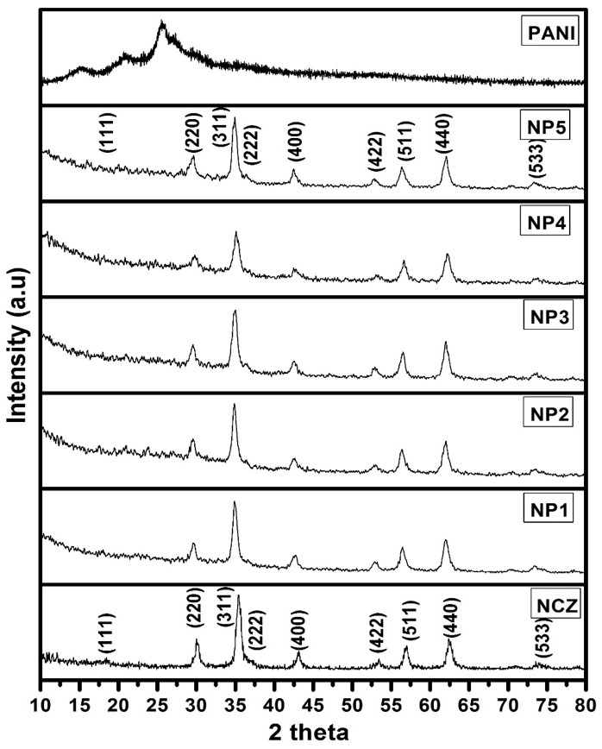
Fig. 1 XRD patterns of NCZ-PANI nanocomposites. Reproduced with the permission from, Raju, P., P. Neelima, G. Neeraja Rani, and M. Kanakadurga. "Enhanced microwave absorption properties of Ni0. 48Cu0. 12Zn0. 4Fe2O4+ polyaniline nanocomposites." Journal of Physics and Chemistry of Solids 154 (2021): 110048.
The chemical structures of nanocomposites were characterized by Fourier Transform Infrared (FTIR) spectroscopy. Fig. 2 shows FTIR spectra of the ferrite (NCZ), nanocomposites of varied fractions of polyaniline with respect to ferrite.
The IR absorption bands of solids in the range 100 – 1000 cm-1 are usually assigned to vibrations of ions in the crystal lattice. In ferrites, the metal ions are usually situated in two different sublattices, designated as tetrahedral and octahedral sites according to the geometrical configuration of the oxygen nearest neighbours. The vibrational spectra of spinel ferrites (MFe2O4) are attributed to the high-frequency band (600–550 cm-1) to the intrinsic vibration of the tetrahedral sites and the low-frequency band (440–400 cm-1) to the octahedral sites [26, 27]. The bands observed in ferrite at 1635 cm-1, 1400 cm-1, and 1122 cm-1 are due to the vibration of the C-O, C–O–C and C–H groups of the surfactant. [28, 29]
The characteristic peaks of polyaniline are observed at 1612, 1558, 1473, 1145, 837, 617 and 503 cm-1. The band appeared at 1612 cm-1 is attributed to the C-N vibration of the quinoid ring. The bands observed in the spectrum of PANI with absorption at 1558 cm-1 and 1473 cm-1 are attributed to the C-C stretching vibrations of the quinoid ring and benzenoid ring, respectively. The band appeared at 1145 cm-1 is the stretching of C–N bonds of the second aromatic amines. The stretching of the C–N+ polaron structure was observed at 837 cm-1. The absorption at 917 cm-1 is assigned to the protonated amine group on the polyaniline backbone chain. The band observed in the spectrum at 503 cm-1 corresponds to the aromatic ring deformation and the out-of-plane vibrations of the C–H bond. [30]
It can be seen from Figure 2, that for the polyaniline-ferrite nanocomposite samples, the characteristic peaks of both ferrite and PANI appeared. The characteristic peak of NCZferrite appearing at 561 cm-1 is shifted with an increase in PANI content. The intensity of the peak at 561 cm-1 decreased with a decrease in the weight percentage of ferrite in the nanocomposite. The bands appeared at 1400–1600 and 1130 cm-1 of the composites show the coupling effect of ferrite and polyaniline. All the bands of these nanocomposites correspond to vibration modes in the ferrite matrix, and they are little-shifted when compared with the FTIR spectra of pure PANI. This may indicate that the PANI is formed together with the ferrite nanocrystals. The incorporation of polymer in the NCZ matrix led to the shifting of some FTIR bands of the PANI in the nanocomposites. The results reveal that there exists an interaction between NCZ ferrite and PANI chains and suggest the effective formation of the NCZ-PANI nanocomposites.
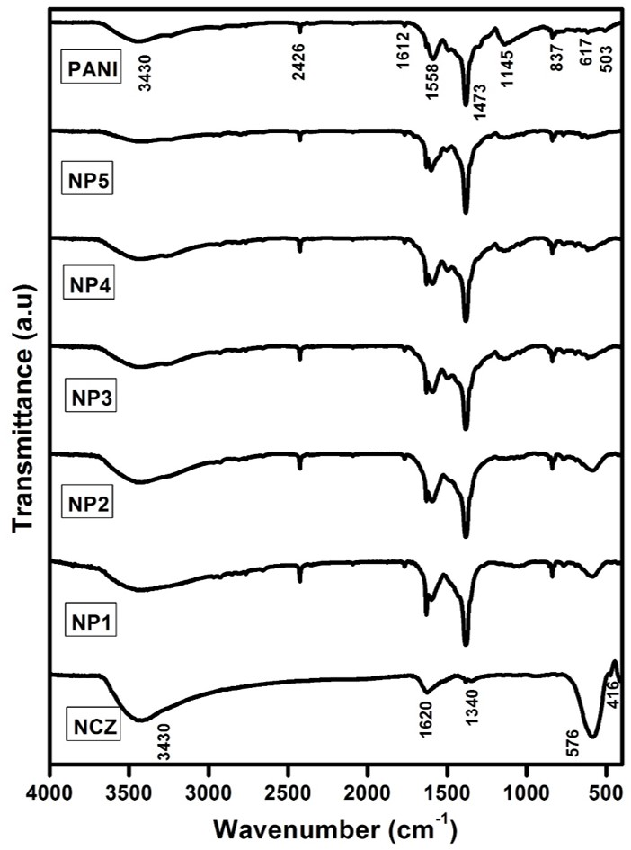
Fig. 2 FTIR spectra for NCZ-PANI nanocomposites. Reproduced with the permission from, Raju, P., P. Neelima, G. Neeraja Rani, and M. Kanakadurga. "Enhanced microwave absorption properties of Ni0. 48Cu0. 12Zn0. 4Fe2O4+ polyaniline nanocomposites." Journal of Physics and Chemistry of Solids 154 (2021): 110048.
The morphologies of NCZ, polyaniline, and its nanocomposite were examined by SEM and were given in Fig. 3. It can be seen from the SEM picture of ferrite nanoparticles (NCZ) indicated a spherical shape with lots of agglomeration between ferrite particles and an average diameter of 30 nm. As observed in Figure, polyaniline (NP4) was estimated to have an average diameter of 60 nm and a length of 100 nm. Polyaniline is tubular in shape and tends to form an entangled network that is useful for the effective transport of electrons. Fig. 3 (NP3 & NP4) clearly showed that ferrite nanoparticles are assembled on the surface of polyaniline. Fig. 3.6 (NP3) shows the possible way by which the ferrite nanoparticles were attached to the polyaniline surface. The image of the nanocomposite in Fig. 3 (NP4) indicates that ferrite nanoparticles were uniformly attached to the polyaniline surface. No aggregation of ferrite was observed on the polyaniline surface. It can be seen from the SEM micrographs of nanocomposites exhibit a two-phase system with polymer grains (white) and ferrite grains (black). Energy-dispersive X-ray spectroscopy has been used to confirm the grains of these two phases. The connectivity of NiCuZn ferrite grains is dispersed by the distribution of polymer grains, which leads to the variation of magnetic properties of the composites.
The average grain sizes of the samples are estimated with the help of SEM pictures by using the equation $G={1.5L}/{MN}$ (3.5) where L is the total test line length in cm; M the magnification; N is the total number of intercept, and the results are given in Table 1. It can be observed that the estimated average grain sizes are in the desired nanosizes although they are larger than the corresponding ‘‘crystallite’’ sizes estimated from X-ray diffraction analysis, this is expected because it is well known that X-rays can detect the crystallites only, i.e., the well-ordered parts of the particles and they cannot detect the disordered grain boundaries, which occupy a considerable volume in the case of nanoparticles. Besides there is a probability of agglomeration of more than one particle such that they appear like one large particle in the SEM images. Such agglomerations may not be detected by the X-rays. Similar observations and interpretation are reported in the literature [31, 32].
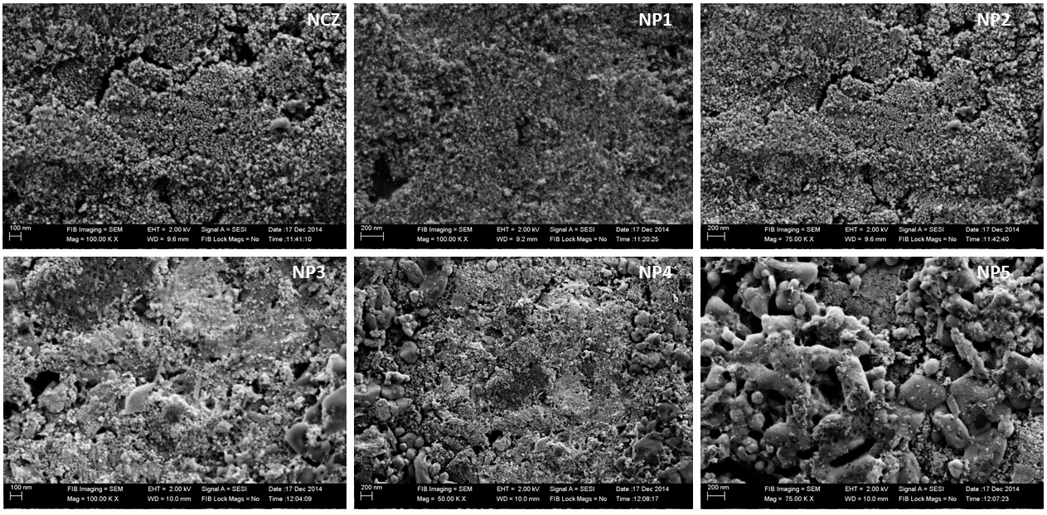
Fig. 3 SEM images of NCZ-PANI nanocomposites. Reproduced with the permission from, Raju, P., P. Neelima, G. Neeraja Rani, and M. Kanakadurga. "Enhanced microwave absorption properties of Ni0. 48Cu0. 12Zn0. 4Fe2O4+ polyaniline nanocomposites." Journal of Physics and Chemistry of Solids 154 (2021): 110048.
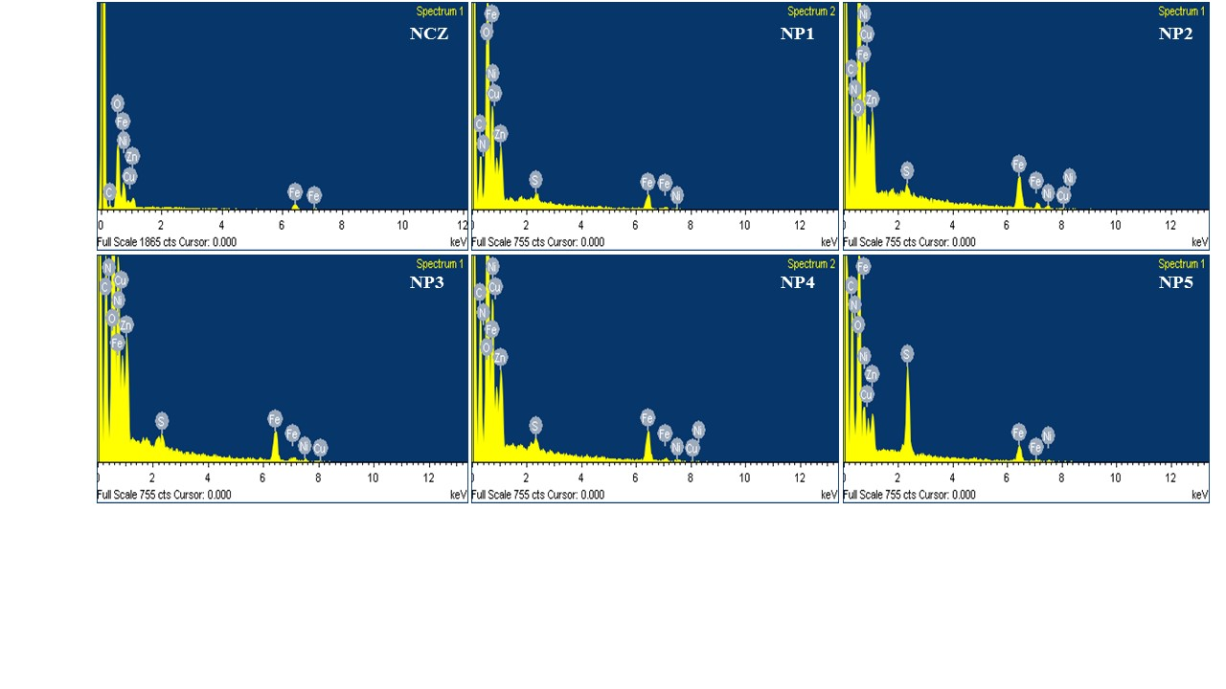
Fig. 4 EDS spectra of NCZ-PANI nanocomposites. Reproduced with the permission from, Raju, P., P. Neelima, G. Neeraja Rani, and M. Kanakadurga. "Enhanced microwave absorption properties of Ni0. 48Cu0. 12Zn0. 4Fe2O4+ polyaniline nanocomposites." Journal of Physics and Chemistry of Solids 154 (2021): 110048.
Table 1 Structural data of NCZ-PANI nanocomposites
Sample | XRD Crystallite size (nm) | Lattice parameter (Ǻ) | Density g/cm³ | Grain size (nm)
NCZ | 35 | 8.439±0.001 | 5.25 | 40
NP1 | 33 | 8.424±0.001 | 5.23 | 38
NP2 | 30 | 8.412±0.001 | 5.21 | 35
NP3 | 29 | 8.403±0.001 | 5.13 | 33
NP4 | 27 | 8.402±0.001 | 5.11 | 29
NP5 | 25 | 8.401±0.001 | 5.01 | 27

Table 2 EDS elemental analysis of NCZ-PANI nanocomposites. Reproduced with the permission from, Raju, P., P. Neelima, G. Neeraja Rani, and M. Kanakadurga. "Enhanced microwave absorption properties of Ni0. 48Cu0. 12Zn0. 4Fe2O4+ polyaniline nanocomposites." Journal of Physics and Chemistry of Solids 154 (2021): 110048.
Fig 4 depicts the EDS spectra of SEM photographs that have been investigated for the distribution of Nano ferrite in the PANI polymer. From these EDS spectra, it is verified that the NCZ particles were distributed equally in the polymer. It has been found that as the weight percentage of NCZ in NCZ-PANI nanocomposites increases the intensity of NCZ in the EDS spectra also more. That shows that the NCZ particles were distributed very well within the polymer. Table 2 shows the elemental weight and atomic percentage of NCZ-PANI nanocomposites.
The thermal stability of nanocomposites and the interactions between ferrite and polyaniline were studied by thermogravimetric analysis. Figure 5 shows the thermogravimetric curves (TG) of NCZ and NCZ-PANI nanocomposites. The materials were heated from 30 to 850ºC under a constant heating rate of 10ºC/min and in the inert atmosphere of nitrogen gas. Nanocomposites with varying ratios of PANI to the ferrite showed distinct steps of thermal degradation. The NiCuZn ferrite has excellent thermal stability up to 850ºC and weight loss was only around 8 %. The TGA curve of nanocomposites indicated the first weight loss at 110ºC may be attributed to the loss of water and other volatile species. This attribution is supported by Gomes and Oliveira [33]. The weight loss below 250ºC is attributed to the removal of water and dopant molecules adsorbed on polyaniline and the degradation of oligomers.[34] The third degradation step is attributed to the decomposition of molecular chains of the polyaniline.[35] The degradation of polyaniline backbone chains results in the formation of small aromatic fragments, substituted aromatic fragments, and extended aromatic fragments.[33] As expected, the nanocomposites became more resistant to thermal degradation with higher ferrite contents. These thermograms reveal an increased thermal stability of polyaniline in the nanocomposites perhaps attained by the strong interactions between the ferrite and polyaniline surface.
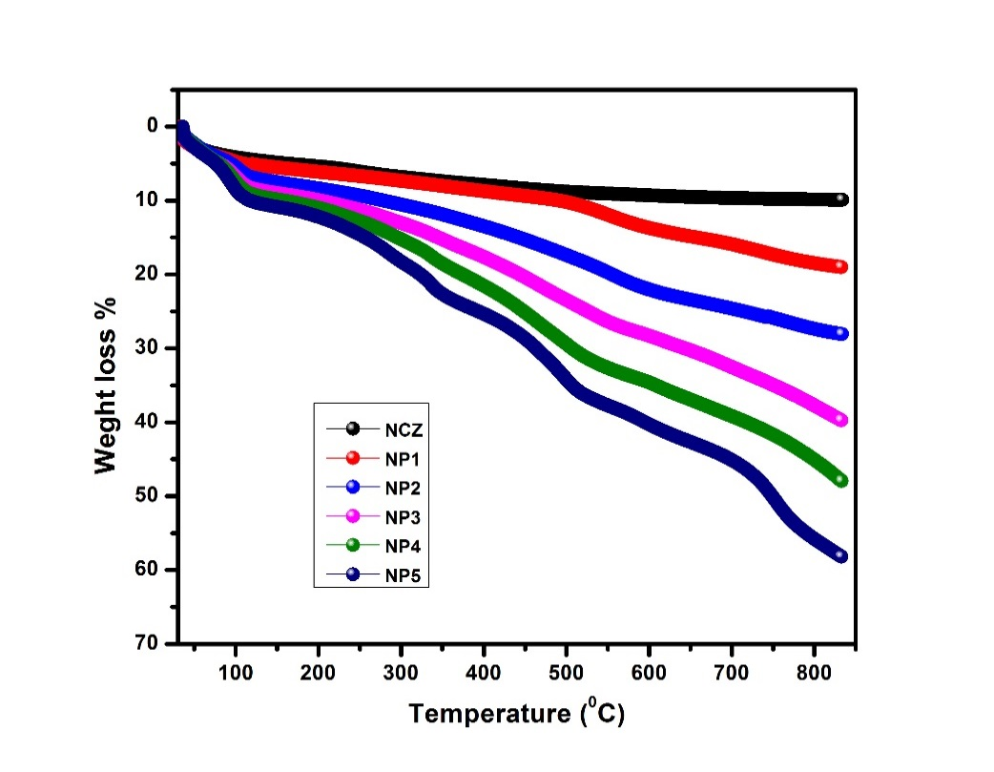
Fig. 5 TGA graphs for NCZ-PANI nanocomposites. Reproduced with the permission from, Raju, P., A. Thirupathi, Ch Kalyani, Sk Mahammed Ali, J. Shankar, G. Neeraja Rani, J. Anjaiah, and M. Kanaka Durga. "Synthesis and thermal stability of ferrites added polymers nanocomposites." Materials Today: Proceedings (2023).

Fig. 6 gives a plot of dc conductivity versus wt% of PANI for NCZ-PANI nanocomposites at room temperature. It can be observed from the figure that the conductivity decreases with an increase in NCZ content. It may be due to the interactions between the polymer and NCZ nanoparticles will increase the charge carrier scattering and thus increase the sample’s resistivity resulting in a decrease in the conductivity of NCZ-PANI nanocomposites with an increase in NCZ content [36, 37]. Other effects like increased charge carrier trapping, either by the nanoparticles themselves or by morphological changes and defects induced by them, could also play a role. To explain the conductive behaviour in our samples we suggested the formation of polarons upon oxidation of polyaniline molecule and the combination of two close polarons to form bipolaron. The net effect is the formation of a doubly charged defect (bipolaron) delocalized over several rings of polyaniline.
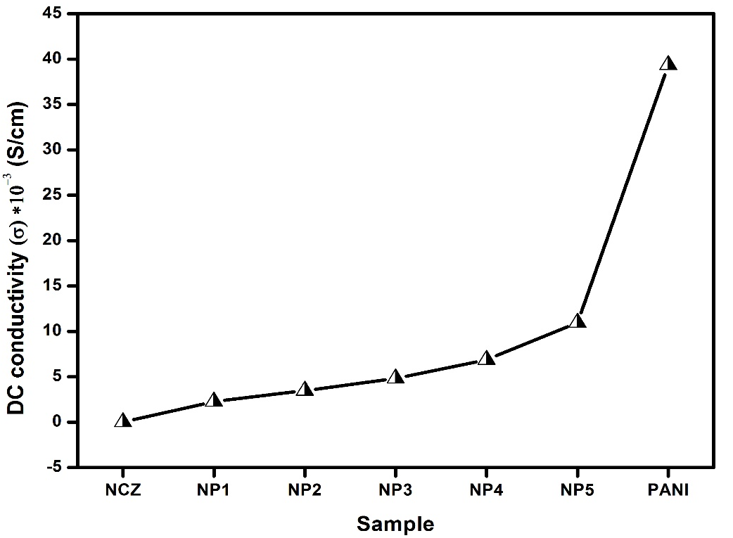
Fig. 6 DC conductivity of NCZ-PANI nanocomposites at room temperature. Reproduced with the permission from, Raju, P., A. Thirupathi, Ch Kalyani, Sk Mahammed Ali, J. Shankar, G. Neeraja Rani, J. Anjaiah, and M. Kanaka Durga. "Synthesis and thermal stability of ferrites added polymers nanocomposites." Materials Today: Proceedings (2023).
3.1 Complex permittivity spectra of NCZ-PANI nanocomposites
Figs. 7 shows the real and imaginary parts of complex permittivity spectra (ε*) of NCZ-PANI nanocomposites in the X-band (8-12 GHz) frequency range. The ε′ for NCZ is a low value of 6.87 at 8.2 GHz, with almost constant behaviour throughout the frequency range except a resonance peak was observed at 9.7 GHz. It was found that both the real (εʹ) and the imaginary part (εʹʹ) of the permittivity of the composites increased with the increasing weight percentage of PANI.
The real part of permittivity depends mainly on the polarization in the polymer backbone and the interfacial polarizations among the ferrite nanoparticles and polyaniline nanofibers. The conducting polyaniline in its emeraldine base form, when protonated by HCl acid solution, possesses permanent electric dipoles. NCZ is a ferrimagnetic material exhibiting high resistivity and in ferrites, it is observed that the mechanism of dielectric polarization is similar to the mechanism of electrical conduction. The variation of dielectric permittivity can hence be related to the collective behaviour of both types of electric charge carriers, electrons and holes. This can be explained on the basis of the Rezlescue model [38]. According to this model, electron exchange between Fe2 + and Fe3 + ions and holes that transfer between the substituted metallic ions are responsible for electric conduction and dielectric polarization in ferrites [39, 40]. Therefore, in both cases, orientation (dipolar) polarization is the dominant polarization and the associated relaxation phenomena constitute the loss mechanisms. Additionally, the joule-heating loss will also occur due to the finite conductivity of the polyaniline. Since with the polymer, the homogeneity of the system decreases this constitutes a heterogeneous system and interfacial polarization is another important polarization process and associated relaxation also will give rise to a loss mechanism [41].
The two main contributors for εʹ, in these composites are expected to be (i) orientational polarization and (ii) interfacial polarization. The decreasing percentage of polyaniline also reduces the contribution from orientational polarization, thus leading to the low values of εʹ. Understandably, both the above-mentioned contributions will be maximum when the composite consists of an equal percentage of the conductor (polyaniline) and insulator (NCZ), leading to maximum net polarization in NP5. As shown in Fig. 7b, the values of εʹʹ for all frequencies increase with increasing polyaniline concentration. This is expected, as both the dc/ac conductivity and dipole relaxation in the samples will increase with increasing polyaniline content. Table 4 shows the values of the complex permittivity of all samples. The resonance peaks were observed at 9.7 GHz in the case of samples NCZ, NP1, NP2 and NP3 may be attributed to the relaxation phenomena in ferrite. This may be shielded in remaining composites (NP4, NP5) because of more conductive loss contributed by the higher percentage of polyaniline and a lower percentage of NCZ.
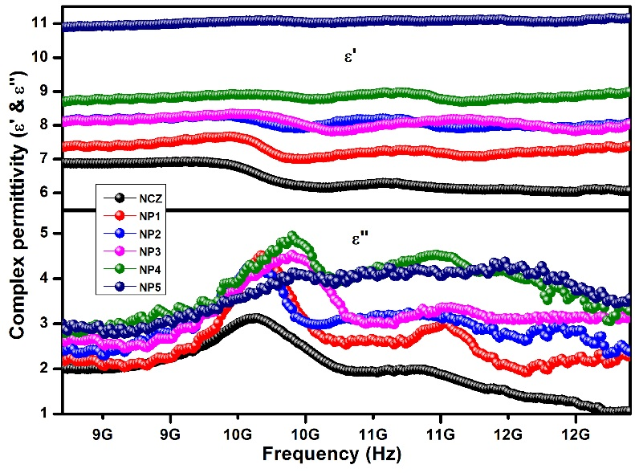
Fig. 7 Complex permittivity of NCZ-PANI nanocomposites in X-band region. Reproduced with the permission from, Raju, P., J. Shankar, J. Anjaiah, and S. R. Murthy. "Shielding effectiveness studies of NiCuZn ferrite-polyaniline nanocomposites for EMI suppression applications." In AIP Conference Proceedings, vol. 2162, no. 1. AIP Publishing, 2019.
The complex permittivity (ε*) spectra of the NCZ and NCZ-PANI nanocomposites in the Ku band (12-18 GHz) frequency range are shown in Fig. 8, from which it can be seen that the value of ε′ and ε″ show increasing tendency with increasing PANI content. The increase in ε′ can be explained as with increase in conductive PANI content in the nanocomposites may lead to an increase in orientation polarization, which further enhances the ε′ values. It can also be seen that the resonant behaviour of the permittivity can be found around 15.5 GHz. Dielectric resonance in the Ku-band is attributed to the conductance resonance within and between the nanoparticles [42]. The values of both ε′ & ε″ are presented in the Table 4. It is observed that the value of ε′ is increased from 5.43 for NCZ to 9.02 for NP5. Whereas ε″ is increased from 1.003 for NCZ to 2.122 for NP5.
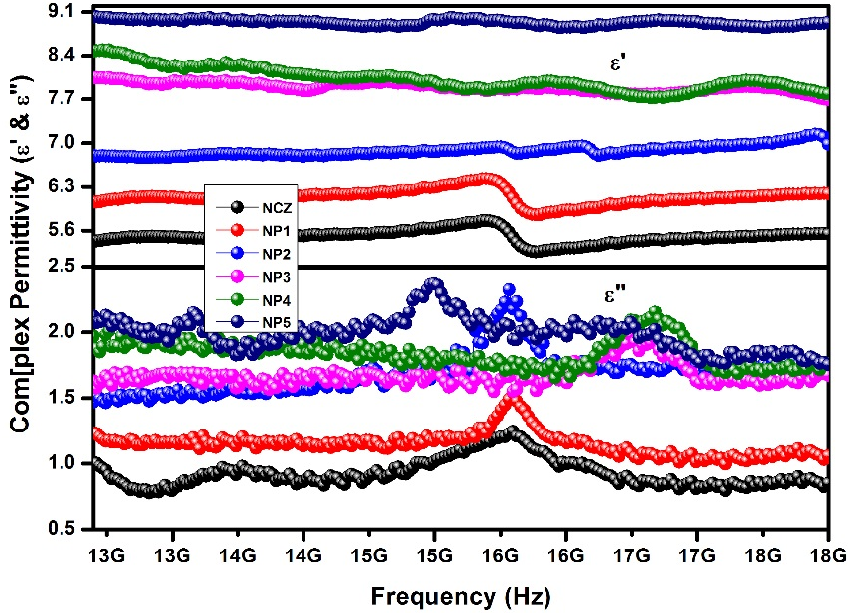
Fig. 8 Complex permittivity of NCZ-PANI nanocomposites in Ku-band region. Reproduced with the permission from, Raju, P., J. Shankar, J. Anjaiah, and S. R. Murthy. "Shielding effectiveness studies of NiCuZn ferrite-polyaniline nanocomposites for EMI suppression applications." In AIP Conference Proceedings, vol. 2162, no. 1. AIP Publishing, 2019.
The dielectric loss, magnetic loss and the complementarities between the two losses are of great importance to microwave adsorption properties. We adopt the Debye dielectric relaxation model (Cole-Cole model) to further interpret the mechanisms of the permittivity dispersion. It is noticed from Figure 9 (a-c) that at least two Cole-Cole semicircles are clearly found in the whole ε'-ε" curves of NCZ-PANI nanocomposites. This suggests that besides the Debye relaxation, other mechanisms such as the Maxwell–Wagner relaxation, electron polarization and dipolar polarization also existed in NCZ-PANI nanocomposites, representing the contribution of the Debye relaxation process to the enhanced dielectric properties of nanocomposites. In the nanocomposites, the existence of interfaces gives rise to interfacial polarization or the Maxwell-Wagner effect. This phenomenon appears in heterogeneous media due to the accumulation of charges at the interfaces and the formation of large dipoles on particles or clusters. [43] Evidently, the Cole-Cole semicircle is distorted, suggesting that except for the dielectric relaxation, other mechanisms such as conductance loss, interfacial polarization, and oxygen defects may contribute to the permittivity spectra. [44]
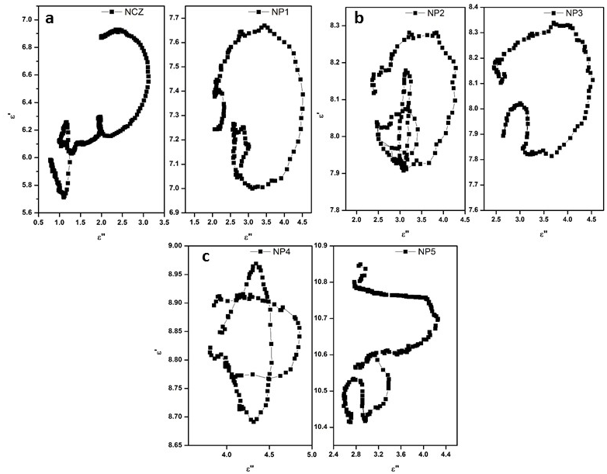
Fig. 9 Typical Cole–Cole semicircles (ε′ versus ε″) for (a) NCZ & NP1, (b) NP2 &NP3 and (c) NP4 &NP5 in the frequency range of 8.2–18 GHz. Reproduced with the permission from, Raju, P., P. Neelima, G. Neeraja Rani, and M. Kanakadurga. "Enhanced microwave absorption properties of Ni0. 48Cu0. 12Zn0. 4Fe2O4+ polyaniline nanocomposites." Journal of Physics and Chemistry of Solids 154 (2021): 110048.
5.3.2 Complex permeability spectra of NCZ-PANI nanocomposites
Fig. 10 describes the real (µ′) and the imaginary part (µ″) of the complex permeability of NCZ-PANI nanocomposites in the X-band (8-12 GHz) frequency range. The real part of complex permeability (µ′), also known as the elastic or dispersion component, shows the extent of the magnetic energy stored in materials. The imaginary part of complex permeability µ″, also called inelastic or absorption component, shows the degree of magnetic energy loss in materials. The real part (µ') of the permeability for the sample NCZ decreases with an increase in frequency from 8.2–12 GHz, whereas the imaginary part (µ'') exhibits a resonance peak at around 10.5 GHz frequency. The real part of the permeability µ' comes from the cooperative effect of the domain wall resonance and spin rotational resonance of ferrite nanoparticles. It was found that the µ' value of the composites decreased with the increasing weight percentage of the polymer. The decreased permeability of magnetic materials is frequently observed when they are coated or embedded by nonmagnetic material, which can be attributed to the reduction of saturation magnetization after combination with nonmagnetic materials [45].
The magnetic loss (µ'') is a result of eddy current effects, natural resonances and anisotropy energy present in the composites.[46] In the microwave ranges, the presence of nanoferrite particles in the composite is the main cause of eddy current. The natural resonances in the X-band can be attributed to the small size of ferrite in the composites. Anisotropy energy of the small-size materials, [47] especially in the nanoscale, would be higher due to the surface anisotropic field due to the small size effect [48]. The higher anisotropy energy also contributes to the enhancement of microwave absorption. For µ'', there are noticeable resonance peaks at around 10 GHz for the composite samples. Based on Aharoni's theory, [49] the resonance peaks at high frequency in the curve of µ'' are related to the exchange resonance, and the peaks located at lower frequencies are associated with the natural ferromagnetic resonance [50]. With polymer content, the magnetic loss µ'' increased it may be due to the magnetic loss in the composites and pure ferrite being caused by the sum of domain wall resonance and natural resonance at high frequencies. The obtained complex permeability values of NCZ-PANI nanocomposites were tabulated in Table 4.
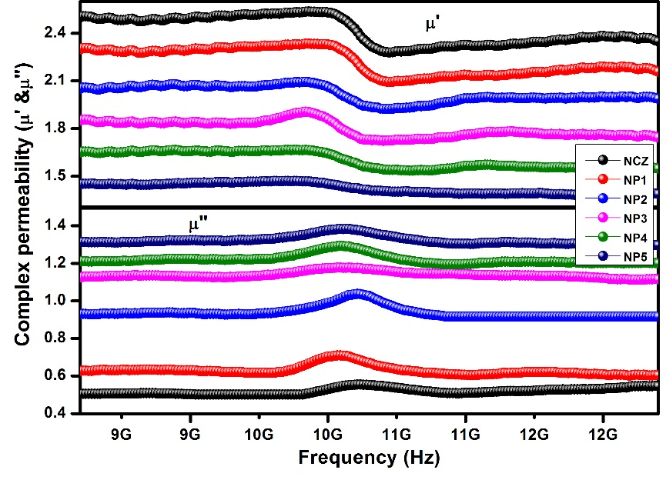
Fig. 10 Complex permeability of NCZ-PANI nanocomposites in X-band region. Reproduced with the permission from, Raju, P., J. Shankar, J. Anjaiah, and S. R. Murthy. "Shielding effectiveness studies of NiCuZn ferrite-polyaniline nanocomposites for EMI suppression applications." In AIP Conference Proceedings, vol. 2162, no. 1. AIP Publishing, 2019.
The real (µ') and imaginary (µ'') parts of the complex permeability of (NCZ-PANI) nanocomposites samples measured in the Ku-band (12-18 GHz) frequency range are shown in Fig. 11. From the figure it is shown that the µ′ is decreased and µ″ is increased with increase in addition of nonmagnetic PANI content in the sample. From fig. 5.6 it can be seen that the resonance peaks of both µ' and µ'' of complex permeability are shifted to higher frequency with increasing addition of PANI. The resonance peak appears at 14.5–17 GHz with composites ascribed to spin rotational resonance, which is sensitive to composition and structure [51, 52]. The table 4 shows µ′ & µ″ values of nanocomposites at 12.4 GHz. The value of µ′ is decreased from 2.35 to 1.35 and µ″ increased from 0.501 to 1.299 as an increase in PANI content.
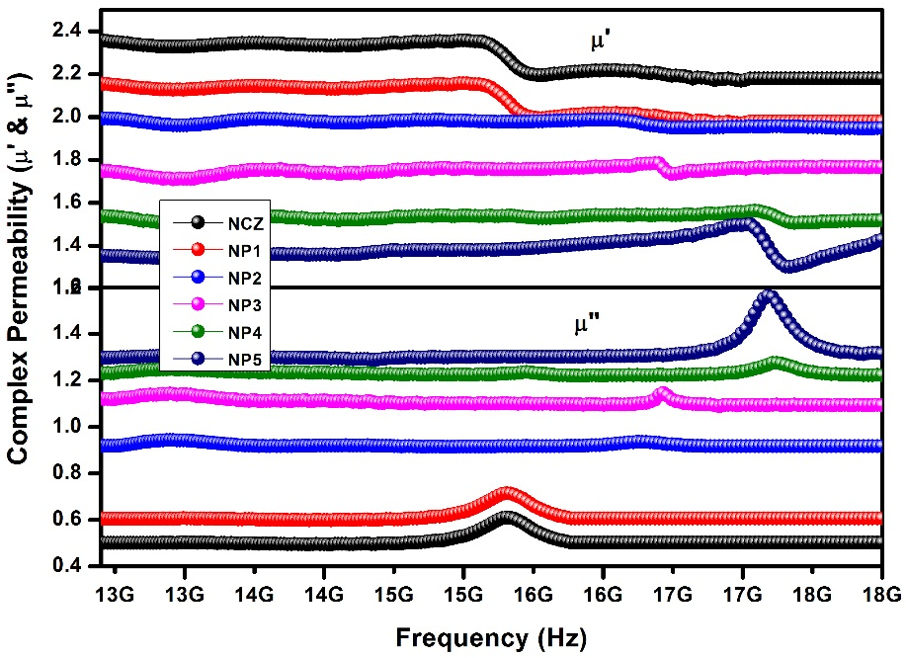
Fig. 11 Complex permeability of NCZ-PANI nanocomposites in Ku-band region. Reproduced with the permission from, Raju, P., J. Shankar, J. Anjaiah, and S. R. Murthy. "Shielding effectiveness studies of NiCuZn ferrite-polyaniline nanocomposites for EMI suppression applications." In AIP Conference Proceedings, vol. 2162, no. 1. AIP Publishing, 2019.
Table 4 Complex permittivity properties of NCZ-PANI nanocomposites. Reproduced with the permission from, Raju, P., J. Shankar, J. Anjaiah, and S. R. Murthy. "Shielding effectiveness studies of NiCuZn ferrite-polyaniline nanocomposites for EMI suppression applications." In AIP Conference Proceedings, vol. 2162, no. 1. AIP Publishing, 2019.
S. No | Sample code | Conductivity S/cm | at 8.2 GHz (X-band) |  |  |  | at 12.4 GHz (Ku-band)
 |  |  | ε' | ε" | µ' | µ" | ε' | ε" | µ' | µ"
1 | NCZ | 1.13*10⁻⁶ | 6.80 | 2.012 | 2.52 | 0.504 | 5.43 | 1.003 | 2.35 | 0.501
2 | NP1 | 2.259*10-3 | 7.36 | 2.176 | 2.31 | 0.627 | 6.05 | 1.230 | 2.15 | 0.605
3 | NP2 | 3.475*10⁻³ | 8.12 | 2.430 | 2.05 | 0.929 | 6.79 | 1.470 | 1.99 | 0.918
4 | NP3 | 4.821*10⁻³ | 8.11 | 2.619 | 1.85 | 1.125 | 8.04 | 1.629 | 1.75 | 1.122
5 | NP4 | 6.874*10⁻³ | 8.70 | 2.849 | 1.65 | 1.211 | 8.48 | 1.969 | 1.54 | 1.232
6 | NP5 | 1.095*10⁻² | 10.9 | 3.007 | 1.45 | 1.313 | 9.02 | 2.122 | 1.35 | 1.299
The magnetic loss of NCZ-PANI nanocomposites, originating from the magnetic properties of the NCZ particles, plays an important role in enhancing the adsorption. The magnetic losses for magnetic materials such as ferrite are mainly derived from domain wall resonance, hysteresis loss, eddy current loss, and natural resonance.[53, 54] The domain wall resonance normally happens at a frequency lower than 100 MHz, and thus it can be neglected in the microwave range. The hysteresis loss is produced in a very strong external magnetic field, and there is no hysteresis loss in the weak magnetic field derived from microwaves. Therefore, the eddy current loss and natural resonance loss are key factors affecting magnetic loss in the frequency range of microwave.[55] For the ferrite composite absorber, the microwave absorption properties are usually subject to degradation caused by the eddy current effect in the high-frequency region. The µ can be expressed by [56]
$µ^{″}≈2πμ_{0}{\left(µ^{'}\right)}^{2}σ∙d^{2}f/3$ -- (4)
where σ and µ0 are the electric conductivity and the permeability in vacuum, respectively. Thus, C0 can be described by
$C_{0}=µ^{″}{\left(µ^{'}\right)}^{-2}f^{-1}=2πμ_{0}σ∙d^{2}/3$ -- (5)
If the magnetic loss results from eddy current loss, the values of C0 are constant when the frequency is varied which is called the skin-effect criterion. [57, 58]
Fig. 12 (a-c) are the Cole-Cole plots for the NCZ-PANI nanocomposites. The Cole-Cole plots of µ′ versus µ″ show some semicircle (its tendency) shaped curves which mean the relaxation dispersion. But there are some differences in the shape of curves comparing to the normalized curve of µ* [59]. The NiCuZn ferrites and other spinel ferrites in various applications show relaxation phenomena as increasing the frequency owing to the damping in magnetization process. The Cole-Cole plot with increasing PANI content shows a decrease in the size of the ellipsoidal curve as shown Fig. 5, which gives the narrower peak of µ*. This provides another method of representation to identify the relaxation phenomena for various ferrites.
Fig. 12d shows the C0-ƒ curves of the pure NCZ and the NCZ-PANI nanocomposites. For the pure NCZ, the values of C0 are almost constant in the high-frequency region (8-18 GHz). However, for the NCZ-PANI nanocomposites, those values of C0 exhibit two resonance peaks in the measured frequency range. These imply that the pure NCZ have a significant eddy current effect in the high-frequency region (8.2-18 GHz), and the range of eddy current effect will be decreased with the introduction of PANI. Besides, the magnetic loss in NCZ-PANI nanocomposites was mainly caused by the natural resonance and the eddy current effects.
In natural resonance, the resonance frequency fr and anisotropy field Ha are related as follows: 2 πfr = γHa (γ is the gyromagnetic ratio). Moreover, Ha is proportional to the anisotropy constant K1 of magnetic crystal, written as Ha = 4|K1|/3 μ0Ms. The anisotropy constant K1 of the cubic NCZ ferrite is 1.1 x 104, J /m3. Therefore, the intrinsic resonance frequency, fr, in the bulk magnetic material is almost several hundreds of Hz. However, for nanosized magnetic particles, Ha on the surface of magnetic particles is strongly influenced by the nanometer size effect, and it greatly increases accordingly. It will possibly result in the resonance frequency, fr, existing in the range of GHz. Thus, the magnetic loss of nanocomposite in the X-band is partly due to natural resonance loss derived from nanosized magnetic nanoparticles.
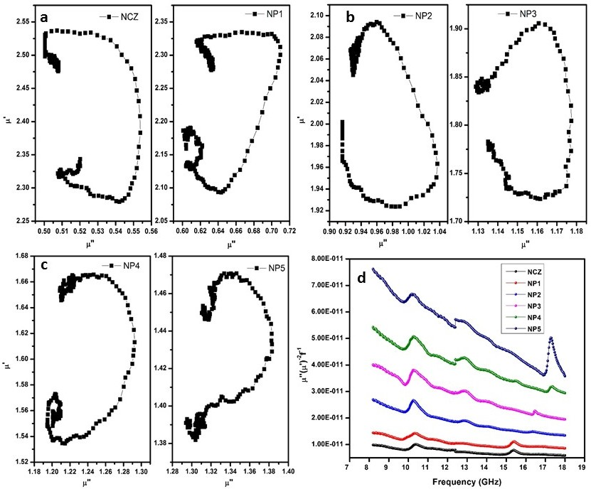
Fig. 12 (a-c) cole-cole plot of complex permeability of a) NCZ, NP1 b) NP2, NP3 c) NP4, NP5 d) Plot of µ″(µ′)⁻²f⁻¹ vs. frequency for the NCZ-PANI nanocomposite. Reproduced with the permission from, Raju, P., P. Neelima, G. Neeraja Rani, and M. Kanakadurga. "Enhanced microwave absorption properties of Ni0. 48Cu0. 12Zn0. 4Fe2O4+ polyaniline nanocomposites." Journal of Physics and Chemistry of Solids 154 (2021): 110048.
The S-parameters are related to the voltage of the reflected (R) and incident (I) waves and can be correlated with the respective powers (P) by:
P_{R} = |S₁₁|² = |S₂₂|² (6)
P_{T} = |S₁₂|² = |S₂₁|² (7)
Thus, the absorbed power (PA) can be calculated taking into account that the incident power (P_{I}) is 1 mW as:
P_{A} = 1 − P_{R} − P_{T} = 1 − |S₁₁|² = |S₁₂|² (8)
To reflect the loss of incident power, as the wave strikes the material and passes through it, the S-parameters can be conveniently assessed to obtain the total shielding efficiency and to separate the absorption and reflection loss contributions as:
${SE}_{T}=-10\log{\frac{P_{I}}{P_{T}}}={SE}_{R}\left(dB\right)+{SE}_{A}\left(dB\right)=-10\log{\frac{1}{{|S_{21}|}^{2}}}$ (9)
${SE}_{R}=-10\log{\frac{P_{I}}{P_{I}-P_{R}}=-10}\log{\frac{1}{1-{\left|S_{11}\right|}^{2}}}$ (10)
${SE}_{A}=-10\log{\frac{P_{I}-P_{R}}{P_{T}}}=-10\log{\frac{1-{\left|S_{11}\right|}^{2}}{{\left|S_{21}\right|}^{2}}}$ (11)
Reflection coefficient, Transmition coefficient, Absorption coefficient, Absorption efficiency and Shielding effectiveness were calculated using equations 6-11.
The variations of reflection, transmission and absorption coefficient values with different frequencies for NCZ-PANI nanocomposites placed at rectangular waveguide cross section are presented in Figure 13 & 14. The reflection coefficient of composites was increased with polymer over the entire frequency range. It can be deduced that an increased value of polymer in nanocomposites leads to an increase in the magnitude of reflection coefficient and a decreases in magnitude of transmission coefficient. Hence, samples with higher percentages of polymer resulted in higher reflection and lower transmission.
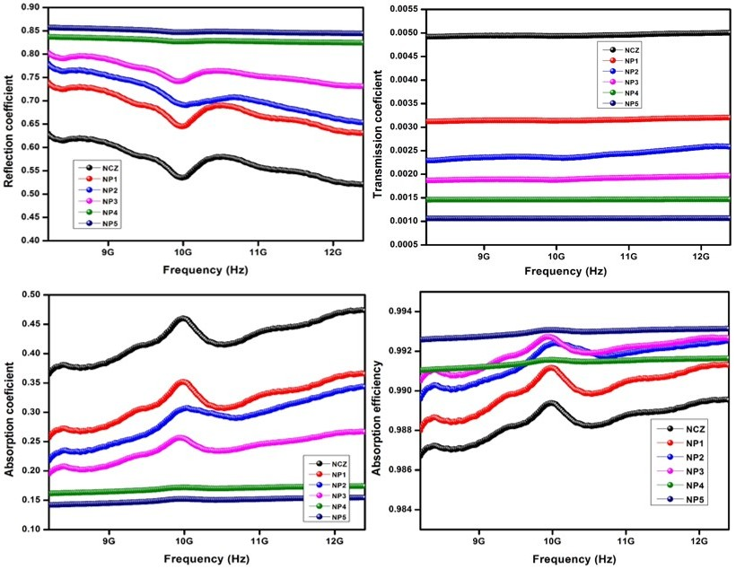
Fig 13 Reflection, Transmission, Absorption coefficients and Absorption efficiency of NCZ-PANI nanocomposites in X band region.
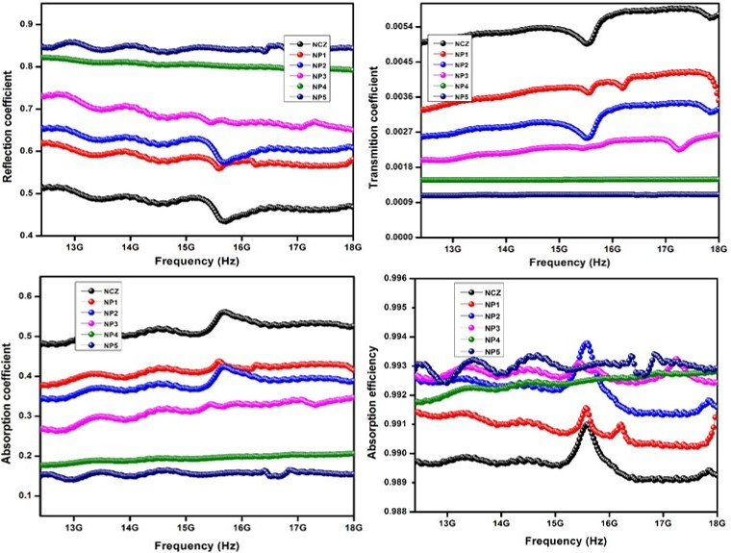
Fig 14 Reflection, Transmission, Absorption coefficients and Absorption efficiency of NCZ-PANI nanocomposites in Ku band region.
Fig. 15 (a & b) & 16 show the response of EMI shielding effectiveness due to reflection (SER), absorption (SEA) and total shielding effectiveness (SET) of NCZ–PANI nanocomposite in X-band frequency range respectively. It can be seen from the figure that the total shielding effectiveness has increased from 23.08 dB for NCZ to 29.75 dB for NP5. From table 5 it can be observed that the NCZ–PANI nanocomposite has shielding effectiveness (SE) mainly due to absorption which is found maximum of 21.47 dB for sample NP5. The SEA is found to increase with increasing percentage of conducting polymer. The shielding effectiveness due to reflection was nominal and values of SER lie between 4.32 dB and 8.45 dB. The SE of the composites increases with the polymer content exhibiting excellent frequency stability in the measured frequency range. This increase in the absorption part with the addition of PANI may be attributed to the higher dielectric and magnetic losses observed in the polymer composites. It can also be explained that the increase in conductivity and dielectric constant of nanocomposites contribute to a high EMI shielding efficiency [60].
The primary mechanism of EMI shielding is via reflection of the electromagnetic radiation incident on the shield, which is a consequence of the interaction between EMI radiation and the free electrons available on the surface of the conducting shield.[61] EMI shielding via absorption is mainly a secondary mechanism, whereby electric dipoles in the shield material interact with electromagnetic waves. Moreover, EMI shielding using conducting materials, such as, conducting polymers and carbon nanotubes, is mainly due to reflection rather than absorption.[62] On the other hand, conducting polymer nanocomposites provide EMI shielding predominantly due to absorption, owing to the presence of electric dipoles.[63, 64]
From the basic theory of EMI shielding [65-67], an ideal microwave shield must be a multiphase composite which contains the optimum concentration of electrically conducting material, dielectric filler and magnetic material. Along with this, physical geometry also plays crucial role in improving the SE. Moderate conductivity (10-4 to 10-1 S/cm) of the composite improves SE in two ways, first, incident EM wave reflected from the front face of conducting shield because interaction of electric vector with mobile charge carriers present on conducting surface resulted in ohmic losses (heat). Second, for materials consisting of a high concentration of charge carriers (i.e., with a high conductivity), polarization due to the migration of charge carriers to form space charges at interfaces or grain boundaries becomes important. This space charge polarization enhances the polarization effect [68].
Fig 15 EMI shielding effectiveness a) due to Reflection (SE_{R}) and b) due to Absorption of NCZ–PANI nanocomposites in X-band region. Reproduced with the permission from, Raju, P., J. Shankar, J. Anjaiah, and S. R. Murthy. "Shielding effectiveness studies of NiCuZn ferrite-polyaniline nanocomposites for EMI suppression applications." In AIP Conference Proceedings, vol. 2162, no. 1. AIP Publishing, 2019.
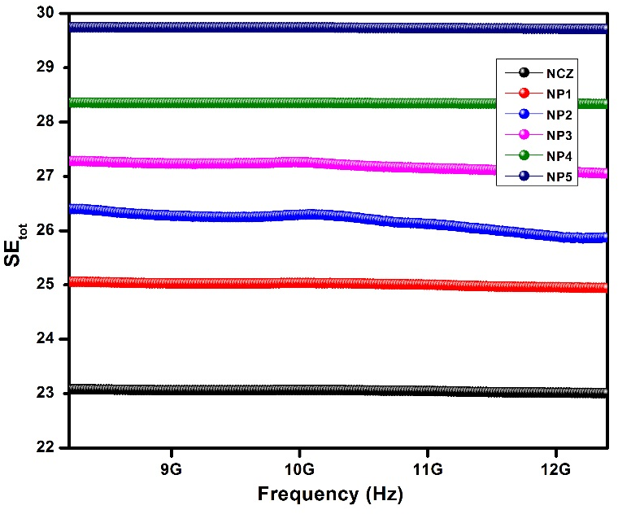
Fig 16 EMI Total shielding effectiveness (SE_{tot}) of NCZ–PANI nanocomposites in X-band region. Reproduced with the permission from, Raju, P., J. Shankar, J. Anjaiah, and S. R. Murthy. "Shielding effectiveness studies of NiCuZn ferrite-polyaniline nanocomposites for EMI suppression applications." In AIP Conference Proceedings, vol. 2162, no. 1. AIP Publishing, 2019.
The obtained SE towards EMI for NCZ-PANI nanocomposites in Ku-band frequency range is shown in Fig. 17 (a & b), 18. As observed from the SE plots in Fig. 5.14, the EMI SE of the anocomposites both depends on the frequency and weight ratio. The SE of the NCZ-PANI nanocomposites increases with increasing weight ratio of PANI, and the SE values of CFF composites with 0, 10, 20, 30, 40, and 50 wt% PANI are 23.03, 24.88, 25.92, 27.05, 28.32 and 29.71 dB, respectively, at 12.4 GHz. In general, the EMI shielding performances of the composites depend on the reflection from the material's surface, absorption of the EM energy, and propagation paths of the EM wave, which are determined by the nature, shape, size and microstructure of the fillers.[69, 70]
The obtained SER and SEA are plotted in Fig. 17a and b. From the sets of Fig. 17b, the SEA values considerably increase with increasing weight ratio of the PANI over the entire frequency range. The SEA values of the composites with 0, 10, 20, 30, 40, and 50 wt% PANI are 19.87, 20.66, 21.28, 21.32, 20.82 and 21.47 dB, respectively, at 12.4 GHz. The SER values of the NCZ-PANI nanocomposites have a maximal value around 8.23 dB, and the values of SER increase with increasing weight ratio of PANI. Moreover, the SEA values of the nanocomposites are higher than the SER values, indicating the primary absorption characteristic of the NCZ-PANI composites towards EM wave.
Fig 17 EMI shielding effectiveness a) due to Reflection (SE_{R}) and b) due to Absorption of NCZ–PANI nanocomposites in Ku-band region. Reproduced with the permission from, Raju, P., J. Shankar, J. Anjaiah, and S. R. Murthy. "Shielding effectiveness studies of NiCuZn ferrite-polyaniline nanocomposites for EMI suppression applications." In AIP Conference Proceedings, vol. 2162, no. 1. AIP Publishing, 2019.
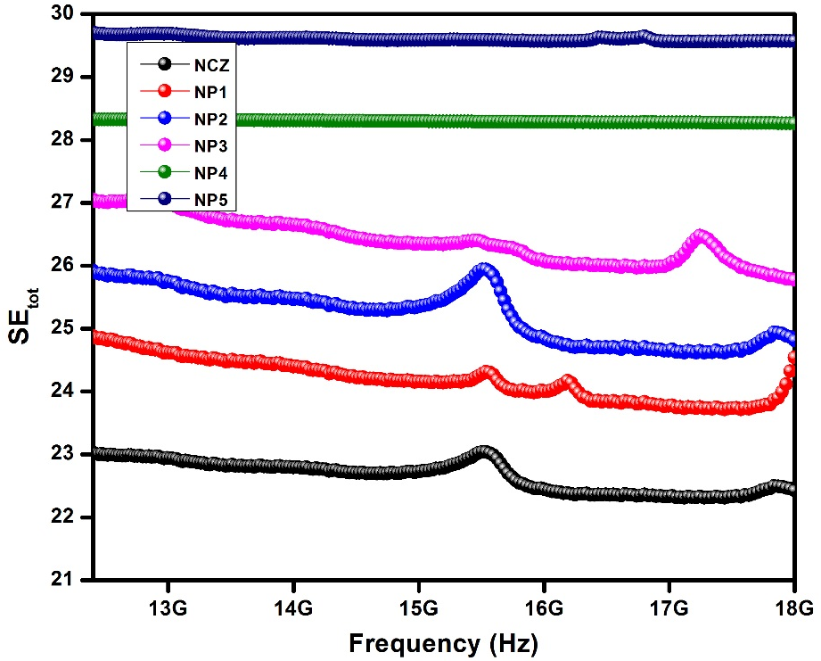
Fig 18 EMI Total shielding effectiveness (SE_{tot}) of NCZ–PANI nanocomposites in Ku-band region. Reproduced with the permission from, Raju, P., J. Shankar, J. Anjaiah, and S. R. Murthy. "Shielding effectiveness studies of NiCuZn ferrite-polyaniline nanocomposites for EMI suppression applications." In AIP Conference Proceedings, vol. 2162, no. 1. AIP Publishing, 2019.
Table 5 Shielding effectiveness properties of NCZ-PANI nanocomposites. Reproduced with the permission from, Raju, P., J. Shankar, J. Anjaiah, and S. R. Murthy. "Shielding effectiveness studies of NiCuZn ferrite-polyaniline nanocomposites for EMI suppression applications." In AIP Conference Proceedings, vol. 2162, no. 1. AIP Publishing, 2019.
S. No | Sample code | at 8.2 GHz (X-band) |  |  | at 12.4 GHz (Ku-band)
 |  | SE_{R} | SE_{A} | SE_{tot} | SE_{R} | SE_{A} | SE_{tot}
1 | NCZ | 4.32 | 18.76 | 23.08 | 3.15 | 19.87 | 23.03
2 | NP1 | 5.85 | 19.20 | 25.06 | 4.22 | 20.66 | 24.88
3 | NP2 | 6.57 | 19.83 | 26.40 | 4.64 | 21.28 | 25.92
4 | NP3 | 7.05 | 20.22 | 27.28 | 5.73 | 21.32 | 27.05
5 | NP4 | 7.88 | 20.47 | 28.36 | 7.50 | 20.82 | 28.32
6 | NP5 | 8.45 | 21.29 | 29.75 | 8.23 | 21.47 | 29.71

The reflection loss (RL) is a parameter that characterizes the absorbing ability of microwave absorbers in decibels (dB). The level of the reflection coefficient equal to –10 dB ensures 90% absorption of incident energy by microwave absorber (presuming the absence of transmitted energy). The operating frequency range, which is another important parameter characterizing microwave absorbers, is the difference between the edge frequencies (fmax and fmin) of the interval where RL is below –10 dB.
The microwave absorbance of the samples can be predicted from a study of reflection loss (RL) in the materials. In general, the larger the negative value of RL, the greater the microwave absorption properties of materials. Generally, microwave absorption abilities result from the synergistic effect of the complex permittivity and permeability of the electromagnetic absorbing materials. Especially, the optimal wave absorption property may be induced when the electromagnetic match keeps a balance between magnetic loss and dielectric loss [71].
RL value is used to evaluate the microwave absorption efficiency of materials. Measured values of ε* and µ* are used to determine the reflection loss in the composite samples based on a model of a single-layered plane wave absorber proposed by Naito and Suetake [72]. In this model, the wave impedance (Z) at air–absorber interface is given as
$Z_{in}=Z_{0}{\left(\frac{µ^{*}}{ε^{*}}\right)}^{1/2}tanh⁡\left\{j\left(\frac{2πfd}{c}\right){\left(µ^{*}ε^{*}\right)}^{1/2}\right\}$ -- (12)
where µ*=µ′-jµ″ and ε*=ε′-jε″ are the relative complex permeability and permittivity of the absorber medium, respectively. Zo=377 Ω and f are wave impedance and frequency, respectively, in free space, c is the velocity of light and d is the sample thickness.
The reflection loss (RL) in decibels (dB) is then determined as
$RL=-20\log\left|\frac{Z_{in}-Z_{0}}{Z_{in}+Z_{0}}\right|$ -- (13)
The impedance matching condition representing the perfectly absorbing properties is given by Zin=Zo. This condition is satisfied at a particular matching thickness (tm) and a matching frequency (fm), where minimum reflection loss occurs. [73]
There are two different concepts to satisfy the zero-reflection condition. The first concept is the “matched characteristic impedance.” The intrinsic impedance characteristic of the material is made equal to the impedance characteristic of the free space. The second is the “matched-wave-impedance” concept. The wave impedance at the surface of the metal-backed material layer is made equal to the intrinsic impedance of the free space. In this work, the second concept was applied. The condition of maximal absorption is satisfied at a particular point where thickness and frequency match each other. Ferrites are the only materials that present two matching frequencies and thicknesses. The first matching at low frequency is associated with the mechanisms of magnetic resonance and shows a dependence on the chemical composition. The second matching at high frequency is associated with the thickness of absorber material.
To satisfy the zero-reflection condition where maximum absorption would occur, Zin should be 1 to prevent reflection. This can be ideally achieved when the material presents |$µ^{*}$| = |$ε^{*}$|. In this case, the performance of electromagnetic wave-absorbing material increases linearly with the increase in thickness. In practical terms, however, this is rarely achieved because the values of complex permeability and complex permittivity are very different in the frequency range of interest.
When |$µ^{*}$|≠|$ε^{*}$|, there are two other cases. For materials with intrinsic impedances greater than unity, |$µ^{*}$| > |$ε^{*}$|, the minimum reflection loss occurs at around a half-wavelength thickness of the material, and for materials with intrinsic impedances lower than unity, |$µ^{*}$| < |$ε^{*}$|, the minimum reflection loss occurs at around a quarter-wavelength thickness of the material. Within the microwave region, ferrites usually present electromagnetic characteristics of |$µ^{*}$| < |$ε^{*}$|, giving rise to the term “quarter-wavelength absorbers.” Minimum loss occurs when the thickness is about an odd multiple of one quarter of the wavelength of the incident frequency, measured inside the absorbing material, and the material has the proper loss factor for this particular thickness. The thickness, d, can be written as equation 14, where c is the speed of light and f is the frequency of interest [74]:
$d=\frac{c}{4f\sqrt{|µ^{*}| |ε^{*}|, }}=\frac{λ}{4}\frac{1}{\sqrt{|µ^{*}| |ε^{*}| }}$ -- (14)
The calculated reflection loss values of NCZ-PANI nanocomposites and NCZ-PFD nanocomposites for different thickness of the samples were analyzed and presented in the fallowing sections.
The microwave-absorbing properties of the nanocomposites with the sample thickness of 2.1 mm, were investigated by using vector network analyzers in the frequency range of 8.2–18 GHz. Fig. 19 shows the variation of reflection loss versus frequency determined on NCZ-PANI nanocomposites. It can be seen from the figure that NP3, NP4, and NP5 samples show two minimum reflection loss dips whereas NCZ, NP1 and NP2 samples show a single dip of minimum reflection loss. The minimum reflection loss of the nanocomposites and its corresponding frequencies are presented in Table 5.9. It can also be seen from the figure that the minimum reflection loss is found to increase with an increase of PANI content.
The absorbing property of pure NiCuZn ferrite nanoparticles is low, the minimum reflection loss is only −28.50 dB, and bandwidth under −10 dB is nearly 2.1 GHz. The absorbing properties of NCZ-PANI nanocomposites were improved when NCZ ferrite was packed by PANI, the minimum reflection loss is up to −39.74 dB, and bandwidth under −10 dB is 9.8 GHz. Synergistic effects of NCZ and PANI play an important role in enhancing the absorbing properties of NP5 nanocomposite. Firstly, the PANI with the large specific surface area can form a complete conductive network, which can improve the dielectric loss. Secondly, the NCZ ferrite nanoparticles absorbed on the surface of the polymer have high dispersion, which can improve magnetic loss. When the incident electromagnetic wave hits the nanocomposites, the oscillating current was formed due to movement dielectric relaxation and dielectric polarization are triggered because of interface charge. The NCZ nanoparticles absorbed on the surface of the polymer can also be used as multi-pole polarization center, strengthening the electronic polarization of nanocomposites and regulating the incident electromagnetic wave, which is conducive to strong absorption of the electromagnetic wave. Finally, the presence of PANI enhances the Debye dipole relaxation, the conjugated electron clouds of PANI molecular chains are transferred by electronic polarization to form electron tunneling between PANI and NCZ, which has the tunnel effect and enhances the absorption of NCZ-PANI nanocomposites for electromagnetic wave. Moreover, the absorbing materials not only require a single high dielectric loss and magnetic loss but also have excellent matching characteristic, namely dielectric loss of the materials is close or equal to the magnetic loss present nanocomposites have excellent matching characteristics, which make a great contribution to improving microwave-absorbing properties
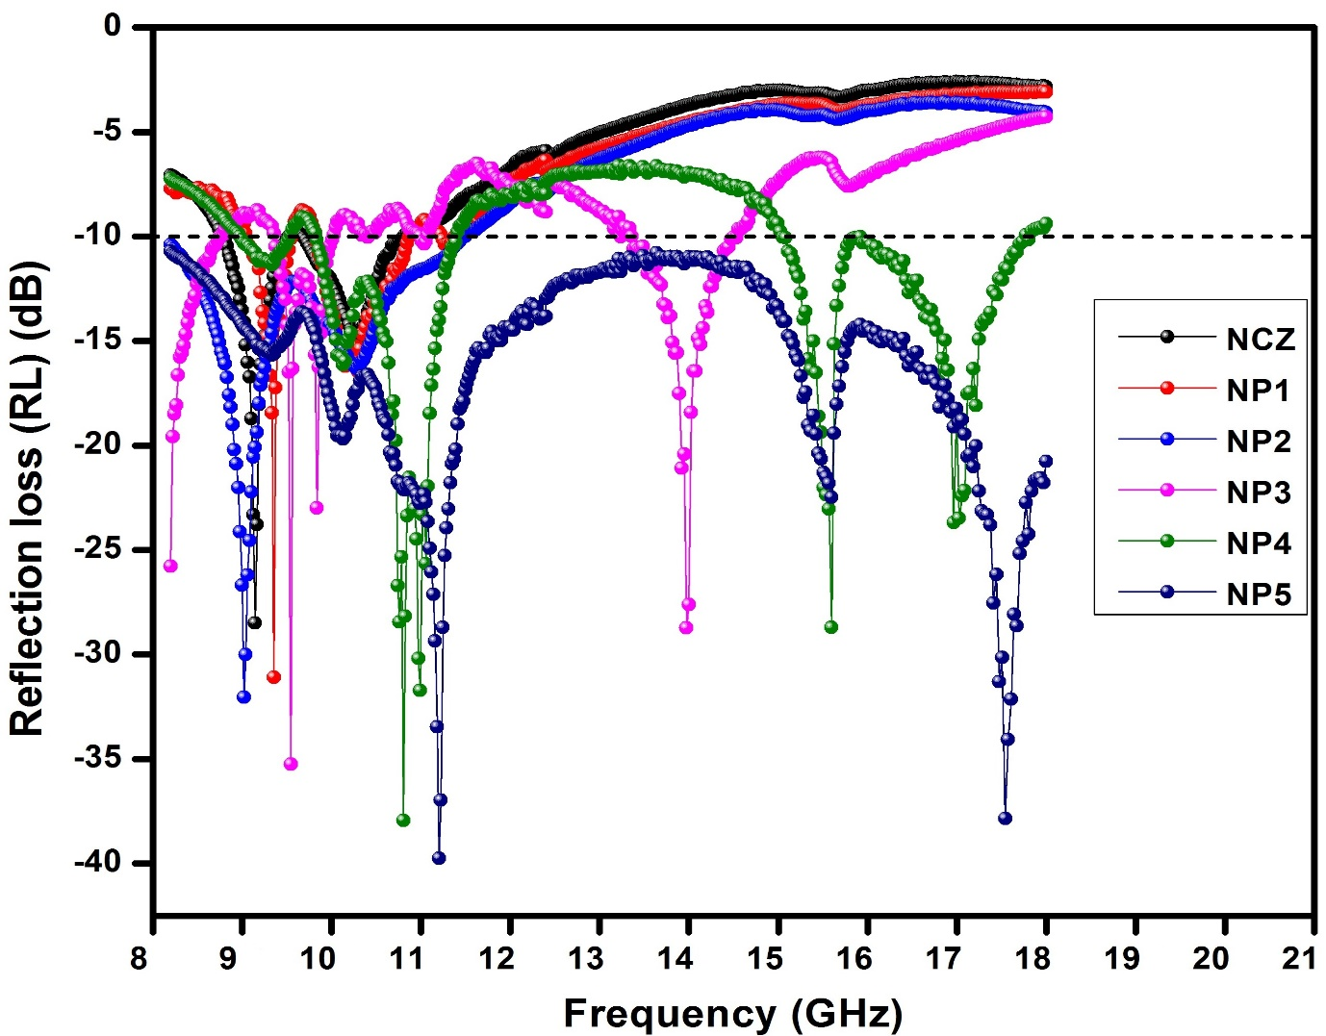
Fig. 19 Reflection loss (RL) curves of NCZ-PANI nanocomposites
The bandwidth is defined as the frequency width in which the reflection loss is less than -10 dB. Such wide absorption widths and high absorption loss peaks indicate the attractive potential microwave applications. It clearly appears from the figure that the bandwidth of NP5 sample covers the entire frequency (8.2-18 GHz) band range. Therefore, this sample may have applications for military radar and direct broadcast satellites (DBS) for obtaining high-resolution imaging, satellite communications, and precision target identification. [75]. It is well indicated from the graphs that with an increase in PANI content in nanocomposites, the bandwidth coupled with reflection loss values are increasing. Table 5.9 gives the values of RL along with bandwidths observed for all the nanocomposites under investigation.
It is interesting to note that the minimum reflection loss of present samples is significantly higher than those reported in the literature for comparable materials, i.e., PANI-NiZn-ferrite (-20 dB) [76], PANI-graphite-CoFe2O4 (-11.2 dB) [50 78], PANI-MnFe2O4 (-15.3 dB) [77], and PANI-BaFe12O19 (-19.7 dB) [84].
Table 6 Reflection loss values of NCZ-PANI nanocomposites in X-band region. Reproduced with the permission from, Raju, P., P. Neelima, G. Neeraja Rani, and M. Kanakadurga. "Enhanced microwave absorption properties of Ni0. 48Cu0. 12Zn0. 4Fe2O4+ polyaniline nanocomposites." Journal of Physics and Chemistry of Solids 154 (2021): 110048.
S. No | Sample | Minimum reflection loss (dB) and frequency (GHz) | Bandwidth over −10 dB (GHz)
1 | NCZ | -28.5 dB at 9.14 GHz | 8.78-10.8
2 | NP1 | -31 dB at 9.35 GHz | 9.06-10.86
3 | NP2 | -32 dB at 9.02 GHz | 8.2-11.47
4 | NP3 | -35.26 at 9.29, -28.73 at 13.97 | 9.37-10.13, 13.38-14.53
5 | NP4 | -37.94 at 10.8, -28.7 at 15.59 | 8.99-11.39, 15.05-17.76
6 | NP5 | -39.74 at 11.2, -37.85 at 17.53 | 8.2-18
In order to study the optimum thickness of microwave absorption performance in-depth, Fig. 20 shows the reflection losses of NP5 nanocomposite with different matching thickness of 0.5, 1.2, 1.5, 1.7, 2.0,2.2, 2.5, 3.0, 3.3, 3.5, 4 and 4.5 mm. As shown in Fig. 5.16, NP5 nanocomposite has the best microwave-absorbing properties and the minimum RL value is −42.10 dB at 9.35 GHz, with the bandwidth of 4.2 GHz at matching the thickness of 2.5 mm. Similarly, the maximum reflection losses of -39.43 dB at 8.87 GHz, -39.21 dB at 11.95 GHz, -39.11 dB at 12.51 GHz are observed with matching thicknesses 3.3mm, 2.0mm, and 2.2 mm, respectively. When the matching thickness is 0.5 mm, the minimum reflection loss of -8.7dB at 18.0GHz has been observed. A minimum reflection loss of -15.52 dB and -11.45 dB has been observed at a matching thickness of 4.0 and 4.5 dB, respectively. According to the following formula [46]: fm = C/2πµ" dm, where fm is the frequency of the minimum reflection loss peak and dm is the matching thickness, it is obvious that the matching thickness for absorbing properties of nanocomposites has a regulatory role and reflection loss peaks move to low frequency with the increasing matching thickness. This phenomenon is consistent with the matching relationship between frequency fm and thickness dm of the absorbing material. It shows that the optimal matching and absorption can be achieved by changing the frequency fm and the thickness dm of the absorbing material. As shown in Fig. 20, when the layer thickness is in the range of 0.5–4.5 mm, the minimum reflection loss of the nanocomposite increases firstly and then decreases with the increase of the layer thickness. The minimum reflection loss for varies thickness is tabulated in Table 7. It can be observed from the table when the layer thickness is 2.5 mm, the minimum reflection loss reaches the maximum value of -42.0 dB at 9.35 GHz with a bandwidth of 3.8 GHz above -10 dB loss. When the layer thickness is larger than 2.5 mm, the maximum reflection loss starts to reduce, indicating that there exists an optimal thickness for these wave-absorbing materials.
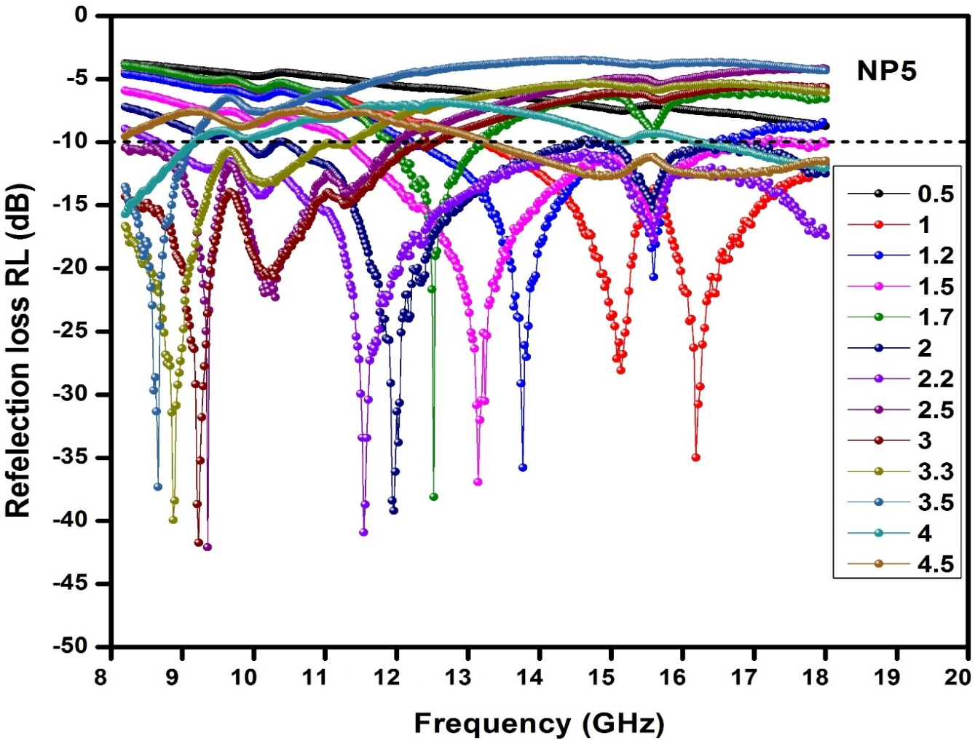
Fig. 20 Reflection loss (RL) curves of NP5 sample for varies thickness
Table 7 Reflection loss values of NP5 sample for different thicknesses
S. No | Sample thickness (mm) | Minimum reflection loss (dB) and frequency (GHz) | Bandwidth over −10 dB (GHz)
1 | 0.5 | -8.7 dB at 18 GHz | --
2 | 1 | -35.01 dB at 16.21 GHz | 13.21-18
3 | 1.2 | -35.79 dB at 13.76 GHz | 12.21-16.49
4 | 1.5 | -36.95 dB at 13.13 GHz | 11.3-17.82
5 | 1.7 | -39.11 dB at 12.51 GHz | 11.91-13.16
6 | 2 | -39.21 dB at 11.95 GHz | 9.88-18
7 | 2.2 | -40.92 dB at 11.53 GHz | 8.66-18
8 | 2.5 | -42.10 dB at 9.35 GHz | 8.2-12
9 | 3 | -41.74 dB at 9.22 GHz | 8.2-12.4
10 | 3.3 | -39.93 dB at 8.87 GHz | 8.2-11.3
11 | 3.5 | -37.31 dB at 8.66 GHz | 8.2-9.12
12 | 4 | -15.72 dB at 8.2 GHz | 8.2-9.16, 16.24-18
13 | 4.5 | -11.45 dB at 18 GHz | 13.26-18

From the plots of reflection loss of the NCZ-PANI and NCZ-PFD nanocomposites it has been observed that the minimum RL values for the samples NP5 -42.1 dB at 9.35 for the 2.5 mm sample thickness. In Table 8, we list the reflection loss properties of some typical composites of PANI and various magnetic particles published in recent years. From the table, we observed that the present work values are found to be superior when compared to the published literature. Thus, Ferrite-polymer nanocomposites proved to be effective materials for producing high strength, lightweight nanocomposites for efficient microwave absorbing material. The minimum Reflection loss of pure ferrite was found to be enhanced from -28.49 dB (NCZ) to -39.74 dB for NCZ-PANI nanocomposite (NP5) with matching thickness of 2.1mm. The minimum value of reflection loss demonstrates the potential of these materials as futuristic microwave absorbing materials.
Table 8 Microwave absorbing properties of different absorbers in previous references and this work.
S. No | Absorber | Thickness (mm) | Minimum reflection loss and frequency | Bandwidth over −10 dB (GHz) | Ref
1 | NiZn-ferrite-PANI | 2.0 | -20 dB at 14.0 GHz | 12.1-16.7 | 76
2 | MnFe₂O₄ -PANI | 1.5 | -15.3 dB at 10.4 GH | 8.4-12.0 | 77
3 | CoFe₂O₄ –PANI-graphite | 2.0 | -11.2 dB at 3.8GHz | 3.4-4.1 | 78
4 | Fe₃O₄ –PANI-CIP | 2.0 | -25.5 dB at 8.4 GH | 7.1-10.0 | 79
5 | Hollow PANI-Fe₃O₄ microsphere | 2.0 | -15.6 dB at 15.2 GHz | 9.1-17.1 | 80
6 | MnFe2O4 -Polypyrrole | 1.5 | −12 dB at 11.3 GHz | -- | 81
7 | NiZnFe2O4 | 2.5 | -24.5 dB at 8.5 GHz | 7-11 | 82
8 | SmSrFe2O4-PANI | 3.0 | -26.0 dB at 14.2 GHz | 11.5-18 | 83
9 | BaFe12O19-PANI | 2.0 | -17.8 dB at 9.5 GH | 8.7-10.5 | 84
10 | PANI-Fe3O4 microspheres | 2.0 | -18.6 dB at 14.0 GHz | 12.1-16.0 | 85
11 | NP5 | 2.1 | -39.74 dB at 11.2 GHz  -37.85 dB at 17.53 GHz | 8.2-18 | Present work

4. Conclusions
In summary, the NCZ-PANI nanocomposites were successfully prepared by mechanical milling method. The structural characteristics of composites were investigated by XRD, FT-IR, and SEM. Electrical and magnetic studies of nanocomposites were investigated. The frequency dependence of real and imaginary parts of permittivity and permeability of nanocomposites shows that the content of polymer increases the complex permittivity and imaginary part of permeability it decreases the real part of permeability. The frequency dependence of Reflection, Transmission, Absorption coefficients and Absorption efficiency of nanocomposites were measured from X band range and Ku band frequency range. The values of shielding effectiveness were found to be increasing with an increase of polymer content, in NCZ-PANI nanocomposites. In addition, the measurements of microwave adsorption properties revealed that the minimum reflection loss of NCZ-PANI nanocomposites can reach –41.72 dB at 9.35 GHz with the thickness of 3 mm, and the effective bandwidth corresponding to RL less than –10 dB was 3.8 GHz (from 8.2 to 12 GHz). The important observation from all of our studies is as PANI increases the absorption ability of nanocomposites is increases and density decreases. We have achieved better microwave absorption for the less weight of the layer. The other benefit from our sample is as the polymer increases the flexibility, mechanical strength increases. Therefore, the NCZ-PANI nanocomposites will be attractive candidates for microwave adsorption materials.
5. References
[1] D.D.L. Chung, Carbon., 39 (2001) 279.
[2] Keyu Chen, Chen Xiang, Liangchao Li, Haisheng Qian, Qiushi Xiao and Feng Xu, J. Mater. Chem., 22 (2012) 6449
[3] R. D. C. Lima, M. S. Pinho, M. L. Gregori, C. ReisNunes and T. Ogasawara, Mater. Sci., 22 (2004) 245.
[4] M. J. Park, J. Choi and S. S. Kim, IEEE Trans. Magn., 36 (2000) 3272.
[5] V. Choudhary, Polym. Advn. Technol., 21 (2010) 1
[6] P. Saini, Synth. Met., 161 (2011) 1522,.
[7] F. F. Fang, B. M. Lee and H. J. Choi, Macromol. Res., 18 (2010) 99.
[8] P. Barber, S. Balasubramanian, Y. Anguchamy, S. Gong, A. Wibowo, H. Gao, H. J. Ploehn and H. Loye, Materials., 2 (2009) 1697.
[9] M. T. Sebastian and H. L. Jantunen, Int. J. Appl. Ceram. Technol., 434 (2010) 415.
[10] J. H. Jean, C. H. Lee, W. S. Kou, J. Am. Ceram. Soc. 82 (2) (1999) 343.
[11] R. Patil, A. S. Roy, K. R. Anilkumar, K. M. Jadhav and S. Ekhelikar, Composites, Part B., 43 (2012) 3406.
[12] Y. Li, H. Zhang, Y. Liu, Q. Wen and J. Li, Nanotechnology., 19 (2008) 105605.
[13] Y. Li, Y. Liu, J. Li, F. Long and J. Kang, J. Electron. Sci. Technol. Chin., 5 (2007) 296.
[14] Y. Li, H. Zhang, Y. Liu and J. Q. Xiao, Chin. J. Chem. Phys., 20 (2007) 739.
[15] P. Xiong, Q. Chen, M. He, X. Sun and X. Wang, J. Mater. Chem., 22 (2012) 17485.
[16] E. E. Tanrıverdi, A. T. Uzumcu, H. Kavas, A. Demir and A. Baykal, Nano-Micro Lett., 3 (2011) 99.
[17] S. Xuan, Y.-X. J. Wang, J. C. Yu and K. C.-F. Leung, Langmuir., 25 (2009) 11835.
[18] N. E. Kazantseva, Y. I. Bespyatykh, I. Sapurina, J. Stejskal, J. Vilˇ c´ akov´ a and P. S´ aha, J. Magn. Magn. Mater., 301 (2006) 155.
[19] O. Yavuz, M. K. Ram, M. Aldissi, P. Poddar and S. Hariharan, J. Mater. Chem., 15 (2005) 810.
[20] J. Jiang, L. Ai and L. C. Li, J. Mater. Sci., 44 (2009) 1025.
[21] X. Li, H. Yi, J. Zhang, J. Feng, F. Li, D. Xue, H. Zhang, Y. Peng and N. J. Mellors, J. Nanopart. Res., 15 (2013) 1.
[22] L. Li, P. Yih and D. Chung, J. Electron. Mater., 21 (1992) 1065
[23] V. Panwar, B. Kang, J.-O. Park, S. Park and R. Mehra, Eur. Polym. J., 45 (2009) 1777
[24] J.L. Guo, H. Wu, X.P. Liao, B.J. Shi, Journal of Physical Chemistry C., 115 (2011) 23688
[25] B. Assa, R. Nechache, D. Therriault, F. Rosei, M. Nedil, Applied Physics Letters 99 (2011) 183505.

[26] J. Jiang, L. Li, F. Xu, Journal of Physics and Chemistry of Solids., 68 (2007) 1656
[27] Ö. Yavuz, M. K. Ram, M. Aldissi, P. Poddar, S. Hariharan, Journal of Materials Chemistry 15 (2005) 810.
[28] K.W. Wagner, Ann. Phys., 40 (1993) 818.
[29] C.G. Koops, Phys. Rev., 83 (1951) 121.
[30] S. Xuan, Y.-X. J. Wang, J. C. Yu and K. C.-F. Leung, Langmuir., 25 (2009) 11835.
[31] S.K. Pradhan, S. Bid, M. Gateshki, V. Petkov, Mater. Chem. Phys., 93 (2005) 224.
[32] M.K. ElNimr, B.M Moharram, S.A Saafan, S.T Assar, J. Magn. Magn. Mater., 322 (2010) 2108
[33] E. C. Gomes and M. A. S. Oliveira, Am. J. Polym. Sci., 2 (2012) 7.
[34] A. H. Elsayed, M. S. M. Eldin, A. H. A. Elazm and H. A. Motaweh, Int. J. Electrochem. Sci., 6 (2011) 215.
[35] M. Gyu, Y. Jin, S. Woen and S. Soon, Synth. Mat., 124 (2001) 342.
[36] Z H Wang, H S Javadi, A Ray, A G Macdiarmid and A J Epstein, Phys. Rev., 42 (1990) 5411
[37] W Li and M Wan, Synth. Met., 92 (1998) 12
[38] N. Rezlescu, E. Rezlescu, Phys. Status Solidi A 23 (1974) 575.
[39] D. Ravinder, K. Latha, J. Appl. Phys. 75 (1994) 6118.
[40] A.M. Abdeen, J. Magn. Magn. Mater. 192 (1999) 121.
[41] Complex permittivity and microwave absorption properties of BaTiO3–polyaniline composite,. S.M. Abbas a,1, A.K. Dixit b, R. Chatterjee a,∗, T.C. Goel c,. Materials Science and Engineering B 123 (2005) 167–171
[42] K.J. Song, T. Pan, Q. Xue, Compact ultra-wideband notch-band bandpass filters using multiple slotline resonators, Microwave and Optical Technology Letters 54 (2012) 1132–1135.
[43] S. He, G. S. Wang, C. Lu, J. Liu, B. W., H. Liu, L. Guo and M. S. Cao, J. Mater. Chem. A., 1 (2013) 4685
[44] H. J. Wu, L. D. Wang, S. L. Guo, Y. M. Wang and Z.Y. Shen, Mater. Chem. Phys., 133 (2012) 965
[45] One-pot synthesis of CoFe2O4/graphene oxide hybrids and their conversion into FeCo/grapheme hybrids for lightweight and highly efficient microwave absorber Xinghua Li,‡ab Juan Feng,‡b Yaping Du,c Jintao Bai,a Haiming Fan,*ad Haoli Zhang,e Yong Peng*b and Fashen Lib,.. J. Mater. Chem. A, 2015, 3, 5535
[46] Conducting ferrofluid: a high-performance microwave shielding material,. Monika Mishra,a Avanish Pratap Singh,a B. P. Singh,b V. N. Singhc and S. K. Dhawan*a J. Mater. Chem. A, 2014, 2, 13159
[47] D. L. Leslie-Pelecky and R. D. Rieke, Chem. Mater., 1996, 8, 1770–1783.
[48] Y.-J. Chen, P. Gao, R.-X. Wang, C.-L. Zhu, L.-J. Wang, M.-S. Cao and H.-B. Jin, J. Phys. Chem. C, 2009, 113, 10061–10064.
[49] G. Viau, F. Fievet-Vincent, F. Fievet, P. Toneguzzo, F. Ravel and O. Acher, J. Appl. Phys., 1997, 81, 2749.
[50] F. S. Wen, F. Zhang and Z. Y. Liu, J. Phys. Chem. C, 2011, 115, 14025–14030.
[51] J. Xie, M. Han, L. Chen, R. Kuang and L. Deng, J. Magn. Magn. Mater., 2007, 314, 37.
[52] H. J. Kwon, J. Y. Shin and J. H. Oh, J. Appl. Phys., 1994, 75, 6109.
[53] X. Zhang, X. Dong, H. Huang, Y. Liu, W. Wang, X. Zhu, B. Lv, J. Lei and C. Lee, Appl. Phys. Lett., 89 (2006) 053115
[54] V. Petrov and V. Gagulin, Inorg. Mater. 37 (2001) 93.
[55] Jiacheng Wang, Hu Zhou, Jiandong Zhuang and Qian Liu, Phys.Chem.Chem.Phys., 17 (2015) 3802
[56] C. L. Zhu, M. L. Zhang, Y. J. Qiao, G. Xiao, F. Zhang, and Y. J. Chen, J. Phys. Chem. C., 114 (2010) 16229
[57] M. Z. Wu, Y. D. Zhang, S. Hui, T. D. Xiao, S. H. Ge, W. A. Hines, J. T. Budnick and G. W. Taylor, Appl. Phys. Lett., 80 (2002) 4404.
[58] X. F. Zhang, X. L. Dong, H. Huang, Y. Y. Liu, W. N. Wang, X. G. Zhu, B. Lv and J. P. Lei, Appl. Phys. Lett., 89 (2006) 053115.
[59] J. Smit and H. M. J. Wijn, Ferrites (Netherlands: Eindhoven) 78 (1959).
[60] Ohlan, A., et al., Microwave absorption properties of conducting polymer composite with barium ferrite nanoparticles in 12.4-18 GHz. Applied Physics Letters, 2008. 93(5).
[61] D. D. L. Chung, Carbon, 2001, 39, 279–285.
[62] Y. Yang, M. C. Gupta, K. L. Dudley and R. W. Lawrence, Nano Lett., 2005, 5, 2131–2134.
[63] R. C. Che, L. M. Peng, X. F. Duan, Q. Chen and X. L. Liang, Adv. Mater., 2004, 16, 401–405.
[64] P. Sambyal, A. P. Singh, M. Verma, M. Farukh, B. P. Singh and S. K. Dhawan, RSC Adv., 2014, 4, 12614–12624.
[65] Sambyal, P.; Singh, A. P.; Verma, M.; Farukh, M.; Singh, B. P.; Dhawan, S. K.;RSC Advances, 2014, 4 (24), 12614-12624. DOI: 10.1039/C3RA46479B
[66] Singh, A. P.; Mishra, M.; Sambyal, P.; Gupta, B. K.; Singh, B. P.; Chandra, A.; Dhawan, S. K.;Journal of Materials Chemistry A, 2014, 2 (10), 3581-3593. DOI: 10.1039/C3TA14212D
[67] Ebrahimi, F.; Nanocomposites - New Trends and Development., InTech: 2012.
[68] Das, C. K.; Mandal, A.;Nanocomposites., 2012, 1 (1), 43-53. DOI: 10.5539/jmsr.v1n1p45
R13375–R13378, 1998.
[69] A. P. Singh, M. Mishra, P. Sambyal, B. K. Gupta, B. P. Singh, A. Chandra and S. K. Dhawan, J. Mater. Chem. A, 2014, 2, 3581–3593.
[70] B. Wen, X. X. Wang, W. Q. Cao, H. L. Shi, M. M. Lu, G. Wang, H. B. Jin, W. Z. Wang, J. Yuan and M. S. Cao, Nanoscale, 2014, 6, 5754–5761.
[71] X.L. Shi, M.S. Cao, J. Yuan, Q.L. Zhao, Y.Q. Kang, X.Y. Fang, Y.J. Chen, Applied Physics Letters., 93 (2008) 183118
[72] Y. Naito, K. Suetake, IEEE Trans. Microwave Theory Tech., 19 (1971) 65.
[73] Y. Zhang, Z. Huang, F. Tang, and J. Ren, Thin Solid Films., 515 (4) (2006) 2555
[74] A. R. Bueno, M. L. Gregori, and M. C. S. Nobrega, Journal of Magnetism and Magnetic Materials., 320 (6) (2008) 864
[75] X. H. Li, H. B. Yi, J. W. Zhang, J. Feng, F. S. Li, D. S. Xue, H. L. Zhang, Y. Peng and N. J. Mellors, J. Nanopart. Res., 15 (2013) 1472
[76] T. H. Ting, R. P. Yu, and Y. N. Jau. Mater. Chem. Phys., 126 (2011) 364.
[77] S. H. Hosseini, S. H. Mohseni, A.Asadniac and H. Kerdari, J. Alloy. Compd., 509 (2011) 4682.
[78] K. Y. Chen, C. Xiang, L. C. Li, H. S. Qian, Q. S. Xiao and F. Xu. J. Mater. Chem., 22 (2012) 6449.
[79] Z. F. He, Y. Fang, X. J. Wang and H. Pang, Synth. Met., 161 (2011) 420.
[80] C. M. Yang, H. Y. Li, D. B. Xiong, and Z. Y. Cao, React. Funct. Polym., 69 (2009) 137.
[81] Seyed Hossein Hosseini and Ahmad Asadnia. Volume 2012, Article ID 198973, 6 pages
[82] Na Chen, Mingyuan Gu. Open Journal of Metal, 2 (2012)37
[83] Juhua Luo, Yang Xu, Duoduo Gao., Solid State Sciences 37 (2014) 40
[84] X. Tang and Y. G. Yang, Appl. Surf. Sci., 255 (2009) 9381.
[85] C. K. Cui, Y. C. Du, T. H. Li, X. Y. Zheng, X. H. Wang, X. J. Han and P. Xu, J. Phys. Chem. B., 116 (2012) 9523.

