Humic acid: Sources,Extraction methods and it application effects on rice crop –A mini review
¹Catherine Pockisha,R., ¹Arivazhagan,K., ¹Senthilvalavan,P., and ²Natarajan,S
¹Department Soil Science and Agricultural Chemistry, Faculty of Agriculture, Annamalai University
²Department of Agronomy, Faculty of Agriculture, Annamalai University,
Annamalainagar, Tamil Nadu, India

Corresponding author email: pockshac@gmail.com ; senvalavan_m2002@yahoo.co.in

Abstract
Rice (Oryza sativa L.) is a widely grown crop all around the world and is considered as the “global grain’’. In present scenario the growing need for food production through sustainable cultivation practices, without reducing crop yield and producer income, is a major objective due to increased environmental pollution, increased use of chemical fertilizers and the gradual degradation of cultivated soils. To avoid such environmental degradation, to reduce use of chemical fertilizers, cost of cultivation and to attain sustainability in production, a promising and environmental-friendly innovation would be the use of natural plant bio-stimulants (PBs) that enhance flowering, plant growth, fruit set, crop productivity and nutrient use efficiency (NUE), and are also able to improve the tolerance against a wide range of abiotic stresses. Researchers have shown that bio-stimulant like humic acid which contain a complex mixture of polysaccharides, micronutrients and plant growth hormones, promote plant growth and improve plant resistance to abiotic stresses. Humic substances are extremely versatile and critical components of the natural soil- ecosystem, where they have persisted for hundreds of years. Foliar application of humic acid could increase osmotic regulators compared with other fertilizer resources, reducing the damage caused by drought stress to some functional traits of cultivars. Humic acid, in comparison with other nutritional systems at higher levels, lead to increase in chlorophyll levels. It also causes photosynthetic stability with increase in yield. Humic acid has a positive impact on the effectiveness of the enzymes and nutrients plant metabolism. It improves the chemical, physical and biological characteristics of the soil. In this mini review ,we detailed the humic acid sources, extraction methods and its benefits and effect of humic acid application combined with NPK fertilizer to rice.
Key words : Drought and saline stress, Humic acid, Rice, Yield

- Introduction
Humic substances are extremely versatile and critical components of the natural soil- ecosystem, where they have persisted for hundreds of years (Mayhew, 2004). Humic acid is the final break-down constituent of the natural decay of plant and animal materials. Humus is produced as a result of chemical and biological humification of plant and animal matter and the biological activity of microorganisms. They're the maximum broadly used allotted organic products of biosynthesis on the floor of the earth, exceeding the quantity of organic carbon contained in all dwelling organisms.
They provide a focused and reasonably priced shape of organic be counted which could replace humus depletion as a result of conventional fertilization techniques in soil. The addition of humic substances to soils can stimulate plant growth past the outcomes of mineral nutrients alone. Humic materials are drastically used all over the globe because of their benefits in agricultural soils, mainly in soils with low organic content. The sources of Humic Acid consist of coal, lignite, soils, and organic materials. Humic acid can positively have an effect on soil physical, chemical, and biological characteristics, along with texture, shape, cation exchange potential, pH, soil carbon, enzymes, nitrogen biking, and nutrient availability.
2. Humic acid
2.1 Structure-function relationship of humic acids
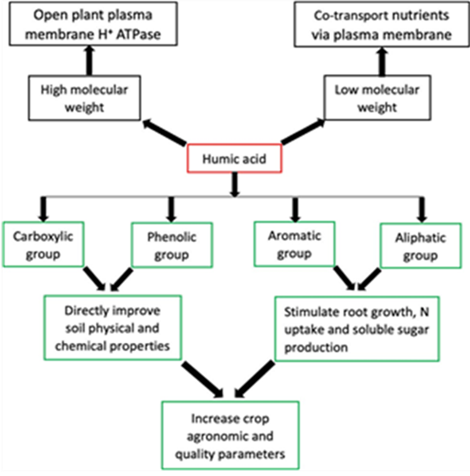
The features of HA are associated with their structures, which are source dependent (Nardi et al., 2021).
Fig.1 Aromatic and Aliphatic functional groups of humic acid
2.1.1 Aromatic and Aliphatic functional groups of HA
Recent research by van Tol de Castro et al. (2021) proved that the aromatic and aliphatic functional groups of HA were responsible for increasing N uptake and soluble sugars, which resulted in a corresponding yield increase in rice; meanwhile an earlier finding by Garciá et al. (2016) confirmed that HS aliphatic and aromatic functional groups stimulated root growth in rice seedlings.
2.1.2 Phenolic and Carboxylic groups of HA
HA structure contains many functional groups, the maximum major is phenolic (OH), and carboxylic (COOH) groups. The COOH and OH functional groups are mainly responsible for HA functions such as improving soil physical and chemical properties in addition to plant growth.
Dissociation of these functional groups creates polar and non- polar ends, which are the hydrophilic and hydrophobic parts, respectively. The hydrophilic end is mainly involved in chelating functions, while the hydrophobic end is connected with repelling purposes
2.1.3 Low and High molecular weight groups of HA
Humic acids with low molecular weight (LMW) contains more phenolic and carboxylic groups than high molecular weight (HMW) HA. The ability to chelate HA has also been attributed to LMW, which is effective in modifying soil biochemical properties.
The HMW is efficient in enhancing the soil physical conditions. HA with HMW have also been observed to stimulate plasma membrane H+ ATPase, allowing LMW HA to co-transport nutrients and perform different biological activities in plants.
2.2. Formation of Humic substances
Humification is a natural system of changing organic matter such as leaves into humic substances by using geo- microbiological mechanisms. This process starts whilst organic residues from flora and animals come in touch with microbial existence in the soil. At some point of humification, microbes make use of carbon compounds for its personal metabolism with the undigested part of residue gathering as humus.
However, regardless of the degree at which the pathway is favored, all pathways considered are feasible for the synthesis of humic substances in nature. Nevertheless, their contribution may differ from one environment to another. The assimilation of nutrients from the organic residues with the aid of microorganisms constitutes the first stage of forming humus. This procedure ends in the formation of complex chemical systems, which are extra stable than the chemical structures of the beginning materials. When the decomposed organic matter reaches a certain degree of humification, it can be referred to as humus (humic substances) that is an aggregate of complex natural compounds (humic acid, fulvic acid and humins). Numerous pathways were postulated to give an explanation for the genesis/formation of humic substances all through the decay of plant and animal matter in soil.
But, irrespective of the degree at which the pathway is desired, all pathways considered are possible for the synthesis of humic substances in nature. Despite the fact that, their contribution might also fluctuate from one environment to some other.
2.2.1. The lignin theory (pathway 1)
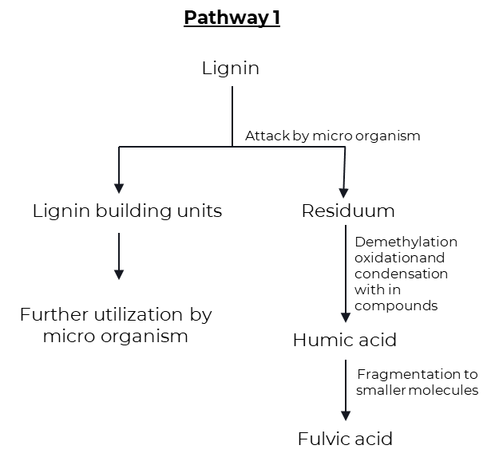
This theory assumes that lignin is incompletely utilized by the microorganisms and the residue becomes part of the soil humus. The amendment of lignin includes the loss of methoxy groups (-OCH3) with the generation of o-hydroxyphenols (C6H5OH) and carboxyl groups (-COOH). This m material is what has humic and fulvic acids.
Fig.2 Lignin theory
The subsequent evidence was cited through Waksman (1932) in assist of the lignin principle of humic acid formation:
- Both lignin and humic acid are decomposed with extensive difficulty by the great majority of fungi and bacteria.
- Both lignin and humic acid are partly soluble in alcohol and pyridine.
- Both lignin and humic acid are soluble in alkali and precipitated by acids.
- Both lignin and humic acid are acidic in nature.
- When Lignins are warmed with aqueous alkali, they are converted into methoxyl-containing humic acids.
- Humic acids have properties similar to oxidized Lignins.
2.2.2.The polyphenol theory (Pathway 2 and 3)
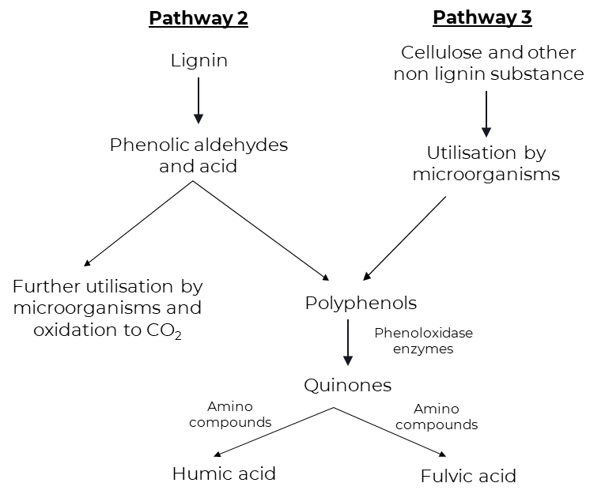
Pathways 2 and 3 are truly similar besides that polyphenols in pathway 2 are synthesized by microorganisms from non-lignin carbon (C) sources like cellulose. Polyphenols are then enzymatically oxidized to quinones and converted to humic substances. Quinones of lignin origin, collectively with those synthesized by means of microorganisms are assumed to be the main building blocks from which humic substances (humic and fulvic acids) are shaped in pathway 3, cellulose and different non-lignin substances are the starting substances.
Fig.3 Polyphenol thoery
In this pathway lignin still plays an crucial function inside the humus synthesis, but in a exclusive way from the lignin concept. Phenols, aldehydes, and acid launched from lignin (beginning cloth for pathway 2) all through microbial attack undergo enzymatic conversion to quinones. Those quinones in turn polymerize within the presence or absence of amino compounds to form humic-like micromolecules (Stevenson, 1982). Lignin is freed of its linkage with cellulose in the course of the decomposition of plant residues and subjected to oxidative splitting with the formation of primary structural units along with derivatives of phenyl propane.
The side chains of lignin-constructing units are then oxidized and demethylation happens. The ensuing polyphenols are transformed into quinones with the aid of polyphenoloxidase enzymes. These quinones arising from lignin and possibly from different sources react with nitrogen-containing compounds to form dark-coloured polymer humic materials, that is a combination of humic and fulvic acids.
2.2.3. Sugar amine condensation (Pathway 4)
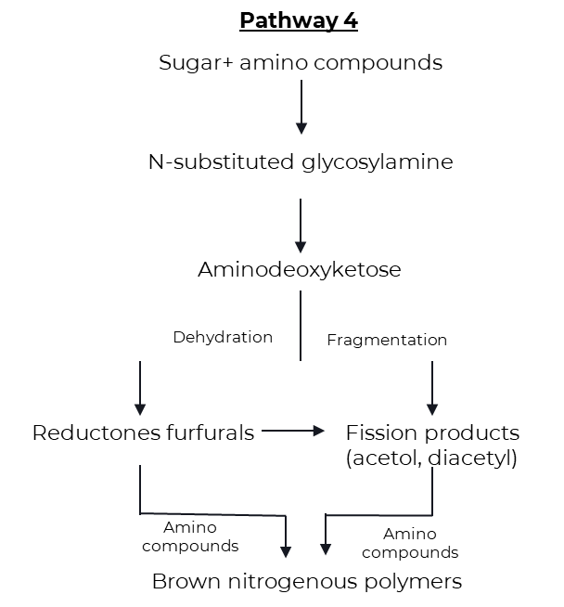
According to pathway 4, reducing sugars and amino acids, which are formed as by-products of microbial metabolism, undergo nonenzymatic polymerization to form brown nitrogenous polymers of the kind produced throughout dehydration of certain food products at moderate temperatures. Drastic and frequent adjustments inside the soil surroundings (freezing
Fig.4 Sugar amine condensation theory
and thawing, wetting and drying) coupled with the intermixing of reactants and mineral substances having catalytic residences can also facilitate condensation.
An appealing feature about this theory is that the reactants (sugars, amino acid, etc.) are produced in abundance through the activities of microorganisms. Throughout the preliminary sugar amine condensation, amine is added to the aldehyde group of the sugar to shape n-substituted glycosylamine. Glycosylamine is in turn oxidized to form n-substituted-1-amino-deoxy-2- ketose. This is subjected to fragmentation and dehydration processes. Fragmentation results in the formation of 3-carbon chain aldehydes and ketones inclusive of acetol, diacetyl, and so on., whilst dehydration ends in the formation of reductones and hydroxymethyl furfurals. These compounds with ease polymerize within the presence of amino compounds to shape brown-colored products, in particular humic and fulvic acids (Stevenson, 1982).
2.3. Sources of humic acid
Humic substances can also originate from litters, roots, dead organisms and excrements of dwelling organisms determined in both soil or water. Traditional researchers have been keeping apart humic materials from soils and water. These humic substances had been re-generated within the soil via practices consisting of crop rotation, planting legumes, plowing beneath green manure and alertness of compost.
Table.1 Different sources of humic substances with different concentrations
Natural Source | % Humic acid /  Fulvic acid
Leonardite | 25 to 90
Compost | 5 to 25
Peat | 5 to 20
Lignite | 5 to 15
Manure | 1 to 3
Soft coal | 2 to 5
Hard coal | 0 to 1

2.4. Extraction of humic acid
2.4.1. Extraction of Humic acid from lignite by fractionation procedure by Stevenson (1982)
The Lignite is ground and passed through 0.25mm sieve.

The sieved lignite powder is dissolved in 0.5N sodium hydroxide solution (lignite: NaOH in 1:10)

The dark brown liquid is filtered through Whatman No.1 filter paper.

The filtrate is collected, the pH of the solution was adjusted to 1.0 with con. HCl and the precipitate (HA) is allowed to settle.

The supernatant is siphoned off (FA) and the suspension is filtered.

The precipitate is purified by redissolving in 0.5N NaOH and reprecipitating with con. HCl. This is repeated five times.

Then the humic acid is washed with distilled water till free of chloride, dried and ground to a fine powder.

2.4.2. Extraction of Humic Acid from Lignite by KOH-Hydrothermal Method
The air-dried sample of lignite powder (20 g) is treated with potassium hydroxide (KOH) and distilled water.

Then, the mixture is placed into oven (130–190 ◦C) and its naturally cooled to room temp.

The supernatant is separated from residues by centrifugation. The residue is washed with distilled water until almost reaching neutral pH.

Then, the residue is filtered and dried in a vacuum oven at 105 ◦C.

The pH of supernatant is brought to pH < 2 with HCl, further separated by centrifugation, and dried in a vacuum oven at 60 ◦C.

The obtained dried material is the Humic Acid
2.4.3. Extraction of Humic Acid from Lignite by Ion Exchange Method
The humic acid is extracted from the lignite by combining the method of nitric acid peroxidation and the method of alkali solution and acid eduction.

Lignite is crushed and sieved using 80 mesh sieves.

The lignite (10 g) along with 0.5M NaOH is centrifuged for an hour.

The extracted solution was filtered using a Whatman paper.
The filtrate is treated with resin cation in order to obtain a humic acid solid.
The filtrate is treated with resin cation in order to obtain a humic acid solid.
2.5. Benefits of Humic acid
Physical benefits
- Improved structure of soil: Prevents excessive water and nutrient losses in sandy soils, simultaneously changing them into productive soils with the aid of way of decomposition.
- Prevents soil cracking, surface water runoff and soil erosion by the using growing ability of colloids to mix.
- Enables the soil loosen and disintegrate, and accordingly will increase aeration of soil in addition to soil workability. Increases water holding capacity of soil and thus helps resist drought.
- Darkens the colour of the soil and thus helps absorption of the sun’s energy.
Chemical benefits
2 Chemical benefits
- Increases buffering properties of soil.
- Acts as natural chelator for metal ions underneath alkaline situations and promote their uptake by means of the roots.
- Possesses extremely high cation-trade capacities.
- Promotes the conversion of nutrient elements (N, P, k + Fe, Zn and other hint factors) into forms available to vegetation.
- Complements the uptake of nitrogen by using vegetation.
- Reduces the response of phosphorus with Ca, Fe, Mg and Al and liberates it into a form that is available and beneficial to plants.
- Liberates carbon dioxide from soil calcium carbonate and allows its use in photosynthesis.
- Reduces the provision of poisonous substances in soils.

Biological benefits
- Acts as an organic catalyst in lots of biological techniques.
- Stimulates growth and proliferation of suited micro-organisms in soil
- Complements plant’s natural resistance against diseases and pests.
- Stimulates root increase, specifically vertically and allow better uptake of nutrients.
- Increases root respiration and root formation.
- Promotes the development of chlorophyll, sugars and amino acids in plants and resource in photosynthesis.
- Stimulates plant growth (higher biomass production) by accelerating cell division, increasing the rate of development in root systems and increasing the yield of dry matter.
- Increases the quality of yields; improves their physical appearance and nutritional value.
2.6. Effect of humic acid on growth and yield of rice
The study on the effect of humic-acid based bio-stimulant on growth, yield and yield attributing characters of kharif rice (oryza sativa L.) concluded that, soil application (broadcasting) of bio-stimulant (humic acid) @ 20 kg ha-1 (at 2-3 weeks of transplanting and at panicle initiation of rice) had higher crop growth parameters viz., plant height, number of leaves per hill, tillers per hill and dry weight and yield parameters viz., panicle length, no. of panicles per hill, no. of grains per panicle and grain yield and straw yield. The rice grain yield was also increased by 30.5 per cent over control treatment. (Karennavar et al., 2022)
Mitkar et al., (2022) concluded that the application of bio-stimulants showed positive effect on growth, yield and yield attributing characters of kharif rice. Significantly higher values of growth parameters were recorded at 60 DAT, 90 DAT and at harvest with the application of humic acid @ 0.5 per cent.
Humic acid at 2 g/mL with half of the recommended NPK can produce better vegetative growth and yield of Tadong upland rice. Also, it can reduce chemical fertilizer usage in rice cultivation. (Armeylee Joneer and Lum Mok Sam, 2022)
Kalyanasundaram et al., (2021) in the study of Yield maximization of direct sown rice (Oryza sativa l.) under water constraint situation concluded that the Tensiometer based irrigation with soil application of humic granules @ 2.5 kg ha-1 can be a feasible approach for increasing grain yield and conserve water in north eastern region of Tamil Nadu, by promoting water use efficiency method in direct rice cultivation areas.
The positive role acid humic which has a positive impact on the effectiveness of the enzymes and nutrients plant metabolism and this leads to a high amount of carbohydrates for most plants, which has impact on plant production and increase yield, as well as the impact of Humic acid in some metabolic processes of the plant, such as respiration and photosynthesis as well as the increase of antioxidants due keeps on securities content of chlorophyll from the demolition process.( Ragheb hadi AL-bourky et al., 2021)
The application of Humic acid 12% @ 12.5 l ha-1 (T5) increased the growth attributes. Therefore, this experiment concluded that the application of humic acid 12% @ 12.5 L ha⁻¹ was found to be agronomical superior, economically sustainable and ecologically viable practice for cultivation of rice. (Kumaravel et al., 2022)
The amino group and carboxylic group attached to natural buffering group for the ion exchanged in soil agriculture. The composition of humic acid consists of C, O, Al, Si and KCl. Humic substances were used to condition soils either by applying it directly to the soil as soil fertilizer. This research on the impact of short-term humic acid application on rice growth. HA and leonardite was beneficial to leaf and root growth of rice compared with the control. (Buntita jomhataikool et al., 2019)
Yield contributing characters were significantly influenced by different treatment combinations of HA and PM along with chemical fertilizers and became maximum when humic acid and poultry manure were applied @ 6 L ha⁻¹ and 3 t ha⁻¹, respectively (Saha et al., 2013)
The results of experiment on Efficiency of Various Sources and Doses of Humic Acid on Physical and Chemical Properties of Saline Soil and Growth and Yield of Rice by Wanti Mindari et al., (2018) Studies have shown that peat humic acid can increase plant biomass, plant root weight, tiller number and chlorophyll content more than other substances. Humic acid can effectively increase rice yield by 10-20% by adjusting soil pH, nutrient availability and soil salinity.
2.7. Effect of humic acid on growth of rice under drought and saline stress condition
Foliar application of humic acid could increase osmotic regulators compared with other fertilizer resources, reducing the damage caused by drought stress to some functional traits of cultivars. Humic acid, in comparison with other nutritional systems at higher levels, led to an increase in chlorophyll levels. It also caused photosynthetic stability with increased yield. (Jaber Mehdiniya Afra et al., 2022)
Foliar spray with mixture of humic acid and K+ at panicle initiation and mid booting stages was significantly the most efficient treatment in improving rice grain quality, growth and yields. The mixture of humic and K+ could be recommended for improving rice quality and productivity of Giza 179 under salt stress.( Amira M. Okasha et al., 2019)
Application of Gypsum, Farmyard manure and Humic acid helped in improvement of soil properties and leaching of excessive ions to the deeper layer. Thus, concentration of salts was decreased in the upper layers which favoured the growth of plant and ultimately a significant increase in rice grain was observed. (M. Shaaban et al., 2013)
2.8. Effect of humic acid on nutrient uptake of rice
Humic substances (humic acid) attract positive ions, forms chelate with micronutrients and releases them slowly when required by plants and act as chelating agents there by prevents formation of precipitation, fixation, leaching and oxidation of micronutrients in soil. Humic substances (humic and fulvic acids) and their auxin activity exert hormonal effects on catalytic activity cell permeability and increases nutrient uptake and dry matter yield. (M Eshwar et al., 2017)
In the study of Differential responses of rice (Oryza sativa L.) to foliar fertilization of organic potassium salts, the potassium humate performed best among the different application of potassium salts significantly increased the number of leaves, root biomass and nutrient uptake. This study confirmed the growth promoting attributes of organic potassium salts by improving yield and nutrient uptake of submerged rice. (Arnab Kundu et al., 2020)
Spraying humic acid or compost extract led to significant increases in most parameters of yield and its components as well as N, p & K content of grains and straw compared to no addition of such organic compounds in both seasons (El-Gohary et al., 2010)
2.9. Effect of humic acid on nutrient availability
The experimental results show that peat humic acid can increase the plant biomass, plant root weight, tiller number and chlorophyll content better than other humic acids. Humic acid efficiently can improve rice yields 10–20% supported by the suitability of soil pH, nutrient availability and soil salinity. (Wanti Mindari et al., 2019)
From the experiment on Effect of Lime, Humic Acid and Moisture Regime on the Availability of Zinc in Alfisol, Sushanta Kumar Naik and Dilip Kumar Das (2007) concluded that the humic acid application have favorable effect on the Zn availability at saturated condition.
- Summary and conclusions
The humic acid application has potential significant effect on crop agronomic performance and soil quality parameters. The humic acid chemical structure, solubility and application rate, soil crop type also affect the Humic acid effects on crop performance. From the above findings the humic acid showed the higher crop response, yield and yield attributing characters. Nutrient uptake and nutrient availability were also significantly increased. Recently there is an increase in the use of organic material as fertilizer or soil amendments. This interest may be attributed to reduction in the use of chemical fertilizers, Concern for potential polluting effects of chemical in soil, a need for energy conservation. Therefore, humic material is one of the organic natural resources with the potential for meeting some of these needs.
References
Alan B., Hurst, H. M., Walkden, S. B., Dean, F. M., and Hirst, M. (1963). Nature of humic acids. Nature, 199(4894): 696-697.
Amira, M.O., Abbelhameed, M.M., and Elshayb, O.M. (2019). Improving rice grain quality and yield of Giza 179 rice cultivar using some chemical foliar spray at late growth stages under salt stress. Journal of Plant Production, 10(9): 769-775.
Ampong, K., Thilakaranthna, M.S., and Gorim, L.Y. (2022). Understanding the role of humic acids on crop performance and soil health. Frontiers Agronomy, 4: 848621.
Arnab, K., Raha, P., Dubey, A.N., Rani, M., Paul, A., and Patel, R. (2020). Differential responses of rice (Oryza sativa L.) to foliar fertilization of organic potassium salts. Journal of Plant Nutrition, 44(9): 1330-1348.
Barai, S., Islam, M.M., Parvin, S., Nizam, R., and Bithy, P.A. (2018). Influence of humic acid on morpho-physiology and yield of rice. Journal of Bioscience and Agriculture Research, 29(01): 2407-2415.
Beckley, V.A. (1921). The preparation and fractionation of humic acid. Journal of Agricultural Science, 11(1): 66-68.
Brattebø, H., Ødegaard, H., and Halle, O. (1987). Ion exchange for the removal of humic acids in water treatment. Water Research, 21(9): 1045-1052.
Bruna, A. G., Motta, F. L., and Santana, M. H. A. (2016). Humic acids: Structural properties and multiple functionalities for novel technological developments. Materials Science and Engineering, 62: 967-974.
Cheng, G., Niu, Z., Zhang, C., Zhang, X., and Li, X. (2019). Extraction of humic acid from lignite by KOH-hydrothermal method. Appl. Sci., 9(7): 1356.
Colla, G. and Rouphael, Y. (2015). Biostimulants in horticulture. Scientia Horticulturae, 196: 1-2.
Cornelius, S. (1963). What is humic acid?. Proceedings of the California associaton of chemistry teachers, 40(7): 379-384.
Davies, G., Ghabbour, E. A., and Steelink, C. (2001). Humic acids: Marvelous products of soil chemistry. Journal of Chemical Education, 78(12): 1609.
El-Gohary, A.A., Osman, E.A.M., and Khatab, K.A. (2010). Effect of nitrogen fertilization, humic acid and compost extract on yield and quality of rice plants. Journal of Soil Sciences and Agricultural Engineering, 1(1): 77-91.
Eshwar, M., Srilatha, M., Rekha, K.B., and Sharma, S.H.K. (2017). Effect of humic substances (humic, fulvic acid) and chemical fertilizers on nutrient uptake, dry matter production of aerobic rice (Oryza sativa L.). Journal of Pharmacognosy and Phytochemistry, 6(5): 1063-1066.
García, A.C., Berbara, R.L.L., Farías, L.P., Izquierdo, F.G., Hernández, O.L., Campos, R.H., and Castro, R.N. (2012). Humic acids of vermicompost as an ecological pathway to increase resistance of rice seedlings to water stress. African Journal of Biotechnology, 11(13): 3125-3134.
García, A.C., Santos, L.A., Izquierdo, F.G., Rumjanek, V.M., Castro, R.N., Dos, F.S. and Berbara, R.L.L. (2014). Potentialities of vermicompost humic acids to alleviate water stress in rice plants (Oryza sativa L.). Journal of Geochemical Exploration, 136: 48-54.
Herviyanti, Teguh, B.P., Fachri A. and Darmawan. (2018). The Properties of Humic Acids Extracted from Four Sources of Organic Matters and Their Ability to Bind Fe2+ at New Established Rice Field. Journal of Tropical Agriculture, 15(3): 237-244.
Jaber, M.A.Y., Niknejad, H., Fallah Amoli and Barari Tari. (2020). Effects of drought stress on some phytochemical characteristics of rice cultivars under different chemical and organic nutritional sources. Journal of Plant Nutrition, 44(8): 1193-1206.
Jomhataikool, B., Faungnawakij, K., Kuboon, S., Kraithong, W., Chutipaichit, S., Fuji, M., and Eiad-Ua, A. (2019). Effect of humic acid extracted from Thailand’s leonardite on rice growth. Journal of Metals, Materials and Minerals, 29(1): 1-7.
Kalyanasundaram, D., Arthi, E., Kumar, K.S., and Sri. S. H. (2021). Yield maximization of direct sown rice (Oryza sativa l.) under water constraint situation. Journal of Applied and Natural Science, 13(1): 373-376.
Karennavar, S.S., Chavan, V.G., More, V.G., Dhopavkar, R.V., Desai, S.S. and Bodake, P.S. (2022). Effect of humic acid-based bio-stimulant on growth, yield and yield attributing characters of kharif rice (Oryza sativa L.). The Pharma Innovation, 11(11):319-322.
Kononova, M. M., and Alexandrova, I. V. (1973). Formation of humic acids during plant residue humification and their nature. Geoderma, 9(3): 157-164.
Kumaravel, S., Nandakumar, P., and Maheshwaran, M.M.K. (2022). Effect of different plant growth regulators on the growth of transplanted rice (Oryza sativa L.). The Pharma Innovation, 11(12): 1461-1464.
Kumaravel, S., Nandakumar, P., and Maheshwaran, M.M.K. (2022). Effect of different plant growth regulators on the yield of transplanted rice (Oryza sativa L.). The Pharma Innovation, 11(12): 4005- 4008.
Kurniati, E., Muljani, S., Virgani, D. G., and Neno, B. P. (2018). Humic acid isolations from lignite by ion exchange method. In Journal of Physics: Conference Series, 953(1):012234. IOP Publishing.
Mayhew, L. (2004). Humic substances in biological agriculture. Acres, 34: 54-61.
Mikkelsen, R.L. (2005). Humic materials for agriculture. Better crops, 89(3): 6-10.
Mitkar, G.V., Sagvekar, V.V., Bodake, P.S., Thorat, T.N., Mahadik, S.G., Khobragade, N.H. and Ghodake, S.S. (2022). Effect of foliar application of bio stimulants on growth, yield attributing characters and yield of Kharif rice (Oryza sativa L.) under lateritic soils of Konkan. The Pharma Innovation, 11(11): 1788- 1791.
Mohammad, F., Moradi, H., Noori, M., Sobhkhizi, A., Adibian, M., Abdollahi, S., & Rigi, K. (2014). Influence of humic acid on increase yield of plants and soil properties. International Journal of Farming and Allied Sciences, 3(3): 339-341.
Moskalenko, T., Mikheev, V., and Vorsina, E. (2020). Intensification of humic acid extraction from lignites. EDP Sciences, 192: 02024.
Nagamitsu, M., Watanabe, A., and Kimura, M. (1997). Origin and properties of humus in the subsoil of irrigated rice paddies: I. Leaching of organic matter from plow layer soil and accumulation in subsoil. Soil science and plant nutrition, 43(4): 901-910.
Nethala nivalini ushadhree (1988). Humic acid and its influence on crop plants. M.Sc. (Agri.), Thesis, Annamalai University.
Niladri, P., Debarata, D., Ashin, D., Dipankar, S. (2017). Comparative Study of Organic Matter Vis-a-Vis Humic Acid on Change in Nutrients Availability in Rice-Mustard Cropping Sequence. International Journal of Agriculture Environment and Biotechnology, 10(3): 303-314.
Perumal, P., Ahmed, O.H., Majid, N.M., Jalloh, M.B., and Susilawati, K. (2015). Improving lowland rice (O. sativa L. cv. MR219) plant growth variables, nutrients uptake, and nutrients recovery using crude humic substances. The Scientific World Journal, 2015(906094):14.
Ravindra Prasad G. (1988). The influence of lignite humic acids in the growth, yield and nutrient content and uptake of paddy IR 20. M.Sc. (Agri.) Thesis, Annamalai university.
Ragheb, H.M.A. Manshood, M.R. Mahmoud, S.T. and Al-mousawy. (2021). Effect of Humic Acid on Growth and Yield of Several Genotypes of Rice (Oryza Sativa L.). Environmental Earth Sciences, 923(1): 012-059.
Ronald, L.M., and MacCarthy, P. (1986). Limitations in the use of commercial humic acids in water and soil research. Environmental Science & Technology, 20(9): 904-911.
Sai, M. K., Subbaiah, P.V., Prasad, P.R.K. and Rekha, M.S. (2021). Available Nutrient Status of Soil as Influenced by Combined Application of Humic Acid and Inorganic Nitrogen. International Journal of Plant and Soil Science, 33(22): 209-217.
Samir, P. and Sengupta, M. B. (1985). Nature and properties of humic acid prepared from different sources and its effect on nutrient availability. Plant and Soil, 88: 71-91.
Satish, Y.S., Nayak, S.B., Reddy, C.V.C.M., Arun, K.A., Vishnuvardhan, K.M., Kiranmayi, J. and Narayana, E.N. (2022). Effect of Potassium humate fertilizers on soil nutrients and productivity of Rice crop in vertisols of Southern India. Ecology, Environment and Conservation, 29(1): 43-48.
Senn, T.L., and Kingman, A.R. (1973). A review of humus and humic acids. Research series, 145: 1-5.
Senthil Kumar K. (1995). Studies on the effect of lignite derived humic substances and nitrogen on low land rice. M.Sc. (Agri.) Thesis, Annamalai university.
Shaaban, M., Abid, M., and Shanab, R.A.I. (2013). Amelioration of salt affected soils in rice paddy system by application of organic and inorganic amendments. Plant, Soil and Environment, 59(5): 227-233.
Shozo, K., Tsutsuki, K., and Kumada, K. (1978). Chemical studies on soil humic acids: 1. Elementary composition of humic acids. Soil Science and Plant Nutrition, 24(3): 337-347.
Sivakumar, K., Devarajan, L., Dhanasekaran, K., Venkatakrishnan, D., and Surendran, U. (2007). Effect of humic acid on the yield and nutrient uptake of rice. Oryza, 44(3): 277-279.
Suhardjadinata, Sunarya, Y., and Tedjaningsih, T., (2016). Increasing Nitrogen Fertilizer Efficiency on Wetland Rice by Using Humic Acid. Journal of Tropical Soils, 20(3): 143-148.
Sushanta, K.N. and Dilip, K.D. (2007). Effect of lime, humic acid and moisture regime on the availability of zinc in alfisol. The Scientific World Journal, 7: 1198-1206.
Tadeu, A.T.C., Ricardo, L. L.B., Orlando, C.H.T., Debora, F.G.M., Erinaldo, G.P., Camila, C.B.S., Luis, M.E. and Andres, C.G. (2021). Humic acids induce a eustress state via photosynthesis and nitrogen metabolism leading to a root growth improvement in rice plants. Plant Physiology and Biochemistry,162: 171-184.
Wanti, M., Sasongko, P.E., Kusuma, Z., Syekhfani, S., and Aini, N. (2018). Efficiency of various sources and doses of humic acid on physical and chemical properties of saline soil and growth and yield of rice. AIP Conference Proceedings, 2019(1):03000- 030008.
Zheng, E., Yinhao, Z., Jianyu, H. and Tiamyu, X. (2022). Effects of humic acid organic fertilizer on soil environment in black soil for paddy field under water saving irrigation. Nature Environment and Pollution Technology, 21(3): 1243-1249.

