SYNTHESIS AND CHARACTERIZATION OF TRIMETALLIC ALLOY NANOPARTICLES
^{*1}Dr.R.SIVAKUMAR
Assistant Professor, PG and Research Department of Chemistry
J.J College of Arts and Science (Autonomous)
Pudukkottai, Tamilnadu, India-622422
Corresponding author Email: sivachemjj86@gmail.com

²Dr.A.ASRAR AHAMED
Assistant Professor, PG and Research Department of Chemistry
Jamal Mohamed College (Autonomous)
Trichy, Tamilandu, India

³Dr.V.MARIMUTHU
Guest Lecturer, Department of Chemistry
Government Arts College
Karambakudi, Pudukkottai, Tamilnadu, India

ABSTRACT
An aqueous solution of Caparis Zylanica leaf extracts was used to produce and stabilize a tri-metallic nanometal alloy consisting of crystallized Manganese (Mn), Nickel (Ni), and Zinc (Zn). By treating aqueous solutions of Mn⁺², Ni⁺², and Zn⁺² ions in a 1:1:1 ratio with a filtered resolution of Caparis Zylanica leaves extract, Mn-Ni-Zn tri-metallic alloy nanoparticles (Mn-Ni-ZnNPs) were formed. The nanometal alloy, derived from organic sources, exhibited excellent functionality. Colloidal suspensions of the nanoparticles remained stable for 2-3 weeks. The nanoparticles' composition, shape, size, and structure were analyzed using UV-Visible, FTIR, and SEM techniques.
Key words: Trimetallic alloy nanoparticles, Capparis zeylanica, FTIR, SEM
I. INTRODUCTION
Nanotechnology encompasses the understanding of central physics, chemistry, biology, and knowledge of nanometer-scale matters [1]. Nanoparticles can be classified into two main types: organic and inorganic nanoparticles. Organic nanoparticles include carbon nanoparticles such as fullerenes and carbon nanotubes. In contrast, inorganic nanoparticles consist of compelling nanoparticles like silver, gold [2], semi-channel [3], and zinc oxide [4]. Metallic nanoparticles like silver [5], gold [6], and copper [7] exhibit promising practical properties, making them indispensable tools for biomedical research. Green chemistry involves the biosynthesis of nanoparticles using plant extracts [8]. This method is considered cost-effective and safe due to the widespread availability of plants and easy handling [9]. The processes involved in producing nanoparticles using plant extracts are scalable and generally less expensive [10] compared to bacterial-based methods [11]. Moreover, nanoparticles derived from plant extracts possess therapeutic properties, making them suitable for medicines, targeted drug delivery, and cosmetic applications [12].
Moreover, when compared to chemical and physical techniques, green synthesis offers numerous advantages, including its eco-friendly nature, cost-effectiveness, and scalability for large-scale production. The growing demand for environmentally friendly nanoparticles has attracted multiple researchers to explore green synthesis methods for various metal nanoparticles [13], as they possess intriguing properties and find applications beyond their bulk counterparts [14]. The green synthesis method is particularly advantageous among multiple procedures like photochemical reduction, chemical reduction, electrochemical reduction, and thermal evaporation [15]. This method involves using plant extracts as reducing and capping agents for nanoparticle synthesis [16], owing to their remarkable reducing properties [17]. The nanoparticles exhibit precise characteristics such as size, distribution, and morphology [18].
Capparis zeylanica Linn, belonging to the Capparidaceae family and commonly known as Indian caper, is a climbing scandent shrub found across India. It has been traditionally used as a 'Rasayana' drug and is currently being investigated. The plant extract of C. zeylanica Linn was utilized as a reducing agent for synthesizing Mn-Ni-Zn nanoparticles [19]. The extract primarily contains fatty acids, alkaloids, and flavonoids. Studies have indicated that C. zeylanica possesses antioxidant, antimicrobial, anti-inflammatory, and immune-stimulant properties [20].

II. MATERIALS AND METHODS
A. MATERIALS
Plant
Capparis zeylanica leaf was collected from Thirumayam, Pudukkottai, Tamilnadu, India.
Chemicals
The metal salt solutions used were 0.1M Manganese sulphate-MnSO_{4,} 0.1M Nickel chloride-NiCl₂, 0.1M Zinc sulphate-ZnSO₄
General Information of Plant
Capparis zeylanica is an evergreen climbing shrub producing stems 2-5 meters long, occasionally to 10 meters. The plant is harvested from the wild for local use as a medicine and occasionally as a food. Beautiful flowers, which are essentiality a spreading spray of pink-white stamens, are 4-5sm across, and appear solitary in leaf axils. The flowers turn dark pink while fading.

B. METHODS

The bottom-up biosynthetic approach was used. The leaves were first properly washed and pulverized with a mortar and pestle. After crushing the leaves, they were cooked in distilled water. The remaining leaves were filtered out, and the resulting extract solution was refrigerated. To make the Mn-Ni-Zn trimetallic alloy, 0.1M salt solutions of manganese sulfate, nickel chloride, and zinc sulfate were combined in a 1:1:1 ratio. In particular, 25ml of each of these salts was mixed. Afterwards, 25ml of the leaf extract was added, causing a visible colour change from pale yellow to reddish, progressively darkening. The mixture was then allowed to cool to room temperature. Following the completion of the synthesis procedure, the sample was sent for characterization tests such as UV-visible spectroscopy, scanning electron microscopy (SEM), and Fourier transform infrared spectroscopy (FTIR). These tests were designed to investigate and evaluate the sample's qualities and makeup.
Preparation of Extract
The extraction process was conducted by adapting the method described [21]. The collected Capparis zeylanica leaves were thoroughly washed multiple times with water to eliminate any contaminants. Additionally, they were rinsed with deionized water to ensure further purification. Next, 10g of sliced Capparis zeylanica leaves were accurately weighed and soaked in deionized water for 10 minutes. The resulting mixture was then filtered using Whatman's No. 1 filter paper to obtain a clear filtrate. The filtrate was carefully collected in a clean and dry conical flask and set aside for future use.
Table.1. General Information of plant
Caparis zylanica leaf | Leaf Powder | Scientific Classification
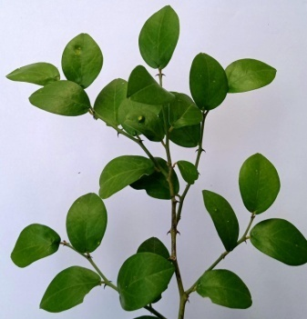 | 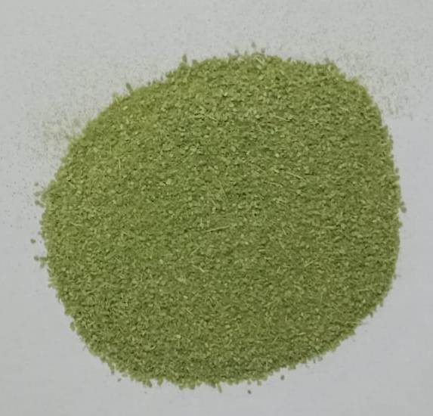 | Kingdom | Plantae
 |  | Phylum | Tracheophyta
 |  | Class | Magnoliopsida
 |  | Order | Capparales
 |  | Family | Capparaceae(caper family)
 |  | Genus | Capparis
 |  | Species | Capparis zeylanica.L
 |  | Common name | Ceylon coper,Indian caper
 |  | Tamil name | Adondai, Karrottai

Synthesis of Mn-Ni-Zn Nanoparticles
The synthesis of Mn-Ni-Zn metallic alloy nanoparticles involved the gradual addition of a 25ml stock solution of leaf extract into a 10ml solution of Mn-Ni-Zn while continuously stirring for 20 minutes. Once the leaf extract was completely added, the initially colorless solution transformed into a pale yellow shade. After an additional 20 minutes, the color further changed from pale yellow to reddish brown, indicating the successful formation of Mn-Ni-Zn metallic alloy nanoparticles. Subsequently, the solution was subjected to centrifugation at 6000 rpm for 15 minutes.
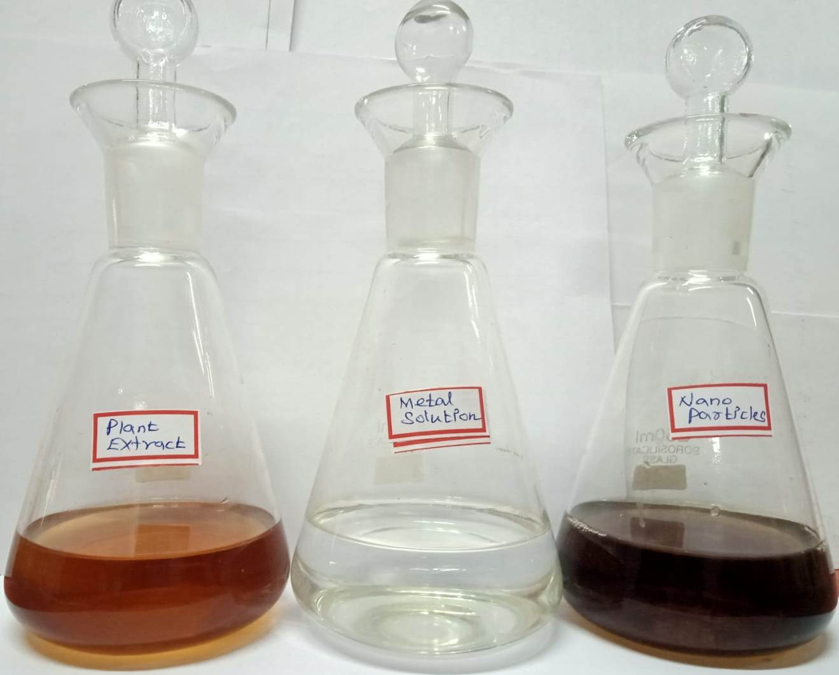

Fig.4.Synthesis of Nanoparticles

Characterization
The Mn-Ni-Znmetallic alloy nanoparticles formation was confirmed through UV-Visible spectral measurements utilizing the PERKIN ELMER-UV-WIN spectrophotometer instrument, covering 200-800nm [22]. FTIR experiments were conducted within a spectral range of 400-4000 cm⁻¹ to identify the biomolecules responsible for the reduction of Mn-Ni-Zn ions. The leaf extract sample underwent centrifugation at 9000 rpm for 15 minutes, followed by drying and grinding with KBr to form a pellet. The analysis of the pellet was performed using the PERKINELMER-FTIR model. A carbon-coated grid was utilized for SEM analysis, and a small quantity of the prepared Mn-Ni-ZnNPs was applied to the grid. The excess solution was removed using blotting paper, and the sample was allowed to dry. The SEM analysis was carried out using a Suprazeis microscope with a resolution of 1nm at 30kV, equipped with a 20mm Oxford EDS detector.
Phytochemical Screening
Qualitative phytochemical of [23] the following tests were performed on extracts to detect various phytochemicals present in them.
Table.2. Phytochemical Screening analysis of plant material
Test | Specific Test | Reagent Composition | Observed Color | Inference
Detection of Flavonoids | Ferric chloride Test | Solution when treated with a drop of Ferric chloride | Blackish red color | Presence of Flavonoids
Detection of Alkaloids | Mayer’s Test | Extract mixed with ammonia and then with chloroform solution. Dil HCl was added. Acid layer with a few drops of Mayer’s reagent. | Creamy white precipitate | Presence of Alkaloids
Detection of Tannins | - | 5ml of extract, FeCl₃ was added. | Deep blue (or) greenish black color | Presence of Tannins
Detection of Glycosides | Keller killani’s Test | Dissolved the extract in water with glacial acetic acid, FeCl_{3,}Con.H₂SO₄ | Brown ring | Presence of Glycosides
Detection of Steroids | Salkowski’s of Steroids | 2ml of extract, 2ml of chloroform was added, followed by 3ml of H₂SO_{4.} | Reddish brown color | Presence of Steroids
Detection of Phenols | - | Extract was dissolved in 5ml of distilled water. Few drops of neutral 5% FeCl₃ solution was added. | Dark green color | Presence of Phenolic Compound.
Detection of Saponis | - | A pinch of dried powdered plant was added to 2-3 ml of distilled water. The mixture was shaken vigorously | - | Presence of saponis
Detection of Carbohydrates | Molish Test | Powdered plant extracts 1ml of napthol solution.con. H₂SO₄ was added to the sides of test tube | Purple (or) reddish Violet color | Presence of Carbohydrates
Detection of Proteins | Xanthoprotein Test | Few mg of powder 1ml of Con.HNO₃ was added. It was then boiled and cooled | White precipitate | Presence of Proteins
Detection of Amino acid | - | 3ml of test solution and 3 drops of 5% Ninhydrin solution were added in test tube and heated in water bath for 10 minutes. | Purple (or) bluish Color | Presence of Amino acid

III.RESULT AND DISCUSSION
A. UV-Vis Spectroscopy Analysis
The mixture's colour change from brown to sea green within a few minutes indicates the formation of metal nanoparticles. After allowing the solution to sit for a day, it becomes darker than the previous colour. Figure 2.a and Figure 2.b confirm and display the UV-Visible spectroscopy analysis of the plant extract and Mn-Ni-Zn nanoparticles. A pale yellow colour was observed when the plant extract was added to the Mn-Ni-Zn solution. After 20 minutes, the colour transformed from pale yellow to a dark reddish brown. The UV-Vis analysis of the reaction mixture revealed the absorption spectra of the Mn-Ni-Zn nanoparticles in the range of 200-800nm. The Mn-Ni-ZnNPs exhibited a sharp absorbance with the highest peak at 438nm, gradually decreasing while increasing [24].

B. FTIR Analysis
FTIR measurements were conducted to determine the reducing, capping, and stabilizing capacities of Capparis zeylanica leaf extract. The FTIR analysis was performed on both the plant extract and Mn-Ni-Zn NPs. Figure 3a illustrates the peaks observed in the aqueous plant extract, namely 1636 cm⁻¹, 2119.75cm⁻¹, 3331.76cm⁻¹, and 592cm⁻¹. The peak at 2119.75 cm⁻¹ indicates bonds corresponding to alkynes [25]. In contrast, the peak at 3331.76 cm⁻¹ corresponds to the O-H stretching of carboxylic acid and C≡C stretching, resembling gallic acid, acetic acid, and gibberellic acids. The peak at 1636 cm⁻¹ represents C=O stretching [26], and the peak at 592 cm⁻¹ represents C-Cl stretching. The strong absorption peak at 1636 cm-1 indicates the characteristic IR absorption of polysaccharides and the bonds related to C=O stretching and amines[27]. On the other hand, the Mn-Ni-Zn nanoparticles in the solution exhibit peaks around 1637 cm⁻¹, 2123.39 cm⁻¹, 3331.73 cm⁻¹, and 592.51 cm⁻¹, as shown in Figure 3b. The peak at 1637 cm⁻¹ corresponds to C=O stretching (amides), while the peak at 2123.39 cm⁻¹ corresponds to the C≡C stretching of phenolic compounds. The peak at 3331.73 cm⁻¹ and the other peaks observed in the Mn-Ni-Zn alloy nanoparticle sample arise from the O=H stretching of hydroxyl groups [28,29]. Notably, the plant leaves contain chemical constituents such as phenolic compounds, alkaloids, flavonoids, and fatty acids, including thioglycoside, β-carotene, glycocapparin, and α-amyrin, which act as capping and reducing agents[30].
C. Scanning Electron Microscopy (SEM) analysis
A scanning electron microscope (SEM) was used to examine the surface morphology of Mn-Ni-Zn alloy nanoparticles. The investigation was carried out using the EVO-18 CAREL ZEISS model at a voltage of 10 kV. A little amount of dry powder sample was placed on a grid to execute the operation, and any surplus sample was removed with blotting paper. SEM examination was used to determine the form and morphology of the produced nanoparticles. Figure 4 shows SEM images of the produced Mn-Ni-Zn metallic alloy nanoparticles at various magnifications (X10,000, X25,000, X35,000, and X45,000). These photos show the presence of nanoparticles that are spherical in shape. The study revealed that the Mn-Ni-Zn metallic alloy nanoparticles were spherical and generally consistent in size, ranging from 253 to 350 nm.
Fig.4. SEM images of Synthesized Mn-Ni-Zn trimetallic alloy nanoparticles

IV.CONCLUSION
There is an excellent need in nanotechnology to find dependable and ecologically friendly procedures for producing steel nanoparticles. This study fulfils this need satisfactorily by adopting a simple approach for the 'Green' synthesis of Mn-Ni-Zn trimetallic alloy nanoparticles. For the first time, unique Capparis zeylanica plant leaves were successfully used to produce Mn-Ni-Zn alloy nanoparticles, providing a cost-effective, simple, and efficient synthesis method. FTIR analysis revealed the existence of the functional group in the leaf extract. UV-Vis, FTIR, and SEM examination techniques were used to evaluate the properties of the produced Mn-Ni-Zn alloy nanoparticles. The experimental results demonstrated the stability of the produced Mn-Ni-Zn trimetallic alloy nanoparticles, which ranged in size from 253 to 350 nm on average.
V. REFERENCE
- Ghorbani,H . R.,A.A.Safekordi,H. AttarandS. Sorkhaba- di, 2011. “Biological and non-biological methods for silver nanoparticles synthesis”. Chemical and Biochemical Engineering quarterly, 25 (3): 317-326.
- Veerasamy,R., T.Z. Xin,S. Gunasagaran, T.F.W. Xiang, E.F.C. YangandN. Jeyakumar,2011.”Biosynthesisofsilver nanoparticles using mangosteen leaf extract and evaluation of their antimicrobial activities”. Journal of Saudi Chemical Society, 15 (2):113-120.
- Mittal, A.K., Y.Chisti and U.C.Banerjee, 2013. “Synthesis of metallic nanoparticles using plant extracts”. Biotechnology Advances, 31 (2): 346 56.
- Iravani, S., 2011. “Green synthesis of metal nanoparticles using plants”. Green Chemistry, 13 (10): 2638-2650.
- Mittal,J., A.Batra, A.SinghandM.M.Sharma,2014. “Phytofabrication of nanoparticles through plant as nanofactories”. Advances in Natural Sciences: Nanoscience and Nanotechnology, 5 (4): 043002.
- Saranyaadevi, K., V.Subha,R.E. Ravindran and S.Renganathan, 2014. Synthesis and characterization of copper nanoparticle using Capparis zeylanica leaf extract. International Journal of Chemistry, Technology and Research, 6(10) : 4533-4541 .
- Christopher L, Kitchens, Douglas E,Hirt,Scott M, Husson, Alexey A, Vertegel. Synthesis, Stabilization, and Characterization of Metal Nanoparticles. The Graduate School of Clemson Universit y 2 010;
- Hasna Abdul Salam, Rajiv P , KamarajM, Jagadeeswaran P, Sangeetha Gunalan and Rajeshwari Sivaraj. Plants: Green Route for Nanoparticle Synthesis. Inter. Res .J . Bio.Sci.2012;1(5):85-90.
- Geoprincy G, VidhyasrrBN, Poonguzhali U, NagendraGandhiN, Renganathan S. A review on green synthesis of silver rnanoparticles. Asian.J . Pharma.Clini.res.2013; 6(1):8–12.
- Akl MAwwad1, Nidà M. Green Synthesis of Silver Nanoparticles by Mulberry Leaves Extract Nanoscience and Nanotechnology.2012;2(4):125-128.
- Umesh B. Jagtap, VishwasA. Bapat.Green synthesis of silver nanoparticles using Artocarpus heterophyllus Lam. Seed extract and its anti bacterial activity. Industrial Crops and Products.2013; 46:132–137.
- Nethra Devi C, Sivakumar P, Renganathan S ,Green synthesis of silver nanoparticles using Datura metel flower extract and evaluation of their anti imicrobial activity .Inter.J. Nanomat.Biostruct.2012;2(2):16 –21.
- Choi , Hyungsoo, and Sung-HoPark."Seedless growth offree-standing copper nanowires by chemical vapor deposition."Journal of the American Chemical Society126, 20 (2004):6248-6249.
- Huang, Lena, HeqingJi ang, Jisheng Zhang, Zhijun Zhang, and Pingyu Zhang."Synthesis of copper nanoparticles containing diam ond-like carbon films bye lectrochemical method." Electrochemistry Communications8, no. 2 (2006): 262-266.
- Joshi,S. S., S. F. Patil, V. Iyer, and S.Mahumuni. "Radiation induced synthesis and characterization of copper nanoparticles." Nanostructured materials 10, no. 7 (1998):1135-1144.
- Dhas,N. Arul,C. Paul Raj,and A.Gedanken. "Synthesis, characterization, and properties of metallic copper nanoparticles."Chemistry of materials 10,no. 5 (1998):1446-1452.
- Hashemipour, Hassan, Maryam Ehtesham Zadeh, Rabee Pourakbari,and Payman Rahimi. "Investigation on synthesis and size control of copper nanoparticle via electro chemical and chemical reduction method."International Journal of PhysicalSciences6, 18 (2011):4331-4336.
- Saranyaadevi, K., V. Subha, RS ErnestR avindran, and S. A.H. A.D.E.V.A.N. Renganathan. "Green synthesis and characterization of silver nanoparticles using leaf extract of Capparis zeylanica."Asian J. Pharm.Clin. Res 7 (2014):44-48
- Lather Amit, Chudhary AmrendraKumar, GuptaVikas, Bansar Parveen, BansarRenu. Phytochemistry and Pharma cological Activities of Capparis zeylanica: anover view.Inter.J.Pharma.Anal.Res2010;1(2):384-389.
- DhabalePN, ShrikhandeVN SakharkarDM. Physicochemicals and Phytochemicals Evaluation of Capparis Zeylanica Linn Inter.J.Pharma.Sci.Res.2012;3(1):198-200
- K Saranyadevi, Vsubha, ErnestR and S Renganathan 2014. Chennai, India IJ.Chem Tech Research, 64533-4541
- Muthu Karuppiah, Rangasamy Rajmohan. Green synthesis of silver nanoparticles using Ixora coccinea leaves extract.MaterialsLetters2013;97:141–143.
- Kokate CK, purohit AP, Gokhale SB (1995) Pharmacognosy, 3rd edition, Nlrall prakashan, pune, india.
- Suman TY, Radhika Rajasree SR, Kanchanab A, Beena Elizabethc SS. Biosynthesis, characterization and cytotoxic effect of plant mediated silver nanoparticle susing Morinda citrifoliaroot extract. Colloids SurfB: Biointer faces 2013;106:74–78.
- Mehrdad Forough1, Khalil Farhadi. Biological and green synthesis of silver nanoparticle TurkishJ. Eng.Env.Sci. 2010;34:281-287.
- Rajathi1K, Sridhar S. Green Synthesized Silver Nanoparticles from the Medicinal Plant Wrightia Tinctoria and Its Antimicrobial Potential. Inter.J. ChemTech Res: 2013; 5 (4):1707-1713.
- .Jannathul Firdhouse M, Lalitha P. Green Synthesis of Silver Nanoparticle susing the aqueous extract of Portulaca Oleracea (L.). Asian.J.Pharma.Clinic.Res2013;6(1).
- Rastogi L, Arunachalam J. Sun light based irradiation strategy for rapid green synthesis of highly stable silver nanoparticles using aqueous garlic (Allium sativum) extract and their antibacterial potential. Mat. Chem. Physics. 2011; 129: 558 –563.
- Prakash P, Gnanaprakasam P, Emmanuel R, ArokiyarajS, Saravanan M. Green synthesis of silver nanoparticles from leaf extract of Mimusops elengi, Linn. For enhanced antibacterial activity again stmulti drugresis tantclinical isolates. Colloids and Surf B: Biointerfaces. 2013; 108:255–259.
- Baker C, Pradhan A, PakstisL, Pochan DJ, Shah SI. Synthesis and Antibacterial Properties of Silver Nanoparticles. Nanosci. Nanotechnol. 2005; 5:224-249.

