DIGITAL INNOVATIONS
INTRODUCTION
The integration of technology and dentistry has given mind-blowing results. The technology and the armamentarium with the patient’s need has been interwoven to achieve the highest success Rates. It brings many advantages on the table for the dentist, the assistant and the patient. Technology has not only uplifted the accuracy and intricacy of dentistry but has reduced the burden on the clinician as well. The astounding thing about dental technology is how much it lends from other industries—CAD/CAM came from the manufacturing sector, and it just took some software tweaks to improve the accuracy.
Traditionally, case history and physical examination, two-dimensional X-ray data radiology (periapical, panoramic, and cephalometric radiographs), was the backbone for the necessary preparatory stages for formulating a treatment plan and for carrying out the therapy. With only two dimensional X-ray data available, establishing correct diagnosis and an appropriate treatment plan could be arduous; therapies essentially relied on the manual skills and experience of the operator.1 But now, Digitalisation comes with bounty of blessings. The speed and simplicity of procedures, which means the patient can be in and out of the clinic with their teeth completely restored in way less time than with conventional techniques. Temporisation and never ending repeat appointments are a thing of past now, dentistry has revolutionised the patient experience. Single appointment techniques with the ability to diagnose, create and fit the restoration has made dentistry more fit for the 21st century. One can enter and access big data just at the touch of our fingers¹.
In the following years, digital dentistry actually continued to evolve rapidly. Indeed, companies such as 3Shape, Dentsply Sirona, and Align Technology, to mention a few, developed advanced digital imaging and scanning technologies, 3D printers, and software systems for virtual treatment planning and simulation; technologies that have been used in a wide range of dental fields, including restorative and aesthetic dentistry, orthodontics, implant dentistry, and surgery.²

The Role of Medicine and Technology in Shaping the Future of Oral Health

Oral health in the 21st century is not just a “drill-and-fill” routine. While earlier efforts in dentistry conformed to removal of diseased tissue and restoration of lost tooth structure, newer advances are emphasizing prediction and prevention of the disease process.³

Although we live in one of the most technologically, medically and scientifically advanced societies, we clearly still have much work to do if we are to live up to our full potential. In this country, we still have more than 28 million citizens without health care coverage, two out of three adults without dental insurance, 37,000 new cases of oral cancer each year⁷ and a continuing crisis in oral health.³

The emergence of new technologies, be it robotics, artificial intelligence, tissue and organ transplants, use of novel antimicrobials or even application of genomics to create personalized oral care, will have a lasting impact on patient care. The integration of dental practices with comprehensive medical teams — embedding dentists within a team of physicians, pharmaceutical providers along with geneticists — would be a first step toward providing comprehensive diagnosis and treatment for all patients.³

A promising development where genomics overlaps with other areas of dentistry is in the use of salivary imaging and diagnostics employing novel salivary proteins, nucleic acids, metabolites and other markers for the early detection of both oral and non oral disease.3

Due to the ever-evolving nature of microbes and the desire to avoid abuse of antibiotics, novel antimicrobial therapies are being developed that rely on the use of naturally occurring salivary antimicrobial proteins like histatins, immunoglobulins and defensins. In addition, the targeted delivery of antimicrobial proteins using salivary gland gene transfers is being considered^{.3}

The Modern and Digital Transformation of Oral Health Care.

Dentistry is a part of the field of medicine which is advocated in this digital revolution. The increasing trend in dentistry digitalization has led to the advancement in computer-derived data processing and manufacturing. This progress has been exponentially supported by the Internet of medical things (IoMT), big data and analytical algorithm, internet and communication technologies (ICT) including digital social media, augmented and virtual reality (AR and VR), and artificial intelligence (AI). The interplay between these sophisticated digital aspects has dramatically changed the healthcare and biomedical sectors, especially for dentistry. This myriad of applications of technologies will not only be able to streamline oral health care, facilitate workflow, increase oral health at a fraction of the current conventional cost, relieve dentist and dental auxiliary staff from routine and laborious tasks, but also ignite participatory in personalized oral health care.⁴

. Tele-Dentistry with Remote Consultation : The key to comprehensive oral healthcare is to be based around patient-centered care. The current challenge in this era is the rapid increase of dental treatment cost, the steady incline of population age, the chronic oral diseases that have affected the quality of life, and the need for dental treatment especially for patients from remote areas with difficult-to-reach geographical locations [22]. Telemedicine in dentistry was introduced to facilitate and set a pathway to the patient to reduce the number and timing of dental office visits while at the same time empowering oral health self-care at home. It can be used to aid in diagnosis of caries detection, impacted wisdom teeth detection, screening of oral diseases such as precancerous lesions, and others. This system also provides other advantages, for example in monitoring health conditions and oral health education for elderly patients in assisted communal facilities care.⁵

Remote clinical consultation is a platform that enables sharing of a patient’s data between primary and secondary care as a way to allow a fully integrated comprehensive total patient management system by using a superfast internet connection utilizing visual and audio aid streaming [25]. This will enable simultaneous discussion and decision to occur among patient, dentist, and specialist, thus, enabling a comprehensive oral health care to take place. This system will prevent unnecessary travelling and allow the review or consultation to be conducted at home, at communal facilities, or primary care settings. It will effectively prevent and minimize the risk of infection, especially to the immunocompromised community like the elderly, people with chronic disease such as asthma, heart disease, renal failure, and children.⁵

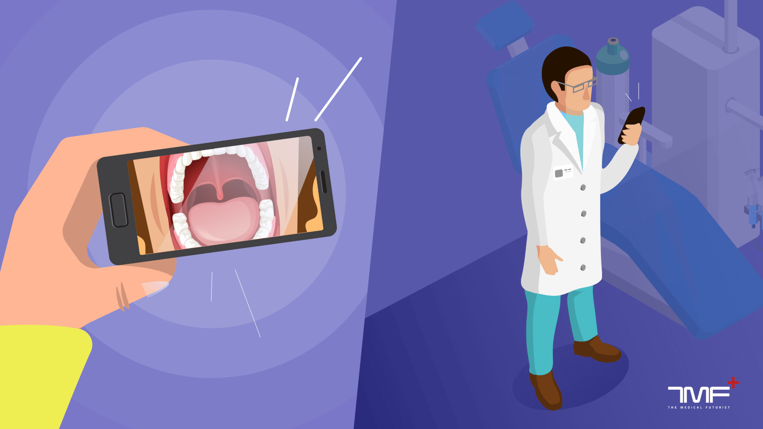

Rapid Prototyping(RP) : RP is a technique to quickly and automatically construct three-dimensional(3D) models of a final product or a part of a whole using 3D-printers. The additive manufacturing process allows inexpensive production of complex3D-geometries from various materials and minimal material wastage. RP offers great potential in dental technology form as production of dental models, but also for the fabrication of implant surgical guides For those indications ,prolonged intraoral retention is not required. From an economic point of view ,a great advantage is the production in large quantities at the same time in are producible and standardized way. Another important area of application is the use of 3D-printed models in dental education based on CBCT or µCT^{.6}

CRISPR
CRISPR (Clustered Regularly Interspaced Short Palindromic Repeats) is a revolutionary tool that has recently been introduced in dentistry, primarily for treating genetic dental disorders. It is a precise gene editing technique that allows dentists to modify the human genome to eliminate, repair or introduce specific traits in the genetic material.CRISPR has the potential to revolutionize the field of dentistry by offering a permanent solution to a range of dental disorders such as enamel hypoplasia, dentinogenesis imperfect, and amelogenesis imperfecta. With the use of CRISPR, we may see a drastic change in the way dental treatments are done in the near future.⁶
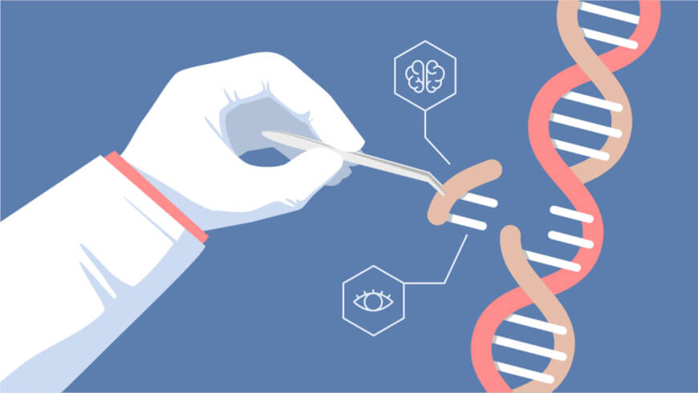

Robotic Surgery
One of the latest innovations in dentistry is the use of robotic surgery in dental procedures. This technology allows for greater precision and accuracy in complex dental surgeries such as implant placement, gum tissue removal, and tooth extractions.Robotic surgery also minimizes the risk of human error and reduces recovery time for patients. While not yet widely available, the use of robotics in dentistry shows promising potential in improving the overall patient experience and outcomes.⁶

Augmented Reality
Augmented Reality (AR) is a technology that blends the physical and digital worlds by overlaying computer-generated content onto our view of reality. In the field of dentistry, AR has been used in various ways to enhance the patient experience and make dental procedures more efficient.
For example, AR can be used to simulate different treatment options and show patients what their teeth would look like after each option.
It can also be used to guide dentists during procedures by projecting a magnified image of the tooth onto a screen for precise operations. With the help of AR, dentistry is becoming more innovative and efficient, ultimately leading to better patient outcomes.⁶
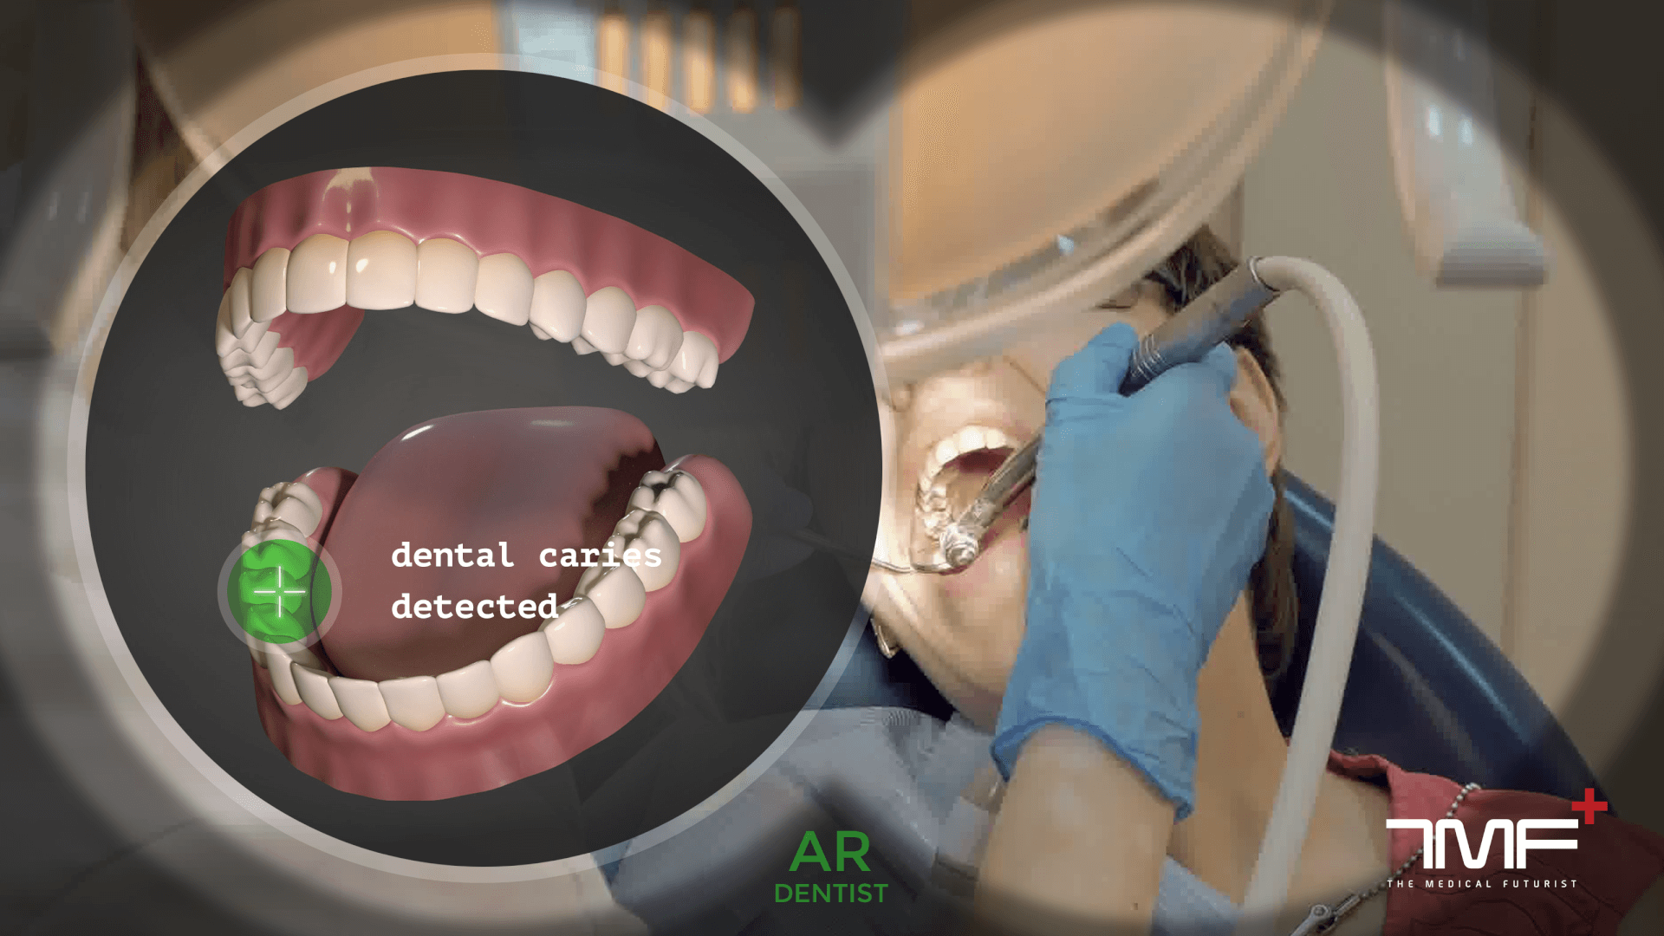
Artificial Intelligence (AI) and Machine Learning(ML)
AI (includingML) has already invaded and established itself in our daily lives, although in more subtle means, such as virtual assistants named “Siri” or “Alexa”. The basis for AI is the increasing power of computers to think like and complete tasks currently performed by humans with greater speed, accuracy, and lower resource utilization. Therefore, AI technology is perfect for work that requires the analysis and evaluation of large amounts of data. Repetitive activities are boring and tiring for humans in the long-run with increased risk of error, while AI-based applications do not show signs of fatigue. In contrast to humans, the artificial learning process results in constant better performance with increasing workload.Additionally, computers are not biased compared to humans, who come with innate biases and may judge things prematurely and differently from each other.
The most valuable indication for the use of AI and ML in dentistry is the entire field of diagnostic imaging in dento-maxillo facial radiology. Currently, applications and research in AI purposes in dental radiology focus on automated localization of cephalometric landmarks, diagnosis of osteoporosis, classification/ segmentation of maxillofacial cysts and / or tumors,and identification of periodontitis /periapicaldisease. Computer software analysing radiographs has to be trained on huge datasets (“bigdata”) to recognize meaningful patterns. The diagnostic performance of AI models varies among different algorithms used, is also dependent on the observers labelling the datasets,and it is still necessary to verify the generalizability and reliability of these models by using adequate, representative images. AI software must be able to understand new information presented by images as well as written text or spoken language with proper context. Finally, the software must be able to make intelligent decisions regarding this new information, and then, learn from mistakes to improve the decision-making for future processing.
A beneficial AI system should realize all of this in about the same time that a human being can perform the given task. Uptonow, applications of AI on a broad scale were not technically feasible or cost-effective, so the reality of AI has not yet matched the possibilities in routine dental applications, although the technical progress is exponential, and very soon, a large number of AI models will be developed for automated diagnostics of 3D-imaging identifying pathologies, prediction of disease risk, to propose potential therapeutic options, and to evaluate prognosis. 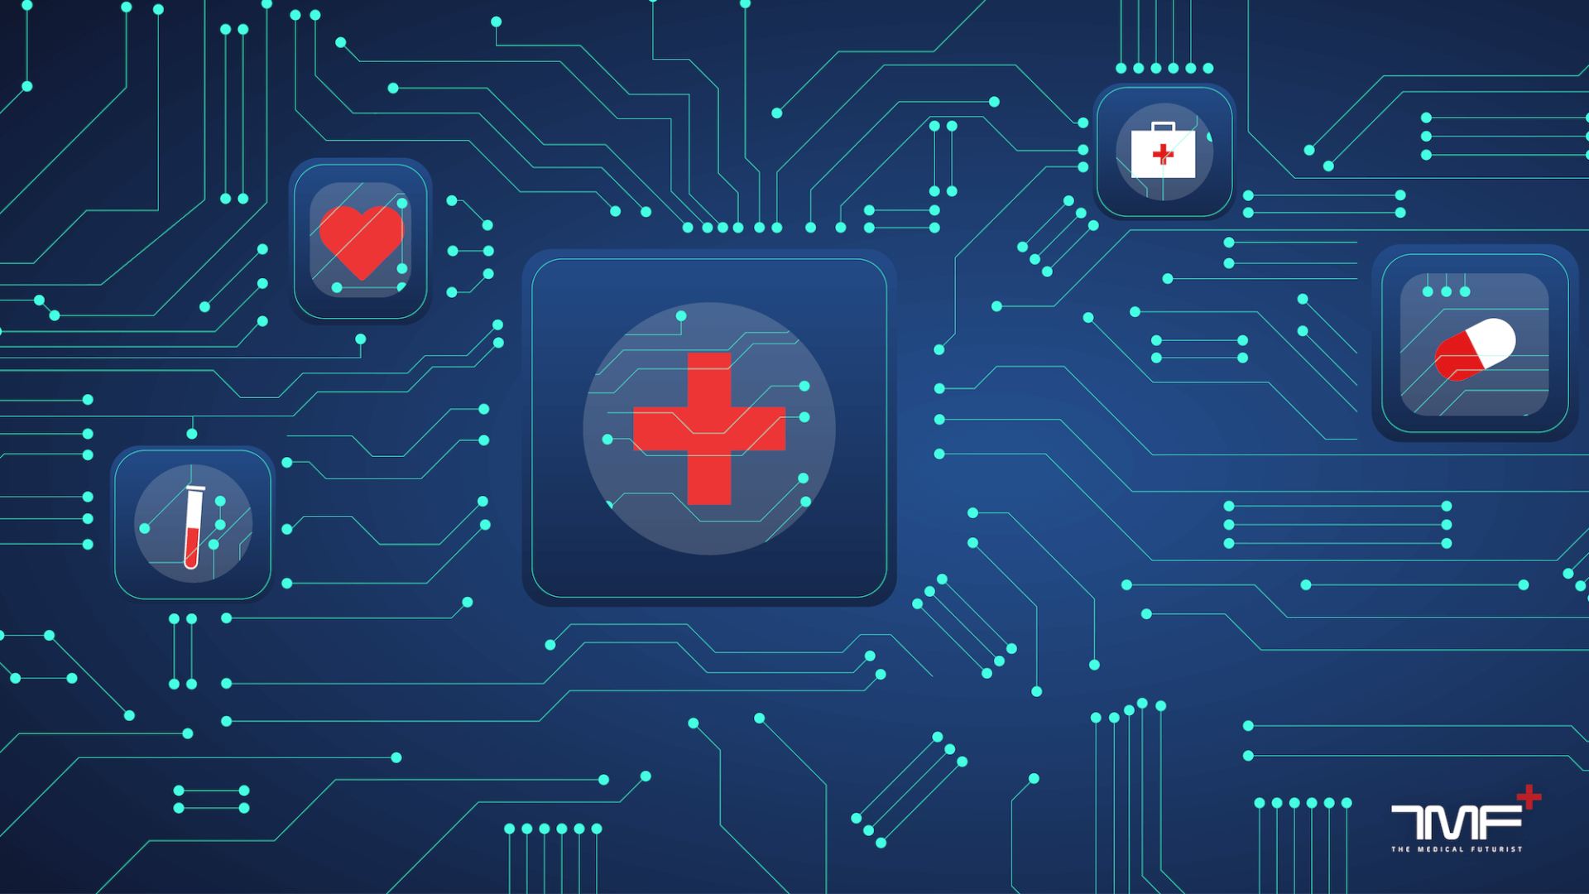
Personalized (Dental)Medicine : The structured assessment and systematic collection of patient information is an effective instrument in health economics. Health data can be obtained from routine dental health care and clinical trials, as well as from diverse new sources, as IoT in general,and specifically, data on the social determinants of health.
The linkage of individual patient data gathered from various sources enables the diagnosis of rare diseases and completely novel strategies for research. Overall, personalized medicine holds the key to unlocking new frontier in dental research. Genomic sequencing, combined with the developments in medical imaging and regenerativetechnology, has redefined personalized medicine using novel molecular tools to perform patient-specific precision healthcare.It has the potential to revolutionize healthcareusing genomics information for individual biomarker identification. The vision is an interdisciplinary approach to dental patient sample analysis, in which dentists, physicians, and nurses can collaborate to understand the inter-connectivity of disease in a cost-effective way.⁶
20 INNOVATIONS IN DENTISTRY THAT WILL SHAPE THE FUTURE ⁷
- Digital Dentistry: The use of digital technology in dentistry has revolutionized the way dentists work. It includes tools such as digital impressions, CAD/CAM, and computer-guided implant surgery.
- 3D Printing: 3D printing has been a game-changer in dentistry, enabling the creation of custom dental appliances and prosthetics quickly and with high precision.
- Laser Dentistry: Laser technology has allowed for less invasive and more precise procedures, such as gum reshaping and cavity removal.
- Teledentistry: Telecommunication technology has made it possible for dentists to remotely diagnose and treat patients through virtual consultations.
- Dental Implant Innovations: Innovative dental implants have advanced significantly, with improvements in materials, techniques, and implant designs.
- AI in Dentistry: Artificial intelligence is being used to improve diagnoses, treatment plans, and patient outcomes.
- Intraoral Cameras: Intraoral cameras allow for detailed and accurate imaging of the mouth, making it easier for dentists to diagnose and treat dental issues.⁸
- 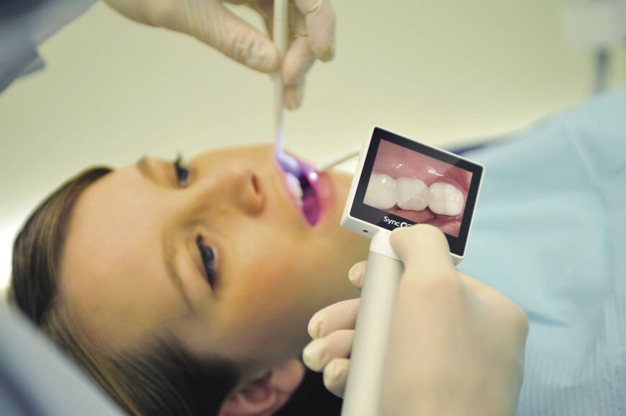
- CAD/CAM: Computer-aided design and manufacturing have made it possible to create custom dental restorations in a matter of hours.
- Digital X-rays: Digital X-rays are faster, safer, and more efficient than traditional X-rays, while providing better image quality.
- Dental Microscopes: Dental microscopes enable dentists to see more clearly and perform more precise procedures, such as root canal treatments.
- Dental Sealants: Dental sealants are a protective coating applied to teeth to prevent decay, and they have improved significantly in recent years.
- Tooth-Colored Fillings: Tooth-colored fillings blend seamlessly with natural teeth, providing a more aesthetically pleasing alternative to traditional metal fillings.
- Happynecks: Happynecks is an innovative dental cushion designed to provide maximum comfort and support to patients and dentists ergonomics during dental procedures. A Happynecks® headrest provides maximum support from the entire neck to the upper back for optimal comfort and relaxation during treatment.
- Smart Toothbrushes: Smart toothbrushes use technology to track brushing habits and provide personalized feedback to users, improving dental hygiene.
- Invisalign: Invisalign is a clear aligner system that has revolutionized orthodontics, providing a more discreet and comfortable alternative to traditional braces.
- Cone Beam CT Scans: Cone Beam CT scans provide detailed 3D imaging of the mouth, allowing for more accurate diagnoses and treatment planning.
- Dental Veneers: Dental veneers are thin shells of porcelain or composite material that are bonded to the front of teeth to improve their appearance.
- Guided Implant Surgery: Guided implant surgery uses computer-guided technology to precisely place dental implants for better outcomes.
- Ozone Therapy: Ozone therapy is a natural and non-invasive treatment that can help prevent and treat dental issues such as cavities and gum disease.
- Teeth Whitening: Teeth whitening has become more effective and accessible with advances in technology, such as laser whitening and at-home whitening kits.

CONCLUSION.
Digital dentistry has transformed the field of dentistry, improving the precision, accuracy, and efficiency of dental procedures, as well as patient outcomes. As the use of digital technologies. Digital dentistry has revolutionized the way dental professionals provide patient care, allowing for greater precision, efficiency, and accessibility. Advancements in imaging, CAD/CAM technology, 3D printing, and regenerative dentistry have transformed the dental industry. Current and future
applications of digital dentistry, such as AI, AR, and teledentistry, have the potential Digital Medicine and Healthcare Technology 11/16 to further enhance the capabilities of digital dentistry. Indeed, it can be stated and expected that the future of digital dentistry is exciting and promising, with new technologies and innovations emerging and progressing all the time. However, there
are also limitations to digital dentistry, including cost and cybersecurity concerns. Ethical considerations must also be taken into account, particularly with regard to patient privacy. As the use of digital technologies in dentistry continues to grow, it is important for dental professionals to stay up to date with the latest advancements and ethical considerations. It is also important to keep in mind that the adoption of new technologies and techniques can require additional training and investment, so it’s important to carefully evaluate the potential benefits and costs before making
any changes to dental practice. Ultimately, the decision to incorporate digital dentistry into dental practice should be based on careful consideration of the needs of patients and the resources available. Continued research, development and innovation in digital dentistry will help improve the capabilities of dental professionals and benefit our patients.²

REFERENCES
- Mehta.N.Digitilising Dentistry: A Review. Int Healthcare Res J 2018;2(4):82-85
- Ziyad S Haidar (2023), Digital Dentistry: Past, Present, and Future.Digital Medicine and Healthcare Technology 2023(2), 1–16.

3. Bahrami G. The role of digital dentistry in enhancing dental treatments and procedures. J Dent Res Dent Clin Dent Prospects.
2021;15(1):1–2.

4. Huang, T.K.; Yang, C.H.; Hsieh, Y.H.;Wang, J.C.; Hung, C.C. Augmented reality (AR) and virtual reality (VR) applied in dentistry.
Kaohsiung J. Med. Sci. 2018, 34, 243–248.

5. Alauddin,M.S.; Baharuddin, A.S.;Mohd Ghazali,M.I. TheModern and Digital Transformation of Oral Health Care: AMini Review.
Healthcare 2021, 9, 118.

6. TJoda , M M. Bornstein , R Jung , M Ferrari , T Waltimo and Nicola U. Zitzmann : Recents trends and future direction of dental research
in dental era. Int. J. Environ. Res.Public Health 2020, 17.

7. 20 innovations in dentistry ; Blog

8. Dr. Bertalan Mesko.9 Technologies That Will Shape The Future Of Dentistry.TMF ⁺ The
Medical futurist . April 2022

