Production Of Stabilized Mud Block Using Areca-Nut Husk Ash

Dr. Vinaya Shyam D
Assistant Professor, Department of Civil Engineering
SDM Institute of Technology
Ujire, Belthangady, Karnataka, India
vinayd@sdmit.in

Karthik M.R, Niranjan N, Pranith H, Ravi S.A
Students, Department of Civil Engineering
SDM Institute of Technology
Ujire, Belthangady, Karnataka, India

ABSTRACT

Stabilized mud blocks (SMBs) are a cost-effective and environmentally friendly alternative to traditional bricks. They are made by mixing soil, stabilizer and water, which is then compressed into blocks and left to dry. Cement is used in the production of SMB, production of cement contributes CO₂ emissions, and however the use of cement cannot be replaced completely in the construction field. We can reduce the use of cement in the production of SMB. One of the challenges in making SMBs is the lack of suitable stabilizers, which can increase the strength and durability of the blocks. Areca-nut husk ash (AHA) is a waste product that is generated during the processing of areca-nuts. It is abundant in certain regions of India and has been proven for having good pozzolanic properties, making it a potential stabilizer for SMBs. This study aimed to investigate the feasibility of using AHA as a stabilizer for SMBs. In this study, the blocks were produced using a mix of soil, clay, lime and AHA in varying proportions to produce SMBs. The compressive strength of the blocks were then tested. The results showed that the usage of AHA in the mix showed a significant strength. The blocks prepared only using AHA had a compressive strength of 4.2 MPa. However, the blocks made using both AHA and lime showed strength of 4.5 MPa which is well above the minimum requirement of 3.5 MPa for load-bearing walls. Overall, the study demonstrated that AHA can be used as a stabilizer for SMB.

Keywords—SMB, Areca nut husk ash, building block

INTRODUCTION

Cement is an essential building material used in the construction industry. It is well- known fact that manufacture of cement contributes to a lot of CO2 emissions globally which cannot augur well for a low-cost green material. According to the Global Carbon Project, cement manufacturing accounts for about 8% of global carbon emissions, making it one of the largest industrial sources of carbon pollution. The production of cement involves a complex process that requires high temperatures, resulting in the release of significant amounts of carbon dioxide (CO2). The main source of CO2 emissions in cement production is the chemical reaction that occurs when limestone is heated with clay and other materials to produce clinker, the main component of cement. The cement industry has made efforts to reduce its carbon footprint by investing in cleaner technologies, such as using alternative fuels like biomass, waste, or using carbon capture and storage (CCS) techniques. However, the deployment of these technologies has been limited by the high costs associated with them [17].
In this study, an attempt has been made to adopt Areca-nut husk ash (AHA) as an additive in stabilized mud blocks to replace the use of cement in them. Areca plantation is extensively grown in Dakshina Kannada region. Usually, areca-nut husk is either used instead of firewood or it is used for mulching in agriculture. So, an effective use of areca-nut husk is to be done. Hence, we have used the ash of the areca-nut husk in this SMB as an alternative to cement. Utilization of lime and husk ash for soil stabilization may produce considerable strength gain and other geotechnical properties of the stabilized soil blocks. Areca-nut husk ash is used as the filler along with soil to prepare the blocks. The areca-nut husk ash from the furnace is rich in amorphous silica. Mixture of lime and AHA acts as stabilizer in SMB. Sandy soil, clay, AHA and water is mixed in desired proportion and this mixture is moulded and dried and is tested for various strength parameter.

A. Stabilized Mud Block
Stabilized mud blocks are eco-friendly and cost effective alternative to conventional bricks used in construction. They are aesthetic in appearance, easy to handle and durable. They are made from mixture of soil, stabilizer and water. Manufacturing of SMB involves two processes, one is densification (i.e, densifying the soil by compression, ramming or any other means) and another is stabilization. Upon mixing the soil with water in proper proportions, mixture gains plasticity. The plastic mass which include a wetted mixture of soil, sand, and stabilizer can be easily moulded, compacted and dried to prepare the high-density blocks for the constructional utility. A density of 2 g/cc is to be achieved while compacting. The stabilizer used in SMB can vary, but they typically include materials like cement, lime, fly ash or a combination of these. The stabilizer improves the properties of soil by reducing its water absorption and increasing its strength, making it suitable for use in construction. When hydrated lime is mixed with clay particles, it permanently forms strong cementitious bonds. Lime has been known to reduce the swelling potential, liquid limit, plasticity index and maximum dry density of soil and increases its OMC, shrinkage limit and strength [18]. Compressive strength and water absorption are key quality parameters of blocks, provides the ability to sustain load and weathering. In order to prepare blocks with appropriate physical and mechanical properties, essential additives having various contributive properties are used. As the input additives are varied, block exhibits modified characteristics. High density blocks with high compressive strength and least water absorption ability forms the present global demand towards construction material arena.
Some of the advantages of SMB [6]
SMB can be manufactured by soil which is a locally available material and would be cheaper. Since soil is major constituent, therefore these blocks are environment friendly. It requires no high skilled labours. It also provides good aesthetic view. Even after demolition, the building won’t contribute pollution as the blocks are made of soil. These blocks provide better sound absorption. Thermal insulating property is good in mud blocks; hence it is suitable for both hotter and colder climatic conditions.
Some of the disadvantages of SMB [6]
In high rainfall region, these blocks are difficult to use. Blocks can be affected by water in long term exposure and can be deteriorated. High maintenance is required. Since it is made by soil, it can be affected by termite so, termite protection is required. After casting, time required for drying is more.
B. Areca nut Husk Ash (AHA)
Areca-nut (areca catechu), a tropical crop, is popularly known as betel-nut, as its common usage in the country is for mastication with the betel-leaves. It is a palm tree species under the family of Arecaceae. Areca-nut production in India is the largest in the world as per the food and agriculture organization (FAO) of the United Nations (UN) statistics for the year 2017 accounting for 54.07% of its world output, and is exported to many countries. Within India, as of 2013-14, Karnataka produces 62.69% of the crop followed by Kerala and Assam. In Karnataka, in the Uttara-Kannada district and Shimoga district the crop is grown extensively. Areca-nut husk ash is a by-product of the areca-nut industry, produced when areca-nut husks are burnt in the process of preparing betel nut. The areca nut is a popular chewing stimulant in many parts of the world, particularly in South and Southeast Asia. According to ministry of agriculture and farmers’ welfare, government of India, the total production of areca-nut in India was around 5.79 lakh metric tonnes during the crop year 2020-21(July-June) [19]. The ash is rich in minerals and nutrients, making it a valuable resource for a variety of applications. One of the primary uses of areca-nut husk ash is as a fertilizer. Areca-nut husk ash can also be used as a soil amendment to improve soil structure, water-holding capacity, and nutrient retention. It can reduce soil acidity and improve the growth of plants. In addition to its use in agriculture, areca-nut husk ash has insecticidal properties and can be used as a natural pesticide to control pests such as termites, ants, and cockroaches. It is also used in water treatment as a coagulant to remove impurities from water. Areca-nut husk ash is believed to have medicinal properties and is used in traditional medicine to treat various ailments. It is rich in minerals such as calcium, magnesium, and potassium, which are essential for good health.
Some of the advantages of the AHA given by the various researchers ([20] [21] [22] [23] [24]) are,
Pozzolanic Properties: Areca-nut husk ash (AHA) contains high silica content, making it a suitable pozzolanic material. When combined with lime or cement, it reacts to form additional cementitious compounds, enhancing the strength and durability of the construction material. Environmental Sustainability: Utilizing areca-nut husk waste as a raw material reduces environmental impact by diverting it from landfills. This waste-to- resource approach contributes to waste management and promotes sustainability in the construction industry. Improved Workability: AHA improves the workability of concrete due to its finer particle size and spherical shape. It enhances the flowability and cohesiveness of the concrete mix, facilitating easier placement and compaction. Reduced Carbon Footprint: AHA-based materials offer reduced carbon emissions compared to traditional cement-based materials. By incorporating AHA, the cement content can be partially replaced, resulting in lower CO₂ emissions during production. Enhanced Durability: The pozzolanic reaction between AHA and cementitious materials leads to denser concrete with reduced permeability. This improved density results in higher resistance to water absorption, chemical attack, and chloride penetration, thereby enhancing the durability of structures.
Some of the disadvantages of the AHA given by the various researchers ([25] [26] [27] [28]) are,
Limited Availability and Regional Suitability: The availability of areca-nut husk ash may be limited to regions where areca-nut cultivation is prevalent. This restriction can hinder the widespread use of AHA-based materials in certain areas. Lack of Standardization: The manufacturing processes and quality control standards for AHA-based materials may vary, leading to inconsistencies in product quality. The absence of standardized procedures can affect the performance and reliability of these materials. Long-term Performance and Durability: Although AHA has shown promising results in short-term studies, long-term research on the durability and performance of AHA-based materials is limited. Further studies are necessary to evaluate their long-term behaviour under various environmental conditions. Skill Requirements and Training: The production and utilization of AHA-based materials may require specialized knowledge and training. Adequate skills and expertise are essential to ensure proper mix design, manufacturing, and quality control, which could increase costs and complexity.

Literature Review

Researchers produced Geo-polymer blocks which Constituents used are Rice husk ash + egg shell powder + caustic soda were used as additives. Optimum mix proportions of constituents were studied. ESP (egg shell powder) to RHA (rice husk ash) ratio (10:90, 20: 80, 30:70, and 40:60) were studied.10:90, 20:80 were suitable for block production. Tests conducted: Density, moisture absorption, compressive strength, flexural tensile strength, impact strength [1]. Their opinion says, it exhibits high strength, low creep, very minimum water absorption and good erosion resistance. About 20-25% of dry volume soil is replaced by a combination of fly ash with the addition of a geo-polymer solution. Waste materials bring the compressed stabilized earth block as eco-friendly to the environment and cost effective [2]. In another research work, Red soils, fly ash, Groundnut shell ash, Bagasse Ash, Ground granulated blast furnace slag (GGBFS) were used. Here Geo-polymer is used in manufacturing of Stabilized mud blocks as a binding agent. Geo-polymer manufacturing needs 60% less energy with 80% less CO2 compared to OPC (Ordinary Portland Cement).Low-cost manufacturing and environmental friendliness and it are alternative for OPC. Here 13.25% of was added to soil to prepare the mixes. The fly ash, ground nut ash, Bagasse Ash and GGBFS were added to produce stabilized mud blocks, in these the GGBFS had a good strength and durability. The 45 to 50 percentage partial replacement of GGBFS to red soil with the addition of 13.25% geo-polymer combination shows better results among the other mix proportion [3]. Blocks manufactured from soil (A-4, A7-5) and alkali activated binder. Fly ash with high content of unburnt carbon (up to 39%) was used as a Precursor. Paving blocks using soil type A-4 reported compressive strength of 17 MPa at 28 days. Global warming potential of these blocks was reduced up to 75% compared to commercial pavers. Blast furnace slag and lime were used as calcium sources. According to this study, texture of the soil is very important in SMB, as soil with high sand content (A-4) showed high dry density. Hence, contributed lower percentage of permeable pores thus, low water absorption was observed and also 17 MPa compressive strength [4]. Compressive strength investigates about strength of Mud blocks both in dry and wet conditions. Water absorption and density tests were conducted. The blocks produced from 5% cement with red soil, fly ash, quarry dust,10% lime, River sand have the test results values are more. Increase in the cement content results in the increase in the Compressive strength value of block, by increasing 2 to 5% of cement content it yields 58.3% increment in Compressive strength value of block. Increasing lime content to 6 to 10%, increase, it yields 6.33% increase in Compressive strength of block [5].
The bricks 7% cement and 1% fly ash are provided to be economic and it can be used for two storied buildings. The Stabilized Mud block is produced with a dry density of 1.80 – 1.85 g/cc. Stabilized mud blocks are prepared in two different material proportions; one by replacing cement with fly ash and another one in is using cement, quarry dust, mud and fly ash. SMB compressive strength and cost are compared with standard bricks strength and cost. The compressive strength is 3.52N/mm2 for 8% cement replaced by 1% fly ash, which is greater than the standard value prescribed for bricks [6]. Increase the strength and durability of lateritic soil blocks using MHA and bitumen as additive. Lateritic soil treated with 0%, 10%, 15%, 20%, 30%, 40%, and 50% of MHA by weight of laterite. The above mixture later admixed with 0%, 2%, 4%, 6%, 8%, 10%, 12%, 14% cutback bitumen. Result: the MHA and bitumen acted as pozzolana. Up to 30% MHA-laterite and 20% MHA admixed with 8% laterite were found to give optimum strength of 10.8 N/mm2 and 10.9 N/mm2. 50% MHA blended with 14% bitumen solution ensured water tightness [7] [8].
In other study, cement used was OPC. OPC and SBA were blended and were used in blocks. 4% and 10% OPC induced in blocks were tested. SBA admixed by 4%, 6%, 8% by dry weight of soil. All blocks were casted to a same density. All test results met the specifications of BIS. Addition SBA increased the compressive strength and also slightly increased the water absorption, but still the results met the minimum requirements of BIS [9]. Bricks lead to faster construction with less cost. The grain size of soil, the soil passing through 600µ gives better results compared to other grain size. The maximum compression strength of 1.65N/mm2 when other admixtures are added to it. The bagasse ash are mixed with compressed earth brick to study its behaviour of compressive strength [10]. Disintegration of raw specimen during water absorption test clearly suggests the essentiality of cement stabilization. Static compaction with cement stabilization reduces water absorption. 10- 15% cement stabilization reduces the water absorption to fall within the BIS specifications. The sorptivity values varied from 0.984 to 0.304 mm [11]. Five different levels of stabilization (0%, 5%, 10%, 15% and 20%) using corn husk ash were adopted for this study Here Compressive strength of 4.177MPa, 4.380MPa and 4.053MPa were obtained for blocks admixed with 0%, 5% and 10% corn husk ash respectively. 20% of corn husk ash has highest Compressive strength of 5.311MPa and 15% is 4.917Mpa. A significantly strong negative correlation of 0.754 existed between the abrasion coefficients and the water absorption coefficients of soil blocks [12]. Usage of lime and rice husk ash to produced unfired brick. Compressive and flexural strength of the clay brick are improved by adding of lime and rice husk ash. The best mix design of lime and RHA is 1:1 ratio (by weight). Addition sand resulted more improvement in the water retention ability [13].
Strength of brick with increasing fly ash increases with the age. All mix proportions gives satisfactory higher value of compressive strength. Brick will be light in weight [14]. The wool and alginate increases the compressive strength of stabilized soil. To understand better bond between soil matrix and fibre, prevention of visible shrinkage cracks due to the drying process. Low percentage of wall fibre 0.25%, can be more effective than a higher content of wool [15]. The areca nut husk comprises rich content of silica in it hence mixed with clay in various ratio to prepare the husk-based class II bricks. Bricks prepared had very low water absorption ability and had superior compression strength [16].

PROBLEM IDENTIFICATION AND OBJECTIVES

A. Problem Identification of the present study is
Effective utilization of Areca-nut husk is missing
Avoiding usage of cement in SMB
Production of engineering quality bricks
B. Objectives of the present study is
To produce the SMB using areca nut husk ash as a replacement to cement
To study the strength parameters of SMB made using AHA (Areca nut husk ash) as an additive

MATERIALS AND METHODOLOGY

A. Materials

Raw materials required for the production of this stabilized mud blocks involves

• 75 % of sandy soil is used

• 15 % of clay is used

• Lime and Areca-nut husk ash (AHA) as additive (10%) is used

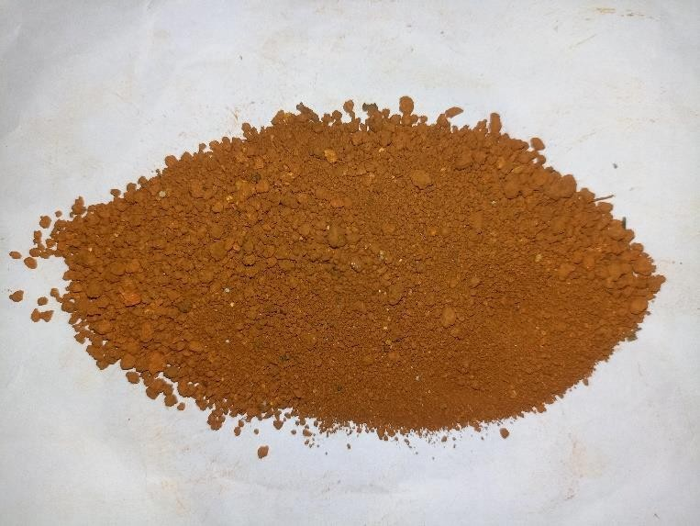
The soil required for the SMB is excavated near kelthaje, Belthangady. The soil is sun- dried and after thorough drying, the soil is sieved in 1.18 mm sieve is shown in Fig. 1. Primarily, sand is the small pieces of eroded rocks with a gritty texture. It has the largest particle among different soil particles. In sandy soil, most of the soil particulars are bigger than 2mm in diameter. Sandy soil has very good frictional properties.

Fig. 1 sandy soil

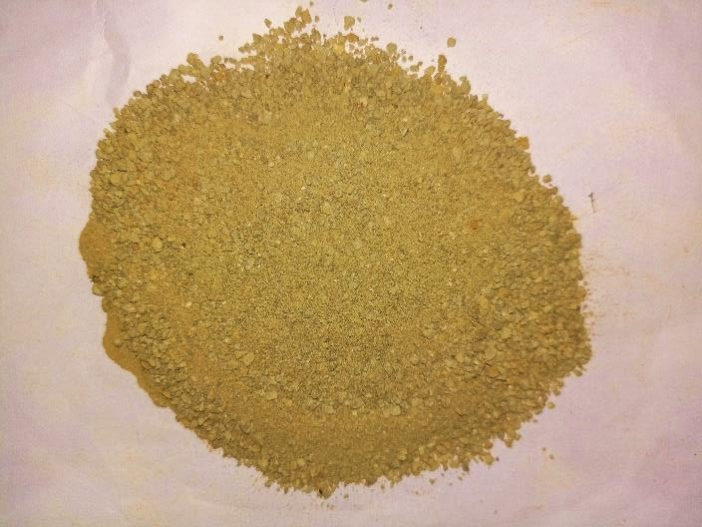
The clay required for the production of SMB was obtained from Didupe, Belthangady. The clay obtained was in large masses and chunks. These chunks were further crushed and powdered is shown in Fig. 2. The powdered clay was further sieved with a 600µ IS sieve. The sieved clay passing 600µ was used in the production of SMB. The defining mechanical property of clay is its plasticity when wet and its ability to harden when dried or fired. Clays show a broad range of water content within which they are highly plastic, from a maximum water content (called the liquid limit) where the moulded clay is just dry enough to hold its shape, to a minimum water content (called the plastic limit) where the clay is just moist enough to mould

Fig. 2 clay

Lime is an inorganic material composed primarily of calcium oxides and hydroxide. The lime required for the SMB was bought at a retailer store. The purchased lime was a hydrated lime in a powdered form is shown in Fig. 3. Hence there was no need for slaking of the lime.

Before use, quicklime is hydrated, that is combined with water, called slaking, so hydrated lime is also known as slaked lime, and is produced according to the reaction:

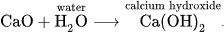
Dry slaking is slaking quicklime with just enough water to hydrate the quicklime, but to keep it as a powder; it is referred to as hydrated lime.

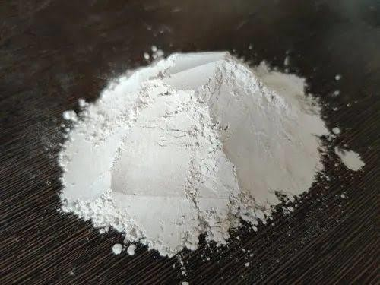

Fig. 3 Lime

Areca plantation is extensively grown in Dakshina Kannada region, hence its husk has been selected as the raw material for the block. Husk was fed into the furnace, which was kept at a temperature of around 600-8000C [16]. The husk was exposed in the furnace for 5-6 hours. The resultant ash obtained from the furnace is shown in the Fig. 4. The isolated areca-nut husk ash from the furnace was rich in amorphous silica. Output of ash was 10% of raw husk by weight. After sieving, the actual weight of obtained cleaned ash was 90% of total burnt ash by weight. Hence, the ash obtained is only around 9-10% of amount of husk by weight.
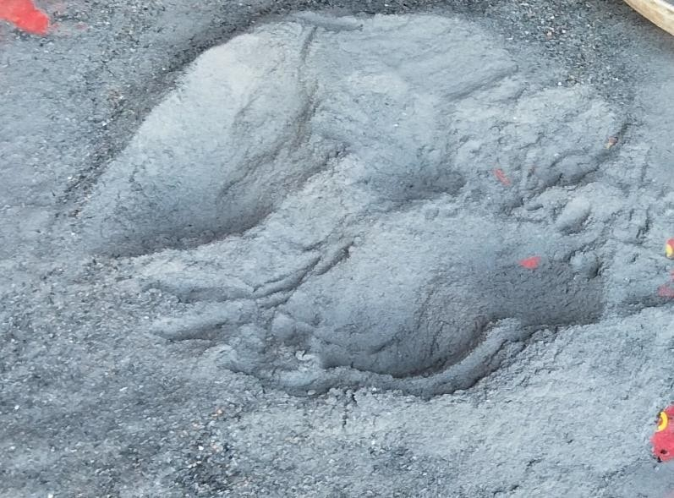

Fig. 4 Areca-nut Husk Ash

B. Methodology

Preparation of Blocks

● Sieving of soil: The soil shown in the Fig. 5 is excavated near Kelthaje, Belthangady. The soil is of sandy soil type. The soil is sieved in 1.18 mm IS sieve.

● Burning of areca-nut husk: The husk is burnt in a furnace for about 6 hours at 600-800ºC. The ash is taken out of the furnace only after the husk is completely burnt and cooled. The burning process and the furnace used for preparing the AHA is shown in the Fig. 6.

● Fig. 7 is sieved through 600µ sieve which helps to separate out any large particles or impurities that may be present in the ash. In SMB a uniform particle size of the ash can result in bricks with consistent strength and durability.
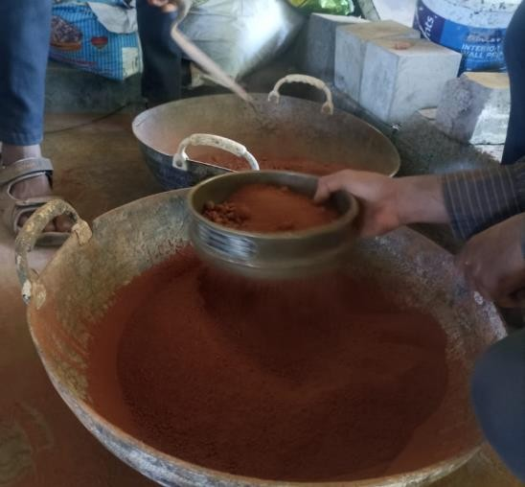
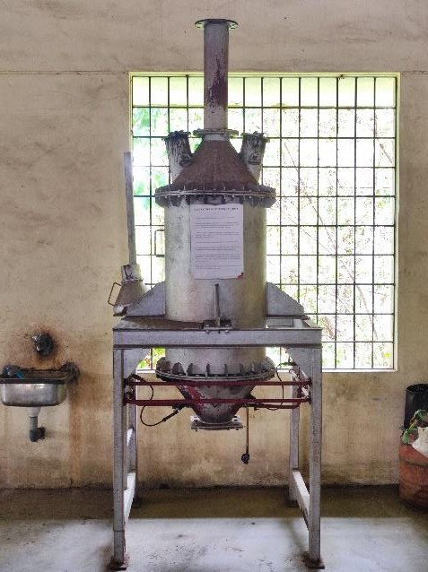
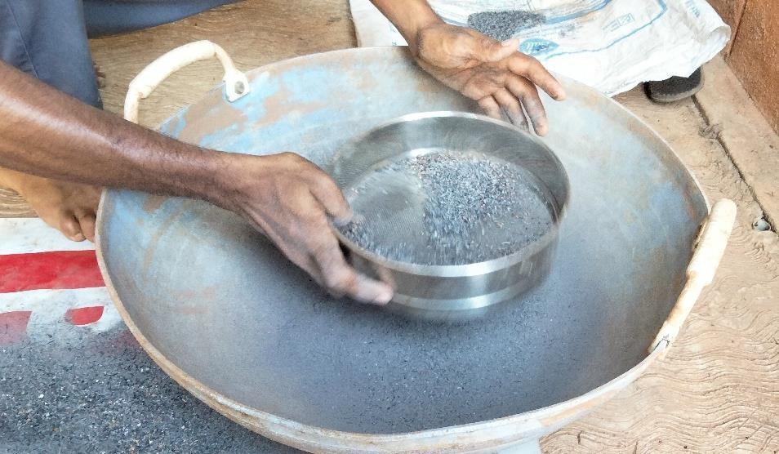
Fig. 5 sieving of soil Fig. 6 Burning of Areca-nut husk Fig. 7 Sieving of AHA

● Dry mixing of raw materials:

Mix proportion (with lime): since, lime and AHA are very fine particles, the lime (5%) and AHA (5%) is blended for about 30 minutes to ensure proper mixing of these constituents as shown in Fig.8. Then the soil (75%), clay (15%) and previously prepared mix is all together mixed and blended evenly as shown in Fig. 9.

Mix proportion (without lime): soil (75%), clay (15%) and AHA (10%) are mixed thoroughly until the mixture is uniform.

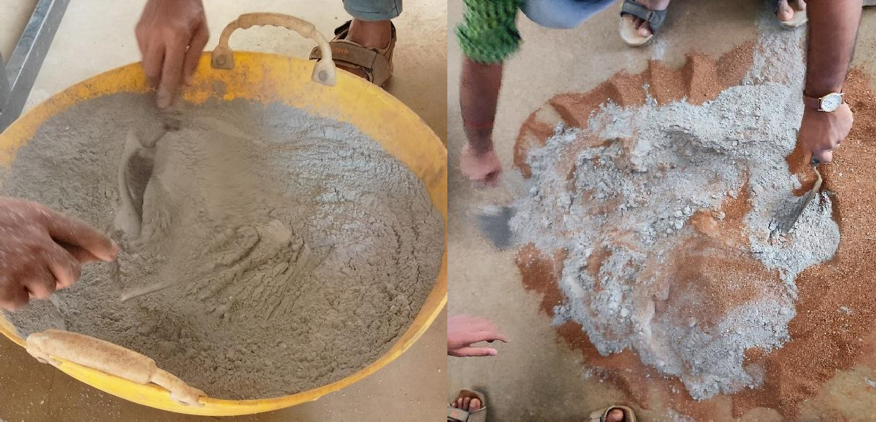

Fig. 8 Blending AHA and lime Fig. 9 Dry mixing of raw materials

● Wet mixing of raw materials:

Water is added to the mixture at a specified quantity determined by conducting standard proctor test. Water content is based on optimum moisture content which signifies maximum dry density of the soil mixture. At this stage, the soil is plastic in nature as shown in Fig. 10 and can be moulded to any desired shape.

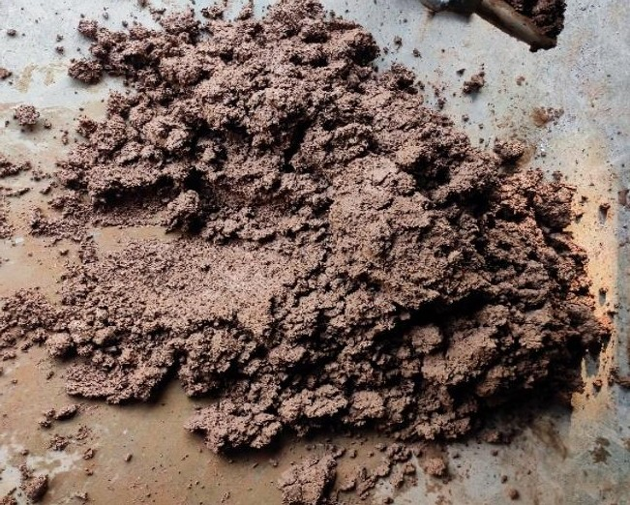

Fig. 10 Wet mixing of materials

● Casting & Testing of blocks: The blocks were casted in a mould of size 10*8*5 inch shown in Fig. 3.11. The soil mixture is placed inside the mould in 3 layers and compressed every time using CTM. The blocks were casted so as to achieve a density of 2g/cc. The blocks were tested for compressive strength for 7, 14 and 28 days in a CTM as shown in Fig. 3.12.

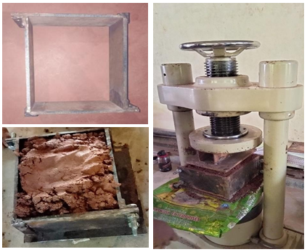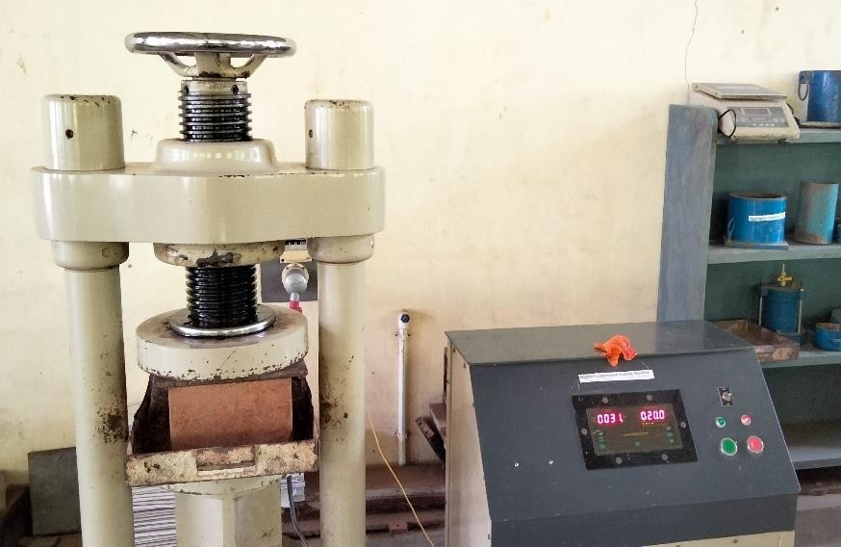

Fig. 11 Casting of blocks Fig. 12 Testing of blocks

C. Test on soil to determine the optimum moisture content

Standard proctor test

Weight the empty proctor mould (W1) with base plate removing collar. Apply grease on inner surface of mould and base plate. Place collar on top of assembly. Take about 3kg of dry soil passing through 4.75mm IS sieve in a mixing tray, add water to get moisture content, starting around 5%. After leaving soil-water mixture for few minutes, place it in layers inside mould. Using rammer, compaction is carried out with specific number of hits for each layer as shown in Fig. 13. Take weight of mould with compacted soil (W2) without collar. Trim excess soil using knife. Measure the dimension of mould to calculate volume (V). Conduct trials till there is a decrease in trend or no change in wet compacted weight of soil.

Wet density of soil is
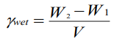
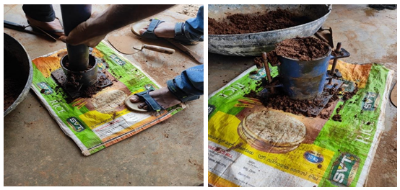

Fig. 13 Standard proctor test

D. Method to the determine the compressive strength of SMB

Compressive strength is the capacity of material or structure to resist or withstand under compression. The Compressive strength of a material is determined by the ability of the material to resist failure in the form of cracks and fissure.

The steel bearing plates are kept on and below the blocks while placing in the CTM so as to distribute the load throughout the surface and the centroid of the blocks are aligned with the CTM are compressing faces. The block is firmly fixed within the faces of CTM using a rotating handle on top of the CTM. Then, a constantly increasing load is applied on the block until a failure is observed in the block. The failure load is recorded. 3 trials are conducted and the average of the three value is determined as the failure load and compressive strength based on the failure load is calculated.

V. RESULTS AND DISCUSSIONS

A. Standard Proctor Test

In the Table No. 1, the trend line gradually increases while there is an increase in both water content and dry density. After certain water content, the increasing in dry density stops and further addition of water decreases the dry density and there is a gradual fall in the trendline. The maximum value of the dry density obtained for a specific moisture content is the optimum moisture content (OMC). Optimum moisture content of the soil mix (with lime) is 22%.

Table No. 1 Standard proctor test (with lime)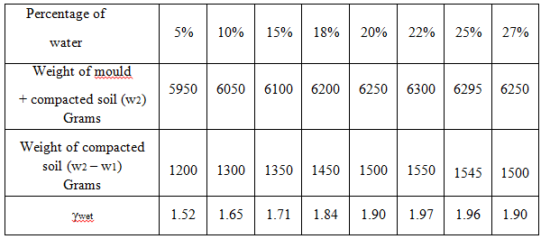

The trend line gradually increases while there is an increase in both water content and dry density. After certain water content, the increasing in dry density stops and further addition of water decreases the dry density and there is a gradual fall in the trendline. The maximum value of the dry density obtained for a specific moisture content is the optimum moisture content (OMC).
Optimum moisture content of the soil mix (without lime) is 19%.

Table No. 2 Standard proctor test (without lime)
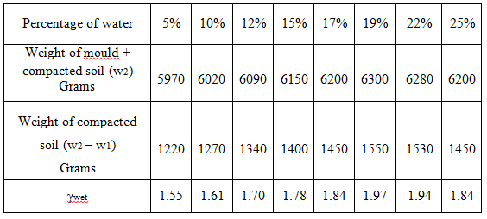

B. Compressive strength test

Compressive strength of Stabilized Mud block= average load / area of specimen Density of the SMB = weight of the block / volume of the block
Cross sectional area of the block = length * breadth
= 254 *203.2 mm
= 51612.8 mm²
Table No. 2 Compressive strength test on blocks (with lime)
Sl. No | Curing Periods  ( days) | Average Compressive Strength (MPa)
1 | 7 | 1.60
2 | 14 | 2.99
3 | 28 | 4.38

Table No. 3 Compressive strength test on blocks (without lime)
Sl. No | Curing Periods  ( days) | Average Compressive Strength (MPa)
1 | 7 | 2.81
2 | 14 | 3.80
3 | 28 | 4.20

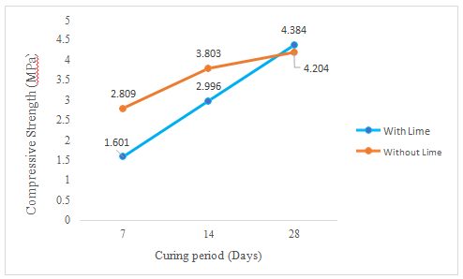
Fig. 14 Curing period Vs Compressive strength

By analyzing Fig. 14, we can observe that the block prepared using lime initially had very less strength. After 14 days, we can observe a drastic increase in strength from 1.601 MPa to 2.996 MPa. Similarly, after 28 days of curing, the strength gained by the block is 4.384 MPa. This is because of the reaction between calcium present in the lime and silica in AHA, which forms Calcium Silicate. The reaction between the two components results in superior bonding ability. The final strength obtained by the block with lime and without lime are 4.384 MPa and 4.204 MPa, respectively In the block without lime, there is no significant variation in the strength since, there is no any significant reaction taking place with AHA. Here the AHA acts as filler material which fills in the small pores in the soil structure and improves the density of the block and hence increasing the strength.

C. Compressive strength of SMB (with cement)

Table 4 [29] shows the compressive strength of SMB with cement as an additive at various curing periods.
Table No. 4 Compressive strength of SMB with cement
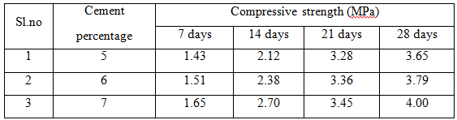

D. Density of SMB

Density of SMB (with lime)
Table No. 5 Density of block (with lime)
Sl. No | Curing Periods  ( days) | Average Density (g/cc)
1 | 7 | 1.847
2 | 14 | 1.774
3 | 28 | 1.667

Density of SMB (without lime)

Table No. 6 Density of block (without lime)
Sl. No | Curing Periods  ( days) | Average Density (g/cc)
1 | 7 | 1.825
2 | 14 | 1.776
3 | 28 | 1.743

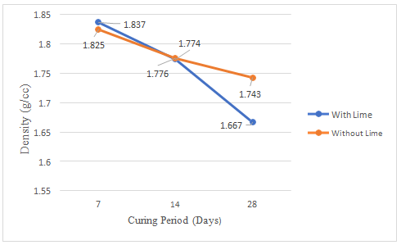
Fig. 15 Curing period Vs Density

Initially, the blocks were casted for a density of 2g/cc. By observing the Fig. 4.4, the density of blocks with lime and without lime after 7 days of curing are 1.837 g/cc and 1.825 g/cc respectively. After 14 days, the densities of both the blocks are reduced to 1.774 g/cc and 1.776 g/cc respectively. Similarly, after 28 days, densities of both the blocks have been reduced to 1.667 g/cc and 1.743 g/cc respectively. initially, the block containing lime had greater density but, after 28 days, it had the lesser density than the block having only AHA because, density of AHA is 2.69g/cc whereas lime is 2.4 g/cc. Therefore the block prepared without using lime retained greater density than the block prepared using lime.

VI. CONCLUSIONS
Based on present research, following conclusions were drawn,
● SMB was produced using AHA as an additive without compromising the compressive strength.
● The Compressive strength of SMB with lime is 4.384 MPa and compressive strength of SMB without lime is 4.204 MPa at the age of 28 days. Only a marginal difference of 0.18MPa was observed.
● Compressive strength of SMB with cement as an additive [29] is 4.00 MPa. Hence, compressive strength of SMB with cement and SMB with AHA is comparable.

REFERENCES

K. Poorveekan, K.M.S. Ath, A.Anburuvel,N.Sathiparan, “Investigation of the engineering properties of cementless stabilized earth blocks with alkali-activated eggshell and rice husk ash as a binder”, Construction and Building Materials (2021), Volume 277-29
Sangeethavani B, Muthukannan M, Deepak R, Arun Pradeep A, “A performance assessment on compressed stabilized earth block using geo-polymeric binders”, IOP conference series: Materials science and engineering December 2020.
N. P. Vignesh K. Mahendran, and N. Arunachelam, “Effects of Industrial and Agricultural Wastes on Mud Blocks Using Geopolymer”, Hindawi Advances in Civil Engineering Volume 2020.
Jonathan Fernando Rivera, Ruby Meija de Gutierrez, Sandra Ramirez- Benavides, Armando Orobio, “Compressed and stabilized soil blocks with fly-based alkali- activated cements”,construction and building materials, volume 264: 2020
Dhanalakshmi Ayyanar,M.Gokulakrishnan, “Experimental Investigation on Stabilized Mud Blocks”, Journal of Scientific Research and Development, Vol. 6/Issue 02/2018/941
Anil Kumar Chandra S, Sharath. M Y, Theertharama N, Vasipalli Vamsi Krishna Reddy, “Experimental Study on Behaviour of Stabilized Mud Blocks Using Fly ash and Quarry Dust”, International Journal for Research Trends and Innovation, Volume 2, Issue 6 - 2017
M. T. Abdulwahab, O. A. U. Uche, G. Suleiman, “Mechanical Properties of Millet Husk Ash Bitumen Stabilized Soil Block”, Nigerian journal of technological development, volume 14 no 1 June 2017.
Muhammad Azhar Saleem, Safeer Abbas and Mujtaba Haider, “Jute fiber reinforced compressed earth bricks - A sustainable solution”, Pak. J. Engineering and application science, volume 19 July 2016
Jijo James, Kashinath Pandina,K.Deepika, J. Manikanda Venkatesh Manikanda,and P. Manikumaran, “Cement stabilised soil blocks admixed with sugarcane bagasse ash”, Hindawi publishing corporation journal of engineering, volume 2016- January 2016
M Prasanth, Rejith Thomas, S Sandana Socrates, S Sasi Kumar’s S Manu, “Experimental investigation on the compressive strength of pressed composite earthbrick”, IRJET: International journal of research in engineering and Technology, volume:04 Issue:08 August 2015
C.K. Subramani prasad, Benny Mathews Abraham, E.K. Kunhanandan Nambiar, “Sorption characteristics of stabilised soil blocks embedded with waste plastic fibres”, Construction and Building Materials, Volume 63, 30 July 2014
Peter Paa Kofi Yalley,Emmanuel Asiedu, “Enhancing the Properties of Soil Bricks by Stabilizing with Corn Husk Ash”, Civil and Environmental Research, Vol.3, No.11, 2013.
Muhammadiyah Yogyakarta, Jl. Lingkar Selatan, Taman Tirto, “Engineering characteristics of the compressed-stabilized earth brick”, Construction and Building Materials, Volume 25, Issue 11, November 2011
J. N. Akhtar, J. Alam and M. N. Akhtar, “An experimental study on fibre reinforced fly ash-based lime brick”, International Journal of the Physical Sciences, Vol. 5(11), pp. 1688-1695, 18 September 2010
C. Galan- Marin, C- Rivera Gomez, J Petric, “Clay based composite stabilized with natural polymer and fibre”, construction and building materials - volume 24 Issue 8, August 2010
Subramanya R Sharma, Sanjay S. S, “Use of areca-nut husk ash (AHA) in brick preparation and its impact analysis”, research square
https://www.researchgate.net/publication/257895979_Cement_and_carbon_emis sions
https://link.springer.com/article/10.1186/s40703-017-0064-9
https://en.wikipedia.org/wiki/Areca_nut_production_in_India
Vipulanandan, C., & Huang, R, “Mechanical properties of concrete with Areca- nut Husk Ash as partial replacement of cement”, Construction and Building Materials (2019), volume 211, 9-18.
Tushar, M. D., & Renuka, B. S, “Experimental investigation on areca nut husk ash-based geopolymer concrete”, Materials Today(2019), volume 16, 1883-1890.
Singh, G., Kumar, R., & Singla, A, “Effect of pozzolanic material (areca nut husk ash) on fresh and hardened properties of self-compacting concrete”, International Journal of Engineering & Technology (2018), volume 7(3.28), 46-49.
Kumar, R., & Singla, A, “Assessment of CO2 emission reduction potential by the utilization of agro-waste in concrete”, Journal of Cleaner Production (2018), volume 208, 1399-1413.
Barai, S. V., & Mandal S, “Performance evaluation of areca nut husk ash blended cement concrete”, Construction and Building Materials(2016), volume 124, 10-19.
Zala, S., & Patel, R, “Investigation on areca nut husk ash (AHA) as a partial replacement of cement in concrete”, International Journal of Engineering and Innovative Technology (2016), volume 6(6), 56-61.
Mehta, P. K., & Monteiro, P. J, “Concrete: Microstructure, Properties, and Materials. McGraw-Hill Education (2013)
Babu, D. S., & Swathi, K, “Performance study on concrete by partially replacing cement with areca nut husk ash”, International Journal of Research in Engineering and Technology (2013), volume 6(4), 522-525.
Chavan, K. M., & Deshpande, S, “Effect of areca-nut husk ash on mechanical properties of concrete”, International Journal of Current Engineering and Technology (2013), volume 6(3), 1126-1129.
Rohith kumar reddy M. H, Veeresh G. M, Sangeetha G, Meghashree M, “Strength analysis of Stabilized mud blocks”, International Journal of Research in Engineering and Technology (2021), NCACE-EWIT-2020 (volume 09- issue 01)

