MRI safety

Hitesh Sharma
M.Sc. Radio-Imaging Technology
SGT University, Gurugram
Hiteshsharma2201@gmail.com

Amit Kumar Mishra
M.Sc. Radio-Imaging Technology
SGT University, Gurugram
Amiturm1997@gmail.com

Disha Sharma
M.Sc. Radio-Imaging Technology
SGT University, Gurugram
Dishasankhyan1020@gmail.com

Sanjay Yadav
M.Sc. Radio-Imaging Technology
SGT University, Gurugram
Ydvsanjay880@gmail.com

Mohit Deswal
Assistant Professor
Department of Paramedical
SGT University, Gurugram
Mohitdeswal.md.md@gmail.com

Navreet
Assistant Professor
Department of Paramedical
SGT University, Gurugram
Navreet999@gmail.com

MRI stands for “Magnetic Resonance Imaging”. Originally known as “Nuclear Magnetic Resonance” (NMR). It is used in medical field to produce image of internal structures of living organism. The MR environment poses risks not only to the patient but also to accompanying family members, attending medical professionals, and other people who only occasionally or infrequently come into contact with MR scanner magnetic fields, such as security or housekeeping staff, firefighters, police, etc. The need for a safety evaluation by an expert panel has been highlighted by reports in the medical literature and print media describing adverse Magnetic Resonance Imaging (MRI) incidents involving patients, equipment, and workers. The Blue-Ribbon Panel on MR Safety was first established by the American College of Radiology with this purpose in mind.

ACR GUIDANCE DOCUMENT ON MR SAFE PRACTICES: 2013 A. Establish, Implement, and Maintain Current MR Safety Policies and Procedures
1. MR safety procedures should be followed at all clinical and research MR locations, regardless of magnet format or field intensity, including installations for diagnostic, research, interventional, and/or surgical purposes.
2. The safety characteristics of the site's MR environment should be examined concurrently with the introduction of any significant changes (such as the addition of quicker or stronger gradient capabilities or higher RF duty cycle studies), and these rules and procedures should be amended as necessary. Before defining local guidelines, rules, and procedures, this evaluation process should take into account national and international standards and recommendations.
3. Each of the sites will be assigned an MR medical director, whose duties involve seeing to it that the site's MR safe practise guidelines are prepared and kept up to date. The administration of the site is responsible for seeing to it that all staff members follow the rules and regulations that flow from these MR safe practise standards at all times.
4. Any undesirable occurrences, MR safety incidents, or "close to incidents" should be stated to the medical supervisor as soon as they happen (for example, within twenty-four hours or one business day) so that they can be used in ongoing quality improvement projects. It is important to note that the Food and Drug Administration (FDA) has stated that the sites must use their MedWatch programme to report accidents and problems to them. The ACR supports this requirement and thinks that building and maintaining this comprehensive record of such events will help us all gain insights into them and improve our ability to prevent them in years to come.

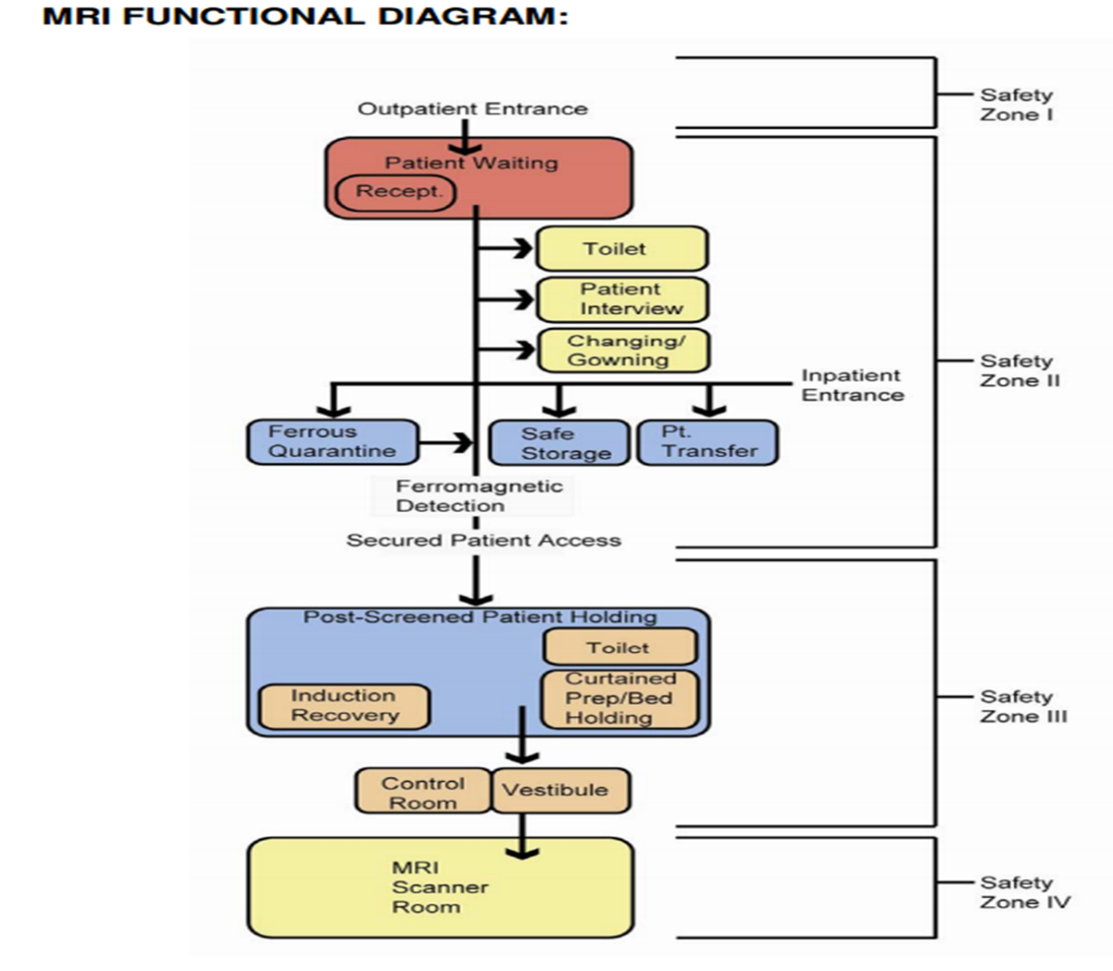

MR BIOEFFECTS
3 various kinds of electromagnetic fields can be observed when an individual is receiving a magnetic resonance (MR) scan.
- Static magnetic field
- Gradient magnetic field
- RF electromagnetic field
Static magnetic field
The surface temperature of the epidermis may rise. Despite an increase in T-wave amplitude, it may result in cardiovascular consequences as well as electric inducement. It has potential effects on neurons. All these bioeffects are not proved to be hazardous at field strength < 3T whereas scanning at field strength >2T can trigger nerves in the extremities and induce vertigo, headaches, and pain.
Gradient magnetic field
Cardiovascular fibrillation, epileptogenic possibilities, and ocular disturbances are some of possible side effects. Heating impacts are also present. All of these consequences haven't been felt in medical Mri systems today.
RF magnetic field
It could lead to cell warming and energy accumulation. The unit of measurement of the specific absorption rate (SAR), which measures tissue energy deposition, is Watt/kg. Parameters for Complete Person Warming Per IEC/FDA For all cases, the standard mode range 0.5 degrees Celsius or 2 W/kg 1.0 degrees Celsius or 4 W/kg is the initial level-controlled mode (under medical supervision). More than one degree Celsius or 4 W/kg in the second-level regulated mode (needs IRB permission)

ACOUSTIC NOISE
This is brought due to the tremors of the gradient coils, which gets worse using narrow slices, tiny FOVs, low TR or TE, prolonged phases, or steeper phase transitions.
Individuals and the other individual need to be given earbuds and headphones.

FARADAY CAGE
The obstacle designed to stop electromagnetic waves is called the Faraday cage or barrier. Considering the scenario involving a Faraday cage, a wire mesh of electrically conductive materials might be used to create a Faraday barrier as a constant enclosure.
These Faraday enclosures utilise a metallic barrier which transmits energy to produce an insulation affect. Faraday enclosures are available in a variety of dimensions and designs.
How faraday cage works?
This Faraday enclosure disperses charges of electricity as well as energy throughout the enclosure's perimeter while cancelling them away inside its walls. An Faraday enclosure, in essence, constitutes a cylindrical Conductor that ensures the electrical current is maintained within the enclosure's exterior.
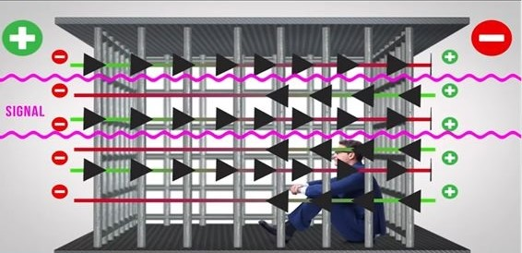

Note:
In MRI faraday enclosure is built for RF shielding
RF shielding is important because:
- To safeguard the magnetic resonance (MR) information from being contaminated by unrelated magnetic fields (RF).
- To protect surrounding healthcare facilities being interfered with any MRI equipment electromagnetic radiation.

An area should have nested items.:
1) A safeguarding outer coating for structures
2) A centrally located metal RF-shield
3) A finish-materials-based inner layer.
Typically, the flooring is comprised from pure copper that has been monolithically formed.
Entrance should be shielded with a series of electrically conductive panels or an ongoing steel pneumatic equipment pipe that will avoid unwanted RF leakage.
Metal netting that has been tarnished is sandwiched over two sheets of glass to form windows.
Virtually any metal can be used including aluminium and steel but copper is generally used because it is more conductive metal.

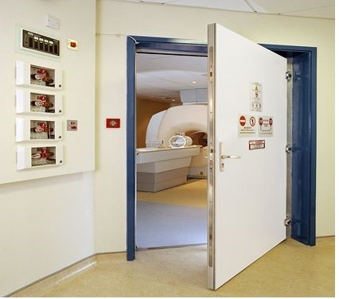

SITE ACCESS RESTRICTION

1) ZONING: - In terms of concept, the magnetic resonance imaging (MRI) area is separated into four distinct areas..

ZONE 1: - Any regions which are publicly available to everyone are included within this zone. Patients, medical professionals, as well as other MR site employees reach the medical imaging facility via this location, that's normally beyond the MR field itself.

ZONE 2: - The publically readily available unrestricted Zone I and the tightly monitored Zone III meet here. In most cases, patients are welcomed in Zone 2 and aren't permitted to wander around at leisure; instead, they're under the watchful eye of MR staff. Response to MR questionnaires, histories of patients, queries about health insurance, etc. are often acquired in Zone II.

ZONE 3: - Due to the interactions among the people or technology and the particular conditions of the MR scanner, unrestricted entry by unscreened non-MR employees or ferromagnetic materials or equipment may cause serious harm or death in this area. These relationships comprise, but aren't restricted to, encounters that involve the time-dependent. and static magnetic waves of the MR scanner. The third zone must have severe physical constraints on all entry, and all areas within it, especially Zone IV, must be completely monitored and supervised by MR employees.
ZONE 4: - This space is the same as the magnet room for the MR scanner. Zone III will always contain Zone IV by definition since Zone III is created by the MR magnet and the magnetic field that it produces. For the whole time they are in either Zone III or Zone IV prohibited areas, Non-MR Employees must be escorted by, or beneath direct oversight of, and in visual proximity by, one particular level 2 MR employee. Employees with MR levels 1 and 2 are free to move across any zone they want.

2) MR Personnel and non-MR personnel

a) It ought to be established that each person who works in no fewer than the third area of the magnetic resonance (MR) facility has finished a minimum of one of the real-time seminars or taped sessions on MR protection that have been authorised via the MR professional director. In order to verify these continuing educational initiatives, participation must be redone not less than once a year and adequate proof ought to be given. These people will from now on be referred to as MR professionals.

b) MR staff are divided into two levels:
1. Level 1 MR individuals: From this point forward, MR workers whom have undergone the barest of safety-related training requirements to guarantee their own protection while working in the third zone are going to be designated to as first-level MR individuals.

2. Level 2 MR individual: Second-level MR workers are the ones who have undergone further extensive training and education in the more general facets of MR security concerns, such as, for instance, problems relating to the risk of thermal trauma or burns and lead neurological and muscular stimulation from fluctuating gradients. A level Two MR staff must be identified by the MR healthcare director, whom is additionally responsible for determining the right level of education. The healthcare director are going to, as assumed, be qualified for level two MR employees because they have undergone the education and expertise required for MR safety.

c) All individuals who have not followed certain MR precautionary requirements are going to be referred as non-MR employees. Non-MR employees, as determined according to the MR security supervisor of that setup, as the phrase utilised to denote any individual or organisation who have not received the necessary specialised instruction in MR security concerns over the past one year.

3) Patient and non-MR personnel screening

MR employee should screen patient and relatives for any metallic or ferromagnetic objects before allowing entry into zone3 and zone4.
Individuals ought to be instructed to eliminate any metallic items off of them and clothing with lose metallic components and cosmetics.
Metallic objects can be screened with hand held magnet or with the help of metal detector.
Anyone suspicious of having a metallic external object in their orbital or close to a critical area ought to undergo a plain radiograph inspected.
Intraocular external objects are a strict no-no for conducting an MR scan with metallic devices since they may trigger displacement, electric current generation in the substance, overheating that could result in burns, as well as interpretation errors due to artefacts.
Patient ought to change into clothes made for the appropriate spot.

4) MR employee Screening

To protect the security of those working in the MR surroundings, all MR staff must go through an MR assessment procedure as a component of their hiring interview procedure. All MR workers must notify any trauma, process, or surgical treatment they encounter or go through in which a ferromagnetic item or instrument might have been proposed inside them or placed upon these individuals right away to the MR medical supervisor for their own safety and for the safety of the other non-MR employees that they are in charge for. It allows the worker to undergo the necessary testing to establish whether it is acceptable to let them enter Zone 3.

5) Device and object screening

It is divided into 3 main categories: -

MR safe: item pose no known hazards in all MR environments and are indicated by a green and white icon.
MR conditional: items do not pose any known hazards in a specific MR environment with specific condition of use. The icon consists of MR inside a yellow triangle.
MR unsafe: items such as any magnetic item are unsafe in all MR environments. Unsafe icon features a MR inside of a red circle with a bar through it.
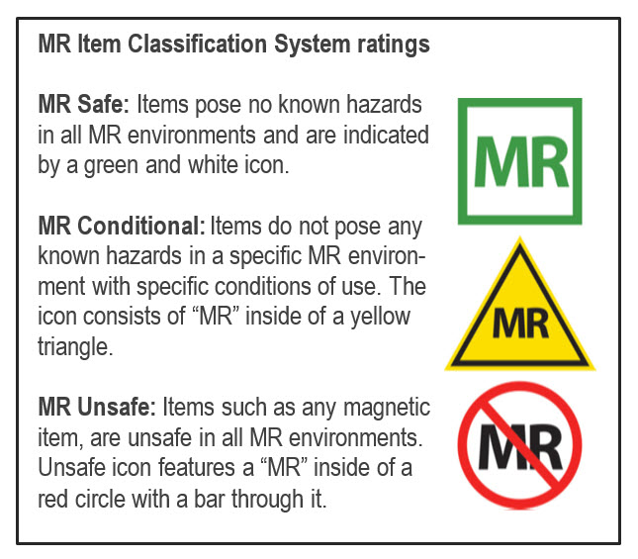

6) MR Technologist
1. The Magnetic resonance (MR) Certification Programme Criteria state that MR technicians must meet the technical criteria.
2. A minimal number of two MR technicians, or one MR technician and one additional worker with the title of MR workers, must be present within the nearby zone two through the fourth zone MR surroundings, with the exception of emergency coverage. As long as there is on-site, prepared urgent backup by authorised division of radiology MR employees (e.g., radiology house staff or radiology attending), the MR technologist can scan without any other people present in their Zone II through Zone IV surroundings.

7) Pregnancy related issues-
Development abnormalities may be caused by the magnetic fields that are utilised in MRIs. It might have an impact on the growing fetus's division of cells. On this matter, there is now scant information available.
a) Pregnant health care practitioner: -
All phases of gestation are acceptable for expecting medical personnel who work in and within the MR atmosphere. Placing patients, imaging, storage, providing contrast, and going into the Mri scanning area in the event of a crisis are all permitted actions. Expecting medical personnel are welcome to perform their duties in and close to the MR surroundings, however they are asked to leave the fourth zone or the MR scanner bore while collecting information or imaging.
MR employees who are expecting may be allowed to remain employed within or near the premises of MR during their entire pregnancy. Yet, it must be recommended that they leave the scanning area whenever the procedure is actually collecting data.
b) Pregnant patient
Any phase of gestation may be allowed for women who are expecting to get MR examinations provided, in the view of an accompanying radiologist approved by the second-level MR specialists, the woman's risk-benefit relationship justifies the investigation's execution. In these radiological report or the individual's medical file, the radiologists must speak with the doctor who referred the patient to note the following:
1. The data that is needed gathered through MR research can't be obtained using non-ionizing techniques (like ultrasonography).
2. The information is required in order to possibly influence the treatment of the individual or foetus during gestation.
3. When recommending doctor feels that waiting until the female patient is not anymore expecting before getting this information wouldn't be appropriate.
A woman who is pregnant may be scanned at any point of gestation, according to the ACR white paper. Additionally, it proposes a case-by-case study to determine if the information from the MR test will have a substantial impact on the individual's therapy, if delaying the MRI till after the child's birth is practical, and whether the information can be obtained using another modality. The individual's aware and in-writing permission must be acquired.
c) contrast media during pregnancy
Pregnant women shouldn't typically receive MR contrast medications. This choice needs to be decided on an individual basis by the accompanying radiologist authorised by the referring second-level MR professionals, who will take into account the risks and benefits regarding that specific patient. The choice to give expecting mothers a gadolinium-based MR contrast drug needs to be supported by a thorough and considered risk-benefit assessment. This evaluation ought to be capable to support a choice to provide the contrast medication depending on the individual's or fetus's possible benefits surpassing the hypothetical but maybe real hazards of exposing the growing foetus to free gadolinium
d) contrast media in lactating mothers
The excretion of gadolinium in human milk. After receiving an injection, the milk from the breast must be extracted and discarded. For 36–48 hours, a baby shouldn't be nursed.
8. Aneurysm & hemostatic clips
Many of the clips in use are ferromagnetic & they are an absolute contraindication for MR examination. Only those aneurysm clips made up of titanium & tested non ferromagnetic prior to placement along with written documentation by referring physician can undergo MR examination.
At any particular static electromagnetic field strength, an individual who had an aortic clip (or other implant) could have gone through a previous MR exam without risk. This fact alone does not demonstrate the implant's MR safety, and therefore should not be used as the only basis for determining the MR security or suitability rating for that aortic clip (or another implant).

9. Dental devices & materials
These instruments have lower risks of relocation; therefore, they aren't contraindicated, but the artefacts they produce can be troublesome.
Time Varying Gradient Magnetic Field Related Issues: Induced Voltages
Patient categories that require particular caution: Especially from faster MRI sequences like echo planar imaging (which may be used in sequences like diffusion weighted imaging, functional imaging, perfusion weighted imaging, MR angiographic imaging, etc.), patients with implanted or retained wires in anatomically or functionally sensitive areas (such as the myocardium or epicardium, implanted electrodes in the brain) should be considered to be at higher risk. The level 2 MR personnel-designated attending radiologist supervising the case or patient should examine the choice to limit the maximum intensity of the magnetic field of the gradient subsystems and the dB/dt (rate of magnetic field change) during imaging of such patients.

Time Varying Gradient Magnetic Field Related Issues: Auditory Considerations
1. Before undergoing any imaging in any MR scanners, hearing protection should be made available to and recommended by all patients and volunteers. According to the FDA's most recent MR Guidance Document, instructions from MR equipment manufacturers should specify that hearing protection is necessary for all patients being studied on MR imaging systems that can generate sound pressure levels higher than 99 dB(A).
2. Hearing protection must be in place before beginning any MR sequences on any patients or volunteers on whom research sequences will be conducted. Non-FDA approved MRI sequences should not be performed on patients or volunteers without adequate hearing protection.

Time Varying Radiofrequency Magnetic Field Related Issues: Thermal
1. Prior to the start of imaging, all extra or unused electrically conductive materials from the patient's environment should be taken out of the MR system. Simply "unplugging" or disconnecting unused, pointless electrically conductive material and leaving the patient inside the MR scanner during imaging is insufficient. Before each use, the scanning MR technologist must visually inspect any electrical connections, such as those on surface coil leads or monitoring devices, to confirm the quality of the thermal and electrical insulation.
2. During the MR imaging process, electrical voltages and currents may be induced within electrically conductive materials that are inside the bore of the MR imager. This could cause this material to heat up due to resistive losses. The intensity of this heat could be high enough to harm human tissue. As previously mentioned, one factor that affects the amount of induced voltage or current is the diameter of the conductive loops. The larger the diameter, the greater the potential for induced voltages or currents and, consequently, the greater the potential for thermal injury to nearby or nearby patient tissue.

Cryogen-Related Issues
It is critical that each of the employees and patients leave the magnetic resonance imaging (MR) scan room right away as it is reasonable to do so in the case of a cryogenic systems quench, and that any access to the site be instantly prohibited until the arrival of MR equipment servicing specialists. This is particularly true if it is discovered that cryogenic gases have partially or entirely leaked into the imaging room, which is indicated, at least in part, by the abrupt development of white "clouds" or "fog" around or above the Magnetic resonance imaging (MR) scanner. As that could possibly be a sizable static magnetic field present regardless of a quench or limited quench caused by the magnet, it is especially crucial to make sure that all emergency responders from the police and fire departments are prohibited from entering the magnetic resonance (MRI) scan place with their tools (axes, air tanks, guns, etc.).

REFERENCES
[1] Patient death illustrates the importance of adhering to safety precautions in magnetic resonance environments. Health Devices 2001;30:311–314.
[2] Chaljub G, Kramer LA, Johnson RF III, Johnson RF Jr, Singh H, Crow WN. Projectile cylinder accidents resulting from the presence of ferromagnetic nitrous oxide or oxygen tanks in the MR suite. AJR Am J Roentgenol 2001;177:27–30.
[3] Kanal E, Borgstede JP, Barkovich AJ, et al. American College of Radiology White Paper on MR Safety: 2004 update and revisions. AJR Am J Roentgenol 2004;182:1111–1114.
[4]. Kanal E, Borgstede JP, Barkovich AJ, et al. American College of Radiology White Paper on MR Safety. AJR Am J Roentgenol 2002;178:1335–1347.
[5]. Kanal E, Shellock FG. Policies, guidelines, and recommendations for MR imaging safety and patient management. SMRI Safety Committee. J Magn Reson Imaging 1992;2:247–248.
[6]. Shellock FG, Kanal E. Policies, guidelines, and recommendations for MR imaging safety and patient management. SMRI Safety Committee. J Magn Reson Imaging 1991;1:97–101.
[7]. ACR practice guideline for performing and interpreting magnetic resonance imaging (MRI). Available at: http://www.acr.org/ SecondaryMainMenuCategories/quality_safety/guidelines/dx/mri_ performing_interpreting.aspx. Accessed September 13, 2011.
[8]. Shellock FG, Kanal E. Guidelines and recommendations for MR imaging safety and patient management. III. Questionnaire for screening patients before MR procedures. The SMRI Safety Committee. J Magn Reson Imaging 1994;4:749–751.
[9]. Kanal E, Barkovich AJ, Bell C, et al. ACR guidance document for safe MR practices: 2007. AJR Am J Roentgenol 2007;188: 1447–1474.
[10]. Device Advice: Comprehensive regulatory assistance. Available at: http://www.fda.gov/MedicalDevices/DeviceRegulationandGuidance/ default.htm. Accessed September 19, 2011.
[11]. Jarvik JG, Ramsey S. Radiographic screening for orbital foreign bodies prior to MR imaging: is it worth it? AJNR Am J Neuroradiol 2000;21:245–247.
[12]. Seidenwurm DJ, McDonnell CH III, Raghavan N, Breslau J. Cost utility analysis of radiographic screening for an orbital foreign body before MR imaging. AJNR Am J Neuroradiol 2000;21: 426–433.
[13]. Kanal E, Gillen J, Evans JA, Savitz DA, Shellock FG. Survey of reproductive health among female MR workers. Radiology 1993; 187:395–399.
[14]. American Academy of Pediatrics Committee on Drugs: Guidelines for monitoring and management of pediatric patients during and after sedation for diagnostic and therapeutic procedures. Pediatrics 1992;89:1110–1115.
[15]. Guidelines for monitoring and management of pediatric patients during and after sedation for diagnostic and therapeutic procedures: addendum. Pediatrics 2002;110:836–838.
[16]. Practice guidelines for sedation and analgesia by non-anesthesiologists: An updated report by the American Society of Anesthesiologists Task Force on Sedation and Analgesia by NonAnesthesiologists. Anesthesiology 2002;96:1004–1017.
[17]. Standards and intents for sedation and anesthesia care. Comprehensive Accreditation Manual for Hospitals. Chicago, IL: Joint Commission on Accreditation of Healthcare Organizations; 2002: Report no. TX 2–2.
[18]. US Food and Drug Administration Manufacturer and User Facility Device Experience (MAUDE) Data Base (MDR Report Key 434259, 489264, 410913). Available at: http://www.accessdata.fda.gov/ scripts/cdrh/cfdocs/cfMAUDE/TextSearch.cfm. Accessed September 8, 2011.
[19]. Gandhi OP, Chen XB. Specific absorption rates and induced current densities for an anatomy-based model of the human for exposure to time-varying magnetic fields of MRI. Magn Reson Med 1999;41:816–823.
[20]. Konings MK, Bartels LW, Smits HF, Bakker CJ. Heating around intravascular guidewires by resonating RF waves. J Magn Reson Imaging 2000;12:79–85.
[21]. Food and Drug Administration Public Health Advisory: Risk of Burns during MRI Scans from Transdermal Drug Patches with Metallic Backings, March 5, 2009, Updated March 9, 2009. Available at: http://www.fda.gov/Drugs/DrugSafety/PostmarketDrugSafetyInformationforPatientsandProviders/DrugSafetyInforma tionforHeathcareProfessionals/PublicHealthAdvisories/ucm111313. htm. Accessed May 15, 2012.
[22]. IEC 60601–2-33, Ed. 2.0 Medical Electrical Equipment-Part 2: Particular requirements for the safety of magnetic resonance equipment for medical diagnosis. Geneva, Switzerland: International Electrotechnical Commission (IEC); 2002.
[23]. ACR-SIR practice guideline for adult sedation/analgesia. Available at: http://www.acr.org/SecondaryMainMenuCategories/quality_safety/guidelines/iv/adult_sedation.aspx. Accessed September 13, 2011.
[24]. Standards for basic anesthesic monitoring. (Approved by the ASA House of Delegates on October 21, 1986, and last amended on October 20, 2010 with an effective date of July 1, 2011.) Park Ridge, IL: American Society of Anesthesiologists.
[25]. Standards for postanesthesia care. (Approved by the ASA House of Delegates on October 27, 2004, and last amended on October 21, 2009.) Park Ridge, IL: American Society of Anesthesiologists.
[26]. Statement on non-operating room anesthetizing locations. (Approved by the ASA House of Delegates on October 19, 1994 and last amended on October 22, 2008.) Park Ridge, IL: American Society of Anesthesiologists.
[27]. American College of Radiology. ACR digest of council actions. Reston, VA: ACR, 1999:126 (Res 1-H 1987, 1997).
[28]. American College of Radiology. ACR Manual on Contrast Media, Version 8, 2012. Available at: http://www.acr.org/SecondaryMain MenuCategories/quality_safety/contrast_manual.aspx. Accessed September 13, 2011.
[29]. Al-Sabagh KH, Christensen BE, Thogersen AM, et al. [Safety of magnetic resonance imaging in patients with pacemaker and implantable defibrillator]. Ugeskr Laeger 2010;172:1740–1744.
[30]. Gimbel JR. Unexpected asystole during 3T magnetic resonance imaging of a pacemaker-dependent patient with a ’modern’ pacemaker. Europace 2009;11:1241–1242.
[31]. Gotte MJ, Russel IK, de Roest GJ, et al. Magnetic resonance imaging, pacemakers and implantable cardioverter-defibrillators: current situation and clinical perspective. Neth Heart J 2010;18: 31–37.
[32]. Avery JK. Loss Prevention case of the month. Not my responsibility! J Tenn Med Assoc 1988;81:523.
[33]. Ferris NJ, Kavnoudias H, Thiel C, Stuckey S. The 2005 Australian MRI safety survey. AJR Am J Roentgenol 2007;188: 1388–1394.
[34]. Irnich W, Irnich B, Bartsch C, Stertmann WA, Gufler H, Weiler G. Do we need pacemakers resistant to magnetic resonance imaging? Europace 2005;7:353–365.
[35]. Langman DA, Goldberg IB, Finn JP, Ennis DB. Pacemaker lead tip heating in abandoned and pacemaker-attached leads at 1.5 Tesla MRI. J Magn Reson Imaging 2011;33:426–431.
[36]. Hartnell GG, Spence L, Hughes LA, Cohen MC, Saouaf R, Buff B. Safety of MR imaging in patients who have retained metallic materials after cardiac surgery. AJR Am J Roentgenol 1997;168: 1157–1159.
[37]. Murphy KJ, Cohan RH, Ellis JH. MR imaging in patients with epicardial pacemaker wires. AJR Am J Roentgenol 1999;172: 727–728.
[38]. Kanal E. Safety of MR imaging in patients with retained epicardial pacer wires. AJR Am J Roentgenol 1998;170:213–214.
[39]. Faris OP, Shein M. Food and Drug Administration perspective: Magnetic resonance imaging of pacemaker and implantable cardioverter-defibrillator patients. Circulation 2006;114:1232–1233. ACR Guidance on MR Safe Practices 529
[40]. Gimbel JR. Magnetic resonance imaging of implantable cardiac rhythm devices at 3.0 tesla. Pacing Clin Electrophysiol 2008;31: 795–801.
[41]. Nazarian S, Halperin HR. How to perform magnetic resonance imaging on patients with implantable cardiac arrhythmia devices. Heart Rhythm 2009;6:138–143.
[42]. Gimbel JR. Guidelines and the growing service burden. J Interv Card Electrophysiol 2010;28:83–85.
[43]. Hauser RG, Kallinen L. Deaths associated with implantable cardioverter defibrillator failure and deactivation reported in the United States Food and Drug Administration Manufacturer and User Facility Device Experience Database. Heart Rhythm 2004;1: 399–405.
[44]. Jilek C, Tzeis S, Reents T, et al. Safety of implantable pacemakers and cardioverter defibrillators in the magnetic field of a novel remote magnetic navigation system. J Cardiovasc Electrophysiol 2010;21:1136–1141.
[45]. Gimbel JR. Unexpected pacing inhibition upon exposure to the 3T static magnetic field prior to imaging acquisition: what is the mechanism? Heart Rhythm 2011;8:944–945.
[46]. The Facility Guidelines Institute. Guidelines for the Design and Construction of Health Care Facilities, 2010 edition. Chicago: American Society for Healthcare Engineering; 2010

