FUTURISTIC TRENDS IN MEDICAL SCIENCES- NEWER APPROACHES TO MANAGEMENT OF GROIN HERNIAS

AUTHORS
1.COL (DR) VIVEK UPADHYAY
MS GENERAL SURGERY
HOD MILITARY HOSPITAL, SECUNDERABAD
2.WG CDR (DR) HARSH PREET
MS, DNB GENERAL SURGERY
14 AIRFORCE HOSPITAL, HYDERABAD

INTRODUCTION
A common problem of the modern world is Hernia and its incidence is more in developing countries. The most common groin hernia repaired worldwide is inguinal hernia. The incidence of hernia is around 5-7% however in countries like India this prevalence of hernia is far greater amounting to a major health care burden. Inguinal hernia amount to 75% of all groin hernias.^{[1,2]}. Therefore one of the most commonly performed surgery worldwide is the repair of groin hernias.

“Hernia” comes from the Latin word “rupture”. It is as an abnormal protrusion of an organ or tissue through a defect or ring in its surrounding walls. These defects most commonly involve the abdominal wall, particularly the inguinal region, although a hernia can occur at various sites of the body . It is prudent that the operating surgeon must understand at which surgico-anatomical layer this hernia occurs and the other implicated surgico-anatomical layers, the boundaries of the ring and the content of the hernia.

A basic classification involves segregating hernia into reducible, irreducible and strangulated. It is reducible when the hernia contents can be replaced within the surrounding musculature. It is irreducible or incarcerated when it cannot be reduced .A serious and potentially fatal complication is strangulation when the blood supply to hernia contents is compromised.
INCIDENCE
The inguinal hernias carry a life time risk of 27% in men and 3% in women and the proportion of inguinal hernia repairs, men amount to 90% and 10% in women. Among groin hernias, inguinal hernias are 5 times more frequent than femoral hernias. Indirect inguinal hernia is the most common subtype of groin hernia in men and women and indirect hernias predominate over direct hernias at a ratio of 2: 1.Even in women who have a higher frequency of femoral hernias than men, inguinal hernias still remain the most common hernia in them.Albeit femoral hernias are rare in men. 50% of men and 10% of women who have a femoral hernia have or will develop an inguinal hernia in future.
Right sided inguinal hernias are more common than left sided which is attributed to a delay in atrophy of the processus vaginalis during fetal development after the normal slower descent of the right testis to the scrotum. The incidence of hernias, likelihood of strangulation and need for hospitalization increases with age. The most common serious complication of a hernia is strangulation occurs in only 1% - 3% of groin hernias and is frequently more common at the extremes of life. [.^{3,4,5]}
TYPES
Traditionally inguinal hernias were classified into basic 3 types as indirect, direct, and femoral. The basis of this classification was site of herniation relative to surrounding structures. Indirect hernias protrude lateral to the inferior epigastric vessels, through the deep inguinal ring. Direct hernias protrude medial to the inferior epigastric vessels,within Hesselbach’s triangle.
The newer Nyhus classification has categorized hernia defects by size, location and type. They are divided into 6 types:
Type I - Indirect hernia; internal abdominal ring normal; typically in infants, children, small adults
Type II Indirect hernia; internal ring enlarged without impingement on the floor of the inguinal canal; does not extend to the scrotum
Type IIIA Direct hernia; size is not taken into account
Type IIIB Indirect hernia that has enlarged enough to encroach upon the posterior inguinal wall; indirect sliding or scrotal hernias are usually placed in this category because they are commonly associated with extension to the direct space; also includes pantaloon hernias
Type IIIC Femoral hernia
Type IV Recurrent hernia; modifiers A–D are sometimes added, which correspond to indirect, direct, femoral, and mixed, respectively
RELEVANT SURGICAL ANATOMY
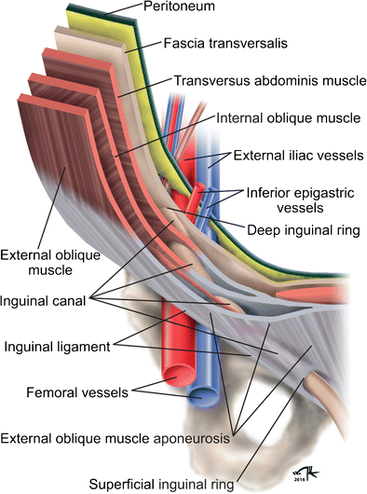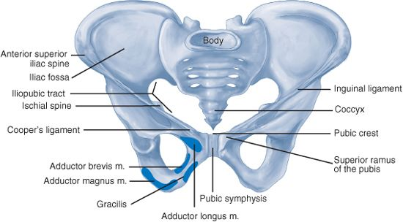
The inguinal canal is a 4- 6 cm cone shaped region present in the anterior portion of the pelvic basin. The canal starts on the posterior abdominal wall, where the spermatic cord passes through the deep inguinal ring which is a gap in the transversalis fascia. The canal ends medially at the superficial inguinal ring and at this point the spermatic cord crosses a defect in the external oblique aponeurosis.
The boundaries of the inguinal canal are marked anteriorly by external oblique aponeurosis, laterally by internal oblique muscle, posteriorly by the transversalis fascia and transversus abdominis muscle, superiorly by the internal oblique muscle and inferiorly by the inguinal (Poupart’s) ligament. The inguinal canal is traversed by spermatic cord, and it harbours 3 arteries, 3 veins, 2 nerves, the pampiniform venous plexus, and the vas deferens. It is enclosed in 3 layers of spermatic fascia. Additional structures of importance surrounding the inguinal canal include, the lacunar ligament, the iliopubic tract ,the Cooper’s ligament, and the conjoined tendon. The vascular space is found between the posterior and anterior laminae of the transversalis fascia, and it contains the inferior epigastric vessels which supplies the rectus abdominis. The inferior epigastric artery is derived from the external iliac artery, and it anastomoses with the superior epigastric artery which is a continuationof the internal thoracic artery. The course of epigastric vein is parallel to the arteries within the rectus sheath. A close inspection of the internal inguinal ring reveals the deep seated location of the inferior epigastric vessels. The nerves of interest in the inguinal region are the, iliohypogastric, ilioinguinal, genitofemoral, and the lateral femoral cutaneous nerves.
During laparoscopic hernia repair a study of preperitoneal anatomy led to characterization of critical anatomic areas of importance, known as the triangle of doom, the triangle of pain, and the circle of death .
The triangle of doom is surrounded medially by the vas deferens and laterally by the vessels of the spermatic cord and it contains the external iliac vessels, deep circumflex iliac vein, femoral nerve, and genital branch of the genitofemoral nerve. The triangle of pain is a region marked by the iliopubic tract and gonadal vessels, and its contents include the lateral femoral cutaneous, femoral branch of the genitofemoral, and femoral nerves. The circle of death is a vascular channel formed by the internal iliac, common iliac, inferior epigastric, obturator and external iliac vessels^{[6]}.
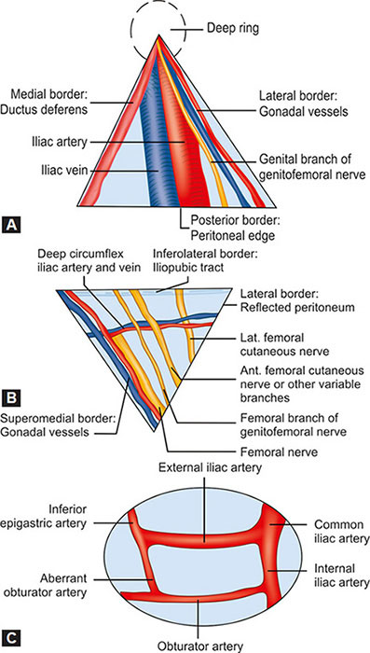
Triangle of Doom (A), Triangle of Pain(B) & Circle of Death(C)

APPROACH TO MANAGEMNT OF INGUINAL HERNIAS
Surgical repair is the definitive treatment of inguinal hernias; however, surgery is not necessary in a subset of patients. In minimally symptomatic patients nonoperative management is an appropriate consideration. A nonoperative approach is optimal for minimally symptomatic inguinal hernia cases & it also does not increment the risk of developing hernia complications and these include approaches like trusses and recumbent position^{[7,8]}.
HISTORICAL OR OPEN APPROACH
Open approaches are subdivided into techniques which use prostheses to create a tension-free repair and others that restore the inguinal floor using native tissue. Tissue repairs are usually indicated when the usage of prosthetic material is contraindicated as in conditions like contamination or strangulation).
In open approach a common start point is exposure of the anterior inguinal region. An oblique or horizontal incision is executed over the groin region followed by a minute incision in the external oblique aponeurosis parallel to the direction of the muscle fibers. This is then followed by the elevation of the flaps of external oblique aponeurosis ,dissection of the fibers of interior oblique and finally dissection of the inferior flap revealing the shelving edge of the inguinal ligament.
The nervous supply by iliohypogastric and ilioinguinal nerves are identified and preserved. The cord structures are atraumatically dissected off the pubic tubercle and the cord is elevated 2 cm above the pubic symphysis in an avascular plane. An indirect hernia is usually found on the anterolateral surface of the spermatic cord. For direct hernias the floor of the inguinal canal is fully assessed for direct hernias.The preperitoneal space should be explored for a femoral hernia If a hernia is not visualized upon entry into the inguinal canal. At this point, the reconstruction of inguinal canal is done, either with prostheses or with native tissue.
TISSUE BASED HERNIORRHAPHY
Tissue-based herniorrhaphy is an acceptable approach when prosthetic materials cannot be used safely or are contraindicated. The 3 approaches popularly used are the Bassini repair, the Shouldice repair and the Mcvay repair. The Bassini repair was considered a historic evolution in hernia repair technique. However its current use is limited, as the current modern techniques are better in reducing recurrences. The original Bassini repair includes dissection of the spermatic cord followed by the hernia sac dissection with high ligation and extensive reconstruction of the inguinal canal floor .
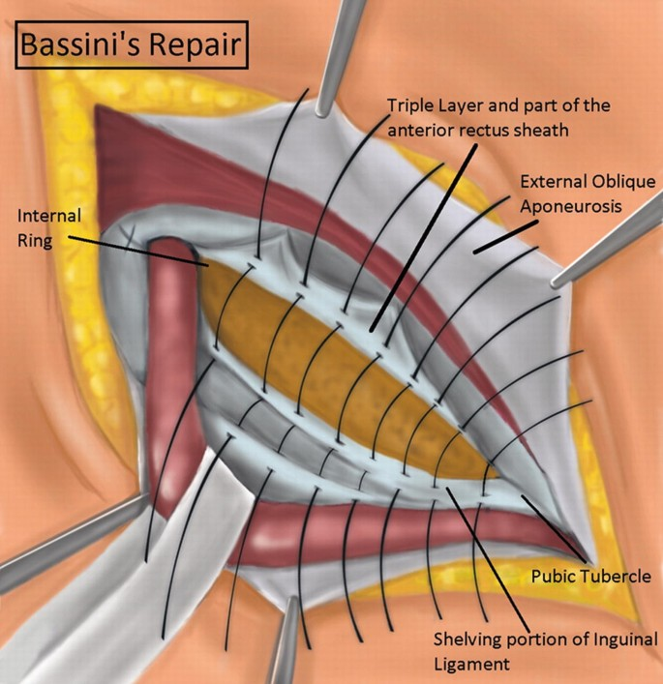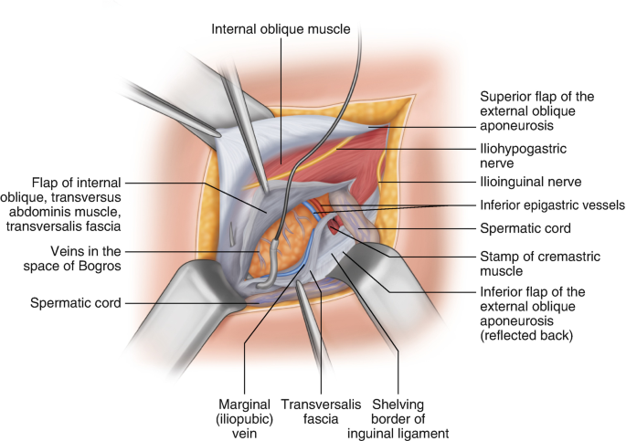
Bassini Repair Shouldice repair
The Shouldice repair restates the principles of the Bassini repair & its dissemination of tautness over several tissue layers resulting in lower recurrence rates. The iliopubic tract is sutured at the pubic tubercle to the lateral edge of the rectus sheath using a non absorbable, synthetic, monofilament suture. The suturing is continuous and progresses laterally joining the edge of the inferior transversalis flap to the posterior aspect of the superior flap. The suture continues back in the medial direction at the internal inguinal ring, joining the edge of the superior transversalis fascia flap to the shelving edge of the inguinal ligament. This suture is tied to the tail of the original stitch at the pubic tubercle.At the internal inguinal ring the next suture begins, and it continued medially to appose the aponeuroses of the internal oblique and transverses abdominis to the external oblique aponeurotic fibers. The suture doubles back through the same structures laterally at the pubic tubercle toward the tightened internal ring.
In McVay repair A 2- 4 cm relaxing incision is made vertically in the anterior rectus sheath originating from the pubic tubercle. This incision is critical to lessen the tension on the repair; however it may result in higher risk of ventral abdominal herniation and increased postoperative pain .Interrupted or continuous suture are then utilized and the superior transversalis flap is then fastened to Cooper’s ligament, and this repair is then continued laterally along Cooper’s ligament to occlude the femoral ring. A transition stitch is placed lateral to the femoral ring, affixing the transversalis fascia to the inguinal ligament. The transversalis is then stitched to the inguinal ligament laterally to the internal ring.

Mcvay repair

TRANSITION TO PROSTHETIC REPAIRS
Tension-free prosthetic mesh repairs brought about a paradigm shift in the surgical approach of inguinal hernia repair. Now a days mesh-based hernioplasty is the most frequently performed general surgical procedure.
The Lichtenstein technique broadens the terrain of the inguinal canal by fortifying the inguinal floor with a prosthetic mesh, resulting in minimal tension in the repair. The shelving edge of the inguinal ligament is exposed following dissection of the inguinal canal. The medial edge of the mesh is attached to the anterior rectus sheath in a way that it overlays the pubic tubercle by 1.5 - 2 cm. This rectification to the original Lichtenstein repair technique minimizes medial recurrence ^{[9]}.
Plug and Patch Technique .This is a modification of the Lichtenstein technique in which before placing the prosthetic mesh patch over the inguinal floor, a 3D prosthetic plug is placed in the area previously occupied by the hernia sac. The plug is placed beside the spermatic cord via the internal ring. Prosthetic plugs of various dimensions are available, and an appropriate size plug is fixed to the margins of the internal ring using interrupted sutures^{[10,11]}
Prolene Hernia System The Prolene Hernia System or popularly known as PHS repair strengthens the anterior and posterior aspects of the abdominal wall. For the indirect hernia, the sac is dissected from the spermatic cord and the preperitoneal space is dissected via the internal ring. For the direct hernia, the transversalis fascia is opened at the hernia defect, and the preperitoneal space is bluntly dissected to make a space for the mesh. The advantage of this preperitoneal mesh position is that in the scenario of increased intra-abdominal pressure, it pushes the mesh into closer contact to the abdominal wall.
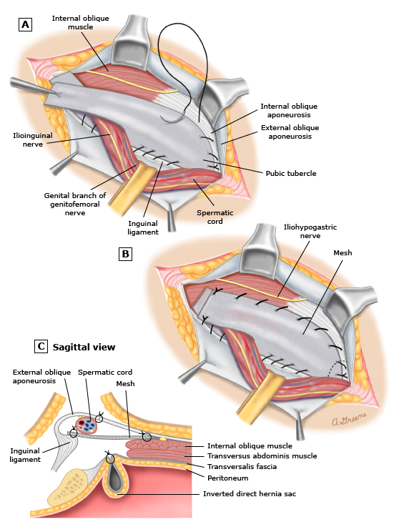
Lichtenstein technique
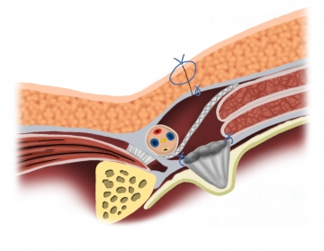
Plug and patch repair
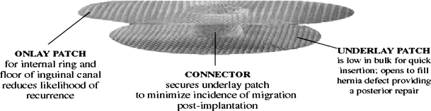
Prolene Hernia System
ADVENT OF LAPROSCOPIC TECHNIQUES
Laparoscopic inguinal hernia repairs use a posterior approach to reinforce the abdominal wall. Principal laparoscopic methods include the transabdominal preperitoneal (TAPP) repair, the totally extraperitoneal (TEP) repair, and the less commonly performed intraperitoneal onlay mesh (IPOM) repair.
Most surgeons are in concordance that the laparoscopic approach to bilateral / recurrent inguinal hernias is much superior to the open approach^{[12]}. International Endohernia Society (IEHS) guidelines provide a Grade A recommendation that TEP and TAPP are preferred alternatives to Lichtenstein repair for recurrent hernias following open anterior repair.^{[13]}
Port placement in TAPP(A) & TEP(B)
The transabdominal approach(TAPP) accord the advantage of an intraperitoneal perspective, which is advantageous for bilateral hernias, large sized hernia defects, and any scarring from previous lower abdominal surgery. For bilateral inguinal hernia repair, bilateral peritoneal incisions are advocated, leaving a midline bridge of tissue to circumvent injuring a potential patent urachus. The lower edge of incised peritoneum is retracted, and the preperitoneum is dissected to expose the spermatic cord. If a direct hernia is stumbled upon, the sac is inverted and fixed to Cooper’s ligament to prevent development of seroma or haematoma. An indirect hernia sac will usually protrude anterior to the spermatic cord. In such case, the sac is grasped and elevated upwards from the cord and the space below is built bluntly to allow the placement of the mesh. The sac is then dissected from its adhesions and the cord skeletonized. The mesh is then rolled along its length and placed through the 12-mm trocar and it is then unrolled in the preperitoneal space .The prosthesis is then secured with staples, glue or tack.The medial edge is tacked or stapled to the soft tissue around the contralateral pubic tubercle and the symphysis pubis. The medial , inferior border is attached just above Cooper ligament. Following this the prosthesis is secured along the superior border to the posterior rectus sheath and transversalis fascia around 2cm above the hernia defect. The last step is the closure of the prosthesis by closing the peritoneum with sutures, staples, tacks or glue.
Incision of peritoneum Entering lateral inguinal space Hernial sac dissection
Pseudosac dissection in direct hernia Mesh is rolled and inserted Smoothed out mesh
Mesh is fixed to Cooper’s Ligament Securing the superior border of mesh Peritoneal closure
Totally Extraperitoneal Procedure(TEP).The primary advantage of the TEP repair is the access to the preperitoneal space without infiltration of intraperitoneal space. This approach consequently minimizes the risk of injury to intra-abdominal organs and port site herniation via an iatrogenic defect in the abdominal wall. Similar to TAPP, TEP is indicated for repair of bilateral inguinal hernias or also for unilateral hernias when scarring makes the anterior approach formidable. A minute horizontal incision is made inferior to the umbilicus. Subcutaneous tissue is then dissected upto the level of the anterior rectus sheath, which is then continued lateral to the linea alba.The rectus muscle is retracted superolaterally followed by advancing a dissecting balloon through the incision toward the pubic symphysis. Utilizing a 30° laparoscope, the balloon is inflated slowly to bluntly dissect the preperitoneal space . The dissecting balloon is substituted with a 12-mm balloon trocar, and pneumopreperitoneum is accomplished by insufflation to 15 mmHg. Next a 5-mm trocar is positioned suprapubically in the midline, and another trocar is placed inferior to the insufflation port. Following this the patient is placed in the Trendelenburg position, and the surgery proceeds in an identical fashion to TAPP.
The balloon is then inflated to create a working space
Preperitoneal space dissection-the balloon dissector is inserted into the preperitoneal space amd advanced to the pubic symphysis

The balloon deflated , removed and replaced with a Hasson or Balloon tip cannula. The preperitoneal working space is visualized with the laproscope and other ports are placed
Blunt graspers and gentle traction are used to reduce indirect sacs as they course with the cord structures through the internal inguinal ring

Intraperitoneal Onlay Mesh Procedure(IPOM) IPOM procedure allows the posterior approach without the need for preperitoneal dissection. It is a lucrative procedure in cases where the anterior approach is unfeasible as in recurrent hernias which are refractory to other approaches, or in cases of extensive preperitoneal scarring which would make TEP or TAPP challenging. In this the sac itself is not inverted from the preperitoneal space, instead a mesh is placed directly over the defect and fixed with sutures or spiral tacks.

NOVELISTIC APPROACHES TO HERNIA REPAIR

Desarda technique The Desarda technique of inguinal hernia repair utilizes live muscle tissue adjoining the hernia site to repair and reinforce the weakened space. The synthetic mesh material is not used in this operation. A strip of live muscle tissue is separated from the external oblique aponeurosis but keeping its insertion and continuity with the parent muscle intact. This strip is tacked to the inguinal ligament below and the internal oblique muscle or aponeurosis above. This strip of natural tissue now over rides the area of the hernia in the posterior wall of the inguinal canal. The main advantages of this technique of repair is that it is performed with the patient's own tissue(natural tissue repair), avoidance of entry into the abdomen and negligible injury to intestine or any major blood vessels, low risk of infection or major complications and it can also be done under local or regional anesthesia.^{[14,15]}
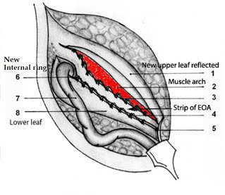
Desarda Technique
NOTES Natural orifice transluminal endoscopic surgery (NOTES) continues to be experimented as a future alternative for general surgery. Advocators of this approach claim a potential advantage in cosmesis, reduced pain, early return to routine work, decreased port site complications, and more specifically better advantages in the obese population. However contrary to this some surgeons concord that NOTES operations for hernia repair aggravate the risk of major complications, and these techniques should strongly be considered only experimental for now and performed under strict institutional research protocols.^{[16]}

Robotic surgery The utility of the da Vinci robot has amplified since its approval by the Food and Drug Administration in 2000^{[17]}. Originally applied for hysterectomy and prostatectomy, it is being nowdays used for an increasing number of general surgery procedures like Nissen fundoplication, single site cholecystectomy, colectomy, and ventral or incisional hernia repair. The highly magnified, three-dimensional, high-definition field of vision, computer-aided elimination of hand tremor, and seven degrees of freedom at the distal ends of the instruments with superior maneuverability, have led to its increasing acceptance ^{[18]}. Majority surgeons are currently utilizing the robot simply to suture the hernia defect closed, and thus place the mesh as an intraperitoneal onlay. The main advantages include short hospital stay, lesser blood loss and less infection rates.^{[19]}
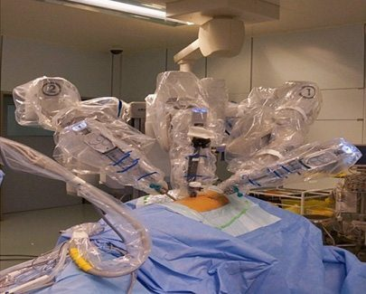
Da Vinci Robot
ADVANCEMENTS IN MESH
The mesh materials have been segregated based on their biological response and general characteristics. The broader categories includes non-absorbable and synthetic, non-absorbable and synthetic with a barrier, synthetic and partially absorbable, combined and biological materials.
Non-absorbable and synthetic materials
Polypropylene(PP) is a nonabsorbable polymer which is available in both coated and uncoated forms but the main disadvantage is its weight where in the abdomen is presented with more foreign body and its consequent intense inflammatory response leads to side effects and complications like formation of thick scar and contraction of the mesh which often lead to hernia recurrence as the mesh “shrinks”. Now days light weight PP mesh has been introduced to overcome the complication of higher weight.^{[20,21]}.
Polyester This mesh is selected for hernia repair mainly to improve conformability and avoidance of tissue in-growth with the abdominal wall. Its biological response in aspects of scar formation, complications and side effects are similar to PP mesh. It has been seen to degrade over time,more frequently during infections, therefore claiming for hernia repair.^{[22]}
Expanded polytetrafluoroethylene (ePTFE) Its usage is generally restricted to surgical situations where visceral adhesion is of primary concern. This mesh has smaller pore sizes and it is this property that inhibits intestinal adhesion and also hampers tissue in-growth in the abdominal wall eventually resulting in encapsulation, thus leading to weaker hernias repair^{[23]}.Its main advantages lie in the fact that it exhibits negligible inflammatory reaction and comparatively thinner scar density.^{[24]}
Non-absorbable and synthetic materials with a barrier
Prosthesis with barrier which can either be absorbable or non-absorbable are used for preventing bowel adhesions when placed intraperitoneally. The primary function of the barrier is to minimize the biological response and provide limited opportunity for initial adhesion of the material to the wall thereby reducing the activation of inflammatory cytokines and cells. The possible barrier materials are ePTFE, polyurethane, oxidised regenerated cellulose, omega-3 fatty acids, collagen and beta glucan. Numerous studies have shown the anti-adhesive properties of these compounds and holds true both with physical (non-absorbable) or chemical (absorbable) barriers.^{[25,26]}

Synthetic and partially-absorbable meshes

The need of constructing a partially absorbable mesh was mainly to reduce the density of the biomaterial and its subsequent reduced inflammatory reaction while maintaining the intraoperative handling characteristics and long-term wound strength. Currently available partially absorbable meshes are developed with a fusion of non-absorbable (PP) and absorbable materials for eg poliglecaprone 25,polyglactin 910 and Polyglycolide copolymer .Advantages of this kind of mesh material are less fibrosis and reduced structural change.^{[27]}

Combined Meshes

Polyester and PTFE combined meshes have been invented with the former allowing the abdominal wall tissue in-growth and the later preventing the occurrence of intestinal adhesion through different pore size of the mesh.

Newer biological meshes

The primary interest for the advent of biological mesh is to overcome the problems of synthetic meshes and to provide better mechanical support and smoother tissue remodeling along the mesh scaffold so as to create highly organized collagen network resulting in establishing a new vascular access to the hernia site which is achieved by taking collagen rich tissues from human or animals, stripping them off the cellular contents and thereby stabilizing the resultant extracellular protein structure which acts as a collagen scaffold for the in growth and deposition of fibroblast and collagen respectively .^{[28]} These materials induce angiogenesis for the remodeling of the tissue resulting in lesser infections .They also have a fairly good success rate for retrieving contaminated and infected fields, particularly when placed with wide overlap.^{[29,30]} The primary drawback lie in the fact that they have lower tensile strength and subsequently higher rates of rupture than the synthetic prostheses^{[31]}. They also known to have varying degrees of tissue biocompatibility and tensile strength between them. Among the biological meshes the cross-linked graft materials are more durable and less prone to failure than the non–cross-linked grafts^{[32]}.
SUMMARY
Inguinal hernia repair continues to change, through a combination of newer and better, more innovative surgical techniques and improvements in technology, such as self-fixing sutureless systems that improve patient experience by reducing postoperative pain. Conventional methods have had a wide success in the past and progress in this field of surgery has largely involved ‘fine tuning’ or modifying a spectrum of intraoperative and postoperative factors to maximize surgeon and patient satisfaction. With the introduction of synthetic meshes, improvements continue to evolve in the aspects of design and materials. The adoption of minimally invasive surgery has been another aspect of progress although the comparative success of these techniques has been limited by its availability and the cost-effectiveness factor. This has led to the concurrent use of both conventional and newer methods. The common focus for all these advances is an improvement in patient care manifested as reduction in postoperative morbidity and more importantly a quicker return to daily activities.
REFERENCES
- Fitzgibbons RJ, Richards AT, Quinn TH. Open hernia repair. In: Souba WS, Mitchell P, Fink MP, Jurkovich GJ, Kaiser LR, et al., editors. ACS Surgery: Principles and Practice. 6th ed. Philadelphia, USA: Decker Publishing Inc; 2002. pp. 828–849.
- Ruhl CE, Everhart JE. Risk factors for inguinal hernia among adults in the US population. Am J Epidemiol. 2007;165:1154–1161.
- Gould J. Laparoscopic versus open inguinal hernia repair. Surg Clin N Am. 2008;88:1073-1081.
- Abramson JH, Gofin J, Hopp C, et al. The epidemiology of inguinal hernia. A survey in western Jerusalem. J Epidemiol Community Health. 1978;32:59.
- Rutkow IM. Epidemiologic, economic, and sociologic aspects of hernia surgery in the United States in the 1990s. Surg Clin North Am. 1998;78:941.
- Spaw AT, Ennis BW, Spaw LP. Laparoscopic hernia repair: the anatomic basis. J Laparoendosc Surg. 1991;1:269.
- Fitzgibbons RJ Jr, Giobbie-Hurder A, Gibbs JO, et al. Watchful waiting vs repair of inguinal hernia in minimally symptomatic men: a randomized clinical trial. JAMA. 2006;295:285.
- Van den Heuvel, Dwars BJ, Klassen DR, et al. Is surgical repair of an asymptomatic groin hernia appropriate? A review. Hernia. 2011;15:251-259.
- Amid PK, Shulman AG, Lichtenstein IL. Critical scrutiny of the open "tension-free" hernioplasty. Am J Surg. 1993;165:369-371.
- Gilbert AI. Sutureless repair of inguinal hernia. Am J Surg. 1992;163:331.
- Millikan KW, Cummings B, Doolas A. The Millikan modified mesh-plug hernioplasty. Arch Surg. 2003;138:525.
- Voyles CR, Hamilton BJ, Johnson WD, et al. Meta-analysis of laparoscopic inguinal hernia trials favors open hernia repair with preperitoneal mesh prosthesis. Am J Surg. 2002;184:6.
- Bittner R, Arregui ME, Bisgaard T, et al. Guidelines for laparoscopic (TAPP) and endoscopic (TEP) treatment of inguinal hernia [International Endohernia Society (IEHS)].Surg Endosc. 2011;25:2773-2843.
- Szopinski J, Dabrowiecki S,Pierscinski S,Jackowski M,Jaworski M, Szuflet Z ..Desarda Versus Lichtenstein Technique for Primary Inguinal Hernia Treatment: 3-Year Results of a Randomized Clinical Trial. World J Surg. 2012; 36(5): 984–992.
- Philipp M, Leuchter M, Lorenz R, Grambow E, Schafmayer C , Wiessner R..Quality of Life after Desarda Technique for Inguinal Hernia Repair—A Comparative Retrospective Multicenter Study of 120 Patients . J Clin Med. 2023 Feb; 12(3): 1001.
- Vorst AL, Christodoulos K, Carbonel AM ,Franz MG .Evolution and advances in laparoscopic ventral and incisional hernia repair.. World J Gastrointest Surg. 2015 Nov 27; 7(11): 293–305.
- Finnerty BM, Afaneh C, Aronova A, Fahey TJ, Zarnegar R. General surgery training and robotics: Are residents improving their skills? Surg Endosc. 2015
- Allison N, Tieu K, Snyder B, Pigazzi A, Wilson E. Technical feasibility of robot-assisted ventral hernia repair. World J Surg. 2012;36:447–452
- Warren JA, Cobb WS, Ewing J, Carbonell AM. Prospective, observational, cohort study of robotic Rives-Stoppa retrorectus incisional hernia repair. 1st World Conference on Abdominal Wall Hernia Surgery; Paper presented at: Hernia Repair 2014, Americas Hernia Society. Las Vegas, NV, March 12-15; 2015. pp. Apr 25–29; Milan, Italy.
- Cobb WS, Kercher KW, Heniford BT. The argument for lightweight polypropylene mesh in hernia repair. Surg Innov. 2005; 12: 63–69.
- Robinson TN CJ, Schoen J, Walsh MD. Surgical Endoscopy. 2005; 19: 1556–1560.
- PB Matthews BD, Pollinger HS, Backus CL, Kercher KW, Sing RF. Heniford BT. J Surg Res. 2003; 114: 126–132
- Woloson SK, Greisler HP. Biochemistry, immunology, and tissue response to prosthetic material. In: Bendavid R, Abrahamson J, Arregui ME, Flament JB, Phillips EH, et al editors Abdominal wall hernias. Principles and management. New York: Springer-Verlag; 2001; 201–207.
- McGinty JJ, Hogle NJ, McCarthy HA, Fowler DL. Comparative study of adhesion formation and abdominal wall ingrowth after laparoscopic ventral hernia repair in a porcine model using multiple types of mesh. Surg Endosc. 2005; 19: 786–790.
- Bellon JM, Garcia-Honduvilla N, Serrano N, Rodriguez M, Pascual G, Bujan J. Composite prostheses for the repair of abdominal wall defects: effect of the structure of the adhesion barrier component. Hernia. 2005; 9: 338–343
- Bellón JM, Serrano M, Rodríguez M, García Honduvilla N, Pascual G, Buján J. Composite prostheses used to repair abdominal wall defects: physical or chemical adhesion barriers?. J Biomed Mater Res B Appl Biomater. 2005; 74: 718–724.
- Wolloscheck T, Gaumann A, Terzic A, Heintz A, Junginger T, Konerding MA. Inguinal hernia: measurement of the biomechanics of the lower abdominal wall and the inguinal canal. Hernia. 2004; 8(3): 233–241
- Baldwin HS. Early embryonic vascular development. Cardiovasc Res. 1996; 31: E34–E45.
- Deprest J, De Ridder D, Roovers JP, Werbrouck E, Coremans G, Claerhout F. Medium term outcome of laparoscopic sacrocolpopexy with xenografts compared to synthetic grafts. J Urol. 2009; 182: 2362–2368.
- Bachman S, Ramshaw B. Prosthetic Material in Ventral Hernia Repair: How Do I Choose?. Surg Clin N Am. 2008; 88: 101–112.
- Earle DB, Mark LA. Prosthetic material in inguinal hernia repair: how do I choose? Surg Clin North Am. 2008;88:179.
- Smart NJ, Bloor S. Durability of biologic implants for use in hernia repair: a review. Surg Innov. 2012;19:221-229.

