English Vocabulary and Recycling Numbers on Plastic Containers
Lieutenant Dr. Vanisree Adoni
Assistant professor of English
Kamala Institute of Technology and Science, Singapur
Huzurabad, Karimnagar, Telangana
vanimbnr@gmail.com
Introduction
In all walks of life, plastic has become an indispensable part. One cannot imagine without plastic in this world. Whatever we buy in the markets: they are either plastic wrapped or the seller wraps in plastic, before giving it to the customer. And in the same manner correct usage of English language plays a predominant role in every sector of the society. Whatever may be the age, educational qualification, profession and geographical area, English language is used everywhere.
An effort is made to connect the English language while learning about numbers on plastic containers. This paper also deals with information about chemicals used in making plastic and consequences of using them and how hazardous to humans in particular and nature too.
While the use of all plastics should, testbook.com describes the usage o f ‘should’ and ‘must’ as follows: must is stronger than should and ought. It is more like an order. Should and ought to, on the other hand, are more like pieces of advice. (advice is a noun - guidance and advise is a verb -recommend) be limited, if at all possible, should be avoided. Not all the plastic containers but, only a few plastic objects have a recycling symbol. That means the objects without recycling numbers are not to be used. Below is a picture from a blog, plasticsforchange.org that briefs about, “The 7 Different Types of Plastic”: 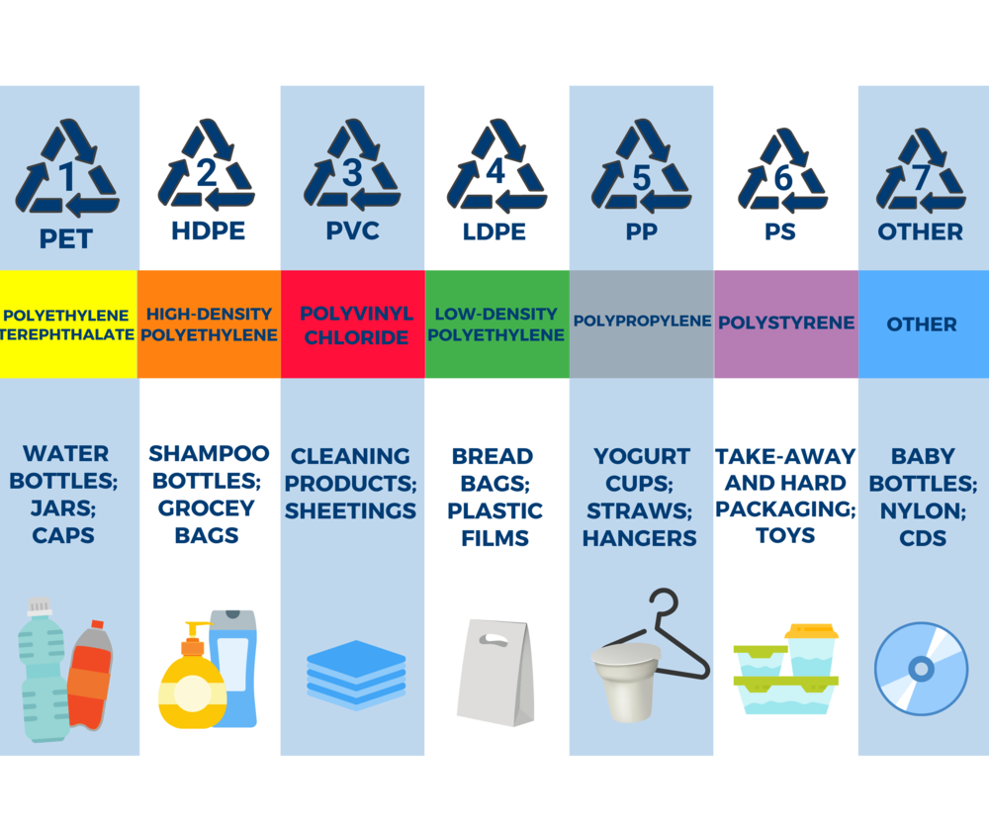
One can see triangle symbol mostly at the bottom of a plastic containers with numbers ranging from 1 to 7 (these are the common numbers). But the disastrous thing is we never heed towards them. According to en.wikipedia.org, these numbers inform every individual that, what chemicals are added actually and how hazardous it is. (actually -indicates the fact and really -intensifies the aim at emphasizing). And how the plastics containers leach into the substances in them (leach- leak, parasite)? They even tell whether that particular plastic is biodegradable or not. And ultimately (synonyms- finally, eventually) how safe the plastic is? Prepositions, like after, as, before, if, since, that, though, unless, until, when, and while are followed “,”. And do use a comma before and if it precedes an independent clause. And a serial comma eliminates the possibility of misreading, so even if one is not using serial commas in writing. And one more fact is that many get confused about usage of single (‘’) and double (“ ”) quotation marks. One can use double quotations marks to refer titles of books, movies, shows, for speciation of any words and single quotation makers are to quote within quotations.
Semicolons “;” are used to separate things in a list or to connect two closely related independent clauses. For example: I enjoy gardening; it helps me relax after a long day. (Prasad Rao, 2004). On the other hand, a colon, ought to be used for a more specific and direct correlate sentences. It highlights, an illustration, or a clarification. For example: Our religious literature, one finds instances of curses having been pronounced by certain Saints: A saint said something ill for a person and came to pass. Another informative example is, not to capitalize the first word after a semicolon.
Numbers ranging from 1 to 7 in Recycling Symbol are clearly discussed below:

#1 – PETE or PET (Polyethylene Terephthalate) :
According to Wikipedia, Hash tags (#) are used to index keywords or topics. They are referred to a method to categorize the information so that it is convenient to find information on social media platform.
Plastic #1 is picked up, here, ‘d’ in ‘picked’ is pronounced as ‘t’, by mainly curbside reprocessing and is usually clear and used, here, ‘s’ in the word ‘used’ pronounced as ‘Z’ , to make soda bottles and water bottles. myenglishpages.com explains this contracted word with examples: It is or it has can written as “it’s”, as it is a contraction form . For instance, it’s a sunny day. Moreover, it is a form of possessive pronoun expressed as “its”. One of the illustrations is, the baby drank its milk. PET is mostly used in bottles of soda, water, beer, and for containers of food and dressing salad and mouthwash bottles.
PET may be considered as harmless to some extent, but allows bacteria to gather. It is hard to clean, and absorb flavors. And one should avoid reusing, as it is not intended for multiple uses.
These are used to make tote (a bag or a basket used to carry things), paneling, carpet, fiber, polar fleece (soft napped insulating fabric made from polyester) etc.
#2–HDPE (High Density Polyethylene)
HDPE is simply recycled and are generally dense. These are safe to use and has a lower risk of leaking and transmits no known chemical in food.
HDPE is mostly used in making milk jugs, there is a difference between the words jug and mug. wikidiff.com explains as, a jug is bigger than a mug. A jug usually holds up to a liter of liquid and is also used if one wants to store a drink in the fridge for a few days. And a mug is just a cup with a handle, usually used to drink coffee or tea. HDPE is also found in shampoo, juice and household containers, cereal box liners (liners -inside layer), etc. accelpolymers.com states that, polyethylene is frequently recycled in making of household things like furniture, toys pipes etc. grammarist.com defines, the difference between Lumber and lumbar along with pronunciation: lumber-move in a slow, heavy, awkward way. and lumbar-relating to the lower part of the back, both pronounced same as /luhm-buh/ .
#3: Polyvinyl Chloride (PVC)
PVC is utilized for a lot. New world Dictionary defines as, a lot, which is often misspelled as alot, means “a large number or quantity” or “very much of plastic food wrapping because of its softness and flexibility. Sheila Y. Oliver (2023)states that, Phthalates (/ˈθæl.eɪt/ /θ/ as in think, /æ/ as in hat, /l/ as in look, /eɪ/ as in day, /t/ as in town) effects children's health and interferes in development of natural hormone functioning and birth of defected infants particularly male, problem of liver, and premature puberty in female and middle age breast and testicular cancer.
There are many programmes on saying no to plastics usage. By conducting awareness programmes and exhibition cum sale on usage of glass, clay, and wooden containers and cloth made bags and dolls is helping a lot not only to cottage industry but also protecting the environment. As PVC products are hazardous to nature and living beings avoid them is the best solution regarding foodstuff or children’s use. They contain venom that leaks all through. Its continuous usage leads to different types of ailments in human beings like- breast cancer, attention- deficit, asthma, hyperactive, II diabetes, phthalates, obesity etc.
It is recycled into household objects.
#4: LDPE (Low-Density Polyethylene)
LDPE is usually, commonly confused and wrongly used words are normally, generally, commonly- Normally is a synonym of usually. Webster's dictionary.
Defines, as adverbs the difference between usually and normally are, that usually is most of the time; less than always, but more than occasionally while normally is under normal conditions or circumstances; usually; most of the time, found in shrink wraps, dry cleaner garment bags, and other items.
Even though the recyclers are trying to find a solution, but breaking down synthetic plastic is a problem as it can generate pollution. So avoiding may be the best solution.
LDPE can be reused and safer for different purposes, but adopting the methods of using naturally made articles is healthier one. Newworld Dictionary of the American world, Second College Edition defines, Adept -highly skilled, expert Adapt- to make fit or a situation by changing or adjusting. Adopt usually means -to take something legally as your own, for use in a different purpose). It transmits no known chemical in food. And also is used in packing eatables, shopping bags and containers.
#5: PP (Polypropylene)
Polypropylene is used in margarine (/mɑːdʒəˈriːn/,), cambridge.org gives the definition as, grease made from animal fats or vegetable oil. It is recyclable. PP is considered safe for reuse. As it transmits no known chemical in food, it is safe to use. calrecycle.ca.gov says that, PP has the following properties:
- Fairly low physical properties 2. Fairly low heat resistance 3. Excellent chemical resistance and 4. Easy processing PP is found in lining of cereal container, nappies, bottles caps, households wares, etc. Merriam-webster.com defines, Yogurt is a fermented slightly acid often flavored semisolid food made from. In India we call it curd. everydayrecycler.com states that, recycled polypropylene can be made into, includes: 1.Kids toys 2. Cutting boards 3. Buckets and storage bins 4. Brooms, brushes, and garden rakes 5. Furniture 6. Flower pots 7. Fabric for bags and clothing 8. Sunglasses and Items used in the automotive industry, e.g., such as bumpers
#6: PS (Polystyrene)
The plastics with these recycle numbers contain polystyrene and should be avoided. Polystyrene is used for disposable Styrofoam, (it is of lightweight, durable foam), take-out containers (food packed in paper, paperboard, corrugated (uneven) fiberboard, plastic, or foam food containers), packing materials, and more.
Styrofoam, a kind of expanded polystyrene used especially for making food containers. It breaks apart so easily. Michelle Rose Rubiot (2021) states as follows: They are risk to the health of human beings because we are at zenith of food cycle. As styrene monomer is utilized in manufacturing. mon·o·mer is a molecule, bonded to other like molecules to form a polymer. Monomer is derived either from petroleum or natural gas, both of which are non re renewable and rapidly depleted, creating environmental sustainability problems.
One should avoid reusing! Webster’s dictionary states that, the exclamation mark, “!”, expresses surprise, strong emotion or determination etc. englishstackexchange.com states that, if “etc.” is at the end of a sentence , the period “.” is applicable for both the sentence and the abbreviation.
The chemicals in polystyrene are associated to human reproductive system dysfunction. The styrene may possibly leach into food products particularly while heating using microwave! And this lead to human carcinogen, (substance causes cancer in living tissue). skillsyouneed.com states, that, there is no need of putting a full stop at the end of a sentence because exclamation is an end in itself.
Polystyrene can be recycled into household wares, optical disc packing, disposable articles and also for insulation purposes. #7: Polycarbonate, BPA, and Other Plastics
In a blog by nontoxicrevolution.org explains that, recycle number 7 is everything that is composed of different types plastics, that may include bioplastics also. Highly toxic BPA (Biphenyl A) and Polycarbonate belong to this category. So, one must avoid any food or drink filed in such articles containing BPA. In general, number 7 plastics cannot be recycled in curbside recycling bins, because it is the combination of many plastics. non toxicrevolution.org further says, that
#7: can be reused into equipment for medical and sports , few vehicle parts and also utilized in electrical wiring.

CONCLUSION
In present condition one may find difficulty and rather impossible to avoid plastic in modern society, one should reduce using plastic. This can be done by bringing awareness programmes. Encouraging, the public to use cotton bags, glass or wooden articles, may serve the purpose to some extent. But, compelling to stop plastic usage is all the same, when compared to students, to use English vocabulary and to pay fine for not using. For example, instead of compelling students to learn English vocabulary: a small piece of any informational text like above, certainly helps to increase vocabulary and knowledge about punctuation.
Further one must remember that, recycle symbol #2, #4 and #5 are relatively safer. Still, must be avoided to utilize in oven, even though they are microwavable safe. Products with recycling codes #3, #6 and #7 plastic must be hardly ever used, especially with food and drinks. #1 plastic isn’t very bad but one must store it in a cool environment and it shouldn’t be reused. Greg Seaman suggests, avoiding these items as they leach chemicals and harmful to consume the food packed in them.
So let's, grammarly.com defines, let’s: let us, often use to make suggestions which include ourselves, Let: permission and (‘-’ used to join words, or parts of words, in compound modifiers, one adjective in describing a noun.) all take an oath together to Avoid Plastic, Arise Cleanliness and Awaken Happiness.
References: Retrieved on 12 July 2023 from testbook.com/key-differences/difference-between-should-ought-to-and-must
Retrieved on 2 June 2023 from www.plasticsforchange.org
en.wikipedia.org/wiki/Recycling_codes
Rao.Prasad, N.D.V, S. Chand & CompanyLtd. 2004. ‘When should I use a colon or semicolon? High school English Grammar & Composition by Wren &Martin’ pg
Retrieved from en.wikipedia.org/wiki/Hashtag dated 10 July 2023.
Retrieved 1 July 2023 from ww.myenglishpages.com/english/grammar-lesson-contraction.php dated 22 June 2023.
Retrieved on 2 July 2023 from www.askdifference.com/jug-vs-mug/. 13 May 2023
Retrieved on 21 June 2023 from accelpolymers.com/what-can-high-density-polyethylene-be-recycled-into/
Retrieved 21 July 2023 from grammarist.com
Retrieved on 22.07.2023 from Newworld Dictionary of the American world, Second College Edition,
Oliver, Sheila. Lead and Environmental Health Links. Retrived from https://www.state.nj.us/humanservices/opmrdd/health/pvc.html. Dated 12 July 2023
Webster's dictionary. Retrieved on 20 July 2023 https://en.wikipedia.org › ...

Newworld Dictionary of the American world, Second College Edition
dictionary.cambridge.org
https://calrecycle.ca.gov/plastics/markets/ppprofile/ ^{23 June 2023}
merriam-webster.com
Rubio, Michelle Rose. September 3, 2021 ‘ Dealing with Polystyrene Wastes’. Environment, Recycling, Waste Management . https://www.ecomena.org/author/michelle/ dated 13July 2023
english.stackexchange.com Retrived on 10 July 2023. Develop The Skills You Need For Life
www.skillsyouneed.com
Lifestyle, Plastic Sucks! . May 30, 2017 . Retrieved on 22 June 2023 from https://www.non toxicrevolution.org/blog/7-types-of-plastic
Lifestyle, Plastic Sucks! . May 30, 2017. Retrieved on 22 June 2023 from https://www.non toxicrevolution.org/blog/7-types-of-plastic
How to Use a Hyphen Correctly. Retrieved on 15 July 2023 from https://www.grammarly.com/blog/hyphen/

