Bioenergy and Biofuels
- Introduction
  - Climate Crisis and global action
Climate change is one of the key challenges ever to take on humanity. The impacts of climate change are already showing and will escalate over time if left uncurbed. The efforts to reduce greenhouse gases remains inadequate. Even if each current commitments and plans to limit emissions were delivered completely without any delay, global emissions would still keep thriving in the next decade, under the present disposition. More rigorous actions to reduce greenhouse gas emissions, cannot be deferred much longer. In view of the climate crisis, the most recent commitment to climate goals was made at the 26th Conference of the Parties (COP26) held in Glasgow in November 2021 [1]. COP 26 led to the adoption of the Glasgow Climate Pact, which aims to turn the 2020s into a decade of climate action and support. As adaptation to the impacts of climate change is now deemed to be of equal importance to emission reductions, a work programme on climate change adaptation has been developed.

  - Greenhouse gas (GHG) emissions and global warming
Greenhouse gases (GHGs) absorb energy and slow down the rate at which energy escapes to space and thus they behave like a blanket insulating the earth, resulting in warming the earth. Different GHGs can have different effects on the Earth's warming (Figure- 1). The differences in absorbing capacity and the time duration of their stay in the atmosphere vary with the gases. The Global Warming Potential (GWP) gives comparisons of the global warming effects of different gases in the atmosphere. Table -1. depicts the GWP of key gases according to IPCC Fifth Assessment Report, 2014 [2].
GWP : It is a measure of how much energy the emissions of 1 ton of a gas will absorb over a given period of time, relative to the emissions of 1 ton of carbon dioxide (CO2).

At the global scale, the key greenhouse gases emitted are carbon dioxide, methae, nitrous oxide , sulphur hexaflouride, chloroflourocarbon. At the global scale, the key greenhouse gases emitted are carbon dioxide, methae, nitrous oxide , sulphur hexaflouride, chloroflourocarbon.

Fig. -1. Global warming impact of GHGs

Fossil fuel usage is the primary source of CO2. GWP of CO2 is considered as 1 regardless of the time period and is used as the reference. CO2 remains in the climate system for a very long time: CO2 emissions cause increases in atmospheric concentrations of CO2 that will last thousands of years.

Table-1 Global warming potential greenhouse gasses (GHGs)
Green house gases | GWP over 100 years time horizon | Remains in the atmosphere | Sources
Carbon dioxide (CO2) | 1* | 1000s of years | Cumbustion of fossil fuel, cooking
Methane (CH₄) | 28 | A decade on average | Agriculture activities,fossil fuel burning
Nitrous Oxide (N2O) . | 265 | More than 100 years | Fertilizer use, combustion of fossil fuel
Sulfur hexafluoride (SF6) | 23,500 | - | electrical transmission & distribution equipment, manufacture of electronics & semiconductors, production of magnesium
Chloroflourocarbon (CFC) | 15000 | - | Refrigators, air conditioners, sprays, paints,fire extinguishers
*Regardless of time period , used as a reference point.
Some solid particle or aerosol like Black carbon also contribute to the warming of the atmosphere.

- Bioenergy and Biofuels
A new era is dawning when it comes to renewable energy growth. At present bioenergy contributes 55% of total renewable energy supply , a largest source of global energy supply globally. The global statistical consumption data is charted in Fig.-2 [3]. Bioenergy is defined as a renewable energy that is manufactured from biomass. Organic materials such as trees, plants and waste materials come under the broad area of biomass. Bioenergy has received a great interest in recent times because of the hike in fuel prices, rapid depletion of fossil fuels, ecological degradation by fossil fuels leading to an alteration of global climate. Bioenergy and biofuel are the two of the most important terms considered in the reduction of GHG emissions. The word biofuel frequently used interchangeably with bio-energy, which is energy derived from biomass (Biogenic feedstock from renewable sources) such as organic waste like dung, grasses, forest wood etc.

Fig.-2. Statistical review of world energy: 2023 { Sourced from[3]}

Biofuels are fuels used in means of transport in liquid or gaseous states, such as biodiesel , bioethanol , biomethanol and biohydrogen, which are obtained from biomass.

2.1 Classification of Biofuels
Based on the feedstocks they are grouped as the following :
- First-generation biofuel
- Second-generation biofuel
- Third-generation biofuels
- Fourth-generation biofuels
Fuels across generations are summarised in Table- 2.
2.1.1 First-generation biofuels :
The first generation fuel is sourced mainly from food crops or other food products . The production technology mainly focuses on the production of fuel and the remaining part of biomass can be utilized for other purposes.
2.1.2. Second-generation biofuels :
Second-generation biofuels are derived from non-food crop feedstocks, agricultural and forest residue,s lignocellulosic biomass and industrial wastes. They are mainly produced by the processes that utilizes Physical, biochemical and thermo-chemical, technologies. The biomass feed-stock is generally used after treatment.

2.1.3. Third-generation biofuels
The third-generation biofuels are sourced from microalgae. Biofuel generated from the algal oil through transesterification or hydrotreatment process. These biofuel yield can be efficiently increased using these methods. The first generation biofuels that use traditional crops .
The second and third-generation biofuels are put together in advanced biofuels categories as they are still in developing phase. They are derived from resources that are readily available and, most importantly, they don’t affect the food chain, and are flexible towards environmental parameters. These sources are majorly microalgae, oils ( animal, fish, waste cooking ) [4].

2.14. Fourth-generation biofuels
The fourth-generation biofuels use genetically modified organisms (GM) like algae and photo-biological solar fuels and electro-fuels. The Genetic engineering can be helpful in improving traits like biofuel yield, photosynthetic efficiency, increasing algal biomass, product secretary systems which ultimately leads to increase in biofuel yield. Genome editing tools such as clustered regularly interspaced palindromic sequences (CRISPR/Cas9), zinc-finger nuclease (ZFN), transcription-like effector nucleases (TALEN), and c are widely used bioinformatics tools. The fourth-generation solar raw materials are abundantly available, more economical and inexhaustible[5].

Table -2. Generations of biofuel on the basis of feed-stock used

Generations | Sources | Examples | Benefits | Challenges
First | Edible- Food sources | Ethanol or butanol by fermentation of starches (corn, wheat, potato) or sugars (sugar beets, sugar cane)  – Biodiesel by transesterification of plant oils, also called fatty acid methyl esters (FAMEs) and fatty acid ethyl esters. Palmoil,soya bean oil, coconut oil | Simple , cost effective, well established  No intensive pretreatment | Food Vs Fuel conflict  High land use , high freshwater use
Second | Non-food agri-sources and agro-industry wastes | Seed oil : Jatropha, Miscanthus, Switch grass etc.  Waste proucts: Agri -resdiues, forest residues, organic waste include food waste | Valorization of wastes  Bypasses food Vs Fuel conflict | Limited amount of biomass  For the complex nature of feed stocks go through extensive pre treatment
Third | Photoosynthetic living organism | Microalgae, Animal fats, Waste cooking oil | Direct capture of Co2  No land use
Fourth | Diverse, genome edited organism  Photobiological originated | Biofuel from genetic modified organisms,  Photobiologial solar source, Electro-biofuels | -Higher yields, improved efficiency due to genetic improvements  -often included direct use of CO2, Syngas | Higher regulations due to safety concerns

  - Other categories of biofuel
Based on the physical state of biofules under ambient condition, biofuel can be split up into three categories, Solid biofuel, liquid and gaseous biofuel [6]. The three types are summarised in Table-3.
Table 3 : Types of biofuel on the basis of their physical state
Biofuel type | Solid biofuel | Liquid biofuel | Gaseous biofuel
Phase under ambient conditions | Solid form , releases heat and energy upon burning | Liquid form biofuel, can release energy to perform work , very suitable for blending. | Gas form, readily transforms energy, has a low density.
Shape | Definite shape | No definite shape, take the shape of a container | No definite shape, spread through space
Ease of transportation | Easy | Easier than gas form | Difficult owing to the large volume it occupies
Examples | Agri-residues, wood pellets, wood residue, charcoal animal waste, biochar | Biogasoline, biojet kerosene, Biodiesel (Biomethanol  Bioethanol), BTL diesel , Bio-oil | Biogas ,Biohydrogen, biosyngas

Solid biofuels : The solid biofuels are comprised of solid organic, non-fossil biomass of biological origin. . Sources of these biofuel include, residues of agriculture and wood, wood pellets, charcoa,l other renewable organic waste. Biochar is an important example. The application of biomass lies in generation of heat, energy and thus electricity.
Liquid biofuels includes all liquid fuels that can be either triglycerides or lignocellulosic based . origin and are produced by thermal combustion of biomass, fatty acid ester derived from vegetable oil or algae, anaerobic digestion of biodegradable fraction of biomass or biowaste, Liquid biofuel are suitable to be blended with or replace liquid fuels of fossil origin , safer and easier to transport than its gaseous counterpart. Significant examples are biogasoline, biodiesels, bio jet kerosene and other liquid biofuels like bio-oil, BTL diesel.
Gaseous biofuels : that exist in gaseous form under ambient conditions and have low density. They can be produced by the process of thermal combustion of biomass (Pyrolysis or gasification)or anaerobic digestion of biomass. These biofuels can readily transmit heat and energy and can be transported through pipes. Significant examples are gaseous hydrocarbons (Biogas), Biohydrogen.
- Technologies for Biomass to energy conversion
The fundamental advantages of using biomass is its renewable nature , less damaging to the environment due to low emissions of GHG gasses and economically more viable as compared to fossil fuels. The conversion methods for biomass depends on the nature of the feedstocks. The methods of production of biofuels varies and relies on factors like energy density, moisture content, size, and their supply [7]

The biomass conversion to produce energy is accomplished by two major processes:
  - Thermo-chemical conversion
  - Biochemical (or biological) conversion

The biomass is converted via these processes to obtain primarily three forms of products, biofuels, heat and power [Figure 2].

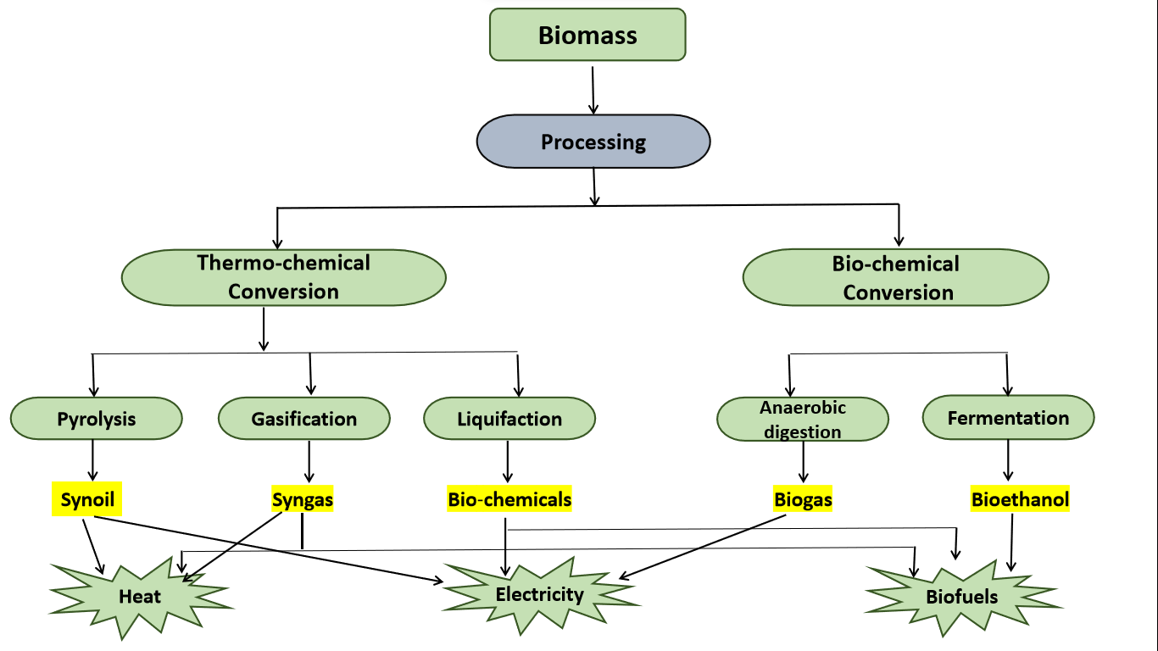
Fig.-2. Various processes depicting biomass conversion

3.1. Thermo-chemical processes
The biomass, majorly bio-oils obtained after thermo-chemical conversion, has major importance in fuel industries as alternative sources of fuels and chemicals.
3.1.1. Pyrolysis : Pyrolysis entails heating of organic material in the absence of oxygen to break the long-chain molecules to their respective short-chain [7]. Pyrolysis is one of the primary biomass conversion processes in the production of biofuels. To produce concentrated fuel as well to recover bio-fuels with medium-low calorific value, fast pyrolysis has given striking results. Primary feedstock such as biomass or organic are generally used to produce syngas and liquid fuels in variable process conditions. Biomass pyrolysis generates fuels like charcoal, biodiesel, bio-oil, methane, and hydrogen.

3.1.2. Gasification : Gasification is heating organic materials at a high temperature (between 800°C and 900°C) along with supply of controlled amounts of free oxygen / steam into the reactor to produce a mixture of gases i.e. syngas which is rich in carbon monoxide and hydrogen. Syngas as a fuel can be utilized for generating electricity in gas turbines, for diesel engines, and for heating purposes. Syngas is prepared to produce liquid fuels via Fischer–Tropsch process. Hydrogen can be produced from syngas by separating it the from other components in syngas which can be further used a fuel. [8]

4.1.3. Liquefaction : Liquefaction entails converting of Biomass (organic material) into stable liquid hydrocarbons under high hydrogen pressure and low temperature [9]. Air-dried wood produces bio-oils constitute a complex mixture organic compounds such as alcohols volatile organic acids, aldehydes, ketones, furans, phenols, ethers, esters, hydrocarbons under the high-pressure liquefaction. To produce products with higher energy density in the liquid phase catalytic liquefaction is an efficient process. The catalytic conversion is assisted by using a catalyst or under high hydrogen partial pressure. Still, this application poses many technical issues and has narrowed the utilisation of the process.

  - Biological conversion of biomass utilizes processes like fermentation and anaerobic digestion for the synthesis of ethanol and to produce biogas respectively.

Trans-estrification A chemical conversion process known that is used for converting vegetable oils, animal fats, and greases into fatty acid methyl esters (FAME) to produce biodiesel.

It also forms in and may be captured from solid waste landfills. These renewable fuels are utilized as a substitute for fossil fuels.. Table- 4. lists some of the key organisms responsible for biological conversion.

Table-4. Biological conversion : Process and Organisms
Process | Microranism | Final products
Hydrolysis | Sacchromyces Sp,  Clostridium Sp | Simple sugar, Amino acids, Fatty acid, glycerol
Acidogensesis | Psuedomonas Sp Stapylococcus Sp | Acid, Alcohol, Gasses
Acetogenesis | Propionobacterium Sp. , Actinomyces Sp. | Acetic acid and Gasses
Methanogenesis | Methanobacterium Sp.Methanococcus Sp. | Gaseous fuels
3.2.1. Anaerobic digestion:
It involves the use of microorganisms in oxygen-free environments to break down organic material and releases methane (a carbon-rich biogas), hydrogen sulphide and heat. It’s a multistage process that involves hydrolysis to break down complex organic matter into simpler ones (sugar , amino acids) using certain kinds of bacteria followed by the conversion to Carbon dioxide, hydrogen, ammonia and organic acids by another set of bacteria under certain temperature conditions (0° C and up to 60° C). The process takes several days and involves use of feed stock from crop residues, food waste and manure. The process is considered the most energy-efficient and eco-friendly for the production of biogas. [10]
Anaerobic digestion is often used in wastewater treatment and to reduce emissions from landfills.

3.2.2. Fermentation
It is an anaerobic and is commercially utilized to produce ethanol (bioethanol) from carbohydrate sources such as sugarcane, wheat and sugar beet.
The process involves breaking down of saccharides followed by conversion using enzymes and yeast to produce ethanol and finally, the product gets purified via distillation. The solid residues remains can be utilized as animal feed, fuel run boilers ( e.g. sugarcane product), and or gasification purpose. Sugarcane is preferred as feedstock for its high energy potential of residues and high productivity[7].
Apart from the above mentioned crops, the lignocellulosic biomass such as wood, grasses are also used, but these compounds have a more complex structure (due to the presence of longer-chain polysaccharides). Therefore, it is subjected to acid or enzymatic hydrolysis and then fermented to form ethanol. However, ethanol sourced from lignocellulosic materials is less cost-effective than conversion of starch and sugar crops to ethanol.

- Breakthrough development in bio-energy at a glance
4.1 Biohydrogen (H2)
Green hydrogen is receiving increasing policy attention. Hydrogen has been pegged as the “fuel of the future” . It has a high energy density (120-142.9 MJ/kg), low heating value and, more importantly, it doesn't release greenhouse gases upon burning. These properties make H₂ a more efficient fuel than hydrocarbon-based fossil fuels and are being considered for transportation chemical industries. The global demand for hydrogen was reported to be 94.3 million metric tons per annum in the year 2021. The worldwide demand for hydrogen is anticipated to increase nearly twofold between 2021 and 2030. The International Renewable Energy Agency (IRENA) reports that H2 is produced from a wide range of sources, pegged as the “fuel of the future”. Industrial H2 is majorly derived from steam-methane reforming (SMR), followed by oil and coal gasification (CG). However, steam methane reforming and other fossil fuel-based technologies are neither green nor sustainable ) [11]. Although electrolysis appears to be a clean method of generating hydrogen, it requires a massive amount of energy. If the energy used to split the water atoms into H2 and oxygen (O2) atoms is derived from fossil-based energy, then the process is still far from being carbon-neutral. To be sustainable, H2 must be produced from renewables. Biohydrogen is considered as promising biofuel (energy carrier) as it provides more efficient source of clean energy .
Hydrogen that obtained from biological processes (via microbial routes) is called biohydrogen
4.1.1. Methods of production of biohydrogen
      - Biohydrogen is produced from various eco-friendly processes having biological routes such as biophotolysis of water (Direct biophotolysis & Indirect biophotolysis), , Fermentation (Photo fermentation & Dark fermentation) and Biocatalyzed electrolysis ( microbial electronic cells) briefed in Fig. -3. .[12].
Figure 3 : Biological routes to hydrogen production
Biohydrogen production requires biomass or biogenic materials such as agricultural and forestry residues, organic waste and water, giving a favor over the conflict of food verses fuel, high energy input and cost. Compared to the conventional methods of H2 production, biological routes offer a more eco-friendly and less energy-intensive alternative.

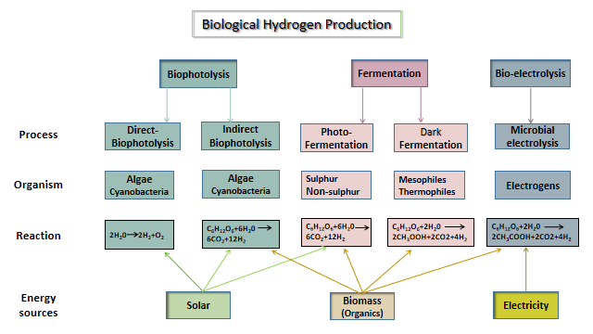
Fig.-3. Methods for production of biological hydrogen

4.1.2. Applications of Biohydrogen:
Biohydrogen has its applications (tabulated in Fig.-4.) [13]. as fuel to reduce the carbon footprints by decarbonising the industries:
- As a fuel to decarbonise transportation system (land, Aviation and marine)
- Decarbonsing the chemical industries, specifically steel and agriculture industries , contributes to maximum GHGs emissions.
- Synthesis of green ammonia, green methanol, green methane etc.
Biohydrogen has shown potential for decarbonising the sectors primarily responsible for greenhouse gas emissions.
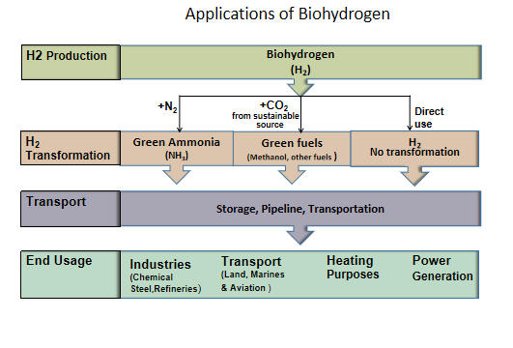
Fig.-4. Applications of Biohydrogen

4.2. Microbial fuel cell (MFC)
In recent years, the microbial fuel cell (MFC) technology has become one of the most representative research hotspots in the bioenergy field. MFC is a type of fuel cell that uses an active microorganism as a biocatalyst in an anaerobic anode compartment for the production of bioelectricity (Power generation from organic substrate in batch and continuous flow microbial fuel cell operations. [14].

4.2.1. The concept of Microbial fuel cell
The basic concept of MFCs is shown in Fig.-5. adapted from [14], comprised of two compartments, anode and cathode, separated by a proton exchange membrane (PEM). The biocatalyst oxidises the carbon source resulting in generation electrons and protons. The generated electrons pass through the external circuit whereas the protons are conducted to the cathode chamber through the PEM. In the cathode chamber, the reaction between electrons and Protons takes place along with parallel reduction of oxygen to water. The active biocatalyst has a pivotal role in oxidizing the carbon sources to generates electrons and protons[15]

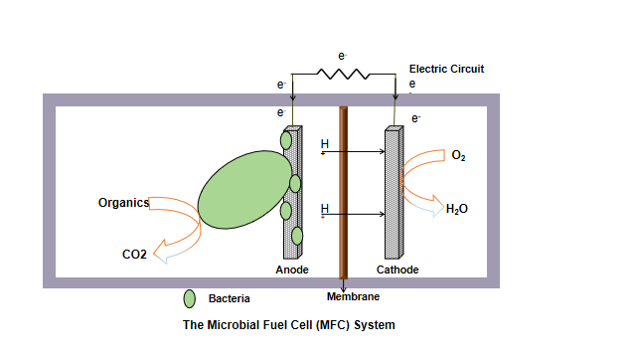
Fig.-5. A typical microbial fuel cell system

4.2.2. Applications of microbial fuel cell (MFC) technology
The MFC technology has shown potential applications as an integrated system for (i) sustainable energy recycling, (ii) sustainable energy recycling, (iii) Waste treatment, (iv) Biomass valorization, (v) Electricity generation, (vi) COD removal, Biosensor and (vii) Production of value-added products. MFC-based biosensors are considered as a portable and cost-effective detection device for bioactive toxicants comparing with other biosensors. However, few challenges in the scaling-up and commercialization of MFC systems need to be overcome. As the operation of MFC systems relies on the utilization of substrates by microbes , the selection of substrates necessarily focuses on the utilization efficiency of specific substrates by specific strains. For the improvement in the substrate availability and electricity generation of electro-chemically active microbes, The technologies like mixed culture and genetic engineering are instrumental .[16]
For the better efficiency in operations of an MFC system, in addition to the reduction of substrate cost , wastewater and LCB (Lignocellulosic biomass ) are potential feedstock to achieve of MFC systems. Modifications in making material of anode and cathode can enhance extracellular electron transfer and oxygen reduction efficiency, respectively , resulting in improvement in the electricity output of MFC systems . Despite the present challenges, MFCs have a tremendous role in scaling up for diverse application systems
Summary
Global energy demand is on the rise due to economic growth and a rapidly growing world population. It correlates with increased ene rgy consumption, as energy is needed in almost every aspect of our lives such as transport , in agriculture, industrial, and domestic sectors. Fossil fuels are still a primary contributor to global energy demand , despite being a major instigator for global warming. However, with increasing demands for renewable source of energy, which is evident from the trends and data that energy production from biogenic sources shares a more promising and stable sources. The guidelines or protocols pursued during production and conversion dictate the efficacy of biofuel industry. New technologies like biochemical, bio-catalyzed electrolysis can replace conventional biofuel production methods that are more eco-friendly and safe. Renewable hydrogen has garnered an unprecedented amount of attention for its potential in reducing carbon footprints. Biohydrogen has an important role to play in energy transition. Its applications are not limited to hydrogen fuel as transport, but has huge utilization in chemical industries like steel and fertilizer. The microbial fuel cell has been regarded as a promising substitute to conventional fossil energy. MFCs have promising future various domains like waste management, energy production, and biomass valorization. Clean fuels, significantly fuel cells and biofuels, as new sources of energy are suitable replacements of traditional fossil fuels.

Abbreviations

BTL- Biomass to liquid
CO₂ - Carbon dioxide
COD- Chemical Oxygen demand
GHG - Green house gases
GWP- Global warming potential
LCB - Lignocellulosic biomass
MFC- Microbial fuel system
NH₃ - Ammonia
PEM - Proton exchange membrane

References :

- https://unfccc.int/conference/glasgow-climate-change-conference-october-november-2021
- https://www.ipcc.ch/assessment-report/ar5/
- https://www.forbes.com/sites/rapier/2023/08/06/global-energy-trends-insights-from-the-2023-statistical-review-of-world-energy/?sh=23197c9a3502
- H.K. Jeswani, A. Chilvers, A. Azapagic (2020).Environmental sustainablility of biofuels: a review . Royal Society Publishing, 476 (2243).
- D.Sharma D.Singh, S.L. Soni, S. Sharma, P. Kumar Sharma, A. Jhalani (2020).
A review on feedstocks, production processes, and yield for different generations of biodiesel . Fuel :262, , 116553.
- Sangita Mahapatr , Dilip Kumar, Brajesh Singh, Pravin Kumar SachanBiofuels and their sources of production(2021). A review on cleaner, sustainable alternatives against conventional fuel, in the framework of the food and energy nexus. Energy Nexus, 4:100036.
- R. Ruan, Y. Zhang, P. Chen, S. Liu, L. Fan, N. Zhou, K. Ding, P. Peng, M. Addy, Y. Cheng, E. Anderson, Y. Wang, Y. Liu, H. Lei, B. Li, Biofuels: alternative Feedstocks and Conversion Processes for the Production of Liquid and Gaseous Biofuels, in: Biomass, Biofuels, Biochemicals, Elsevier, 2019, pp. 3–43.
- WorldBioenergy Association, global bioenergy statistics 2020- http://www.worldbioenergy.org/uploads/201210%20WBA%20GBS%202020.pdf
- N.S. Hassan, A.A. Jalil, C. Hitam, D.V. Vo, W. Nabgan, Biofuels and renewable chemicals production by catalytic pyrolysis of cellulose: a review, Environ. Chem. Lett. 18 (2020) 1625–1648, doi:10.1007/s10311-020-01040-7.
- P. Adams, T. Bridgwater, A. Lea-Langton, A. Ross, I. Watson, Biomass conversion technologies. In: P. Thornley, P. Adams, (eds.) Greenhouse Gases Balances of Bioenergy Systems.Academic Press, pp. 107–139. https://doi.org/10.1016/B978-0-08-101036- 5.00008-2
- IRENA. Hydrogen from renewable power. September. 2018.
- Younas M, Shafique S, Hafeez A , Javed F and Rehman F. (2022). An Overview of Hydrogen Production: Current Status, Potential, and Challenges, 15 : 123317.
- Li W, Cheng C, Cao G and Ren N. Enhanced biohydrogen production from sugarcane molasses by adding Ginkgo biloba leaves (2020). Bioresour Technol ;298(73): 122523. https://doi.org/10.1016/j.biortech.2019.122523.
- Kondaveeti, S.; Mohanakrishna, G.; Kumar, A.; Lai, C.; Lee, J.-K.; Kalia, V.C. Exploitation of Citrus Peel Extract as a Feedstock for Power Generation in Microbial Fuel Cell (MFC). Indian J. Microbiol. 2019, 59, 476–481
- Vinayak, V.; Khan, M.J.; Varjani, S.; Saratale, G.D.; Saratale, R.G.; Bhatia, S.K. Microbial fuel cells for remediation of environmental pollutants and value addition: Special focus on coupling diatom microbial fuel cells with photocatalytic and photoelectric fuel cells. J. Biotechnol. 2021, 338, 5–19.
- ianfei Wang , Kexin Ren , Yan Zhu , Jiaqi Huang and Shijie Liu (2022). A Review of Recent Advances in Microbial Fuel Cells: Preparation, Operation, and Application. BioTech, 11: 44.

