Transdermal Drug Delivery System
of Cardiovascular Drug

Namita V Sanap1 , Sachin B. Somwanshi2 & Kiran B. Kotade3

1. Research Scholar, Department of Pharmaceutics, PRES’s, College of Pharmacy (For Women), Chincholi, Nashik, MH, India-422102 E-mail: sanapnamita1@gmail.com
2. Associate Professor, Department of Pharmaceutics, PRES’s, College of Pharmacy (For Women), Chincholi, Nashik, MH, India-422102 E-mail: sachinsomwanshi27@gmail.com
3. Associate Professor, Department of Pharmacology, PRES’s, College of Pharmacy (For Women), Chincholi, Nashik, MH, India-422102 E-mail: kirankotade@gmail.com

Abstract:

Azelnidipine is a cardiac L type of calcium channel blocker . When administered by orally, undergoes extensive first pass metabolism. When these two drugs are administered via Transdermal rout would reduce deficiencies which associated by oral administration and enhance bioavailability.

In the présent study, Transdermal Patches of Azelnidipine and hydrochorie were developed by différent ratios of Hydroxypropyl Methylcellulose, (HPMC) Eudragit RL-100, Eudragit RS-100 and Ethylcellulose (EC) by solvent evaporation technique. The effet of Dimethyl Sulfoxide (DMSO) on Transdermal Delivery of Azelnidipine was studied.

Ex Vivo drug release was performed on albino rat abdominal skin by use of Franz diffusion cell. The diffused drug was analysed by Uv-Spectrophotomèter. In vivo drug release and importent pharmacokinetics were determined on male albino rats, the released drug in plasma was measured by using HPLC.

The drug- polymer interaction was evaluated by FTIR. All formulations were subjected to physicochemical evaluation tests like drug content, weight variation, thickness, moisture absorption and loss, water vapor transmission rate, percentage of flatness, folding endurance, skin irritation and stability.

INTRODUCTION:

Administered in the traditional forms generally produces bulky range offluctuations in plasma of drug its leads to unwanted effects like toxicity or poorefficiency of drug. This factor further more repeated dosing and irregular absorptionget the approach of the controlled drug delivery (CDDS) [1, 2].

The controlled drug delivery definition reported by V.Sankar [3] as dosagethat deliver one (or) more one drugs regularly in a prearranged pattern for a fixed timeof period, either/or systemically or to a specified target organ. Controlled drug delivery is to provide safety and improve efficacy of drugs, toproduce the patient compliance.

This is achieved by superior control of drug level inblood, reducing dose administration times [2].. A.P. Kakkar and AjayGupta [4] reported definition of Transdermal Drug Delivery systems (TDDS) is selfcontained distinct dosage forms, when it applied on the skin; deliver the drug(s) intocontrolled rate in to systemic circulation.

The first TDDS prepared in 1970s. The first patch of scopolamine was accepted by USFDA in 1979s the active medicament is the scopolamine used to treatthe motion sickness. The transderm scopolamine was described byK.P.R. Chowdary,AbdulAhad and N.Udupa [2, 5,and 6].
The membrane is a polypropylene microporous film; reservoir is a liquid ofscopolamine with combination of polyisobutylene and mineral oil, gives similar effect
as those of i.v infusion. It has surface area.

ADVANTAGE:

- TDDS is to divert the hepatic and pre-systemic metabolism of therapeutic active drug (s)resulting increasing bioavailability.

- To avoid the inconveniences of i.v therapy and risk.

- Once administer TDDS to decreases dose administration intervals and to
- provide desirable sustained, extended drug release for fixated period.

- To provide simple end of drug therapy or treatment.
- .
- To ensure better patient conformity due to elimination of multiple dosing.

- To provide better remedial efficiency by avoiding the fluctuations in peaks plasma drug.

DISADVANTAGE

The following characteristics of drugs cannot be suitable for this route;

- The drug(s) need in high dose to produce pharmacological action not suitable.
- Those drugs cause irritation, dermatological disorders.
- Drugs have higher molecular weight.
- Degradation when passing across skin.
- The skin is different in nature from place to place and from person to person& also with age.

THE HUMAN SKIN:
The human skin average surface area approximately two meters square and its receives 1/3 of blood circulating throughout the body.
The skin major functions, to defense tissues from disease, prevent body fluid loss, and cushion internal structures and to regulate temperature of body.
Human skin divided in to three different layers these are the epidermis, dermis, Hypodermis

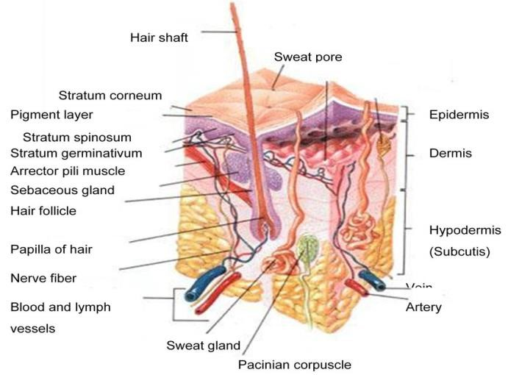
Fig. Human skin in cross section.

Epidermis:
Epidermis is outer most layers of the skin stratified epithelial cells. These epithelial cells to be apprehended collectively with greatly tortuous interlocking bridges, which are resulted exclusive integrity of skin. Microscopic section of epidermis was show two major parts; this includes a.Stratumcorneum b. Stratum germinativum, stratum corneum develop outmost layer to epidermis and consist of various layers of dehydrated, flattened and keratinized cells in stratified layers.

Dermis:
Lies between epidermis and subcutaneous layer. This middle layer of skin contains connective tissue is collagen, elastin with rich intertwining blood supply. The types of cells situated in the dermis are fibroblast, mast cells, and bistocytes. Hair follicles nerves lymphatic vessels and sweat glands also reside in the dermal layer of skin.

Subcutaneous Tissue:
Subcutaneous tissue is area including areolar tissue (superficial fascia) and intact dermis to fundamental structures.

SKIN PATHWAYS FOR RELEASE OF DRUGS FROM TDDS:
When the TDD patch apply on the skin, drugs penetrating in to skin into bloodcirculation by different skin pathways [10-14, 21]. The drug(s) get systemic
circulation by 1. Stratum corneum is transepidermal route or 2. An appendage is transappendageal route

BASIC COMPONENTS OF TDD PATCHES:
The Transdermal Drug Delivery Patches mainly included the followings [14, 15].
- Polymer matrix
- Drug
- Permeation enhancers
- Other excipients

- POLYMER MATRIX:
The polymers are mainly useful for control of drug release.
Natural polymers:
Starch, proteins, natural rubber collecting from rubber plants etc.

Synthetic Elastomers:
Polybutadiene, Polysiloxane, Vinyl Methyl Silicone, Polyacrylate Rubber, Ethylene-acrylate Rubber, Fluoro Silicone etc.
Synthetic polymers:
Polypropylene, Polyvinyl alcohol, Polymethyl methacrylate, Epoxy Polyvinyl
2.DRUG:
Physicochemical characteristics:
- Drug should suppose to low molecular weight.
- Drug lower melting point temperature.
- Drug hydrophilic and lipophilic property.

3. PERMEATION ENHANCERS:
Permeation promoters or enhancers are substances which are not having therapeutic activity but can move from therapeutic system into skin by sorption mechanism. The flux, of drugs which move in to skin equation reported by B.W.Barry [16] as:
- =DKC/h
Where, D = Diffusivity
- = Partioncoefficient C = Concentration gradient h =Diffusion path length.
The basic concepts concerning enhancement of flux can calculate by above equation. The drug concentration difference (gradient) in body is a thermodynamicprinciple and D is the related with the diameter and structure of active agent [14].
Hence the increased of flux through the biological barrier simplified to following consideration.
1.Thermodynamics includes lattice energies, distribution coefficients.
2.Moiety shape and size.
Dropping the energy need to make openings in biological membrane for molecules. Permeation increasing agents are assumed to have an effect on layers to attain skin penetration. Many compounds have been examined for their capability to promote drug(s) across stratum corneum. These are classified as
Solvents:
Solvents are compounds which are added to enhance penetration of drug by:
1) Polar pathways swelling in skin. 2). Lipids Fluidization.
Surfactants:
Surfactants are agent which enhance the polar transport system, in particularly of water soluble pharmacological active substances.The capability of a surfactant to modify the diffusion as result of its monomer polar head and length of hydrocarbon chain.

The surfactants are classified as:
- Anionic Surfactants:
Carboxylates, Petroleum Sulphonates, Naphthalene sulphonates, Dioctyl sulphosuccinate, Alkyl sulphates, Decodecylmethylsulphoxide.
- Nonionic Surfactants: Pluronic F68, Pluronic F127, Ethoxylated aliphatic alcohol, Carboxylic amides.
- Miscellaneous Chemicals:
Miscellaneous agents are moisturising agents, keratolytic agents, Calcium thiogylcolate.
4.OTHER EXCIPIENTS
a)Adhesives:
The binding of TDDS on skin done by pressure sensitive adhesive (PSA).Theadhesive tape fixed on the device and extending peripherally.

Both adhesive systems should accomplish the following characteristics.
- Does not irritate the skin.
- It must be adhere to skin without disturbed by daily activities like bathing, exercise.
- It’s easily removed without any adverse effects.
- The adhesive residues not to be retaining on the surface of skin.
- It must be an outstanding contact with skin.
a)Backing membrane:
Backing membranes are flexible and they provide a good bond to the drug reservoir, prevent drug from leaving the dosage form through the top, and accept printing.

APPROACHES FOR DEVELOPING TDDS:
Different approaches are applied to develop transdermal preparations which offer control release of drug over the period of time(7,17)
- Polymer membrane permeation-controlled TDD Systems.
- Polymer matrix Diffusion-Controlled TDD Systems.
- Drug Reservoir Gradient-Controlled TDDSystems.
- Microreservoir Dissolution-Controlled TDD Systems.

A.Polymeric Membrane Permeation-Controlled TDDS:
The medicine reservoir is packed in a impermeable plastic metallic laminate and polymeric membrane. The therapeuticmoieties are allowed to move across polymeric membrane, the polymeric membrane able to control the release rate of drug.

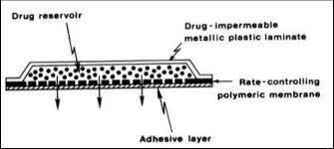
Fig.membrane permeation-controlled TDDS in cross section.
B] .Polymer Matrix Diffusion-Controlled TDDS:
The medicine reservoir was prepared by dispersing drug in polymer matrix and the medicated polymer prepared and sizedwith a distinct surface area with optimised thickness. The prepared medicated polymeric disc is pasted onbase plate of drug -impermiable plastic laminate.

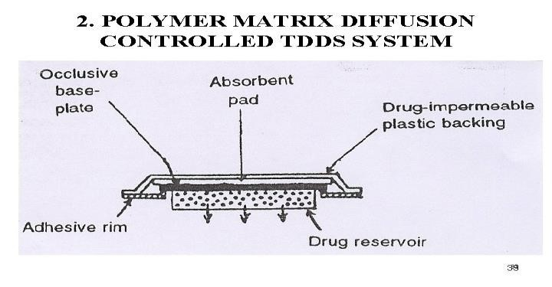

Fig. Matrix diffusion- controlled TDDS in cross section.

C. Drug Reservoir Gradient-Controlled TDD Systems:
The TDD Systems to non zero-order drug release profiles, the above described matrix type of TDD system could be changed to have the drug loading stages are in enhancing manner, by this forming gradient type of drug reservoir withdiffusional path to multilaminate adhesive layer. Ex: Deponit system.

D. Microreservoir Dissolution-Controlled TDDS:
The reservoir was prepared by drug particles were suspending in cosolubilizer (polyethylene glycol) and then drug suspension homogeneously dispersedin a lipophilic polymer, at high mechanical force, to form 1000s of unleachable drugreservoirs. This is thermodynamically not stable dispersion so that is rapidly stabilizedby cross-linking chains in polymer, which forms medicated polymer disc and producea fixed thickness. Transdermal system is then formed by mounting the medicated disk at middle part of adhesive pad. Ex: Nitrodisc system.

AIM AND OBJECTIVE

To develop and characterization of transdermal drug delivery system (patches)of cardiovascular drugs such as Azelnidipine.

PLAN OF WORK:

- Introduction of azelnidipine.

- Analytical method of development for azlenidipine.

- Analytical method development for azlenidipine using HPLC.

- Preformulation studies of azlenidipine.

- Preparation of TDD patches of azlenidipine.

- Ex vivo and In vivo evaluation of TDD patches of azlenidipine

- Evaluation of TDD patches of azlenidipine.

Azelnidipine

Chemical Name:

Azelnidipine, ((±)-(3)-(1- diphenylmethylazetidin-3-yl)-5isopropyl-
2-amino-1, 4-dihydro-6-methyl-4-(3-nitrophenyl)-3, 5- pyridinedicarboxylate.

Molecular formula: C33H34N4O6

Molecular mass: 582.646grams/mol.

Structural formula
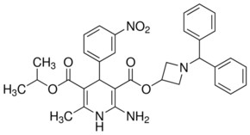

PHYSICAL PROPERTIES:

Description:
- Pale yellow crystalline power
- odorless
- tasteless
MP: 122123⁰C
PKa: 7.89

BCSClass:ClasII
Solubility: Soluble in DMSO: >10 mg/ml.
Dose: Orally 8, 16 mg/day, trademark of CALBLOCK®.
Mechanism of action:
Azelnidipine is a calcium channel blocker; inhibit the entry of
extracellularCa+2 while depolarization of muscles smooth muscles in heart, to produces control blood pressure principally by relaxation of vascular smooth muscles and resulted decreased peripheral vascular resistance.

Pharmacokinetic Profile:
Oral Azelnidipine shows rapid, dose-dependent absorption,
After oral administration of one dose 5–15 mg to healthy, in fastinadul volunteers, the Cmax 3.0-13.1 ng/ml occurred 2.3-2.7 hours (tmax) post dose.

Metabolism:
Azelnidipine posses greater first-pass hepatic metabolism explained by K Wellington. Azelnidipine is metabolized by cytochrome P450 (CYP) 3A4 in the liver and has no active metabolite.
Bioavailability:Less than 50%.
Half life: 16-24 hrs.
Applications:
Azelnidipine is used for control of hypertension and used in cardiac remodel after the myocardial infarction. Azelnidipine is cardio-protective, anti-atherosclerotic effects, cerebro-protective, also improves insulin resistance.
Stability: Stablefor 39 months at 25ºC [48-50].

❖ANALYTICAL METHOD DEVELOPMENT FOR
AZELNIDIPINE:
Preparation of Sorenson Phosphate Buffer pH7.4:
Solution X:35.61 grams of Na2HPO4.2H2O taken in 1000 ml of (volumetric) flask and up to the mark filled with distilled water, and then mixed until dissolved.

Solution Y: 27.6 grams of NaH2PO4.H2O taken in 1000 ml of (volumetric) flask and filled with water up to the mark and then mixed until dissolved.

Taken 40.5 ml of solution X solution and 9.5 ml of Y solution in a 50 ml of flask and mixed together to obtain 50 ml 0.2M buffer and it was checked to confirm the pH is 7.4.

Preparation of Azelnidipine Stock Solution:
100 mg of Azelnidipine, and placed in 100 ml of volumetric flask, added few ml of methanol to solubilized drug then added freshly prepared Sorenson buffer pH 7.4 up to 100 ml. It contains 1.0 mg/ml of drug (stock-I).
Determination of ƛmax of Azelnidipine:
The drug ƛmax was determined by using 20 µg/ml standard solution. Sorenson phosphate buffer pH 7.4 used as a blank solution.

Preparation of Azelnidipine Standard Solutions:
The standard solution of Azelnidipine was subsequently diluted with Sorenson buffer (pH 7.4) to resultant 3, 6, 9, 12, 15 μg/ml of solution. The absorbance of solution determined at 254 nm using the So r e ns o n buffer as blank.
❖
ANALYTICAL METHOD DEVELOPMENT FOR AZELNIDIPINE

USING HPLC:
Chromatographic method normally used for the quantitative and qualitative analysis of the raw materials, drug molecules or metabolites in biological fluid objective of chromatographic method development is to produce consistent data. [54- 60].
- Instruments and Chromatographic Conditions:
HPLC model is LC10AD Pump Shimadzu and SPD-10A UV-Detector. The
Inspire reverse phase analytical C18 column (250 X 4.5 mm, 5 μm), Methanol: Water (3:1 v/v) & 0.1% (v/v) of Gaa (Glacial acetic acid) used as mobile phase, 1ml/min flow rate and the 20 μL injection volume was used. The HPLC Uv- detector was fixed at 254 nm, AUFS at 0.01.
- Preparation of Azelnidipine Standard Solutions:
Primary stock solutions of Azelnidipine was prepared by 50 mg in 50 ml of mobile phase (Methanol: Water in 3:1) to gives 1 mg/ml and stored at – 80ºC until use.
This was diluted with mobile phase to gives 1.0 to 50 μg /ml.
- Solution Stability:
The stability of drug in plasma determined by preparing concentrations low and high of the standard samples, these are stored at ambient temperature in the laboratory up to 24 hrs in the plasma, at 6, 12 and 24 hr collected samples and drug extracted from plasma and reconstituted with 50% of the acetonitrile. These samples were analysed by HPLC for quantity of drug.
These obtained results were expressed in percent of recovery relative to the initial (nominal) concentration at time zero. Stability was defined as less than 10% loss of the initial concentration.

❖PREFORMULATION STUDIES OF AZELNIDIPINE:
a.Determination of Solubility:
The solubility of drug determined in 20 ml of Sorenson buffer pH 7.4 and determined in various standard solutions of surfactant (sodium lauryl sulphate). Mixed an overload ofdrug up to get supersaturating solutions was obtain, then allowed for continuous shaking per 24 hrs on orbitalshaker and then filter.

b. Determination of Partition Coefficient:
Determined by taking volume in equal of n-octanol (as an oil phase) and Sorenson buffer pH7.4 (as an aqueous phase) in a separating funnel then added 50 mg of drug then shaken for 15 min and set aside for 24 hrs with frequent shaking. Finally an aqueous phase and oily phase separated in individual beakers and determined content of drug partitioned in two phases by using UV-Spectrophotometer [63-66].
c.Drug and Excipients Compatibility Studies:
The compatibility of drug with excipients carried out using FTIR Spectrophotometer. The individual pure drug and its physical mixture of excipients were used. The FTIR test is carried by using pressed pellet technique, in which a small quantity of sample is grind with specially purified salt of potassium bromide and the mixture is heated to 100°C for 1.0 hr to remove the moisture and is pressed by a mechanical compressor to form a pellet, the pellet was positioned in a FTIR sample holder, during test the beam of spectrophotometer light was passed through the sample and it gives the spectrum [67, 68].
- PREPARATION OF TDD PATCHES OF AZELNIDIPINE:
- Glass Substrate Method:
Required quantity of polymers Hydroxymethyl cellulose (HPMC), Eudragits (ERL100, ERS100) and Ethyl cellulose (EC) dissolved in 20 ml of solvent mixture consisting of 1:1 ratio of Dichloromethane (DCM) and methanol. The mixture of solution allowed for swelling at least 5 hrs. Then required quantities of dibutyl phthalate (DBP) and Azelnidipine, Dimethyl sulfoxide (DMSO)added and vortexed and it was set-a side for exclude of any captured air and then is poured in a previously cleaned anumbrapetriplate and this was set aside for evaporation of solvent.
The rat of solvent evaporation was controlled by arranging a glass funnel on the surface of petriplate in reverse position Figure 5.1.1. After the dried films were carefully peeled from glass petriplate and stored indesiccators till use Table 5.1.1and 5.1.2. [26, 39]
40

Table 5.1.1: Formulation chart of TDD Patches of Azelnidipine.

Formulation | HPMC-  E15 (mg) | ERL100 (mg) | ERS100 (mg) | EC  (mg) | Azelnidipine (mg) | DBP  (ml)
F1 | 800 | 200 | - | - | 100 | 0.4
F2 | 600 | 400 | - | - | 100 | 0.4
F3 | 400 | 600 | - | - | 100 | 0.4
F4 | 800 | - | 200 | - | 100 | 0.4
F5 | 600 | - | 400 | - | 100 | 0.4
F6 | 400 | - | 600 | - | 100 | 0.4
F7 | 800 | - | - | 200 | 100 | 0.4
F8 | 600 | - | - | 400 | 100 | 0.4
F9 | 400 | - | - | 600 | 100 | 0.4

Table 5.1.2: Formulation chart of TDD Patches of Azelnidipine with Penetration enhancer.
Formulation | HPMC-  E15 (mg) | ERS100 (mg) | Azelnidipine (mg) | DBP  (ml) | DMSO  (ml)
F10 | 400 | 600 | 100 | 0.4 | 0.4
F11 | 400 | 600 | 100 | 0.4 | 0.6
F12 | 400 | 600 | 100 | 0.4 | 0.8
F13 | 400 | 600 | 100 | 0.4 | 1.0
❖EX VIVO AND IN VIVO EVALUATION OF TDD PATCHES OF AZELNIDIPINE:

1. Preparation of Rat Skin:
The rat was sacrificed by stumping method and hair on the abdominal skin was removed with an adhesive tape stripping method, taking extreme precaution not to damage skin. The stripped skin was then excised from the animal, and the skin surface was experimentally checked under microscope for any minor cuts. After the separated full thickness of skin was soaked in water at 60ºC for 5 min, followed with removal of epidermis intact to stratum corneum. The epidermis was cleaned with pure
41
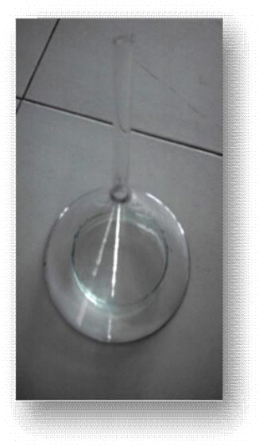
Figure 5.1.1: Casting of TDD Patch of Azelnidipine.

2.Vivo Drug release through Rat Abdominal Skin:
Ex vivo studies were conducted on rat excised epidermis, was placed between the donor cell and receptor cell with help of a clamp the Figure was shown in 5.1.2 the skin epidermis always contact with transdermalpatch in the donor cell and the dermis side was continuously contact with receptor cell diffusion medium, was Sorenson buffer pH 7.4 containing 0.5%of SLS. The setup was placed on temperature controlled magnetic stirrer and it temp set at 32 ^{1o}C.
Three ml of sample was collected at predetermined time intervals and receptor cellwas refilled with three ml of fresh buffer at each time interval to maintain sink

3.In Vivo Drug release (Animal Pharmacokinetics):
Male albino rats weight 200-250 grams were purchased from licensed animal house Hyderabad. Rats were acclimatized for a week with free of antioxidants food. The animals were maintained on a 12 hr light–dark cycle at room temperature and 60% relative humidity.
The study was conducted by taking approval by the Institutional animal ethical committee (SLS/01/02/2014/2); the rats fasted overnight and these are divided in to five groups each group 6 rats used. Group I is control, Group II is treated with oral route administration of Azelnidipine at dose of 10 mg/kg in a 5.0 % suspension of gum acacia [76] and Group III, Group IV and Group V are treated with optimized transdermal patches (F1, F6 and F13) by applied on the neatly shaved dorsal portion of rats, [77-80] with help of adhesive tape Figure 5.1.3 and 5.1.4.
42
The blood samples (300μL) were collected at predetermined time intervals by retro orbital puncture under the mild ether anesthesia condition. Immediately the collected blood samples plasma was isolated by centrifugation and the obtained plasma samples were stored properly in a freezer at -80⁰C until analysis. At the time of analysis from the plasma samples to extract the drug and determine the drug in blood samples by using HPLC.

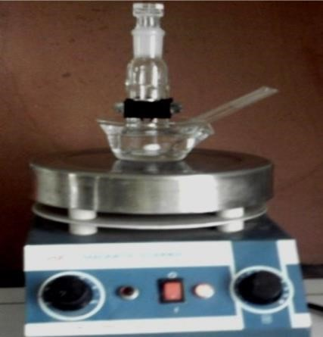
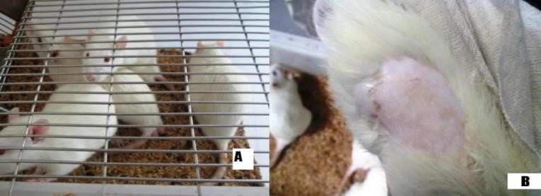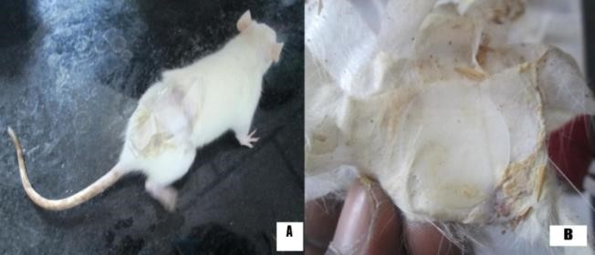
Fig A).Laboratory animals used for in vivo studies. B). before administration of TDD Patch.

Photography of Franz diffusion cell. A)After administration of TDD Patch B).
After removal of TDD Patch.
❖

4. Extraction of Plasma Samples:
To 100 μL of plasma samples, 20 μL of internal standard (from 100 μg/ml of working solution) and 400 μL of methanol was added, the resulting solution was centrifuged at 4000 rpm and supernant layer was separated, which is called Supernatant 1 and 400 μL of methanol was added to residue and the resultant solution was mixed again for 5 min on cyclomixer and centrifuged at 4000 rpm and then collected Supernant layer was added to the Supernatant 1.
❖ EVALUATION OF TDD PATCHES OF AZELNIDIPINE:
- Determination of Weight Variation:
Each formulation was prepared in triplicate and cut specified (3.14 cm²) from each film. The weight was noted by (Saritorius) digital balance [83].

- Determination of Thickness:
The formulated TDD films thickness is determined by measuring thickness at six different points by screw gauge digital Japan Mitutoyo [84, 85].

- Determination of Drug Content:
The TDD films 3.14 cm² area was cut solubilised in 5% of methanol aqueous solution. This was shaken for 12 hrs on orbital shaker and allowed for sonication for 15 min, then centrifuged at 4000 rpm for 20 min, filtered this by whatman filter paper, finally the obtained filtrate to taken one ml of sample in a test tube and diluted sufficiently with same solvent. By using UV-Spectrophotometer to determined drug content. The respective placebo film was taken as blank solution [86- 89].

- Moisture Absorption:
The films are weighed accurately, stored in a glass desiccator. The desiccator maintained at 84% RH by filling with saturated liquid of Potassium Bromide. After the 3 days, the films were reweighed and noted the final weights [89, 45, 66].

(Final wt – Initial wt)
% Moisture absorbed= ---------------------------------------------- 100 I Initial Weight

- Moisture Loss:
The films are weighed exactly, placed in a glass desiccator. It previously
filled
with calcium chloride and maintained at 40 ºC for 24 hr. The final weight of each formulation films were noted when these are does not change in their weight further [90, 91].
(Initial wt – Final wt)
% Moisture Loss = X100
Final wt

- Water Vapor Transmission Rate:
The equal diameter of glass vials were selected as transmission cells. Before starting of this test the selective transmission cells were neatly washed and dried at 100 ºC in a hot air oven. One gram of calcium chloride (anhydrous form) was taken and labeled the cells with code then the respective code of transdermal film was attached over its brim individually. Then these glass vials exactly weighed, placed in a glass desiccator, it previously saturated with liquid of Kcl to resultant relative humidity (RH) of 84%. After 24 hr storage collected the cells and noted the final weights. The content of water vapor transmitted through the film was calculated by [25, 92].
Final Weight – Initial Weight
WVTR =
Time X Area
- Folding Endurance:
TDD films folding endurance determined by manually. In this test a film dimensions 4x3 cm was taken, repetitively folded many times at same place of film up to it broke. Number of times of folded without any breaking that was the accurate folding endurance value [67].

- Determination of Flatness:
The flatness determined by taking three longitudinal strips, which were cut out from each prepared TDD film, one from the center of film, second film cut from the left side, and third film cut from the right side. Finally the length of each strip was
measured by scale and the variation in length was calculated. And it was expressed in percent constriction; the result of zero percentage of constriction was equivalent to hundred percentage of flatness [67, 89].
Final length of strip- Initial length of strip
Constriction (%) = ----------------------------------------------- X100
Final Length of Strip

- Skin Irritation Test:
The test was tested on thealbino rat skin. The rats were divided into 5 groups, on the prior day of the experiment; the hairs of rats removed on the backside area. The group I animals were served as normal (free from treatment). The second group (Group II, control) of animals was treated with standard adhesive tape (USP). For third group of animals treated with placebo patches i.e. without drug and fourth group
(IV) of rats treated with optimized TDD patch. 0.8% v/v of formalin applied as a standard irritant for the fifth group rats (Group V).
The animals were applied with new formalin solution each day up to 7 days.
Finally the sites were graded [93-96] [Appendix A].

•Stability Studies:
Stability studies were performed for 3 months using optimized formulations. Prepared patches were kept in a refrigerator, stability chamber and incubator which maintaining the temperature of 4°C, 40°C and 60°C respectively. The sample (formulation) was collected and analyzed by Uv- Spectrophometer [97-99].

SUMMARY:
The TDDS has been became very importance in current days. Because of its offer mainly two potential advantages, 1. Avoid hepatic first pass metabolism 2. Maintaining drug concentration constantly in therapeutic range for fixed period of time by that reduce the number times of dosing ultimately to improve the bioavailability and to ensure patient compliance. Some of the cardiac drugs already prepared in the form of TDD Patches but most of them still unknown.
In this study TDD Patches are prepared using hydrophilic and hydrophobic polymers, methanol and dichloromethane in 1:1 ratio used as solvent for formation of TDD films and dibutylpthalate, polyethylene glycol used as plasticizer.
The obtained solubility, and partition coefficient values of Azelnidipine found to be sufficient for preparation of TransdermalPatches. In this investigation found to be there is no drug-polymers interaction concluded by FTIR studies. The prepared Transdermal Patches found to be smooth, flexible and uniform in drug distribution and thickness.

CONCLUSION:
Azelnidipine is calcium channel blocker and, used in control of blood pressure. HPLC analytical method was developed validated for estimation of drug in blood samples. The Azelnidipine FTIR results revealed that drug and polymers are safer in use. Ex Vivo experimental results of formulation F1 and F13 Azelnidipine shown better drug release per 24 hr, F1 is formulated with HPMC: ERL100 and DBP and F13 formulatedHPMC: ERS100, DBP and DMSO. Based on mathematical data the drug release was best fitted with zero and near zero order drug release kinetics. The animal studies reports showed that Transdermal release of Azelnidipine (F13) is better than the oral route.
Transdermal drug delivery Patches were evaluated for Physico-chemical properties, the obtained results were more satisfactory.
The skin irritation test results proved that TDD Patches are safe on application on skin and the stability studies during on storage reveled that stable in the TDDS.
Thus it concluded that Transdermal delivery of cardiac drugs is an incredibly promising carrier for creating a new opportunities for topical application of Azelnidipine in the treatment of high blood pressure.

Reference:

- Praveen Tyle, Drug Delivery Devices Fundamentals and Applications, 32 (1988) 385-419.
- K.P.R.Chowdary, R.A.S. Naidu, Transdermal drug delivery: A Review of current status, Ind.
Drugs, 32(9) (1995) 414-422.
- V. Sankar, G. Velrajan, R. Palaniappan and S. Rajasekar,Design and evaluation of Nifedipine Transdermal Patches, Ind. J. Pharm. Sci, 65(5)(2003) 510-515.

- A.P. Kakkar, Ajay Gupta, Gelatin Based Transdermal Therapeutic System,Ind. Drugs, 29 (7) (1991) 308-315.
[5]Abdul Ahad, Fahad I. AI Jenoobi, Abdullah M. AI Mohizea, Naseem Akhtar,
Mohammad Raish, Mohd. Aqil, Systemic Delivery of β- blockers via Transdermal Route for Hypertension, Saudi Pharma. J, 30(1) (2014) 1-16.
[6]Dr. N. Udupa, Transdermal Drug Delivery Systems,Pharmatimes, October (1992) 9-16

[7]YieW.Chien,
NovelDrugDeliverySystems, Second ed., Revised andExpanded, 50 (2005)301-38
[8]Joseph R. Robinson, Vincent H. L. Lee, Controlled Drug Delivery

- Gilbert S. Banker, Christopher T. Rhodes, Modern Pharmaceutics, Second ed.,Revised and Expanded, (1996) 263-298.
- N. K. Jain, Controlled and Novel Drug Delivery, CBS publishers & distributors, (1997) 100-115.

- Balasubramanian V. Iyer and Ravindra C. Vasavada, Evaluation of Lanolin

- K. P. R. Chowdary and R. A. S. Naidu, Preparation and Evaluation of Cellulose Acetate Films as Rate Controlling Membranes for Transdermal use, Ind. Drugs, 29 (7) (1992) 312-315.

[13]Updesh B. Lade, Yogesh M. Amgaonkar, Ruoesh V. Chikhale, Design
Formulation and Evaluation of Transdermal Drug Delivery System of Budesonide, Pharmacol& Pharma, 2 (2011) 199-211

[14]F. V. Manvi, P. M. Dandagi, A. P. Gadad, V. S. Mastiholimat and T.

[15]Divyesh Patel, Nirav Patel, Transdermal Drug Delivery System-Review, Int. J. Biopharm. &Toxicol. Res, 1(1) (2011)

