Development of Improved Z Source Converter for SVPWM Based PMSM

Riyaz A Rahiman¹, S. Sri Devi², P. Subha Karuvelam³, K. S. Kavin⁴

¹Associate Professor, School of Electronics and Communication, Reva University, Bangalore, India. riyazarahiman8@gmail.com
²Associate Professor, Achariya college of Engineering Technology, Puducherry, India. sriravan.1975@gmail.com
³Professor, Department of Electrical and Electronics Engineering, Government College of Engineering, Tirunelveli, Tamilnadu, India. subha@gcetly.ac.in
⁴Research Scholar, Department of Electrical and Electronics Engineering, Government College of Engineering,
Tirunelveli, Tamilnadu, India. kavinksk@gmail.com
ABSTRACT
Permanent Magnet Synchronous Motors (PMSM), which operate at extremely high speeds, are frequently used in a broad range of industrial applications today that demand high levels of precision and efficiency, including robots numerical control machines and broad speed range and high efficiency. The performance of a photovoltaic (PV) panel is enhanced by the employment of a improved Z-Source Converter (ZSC) driving mechanism for PMSM in this work. When the PMSM has to function at a fast speed, the ZSC offers a programmable boost voltage. Utilizing Space Vector Pulse Width Modulation (SVPWM) control methods, the PMSM drive's speed is managed. The SVPWM Technique is one of the essential PWM methods for regulating PMSM using a three-phase voltage source inverter (VSI). The PMSM is driven by analysis and simulation using Matlab-Simulink. The PMSM's speed at 2000 and 2500 RPM remains steady after 0.35 and 0.45 seconds, respectively.
Keywords: PMSM, SVPWM, improved ZSC, PV Panel, Three phase VSI
- INTRODUCTION
Energy has a significant impact on both our daily lives and the economy. The requirement for energy has considerably increased since the industrial revolution. Energy sources like fossil fuels are starting to dwindle over time [1]. Due to its cleanliness, affordability, and universal availability, solar energy is playing a significant role as an essential renewable energy source [2]. A photovoltaic (PV) system's main goal is to produce the required amount of power by converting energy from the sun into current electricity. The weather, including temperature and irradiation levels, has an impact on how much power a PV panel can generate. The PV panel's immediate output power fluctuates at these levels. The irradiance has a favourable impact on the electricity that the PV panel harvests, whereas the ambient temperature has a negative impact [3].
The PV panel is made up of solar cells, which are the fundamental solar unit. Depending on the panel's parameters, these cells are connected in series or parallel. [4]. Since the inverter is a component of a PV system, a proportional-integral (PI) current management approach is used to keep continuous output current, have strong responsiveness under quickly changing environmental conditions and keep the power factor close to unity[5].
PMSM has grown to be one of the most popular powered equipment for traction applications. In practice, PMSM has been used to home appliances, wind and solar power generation, and electric cars, as well as the advancement and development of driving technology [6].On the other hand, as the PMSM system's capacity improves, so does the full power converter's capacity. Due to the switch device's limitations, high power converters are not only more expensive but also more challenging to use reliably and effectively under real-world conditions.
The ZSC was a cost-efficient and reliable converter. With two inductors and two capacitors, the Z-source network may be built. The converter and the power supply are connected by the ZSC and a special LC network. The PMSM can run at a considerably greater speed without the requirement for field weakening, and a broader range of speed will be reached by including the improved ZSC into the drive system [7]. The Z source network's current can flow in the other way with the addition of an active switch and an input capacitor, adapting to a variety of load changes. However, in order to control the ZSC, the PWM approaches must be modified. Several PWM control approaches have been developed and used to regulate speed.
The SVPWM, which may decrease electromagnetic torque pulsation, minimize current harmonics, and lower the dc bus voltage, has drawn a lot of attention and research in an effort to overcome the limitations of the PMSM system's structural design and enhance operating performance [8]. As a result, the SVPWM is especially well suited for electric cars in order to achieve a greater speed operation range and improved operation performance [9]. This technique provides a direct connection between PWM and SVPWM. It offers a broad range of controlled AC output voltage and an improved line harmonic profile. The SVPWM method is applied in this study for applications involving variable speed and shoot-through control [10].
This study suggests an improved Z-Source converter for SVPWM-based PMSM to address the issues. PMSM effectively controls the output voltage of PV. The ZSC provides configurable boost voltage when the PMSM has to operate quickly. SVPWM control techniques are used to regulate the PMSM drive's speed. Simulations and testing are done to check the recommended technique's accuracy and effectiveness
The structure of this work is as follows: In the second section, similar works are suggested .In the third section of the current work, the suggested system is explored in greater detail. The study's results are summarized in Section fourth.
- RELATED WORKS
Yingliang Huang et al (2022) proposed a modified single-edge-SVPWM (MS-SVPWM) method for three-phase VSI by altering the zero vectors of SVPWM method in order to decrease switching losses and raise PWM noise frequency. The implementation of the suggested MS-SVPWM follows a careful mathematical examination, PWM noise investigation with time variation and experimental data are used to analyze the differences in PWM noise reduction between the MS-SVPWM and modified SVPWM techniques.
Tao Li et al (2018) has made various theoretical analyses and simulation research recommendations about the most prevalent topologies of ZS. The ordinary ZS inverter has many disadvantages, including a greater capacitor voltage and beginning shock, as we are all know. Academics have created a variety of improved ZS topologies to solve these problems. Some of these topologies can reduce the capacitor voltage, while others can increase boost capacity. Customers may find it challenging to choose which topologies to use because these topologies can only partially address the problems with the traditional Z-source inverter.
Zeeshan Aleem et al (2021) had provided a collection of single-phase transformer-based ZSAC in his work. The specified converters keep all the benefits of the traditional ZSAC, including greater reliability, buck-boost operation, and preserving the phase angle. The recommended converters also include a common ground between the input and output as well as continuous input current and an improved input profile. Additionally, they use the transformer turns ratio to give the required voltage gain, which may be adjusted depending on how the ZS structure is set up by either raising or lowering the transformer turns ratio.
Shadab Murshid et al (2021) have proposed a system that makes use of a PMSM, a centrifugal pump, a boost converter, a three-phase VSI, and a solar PV array. The incremental conductance (INC) technique is used to adjust the duty ratio in order to get the most power possible from the PV for the first goal, maximum power point tracking. The second element, system security, was recently brought up. The pump is driven by a PMSM that operates in vector control mode. The system is more dynamically responsive when utilizing a power feed. But the speed of the PMSM cannot be increased.
Arra Hanmandlu et al (2022) have suggested P&S MT (Power & Signal Multiplex Transmission) technology employs a three-phase cascaded multilevel inverter. For an EV, the CAN bus is not required because a suggested architecture would transmit indications of communication at no cost. The system that was created has the capacity to control both battery balance discharge and motor speed. SVPWM seeks to do away with the drawbacks of PWM while maintaining the proper levels of harmonics and transients.
- PROPOSED SYSTEM
The system described in this study includes a PV panel, three-phase VSI, PMSM, improved ZSC. The PMSM improves a photovoltaic (PV) panel's performance. When the PMSM has to function at a fast speed, the ZSC offers a programmable boost voltage. The PMSM drive's speed is managed utilizing SVPWM control methods. The proposed ZSC for PMSM is shown in Figure 1
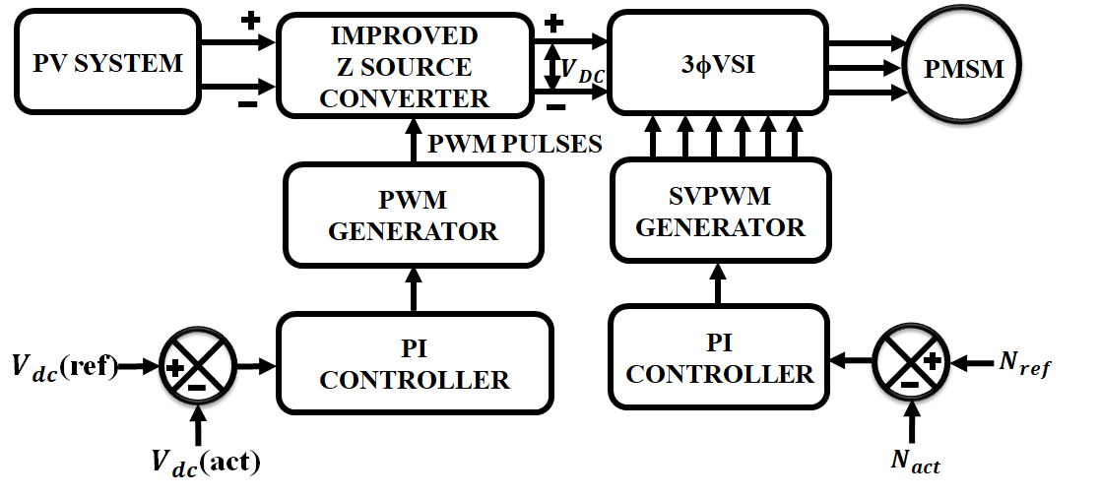
Figure 1: Proposed Improved Z Source converter for SVPWM
In the recommended configuration, the correct operation of the PMSM required an input from the $3Φ$ VSI supply. With the aid of SVPWM and the PI controller, the input supply is converted to DC for effective voltage management. The SVPWM generator helps to provide reliable and consistent switching by employing a PI controller. SVPWM additionally controls the $3Φ$ VSI in addition to controlling the speed of the PMSM drive. Dynamic performance is thereby successfully achieved.
- Design of PV Array
A solar PV module is created by combining PV cells. The power rating of these modules is typical. These PV modules may be connected in series to raise voltage, and in parallel to increase current. The quantity of PV modules is chosen based on the necessary power. According to the required system voltage and current, PV panels are additionally stacked in series and parallel.
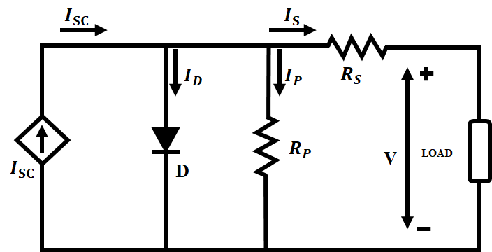
Figure 2: Equivalent circuit of PV
$I_{SC}$ = $I_{D}$ +$I_{P}$ (1)
$I_{D}$ =$I_{O}$($e^{\frac{V_{D}}{V_{T}}}$ -1) (2)
$I_{P}$ = $\frac{V_{D}}{R_{P}}$ (3)
The solar cell's corresponding electric circuit is seen in Figure 2. The serial resistor${ R}_{S}$ is being traversed by the output current. The resulting voltage will rise to a level proportionate to the number of series $N_{S}$linked solar cells when the solar cells are connected in series.
- Improved Z-Source Converter
A power electronics converter topology, the ZSC is appropriate for both motor driving applications and energy storage devices like batteries and ultra-capacitors. Due to its ability to get beyond the standard VSC's conceptual and theoretical constraints, the ZSC is a very competitive and promising topology.
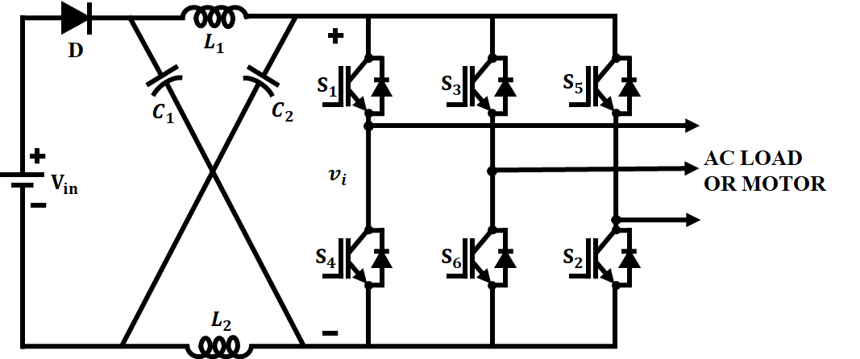
Figure 3: ZSC basic configuration
A unique Z-network made up of two inductors ($L_{1}$ and $L_{2}$) and two capacitors ($C_{1}$ and $C_{2}$) coupled in an X pattern and positioned next to the three-phase bridge makes up the improved ZSC topology, as illustrated in Figure.3. The ZSC contains an extra switching state known as the Shoot-Through (ST) state in addition to the eight conventional Non-Shoot-Through (NST) states shown in Figure 4.

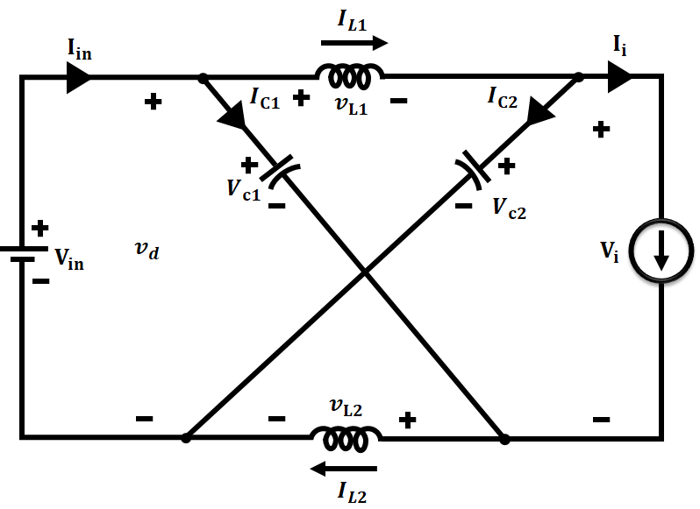
Figure 4a: NST
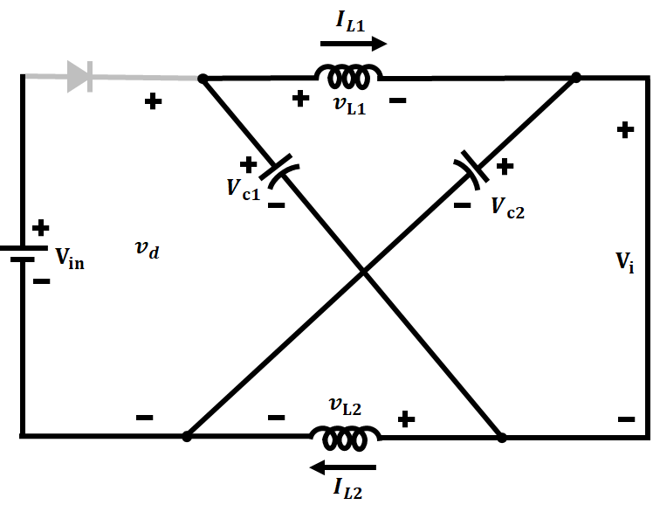
Figure 4b: ST
The input diode is reverse biased, the input dc source is disconnected from the load, and the two capacitors release energy into the two inductors, the load, and the input diode during the ST state. The NST state causes the input diode to turn ON, the dc input voltage source to transfer energy to the load and charge the two capacitors, and the two inductors to transmit energy to the load. As a result, the dc-link voltage of the bridge is increased, the capacitor voltage ($V_{c}$), and the dc-link voltage (${\hat{V}}_{i}$) are all supplied by:
$V_{c}$ = $\frac{V_{in}}{1-D_{o}}$ (4)
${\hat{V}}_{i}$ = $B.V_{in}$ = $\frac{V_{in}}{1-2D_{O}}$ (5)
${\hat{V}}_{ac}$ = $M.\frac{{\hat{V}}_{i}}{2}$ = $M.B.\frac{V_{in}}{2}$ (6)
The main feature of the ZSC is its ability to control the peak output phase voltage (${\hat{V}}_{ac}$) which may be done by adjusting M (modulation index) and ST time.

- Three Phase VSI
Figure 5 depicts the schematic diagram of a typical three-phase VSI the switching variables a, a', b, b', c, and c' control the sin's power switches, S1 to S6, which shape the output. When the corresponding lower switches (a', b', and c') are switched OFF, the corresponding top switches (a, b, and c) are switched ON, i.e., a, b, and c = 1. The bottom switches and the higher switches work well together. The output voltages are therefore determined by the ON and OFF states of the upper and lower switches.
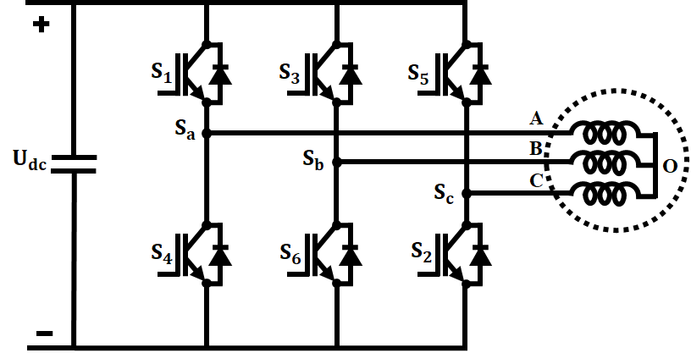
Figure 5: Three phase VSI with a load and neutral point
The space vector notion, which is derived from the induction motor's spinning field, is used to control the inverter's output voltage. In the modulation approach, either synchronously revolving frames or stationary frames can be used to convert three-phase quantities into their equal two-phase quantities. Let the three-phase sinusoidal voltage component be with respect to the stationary reference frame.
$V_{a}$ = $V_{m}sin ωt$ (7)
$V_{b}$ = $V_{m}sin (ωt-2π/3)$ (8)
${ V}_{c}$ = $V_{m}sin (ωt-4π/3)$ (9)
The AC machine experiences a spinning flux in its air gap when these three phase voltages are applied. A single rotating voltage vector can be used to describe this revolving resultant flux.
- SVPWM
For controlling speed, several PWM control techniques have been created and applied. However, those PWM techniques must be changed in order to leverage shoot-through state to regulate the DC boost of ZSI. PWM and SVPWM are directly connected by means of this technology. It offers a superior line harmonic profile and a wide range of controllable output voltage. In this study, the SVPWM technique is used for variable speed applications.
The concept of spatial vector is based on three-phase voltage conversion ${ V}_{an}$($t)$,$V_{bn}$($t)$ + $V_{cn}$($t)$ by a reference vector$V_{r}$ as given in (10):
$V_{r}=\frac{2}{3}$ [ $V_{an}$($t)$+ $e^{\frac{2}{3} π}$ $V_{bn}$($t)$ +$e^{\frac{4}{3} π}$ $V_{cn}$($t)$] (10)
Angles between any consecutive vectors are all equal to 60 degrees. The reference vector's (${\overline{V}}_{ref}$) value is modified.
${\overline{V}}_{ref}$ = $\frac{t_{0}}{T_{Z}}$ ${\overline{V}}_{0}$ + $\frac{t_{1}}{T_{Z}}$ ${\overline{V}}_{1}$+ ….+$\frac{t_{7}}{T_{Z}}$ ${\overline{V}}_{7}$ (11)
Where $T_{Z}$ is the whole sample period, and $t_{7}$, $t_{6}$, and $t_{0}$are the vectors' ON state times. $V_{d}$ and$V_{q}$, d-q axes voltage and $V_{an}$, $V_{bn}$, and $V_{cn}$, phase load voltage are related, as shown in Eq. (12). The locus of the $V_{ref}$ is a circle with a $V_{dc}$ value, and the maximum length of the active vectors is equal to (2/3$V_{dc}$).
$\left[\begin{matrix}V_{d} \\ V_{q}\end{matrix}\right]$ = $\frac{2}{3}$ $\left[\begin{matrix}1 & -\frac{1}{2} & -\frac{1}{2} \\ 0 & \frac{\sqrt{3}}{2} & -\frac{\sqrt{3}}{2}\end{matrix}\right]$ (12)
$α=\tan^{-1 }$ $\left(\frac{V_{q}}{V_{d}}\right)$ and $\left|{\overline{V}}_{ref}\right|$ = $\sqrt{V_{d }^{2}}$ $\sqrt{V_{d }^{2}+V_{q}^{2}}$ (13)
The inverter acts as a current or voltage source inverter depending on the values of $C_{1}$, $C_{2}$, and$L_{1}$, $L_{2}$ which overcomes the restriction of ordinary PWM inverters.
- PMSM
Permanent magnets are used in the rotor and conductor winding is used to build PM machines. The geometry and form of the spinning magnetic field are determined by the design of a PM machine and the interaction between the rotor and stator.
The d,q axis equation of a PMSM in rotor is given by
$V_{q}$ = $R_{S}i_{q}$ +$ω_{r}λ_{d}$ +$ρλ_{q}$ (14)
$V_{d}$ = $R_{S}i_{d}$ -$ω_{r}λ_{q}$ +$ρλ_{d}$ (15)
Flux Linkages are$λ_{q}$ = $L_{q}I_{q}$ (16)
$λ_{d}$ = $L_{d}I_{d}$ +$λ_{f}$ (17)
$\left[\begin{matrix}V_{q} \\ V_{d}\end{matrix}\right]$ = $\left[\begin{matrix}R_{s}+ρL_{q} & ω_{r }L_{d} \\ -ω_{r}L_{q} & R_{S}+ρL_{d}\end{matrix}\right]$ $\left[\begin{matrix}I_{q} \\ I_{d}\end{matrix}\right]$ + $\left[\begin{matrix}ω_{r}λ_{f} \\ ρλ_{f}\end{matrix}\right]$ (18)
The developed torque motor is:
$T_{e}$=$\frac{3}{2}\left(\frac{P}{2}\right)\left(λ_{d}i_{q}-λ_{q}i_{d}\right)$
The mechanical Torque equation is
$T_{e}$=$T_{L}$+$Bω_{m}$+$J\frac{dω_{m}}{dt}$
The rotor mechanical speed
$ω_{m}$ =$ω_{r}\left(\frac{2}{P}\right)$
Where $ω_{r}$the rotor is electrical speed and $ω_{m}$ is the rotor mechanical speed.
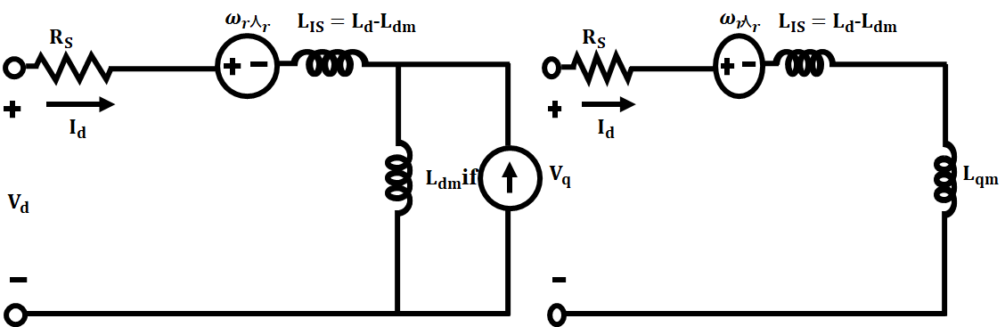
Figure 6: Equivalent circuit of PMSM
SVPWM controls the PMSM motor's speed and torque. Due to these benefits, PMSMs are frequently utilized in contemporary variable speed drives.
- RESULTS AND DISCUSSION
- PV Waveform
In this stage, the installation is stimulated using MATLAB to test the PMSM. Figures depict the characteristic curves of the PV panels in relation to temperature and insolation parameters in the proposed PV system.Table 1. gives the parameter specifications of PV and Table 2. gives the parameters of PMSM
Table 1: Parameter Specification of PV
Parameter | Specification
$$Peak Power$$ | $$10kw$$
$$Capacity$$ | $$5W$$
$$Number of Panels$$ | $$20$$

Table 2: Parameter Specification of PMSM
Parameter | Specification
$$Speed Rate$$ | $$2000 rpm$$
$$Torque Rate$$ | $$0.318 N-m$$
$$Constant Torque$$ | $$0.47565 N-M$$
$$Rated Voltage$$ | $$230 V$$
$$Rated Current$$ | $$20 A$$
$$No. of Pairs of Poles$$ | $$4$$
$$Flux Linkage$$ | $$0.1057 wb$$
$$Resistance to Stator Winding (R_{s})$$ | $$4.3Ω$$
$$d-axis Inductance (L_{d})$$ | $$8.5 mH$$
$$q-axis Inductance (L_{q})$$ | $$8.5 mH$$
$$Motor Inertia$$ | $$0.002 Kgm^{2}$$
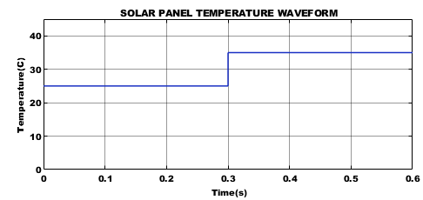
Figure 7: PV Temperature Waveform
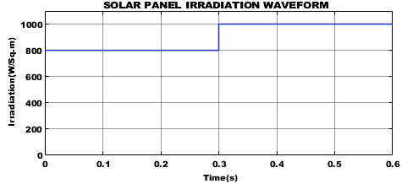
Figure 8: PV Irradiation Waveform
Figures 7 and 8 display the temperature waveform and irradiance waveform of a solar panel, respectively. The temperature and irradiance in this waveform are both constant at 25°C and 800(W/sq-m), respectively.
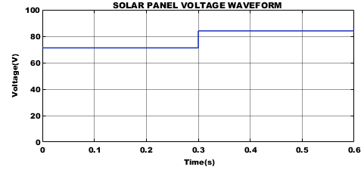
Figure 9: PV Voltage Waveform
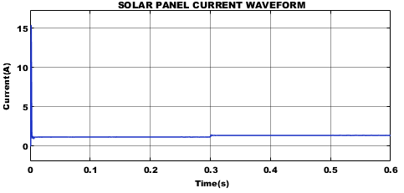
Figure 10: PV Current Waveform
Figures 9 and 10 depict the voltage waveform and current waveform of a solar panel, both of which show that the voltage stays constant at 82 V and the current stays constant at 1 A .
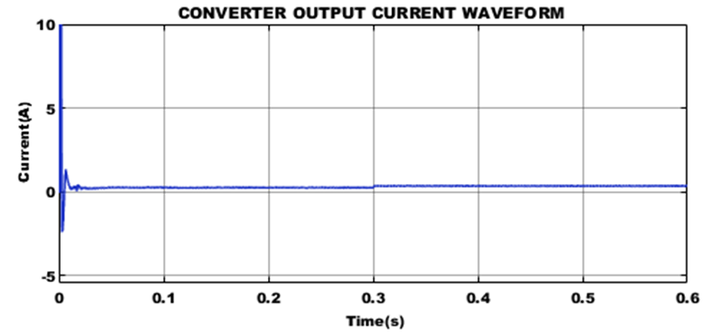
Figure 11: Output Current of Converter
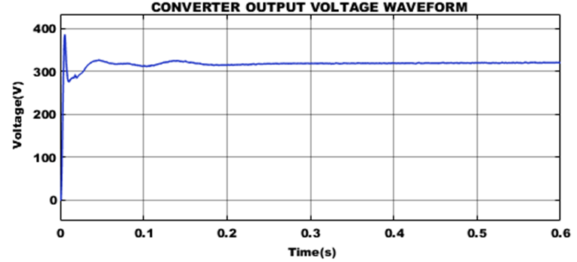
Figure 12: Output Voltage of Converter
The converter output Current Waveform and Voltage waveform in Figure 11 and 12 shows that the current remains constant after 0.1 s with a value of 0.1A and the voltage slightly varies up to 0.2s after that it remains constant at the value of 310 V.
B. PMSM
A) PMSM Speed Waveform = 2000 rpm
The suggested PMSM is simulated in Matlab. The input voltage and the PMSM's speed are both controlled by SVPWM, which is modeled and constructed. The results of the PMSM simulation demonstrate a controlled output voltage and steady speed. Results are gathered between 2000 and 2500 RPM at various speeds.
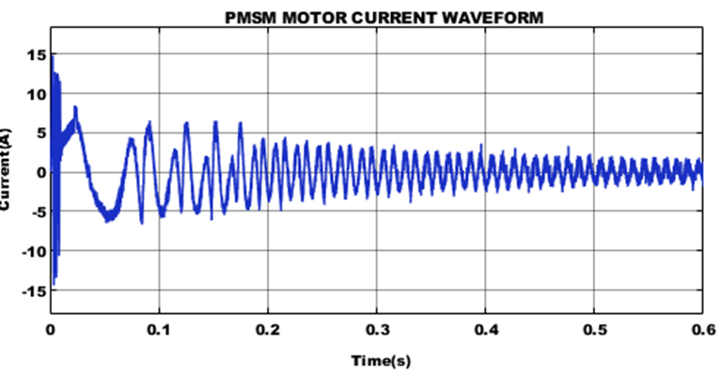
Figure 13: PMSM Motor Current Waveform
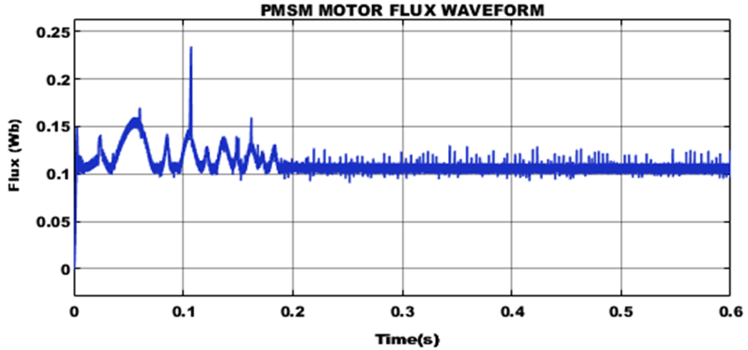
Figure 14: PMSM Motor Flux Waveform
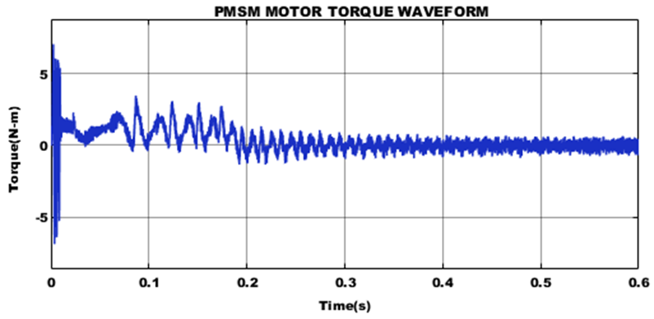
Figure 15: PMSM Motor Torque Waveform
Figures 13, 14, and 15 show the PMSM waveforms of current, flux, and torque, which indicate that the current kept on increasing upto 0.3s.
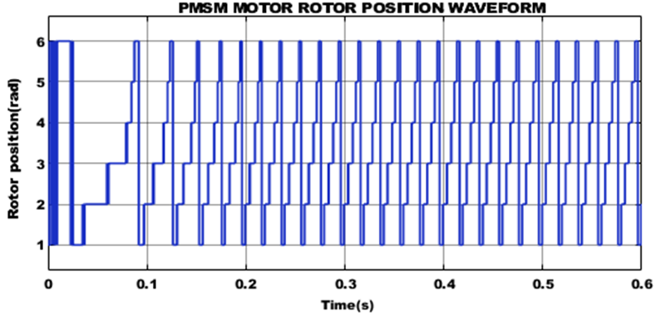
Figure 16: PMSM Motor Rotor Position Waveform
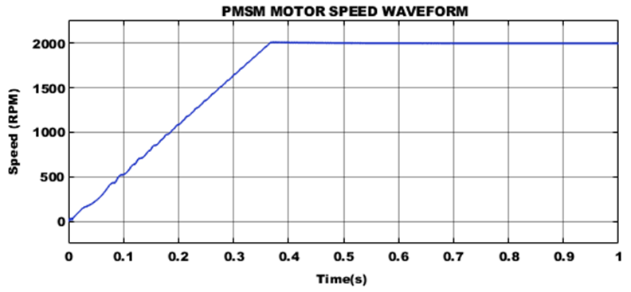
Figure 17: PMSM Motor Speed Waveform
Figure 16 shows the rotor's angular location as a function of time in the form of a waveform. Due to the rotating nature of the motor, the PMSM rotor position waveform frequently displays periodic behavior. The waveform repeats with each cycle of the motor's rotation. Figures 17 illustrate the PMSM Motor Speed Waveform.They demonstrate that after 0.35s, the motor's speed stays constant at 2000 RPM.
b) PMSM Speed Waveform = 2500 rpm
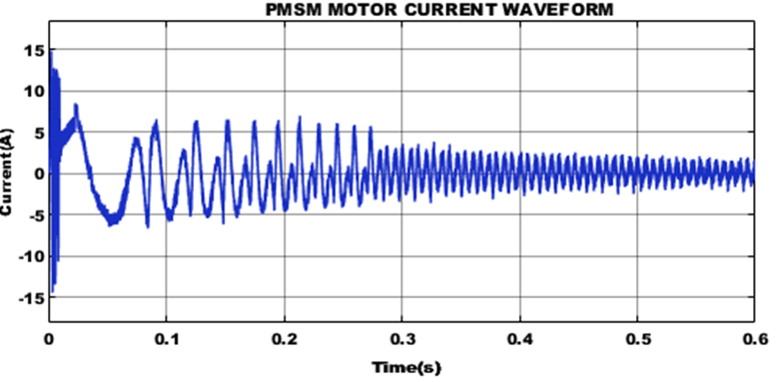
Figure 18: PMSM Motor Current Waveform

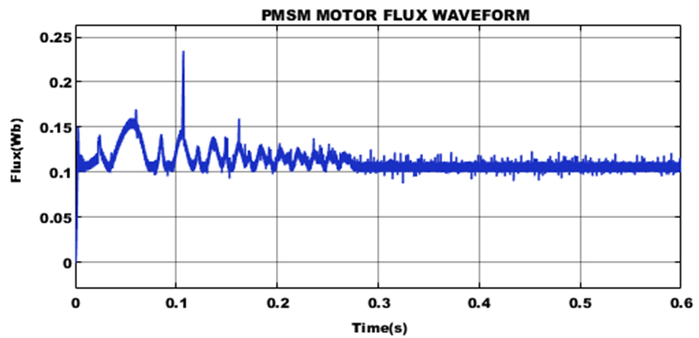
Figure 19: PMSM Motor Flux Waveform
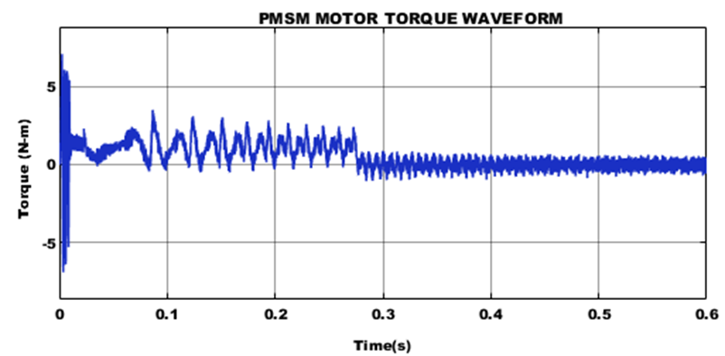
Figure 20: PMSM Motor Torque Waveform
Figures 18, 19, and 20 show the PMSM waveforms of current, flux, and torque, which indicate that the current kept on increasing upto 0.3s.
Figure 21: PMSM Motor Rotor Position Waveform
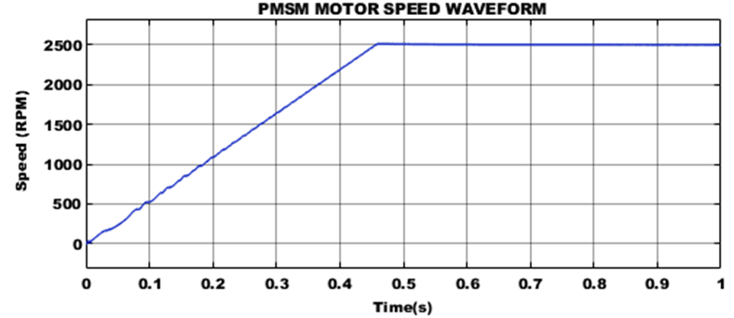
Figure 22: PMSM Motor Speed Waveform
The PMSM Motor position waveform in Figure 21 depicts the angular position of the rotor as a function of time.The PMSM rotor position waveform often exhibits periodic behavior due to the rotating nature of the motor. Each cycle of the motor's rotation causes the waveform to repeat. Figures 22 illustrate the PMSM Motor Speed Waveform.They demonstrate that after 0.45s, the motor's speed stays constant at 2500 RPM.
- CONCLUSION
The maximum boost control approach to drive PMSM is introduced in this study. This kind of approach was used with the SVPWM drive system that was designed in the MATLAB/SIMULINK environment. With many advantages over the conventional motor drive system, including single stage conversion with buck/boost capability, improved efficiency, and an expanded output voltage, the Improved ZSC is a promising converter topology for motor drive applications. When compared to other motor types, the ZSC has a wide range of applications for various phase numbers and control strategies. After 0.35 and 0.45 seconds, respectively, the speed of the PMSM at 2000 and 2500 RPM stays constant. Additionally, the use of the ZSC for the PMSM is extremely promising and requires further research for the entire system control.
REFERENCES
- Mohamed, Ahmed T., Mahmoud F. Mahmoud, R. A. Swief, Lobna A. Said, and Ahmed G. Radwan. "Optimal fractional-order PI with DC-DC converter and PV system." Ain Shams Engineering Journal, Vol .12, no. 2, pp: 1895-1906, 2021.
- N. M. Haegel and S. R. Kurtz, "Global Progress Toward Renewable Electricity: Tracking the Role of Solar," in IEEE Journal of Photovoltaics, vol. 11, no. 6, pp. 1335-1342, Nov. 2021.
- Z. Wu, Y. Hu, J. X. Wen, F. Zhou and X. Ye, "A Review for Solar Panel Fire Accident Prevention in Large-Scale PV Applications," in IEEE Access, vol. 8, pp. 132466-132480, 2020.
- S. Bouguerra, M. R. Yaiche, O. Gassab, A. Sangwongwanich and F. Blaabjerg, "The Impact of PV Panel Positioning and Degradation on the PV Inverter Lifetime and Reliability," in IEEE Journal of Emerging and Selected Topics in Power Electronics, vol. 9, no. 3, pp. 3114-3126, June 2021.
- S. K. Dash and P. K. Ray, "Power quality improvement utilizing PV fed unified power quality conditioner based on UV-PI and PR-R controller," in CPSS Transactions on Power Electronics and Applications, vol. 3, no. 3, pp. 243-253, Sept. 2018.
- L. Li et al., "Robust position anti-interference control for PMSM servo system with uncertain disturbance," in CES Transactions on Electrical Machines and Systems, vol. 4, no. 2, pp. 151-160, June 2020.
- M. Muhammad, Z. Rasin, A. Jidin, A. M. Razali and N. A. Yusoff, "Investigation on quasi-Z-source inverter with hybrid energy storage for PMSM drive system," 5th IET International Conference on Clean Energy and Technology (CEAT2018), Kuala Lumpur, pp. 1-7, 2018.
- S. M. Suhel and R. Maurya, "A new switching sequences of SVPWM for six-phase induction motor with features of reduced switching losses," in CES Transactions on Electrical Machines and Systems, vol. 5, no. 2, pp. 100-107, June 2021.
- G. Sun, G. Yang, J. Su and M. Wang, "A Hybrid Random SVPWM Method with Full Modulation Ratio of Five Phase VSI," 2018 IEEE International Power Electronics and Application Conference and Exposition (PEAC), Shenzhen, China, pp. 1-6, 2018.
- H. Yao, Y. Yan, T. Shi, G. Zhang, Z. Wang and C. Xia, "A Novel SVPWM Scheme for Field-Oriented Vector-Controlled PMSM Drive System Fed by Cascaded H-Bridge Inverter," in IEEE Transactions on Power Electronics, vol. 36, no. 8, pp. 8988-9000, Aug. 2021..
- Y. Huang, Y. Xu, W. Zhang and J. Zou, "Modified Single-Edge SVPWM Technique to Reduce the Switching Losses and Increase PWM Harmonics Frequency for Three-Phase VSIs," in IEEE Transactions on Power Electronics, vol. 35, no. 10, pp. 10643-10653, Oct. 2020.
- T. Li and Q. Cheng, "A comparative study of Z-source inverter and enhanced topologies," in CES Transactions on Electrical Machines and Systems, vol. 2, no. 3, pp. 284-288, September 2018.
- Z. Aleem, H. -K. Yang, H. F. Ahmed, S. L. Winberg and J. -W. Park, "A Class of Single-Phase Z-Source AC–AC Converters With Magnetic Coupling and Safe-Commutation Strategy," in IEEE Transactions on Industrial Electronics, vol. 68, no. 9, pp. 8104-8115, Sept. 2021.
- S. Murshid and B. Singh, "Double Stage Solar PV Array Fed Water Pump Driven by Permanent Magnet Synchronous Motor," in IEEE Transactions on Industry Applications, vol. 57, no. 2, pp. 1736-1745, March-April 2021.
- A. Hanmandlu and S. Rajasekaran, "SVPWM-based improved Three Phase Multilevel Inverter for Electric Vehicle Applications," 2022 IEEE North Karnataka Subsection Flagship International Conference (NKCon), Vijaypur, India, pp. 1-6, 2022.

