Chemical Basis of Stability of Drug
Authors: Dr. Manisha Ashwin Tayde
Professor, HOD, Pharmaceutical Chemistry Department
SPE’s Smt. Narmadaben Popatlal Thakkar Institute of Pharmacy
Nasik 422003.
Maharashtra, India
Mail Id: mtayde82@gmail.com
ABSTRACT:
Pharmaceutical stability indicates the capacity of substance to maintain the predetermined levels of identity, potency, and purity over the period of its shelf life. The chemical stability of pharmacological compounds in the solid state is the main topic of this chapter. A marketable medicine must maintain its stability under a range of circumstances, such as extremes in temperature and relative humidity. Pharmaceuticals' chemical instability affects their therapeutic efficacy and toxicological effects. The chapter investigates the chemical reactivity of pharmacological compounds, namely those in the crystalline state. It examines solid-state reaction pathways and processes as well as diverse examples of solid-state reactions used in pharmaceutical applications.
Stability testing demonstrates that when a drug substance or product is exposed to various environmental factors over time, the quality of the substance or product changes. In order to examine approaches to increase some functional groups' stability during storage, this chapter provides an overview of the chemical explanation for some functional groups' resistance to events like hydrolytic and oxidative degradation inside pharmacological molecules.
The chapter goes over the variables that influence how quickly chemical reactions occur. It outlines methods for reducing chemical reactions and/or stabilising medicinal ingredients.
Keywords: Stability of drug, Metabolism, Chemical Reactions,

1. INTRODUCTION
The ability of a medication to maintain its therapeutic effects during the course of storage or its shelf life is referred to as "drug stability". Everyone has probably noticed the expiration dates on the many bottles of medicines, liquids, and ointments we keep, and we've all probably wondered why some of them last longer than others. The stability of a medicine is affected by a variety of elements, some of which are environmental and others which are drug-specific.
Drug research and development must prioritise safety and efficacy, therefore formulations must be created in a way that ensures a drug's proper bioavailability and physico-chemical stability over the specified shelf-life.(1)
Both chemical and physical changes might occur to a medication product. The first alters the chemical substance's form but not its chemical makeup, so no new or broken chemical bonds are created (2).
A drug's physical instability can occur in a variety of ways, including changes to how it looks, drug release, polymorphic alterations, adsorption, and more. On the other hand, chemical modifications describe alterations in the chemical structure brought on by drug degradation and interactions with excipients in the formulation. These modifications may lessen the drug's strength, raising questions about its usefulness, while also posing a safety risk because the breakdown products may be hazardous.(3,4)
A drug's intrinsic feature of chemical stability is governed by its chemical structure. Due to the addition of other substances (such excipients), the dose form may create drug instability. Drug stability must also be checked during the drug's packaging, storage, and manufacturing processes. In this context, the issue of drug product stability is a crucial one for both new and generic medications when conducting drug research and development. (5)
According to USP, product stability refers to how well a product maintains its original attributes during its entire shelf life. Our compounded preparation shouldn't undergo any alterations after its expiration date. The five categories of stability that make up a compound's overall stability are chemical, physical, microbiological, therapeutic, and toxicological. Chemical stability refers to the preservation of the chemical identity and potency of each active pharmaceutical ingredient (API). Physical stability refers to the preservation of characteristics like appearance, solubility, suspendability, and particle size. Microbiological stability refers to the preservation of resistance to microbial expansion. Therapeutic stability refers to a persistent therapeutic effect. There is no appreciable rise in toxicity, which is referred to as toxicological stability.
Chemical modifications are alterations in the chemical composition that result from medication degradation and interactions with excipients included in formulations. These modifications may lessen the drug's strength, raising questions about its usefulness, while also posing a safety risk because the breakdown products may be hazardous. (6)

1.1Factors affecting stability of drugs

USP 1191 discusses 11 elements that impact a product's stability. Heat, light, oxidation, and hydrolysis are the four most important and frequent elements for compounded medications out of those 11.

1.1.1Heat
In order to prepare several regularly compounded dosage forms, heat is needed. This comprises rapid dissolve tablets (RDTs), troches, lollipops, and suppositories. Compounders must exercise caution since several APIs, such as liothyronine sodium (T3) and oxytocin, are highly prone to degrading at temperatures below or close to those needed to create these dosage forms.
Making oxytocin troches is a common request. Troche bases normally need to melt between 50 and 65 degrees Celsius. At PCCA, we heated oxytocin to 55° C and held it there for five minutes in order to study the oxytocin's deterioration. 10% of the oxytocin's efficacy was lost. This shows that oxytocin shouldn't be exposed to heat and that using a troche instead of another dose form, like sublingual drops or sprays, is a good idea.
Seasonal temperature variations should also be taken into account, particularly if the compound is being delivered. In those weather conditions, insulated shipment packaging might be required. Taking this into account when acquiring chemicals is also important.
Additionally, heat always quickens chemical processes. Each 10° increase in temperature may result in an exponential rise in the pace at which an API degrades when considering processes like hydrolysis and oxidation. For instance, a medicine that is vulnerable to hydrolysis and is exposed to a 20° increase in temperature may lose up to 96% of its shelf life in an extreme scenario detailed in USP Chapter 1191. This scenario does not apply to all hydrolizable compounds, but it does highlight the importance of understanding how heat can impact a medicine.
- The broad temperature ranges needed to prepare different dosage forms that need to be heated are listed below; however, the actual temperature may vary depending on the formula's contents, including the base employed, and the process. For instance, RDTs can be baked at 80° C for 30 minutes instead of the standard 110° C for 15 minutes when utilizing PCCA's basic RDT-PlusTM. The temperature is frequently raised to 160° C for lollipops, but the compounder wouldn't add the API until the temperature has returned to 90° C.
- Suppositories: 38-55° C
- Troches: 50-65° C
- Rapid dissolve tablets: 80-110° C
- Lollipops: 90-160° C

1.1.2 Light
Some APIs are light-sensitive. Both photo-oxidation and photolysis can be brought on by light. Free radicals, which are chemical intermediaries capable of sustaining chain reactions, can also be produced by light. Consequently, if at all possible, it is a good idea to disperse substances in light-resistant containers.
One medication that is susceptible to UV light is retinol. In a study, Del Rosso et al. (2012) found that micronized tretinoin in one type of gel degraded by 9% and another type of gel by 72% after being exposed to UV light for eight hours. Even though there was a sizable variation in the two products' rates of chemical deterioration, the one with 9% degradation still raises questions.(7)

When in water, methylcobalamin is extremely light sensitive. When exposed to light, it will not, however, change in appearance. Beakers and containers should be covered in aluminum foil to reduce light exposure while mixing with methylcobalamin. Additionally, it must always be kept in a light-resistant container.

Contrarily, apomorphine does undergo a color change when exposed to light and water. Compounders should take the necessary steps to minimize its exposure to light as it transforms from a grayish-white look to a dark greenish-black appearance.

Oxidation

Some compounds or drug molecules are susceptible to oxidation. Ex.Hydroquinone has a molecular structure containing two hydroxyl groups directly attached to an aromatic ring. Because of its structure, hydroquinone is more likely to oxidize. Hydroquinone turns dark and loses its medicinal efficacy as it oxidizes. Another frequent compounded ingredient that oxidizes to a brown color and loses its therapeutic efficacy is epinephrine.
Conjugated dienes (free fatty acids) and heterocyclic aromatic rings (nitroso derivatives) are other chemical structures
that can oxidize.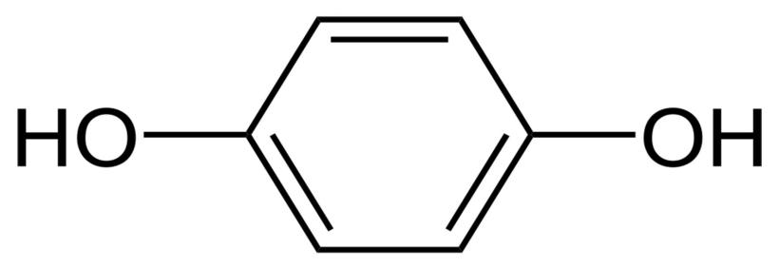
Figure 1: Chemical Structure of Hydroquinone
The chemical structure of hydroquinone (pictured above), with its two hydroxyl groups bonded to an aromatic ring, makes it very likely to oxidize. (8)

1.1.3 Hydrolysis

The chemical linkages that are most likely to hydrolyze in the presence of water are amides and esters. For instance, in the presence of water, aspirin hydrolyzes to acetic acid and salicylic acid, but in a dry environment, aspirin hydrolysis is negligible. When designing formulations that are anhydrous, it is useful to distinguish compounds that include amide and/or ester functional groups in order to spot probable hydrolysis.

Figure 2: Chemical structure of amide
An amide functional group (pictured above) is a chemical structure within a molecule that, among other things, makes that molecule more likely to decompose in the presence of water.
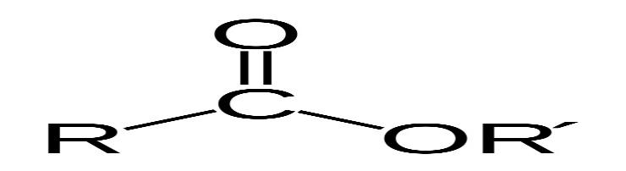
Figure 3: Chemical structure of ester group
An ester functional group (pictured above) is a chemical structure that gives molecules various properties, including the tendency to break down in the presence of water. (9,10)
1.2Chemical aspects of Drug metabolism:
As soon as the injected molecule interacts with enzymes that have the ability to change its chemical structure, the medication is metabolized via fundamental chemical processes. On the other side, a medicine's stability after delivery is primarily due to the body's enzymes not converting it. The chemical deterioration that many medications undergo, whether as a result of interactions with enzymes or inappropriate handling and storage, frequently leads to a decrease in efficacy.
Knowing the functional groups inside drug molecules, including those that are more likely to be susceptible to metabolism and those that are more likely to be resistant, could be helpful when counselling patients on how to store and use their prescription prescriptions.
Dispensing medications into monitored dose systems (MDS), when they are taken out of their manufacturer's packaging and put in an environment where stability is unknown, is a typical illustration. Similarly, when alternative medicinal compounds from a particular chemical class are being explored as part of a medicines usage review, knowledge of functional groups is helpful.

1.3 Chemical reactions

Drugs frequently contain very small chemical components. Due to difference in bond connections, structure of functional groups the two drugs are distinguished from one another.
Oxidation and hydrolysis are the principal chemical processes that impact a drug's stability. A molecule undergoes oxidation when its electrons are removed (or added) and such processes can be started by light, heat, or specific trace metals. Since oxidative degradation can frequently be reduced to acceptable levels by storing susceptible drugs in the absence of light (e.g., use of amber vials) and oxygen (e.g., store under nitrogen or argon), or by using antioxidants in the formulation, it has not been studied in as much detail as hydrolysis
Hydrolysis is the more prevalent method of drug breakdown and can be considered in regard to both stability as well as metabolism.

1.3.1 Hydrolysis
Hydrolysis is the process by which a molecule reacts with water to destroy a chemical bond within itself. The functional groups that are most frequently found in drugs that are susceptible to hydrolysis are esters and amides, but there are numerous other functional groups that are as well. A carboxylic acid and either an alcohol (XH=ROH) or an amine (XH=R1R2NH) are the cleavage reaction products of an ester (X=OR) or an amide (X=NR1R2, where R, R1 and R2 can each have any arbitrary structure).
Figure 1 depicts the mechanism for this reaction.

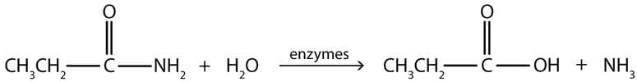
Figure 4: Simple mechanism of hydrolysis of esters and amides
The C=O double bond in an ester or amide becomes polarized, leaving the oxygen with a tiny negative charge and the carbon with a slight positive charge. This is observed due to electron negativity of oxygen than carbon and so it withdraws electrons to itself. This polarization allows the electrons of the oxygen atom in water to be attracted to the slightly positive charge of the aforementioned carbon atom, which results in hydrolysis. This polarization and subsequent interactions are increased by protonating the carbonyl oxygen.
Esters react with water more quickly than amides do, and both an acid and a base are capable of catalysing these reactions. The pH of the aqueous solution affects the rate. Similar to this, the in vivo metabolism of esters and amides in medications is catalysed by hydrolytic enzymes found in various tissues and plasma. The differences in the rates of ester and amide hydrolysis are brought about by the structural differences between these two functional groups. The ester has an oxygen atom, whereas the amide has a nitrogen atom in the same location.
This difference boosts the attraction between the carbonyl group's (C=O) carbon and a water molecule by making the carbonyl group's (C=O) carbon much more positively charged in the ester than in the amide. The nitrogen atom in amides diminishes the positive charge on the carbonyl carbon atom, making it less appealing to incoming water molecules, hence the amide, on the other hand, displays the opposite behavior.
This difference in the hydrolysis of esters and amides is exemplified with lidocaine and procaine (Figure 5).

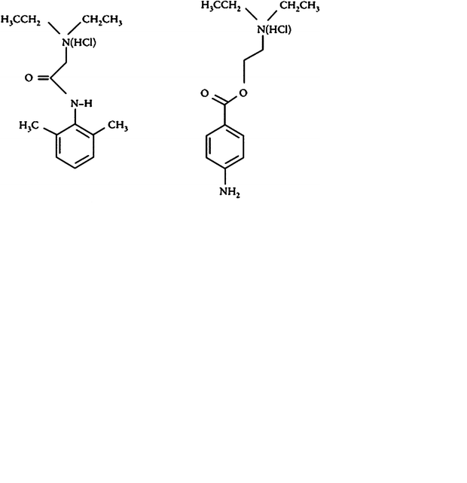
Figure 5: Chemical structures of lidocaine and procaine
Procaine, a local anesthetic that contains an ester, is no longer frequently used. Despite being a good local anesthetic, its effects are short-lived because its ester group hydrolyzes quickly. In contrast, the amide bond in lidocaine is less easily hydrolyzed than the ester of procaine. Since it is more resistant to the effects of hydrolysis, together with its bulkier structure, lidocaine has a longer duration of action than other local anesthetics.
Additionally, hydrolytic enzymes readily hydrolyze the methyl ester in the ADHD medicine methylphenidate (Figure 6) to create ritalinic acid, which is the primary (inactive) urine metabolite in individuals.

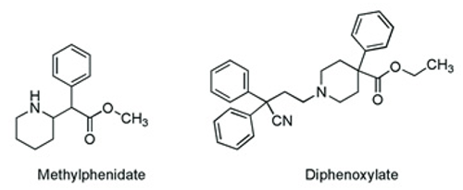
Figure 6: the chemical structures of methylphenidate and diphenoxylate

Since the medicine is rendered inactive by such a readily hydrolysable functional group, maintaining therapeutic levels requires more frequent administration of the drug than once per day. Hydrolysis, on the other hand, has a place. The antimotility medication co-phenotrope contains the ester diphenoxylate (Figure 6), an easily hydrolyzed carboxylic acid in humans that is five times more powerful than the parent ester at preventing diarrhea.

1.3.1.1 Prodrug strategy
Salicylic acid works well as a pain reliever. However, the presence of the naked alcohol moiety causes gastric hemorrhage. This effect is reduced by disguising this alcohol group as an ester and providing us with aspirin, which is subsequently hydrolyzed in the body to release the active component. Such a method is one that is used in pro-drug strategies. Another result of aspirin hydrolysis is acetic acid. When aspirin pills are incorrectly stored, a lingering vinegar odour suggests that hydrolysis is occurring.
An interesting illustration of a prodrug is the angiotensin-converting enzyme inhibitor Enalapril, whose ester is hydrolyzed in the body to form the active carboxylic acid derivative Enalaprilate (used as an intravenous version of Enalapril for hypertensive circumstances).
The cyclic ester (a lactone) in type I statins like Simvastatin is hydrolyzed by body enzymes to form the ring-opened, pharmacologically active hydroxy-acid that is characteristic of these cholesterol-lowering medications.

1.3.1.2 Amide-containing drugs
Amide-containing drugs can also hydrolyze, as was earlier shown, but this process proceeds much more slowly than it does with esters. One example is the hydrolysis of the b-lactam antibiotics stretched cyclic-amide rings (amides that are a part of rings are known as lactams). Penicillin antibiotics are commonly made as aqueous pediatric solutions just before dispensing since they are not sufficiently stable to be administered and stored in water for an extended period of time.

Some suspensions (containing lactam) should also be kept in the refrigerator to reduce hydrolysis of the strained lactam ring. Through the action of hydrolytic enzymes, b-lactam antibiotics are likewise sensitive to hydrolysis. The selected route of administration may be directly impacted by such chemical instability and its repercussions. To understand why some substances (like penicillins and cephalosporins, which both include a stretched, hydrolysis-prone b-lactam ring) are incompatible with continuous infusion, one only needs to consider them.

1.3.1.3Other functional groups

The two classes of medicines that are most frequently found to be hydrolysable are esters and amides. However, a great number of different functional groups can interact with water in a way that breaks bonds. Examples include imines, found in Diazepam, acetals, found in Digoxin, sulphates, found in heparin, and phosphate esters, found in Hydrocortisone sodium phosphate.

1.3.1.4 Preventing hydrolysis
Although hydrolysis can be problematic, as was already indicated, there are a number of ways to prevent or reduce it. For in vivo metabolism, the protective measures are a little more challenging to get around. However, it is possible to chemically change the active compound's structure to prevent hydrolysis if the problematic hydrolysis is identified early enough in the therapeutic research process.
However, for drugs that are already prone to instability, preventive measures may also involve various dosage form changes. Dry powders should be stored and reconstituted in water before administration since drug breakdown in liquid dosage forms depends on the presence of water.
Similar to this, patients can be informed about the need to store medications in a cool environment if they are known to hydrolyze at room temperature. Additionally, its duty of chemists to accurately mark the box with the necessary details.
Additionally, sterilization using heat for some medicines may be difficult as speed of hydrolysis reaction is affected by temperature. For semi-solid dosage forms (ointments and creams), the stability of the active component can be controlled by changing the composition of base. Incorporation of a less hygroscopic salt of the medicine or reducing the water content of the excipients used in the formulation are two similar techniques for reducing a drug's sensitivity to hydrolysis in a solid dosage form.
After investigation with the help if findings, Important factors can be identified and appropriate actions can be taken to prevent the problems that oxidation poses to the quality of a medical product.
1.4 Oxidation:
Oxidation is the second most common drug decomposition process after hydrolysis. However, because oxidation is mechanistically more complex than hydrolysis and generates a wider range of breakdown products, it can be challenging to control. A drug's propensity for oxidation can be discovered by studying forced degradation. Accelerated study of drug and excipient mixtures can give a more accurate picture of how degradation in the solid form develops since excipients are the most frequent sources of pollutants that might begin oxidation of a solid medicinal product.
Phenols (like morphine), catecholamines (such as adrenaline (epinephrine) and noradrenaline (norepinephrine), as well as polyunsaturated substances like oils, fats, and fat-soluble vitamins (such as vitamins A and E), are among the some pharmacological classes that show effect of oxidation. Oxidation reaction may involve radical chain reactions, often known as autoxidation reactions, can be quite challenging.
The primary oxidative degradation pathways listed below are
1.4.1Autoxidation (initiated by radicals);
Initiation:
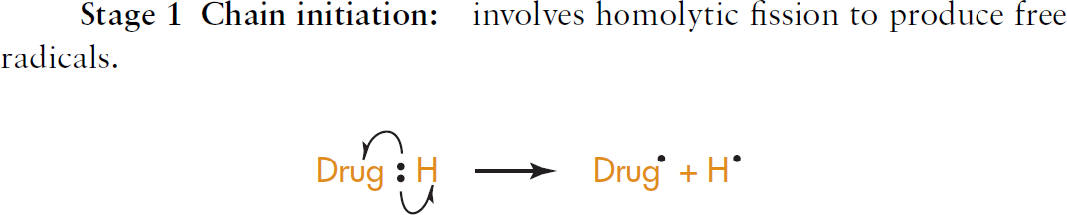
Propagation
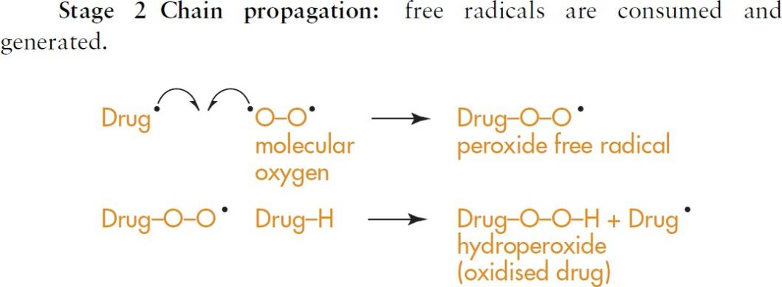

Termination:
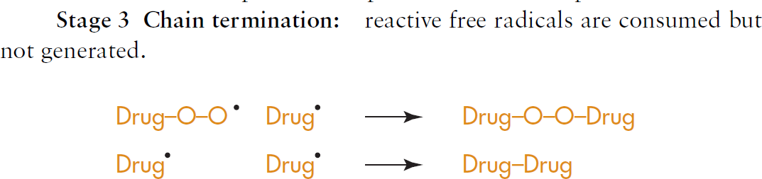
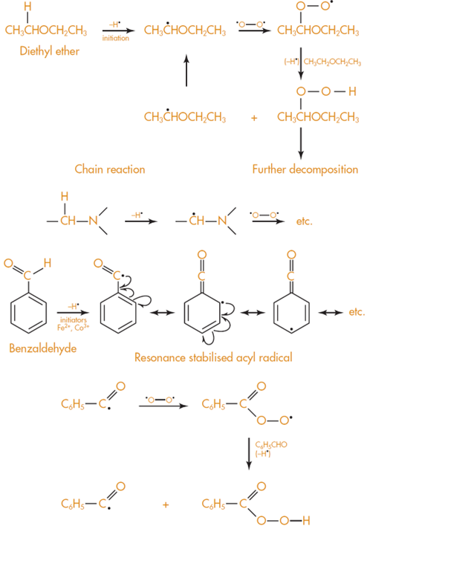

Figure7:Carbon hydrogen bond cleavage in ethers, amines and aldehydes

Other bonds that oxidise easily are the oxygen–hydrogen bond found in phenols and the nitrogen hydrogen bonds found in aromatic amines
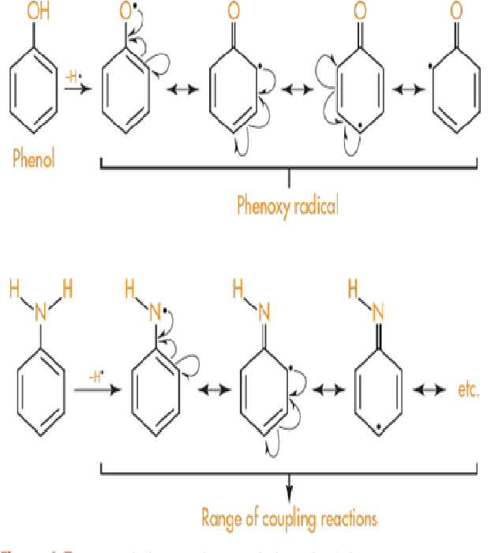
Figure 8: Oxygen hydrogen and nitrogen hydrogen bond cleavage
1.4.2 Nucleophilic/electrophilic Oxidation:
Drugs containing phenolic groups include the analgesics morphine (and related opiates) and paracetamol as well as the bronchodilator salbutamol, widely used in the treatment of acute asthma. (Figure 9).

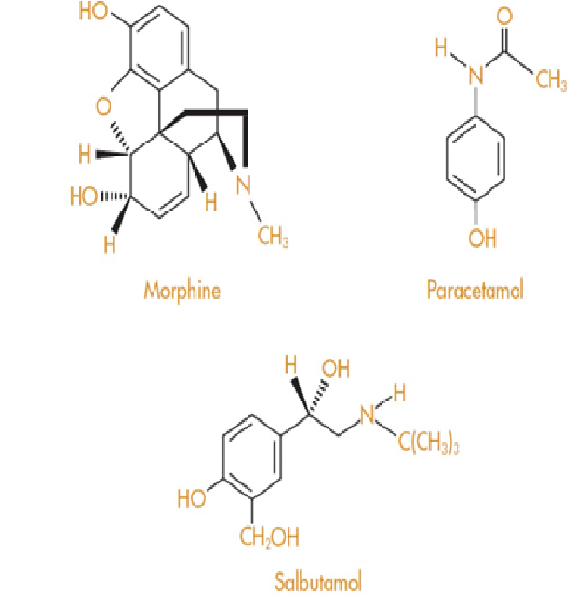

Figure 9: Structure of Morphine paracetamol; and salbutamol containing phenolic groups

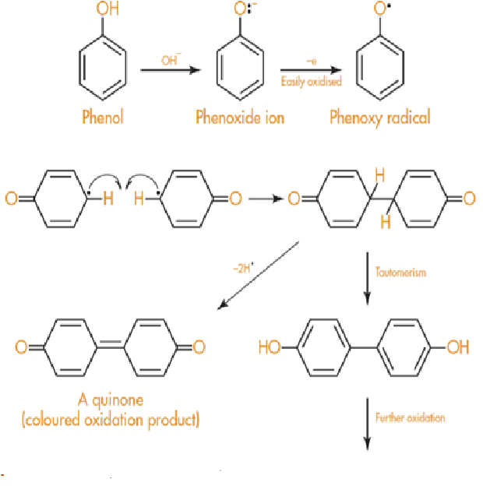
Figure10: Oxidation of phenoxide ion
Drugs that contain two phenolic groups, such as adrenaline (epinephrine) and other catecholamines such as noradrenaline (norepinephrine) and isoprenaline are particularly susceptible to oxidation and have to be formulated at acidic pH. All of these compounds are white crystalline solids that darken on exposure to air.
Adrenaline forms the red coloured compound adrenochrome on oxidation (Figure 11), which can further polymerise to give black compounds similar in structure to melanin, the natural skin pigment.

Injections of adrenaline that develop a pink colour, or that contain crystals of black compound, should not be used for this reason. Adrenaline for injection is formulated as the acid tartrate (Figure 11), which, in aqueous solution, gives a pH of approximately 3.
It is called the acid tartrate since only one carboxylic acid group of tartaric acid is used up in salt formation with adrenaline. This leaves the remaining carboxylic group to function as an acid.

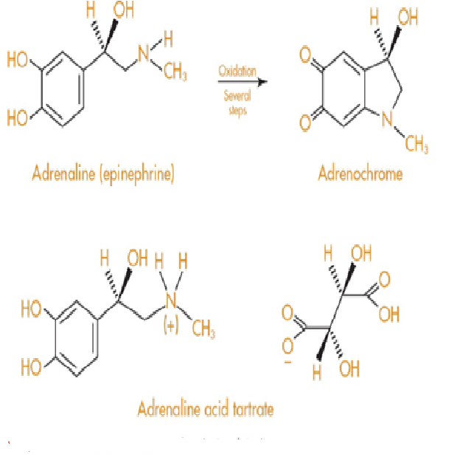

Figure 11:Oxidation of Adrenaline

Cleavage of the nitrogen–hydrogen bond in aromatic amines occurs in a similar manner to that described for phenols, to give a complex mixture of products due to coupling reactions of the type shown in Figure 12.
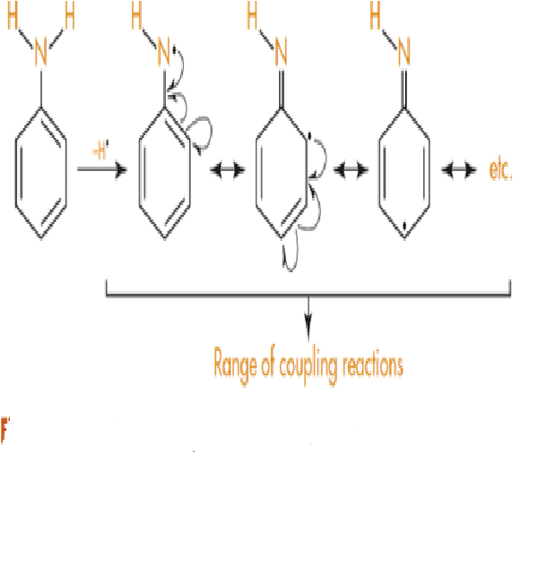
Figure 12:Nitrogen hydrogen bond cleavage in amines

1.4.3Prevention of oxidative deterioration
1.4.3.1Exclusion of oxygen
This is pretty obvious; if oxygen in the air is causing the oxidation, then exclusion of oxygen from the formulation will minimize oxidative deterioration. This is usually achieved by replacing the oxygen with an inert gas atmosphere (e.g. nitrogen or argon). The container should also be well filled with product and closed tightly to minimize the possibility of air getting to the medicine.
1.4.3.2Use of amber or coloured glass containers
Amber glass excludes light of wavelengths 470 nm and so affords some protection to light sensitive compounds. Special formulations, such as metered dose inhalers used in the treatment of asthma, also offer protection from light and oxygen since the drug is dissolved or suspended in propellant and stored in a sealed aluminium container.
1.4.3.3Use of chelating agents
Oxidation reactions can be catalyzed by the presence of tiny amounts of metal ions (for example,
0.05 ppm Cu2_ can initiate decomposition of fats) and so stainless steel or glass apparatus should be used wherever possible during manufacture of susceptible compounds. If the presence of metal ions cannot be avoided, then chelating agents, such as disodium edetate, are used to chelate and remove metal ions. Disodium edetate is the disodium salt of ethylenediaminetetraacetic acid, or EDTA, and is shown in Figure 13.

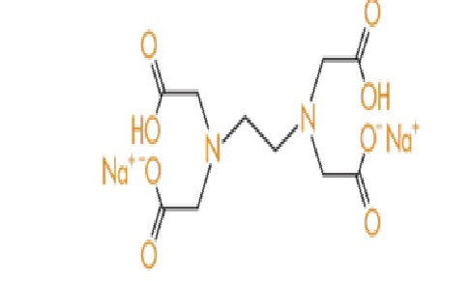

Figure 13: Structure of Disodium EDTA
1.4.3.4Use of antioxidants
Antioxidants are compounds that undergo oxidation easily to form free radicals but which are then not sufficiently reactive to carry on the decomposition chain reaction. They selflessly sacrifice themselves to preserve the drug or medicine. Most antioxidants are phenols and two of the most commonly used are shown in Figure14.

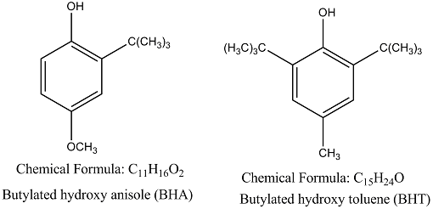
Figure14 : Structure of BHT and BHA

Ascorbic acid (vitamin C) also functions as an antioxidant and is added to medicines and foodstuffs for this reason. Food manufacturers enthusiastically label their products as having ‘added vitamin C’. What they are not so keen to tell you is that the vitamin is not there for the consumers’ benefit but rather as an antioxidant to stop their product decomposing oxidatively (see Figure 15).

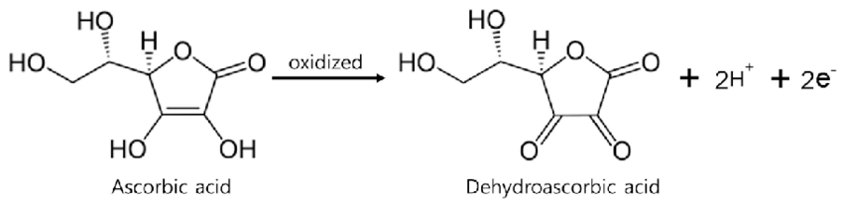
Figure 15: Ascorbic acid oxidation to diketone

2.0 Conclusion:

Pharmaceutical items are frequently subjected to stability studies to ensure that they remain secure, of superior quality, and efficient throughout the duration of their shelf lives. The World Health Organisation (WHO), the International Conference on Harmonisation (ICH), and other groups have established guidelines for certain medicinal products. Oxidation is the second most common medication breakdown process after hydrolysis. However, because oxidation is mechanistically more complex than hydrolysis and generates a wider range of breakdown products, it can be challenging to control. To provide patients with a medication that is both safe and effective, chemists need to be aware of the basic chemistry underpinning drug stability.

2.0 REFERENCES:
1. Guo J.J., Pandey S., Doyle J., Bian B., Lis Y., Raisch D.W. A Review of Quantitative Risk–Benefit Methodologies for Assessing Drug Safety and Efficacy—Report of the ISPOR Risk–Benefit Management Working Group. Value Health. 2010;13:657–666. doi: 10.1111/j.1524-4733.2010.00725.x
2. Zumdahl S.S., Zumdahl S.A. Chemistry. 9th ed. Brooks/Cole, Cengage Learning; Belmont, CA, USA: 2014
3. Rams-Baron M., Jachowicz R., Boldyreva E., Zhou D., Jamroz W., Paluch M. Physical Instability: A Key Problem of Amorphous Drugs. In: Rams-Baron M., Jachowicz R., Boldyreva E., Zhou D., Jamroz W., Paluch M., editors. Amorphous Drugs: Benefits and Challenges. Springer International Publishing; Cham, Switzerland: 2018. pp. 107–157.
4. Sinclair W., Leane M., Clarke G., Dennis A., Tobyn M., Timmins P. Physical Stability and Recrystallization Kinetics of Amorphous Ibipinabant Drug Product by Fourier Transform Raman Spectroscopy. J. Pharm. Sci. 2011;100:4687–4699. doi: 10.1002/jps.22658.
5. Anonymous. ICH Q1A (R2) Stability Testing of New Drug Substances and Products. [(accessed on 24 April 2021)]. Available online: https://www.ema.europa.eu/en/ich-q1a-r2-stability-testing-new-drug-substances-drug-products
6. Ali M.A., Hemingway R., Ott M.A. In Silico Drug Degradation Prediction. In: Bajaj S., Singh S., editors. Methods for Stability Testing of Pharmaceuticals; Methods in Pharmacology and Toxicology. Springer; New York, NY, USA: 2018. pp. 53–73.
7. Del Rosso, J. Q., Harper, J., Pillai, R., & Moore, R. (2012). Tretinoin photostability: Comparison of micronized tretinoin (0.05%) gel and tretinoin (0.025%) gel following exposure to ultraviolet A light. The Journal of Clinical and Aesthetic Dermatology, 5(1), 27-29.
8.United States Pharmacopeial Convention. (2021). General Chapter 1191 stability considerations in dispensing practice. InUnited States pharmacopeia and national formulary 2021. https://www.uspnf.com/
9.United States Pharmacopeial Convention. (2021). Proposed revisions to 795 pharmaceutical compounding — Nonsterile preparations .
10.Handbook of Pharmaceutical Analysis by HPLC
Anissa W. Wong, Aruna Datla, in Separation Science and Technology, 2005.
11.Tiwari R.N., Bonde C.G. LC, LC–MS/TOF and MSn Studies for the Identification and Characterization of Degradation Products of Nelfinavir Mesylate. J. Pharm. Biomed. Anal. 2011;55:435–445. doi: 10.1016/j.jpba.2011.02.020.
12.Beckwith A.L.J., Eichinger P.H., Mooney B.A., Prager R.H. Amine Autoxidation in Aqueous Solution. Aust. J. Chem. 1983;36:719–739. doi: 10.1071/CH9830719.
13. Guerrieri P., Taylor L.S. Role of Salt and Excipient Properties on Disproportionation in the Solid-State. Pharm. Res. 2009;26:2015–2026. doi: 10.1007/s11095-009-9918-y.
14.The Pharmaceutical Journal, Oct 2010.DOI:10.1211/PJ.2021.1.72642.
15. TJ Snape, AM Astles, J Davies, Understanding the chemical basis of drug stability and degradation; Pharm J,2010;28576224106.
16.DW Reynolds, KL Facchine, J Mullaney, Available guidance and best practices for conducting forced degradation studies; PharmTechnol,2002;2624856.

17. Rao G, Goyal A, Development of stability indicating studies for pharmaceutical products: an innovative step; Int.J.Pharm Chem Anal.2016;3(03)110-16.
18. Schmidt, G.M.J. (1971). Photodimerization in the solid state. Pure and Applied Chemistry 27 (4): 647–678.

